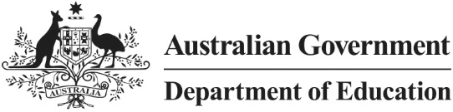

Indigenous Students in Higher Degrees by Research

Statistical Report, August 2019



Opportunity through learning

ISBN

978-1-76051-904-9 [PDF]  
978-1-76051-905-6 [DOCX]

Creative Commons

With the exception of the Commonwealth Coat of Arms, the Department’s logo, any material protected by a trade mark and where otherwise noted all material presented in this document is provided under a [Creative Commons Attribution 4.0 International](http://dnet.hosts.network/education/Resources/Documents/Creative%20Commons%20Attribution%204.0%20International) (http://creativecommons.org/licenses/by/3.0/au/) licence.

The details of the relevant licence conditions are available on the Creative Commons website (accessible using the links provided) as is the full legal code for the [CC BY 4.0 International](http://dnet.hosts.network/education/Resources/Documents/CC%20BY%204.0%20International) (http://creativecommons.org/licenses/by/4.0/legalcode).

The document must be attributed as *Indigenous Students in Higher Degrees by Research. Statistical Report, August 2019.*

Contents

List of Figures 4

List of Tables 4

Preface 5

Analysis of enrolments, commencements and completions 6

Indigenous Access to Scholarships 18

Overview 18

Survey of university-administered stipends 20

Cohort Analysis 22

Bibliography 25

# List of Figures

Figure 1: Indigenous enrolments/proportion of all HDR domestic enrolments, 2006–17 6

Figure 2: Indigenous HDR enrolments by type of attendance, 2006–17 7

Figure 3: Indigenous HDR commencements/proportion of all HDR domestic commencements, 2006–17 8

Figure 4: Indigenous HDR completions/proportion of all HDR domestic completions, 2006–17 9

Figure 5: Indigenous HDR candidates as a proportion of all domestic HDR commencements and completions, 2006–17 10

Figure 6: Indigenous HDR enrolments by gender, 2006–17 11

Figure 7: Proportion of HDR domestic student enrolments by age bracket and Indigenous status, 2017 12

Figure 8: Indigenous HDR enrolments by age bracket, 2006–17 13

Figure 9: Proportion of domestic enrolments by SES and Indigenous Status, 2017 14

Figure 10: Proportion of HDR domestic enrolments by university alliance and Indigenous status, 2017 15

Figure 11: Number of Indigenous HDR enrolments by home state of institution, 2013–17 16

Figure 12: Distribution of 2017 Indigenous HDR enrolments and Australian universities by State 16

Figure 13: Indigenous HDR enrolments by fields of education, 2006–17 17

Figure 14: Proportion of domestic students awarded an APA/RTP stipend by Indigenous status, 2006–17 19

Figure 15: Indigenous doctoral student stipend rates (per annum), based on 2017–18 survey data 21

# List of Tables

Table 1: Cohort analysis for Indigenous students commencing a HDR course in 2007 to 2014 over a four year period, 2007–2010, 2008–2011, 2009–2012, 2010–2013, 2011–2014, 2012–2015, 2013–2016 and 2014–2017 (per cent) 22

Table 2: Cohort analysis for Indigenous students commencing a HDR course in 2007 to 2012 over a six year period, 2007–2012, 2008–2013, 2009–2014, 2010–2015, 2011–2016 and 2012–2017 (per cent) 23

Table 3: Cohort analysis for Indigenous students commencing a HDR course in 2007 to 2009 over a nine year period, 2007–2015, 2008–2016 and 2009–2017 (per cent) 23

Table 4: Nine-year completion rates for commencing Indigenous HDR students by selected characteristics, 2007-2015, 2008-2016, 2009-2017 (per cent ) 24

# Preface

The 2016 *Review of Australia’s Research Training System* (the Review), conducted by the Australian Council of Learned Academies (ACOLA), included a discussion of the representation of equity groups in higher degree by research (HDR) training. The discussion had a particular focus on the low representation of Aboriginal and Torres Strait Islander peoples in HDR training. In response to the Review, the Research Training Implementation Plan (RTIP) was developed by a working group comprised of representatives from the higher education, government and industry sectors, including Indigenous and HDR student representatives. RTIP was released by the Australian Government in December 2017 and includes a number of action items related to the participation of equity groups in HDR training. Action 3.1: *Better data collection, monitoring and analysis* included a requirement for the Department of Education to:

‘Explore improvements to data reporting to support a better understanding of Indigenous student participation in the HDR system, including pathways taken to HDR, access to scholarships and completion rates.’

A separate RTIP action item includes a commitment to report on levels of scholarship and stipend support for Indigenous Australian students, based on data provided by the university sector (Action 3.4).

This report responds to those commitments and should be read in conjunction with RTIP progress reports. It covers enrolments, commencements and completions for Indigenous HDR (predominately master’s by research and doctorate by research) over the period 2006 to 2017 as collected through the Higher Education Student Data Collection (HESDC), and presents the results of a survey on Indigenous access to scholarships conducted by the Department of Education and Training in 2018. The data includes all institutions that enrol HDR students, both universities and one other higher education provider. Given the size of the cohort, the data refers to individual students, not equivalent full-time student load (EFTSL). All data is based on custom requests to the department’s internal databases.

The data reveals that despite a recent increase in the number of Indigenous HDR enrolments, there remain significant issues in the representation and retention of Indigenous Australians in research training. Indigenous students are more likely than non-Indigenous domestic students to be from a low socioeconomic and regional/remote background, and have less access to   
Commonwealth-supported financial assistance provided through their institution. Completion rates for Indigenous HDR students are consistently lower than for non-Indigenous students. With Indigenous HDR students being markedly older than non-Indigenous HDR students, effort is required to increase the number of younger Indigenous HDR students.

The department would like to thank all those who assisted in the preparation of this report, particularly the university staff who provided data on access to scholarships for Indigenous students.

# Analysis of enrolments, commencements and completions

This section explores Aboriginal and Torres Strait Islander enrolments, commencements and completions between 2006 and 2017, with discussion on student characteristics including age, level of financial support, gender and field of education.

The number of Indigenous HDR student enrolments and their proportion of the domestic HDR student enrolments rose steadily between 2006 and 2017 (Figure 1), reaching 592 Indigenous HDR student enrolments by the end of this period, just over one per cent of domestic student enrolments. The growth in Indigenous HDR enrolments was largely driven by full-time enrolments. Until 2013, enrolments were distributed roughly evenly between full-time and part-time, but from 2014 the most growth has been in full-time students (Figure 2). Between 2006 and 2017, the popularity of doctoral degrees appears to have increased at the expense of master’s degrees; doctoral degrees made up 69 per cent of Indigenous research enrolments in 2006, increasing to 76 per cent by 2017, with master’s declining from 31 to 24 per cent of enrolments.

Figure 1: Indigenous enrolments/proportion of all HDR domestic enrolments, 2006–17

From 2006 to 2017, Indigenous HDR student enrolments and their proportion of all domestic HDR student enrolments rose steadily. Indigenous enrolments started at 360 in 2006 and reached 590 in 2017 (just over one per cent of all domestic student enrolments).
Note: figures are rounded to the nearest ten.

Figure 2: Indigenous HDR enrolments by type of attendance, 2006–17

From 2006 to 2013, Indigenous HDR enrolments were distributed roughly evenly between full-time and part-time. Between 2014 to 2017, the most growth was in full-time students (starting at 280 in 2014 and reaching 370 in 2017). From 2006 to 2017, the number of part-time students gradually increased from 170 in 2006 to 220 in 2017.
Note: figures are rounded to the nearest ten.

Indigenous HDR commencements showed an overall increase between 2006 and 2017 from a low of 82 in 2013 to a high of 163 in 2017 (Figure 3). Among students commencing a doctorate, about half had completed a prior postgraduate course, while about a third had only completed a bachelor course. A small number of students had lower or incomplete qualifications prior to commencement.

Figure 3: Indigenous HDR commencements/proportion of all HDR domestic commencements, 2006–17

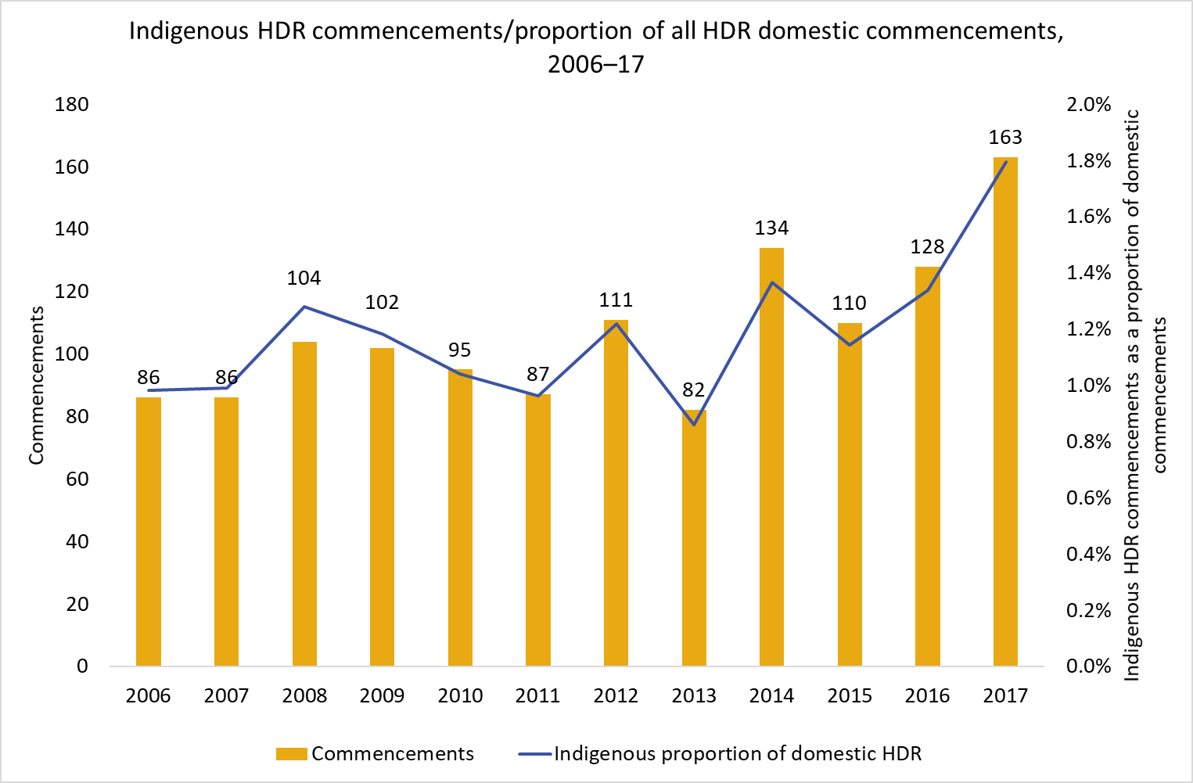

Completion numbers for Indigenous HDR students showed no clear pattern between 2006 and 2014, but markedly increased after 2014 (Figure 4). While the cause of the post 2014 increase is unclear, research suggests that the following factors can influence the completion rates of Indigenous HDR students:

* the quality of the student-supervisor relationship
* the involvement of members of the Indigenous community in the supervisory process
* the availability and provision of academic and non-academic support by universities
* access to appropriate financial assistance, and
* the ability to overcome feelings of social and cultural isolation within the university environment.[1]

Figure 4: Indigenous HDR completions/proportion of all HDR domestic completions, 2006–17

From 2006 to 2014, Indigenous HDR completions showed no clear pattern, starting at a base of 33 in 2006, rising to a peak of 43 in 2010, then falling to 34 in 2014. However, Indigenous completions significantly increased from 2014 to 2017, rising to a peak of 62 in 2016. As a proportion of all domestic HDR completions, Indigenous completions rose from a base of 
0.6 per cent in 2006 to a peak of 
0.9 per cent in 2016.

The ACOLA *Review of Research Training* noted that, in data to 2014, there was an ongoing and widening gap between Indigenous HDR commencements and completions.[2] Data to 2017 shows that the gap still exists, and the impact of recent commencement rate growth on completion rates is as yet unclear (Figure 5). Due to the time lag between student commencement and completion, it is unlikely to see increased Indigenous commencement rates reflected in completion rates for a number of years. For more data on completion rates and time completion patterns, see the Cohort Analysis section at the end of this report.

Figure 5: Indigenous HDR candidates as a proportion of all domestic HDR commencements and completions, 2006–17

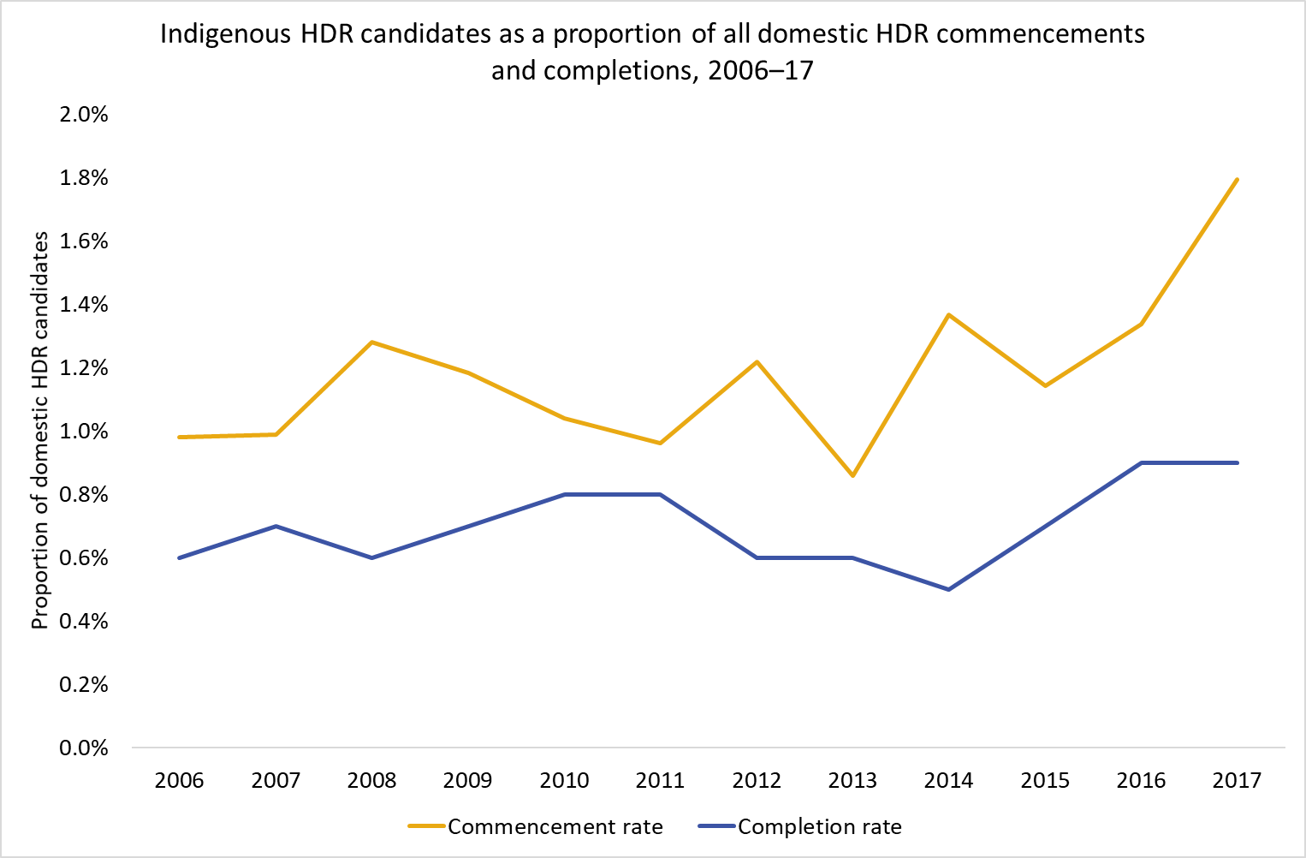

As in the overall domestic HDR population, women make up the majority of Indigenous HDR enrolments, however this gender disparity is more pronounced in Indigenous HDR enrolments. From 2006 to 2017, Indigenous women comprised between 58 per cent and 66 per cent of total Indigenous enrolments (Figure 6), whereas women made up 53 to 54 per cent of total domestic enrolments.

Figure 6: Indigenous HDR enrolments by gender, 2006–17

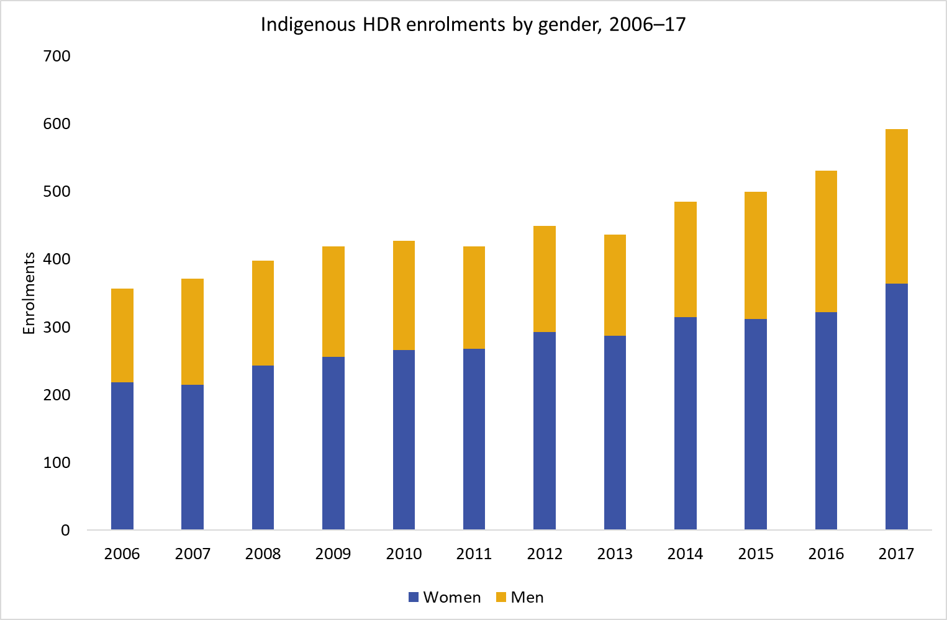

Enrolling Indigenous HDR students were markedly older than non-Indigenous domestic HDR students. In 2017, 40 per cent of Indigenous HDR students were under 40 years of age, compared to 64 per cent of non-Indigenous students. Students under 30 years of age comprised only 17 per cent of Indigenous HDR enrolments, compared with 34 per cent of non-Indigenous enrolments (Figure 7). This age distribution is particularly notable given the Indigenous population is substantially younger than the non-Indigenous population, with a median age of 23 years in 2016, compared to 37.8 years for the non-Indigenous population.[3]

Figure 7: Proportion of HDR domestic student enrolments by age bracket and Indigenous status, 2017

In 2017, the majority of Indigenous HDR domestic enrolments were students aged 45 years or older 
(48 per cent), compared with only 
26 per cent of non-Indigenous students the same age. Only 17 per cent of Indigenous HDR students were aged 29 years or younger, compared with 34 per cent of non-Indigenous enrolments.

Between 2006 and 2007, 40 to 49 was the most common age group for Indigenous HDR student enrolments, followed by 30 to 39 and 50 to 59. Over this time, the proportion of Indigenous HDR enrolments by students below 30 and over 60 both increased (Figure 8).

Figure 8: Indigenous HDR enrolments by age bracket, 2006–17

**From 2006 and 2017, the age group with the highest representation of Indigenous students was 40 to 49 years, which grew from 30 per cent of all enrolments in 2006 to a peak of 
34 per cent in 2008. The age group with the lowest percentage of Indigenous HDR enrolments was 60 years or older, which grew from six per cent in 2006 to a peak of nine per cent in 2013. Students younger than 30 years was the age group with the second lowest representation for Indigenous students, peaking at 17 per cent in 2016.**

Between 2006 and 2017, Indigenous HDR students were much more likely to have a regional or remote status than non-Indigenous domestic students (31 per cent compared to 13 per cent in 2017). Indigenous HDR students were also more than twice as likely to have a low socioeconomic status (SES) (19 per cent compared to 8 per cent of non-Indigenous domestic students in 2017) (Figure 9).

Figure 9: Proportion of domestic enrolments by SES and Indigenous Status, 2017

In 2017, more than twice as many Indigenous domestic HDR students had
low Socio-Economic Status (SES) than non-Indigenous domestic HDR students (19 per cent of Indigenous students compared with eight per cent of non-Indigenous domestic students). The strongest representation for Indigenous students was for students of medium SES (50 per cent). The strongest representation for non-Indigenous students was for students of high SES (47 per cent).

There were differences between Indigenous and non-Indigenous students in the universities they attended. In 2017, 30 per cent of all Indigenous student enrolments were at a Group of Eight (GO8) institution, compared to 46 per cent of all non-Indigenous HDR student enrolments. Indigenous students most commonly attended unaligned universities (32 per cent), followed by Go8, Innovative Research Universities (IRU), Australian Technology Network universities (ATN) and Regional Universities Network (RUN) institutions (Figure 10).

Figure 10: Proportion of HDR domestic enrolments by university alliance and Indigenous status, 2017

In 2017, there were significant differences between Indigenous and non-Indigenous HDR students in the universities they attended: only 
30 per cent of all Indigenous student enrolments were at Group of Eight (Go8) institutions compared to 
46 per cent of all non-Indigenous HDR student enrolments. Indigenous students most commonly attended unaligned universities (32 per cent), followed by Go8 (30 per cent), Innovative Research Universities 
(19 per cent), Australian Technology Network universities  (11 per cent) and Regional Universities Network institutions (eight per cent).

In recent years, the institutions with the highest numbers of Indigenous HDR student enrolments were located principally in New South Wales (NSW), followed by Queensland and Victoria (Figure 11). Non-Indigenous student enrolments were principally located in NSW, followed by Victoria, then Queensland. Notably, a much higher proportion of Indigenous student enrolments were in the Northern Territory, compared to non-Indigenous students. As this data was defined by the flagship campus of the institution, it cannot be assumed that all students at the institution were necessarily based in that state.

The overall distribution pattern of 2017 Indigenous HDR enrolments aligns reasonably well with the distribution of universities by home state (Figure 12). However, NSW has a significantly higher proportion of national Indigenous enrolments compared with the number of NSW universities, with Queensland, the Australian Capital Territory and Tasmania also having a slightly higher proportion of national Indigenous enrolments compared with national university distribution.

Figure 11: Number of Indigenous HDR enrolments by home state of institution, 2013–17

From 2013 to 2017, the institutions with the highest number of Indigenous HDR student enrolments were located in New South Wales, with enrolments steadily rising from 150 in 2006 to 200 in 2017. The state with the second highest number of Indigenous enrolments was Queensland, increasing from 70 in 2006 to a peak of 120 in 2016. Victoria was the state with the third highest Indigenous enrolments, rising from 80 in 2006 to 110 in 2017. In 2017, the two states with the lowest number of Indigenous HDR enrolments were Tasmania (20 enrolments) and National (ACU) (just ten enrolments).
Note: figures are rounded to the nearest ten.

Figure 12: Distribution of 2017 Indigenous HDR enrolments and Australian universities by State

The overall distribution pattern of 2017 Indigenous HDR enrolments aligns reasonably well with the distribution of universities by home state. However, New South Wales (NSW) had a significantly higher proportion of Indigenous HDR enrolments compared with the proportion of universities located in NSW (33 per cent of Indigenous enrolments compared with 23 per cent of universities). Queensland (20 per cent of enrolments compared with 18 per cent of universities), Australian Capital Territory (seven per cent of enrolments compared with five per cent of universities) and Tasmania 
(three per cent of enrolments compared with two per cent of universities) have slightly higher proportions of Indigenous enrolments compared with national university distribution.

Indigenous HDR students had a distinctive pattern in their choice of fields of education, with a strong and increasing emphasis on HASS (humanities, arts and social sciences), particularly the broad field of society and culture (Figure 13).

Figure 13: Indigenous HDR enrolments by fields of education, 2006–17

From 2006 and 2017, the most popular field of study for Indigenous students was humanities and social sciences (HASS). HASS enrolments for Indigenous students increased from a base of 270 in 2006 to 400 in 2017. This was significantly higher than enrolments for the other fields in this graph (STEM, health, architecture and building). From 2006 to 2017, Indigenous enrolments in health increased from 50 to 100, science technology engineering and mathematics (STEM) enrolments increased from 40 to 70 and   architecture and building enrolments rose from just three up to seven students.
Note: figures are rounded to the nearest ten.

The most popular subject area for Indigenous HDR students was society and culture, which includes studies in human society, human welfare studies, behavioural science, law, economics, and language and literature, making up 46 per cent of all Indigenous HDR enrolments in 2017. Within society and culture, the most popular narrow field was studies in human society, which includes anthropology, sociology, history, archaeology, human geography and Indigenous studies. Health was the second most popular subject area for Indigenous enrolments (18 per cent of all Indigenous enrolments). Poor representation in STEM is an issue in the Indigenous HDR landscape: in 2017, only 12 per cent of Indigenous enrolments were in STEM fields compared to 35 per cent of non-Indigenous HDR enrolments.

# Indigenous Access to Scholarships

## Overview

The need for financial support for Indigenous students at both an undergraduate and postgraduate level is recognised within the university sector, with most Australian universities offering scholarships and bursaries specifically for Indigenous students.[4] Sources for these funds at the HDR level include government support (such as the Australian Government’s Research Training Program (RTP)), internal university allocations and charitable foundations and trusts.

The scholarships and bursaries range significantly in value and duration, from minor bursaries for textbooks to major travelling scholarships with three years of support, such as the Charlie Perkins Scholarships. There are also a number of scholarships that are subject area or discipline specific, including support for students undertaking studies in health sciences, Indigenous wellbeing, education and law.

The higher value scholarships are mostly available for full-time HDR students. However, there are a small number of scholarships where candidates can apply to receive scholarships on a part-time basis if there are compelling social reasons (e.g. the need to provide full-time care to others). The majority of Indigenous HDR candidates are mature age, and such students often have caring responsibilities or study part-time.

Some scholarships recognise the intersecting disadvantage experienced by Indigenous students attending university. For example, there are scholarships that aim to support Indigenous women, Indigenous students experiencing financial hardship and Indigenous students who are from rural areas. There are scholarships that seek to address specific barriers, such as the need to move out of home and relocate from another part of the country by covering expenses such as accommodation and relocation costs. A number of university residential colleges offer fee remissions and scholarships ranging from $5,000 to $30,000 in value for Indigenous students who reside in college while attending university.

Some scholarships cover the cost of specific activities. For example, the Nugget Coombs Indigenous Australian Scholarships offered by the Australian National University assists with the costs of fieldwork for Indigenous undergraduate and graduate students. The Aurora Indigenous Scholars International Study Tour provides high achieving Indigenous students with the opportunity to meet with key academics, administrators and current students at overseas universities.

Finally, there are a large number of small bursaries for Indigenous students to cover the cost of purchasing a computer (or other technology) and books needed for university study.

Like other domestic students, Indigenous HDR students are eligible for Commonwealth scholarships provided through the RTP or the Research Training Scheme (RTS), which are administered through their institution. The most commonly awarded form of support, a fees offset, covers tuition fees for the course. Over the period of 2006 to 2017, Indigenous students were slightly less likely to be awarded a fees offset than non-Indigenous students. For example, in 2017, 86 per cent of Indigenous students were awarded a fees offset, compared to 90 per cent of non-Indigenous domestic students.

Students are also eligible for a stipend to cover living costs, through the RTP or the previous Australian Postgraduate Award (APA). Between 2006 and 2017, Indigenous students were substantially less likely to receive a stipend than non-Indigenous students; in 2017, 27 per cent of non-Indigenous domestic students received a stipend, while only 15 per cent of Indigenous students received one (Figure 14). The introduction of the RTP in 2017 coincided with an increase in the proportion of Indigenous students offered a stipend; data for subsequent years will indicate if the events were related.

It is important to note that this data does not include information on scholarship support provided to these students through non-Commonwealth sources (e.g. scholarships offered by universities, professional bodies or charities), which the department does not currently collect. For a preliminary survey of such support, see the section on the Indigenous scholarships survey below.

Figure 14: Proportion of domestic students awarded an APA/RTP stipend by Indigenous status, 2006–17

From 2006 to 2017, the proportion of Indigenous students who were awarded an APA/RTP stipend was significantly lower than for 
non-Indigenous students. For 
non-Indigenous students, the percentage awarded a stipend rose from 14 per cent in 2006 to 27 per cent in 2017. The proportion of Indigenous students awarded a stipend 
was 15 per cent in 2017, which had increased from six per cent in 2006.

## Survey of university-administered stipends

Compared to non-Indigenous domestic students, Indigenous HDR students have been less likely to receive Commonwealth financial support such as an RTP stipend. However, the department does not regularly collect data on non-Commonwealth support provided to students through their university or charitable foundations and trusts. Indigenous students may access these other forms of support to supplement Commonwealth support, or they might only receive non-Commonwealth support. It should be noted that students who receive income from another source to support their living expenses are sometimes deemed ineligible for an RTP stipend.[5]

In order to obtain more information about university support for living costs, in the second half of 2018 the department invited the 42 higher education providers (HEPs) eligible for research block grants to submit data about their Indigenous HDR enrolments. HEPs were asked to provide data on the type and quantum of financial support the HEP provided to these students, including Commonwealth support and other support administered by the HEP, by the type of study and level of HDR. Of the 42 providers invited, 40 provided completed survey forms. Information about scholarships or other forms of support not administered through the university (for example, support provided directly to the student through an external organisation) was not captured.

Some inherent limitations in the student management systems operated by HEPs affected the quality of the survey results. For example, the scope of the survey focussed exclusively on stipend and allowance support. However, many HEP systems do not distinguish between stipend scholarships and other forms of support such as fee offsets. Consequently, there was some uncertainty in interpretation of the data – for example, whether a stipend figure included or excluded the fees offset figure, whether a figure referred to financial or calendar years, and whether data for a part-time student referred to the actual amount received or its full-time annual equivalent. For these reasons, the conclusions of this survey are preliminary, and further surveys would be required to refine the survey methodology and take advantage of upgraded HEP student management systems.

Data was collected for the 2017/18 financial year, providing a “snapshot” of stipend support over that period, including both annual payments of ongoing scholarships and one-off payments for ancillary costs. During this period, the survey reveals that at least 296 Indigenous HDR students received an ongoing scholarship or stipend of some sort. This represents about half of all Indigenous HDR students enrolled at that time; in comparison, only 87 Indigenous students (or 15 per cent) received an RTP stipend in 2017 (see Figure 14).

Figure 15 shows the distribution of total stipend support for doctoral students based on the results of the survey. Most students, both full-time and part-time, received a stipend close to the minimum base full-time RTP stipend ($27,082 in 2018).

There was a wide range in the level of stipend support provided ($1,781 to $56,266) to doctoral students, and the median doctoral full-time stipend ($27,082) was greater than the median stipend

for students studying part-time ($24,739). Of the 233 doctoral students receiving a stipend,   
77 per cent were enrolled full-time.

Doctoral students received higher median stipend rates than master’s students; this was the case for both full-time and part-time students. The majority of master’s students who received a stipend were enrolled full-time (46 students or 78 per cent of the total). The median value of stipends provided to full-time master’s students was $26,982, with part-time students receiving a lower median amount of $19,052. Again, some of the lower stipend rates may have been due to students only being enrolled for part of the twelve-month survey period.

Universities provided additional support to students through top-ups or allowances. In some cases, this payment equated to an ongoing stipend top-up, where an extra amount was paid to the student along with their base stipend payments. In other cases, this payment is more likely to have been a one-off payment, for example to reimburse a student’s travel costs or thesis printing costs. Such payments were provided to 64 (or 36 per cent) of the 179 full-time doctoral students receiving a stipend, with a median value of $5,000. Eighteen (or 13 per cent) of the part-time PhD students receiving a stipend also received a top-up, which had a median value of $4,809. These top-up amounts have not been included in Figure 15.

Figure 15: Indigenous doctoral student stipend rates (per annum), based on 2017–18 survey data

This chart shows the distribution of total stipend support for Indigenous doctoral students based on the results of a survey conducted during the 2017-2018 financial year. Most Indigenous doctoral students, both
full-time and part-time, received a stipend of $25,000-30,000 per annum. Only one student received stipend support of $55,000-60,000 and five students (three full-time and
two part-time) received stipend support of only $5,000 or below.

# Cohort Analysis

This analysis presents the results of tracking commencing Indigenous HDR student outcomes over time. That is, after nominated periods, how many commencing students had completed their studies, how many were still studying, and how many had not completed their course. The methodology for the analysis follows the department’s previous cohort analyses.[6]

Tables 1to 3 show outcomes after four (Table 1), six (Table 2) and nine (Table 3) years following commencement of study, beginning with students who commenced in 2007. Caution is required when interpreting these figures given the small number of enrolments on which these statistics are based. However, it is clear that Indigenous HDR students have tended to engage in their courses over longer timeframes, and have exhibited higher dropout rates and lower completion rates than the general domestic HDR population.

Table 1: Cohort analysis for Indigenous students commencing a HDR course in 2007 to 2014 over a four year period, 2007–2010, 2008–2011, 2009–2012, 2010–2013, 2011–2014, 2012–2015, 2013–2016 and 2014­­­–2017 (per cent)

|  |  |  |  |  |  |  |  |  |
| --- | --- | --- | --- | --- | --- | --- | --- | --- |
| **Cohort group** | **Completed (in any year)** | | **Still enrolled at the end of the 4 year cohort period** | | **Re-enrolled, but dropped out** | | **Never came back after the first year** | |
|  | Indigenous HDR | All Domestic HDR | Indigenous HDR | All Domestic HDR | Indigenous HDR | All Domestic HDR | Indigenous HDR | All Domestic HDR |
| 2007 | 14.3 | 18.4 | 52.4 | 59.4 | 22.6 | 13.9 | 10.7* | 8.2 |
| 2008 | 9.7 | 18.4 | 58.3 | 60.8 | 21.4 | 13.2 | 10.7 | 7.7 |
| 2009 | 13 | 17.3 | 52 | 61.1 | 24 | 14.4 | 11 | 7.1 |
| 2010 | 7.4* | 18.8 | 54.7 | 59.1 | 29.5 | 14.4 | 8.4* | 7.7 |
| 2011 | 5.7* | 17.7 | 58.6 | 61.7 | 24.1 | 13.6 | 11.5 | 6.9 |
| 2012 | 7.2* | 17.9 | 63.1 | 62.2 | 25.2 | 13.9 | 4.5* | 6 |
| 2013 | 18.5 | 17.5 | 59.3 | 63 | 11.1* | 13.5 | 11.1* | 6 |
| 2014 | 12.9 | 20.3 | 57.6 | 59.5 | 22 | 13.6 | 7.6 | 6.6 |

*Calculation is based on fewer than 10 students

Table 2: Cohort analysis for Indigenous students commencing a HDR course in 2007 to 2012 over a six year period, 2007–2012, 2008–2013, 2009–2014, 2010–2015, 2011–2016 and 2012–2017 (per cent)

|  |  |  |  |  |  |  |  |  |
| --- | --- | --- | --- | --- | --- | --- | --- | --- |
| **Cohort group** | **Completed (in any year)** | | **Still enrolled at the end of the 6 year cohort period** | | **Re-enrolled, but dropped out** | | **Never came back after the first year** | |
|  | Indigenous HDR | All Domestic HDR | Indigenous HDR | All Domestic HDR | Indigenous HDR | All Domestic HDR | Indigenous HDR | All Domestic HDR |
| 2007 | 27.4 | 44.5 | 32.1 | 25.5 | 29.8 | 21.9 | 10.7* | 8.1 |
| 2008 | 29.1 | 46.9 | 28.2 | 23.7 | 32 | 21.9 | 10.7 | 7.5 |
| 2009 | 22 | 46.5 | 29 | 23.5 | 39 | 23.1 | 10 | 6.9 |
| 2010 | 20 | 46.7 | 30.5 | 23.2 | 41.1 | 22.6 | 8.4* | 7.5 |
| 2011 | 19.5 | 47.4 | 35.6 | 23.8 | 34.5 | 22 | 10.3* | 6.8 |
| 2012 | 30.6 | 48.3 | 33.3 | 24.3 | 32.4 | 21.6 | 3.6* | 5.9 |

*Calculation is based on fewer than 10 students

Table 3: Cohort analysis for Indigenous students commencing a HDR course in 2007 to 2009 over a nine year period, 2007–2015, 2008–2016 and 2009–2017 (per cent)

|  |  |  |  |  |  |  |  |  |
| --- | --- | --- | --- | --- | --- | --- | --- | --- |
| **Cohort group** | **Completed (in any year)** | | **Still enrolled at the end of the 9 year cohort period** | | **Re-enrolled, but dropped out** | | **Never came back after first year** | |
|  | Indigenous HDR | All Domestic HDR | Indigenous HDR | All Domestic HDR | Indigenous HDR | All Domestic HDR | Indigenous HDR | All Domestic HDR |
| 2007 | 38.1 | 59.7 | 15.5 | 6.5 | 36.9 | 25.7 | 9.5* | 8 |
| 2008 | 38.8 | 61.6 | 6.8* | 6.4 | 43.7 | 24.8 | 10.7 | 7.3 |
| 2009 | 40 | 61.6 | 12 | 5.6 | 38 | 26 | 10 | 6.8 |

*Calculation is based on fewer than 10 students

Table 4 shows nine-year completion rates by a number of student characteristics. Again, caution is warranted given the relatively small number of students represented. Students studying   
full-time and those who were male, who commenced when aged under 45, from a high SES, and from metropolitan areas exhibited greater success rates than those without these characteristics. This is consistent with the characteristics of high completions in the total domestic HDR population, and affirms what we know of the challenges faced by students who are female, mature-aged, from low SES backgrounds, and from regional or rural areas.

It was not possible to publish completion rates according to stipend status, as the number of Indigenous HDR students who received an Australian Postgraduate Award in the 2007–09 cohorts was too few to produce reliable statistics. Students who received a fees offset through the RTS, but no stipend, had a completion rate of around 40 per cent in each cohort.

Table 4: Nine-year completion rates for commencing Indigenous HDR students by selected characteristics, 2007-2015, 2008-2016, 2009-2017 (per cent ) [7]

|  |  |  |  |
| --- | --- | --- | --- |
|  | **2007** | **2008** | **2009** |
| **Total (Domestic) Indigenous HDR students** | 38.1 | 38.8 | 40.0 |
| **Type of course** | | | |
| Doctorate by Research | 40.0 | 44.3 | 45.2 |
| Master’s by Research | 35.3 | 27.3* | 31.6 |
| **Course load** | | | |
| Full-time | 40.8 | 44.6 | 44.1 |
| Part-time | 34.3 | 28.9 | 31.3 |
| **Gender** | | | |
| Female | 31.9 | 34.8 | 32.7 |
| Male | 45.9 | 45.9 | 47.9 |
| **Age** | | | |
| 44 years and under | 50.0 | 46.8 | 48.6 |
| 45 years and over | 20.6* | 26.8 | 20.0* |
| **Highest qualification** | | | |
| Completed Bachelor course | 50.0 | 46.8 | 35.6 |
| Completed Postgraduate course | 42.9 | 41.7 | 40.9 |
| **Socioeconomic Status** | | | |
| High SES | 55.6 | 45.2 | 55.2 |
| Medium SES | 29.7 | 37.9 | 33.3 |
| Low SES | 30.0* | 16.7* | 31.8* |
| **Regionality** | | | |
| Metropolitan | 49.1 | 47.1 | 42.2 |
| Regional and remote | 16.7* | 23.3* | 36.7 |

*Calculation is based on fewer than 10 students

# Bibliography

Anderson, I., Reich, H. (2016) [Indigenous higher education - creating pathways to PhD study for Indigenous Australians. Global Access to Postsecondary Education](http://www.gaps-education.org/wp-content/uploads/2016/12/The_GAPS_Think_Piece_Issue_16.pdf).

Anderson, I. (2016) Indigenous Australians and higher education: The contemporary policy agenda. In: Harvey A., Burnheim C., Brett M. (eds) *Student Equity in Australian Higher Education*. Springer, Singapore. 221-40.

Australian Bureau of Statistics (2018) 3238.0.55.001 - [Estimates of Aboriginal and Torres Strait Islander Australians](https://www.abs.gov.au/ausstats/abs@.nsf/mf/3238.0.55.001), June 2016.

Barney, K. (2018) ‘We need more mob doing research’: developing university strategies to facilitate successful pathways for Indigenous students into Higher Degrees by Research. *Higher Education Research & Development* 37(5): 908-922.

Chirgwin, S. K. (2015) Burdens too difficult to carry? A case study of three academically able Indigenous Australian Master’s students who had to withdraw. *International Journal of Qualitative Studies in Education* 28 (5): 594-609.

Hutchings, K., Bainbridge, R., Bodle, K., & Miller, A. (2019) Determinants of Attraction, Retention and Completion for Aboriginal and Torres Strait Islander Higher Degree Research Students: A Systematic Review to Inform Future Research Directions. *Research in Higher Education* 60 (2): 245‑272.

Liddle, C. (2016) First peoples: Aboriginal and Torres Strait Islander participation in higher education. In: Harvey A., Burnheim C., Brett M. (eds) *Student Equity in Australian Higher Education*. Springer, Singapore. 53-68.

McGagh J., Marsh H., Western M., Thomas P., Hastings A., Mihailova M., Wenham M. (2016) *Review of Australia’s Research Training System*. Report for the [Australian Council of Learned Academies](http://www.acola.org.au).

Moodie, N., Ewen, S., McLeod, J., & Platania-Phung, C. (2018) Indigenous graduate research students in Australia: a critical review of the research. *Higher Education Research & Development* 37(4): 805-820.

Trudgett, M. (2013) Stop, collaborate and listen: A guide to seeding success for Indigenous higher degree research students. In: Craven, R. G., Mooney, J. (ed.) *Seeding Success in Indigenous Australian Higher Education*. Emerald Group Publishing Limited.

Trudgett, M. (2014) Supervision provided to Indigenous Australian doctoral students: A black and white issue. *Higher Education Research & Development* 33 (5): 1035-1048.

Trudgett, M., Page, S., & Harrison, N. (2016) Brilliant minds: A snapshot of successful Indigenous Australian doctoral students. *The Australian Journal of Indigenous Education* 45 (1): 70-79.

1. See Trudgett (2013, 2014, 2016); Chirgwin (2015); Moodie et al. (2018); Hutchings et al. (2019).
2. McGagh et al. (2016), 94.
3. See ABS: 3238.0.55.001 - [Estimates of Aboriginal and Torres Strait Islander Australians, June 2016](https://www.abs.gov.au/ausstats/abs@.nsf/mf/3238.0.55.001)
4. For a list of scholarships available to Indigenous Australians for VET and university study, see [the Aurora Education Foundation’s Indigenous Scholarships Portal](http://www.indigenousscholarships.com.au).
5. Section 1.5(2) of the *Commonwealth Scholarship Guidelines (Research) 2017*
6. See [Completion rates - cohort analyses](https://www.education.gov.au/completion-rates-cohort-analyses)
7. Omits students with a highest reported qualification equal to or lower than a completed bachelor course, and those with unknown regionality.