

Student Equity in Higher Degrees by Research

Statistical Report, August 2019



Opportunity through learning

ISBN  
978-1-76051-906-3 [PDF]  
978-1-76051-907-0 [DOCX]

Creative Commons

With the exception of the Commonwealth Coat of Arms, the Department’s logo, any material protected by a trade mark and where otherwise noted all material presented in this document is provided under a [Creative Commons Attribution 4.0 International](http://dnet.hosts.network/education/Resources/Documents/Creative%20Commons%20Attribution%204.0%20International) (http://creativecommons.org/licenses/by/3.0/au/) licence.

The details of the relevant licence conditions are available on the Creative Commons website (accessible using the links provided) as is the full legal code for the [CC BY 4.0 International](http://dnet.hosts.network/education/Resources/Documents/CC%20BY%204.0%20International) (http://creativecommons.org/licenses/by/4.0/legalcode).

The document must be attributed as the *Equity in Higher Degrees by Research. Statistical Report, August 2019*.

Contents

List of Figures 4

List of Tables 4

Executive Summary 5

Preface 6

1. Overview 8

2. Financial Support 10

3. Gender 13

4. Socioeconomic Status 20

5. Regional and Remote Status 23

6. People with Disability 26

Bibliography 28

# List of Figures

Figure 1: HDR enrolments by citizenship and gender, 2006–17 8

Figure 2: HDR commencements and completions, 2006–17 9

Figure 3: Domestic HDR student funding sources for tuition fees, 2006–17 10

Figure 4: Proportion of domestic students awarded RTP stipends by type of attendance, 2006–17 12

Figure 5: Domestic HDR enrolments by gender, 2006–17 13

Figure 6: Fields with the largest enrolments of domestic HDR students, men, 2017 14

Figure 7: Fields with the largest enrolments of domestic HDR students, women, 2017 15

Figure 8: Domestic HDR enrolments by gender in Science, 2017 16

Figure 9: Domestic HDR enrolments by gender in Engineering and IT, 2017 16

Figure 10: Domestic HDR enrolments by gender in Health, 2017 17

Figure 11: Domestic HDR enrolments by gender in Creative Arts and Education, 2017 18

Figure 12: Domestic HDR enrolments by gender in Society and Culture, 2017 19

Figure 13: Proportion of domestic HDR enrolments by SES, 2011–17 21

Figure 14: Distribution of HDR enrolments among university alliances by SES, 2017 22

Figure 15: Proportion of domestic HDR enrolments by age and regionality, 2017 24

Figure 16: HDR enrolments by alliance and regionality, 2017 24

Figure 17: Proportion of domestic HDR enrolments by broad FoE and regionality, 2017 25

Figure 18: Proportion of enrolled domestic HDR students with disability, 2006–17 26

Figure 19: Proportion of enrolments for domestic HDR students with disability, by field of education, 2006–17 27

# List of Tables

Table 1: Age distribution among domestic HDR students, 2017 9

Table 2: Selected cohorts and proportions awarded RTP stipends each year, 2006–17 11

# Executive Summary

In response to the 2016 *Review of Australia’s Research Training System*, the Australian Government made a commitment to monitor and undertake analysis of issues surrounding representation of equity groups in higher degree by research (HDR) training.

This report presents analysis and selected data on enrolments, commencements and completions for HDR students over the period 2006 to 2017, organised by the themes of financial support, gender, socioeconomic status (SES), regional/remote status, and disability. Some of the key findings include:

* Access to Commonwealth fee offsets and stipends for domestic students increased over the period. Some groups have a consistently lower rate, including low SES and part-time students.
* Women made up the majority of domestic HDR enrolments, commencements and completions. However, women were a minority in most science, technology, engineering and mathematics (STEM) fields with the exception of biological sciences and other natural and physical sciences.
* Men were well-represented in STEM but under-represented in virtually all fields of health, education and creative arts.
* Regional and remote students, and students of medium and low SES remained significantly under-represented in the HDR student population. There was little change in the representation of these students over the period.
* Regional students were more likely to be older, and less likely to attend their course internally compared to metropolitan students.
* Regional and remote students were most strongly represented in the fields of agriculture, environment and related studies and education.
* The proportion of HDR students with disability increased significantly between 2006 and 2017.
* Overall, the HDR cohort mirrors many of the equity participation patterns seen in undergraduate education, though most equity groups exhibit lower rates of participation in HDR compared to undergraduate courses.

# Preface

The 2016 *Review of Australia’s Research Training System* (the Review), conducted by the Australian Council of Learned Academies (ACOLA), included a discussion of the representation of equity groups in HDR training. The primary focus was on the low representation of Aboriginal and Torres Strait Islander peoples in HDR training, but it also noted the challenges faced by other equity groups including students from a rural or low socioeconomic background.[1]

In response to the Review, stakeholders developed a Research Training Implementation Plan (RTIP), released by the Australian Government in December 2017. The RTIP includes a number of action items related to the participation of equity groups (Actions 3.1 to 3.4). Among these is a commitment to monitor and undertake analysis of issues surrounding participation of equity groups including students of low socioeconomic and regional/remote backgrounds and Aboriginal and Torres Strait Islander students (Action 3.1).[2]

This report is one of a number of responses to these actions released by the Department of Education (the department). It presents selected data and analysis on enrolments, commencements and completions for HDR programs over the period 2006 to 2017, organised by the themes of financial support, gender, SES, regional/remote status and disability. The data refers to all Australian institutions that enrol HDR students, both universities and a small number of other higher education providers. In all cases, the data is derived from custom queries to the department’s internal databases. Due to the coding used to remove double counting of enrolments, the results may differ slightly from other public data.

Student numbers are presented on the basis of individual student enrolments, rather than an equivalent full-time student load (EFTSL) basis. One reason for this approach is that HDR students do not undertake typical units of study and therefore it can be difficult to consistently estimate EFTSL. Further, as some equity groups have different attendance type patterns, enrolments give a more meaningful picture of equity group participation than EFTSL.

Where representation has remained relatively static over this period, the report generally only provides a chart for the most recent available year, while some more significant changes are shown as a time series. As domestic students remain the primary focus of efforts to improve the representation of equity groups, this report does not address the position of international students except as a point of comparison.

While the HDR cohort mirrors many of the patterns seen in undergraduate education, most equity groups exhibit lower rates of participation in HDR compared to undergraduate courses.[3] By making departmental data at this level of detail more readily available, it is hoped that the report will serve as a useful resource in highlighting the under-representation of equity groups in HDR. Further, the

analysis identifies areas of need where policy interventions could improve commencements, enrolments and completions.

A separate report, *Indigenous Students in Higher Degrees by Research*, focuses on Aboriginal and Torres Strait Islander peoples’ participation in HDR, and includes the results of a survey on financial support for Aboriginal and Torres Strait Islander students.

# Overview

In 2017 there were 66,145 students enrolled in a HDR program in Australia, representing 4 per cent of all higher education enrolments. Total HDR enrolments rose every year between 2006 and 2017, with particularly strong growth between 2009 and 2015. This growth was driven by international enrolments, which increased as a proportion of total enrolments from 18 per cent in 2006 to 33 per cent in 2017. Domestic enrolments generally increased every year, but declined by 541 in 2017 – the first decline since 2008 (Figure 1).

Figure : HDR enrolments by citizenship and gender, 2006–17

From 2006 to 2017, total HDR enrolments increased each year, from a base of 49,000 in 2006 to 66,000 in 2017. Domestic women were the majority of domestic enrolments across this period. International men made up the majority of international enrolments from 2006 to 2017.
Note: figures are rounded to the nearest hundred.

Proportionally, the largest cohort through this period was domestic women, followed by domestic men, international men and international women.

In 2017 14,896 students commenced an HDR degree, including 9,083 domestic and 5,813 international students. The number of domestic commencements declined from a high of 9,810 in 2014, although domestic completions, which lag commencements, were still rising (Figure 2).

Between 2006 and 2017, about 20 per cent of all domestic enrolments each year were first-year students starting their degree (commencements). In 2017, 10,739 students completed their degree, including 6,787 domestic and 3,952 international students. Over this period, students who completed their degree were between 13­­­­­­–15 per cent of all domestic enrolments each year, and international completions were between 13–18 per cent of international enrolments.

**Figure 2: HDR commencements and completions, 2006–17**

**From 2006 to 2017, HDR domestic commencements rose from a base of  8,800 in 2006 to a high of 9,800 in 2014, then declined after 2014. The number of domestic completions remained steady from 2006 to 2012, then significantly increased from 2012 to 2017. Notably, both international commencements and completions more than doubled from 2006 and 2017. International commencements increased from 2,500 in 2006 to 5,800 in 2017. International completions rose from 1,500 in 2006 to 4,000 in 2017.
Note: figures are rounded to the nearest hundred.
**

The vast majority of domestic HDR students were studying doctorates by research; over the period 2006–17, this proportion increased from 82 to 85 per cent, with the remainder studying for a masters by research or other HDR programs.

The proportion of domestic students studying part-time (less than 0.75 EFTSL) declined from   
51 per cent in 2006 to 41 per cent in 2014, before rising to 44 per cent in 2017.

In 2017, around 90 per cent of domestic HDR students studied on-campus, about 9 per cent   
off-campus and the remainder studied both on-campus and off-campus.

Over the period 2006–17, people aged in their 30s increased their representation among domestic students slightly, however the majority of students were over 40 years old (Table 1).

Table : Age distribution among domestic HDR students, 2017

| Age | Domestic |
| --- | --- |
| <30 | 34% |
| 30-39 | 30% |
| 40+ | 36% |

# Financial Support

In 2017, almost all domestic HDR students received a Research Training Program (RTP) fee offset to cover their tuition fees. Over the period 2006–17, the proportion of domestic students receiving this fee offset (or the previous Research Training Scheme (RTS) fee offset) increased from 83 per cent to   
90 per cent. A small number of students received a non-Commonwealth supported place with an exemption scholarship, paid their fees upfront, or deferred them through FEE-HELP; these categories declined as a proportion of all tuition fee arrangements (Figure 3). There was little or no difference among cohorts in their access to RTP fee offsets; an exception was part-time students, where the proportion awarded a fee offset was consistently 7 to 10 percentage points lower each year than the proportion of full-time students awarded an offset.

Figure : Domestic HDR student funding sources for tuition fees, 2006–17

From 2006 to 2017, the number of domestic HDR students who either had a non-Commonwealth supported place with fees offset or paid their fees upfront/deferred their fees through FEE-HELP gradually declined. The proportion of domestic students receiving fee offsets from either the Research Training Program (RTP) or Research Training Scheme (RTS) steadily increased from 83 per cent in 2006 to 
90 per cent in 2017.

To assist with living expenses, HDR students may also be awarded RTP stipends (which replaced Australian Postgraduate Awards (APA) in 2017). Over the period 2006–17, the proportion of domestic HDR students awarded an APA/RTP stipend increased from 14 to 27 per cent. However, there were consistent differences between groups in the proportion of the group to receive RTP stipends (Table 2). In 2017 for example, the proportion of high SES students who were awarded an APA was 30 per cent, while the proportion of low-SES students awarded a stipend was 24 per cent.[4]

Table : Selected cohorts and proportions awarded RTP stipends each year, 2006–17

| Cohort | Proportion of cohort awarded an RTP stipend each year |
| --- | --- |
| Women | 1-2 p.p. more than proportion of men |
| Low SES students | 2-6 p.p. less than proportion of high SES students |
| Regional/remote students | 3-6 p.p. less than proportion of metropolitan students |
| Part-time students | 17-37 p.p. less than proportion of full-time students |

p.p. = percentage points

It is important to note that the data does not indicate the total level of scholarship support offered to these students outside the RTP, as the department does not collect detailed data on   
non-Commonwealth stipends. However, research shows that low-SES students have lower incomes and tend to be more debt averse than those from higher SES backgrounds.[5] A lower rate of income support for HDR study by low-SES students is therefore more likely to act as a disincentive to participation in HDR.[6] For more discussion on low-SES students in HDR, see Section 4.

There is a notable difference in stipend award rates for full-time and part-time students, with the disparity widening during the period 2006–17 (Figure 4). This may have been partly due to the earlier requirement under the previous APA that a student must be full-time, unless the university approved part-time study. The difference may also be due to the impact of completions in the research block grant funding formula. Higher education providers may be incentivised to fund full- time students, who have higher and faster completion rates, in order to receive more RTP funding.

Figure : Proportion of domestic students awarded RTP stipends by type of attendance, 2006–17

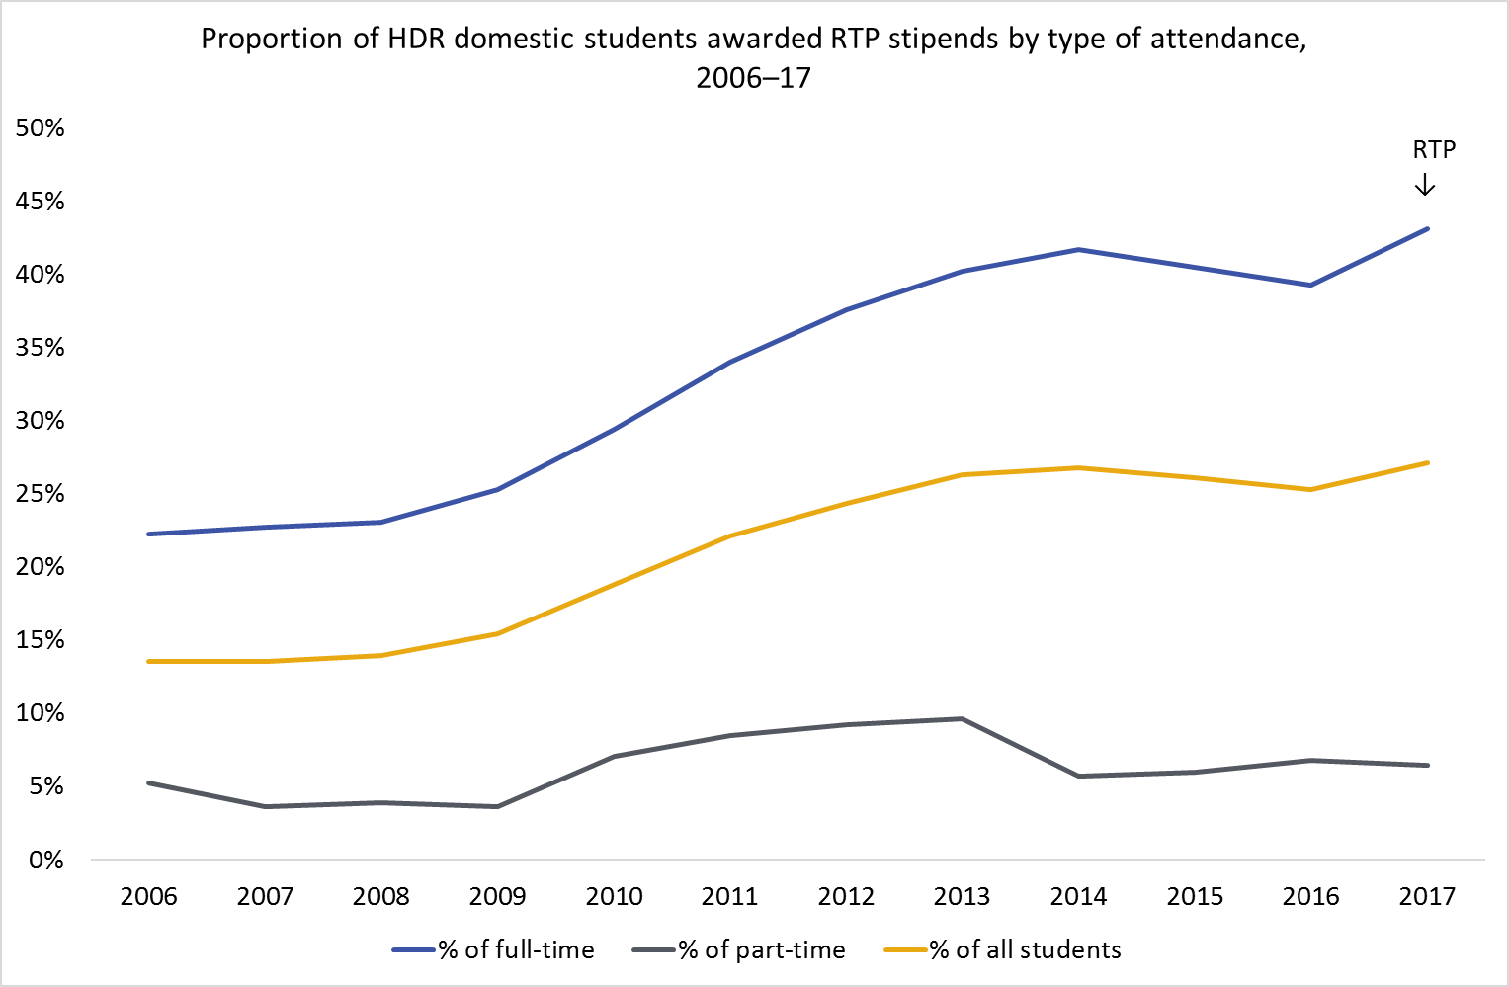

The introduction of the RTP in 2017 coincided with an increase in the proportion of students awarded a stipend. Significant flexibility in university allocations was added alongside the implementation of the RTP, including for part-time arrangements. It is worth noting that RTP stipends awarded to part-time students did not increase in 2017, perhaps indicating that the full-time/part-time discrepancy was not solely due to APA inflexibility. Data for subsequent years is required to better understand the effect of the research funding changes on fee offsets and stipends.

# Gender

From 2006 to 2017 women made up the majority of domestic HDR enrolments (Figure 5), with the proportion increasing slightly from 53 per cent in 2006 to 54 per cent in 2017. By comparison, 58 per cent of domestic undergraduate bachelor students were women in 2017, indicating that there is a proportional loss of women between undergraduate study and postgraduate research.

Doctorates and masters by Research have similar gender distribution patterns. For doctorates, the gender distribution remained steady from 2012, with women making up nearly 55 per cent of enrolments. In masters, the gender distribution has remained steady since 2006, with women consistently making up around 53 per cent of enrolments.

Figure : Domestic HDR enrolments by gender, 2006–17

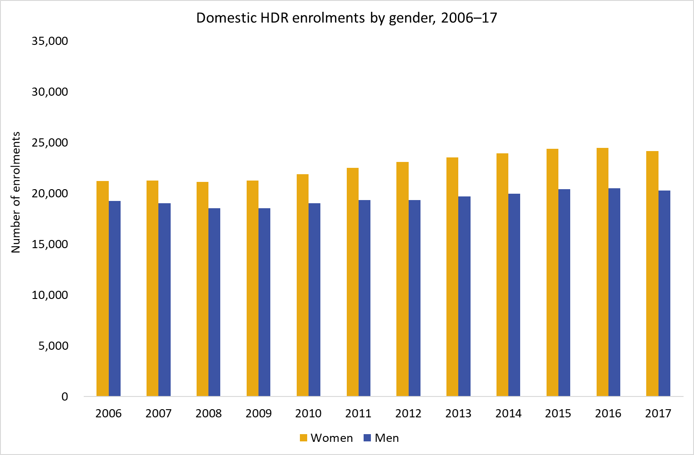

The gender distribution of commencements was similar to enrolments, with women consistently making up around 54 per cent of domestic HDR commencements during this period. Women comprised 51 per cent of degree completions in 2006, which had grown to a steady 54 to 55 per cent by 2013. Women made up between 53 and 54 per cent of full-time students enrolled during 2006–17, while the proportion of women studying part-time increased from 53 to 56 per cent of all part-time enrolments.

Women made up the majority of enrolments in every domestic age group, and over this period increased their enrolment representation from 51 to 56 per cent among those in their 30s, and from 55 to 57 per cent among those over 40 years. Of enrolments from the under 30 age group, the proportion of women decreased slightly from 52 per cent to just over 50 per cent.

There was a marked difference in the gender composition across different fields of education (FoE). The narrow fields of education with the largest number of enrolments for men in 2017 were medicine[7], biological sciences, studies in human society (including history, sociology, anthropology and related disciplines), other natural and physical sciences (including medical science and pharmacology), engineering, and business and management. Of these fields of education, men were a minority in the first four fields but a majority in the next four, which were engineering and business-related (Figure 6).

Figure : Fields with the largest enrolments of domestic HDR students, men, 2017

In 2017, the fields with the largest number of enrolments for male domestic HDR students were medical studies (1440), biological sciences (1340), studies in human society (1270), other natural and physical sciences (1150), electrical and electronic engineering and technology (850), process and resources engineering (820), business and management (790) and civil engineering (760). Of these eight fields, men were a minority in the first four but a majority in the next four, which were engineering and 
business-related.
Note: figures are rounded to the nearest ten.

For women, the fields of education with the largest number of enrolments were medicine, biology, studies in human society, behavioural science (psychology), other natural and physical sciences, curriculum and education studies, public health and other health (including nutrition, human movement and paramedics). Women were a majority in all these fields (Figure 7).

Figure : Fields with the largest enrolments of domestic HDR students, women, 2017

In 2017, the fields with the largest number of enrolments for female domestic HDR students were medical studies (2180), biological sciences (1810), studies in human society (1780), behavioural science (1670), other natural and physical sciences (1300), curriculum and education studies (950), public health (830) and other health (720). Women were also the majority for all of these fields.
Note: figures are rounded to the nearest ten.

In the sciences, women were the majority among domestic students in biological sciences, and in other natural and physical sciences. In contrast, men were a significant majority in mathematical sciences and physics and astronomy (Figure 8). Men were a significant majority in information technology and engineering, particularly mechanical and industrial and electrical and electronic engineering.

Figure : Domestic HDR enrolments by gender in Science, 2017

*In 2017, men were the majority of enrolments for four out of six fields within science: physics and astronomy 
(77 per cent), mathematical sciences
(72 per cent), chemical sciences 
(57 per cent) and earth sciences
(53 per cent). Women were the majority for the remaining two fields: other natural and physical sciences 
(53 per cent) and biological sciences 
(58 per cent). *

*(Note: the number in brackets is the total number of enrolments)*

Figure : Domestic HDR enrolments by gender in Engineering and IT, 2017

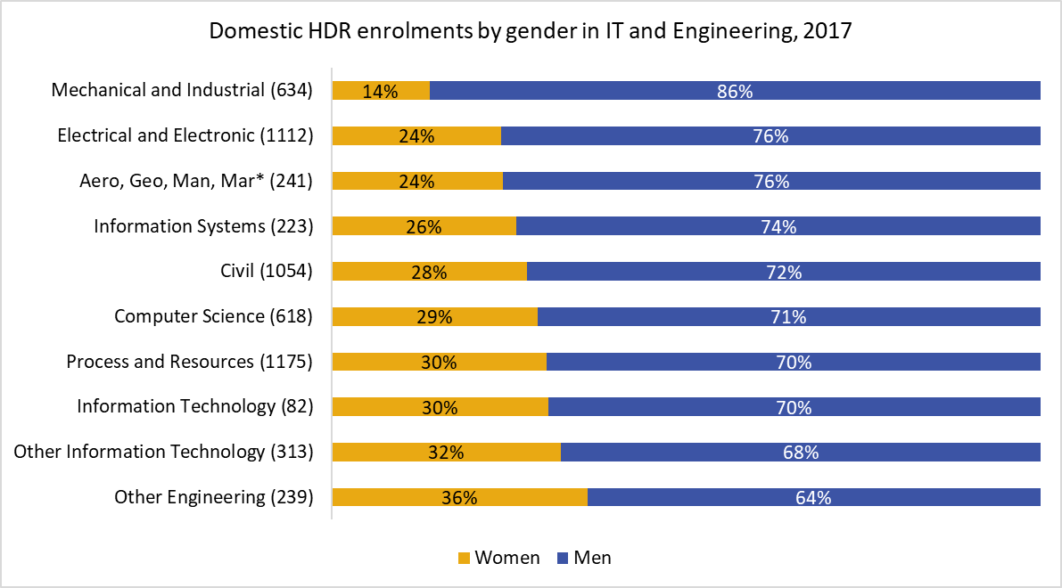

*(*Aerospace, Geomatics, Manufacturing, Maritime Engineering)*

There has been much discussion about the low representation of women in most areas of STEM. Reasons proposed for this imbalance include a lack of encouragement from academic staff at universities, unwelcoming environments in STEM fields, a lack of women role models, gender stereotyping, and a perception of less flexible and family-friendly working arrangements within STEM fields.[8]

The low representation of men in other HDR fields has received little attention. In 2017, men were in the minority of HDR students in virtually all fields of health, education and creative arts (Figure 10, Figure 11). Men also had notably low representation in nursing, rehabilitation, dental studies, public health and veterinary studies.

Figure : Domestic HDR enrolments by gender in Health, 2017

In 2017, men were the minority of domestic HDR enrolments in all fields of health. Men had a notably low representation in the following fields: public health (27 per cent), veterinary studies (25 per cent), dental studies 
(24 per cent), rehabilitation therapies (23 per cent) and nursing (16 per cent). The fields with the highest representation of men were optical science (47 per cent) and radiography (44 per cent).

**Figure 11: Domestic HDR enrolments by gender in Creative Arts and Education, 2017**

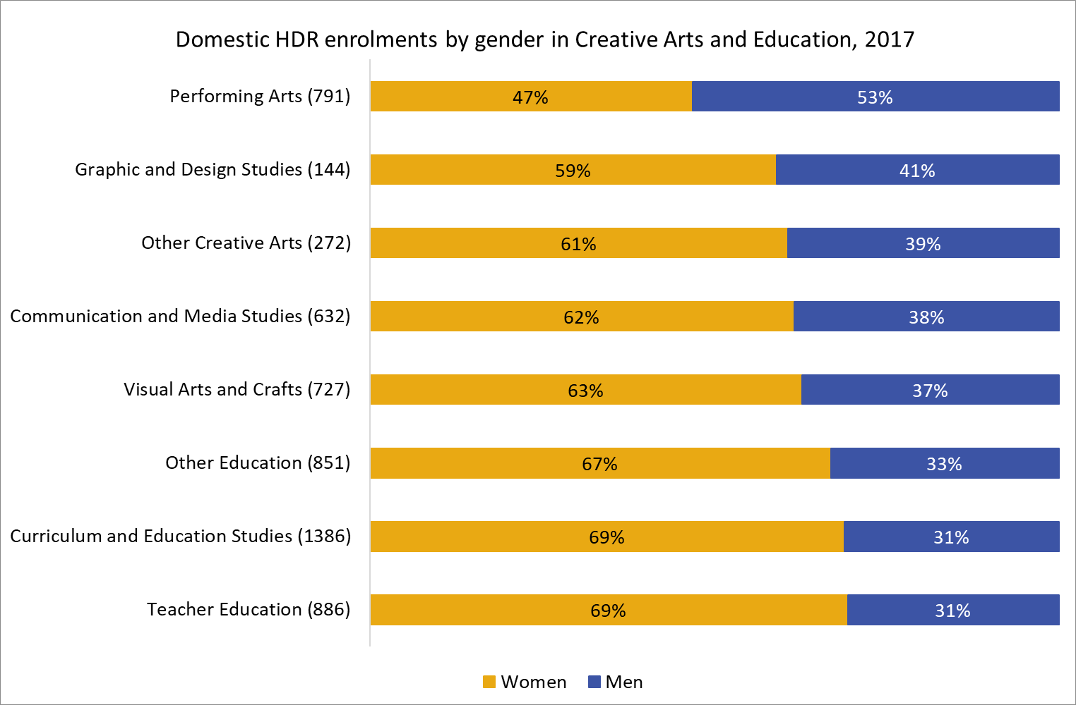

Society and culture presented a more mixed picture: men made up only a quarter of behavioural science (psychology) enrolments in 2017, however, they notably made up the majority of enrolments in philosophy and religious studies, economics and econometrics and sport and recreation (Figure 12).

Figure : Domestic HDR enrolments by gender in Society and Culture, 2017

In 2017, domestic HDR enrolments in society and culture presented a mixed picture. Women made up the significant majority of enrolments for human welfare studies and services 
(77 per cent) and behavioural science (74 per cent). However, men made up the majority for almost half (five of the 11 fields) in society and culture. The three fields with the highest male representation were sport and recreation (68 per cent), economics and econometrics (64 per cent) and philosophy and religious studies 
(64 per cent).

*(Note: Librarianship and Information Management omitted due to low numbers)*

# Socioeconomic Status

*Note: This section analyses student data according to a measure of socioeconomic status (SES) derived from the SA1 (statistical area 1) measure, based on the student’s permanent home residence. The address used to determine the SES of students was their address at the time of enrolment, which may not be reflective of all students’ SES status. This data should therefore be used with caution. Data on this measure is not available prior to 2011.*

*Low SES is the bottom quartile and high SES the top quartile.*

*SES data refers only to domestic students, as it is not reported for international students. Between   
5 and 7 per cent of student enrolments had an unknown SES status each year; data for these students has been disregarded here.*

The proportion of students in each SES band (low, medium and high) changed little between 2011 and 2017. Students of high SES remained the dominant SES band in the HDR student population, while medium and low SES students were underrepresented. In 2011, 8 per cent of all domestic HDR enrolments were students classified as low SES, 37 per cent were students classified as medium SES, and 49 per cent were students classified as high SES.[9] By 2017, the share of low SES was unchanged, medium SES had increased slightly to 39 per cent, while high SES had decreased slightly to 47 per cent of enrolments (Figure 13).

**Figure 13: Proportion of domestic HDR enrolments by SES, 2011**–**17**

**From 2011 to 2017, the representation of students from each 
Socio-Economic Status (SES) band (low, medium and high) changed little. Students of high SES remained the dominant SES band, while medium and low SES students were underrepresented. In 2011, eight per cent of all domestic HDR enrolments were students classified as low SES, 
37 per cent were classified as medium SES and 49 per cent were classified as high SES. By 2017, the representation of low SES students was unchanged, medium SES had increased slightly to 39 per cent and high SES enrolments had decreased slightly to 47 per cent.**

*(Note: 5-7 per cent of enrolments between 2011 and 2017 were unknown SES)*

Proportional representation of each SES level would occur if 25 per cent of students were low SES, 50 per cent of students were medium SES, and 25 per cent of students were high SES. Therefore, low-SES students have approximately one third of their proportional representation, and high-SES students have just under two times their proportional representation.

Commencements and completions also showed little change. Between 2011 and 2017, low SES commencements rose slightly from 8 to 9 per cent, medium SES commencements rose from 37 to 40 per cent, and high SES commencements declined from 47 to 46 per cent. Available completion rates were similar: in 2017, low-SES students made up 6 per cent of all HDR completions, medium-SES students made up 31 per cent of completions, and high-SES students made up 40 per cent of completions. However, a significant proportion (23 per cent) of graduating students had an unknown SES; as data for recent students becomes available a more comprehensive picture will emerge.

In 2017, women were the majority of enrolments in each SES band, making up 55 per cent of high and medium SES enrolments and a slightly lower 54 per cent of low SES enrolments.

In 2017, 57 per cent of high-SES students and 31 per cent of low-SES students attended the   
research-oriented Group of Eight institutions. In contrast, 2 per cent of high-SES students attended Regional University Network institutions, compared to 11 per cent of low-SES students (Figure 14).

**Figure 14: Distribution of HDR enrolments among university alliances by SES, 2017**

In 2017, high Socio-Economic Status (SES) students made up the majority of HDR enrolments at Group of Eight institutions (57 per cent), compared with 36 per cent of medium SES and 
31 per cent of low SES students. Conversely, high SES students were significantly underrepresented at Regional Universities Network (RUN)institutions. Only two per cent of high SES students attended RUN institutions, compared with seven per cent of medium SES and 11 per cent of low SES students.


*(Note: ATN = Australian Technology Network of Universities; Go8 = Group of Eight; IRU = Innovative Research Universities; RUN = Regional Universities Network)*

Although there was little difference between whether different SES groups attended in a full or part time capacity (56 per cent of low-SES students and 57 per cent of high-SES students attended full-time in 2017), differences were more evident in the mode of attendance. In 2017, high-SES students were more likely to be attending their institution internally (92 per cent) than low-SES students (85 per cent). Compared to high-SES students, it was more common for low-SES students to attend externally (12 per cent of low SES versus 6 per cent of high SES) and multi-modally (3 per cent of low SES versus 2 per cent of high SES).

The low representation of low-SES students was consistent across fields of study, albeit with some minor variation. Representation was particularly low in architecture and building, economics, dentistry, law, performing and creative arts, language and literature, and communication and media studies (all less than 6 per cent of enrolments). Representation was comparatively higher in STEM, agriculture, environment and related studies, education, and some health disciplines.

In terms of total enrolments, the most popular fields for low-SES students were biology, medical studies, studies in human society, other natural and physical sciences, and behavioural science.

# Regional and Remote Status

*Note: Regional and Remote categories have been derived from the ABS Australian Statistical Geography Standard (ASGS). ASGS data is available from 2011. The regionality of some students, particularly those completing and those who have been enrolled for many years, was unknown.*

From 2011 to 2017, the proportion of domestic HDR enrolments from regional and remote areas was stable at between 13 and 14 per cent of students, with metropolitan enrolments also stable at between 80 and 81 per cent of students. The remaining students were of unknown regionality. Given that 27 per cent of Australians aged 15-64 live in regional and remote areas,[10] the proportion of regional and remote students enrolled in HDR is considerably under-representative of the population. In terms of 2017 domestic completions, 68 per cent were by metropolitan students, 10 per cent were by regional/remote students, and 22 per cent were by students of unknown regionality, with little change from 2011.

There is no difference in the provision of fees offsets in regional and remote students compared with metropolitan students. In 2017, 90 per cent of domestic HDR students receive an RTS fee offset, as did regional and remote students. Regional and remote students are approximately three to six per cent less likely to be awarded an RTP stipend each year (2011–2017) compared to metropolitan students. In 2017, 26 per cent of regional and remote students received a stipend compared with 30 per cent of metropolitan students. However, regional and remote students are no less likely to receive an RTP stipend than metropolitan students when type of attendance (part-time/full-time) is accounted for.

From 2013 to 2017, just over half of enrolments by regional/remote HDR students were fulltime, with 51 per cent in 2017. The proportion of full-time metropolitan HDR students was consistently about 5 percentage points higher than the proportion of full-time regional/remote students.

The regional/remote HDR population tended to be older than metropolitan HDR students, with 50 per cent of regional/remote students aged 40 years or older in 2017, versus 34 per cent of metropolitan students (Figure 15).

While more than 90 per cent of metropolitan students attended their course internally (91 per cent in 2017), fewer than 80 per cent of regional and remote students did so (79 per cent in 2017).

Regional HDR students were more likely to attend regional universities. While 50 per cent of metropolitan students attended Group of Eight institutions, only 23 per cent of regional/remote students attended those universities in 2017. In comparison, 19 per cent of regional and remote students attended Regional University Network institutions, versus just 3 per cent of metropolitan students (Figure 16).

**Figure 15: Proportion of domestic HDR enrolments by age and regionality, 2017**

In 2017, there were significantly more regional/remote domestic HDR students aged 40 years or older than metropolitan students: 50 per cent of regional/remote students were 40 years or older compared with only 
34 per cent for metropolitan students. 35 per cent of metropolitan students were aged 29 years or younger compared with 26 per cent for regional/remote students.


*Note: Enrolments with known regionality constituted 5 per cent of all domestic HDR enrolments in 2017, and were omitted in this analysis.*

**Figure 16: HDR enrolments by alliance and regionality, 2017**In 2017, a significantly lower proportion of regional/remote students attended a Group of Eight (Go8) university than metropolitan HDR students: 50 per cent of HDR enrolments at Go8 universities were metropolitan students compared with only 23 per cent for regional/remote students. Regional students had a significantly higher representation at Regional Universities Network (RUN) institutions than metropolitan students:19 per cent of RUN enrolments were regional/remote students compared with only 
three per cent for metropolitan students.

The proportion of students from a regional or remote background who were women increased from 57 per cent in 2011 to 59 per cent in 2017. This is slightly higher than the proportion of women from a metropolitan background which was steady at around 54 per cent from 2011 to 2017.

Regional/remote students were most strongly represented in agriculture, environment and related studies and education. The lowest representations of regional/remote students were in IT, engineering and related technologies and architecture and building (Figure 17).

**Figure 17: Proportion of domestic HDR enrolments by broad FoE and regionality, 2017**

**In 2017, the two broad Fields of Education (FoEs) that regional/remote domestic HDR students were most strongly represented in were agriculture, environment (33 per cent) and education (21 per cent). The FoEs with the lowest representation of regional/remote HDR students were engineering (7 per cent), architecture and building (8 per cent) and IT 
(8 per cent). Metropolitan students were the significant majority for all FoEs with highest representation in architecture and building (87 per cent), IT (84 per cent) and health (84 per cent).**

# People with Disability

The number of enrolled domestic HDR students who identified as living with disability grew from 1520 in 2006 to 2447 in 2017 — an increase of 61 per cent. As a proportion of total domestic HDR students, people with disability increased from 3.8 per cent in 2006 to 5.5 per cent in 2017 (Figure 18). An analysis on data from the Australian Bureau of Statistics’ Survey of Disability, Ageing and Carers by the Australian Institute of Health and Welfare showed that people with disability generally have lower levels of educational attainment compared to people without disability. Between 2003 and 2015 there were small improvements in education attainment for students living with disability, Year 12 and bachelor attainment increased by 1.2 and 1.8 percentage points respectively.[11] The increase in the number of enrolled domestic HDR students living with disability is consistent with these increases.

**Figure 18: Proportion of enrolled domestic HDR students with disability, 2006–17**

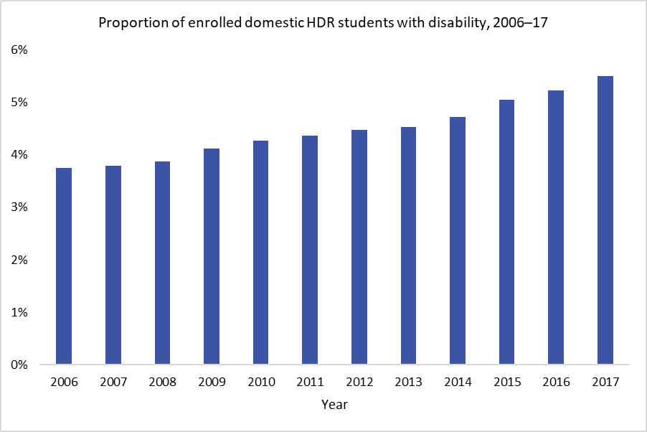

Between 2006 and 2017, there was a consistently higher percentage of students with disability undertaking research in humanities and social science (HASS) subjects (Figure 19). In 2017, 56 per cent of HDR students who identified as living with disability were enrolled in HASS research, while 27 per cent were undertaking STEM research, and 11 per cent were enrolled in other subjects.

**Figure 19: Proportion of enrolments for domestic HDR students with disability, by field of education, 2006**–1**7**

From 2006 to 2017, domestic HDR students with disability were most strongly represented in Humanites and Social Science (HASS) subjects. In 2017, 
56 per cent of students with disability were enrolled in HASS research, while 27 per cent were undertaking STEM research, and 11 per cent were enrolled in other subjects.

# Bibliography

AIHW analysis of the ABS 2003 and 2015 Surveys of Disability, Ageing and Carers data.

Bell S. (2016) Ivory Towers and Glass Ceilings: Women in Non-traditional Fields. In: Harvey A., Burnheim C., Brett M. (eds) *Student Equity in Australian Higher Education*. Springer, Singapore

Bell S., May R. (2016) Ladders of Opportunity: Postgraduate Equity, Professions and the Academic Workforce. In: Harvey A., Burnheim C., Brett M. (eds) *Student Equity in Australian Higher Education*. Springer, Singapore

Burnheim C., Harvey A. (2016) Far from the Studying Crowd? Regional and Remote Students in Higher Education. In: Harvey A., Burnheim C., Brett M. (eds) *Student Equity in Australian Higher Education*. Springer, Singapore

Christie M., Medland A. (2017) Understanding why women are underrepresented in Science, Technology, Engineering and Mathematics (STEM) within Higher Education: a regional case study. *SciELO* 27

Crabb S., Ekberg S. (2014) Retaining female postgraduates in academia: the role of gender and prospective parenthood. *Higher Education Research & Development* 33 (6): 1099-1112

Diekman A., Weisgram E., Belanger A. (2015) New Routes to Recruiting and Retaining Women in STEM: Policy Implications of a Communal Goal Congruity Perspective. *Social Issues and Policy Review* 9 (1):52-88

Dockery P., Seymour R., Koshy A. (2015) Promoting low socio-economic participation in higher education: a comparison of area-based and individual measures. *Studies in Higher Education* 41 (9): 1692-1714

Harvey A., Andrewartha L. (2013) Dr Who? Equity and diversity among university postgraduate and higher degree cohorts. *Journal of Higher Education Policy and Management* 35 (2): 112-123

Harvey A., Andrewartha L., Burnheim C. (2016) Out of Reach? University for People from Low Socio-Economic Status Backgrounds. In: Harvey A., Burnheim C., Brett M. (eds) *Student Equity in Australian Higher Education*. Springer, Singapore

Harvey A., Burnheim C., Brett M. (2016) Towards a Fairer Chance for All: Revising the Australian Student Equity Framework. In: Harvey A., Burnheim C., Brett M. (eds) *Student Equity in Australian Higher Education*. Springer, Singapore

Koshy P. (2018) *Equity Student Participation in Australian Higher Education: 2012–2017*. National Centre for Student Equity in Higher Education (NCSEHE). Perth: Curtin University.

Larkins F. (2018) [*Male Students Remain Underrepresented in Australian Universities. Should Australia be concerned?*](https://melbourne-cshe.unimelb.edu.au/__data/assets/pdf_file/0012/2894718/Gender-Enrolment-Trends-F-Larkins-Sep-2018.pdf) LH Martin Institute, The University of Melbourne

Larkins F. (2019) [*Australian Universities Increased Dependency on Overseas Research Students Highlights A National Policy Failing*](https://melbourne-cshe.unimelb.edu.au/lh-martin-institute/news/increased-dependency-on-overseas-research-students-highlights-a-national-policy-failing)*.* LH Martin Institute, The University of Melbourne

Li I., Mahuteau S., Dockery A., Junankar R., Mavromaras K. (2016) [*Labour market outcomes of Australian university graduates from equity groups*](https://www.ncsehe.edu.au/wp-content/uploads/2016/03/Labour-Market-Outcomes-of-Australian-University-Graduates-from-Equity-Groups.pdf). National Centre for Student Equity in Higher Education

McCulloch A., Thomas L. (2012) Widening participation to doctoral education and research agenda for an emerging policy issue. *Higher Education Research & Development* 32 (2): 214-22

McGagh J., Marsh H., Western M., Thomas P., Hastings A., Mihailova M., Wenham M. (2016) *Review of Australia’s Research Training System*. Report for the [Australian Council of Learned Academies](http://www.acola.org.au).

Norton A. (2016) Equity and Markets. In: Harvey A., Burnheim C., Brett M. (eds) *Student Equity in Australian Higher Education*. Springer, Singapore

Peseta T., Barrie S., Barrow M., Grant BM., Kelly F., Lucas L., Trahar S., Jawitz J., Thesen L. (2016) [*Getting the measure of doctoral curriculum: A response to access and equity?*](https://researchdirect.westernsydney.edu.au/islandora/object/uws:40937) International Academic Identities Conference 2016

Wakeling P., Kyriacou C. (2010) [*Widening participation from undergraduate to postgraduate research degrees*](https://www2.le.ac.uk/departments/doctoralcollege/about/external/publications/widening-participation.pdf). National Coordinating Centre for Public Engagement; Economic and Social Research Council

White K. (2015) [Glass ceilings and monastic men: Keeping women in science](https://search.informit.com.au/documentSummary;dn=277070726835031;res=IELAPA). *Australian Quart*erly 86 (3): 14-19

1. McGagh et al. (2016), Section 11.
2. The RTIP is available at <[Research Training Implementation Plan](https://docs.education.gov.au/documents/research-training-implementation-plan)>
3. For analysis of undergraduate patterns see Koshy (2018).
4. Low SES is the bottom quartile and high SES the top quartile, based on the student’s permanent home residence. More information is provided in Section 4: Socioeconomic status.
5. See Harvey A., Burnheim C., Brett M. (2016)
6. See Harvey and Andrewartha (2013).
7. Medical studies is a special case, as HDR students enrolled in medical studies may also include medical students undertaking a PhD as part of their training.
8. See for example Crabb and Ekberg (2014), White (2015), Diekman et al. (2015), Bell (2016), Christie et al. (2017).
9. The remaining 7 per cent of enrolments were by students of unknown SES.
10. ABS 2016 Census
11. [AIHW, Disability in Australia: changes over time in inclusion and participation in education](https://www.aihw.gov.au/getmedia/34f09557-0acf-4adf-837d-eada7b74d466/Education-20905.pdf.aspxed)