

REVIEW OF THE AUSTRALIAN   
QUALIFICATIONS FRAMEWORK

FINAL REPORT 2019

ISBN

978-1-76051-843-1 [PDF]  
978-1-76051-844-8 [DOCX]

Creative Commons

With the exception of the Commonwealth Coat of Arms, the Department’s logo, any material protected by a trade mark and where otherwise noted, all material presented in this document is provided under a [Creative Commons Attribution 4.0 International](https://creativecommons.org/licenses/by/4.0/) (https://creativecommons.org/licenses/by/4.0/) licence.

The details of the relevant licence conditions are available on the Creative Commons website (accessible using the links provided) as is the full legal code for the [CC BY 4.0 International](http://creativecommons.org/licenses/by/4.0/legalcode) (http://creativecommons.org/licenses/by/4.0/legalcode).

The document must be attributed as the Review of the Australian Qualifications Framework Final Report 2019.

# Chair’s Letter

30 September 2019

The Hon Dan Tehan MP

Minister for Education

House of Representatives

Parliament House

Canberra ACT 2600

Senator the Hon Michaelia Cash

Minister for Employment, Skills, Small and Family Business

Senate

Parliament House

Canberra ACT 2600

Dear Ministers

On behalf of the Expert Panel for the Review of the Australian Qualifications Framework (AQF), I am pleased to submit the Review Report for consideration by the Council of Australian Governments (COAG) Education Council and the COAG Skills Council.

The Panel is recommending substantial reforms to the AQF. It believes that these reforms are essential to ensure that the AQF effectively fulfils its important functions into the future. The Panel’s recommendations and implementation plan suggest a staged approach to the finalisation of the reforms, under the guidance of a new governance body for the AQF.

The Panel extends its thanks and appreciation to the organisations and individuals who made submissions to the Review and who were engaged in the consultation process over the course of the Review. The Panel also recognises the contributions of organisations and individuals who were commissioned to provide advice on specific issues, often within demanding timelines. The substantial and detailed work of the Australian Council of Educational Research (ACER) is especially recognised.

The Panel would also like to express its deep appreciation to the members of the Secretariat to the Review, led by Vicki Ratliff, for their commitment and professionalism over the course of the Review.



Professor Peter Noonan

Chair

For Expert Panel members

|  |  |
| --- | --- |
| Mr Allan Blagaich | Ms Leslie Loble |
| Professor Sally Kift | Professor Elizabeth More AM |
| Ms Megan Lilly | Ms Marie Persson |

Contents

Chair’s Letter i

Contents 2

List of tables and figures 6

Executive Summary 7

Qualifications for the future 7

The case for reform 8

A future AQF 9

Report structure and recommendations 11

Implementation approach 16

1. Introduction 17

Background to the Review 17

Policy context 17

Participation and productivity 17

Specific reforms 19

2. The AQF architecture 21

Background 21

Contextual research 23

Developing a revised framework 23

Initial propositions 23

Testing the feasibility of possible options 24

A revised AQF – key features 26

Focus on qualification design 27

Redefining domains 28

Incorporating Focus Areas 29

Revising descriptors 30

Using fewer bands 31

Applying bands flexibly 31

Identifying general capabilities 37

Describing qualification types 38

Aligning qualification types 41

The status of VET and Levels 5, 6 and 8 45

Status of VET 45

Levels 5, 6 and 8 46

Further observations 46

Recommendations 48

Implementation 48

Actions 49

3. Senior Secondary Certificate of Education 51

Purpose of the SSCE 51

Aligning the SSCE with the AQF 52

Recognising pathways 52

VET in Schools 53

Recommendations 54

Implementation 54

Actions 54

4. Shorter Form Credentials 55

Credentials outside the AQF 55

Microcredentials 56

Recognising shorter form credentials 58

Assuring quality 59

Aligning shorter form credentials to an AQF band 60

Enabling Courses 61

Recommendations 62

Implementation 62

Actions 63

5. Qualifications Pathways Policy and Credit Points 64

Background 64

Improving the Pathways Policy 66

Aligning with sector standards 67

Recognising multi-directional pathways 67

Recognising prior learning 69

Developing a credit point system 69

International comparisons 70

Measuring credit 70

Further observations 71

Recommendations 71

Implementation 71

Actions 71

6. Volume of Learning 73

Background 73

Changing volume of learning 74

Rationale 74

Using guidelines flexibly 75

Expressing volume of learning in hours 76

Framing volume of learning around new learners 77

International comparisons 77

Further observations 78

Recommendations 78

Implementation 78

Actions 79

7. Other policies and supporting documents 80

Background 80

Current AQF policies 80

The AQF Qualifications Issuance Policy 80

The AQF Qualifications Register Policy 82

The AQF Qualification Type Addition and Removal Policy 84

Aligning the AQF with international qualifications frameworks 84

‘Explanations’ in the AQF 84

The AQF Glossary 87

The AQF website 87

Recommendations 88

Implementation 88

Actions 88

8. Implementation 89

Governance 89

AQF governance body 89

Role of the AQF governance body 90

Recommendations 90

Actions 90

Overall Implementation 91

Implementation impacts 91

Implementation approach 92

Glossary for the Report 94

Appendices 98

Appendix 1. Review Terms of Reference 98

Background 98

Terms of Reference 98

Appendix 2. Minimal change option 100

Appendix 3. Revised AQF - Draft Knowledge descriptors 107

Appendix 4. Revised AQF - Draft Skills descriptors 110

Identify and solve problems and make decisions 110

Psychomotor skills 111

Learner self-management skills 112

Appendix 5. Revised AQF - Draft Application descriptors 115

Appendix 6. Describing qualification types with revised descriptors 117

Bachelor Degree 117

Vocational Certificate 119

Diploma 121

Appendix 7. AQF Qualifications Pathways Policy in VET and higher education standards 123

Higher Education Standards Framework (Threshold Standards) 2015 123

Standards for Registered Training Organisations (RTOs) 2015 128

Standards for Training Packages 132

Appendix 8. International use of credit points 135

Appendix 9. AQF Review process 138

Appendix 10. Consultations 140

Stakeholder consultations 141

Appendix 11. Contracted consultancies 144

Research to inform the Review 144

Appendix 12. History of the AQF 150

AQF development history 150

AQF governance 151

# List of tables and figures

Table 1. Key Findings and Recommendations 12

Table 2. National qualifications framework and AQF terms 21

Table 3. Qualification type purpose examples using the ISCED 39

Table 4. Qualification type purpose examples for demonstration purposes 40

Table 5. Option 1: Qualification type alignment 43

Table 6. Option 2: Qualification type alignment 44

Table 7. Option 3: Qualification type alignment 44

Table 8. New certificate names 44

Table 9. DeakinCo alignment with ISCED 61

Table 10. Issuance Policy requirements and sector regulation 81

Table 11. Accrediting authorities 83

Table 12. Explanations 85

Table 13. Submissions breakdown based on states and type of organisation 142

Table 14. Workshop participants 147

Table 15. AQF development history 150

Figure 1. Current and proposed AQF compared 10

Figure 2. Implementation stages 16

Figure 3. Projected employment growth to May 2023 for skill levels by occupation 18

Figure 4. AQF in higher education legislation 22

Figure 5. AQF in VET legislation 22

Figure 6. Minimal change option 25

Figure 7. Proposed AQF architecture 26

Figure 8. The link between qualification design and graduate outcomes through the AQF 27

Figure 9. Domain definitions linked through action 28

Figure 10. AQF domains and focus areas 30

Figure 11. Option 1 32

Figure 12. Option 2 33

Figure 13. Using the current AQF 34

Figure 14. AQF architecture with Application bands 36

Figure 15. Revised AQF diagram 42

Figure 16. Frame for validation of microcredentials 57

Figure 17. VET and higher education student flow 68

Figure 18. Revised AQF implementation approach 93

# Executive Summary

The Australian Qualifications Framework (AQF) is a critical part of the architecture of the Australian education and training system. The AQF defines the essential characteristics, including the required learning outcomes, of the 14 different types of qualifications[1] issued across the senior secondary education, vocational education and training (VET) and higher education systems in Australia.

Australia was among the first countries to develop and implement a national qualifications framework. Although the structure and purposes of national qualification frameworks vary between countries, their central purpose is to ‘establish a basis for improving the quality, accessibility, linkages and public or labour market recognition of qualifications within a country and internationally’.[2]

## Qualifications for the future

To retain their relevance and effectiveness, qualifications will need to respond to current and emerging workforce and social needs, be delivered in ways that meet learners’ needs and circumstances, and be trusted by learners, employers and the community generally. The traditional role of formal qualifications is challenged by the ready availability of information through the Internet, declining trust in institutions and traditional sources of authority. Many people gain skills and experience in a variety of settings outside the formal education and training system.

The ongoing effect of new technology – particularly artificial intelligence – is transforming the world of work through its power to analyse, aggregate and disseminate information, including new knowledge. Production of goods, transportation and services, including health and the media, are in a constant state of disruption and innovation.

Many current job roles will become redundant, particularly in areas of standardised and routine production and service delivery. But new roles are also emerging, roles that place a premium on human aptitudes and capabilities, including the ability to understand, shape, interpret and reshape the use of technology. Skills required for sustainable development, including the transition to lower carbon emissions, and which address the impact of climate change, are also increasingly important.

Workplaces are also transforming. They are becoming more diverse and inclusive, more flexible in employment and work practices, and generally less hierarchical. Teamwork and collaboration are increasingly valued, as is collective rather than individual initiative and achievement. Effective and ethical leadership and governance are essential to the success and reputation of organisations.

Employers have strong and growing expectations that graduates will be work ready and productive. In turn, employees expect to have their skills and capabilities recognised and rewarded with ongoing opportunities for career and personal development. Individuals will need to be able to manage multiple career transitions, and to build their own career paths and business opportunities, through continuous learning and development. Many professions are also refocusing their requirements for professional entry and ongoing accreditation on a broad range of aptitudes and capabilities; their perspective is broadening from the familiar focus on technical and occupational proficiency.

Innovation within firms and across industries, underpinned by workforce capability, will be essential to improved productivity and competitiveness. Australia’s capacity for world leading research, and the application of research outcomes, will be underpinned by research training capacity and the ability to recruit and retain world-class researchers.

Industries, firms, and education and training institutions are increasingly globally engaged. Many Australians will live and work overseas. Immigration will continue to be a source of specialist skills for the Australian economy. Education services will continue to be one of Australia’s major export industries, founded on the quality and recognition of Australian qualifications and the institutions that offer them.

A qualifications framework needs to operate in, and help shape a future in which:

* Central economic and social policy goals are to widen participation in education and training, and to improve educational attainment levels, particularly among those with low levels of participation and attainment.
* Young people can successfully transition into post-secondary education and training through a broad range of options and pathways, and complete at least an initial tertiary qualification. Lifelong learning must become a practical reality for people; it cannot stand as an abstract goal.
* Post-secondary education and training is conceived and redesigned as a diverse set of offerings, available through better linkages and pathways between the VET and higher education sectors. These linkages and pathways will no longer be linear and hierarchical; they will need to recognise that throughout adulthood, people need to develop new skills in different areas and at different levels. Central to this objective is reinvigorating the VET system and raising its standing.
* As they transition into post-school education and training, young people must have a well-informed appreciation of the purpose of different qualifications and the relationship between qualifications. That appreciation must be accessible to adults seeking to deepen existing skills or gain new skills. Qualification outcomes will be relevant, understood, and trusted.
* Firms and people will have ready, flexible access to a broad suite of options and opportunities for developing new skills. They will look to short, purpose-built, flexibly delivered qualifications – within and outside the formal qualification system – to gain new skills and knowledge. Systems and processes for credit recognition and recognition of prior learning will be easier to access, more transparent, and rigorous in applying the credit recognition process to ensure quality is maintained and qualification outcome requirements are met.
* The competitiveness of Australian education and training as a major export industry will be influenced by perceptions of the standing, quality, and relevance of its system of qualifications.

## The case for reform

The Australian Qualifications Framework (AQF) sets the overall framework for the design and quality assurance of education and training in Australia. It does not prescribe course content or methods of delivery and assessment. Factors such as funding, governance, regulation and institutional responsiveness have far greater influence on education and training than the AQF. Qualifications also sit within broader economic, social and cultural contexts, which can strongly influence perceptions about their standing and expectations about what they should provide.

Nonetheless the relevance, effectiveness and utility of the AQF is arguably more important today than when it was first implemented as a loose, largely sector based framework in 1995. It provides the common language for the design and description of the types of Australian qualifications and the relationships between them, in a future where increasing levels and closing gaps in levels of educational attainment will remain a central economic and social policy goal for Australia.

The current version of the AQF is a more comprehensive and complete framework than earlier versions. It is widely used and applied. However, the Panel has found that the AQF should be significantly reformed.

Too much weight is placed on its levels structures rather than the qualifications aligned to those levels. Its ten-level structure is duplicated but not consistently expressed, too rigid and overly hierarchical, with artificial and arbitrary distinctions between levels. This results in poor differentiation between some qualification types, and descriptions of skills and knowledge that do not reflect existing leading practice, let alone meet future requirements. The assumption that knowledge and skills can both be defined and differentiated at ten levels is flawed. The application of knowledge and skills is context dependant and cannot be automatically linked to levels of knowledge and skills without entrenching hierarchical assumptions about VET relative to higher education qualifications.

The use of highly generic graduate outcome statements to define and differentiate qualification types is not meaningful, given the range of different qualifications, their purposes, and also the context within which they are delivered. The Senior Secondary Certificate of Education has sat apart from other qualifications in the AQF since its inception and the AQF currently has little influence on senior secondary education.

The AQF Qualifications Pathways Policy is generally understood by users of the AQF but provides only limited guidance on credit recognition between some qualifications. It was not designed to provide for recognition and alignment of shorter form credentials, including microcredentials, a rapidly emerging and evolving area in education and training.

As currently defined in the AQF, volume of learning reflects dated and increasingly outmoded assumptions about how AQF qualifications are delivered.

## A future AQF

The Panel has proposed a comprehensive set of reforms and an implementation plan that would see a future AQF evolve as follows:

* A less complex AQF structure with a primary focus on the qualification types in the AQF (Degrees, Certificates etc.).
* A single and clearer taxonomy comprising eight bands of knowledge and six bands of skills more flexibly applied. Application is not rigidly locked to other bands (or levels).
* Contemporary definitions of knowledge and skills are used. Knowledge, Skills and Application are defined in terms of action – the information to inform action, the capabilities to take action and the context for action.
* Using these features, the AQF is refocused on the design of qualifications linked to learning outcomes for individual qualifications.
* Additional information is included to help define qualification types, particularly for qualifications leading to Nationally Recognised Training delivered through the VET sector, for apprenticeships and for research-oriented qualifications.
* General capabilities (such as digital literacy and ethical decision making) are identified for use in individual qualifications.
* The AQF Pathways Policy is revised to broaden guidelines for credit recognition across AQF qualifications and to define and provide for recognition of shorter form credentials, including micro-credentials, towards AQF qualifications.
* A prototype national credit points system is developed for voluntary adoption by institutions and sectors.
* Qualification types are realigned against the revised taxonomy (based on options outlined in this Report) including the addition of a higher diploma qualification. VET certificates can be more meaningfully titled to reflect their purpose.
* The Senior Secondary Certificate of Education is more clearly defined and represented in the AQF in terms of its role in preparing young people for a range of pathways into VET and higher education (including with credit).
* Volume of learning is expressed in terms of hours, not years, and applied as a benchmark for compliance and quality assurance.
* An ongoing governance body for the AQF is established to give effect to decisions of the Review of the AQF and to provide advice on revisions to the AQF where required in the future.
* AQF policies are updated or assigned to the relevant agency, with redundant policies removed. The AQF is more consistently referenced and applied in VET and higher education sector standards and guidelines.

Figure 1 below summarises the effect of the principal revisions to the AQF if the Panel’s recommendations, outlined in Table 1, are adopted.

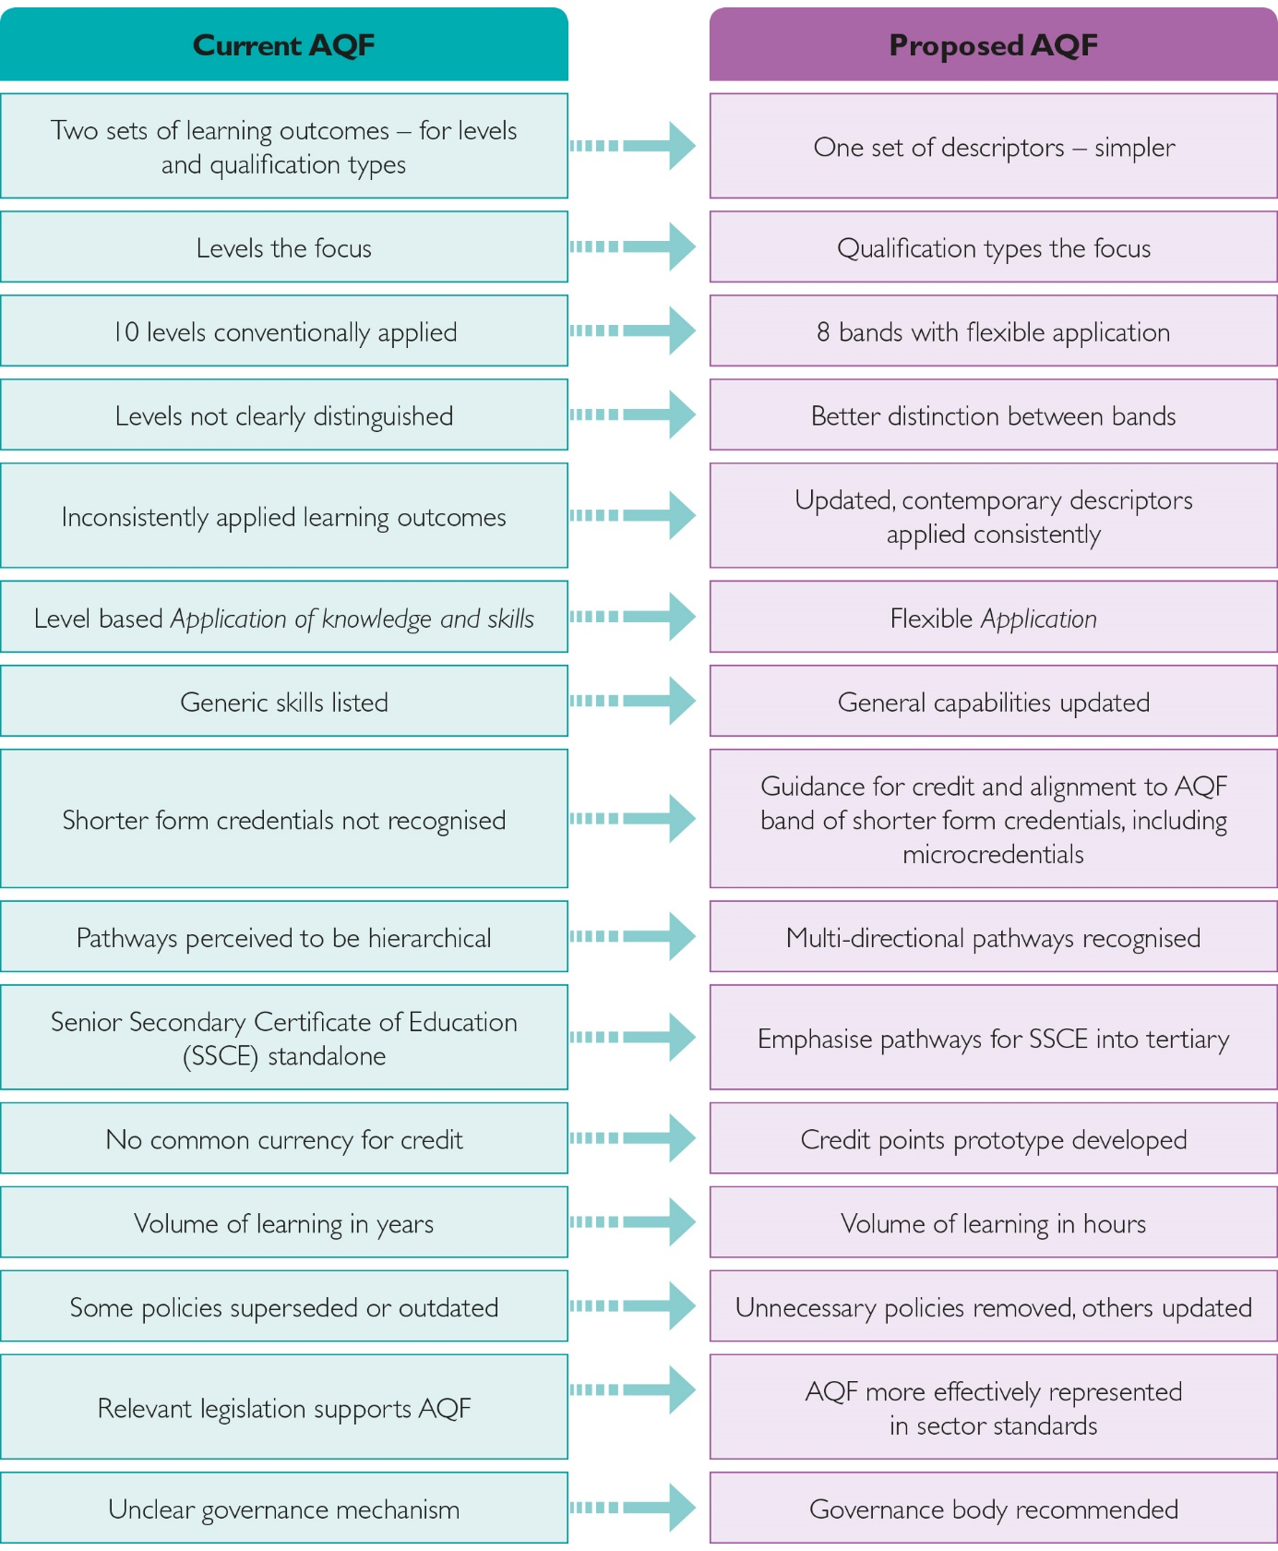Error! No sequence specified.Figure . Current and proposed AQF compared

* Two sets of learning outcomes – for levels and qualification types
  + One set of descriptors – simpler
* Levels the focus
  + Qualification types the focus
* 10 levels conventionally applied
  + 8 bands with flexible application
* Levels not clearly distinguished
  + Better distinction between bands
* Inconsistently applied learning outcomes
  + Updated, contemporary descriptors applied consistently
* Level based Application of knowledge and skills
  + Flexible Application
* Generic skills listed
  + General capabilities updated
* Shorter form credentials not recognised
  + Guidance for credit and alignment to AQF band of shorter form credentials, including microcredentials
* Pathways perceived to be hierarchical
  + Multi-directional pathways recognised
* Senior Secondary Certificate of Education (SSCE) standalone
  + Emphasise pathways for SSCE into tertiary
* No common currency for credit
  + Credit points prototype developed
* Volume of learning in years

## Report structure and recommendations

Each section of this report outlines why the Panel has concluded changes to the AQF are required. Each section contains recommendations for change, and proposed actions for implementing those changes. Overall, the report draws on input received through the consultation process undertaken by the Panel in all capital cities and two regional centres, from the 134 submissions received by the Review, independent research commissioned for the Review, and testing of reform options, draft findings and recommendations.

The Panel is aware it was not possible through the Review process itself to expose and test full details of some of its proposed changes to the AQF. It also acknowledged that full and detailed specifications of revised descriptors of Knowledge and Skills, and Application, can only be completed after further detailed development, testing and consultation. Further, the Panel recognised it would be inappropriate to ask for full and final endorsement of detailed and complex changes to the AQF at single and separate meetings of the COAG Skills and Education Councils, particularly given overlaps between the AQF Review and VET and senior secondary reform processes summarised in Chapter 1.

The Panel’s recommendations, therefore, are designed to gain agreement on the principal features of a future AQF. Final advice on a future AQF would come from a newly established body responsible for ongoing governance of the AQF, which reports to the COAG Skills and Education Councils, and whose initial work is based on the actions and implementation plan contained in this report.

Once agreed, any changes to AQF qualification types, or specifications for qualifications, can be dealt with through the normal cycle of course reaccreditation and new course accreditation, an approach supported by TEQSA and ASQA.

The Panel is aware of the range of consequential issues arising from implementing changes to the AQF. These are particularly pertinent where the AQF is referenced in industrial awards and professional standards, where the AQF is aligned with other national qualification frameworks, and in terms of administrative systems and reporting systems.

However, the Panel believes the changes outlined in this report are necessary. They would enable the AQF to better perform its key functions, and to support and reflect ongoing change and innovation in qualification development and delivery. If changes are not made, there is a risk that the AQF will not be ‘the flexible and responsive instrument that guides the provision of consistent high quality and transparency in the Australian education system’ anticipated in the terms of reference for the Review.

Table . Key Findings and Recommendations

| Findings | Recommendations |
| --- | --- |
| The AQF is widely used by the tertiary education sectors to underpin the validity, reputation and value of formal qualifications in the Australian education and training system. It is also used more broadly, particularly in the employment and international education sectors of the economy.  The AQF requires substantial revision to make it a relevant and useful framework as the education and training needs of the Australian population intensify and diversify, and to help address emerging national policy priorities, including:   * improving pathways from senior secondary education * improving the standing and effectiveness of the VET sector * creating a more coherent tertiary education system * ensuring that graduates have the knowledge and skills required for the future workforce and social participation. | 1. Affirm the important role of the AQF in underpinning the design and delivery of high-quality education and training in Australia, and the standing of Australian qualifications internationally. 2. Agree that the AQF should be revised to ensure that it can more effectively fulfil its core role in defining qualification types, reflect emerging skills needs, facilitate credit recognition – including of shorter form credentials such as microcredentials – and support learner pathways within and between the education and training sectors. |
| **The AQF architecture** | |
| The current AQF taxonomy places too much weight on its levels structures rather than the qualification types that primarily guide qualification development.  There are too many levels, which forces unclear distinctions between levels in terms of Knowledge, Skills and Application of knowledge and skills. This results in poor differentiation between some qualification types.  The AQF has an overly rigid structure that hampers distinction between qualification types at the same level. This structure also imposes definitions that may undervalue some VET qualification types.  There are gaps and inconsistencies in the types of Knowledge and Skillsdescribed between levels, making it harder to compare levels and qualification types.  Lack of clarity between current AQF levels and qualification types makes it hard for qualification developers and regulators to design qualifications and assess their quality, and for students and employers to understand the relative benefits of the qualification types.  AQF definitions of Skills, Knowledge and Application of knowledge and skills, and graduate outcomes do not adequately reflect the process of learning and do not reflect current and emerging approaches to the generation of knowledge and skills. Application is context specific and should not be rigidly linked to levels of knowledge and skills.  Graduate outcomes cannot be meaningfully defined in broad qualification types because they are affected by the nature, purpose and delivery of individual qualifications. AQF qualification type descriptors should instead specify the features that should be designed into individual qualifications to achieve learning outcomes.  As the nature of work changes and the emphasis on lifelong learning increases, employers and students will seek contemporary, transferable skills (general capabilities) from qualifications. Many capabilities can be acquired in the process of learning, but not all can be systematically assessed and reported. The AQF should clarify what general capabilities can be expected from AQF qualifications.  In itself, the AQF cannot alter perceptions about the relative status of VET and higher education; however, a focus on qualification types and a more flexible and less hierarchical approach would highlight the role and value of individual qualifications, rather than their place in a levels-based hierarchy.  The current numerical titles of Certificate qualifications do not adequately convey their purpose and types.  A clearer and extended use of Diploma qualification types would set out a clearer sequence of middle level and shorter formal qualifications to help build learner pathways and provide opportunities for workforce upskilling and retraining at middle and higher skills levels. | 1. Revise the AQF, based on the model outlined at Figure 7, with the following key features: 2. Focus the AQF on describing qualification types. 3. Simplify the AQF to present only one set of descriptors in the revised AQF taxonomy. 4. Shift the focus of the AQF to qualification types that specify descriptors for qualification design, with graduate learning outcomes more appropriately reflected in individual qualifications. 5. Reduce the number of levels in the AQF from ten to eight for knowledge and to six for skills and rename levels as ‘bands’. 6. Enable descriptors from the bands to be applied more flexibly across qualification types within clear rules. 7. Revise the descriptors for Knowledge, Skills and Application based on the approach outlined in Appendix 3, Appendix 4 and Appendix 5.      1. Revise the AQF’s treatment of general capabilities to: 2. List key general capabilities, such as digital literacy and ethical decision making, for incorporation in qualifications as appropriate. 3. Stress they should be taught in the context of a qualification’s core content. 4. Include in the revised AQF taxonomy some general capabilities that can be described in a learning progression such as learning self-management, cooperation and collaboration. 5. Align qualification types to bands in a revised AQF taxonomy based on the new descriptors and considering the alignment models at Table 5, Table 6 and Table 7. 6. Consider creating new qualification types, such as a Higher Diploma, and/or renaming the existing Certificates I to IV as expressed in Table 8. |
| **Senior secondary** | |
| The Senior Secondary Certificate of Education should not be aligned to an AQF band because the range of learning outcomes achieved by graduates makes it difficult to align the qualification type with any one band.  There is scope to significantly improve pathways between the Senior Secondary Certificate of Education and tertiary education, while maintaining qualification outcomes. Increasingly, young people will need to be able to transition into post-secondary education and work through a broad range of options and pathways and complete at least an initial tertiary qualification. | 1. Do not align the Senior Secondary Certificate of Education to a band. 2. Revise the descriptor for the Senior Secondary Certificate of Education to emphasise its role in preparing students for vocational education and training and/or higher education. |

|  |  |
| --- | --- |
| Shorter form credentials, including microcredentials | |
| Shorter form credentials are an important way for students to access life-long learning. They can complement formal qualifications.  Shorter form credentials, particularly microcredentials, will have greater value and portability if they have some quality assurance. Establishing guidelines for recognising shorter form credentials for credit into AQF qualifications will strike a balance of quality assurance without inappropriate regulation.  Some students, particularly from disadvantaged backgrounds, undertake enabling courses to improve their readiness to study AQF qualifications. These courses are often linked to one institution and are not necessarily recognised by others. This can limit options for these students. A qualification type that provides a description of enabling courses could improve portability of those courses. | 1. Develop guidelines in the AQF Qualifications Pathways Policy to facilitate the recognition of shorter form credentials, including microcredentials, for credit, that include the following: 2. The characteristics to be included in shorter form credentials that would facilitate their recognition for credit transfer or articulation to AQF qualifications. 3. The principles to be used by institutions that wish to align shorter form credentials to an AQF band. 4. Consider developing an AQF qualification type (not necessarily aligned at a band) for domestic post-secondary enabling programs, once common learning outcomes for enabling programs have been developed. |
| **Credit Recognition and Pathways** | |
| The AQF Qualifications Pathways Policy provides only limited guidance on credit recognition between some qualifications.  A revised AQF should provide better guidance on how to recognise previous learning toward a new qualification to encourage and support lifelong learning.  Adopting a shared credit point system in Australia could improve student awareness of potential credit, encourage the take-up of pathways between VET and higher education, and facilitate better recognition of students’ qualifications internationally.  Additional measures including addressing funding and regulatory differences between the sectors and supporting innovation in design and delivery of cross sectoral qualifications will be required to improve learner pathways. | 1. Revise and rename the AQF Qualifications Pathway to better recognise and encourage broader credit recognition, both within and between sectors. 2. Develop and test a prototype AQF credit point system for voluntary use by providers, in order to give students and providers a nationally consistent ‘currency’ for negotiating credit transfer. 3. Provide more detailed guidance on recognition of prior learning in the AQF Pathways Policy. |
| **Volume of learning** | |
| Volume of learning performs functions that support the intent of other Review recommendations: differentiating qualification types, and providing a risk indicator to regulators to maintain quality.  Expressing volume of learning in years reflects outmoded assumptions about how AQF qualifications are delivered.  Specifying volume of learning for a typical learner is not clear or transparent. | 1. Retain volume of learning as a benchmark expressing the notional duration, for a new learner, of all teaching and learning activities required to achieve the outcomes specified for a particular AQF qualification type. 2. Specify volume of learning’s unit of measurement in hours only, instead of years and hours. |
| **AQF Policies and supporting documents** | |
| The AQF’s guidance on qualifications issuance is important to retain for consistency and unity of Australia’s tertiary sector.  The policy on qualifications framework alignments should be considered a function of government.  The AQF Qualifications Register Policy was never fully implemented and is not required.  The current AQF Glossary would need to be updated.  The AQF website should be redesigned for a better user experience. | 1. To reflect their current use or allow for future needs: 2. Retain and update the AQF Qualifications Issuance Policy. 3. Retain and update the AQF Qualification Type Addition and Removal Policy. 4. Remove the Principles and Processes for the Alignment of the AQF with International Qualifications Frameworks. 5. Remove the AQF Qualifications Register Policy. 6. Move the AQF Explanations into the AQF and/or appropriate policy. 7. Update the AQF Glossary. 8. Redesign the AQF website to provide a public interface that assists students and employers; and meets the needs of qualification developers and regulators. |
| **Implementation of reforms and ongoing governance** | |
| An ongoing governance body will be required to give effect to decisions by Ministers on the recommendations of the Review of the AQF and to ensure that the AQF remains relevant, is effectively implemented and widely used. The AQF requires clear links through each level of sector regulation for the benefit of improvements to flow quickly and easily to users of the AQF. | 1. Establish a governance body, accountable to the relevant Council of Australian Governments (COAG) councils, with representation from government, schools, VET, higher education, industry and professional bodies, to implement agreed reforms to the AQF, and with authority to convene and oversee technical working groups to undertake specialist tasks. 2. In addition to implementation of agreed AQF reforms, the governance body will meet as required to: 3. liaise with higher education, VET and schools standards bodies and regulators about matters related to the AQF 4. monitor developments in education and the economy and their implications for the AQF, including shorter form credentials and general capabilities 5. advise on the addition or removal of qualification types in the AQF 6. make recommendations and oversee additional reforms where necessary. 7. Strengthen alignment between the AQF, the Higher Education Standards Framework and the Standards for Training Packages and RTOs. |

## Implementation approach

To mitigate the impact of change on the sector and stakeholders, the Panel recommends a staggered implementation. This would allow ongoing consultation with stakeholders and sufficient time to fully review and identify relevant considerations. The implementation approach identifies five overlapping stages as shown in Figure 2. Chapter 8 has further details on implementation, including an implementation roadmap at Figure 18.

Figure . Implementation stages

- Governance and Guidelines
- Drafting and Consultation
- Guidance and Communication
- Revised AQF
- Internal policies/legislation
- Transition

1. Introduction

## Background to the Review

The AQF underpins the quality of all formal education and training qualifications issued by all accredited education and training providers in Australia from senior secondary through to VET and higher education. It is used as a primary reference point in designing qualifications and quality assuring qualifications. Many pieces of legislation, industrial awards and professional standards reference the AQF, which is referenced to other national qualification frameworks. Every year over four million people, including over half a million international students, are enrolled in courses recognised under the AQF.[3]

In June 2018, the Minister for Education and Training and the Assistant Minister for Vocational Education and Skills announced the appointment of the initial members of an Expert Panel to undertake a review of the AQF. Final members of the Panel were announced in November 2018 by the Minister for Education and the Minister for Small and Family Business, Skills and Vocational Education.

In summary, the Terms of Reference (see Appendix 1) require the Panel to review the AQF structure and components to ensure that they:

* position the AQF for the future as a flexible and responsive instrument that guides the provision of consistent high quality and transparency in the Australian education system
* reflect the knowledge, skills and capabilities required by individuals for effective economic and social participation and which meet the current and anticipated skills needs of the Australian economy
* effectively facilitate access to learning pathways and mobility within and between education sectors, AQF levels and AQF qualifications
* reflect international good practice.

Specific issues in the terms of reference include:

* Whether the AQF is effective in defining and differentiating between AQF levels and qualification types.
* Whether the AQF implies a status hierarchy between VET and higher education.
* Whether current AQF learning outcomes definitions will meet future skills needs.
* Whether the AQF is sufficiently flexible to accommodate innovative developments such as microcredentials.
* How the senior secondary certificate of education should be aligned in relation to other AQF qualification types.
* Whether AQF policies are effective, particularly in facilitating learner pathways across the education sectors.
* Whether volume of learning should be retained in the AQF.

## Policy context

### Participation and productivity

The 2015 Intergenerational Report prepared by the Commonwealth highlights the effect population aging is projected to have on workforce participation levels in coming decades. The report forecasts that ‘overall, participation for all people aged 15 years and over is projected to fall from 64.6 per cent in 2014-15 to 62.4 per cent in 2054-5’.[4] However, labour market participation is projected to increase for the 15-64 age population (overall participation declines because there are proportionally fewer people in the 15-64 age cohort).

The report notes that workforce participation levels are influenced by a range of factors including levels of educational attainment. It also notes that increases in levels of educational attainment since the 1970s have contributed to productivity growth in Australia.[5]

School retention and completion rates have risen from 30% in the early 1980s to more than 80% today. Post-school educational attainment has also increased. The proportion of adults holding post-school qualifications has increased from under 50% in 1985 to 66% in 2018. Nearly 10 million Australians aged over 20 have a post-school qualification.[6]

Formal qualifications will continue to be important to individuals in the labour market. More than 90% of new jobs expected to be created in Australia by 2023 will require a post-school qualification.[7] Projected employment growth by both skill level and occupation is reflected in Figure 3 below.

Figure . Projected employment growth to May 2023 for skill levels by occupation[8]

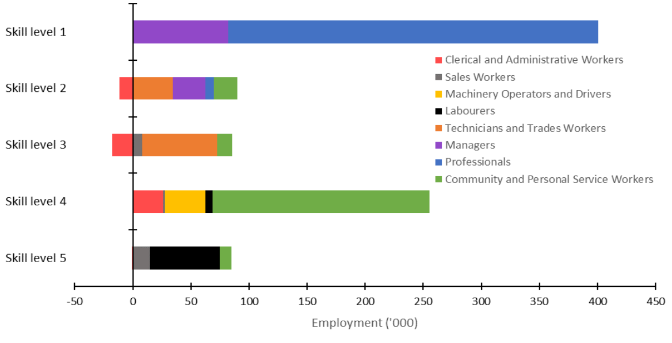

Note: Figure 3 refers to five skill levels; the Australian Bureau of Statistics (ABS) classifies occupations according to five skill levels commensurate with the following qualification(s) or where relevant work experience with training may be a substitute for formal qualifications:

Skill level 1: Bachelor Degree or higher qualification

Skill level 2: Advanced Diploma or Diploma

Skill level 3: Certificate IV or Certificate III with at least two years on-the-job training

Skill level 4: Certificate II or III

Skill level 5: Certificate I or secondary education

Overall, educational attainment levels have risen significantly in Australia over recent decades. Nonetheless, there is significant variation in attainment levels across the population.

For individuals, educational attainment remains strongly correlated with their socio-economic status and levels of family educational attainment. Lower than average levels of educational attainment, reflecting lower levels of participation in education and training, are evident for Indigenous Australians, people who live in rural and regional areas, those who have disabilities, and those from some culturally and linguistically diverse groups. These gaps widen over time; people with high levels of initial educational attainment are more likely to participate in formal education for longer; and to enrol in and complete qualifications with the highest private returns. In 2010, around half of Australia’s long term unemployed had not attained Year 12 or above as their highest educational attainment.[9]

There are compelling economic and social equity reasons to continue widening access to participation in education and training in Australia, and to continue improving educational attainment levels, particularly for those with low participation and attainment levels.

### Specific reforms

The AQF Review is closely connected to several areas of policy reform, which have informed the Panel’s work. In turn, Review outcomes will provide important underpinnings for these broader reform objectives.

#### Reviewing senior secondary pathways

As the proportion of students undertaking senior secondary school has increased[10], the purpose of senior secondary education has also broadened. Its role now goes beyond its traditional role in preparing school leavers for entrance to university. However, too many young people still do not make successful transitions to post-secondary education and training, or to work.[11]

The COAG Education Council has agreed to a review of pathways from senior secondary education. It will investigate barriers and examine how students can be supported, in terms of better recognition of their skills, knowledge and capabilities and better information to them about available options, to choose the best pathway into work, further education or training.[12]

#### Strengthening the VET system

Following the release of the Strengthening Skills expert review report[13], the Australian Government also announced budget measures to implement some of the review’s recommendations, including the establishment of a National Careers Institute to provide advice to young Australians transitioning careers and the establishment of a National Skills Commission to promote a nation-wide approach to skills development.[14]

Subsequently, COAG at its August 2019 meeting agreed on a vision for the future of the VET system. COAG’s vision includes that VET:

* provides workforce skills and relevant, up-to-date qualifications that are well-matched to the evolving opportunities and challenges of Australia’s modern economy
* is flexible in providing skills at all points in an individual’s career cycle whether it be foundational training, initial training, upskilling or re-skilling
* provides VET qualifications to school students that are valued by employers and provides a clear pathway from school to careers that require VET qualifications.[15]

In its August meeting communique, COAG asked that skills ministers work together through a new COAG Industry and Skills Council, in consultation with education ministers, to advise leaders on future reform priorities by the end of 2019 and provide a reform roadmap to COAG in early 2020.[16]

Individual states have also implemented a range of measures to strengthen their VET systems, particularly in areas of skills shortages and state labour market priorities.

#### A better connected post-secondary system

COAG’s vision for VET makes a strong statement that ‘VET and higher education are equal and integral parts of a joined up and accessible post-secondary education system with pathways between VET, higher education and the school system’.[17] This statement reflects a growing consensus that an imbalance between higher education and VET has developed over the past decade reflecting in part long standing perceptions about the relative value of VET and higher education qualifications.

#### Learner centred pathways and credit recognition

A joined up and accessible post-secondary education and training system would see post-secondary education and training as a diverse range of offerings with clear and flexible entry and exit points, including pathways within and between VET and higher education; and from senior secondary to post-secondary education and training. Credit recognition for prior learning should underpin these pathways, particularly for continuing learners and people returning to formal learning with existing qualifications and workforce experience.

#### Improving employment outcomes

Employment outcomes for graduates have softened over the past decade, alongside skills shortages in key occupations and industry sectors, and ongoing debate about levels of skilled migration to Australia. The introduction of performance related funding in higher education is in part a response to graduate employment outcomes. It also reflects government and community expectations that investment in education and training will yield productive outcomes in terms of the contribution of education and training to meeting Australia’s labour market needs, particularly in areas of skills shortages.

#### Support for regional, rural and remote students

To promote greater access to tertiary education for regional, rural and remote students, the Australian Government has accepted the aim of recommendations of the National Regional, Rural and Remote Education Strategy[18] that include increasing access to tertiary education in regional areas, support for students and raising their aspirations. These include initiatives covering both VET and higher education and expanding access to high quality VET programs in regional and remote schools.

1. The AQF architecture

This chapter outlines the Panel’s proposals for reforms to the key features of the AQF – its current levels system and the way that levels are used to define and align the different qualification types currently included in the AQF.

Terms relevant to national qualifications frameworks generally and the AQF specifically are defined in Table 2 below.

Table . National qualifications framework and AQF terms

| Term | Definition |
| --- | --- |
| AQF Taxonomy | The description and classification of Knowledge, Skills and Application across a number of bands or levels. |
| Band | A new term for a revised AQF to replace levels. Bands provide an indication of the relative complexity and/or depth of achievement and the Knowledge, Skills and Application required to demonstrate that achievement. |
| Domain | A grouping of the learning requirements of a qualification type. In the current AQF the domains are Knowledge, Skills and the Application of knowledge and skills. In the revised AQF the domains would be Knowledge, Skills and Application. |
| Descriptor | Terms that describe the Knowledge, Skills and Application features of bands and qualification types. |
| Focus Area | The themes within each domain that are described by descriptors. Examples of focus areas include information management and problem solving and decision making. |
| Level | Used in the current AQF, levels are an indication of the relative complexity and/or depth of achievement and the autonomy required to demonstrate that achievement. AQF level 1 has the lowest complexity and AQF level 10 has the highest complexity (AQF Glossary of Terminology). |
| Qualification | A formal certification, issued by a relevant approved body, to recognise that a person has achieved the intended learning outcomes or competencies. |
| Qualification Type | Refers to the broad discipline-free nomenclature used in the AQF to describe each category of AQF qualification (AQF Glossary of Terminology).  Qualification types are inclusive of a variety of qualification designs, including curriculum-based qualifications, Training Packages and Accredited Courses. |

## Background

The Review terms of reference required the Panel to consider:

* the relationships and clarity between levels and qualifications
* whether learning outcomes are expressed in simple language that is readily and consistently interpreted
* the placement of VET and higher education qualifications in the AQF
* issues at AQF Levels 5, 6 and 8
* the extent to which the AQF currently implies a status hierarchy from VET to higher education qualifications and whether changes to the AQF can address it
* whether the AQF can assist with greater consistency in regulation of AQF compliance between higher education and VET.

These are important issues. Figure 4 and Figure 5 show the relationship between the AQF and the broader regulatory and quality assurance environment in both the VET and higher education systems. They show how specifications in the AQF affect what is delivered in VET and higher education qualifications.

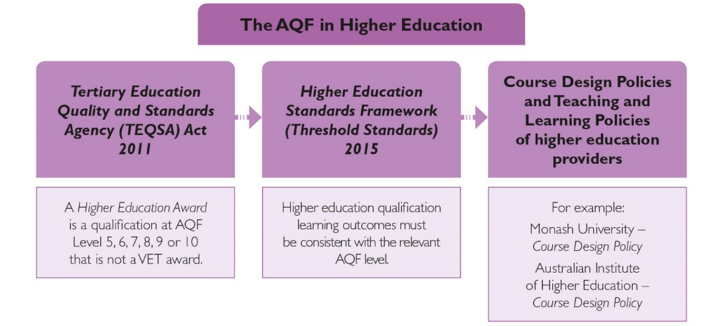Figure . AQF in higher education legislation

The figure shows how the Tertiary Education and Quality Standards Agency (TEQSA) Act 2011 defines a higher education award as a qualification at AQF levels 5-10 that is not a VET award. This flows to the Higher Education Standards Framework (Threshold Standards) 2015, which state that higher education qualification learning outcomes must be consistent with the relevant AQF level. This flows to the course design policies and teaching and learning policies of higher education providers, for example Monash University’s Course Design Policy.

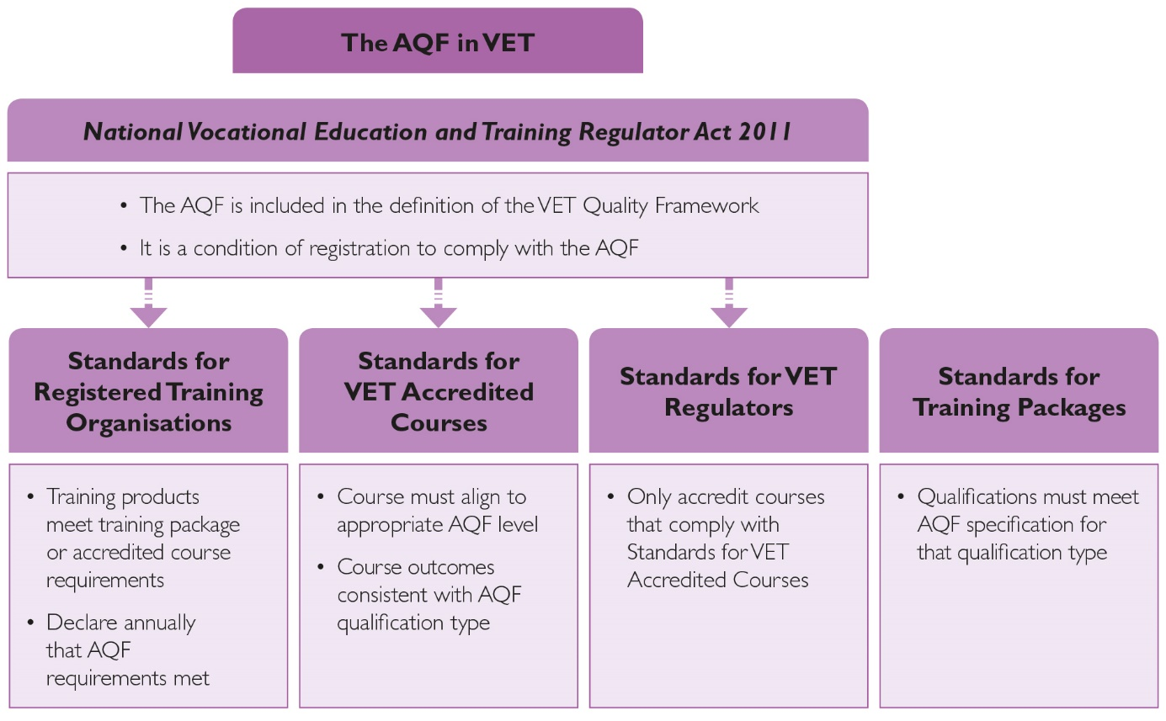Figure . AQF in VET legislation

The figure shows how the National Vocational Education and Training Regulator (NVETR) Act 2011 includes the AQF in the definition of the VET Quality Framework. The NVETR Act flows down to the Standards for Registered Training Organisations, the Standards for VET Accredited Courses and the Standards for VET Regulators. These standards require training organisations to meet AQF requirements and for regulators to accredit only those courses that comply with the standards. The Standards for Training Packages are shown alongside the Standards for VET Accredit Courses, and both show that qualifications must align to AQF qualification types.

### Contextual research

Prior to the establishment of the AQF Review Expert Panel, the Department of Education and Training commissioned PhillipsKPA to undertake an initial analysis of the AQF and consultations with stakeholders to help inform the scope and focus of the Review. In its advice, PhillipsKPA concluded that:

There is considerable feedback across regulators, providers, professions, industry and government agencies that the descriptors of levels and qualifications are not as effective as people would wish them to be. The 2018 review will need to focus on the language, presentation and underpinning concepts of the AQF to make it more easily understood and implemented.[19]

The PhillipsKPA report found the current AQF has ambiguity in terminology, inconsistencies in qualification type and levels criteria and:

* it uses terms that are not clear or readily understood, for example, the difference between ‘expert judgement’ and ‘authoritative judgement’
* it has close similarity between levels and qualifications descriptors, which is confusing for users
* the respondents questioned the need for both ‘level criteria’ and ‘qualification type descriptors’ and claimed that the existence of both created confusion and lack of clarity for compliance
* there is widespread concern about interpreting and implementing AQF Levels 5, 6 and 8
* there is an increasing need for clarity and simplicity around qualification types as boundaries between higher education and vocational education blur. [20]

| As a document, the AQF currently fails in one of its key objectives, which is to clarify for the general public the options from which they may choose to achieve their learning and employment goals. This conclusion is inescapable given the considerable expressions of confusion among those whose job it is to design, deliver and quality assure educational programs.  PhillipsKPA, Contextual Research for the AQF Review |
| --- |

## Developing a revised framework

### Initial propositions

Having regard to the Review terms of reference, and the issues raised in the PhillipsKPA report, the Review discussion paper proposed the following approaches to simplify and update the AQF and to potentially allow the levels to be applied more flexibly:

* Use AQF levels only to describe Knowledge and Skills and the Application of knowledge and skills; and provide a description of each qualification type that is linked to levels.
* Review the Application of knowledge and skills domain of the AQF taxonomy and how it should be applied across the AQF levels.
* Revise descriptions of learning outcomes to simplify them and ensure clear distinctions between levels.

Through submissions and in consultations, there was strong support for moving to a single set of learning outcomes for Knowledge, Skills and Application of knowledge and skills.

There was also strong support to simplify descriptors and ensure clear distinctions between levels, and to review the Application of knowledge and skills domain of the taxonomy. Submissions pointed out inconsistencies between qualification types at the same AQF level and ways in which some qualification types may not align with the level to which they are assigned.

For example, Navitas noted the AQF is unduly complex, incorporating language and terminology that is not clearly understood by learners, providers or employers.[21] There was also support for a primary focus in the AQF on qualification types – for example, VETASSESS[22] considered that placing greater emphasis on qualification descriptors as opposed to levels of increasing complexity would dissipate public misconception of the relative value of VET and higher education.[23]

Some stakeholders wanted to retain qualification type descriptors for knowledge, skills and their application to help distinguish between qualification types at the same level. A small number of submissions felt that issues identified with the AQF did not warrant changes to the AQF structure and learning outcomes.

For example:

|  |
| --- |
| UTS is of the view that there are no significant matters that warrant change to the AQF and is concerned that any material changes may upset the balance of levels and qualifications currently in place. The framework requirements are broadly stated to allow flexibility, diversity and innovation – they allow education providers to follow their own academic direction so long as it is defensible in the context of the AQF.[24] |

### Testing the feasibility of possible options

To test the feasibility of the approach outlined in the Discussion Paper, the Review commissioned the Australian Council for Educational Research (ACER) to advise the Panel on how the AQF level and qualification type descriptors could be revised to provide one set of descriptors within the existing ten level framework.

This option is shown in Figure 6. It combines the current AQF level and qualification type descriptors into one set of Knowledge, Skills and Application of knowledge and skills descriptors. The revised set of descriptors is at Appendix 2. It is presented using the concept of focus areas to assist with comparison of the Panel’s preferred approach outlined later in this chapter of the Report.

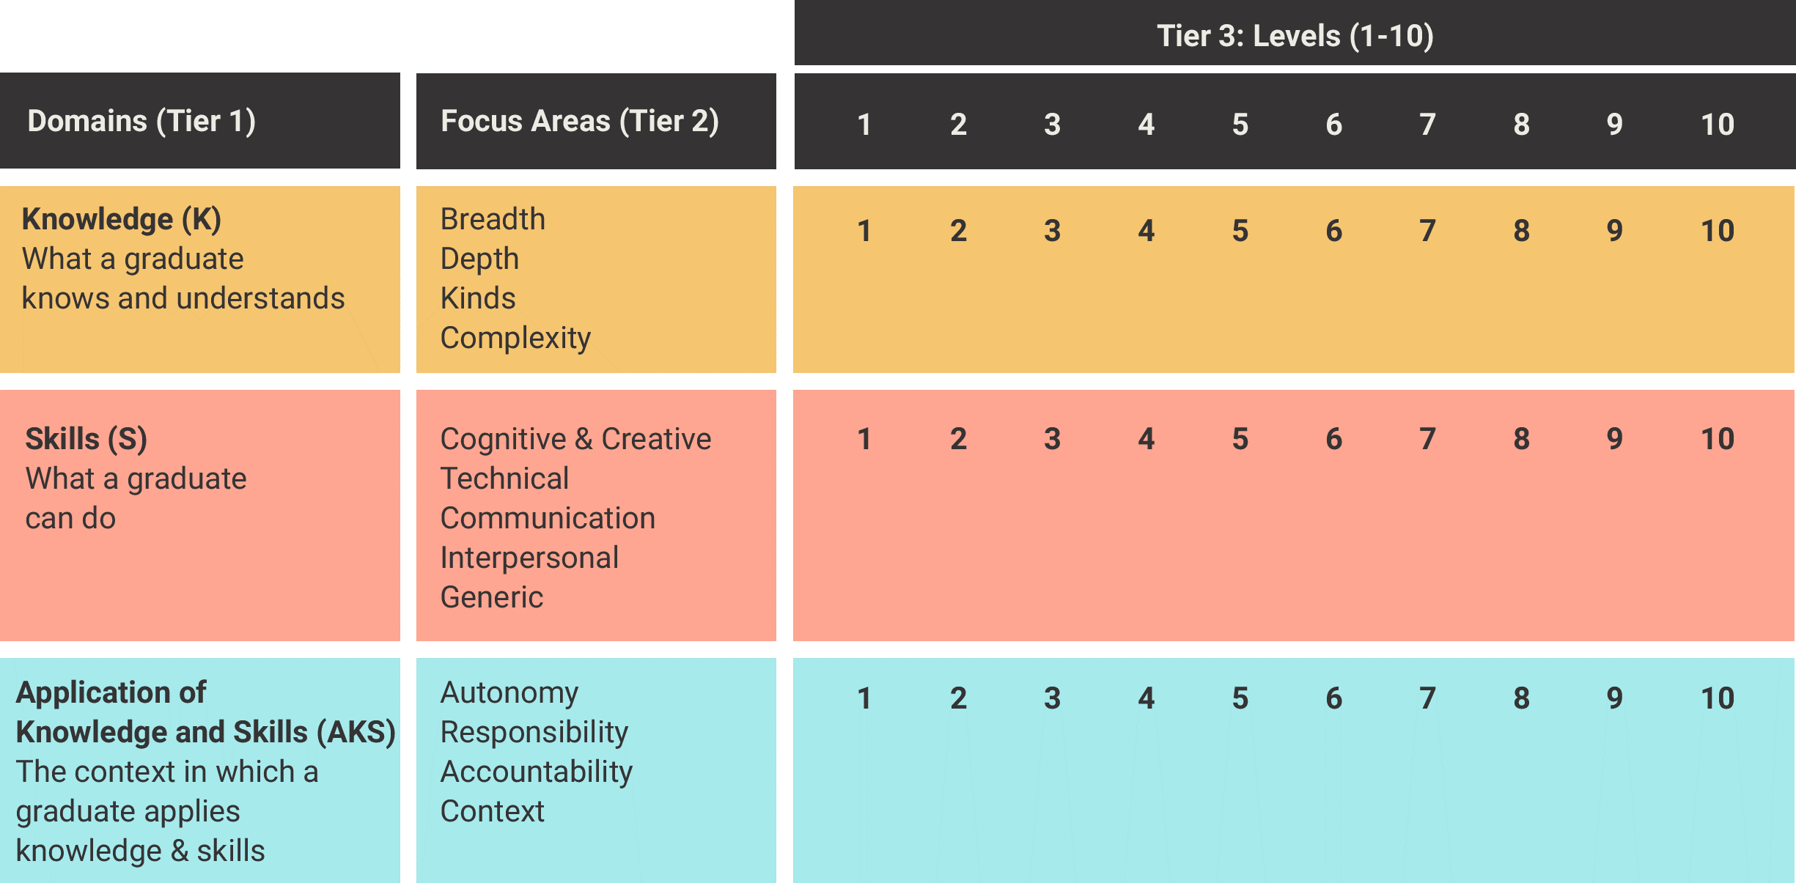Figure . Minimal change option[25]

The figure shows the AQF’s 10 levels divided into its three domains with the current Focus Areas listed for each. The descriptor text is not shown.

The Focus Areas for Knowledge are: Breadth, Depth, Kinds, Complexity.

The Focus Areas for Skills are: Cognitive & Creative, Technical, Communication, Interpersonal, Generic

The Focus Areas for Application of knowledge and skills are: Autonomy, Responsibility, Accountability, Context.

However, in its advice to the Panel on a revised and simplified ten-level framework ACER concluded that:

significant issues …cannot be ‘fixed’ through a revision of the language. The general lack of clarity, specific ambiguities and widespread inconsistencies are symptoms only, stemming from the real problem, which is the lack of a sound conceptual base. In the absence of such a foundation, decisions about how to change the descriptors will be arbitrary and may well create as many problems as they solve.[26]

Based on this advice and the other inputs into the Review, the Panel concluded that more fundamental reform to the AQF was required and commissioned ACER to develop alternative AQF models with fewer levels and innovative ways of specifying qualification types.

ACER developed several alternative conceptual models. The Panel tested these with key stakeholders. The conceptual models varied in the extent to which they allowed differences in the nature of knowledge, skills and the application of knowledge and skills to be reflected in the revised AQF structure. Through this process the Panel found a willingness by most stakeholders to explore and seriously consider alternatives to the current ten-level AQF structure - although most also indicated that they could only make final judgements when a more fully developed alternative model was available. Most also identified potential implementation issues and costs and indicated that final decisions would need to balance the benefits of reform against these issues.

The Panel has concluded that major reforms to the AQF are required. The option presented above in Figure 6 and presented in detail at Appendix 2 would be a ‘minimal change’ option.[27] However, while it would simplify the presentation of the AQF it would not resolve the problems highlighted above and the Panel does not recommend it. Under a minimal change option, the AQF would become largely a legacy framework, observed for compliance but increasingly irrelevant to the dynamic, complex and changing world within which qualifications are designed and delivered. The Panel also recognised that it was neither feasible nor appropriate to finalise and recommend a fully detailed revised AQF. Rather, the text below outlines its key features as the basis of endorsement for further development, testing and consultation.

Appendix 3, Appendix 4 and Appendix 5 provide additional detail. The Panel has framed the recommendations and associated actions accordingly. The Panel also commissioned dandolopartners to undertake an analysis of the potential impacts of implementing the recommendations of the Review. Decisions on those recommendations could then be taken on the basis of an initial assessment of implementation issues, consequential effects and the actions required to address them.

## A revised AQF – key features

The key features of a revised AQF are summarised in Figure 7 and described in the following sections.

Figure . Proposed AQF architecture[28]

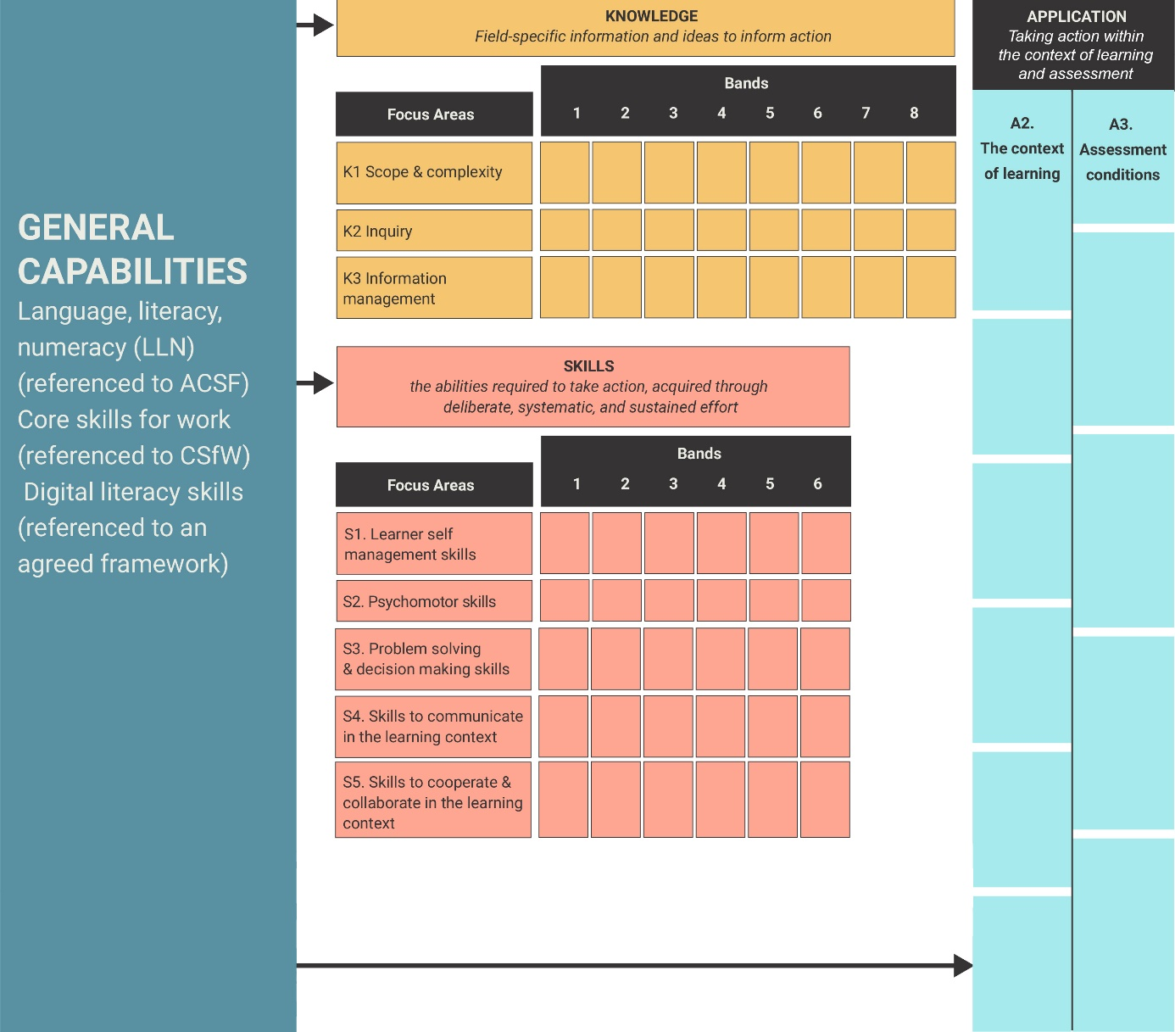The figure shows General Capabilities on the left, which flow into the three Domains. The General Capabilities listed are:

* Language, literacy, numeracy (referenced to ACSF)
* Core skills for work (referenced to CSFW)
* Digital literacy skills (reference to an agreed framework)

Knowledge is defined as ‘field specific information and ideas to inform action’. It is divided into three Focus Areas of eight Bands:

* Scope & complexity
* Inquiry
* Information management

Skills are defined as ‘the abilities to take action, acquired through deliberate, systematic and sustained effort’. They are divided into five Focus Areas of five Bands:

* Learner self management skills
* Psychomotor skills
* Problem solving and decision making skills
* Skills to communicate in the learning context
* Skill to cooperate and collaborate in the learning context

Application is defined as ‘taking action within the context of learning and assessment’. It is divided into two Focus Areas without Bands:

* The context of learning
* Assessment conditions

### Focus on qualification design

Like most qualification frameworks, the AQF currently states that ‘graduates will’ achieve certain learning outcomes. It attempts to project forward the knowledge and skills that ‘graduates will’ have in work or study contexts beyond the learning environment upon completion of a qualification. This approach is problematic because:

* It assumes all qualifications within a qualification type, for example a Bachelor Degree, are equally likely to lead to employment at a certain hierarchical level.
* It assumes all qualifications at a level provide the same opportunities to practice knowledge and skills and that these opportunities are sufficient for a graduate to ‘hit the ground running’.[29]
* The design of learning outcomes usually relates to their use in individual qualifications, where there is a clear scope and context, and not in qualification types.[30]

For these reasons, graduate outcomes cannot be meaningfully defined in broad qualification types. Therefore, the Panel supports ACER’s proposal for qualification types to specify features for qualification design, rather than graduate outcomes. The practical application of this approach is that the AQF would stipulate that ‘qualifications of this type will’ incorporate the features specified by the descriptors of Knowledge, Skills and Application in the qualification type.

This approach places a focus on qualification design as a necessary precursor to the achievement of graduate outcomes, as shown in Figure 8. As a first step, the qualification type specifies the descriptors that describe features such as problem solving and communication skills to be built into qualifications. Secondly, qualification developers apply these in qualification design. Finally, the design features are given effect in course specific graduate outcome statements and in the outcomes achieved.

Figure . The link between qualification design and graduate outcomes through the AQF

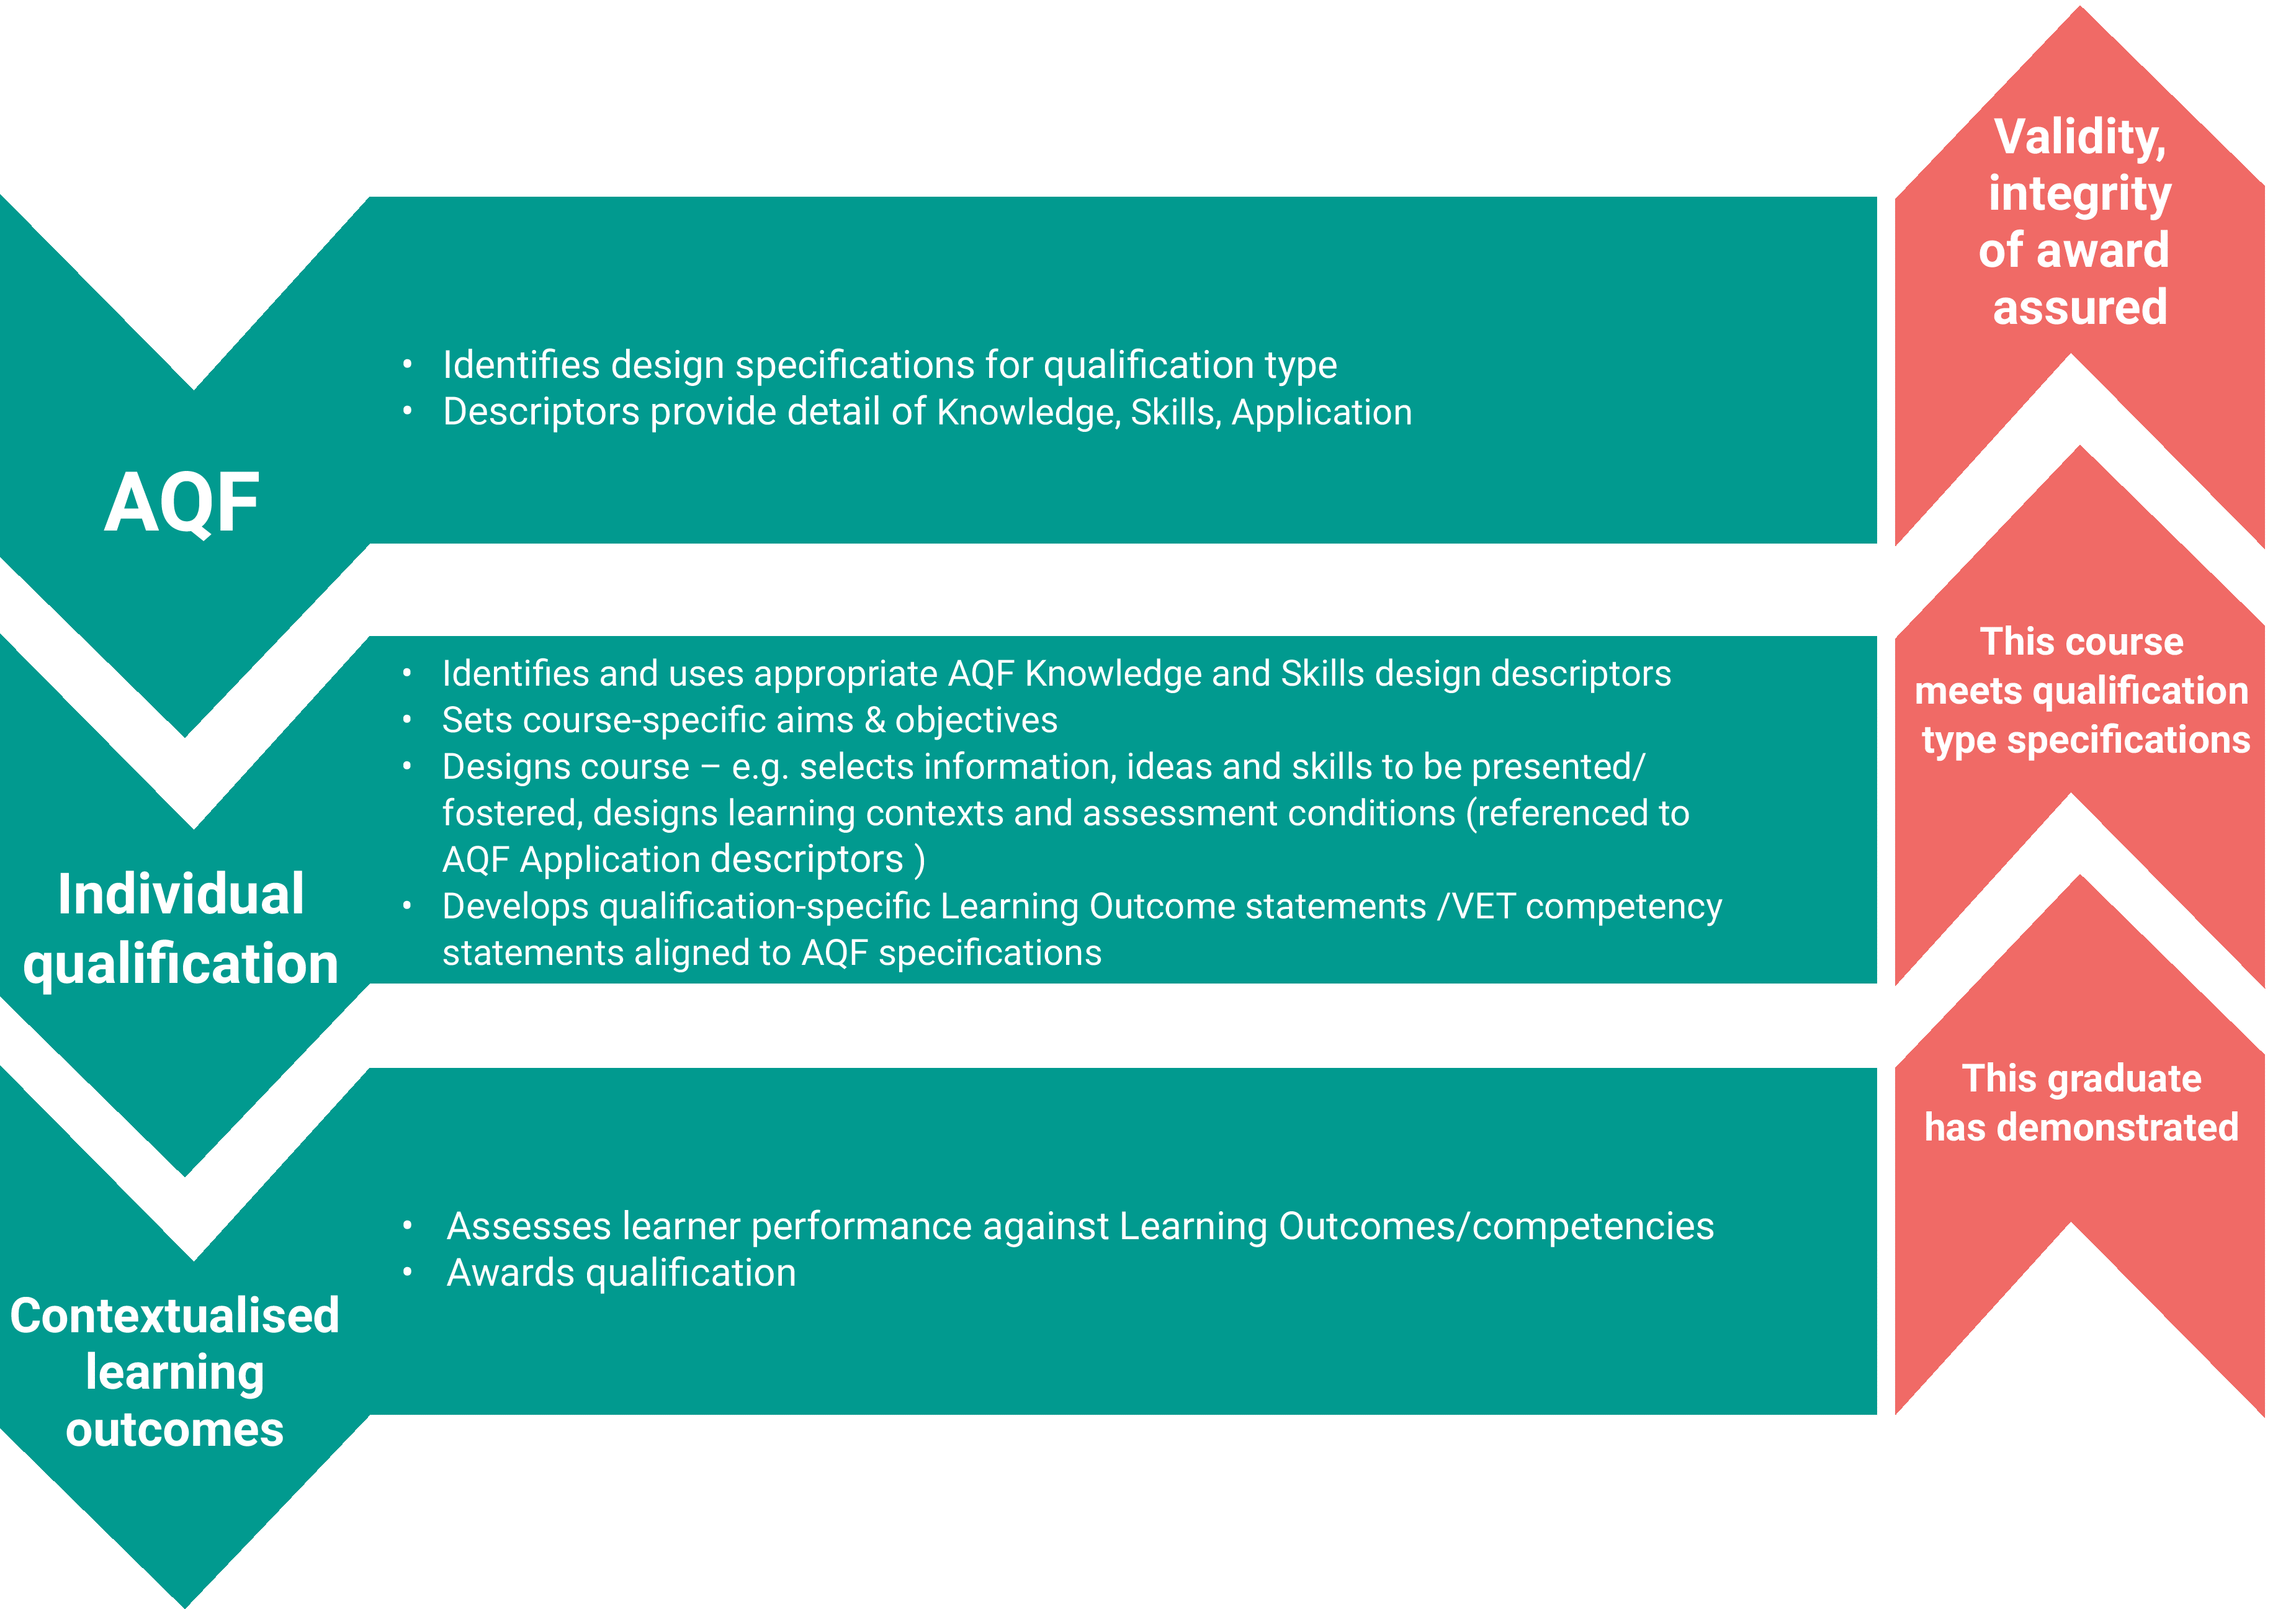The figure shows how the AQF defines the specifications for qualification types, which are then incorporated into individual qualifications along with the qualification’s contextualised learning outcomes. By graduates demonstrating these outcomes, and the course meeting qualification type specifications, the validity and integrity of the award is assured.

### Redefining domains

Like many qualification frameworks, the current AQF specifies key descriptors in three separate domains (Knowledge, Skills and Application of knowledge and skills). This may lead to Knowledge, Skills and Application of knowledge and skills being considered in isolation from each other, when in practice this is not the case.[31]

To address this issue, the Panel proposes the following domain definitions that link Knowledge, Skills and Application through action:

* Knowledge – field specific information and ideas needed to inform action.
* Skills – the abilities required to take action, acquired through deliberate, systematic, and sustained effort.
* Application – taking action within the context of learning and assessment.

These definitions link Knowledge, Skills and Application through action. They recognise that Knowledge and Skills, as well as Application, are necessary to achieve learning outcomes, as illustrated in Figure 9.

The Panel proposes that Application of knowledge and skills be renamed Application (because it is a simpler term).

Figure . Domain definitions linked through action[32]

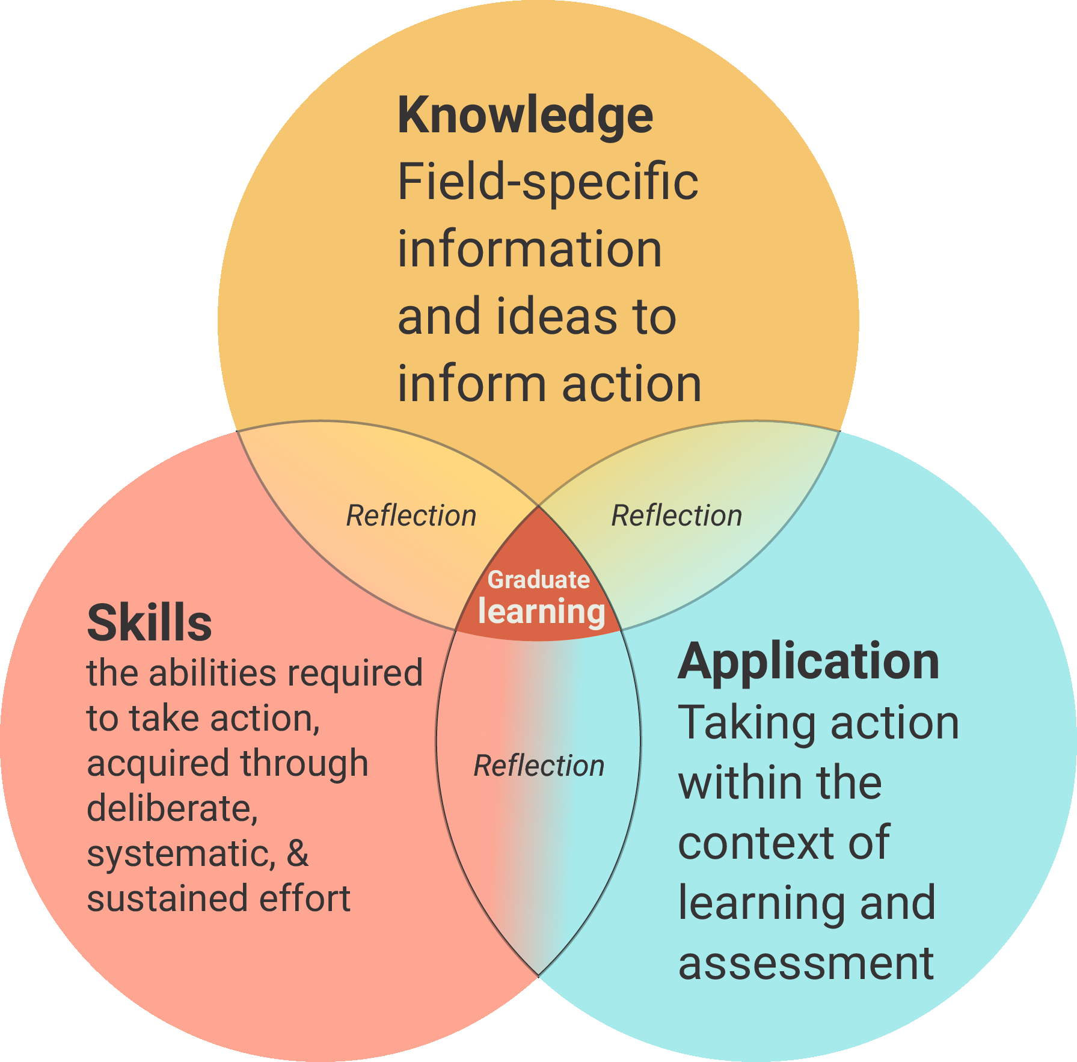

### Incorporating Focus Areas

In addition to clear domain definitions, the Panel formed the view that the AQF should incorporate focus areas in the revised AQF taxonomy. This will make transparent the themes of Knowledge, Skills or Application that are specified by the descriptors. Use of focus areas would make it clearer to users of the AQF what themes of knowledge and skills are intended to be progressed across the AQF bands; and be used to differentiate qualification types. The choice of focus areas provides an opportunity to improve the definition of Skills and Knowledge in more a more useful way. The suggested focus areas are outlined in Figure 10 and flow from the action-oriented definitions of Knowledge, Skills and Application given above.

#### Knowledge

The Knowledge focus areas provide the abilities necessary for lifelong learning. They enable people to effectively and efficiently find and deal with information in a knowledge-based society.

The focus areas proposed are:

* Scope and complexity of information that learners are expected to access and understand
* Inquiry – identify, locate, evaluate and acknowledge sources of information
* Information management – manipulate information in various ways.

#### Skills

The Skills focus areas have each been consistently identified by a wide range of stakeholders (in Australia and internationally) as critical to performance in life, study and work contexts. One or more of these will be integral to the effective application of the field-specific ideas and information presented in a formal course; and it is possible to enhance these skills through teaching and learning. It is possible to differentiate and describe stages of performance for these skills.

The focus areas proposed are:

* Learner self-management skills
* Problem solving and decision making skills
* Skills to communicate in the context of learning
* Skills to cooperate and collaborate in the context of learning
* Psychomotor skills.

The inclusion of psychomotor skills[33] for the first time, provides the opportunity to signal the value of a course that is fostering the development of sophisticated specialist skills involving the use of one’s own body and/or tools.[34] These skills underpin many vocational qualifications, professional qualifications requiring high levels of dexterity and the creative and performing arts.

#### Application

Prospective employers may want to know if graduates are able to adapt and apply what they have learned in an employment context. However, it is not possible to define application across the widely differing contexts in which learning outcomes will be applied after course completion. Rather, it is more appropriate to reflect contexts within which learners have applied information and skills during the learning process and the conditions under which the knowledge and skills were assessed. Practice or assessment in authentic or ‘real-world’ conditions including workplaces can be an indicator of transferability.[35]

The Application focus areas provide the opportunity to give a context to the learning environment and to indicate whether individual qualifications provide an opportunity to apply field-related information, ideas and skills; and to identify the assessment conditions for individual qualifications in terms of how they assess the application of knowledge and skills.

Based on ACER’s research, the proposed focus areas are:

* The context of learning
* Assessment conditions.

ACER also trialled another Application focus area – scope and purpose - to describe the nature of activities and associated problems that learners within a qualification type are likely to engage with.[36] The Panel has not listed this focus area here because it was developed late in the Review process, but it could be considered during development and implementation of a final revised AQF taxonomy.

Figure 10 shows the proposed focus areas for Knowledge, Skills and Application and their interaction with general capabilities (described later in this chapter) in the context of learning.

Figure . AQF domains and focus areas[37]

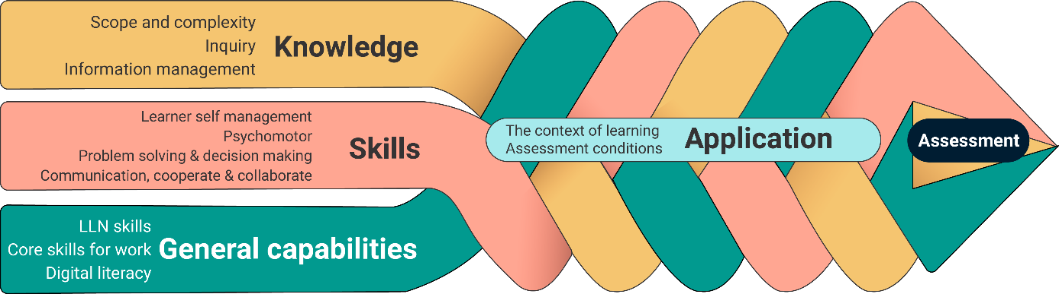

### Revising descriptors

The main content of a revised AQF taxonomy is the revised descriptors. They specify the Knowledge, Skills and Application features of bands and qualification types. As such, they specify what features should be used in qualification design (see Figure 8) to foster the appropriate graduate outcomes. They also provide a learning progression for Knowledge and Skills focus areas and a list of possible design features for Application focus areas.

The ability to specify descriptors that effectively differentiate qualification types is determined by the choice of focus areas. The focus areas proposed in Figure 7 describe characteristics of knowledge and skills that allow qualification types to be readily distinguished, as well as specifying the relevant and contemporary knowledge and skills likely to be required.

For example, the current AQF implies the following focus areas for knowledge – breadth, depth and kinds and complexity of Knowledge. *Kinds of knowledge* can be described as factual, technical, procedural and theoretical, but it is not clear that these kinds lie in a continuum or how, for example, technical knowledge is differentiated between qualification types. It also does not tell a student or employer independently of the context of the specific qualification what a graduate might know or be able to do with the knowledge.

By comparison, the Knowledge focus areas proposed for consideration in the design of a revised AQF can be differentiated along a continuum and describe capabilities in a useful way. For example, the Knowledge focus area ‘information management’ describes early in the continuum ‘help learners to summarise, sort, compare, sequence’ and later in the continuum ‘help learners to collect and analyse own data, analyse, synthesise, theorise, select and apply conceptual models to aid understanding’.[38]

As part of its work for the Review, ACER developed draft descriptors. They are given at Appendix 3 (Knowledge), Appendix 4 (Skills) and Appendix 5 (Application).

### Using fewer bands

Internationally, qualifications frameworks mainly have between eight and ten levels across the whole education and training spectrum. The ten levels in the current AQF is relatively high by international standards because they only cover tertiary qualifications. By comparison, Denmark, Finland and Germany’s frameworks have eight levels ranging from exit level primary school to the doctorate. Blooms Taxonomy of Educational Objectives: Cognitive Domain, which forms the basis of many national qualification frameworks, has six levels.[39]

The Panel proposes that levels be renamed bands to focus more on the outcomes of each band rather than its place in a hierarchy. Band may also be a more appropriate term for a revised AQF that is not ‘locked to level’ (see section on applying bands flexibly).

The more bands there are in a framework, the more difficult it is to express differences between them. Reducing the number of bands in the AQF will make it possible to develop descriptors that more clearly define qualification types.

The Panel proposes there be eight bands for Knowledge and six for Skills on the basis of research and analysis by ACER, which shows that it is only possible to clearly differentiate relevant descriptors across that many bands.[40] This would need to be subject to testing and confirmation prior to implementation.

### Applying bands flexibly

The current AQF presents tables that describe Knowledge, Skills and Application of knowledge and skills in a locked progression across the ten levels. However, in reality not all characteristics of Knowledge, Skills and Application of knowledge and skills progress uniformly across the ten levels. The AQF Review discussion paper pointed out that this is particularly the case for Application of knowledge and skills.

Current AQF qualification types are ‘locked to level’, meaning they must incorporate all the learning outcomes from the band to which they are aligned, and only from that band. This rigidity undervalues the capabilities acquired in the VET qualifications. For example, ‘locked to level’ means that a Certificate III qualification type could not describe the greater levels of autonomy and responsibility that may be achieved compared to some qualification types aligned to higher levels.

The AQF should therefore provide flexibility to ‘unlock levels’ from one another, for example, for a Certificate III to be described with Knowledge descriptors from one band, some Skills features from one band and other Skills features from another band. This would provide greater flexibility to describe accurately qualification types and could contribute to parity of esteem between VET and higher education qualifications by enablingthe purposes of each to be better described. It recognises that not all learning lies within a simple progression. With this flexibility the AQF would be a more relevant and contemporary instrument.

#### Unlocking levels

‘Unlocking levels’ allows for two approaches to describing qualification types.

##### Option 1 – specify the exact descriptors that should be used

The first approach is for the qualification types to specify the exact descriptors that should be used to guide design of a qualification. These descriptors could be taken from different bands of the AQF taxonomy using rules developed during implementation of a revised AQF. This approach is shown in Figure 11. It would allow the descriptors for different focus areas to be incorporated in a qualification type from different bands; and would provide flexibility to better differentiate qualification types aligned to the same AQF band. It would also provide for consistency of qualifications of the same qualification type. It would be clear to students, employers, regulators and international audiences what high level outcomes the qualification is designed to meet.

#### Figure . Option 1

Note Figure 11 is an example only to show how descriptors in a revised AQF taxonomy might be used to describe a Diploma qualification type and then to design a new Diploma qualification. It does not imply that the illustrated bands are the appropriate ones from which to draw descriptors to describe a Diploma.

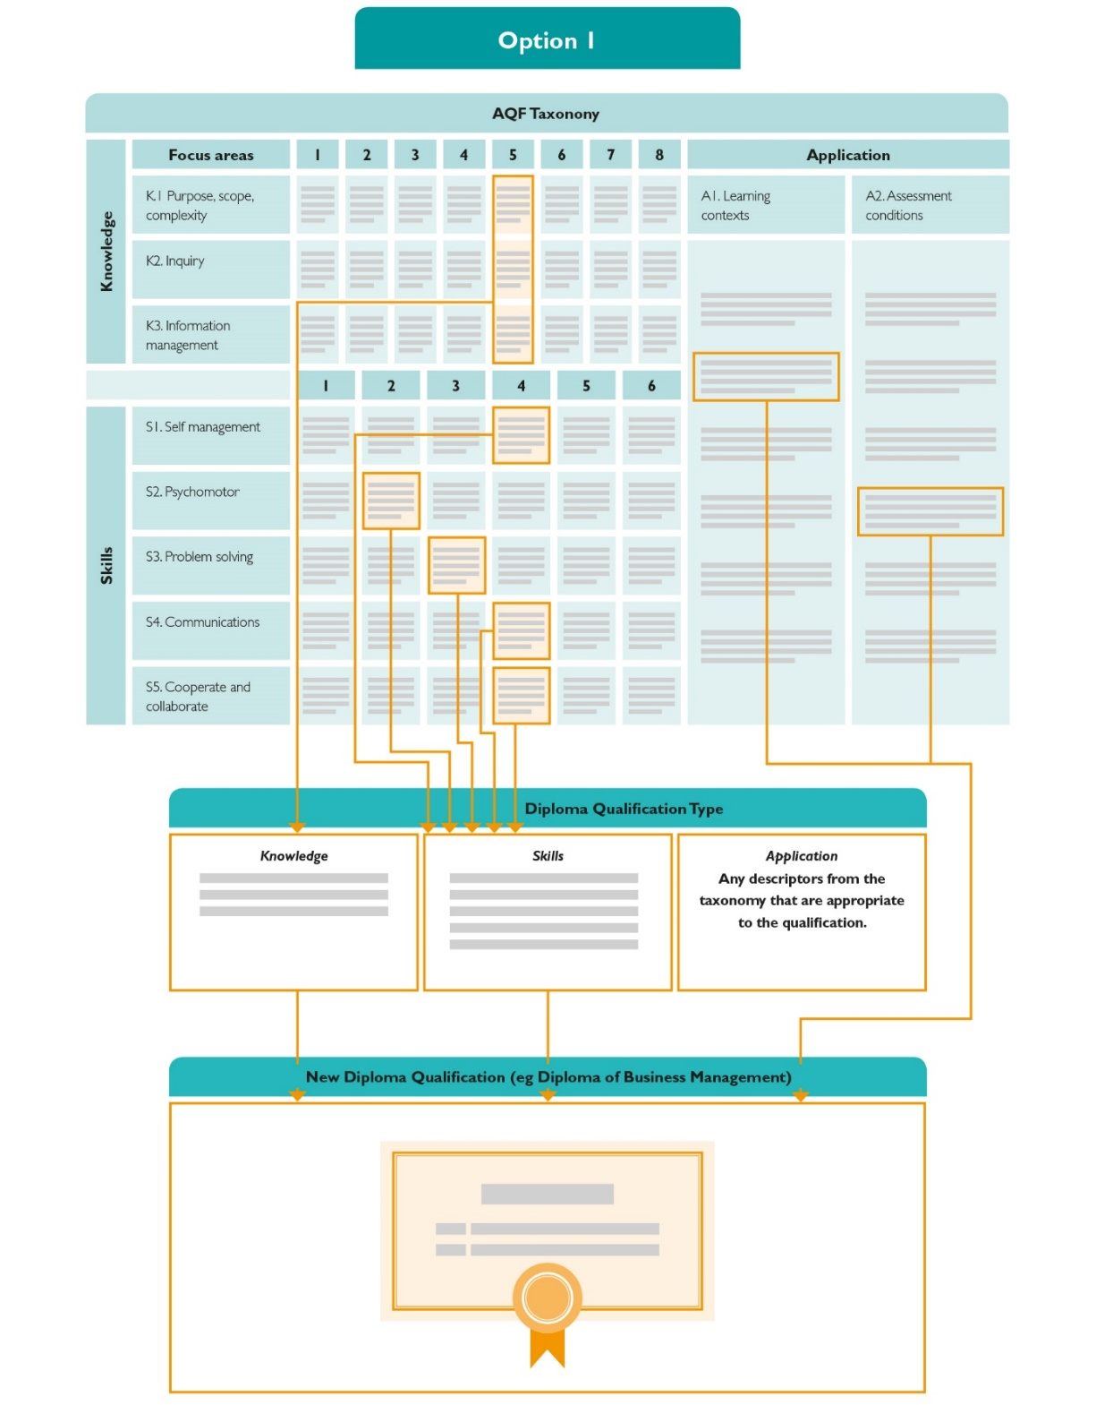

Appendix 6 shows examples of ways in which draft descriptors developed by ACER could be included in qualification types under *Option 1*.

##### Option 2 – specify a range of bands from which descriptors can be chosen

The second approach is for the qualification types to specify a range of bands, within rules, from which qualification developers could choose descriptors for each focus area for use in the design of a qualification. This approach means that at the time of designing a qualification, the qualification developer would choose from within the specified range what degree of complexity would be built into the qualification with respect to each focus area. This approach is shown in Figure 12.

Figure . Option 2

*Note Figure 12 is an example only to show how descriptors in a revised AQF taxonomy might be used to describe a Diploma qualification type and then to design a new Diploma qualification. It does not imply that the illustrated bands are the appropriate ones from which to draw descriptors to describe a Diploma.*

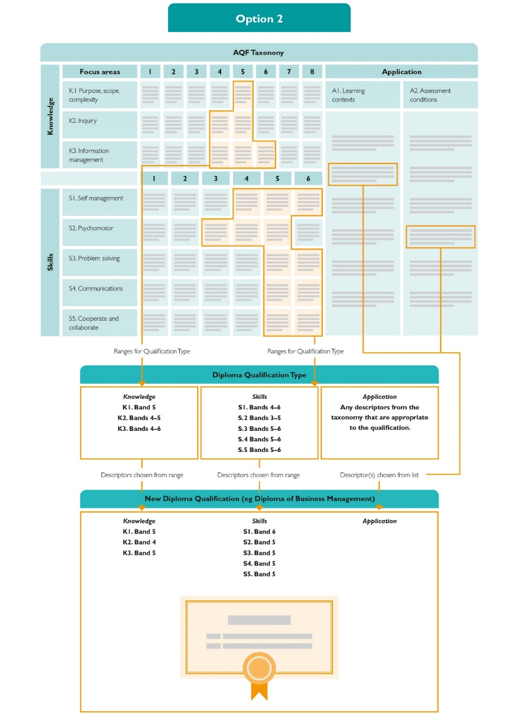

The approach shown in Figure 12 recognises there is considerable variation between qualifications of the same type. It provides the opportunity to more accurately reflect the nature of individual qualifications. However, it would be less clear to students, employers, regulators and international audiences what specific high-level outcomes the qualification is designed to meet.

##### The approach in the current AQF

In contrast to these options, the current AQF does not allow for flexible application of bands and a qualification must consider both the level and qualification type descriptors. Figure 13 shows that under the current AQF, if a provider were to develop a new Diploma qualification, the qualification design would need to comply with both the current Level 5 descriptors and the current qualification type descriptors for a Diploma.

Figure . Using the current AQF

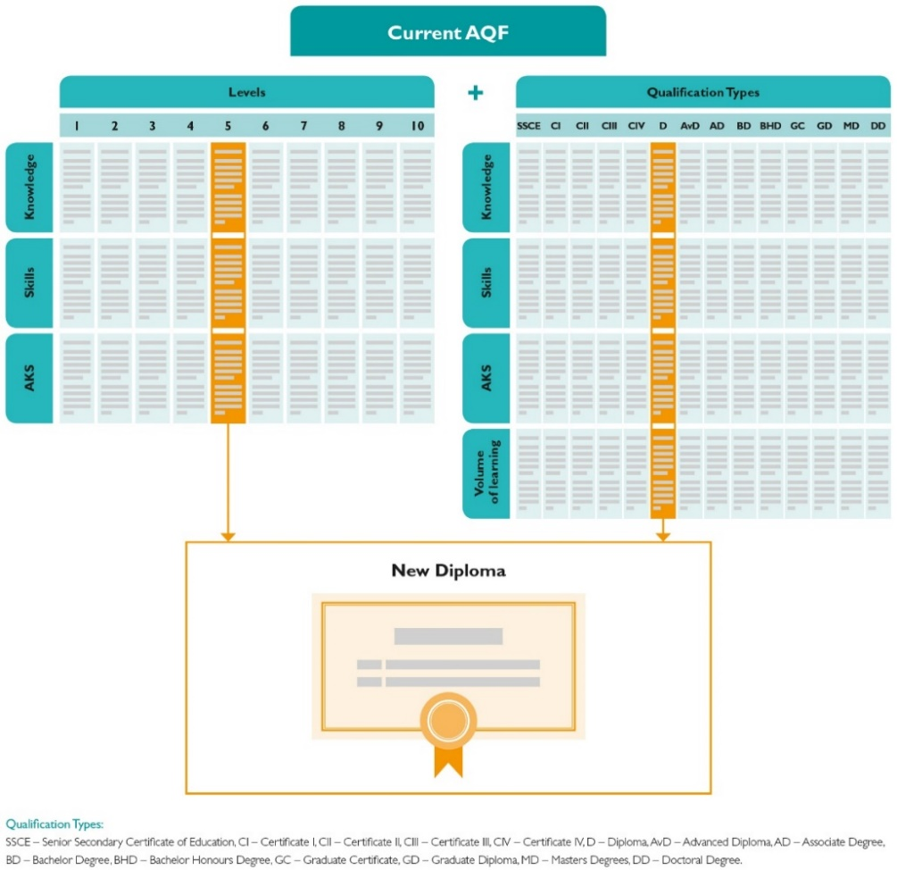

ACER pointed out that this questions assumptions that appear to underpin the Application of knowledge and skills domain in the current AQF: that application is uniform across qualification types at the same level or qualifications of the same qualification type; and that autonomy and responsibility increase in lock-step with the level of knowledge and skills.[41]

This context specific nature of Application, and the wide variability of qualifications for any single qualification type, can make it difficult to describe all Application focus areas as a learning progression across AQF bands. This also means it is difficult to describe Application accurately for qualification types.

As noted above, ACER found that the initial, useful focus areas it identified - context of learning and assessment conditions - could not be expressed as a learning progression.[42] In its final advice to the Review, ACER identified a focus area – scope and purpose – that it felt could be described across a learning progression and that therefore could be included in qualification types.[43] The Panel was not able to fully consider how useful that focus area, which has a close relationship with some Knowledge descriptors[44], might be.

The Panel considers the revised AQF taxonomy needs to enable Application descriptors that cannot be expressed as a progression to be specified in qualifications directly, rather than in qualification types. It would list the Application descriptors that should be considered in qualification design and leave it to qualification developers to apply the descriptors most appropriate to the course aims and objectives. This is shown in Figure 7.

This approach to Application would make it possible to describe qualifications more accurately and the context in which they are delivered. It would be easier for qualifications developers to comply with the AQF because they would be able to include in a qualification the Application descriptors that are most appropriate to its purpose and nature.

However, should development and testing of a revised AQF taxonomy during subsequent implementation identify Application focus areas that can be described in a learning progression, they could be included in the way Application scope and purpose is shown in Figure 14.

Figure . AQF architecture with Application bands[45]

#### The figure is a reproduction of Figure 7, except it includes an additional eight Band Application Domain.

#### Specify Application ‘in the context of learning and assessment’

As outlined earlier in this chapter, the Panel is proposing that AQF descriptors should outline features of qualification design, rather than graduate outcomes. Graduate outcomes would be specified at the individual qualification level, as shown in Figure 8. This would place the onus on good qualification design to deliver the intended graduate outcomes.

It follows from a focus on qualification design, that the context for the Application domain, which involves taking action, must be the context of learning and assessment.

Learning and assessment is defined broadly to emphasise the important role of structured work based learning and assessment leading to competency outcomes and national recognition in VET. It includes recognition of prior learning and recognition of current competence. It also encompasses work placement and supervised practice requirements necessary for professional accreditation where these requirements are built into qualifications.

The proposed Application focus areas reflect the range of contexts within which knowledge and skills are applied and demonstrated; ranging from controlled situations to those more reflective of real world, variable environments in classroom, workplace or community based settings (see Appendix 5).

### Identifying general capabilities

General capabilities (termed enterprise and social skills in the AQF Review discussion paper) are important and have always been so.

While most general capabilities can be taught or acquired to varying degrees in education and training; some of them are hard to define and can be subjective. They can be difficult to assess and report on, using reliable and valid methods.

In the discussion paper, the approach suggested by the Panel was that general capabilities should be able to be:

* taught in the context of the qualification’s core content
* acquired through the process of teaching and learning
* assessed and reported in ways that are fair, valid and reliable.

This approach was strongly supported in consultations and submissions. Ai Group noted that ‘while employers need individuals to have these enterprise-based skills to adapt quickly and be able to make decisions in uncertain situations, the skills are grounded by specific qualifications and discipline areas’[46].

Judgements then have to be made about the extent to which general capabilities can be encompassed in the revised AQF taxonomy (in effect mandating their inclusion in qualification types and individual qualifications). As La Trobe University stated in its submission ‘these kinds of skills are developed differently and applied in different ways according to discipline and are not amenable to broad-level qualification descriptions, or to assessment and reporting’.[47]

Nonetheless, ACER’s analysis showed that some general capabilities can be expressed as learning progressions. The Panel proposes that the capabilities ‘cooperation and collaboration’ and ‘learning self-management’ be included in the Skills domain of the revised AQF taxonomy given their importance in the workplace and to engagement in lifelong learning.

The Panel also believes that, consistent with the current AQF’s treatment of generic skills, some general capabilities should be listed for incorporation in the development of qualifications without including them in the AQF focus areas. This approach was favoured by most stakeholders.[48]

Some stakeholders expressed caution at creating too long a list, as the general capabilities desired by employers are likely to develop and change over time.[49] In addition, institutions favoured the ability to vary the emphasis on capabilities and respond flexibly to new requirements.[50]

ACER identified the following general capabilities for incorporation in qualification development as appropriate:

* language, literacy and numeracy skills (LLN)
* some core skills for work
* digital literacy skills.

The relationship of these skills to the AQF domains is shown in Figure 10. The necessary LLN and learning skills could be indicated with reference to the Australian Core Skills Framework [51](ACSF) and some core work skills could be referenced to the Core Skills for Work Developmental Framework.[52]

A number of submissions stressed the importance of digital literacy skills.[53] However, the Panel does not propose them for inclusion in the revised AQF taxonomy because it is difficult to identify a progression in complexity for digital literacy independently of the relevant field or discipline. For example, a Doctoral student in the humanities may require digital literacy skills for online research and for publication. However, these skills are not likely to be as broad and complex as the digital literacy skills required of a student undertaking a Diploma in cyber security or games and application development.

While not included in the list proposed by ACER, the Panel believes that ethical decision making should be considered for inclusion as a general capability. This should be done given its current and important use in discipline specific and professional standards, its importance in the context of automation and the destructive impact unethical decision making has on people’s lives, on consumer confidence and ultimately on the economy.

### Describing qualification types

Adoption of a new architecture for the AQF would require existing qualification types to be redescribed using new descriptors. A more flexible AQF taxonomy offers the opportunity to more accurately reflect the nature of existing qualification types and clarify the differences between them. This flexibility is shown in Figure 11 and Figure 12.

The Panel considers that rules would be required to specify the limits of variation allowed in choosing descriptors from different focus areas and bands of the revised AQF taxonomy. This would be necessary to ensure that there is a reasonably consistent degree of complexity of knowledge and skills used to describe any one qualification type.

To help distinguish between qualification types that may be aligned with the same band, the following information should be added to the qualification type specifications.

#### A purpose that describes common use

The current AQF sets out a purpose for each qualification type. They are described in terms of learning outcomes and may not convey the nature of the qualification type to students and employers. Descriptions in terms of the everyday use and intent of the qualification type could help differentiate qualification types.

Table 3 gives examples of current and possible revised purposes for some existing qualification types, using International Standard Classification of Education (ISCED) definitions. However, ISCED only supplies discrete definitions for Bachelor Degrees, Masters Degrees and Doctoral Degrees, so purpose statements would need to be developed for other Australian qualification types. Table 4 provides a simple example for demonstration purposes.

Table . Qualification type purpose examples using the ISCED

|  |  |  |
| --- | --- | --- |
| Qualification Type | Purpose in Current AQF | Revised Purpose using the ISCED |
| Bachelor Degree | The Bachelor Degree qualifies individuals who apply a broad or coherent body of knowledge in a range of contexts to undertake professional work and as a pathway for further learning. | The Bachelor Degree is designed to provide participants with intermediate academic and/or professional knowledge, skills and competencies, leading to a first degree or equivalent qualification. Programs at this level are typically theoretically based but may include practical components and are informed by state of the art research and/or best professional practice. |
| Masters Degree | The Masters Degree qualifies individuals who apply an advanced body of knowledge in a range of contexts for research and scholarship and as a pathway for further learning. | The Masters Degree provides participants with advanced academic and/or professional knowledge, skills and competencies, leading to a second degree or equivalent qualification. Programs at this level may have a substantial research component but do not yet lead to the award of a doctoral qualification. Typically, programs at this level are theoretically based but may include practical components and are informed by state of the art research and/or best professional practice. |
| Doctoral Degree | The Doctoral Degree qualifies individuals who apply a substantial body of knowledge to research, investigate and develop new knowledge, in one or more fields of investigation, scholarship or professional practice. | The Doctoral Degree is devoted to advanced study and original research. Doctoral programs exist in both academic and professional fields. |

Table . Qualification type purpose examples for demonstration purposes

|  |  |  |
| --- | --- | --- |
| Qualification Type | Purpose in Current AQF | Revised Purpose |
| Certificate I | The Certificate I qualifies with basic functional knowledge and skills to undertake work, further learning and community involvement. | The Pre-vocational Certificate may qualify individuals with:   * the foundation skills needed to access a vocational pathway such as reading, writing, numeracy and entry level digital technology skills * basic knowledge and skills needed to prepare for work or work experience or a probationary period in a specific field. |
| Diploma | The Diploma qualifies individuals who apply integrated technical and theoretical concepts in a broad range of contexts to undertake advanced skilled or paraprofessional work and as a pathway to further learning. | The Diploma may qualify individuals with:   * theoretical knowledge and/or practical skills in a specific field * technical knowledge to assist them in employment and/or prepare them for future study * skills for management or specialist technical roles in a specific field (if the Diploma is Nationally Recognised Training). |

#### Entry requirements

Entry requirements would specify broad entry requirements for that qualification type, including pathway options. For example, the Doctorate could specify the requirement of a Masters Degree (Research) for entry.

#### Including flags

Flags could be added to qualification types to signal the focus of the qualification. These would include:

##### Research

This flag would signal that this qualification type has a focus on research. It could be used to distinguish research and non-research qualification types at the same level, for example current Level 8.

The research flag for a Bachelor Honours Degree could say ‘developing research skills and conducting research is a requirement of the Bachelor Honours Degree’.

The research flag for a Diploma could say ‘research is not the focus of a Diploma’.

##### Nationally Recognised Training

This flag would state that some qualifications of this type can be nationally recognised training and outline briefly the characteristics of nationally recognised training. The flag would help employers and students understand the type of qualification available.

The nationally recognised training flag for a Diploma could say:

Some Diplomas are Nationally Recognised Training.

Nationally recognised training is any program of training leading to vocational education and training qualifications and credentials that are recognised across Australia.

These include:

industry training package qualifications and units of competency as listed on [training.gov.au](http://training.gov.au/)

courses that have been accredited by a vocational education and training regulator.

##### Apprenticeship

This flag would signal that some qualifications of this type can be delivered through apprenticeships or that apprenticeships are typically not available. It would alert users to differences in volume of learning and delivery mode that may have a bearing on qualification design.

### Aligning qualification types

The current AQF aligns qualification types to levels. This is necessary because the AQF describes learning outcomes for both levels and qualification types and AQF qualifications must comply with both sets of descriptors.

Under the proposed revised AQF architecture, there would be no levels and the proposed bands would become less important over time. They would exist in the AQF taxonomy as a means of clearly setting out descriptors to be used to describe and differentiate qualification types.

Under the option to develop qualification types described in Figure 11, all the specifications for developing an AQF qualification would be specified in the qualification type, including the descriptors that would have been incorporated from the revised AQF taxonomy. As a result, the band to which a qualification type is aligned will over time become be less important.

Under the option to develop qualification types described in Figure 12, descriptors could be reflected in qualification design from a range of bands, making alignment to any one band less meaningful.

Under a revised AQF, it would therefore be less meaningful to represent qualification types as directly aligned to bands. This reduces the need to show the AQF as a hierarchy of qualifications aligned to rigid and locked levels, and allows it to be shown as a spectrum of qualifications in the revised AQF diagram at Figure 15.

Figure 15. Revised AQF diagram

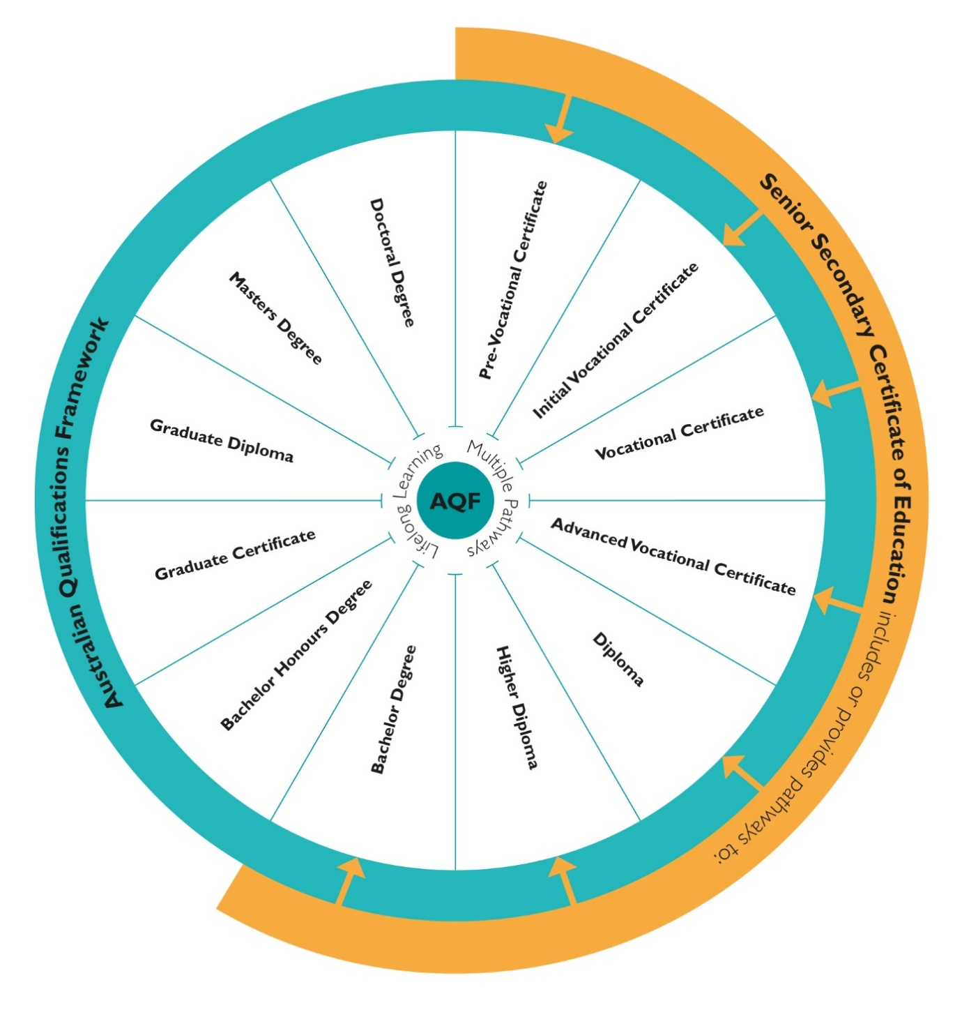

The Panel considers that the Senior Secondary Certificate of Education should not to be aligned to an AQF band (see Chapter 3).

#### Realignment options

To show that it is possible to allocate the existing qualification types within an eight-band framework, the Review developed a number of alignment options.

All options combine the current Levels 5 and 6 because their current level descriptors are similar.[54] Option 1 (Table 5) combines current Levels 1 and 2 because they are preparatory or introductory in nature. Although they have occupational outcomes in the current descriptors, they afford fewer employment outcomes, so the distinction for employers is not as necessary as for other qualifications.

Options 2 (Table 6) and 3 (Table 7) essentially remove current Level 8 because many submissions highlighted the lack of consistency between the research and non-research qualification types assigned to that level.

##### A new qualification type: The Higher Diploma

Combining current AQF Levels 5 and 6 could lead to the current Diploma, Associate Degree and Advanced Diploma being collocated. The Panel believes it would be undesirable to have two different diplomas at the same level.

The Panel therefore proposes creating a Higher Diploma in both VET and higher education at the same band as the Bachelor Degree. Creating a Higher Diploma would create a sequence of shorter, specific qualifications from the Diploma to the Graduate Diploma. It would enable both sectors to offer shorter qualifications to provide up-skilling and re-skilling opportunities in the future. This is also consistent with the recommendation of the Expert Review of Australian’s VET System that strong and successful qualifications pathways be developed including higher-level diplomas.[55]

##### Options for qualification type alignment

The Panel has identified three options for the realignment of qualification types into the proposed eight-band framework. These are presented below in Tables 5, 6 and 7. They are included here for illustrative purposes.

Table . Option 1: Qualification type alignment

|  |  |  |  |  |  |  |  |
| --- | --- | --- | --- | --- | --- | --- | --- |
| Band 1 | Band 2 | Band 3 | Band 4 | Band 5 | Band 6 | Band 7 | Band 8 |
| Pre-vocational Certificate  Initial Vocational Certificate | Vocational Certificate | Advanced Vocational Certificate | Diploma  Associate Degree | Bachelor Degree  Higher Diploma | Graduate Certificate  Graduate Diploma  Bachelor Honours Degree | Masters Degree | Doctoral Degree |

Table . Option 2: Qualification type alignment

|  |  |  |  |  |  |  |  |
| --- | --- | --- | --- | --- | --- | --- | --- |
| Band 1 | Band 2 | Band 3 | Band 4 | Band 5 | Band 6 | Band 7 | Band 8 |
| Pre-vocational Certificate | Initial Vocational Certificate | Vocational Certificate | Advanced Vocational Certificate | Diploma  Associate Degree | Bachelor Degree  Higher Diploma  Bachelor Honours Degree | Graduate Certificate  Graduate Diploma  Masters Degree | Doctoral Degree |

Table . Option 3: Qualification type alignment

|  |  |  |  |  |  |  |  |
| --- | --- | --- | --- | --- | --- | --- | --- |
| Band 1 | Band 2 | Band 3 | Band 4 | Band 5 | Band 6 | Band 7 | Band 8 |
| Pre-vocational Certificate | Initial Vocational Certificate | Vocational Certificate | Advanced Vocational Certificate | Diploma  Associate Degree | Bachelor Degree  Higher Diploma  Graduate Certificate | Graduate Diploma  Bachelor Honours Degree  Masters Degree | Doctoral Degree |

##### Rename certificates

The titles of some qualification types could be changed. In particular, the titles of Certificates I – IV could be renamed to better describe their intent and purpose. This would mean that they were titled independently of an AQF band as expressed in Table 8. This would help to recognise the intrinsic value of these qualifications rather than them being expressed as part of a numerical hierarchy. However, the Panel recognises that decisions on the titles and alignment of qualifications delivered in the VET sector will need to be considered in the broader context of skills reform through COAG.

Table . New certificate names

| Current Name | New Name |
| --- | --- |
| Certificate I | Pre-vocational Certificate |
| Certificate II | Initial Vocational Certificate |
| Certificate III | Vocational Certificate |
| Certificate IV | Advanced Vocational Certificate |

## The status of VET and Levels 5, 6 and 8

The terms of reference require the Review to consider:

* similarities and optimal points of differentiation of VET and higher education qualifications, particularly at Levels 5, 6 and 8
* the extent to which the AQF currently implies a status hierarchy from VET to higher education qualifications and whether changes to the AQF could mitigate this
* means by which the AQF can assist with greater consistency in regulation of AQF compliance between higher education and VET.

Contextual research for the Review and stakeholder submissions raised a number of concerns about current AQF levels 5, 6 and 8, including:

* differences in eligibility, funding (particularly student support payments), and the process of qualification development between VET and higher education
* possible confusion about awards with the same name in VET and higher education and whether a qualification type delivered in both sectors should be differentiated between the sectors
* different approaches to approving courses of the same qualification type taken by ASQA and TEQSA
* whether the Advanced Diploma and Associate Degree at Level 6 can be sufficiently differentiated or are both required
* different nature of diplomas offered in VET and higher education, with VET diplomas tending to be a higher-level field specific qualification, and higher education diplomas tending to be broader generic qualifications
* disparity of purpose and apparent complexity of qualification types at current Level 8, particularly the Bachelor Honours Degree in comparison to a Graduate Certificate
* post-graduate qualifications sometimes not being more complex than undergraduate qualifications if they are designed as articulation pathways for those with non-cognate or foreign qualifications.

### Status of VET

VET and higher education offer different approaches to the acquisition of skills and knowledge; both play critical roles in equipping graduates with the skills necessary for effective economic and social participation.

It is not possible for the AQF to address the funding and cultural factors that affect perceptions of the relative status of VET and higher education. Charles Sturt University stated in its submission:

… addressing perceptions of status differentials between vocational education and training and higher education are best achieved through investments in aspiration, awareness, support, brand, tool-kits, and life-long learning, as well as pathway options and mobility opportunities for future and current students.[56]

However, the Panel believes that measures proposed by the Review can help to signal the value of individual qualification types independently of the hierarchy of learning outcomes that is inherent in a qualifications framework. As an example, the Senior Secondary Certificate of Education is not less valued because it is introductory or preparatory to further education.

Changes recommended by the Panel that would enable the value of individual qualification types to be better recognised include:

* flexibility for a qualification type to be described using descriptors from different bands – this would allow more advanced skills outcomes to be recognised where they apply for Certificates I – IV (for example, if Option 2 shown by Figure 12 was adopted, the outcomes of some qualifications such as trade qualifications could be better recognised)
* the introduction of psychomotor skills, which would allow the nature and strength of some VET qualification types to be better recognised
* the focus on qualification types at the front of the AQF and the proposed renaming of Certificates I – IV will help to separate them from association with the taxonomy, which reflects a hierarchy of increasing complexity (this approach is reflected in the revised AQF diagram at Figure 15, which shows each qualification type independently, with similar weight and without the bands)
* the Nationally Recognised Training flag and Apprenticeship flag would enable the strengths and distinctive nature of the VET system to be recognised.

The Panel does not agree with calls by some stakeholders[57] to create separate qualification types for VET and higher education Diplomas, Advanced Diplomas, Graduate Certificates and Graduate Diplomas. The Panel believes such a step could reinforce the perceptions of the lesser status of VET. In 2013, removal of the distinction between Graduate Certificates and Diplomas issued in the VET and higher education sectors received strong support from stakeholders.[58]

### Levels 5, 6 and 8

It would be possible to acknowledge the different nature in VET and higher education of some dual sector qualification types by revising the purpose statement for the qualification type. An example is provided for the Diploma at Table 4. It points out the slightly different purpose of Diplomas that are Nationally Recognised Training.

Reducing the number of AQF levels to eight bands provides the opportunity to consider the alignment of qualification types. For example, alignment of the Graduate Certificate with the Bachelor Honours Degree could be re-considered – see Table 7. The proposed creation of a Higher Diploma, and removal of the Advanced Diploma, would resolve issues around the Associate Degree and the Advanced Diploma.

The proposed research flag could be used to differentiate the Bachelor Honours Degree from the Graduate Certificate and Graduate Diploma and the flexibility provided for incorporating descriptors into qualification types would allow the research descriptor to be omitted from qualification types to which it did not apply.

ASQA and TEQSA highlighted difficulties that arise in accrediting courses that could be offered in either sector if the course developer has not sufficiently considered the requirements of the sector. The information currently provided in qualification types about responsibility for accreditation and development could be amended to highlight which regulator was responsible.

## Further observations

The current AQF allows for three forms of Doctoral Degree at Level 10 with the same descriptor within the Doctoral Degree qualification type: the Doctoral Degree (Research); the Doctoral Degree (Professional) and the Higher Doctorate.

Without a distinguishing descriptor, the Doctoral Degree (Professional):

* has the same volume of learning (3-4 years) as the Doctoral Degree (Research)
* has research as its “defining characteristic”
* is subject to the specification that “Research in the program of learning will be for at least two years and typically two-thirds or more of the qualification”.

Often those attracted to the professional doctorate are experienced practitioners who are immersed in industry-leading practice and have advanced analytical, conceptual and/or creative skills. For such students, already at the innovative edge of their discipline or industry, the traditional requirements of a research doctorate may need to be reconsidered. This is important given the context of the knowledge economy. As new knowledge is produced and transferred in new ways, in new industries, increasingly with the aid of new technologies, it is timely to consider whether a new qualification type that provides recognition of professional achievement and innovation at the Doctoral level might be desirable.

Further, in relation to professional doctorates, the Panel heard from the Australian Clinical Psychology Association[59] and the Australian Psychology Accreditation Council[60] that changes to the Doctoral Degree specification in the 2011 version of the AQF had a negative impact on Australian psychology programs. It did so by specifying that Professional Doctorates will typically include at least two years of research, whereas previously this was not the case. Any redrafting of the qualification type specifications should consider this issue, as well as the effect that changing the descriptor could have on other Professional Doctorate programs throughout Australia.

The Panel was also made aware of the two quite different purposes to which the current AQF Level 8 Bachelor Honours Degree is applied. These purposes are referenced in the volume of learning statement in the Bachelor Honours Degree qualification type descriptor as follows: “The volume of learning of a Bachelor Honours Degree is typically 1 year following a Bachelor Degree. A Bachelor Honours Degree may also be embedded in a Bachelor Degree, typically as an additional year.”

Many existing four-year Bachelor degrees have now been redeveloped as Level 8 qualifications on the basis of “embedded honours”, while the more traditional Honours Degrees, “typically 1 year following a Bachelor Degree”, also continue to be offered, primarily as a pathway for research. Given the quite different purposes of these two types of Bachelor Honours Degrees, it might be useful to consider distinguishing them with a new qualification type for the “embedded honours” qualification.

| Recommendations  1. Revise the architecture for the AQF, based on the model outlined at Figure 7, with the following features: 2. Focus the AQF on describing qualification types. 3. Simplify the AQF to present only one set of descriptors in a revised AQF taxonomy. 4. Shift the focus of the AQF to qualification types that specify descriptors for qualification design, with graduate learning outcomes more appropriately reflected in individual qualifications. 5. Reduce the number of levels in the AQF from ten to eight for knowledge and to six for skills and rename levels as ‘bands’. 6. Enable the bands to be applied more flexibly across qualification types within clear rules. 7. Revise the descriptors for Knowledge, Skills and Application based on the approach outlined in Appendix 3, Appendix 4 and Appendix 5. 8. Revise the AQF’s treatment of general capabilities to: 9. List key general capabilities, such as digital literacy and ethical decision making, for incorporation in qualifications as appropriate 10. Stress they should be taught in the context of a qualification’s core content 11. Include in the revised AQF taxonomy some general capabilities that can be described in a learning progression, such as learning self-management, cooperation and collaboration. 12. Align qualification types to bands in a revised AQF taxonomy based on the new descriptors and considering the alignment models at Table 5, Table 6 and Table 7. 13. Consider creating new qualification types, such as a Higher Diploma, and/or renaming the existing Certificates I to IV as expressed in Table 8. |
| --- |

### Implementation

The Panel is aware that implementation of these recommendations will have implications for stakeholders, including for their course design policies, teaching and learning policies and regulatory policies in the higher education and VET sectors. It also has broader implications for data collection, industrial relations, student visas and migration policies. To enable changes to occur effectively, there would need to be a three-stage implementation process.

The first stage would involve changing the architecture of the AQF by developing a revised AQF taxonomy, defining qualification types in relation to this and aligning the qualification types to the model. Ongoing consultation and engagement with stakeholders would be conducted to inform the drafting of, and testing of, the revised AQF taxonomy.

The second stage would involve stakeholders revising any internal policies, regulations, legislation and procedures that are affected by changes to the AQF. This stage would include extensive communication, to explain further the changes and the benefits associated with them. For international stakeholders, including bilateral partners, multilateral institutions, and international education agents, an international engagement strategy would be used to explain the revised AQF and its taxonomy.

The third and final stage of the implementation would include transition to the revised AQF, which would involve revising and reaccrediting qualifications, where necessary, using usual accreditation processes, to align with the revised AQF. TEQSA and ASQA have advised the Panel that it would be preferable to accommodate changes in the usual cycle of accreditation. Chapter 7 provides detailed information about the implementation plan.

The aim is to provide sufficient time and guidance for stakeholders to enable successful transition to the revised AQF.

### Actions

To ensure effective implementation of the recommendations, the following actions are required.

#### To redesign the AQF

* Through a process of change management, develop a revised AQF taxonomy with the following characteristics:
* Levels that are renamed as ‘bands’.
* Domains of Knowledge (eight bands), Skills (six bands) and Application (no bands).
* Focus areas for Knowledge, Skills and Application that are founded on research and reflect abilities that are required in an evolving economy and can be taught, learned and assessed.
* Descriptors for each focus area that stakeholders can understand readily and that differentiate between AQF levels.
* Descriptors from different bands in the revised AQF taxonomy are able to be used to describe qualification types.
* Test the effectiveness of the descriptors with qualification developers, regulators, industry and students.
* Specify rules for allocating descriptors from the revised AQF taxonomy to qualification types.
* Redescribe qualification types, including the Senior Secondary Certificate of Education with Knowledge, Skills and Application descriptors from the revised AQF taxonomy using the specified rules that clarify their purpose and nature.
* Align qualification types to bands in the revised AQF taxonomy.
* Consider developing more descriptive names for some existing qualification types, for example:
* Certificate I as Pre-vocational Certificate
* Certificate II as Initial Vocational Certificate
* Certificate III as Vocational Certificate
* Certificate IV as Advanced Vocational Certificate.
* Consider creating a new qualification type called the Higher Diploma at the same band as the Bachelor Degree that would be available in VET and higher education.
* Consider whether a new qualification type that provides recognition of professional achievement and innovation at the Doctoral level might be desirable.
* Consider creating a new qualification type for the “embedded honours” qualification.
* Update the AQF list of ‘generic learning outcomes’ with general capabilities (such as digital literacy and ethical decision making) that would improve graduate outcomes in the future workforce and that can be:
* taught in the context of a qualification’s core content
* acquired through the process of learning and teaching
* assessed and reported in ways that are fair, valid and reliable.
* Develop a description for each qualification type that includes the following new or revised elements:
* The purpose of the qualification type, in terms of the learning and occupational outcomes achieved and within what context.
* The descriptors for the focus areas of each domain of the revised AQF taxonomy that apply for the qualification type.
* Volume of learning in hours.
* Any entry requirements for the qualification type in terms of prior AQF qualifications or equivalent experience.
* A flag that shows that some qualifications of this type could be Nationally Recognised Training.
* A flag that shows that research is the focus of the qualification type.
* A flag that shows that this qualification type can include apprenticeships.
* Actual nomenclature for the qualification type instead of a reference to the AQF Qualifications Issuance Policy.
* Include the following existing elements:
* Responsibility for accreditation and development of the qualification type, including recognition of which bodies accredit National Recognised Training.
* Authority to issue the qualification type.
* Amend AQF statements on responsibility for accreditation and development of qualifications included for each qualification type to guide qualification developers to the appropriate regulator.

#### Transition to the revised AQF

The following actions may be required during the transition phase to the revised AQF, depending on the type of change:

* Regulators would need to update their internal policies and practices and retrain auditors.
* The Department of Social Services and the Department of Human Services would need to undertake a comprehensive review of all other relevant social services regulation, policies and processes.
* State Training Authorities may need to reconsider funding policies if the number of AQF levels is reduced.
* Extensive communication and consultation to inform and educate Industry Reference Committees, Training Product developers and industry stakeholders.
* The Department of Education would need to review and update the 127 Country Education Profiles that are used by various entities, including providers, to understand how overseas qualifications align with AQF qualifications.
* The training.gov.au website would need to be updated to reflect changes.
* If there are substantive changes to qualification types, the following activities would be required in relation to data collection:
* The development of guidance documents to support changes in data collection requirements.
* Analysis to map historical data.
* Consideration of the required changes to the Unique Student Identifier (USI) transcript, System and IT updates to the National Training Register (training.gov.au).
* If changes to qualification types go beyond naming conventions, then this would require providers to:
* Discontinue, redevelop or develop course offerings.
* Transition students to new qualifications.
* Update learning materials and teaching capabilities.
* The Department of Home Affairs would need to review current policy and practice, particularly the point allocation system embedded within skilled migration policy. A reduction in the number of levels, would have an impact on visa policy settings and would require amendments to the *Migration Regulations 1994*, affecting a number of visas, including:
* Student (subclass 500) visa
* Temporary Graduate (subclass 485) visa
* Skilled Migration points-tested visas.

1. Senior Secondary Certificate of Education

The Panel is of the view that there should be better recognition of the pathways from school to tertiary education in the AQF. In particular, there should be better credit transfer arrangements in place.

There are currently two reviews underway that may have implications for the treatment of the SSCE in the AQF. Full consideration of the future of the SSCE should only be agreed once the work of the following reviews is complete:

* Review of Senior Secondary Pathways into Work, Further Education and Training as part of the broader National School Reform Agreement.[61]
* Review of The Melbourne Declaration on Educational Goals for Young Australians, which provides the policy framework for the Australian Curriculum.[62]

## Purpose of the SSCE

Around half of the students finishing Year 12 transition to university and another 15 per cent enrol in other forms of post school education and training.[63] Senior secondary is the last formal education for around one-third of Year 12 completers[64], so preparation for general, non-occupation specific preparation for work is still an important purpose the SSCE. However, the majority of employment growth over the last five years has been in occupations that generally require VET or higher education qualifications, and this trend is likely to continue.[65] The projected employment growth to May 2023 for skill levels by occupation (Figure 3) shows that the greatest growth will be for skill level 1 (Bachelor Degree or higher) in professional occupations, with the second highest level of growth for skill level 4 (Certificate II or III) in community and personal service work.[66]

In 2018, people with post-school qualifications had lower unemployment rates and achieved higher median weekly earnings than people with only school qualifications.[67] Some predictions suggest that by 2040 Australians will need to double the share of learning they do after age 21 from 19 to 41 per cent.[68] For these reasons, the SSCE graduates of the future will need to be prepared for VET, higher education or other forms of lifelong learning.

The Panel recommends, therefore, revising the purpose of the SSCE to emphasise its role in preparing students for further learning.

The current purpose of the SSCE states:

The Senior Secondary Certificate of Education qualifies individuals with knowledge, skills and values for diverse pathways to further learning, work and effective participation in civic life.

A revised purpose could state:

The Senior Secondary Certificate of Education qualifies individuals with knowledge, skills and values for diverse pathways to further learning (particularly through tertiary education), work and effective participation in civic life.

## Aligning the SSCE with the AQF

The AQF Review discussion paper proposed that the SSCE not be aligned to one or more AQF levels because the level of learning outcomes achieved by SSCE graduates do not easily or directly align with particular AQF levels. For example, secondary school students can study VET Certificates I, II or III (AQF Levels 1, 2 or 3). In some states, Year 11 or 12 students can study Certificate IV (Level 4) and VET Diploma (Level 5) courses as part of their SSCE, although they make up only 3.1 per cent of all students doing VET.[69] Some graduates with an ATAR, or a Certificate IV in Tertiary Preparation, are deemed to have knowledge and skills suitable for entry to an AQF Level 7 Bachelor Degree. Some universities also provide credit to SSCE graduates for particular subjects.

The Council for International Education’s Expert Members pointed out that ‘…assigning [the SSCE] to an existing AQF level may diminish its understanding and value internationally, as well as that of other AQF qualifications should the SSCE be placed at a specific AQF level.’[70]

The discussion paper proposed revising the SSCE descriptor to recognise that the knowledge and skills acquired in the SSCE can be at a broad range of AQF levels, and result in multiple pathways, to explain why the SSCE is not set at a level like other qualification types in the AQF. Stakeholders overwhelmingly supported the position put in the discussion paper.

## Recognising pathways

As the number of students progressing into tertiary education increases, it is important for students who do so to receive appropriate acknowledgement of the knowledge and skills they have obtained during their school years. The recently released discussion paper for the Review of Senior Secondary Pathways into Work, Further Education and Training[71] raised potential need for disruption in traditional ways of thinking about pathways, that could be considered in terms of better credit recognition for secondary school students.

For secondary students undertaking vocational education, the situation is relatively straightforward because of the integration of VET into the secondary schools system. VET undertaken as part of the SSCE is drawn from nationally recognised training packages or accredited courses, and delivered and/or assessed by Registered Training Organisations (RTOs) or in partnership with an RTO.

The interaction between non-VET upper secondary education and higher education is more uneven. Universities’ credit policies generally make no explicit mention of credit from the SSCE, though some include provisions for graduates of the International Baccalaureate (IB). As an example of where credit for SSCE subjects is mentioned, the University of Melbourne specifies advanced standing may be granted to students that have ‘demonstrated mastery of the content of a first-year subject through … outstanding results on relevant secondary studies’.[72]

The Review understands that universities may offer SSCE students the opportunity to undertake a university unit that provides credit should the student attend that university. It is not clear how portable such arrangements are.

The current AQF Qualifications Pathways Policy calls on providers to ‘recognise learning regardless of how, when and where it was acquired, provided it is relevant and current and has a relationship to the learning outcomes of the qualification.’ The Review of Senior Secondary Pathways’ discussion paper also suggests there is a need for a balance between the emphasis on academic achievement and ‘broader skills, knowledge and capabilities a student achieves through community engagement, work related learning, team-based sports, volunteering and activities undertaken outside the school gate.’[73]

As the number of secondary students transitioning to higher education increases, there is an opportunity for higher education providers to provide more seamless pathways for secondary graduates without compromising outcomes. A revised Pathways Policy would encourage this.

## VET in Schools

As noted by *Strengthening Skills*, the Expert Review of Australia’s Vocational Education and Training System, ‘the most important purpose of delivering VET qualifications in secondary school must be to offer students clear pathways towards VET careers’.[74] This is true whether these pathways lead straight to the workforce or to further training. One of the VET Review’s recommendations was to define VET in Schools as a separate stream, ‘because the system currently finds it hard to measure exactly what is being delivered across the country in schools.’

In many cases, students are undertaking low level AQF qualifications[75] that may not be recognised or valued by employers[76] and which do not provide the breadth and depth required for pathways into full VET qualifications. There is benefit in exposing school learners to a variety of options, and some learners may be able to derive benefit from completing a small cluster of units of competency, but as a whole, the system must look to provide meaningful and coherent VET offerings for students.

However, there is a danger in placing too much emphasis on completion of full AQF qualifications, particularly if students are undertaking higher level VET qualifications where employers cannot be confident that a student holds all of the competencies attested by the qualification. In some cases, students are undertaking, and completing, full Diploma and Certificate IV qualifications as part of their SSCE. This leads to questions about the qualification outcome, given the potential difficulty of fulfilling the volume of learning required while simultaneously completing other subjects. There are also issues about the level of practical experience generally available to school students.

In addition, the Panel has heard concerns from stakeholders about the use of VET qualifications that are unrelated to tertiary preparation being used as a substitute Australian Tertiary Admission Rank (ATAR) for university entry. This was seen to weaken the integrity of the SSCE and the foundational learning it provides. There was a view that these VET qualifications were not being offered for the purpose for which they were designed, and did not provide comparable preparation to the SSCE for further education. The Panel concluded that the emphasis should be on completing a broad SSCE, where any VET included is a genuine component consistent with its important role in Australia’s education and training system.

| Recommendations  1. Do not align the Senior Secondary Certificate of Education to a band but show pathways to qualifications up to degree level. 2. Revise the qualification type specification for the Senior Secondary Certificate of Education to emphasise its role in preparing students for vocational education and training and/or higher education. |
| --- |

### Implementation

Revising the descriptor for the Senior Secondary Certificate of Education would be a straightforward process, which would be done along with drafting the qualification types for a revised AQF. These changes should not be finalised without due consideration of the outcomes of the Melbourne Declaration and the Senior Secondary Pathways into Work, Further Education and Training reviews.

### Actions

* Revise the SSCE descriptor to recognise that:
* the knowledge and skills acquired in the SSCE can be at a broad range of AQF levels
* while the primary purpose of the SSCE is to prepare people for diverse pathways to further learning, work and effective participation in civic life, the pathways to further and lifelong learning will be of increasing importance into the future.
* Revise the Pathways Policy to encourage education providers to award credit, where appropriate, for SSCE graduates into higher education.

1. Shorter Form Credentials

The AQF was not designed for the recognition of shorter form credentials (a term that refers to microcredentials, skill sets and other shorter credentials that are not recognised as AQF qualifications). Such credentials are in widespread use. They are increasingly important to learning for up-skilling and re-skilling both within the workplace and through education and training providers. This trend has been occurring without guidance in the formal learning system. The Panel concluded that it was important to address the relationship between shorter form credentials, including microcredentials, and full AQF qualifications.

Similarly, enabling courses (also called foundation, access, widening participation, pathway, bridging or tertiary preparation programs) are not currently recognised in the AQF. This can mean students enrolled in an enabling course may not be able to transfer their learning to another institution due to lack of clear pathways or credit policy. This may adversely affect students from disadvantaged backgrounds, such as regional and remote students and Aboriginal and Torres Strait Islander students. These enabling courses are distinct from foundation programs targeting international students, which are required to be comparable with the Australian Year 12 curriculum and have pathways into higher education studies in Australia.[77]

AQF qualifications are the foundation of the Australian education and training system. Of the enrolments in the higher education sector reported through the Higher Education Information Management System in 2017, 97 per cent were in AQF qualifications.[78] In 2018, there were approximately four million students enrolled in VET. Of these, approximately half were enrolled in full AQF qualifications.[79] In 2018 just under half a million students were enrolled in senior secondary school studying for the SSCE.[80]

The current predominance of AQF qualifications suggests they will continue to provide foundation and extended education and training in vocations, professions and broad disciplines for some time. This view is supported by stakeholders.[81]

## Credentials outside the AQF

Future workers are increasingly likely to access formal, non-formal and informal learning through a process of lifelong learning. The availability of courses to meet this need is likely to increase rapidly.

A range of formal and non-formal credentials sits outside the AQF. They are generally shorter and can complement AQF qualifications. The AQF Review discussion paper identified a number of shorter form credentials. Many are of long standing such as enabling courses and foundation courses. Others, such as VET skill sets, are subject to regulated quality assurance processes. Some interact with AQF qualifications, for example to provide credit, like some Massive Open Online Courses (MOOCs).

## Microcredentials

Consultations on the discussion paper identified microcredentials as a major issue for stakeholders. They were also the focus of most of the submissions to the Review in relation to shorter form credentials.

There is currently no widely accepted definition of microcredentials. A definition would provide a common understanding of the role and purpose of these credentials. The Review has used the definition of a microcredential developed by Emeritus Professor Beverley Oliver:

A micro-credential is a certification of assessed learning that is additional, alternative, complementary to or a component part of a formal qualification.[82]

This definition clearly distinguishes microcredentials from unassessed certificates of participation and is intended to promote confidence in microcredentials by employers and students because they would be assessed. It is broad enough to encompass existing types of microcredentials such as MOOCs, micro masters and nano degrees. Swinburne University proposed distinguishing between micro qualifications (potential components of macro qualifications such as MOOCs or VET skills sets) and microcredentials (to recognise attainment of particular skills or attributes)[83], but the broader scope of the proposed definition reflects the common use of the term microcredential.

There is little data available for shorter form credentials offered in the higher education sector. Higher Education Information Management System data shows that enrolments in non-award courses have decreased by 15 per cent from 22,815 in 2007 to 19,424 in 2017, but these figures do not necessarily include MOOCs and other microcredentials.

The VET sector has data on all formal learning undertaken, including enrolments at a unit of competency level, skill sets and accredited courses. In VET, total program enrolments in these non-AQF award courses rose by 31.2 per cent between 2015 and 2018.[84]

As data on shorter form credentials, including microcredentials, is limited, there is not a strong evidence base to assess future demand for new credentials. We do know that the market is growing – education and training providers and qualification developers are responding to the call for shorter, more responsive credentials. For example, 36 of 42 universities are either offering or developing some kind of microcredential.[85]

Governments are encouraging the uptake of some shorter form credentials. In VET, the 2015 training product reforms agreed by the COAG Industry and Skills Council included fostering greater recognition of skill sets. Total program enrolments in nationally accredited skill sets have risen by 65 per cent between 2015 and 2018 and now make up almost half of non-AQF VET program enrolments.[86] To further this work the Expert Review of Australia’s Vocational Education and Training System has recommended consideration be given to further encouraging the use of short-form credentials such as skillsets or microcredentials to provide more flexible training options to industry.[87]

| Growth in microcredentialling is likely to continue. ……. While it is impossible to predict the trajectory that innovation in microcredentialling will take, we should expect that providers will continue to experiment in the development of these programs, given the potential benefits relating to efficiency and to industry relevance.  University of Melbourne, Submission to the Review |
| --- |

Professor Oliver provides the following diagram (Figure 16) to describe the ways microcredentials can be validated, either standalone or with a formal qualification.[88] This sets a frame for discussing how the AQF can reference microcredentials into the future.

Figure . Frame for validation of microcredentials

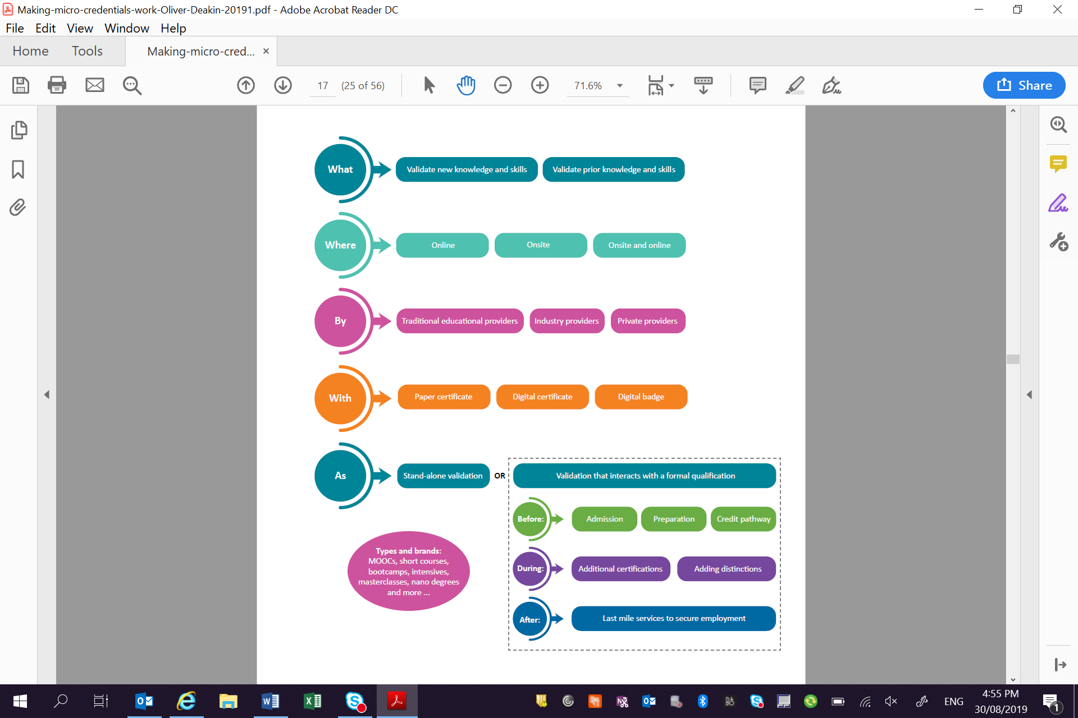What:

* Validate new knowledge and skills
* Validate prior knowledge and skills

Where:

* Online
* Onsite
* Onsite and online

By:

* Traditional education providers
* Industry providers
* Private providers

With:

* Paper certificate
* Digital certificate
* Digital badge

As:

* Stand-alone validation, or
* Validation that interacts with a formal qualification
  + Before:
    - Admission
    - Preparation
    - Credit Pathway
  + During
    - Additional certifications
    - Adding distinctions
  + After
    - Last mile services to secure employment.

## Recognising shorter form credentials

The Panel formed the view that the AQF should specify that AQF qualifications are the primary means of providing tertiary education. It should also recognise and illustrate the variety of credentials that sit outside the AQF and provide education and training in a specific topic as standalone credentials or to provide credit toward an existing AQF qualification. This can be done in the AQF’s introduction or preamble. This would show that the Australian education and training system provides many credentials that are additional to or complement formal qualifications and facilitate or provide for lifelong learning in a variety of ways.

Shorter form credentials provide knowledge and skills at a variety of current AQF levels and it is difficult, therefore, to assign them to AQF bands.

The AQF Review discussion paper raised the possibility of recognising shorter form credentials as one or more qualification type in the AQF.

Stakeholders did not support including shorter form credentials in the AQF as qualification types. The reasons provided mainly related to microcredentials, including:

* They vary widely in their scope and level of complexity and so cannot be allocated as a qualification type to any one AQF level.
* There is potential for an increased administrative burden and cost to regulators and providers of complying with the regulatory requirements associated with an AQF qualification for a large number of microcredentials.
* The requirement to meet the regulatory or other requirements of an AQF credential may delay the speed to market of microcredentials or stifle innovation, negating the benefit and promise of these credentials.
* The potential for confusion in the market as to which credentials are included in the AQF and which are not if inclusion in the AQF is voluntary.
* Shorter form credentials of uncertain quality could undermine the AQF and could be open to exploitation by unscrupulous providers.
* There are possible unintended reputational concerns internationally relating to perceptions of diminished standards should short courses be included in the AQF in the same way as full qualifications.

Overall, there was a strong view that it was premature to include shorter form credentials, particularly microcredentials, as qualification types in the AQF. The Panel formed the view that credit recognition was the preferred way of recognising shorter form credentials. This view was supported by submissions to the Review, including their use in recognition of prior learning (RPL).

| There is perhaps more opportunity to respond to emerging demands of future learning and future students, through a more formalised, or standardised, sector wide approach to RPL, where all learning outside the AQF may be considered.  Queensland University of Technology, Submission to the Review |
| --- |

Recognising shorter form credentials, including microcredentials, through credit and RPL would build on current practice. Providers are already offering credit for shorter form credentials into AQF qualifications. For example, units from the Archive and Keep Records Skill Set can provide credit towards the Certificate III in Library and Information Services. In higher education, a number of universities offer credit of up to 25 per cent for edX MicroMasters courses into their own degrees[89], making a Masters Degree less expensive for students.

### Assuring quality

Current quality assurance arrangements may come under pressure as the demand for, and supply of, shorter form credentials increases. This is likely to be fuelled by the necessity for lifelong learning and global competition in the supply of education and training. The AQF should provide guidance on requirements for awarding credit for shorter form credentials, to ensure consistency of quality into the future. This would improve confidence in the credentials by employers and industry associations and improve recognition by providers for credit purposes. For students, it would provide some quality assurance, portability and consumer protection.

| *….we believe that shorter-form credentials must include appropriate protections to ensure they do not have long-term unintended impacts such as undermining individuals’ opportunity to build a rewarding career and the transferability of skills…*  *Protections should include:*   * *Policy settings that reinforce the continuing importance of full qualifications and that encourage shorter-form credentials to be used primarily:*    + *for upskilling/re-skilling as a top-up of existing qualifications*   + *to foster a lifelong learning culture, or*   + *as a clear pathway to a qualification…* * *Such credentials are required to meet a consistent set of nationally agreed standards and are quality assured.* * *Their development, review and endorsement is led by industry.*   SkillsIQ, Submission to the Review |
| --- |

The need for quality assurance of microcredentials is recognised internationally. The European MOOC Consortium launched a Common Microcredential Framework to provide an international quality assurance standard for MOOCs.[90] The framework recognises the need for greater consistency, quality and portability of microcredentials and provides a guide to the type of characteristics that a shorter form credential should have in order to be awarded credit toward an AQF qualification.

A microcredential within the Common Microcredential Framework must:

* have a total study of 100 – 150 hours including assessment
* be levelled at Level 6 or Level 7 of the European Qualification Framework or equivalent
* provide a summative assessment
* have a reliable method of identity verification at the point of assessment
* provide a transcript that sets out learning outcomes, total study hours, European Qualification Framework level and number of credit points.

Guidance on quality assurance of shorter form credentials in Australia could set out the following requirements for a credit bearing credential. The credential could:

* provide a summative assessment, and have a means of verifying identity at the time of assessment
* set out learning outcomes for consideration by the crediting institution
* have a minimum volume of learning
* specify a purpose, showing how it could be used
* be subject to a verifiable internal or external quality assurance process.

In addition, where shorter form credentials are to make up, through credit or by design, a significant proportion of an AQF qualification, it is reasonable that they should meet the same quality standards as the AQF qualification.[91] This would mean meeting the requirements of the Higher Education Standards Framework (Threshold Standards) 2015 or the Standards for Training Packages and the Standards for Registered Training Organisations 2015.[92] Application of the sector standards would need to be nuanced so that a minimal set of the standards would apply for credentials designed to attract only small amounts of credit compared to the requirements for credentials being awarded significant amounts of credit, such as 25 per cent of the qualification.

The Panel proposes adopting Professor Oliver’s definition for a credit-bearing microcredential:

Credit-bearing micro-credentials include assessment aligned to a formal qualification level. Achievement of the learning outcomes leads to an offer of admission to or credit towards at least one formal qualification, regardless of whether or not the offer is taken up by the learner. Credit-bearing micro-credentials mirror and contribute to the academic standards required in the target qualification(s). The duration and effort required by the learner are in keeping with the amount of credit earned in the target qualification(s).

Credit-bearing micro-credentials already exist. For example, MicroMasters, which are purposefully designed as a credit pathway to a qualification, and others that subsequently achieve recognition for credit (for example, the Australian Institute of Company Directors Course).[93]

### Aligning shorter form credentials to an AQF band

When providers assess whether to award credit towards an AQF qualification for a shorter form credential, including a microcredential, they should consider if the credential achieves any of the learning outcomes of the AQF qualification, and whether it is of a suitable depth and level of complexity. If a shorter form credential has been credibly aligned with an AQF band, this process could be more efficient.

Aligning a shorter form credential to an AQF band would show providers the complexity of material studied for credit purposes, as well as showing students and employers what outcomes to expect from the credential.

Some stakeholders questioned the feasibility of aligning shorter form credentials to an AQF band.[94] They queried whether, for example, a unit of study could achieve the full specifications of a particular AQF band and noted that it is only in combination that units can reflect the learning outcomes of the relevant band. Shorter form credentials cannot be expected to meet the breadth specifications of an AQF qualification. However, it is possible to assess if they contribute to the skills and knowledge delivered at a particular band. While an AQF qualification may consist of units with differing levels of complexity, in combination the overall AQF qualification type outcome must be achieved. A shorter form credential would be assessed for recognition of credit in this context. In fact, this already exists within current practice where, for example, units for a Bachelor Degree are developed with first, second, or third year complexity in mind.

Means of aligning shorter form credentials with qualification framework levels are already in operation, so there is experience to draw on. The New Zealand Qualifications Authority offers the service of aligning microcredentials with levels on the New Zealand Qualifications Framework. To date it has aligned 59 microcredentials.[95] DeakinCo has adopted a means of aligning microcredentials to AQF qualifications in higher education that draws on global terms set out in the International Standard Classification of Education (ISCED), as outlined in Table 9. To enhance the international portability of microcredentials, Professor Oliver proposed that higher education microcredentials be aligned with the commonly understood ‘bands’ of pre-Bachelor, Bachelor, pre-Masters, Masters and Doctoral band.[96]

Table . DeakinCo alignment with ISCED

|  | Pre-Bachelor | Bachelor | Pre-Masters | Masters |
| --- | --- | --- | --- | --- |
| ICSED mapping | Level 5 | Level 6 |  | Level 7 |
| AQF | Level 6 | Level 7 | Level 8 | Level 9 |

Source: Communication from DeakinCo

#### Non self-accrediting providers

Self-accrediting providers are already able to align shorter form credentials to an AQF level. The Tertiary Education Quality and Standards Agency (TEQSA), Australian Skills Quality Authority (ASQA) and other regulators would need to be resourced to approve the alignment to levels by non self-accrediting providers.

To ensure consistency of alignment, guidelines should be developed on assigning shorter form credentials to an AQF band. Regulators would use these to approve alignments by non self-accrediting providers and by self-accrediting providers.

## Enabling Courses

Providers have offered enabling programs in Australia for many decades, as a way to prepare students for access to further educational opportunities in VET and higher education. They are designed to assist the unemployed, migrants, international students and those wanting to re-enter formal education and training. They also have a preparatory function for students with socio-economic or educational disadvantage, as recognised in the 2011 Base Funding Review.[97] Higher education enrolments in enabling courses rose by 230 per cent from 8,771 in 2007 to 28,901 in 2017. [98]

Enabling programs eligible for Commonwealth financial support give students the requisite background skills and knowledge to undertake higher education by providing students with general study skills deemed equivalent to the SSCE. Higher education providers may also offer enabling courses as a preparatory or concurrent study option.

Many international students undertake enabling courses to gain better English language skills[99], or foundation programs[100] that provide students with a strong academic foundation suitable for tertiary study in Australia. All courses offered to international students in Australia are the subject of regulation. In their joint submission to the review, the International Education Association of Australia and English Australia suggest that alignment of these regulated courses with an AQF band would face the same difficulties as alignment of the SSCE for domestic students.[101]

Other forms of enabling courses may provide pathways from one form of study to another by filling a gap in prerequisite knowledge. As with the SSCE, the diversity of students and subject matter makes it difficult to align enabling courses to a single level of the AQF. In its submission to the Review, the National Association of Enabling Educators of Australia (NAEEA) proposed enabling programs should be included in the AQF as a separate qualification type in a way similar to the SSCE, and not aligned to one or more levels.[102] Other submissions considered enabling courses could sit at a specific level.[103]

In a second submission to the Review, the NAEEA Executive agreed there was a case for a more consistent approach that would provide a benchmark for the recognition of enabling programs. The NAEEA Executive members advised they were currently developing common learning outcomes and a benchmarking framework for enabling programs.[104]

The Panel considers the current diversity of enabling courses makes it difficult to define a single qualification type within the AQF. However, if the scope of an enabling course is refined to have a common set of descriptors, the Panel considers it may be possible to recognise enabling courses specifically aimed at post-secondary domestic students within the AQF. Having a common set of descriptors may increase the portability of enabling courses, as many of them are designed for one institution and are not recognised more broadly.

The Panel does not propose a specific qualification type for enabling programs aimed at international students. However, the qualification type developed for domestic enabling programs could be used by enabling programs designed for international students if desired and appropriate.

| Recommendations  1. Develop guidelines in the AQF Qualifications Pathways Policy to facilitate the recognition of shorter form credentials, including microcredentials, for credit, that include the following: 2. The characteristics to be included in shorter form credentials that would facilitate their recognition for credit transfer or articulation to AQF qualifications. 3. The principles to be used by institutions that wish to align shorter form credentials to an AQF band. 4. Consider developing an AQF qualification type (not necessarily aligned at a band) for domestic post-secondary enabling programs, once common learning outcomes for enabling programs have been developed. |
| --- |

### Implementation

The implementation plan to give effect to the first recommendation involves a three-stage process.

The first stage would include the following steps.

* Drafting the guidelines for recognising shorter form credentials, including microcredentials, for credit towards AQF qualifications and the guidelines for aligning them to AQF bands.
* Consulting with the providers and the regulatory bodies in higher education and VET on the draft guidelines. This step would include a communication strategy on the standing of shorter form credentials, which would clarify the interplay between them and full AQF qualifications.
* Revising the guidelines based on stakeholder input and feedback.
* Releasing the revised guidelines as part of the revised Qualifications Credit and Pathways Policy.

The second stage would enable stakeholders to update any relevant policies based on the new guidelines. Regulatory bodies in the higher education and VET sectors would also consider whether their regulations and guidance required updating. Providers would need to update their internal credit and articulation policies to accommodate credit bearing shorter form credentials.

The third stage would involve ongoing monitoring by the AQF governance body to assess the reputational impact of the recognition of shorter form credentials.

To give effect to the second recommendation, the governance body would liaise with the higher education sector on common qualification outcomes for enabling programs. Once a set of qualification outcomes for enabling programs was developed, development of an AQF qualification type for domestic post‑secondary enabling programs could be proposed to the governance body under the AQF Qualification Type Addition and Removal Policy. This phase would also include consultations with stakeholders.

### Actions

The following actions are required for effective implementation of recommendations:

* Clarify the relationship between AQF qualification types and shorter form credentials by specifying in the introduction to the AQF that:
* Qualification types included in the AQF are the primary means of providing a tertiary education in Australia.
* AQF qualification types are complemented by a variety of shorter form credentials that sit outside the AQF and can provide education and training in a specific topic, either by itself or sometimes with the purpose of upskilling or reskilling those with existing AQF qualifications and/or to provide credit toward an existing AQF qualification.
* In the preamble to the AQF, give an outline of the types of shorter form credentials that complement formal qualifications in the Australian education and training system and describe how they contribute to lifelong learning.
* Define microcredentials as follows: *A microcredential is a certification of assessed learning that is additional, alternative, complementary to or a component part of a formal qualification*.
* Define credit bearing microcredentials as follows: *Credit-bearing micro-credentials include assessment aligned to a formal qualification level. Achievement of the learning outcomes leads to an offer of admission to or credit towards at least one formal qualification, regardless of whether or not the offer is taken up by the learner. Credit-bearing micro-credentials mirror and contribute to the academic standards required in the target qualification. The duration and effort required by the learner are in keeping with the amount of credit earned in the target qualification(s).*
* Enable the Tertiary Education Quality and Standards Agency, the Australian Skills Quality Authority, the Victorian Registration and Qualifications Authority and the Tertiary Accreditation Council Western Australia to approve the alignment of shorter form credentials to the AQF at the request of non self-accrediting institutions using the guidelines for aligning shorter form credentials.

1. Qualifications Pathways Policy and Credit Points

The AQF Qualifications Pathways Policy (Pathways Policy) is used to provide guidance on pathways and credit. The policy focuses primarily on higher education qualifications and does not have adequate regard for multidirectional or intra-sector pathways. Students are accessing both VET and higher education qualifications, sometimes as complementary learning (for example, an engineer might need to understand site operations), or as additional learning (for example, a teacher might need a first aid qualification). A revised version of the Pathways Policy needs to recognise the multidirectional pathways within and between sectors that learners are already following; and encourage learners to gain the knowledge and skills they most need.

Some of the Panel’s recommendations relating to credit have been discussed in the shorter form credentials chapter. There are additional ways in which the policy could be improved, including the recognition of prior learning (RPL). RPL is an underused way of assessing learners’ existing knowledge skills. It will be crucial in an age of lifelong learning, as the need to recognise non-formal[105] and informal[106] learning increases. The AQF’s detailed advice on RPL is presently outside the Pathways Policy in a separate explanation guide; it should be elevated and modernised, with appropriate consideration of shorter form credentials.

A focus on credit recognition and RPL is essential to support lifelong learning as it will affect the return on investment of a new learning experience. Other countries have developed national credit point systems to improve transparency for students and provide better pathways for students. Australia should prototype an optional credit point system with the aim of improving student awareness of potential credit and to encourage the take-up of pathways between VET and higher education. It would have the added advantage of making qualifications more easily recognised internationally.

## Background

Since its introduction in 1995, part of the AQF’s role has been to help students access and move between different qualifications, with credit transfer, recognition of prior learning (RPL) or via articulation pathways, as appropriate. The Pathways Policy sets the current guidance to enable this.

Changes in the nature of work, brought about by globalisation and technological and demographic changes, have altered the notion that formal education and training ends when students enter the workforce. In the future, people are likely to require more interactions with education and training to learn new skills and knowledge to enable them to thrive. These will include shorter form credentials, including microcredentials. They are likely to be more mobile: moving between different jobs, careers, industries and countries. Australia’s education and training system will need to better recognise and document the knowledge and skills they have learned through non-formal and informal learning experiences. Assumptions about pathways and qualifications will need to change, to reflect the reality that what learners need to learn may not always be at a higher AQF level, or in the same sector. Educators in all sectors will need to work more closely to ensure student mobility and outcomes are not impeded by perceived differences in approaches to learning or status. A poorly functioning network of pathways would create friction in a system that is crucial to Australia’s well-being and prosperity.

At the beginning of the Review, the Department of Education commissioned Ithaca Group to undertake a research project into credit and pathways in VET and higher education.[107] This research provided important information on the current practice in both sectors, and views of the Pathways Policy.

The AQF Review discussion paper proposed revising the Pathways Policy noting that it should remain as guidance. It also suggested developing a voluntary AQF credit point system, to help facilitate pathways between levels and qualification types. Another proposal in the discussion paper was for a shared credit transfer register, to improve information provision to students.

In submissions to the Review, almost all stakeholders supported retaining the Pathways Policy[108] and updating it to take into account the changing nature of work and learning.[109] There was also support for using it to include guidance on recognition of shorter form credentials, including microcredentials,[110] and promoting multidirectional pathways within and between different sectors and qualifications.[111]

The majority of submissions were supportive of a shared credit points system,[112] with most of those favouring an optional system but some suggesting it should be binding. In particular, the Council for International Education’s Expert Members noted that the lack of a national credit system affected international recognition and portability of Australian qualifications.[113] Where stakeholders were against the proposal, the most common reasons were that it was functionally equivalent to volume of learning in deriving value from time durations,[114] or that it would undermine the ability of providers to make credit recognition decisions.[115] Some felt the AQF’s role should not extend into creating a credit point system.[116] Where providers were supportive, they agreed that there would be benefits for comparison between different providers,[117] recognition of prior learning[118] and articulation pathways.[119] It was also seen as useful for greater consideration of shorter form credentials.[120]

While most stakeholders were supportive of a voluntary credit point system, some said they were unable to comment without more detail.[121] Others qualified their support by saying that the system could be useful, but had different opinions about whether the system should be based directly on notional hours of learning[122] or not.[123] In higher education, some suggested using Equivalent Full-Time Study Load (EFTSL) as an alternative.[124]

The possible approach of developing a shared credit transfer register received mostly negative feedback. Although some providers maintain their own registers[125], stakeholders felt a shared AQF register was unnecessary[126] and reported that the cost required to create and maintain it would likely be greater than its benefit to students.[127] Accordingly, the Review has not considered the option further.

The Panel recommends retaining and refreshing the Pathways Policy to focus more on multidirectional pathways. Further guidance on RPL should be included, as well as guidance on emerging shorter form credentials, including microcredentials. A common, but voluntary, credit point system should be trialled to contribute to parity of esteem and smoother pathways between different qualifications and sectors. The remainder of the chapter sets out the rationale for these recommendations.

## Improving the Pathways Policy

Evidence presented to the Review indicated that education and training providers were more driven by institutional priorities and compliance with sector regulations in relation to credit and RPL than with the Pathways Policy.[128] In some areas, sector regulation accords with the guidance in the Pathways Policy but does not explicitly refer to it. The Higher Education Standards Framework (Threshold Standards) covers most of the same content, with gaps. The Standards for Registered Training Organisations (RTOs) 2015 cover a minority of the content.[129]

Despite the lack of a formal link between the Pathways Policy and sector standards, the majority of higher education providers reported that the ‘[Pathways] Policy and the AQF had played a useful role in establishing their arrangements for credit transfer, articulation and RPL.’[130]

As a whole, stakeholders saw value in having a national statement on credit, to ‘provide a statement of principle and intent that makes national priorities for tertiary education clear to all involved, and a platform to facilitate credit transfer and articulation.’[131]

Almost all stakeholder submissions to the Review supported retaining the Pathways Policy. Additionally, they saw value in the policy remaining a ‘guideline’, not a strong regulatory tool. This provides flexibility in the way learning is assessed between qualifications and respects provider autonomy regarding course assurance and qualification integrity.

The Pathways Policy would need to be revised to encourage credit where appropriate for shorter form credentials. Recommendations on shorter form credentials, including microcredentials, are discussed under Chapter 4.

### Aligning with sector standards

There is a case for improving the alignment between sector standards and the Pathways Policy, to ensure a consistent and unified message to providers, students and regulators. An example is the difference in emphasis between the Pathways Policy and the Higher Education Standards Framework (HESF) when it comes to awarding credit. The Pathways Policy states that credit decisions should:

recognise learning regardless of how, when and where it was acquired, provided that the learning is relevant and current and has a relationship to the learning outcomes of the qualification.[132]

This is in contrast to the HESF, which requires that:

credit through recognition of prior learning is granted **only if**: students granted such credit are **not disadvantaged** in achieving the expected learning outcomes for the course of study or qualification, and the integrity of the course of study and the qualification are maintained [emphasis added].[133]

Although the Pathways Policy also states giving credit should not impinge on the integrity of qualification outcomes, discipline requirements, or the likelihood of the student completing the qualification, the HESF could be revised to more directly support the intent of the Pathways Policy. It could be changed to read:

Credit through recognition of prior learning will recognise learning regardless of how, when and where it was acquired, provided that the learning is relevant and current and has a relationship to the learning outcomes of the qualification, and students granted such credit are judged likely to complete the qualification and the integrity of the course of study and the qualification are maintained.

### Recognising multi-directional pathways

The most used section of the Pathways Policy is a clause that sets out potential credit amounts for a Diploma, Advanced Diploma, or Associate Degree towards a Bachelor Degree.[134] As suggested by the Pathways Policy, it serves as a basis for negotiating articulation agreements between institutions. It also guides qualifications development to support credit transfer. The pathway between these qualifications is the most significant articulation pathway between AQF qualification types,[135] but stakeholders have criticised the Pathways Policy as focusing only on the movement of students from VET into higher education qualification types, rather than a broader view of student pathways. Figure 17 shows this movement in practice.

Figure . VET and higher education student flow

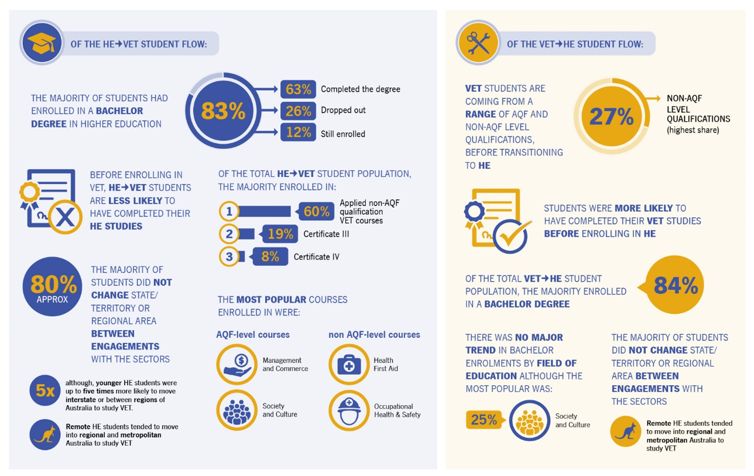The figure shows the movement between higher education in VET. In particular, it shows of the higher-education to VET student population: 60 per cent were in enrolled in applied non-AQF qualification VET courses, 19 per cent were enrolled in Certificate III and 8 per cent were enrolled in Certificate IV. The most popular AQF level courses were Management and Commerce and Society and Culture. The most popular non AQF level courses were Health, First Aid and Occupational Health and Safety.

Source: Department of Education, [Better Understanding Student Journeys](https://www.education.gov.au/better-understanding-student-journeys), 2019

Learning can flow from VET to higher education and higher education to VET, as well as between the schools sector and tertiary education and training. These pathways are dependent on the skills and knowledge an individual chooses to acquire, either for re-skilling, up-skilling or personal interest. The Pathways Policy should recognise the different pathways between AQF qualifications that students may take. For example, TAFE Queensland has established a credit pathway that would allow graduates of a Bachelor of Education to gain credit towards a Diploma of Early Childhood Education.[136] Better focus on multi-directional pathways would help recognise the value of qualification types at all levels of the AQF, and show a more realistic student-centred approach to learning.

A revised AQF taxonomy could also enable multidirectional pathways, and qualifications that offer credit in both VET and Higher Education. Rather than describing the learning outcomes of the two sectors, a revised AQF would focus on a common set of descriptors. This would clearly show the shared characteristics of both qualifications being considered in the credit assessment and the relationship between the two. The flexibility of the bands system might also mean that both qualifications were directly aligned on several focus areas, and would therefore allow for easier credit recognition.

The Panel is of the view that renaming the Pathways Policy to ‘*AQF Pathways Policy – Credit and Recognition of Prior Learning*’ could increase its use.

The terms ‘pathways’ is not instantly associated with credit or RPL. Adding the terms ‘credit’ and ‘Recognition of Prior Learning’ would make it clearer to stakeholders what the policy covers, particularly in VET where ‘RPL’ is understood as an assessment method for a learner to demonstrate competency against the requirements of a qualification.

### Recognising prior learning

The AQF previously contained a set of National Principles and Operational Guidelines for Recognition of Prior Learning. The current Pathways Policy contains no specific advice on RPL, though some guidance is contained in a separate RPL explanation document.[137] This guidance could be more prominent in the AQF.

RPL is used less in higher education than other credit mechanisms such as precedent databases and articulation arrangements.[138]For VET providers it was the most used mechanism, though AVETMISS data indicates RPL granted as a proportion of subject results declined from 4.4% in 2014 to 3.4% in 2017.[139] The use of RPL tends to vary with the diversity of the student cohort and reflects the different strategies and missions of providers. One of the significant difficulties with RPL is the time-consuming process of gathering evidence and mapping it to learning outcomes. Furthermore, when qualifications are updated, a process of remapping must be undertaken. These factors can encourage both students and providers to avoid the RPL process and repeat learning, which may be easier if a student is already familiar with the course material.

Through lifelong learning, students will have more interactions with formal, non-formal and informal learning. Accordingly, a poorly functioning RPL system will present a more significant problem over time. Better guidance alone cannot solve this problem, but it increases the importance of having clear and useful information on RPL.

Guidance on RPL is important for application by education and training providers and for students who bear the cost of not having an adequate policy in place by paying for learning that they do not require.

## Developing a credit point system

A credit point system, based on learning outcomes and notional duration, would provide greater transparency about what students have learned and how long it has taken them to do so. Notional durations of learning include all the activities required for the achievement of the learning outcomes, not just the amount of teaching or training by the provider.[140] It would make learning outcomes more comparable between different institutions and contribute to parity of esteem between VET and higher education by expressing the equivalence in value of learning from both systems. It would future proof the AQF as, in time, it may be used to support the recognition of shorter form credentials by establishing a common means of assigning value.

Higher education providers in Australia commonly use credit points, but there is great variation between institutions in the number of credit points typically assigned to a unit of study. Tertiary admissions centres (TACs) report that most learners are unaware of what credit they may be able to obtain,[141] and providers generally acknowledge that more could be done to inform students.[142] A common credit point system in Australia, if adopted by enough providers, would give students a better sense of the learning outcomes they have attained in comparison to other qualifications, by expressing them in the same format. It would also make credit transfer simpler for providers. This does not mean that students would always be entitled to receive credit. Credit decisions would remain at the discretion of providers who need to compare and assess learning outcomes.

| A well-defined national credit points system that is fit-for-purpose and recognises varied entry pathways will provide a more transparent system across all learning sectors in Australia, and minimise barriers when benchmarking an overseas qualification to its most appropriate level on the AQF. This will also provide clearer, more objective articulation pathways within and between higher education and the technical and vocational sectors.  VETASSESS, Submission to the Review |
| --- |

### International comparisons

Credit point systems are a common feature among qualifications frameworks internationally, particularly the European Credit Transfer and Accumulation System (ECTS) in Europe and the New Zealand Qualifications Framework. The credit points derive their value by being linked to notional amounts for learning: in the ECTS the value of countries’ hours vary but each year is worth 60 credit points, while in New Zealand 10 hours is worth 1 credit point.[143]

Having a single national standard for overseas audiences, which can be easily converted to their credit point system, would support recognition of Australian qualifications. The Council for International Education’s Expert Members advocate for a national credit point system on the basis that Australia’s lack of one has an impact on the international recognition and portability of Australian qualifications.[144]

### Measuring credit

A number of submissions to the Review suggested using Equivalent Full-Time Study Load (EFTSL) as an alternative to a system based on notional study hours.

The following example shows how a system could be developed:

In higher education, each unit of study is assigned an EFTSL value for funding purposes. Currently 1 EFTSL is 1 year of study and a standard undergraduate unit is 0.125 EFTSL (1/8th of a year). The AQF currently defines 1 full time year as 1200 hours. Assigning 1 credit point to 10 hours of study, as per the New Zealand Qualifications Framework, creates a full-time year figure of 120 credit points, a simple doubling from the European ECTS system. Establishing an equivalence between 1 EFTSL and 120 AQF credit points would allow a standard undergraduate unit of study to be set at 15 credit points.

Application of credit points to VET qualifications is more complex. Nominal hours are the notional time it takes an *RTO to train* a unit of competency. It is not the time it takes a *student to learn* to become competent because it does not include the unsupervised learner activities that form part of the full volume of learning. It is necessary to include unsupervised learning in the assessment of credit points in order to not disadvantage disciplines or courses that are successfully delivered with fewer contact hours.

The Expert Review of Australia’s Vocational Education and Training System recommended specifying benchmark hours for VET qualifications. If implemented, this may not provide additional benefit regarding credit points if the benchmark hours only specify the amount of RTO training, not the notional student learning. Benchmark hours should include student learning to provide accurate credit point values.

Expressing all learning outcomes in the same format could encourage credit transfer and signal the equivalence in value of learning from all sectors in the Australian education and training system to learners and overseas audiences.

## Further observations

Credit recognition for previous studies and the development of student pathways have been an important policy objective for governments for many years and have been central to the purpose of the AQF. However, as the work for the Review by Ithaca Group shows, decisions on credit and student pathways are shaped by several factors and essentially reflect providers’ priorities and policies.

Maintaining an effective system of pathways cannot be achieved solely through changes to the AQF and the Pathways Policy. Decisions on the future role of the AQF in helping to improve arrangements for credit recognition and pathways must be considered in the context of broader reforms to better align the higher education and VET sectors, particularly through more coherent funding arrangements. A national focus on qualification design and pedagogy across the VET and higher education sectors would also assist providers in developing and delivering pathways, including courses with embedded content from both sectors.

Further, funding policies can affect student pathways by driving learners towards particular sectors or qualification types. Differences in regulation, including between dual-sector qualification types, can also have an effect. Ithaca Group’s ecosystem analysis, undertaken as part of its research for the review, detailed many examples of innovative cross-sector collaboration deserving of support.[145]

| Recommendations  1. Revise and rename the AQF Qualifications Pathways Policy to better recognise and encourage broader credit recognition, both within and between sectors. 2. Develop and test a prototype AQF credit point system for voluntary use by providers, in order to give students and providers a nationally consistent ‘currency’ for negotiating credit transfer. 3. Provide more detailed guidance on recognition of prior learning in the AQF Pathways Policy. |
| --- |

### Implementation

Changes to the Pathways Policy to include multidirectional pathways within and between sectors and RPL could be drafted relatively quickly, but the implementation process would likely take longer due to a period of stakeholder input and revision. The revised Pathways Policy could be rolled out as part of the revised AQF version with the changes to the taxonomy.

The preparatory work to create a prototype credit point system for higher education could be accomplished within a short timeframe once an equivalence between EFTSL values and AQF credit points is agreed. Testing could involve engaging a small number of providers from different groupings and mapping equivalences between existing EFTSL values and credit points.

Assigning credit point values to VET qualifications is a more difficult process and implementation would depend on the scope of the prototype envisioned. To start, a prototype could involve some of the most common Diploma and Advanced Diploma qualifications used in pathways to higher education.

### Actions

Implementing the recommendations would involve the following actions:

* Amend the AQF Qualifications Pathways Policy to provide equal emphasis to pathways from vocational education and training to higher education and from higher education to vocational education and training, and within sectors, by including examples of the pathways that are possible and any requirements associated with them.
* Provide more detailed guidance on recognition of prior learning in the AQF Pathways Policy.
* Develop and test a prototype AQF credit point system for voluntary use by providers.
* Rename the AQF Qualifications Pathways Policy as the AQF Qualifications Pathways Policy: Credit and Recognition of Prior Learning.

1. Volume of Learning

The current AQF presents a typical volume of learning for each qualification type in full-time years. This reflects dated and increasingly outmoded assumptions about how AQF qualifications are delivered. The Panel formed the view that hours would be a better unit of measurement: they are better able to recognise intensive and innovative forms of course delivery, for example block model learning[146] or a trimester system.

The AQF allows for qualifications to be completed in more or less time than the volume of learning, but the provider must be able to justify the difference based on student needs in achieving the learning outcomes. Despite this, providers continue to report that volume of learning is treated as a requirement by regulators. A revised AQF should specify volume of learning is a benchmark guide against risks to quality.

## Background

Each qualification type in the AQF has a volume of learning specified. Volume of learning is the typical duration that is required for a student to achieve the learning outcomes for that qualification type. It indicates the amount of learning content that generally requires a corresponding duration of delivery, and the length of time over which a course for that qualification type would generally be delivered. The AQF measures volume of learning in full time years in the main document, and both hours and years in its volume of learning explanation guide.[147] This guide defines one year as 1200 hours. In the VET sector, ASQA provides both formats in its guidance to RTOs.[148]

When the AQF Council introduced volume of learning, it explained that its uses were:

…to augment the learning outcomes descriptors of qualification types to further clarify the relative complexity and value of a qualification type and to support the differentiation of qualification types. Application of a measure for the volume of learning leads to greater consistency in and between qualification types by indicating how long it takes a student, on average, to achieve the requirements of a qualification.[149]

Its introduction was also a response to criticism from stakeholders in the VET and higher education sectors about the lack of consistency in complexity and length of qualifications within the same type, particularly the Certificate III and Masters Degree types.[150] This rationale still exists.

The Review’s terms of reference tasked the Panel to advise on whether a measurement of volume of learning is necessary in the AQF; whether it should be a time-based measurement; and whether it should be aligned with other time-based measurements currently used in the VET sector.

## Changing volume of learning

Contextual Research for the Review found that expressing volume of learning in years was out of step with modern international practice, which favours credit point systems based on notional hours of learning.[151]

The AQF Review discussion paper proposed changing the volume of learning unit of measurement from years to hours, based on the needs of a new learner.

In response, stakeholders expressed a diversity of views about volume of learning in consultations and submissions. Some stakeholders argued to retain volume of learning in years as a stable[152] or more advisory unit of measure.[153] Others felt that the unit of measure should be changed to hours,[154] noting it would focus on the student rather than the teacher,[155] and improve transparency for part-time and sporadic students.[156] A number of submissions believed that implementing a common system of credit points based on hours would be beneficial.[157] A minority of stakeholders stated that volume of learning should be removed entirely from the AQF.[158] Overall, the discussion paper’s possible approach received the most support, though many submissions provided additional comments and suggestions.

The Panel is of the view that volume of learning is an important element of the current AQF and should be retained. It recommends changing volume of learning from years to hours; and specifying that duration is framed around ‘new learners’, which would need to be defined.

The Panel emphasises that this change would not affect other government policies such as funding arrangements or delivery hours in VET.

### Rationale

The Panel recognises that time-based approaches are imperfect measures of the quality of learning; however, there is evidence that the amount of time spent on a course can provide an indication of the quality of the course. This is shown by NCVER’s recent study on the relationship between course durations and training outcomes,[159] and reflected in ASQA’s 2017 review of issues relating to unduly short training.[160]

One of the AQF’s objectives is ‘to underpin national regulatory and quality assurance arrangements for education and training’. Industry regulators argue for the inclusion of a volume of learning measure, in tandem with quality requirements, because they believe that this provides an additional level of surety when they issue a licence to practice.[161] Some employers also find reassurance in volume of learning. The Minerals Council of Australia considers that the inclusion of a volume of learning measure may contribute to increased trust in the qualifications, competencies and skills supported by the AQF.[162] However, the Australian Chamber of Commerce and Industry disputes this, saying that ‘industry has concerns about volume of learning being applied to VET given that it is a competency-based system.’[163]

Where a course of study can be completed in substantially less time than the specified volume of learning, it calls into question whether the content of the course has been designed to sufficiently meet the learning outcomes for the qualification. This includes the technical or conceptual difficulty of the course and also whether there is sufficient time for repeatability to ensure students have had the time to absorb the content and/or apply the practical skills required.

Some stakeholder submissions believed that the definition of volume of learning, and the activities that may contribute to it, are unclear. In the AQF explanation guide, published separately to the main document, it states:

The volume of learning allocated to a qualification should include all teaching, learning and assessment activities that are required to be undertaken by the typical student to achieve the learning outcomes. These activities may include some or all of the following: guided learning (such as classes, lectures, tutorials, on-line study or self-paced study guides), individual study, research, learning activities in the workplace and assessment activities.[164]

The presence of clarifying information outside the AQF is confusing for providers and regulators. The current AQF is long and complicated, but important information on volume of learning should be included in the main document to give a comprehensive and detailed reference for users.

### Using guidelines flexibly

As volume of learning is specified at the level of a qualification type, it is an imprecise measure. The AQF allows qualifications to be completed in more or less time than the typical volume of learning indicates. The volume of learning explanation guide states:

Providers may offer the qualification in more or less time than the specified volume of learning, provided that delivery arrangements give students sufficient opportunity to achieve the learning outcomes for the qualification type, level and discipline.

If the duration of delivery is substantially different from the volume of learning specified by the qualification type specification, providers should be able to provide a pedagogical rationale to support the variation.[165]

This treatment is reflected in the advice to providers given by TEQSA[166] and ASQA,[167] but the Review heard that their guidance is not always applied with the intended flexibility. The Panel has emphasised to national regulators that in order for volume of learning to remain relevant, this guidance must be given appropriate consideration.

This is also an area where closer alignment between the AQF and the Higher Education Standards Framework (HESF) is necessary. Volume of learning is specified in the *qualification type* descriptor of the AQF. Paragraph 1.5.3 of the Higher Education Standards (HESF) specifies the learning outcomes for a qualification must only be ‘consistent with the *level* classification for that qualification in the Australian Qualifications Framework.’[168]

There are references throughout the HESF to ‘qualifications’, which invoke the AQF relevant to the different qualification types within each level, including volume of learning. To make this more explicit, the full qualification type *specification* should be referred to in sector regulation, regardless of any change to the AQF’s taxonomy. The qualification type specification includes the AQF level and qualification type descriptors, volume of learning, and additional information.

## Expressing volume of learning in hours

| …the approach to volume of learning taken in the current AQF is out-dated, out of step with global practice and creating significant difficulties for providers, regulators and those at the interface of international mobility.  PhillipsKPA, ‘Contextual Research for the Australian Qualifications Framework Review’ |
| --- |

Currently the AQF presents volume of learning in dual formats: years in the main document and both years and hours in the volume of learning explanation guide. Developments in learning are eroding the concept of traditional classroom formats and academic calendars. Changing how the AQF presents typical volumes of learning for different qualification types would provide more flexibility and transparency for students, while supporting innovation in course delivery and the development of shorter form credentials, including microcredentials. Hours can better reflect different modes of learning: whether they are classroom or industry based; in person or online; full time or part time.

Some universities (for example, Deakin University, Griffith University and the University of New South Wales) have transitioned to a trimester calendar, where students can potentially complete the required hours for a Bachelor Degree in different timeframes than the traditional three years, but within the same hour guidelines.

Volume of learning is currently expressed in *full-time* years. However, in 2018, only 22 per cent of enrolments in VET programs with an AQF level were by full-time students.[169] This means expressing volume of learning in years requires some conversion for the majority of VET students.

Transitioning to an hours-only system would provide one simplified expression for volume of learning, rather than the dual format currently used. The VET system in particular already uses hours for funding and statistical reporting. It also uses hours for provider regulation if a provider’s training and assessment strategy uses hours. There may be some initial confusion for stakeholders because the way hours are currently used can serve different purposes. However, an hours-only system would allow for easier comparison by presenting all in the same format. This change would not affect other government policies such as funding arrangements or delivery hours in VET.

An hours-based system is also more suitable for measuring the duration of shorter courses. It would be easier for the AQF to recognise shorter form credentials, including microcredentials, in the future, if it used hours to measure volume of learning. The New Zealand Qualification Authority has set a minimum duration of 5 credits, or around 50 hours, for an approved microcredential.[170] A similar and hypothetical requirement under the AQF, if years were to be used, would specify its duration as 0.04 years. This would not be a practical way to measure volume of learning for these type of courses.

If implemented, a full-time year could be defined as 1200 hours, and the corresponding hours assigned to each qualification type. In developing the 2011 AQF, the AQF Council tested the volumes of learning with stakeholders: 76 per cent of respondents agreed or strongly agreed with the volumes of learning specified then,[171] but the durations should be retested for appropriateness. For example, the Council of Australian Postgraduate Associations has raised concerns that the volume of learning for the Doctoral Degree may be too short;[172] this should be considered as part of future testing of the volumes.

### Framing volume of learning around new learners

The Panel was of the view that the volume of learning should be framed around new learners. The descriptor for each qualification type in the AQF states that the volume of learning is ‘typically’ a certain duration. This is intended to allow some flexibility for different learner cohorts, which may require more or less time to achieve the qualification’s learning outcomes. However, a ‘typical’ duration is ambiguous, and may refer to different types of students for different qualifications. This is problematic in the regulation of qualifications, where an appropriate volume of learning is therefore subjective.

| ‘…to provide a common baseline for volume of learning, base the number of hours for a qualification type on the needs of a new learner.’  Australian Skills Quality Authority |
| --- |

Transitioning from ‘typical’ duration to a duration for ‘new’ learners can set an objective standard against which students could be compared. The Panel proposes that ‘new’ learners are those:

new to the course content or research qualification type and who meet the entry requirements for the qualification.

This definition recognises that new learners who are completing nested qualifications or higher-level research qualifications would have familiarity with the field’s subject matter, but not the specific course content or research qualification type. The definition of a new learner should not affect granting of recognition of prior learning.

### International comparisons

Volume of learning is a useful benchmark for international qualifications comparison. It forms part of the basis by which the Department of Education’s Country Education Profiles (CEPs)[173] compare international qualifications to AQF qualifications. Australian universities and skilled migration assessing authorities use the CEPs to recognise overseas qualifications for educational and labour market purposes within Australia. Volume of learning is also useful for overseas audiences unfamiliar with Australian qualifications by providing contextual information on student pathways.

Other countries, and different institutions within other countries, have different approaches to expressing learning outcomes. Some use subjects, hours, or years, and many increasingly use credit points.

Changing the format of volume of learning to hours for AQF for AQF qualifications, in the absence of a national credit system, may influence how Australian qualifications are recognised, and would need to be carefully considered during implementation. This is because other countries have different approaches to the recognition of foreign qualifications. Some countries focus on qualitative factors such as learning outcomes and the effectiveness of quality assurance systems, whereas other countries focus on quantitative measures, such as length of study or number of hours. The latter approach tends to exacerbate differences between Australian and foreign system qualifications.

It is also currently the case that there is considerable variability in volume of learning within and between qualifications of the same qualification type.

## Further observations

The Expert Review of Australia’s Vocational Education and Training System recommended that qualification developers should specify benchmark hours in qualifications.[174] This would serve as a guide to the average amount of training required for a new learner, with no experience in the industry, to develop the required competencies in the qualification. The Panel welcomes this recommendation but notes that the AQF’s volume of learning is broader than the amount of training an *RTO provides*, it is the average amount of time it takes for a *student to achieve* all the learning outcomes of a qualification type. This includes a significant period of unsupervised learning by the student, which may not be reflected in benchmark hours.

| Recommendations  1. Retain volume of learning as a benchmark expressing the notional duration, for a new learner, of all teaching and learning activities required to achieve the outcomes specified for a particular AQF qualification type. 2. Specify volume of learning’s unit of measurement in hours only, instead of years and hours. |
| --- |

### Implementation

The recommended changes to volume of learning could be drafted relatively quickly following stakeholder consultation. A communication strategy would be developed to be used during the consultations. This strategy would provide clear guidance about what is included in the definition of volume of learning and explain that other parts of government policy such as funding arrangements and delivery hours in VET would not be affected by this recommendation. This would also include guidance for international stakeholders, for example, by providing advice to international students prior to enrolment if any recognition issues are identified in their home country.

The AQF governance body would engage with pedagogy experts in all sectors to ensure there was broad support for the volumes of learning assigned to qualification types; the definition of a full-time year; and the activities that comprise volume of learning. It would also identify any unexpected consequences during this process. The revised AQF would clearly state that the volume of learning should be used as a benchmark rather than a rigid rule. The governance body would liaise with regulators to ensure the approach was well understood and reflected in their guidance and procedures.

The changes to volume of learning would be implemented alongside the revised AQF qualifications design model. This would allow for a predictable, orderly transition, with sufficient time for providers to assess their courses and make any changes necessary. In the meantime, volume of learning would continue to function as a point of reference and there would remain flexibility for individual qualifications and learner cohorts where they can be justified.

### Actions

Implementing the recommendation would involve the following actions:

* Change the unit of measurement to hours only; and confirm the current AQF definition of a year being 1200 hours.
* Test the appropriateness of current volumes of learning for the qualification types, given current learner cohorts and delivery methods.
* Specify that the volume of learning applies to a new learner; defined as a learner who is new to the course content or research qualification type and meets the entry requirements for the qualification.
* Place the definition of what activities comprise volume of learning in the main AQF document (instead of the volume of learning explanation guide); and allow stakeholders to offer feedback prior to finalisation.
* Stipulate that regulators should use volume of learning as a benchmark for risk management purposes, rather than as a regulation.

1. Other policies and supporting documents

The Panel suggests that some AQF policies are redundant and should be removed. The Qualifications Register Policy was never fully implemented, while the Principles and Processes for the Alignment of the AQF with International Qualifications Frameworks is better considered a function of government and does not require a written policy. Removing these would shorten and simplify the AQF document.

Other policies provide important functions and should be retained and updated. The Qualifications Issuance Policy supports a shared approach to qualification terminology and issuance of student records. The Qualification Type Addition and Removal Policy would allow the revised AQF to remain current by allowing for new qualifications, such as a future microcredential or enabling qualification type, to be added in the future if necessary. Important information from the AQF’s separate explanation documents should be integrated into the main document to provide a clear, complete and authoritative text for users.

The Qualifications Pathways Policy has been considered separately in this report.

The AQF Glossary should be refreshed and updated with new definitions arising from this report.

The AQF website should also be refreshed to be more accessible and user friendly. A better website would support learners to make better choices about qualifications and pathways, assist qualification developers, and provide employers with a clearer indication of what they can expect from graduates.

## Background

Unlike most qualification frameworks internationally, the AQF contains a number of policies packaged as part of the framework.[175] The Australian Qualifications Framework Council developed these policies before the establishment of the national regulators, TEQSA and ASQA. Some of these policies cover matters that are now also covered by the regulatory frameworks. The Review’s terms of reference tasked the Panel with advising on any changes that would be required to these policies to give effect to the Review’s recommendations and to consider whether any of these policies that deal with domestic matters should be situated within TEQSA’s and the VET regulators’ registration and accreditation guidelines.

Stakeholder submissions were consistent in their support for removing redundant policies. There was mixed support for retaining the AQF Qualifications Issuance Policy (Issuance Policy) due to some crossover with regulatory requirements. Similarly, there was mixed support for moving the information currently found in the Explanations to other parts of the AQF.

The Panel found that some of the policies require updating, including to remove duplication. This process needs to take into account the role that the AQF plays as an instrument that connects VET and higher education. There is merit in retaining some of the policies, in particular the Issuance Policy, to allow for better connection between sectors in the future.

## Current AQF policies

### The AQF Qualifications Issuance Policy

The purpose of the Issuance Policyis to ensure that:

* graduates receive the certification documentation to which they are entitled
* AQF qualifications are correctly identified in certification documentation
* AQF qualifications are protected against fraudulent issuance
* a clear distinction can be made between AQF qualifications and non-AQF qualifications
* certification documentation is used consistently across the education and training sectors
* graduates and others are confident that the qualifications they have been awarded are part of Australia’s national qualifications framework – the AQF.

The Issuance Policy sets out requirements for issuing a testamur and record of results for graduates and specifies the nomenclature for AQF qualifications. It provides a common approach for VET and higher education.

Except for the specification of post-nominals, the provisions of the Issuance Policy are reflected in sector regulation as shown in Table 10.

Table . Issuance Policy requirements and sector regulation

|  |  |  |
| --- | --- | --- |
| AQF Qualifications Issuance Policy Requirement | Standards for Registered Training Organisations (RTOs) 2015 | Higher Education Standards Framework (Threshold Standards) 2015 |
| All graduates entitled to receive a testamur and a record of results | Standard 3 and Schedule 5 | Standard 1.5, point 4 |
| Optionally, graduates may be given a graduation statement | Not an option | Standard 1.5, point 4 |
| The testamur or graduation statement will identify the qualification as an AQF qualification | Standard 3 and Schedule 5 | Standard 1.5, point 4. e. |
| Specifies what information is required on the testamur and graduation statement | Standard 3 and Schedule 5 | Standard 1.5, points 4, 5 and point 6 |
| Specifies responsibilities of issuing organisations to ensure the authenticity of AQF qualifications | Standard 2 | Standard 1.5, point 5 |
| Issuing organisations will have policies for replacing documentation | Schedule 5 | Standard 1.5, point 5 |
| Specifies AQF qualification titles | Schedule 5 | Not referenced directly. Standard 1.5, point 9 states qualifications that do not align with a qualification that is recognised in the *Australian Qualifications Framework* are not described using the nomenclature of the *Australian Qualifications Framework.* |
| Specifies use of post nominals | Not referenced. | Not referenced. |
| Specifies requirements for issuing statements of attainment | Schedule 5 | Standard 1.5, point 7 and standard 1.5, point 10. |

The Issuance Policy provides that all students who complete part of the requirements of an AQF qualification receive a record of results that recognises their achievement.[176] The AQF also currently allows providers to design nested qualifications, which provide for different qualifications to be issued at defined exit points within an overall qualification.

Industry and education and training sectors see the need for better connections between higher education and VET. For this reason, the Panel believes the Issuance Policy should be retained in the AQF. This would ensure ongoing consistency of qualification nomenclature and issuance of student records between the sectors.

The Issuance Policy requires amendment to remove redundant references and reflect changes arising from the Review. For example, references to the Register Policy should be removed given the recommendation to remove that policy.

The section on nomenclature requires revision. There are two types of Doctoral Degrees allowed for in the qualification descriptors.[177] However, the nomenclature in the Issuance Policy does not allow for this distinction.[178] When revising the policy the qualifications titles table should be amended to allow for two separate types of qualifications: the Doctoral Degree (Research) with the title ‘Doctor of Philosophy’ and the Doctoral Degree (Professional) with the title ‘Doctor of [field of study]’.

### The AQF Qualifications Register Policy

The AQF Qualifications Register Policy (the Register Policy) was intended to facilitate the public identification and verification of AQF qualifications and contribute to the protection of AQF qualifications. There were to be three registers:

* Register of accrediting authorities
* Register of AQF qualifications and authorised issuing organisations
* Register of issued qualifications.[179]

The AQF Council did not implement the Register Policy as the policy intersected with the establishment of TEQSA and ASQA, with their subsequent regulatory functions taking over the intent of the Policy. Submissions to the Review agreed that the Register Policy is redundant.

A register of accrediting authorities is not required as this role is restricted by Commonwealth and state legislative requirements as per Table 11.

Table . Accrediting authorities

|  |  |
| --- | --- |
| VET courses[180] | Higher Education courses |
| Australian Industry and Skills Committee[181]  Australian Skills Quality Authority (ASQA)[182]  Victorian Registration and Qualifications Authority (VRQA)[183]  Training Accreditation Council Western Australian (WA TAC)[184] | Tertiary Education Quality and Standards Agency (TEQSA)[185]  Higher education providers registered in the Australian university provider category[186] |

There are sector specific online databases that fulfil the role of the Register of AQF qualifications and authorised issuing organisations. For the VET sector, a complete list of registered organisations and VET courses is found at training.gov.au (TGA)[187] and is updated by the VET regulators.[188] There is no single definitive higher education register; TEQSA maintains a register of approved higher education providers and courses accredited by TEQSA on its website.[189] The recently launched online tool Course Seeker[190] is intended to provide information on higher education courses and providers, including courses accredited and offered by universities.[191]

There is also no single register of issued qualifications across all the education and training sectors. VET[192] and higher education providers[193] are required to keep records of qualifications issued as a condition of registration. Additionally, the Unique Student Identifier (USI) database gives VET students access to a secure online record of their recognised training and qualifications achieved in the VET sector.[194]

Given the comprehensive coverage provided by regulators and online government databases, the Register Policy is redundant and should be removed from the AQF.

### The AQF Qualification Type Addition and Removal Policy

The AQF Qualification Type Addition and Removal Policy sets the criteria for deciding if a qualification type should be included in the AQF. These include the requirement for a clear industry, professional or community need and a sound educational rationale.

The Panel formed the view that there is an ongoing need for this policy. If a revised framework is implemented (or if the framework remains unchanged) the policy is required to enable the creation of new qualification types, such as an enabling qualification as recommended for consideration by the Panel. The policy should be retained and updated to reflect governance changes, including responsibility for making decisions about the addition and removal of qualification types.[195]

## Aligning the AQF with international qualifications frameworks

Since the initial development of the Principles and Processes for the Alignment of the AQF with International Qualifications Frameworks, the concept of alignment has been used interchangeably in practice with the concept of referencing or comparative analysis of frameworks. The Commonwealth Department of Education has conducted a number of referencing projects in recent years and supports making the Principles and Processes for the Alignment of the AQF with International Qualifications Frameworks a departmental policy. This would provide the necessary flexibility for Australia to engage in future projects to ensure the AQF is recognised internationally.

Some stakeholders disagreed with this approach and noted the importance for the AQF to be responsive to the global context.[196] However, the Panel formed the view that this importance would not be lost if the policy were maintained by the department, which has a role in international engagement for the Australian education system.

The Panel considers that the comparison of international frameworks against the AQF is a function of government, which can conduct it without a policy in the AQF.

## ‘Explanations’ in the AQF

The AQF website has eleven short documents published online under the title “AQF Explanations” that were published after the release of the AQF Second Edition. These provide further explanation about how terminology may be applied in the AQF and course development. However, in their current published location, and with no reference to the explanations within the AQF, the status of these explanations is unclear. Stakeholders suggested incorporating the explanations into the AQF or putting them in a more prominent place to optimise their relevance.[197] The Panel formed the view that important information should be included in the main document to give a comprehensive and detailed reference for users.

The Panel recommends that the explanations be reviewed and consideration given to incorporating the content into the AQF and its policies, where appropriate. Table 12 sets out a summary of each explanation and possible future location.

Table . Explanations

| Title | Summary of content | Possible future location |
| --- | --- | --- |
| Articulation[198] | An explanation of how articulation arrangements fit in with pathways and credit. | Revised Pathways and Credit Policy |
| Credit Transfer[199] | An explanation of credit transfer and how it is applied. | Revised Pathways and Credit Policy |
| Recognition of prior learning (RPL)[200] | An explanation of RPL and how it is applied, including guidance on RPL assessment methods.  There is some duplication with the RTO Standards – particularly in relation to assessment and assessors[201]  The higher education standards are less prescriptive as to how RPL is undertaken, deferring to institutions’ policies.[202] | Revised Pathways and Credit Policy |
| Bachelor Honours Degree[203] | An explanation of the Bachelor Honours Degree, including how it differs from the Bachelor Degree. | Revised Qualification Descriptor for Bachelor Honours Degree |
| Certification Documentation[204] | Worked examples of a Testamur, Record of Results, and a Statement of Attainment. | Issuance Policy |
| Clustered Qualifications[205] | An explanation of clustered qualifications, including nesting, with a focus on achieving appropriate learning outcomes for each qualification type and discipline. | AQF Glossary of Terminology – the term is currently not found in the AQF.  AQF Pathways Policy – the explanation could be incorporated into the revised Pathways and Credit Policy |
| Discipline[206] | An explanation and application of the term discipline, with reference to the Australian Standard Classification of Education. | Revised Qualification Descriptors, with volume of learning, or responsibility for accreditation and development as relevant. |
| Graduate[207] | Clarification between common language use and the AQF use of the term graduate. | AQF Glossary of Terminology – to clarify the use of graduate in AQF context |
| Proportion of components of a qualification at a level[208] | Explanation of how depth of knowledge and skills should be taken into account when designing courses, including proportion of components of a qualification at each level. | Revised Qualification Descriptors |
| Research[209] | Clarifies the definition of research in the context of the AQF. Applies this in the context of course design, particularly for Bachelor Honours, Doctoral and Masters Degrees. | AQF Glossary of Terminology – to include the first clarifying sentence  Revised Qualification Descriptors, Research flag could include concepts from the clarification |
| Volume of learning[210] | Clarified the application of volume of learning in the context of course design and delivery. | Revised Pathways/Credit Policy; Revised Qualification Descriptors |

## 

## The AQF Glossary

The Panel has made a number of observations and recommendations for updated and new terminology that will require changes to the AQF Glossary of Terminology.

## The AQF website

Contextual research for the Review found that ‘neither the governance framework nor the physical expression of the current AQF facilitates its use as a communication tool for the wider audience beyond course designers and regulators’.[211]

To fulfil the AQF’s objectives of facilitating qualifications recognition and supporting contemporary qualification outcomes, an AQF website should be accessible to students and employers to:

* give students a better indication what they can expect from a qualification
* give employers a better indication of what they can expect from a graduate
* explain to domestic and international students which qualifications are formal qualifications and which are not formal qualifications.

The website is the primary means of disseminating the requirements of the AQF and therefore should be designed to be as user friendly as possible and utilise links to ensure students can access information quickly and intuitively. It should focus on qualification types and link to the My Skills and Course Seeker websites, as well as the sites of the regulators.

The current AQF is available on the home page of the AQF website as a PDF of the full 112 page document.[212] Searching for information on a specific subject is not intuitive. There is a linking page taking viewers to specific information, but it is buried behind four pages before it can be accessed. The Panel recommends the website be redesigned.

The Ontario Qualification Framework[213] and the Ireland National Framework of Qualifications[214], to name just two, direct visitors on their home page to simple descriptors of the various qualifications and levels in their frameworks. The New Zealand Qualifications Authority is currently consulting on a proposal to redesign the way the NZQF is organised and presented, to better signal pathways using a fan design similar to the Irish model.[215]

| Recommendations  1. To reflect their current use or allow for future needs: 2. retain and update the AQF Qualifications Issuance Policy 3. retain and update the AQF Qualification Type Addition and Removal Policy 4. remove the Principles and Processes for the Alignment of the AQF with International Qualifications Frameworks 5. remove the AQF Qualifications Register Policy 6. move the AQF Explanations into the AQF and/or appropriate policy. 7. Update the AQF Glossary. 8. Redesign the AQF website to provide a public interface that assists students and employers, and meets the needs of qualification developers and regulators. |
| --- |

### Implementation

The changes to the policies could be drafted relatively quickly with stakeholder consultation. These recommendations are unlikely to have any implications for stakeholders.

### Actions

The actions required for implementing the recommendations are as follows:

* Revise the AQF Qualifications Issuance Policy and Qualification Type Addition and Removal Policies to reflect changes in governance for the AQF.
* The Commonwealth Department of Education to maintain the Principles and Processes for the Alignment of the AQF with International Qualifications Frameworks.
* Amend the AQF Qualifications Issuance Policy to provide nomenclature for the Doctoral Degree (Research) and Doctoral Degree (Professional).
* Revise and incorporate relevant text from the AQF Explanations into the AQF and/or appropriate policy.
* Update the Glossary of Terminology as part of the revised AQF.
* Redesign the AQF website as the main public interface for the AQF.

1. Implementation

Implementation of the key findings and recommendations will be a complex process. The AQF is detailed and has the potential to have an impact beyond the education and training sectors. There will be flow on effects through to employment and migration. The new architecture described in Chapter 2 requires further work and refinement and would need to be tested with stakeholders prior to implementation. In order to achieve the expected gains from change, including an AQF that focuses first and foremost on qualifications, an external governance body would be required to oversee progress.

## Governance

Since the disbandment of the AQF Council in 2014, the AQF has had no formal governance arrangements. Regulators within each education and training sector have had responsibility for interpreting AQF policy as it applies to their responsibilities. The Terms of Reference for this Review required the Panel to consider what changes may be required to AQF governance arrangements, to the AQF itself or to regulation that references the AQF to ensure consistency of its application and to ensure ongoing currency of the AQF through monitoring and review.

The AQF Review Discussion Paper indicated that the Review final report would propose the type of governance that may be required to ensure the effective implementation of its recommendations. Stakeholders from both higher education and VET sectors welcomed the idea and suggested establishing an independent governance mechanism to ensure the revised AQF is properly implemented.

The form of governance of qualifications frameworks varies around the world. In some countries qualifications frameworks have their own legislation, with the regulatory body overseeing the qualifications framework, and others are established under ministries.[216] In Australia, the AQF is an instrument approved by Commonwealth, state and territory Ministers and given effect through relevant legislation. This legislation requires education and training providers and qualification developers to act in accordance with the AQF, and the activity of providers is monitored by regulators (TEQSA, ASQA, WA TAC and VRQA).

### AQF governance body

The recommendations of this review propose a simpler, flexible and more effective AQF and have the potential for broad impact in the tertiary sector. It is envisaged that an ongoing governance body, accountable to COAG, is essential to give effect to the finalisation and implementation of the decisions flowing from these recommendations and to give effect to them by undertaking a two-step process:

**1. Revise and redesign the current AQF**

The first step would be to revise the current AQF based on the recommendations that are agreed by the governments flowing from this report. Technical working groups under the ongoing governance body could assist with this work.

**2. Transition to revised AQF**

The second step would be to transition to the revised AQF, which would require changes to regulation; grandfathered arrangements for current students; the potential commissioning of further enabling work; and revision to some qualifications within the normal cycle of review.

The Panel recommends that an independent governance mechanism be established to ensure that the revised AQF is implemented effectively, and to review, refresh and refine it, as circumstances require. This would include conducting reviews as required from time to time. It would also provide ongoing oversight of the AQF to monitor its effectiveness, engage with stakeholders and advise on relevant decisions, like the addition or removal of qualification types and other enabling work. The governance body could be established in the short-term following consideration of the Panel’s recommendations.

To avoid confusion and overlap, the body’s terms of reference would need to complement the responsibilities of regulators and other relevant advisory bodies. The body would need to include people with relevant expertise in the education and training sectors and regulatory bodies, and should have an advisory function.

### Role of the AQF governance body

The role of the governance body would include to:

* oversee and provide advice on implementation of the Review’s recommendations
* advise relevant Ministers for the Commonwealth, States and Territories on the addition or removal of qualification types from the AQF
* liaise with higher education and VET regulators and other relevant bodies about matters relevant to the AQF, to create a continuous feedback loop regarding the AQF’s objective to underpin national regulatory and quality assurance arrangements
* monitor developments in education and training, and the labour market, and any implications there may be for the AQF, for example the impact of rapidly developing technologies on education and training delivery and workforce requirements or shifts in general capabilities requirements
* advise on updates to AQF policies and the AQF Glossary of Terminology
* advise how the AQF can be more accessible to students and employers.

In its ongoing role, the body would advise on additional qualification types, including, for example, on the addition of enabling programs or shorter form credentials should a case be made for their inclusion.

| Recommendations  1. Establish a governance body, accountable to the relevant Council of Australian Governments (COAG) Councils, with representation from government, schools, VET, higher education, industry and professional bodies, and with authority to convene and oversee technical working groups to undertake specialist tasks, to implement agreed reforms to the AQF. 2. In addition to implementation of agreed AQF reforms, the governance body would meet as required to: 3. liaise with higher education, VET and schools standards bodies and regulators about matters related to the AQF 4. monitor developments in education and training and the economy and their implications for the AQF, including shorter form credentials and general capabilities 5. advise on the addition or removal of qualification types in the AQF 6. make recommendations and oversee additional reforms where necessary. 7. Strengthen alignment between the AQF, the Higher Education Standards Framework and the Standards for Training Packages and RTOs. |
| --- |

### Actions

The actions required for implementing the recommendations are as follows:

* Establish the AQF governance body to oversee the AQF.
* Develop appropriate administrative arrangements to support the governance body.
* Establish clear demarcations of responsibilities between the governance body and the Departments of Education and Employment.

## Overall Implementation

### Implementation impacts

The AQF is widely used beyond the higher education and training sectors. It is referenced by government and industry more generally, including across skilled migration legislation, modern industrial awards and student payments policy. Consequently, the proposals outlined in previous chapters of this report, particularly those involving changes to AQF levels and qualification types, will have impacts on a range of practices, legislation and data collections.

A preliminary assessment of the impacts of the Panel’s recommendations by dandolopartners found the possible impacts would range from relatively minor administrative and terminology updates, to more significant implications for course design and delivery.[217] It found the most significant impacts are likely to result from any changes to AQF qualification types, particularly the creation, disestablishment or alteration of types. This is because qualification types, rather than AQF levels, tend to be used as the primary reference point for policies, processes, data collection and course design and accreditation. [218]

The assessment found that revising the number of bands in the AQF taxonomy would not cause significant impacts or implementation challenges, as long as qualification types can be easily and clearly mapped to a band. It found expressing volume of learning in hours (instead of years) should not require substantial changes to policy, practice, or regulation. However, it would be important that the change is well explained, particularly that the change would not have implications for delivery hours or funding arrangements.

dandolopartners also found that recommendations for the development of, or changes to, guidelines would largely have a low impact.[219]

#### Migration and Visa Policy

The AQF is used throughout migration regulatory instruments, including in the *Migration Act 1958* and the *Migration Regulations 1994*.

The Department of Home Affairs advised that a reduction in the number of AQF levels would require amendments to the *Migration Regulations 1994* and would affect a number of visas, including:

* Student (subclass 500) visa
* Temporary Graduate (subclass 485) visa
* Skilled Migration points-tested visas.

For example, a student visa holder must maintain enrolment in a course that results in an AQF qualification equal to or higher than the AQF level course in relation to which the visa was granted. A reduction in the number of AQF levels from ten to eight would require the development of transitional arrangements to administer the visa.[220]

The Department of Home Affairs considers that a two-year implementation period would be sufficient to enable the necessary changes to occur.[221]

#### Industrial awards

The Attorney General’s Department advised there are 88 modern awards that reference the AQF[222], either to specific levels, qualification types or both. Most changes are likely to be a substitution of one qualification type or AQF band for another. The Fair Work Commission can make terminology amendments to modern awards if they are non-substantive amendments, but consultation is still required.

If a particular qualification type substantially changes, this may trigger an industrial party or the Fair Work Commission to bring an application to modify an award. These actions could only occur following the implementation of a revised AQF.

#### Student payments

The AQF is used as a benchmark for some student assistance payments. For example, the *Social Security Act 1991* specifies conditions for eligibility for the training supplement, which include the AQF qualification type/s a student may already hold or the AQF qualification type/s they intend to study.

The Department of Social Services would need to undertake a full policy and legislative review to identify the full suite of implications.

#### Australia New Zealand Classification of Occupations (ANZCO)

The ANZSCO classifies occupations according to two criteria - skill level and skill specialisation. The skill level criterion is measured, in part, based on the AQF. The ANZCO codes are used for a variety of purposes, including for assistance payments and migration policy, and therefore any changes may have flow on implications.

ANZCO codes were last updated in 2013. The timing of a potential review is under consideration by the Australian Bureau of Statistics but is unlikely to occur before the 2021 census.[223]

#### Changes to legislation

The Review identified around 52 pieces of Commonwealth legislation that reference the AQF. PhillipsKPA identified 34 pieces of state and territory legislation that reference the AQF.[224] Not all would require change as a result of the Panel’s recommendations, but references to qualification types or AQF levels may need to be amended.

### Implementation approach

Based on initial consultation and the impact assessment, a staged implementation is recommended to assist in mitigating the impact of proposed changes.

It is important that the implementation approach:

* involves ongoing consultation with affected parties
* allows sufficient time for stakeholders to fully review and identify relevant implementation considerations
* communicates extensively and clearly, to correct misperceptions and ensure the rationale for changes and benefits are well understood.

There are five clear stages, as shown in Figure 2.The first stage is the governance and guidelines stage, which involves establishing a governance body and updating policies that are not dependant on the revised AQF taxonomy. The next stage is substantive drafting of the revised AQF taxonomy, informed by stakeholder consultation. Once the revised AQF taxonomy is developed, a communication strategy and the redesign of the public interface (website) are required. After the revised AQF is published, stakeholders, including governments and providers, would need a bedding-in time to allow for implementation and to make changes to their policies. The final stage is transitioning to the revised AQF, which would allow for qualifications to be updated, where required, over a period of time to reflect and comply with the new framework.

A broad implementation plan is provided at Figure 18.

Figure . Revised AQF implementation approach

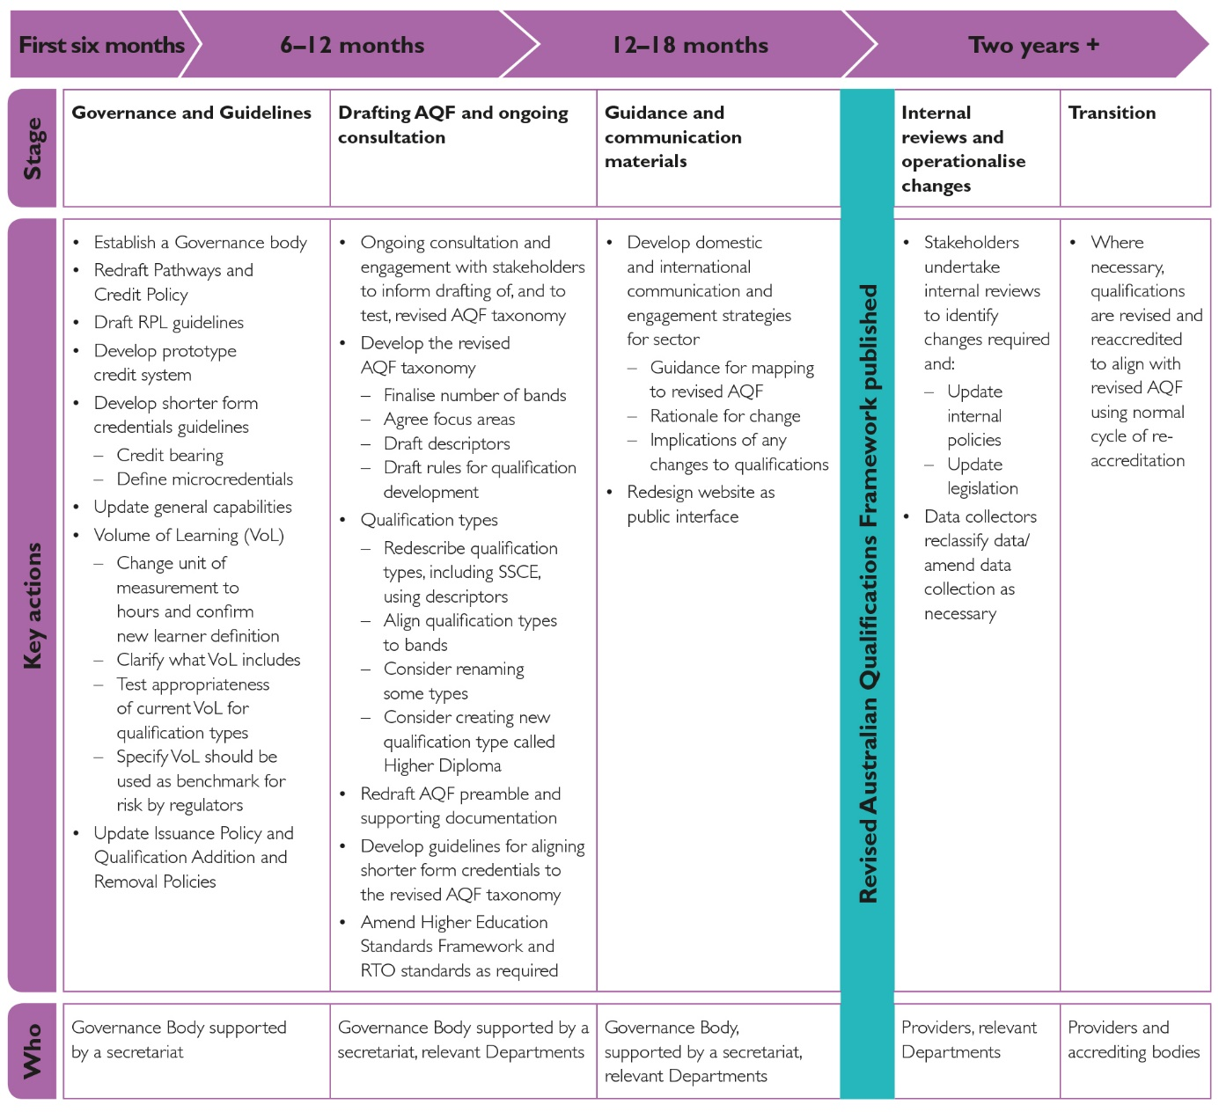

# Glossary for the Report

|  |  |
| --- | --- |
| Term | Definition |
| Application | For the revised AQF would be defined as ‘taking action within the context of learning and assessment’.  The Panel recommends ‘Application’ to replace ‘Application of knowledge and skills’ as a domain in a revised AQF taxonomy. |
| Application of knowledge and skills | How a graduate applies knowledge and skills in context and in terms of autonomy, responsibility and accountability. (AQF Glossary of Terminology) |
| AQF taxonomy | The description and classification of Knowledge, Skills and Application across a number of bands or levels. |
| Assessment | A process to determine a student’s achievement of expected qualification outcomes and may include a range of written and oral methods and practice or demonstration. (AQF Glossary of Terminology) |
| Band | Bands provide an indication of the relative complexity and/or depth of achievement and the knowledge, skills and application required to demonstrate that achievement. |
| Credential | Documentary evidence of an individual’s qualification or competence in a particular educational, academic or occupational field. |
| Credit | The value assigned for the recognition of equivalence in content and learning outcomes between different types of learning and/or qualifications. Credit reduces the amount of learning required to achieve a qualification and may be through credit transfer, articulation, recognition of prior learning or advanced standing. (AQF Glossary of Terminology) |
| Credit arrangements | Formal negotiated arrangements within and between issuing organisations or accrediting authorities that are about student entitlement to credit. They may also be formal arrangements made between issuing organisations and students. (AQF Glossary of Terminology) |
| Credit bearing | A course for which credit can be awarded towards a qualification. |
| Credit transfer | A process that provides students with agreed and consistent credit outcomes for components of a qualification based on identified equivalence in content and learning outcomes between matched qualifications. (AQF Glossary of Terminology) |
| Descriptor | Terms that describe the Knowledge, Skills and Application features of bands and qualification types. |
| Domain | A grouping of the learning requirements of a qualification type. In the current AQF the domains are Knowledge, Skills and the Application of knowledge and skills. In the revised AQF the domains would be Knowledge, Skills and Application. |
| Focus Areas | The themes for descriptors within each Domain. For example, a Knowledge focus area is information management, or inquiry. An example of a Skills focus area would be problem solving, and of Application is learning context. |
| Formal learning | The learning that takes place through a structured program of learning that leads to the full or partial achievement of an officially accredited qualification. (AQF Glossary of Terminology) |
| General capabilities | Qualities that a person exhibits in their general behaviour and attitude to work and life, often gained through informal or non-formal learning experiences but also gained through a formal learning environment. They include language, literacy and numeracy skills, and financial and digital literacy skills. They are sometimes called core skills for work or future skills. |
| Governance body | A body to oversee and advise on the development of AQF policy. |
| Higher Education Provider | A body that is established or recognised by the Commonwealth or a state or territory government to issue qualifications in the higher education sector. It may be a university, self-accrediting institution or non-self-accrediting institution. (AQF Glossary of Terminology) |
| Knowledge | For the revised AQF knowledge would be defined as ‘the information and ideas needed to inform action in a field’. |
| Informal learning | The learning gained through work, social, family, hobby or leisure activities and experiences. Unlike formal or non-formal learning, informal learning is not organised or externally structured in terms of objectives, time or learning support. (AQF Glossary of Terminology) |
| Levels | Used in the current AQF, levels are an indication of the relative complexity and/or depth of achievement and the autonomy required to demonstrate that achievement. AQF level 1 has the lowest complexity and AQF level 10 has the highest complexity. (AQF Glossary of Terminology) |
| Lifelong learning | The term used to describe any learning activities that are undertaken throughout life to acquire knowledge and skills within personal, civic, social and/or employment-related contexts. |
| Microcredential | A microcredential is a certification of assessed learning that is additional, alternative, complementary to or a component part of a formal qualification. |
| Nationally Recognised Training | Programs of training leading to vocational qualifications and credentials that are recognised across Australia and delivered by registered training organisations (RTOs) |
| Non-formal learning | Refers to learning that takes place through a structured program of learning but does not lead to an officially accredited qualification. (AQF Glossary of Terminology) |
| Non-self accrediting provider | A higher education provider that does not have responsibility for accrediting its own qualifications. (AQF Glossary of Terminology) |
| Pathways | Allow students to move through qualification levels with full or partial recognition for the qualifications and/or learning outcomes they already have. (AQF Glossary of Terminology) |
| Provider | An institution that delivers secondary, vocational and/or higher education. |
| Psychomotor skills | Physical skills such as movement, coordination, manipulation, dexterity, grace, strength, speed—actions which demonstrate the fine or gross motor skills, such as use of precision instruments or tools, and walking. |
| Qualification | A formal certification, issued by a relevant approved body, to recognise that a person has achieved the intended learning outcomes or competencies. |
| Qualification type | Refers to the broad discipline-free nomenclature used in the AQF to describe each category of AQF qualification (AQF Glossary of Terminology). |
| Qualification Type Specification | A detailed statement of the characteristics of a particular AQF qualification type. |
| Recognition of prior learning (RPL) | An assessment process that involves assessment of an individual’s relevant prior learning (including formal, informal and non-formal learning) to determine the credit outcomes of an individual application for credit. (AQF Glossary of Terminology) |
| Registered training organisation (RTO) | A training provider registered by ASQA (or, in some cases, a state regulator) to deliver nationally recognised training. |
| Self-accrediting provider | A higher education provider that has been given responsibility to accredit its own qualifications. (AQF Glossary of Terminology) |
| Senior Secondary Certificate of Education | The certificate that is available to be awarded on completion of senior secondary education (typically Year 12). |
| Skills | In a revised AQF Skills would be ‘the abilities required to take action, acquired through deliberate, systematic, and sustained effort’. |
| Skill set | A single unit of competency or a combination of units of competency from a training package that is linked to a licensing or regulatory requirement, or a defined industry need (Standards for Registered Training Organisations (RTOs) 2015). |
| Statement of attainment | Recognises that one or more accredited units have been achieved. (AQF Glossary of Terminology). |
| Taxonomy | The system of classification of learning outcomes in a qualifications framework. (AQF Glossary of Terminology) |
| Tertiary education | Vocational education and training (VET) and higher education. |
| Training package | The components of a training package endorsed by the Skills Council or its delegate in accordance with the Standards for Training Packages. The endorsed components of a Training Package are: units of competency; assessment requirements (associated with each unit of competency); qualifications; and credit arrangements.  A training package also consists of a non-endorsed, quality assured companion volume/s, which contains industry advice to RTOs on different aspects of implementation. (Standards for Registered Training Organisations (RTOs) 2015). |
| Unit of Competency | The specifications of skills and knowledge and how they need to be applied to perform effectively in a workplace context. |
| Unspecified credit | Credit granted towards elective components of a qualification or program of learning. (AQF Glossary of Terminology) |
| Volume of learning | A dimension of the complexity of a qualification. It is used with the level criteria and qualification type descriptor to determine the depth and breadth of the learning outcomes of a qualification. The volume of learning identifies the notional duration of all activities required for the achievement of the learning outcomes specified for a particular AQF qualification type. It is currently expressed in equivalent full-time years, though the Panel has recommended changing to hours. |

# Appendices

## Appendix . Review Terms of Reference

### Background

The Australian Qualifications Framework (AQF) was introduced in 1995. It provided criteria for defining qualifications based on educational characteristics and outcomes for each qualification. The main AQF goals were to provide nationally consistent recognition of qualifications and facilitate student mobility between education and training sectors and the labour market.

Following a two-year review, a revised AQF was released in 2011, with a second edition released in 2013. It introduced the current ten level structure and aligned the AQF more closely with international practice. The revised AQF focused on descriptors for knowledge, skills and their application in increasing complexity over the ten levels of qualifications, complemented by volume of learning descriptors. It also introduced new and revised supporting policies.

The AQF remains an integral part of Australia’s framework for quality assurance in education and training and is a key feature of Australia’s international education standing. Since it was last revised, there have been innovations in qualifications frameworks internationally, as well as changes in the nature of work that affect Australia’s skills requirements. There have also been changes in education and training practice and relevant regulatory structures.

In light of these developments, the Australian Government will appoint a panel to review the AQF.

### Terms of Reference

Taking into account developments in school, vocational and higher education, the nature of work, qualifications frameworks internationally, and the views of international and domestic stakeholders, the AQF Review Panel will:

1. Review the AQF structure and components (levels, qualifications and relevant explanations) and associated guidelines to ensure that they:
2. position the AQF for the future as a flexible and responsive instrument that guides the provision of consistent high quality and transparency in the Australian education and training system;
3. reflect the knowledge, skills and capabilities required by individuals for effective economic and social participation and which meet the current and anticipated skills needs of the Australian economy;
4. effectively facilitate access to learning pathways and mobility (for example through articulation arrangements, credit transfer and recognition of prior learning) within and between education sectors, AQF levels and AQF qualifications;
5. reflect international good practice.
6. Review the desirability and feasibility of developing a system for the quality assurance and incorporation within the AQF of non-AQF credentials such as skill sets, enabling and foundation courses, microcredentials and in-service and advanced training provided by industry or professions and other non-AQF credentials.
7. Provide specific advice on:
8. the relationships between levels and qualifications to ensure that they are clear, appropriate and unambiguous, taking into account their use in different education and training sectors;
9. whether the descriptors are expressed in simple language that supports ready and consistent interpretation and application;
10. volume of learning including whether:
11. it should be a time based measure and, if so, whether it should be aligned with other time based measures employed in vocational education and training sector specifications and requirements;
12. it should be replaced by a credit point system;
13. the disparities in volume of learning between qualifications at the same level can be supported by additional information such as prerequisite learning; and
14. it is a necessary descriptor in the AQF
15. the placement of vocational education and training (VET) and higher education (HE) qualifications in the AQF and consider:
16. any areas of convergence and optimal points of differentiation of VET and HE qualifications in general and specifically at levels 5, 6 and 8;
17. the extent to which the AQF currently implies a status hierarchy from VET to HE qualifications and whether this can be mitigated through changes to the structure or language of the AQF;
18. means by which the AQF can assist with greater consistency in regulation of AQF compliance between HE and VET.
19. whether and how the AQF should incorporate guidance for people wishing to build a qualification from a variety of courses and/or providers.
20. Provide advice on changes to AQF policies[225] that would be required to give effect to the outcomes of the Panel’s advice on the Terms of Reference 1-3 and other desirable changes. Consider whether any of these policies that deal with domestic matters should be situated within Tertiary Education Quality and Standards Agency and VET regulator registration and accreditation guidelines.
21. Consider what changes may be required to AQF governance arrangements, to the AQF itself or to regulation that references the AQF to ensure consistency of its application and to ensure ongoing currency of the AQF through monitoring and review.
22. The Panel will provide an initial report including recommendations on consequential changes to the AQF on the matters outlined above and subsequent to consideration of that report develop an implementation plan required for implementation of the changes.

In order to address the terms of reference the AQF Review Panel will:

* advise the Secretariat how the AQF Review should be considered and approached
* advise which stakeholders should be consulted and what sources of data and research should be considered
* meet with key stakeholders and possibly hold public forums
* advise on and approve both the public discussion paper and the final report
* in addition to consulting with stakeholders, meet as required (once every two months, maximum once a month).

## Appendix . Minimal change option

|  |  |  |  |  |
| --- | --- | --- | --- | --- |
| **Domain / Focus** | **Level 1** | **Level 2** | **Level 3** | **Level 4** |
| **Preamble** | A Graduate at this level will have: | A Graduate at this level will have: | A Graduate at this level will have: | A Graduate at this level will have: |
| **Knowledge**  (Kinds, Depth and Breadth) | Foundational, factual, technical and procedural knowledge. | Basic factual, technical and procedural knowledge. | Broad factual, technical, procedural and some theoretical knowledge with depth in some areas. | Broad factual, technical, procedural and some theoretical knowledge within a specific vocation/field with depth in some areas. |
| **Skills (**Cognitive, Creative, Technical, Communicable, Interpersonal) | Foundational cognitive skills to:  a) receive, pass on and recall information in a narrow range of areas;  b) basic skills to participate in everyday life and further learning.  Foundation technical skills to use tools appropriate to the activity and use of basic communication technologies.  Communication skills to receive, pass on and recall information in a narrow range of areas and report simple issues and problems. | Basic cognitive skills to:  a) access, record and act on a defined range of information from a range of sources;  b) apply known solutions to a limited range of predictable problems.  Basic technical skills to use a limited range of equipment to complete tasks involving known routines and procedures with a limited range of options.  Communication skills to communicate known solutions to a limited range of predictable problems. | Cognitive skills to:  a) interpret and act on available information;  b) apply and communicate known solutions to a variety of predictable and sometimes unpredictable problems and deal with unforeseen contingencies using known solutions.  Technical skills to:  a) undertake routine and some non-routine tasks in a range of skilled operations;  b) apply technical solutions to a range of predictable and some unpredictable problems.  Communication skills to:  a) interpret and act on available information;  b) apply and communicate known solutions to: a variety of predictable problems and to deal with unforeseen contingencies using known solutions;  c) to provide technical information to a variety of audiences. | Cognitive skills to:  a) identify, analyse, compare and act on information from a range of sources;  b) apply and communicate technical solutions of a non-routine or contingency nature to a range of predictable and unpredictable problems with some critical thinking.  Specialist technical skills to:  a) complete routine and non-routine tasks and functions;  b) apply technical solutions of a non-routine or contingency nature to: a range of predictable and unpredictable problems.  Communication skills to:  a) identify and provide technical advice in the area of work and learning and guide activities;  b) to communicate technical solutions of a  non-routine or contingency nature to: a range of predictable and unpredictable problems. |
| **Application of Skills and Knowledge (**Autonomy, responsibility, accountability, context and tasks) | Limited autonomy responsibility for own outputs in learning and responsible for own outputs or tasks within supervised work and some accountability for the quality of own outcomes in defined contexts and within established parameters; in contexts that may include preparation for further learning, life activities and/or a variety of initial routine and predictable work-related activities including participation in a team or work group Skills for initial work, everyday life and further learning; able to undertake defined routine activities undertake defined, routine activities. | Limited autonomy and judgement in the completion of own defined tasks; to complete routine but variable tasks in collaboration with others responsibility for own outputs in learning and responsible for own outputs or tasks within supervised work and some accountability for the quality of own outcomes in known and stable contexts; in a team environment within a defined area of work; able to undertake and complete routine tasks. | Discretion and judgement in the selection of equipment, services or contingency measures; and autonomy to complete routine and defined tasks.  Responsibility for own outputs in learning and in work including participation in teams and taking limited responsibility for the output of others.  Work based skills within a specific area/field; able to adapt and transfer skills and knowledge to undertake and complete routine and some non-routine tasks in a range of skilled operations. | Personal autonomy in performing routine and  non-routine tasks and functions to: a range of predictable and unpredictable problems; with initiative and judgement organise the work of self and others.  Responsibility for own functions and outputs, and some responsibility for the organisation of others and for the quantity and quality of the output of others in a team within limited parameters; in known or changing contexts.  Specialised skills within a specific area/field; able to: adapt and transfer skills and knowledge to undertake and complete specialised tasks and functions in a range of skilled operations. |

|  |  |  |  |
| --- | --- | --- | --- |
| **Domain / Focus** | **Level 5** | **Level 6** | **Level 7** |
| **Preamble** | A Graduate at this level will have: | A Graduate at this level will have: | A Graduate at this level will have: |
| **Knowledge**  (Kinds, Depth and Breadth) | Technical and theoretical knowledge and concepts depth in some areas. | Advanced technical knowledge, as well as theoretical knowledge and with some depth in underlying principles and concepts. | Comprehensive technical knowledge as well as theoretical with depth in underlying principles and concepts including research methods and analysis and evaluation of information. |
| **Skills**  **(**Cognitive, Creative, Technical, Communicable, Interpersonal) | Cognitive skills to:  a) identify, analyse, synthesise and act on information from a range of sources;  b) analyse, plan, design and evaluate approaches to unpredictable problems and/or management requirements;  c) critical thinking to provide solutions to sometimes complex problems.  Technical skills to:  a) analyse, plan, design and evaluate approaches to predictable and unpredictable problems and/or management requirements  Communication skills to:  a) identify, analyse, synthesise and act on information from a range of sources;  b) to: analyse, plan, design and evaluate approaches to unpredictable problems and/or management requirements;  c) transfer knowledge and specialised skills to others and demonstrate understanding of knowledge;  d) transmit solutions to sometimes complex problems. | Cognitive skills to:  a) identify, analyse, synthesise and act on information and concepts from a range of sources;  b) with analytical skills, to interpret and transmit responses to complex problems;  c) with wide-ranging specialised creative or conceptual skills to express ideas and perspectives; and  d) with creative thinking skills associated with the solving of problems or the creation of new solutions/applications based on knowledge/specialist knowledge.  Technical skills to:  a) demonstrate a broad understanding of specialised knowledge with depth in some areas;  b) wide-ranging specialised technical or conceptual skills to express ideas and perspectives.  Communication skills to:  a) identify, analyse, synthesise and act on information and concepts from a range of sources;  b) with analytical skills, to interpret and transmit responses to complex problems;  c) make a clear and coherent presentation of knowledge and ideas with some intellectual independence;  d) transmit information and skills to others. | Cognitive skills to select and apply methods and technologies to:  a) review critically, analyse, consolidate and synthesise knowledge; b) with creative skills, to exercise critical thinking and judgement in identifying and solving problems with intellectual independence;  c) to demonstrate a broad understanding of knowledge with depth in some areas;  d) analyse and generate solutions to unpredictable and sometimes complex problems.  Technical skills to:  a) demonstrate a broad understanding of knowledge with depth in some areas;  b) analyse and generate solutions to unpredictable and sometimes complex problems.  Communication skills to:  a) present a clear, coherent and independent exposition of knowledge and ideas;  b) with analytical skills, to interpret and transmit responses to complex problems;  c) transmit solutions to unpredictable and sometimes complex problems;  d) transmit knowledge, skills and ideas to others. |
| **Application of Skills and Knowledge** (Autonomy, responsibility, accountability, context and tasks) | Personal autonomy in performing complex technical operations; with initiative and judgement to organise the work of self and others and plan, coordinate and evaluate the work of teams.  Personal responsibility in performing complex technical operations and tasks; responsible for own outputs and the organisation and output of others within a team within broad parameters for quantity and quality within broad but generally well-defined parameters; with depth in some areas of specialisation in known or changing contexts; in a range of situations.  Specialised skills with depth in some areas; able to transfer and apply theoretical concepts and/or technical and/or creative skills to complete a range of activities. | Personal autonomy in performing complex technical operations; initiative and judgement in planning, design, technical or management functions with some direction.  Personal responsibility in performing and managing complex technical operations and tasks; responsible for own outputs and accountable for the organisation and outcomes of a team within broadly defined parameters: with accountability for personal outputs and personal and team outcomes.  Within broad parameters; in contexts subject to change with depth in areas of specialisation; to: adapt a range of fundamental principles and complex techniques to known and unknown situations; across a broad range of technical or management functions. | Personal autonomy, initiative and judgement in planning, problem solving, decision making and management functions.  Within broad parameters; in paraprofessional practice; in a range of contexts and/or for further studies in one or more disciplines.  Adapt knowledge and skills; to: adapt fundamental principles, concepts and techniques to known and unknown situations. |

|  |  |  |  |
| --- | --- | --- | --- |
| **Domain / Focus** | **Level 8** | **Level 9** | **Level 10** |
| **Preamble** | A Graduate at this level will have: | A Graduate at this level will have: | A Graduate at this level will have: |
| **Knowledge**  (Kinds, Depth and Breadth) | Advanced theoretical knowledge and concepts, including research methods and analysis and evaluation of information. Knowledge of research principles and methods. | A complex body of knowledge, including of research principles and methods, and the understanding of recent developments and their relevance/impact. | A complex and substantial body of knowledge, including of research principles and methods, and knowledge that constitutes a significant or original contribution. |
| **Skills**  **(**Cognitive and Creative, Technical, Communication) | Cognitive skills to:  a) review, analyse, consolidate and synthesise knowledge to identify and provide solutions to complex problems with intellectual independence;  b) creative skills in a field of highly skilled and/or professional practice;  c) demonstrate a broad understanding of a body of knowledge and theoretical concepts with advanced understanding in some areas;  d) think critically, exercise judgement and to generate and evaluate complex ideas” – and creativity - to create new solutions for complex problems.  e) analyse critically, evaluate and transform information to complete a range of activities.  Technical skills to:  a) demonstrate a broad understanding of a body of knowledge and theoretical concepts with advanced understanding in some areas;  b) to design and use research in a project;  c) specialised technical skills in a field of highly skilled practice.  Communication skills to:  a) demonstrate an understanding of theoretical concepts;  b) to present a clear and coherent exposition of knowledge and ideas to a variety of audiences. | Cognitive skills to:  a) demonstrate mastery of theoretical knowledge and to reflect critically on theory and professional practice or scholarship;  b) with creative skills, to investigate, analyse and synthesise complex information, problems, concepts and theories and to: apply established theories to different bodies of knowledge or practice;  c) with creative skills, to generate and evaluate complex ideas and concepts at an abstract level;  d) to design, use and evaluate research and research methods;  e) analyse critically, reflect on and synthesise complex information, problems, concepts and theories.  Technical skills to:  a) investigate, analyse and synthesise complex information, problems, concepts and theories and to: apply established theories to different bodies of knowledge or practice;  b) technical research skills to justify and interpret theoretical propositions, methodologies, conclusions and professional decisions to specialist and non-specialist audiences;  c) to generate and evaluate complex ideas and concepts at an abstract level;  d) to design, use and evaluate research and research methods;  e) to design, evaluate, implement, analyse and theorise about developments that contribute to practice or scholarship.  Communication skills to:  a) justify and interpret theoretical propositions, methodologies, conclusions and professional decisions to specialist and non-specialist audiences;  b) to design, evaluate, implement, analyse and theorise about developments that contribute to practice or scholarship;  c) interpret and transmit knowledge, skills and ideas to specialist and non-specialist audiences. | Cognitive skills to:  a) demonstrate expert understanding of theoretical knowledge and reflect critically on theory and practice;  b) creative skills applicable to the field of work or learning;  c) to design, implement, analyse, theorise and communicate research that makes a significant and original contribution to knowledge and/or professional practice;  d) use of intellectual independence to think critically, evaluate existing knowledge and ideas, undertake systematic investigation and reflect on theory and practice to generate original knowledge.  Technical skills to:  a) design, implement, analyse, theorise and communicate research that makes a significant and original contribution to knowledge;  b) expert research skills to investigate, analyse and synthesise complex information, problems, concepts and theories and to develop and apply theories to different bodies of knowledge or practice;  c) expert skills to design, implement, analyse, theorise and communicate research that makes a significant and original contribution to knowledge and/or professional practice.  Communication skills to:  a) explain and critique theoretical propositions, methodologies and conclusions;  b) to design, implement, analyse, theorise and communicate research that makes a significant and original contribution to knowledge;  c) to present cogently a complex investigation of originality or original research for external examination against international standards and to communicate results to peers and the community. |

|  |  |  |  |
| --- | --- | --- | --- |
| **Domain / Focus** | **Level 8** | **Level 9** | **Level 10** |
| **Preamble** | A Graduate at this level will have: | A Graduate at this level will have: | A Graduate at this level will have: |
| **Application of Skills and Knowledge** (Autonomy, responsibility, accountability, context and tasks) | Personal autonomy, initiative and judgement; to make high level, independent judgements in a range of technical or management functions apply knowledge and skills to demonstrate autonomy, well developed judgement, adaptability and responsibility as a practitioner or learner.  Responsibility for own learning, practice and personal outputs, in collaboration with others; accountable for all aspects of the work or function of others. in varied specialised contexts; in professional practice and/or scholarship; in diverse contexts; in varied specialised technical and/or creative contexts;  Within broad parameters to: adapt knowledge and skills; to initiate, plan, implement and evaluate broad functions; to plan and execute project work and/or a piece of research and scholarship with some independence. | High-level personal autonomy, initiative and judgment; to make independent judgements and implement new solutions in a range of management functions.  Responsibility for own learning, practice and personal outputs, in collaboration with others; high-level accountability for all aspects of the work or function of others with high level personal accountability.  Within new situations and/or for further learning to plan and execute a substantial piece of research or research-based project, a capstone experience and/or professionally focussed project/piece of scholarship. | Intellectual independence; with initiative and high level of discretion to initiate new approaches in a field of work or learning.  Responsibility for own learning, practice and personal outputs; high-level accountability for all aspects of the work or function of others and in the planning and execution of original research.  Within the context of professional practice; in new situations and/or for further learning to plan and execute original research; with the ongoing capacity to generate new knowledge. |

## Appendix . Revised AQF - Draft Knowledge descriptors

Note: Draft descriptors are to indicate feasibility only and would be subject to further refinement, testing, consultation and agreement. The descriptors in Appendix 3 are examples of long version descriptors to be used by course designers. Summary versions of the descriptors would be developed for inclusion in qualification types. These would provide more appropriate guidance for students, employers and others.

|  | *At Band 1, qualifications* | *At Band 2, qualifications* | *At Band 3, qualifications* | *At Band 4,* *qualifications* | *At Band 5, qualifications* | *At Band 6, qualifications* | *At Band 7, qualifications* | *At Band 8,* *qualifications* |
| --- | --- | --- | --- | --- | --- | --- | --- | --- |
| **Purpose, scope and complexity** | * focus on a small selection of facts and procedures relevant to a narrowly defined role/field. * utilise easily accessible, clearly presented information and ideas with limited requirement for interpretation   for the purpose of:   * undertaking a small set of well-defined activities * recognising some common problems associated with these | * focus on a selection of facts, procedures and basic principles relevant to a narrowly defined role/field * utilise sources of information and ideas with a clear relationship to the scope of inquiry   for the purpose of:   * undertaking well-defined, routine activities * recognising and addressing simple, predictable problems associated with these | * focus on field-specific procedures, practices and processes supported by a small range of theoretical concepts * utilise a range of field-specific written, visual and oral sources with some specialised vocabulary   for the purpose of:   * undertaking a specified range of routine activities * identifying and addressing predictable problems, and * laying the foundations for managing some non-routine problems | * focus on field-specific procedural, process related information, principles and concepts. * Begin to utilise written, visual and oral sources containing concepts, some technical specificity, embedded information and specialised vocabulary   for the purpose of:   * undertaking a broad range of routine, and some less routine, activities * anticipating, recognising and addressing predictable, routine problems and an expanding range of non-routine problems | * focus on increasingly specialised field-specific factual, procedural, process-related information, principles and concepts * utilise technically specific written, visual and oral sources involving some complex concepts, embedded information and specialised vocabulary   for the purpose of:   * undertaking multiple routine and non-routine activities * anticipating, recognising and addressing an expanding range of predictable and less predictable problems   AND/OR   * focus on introductory theoretical underpinnings and factual/ procedural information associated with a recognised discipline of knowledge * begin to utilise written, visual and oral sources involving concepts, specialised vocabulary and some embedded information and discipline-specific terminology and symbolism   for the purpose of:   * understanding and exploring ideas, known solutions to discipline-specific problems * laying the foundations for exploring issues that may not have obvious solutions | * focus on highly specialised field-specific factual, procedural, process-related information, principles, concepts and practices * utilise technically-specific written, visual and oral sources involving complex concepts, embedded information and specialised vocabulary   for the purpose of:   * undertaking/overseeing a broad range of integrated activities with sometimes complex relationships * anticipating, recognising and addressing an expanding range of predictable and less predictable problems   *and/or*   * focus on domain-specific theories and practices associated with a recognised discipline * utilise written sources with complex syntactic structures, technical specificity, specialised language and symbolism   for the purpose of:   * understanding and exploring ideas and known solutions to discipline-specific problems * developing responses to issues that may not have obvious or immediate solutions | * focus on advanced theoretical, procedural and/or specialist technical information and ideas within a recognised discipline/ industry * utilise multiple sources, including written and visual texts with complex syntactic structures, highly embedded information, technical specificity, specialised language and symbolism   for the purpose of:   * undertaking complex activities involving multiple aspects * solving complicated problems * exploring complex issues with a view to finding an effective way forward | * Focus on highly specialised information and ideas at the forefront of a recognised discipline/ industry * Utilise a broad range of sources including highly complex, written and visual texts incorporating technical specificity, specialised language and symbolism   for the purpose of:   * generating new knowledge * addressing complex issues and ‘dilemmas with multiple interpretations and possible solutions |

|  |  |  |  |  |  |  |  |  |
| --- | --- | --- | --- | --- | --- | --- | --- | --- |
|  | *At Band 1, qualifications* | *At Band 2, qualifications* | *At Band 3, qualifications* | *At Band 4,* *qualifications* | *At Band 5, qualifications* | *At Band 6, qualifications* | *At Band 7, qualifications* | *At Band 8,* *qualifications* |
| **Inquiry** | support learners to   * identify relevant information in the simple oral, visual and written sources provided | support learners to:   * pose simple questions to be answered through inquiry * recognise the purpose and features of some field- specific written, oral and visual sources * apply a small set of strategies to locate information and begin to evaluate its relevance to their needs | support learners to:   * recognise the value of using a range of sources and form a point of view * pose some search questions * identify and evaluate relevance of information from sources with some conceptual and technical language * consider what makes a source credible | assist learners to:   * pose search questions * identify and evaluate the relevance of information and ideas * consider source credibility | assist learners to:   * pose and begin to refine search questions * identify and evaluate potential information sources considered routine in the domain * identify and evaluate relevance and credibility of information and ideas | mentor learners to:   * pose and refine search questions as part of an iterative research process * conduct searches across multiple source materials * critically evaluate the relevance, credibility and validity of information from a wide variety of sources | mentor learners to:   * design, evaluate, implement, analyse, theorise and disseminate research that makes a contribution to public knowledge * conduct searches across multiple source materials * critically evaluate the relevance, validity and credibility of information and ideas from a wide variety of sources | mentor learners to:   * design, evaluate, implement, analyse, theorise and disseminate research that makes a significant original contribution to public knowledge * conduct searches across an extensive range of multiple source materials, including from other disciplines |
| **Information management** | help learners match information to the appropriate application with limited alteration | help learners to summarise, sort, compare, sequence | help learners to: compare, sequence, interpret with simple extrapolation and inferencing | help learners to: sequence, interpret, integrate, extrapolate, infer, generalise | help learners:   * synthesise, extrapolate, infer, generalise * begin to collect and undertake basic analysis of own data | help learners:   * design and undertake a highly structured piece of research * analyse, synthesise, theorise, select and apply conceptual models to aid understanding | expect learners to:   * collect and analyse own data and that of others * analyse, synthesise, predict, theorise/ develop new schema, hypothesise, model | expect learners to:   * collect and analyse own data and that of others * develop new schema, hypothesise, model, challenge and reframe, create new public knowledge |

## Appendix . Revised AQF - Draft Skills descriptors

Note: Draft descriptors are to indicate feasibility only and would be subject to further refinement, testing consultation and agreement. The descriptors in Appendix 4 are examples of potential long version descriptors to be used by course designers. Summary versions of the descriptors would be developed for inclusion in qualification types. These would provide more appropriate guidance for students, employers and others.

### Identify and solve problems and make decisions

|  |  |  |  |  |  |  |
| --- | --- | --- | --- | --- | --- | --- |
| Characteristics | *At Band 1, qualifications focus on* | *At band 2, qualifications focus on* | *At Band 3, qualifications focus on* | *At Band 4, qualifications focus on* | *At Band 5, qualifications focus on* | *At Band 6, qualifications focus on* |
| **Types, range, scope** | * recognising and responding to a small set of highly obvious, predictable problems with clearly identifiable causes and pre-determined solutions | recognising and responding to a small set of predictable problems with clearly identifiable causes and known solutions | * recognising and responding to a set of routine problems with largely known solutions in order to restore agreed requirements /maintain the status quo * learning to recognise early warning signs | * diagnosing and responding to a broad range of commonly occurring issues some requiring adaptation of standard responses to maintain the status quo * increasing focus on recognising early warning signs and averting problems * learning to tackle problems with no immediately obvious cause or pre-determined solution | * learning to recognise and address a range of complicated, ill-structured problems where root causes are not obvious and where there may be several possible courses of action | * developing responses to highly complex ill-structured problems with no clear root cause, multiple interpretations and no one right answer |
| **Problem solving and decision making processes** | * learning how to recognise that there is a problem, selecting and applying a response pre-determined by others * following simple step-by-step processes for identifying and addressing problems within a limited scope | * using simple step-by-step processes to identify the problem and select an appropriate response, taking some situational factors into account | * selecting one response from several possibilities, taking situational factors into account * applying step-by-step problem solving processes | * applying standard procedures for a broad range of routine problems, with scope for minor modifications * developing diagnosis/ troubleshooting skills involving a logical systematic search for the source of a problem | * applying formal processes to articulate underlying beliefs and assumptions, and reframe perceptions of the situation * separating symptoms from underlying causes, posing questions to better understand causality and redefine the problem * using systematic processes to set goals, gather and analyse information and identify and evaluate possible options against agreed criteria | * enhancing ability to reframe perceptions of a situation in order to identify key issues, underlying causes and possible ways forward questioning, reframing, reinvention * refining ability to articulate goals and identify key factors to be taken into account in decision making process (including own values and principles and stakeholder needs, power, values etc.) |
| **Reflection on processes/ solutions** | * learning to recognise when a solution did not work as intended and to consider ways to rectify this | * recognising where and why a solution worked or did not work as intended, and whether/how to change subsequent response | * recognising where and why a solution worked or did not work as intended, and whether/ how to change responses next time * some discussion of grey areas | * reviewing responses to non-standard issues * distinguishing between symptoms and root causes | * encouraging development of skills for deep reflection that may lead to refinement and/or re--conceptualisation of thinking | * engaging in deep reflection that may lead to refinement, re-conceptualisation and innovation |

### Psychomotor skills

|  |  |  |  |  |  |  |
| --- | --- | --- | --- | --- | --- | --- |
| The qualification provides learners with the opportunity to: | Band 1 | Band 2 | Band 3 | Band 4 | Band 5 | Band 6 |
| **Use an analysis of sensory feedback to make decisions about the appropriate physical response/body movement or skills\***  **(Scale: reproductive to productive)**  **(Definition: Applying standard known procedures through to those requiring strategy, planning and innovation skills)** | Reproduce appropriate movement responses  based on observation or direct instruction | Perform  relevant movements based on memory | Demonstrate complex coordinated movements based on practice | Skilfully perform, and modify where required, combinations and sequences of complex movement | Adapt and adjust, combinations and sequences of complex movement | Design and create  new movement patterns  or alternative creative strategies |
| **Complete tasks**  **(Scale: closed to open tasks)**  **(Definition: Closed tasks require a response to a stable environment and open tasks require continuous adjustment to account for unpredictable changing environments)** | To complete  set closed tasks | To complete  well-defined closed tasks | To complete closed and some increasingly open tasks | To manage a range of closed and open tasks | To manage a range of closed and open tasks | To manage a range of closed and open tasks (or special situations) |
| **At an expected level of performance of consistency, ease and assurance**  **(Scale: inconsistent to consistent)** | Inconsistent level of performance and assurance | Reasonably consistent level of performance and assurance | Consistent level of performance and assurance | Automatic and consistent performance with ease and assurance | Automatic and consistent performance with ease and assurance | Automatic and consistent performance with ease and assurance |

### Learner self-management skills

|  | *At Band 1, qualifications support learners to…* | *At Band 2, qualifications support learners to…* | *At Band 3, qualifications support learners to…* | *At Band 4, qualifications assist learners to…* | *At Band 5, qualifications expect learners to…* | *At Band 6, qualifications expect learners to…* |
| --- | --- | --- | --- | --- | --- | --- |
| **General responsibility /support** | * build confidence to engage in learning activities where scaffolding reduces the need for risk taking | * take responsibility for some aspects of the learning process within a scaffolded environment | * take responsibility for learning in routine contexts * and develop strategies to tackle some new learning challenges * reflect on actions and outcomes, recognising and addressing issues identified * independently access a range of support resources * anticipate potential barriers to learning and ways to address these | * Self directs learning in a range of familiar and less familiar contexts | * self direct and self regulate learning | * self direct and self regulate learning in contexts presenting high levels of challenge |
| **Plan and organise** | * set a learning objective and think about how to begin a new activity | * set some learning objectives and develop simple plans to achieve these * identify some potential barriers to learning and develop a small repertoire of strategies to address these * draws on prior knowledge to | * set learning goals and plans with achievable steps and timeframes prioritised steps and timelines and awareness of need to make allowances for unforeseen events | * set learning goals and sequenced plans with steps and timeframes prioritised steps and timelines * Pose explicit questions to help focus planning assesses nature and scope of new tasks in unfamiliar contexts, identified established procedures where applicable and develops formal plans with sequenced, prioritised steps and timeframes | * Take responsibility for setting learning goals that may lead into unfamiliar contexts * Develop formal plans, allowing for different and possibly competing requirements and expectations | * Develop short/medium and long term strategies to achieve specialised learning goals * develop plans involving management of multiple variables, taking risks into account |
| **Learning strategies** |  | * develop and apply a small set of learning strategies, including those that facilitate self-reflection |  |  | * experiment with various approaches to learning and reflect on effectiveness in different situations | * draw on a broad range of strategies to facilitate learning |
| **Reflection** |  |  |  |  | * develop and use some formal processes to facilitate reflective practice * seek and reflect on advice and feedback from a range of established sources | access and evaluate feedback and advice from a broad range of sources |

## Appendix . Revised AQF - Draft Application descriptors

Note: Draft descriptors are to indicate feasibility only and would be subject to further refinement, testing, consultation and agreement. The descriptors in Appendix 5 are examples of potential long version descriptors to be used by course designers. Summary versions of the descriptors would be developed for inclusion in qualification types. These would provide more appropriate guidance for students, employers and others.

| *Focus Areas* | *At Band 1, learners* | *At Band 2, learners* | *At Band 3, learners* | *At Band 4,* *learners* | *At Band 5, learners* | *At Band 6, learners* | *At Band 7, learners* | *At Band 8*, learners |
| --- | --- | --- | --- | --- | --- | --- | --- | --- |
| **Scope and purpose** | * adapt and apply knowledge and skills within a small set of well-defined activities * recognise and begin to address some common problems associated with these | * adapt and apply knowledge and skills within well-defined, routine activities * recognise and address simple, predictable problems associated with these | * adapt and apply knowledge and skills within a specified range of routine activities * identify and address predictable problems, and laying the foundations for managing some non-routine problems | * adapt and apply knowledge and skills within a broad range of routine, and some less routine, activities * anticipate, recognise and address predictable, routine problems and an expanding range of non-routine problems | * adapt and apply knowledge and skills within multiple routine and non-routine activities * anticipate, recognise and address an expanding range of predictable and less predictable problems * begin to recognise issues that may not have obvious solutions | * adapt and apply knowledge and skills to a broad range of integrated and sometimes complex activities * anticipate, recognise and address a wide range of predictable and some less predictable problems * begin to develop responses to issues that may not have obvious or immediate solutions | * adapt and apply knowledge and skills to complex activities involving multiple aspects * solve complicated problems and explore complex issues with a view to finding an effective way forward | * adapt and apply knowledge and skills to address complex issues with multiple interpretations and possible solutions * draw on specialised knowledge and practical experience in order to generate new knowledge |

|  | Focus Area 2  Learning contexts |  | Focus Area 3  Assessment conditions |
| --- | --- | --- | --- |
| **A1.1** | * within activities and problems with a small number of controlled variables | A2.1 | * in situations that are very similar to those experienced during the learning process |
| **A1.2** | * to activities and problems with a number of controlled variables, intended to reflect aspects of real-world contexts relevant to the course of study | A2.2 | * in controlled situations where a small range of variables differ to those considered during the learning process |
| **A1.3** | * to ‘authentic’ activities and issues involving multiple variables and reflecting real-world situations and associated problems | A2.3 | * in controlled situations where a number of variables are unpredictable and differ from those encountered during the learning process |
| **A1.4** | * through project-based activities involving ill-defined, real-world issues with multiple interpretations explored in context | A2.4 | * through small scale community/work based or field/discipline specific projects |
| **A1.5** | * to activities and problems that arise as part of structured work placements undertaken for short periods of time | A2.5 | * through large scale, complex community/work based or field/discipline specific projects |
| **A1.6** | * to activities and problems that occur as an integral part of a structured on and off the job learning process over an extended period of time | A2.6 | * in on the job contexts where some variables are unpredictable and differ from those encountered during the learning process |
|  |  | A2.7 | * in multiple on and off the job contexts where a number of variables are unpredictable and differ from those encountered during the learning process |

## Appendix . Describing qualification types with revised descriptors

Note: These qualification types are examples only and are not intended to suggest that the selected descriptors are the appropriate descriptors for the qualification type.

### Bachelor Degree

|  |  |
| --- | --- |
| Purpose | The Bachelor Degree qualifies individuals who apply a broad and coherent body of knowledge in a range of contexts and as a pathway for further tertiary education. |
| **Knowledge Focus Areas:** | The Bachelor Degree will: |
| *1) Purpose, Scope and Complexity* | * focus on specialised procedural and process-related information, principles and concepts |
|  | * utilise technically specific written, visual and oral sources involving some complex concepts, embedded information and specialised vocabulary |
|  | for the purpose of |
|  | * undertaking a broad range of integrated activities with sometimes complex relationships, and |
|  | * anticipating, recognising and addressing a wide range of predictable and less predictable problems |
| *2) Inquiry* | assist learners to: |
|  | * pose and refine search questions as part of an iterative research process |
|  | * conduct searches across multiple source materials |
|  | * critically evaluate the relevance, validity and credibility of information and ideas from a variety of sources |
| *3) Information Management* | help learners develop skills to: |
|  | * design and undertake a highly structured piece of research/ project |
|  | * analyse, synthesise, theorise, select and apply conceptual models to aid understanding |
| **Skills Focus Areas:** | The Bachelor Degree provides learners with the opportunity to: |
| *1) Learner self-management skills* | * to take responsibility for determining and achieving learning outcomes, initiating and using support from a range of established sources |
| *2) Psychomotor Skills* | * Skilfully perform, and modify where required, combinations and sequences of complex movement |
|  | * To manage a range of closed and open tasks |
|  | * Automatic and consistent performance with ease and assurance |
| *3) Problem solving and decision making skills* | * diagnosing and responding to a broad range of commonly occurring issues some requiring adaptation of standard responses to maintain the status quo |
|  | * increasing focus on recognising early warning signs and averting problems |
|  | * learning to tackle problems with no immediately obvious cause or pre-determined solution |
|  | * applying standard procedures for a broad range of routine problems, with scope for minor modifications * developing diagnosis/ troubleshooting skills involving a logical systematic search for the source of a problem |
|  | * reviewing responses to non-standard issues * distinguishing between symptoms and root causes |
| *4) Skills to communicate in the learning context* | To be developed |
| *5) Skills to cooperate & collaborate in the learning context* | To be developed |
| **Application Focus Areas:** |  |
| *Learning Contexts* | Individual qualifications provide opportunities for application of field-related information, ideas and skills to activities and problems with a number of controlled variables, intended to reflect aspects of real-world contexts relevant to the course of study |
| *Assessment Conditions* | Individual qualifications provide opportunities for application of field-related information, ideas and skills in controlled situations where a small range of variables differ to those considered during the learning process |

### Vocational Certificate

|  |  |
| --- | --- |
| Purpose | The Vocational Certificate qualifies individuals with a broad range of knowledge in varied contexts to undertake skilled work as a trade or in other forms of employment. The Vocational Certificate is also a pathway for further tertiary education. |
| **Knowledge Focus Areas:** | The Vocational Certificate will: |
| *1) Purpose, Scope and Complexity* | * focus on procedures and processes supported by a small range of principles and concepts |
|  | * utilise a range of written, visual and oral sources with some specialised vocabulary |
|  | for the purpose of |
|  | * undertaking a specified range of routine activities |
|  | * identifying and addressing predictable problems, and |
|  | * laying the foundations for managing some non-routine problems |
| *2) Inquiry* | support learners to: |
|  | * recognise the value of using a range of sources |
|  | * pose some search questions |
|  | * identify and evaluate relevance of information from sources with some conceptual and technical language |
|  | * consider what makes a source credible |
| *3) Information Management* | help learners compare, sequence, interpret with simple extrapolation and inferencing |
| **Skills Focus Areas:** | The Vocational Certificate provides learners with the opportunity to: |
| *1) Learner self-management skills* | * Work independently and access familiar support resources, taking responsibility for carrying out defined activities individually and as a group member |
| *2) Psychomotor Skills* | * Skilfully perform, and modify where required, combinations and sequences of complex movement |
|  | * To manage a range of closed and open tasks |
|  | * Automatic and consistent performance with ease and assurance |
| *3) Problem solving and decision making skills* | * recognising and responding to a set of routine problems with largely known solutions in order to restore agreed requirements /maintain the status quo |
|  | * learning to recognise early warning signs |
|  | * selecting one response from several possibilities, taking situational factors into account |
|  | * applying step-by-step problem solving processes * recognising where and why a solution worked or did not work as intended, and whether/ how to change responses next time * some discussion of grey areas |
| *4) Skills to communicate in the learning context* | To be developed |
| *5) Skills to cooperate & collaborate in the learning context* | To be developed |
| **Application Focus Areas:** |  |
| *Learning Contexts* | Individual qualifications provide opportunities for application of field-related information, ideas and skills and off the job learning process over an extended period of time |
| *Assessment Conditions* | Individual qualifications provide opportunities for application of field-related information, ideas and skills in on the job contexts where some variables are unpredictable and differ from those encountered during the learning process |

### Diploma

|  |  |
| --- | --- |
| Purpose | The Diploma qualifies individuals who apply integrated technical and theoretical knowledge in a broad range of contexts to undertake advanced skilled or paraprofessional work and as a pathway for further learning. |
| **Knowledge Focus Areas:** | The Diploma will: |
| *1) Purpose, Scope and Complexity* | * focus on procedural, process related information, principles and concepts |
|  | * Begin to utilise written, visual and oral sources containing concepts, some technical specificity, embedded information and specialised vocabulary |
|  | For the purpose of: |
|  | * undertaking a broad range of routine, and some less routine, activities |
|  | * anticipating, recognising and addressing predictable, routine problems and an expanding range of non-routine problems |
| *2) Inquiry* | * assist learners to: |
|  | * pose search questions |
|  | * identify and evaluate the relevance of information and ideas |
|  | * consider source credibility |
| *3) Information Management* | * help learners develop skills to sequence, interpret, integrate, extrapolate, infer, generalise |
|  | * help learners develop skills to sequence, interpret, integrate, extrapolate, infer, generalise |
|  | * help learners develop skills to sequence, interpret, integrate, extrapolate, infer, generalise |
| **Skills Focus Areas:** | The Diploma provides learners with the opportunity to: |
| *1) Learner self-management skills* | * take responsibility for learning in routine contexts * and develop strategies to tackle some new learning challenges * reflect on actions and outcomes, recognising and addressing issues identified * independently access a range of support resources * anticipate potential barriers to learning and ways to address these |
| *2) Psychomotor Skills* | * set learning goals and plans with achievable steps and timeframes prioritised steps and timelines and awareness of need to make allowances for unforeseen events |
|  | * To complete closed and some increasingly open tasks |
|  | * Consistent level of performance and assurance |
| *3) Problem solving and decision making skills* | * recognising and responding to a set of routine problems with largely known solutions in order to restore agreed requirements /maintain the status quo * learning to recognise early warning signs |
|  | * selecting one response from several possibilities, taking situational factors into account * applying step-by-step problem solving processes |
|  | * recognising and responding to a set of routine problems with largely known solutions in order to restore agreed requirements /maintain the status quo * learning to recognise early warning signs |
|  | * selecting one response from several possibilities, taking situational factors into account * applying step-by-step problem solving processes * recognising where and why a solution worked or did not work as intended, and whether/ how to change responses next time * some discussion of grey areas |
| *4) Skills to communicate in the learning context* | To be developed |
| *5) Skills to cooperate & collaborate in the learning context* | To be developed |
| **Application Focus Areas:** |  |
| *Learning Contexts* | Individual qualifications provide opportunities for application of field-related information, ideas and skills and off the job learning process over an extended period of time |
| *Assessment Conditions* | Individual qualifications provide opportunities for application of field-related information, ideas and skills in on the job contexts where some variables are unpredictable and differ from those encountered during the learning process |

## Appendix . AQF Qualifications Pathways Policy in VET and higher education standards

### Higher Education Standards Framework (Threshold Standards) 2015

|  |  |
| --- | --- |
| AQF Qualifications Pathways Policy | Higher Education Standards Framework (Threshold Standards) 2015 |
| **2. Policy**  **2.1 Responsibilities of issuing organisations** |  |
| 2.1.1 All issuing organisations will have clear, accessible and transparent policies and processes to provide qualifications pathways and credit arrangements for students.  **Requirement covered.** | **7 Representation, Information and Information Management**  **7.2 Information for Prospective and Current Students**  2. Information for students is available prior to acceptance of an offer, written in plain English where practicable, accompanied by an explanation of any technical or specialised terms, and includes:  a. information to assist in decisions about courses or units of study, including the course design, prerequisites, assumed knowledge, when and where courses/units are offered, application dates, arrangements for recognition of prior learning, standing credit transfer arrangements, pathways to employment and eligibility for registration to practise where applicable  d. information to give access to current academic governance policies and requirements including admission, recognition of prior learning, transition, progression, assessment, grading, completion, qualifications, appeals, academic integrity, equity and diversity, intellectual property and withdrawal from or cancellation of enrolment |
| 2.1.2 These policies and processes will:  • ensure that pathways into and between qualifications are available to all students for all relevant qualifications  • be made publicly available, widely promoted and easily accessible to all prospective and existing students to enable them to:  - make well-informed choices between alternative pathways  - take into account the credit that may be available to them, and  • be regularly reviewed to maximise applicability to new and updated qualifications and to student and industry needs.  **Requirement partially covered. No requirement for policies and processes to widely promoted or easily accessible.** | **1 Student Participation and Attainment**  **1.1 Admissions**  1. Admissions policies, requirements and procedures are documented, are applied fairly and consistently, and are designed to ensure that admitted students have the academic preparation and proficiency in English needed to participate in their intended study, and no known limitations that would be expected to impede their progression and completion.  2. The admissions process ensures that, prior to enrolment and before fees are accepted, students are informed of their rights and obligations, including:  a. all charges associated with their proposed studies as known at the time and advice on the potential for changes in charges during their studies  b. policies, arrangements and potential eligibility for credit for prior learning, and  c. policies on changes to or withdrawal from offers, acceptance and enrolment, tuition protection and refunds of charges.  **1.3 Orientation and Progression**  6. Students have equivalent opportunities for successful transition into and progression through their course of study, irrespective of their educational background, entry pathway, mode or place of study.  **2 Learning Environment**  **2.2 Diversity and Equity**  3. Participation, progress, and completion by identified student subgroups are monitored and the findings are used to inform admission policies and improvement of teaching, learning and support strategies for those subgroups. |
| 2.1.3 Issuing organisations’ decisions regarding the giving of credit into or towards AQF qualifications will:  • be evidence-based, equitable and transparent  • be applied consistently and fairly with decisions subject to appeal and review  • recognise learning regardless of how, when and where it was acquired, provided that the learning is relevant and current and has a relationship to the learning outcomes of the qualification  • be academically defensible and take into account the students’ ability to meet the learning outcomes of the qualification successfully  • be decided in a timely way so that students’ access to qualifications is not unnecessarily inhibited  • allow for credit outcomes to be used to meet prerequisites or other specified requirements for entry into a program of study leading to a qualification or for the partial fulfilment of the requirements of a qualification, and  • be formally documented for the student including any reasons for not giving credit.  **Requirement covered for formal documentation and access to appeal and review. No specific requirement for evidence-based, equitable and transparent decisions, or for recognition of learning regardless of how, when and where it was acquired.** | **2 Learning Environment**  **2.4 Student Grievances and Complaints**  1. Current and prospective students have access to mechanisms that are capable of resolving grievances about any aspect of their experience with the higher education provider, its agents or related parties.  2. There are policies and processes that deliver timely resolution of formal complaints and appeals against academic and administrative decisions without charge or at reasonable cost to students, and these are applied consistently, fairly and without reprisal.  3. Institutional complaints-handling and appeals processes for formal complaints include provision for confidentiality, independent professional advice, advocacy and other support for the complainant or appellant, and provision for review by an appropriate independent third party if internal processes fail to resolve a grievance.  4. Decisions about formal complaints and appeals are recorded and the student concerned is informed in writing of the outcome and the reasons, and of further avenues of appeal where they exist and where the student could benefit.  5. If a formal complaint or appeal is upheld, any action required is initiated promptly. |
| 2.1.4 Giving credit into or towards an AQF qualification should not impinge upon:  • the integrity of qualification outcomes and discipline requirements, or  • the responsibility of issuing organisations to make decisions on admission, prerequisites or programs of study, and the students’ likely successful completion of the qualification.  **Requirement covered.** | **1 Student Participation and Attainment**  **1.2 Credit and Recognition of Prior Learning**  2. Credit through recognition of prior learning is granted only if:  a. students granted such credit are not disadvantaged in achieving the expected learning outcomes for the course of study or qualification, and  b. the integrity of the course of study and the qualification are maintained. |
| 2.1.5 Credit will be given on the basis of formal individual negotiations between students and issuing organisations or formal negotiated agreements between issuing organisations.  **Requirement not specifically covered.** |  |
| 2.1.6 Recognition of prior learning or advanced standing for relevant and current informal or non-formal learning will be available for students and may be used for entry requirements or credit towards an AQF qualification.  **Requirement covered.** | **1 Student Participation and Attainment**  **1.2 Credit and Recognition of Prior Learning**  1. Assessment of prior learning is undertaken for the purpose of granting credit for units of study within a course of study or toward the completion of a qualification, such assessment is conducted according to institutional policies, the result is recorded and students receive timely written advice of the outcome. |
| 2.1.7 Credit can be given to students in the form of block, specified or unspecified credit.  **Requirement not specifically covered.** |  |
| 2.1.8 Issuing organisations will systematically negotiate credit agreements with other issuing organisations for any AQF qualifications to maximise the credit available to eligible students for both entry into and credit towards AQF qualifications.  **Requirement only partially addressed in relation to internal credit arrangements.** | **7 Representation, Information and Information Management**  **7.1 Representation**  3. Where units of study are offered separately from a course of study and are represented as eligible for gaining credit towards a course of study or a qualification:  a. the course(s) of study and qualification(s) for which credit may be gained are specified, and  b. the terms on which credit may be granted are defined. |
| 2.1.9 Credit agreements negotiated between issuing organisations for credit for students towards AQF qualifications at any level, vertical or horizontal, will take into account the comparability and equivalence of the:  • learning outcomes  • volume of learning  • program of study, including content, and  • learning and assessment approaches.  **Requirement not specifically covered.** |  |
| 2.1.10 Credit agreements negotiated between issuing organisations for credit for students towards higher level AQF qualifications in the same or a related discipline, having taken into account 2.1.9, should use the following as the basis of negotiations:  • 50% credit for an Advanced Diploma or Associate Degree linked to a 3 year Bachelor Degree  • 37.5% credit for an Advanced Diploma or Associate Degree linked to a 4 year Bachelor Degree  • 33% credit for a Diploma linked to a 3 year Bachelor Degree  • 25% credit for a Diploma linked to a 4 year Bachelor Degree.  **Requirement not specifically covered.** |  |
| 2.1.11 These agreements do not preclude any further institutional or individual student negotiations for additional credit.  **Requirement not specifically covered.** |  |

### Standards for Registered Training Organisations (RTOs) 2015

|  |  |
| --- | --- |
| AQF Qualifications Pathways Policy | Standards for Registered Training Organisations (RTOs) 2015 |
| **2. Policy**  **2.1 Responsibilities of issuing organisations** |  |
| 2.1.1 All issuing organisations will have clear, accessible and transparent policies and processes to provide qualifications pathways and credit arrangements for students.  **Requirement covered only in relation to the RTO assessment system.** | **Standard 1**  **Assessment**  1.8 The RTO implements an assessment system that ensures that assessment (including recognition of prior learning):  a) complies with the assessment requirements of the relevant training package or VET accredited course; and  b) is conducted in accordance with the Principles of Assessment contained in Table 1.8-1 and the Rules of Evidence contained in Table 1.8-2. |
| 2.1.2 These policies and processes will:  • ensure that pathways into and between qualifications are available to all students for all relevant qualifications  • be made publicly available, widely promoted and easily accessible to all prospective and existing students to enable them to:  - make well-informed choices between alternative pathways  - take into account the credit that may be available to them, and  • be regularly reviewed to maximise applicability to new and updated qualifications and to student and industry needs.  Requirement partially covered. No requirement for policies and processes to widely promoted, easily accessible or regularly reviewed. | **Standard 5**  5.1 Prior to enrolment or the commencement of training and assessment, whichever comes first, the RTO provides advice to the prospective learner about the training product appropriate to meeting the learner’s needs, taking into account the individual’s existing skills and competencies. |
| 2.1.3 Issuing organisations’ decisions regarding the giving of credit into or towards AQF qualifications will:  • be evidence-based, equitable and transparent  • be applied consistently and fairly with decisions subject to appeal and review  • recognise learning regardless of how, when and where it was acquired, provided that the learning is relevant and current and has a relationship to the learning outcomes of the qualification  • be academically defensible and take into account the students’ ability to meet the learning outcomes of the qualification successfully  • be decided in a timely way so that students’ access to qualifications is not unnecessarily inhibited  • allow for credit outcomes to be used to meet prerequisites or other specified requirements for entry into a program of study leading to a qualification or for the partial fulfilment of the requirements of a qualification, and  • be formally documented for the student including any reasons for not giving credit.  **Requirement covered in relation to recognition of credit for formal VET learning and in relation to access to appeal and review. RPL status as an assessment process within VET regulation implies coverage of requirements in relation to evidence-based, equitable, transparent and consistent decisions. The requirement for timely decision making is not covered.** | **Standard 3**  3.5 The RTO accepts and provides credit to learners for units of competency and/or modules (unless licensing or regulatory requirements prevent this) where these are evidenced by:  a) AQF certification documentation issued by any other RTO or AQF authorised issuing organisation; or  b) authenticated VET transcripts issued by the Registrar.  **Standard 6**  6.2 The RTO has an appeals policy to manage requests for a review of decisions, including assessment decisions, made by the RTO or a third party providing services on the RTO’s behalf. |
| 2.1.4 Giving credit into or towards an AQF qualification should not impinge upon:  • the integrity of qualification outcomes and discipline requirements, or  • the responsibility of issuing organisations to make decisions on admission, prerequisites or programs of study, and the students’ likely successful completion of the qualification.  **Requirement not specifically covered.** |  |
| 2.1.5 Credit will be given on the basis of formal individual negotiations between students and issuing organisations or formal negotiated agreements between issuing organisations.  Requirement not specifically covered. |  |
| 2.1.6 Recognition of prior learning or advanced standing for relevant and current informal or non-formal learning will be available for students and may be used for entry requirements or credit towards an AQF qualification.  **Requirement covered – the Policy requires only ‘credit towards and AQF qualification’ not recognition of achievement of a full qualification.** | **Standard 1**  **Assessment**  1.12 The RTO offers recognition of prior learning to individual learners.  **Standard 3**  **Context**  RTOs are not obliged to issue any certification that would be entirely comprised of units or modules completed at another RTO or RTOs. |
| 2.1.7 Credit can be given to students in the form of block, specified or unspecified credit.  **Requirement not specifically covered.** |  |
| 2.1.8 Issuing organisations will systematically negotiate credit agreements with other issuing organisations for any AQF qualifications to maximise the credit available to eligible students for both entry into and credit towards AQF qualifications.  Requirement not specifically covered. |  |
| 2.1.9 Credit agreements negotiated between issuing organisations for credit for students towards AQF qualifications at any level, vertical or horizontal, will take into account the comparability and equivalence of the:  • learning outcomes  • volume of learning  • program of study, including content, and  • learning and assessment approaches.  Requirement not specifically covered. |  |
| 2.1.10 Credit agreements negotiated between issuing organisations for credit for students towards higher level AQF qualifications in the same or a related discipline, having taken into account 2.1.9, should use the following as the basis of negotiations:  • 50% credit for an Advanced Diploma or Associate Degree linked to a 3 year Bachelor Degree  • 37.5% credit for an Advanced Diploma or Associate Degree linked to a 4 year Bachelor Degree  • 33% credit for a Diploma linked to a 3 year Bachelor Degree  • 25% credit for a Diploma linked to a 4 year Bachelor Degree.  Requirement not specifically covered. |  |
| 2.1.11 These agreements do not preclude any further institutional or individual student negotiations for additional credit.  Requirement not specifically covered. |  |

### Standards for Training Packages

|  |  |
| --- | --- |
| AQF Qualifications Pathways Policy | Standards for Training Packages |
| **2. Policy**  **2.1 Responsibilities of issuing organisations** |  |
| 2.1.1 All issuing organisations will have clear, accessible and transparent policies and processes to provide qualifications pathways and credit arrangements for students. | **Companion Volume Implementation Guide Template**  Implementation Information (Mandatory field)  Includes:  Explanation of any mandatory entry requirements for the qualifications.  Pathways advice, particularly in line with requirements of the AQF Pathways Policy. |
| 2.1.2 These policies and processes will:  • ensure that pathways into and between qualifications are available to all students for all relevant qualifications  • be made publicly available, widely promoted and easily accessible to all prospective and existing students to enable them to:  - make well-informed choices between alternative pathways  - take into account the credit that may be available to them, and  • be regularly reviewed to maximise applicability to new and updated qualifications and to student and industry needs. |  |
| 2.1.3 Issuing organisations’ decisions regarding the giving of credit into or towards AQF qualifications will:  • be evidence-based, equitable and transparent  • be applied consistently and fairly with decisions subject to appeal and review  • recognise learning regardless of how, when and where it was acquired, provided that the learning is relevant and current and has a relationship to the learning outcomes of the qualification  • be academically defensible and take into account the students’ ability to meet the learning outcomes of the qualification successfully  • be decided in a timely way so that students’ access to qualifications is not unnecessarily inhibited  • allow for credit outcomes to be used to meet prerequisites or other specified requirements for entry into a program of study leading to a qualification or for the partial fulfilment of the requirements of a qualification, and  • be formally documented for the student including any reasons for not giving credit. | **Unit of Competency Template**  Prerequisite Unit (optional field)  List any unit(s) in which the candidate must be deemed competent prior to the determination of competency in this unit.  **Qualification Template**  Entry Requirements (Optional field)  Specifies any mandatory entry requirements. |
| 2.1.4 Giving credit into or towards an AQF qualification should not impinge upon:  • the integrity of qualification outcomes and discipline requirements, or  • the responsibility of issuing organisations to make decisions on admission, prerequisites or programs of study, and the students’ likely successful completion of the qualification. |  |
| 2.1.5 Credit will be given on the basis of formal individual negotiations between students and issuing organisations or formal negotiated agreements between issuing organisations. |  |
| 2.1.6 Recognition of prior learning or advanced standing for relevant and current informal or non-formal learning will be available for students and may be used for entry requirements or credit towards an AQF qualification. |  |
| 2.1.7 Credit can be given to students in the form of block, specified or unspecified credit. |  |
| 2.1.8 Issuing organisations will systematically negotiate credit agreements with other issuing organisations for any AQF qualifications to maximise the credit available to eligible students for both entry into and credit towards AQF qualifications. | **Credit Arrangements Template**  Credit Arrangement Details (Mandatory field)  Specifies existing credit arrangements between Training Package qualifications and Higher Education qualifications in accordance with the AQF.  Where there are no direct credit arrangements in place the following statement is inserted here:  At the time of endorsement of this Training Package no national credit arrangements exist. |
| 2.1.9 Credit agreements negotiated between issuing organisations for credit for students towards AQF qualifications at any level, vertical or horizontal, will take into account the comparability and equivalence of the:  • learning outcomes  • volume of learning  • program of study, including content, and  • learning and assessment approaches. |  |
| 2.1.10 Credit agreements negotiated between issuing organisations for credit for students towards higher level AQF qualifications in the same or a related discipline, having taken into account 2.1.9, should use the following as the basis of negotiations:  • 50% credit for an Advanced Diploma or Associate Degree linked to a 3 year Bachelor Degree  • 37.5% credit for an Advanced Diploma or Associate Degree linked to a 4 year Bachelor Degree  • 33% credit for a Diploma linked to a 3 year Bachelor Degree  • 25% credit for a Diploma linked to a 4 year Bachelor Degree. |  |
| 2.1.11 These agreements do not preclude any further institutional or individual student negotiations for additional credit. |  |

## Appendix . International use of credit points

Credit points are a method used by education providers to express study load, and by doing so, show how much a particular unit will count towards the completion of a qualification. For example, a typical unit of study may be assigned a value of 3 credit points, and a full qualification may require 72 credit points; equivalent to four units of study over six semesters. In doing this, credit points can also indicate how long it will takes a student to complete the qualification.

This has been extended to other uses, such as assigning value to comparable learning outcomes achieved through non-formal or informal learning; and facilitating learner mobility through shared credit point systems.

An increasingly common approach to credit points is to align them to the European Credit Transfer and Accumulation System (ECTS). The ECTS was instituted in the 1980s as a way for European higher education students to transfer credit from their study abroad experiences towards their degree at their home institution.[226] Later on, it was used as the basis for expressing study load and achieved learning outcomes.

Through a standardised approach of using learning outcomes and student workload as the basis for allocating credits, the ECTS aims to improve transparency and readability for users, and comparability of different higher education providers.

Under the ECTS, the various country systems intersect with a shared definition of 1 year as comprising 60 ECTS credit points. The workload, in terms of the number of hours that comprise a full-time year, ranges from 1500-1800, and the value of hours per credit reflects this with a range from 25-30 hours per credit. Providers are responsible for allocating credit to constituent parts of a program of study ‘on the basis of its learning outcomes and associated workload, taking into account that 60 credits correspond to a full-time equivalent academic year.’[227]

Implementation of the ECTS has been variable in the past, with students criticising many countries for simply converting credit values from their previous system, rather than allocating them based on learning outcomes and workload.[228] However, a 2018 report found that this had improved and around 60 per cent of European countries are now using workload to assign ECTS values.[229]

Scotland is one of the countries in the European Higher Education Area that uses a national system of credit points, which can be converted to ECTS credits. Under the Scottish system, one credit point represents an average of ten hours of learning time. The credit point rating process is undertaken by Credit Rating Bodies (CRBs): Scotland’s colleges, higher education institutions, the Scottish Qualifications Authority or other approved organisations. CRBs may also provide a credit rating for third parties. Credit points can be allocated to a qualification at any time, including during its design stage.[230] Each program must be credit rated (which includes assigning the qualification a level in the framework) before it is loaded onto the Scottish Credit and Qualifications Framework (SCQF) database. Although there are regulated qualifications on the SCQF, it is a voluntary framework.[231]

England has adopted a different approach to most countries by specifying that all regulated awarding organisations have a legal obligation to assign each qualification a number of hours for *Total Qualification Time and Guided Learning*, based on an estimate of what a learner is reasonably likely to undertake. An awarding organisation may then assign a credit value to a qualification, where the equivalence is fixed at one credit point to ten hours from the *Total Qualification Time*.

In New Zealand, all qualifications on the New Zealand Qualifications Framework have a credit value. Qualification developers estimate the typical time for a learner to achieve the learning outcomes and assign credit values based on the estimate.[232] One credit is equivalent to ten notional learning hours and a typical learner undertakes 120 credits per year.

Malaysia has introduced a standardised credit point system through its qualifications framework. Unlike many frameworks, which typically link ten hours to one credit point, the Malaysian Qualifications Framework (MQF) established 40 hours. Previously, systems had varied from institution to institution but the credit system of each university is gradually being brought into line with the MQF system.[233]

Introducing a credit point system would have benefits to Australia, but they differ depending on the type of system implemented.

One system could involve the same credit values being assigned to similar length units of study in higher education (for example, a typical unit of study that is one out of eight units taken in a full-time year) and could be based on EFTSL. Such a system would make each unit standardised across providers for student mobility purposes.

The alternative is to pursue an approach where the number of credits is based on the notional hours of learning for that qualification, and its component units, as determined by the provider. This is more transparent for student; but could have the downside of generating more credit points for qualifications that have the same learning outcomes delivered over longer periods. This may be worse for qualifications recognition system-wide, including for overseas qualifications recognition where some qualifications may be perceived to be better than others because they award more credit points.

Regardless of the type of system pursued, implementation of a national credit point system is likely to improve recognition of Australian qualifications overseas. This is because credit point systems de-emphasise direct time measurements for volume of learning, while allowing for conversion between different systems. They would also express the equivalence of all sectors within the Australian system through a shared format. Both would make different provider offerings more comparable; and facilitate learning portability for students.

The growing use of credit point systems suggests that providers and students find value in the single currency such systems provide. Credit points are being used in both VET (New Zealand) and higher education (Europe) systems. For credit point systems assigning value based on learning outcomes and workload, international experience suggests they can be implemented over the top of existing systems and be refined over time.

## Appendix . AQF Review process

Preparation for the Review commenced with the Department of Education and Training commissioning PhillipsKPA to undertake contextual research for the Review (see Appendix 11). This informed the review’s terms of reference, which the Council of Australian Governments (COAG) Education Council and the COAG Industry and Skills Council subsequently endorsed. The department also commissioned Ithaca Group to provide an up to date snapshot of credit policy and practise in VET and higher education, as well as stakeholder views of the AQF Qualifications Pathways Policy.

In June 2018, the Minister for Education and Training, Senator the Hon Simon Birmingham and the Assistant Minister for Vocational Education and Skills, Karen Andrews announced the appointment of the initial members of the Expert Panel. Following input from COAG, the final members were announced in November 2018.

The AQF Review Panel held 12 meetings during the Review:

* 5 October 2018
* 16-17 October 2018
* 20 November 2018
* 7 December 2018
* 12 December 2018
* 24 January 2019
* 18 March 2019
* 11-12 April 2019
* 30 May 2019
* 4 July 2019
* 16 August 2019
* 26 August 2019

To seek additional input on key issues from subject matter experts, the Panel convened two workshops in December 2018 (see Appendix 11). These workshops focused on general capabilities, microcredentials and the AQF taxonomy.

In December 2018, the Panel released a public discussion paper, which set out possible approaches to the issues raised in the terms of reference. The paper’s purpose was to seek stakeholder views on the possible approaches, as well as identify other issues for the Panel to consider. Stakeholder submissions were due three months after the discussion paper’s release, noting it was released between academic years.

After releasing the discussion paper, the Panel held stakeholder sessions in each state and territory capital, as well as Albury and Townsville (see Appendix 10) in February and March 2019. An additional webinar session took place on 1 March 2019. The Chair gave a presentation on the discussion paper at each session and answered stakeholders’ questions. This provided an opportunity to hear stakeholders’ views on the possible approaches. It also helped stakeholders to clarify their understanding of the discussion paper and write their submissions.

The Panel analysed and considered 134 submissions provided by stakeholders. It directed additional research on key issues and other points mentioned by stakeholders. Simultaneously, two additional research projects were commissioned: the Australian Council for Educational Research (ACER) to analyse and update the AQF descriptors; and dandolopartners and Ithaca Group to jointly undertake an impact assessment on the Panel’s recommendations once they neared finalisation (see Appendix 11). Following a workshop at ACER in May 2019, the Panel was persuaded that greater change to the AQF taxonomy may be necessary and amended ACER’s brief to include a feasibility study into updating the AQF’s conceptual basis. As part of its commission, ACER drafted a revision of the current AQF (see Appendix 2). Ms Adrienne Nieuwenhuis from the University of South Australia provided valuable additional input to the revision.

After considering stakeholder feedback on the possible approaches, the Panel produced new options for testing. These options were discussed with peak organisations and government agencies in June and July 2019 (see Appendix 10).

Throughout the review, the Panel met with government committees and regulators at key periods of activity (see Appendix 10). The committees were the Skills Senior Officials Network (SSON), Australian Education Senior Officials Committee (AESOC), the Australian Industry Skills Committee (AISC) and the Higher Education Standards Panel (HESP). The regulators the Panel met with were the Tertiary Education Quality and Standards Agency (TEQSA), the Australian Skills Quality Authority (ASQA), the Victorian Registration and Qualifications Authority (VRQA) and the Training Accreditation Council Western Australia (WA TAC).

This engagement extended to other government reviews. The Chair consulted with the Chair of the Provider Category Standards Review, Professor Peter Coaldrake, and the secretariats of both reviews held regular progress meetings. The Chair also met with The Hon Dr Denis Napthine, of the Regional Education Expert Advisory Group undertaking the National Regional, Rural and Remote Tertiary Education Strategy, and The Hon Steven Joyce regarding the Expert Review of Australian’s Vocational Education and Training System.

In July 2019, the Chair wrote to the Minister for Education, the Hon Dan Tehan MP, copying to the Minister for Employment, Skills, Small and Family Business, the Senator the Hon Michaelia Cash, to provide advice on the progress of the review and a summary of emerging directions. This letter also proposed to bring the Panel’s advice to governments together in one report, covering recommended changes and an implementation plan, rather than separate reports as previously anticipated. The Panel met with Minister Tehan in August 2019 to discuss the review’s findings and likely recommendations.

The Chair met again with key stakeholders for a third round of consultations in August and early September 2019, before the Panel agreed on the Review’s final recommendations.

## Appendix . Consultations

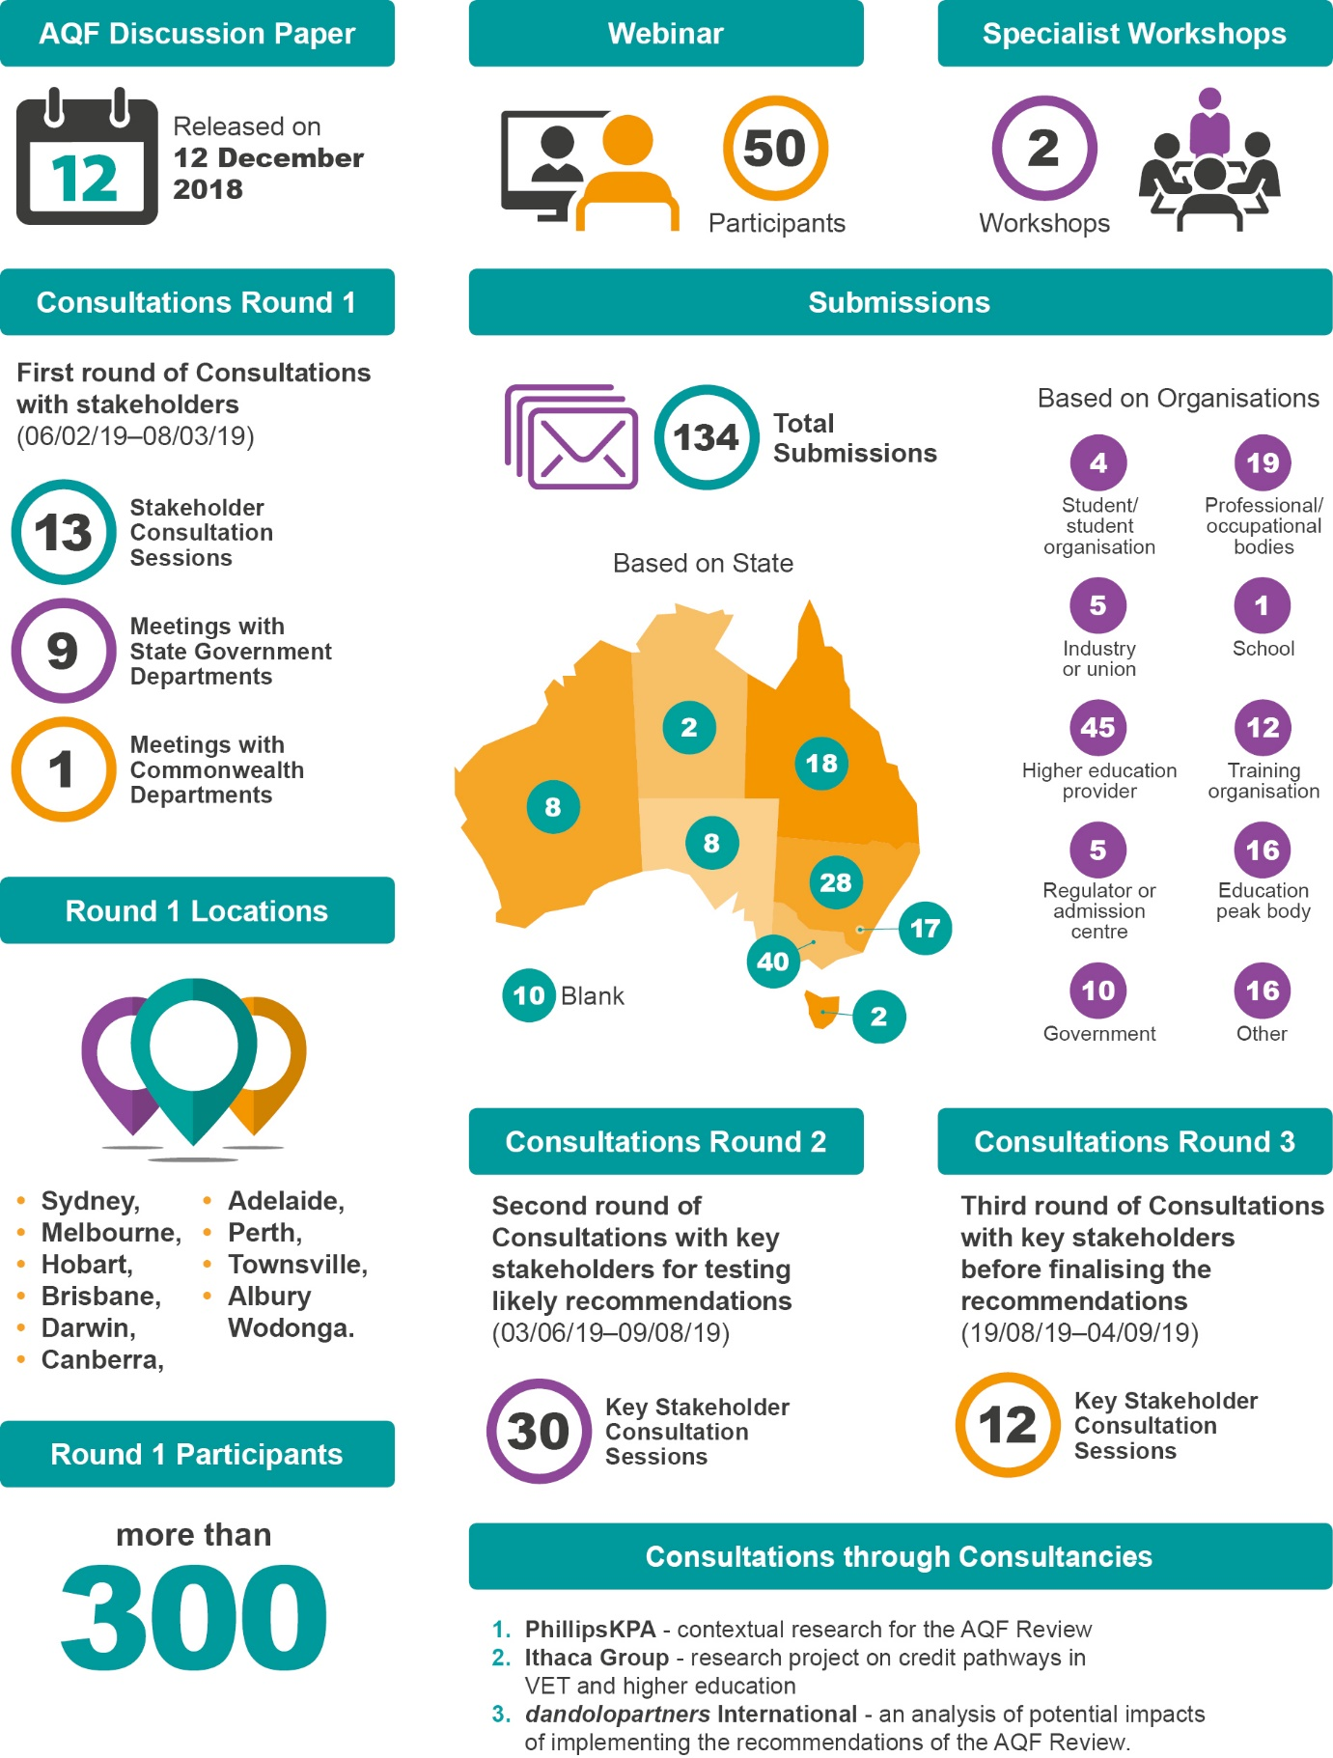The Review conducted extensive consultation processes as shown in this diagram.

The diagram is an infographic providing an overview of the consultation process. The AQF Discussion Paper was released on 12 December 2018. The first round of consultations spanned 6 February 2019 to 8 March 2019. There were 13 stakeholder consultation sessions, 9 meetings with state government departments and 1 meeting with Commonwealth departments. The round one locations were: Sydney, Melbourne, Hobart, Brisbane, Darwin, Canberra, Adelaide, Perth, Townsville, Albury Wodonga. There were more than 300 participants in Round 1. There was a webinar with 50 participants. There were two specialist workshops. There were 134 total submissions: ACT (17), NSW (28), NT (2), QLD (18), SA (8), TAS (2), VIC (40), Blank (10). Based on organisations there were: Student/student organisation (4), Industry or union (5), Higher education provider (45), Regulator or admission centre (5), Government (10), Professional/occupational bodies (19), School (1), Training organisation (12), Education peak body (16), Other (16). There was a second round of consultations with key stakeholders for testing likely recommendations between 3 June 2019 and 9 August 2019. This involved 30 key stakeholders. There was a third round of consultation with key stakeholders before finalising the recommendations between 19 August and 4 September. This involved 12 key stakeholders. There were also consultations through consultancies: 1. PhillipsKPA – contextual research for the review; 2. Ithaca Group – research project on credit pathways in VET and higher education; 3. dandolopartners International – an analysis of potential impacts of implementing the recommendations of the AQF Review.

### Stakeholder consultations

The Chair and Panel members met with stakeholders over the course of the review testing propositions and concepts as they developed. Like the Review process itself, the consultations were an iterative process with key stakeholders consulted multiple times depending on the issue and their interests.

Between 6 February and 8 March 2019, the Panel held stakeholder consultation sessions in each state and territory capital city, as well as Albury-Wodonga and Townsville. The Panel also met with state government departments, including with officials supporting the COAG Education and Industry and Skills Councils.

* Sydney, 6 February (Government Meeting)
* Sydney, 7 February (Two Consultation Sessions)
* Albury, 8 February (Consultation Session)
* Melbourne. 11 February (Two Consultation Sessions)
* Melbourne. 12 February (Government Meeting)
* Hobart, 15 February (Government Meeting, Consultation Session)
* Brisbane, 19 February (Consultation Session, Government Meeting)
* Townsville, 20 February (Consultation Session)
* Darwin, 21 February (Government Meeting, Consultation Session)
* Canberra, 26 February (Consultation Session, Government Meeting)
* Canberra, 28 February (Government Meeting with Commonwealth department officials)
* Adelaide, 5 March (Consultation Session, Government Meeting)
* Perth, 6 March (Consultation Session, Government Meeting)
* Melbourne, 8 March (Consultation Session with Professional Bodies)

More than 300 people attended the consultations.

A webinar was broadcast on 1 March 2019. The webinar attracted over 50 unique log-ins.

The consultations concentrated on the issues outlined in the AQF Review discussion paper (released on 12 December 2018). The Review received 134 responses to its request for submissions.

The submissions were primarily from higher education providers, followed by peak education and training bodies, professional/occupational bodies and training organisations. Only one union made a submission – the National Tertiary Education Union. Ai Group, The Australian Chamber of Commerce and Industry and the Business Council of Australia made a submission.

While organisations in each state and territory made submissions, the majority were received from Victoria, New South Wales and the Australian Capital Territory, reflecting the locations of most peak organisations.

Table . Submissions breakdown based on states and type of organisation

|  |  |  |  |
| --- | --- | --- | --- |
| State |  | Organisation |  |
| ACT | 17 | Student/student organisation | 4 |
| NSW | 28 | Professional/occupational bodies | 19 |
| NT | 2 | Industry or union | 5 |
| QLD | 18 | School | 1 |
| SA | 8 | Higher education provider | 45 |
| TAS | 2 | Training organisation | 12 |
| VIC | 40 | Regulator or admission centre | 5 |
| WA | 8 | Education peak body | 16 |
| Blank | 10 | Government | 10 |
|  |  | Other | 16 |

The submissions varied in their coverage of the main issues and the three questions posed in the discussion paper. A number attempted to propose solutions for the AQF as a whole, while many focused on selected issues. The submissions paid least attention to implementation issues.

Overall, the possible approaches outlined by the Panel in the discussion paper received good support.

In the second round of consultations, the Panel tested likely recommendations with key stakeholders in June and July 2019 including:

* Universities Australia (UA)
* Deputy Vice-Chancellors Academic (DVCA)
* Group of Eight (Go8)
* Innovative Research Universities (IRU)
* Regional Universities Network (RUN)
* Australian Technology Network of Universities (ATN)
* Tertiary Education Quality and Standards Agency (TEQSA)
* Australian Skills Quality Authority (ASQA)
* Training Accreditation Council Western Australia (WA TAC)
* Victorian Registration and Qualifications Authority (VRQA)
* Australian Government departments, including:
* Department of Employment, Skills, Small and Family Business
* Department of Industry, Innovation and Science
* Department of the Prime Minister and Cabinet
* Department of Home Affairs
* Attorney-General’s Department
* Australian Bureau of Statistics
* Higher Education Standards Panel (HESP)
* TAFE Directors Australia (TDA)
* Trades Recognition Australia (TRA)
* Australian Chamber of Commerce and Industry (ACCI)
* Business Council of Australia (BCA)
* VETASSESS
* Professions Australia
* Australian Council of Trade Unions (ACTU)
* The Australian Trade and Investment Commission (Austrade)
* Skills Service Organisations (SSOs), including:
* PwC Skills for Australia
* Artibus
* IBSA
* Skills IQ
* Skills Impact
* Australian Industry Standards
* National Association of Enabling Educators of Australia (NAEEA)
* National Centre for Vocational Education Research (NCVER)
* The Australasian Curriculum, Assessment and Certification Authorities (ACACA)
* Australian Small Business and Family Enterprise Ombudsman
* Independent Higher Education Australia (IHEA)
* Independent Tertiary Education Council Australia (ITECA)
* International Education Association of Australia (IEAA)
* English Australia
* National Union of Students (NUS)
* National Aboriginal and Torres Strait Islander Postgraduates Association (NATSIPA)
* Council of International Students Australia (CISA)
* Council of Australian Postgraduate Associations (CAPA)

In the third round of consultations, the Chair engaged again with key stakeholders before finalising the recommendations. Fifteen meetings were conducted in this round during August 2019 and early September 2019.

## Appendix . Contracted consultancies

### Research to inform the Review

During the process of the Review, the Department of Education commissioned work to inform the Review. The department commissioned:

* PhillipsKPA to undertake contextual research for the Review
* Ithaca Group to undertake a research project on credit pathways in VET and higher education
* The Australian Centre for Educational Research (ACER) to undertake an analysis and revision of the AQF learning outcome descriptors
* dandolopartners and Ithaca Group to undertake an analysis of potential impacts of implementing the recommendations of the AQF Review.

Two smaller pieces of work were also commissioned:

* Ithaca Group facilitated two AQF Review Specialist Workshops
* Emeritus Professor Beverley Oliver provided advice on microcredentials.

#### Contextual Research for the Review

The Department of Education commissioned PhillipsKPA to conduct contextual research for the Review in December 2017. The research covered international qualifications frameworks and initial stakeholder views; and informed the Review’s Terms of Reference. PhillipsKPA finalised its report in April 2018.

Main findings:

* The AQF is very widely used across the Australian tertiary sectors and is generally accepted as a useful instrument with both national and international benefits.
* In the 1990s and early 2000s, Australia was a global leader in the development of qualifications frameworks. However, other countries, particularly in Europe, have moved beyond the concept of qualifications frameworks principally as a tool to establish transparency and equivalence of qualifications, towards qualifications frameworks as a tool to facilitate an agile workforce suited to rapid technological, industrial and social change.
* Prominent within the changing policy context for qualifications frameworks is a desire to design them to allow and encourage more flexible construction of learning pathways. Flexible and multi-directional pathways rather than simple hierarchical ones (as the AQF is perceived to be) are regarded as better suited to lifelong learning and rapid retraining to meet new technological challenges.
* There are issues related to implementation of the AQF by both regulators and providers that require attention. These issues include ambiguity in terminology, inconsistencies in qualifications descriptors, levels criteria and volume of learning.
* There are no mechanisms within the Australian system to assign levels to ‘non-standard’ learning options, or to regulate or quality assure credit towards formal qualifications for in-service or informal learning or microcredentials in a way that ensures national or international consistency.
* The AQF relies heavily on notional volumes of learning expressed in years of study, which is out of step with modern international practice. Movement towards a system based on credit point values related to notional average hours required to achieve learning outcomes would be in keeping with international practice and would have the added advantage of facilitating a common currency for a national credit transfer system to support pathways and recognition of non-formal learning.

#### Credit Pathways in VET and Higher Education

The department commissioned Ithaca Group to examine credit practices in VET and higher education in May 2018. Ithaca Group delivered its final report on 12 October 2018.

Main findings:

* Provider behaviour is mostly driven by the requirements of sector regulation. Providers do not feel compelled to attend to the requirements of the AQF Pathways Policy separately, and regulators do not audit or consider provider compliance with it.
* Higher education regulation allows providers more flexibility in setting their credit policies than VET regulation. This means higher education providers’ practices are determined more by their own assessment of costs and benefits. Some higher education providers value a more diverse student cohort; and attracting additional enrolments through proactive credit practices. Others seek to maintain a reputation for exclusivity and their practices are more passive.
* There is no single source of national data (or combination) that can be used to understand the level of credit pathway activity, and the level of demand for greater access to credit pathways is impossible to ascertain. This means that there is currently no means to determine how many learners access credit pathways, let alone how many more would like to access them.
* Similarly, at the provider level, the form in which information is collected, or not collected, and analysed, or not analysed, varies according to the practice of each provider.
* Despite its status outside sector regulation, almost all the stakeholders that participated expressed a view that the Pathways Policy was valuable for expressing agreed national principles that are relevant across jurisdictions and education and training sectors.
* The Pathways Policy, and the AQF, have played a useful role in establishing the arrangements that they have in place for credit transfer, articulation, and RPL. However, providers were emphatic that their practices would continue regardless of whether or not there was a policy.
* However, both the VET and higher education sectors did not identify with much of the policy’s other content, and a number of stakeholders reported the policy’s guidance on credit and credit arrangements between providers was too simplistic.

#### Analysis and Revision of the AQF Learning Outcome Descriptors

The department commissioned ACER to examine the learning outcomes descriptors of each AQF level in VET and higher education in March 2019. ACER delivered its final report on 23 September 2019.

Main findings:

* If the main purpose of the AQF is to ensure the validity, reputation and perceived value of formal qualifications gained through the Australian education and training system, then the current AQF learning outcomes matrix does not do this.
* There are major issues with the nature and content of the AQF learning outcomes descriptors that cannot be ‘fixed’ through a revision of the language. They include general lack of clarity, specific ambiguities and widespread inconsistencies. These stem from the AQF having been built to accommodate existing qualification types rather than on the basis of a sound learning outcomes progression.
* Most other qualifications frameworks suffer from many of the same weaknesses as the AQF.
* ACER did not recommend a revision of the current learning descriptors. However, it did recognise the need to provide a physical example of what is possible, even though it would retain many current deficiencies.
* ACER found that it was necessary to reduce the number of levels in the AQF in order to develop outcomes that adequately distinguish between levels.
* ACER was able to identify eight levels for the ‘Knowledge’ domain and found it would be possible to develop between five and six levels for ‘Skills’.
* ACER redesigned the level descriptors to genuinely differentiate qualification types and provide common reference points that can be used to inform course design, accreditation and regulation, international comparison and other functions. The approach may also provide better signals to prospective students selecting courses and to potential employers of graduates.
* ACER proposed a new ‘architecture’ for the framework that includes three domains (Knowledge, Skills and Application), They have added ‘focus areas’ to each domain (three for Knowledge, five for skills and two for Application). Knowledge is divided into eight bands of increasingly complex action-oriented knowledge descriptors. Skills has five descriptors and does not have hard borders. Application is not divided into bands. This will allow flexibility in describing qualification types.
* ACER suggested the focus of the framework be changed to the descriptors that are intended to ensure that graduates obtain the desired learning outcomes.
* The model developed by ACER accommodates the possibility that new qualification types might be introduced in the future.

#### Analysis of Potential Impacts of Implementing the Recommendations of the Review of the AQF

The department commissioned dandolopartners and Ithaca Group to examine possible implementation issues in April 2019. The final report was delivered on 29 August 2019.

Main findings:

* The AQF is embedded throughout legislation, regulation, policy, processes and systems, and is used as a reference point for a range of purposes across government and any changes could have significant impacts across a broad range of stakeholders and sectors.
* dandolopartners was not asked to analyse the benefits of the proposals but it did provide a number of comments on the benefits of greater clarity, a more discrete approach to levels and qualification types, and greater consistency.
* The most significant impacts are likely to result from any changes to qualification types, in particular, the creation, disestablishment or alteration of types. This is because qualification types, rather than AQF levels, tend to be used as the primary reference point for policies, processes, data collection and course design and accreditation.
* With some key exceptions, the creation of a revised AQF taxonomy with a different number of bands or levels than the current structure will not cause significant impacts or implementation challenges, as long as qualification types can be easily and clearly mapped to a band.
* While the proposed change to volume of learning, from years to hours, will not necessarily cause large impacts or require significant implementation activities, there remains a high level of concern and uncertainty about what this change may mean for other, existing units of measurement for course duration and for the focus of regulation.
* It will not be possible to fully understand the implications until stakeholders, including providers, undertake comprehensive internal reviews to consider the breadth of the policies, processes, systems and regulations that may need to be updated in response to changes to the AQF.
* It is therefore important that the implementation approach:
* Ensures that all those likely to be affected understand the rationale for the proposed changes and the likely benefits.
* Involves ongoing consultation with impacted parties in the development and the drafting of the revised AQF.
* Allows sufficient time for stakeholders to fully review and identify relevant implementation considerations.
* Ensures that given the effort involved, the maximum, as opposed to incremental, benefits are achieved from the recommendations.

#### AQF Review Specialist Workshops

The department commissioned Ithaca Group to facilitate two AQF Review Specialist Workshops which were held by the AQF Review Panel on 7 and 12 December 2018. The first workshop held in Sydney, focussed on general capabilities. The second workshop focussed on the AQF ‘taxonomy’ and microcredentials.

Key themes from the workshops that Ithaca Group identified were:

* Inconsistency in the interpretation and use of the AQF has resulted in considerable variation in the breadth and depth of knowledge contained in qualifications at the same AQF level.
* The current specification of ‘volume of learning’ – as a duration expressed in years – should be replaced with a measure that accommodates contemporary approaches to learning and more appropriately reflects the complexity and depth of expected qualification outcomes.
* A multi-dimensional framework model could enable the inclusion of detail for nontechnical and context-dependent skills without locking them into the current AQF hierarchy.
* A student-centred approach to the design of the AQF may help to ensure that the framework matches the non-linear reality of learner journeys. Distinguishing between initial and preparatory qualifications and those that are used for skills deepening or upskilling was suggested as a mechanism for clearly depicting pathways.

For the AQF to maintain its relevance in the future, it will be important for it to accommodate the recognition of shorter form credentials, including microcredentials, skill sets, hallmarks, short courses, and enabling courses. The adoption of a credit matrix approach was suggested as a mechanism for supporting the recognition of shorter form credential outcomes.

Panel members were joined in the workshops by the following participants:

Table . Workshop participants

|  |  |
| --- | --- |
| Sydney | Melbourne |
| **Professor Shirley Alexander**  Deputy Vice-Chancellor and Professor of Learning Technologies  University of Technology, Sydney | **Dr Simon Booth**  Executive Director, Tertiary Education Policy and Performance,  **Higher Education and Skills Group (HESG)**  Victoria Department of Education and Training |
| **Professor John Buchanan**  Head of the Discipline of Business Analytics  University of Sydney Business School. | **Professor Berwyn Clayton**  Emeritus Professor, Victoria University |
| **Associate Professor Sandra Milligan**  Director and Principal Fellow of the Assessment Research Centre  Melbourne Graduate School of Education  The University of Melbourne | **Mr Andre Diez de Aux**  Director, Quality Services  TAFE Directors Australia |
| **Ms Kate Perkins**  Senior Research Fellow  Australian Council for Educational Research (ACER) | **Dr Andrew Harvey**  Director of the Centre for Higher Education Equity and Diversity Research  La Trobe University |
| **Mr Graeme Plato**  Executive Director, Skills Policy Enablers & Analytics  NSW Department of Industry, Skills and Regional Development | **Alfred Deakin Professor Beverley Oliver**  Deputy Vice-Chancellor (Education)  Deakin University |
|  | **Mr Bob Paton**  Managing Director  Bob Paton and Associates Pty Ltd |

#### Microcredentials

The Department of Education commissioned Emeritus Professor Beverley Oliver in June 2019 to provide advice on what guidelines should be put in place to recognise microcredentials for credit within full AQF qualifications. Professor Oliver delivered her final report on 11 July 2019.

Main findings:

* While micro-credentials are an exciting innovation in higher education, and they are a key opportunity to ensure learners, particularly working learners, continue to learn and have their learning certified, there is also a great deal of confusion for stakeholders.
* If microcredentials start to qualify for credit in an AQF qualification they would likely need to meet higher teaching and learning standards than is currently required.
* Some credit-bearing microcredentials (for example, MicroMasters) are purposefully designed as a credit pathway to a qualification. Others may be courses that subsequently achieve recognition for credit (for example, Australian Institute of Company Directors Course), in which case expectations of standards practices apply. In contrast, non-credit-bearing microcredentials are assessed but they do not earn admission to, or credit towards, a formal qualification.
* Microcredentials need further definition and the definition needs to incorporate standards.
* Digital badges are validations earned rather than a course itself. Anyone can make a badge and confer it to anyone else, and it can be circulated on social media. Good academic governance and administration are required to govern and manage future claims for acknowledgement or credit.
* A guidance note might be the best medium to clarify the standards with regard to credit-bearing microcredentials related to higher education qualifications. A subsequent good practice note might help to keep providers up to date in this very fast-moving field.

## Appendix . History of the AQF

### AQF development history

Table . AQF development history

|  |  |
| --- | --- |
| Year | Development |
| 1995 | AQF introduced, with full implementation scheduled for 2000. |
| 1995 | Qualifications included were the Senior Secondary Certificate of Education, Certificate I, Certificate II, Certificate III, Certificate IV, Diploma, Advanced Diploma, Bachelor Degree (including Bachelor Honours Degree), Graduate Certificate, Graduate Diploma, Masters Degree and Doctoral Degree. |
| 2002 | National guidelines for cross-sector linkages were included. |
| 2004 | National principles and operational guidelines for recognition of prior learning added.  Associate Degree added. |
| 2005  2009-2010 | Vocational Graduate Certificate and Vocational Graduate Diploma added  The Australian Qualifications Framework reviewed |
| 2011  2013  2015 | The Australian Qualifications Framework First Edition July 2011 introduced, following a review 2009-2010.  Placed the AQF qualification types within a 10-level structure of increasing complexity.  Introduced new and amended policies: a Qualifications Issuance Policy, a Qualifications Pathways Policy, a Qualifications Register Policy, and a Qualification Type Addition and Removal Policy.  Qualifications Issuance Policy permits the use of the word “Doctor” in the qualification titles of six Masters Degrees (Extended): legal practice, medical practice, physiotherapy, dentistry, optometry and veterinary practice.  The Australian Qualifications Framework Second Edition January 2013 released  An [addendum](https://www.aqf.edu.au/sites/aqf/files/aqf-addendum-2014.pdf) was published to allow the use of the qualification title ‘Doctor of …’ for a Masters Degree (Extended) for two qualifications: Doctor of Podiatric Medicine and Doctor of Clinical Podiatry. |

### AQF governance

The Australian Qualifications Framework was endorsed by the Ministerial Council on Education, Employment, Training and Youth Affairs (MCEETYA) in November 1994 and was introduced Australia-wide on 1 January 1995.

MCEETYA agreed to establish the Australian Qualifications Framework Advisory Board (AQFAB) in May 1995. The AQFAB held its inaugural meeting on 17 November 1995.

The First Implementation Handbook for the AQF was developed in August 1995. In early 1997, 27,000 copies of a booklet ‘Introduction the AQF: Certificates, Diplomas, Degrees’ were distributed to VET (TAFE and private) providers, universities and schools. The second edition of the implementation handbook was released in 1998. Two further editions of the implementation handbook were released in 2002 and 2007.

The AQFAB was replaced by the Australian Qualifications Framework Council (AQFC) following a review in 2007. It was established under the authority of MCEETYA (and with the agreement of the Ministerial Council for Vocational and Technical Education (MCVTE), The Terms of Reference set by MCEETYA required the AQFC to provide policy advice to MCEETYA (and MCVTE as appropriate) on:

* strategic strengthening of the AQF required to meet identified needs such as improving national consistency and contemporary relevance, including national and international portability;
* improving flexible qualification linkages and pathways in education and training within and across all sectors, including recognition of non-formal and informal learning;
* relevant national and international issues and their implications for national qualifications policy;
* national and international recognition and comparability of qualification standards and alignment of qualifications standards/frameworks.

The AQFC released the first edition of the ‘strengthened’ AQF in July 2011. The legislation establishing the Tertiary Education Quality and Standards Agency (TEQSA) and the Australian Skills Qualifications Authority (ASQA) was passed in June 2011.

In January 2013, the ‘Australian Qualifications Framework 2nd Edition’ was released. Within the context of the Australian Government’s deregulation agenda, the existence of TEQSA and ASQA rendered the AQFC redundant. When the Minister notified the COAG Education Council he was disbanding the AQFC in May 2014, he committed to undertake a review of the AQF within 5 years.

In August 2014, the AQFC was formally disestablished. Some policy and public advice functions related to the AQF continued to be managed by the Department of Education and Training.

1. Within the 14 qualification types, both the Masters Degree and the Doctoral Degree specify more than one qualification type. The Masters Degree specifies the Masters Degree (Research), the Masters Degree (Coursework) and the Masters Degree (Extended). The Doctoral Degree specifies the Doctoral Degree (Research), the Doctoral Degree (Professional) and the Higher Doctorate.
2. OECD, *Qualifications Systems: Bridges to Lifelong Learning*, Education and Training Policy, 2007, p. 22
3. ACARA, Year 12 Enrolment 2017; NCVER, Total VET students and courses 2018; Department of Education, 2017 Student Summary
4. Commonwealth of Australia, [2015 Intergenerational Report: Australia in 2055](https://static.treasury.gov.au/uploads/sites/1/2017/06/2015_IGR.pdf), p. 16
5. Commonwealth of Australia, [2015 Intergenerational Report: Australia in 2055](https://static.treasury.gov.au/uploads/sites/1/2017/06/2015_IGR.pdf), p. 25
6. Australian Bureau of Statistics, [Education and Work, Australia](https://www.abs.gov.au/ausstats/abs@.nsf/mf/6227.0), May 2018, viewed 27 September 2019
7. Department of Jobs and Small Business, [Employment Outlook to May 2023](https://cica.org.au/wp-content/uploads/Employment-Outlook-to-May-2023.pdf), p. 8
8. Department of Jobs and Small Business, [Employment Outlook to May 2023](https://cica.org.au/wp-content/uploads/Employment-Outlook-to-May-2023.pdf), p. 8
9. Australian Bureau of Statistics, [Australian Social Trends, Sep 2011](https://www.abs.gov.au/AUSSTATS/abs@.nsf/Lookup/4102.0Main+Features20Sep+2011#4), viewed 27 September 2019
10. Commonwealth of Australia, [2015 Intergenerational Report: Australia in 2055](https://static.treasury.gov.au/uploads/sites/1/2017/06/2015_IGR.pdf), p. 25
11. Department of Education and Training, [Through Growth to Achievement: Report of the Review to Achieve Educational Excellence in Australian Schools](https://www.education.gov.au/review-achieve-educational-excellence-australian-schools), 2018, p. 47
12. Council of Australian Governments Education Council, [The Review of Senior Secondary Pathways into Work, Further Education and Training](https://www.pathwaysreview.edu.au/)
13. Commonwealth of Australia, [Strengthening Skills: Expert Review of Australia’s Vocational Education and Training System](https://pmc.gov.au/resource-centre/domestic-policy/vet-review/strengthening-skills-expert-review-australias-vocational-education-and-training-system), April 2019
14. Department of Employment, Skills, Small and Family Business, [Skills and Training Budget Overview 2019-20](https://www.employment.gov.au/skills-and-training-budget-overview-19-20), viewed 27 September 2019
15. Council of Australian Governments, [Vision for Vocational Education and Training](https://www.coag.gov.au/sites/default/files/communique/vision-for-vocational-education-and-training.pdf), August 2019
16. Council of Australian Governments, [Meeting Communique, 9 August 2019](https://www.coag.gov.au/meeting-outcomes/coag-meeting-communique-09-august-2019)
17. Council of Australian Governments, [Vision for Vocational Education and Training](https://www.coag.gov.au/sites/default/files/communique/vision-for-vocational-education-and-training.pdf), August 2019
18. Department of Education, [National Regional, Rural and Remote Education Strategy](https://www.education.gov.au/national-regional-rural-and-remote-education-strategy), August 2019
19. PhillipsKPA, [Contextual Research for the Australian Qualifications Framework Review](https://docs.education.gov.au/system/files/doc/other/aqf_contextual_research_0.pdf), p. 74
20. PhillipsKPA, [Contextual Research for the Australian Qualifications Framework Review](https://docs.education.gov.au/system/files/doc/other/aqf_contextual_research_0.pdf), p. 64-65; 79-82
21. Navitas, [Submission to the Review](https://submissions.education.gov.au/Forms/AQF2019/Documents/061-Navitas.pdf), p. 2
22. VETASSESS is a gazetted skills assessing authority under Australia’s skilled migration program and conducts trade skills assessments on behalf of Trades Recognition Australia.
23. VETASSESS, [Submission to the Review](https://submissions.education.gov.au/Forms/AQF2019/Documents/081-VETASSESS.pdf), p. 3
24. University of Technology, Sydney, [Submission to the Review](https://submissions.education.gov.au/Forms/AQF2019/Documents/026-University-of-Technology-Sydney.pdf), p. 1
25. Figure supplied by ACER
26. ACER, The Australian Qualifications Framework: Revision or Re-vision?, 2019, p. 65
27. The simplified ten level framework produced by ACER highlighted the gaps and inconsistencies of the current AQF. The Review asked Adrienne Nieuwenhuis from the University of South Australia, and member of the Higher Education Standards Panel and Australian Industry and Skills Committee, to suggest terms where gaps existed. The model at Appendix 2 is the outcome of that two-step process.
28. Figure supplied by ACER
29. ACER, The Australian Qualifications Framework: Revision or Re-vision?, 2019, p. 55, 56
30. ACER, The Australian Qualifications Framework: Revision or Re-vision?, 2019, p. 64
31. ACER, The Australian Qualifications Framework: Revision or Re-vision?, 2019, p. 72
32. Figure supplied by ACER
33. Psychomotor abilities can be defined as the process of interaction between the perceptual systems (or five senses), the brain (where perceptual information is interpreted) and the body (where the individual reacts to such perceptual stimuli). (ACER, The Australian Qualifications Framework: Revision or Re-vision?, 2019, p. 152)
34. ACER, The Australian Qualifications Framework: Revision or Re-vision?, 2019, p. 106
35. ACER, The Australian Qualifications Framework: Revision or Re-vision?, 2019, p. 82
36. ACER, The Australian Qualifications Framework: Revision or Re-vision?, 2019, p. 83
37. Figure supplied by ACER
38. Example descriptor for Knowledge at Appendix 3.
39. Bloom, B.S., *Taxonomy of educational objectives: The classification of educational goals*, 1956
40. ACER, The Australian Qualifications Framework: Revision or Re-vision?, 2019, p. 85
41. ACER, The Australian Qualifications Framework: Revision or Re-vision?, 2019, p. 79
42. ACER, The Australian Qualifications Framework: Revision or Re-vision?, 2019, p. 84
43. ACER, The Australian Qualifications Framework: Revision or Re-vision?, 2019, p. 89
44. ACER, The Australian Qualifications Framework: Revision or Re-vision?, 2019, p. 89
45. Figure supplied by ACER
46. Ai Group, [Submission to the Review](https://submissions.education.gov.au/Forms/AQF2019/Documents/075-Ai-Group-Response.pdf), p. 5
47. La Trobe University, [Submission to the Review](https://submissions.education.gov.au/Forms/AQF2019/Documents/028-La-Trobe-University.pdf), p. 6
48. For example: University of Tasmania, [Submission to the Review](https://submissions.education.gov.au/Forms/AQF2019/Documents/116-University-of-Tasmania.pdf), p. 6; TAFE Queensland, North Region, [Submission to the Review](https://submissions.education.gov.au/Forms/AQF2019/Documents/111-TAFE-Queensland.pdf), p. 3
49. University of Newcastle, [Submission to the Review](https://submissions.education.gov.au/Forms/AQF2019/Documents/031-University-of-Newcastle.pdf), p. 3
50. University of Sydney, [Submission to the Review](https://submissions.education.gov.au/Forms/AQF2019/Documents/014-University-of-Sydney.pdf), p. 6; Innovative Research Universities, [Submission to the Review](https://submissions.education.gov.au/Forms/AQF2019/Documents/115-Innovative-Research-Universities.pdf), p. 8
51. Department of Employment, Skills, Small and Family Business, Australian Core Skills Framework[Australian Core Skills Framework](https://www.employment.gov.au/australian-core-skills-framework)
52. Department of Employment, Skills, Small and Family Business, [Core Skills for Work Developmental Framework](https://www.employment.gov.au/core-skills-for-work-developmental-framework)
53. The University of Western Australia, [Submission to the Review](https://submissions.education.gov.au/Forms/AQF2019/Documents/010-University-of-Western-Australia.pdf), p. 4; University of Sunshine Coast, [Submission to the Review](https://submissions.education.gov.au/Forms/AQF2019/Documents/082-University-of-the-Sunshine-Coast.pdf), p. 2
54. Australian Qualifications Framework Council, [The Australian Qualifications Framework 2nd Edition](https://www.aqf.edu.au/sites/aqf/files/aqf-2nd-edition-january-2013.pdf), 2013, p. 12-13
55. Commonwealth of Australia, [Strengthening Skills: Expert Review of Australia’s Vocational Education and Training System](https://pmc.gov.au/resource-centre/domestic-policy/vet-review/strengthening-skills-expert-review-australias-vocational-education-and-training-system), April 2019, p. 34
56. Charles Sturt University, [Submission to the Review](https://submissions.education.gov.au/Forms/AQF2019/Documents/084-Charles-Sturt-University.pdf), p. 9
57. For example: La Trobe University, [Submission to the Review](https://submissions.education.gov.au/Forms/AQF2019/Documents/028-La-Trobe-University.pdf), p. 5; University of Tasmania, [Submission to the Review](https://submissions.education.gov.au/Forms/AQF2019/Documents/116-University-of-Tasmania.pdf), p. 8
58. Australian Skills Quality Authority, [Submission to the Review](https://submissions.education.gov.au/Forms/AQF2019/Documents/124-Australian-Skills-Quality-Authority.pdf), p. 5
59. The Australian Clinical Psychology Association, [Submission to the Review](https://submissions.education.gov.au/Forms/AQF2019/Documents/007-Australian-Clinical-Psychology-Association.pdf), p. 3
60. Australian Psychology Accreditation Council, [Submission to the Review](https://submissions.education.gov.au/Forms/AQF2019/Documents/013-Australian-Psychology-Accreditation-Council.pdf), p. 2
61. Council of Australian Governments Education Council, [The Review of Senior Secondary Pathways into Work, Further Education and Training](https://www.pathwaysreview.edu.au/)
62. Council of Australian Governments Education Council, [Review of The Melbourne Declaration on Educational Goals for Young Australians](https://www.reviewmelbournedeclaration.edu.au/)
63. Department of Education and Training, [Through Growth to Achievement: Report of the Review to Achieve Educational Excellence in Australian Schools](https://www.education.gov.au/review-achieve-educational-excellence-australian-schools), 2018, p. 47
64. Department of Education and Training, [Through Growth to Achievement: Report of the Review to Achieve Educational Excellence in Australian Schools](https://www.education.gov.au/review-achieve-educational-excellence-australian-schools), 2018, p. 47
65. Department of Jobs and Small Business, [Australian Jobs 2019](https://docs.employment.gov.au/documents/australian-jobs-publication), p. 36
66. Department of Jobs and Small Business, [Employment Outlook to May 2023](https://cica.org.au/wp-content/uploads/Employment-Outlook-to-May-2023.pdf), p. 8
67. Department of Jobs and Small Business, [Australian Jobs 2019](https://docs.employment.gov.au/documents/australian-jobs-publication), p. 36
68. AlphaBeta, [Future Skills](https://www.alphabeta.com/wp-content/uploads/2019/01/google-skills-report.pdf), 2019, p. 7
69. National Centre for Vocational Education Research, National VET in School Collection 2018, viewed via VOCSTATS, 6 September 2019.
70. Council for International Education’s Expert Members, [Submission to the Review](https://submissions.education.gov.au/Forms/AQF2019/Documents/126-Council-for-International-Education-Expert-Members.pdf), p. 3
71. Council of Australian Governments Education Council, The Review of Senior Secondary Pathways into Work, Further Education and Training, [Discussion Paper](https://uploadstorage.blob.core.windows.net/public-assets/education-au/pathways/190919%20FINAL%20Discussion%20Paper%20-%20Web%20accessible%20post%20design.pdf), 2019, p. 7
72. The University of Melbourne, [Credit, Advanced Standing and Accelerated Entry Policy (MPF1293)](https://policy.unimelb.edu.au/MPF1293#section-4), Accelerated subject entry, 4.24 (a).
73. Council of Australian Governments Education Council, The Review of Senior Secondary Pathways into Work, Further Education and Training, [Discussion Paper](https://uploadstorage.blob.core.windows.net/public-assets/education-au/pathways/190919%20FINAL%20Discussion%20Paper%20-%20Web%20accessible%20post%20design.pdf), 2019, p. 8
74. Commonwealth of Australia, [Strengthening Skills: Expert Review of Australia’s Vocational Education and Training System](https://pmc.gov.au/resource-centre/domestic-policy/vet-review/strengthening-skills-expert-review-australias-vocational-education-and-training-system), April 2019, p. 97
75. In 2018, 54.9 percent of high school students studying VET completed a Certificate II, 34.8 percent completed a Certificate III and 7.2 percent completed a Certificate I. Source: NCVER VOCSTATS, data accessed 24 September 2019.
76. NCVER, [Entry to vocations: building the foundations for successful transitions](https://www.ncver.edu.au/research-and-statistics/publications/all-publications/entry-to-vocations-building-the-foundations-for-successful-transitions), 2014, p. 20
77. Foundation Courses offered to international students in Australia are covered by the [National Standards for Foundation Programs](https://internationaleducation.gov.au/Regulatory-Information/Education-Services-for-Overseas-Students-ESOS-Legislative-Framework/ESOS-Regulations/Documents/FP_Standards_pdf.pdf), enabled by the *Education Services for Overseas Students Act* 2000.
78. The remaining three per cent is made up of non-award courses, enabling courses and other undergraduate courses. Source: Department of Education, [2017 All Students Statistics](https://docs.education.gov.au/node/51321)
79. NCVER, [Total VET students and courses 2018](https://www.ncver.edu.au/research-and-statistics/publications/all-publications/total-vet-students-and-courses-2018), 2019; The remaining fifty percent were participating in short courses, including individual units of competency and skill sets geared towards upskilling and industry compliance requirements.
80. Australian Curriculum and Reporting Authority, [Number and proportion of students enrolled in schools by school level and school sector](https://www.acara.edu.au/reporting/national-report-on-schooling-in-australia/national-report-on-schooling-in-australia-data-portal/student-numbers#View1), 2018, viewed 11 September 2019
81. For example, The University of Melbourne, [Submission to the Review](https://submissions.education.gov.au/Forms/AQF2019/Documents/099-University-of-Melbourne.pdf), p. 2; New South Wales Government, [Submission to the Review](https://submissions.education.gov.au/Forms/AQF2019/Documents/006-NSW-Government.pdf), p. 14
82. Beverley Oliver, [Making Microcredentials Work](http://dteach.deakin.edu.au/wp-content/uploads/sites/103/2019/08/Making-micro-credentials-work-Oliver-Deakin-2019-full-report.pdf), Deakin University, 2019
83. Swinburne University, [Submission to the Review](https://submissions.education.gov.au/Forms/AQF2019/Documents/063-Swinburne-University.pdf), p. 3
84. NCVER, Total VET students and courses – TVA program enrolments 2015-2018, <http://vocstats.ncver.edu.au> extracted on 19/19/2019. This growth has been largely driven by training package skill sets.
85. Research commissioned by DeakinCo and shared with the Review.
86. NCVER, Total VET students and courses – TVA program enrolments 2015-2018, <http://vocstats.ncver.edu.au> extracted on 19/19/2019
87. Commonwealth of Australia, [Strengthening Skills: Expert Review of Australia’s Vocational Education and Training System](https://pmc.gov.au/resource-centre/domestic-policy/vet-review/strengthening-skills-expert-review-australias-vocational-education-and-training-system), April 2019, p. 65
88. Beverley Oliver, [Making Microcredentials Work](http://dteach.deakin.edu.au/wp-content/uploads/sites/103/2019/08/Making-micro-credentials-work-Oliver-Deakin-2019-full-report.pdf), Deakin University, 2019, p. 17
89. Beverley Oliver, *Advice related to micro-credentials for the AQF Review Panel*, July 2019, p. 14
90. <https://edtechnology.co.uk/Article/european-mooc-consortium-launches-common-micro-credential-framework/>, Viewed 29 July 2019
91. Beverley Oliver, *Advice related to micro-credentials for the AQF Review Panel*, July 2019
92. The Standards for Registered Training Organisations 2015 would apply insofar as they relate to training and assessment strategies and practices.
93. Beverley Oliver, [*Making Microcredentials Work*](http://dteach.deakin.edu.au/wp-content/uploads/sites/103/2019/08/Making-micro-credentials-work-Oliver-Deakin-2019.pdf), p. 19, 20
94. Examples include University of Sydney, [Submission to the Review](https://submissions.education.gov.au/Forms/AQF2019/Documents/014-University-of-Sydney.pdf), p. 5, SkillsIQ, [Submission to the Review](https://submissions.education.gov.au/Forms/AQF2019/Documents/023-SkillsIQ-Submission.pdf), p. 5, Griffith University, [Submission to the Review](https://submissions.education.gov.au/Forms/AQF2019/Documents/036-Griffith-University.pdf), p. 2
95. <https://www.nzqa.govt.nz/nzqf/search/microcredentials.do> Accessed 4 September 2019
96. Beverley Oliver, [*Making Microcredentials Work*](http://dteach.deakin.edu.au/wp-content/uploads/sites/103/2019/08/Making-micro-credentials-work-Oliver-Deakin-2019.pdf)*,* p. 19
97. Department of Education, Employment and Workplace Relations, [Higher Education Base Funding Review](https://www.voced.edu.au/content/ngv%3A49506), 2011
98. Department of Education, [2017 All Students Statistics](https://docs.education.gov.au/node/51321)
99. These are known as English Language Intensive Course for Overseas Students (ELICOS). The delivery of ELICOS is regulated by the [ELICOS Standards 2018](https://www.legislation.gov.au/Details/F2017L01349), enabled by the [Education Services for Overseas Students (ESOS) Act 2000](https://www.legislation.gov.au/Series/C2004A00757).
100. Foundation Courses offered to international students in Australia are regulated by the [National Standards for Foundation Programs](https://internationaleducation.gov.au/Regulatory-Information/Education-Services-for-Overseas-Students-ESOS-Legislative-Framework/ESOS-Regulations/Documents/FP_Standards_pdf.pdf), enabled by the [ESOS Act 2000](https://www.legislation.gov.au/Series/C2004A00757).
101. International Education Association of Australia (IEAA) and English Australia (EA), [Submission to the Review](https://submissions.education.gov.au/Forms/AQF2019/Documents/122-International-Education-Association-of-Australia-and-English-Australia.pdf), p. 2
102. National Association of Enabling Educators of Australia, [Submission to the Review](https://submissions.education.gov.au/Forms/AQF2019/Documents/039-National-Association-of-Enabling-Educators-of-Australia.pdf)
103. Innovative Research Universities, [Submission to the Review](https://submissions.education.gov.au/Forms/AQF2019/Documents/115-Innovative-Research-Universities.pdf), p 6; Western Sydney University, [Submission to the Review](https://submissions.education.gov.au/Forms/AQF2019/Documents/022-Western-Sydney-University.pdf), p. 4
104. National Association of Enabling Educators of Australia, [Second Submission to the Review](https://submissions.education.gov.au/Forms/AQF2019/Documents/134-National-Association-of-Enabling-Educators-of-Australia-Submission-2.pdf), p. 2
105. Non-formal learning takes place through a structured program but does not lead to an officially accredited qualification.
106. Informal learning is not externally structured in terms of objectives, time or learning support. It is gained through work, social, family, hobby or leisure activities and experiences.
107. Ithaca Group, [Credit Pathways in VET and Higher Education](https://docs.education.gov.au/node/51846), 2018
108. For example: Australian film, Television and Radio School, Submission to the Review, p. 7; La Trobe University, [Submission to the Review](https://submissions.education.gov.au/Forms/AQF2019/Documents/028-La-Trobe-University.pdf), p. 7
109. For example: Western Sydney University, [Submission to the Review](https://submissions.education.gov.au/Forms/AQF2019/Documents/022-Western-Sydney-University.pdf), p. 3
110. New South Wales Government, [Submission to the Review](https://submissions.education.gov.au/Forms/AQF2019/Documents/006-NSW-Government.pdf), p. 4
111. Federation University Australia, [Submission to the Review](https://submissions.education.gov.au/Forms/AQF2019/Documents/083-Federation-University.pdf), p. 3
112. For example: TAFE Queensland, [Submission to the Review](https://submissions.education.gov.au/Forms/AQF2019/Documents/111-TAFE-Queensland.pdf), p. 3; Victoria State Government, [Submission to the Review](https://submissions.education.gov.au/Forms/AQF2019/Documents/125-Victoria-State-Government.pdf), p. 8
113. Council for International Education’s Expert Members, [Submission to the Review](https://submissions.education.gov.au/Forms/AQF2019/Documents/126-Council-for-International-Education-Expert-Members.pdf), p. 2
114. Victorian TAFE Association, [Submission to the Review](https://submissions.education.gov.au/Forms/AQF2019/Documents/058-Victorian-TAFE-Association.pdf), p. 8
115. Universities Australia, [Submission to the Review](https://submissions.education.gov.au/Forms/AQF2019/Documents/079-Universities-Australia.pdf), p. 3
116. Charles Darwin University, [Submission to the Review](https://submissions.education.gov.au/Forms/AQF2019/Documents/092-Charles-Darwin-University.pdf), p. 2
117. University of Adelaide, [Submission to the Review](https://submissions.education.gov.au/Forms/AQF2019/Documents/097-University-of-Adelaide.pdf), p. 3
118. Independent Higher Education Australia, [Submission to the Review](https://submissions.education.gov.au/Forms/AQF2019/Documents/085-Independent-Higher-Education-Australia.pdf), p. 4
119. VETASSESS, [Submission to the Review](https://submissions.education.gov.au/Forms/AQF2019/Documents/081-VETASSESS.pdf), p. 4
120. Minerals Council of Australia, [Submission to the Review](https://submissions.education.gov.au/Forms/AQF2019/Documents/091-Minerals-Council-of-Australia.pdf), p. 7
121. Australian Catholic University, [Submission to the Review](https://submissions.education.gov.au/Forms/AQF2019/Documents/118-Australian-Catholic-University.pdf), p. 4
122. The University of Queensland, [Submission to the Review](https://submissions.education.gov.au/Forms/AQF2019/Documents/113-University-of-Queensland.pdf), p. 2
123. Innovative Research Universities, [Submission to the Review](https://submissions.education.gov.au/Forms/AQF2019/Documents/115-Innovative-Research-Universities.pdf), p.2
124. Victorian Tertiary Admissions Centre, [Submission to the Review](https://submissions.education.gov.au/Forms/AQF2019/Documents/005-Victorian-Tertiary-Admission-Centre.pdf), p. 3
125. For example, the [TAFE NSW Credit Transfer website](https://credittransfer.tafensw.edu.au/?_ga=2.127175300.826329024.1568090748-577531066.1568090748)
126. University of New England, [Submission to the Review](https://submissions.education.gov.au/Forms/AQF2019/Documents/057-University-of-New-England.pdf), p. 3
127. Tasmanian Government, [Submission to the Review](https://submissions.education.gov.au/Forms/AQF2019/Documents/119-Tasmanian-Government.pdf), p. 7
128. Ithaca Group, [Credit Pathways in VET and Higher Education](https://docs.education.gov.au/node/51846), 2018, p. 5-6
129. dandolopartners, AQF Qualifications Pathways Policy in VET and HE Standards, see Appendix 7
130. Ithaca Group, [Credit Pathways in VET and Higher Education](https://docs.education.gov.au/node/51846), 2018, p. 7
131. Ithaca Group, [Credit Pathways in VET and Higher Education](https://docs.education.gov.au/node/51846), 2018, p. 6
132. AQF Council, [AQF Qualifications Pathways Policy](https://www.aqf.edu.au/sites/aqf/files/aqf_pathways_jan2013.pdf), Australian Qualifications Framework Second Edition January 2013, Section 2.1.3, p. 78
133. Australian Government, [Higher Education Standards Framework (Threshold Standards) 2015](https://www.legislation.gov.au/Details/F2015L01639), 1.2 Credit and Recognition of Prior Learning
134. Ithaca Group, [Credit Pathways in VET and Higher Education](https://docs.education.gov.au/node/51846), 2018, p. 25
135. Ithaca Group, [Credit Pathways in VET and Higher Education](https://docs.education.gov.au/node/51846), 2018, p. 6
136. Ithaca Group, [Credit Pathways in VET and Higher Education](https://docs.education.gov.au/node/51846), 2018, p. 127
137. AQF Council, [Recognition of Prior Learning: An Explanation](https://www.aqf.edu.au/sites/aqf/files/rpl-explanation.pdf), 2012
138. Ithaca Group, [Credit Pathways in VET and Higher Education](https://docs.education.gov.au/node/51846), 2018, p. 22
139. Ithaca Group, [Credit Pathways in VET and Higher Education](https://docs.education.gov.au/node/51846), 2018, p. 40
140. AQF Council, [Volume of Learning: An Explanation](https://www.aqf.edu.au/sites/aqf/files/volume-of-learning-explanation-v2-2014.pdf), 2014, p. 1
141. Ithaca Group, [Credit Pathways in VET and Higher Education](https://docs.education.gov.au/node/51846), 2018, p. 5
142. Ithaca Group, [Credit Pathways in VET and Higher Education](https://docs.education.gov.au/node/51846), 2018, p. 66
143. Additional information on international use of credit point systems is at Appendix 8.
144. Council for International Education’s Expert Members, [Submission to the Review](https://submissions.education.gov.au/Forms/AQF2019/Documents/126-Council-for-International-Education-Expert-Members.pdf), p. 2
145. Ithaca Group, [Credit Pathways in VET and Higher Education](https://docs.education.gov.au/node/51846), p. 114-129
146. Under block model of learning, learners study one unit at a time rather than several at once.
147. AQFC, [Volume of Learning: An Explanation](https://www.aqf.edu.au/sites/aqf/files/volume-of-learning-explanation-v2-2014.pdf), May 2014
148. ASQA, [Users’ Guide to the Standards for RTOs 2015](https://www.asqa.gov.au/standards/chapter-4/clauses-1.1-1.4-and-2.2), Clauses 1.1 to 1.4 and 2.2 – Implementing , monitoring and evaluating training and assessment strategies and practices, Accessed 25 September 2019
149. AQF Council, [Strengthening the AQF: An Architecture of Australia’s Qualifications](https://www.voced.edu.au/content/ngv%3A46835), Consultation paper, 2009, p. 7
150. AQF Council, [Strengthening the AQF: An Architecture of Australia’s Qualifications](https://www.voced.edu.au/content/ngv%3A46835), Consultation paper, 2009, p. 7
151. PhillipsKPA, [Contextual Research for the Australian Qualifications Framework Review](https://docs.education.gov.au/node/50811), 2018, p. 11
152. The University of Western Australia, [Submission to the Review](https://submissions.education.gov.au/Forms/AQF2019/Documents/010-University-of-Western-Australia.pdf), p. 3
153. Institute of Quality Asset Management Pty Ltd, [Submission to the Review](https://submissions.education.gov.au/Forms/AQF2019/Documents/033-Institute-of-Quality-Asset-Management.pdf), p. 2
154. The National Institute of Dramatic Art, [Submission to the Review](https://submissions.education.gov.au/Forms/AQF2019/Documents/038-National-Institue-of-Dramatic-Art.pdf), p. 2, or Quality Training and Hospitality College, [Submission to the Review](https://submissions.education.gov.au/Forms/AQF2019/Documents/009-Quality-Training-and-Hospitality-College.pdf), p. 2-3
155. University of Wollongong, [Submission to the Review](https://submissions.education.gov.au/Forms/AQF2019/Documents/037-University-of-Wollongong.pdf), p. 5
156. National Centre for Student Equity in Higher Education, [Submission to the Review](https://submissions.education.gov.au/Forms/AQF2019/Documents/078-National-Centre-for-Student-Equity-in-Higher-Education.pdf), p. 9
157. For example, The Australian National University, [Submission to the Review](https://submissions.education.gov.au/Forms/AQF2019/Documents/030-Australian-National-University.pdf), p. 6
158. For example, SkillsIQ, [Submission to the Review](https://submissions.education.gov.au/Forms/AQF2019/Documents/023-SkillsIQ-Submission.pdf), p. 5, or University of Canberra, [Submission to the Review](https://submissions.education.gov.au/Forms/AQF2019/Documents/074-University-of-Canberra.pdf), p. 4
159. NCVER, [Do course durations matter to training quality and outcomes?](https://www.ncver.edu.au/research-and-statistics/publications/all-publications/do-course-durations-matter-to-training-quality-and-outcomes), 2019, p. 3
160. ASQA, [A review of issues relating to unduly short training](https://www.asqa.gov.au/sites/g/files/net3521/f/strategic_review_report_2017_course_duration.pdf), 2017, p. 8
161. Energy Safe Victoria, [Submission to the Review](https://submissions.education.gov.au/Forms/AQF2019/Documents/017-Energy-Safe-Victoria.pdf), p. 2
162. Minerals Council of Australia, [Submission to the Review](https://submissions.education.gov.au/Forms/AQF2019/Documents/091-Minerals-Council-of-Australia.pdf), p. 6
163. Australian Chamber of Commerce and Industry, [Submission to the Review](https://submissions.education.gov.au/Forms/AQF2019/Documents/087-Australian-Chamber-of-Commerce-and-Industry.pdf), p. 3
164. AQF Council, [Volume of Learning: An Explanation](https://www.aqf.edu.au/sites/aqf/files/volume-of-learning-explanation-v2-2014.pdf), p. 1
165. AQF Council, [Volume of Learning: An Explanation](https://www.aqf.edu.au/sites/aqf/files/volume-of-learning-explanation-v2-2014.pdf), p. 2
166. TEQSA, [TEQSA and the AQF: Questions and Answers](https://www.teqsa.gov.au/latest-news/publications/teqsa-and-australian-qualifications-framework-questions-and-answers-1), p. 4
167. ASQA, [Users’ Guide to the Standards for Registered Training Organisations 2015](https://www.asqa.gov.au/standards/chapter-4/clauses-1.1-1.4-and-2.2), What clauses 1.1 to 1.4 and 2.2 mean for your RTO
168. Australian Government, [Higher Education Standards Framework (Threshold Standards) 2015](https://www.legislation.gov.au/Details/F2015L01639/Html/Text#_Toc428368852)
169. NCVER 2019, Australian vocational education and training statistics: Total VET students and courses 2018 - data slicer; The proportion of higher education students was 71.3 per cent full-time, though this figure includes non-AQF courses (Department of Education, [Higher Education 2017 Student summary tables](https://docs.education.gov.au/node/51311)).
170. New Zealand Qualifications Authority, [Approval of micro-credentials](https://www.nzqa.govt.nz/providers-partners/approval-accreditation-and-registration/micro-credentials/#heading2-0)
171. Gillis et al., [Empirical validation of the Strengthened Australian Qualifications Framework using Item Response Theory](http://www.voced.edu.au/content/ngv%3A46858), p. 33
172. Council of Australian Postgraduate Associations, [Submission to the Review](https://submissions.education.gov.au/Forms/AQF2019/Documents/042-Council-of-Australian-Postgraduate-Associations.pdf), p. 3
173. Department of Education, [Country Education Profiles](https://internationaleducation.gov.au/Services-And-Resources/Services/Country-Education-Profiles/Access-CEP/Pages/Default.aspx)
174. Commonwealth of Australia, [Strengthening Skills: Expert Review of Australia’s Vocational Education and Training System](https://pmc.gov.au/resource-centre/domestic-policy/vet-review/strengthening-skills-expert-review-australias-vocational-education-and-training-system), April 2019, p. 46
175. PhillipsKPA, [Contextual Research for the Australian Qualifications Framework Review](https://docs.education.gov.au/node/50811), 2018,

     p. 10-11
176. AQF Council, [AQF Qualifications Issuance Policy](https://www.aqf.edu.au/sites/aqf/files/aqf_issuance_jan2013.pdf), Australian Qualifications Framework Second Edition January 2013, Paragraph 2.1.2
177. AQF Council, [Australian Qualifications Framework Second Edition January 2013](https://www.aqf.edu.au/sites/aqf/files/aqf-2nd-edition-january-2013.pdf), AQF specification for Doctoral Degree, p. 63
178. AQF Council, [Australian Qualifications Framework Second Edition January 2013](https://www.aqf.edu.au/sites/aqf/files/aqf-2nd-edition-january-2013.pdf), Issuance Policy, p. 72
179. AQF Council, [Australian Qualifications Framework Second Edition January 2013](https://www.aqf.edu.au/sites/aqf/files/aqf-2nd-edition-january-2013.pdf), AQF Qualifications Registration Policy, p. 83-85
180. As defined in the [National Vocational Education and Training Regulator Act 2011](https://www.legislation.gov.au/Series/C2011A00012), s. 3
181. <https://www.aisc.net.au/> while not technically an ‘accrediting authority’, the AISC has responsibility for approving training packages for endorsement by the COAG Skills Council. Most VET qualifications are approved through this process as part of a training package.
182. [National Vocational Education and Training Regulator Act 2011](https://www.legislation.gov.au/Series/C2011A00012), Part 3, Division 1, ss. 43-44
183. [Education and Training Reform Act 2006 (Vic)](http://www.legislation.vic.gov.au/Domino/Web_Notes/LDMS/PubStatbook.nsf/f932b66241ecf1b7ca256e92000e23be/575C47EA02890DA4CA25717000217213/$FILE/06-024a.pdf), Part 4.2, paragraph 4.2.2; Part 4.4, paragraph 4.4.2
184. [Vocational Education and Training Act 1996 (WA)](https://www.legislation.wa.gov.au/legislation/statutes.nsf/main_mrtitle_1030_homepage.html), Part 7A, s. 58C
185. [Tertiary Education Quality and Standards Agency Act 2011](https://www.legislation.gov.au/Details/C2017C00271), s. 45
186. [Tertiary Education Quality and Standards Agency Act 2011](https://www.legislation.gov.au/Details/C2017C00271), s. 45*;* [Higher Education Standards Framework (Threshold Standards) 2015](https://www.legislation.gov.au/Details/F2015L01639), Part B: Criteria for Higher Education Providers, B1.2
187. [www.training.gov.au/Home/Tga](http://www.training.gov.au/Home/Tga) contains all VET qualifications that have been either approved through the training package approval process, or accredited by a VET Regulator. It also contains a list of all registered training organisations (RTOs) approved by a VET Regulator to deliver AQF qualifications.
188. ASQA, VRQA and WA TAC all have the ability to add and remove RTOs from TGA. The Commonwealth Department of Education maintains the database.
189. [www.teqsa.gov.au/national-register](http://www.teqsa.gov.au/national-register) contains a register of all higher education providers approved by TEQSA to deliver AQF higher education qualifications, and those AQF qualifications. It does not include qualifications developed by self-accrediting institutions (for example, self-accrediting universities).
190. <https://www.courseseeker.edu.au/>
191. The TEQSA register does not include courses accredited by higher education providers registered in the Australian university provider category. Course Seeker includes some, but not all, courses offered by universities in this category.
192. [Standards for Registered Training Organisations (RTOs) 2015](https://www.legislation.gov.au/Series/F2014L01377), Schedule 5 requires RTOS to retain registers of AQF qualifications issued for a period of 30 years as a condition of registration.
193. The [Higher Education Standards Framework (Threshold Standards) 2015](https://www.legislation.gov.au/Details/F2015L01639), Part A: Standards for Higher Education, Standard 7.3 require higher education providers to maintain accurate and up-to-date records of enrolments, progression, completions and award of qualifications.
194. <https://www.usi.gov.au/> The USI applies to training undertaken by domestic and onshore international students since 1 January 2015.
195. The current policy identifies the defunct AQF Council as having this responsibility.
196. Australian Psychological Society, [Submission to the Review](https://submissions.education.gov.au/Forms/AQF2019/Documents/069-Australian-Psychological-Society.pdf), p. 9; University of Technology Sydney, [Submission to the Review](https://submissions.education.gov.au/Forms/AQF2019/Documents/026-University-of-Technology-Sydney.pdf), p. 3
197. University of Technology Sydney, [Submission to the Review](https://submissions.education.gov.au/Forms/AQF2019/Documents/026-University-of-Technology-Sydney.pdf), p. 3; University of Wollongong, [Submission to the Review](https://submissions.education.gov.au/Forms/AQF2019/Documents/037-University-of-Wollongong.pdf), p. 7.
198. AQF Council, [Articulation: An Explanation](https://www.aqf.edu.au/sites/aqf/files/articulation-explanation.pdf), November 2012
199. AQF Council, [Credit Transfer: An Explanation](https://www.aqf.edu.au/sites/aqf/files/credit-transfer-explanation.pdf), November 2012
200. AQF Council, [Recognition of Prior Learning: An Explanation](https://www.aqf.edu.au/sites/aqf/files/rpl-explanation.pdf), November 2012
201. Australian Government, [Standards for Registered Training Organisations 2015](https://www.legislation.gov.au/Details/F2019C00503), ss1.8, 1.13-1.15.
202. Australian Government, [Higher Education Standards Framework](https://www.legislation.gov.au/Details/F2015L01639/), s1.2
203. AQF Council, [Bachelor Honours Degree: An Explanation](https://www.aqf.edu.au/sites/aqf/files/bachelor-honours-degree-explanation.pdf), November 2012
204. AQF Council, [Certification Documentation: An Explanation](https://www.aqf.edu.au/sites/aqf/files/certification-documentation-explanation.pdf), November 2012
205. AQF Council, [Clustered Qualifications: An Explanation](https://www.aqf.edu.au/sites/aqf/files/clustered-qualifications-explanation.pdf), November 2012
206. AQF Council, [Discipline: An Explanation](https://www.aqf.edu.au/sites/aqf/files/discipline-explanation.pdf), November 2012
207. AQF Council, [Graduate: An Explanation](https://www.aqf.edu.au/sites/aqf/files/graduate-explanation.pdf), November 2012
208. AQF Council, [Proportion of Components of a Qualification at Level: An Explanation](https://www.aqf.edu.au/sites/aqf/files/components-of-a-qualification-explanation.pdf),

     November 2012
209. AQF Council, [Research: An Explanation](https://www.aqf.edu.au/sites/aqf/files/research-explanation.pdf), November 2012
210. AQF Council, [Volume of Learning: An Explanation](https://www.aqf.edu.au/sites/aqf/files/volume-of-learning-explanation-v2-2014.pdf), Version 2, May 2014
211. PhillipsKPA, [Contextual Research for the Australian Qualifications Framework Review](https://docs.education.gov.au/node/50811), p. 12
212. <https://www.aqf.edu.au/>
213. <http://www.tcu.gov.on.ca/pepg/programs/oqf/>, Accessed 6 September 2019
214. <https://www.qqi.ie/Articles/Pages/National-Framework-of-Qualifications-(NFQ).aspx>, Accessed 6 September 2019
215. New Zealand Qualifications Authority, [Further consultation on proposed changes to the New Zealand Qualifications Framework](https://www.nzqa.govt.nz/assets/About-us/Consultations-and-reviews/NZQF-Review/NZQF-second-consultation-paper-FINAL-.pdf), p. 24
216. PhillipsKPA, [Contextual Research for the Australian Qualifications Framework Review](https://docs.education.gov.au/node/50811), p. 17. Of the 21 qualification frameworks considered by PhillipsKPA, 13 had no legislative underpinning, and eight were supported by legislation.
217. dandolopartners , *AQF Impact Assessment*, 2019, p. 4
218. dandolopartners, *AQF Impact Assessment*, 2019, p. 4
219. dandolopartners, *AQF Impact Assessment*, 2019, p. 5
220. Department of Home Affairs, [Submission to the Review](https://submissions.education.gov.au/Forms/AQF2019/Documents/049-Department-of-Home-Affairs.pdf), August 2019, p. 2
221. dandolopartners, *AQF Impact Assessment*, 2019, p. 19
222. Attorney General’s Department, Communication, 10 July 2019
223. dandolopartners, *AQF Impact Assessment*, 2019, p. 20
224. PhillipsKPA, [Contextual Research for the Australian Qualifications Framework Review](https://docs.education.gov.au/node/50811), Appendices 1 and 2
225. Including issuance policy, pathways policy, register policy, addition or removal policy, and principles and processes for alignment with international qualifications frameworks and relevant explanations
226. A European credit system for VET (ECVET) was adopted by European Parliament in 2010. A 2015 monitoring report stated ‘there is still a long way to go to the moment we can speak about a European credit system in VET’. CEDEFOP, [ECVET in Europe: Monitoring report 2015](https://www.cedefop.europa.eu/sv/publications-and-resources/publications/5556), p. 1
227. European Commission, [ECTS Users’ Guide](https://europass.cedefop.europa.eu/sites/default/files/ects-users-guide_en.pdf), p. 25
228. The European Students Union, [Bologna with Student Eyes 2015](http://www.ehea.info/media.ehea.info/file/ESU/32/8/Bologna-With-Student-Eyes_2015_565328.pdf), p. 52
229. The European Students Union, [Bologna with Student Eyes 2018](https://www.esu-online.org/wp-content/uploads/2019/02/BWSE-2018_web_Pages.pdf), p. 87
230. Scottish Credit and Qualifications Framework Partnership, [SCQF Handbook 2015](https://scqf.org.uk/media/1125/scqf_handbook_web_final_2015.pdf), p. 21
231. Scottish Credit and Qualifications Framework Partnership, [SCQF Handbook 2015](https://scqf.org.uk/media/1125/scqf_handbook_web_final_2015.pdf), p. 7
232. New Zealand Qualifications Authority, [The New Zealand Qualifications Framework](https://www.nzqa.govt.nz/assets/Studying-in-NZ/New-Zealand-Qualification-Framework/requirements-nzqf.pdf), 2016, p. 8
233. Department of Education, [Country Education Profile: Malaysia](https://internationaleducation.gov.au/Services-And-Resources/services-for-organisations/Pages/Services-for-organisations.aspx), Higher Education: Courses and Qualifications