

International Education Agents

Overview report

Education agents play an important role within Australia’s international education sector and were involved in approximately 75 per cent of overseas student enrolments in 2018. They are valuable partners for providers offering services to overseas students, and in many cases they are the first point of contact an intending student has with the Australia education system.

The *Education Services for Overseas Students Act 2000* (ESOS Act) and the *National Code of Practice for Providers of Education and Training to Overseas Students 2018* (National Code) recognise the challenges of regulating agents, many of whom are offshore. The ESOS Act and the National Code establish providers as responsible for ensuring the education agents they choose to represent them act ethically, honestly and in the best interest of overseas students.

To assist providers to meet these responsibilities, and in the interests of increased transparency in the international education sector, the Australian Government has committed to publish data on education agents. This report is a part of that commitment, providing a high-level overview of the sector, giving education stakeholders an insight into the activity of education agents.

This overview is one component in a broad suite of tools which will support providers to meet their obligations with respect to education agents. The Government is working towards full public release of education agent data. Full public release of student outcomes for enrolment and visa outcomes of students recruited by agents will facilitate improved decision-making by providers, agents and students and incentivise providers and agents to work towards better student outcomes.

**Education agent involvement in enrolments**

In 2018, there were 6,878 active agencies and 19,413 agents involved in enrolments for overseas students at Australian education providers. Education agencies are the business entities and education agents are the individual counsellors assisting overseas students. The percentage of enrolments facilitated by an education agent varies by sector, as shown in Figure 1. As might be expected, prospective students looking to study English Language Intensive Courses for Overseas Students (ELICOS) are the most reliant on education agents. There has been a gradual increase in education agent involvement in enrolments over the last five years across the Higher Education, VET, Schools, and ELICOS sectors.

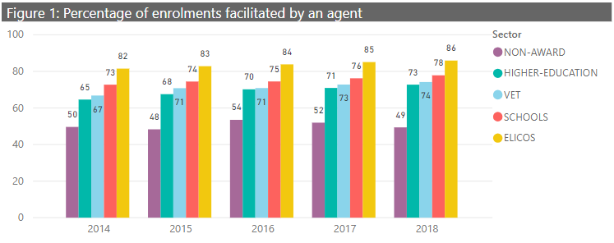

The percentage of enrolments that are facilitated by agents also varies across the top student nationalities for Australia as detailed in Table 1. Notably, emerging partner countries such as Nepal, Brazil and Colombia have a larger proportion of enrolments facilitated by agents, compared to more established partner countries such as China, India and Malaysia.

Table 1 : Agency Numbers and Percentage of Enrolments Facilitated by Agents in 2018

| Student Nationality | % Enrolments Facilitated by Education Agents | Number of Agencies |
| --- | --- | --- |
| China | 73% | 1892 |
| India | 72% | 1427 |
| Nepal | 84% | 977 |
| Brazil | 92% | 479 |
| Colombia | 89% | 423 |
| Vietnam | 77% | 595 |
| Korea, Republic of (South) | 85% | 497 |
| Malaysia | 71% | 722 |
| All countries | 75% | 6878 |

The number of enrolments and the provider agency contacts shown in Table 2 further describes the different relationship between providers and agencies for top student nationalities. There is less variation in the number of education providers each agency works with on average, compared to the number of agencies each provider works with for different student nationalities. This is likely due to the relative size of each market and whether these markets are emerging or established.

Table 2: Agency and Provider relationships in 2018

| Student Nationality | Average Number of Agencies per Provider | Average Number of Providers per Agency | Average Number of Enrolments per Agency |
| --- | --- | --- | --- |
| China | 16 | 5 | 84 |
| India | 15 | 5 | 61 |
| Nepal | 13 | 5 | 53 |
| Brazil | 9 | 7 | 77 |
| Colombia | 9 | 8 | 62 |
| Vietnam | 7 | 4 | 33 |
| Korea, Republic of (South) | 6 | 6 | 45 |
| Malaysia | 6 | 3 | 25 |

**Agency characteristics**

There has been an increase in the number of education agencies working with Australian providers in the last five years. While in part this reflects better data capture, it also reflects growth in student enrolments. Since 2014 to 2018, enrolments have grown by 35%, faster than the 27% growth in the number of agencies.

There is a wide divergence in scale of agencies who work with Australian providers as shown in Figure 2. The distribution of agency size and the percentage of enrolments facilitated over the last five years shows that there is an increasing number of small and medium sized agencies. Small agencies are classified as agencies involved in 1-10 enrolments per year, medium agencies are those involved in 11-500 enrolments per year, and large agencies are those involved in more than 500 enrolments per year.

While there are many small and medium sized agencies, the vast majority of enrolments are facilitated by large agencies as demonstrated in Figure 3. In 2018, small agencies with less than 10 enrolments made up more than half (52%) of all agencies, yet account for around 2 percent of all enrolments. At the other end of the spectrum, larger agencies comprised less than 3.5 percent of all agencies, but accounted for almost 70 percent of enrolments.

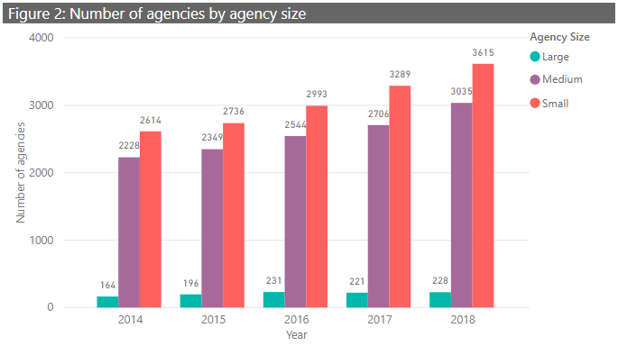

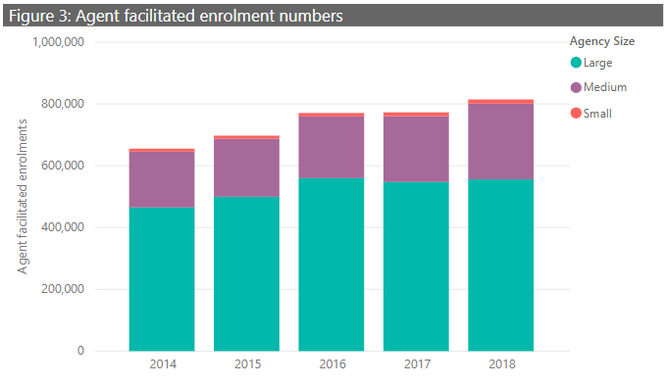

Figure 4 shows that the scale of the agencies appears to have a positive correlation with visa outcomes, with larger agencies experiencing lower visa rejection rates than smaller agencies. In part, this may reflect the sectors or nationalities of enrolment by smaller agencies. As illustrated in Figure 3, small agencies facilitate a relatively small number of enrolments, therefore a small number of visa refusals will more noticeably influence this percentage.

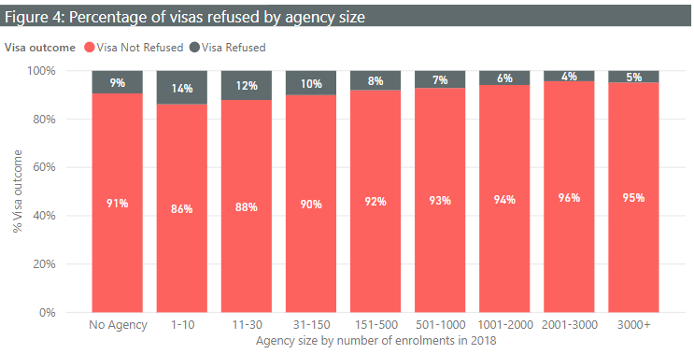

The distribution of the length of operation for agencies active in 2018 demonstrates that there are many young agencies, as shown in Figure 5. The majority of young agencies are small agencies, and this likely reflects newcomers to the industry and higher turnover for small agencies.

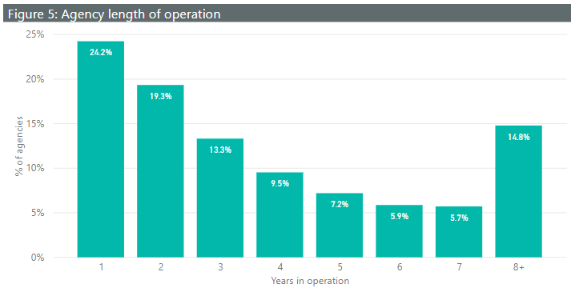

**Student incompletion and visa refusals**

International student visa refusal and incompletion data for 2018 demonstrates the variation in enrolment and visa outcomes for different student nationalities and sectors of enrolment. These plots show the distribution of the visa refusal and student incompletion rates across agencies. Small agencies (10 or less enrolments in 2018 for the relevant sector or nationality) have been excluded to better visualise differences. The different coloured curves allow for comparison across sectors and by top source countries.

**Visa refusal**

The visa refusal rate for an agency is based on the visa outcomes for enrolments they have facilitated. This reveals that generally visa refusal rates tend to be low. The VET and ELICOS Sectors tend to have higher visa refusal rates than Higher Education, Schools or Non-Award. While many agencies have a very low visa refusal rate, agencies facilitating enrolments for students from Nepal tend to have a broader distribution of visa outcomes.

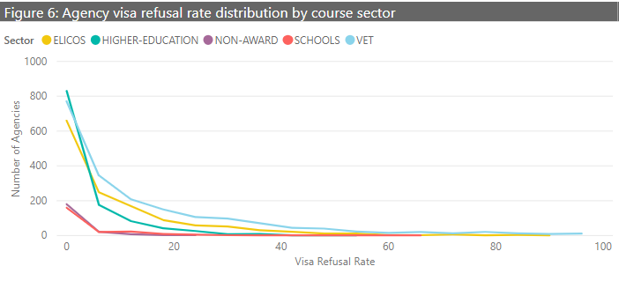

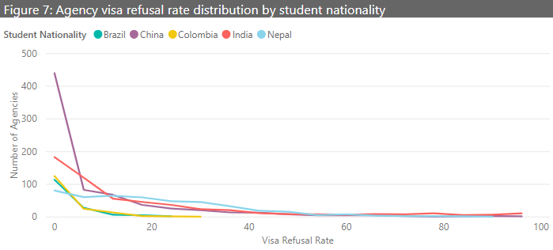

**Student incompletions**

The incompletion rate* for an agency reflects the student outcomes for enrolments facilitated by that agency. Each agency has had their incompletion rate calculated (on the x axis), and the height of the lines (on the y axis) indicates the number of agencies with that incompletion rate. The peak therefore represents the most frequent incompletion rate. A curve where the peak is shifted to the right shows higher incompletion rates than a curve shifted to the left. Here, the schools and non-award sectors demonstrate very low student incompletions, and the VET sector has more agencies with high student incompletion rates. The breakdown of top student nationalities shows that India, China and Nepal have more agencies with high student incompletion rates than Brazil and Colombia.

*Definition of incompletion rate on final page

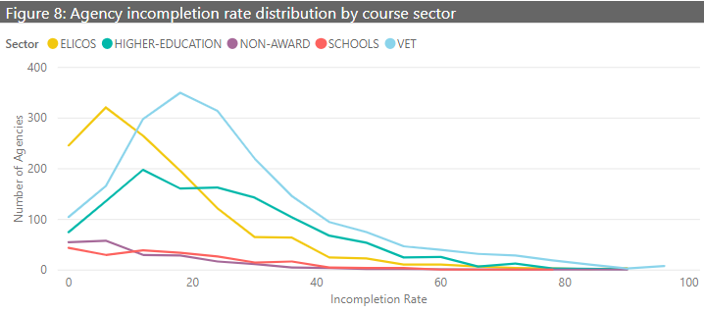

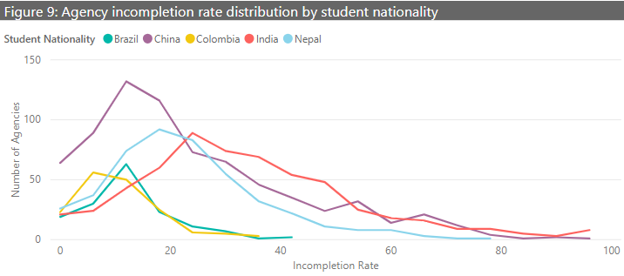

**Where does the data come from?**

This data is sourced from the Australian Government’s Provider Registration and International Student Management System (PRISMS). PRISMS captures enrolment details for all students with student visas and is entered by education providers at the point of enrolment. Providers are also able to nominate education agencies associated with each enrolment. With this information, visa refusals and student enrolment outcomes can be monitored at the sector, provider and education agency level.

Features of PRISMS data include:

* enrolments for students with international student visa activity
* records based on electronic Confirmation of Enrolment (CoE)
* student nationality based on citizenship rather than permanent home residence

**Definitions**

Education Agencies and Agents

An education agency is a business entity that has one or more agents and operates within Australia or overseas or both. Education agents are the individual counsellors assisting overseas students.

**Incompletion rate**

Enrolments are considered “incomplete” when the enrolment record is terminated for the following reasons:

* the student does not commence their studies *
* the student notifies cessation of their studies *
* the student defers or suspends their student enrolment *
* the student transfers to a course at another provider
* the provider decides to cease the student enrolment due to non-payment of fees, student no longer holding a student visa or disciplinary reasons
* there is non-compliance with student visa conditions due to unsatisfactory course progress or unsatisfactory attendance

*For non-commencement, student notifies cessation of studies, and deferment/suspension: terminated enrolment records which have a new enrolment created in the same course at that provider with the same agent involved within 1 day of the initial termination reporting are not included in incompletion.