Short read
Virtual and Augmented Reality and School Education

Erica Southgate
Karen Blackmore
Stephanie Pieschl
Susan Grimes
Jessey McGuire
Kate Smithers

August 2019

Commissioned by the Australian Government Department of Education

To cite this document in APA referencing style:
Southgate, E., Blackmore, K., Pieschl, S., Grimes, S., McGuire, J. & Smithers, K. (2018). Short read: Virtual and augmented reality and school education. Newcastle: University of Newcastle, Australia.
This document is based on the research report below. Please refer to the main report for research and references:
Southgate, E., Blackmore, K., Pieschl, S., Grimes, S., McGuire, J. & Smithers, K. (2018). Artificial intelligence and emerging technologies in schools: A research report. Newcastle: University of Newcastle, Australia.

 | This report is licensed under Creative Commons Attribution 4.0 https://creativecommons.org/licenses/by/4.0/

Virtual and Augmented Reality and School Education
1. Virtual Reality
1.1 What is virtual reality?
Virtual reality (VR) is a 3D computer-generated environment which can be highly imaginative or a realistic simulation of the actual world. Depending on the VR environment, people can interact through first-person view (through their eyes or the eyes of a character) or in the third person (disembodied) perspectives, or they can switch between the two. VR can be delivered via a desktop computer, mobile computing device or with a head mounted display (HMD) which can be a headset or goggles.
1.2 What is immersive virtual reality (IVR)?
For the purpose of this document, we have called VR delivered via a HMD (a headset or googles), immersive VR (IVR). A HMD is a headset or goggles that presents visuals directly to the eyes so that wherever a user looks the display is in front of the eyes, and which tracks (in various ways and degrees) the user’s position in space. This technology creates a feeling of presence, or of psychologically ‘being there’ in a virtual environment. IVR totally replaces the real world with an artificial or simulated reality. The HMD blocks out the world so that the user can be immersed in the artificial world. Different IVR technologies create different levels of immersion and feelings of ‘being there’ in the artificial/simulated environment. Experiences range from passively looking around the virtual world, to those where the user has limited navigation and interaction, to more highly immersive environments where a user can freely manipulate, navigate, interact and create a customised experience.
1.3 The learning properties of virtual reality
Several decades of literature on desktop computer VR has identified the learning properties (known as learning affordances) that can allow for learning with the technology. This literature on desktop computer VR is still relevant for IVR. The properties (or affordances) of the technology can contribute to learning in the following ways:
- First order (person) experiences that support social constructivist conceptions of learning through experiential or guided discovery;
- Natural semantics which is understanding the basis of something before learning about its symbols and abstractions. For example, manipulating angles before learning about why angles are important in mathematics;
- Size and scale manipulation where users can change the size of themselves, objects or environments to interact with micro/macro worlds. For example, going into an atom;
- Reification which is transforming fairly abstract ideas into perceptible representations. For example, travelling with a virus as it mutates and spreads within a population;
- Transduction which is extending user capability to feel ‘data’ that would normally be beyond the range of their senses or experiences. For example, a simulation of the migration paths of whales that allows the learner to follow the paths of different species; and
- Perspective-swapping. For example, recent research highlights the potential for IVR to act as an ‘empathy machine’ to challenge stereotypes and bias.

1.3 Immersive virtual reality and school education
The applications of IVR to school education are only starting to be explored and evaluated through research. A small number of methodologically rigorous studies using desktop computer VR in school STEM classrooms have shown that the technology can assist in developing higher order thinking skills in students. Most literature on IVR in schools is descriptive in nature; that is, it does not evaluate effects on learning outcomes or classroom dynamics that can lead to learning. Some research on highly IVR highlights a range of ethical, safety and child protection issues related to deploying the technology in classrooms and recommends constant supervision of students in IVR. Some surveys of educators identified a range of issues such as: privacy; the potential for learner distraction; cost of equipment; a concern that the novelty of using a new ‘gadget’ would displace the necessary focus on pedagogy and learning design; and a lack of off-the-shelf software suitable for educational purposes. There is some promising research that indicates IVR might be used to engage girls in computational thinking and that customisation (an affordance of some IVR applications) can be used to enhance learning.
1.4 Ethical and safe use of IVR with children
There are no large-scale longitudinal studies on the effects of immersive virtual reality on children or adults. We do not know what the long-term effects of immersion will be. Manufacturers of IVR equipment have issued online health and safety guidelines with age limits on use. These should be consulted before implementing IVR in classrooms. Teachers should consider the physical (motor and perceptual), cognitive, linguistic, emotional (affective), social and moral developmental stage of learners before using IVR in their classroom. IVR can evoke powerful reactions in children who may not be able to cognitively regulate the experience and, for the very young, may come to believe that the virtual experience was real.
Conceptual framework for considering aspects of immersive environments in a developmental context (from Southgate, Scevak and Smith, 2017).
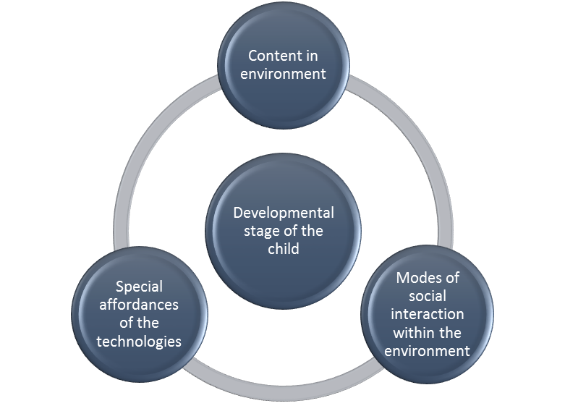
When using IVR for learning, teachers should consider how children at different developmental stages might respond to the content, modes of interaction between students and computer generated characters in the virtual environment, and affordances of IVR technology (Diagram above). There is no way to predict if a child might become cybersick (a type of motion sickness) and so teachers should educate students on identifying symptoms for early opt-out during VR sessions, especially when using highly IVR.
The privacy of students should be considered not only in setting up VR accounts but also in relation to the possibility that biometric data might be collected by manufacturers of VR hardware and software. Biometric data is the automated recognition and collection of measureable data on biological and behavioural characteristics of individuals such as facial recognition or eye tracking. Currently, it is difficult to ascertain if, or what type of, biometric data is being collected. The integration of biometrics in immersive technology presents consent and privacy challenges. This is becoming an area of increasing concern for consumers, law-makers and human rights advocates.
1.5 Conclusion
Whilst immersive learning has arrived, research on the effects of IVR for students and their learning are still emerging. Large-scale longitudinal studies on the effects of immersion are required and rigorous studies on the pedagogical potential of IVR are essential if the affordances of the technology are to be leveraged for creativity, collaboration and deep learning. Building on this knowledge base will take time. In the interim, teachers must take a cautious approach, drawing on manufacturers’ health and safety guidelines and the substantial research on child development. In order to make informed decisions about ethical and safe use of the technology teachers should be aware of privacy, copyright and intellectual property issues when producing and sharing VR content. School systems should be supporting teachers to understand the privacy implications of using immersive technologies with their students.
1.6 Advice for teachers on IVR
A. Consider the educational value of a virtual reality product by asking:
- What can students do with this product that is different from other educational resources or tools? In other words, what are the learning affordances (properties) of the hardware or software which allow me to undertake activities that are different from or extend my usual pedagogical approach?
- Does it offer something that students do not have access to in real life?
- How can the VR product add value to my lessons? Do I want a one-off immersive experience to prompt engagement or experiences that can be revisited or used across key learning areas? Do I want to use it for guided discovery or creative, experimental design – does the product have the affordances that suit my pedagogical approach?
- Can my school meet the technical/hardware and internet network specifications to deploy the VR product? If the school has a BYOD policy, will the student’s device support the VR application?
- Provide opportunities for students to learn with and about VR across curriculum learning areas and in the general capabilities area. Resources on learning with and about VR can be found at The Digital Technologies Hub https://www.digitaltechnologieshub.edu.au/footer/about-dth

B. Stretch your pedagogical imagination with VR ‘sandbox’ or studio environments:
Students do not need to code to be able to create in VR. Look for ‘sandbox’ or studio VR environments that provide learners with easy-to-use tools to create, design, prototype, annotate, interact and navigate with. Sandbox environments such as Minecraft VR or Tilt Brush (a 3D art studio) allow students to build models, simulate places, represent relationships, iterate on design, and exercise creativity. For example, in Minecraft VR students can build models of body organs that are as large as a house, and which allow for guided tours inside and outside the model. Similarly, in history, students can represent an event by researching and creating a 3D map that can be either flown over or toured at ground level. Students reading an historical novel could research and create a map of the setting where the sequence of events are visually symbolised and enhanced with quotes from the text. Tilt Brush can be used for design and prototyping; for example, costume or set design can be created for experiential, formative feedback before the task is undertaken in real life. When considering VR applications, think about whether the software enables creative, interactive or experiential learning, or whether the application (and the school’s internet access) will allow students to collaborate on learning tasks in the virtual environment in ‘multiplayer’ mode.
C. Evaluate how developmentally appropriate the VR experience is for your students:
- Is the content age appropriate?
- How might students respond to modes of social interaction in a virtual environment with other students (if it is networked) and/or with computer generated characters that might populate the environment?
- How might students respond to the learning affordances of VR e.g. cognitively, can they comprehend the purpose of manipulating size and scale? If students can freely navigate in the VR environment, could they become disorientated or overly distracted (and go ‘off-task’)?
D. Consider ethical, legal and safety aspects:
- It is important to undertake a risk assessment. Have students been trained on safety issues including recognising and responding to cybersickness? Has the manufacturer’s health and safety information been consulted and used to screen students who might have medical condition that leaves them vulnerable to negative effects from VR?
- When creating and sharing VR content, have you considered: privacy and cultural issues (images of people and places or information that students are sharing as part of using a VR application); intellectual property (will the platform/vendor own the VR content that we produce and is this an issue); and copyright (are we breaching copyright when incorporating different media in the content we are creating).

2. Augmented reality
2.1 What is augmented reality?
Augmented reality (AR) allows computer-generated information and virtual objects to be overlayed on physical object in real time. Augmented reality is a relatively young technology in terms of mass adoption. Augmented reality can be delivered by via desktop computers, projector systems, mobile devices such as smart phones and tablets, and head mounted displays (headsets, googles or glasses). The most common type of AR is that delivered through mobile devices such as tablets and smart phones.
2.2 Augmented reality and school education
Augmented reality has been used in schools via AR pop-up story and text books, flash cards and educational games; mobile device-enabled augmented field trips; superimposed AR designed for interactive training purposes; and apps that allow students and teachers to create their own AR content. Benefits of using AR learning affordances include:
- the way it transforms content from text to visual and interactive forms;
- its attention grabbing, interactive qualities; its potential to enhance collaboration; and
- the ability of AR simulations to facilitate impossible or infeasible learning experiences (e.g. field trips to far-away places).
Some drawbacks of AR include: useability of some applications and technical issues; the potential for cognitive overload due to the amount of material or complexity of the tasks; and student distraction from key aspects of learning.
2.3 Safe and ethical use of augmented reality
When considering an AR product, the teacher should evaluate the age appropriateness of the content and modes of interaction (see diagram in VR section). It is especially important to assess risks to students who may be moving around in a distracted manner while using mobile devices. When creating and sharing AR content that has been produced by students, teachers should consider student privacy and intellectual property and copyright issues.
2.4 Conclusion
Although AR is a relatively new technology in terms of mass adoption and use in schools, it has potential to engage and motivate students of all ages, especially in learning abstract or theoretical knowledge or allowing for experiences that might be unsafe or infeasible in real life. AR also has potential to encourage collaborative learning. The technology lends itself to small group tasks or more teacher directed learning. The benefits of AR as a training tool are also apparent: being able to look inside or peel back layers of virtual objects, or superimpose images and information on to these objects, can enhance understanding and application of knowledge. AR does present some safety issues, especially in terms of student distraction while using mobile devices. Perhaps the main concerns will be ethical and legal concerning the areas of privacy, intellectual property and copyright, especially in relation to student and teacher generated AR content.

2.5 Advice for teachers
A. Consider the educational value of an augmented reality product for your class by asking:
- What can students do with this AR product that is different from other educational resources or tools?
- Does it offer something that students do not have access to in real life?
- How can the AR product add value to my lessons? Do I want a one-off learning experience to prompt engagement or experiences that can be revisited or used across key learning areas? Does the application allow for student and teacher content creation? How can you use the application to augment or create another educational layer to existing (more traditional) content?
- Can my school meet the technical/hardware and internet network specifications to deploy the AR product? If the school has a BYOD policy, will the student’s device support the AR application?
- Provide opportunities for students to learn with and about AR across curriculum learning areas and in the general capabilities area. Resources on learning with and about AR can be found at The Digital Technologies Hub https://www.digitaltechnologieshub.edu.au/footer/about-dth
B. Evaluate how developmentally appropriate the AR experience is for your students:
- Is the content age appropriate?
- How might students respond to modes of interaction with AR content?
- How might students respond to the learning affordances of AR e.g. cognitively, can they comprehend the purpose of manipulating size and scale?
C. Consider ethical, legal and safety aspects:
- Undertake a risk assessment to ensure the safety of students if they are moving around with devices so that distraction does not lead to injury.
- When creating and sharing AR content, have you considered: privacy and cultural issues (images of people and places or information that students are sharing as part of using a AR application); intellectual property (will the platform/vendor own the AR content that we produce and is this an issue); and copyright (are we breaching copyright when incorporating different media in the content we are creating).

