# **Non-Government Reform Support**

# **STRATEGIC PLAN 2019-2022**

# **SA Commission for Catholic Schools**

# **(SACCS)**

# **February 2019**

# **Logo of Catholic Education South Australia**

## Executive Summary

The SA Commission for Catholic Schools Inc (SACCS) through the Catholic Education Office oversees 102 Catholic schools across two dioceses to deliver a high-quality education to approximately 17% of all school students in South Australia.

The SACCS Reform Support Fund Strategic Plan 2019-2022 has been informed by the CESA Corporate Plan 2018-2020 and the eight National Reforms and National Policy Initiatives as outlined in the National School Reform Agreement 2019 -2023. In addition, the Strategic Plan provides details of the key system initiatives to be undertaken and implemented in SA Catholic schools from 2019-2022 as outlined in the Bilateral Reform Agreement between the Commonwealth and the Government of South Australia.

Reform Direction A– Supporting students, student learning and student achievement

The Strategy for Leading Catholic Schools to New Levels of Excellence presents the key initiatives that SACCS will progressively introduce to strengthen, transform, and promote Catholic education in SA. The Strategy will provide all students from all communities with successful pathways and transitions in their learning.

Reform Direction B– Supporting teaching, school leadership and school improvement

The Living, Learning, Leading Framework and the Continuous Improvement Framework for Catholic Schools are both part of a system-wide strategy to promote a culture and practice of continuous improvement in Catholic schools with a strong focus on improvement activities that ultimately promote quality leadership, quality teaching and improve the learning outcomes, faith development and life opportunities of all students.

Reform Direction C– Enhancing evidence for improvement

Reform Support activities will support the system and schools to systematically collect and use a wide range of school performance data to measure the impact of improvement strategies both in schools and across the system. School and system leaders will be provided with opportunities to develop their capacity and skills to effectively use data and research to inform school and system improvement, planning and policy.

Catholic Education SA (CESA) is the executive and policy implementation arm of the SA Commission for Catholic Schools (SACCS) and its Standing Committees.

The Catholic Education Office (CEO) has been delegated with authority from SACCS to develop, implement and report on the Non-government Reform Support Fund*.*

## CESA Mission, Values and Vision Statement

**Mission-** Animated by our Catholic faith and in partnership with families, our schools a communities which create opportunities for encountering life to the full – in all its personal, religious, political, ecological and cultural richness.

### **Values-**

We value:

* Openness to God’s Spirit at work in our midst and living in Catholic faith.
* Respect for the dignity of each person.
* Commitment to processes of learning that are formative, challenging, engaging, life-long and life-wide.
* Inclusivity of those at the edges.
* Sensitivity, justice and compassion.
* The interconnectedness of all creation.

**Vision-** We create an educational environment which matters to students and their families and which resonates culturally and deeply for them. In each learning area, across the whole life of the school, and in partnership with families each of us discovers in the Spirit, the love of God which is revealed in Jesus Christ, proclaimed by the Church, presented in the scriptures, celebrated in the sacraments and lived by all people of good will.

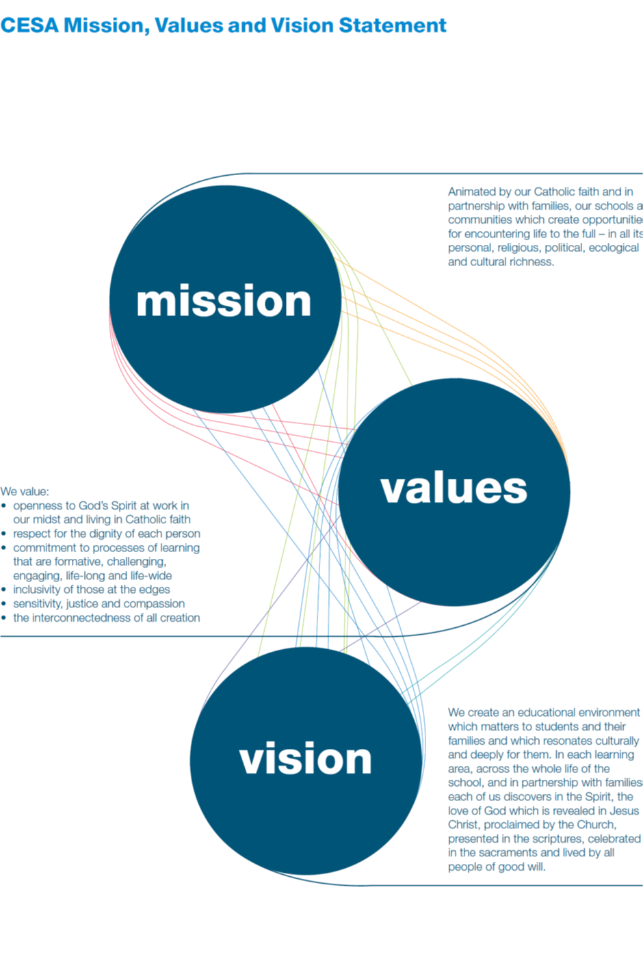

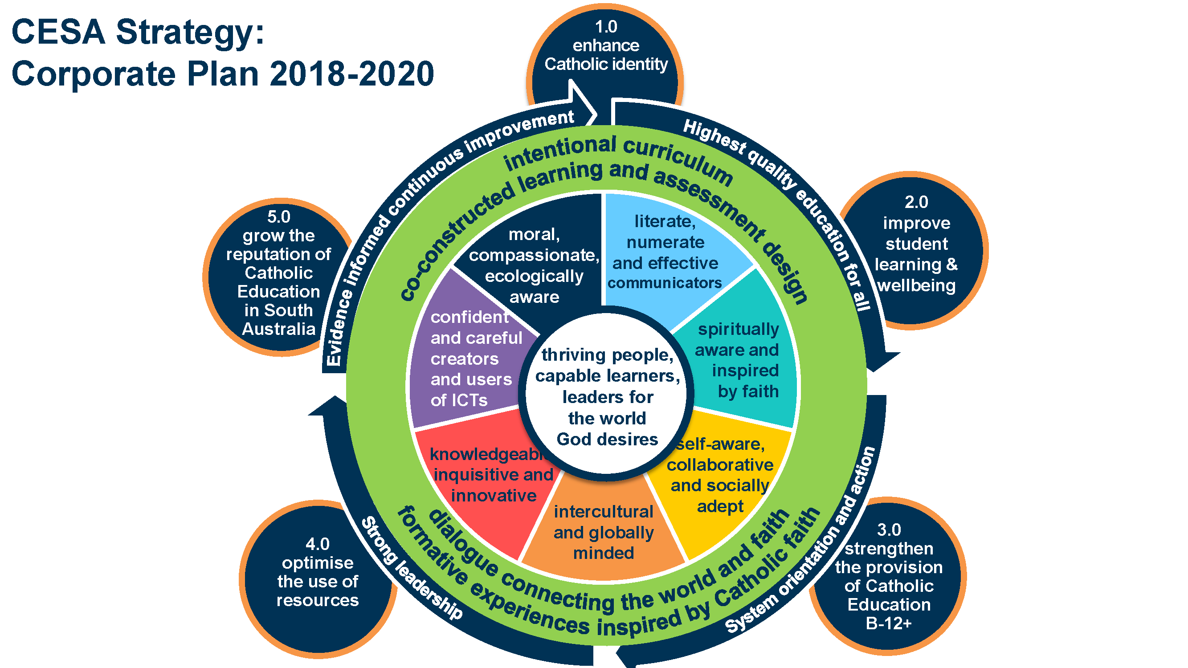

### **Key Drivers**

Education jurisdictions across Australia are responding to current research to lift student engagement and attainment and are supporting schools and systems to achieve improved student outcomes and overall school improvement. Within the South Australian Catholic school context, current key drivers include:

* CESA Strategy: Corporate Plan 2018-2020, in particular
* 2.0 Improve Student learning and wellbeing
* 3.0 Strengthen the provision of Catholic Education B-12+
* 4.0 Optimise the use of resources
* CESA Living Learning Leading Framework
* Continuous Improvement Framework for Catholic Schools
* General Capabilities (ACARA)
* CESA Statement of Learning Commitment
* National School Reform Agreement 2019-2023

### **Current Context**

CESA represents 102 schools and approximately 45,000 students across two Dioceses representing 17.2% of total school enrolments in SA. ATSI students represent approximately 5% of the total enrolment in Catholic schools. 42% of schools are in the Bottom and Lower Middle SEA Quarter. Three schools are classified by the Commonwealth as Remote.

CESA is represented by two Dioceses – Adelaide Archdiocese and Port Pirie Diocese.

The Archdiocese of Adelaide was established in 1842 – six years after the settlement of South Australia. It covers 105,000 square kilometres and includes 280,000 Catholics (approximately 20% of the population of SA). It includes 89 schools educating approximately 39,000 students including 551 ATSI students.

The Archdiocese of Port Pirie was established in 1887. It covers 980,000 square kilometres of rural South Australia and extends to Uluru in the Northern Territory. It includes 13 schools educating 3780 students of which 148 are ATSI background.

SA Catholic schools each have a Strategic Plan that sets out the strategic improvement priorities for a cycle – usually 3 years. The Strategic Plan includes school and system priorities as well as State and national reform priorities where relevant. Each year every school develops an Annual School Improvement Plan based on the Strategic Plan. Towards the end of a strategic planning cycle schools participate in an external validation process. External validation is a process whereby the school engages in a collaborative peer review to reflect on its progress in improving student learning and overall school performance. This process allows the school to validate the implementation of its continuous improvement priorities and provides accountability to the school community and the system. External validation is being progressively implemented across all schools in the sector.

### **Sector Profile**

**Enrolments in Catholic Schools in SA**

Including Full Fee-Paying Overseas Students (FFOS)

August 2018- 45,305

Metropolitan- 39,602

Rural- 5,703

**Total Catholic schools in SA- 102**

Diocese of Port Pirie- 13 schools

* Primary schools- 9
* Secondary schools- 4

Diocese of Adelaide- 89 schools

* Primary schools- 59
* Secondary or Combined schools- 13
* Joint Anglican/Catholic school- 1
* Congregational schools- 14

Special schools- 2

**Funding**

Systemic Schools- 97

Non-systemic schools- 5

### **Objectives**

The CESA objectives for all initiatives including those addressed in the Reform Support Fund are to place each student at the centre of their learning through a strong focus on achievement, engagement and wellbeing; to build the capacity of teachers and school and system leaders; and to be known and valued in the community for educational excellence and for the benefits provided by a contemporary Catholic Education. These objectives are summarised as follows:

* Improve student learning, achievement and wellbeing.
* Strengthen the provision of Catholic Education B-12+.
* Optimise the use of resources.
* Grow the reputation of Catholic Education in SA.
* Develop a collaborative culture across schools and the system.

### **Key Reform Directions**

Education sectorsacross South Australia are undergoing considerable system-wide reform, which will accelerate learning and improve outcomes for children and young people. These reforms span the three reform directions outlined by the Commonwealth Government:

* Supporting students, student learning and student achievement.
* Supporting teaching, school leadership and school improvement.
* Enhancing the national evidence base.

The eight National Reforms as outlined in the National School Reform Agreement 2019-2023 are aimed at sustained reform efforts that will drive improved student outcomes and excellence in classrooms. As the National Policy Initiatives (as outlined in Schedule B of the National School Reform Agreement) are agreed, developed and implemented, it is intended that the annual Workplans will reflect these developments (if they are not already being addressed).

### **Collaboration with State Government**

The heads of the three sectors – Government, Catholic and Independent – have strong collaborative relationships and work together on issues of common interest for South Australia. Current collaborations include:

* shared oversight of the transition to NAPLAN Online.
* developing a narrative for all sectors and the South Australian Certificate of Education (SACE) Board about the critical role of the development of general capabilities.
* Initial Teacher Education, working with providers on programs across six focus areas:
* Program entry.
* Literacy and numeracy.
* Program content.
* Program structure.
* Professional experience.
* Mentoring and supervision.
* Earning and Learning Pathways – considering a collaborative, cross-sector approach to further developing an understanding of the pathways through secondary school to further education, training and employment.
* Cross-sector groups on curriculum, child protection and emergency planning.
* National certification of highly accomplished and lead teachers– to develop capacity to establish environments that improve student educational achievement and growth.

The three sectors maintain collaborative working arrangements including through regular meetings of Education Sector Heads and meetings of cross-sector representatives on specific issues as required.

Whilst the specific context for each school education sector varies, the reform activities being undertaken by all sectors are contributing to the national reform agenda. Reform activity across all sectors includes:

* School improvement strategy – to build a world-class education system that improves outcomes for all students, including Aboriginal students’ outcomes for all students, including Aboriginal students
* Aboriginal education strategy – to improve outcomes and contribute to closing the gap, including through consultation with communities and supporting Aboriginal governance
* STEM strategy – to enable students to develop knowledge, skills and understanding in science, technology, engineering and mathematics
* Literacy and numeracy programs – to improve the core foundation skills in literacy and numeracy
* Early career teacher programs – to support teacher development in the early years of their career
* Supporting teacher development – including providing appropriate professional development for teachers and leaders
* Entrepreneurial education – to provide students the opportunity to acquire the skills needed to become successful entrepreneurs.

### **KEY REFORM DIRECTION ONE:**

**Supporting students, student learning and student achievement**

**Improved Students, Learning and Wellbeing**

**•** Implement evidence-informed, flexible and innovative approaches to curriculum and pedagogy that demonstrate improved student outcomes

• Develop and implement system and sector-wide wellbeing for learning Initiatives

**STEM**

**•** Build System Capacity

* + Conduct an annual STEM Forum
  + Improve access and equity to quality STEM education for schools and students (particularly girls and ATSI) in low socio-economic areas
  + Provide science consultancy to schools

• Build Teacher and Leader Capacity

* + STEM professional learning for primary and middle years teachers
  + Provide high quality STEM professional learning based on real world inquiry and integrated interdisciplinary approach

• Build Dynamic and Sustainable Partnerships

* + Develop partnerships and networks with industry, universities and other education providers

**Literacy and Numeracy**

•Implement CESA Literacy Learning Strategy

• Implement CESA Numeracy Learning Strategy

### **KEY REFORM DIRECTION TWO:**

**Supporting teaching, school leadership and school improvement**

**Supporting teaching**

•Review CESA Aboriginal Education Strategy

• Phased implementation of the revised CESA Aboriginal Education Strategy

• Implement evidence-informed, flexible and innovative approaches to curriculum and pedagogy that demonstrate improved student outcomes.

**School Improvement**

• Review the 2014 Continuous Improvement Framework for Catholic Schools to reflect the Living Learning Leading Framework

• Continue the phased implementation of external validation to all Catholic Schools.

**School Leadership**

• Provide high quality professional learning that focuses on innovation and change

• Provide leadership development programs tailored to career stages – early career; middle leader; new principal; experienced principal; system leader

• Build leadership capacity across networks/clusters to ensure sustainable school and system success that directly impacts on student learning outcomes

• Provide leadership programs that focus on identity and wellbeing of principals and that target key areas of practice through the provision of mentoring, coaching and shadowing opportunities.

**Entrepreneurial Education**

• Initiate and support a CESA Entrepreneurial & Innovation Network of schools to research and enact pedagogies which engage students in developing entrepreneurial skills and dispositions

• Collaborate with schools to develop and implement a CESA Entrepreneurial Learning Initiative

### **KEY REFORM DIRECTION THREE:**

**Enhancing evidence for improvement**

**•** Empower schools and school leaders through coaching and support to access and use data and reports which enable them to identify strengths and potential areas for school improvement.

• Use data and evidence to measure school improvement (both in-school and across system).

• Ensure that system-wide strategic planning, policy and programs allow for the monitoring of outcomes over time using measures that cover all aspects of student learning (eg capabilities, wellbeing, engagement).

• Collaborate with the higher education sector on rigorous research that evaluates impacts on student learning and overall school and system improvement.

**Measurement and Evaluation**

Evaluation is a fundamental part of continuous improvement and helps to build a solid evidence base of what works and what does not work. This knowledge can then inform policy development and program and service delivery to schools.

CESA is strengthening its evaluation culture as part of its continuous improvement strategy. It will utilise a range of data and evidence for both accountability and to drive improvement.

A range of quantitative and qualitative data will be collected on the Reform Support projects and initiatives and will be included in more detail in the Annual Work Plans. Evaluation methodologies will include analysis of standardised assessments such as NAPLAN, PAT-R and PAT-M; SACE and other achievement and wellbeing data.

Methodologies will also include analysis of attendance rates; participation rates (particularly for targeted groups); and school completions. Surveys (parents, staff and students); and external evaluations of specific projects will also be undertaken.