

# **Non-Government Reform Support Fund Strategic Plan**

# **2019-2022**

# **Catholic Schools NSW**

## **Executive Summary**

2019 is the second year that Catholic Schools NSW (CSNSW) has implemented the Non-Government Reform Support Fund.

The CSNSW Non-Government Reform Support Fund Strategic Plan 2019-2022 builds on improvements achieved through 2018 Reform Fund projects which addressed the Australian Government’s 2018 school reform priorities:

* Quality assurance, moderation and support for the continued improvement of the Nationally Consistent Collection of Data on School Students with Disability;
* Implementation of online delivery of the National Assessment Program; and
* Improving Governance and Financial Management Practices.

As 2018 was also the first year of operation of Catholic Schools NSW as the overarching entity for Catholic schools in NSW, the prime focus of 2018 Reform Fund activity was to establish infrastructure and processes required to faithfully respond to the Australian Government’s school reform priorities.

In addition to ongoing implementation of aspects of the 2018 school reform priorities, the CSNSW 2019- 2022 Reform Fund Strategic Plan addresses the agreed reform directions of the National School Reform Agreement (2019-2023):

* Supporting students, student learning and student achievement.
* Supporting teaching, school leadership and school improvement.
* Enhancing the national evidence base.

The associated state-based activities identified in the Commonwealth-NSW bilateral agreement form the basis for the vision and directions of this Strategic Plan. From 2019, CSNSW’s Reform Fund projects will specifically address the 2019-2023 National Policy Initiatives with activities which:

* Ensure support for students at risk of educational disadvantage, including Aboriginal and Torres Strait Islander students, students with disability and students living in regional, rural and remote locations, through the provision of evidence-based tools and resources.
* Address the foundations for learning in the early years of primary and secondary schooling.
* Prepare students for the challenges and opportunities for the future by renewing curriculum and assessment.
* Develop a Catholic-sector Professional Learning Institute.
* Advance excellence in Catholic education by monitoring and reporting on the efficiency and effectiveness of the NSW Catholic school system.

To give cohesion and impetus to delivery of the Reform Fund priorities, two of the Strategic Aims adopted by Catholic Schools NSW for 2019 have been deliberately aligned to the national reform priorities (2018) and the reform directions of the National School Reform Agreement (2019-2023).

The relevant CSNSW strategic aims are:

* Promote the integrity of NSW Catholic schools via delivery of governance best practice.
* Maximise student outcomes and the efficiency and effectiveness of NSW Catholic schools via advisory, analysis and reporting functions.

CSNSW will deliver on the Reform Support Fund 2019-2022 Strategic Plan by seeking to work in collaboration with NSW Catholic School Agencies, the NSW Government and other school sectors. CSNSW’s work will be informed by robust policy and program advice and high-quality research and analysis.

This CSNSW Strategic Plan 2019-2022 has been developed in consultation with senior officers of the NSW Department of Education and the NSW Association of Independent Schools, in the context of the National School Reform Agreement and associated bilateral agreement.

## **Current context**

Catholic Schools NSW (CSNSW) was established by the NSW Bishops in 2017. CSNSW is the overarching entity for Catholic education in NSW and the approved system authority for the NSW Catholic school system.

While CSNSW has an overarching, representative role for NSW Catholic schools, day-to-day operational responsibility lies with each of the eleven Diocesan Catholic School Agencies and with each individual school for Catholic independent schools.

### **NSW Catholic Schools and Students in Profile**

Catholic schooling in NSW is comprised of 596 schools which employ 41,100 staff and enrol 254,600 K- 12 students. The locations of the 596 schools, as they relate to the boundaries of the eleven NSW Catholic dioceses, are shown here.

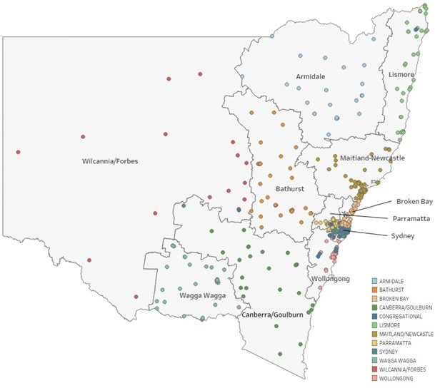

**Figure 1: NSW Catholic Schools**

### **Profile Breakdown of Characteristics of Schools and Students**



14



596

T**otal schools Boarding schools**

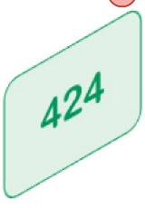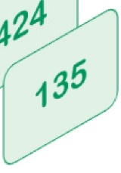

School Levels

Primary

Secondary Combined

Special

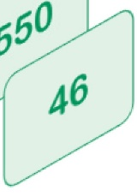

Affiliation

Systemic

Congregational

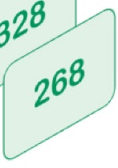

Schools by Geography

Greater Sydney Rest of NSW

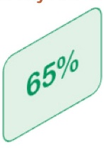

Schools by ABS Remoteness Geography

Major Cities

Inner Regional Outer Regional

Remote

Very Remote

**Figure 2- Characteristics of NSW Catholic schools**



129,940



124,671



17,690



23,410

Teaching

Non-teaching



Student Levels

Primary

Secondary



254,611



8,124



47,897



Occupation



41,100

**Total students**

**Aboriginal and**

**Torres Strait Islander students**

**Students with Disabilities**

**Total staff**

Consistent with the profile of NSW Catholic schools and the students they enrol, along with the directions of the bilateral agreement between NSW and the Commonwealth, the CSNSW Reform Fund Strategic Plan focuses directly, and with priority, on students who are at risk of educational disadvantage, including Aboriginal and Torres Strait Islander students, students with disability and students living in regional, rural and remote locations.

**Figure 3: Characteristics of Students and Staff in NSW Catholic schools**

Since 1985, the number of Aboriginal and Torres Strait Islander students enrolled in NSW Catholic schools has increased by over 7,000 students. Aboriginal and Torres Strait Islander students represent 3.2% of the total student population in NSW Catholic schools, which is slightly higher than the proportion of Aboriginal and Torres Strait Islander people in the broader community (2.8%). One challenge for the sector is noted by NSW Catholic School Agencies when monitoring the movement of Aboriginal and Torres Strait Islander students between schools. There is evidence that these students’ families are more likely to select schools for their children based on communities rather than school sector (government, Catholic or independent). This has always presented a challenge to schools when developing appropriate strategies and personalised programs for Aboriginal and Torres Strait Islander students who are affected by family mobility, particularly when movement goes across sectors and, when within a sector, across metropolitan, regional and remote communities.

As part of their educational and pastoral mission, Catholic schools in NSW have been educating students with disability since the 1870s, long before comparable provision was made in Government schools.

Since the early 1990s the numbers of students with disability in NSW Catholic schools has grown significantly and annually. In NSW there are currently 596 Catholic schools, including seven Special Schools, enrolling almost 50,000 students with disability. Validated 2018 Nationally Consistent Collection of Data of Students with Disability revealed the percentage of total students identified through NCCD processes in NSW Catholic schools was 18.1%.

As outlined in the submission by the Catholic Education Commission NSW (the entity which preceded Catholic Schools NSW) to the Independent Review into Regional Rural and Remote Education conducted by Emeritus Professor Halsey (September 2017), the NSW Catholic sector has monitored, with significant concern, the increasing educational disparity between metropolitan and non-metropolitan schools and communities. CSNSW’s statistics, reported in its submission to Professor Halsey, highlight that inequalities in non-metropolitan NSW and Australia are more nuanced than a simplistic urban/rural divide, and that issues and barriers to equitable educational opportunity differ for schools in coastal and inland communities, and for schools in large and small towns.

### **How NSW Catholic Schools are already Performing**

CSNSW has access to a range of data across key measures which form the basis of understanding how NSW Catholic schools are performing. Through participation in Reform Fund projects, there will be an opportunity to enhance what is known through publicly available data. Through ongoing research and analysis of the sector’s data in the Advancing Excellence in Catholic Education project, CSNSW will make a priority to better understand the data available about its students and schools.

A snapshot and description of data related to some relevant measures follow.

The **Australian Early Development Census (AEDC)**, taken triennially, provides information about indicators of disadvantage of children in Kindergarten according to five domains. From the 2015 Census, children ‘not on track’ in NSW Catholic schools by AEDC Domains and Remoteness are shown below. A snapshot of this data reveals that students in remote schools are already disadvantaged before they start school, when compared with metropolitan schools.

|  |  |  |  |  |  |
| --- | --- | --- | --- | --- | --- |
| **Children not on track (at risk or vulnerable)** | **Physical** | **Social** | **Communications & General knowledge** | **Emotional** | **Language & Cognitive** |
| Major Cities | 19% | 22% | 21% | 20% | 10% |
| Inner  Regional | 17% | 21% | 18% | 19% | 10% |
| Outer  Regional | 16% | 22% | 19% | 24% | 12% |
| Remote | 28% | 30% | 27% | 22% | 18% |
| Very Remote | 52% | 52% | 52% | 32% | 28% |

**Figure 4: Australian Early Development Census (AEDC) 2015 by location**

CSNSW considers **NAPLAN** is only one measure of student achievement in Australian schooling. While it is acknowledged that NAPAN data has limitations as a full measure of quality schooling, with careful interpretation it is used by the sector to better understand literacy and numeracy achievements. Below are graphs showing trends in the performance of students in Catholic systemic schools over ten years, compared to all schools in NSW and all Australian schools. Catholic sector trends, generally, are similar to those at state and national levels.

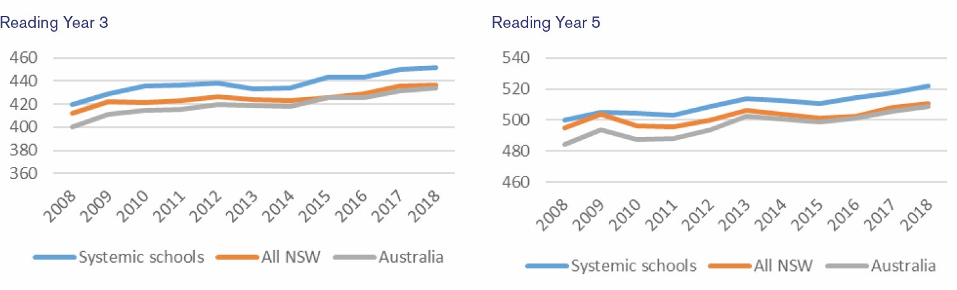

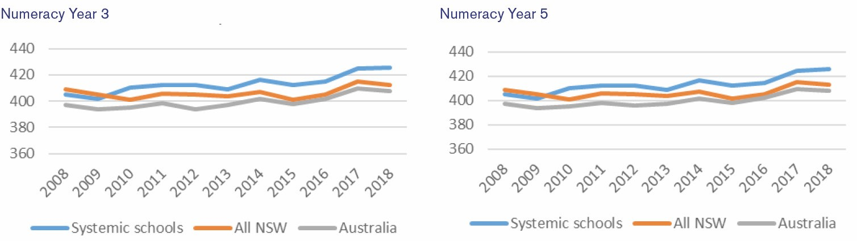

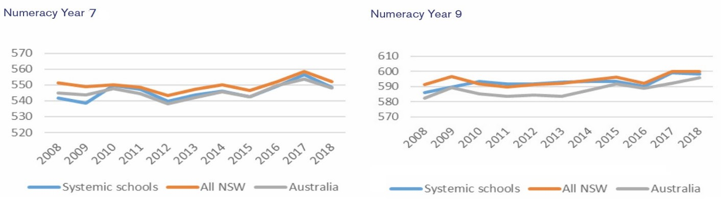

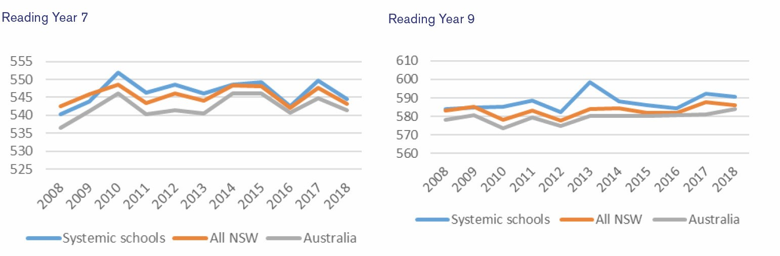

**Figure 5: NAPLAN Years 3, 5, 7 and 9 Reading and Numeracy mean scores, 2018-2018**

Since 2000, CSNSW (and previously Catholic Education Commission, NSW) has commissioned an external analysis of the **Higher School Certificate (HSC)** data of students enrolled in Catholic schools. The analysis takes account of, and thereby discounts, factors such as socio-economic status (SES), gender and prior demonstrated achievement which are known to influence results, but which are not under the influence of the teacher. Schools use this analysis to focus on improving teaching and learning, for example, by using the data to answer the questions:

* *‘*What does this tell us about how teaching and learning are going on within our school?’
* ‘What are we going to do about it?’
* ‘What do we need to learn in order to be able to do this?’

Students in NSW Catholic schools who are at risk of educational disadvantage will be supported through the development and promotion of evidence-based tools and resources which assist schools to implement best practice approaches to supporting students’ learning and development.

Students in NSW Catholic schools will also be supported through this Plan through a priority focus on system effectiveness and efficiency.

Teachers in NSW Catholic schools will be supported to seek higher levels of accreditation through collaboration with Catholic School Agencies and NESA.

Through CSNSW expert policy advice, support, guidance and initiatives, NSW Catholic School Agencies will be assisted to achieve the Reform Fund priorities.

### **National Policy Initiatives**

The Catholic Schools NSW 2019-2022 Reform Fund Strategic Plan addresses the agreed reform directions of the National School Reform Agreement (2019-2023) over the term of this funding.

* Supporting students, student learning and student achievement.
* Supporting teaching, school leadership and school improvement.
* Enhancing the national evidence base.

From 2019, CSNSW’s Reform Fund projects will specifically address the 2019-2023 National Policy Initiatives by:

* Ensuring support for students at risk of educational disadvantage, including Aboriginal and Torres Strait Islander students, students with disability and students living in regional, rural and remote locations, through the provision of evidence-based tools and resources.
* Addressing the foundations for learning in the early years of primary and secondary schooling;
* Preparing students for the challenges and opportunities for the future by renewing curriculum and assessment.
* Scoping the role of a Catholic-sector Professional Learning Institute.
* Advancing excellence in Catholic education by monitoring and reporting on the efficiency and effectiveness of the Catholic school system.

The CSNSW Non-Government Reform Support Fund Strategic Plan 2019-2022 also builds on improvements achieved through 2018 Reform Fund projects which addressed the Australian Government’s school reform priorities:

* Quality assurance, moderation and support for the continued improvement of the Nationally Consistent Collection of Data on School Students with Disability.
* Implementation of online delivery of the National Assessment Program.
* Improving Governance and Financial Management Practices.

The Reform Directions have been endorsed by Catholic Schools NSW given their close alignment with this entity’s strategic directions, which have been deliberately aligned to the national reform priorities (2018) and the reform directions of the *National School Reform Agreement (2019-2023*).

### **State-based Reforms**

Catholic Schools NSW has a well-established, productive and ongoing relationship with the NSW State government through membership of the NSW Schools Advisory Council, the Non-Government Schools Advisory Council, the NSW Non-Government Schools Not-For-Profit Advisory Committee and the Board of the NSW Education Standards Authority (NESA). In addition, CSNSW has direct liaison at the highest level with the External Relations Directorate of the NSW Department of Education and at the operational and policy implementation levels with departmental and NESA officers. These relationships will continue to form the mechanisms which will enable continued engagement with the NSW Government and its representatives over the four years of this Strategic Plan.

CSNSW was involved in consultations with government leading to the finalisation of the Bilateral Agreement between NSW and the Commonwealth on Quality Schools Reform, including the development of the state-based initiatives which will result in actions taken across the three NSW school sectors.

The key reforms from the NSW-Commonwealth bilateral agreement which will be addressed directly by CSNSW over the term of the Reform Fund are as follows.

### **Reform Direction A – Support students, student learning and achievement**

**Action**

* Deliver the review of the K-12 curriculum to ensure the school education system is preparing students for the challenges and opportunities for the future (by end of 2019).
* Implement the refreshed curriculum post 2019 review, ensuring teachers are supported to implement a streamlined curriculum, including timely and informative assessments (from 2020).
* Embed evidence-based practices (particularly to boost early achievement in literacy and numeracy), including implementing the Literacy and Numeracy Plan (end 2020 for LNAP; ongoing).
* Meet the needs of students at risk of educational disadvantage (including students with disability, Aboriginal students, students with low English proficiency and students in rural and regional areas) through evidence-based pedagogy, quality teaching and leadership and innovation (ongoing).

### **Reform Direction B – Support teaching, school leadership and school improvement**

**Action**

* Strengthen the mandatory content requirements of ITE courses in identified areas of STEM, Literacy/Numeracy, Students with Special Needs and Classroom Management (ongoing).
* Identify and support cohorts of high-quality teachers across sectors for certification at Highly Accomplished and Lead Teacher levels (2019).
* Lifting the burden to allow schools to focus on teaching and learning (2019).
* Reduce the administrative burden on schools, principals and teachers to increase the amount of time to focus on high quality teaching and leading (2020).
* De-cluttering the curriculum as part of the NESA review (2020).
* Targeted initiatives to improve system and school effectiveness (2019).
* The Commonwealth will work with NSW to address identified NSW teacher workforce needs (particularly in the areas of maths and science) including through the development of a national and state specific teacher workforce strategy reflecting respective areas of responsibility (2019).
* Strengthen accountability measures for non-government schools that receive state funding, initially through development of memoranda of understanding with sectors (2019).

In addition, CSNSW will work with Government in 2019 to support actions intended to achieve.

### **Reform Direction C – Enhancing the national evidence base.**

**Government Action**

* Establish a Catalyst Lab to explore and test innovative educational practice in partnership with schools and other partners.

**Complementary CSNSW Actions:**

* Develop targeted resources and initiatives to support evidence-based pedagogy, quality teaching and innovation.
* Develop the CSNSW Efficiency and Effectiveness Framework.
* Build internal (CSNSW) data capability (data infrastructure and analytics).
* Develop external partnerships to support data analytics and research.
* Undertake systemwide analysis of student, school and workforce data.

**Objectives and Activities**

| **Objectives** | **Activities** |
| --- | --- |
| Meet the needs of students at risk of educational disadvantage (long-term). | * Provide policy advice, guidance and coordination of NSW Catholic sector programs to support students at risk of educational disadvantage. * Share and/or develop targeted resources and initiatives to support evidence-based pedagogy, quality teaching and innovation. |
| Embed evidence-base practices to boost early achievement (long-term). | * Provide expert policy advice to schools and diocesan authorities. * Support ongoing Catholic sector involvement in NSW Literacy and Numeracy Strategy, including evaluation activities. * Develop an Early years (K-2) initiative to support foundational skills in literacy and numeracy, including connecting with home learning. * Develop an Early Years of Secondary (7-9) initiative to support literacy and numeracy development, including supporting students to meet minimum HSC standards (tracking into years 10-12). * Engage families and the community in students' learning and development. |
| Prepare students for the future through streamlined curriculum and assessment (long-term). | * Provide policy advice, guidance and coordination of sector engagement with NSW K-12 Curriculum Review. * Provide policy advice, guidance and coordination of sector engagement with Review of Senior Secondary Education. |
| Improve teacher quality by creating more opportunities for expert teachers to gain highest levels of teacher accreditation (long-term). | * Provide expert support, advice and guidance for NSW Catholic sector HALT programs. * Scoping the role of a Professional Learning Institute. * Deliver specific teacher and school leadership professional development in Aboriginal and Torres Strait Islander education. |
| Advance excellence in Catholic education by supporting the efficiency and effectiveness of Catholic the school system (long-term). | * Develop and maintain the CSNSW Efficiency and Effectiveness Framework. * Consult on options for developing next generation system improvement methodologies, including standards and benchmarks. * Develop an online Efficiency and Effectiveness system dashboard. * Build internal data capability (data infrastructure and analytics). * Develop external partnerships to support data analytics and research. * Undertake systemwide analysis and reporting of student, school and workforce data. * Conduct specific analysis of annual HSC data with supporting seminars and online platform for professional learning. |
| Support system compliance with improved governance and financial management (mid-term). | * Support implementation of common policies and registers and reasonable market valuation assessment tools. * Implement revised policies and procedures to bring efficiencies in compliance and financial reporting and management. * Work with NSW Government and the independent schools sector on appropriate accountability measures for non- government schools in receipt of state funding, initially through the development of memoranda of understanding between the sectors and the NSW government. * Participate in NSW Not for Profit Committee and other cross-sectoral forums at state and national level. * Continue to develop and provide face-to-face and online governance training targeting existing and emerging high- risk areas. * Provide accurate and timely legal and risk advice to ensure compliance procedures and practices. |
| Continually improve the Nationally Consistent Collection of Data on School Students with Disability (mid- term). | * Provide expert support, advice and training to NSW Catholic school and diocesan personnel necessary to comply with the annual NCCD data collections. * Refine and maintain quality assurance of CSNSW’s PPSD Online Tool including desktop and external site audits. * Maintain a secure online platform for NCCD and personalised planning data, allowing for enhanced data visualisation. |
| Provide continued support for implementation of NAPLAN Online (mid-term). | * Provide expert support, advice and training to NSW Catholic school and diocesan personnel necessary for full participation in NAPLAN Online testing from May 2020. * Develop a customised CSNSW student data analytics application to complement existing tools and to enhance school and system level analysis of student data. |

### **Measurement and Evaluation**

Catholic Schools NSW is committed to promoting a culture that strives for continuous improvement and advances excellence. The Reform Fund Strategic Plan includes activities which will involve monitoring performance, collection, analysis and reporting of data.

Data related to the National Measures, specified in the National School Reform Agreement, will be collected, analysed and reported. At a minimum, the data will relate to:

* Years 3, 5, 7 and 9 literacy and numeracy as assessed through NAPLAN.
* Students who complete Year 12 as assessed through the HSC and/or through an AQF credential.
* The attendance at school of students in Years 1-10.

Additional measures for activities outlined in the Strategic Plan and annual Work Plans are to be determined.

### **Strategies to assess progress**

CSNSW will:

* Develop the CSNSW Efficiency and Effectiveness Framework.
* Consult on options to develop next generation system improvement methodologies, including standards and benchmarks.
* Develop an online Efficiency and Effectiveness system dashboard.
* Build internal data capability (data infrastructure and analytics).
* Develop external partnerships to support data analytics and research.
* Undertake systemwide analysis of student, school and workforce data.
* Conduct specific analysis of 2019 HSC data with supporting seminars and online platform for professional learning.
* Conduct research and analysis of non-academic measures including, for example, student wellbeing.
* Undertake bi-annual reporting to the system of data related to the National Measures (above) along with sector-identified priority measures.

### **Evaluation methodologies**

Evaluation methodologies will be developed appropriate for each project and the activities within each project. In principle, the approach will include:

* Development of indicators of success for each activity within a project.
* Assessment of the outcomes of the activity using both quantitative and qualitative methodologies. For example: Quantitative: analysing measures of student performance (NAPLAN, Literacy and Numeracy Progressions, HSC) and participation (attendance, retention), levels of teacher accreditation; participation in targeted activities, including evaluation activities.
* Qualitative: surveying readiness and attitudes; feedback on the value of initiatives and resources developed; levels of adoption of revised policies and procedures; internal and external audits; self-assessments.