Other Countries – Shorter Form Credentials in Qualifications Frameworks

Many stakeholders perceive the current structure of the AQF to be a single ‘ladder’ rising from Level 1 to Level 10. This approach works well to describe a simple framework. However, a framework that accommodates different durations of study at similar levels of complexity needs to be depicted as a matrix, describing pathways that occur vertically and horizontally. A number of other countries have adopted matrix like frameworks to accommodate further study that requires less time than full qualifications.

# International Frameworks

A number of other countries have qualifications frameworks that include shorter form credentials alongside, or in relation to, qualifications that are more traditional.

## The Scottish and Irish systems

The Scottish and Irish systems appear to offer the most comprehensive frameworks for recognising shorter form credentials. They provide a good model for incorporating short qualifications within the AQF. They are both multi-level frameworks that place qualifications and other credentials against the levels. The levels provide a lateral comparison of knowledge, skills and competency, rather than completeness or time served.

### Scotland

The Scottish Credit and Qualifications Framework (SCQF)[1] has 12 levels. The different levels show the level of difficulty of a particular qualification, with level 12 being the most demanding. SCQF levels are based on a single set of ‘level descriptors’. These are the common reference points that provide a way of recognising learning that is outcome-based and quality-assured, no matter whether that learning is academic, vocational, non-formal or informal.

The level descriptors outline the general outcomes of learning at SCQF levels under five broad headings known as characteristics.

Knowledge and understanding (mainly subject-based)

Practice (applied knowledge, skills and understanding)

Generic cognitive skills (for example, evaluation, critical analysis)

Communication, numeracy and IT skills

Autonomy, accountability and working with others.

These descriptors allow broad comparisons to be made between qualifications and learning and allow learners, employers and the public to understand the range of skills and learning that should be achieved at each level.

The Scottish Qualifications Authority Qualifications (SQA Qualifications) are short qualifications that are broad-banded across a number of levels of the SCQF. They includes the following credentials:

Professional Development Awards that develop skills for people who are already employed and want to extend or broaden their skills

National Certificates that prepare people for employment, career development or more advanced study

National Progression Awards that assess a set of skills and knowledge in specialist vocational areas

Skills for Work courses that focus on generic skills for success in the workplace.[2]

The way that the SQA Qualifications have been incorporated into a holistic framework could provide a model for incorporating Skill Sets and micro-credentials into the AQF. The SCQF is fundamentally a vertical framework extended horizontally to incorporate shorter modes of learning.

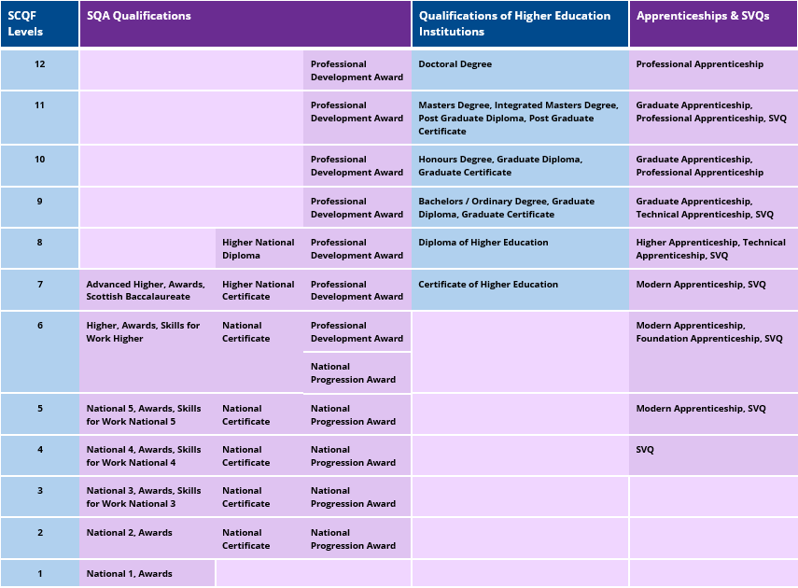

### Ireland

Ireland’s qualifications framework[3] predominately focusses on ‘major’ awards but also includes minor, supplemental and special purpose award types.

Minor award-types are always linked to major award-types

Supplemental award-types always build upon a previous award

Special-purpose award-types may comprise learning outcomes that also form part of major awards.[4]

The Irish framework attempts to allow all learning achievements to be measured and related to each other in a coherent way. The different types and sizes of qualifications included in the National Framework of Qualifications are organised based on their level of knowledge, skill and competence but not on the length of the course.

Ireland’s system is similar to the Scottish system, but is depicted using a fan diagram. The multiple internal arches incorporate shorter form credentials and indicate what types of institutions offer the long form and shorter form credentials. The triangle, box and diamond symbols indicate the types of shorter form credentials available at the various levels. It is an effective design that accommodates a large amount of information. A similar visual concept would likely accommodate any changes to the AQF.

Defining a shorter form credential in relation to a major award, as the Irish approach does, could provide a means of identifying shorter form credentials that, by design, could be aggregated over time to form a major qualification.

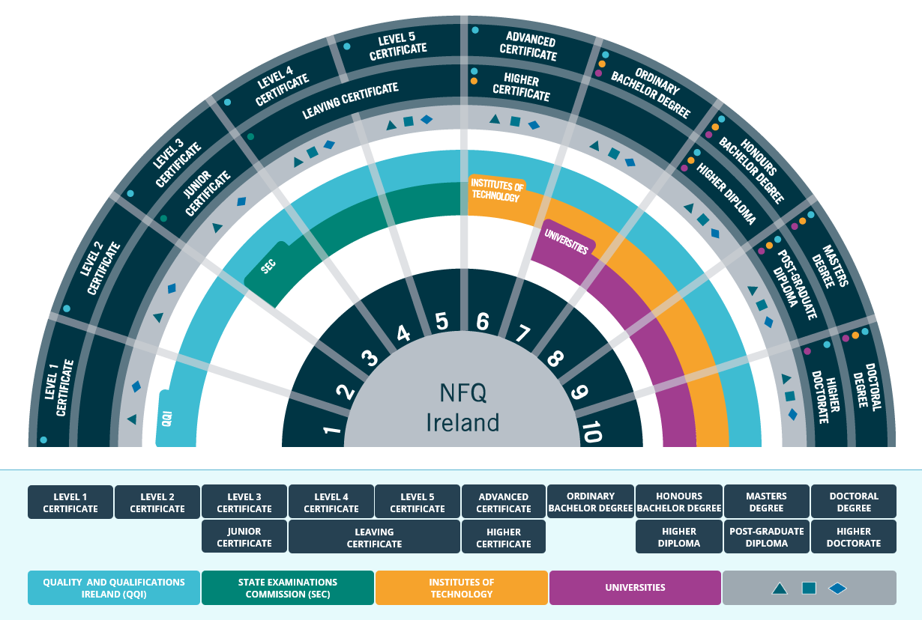

## Other Frameworks

Other countries that have frameworks that recognise short-form qualifications include New Zealand, Denmark, and the Hong Kong Special Administrative Region. These systems are outlined below.

### New Zealand

Approved micro-credentials are recognised by the New Zealand Qualifications Authority (NZQA) but are not be listed in the New Zealand Qualifications Framework (NZQF). A training scheme or a micro-credential can be listed at any NZQF level. A training scheme is a coherent arrangement of learning or training. It is based on clearly linked aims, outcomes, content and assessment practices. A training scheme leads to an award, but does not, of itself, lead to an award of a qualification on the NZQF.[5]

A micro-credential certifies achievement of a set of skills and knowledge. It must meet the requirements of a training scheme as well as have demonstrable evidence of need from employers, industry and/or community, not (typically) duplicate current quality-assured learning approved by NZQA, and be reviewed annually to confirm the micro-credential continues to meet its intended purpose. All micro-credentials must include appropriate assessment activities to provide confidence the learner has achieved the learning outcomes at the appropriate NZQF level.[6]

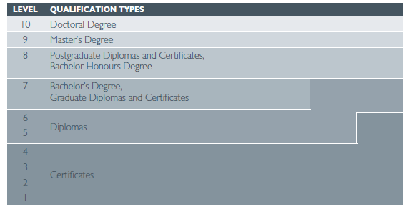[7]

NZQA is currently reviewing the NZQF. This work will be completed in 2019 if no legislative changes are required or later if legislative changes are required. One aim of the review is to ensure the NZQF allows for the recognition of regional qualifications, international qualifications and micro-credentials.

The introduction of the micro-credential system outlined above does not require an immediate update of the NZQF. However, recognising micro-credentials as part of the NZQF system reflects developments in the evolving New Zealand education and training system.

If we followed the current New Zealand approach, we would have two unincorporated silos as shown below. The two silos do not interact but the short course ‘ladder’ reflects the adjacent NZQF.

|  |  |  |  |
| --- | --- | --- | --- |
| **Level** | **Full Course** |  | **Training scheme or micro-credential** |
| **10** | Doctorate |  | approved micro-credential |
| **9** | Masters |  | approved micro-credential |
| **8** | Hons, Post Grad Cert, Post Grad Dip |  | approved micro-credential |
| **7** | Bachelor, Grad Cert. Grad Dip. |  | approved micro-credential |
| **6** | Diploma |  | approved micro-credential |
| **5** | Diploma |  | approved micro-credential |
| **4** | Cert IV |  | approved micro-credential |
| **3** | Cert III |  | approved micro-credential |
| **2** | Cert II |  | approved micro-credential |
| **1** | Cert I |  | approved micro-credential |

### Denmark

Denmark’s qualifications framework includes ‘supplementary qualifications’ which may be a pre-requisite qualification before further study, additions to a qualification, or simply a learning module not related to another qualification as in adult education or continuing education.[8] Some educational institutions in Denmark will also grant conditional admission contingent on passing a relevant pre-requisite supplementary course within a specified timeframe.[9] The supplementary qualifications do not extend to Bachelor and post-graduate qualifications.

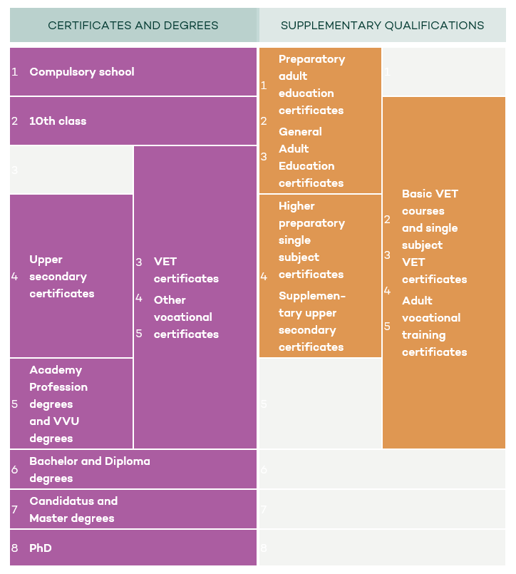[10]

### Hong Kong

In Hong Kong, a ‘credit accumulation transfer system’ helps learners to accumulate credits from diverse courses and convert them into a recognised qualification.[11]

Qualifications recognised under the Hong Kong Qualifications Framework (HKQF) are characterised by their levels, which reflect the depth and complexity of learning leading to a qualification. In 2012 Hong Kong Special Administrative Region Government announced the introduction of the Award Titles Scheme (ATS)and the use of credit under the HKQF. Award titles reveal the nature and range of qualifications, and credit indicates the volume or size of learning of the qualification. The ATS has been introduced to regulate the use of titles for qualifications recognised under the HKQF. The ATS standardises the use of titles and distinguishes learning programs according to their levels and credit size.

A visualisation of the framework:

Foundation Certificate: Levels 1-2
Certificate: Levels 1-6
Diploma: Levels 3-6
Advanced Diploma/Advanced Certificate: Levels 4-6
Professional Diploma/Professional Certificate: Levels 4-6
Higher Diploma, Higher Certificate: Level 4
Associate Degree: Level 4
Bachelor Degree: Level 5
Master Degree: Level 6
Postgraduate Diploma/Postgraduate Certificate: Level 6
Doctor Degree: Level 7[12]

# Incorporating shorter form credentials into the AQF

The AQF has 10 levels, which encompass 14 qualifications from Certificate I to Doctorate. The typical volume of learning of the qualifications ranges from a half year to four years. Volume of learning is not detailed in the level descriptors, it is specified within the qualifications descriptors. Qualifications of shorter duration could be accommodated within the AQF because the learning outcomes descriptors of the AQF are listed within its level based taxonomy of knowledge, skills and application of knowledge and skills. Placing a shorter form credential against one or more of the 10 levels would reflect the complexity of the knowledge, skills and application of knowledge and skills attained through completing the credential.

To incorporate short courses into the AQF could simply involve expanding 10 vertical levels horizontally. The courses could be introductory, deepening or for general interest. The following schemata indicates the concept at its simplest. We have used the phrases ‘micro-credentials’ and skill sets’ only, but they could be replaced as required by terms such as ‘enabling course’, foundation course’, ‘short course’, ‘MOOC’ or any other terminology.[13]

The AQF enlarged horizontally to accommodate broad-banded micro-credentials and skill-sets but with no other changes could present as follows:

|  |  |  |  |  |
| --- | --- | --- | --- | --- |
| **Level** | **Full Course (the Current AQF)** | **Minor Course\*** | **Skill Set\*** | **Supplementary\*** |
| **10** | Doctorate | Minor course at at AQF level 10 |  |  |
| **9** | Masters | Minor course at at AQF level 9 | Skill Set in (subject) at AQF level 9 | Supplementary course AQF level 9 |
| **8** | Honours, Grad Cert., Grad Dip. | Minor course at AQF level 8 | Skill Set in (subject) at AQF level 8 | Skill Set in (subject) at AQF level 8 |
| **7** | Bachelor | Minor course at AQF level 7 | Skill Set in (subject) at AQF level 7 | Skill Set in (subject) at AQF level 7 |
| **6** | Associate Degree, Advance Diploma | Minor course at AQF level 6 | Skill Set in (subject) at AQF level 6 | Skill Set in (subject) at AQF level 6 |
| **5** | Diploma | Minor course at AQF level 5 | Skill Set in (subject) at AQF level 5 | Skill Set in (subject) at AQF level 5 |
| **4** | Cert IV | Minor course at AQF level 4 | Skill Set in (subject) at AQF level 4 | Skill Set in (subject) at AQF level 4 |
| **3** | Cert III |  | Skill Set in (subject) at AQF level 3 | Skill Set in (subject) at AQF level 3 |
| **2** | Cert II |  | Skill Set in (subject) at AQF level 2 | Skill Set in (subject) at AQF level 2 |
| **1** | Cert I |  | Skill Set in (subject) at AQF level 1 | Skill Set in (subject) at AQF level 1 |

**\*** These titles are given as examples. Any grouping of credentials could be applied based on the purpose (for example supplementary) of the credentials or their type (for example micro-credential).

One of the advantages of shorter form credentials, including micro-credentials, is that they can be grouped, aggregated or ‘stacked’, so learners have flexibility in sourcing learning, and can build their credentials into a larger, and more recognisable, aggregated award. [14]

The AQF could include credentials that by definition are related to a major qualification. This would signal that the credential could be aggregated, while noting micro-credentials can count for electives or RPL but cannot replace core content.

Credentials from a given provider could potentially be aggregated into a qualification from that same provider. The Australian Technology Network has suggested that subjects from existing qualifications could be marketed singly as micro-credentials that could be aggregated to form the original qualification.[15]

However, micro-credentials would be more valuable to students if they could be aggregated into qualifications from many providers through credit arrangements. The Business Council of Australia proposes that, after obtaining a base qualification, people should be able to build their own qualifications from micro-credentials.[16]

1. Scottish Credit and Qualifications Framework, [Interactive Framework](https://scqf.org.uk/interactive-framework/)
2. SQA, [Qualifications](https://www.sqa.org.uk/sqa/41278.html)
3. Quality and Qualifications Ireland, [Irish National Framework of Qualifications](http://www.nfq-qqi.com/index.html)
4. Quality and Qualifications Ireland, [Descriptors](https://www.qqi.ie/Publications/Publications/Descriptors%20-%20minor%2C%20special%20purpose%2C%20supplemental.pdf), 2013
5. New Zealand Qualifications Authority, [Guidelines for applying for a training scheme of micro-credential](https://www.nzqa.govt.nz/providers-partners/approval-accreditation-and-registration/micro-credentials/guidelines-training-scheme-micro-credential/)
6. New Zealand Qualifications Authority, [Guidelines for applying for a training scheme of micro-credential](https://www.nzqa.govt.nz/providers-partners/approval-accreditation-and-registration/micro-credentials/guidelines-training-scheme-micro-credential/)
7. New Zealand Qualifications Authority, [New Zealand Qualifications Framework](https://www.nzqa.govt.nz/assets/Studying-in-NZ/New-Zealand-Qualification-Framework/requirements-nzqf.pdf), p.5
8. PhillipsKPA, [Contextual Research for the AQF Review](https://docs.education.gov.au/documents/contextual-research-australian-qualifications-framework-review), 2018, p. 153
9. Danish Agency for Higher Education, [Entry Requirements](https://www.optagelse.dk/vejledninger/english/Entryrequirements2016.pdf), 2016
10. Denmark Ministry of Higher Education and Science, [Danish Qualifications Framework](https://ufm.dk/en/education/recognition-and-transparency/transparency-tools/qualifications-frameworks/types-of-certificates-and-degrees/hardtableview)
11. PhillipsKPA, [Contextual Research for the AQF Review](https://docs.education.gov.au/documents/contextual-research-australian-qualifications-framework-review), 2018, p. 38
12. Honk Kong Qualifications Framework, [Printed Materials](https://www.hkqf.gov.hk/filemanager/printedmaterial/en/upload/4/201210a.jpg)
13. Recognising that some terms, such as ‘micro-masters’ and ‘nanodegree’ can be proprietary.
14. The University of Melbourne, [Micro-credentialing](https://about.unimelb.edu.au/teaching-and-learning/innovation-initiatives/pedagogy-and-curriculum-innovation/micro-credentialing)
15. Australian Technology Network, [Lifelong Skills: Equipping Australians for the future of work](https://www.atn.edu.au/siteassets/publications/lifelong-skills.pdf), 2018, p. 26
16. Business Council of Australia, [Future-Proof](http://www.bca.com.au/publications/future-proof-australias-future-post-secondary-education-and-skills-system), 2018