

**Consultation Paper on the reallocation of Commonwealth supported places for enabling, sub‑bachelor and postgraduate courses**

# Introduction

The Australian Government provides a specified number of Commonwealth supported places (CSPs) for enabling, sub-bachelor (diploma, advanced diploma and associate degree) and postgraduate courses each year. The current distribution of these places among higher education providers reflects historical, ad hoc decisions that may no longer be optimal.

Since implementation of demand driven bachelor funding in 2012, some of the key funding policy developments that have impacted on the allocation of places have been:

• In November 2011 the Government announced the decision to allocate places for enabling courses and courses leading to a diploma, advanced diploma and associate degree. For 2012, estimates were derived from historical student enrolment data and Universities were advised that they could apply for additional places subject to certain principles.

• The 2013-14 Budget provided funding over four years to increase the number of Commonwealth supported places in postgraduate and sub-bachelor courses from 2014 to 2017. These places were to support diploma-level languages courses; enabling and diploma-level tertiary preparation courses and postgraduate-level allied health and nursing places.

• In November 2013 the Government announced additional places for 2014 only for Western Australian Universities to help prepare them for the impact of an historical change to the school entry age.

• In May 2017, the Government announced it would reduce the current allocation of postgraduate CSPs by around 3000 places in line with current utilisation from 1 January 2018.

Charts 1 to 4 illustrate changes in allocation of sub-bachelor and postgraduate changes since 2012. Overall, while there has been an increase in allocated places from 2012 to 2017, the pattern of allocation by provider and cluster has remained relatively stable over time and would now benefit from review.

Chart 1: Sub-bachelor (including enabling) allocation, Table A providers 2012 and 2017 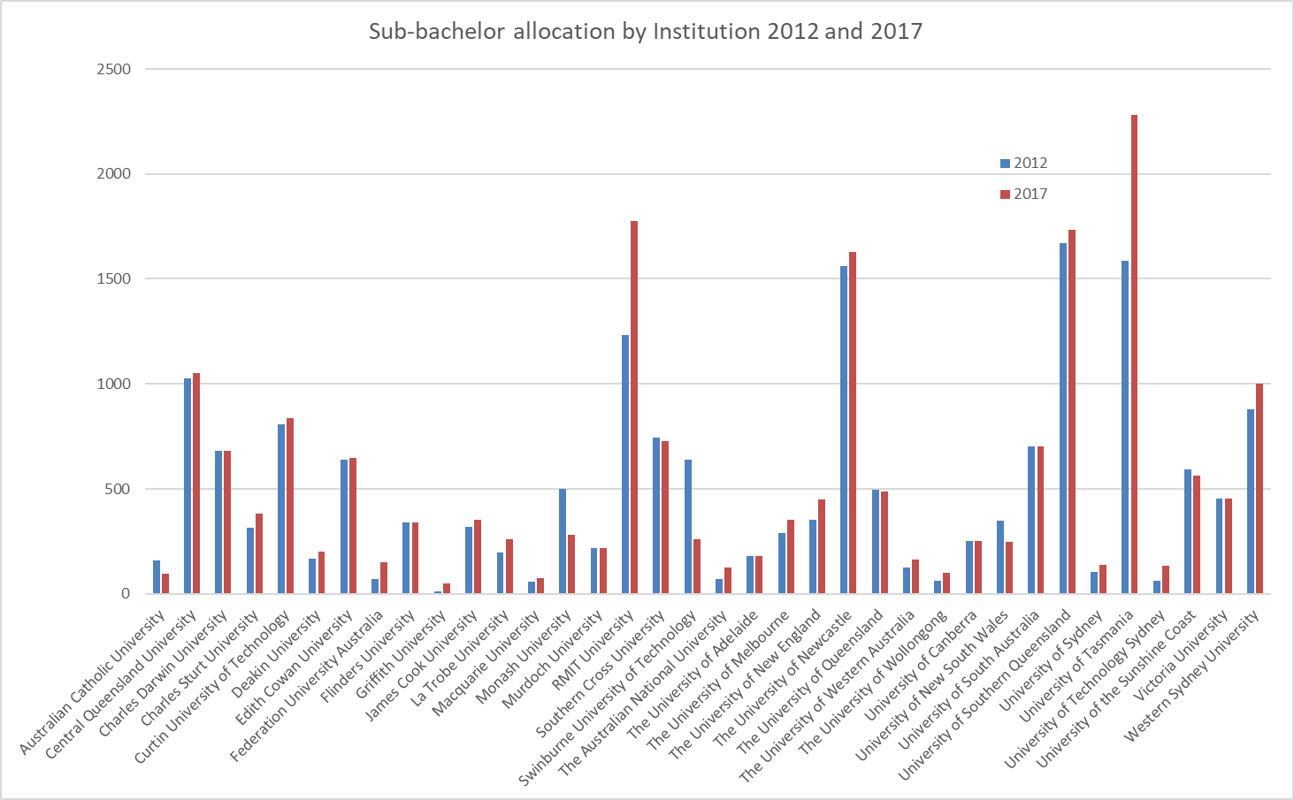

Chart 2: Sub-bachelor (including enabling) allocation by Cluster, Table A providers 2012 to 2017 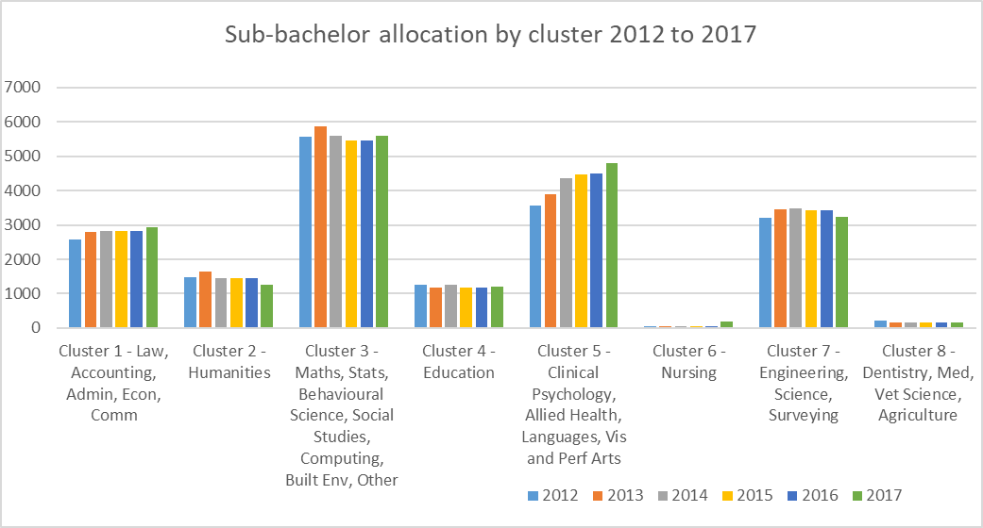

Chart 3: Postgraduate allocation, Table A providers 2012 and 2017

Bar chart showing postgraduate allocation by Institutions for 2012 and  2017.


Chart 4: Postgraduate allocation by Cluster, Table A providers 2012 to 2017

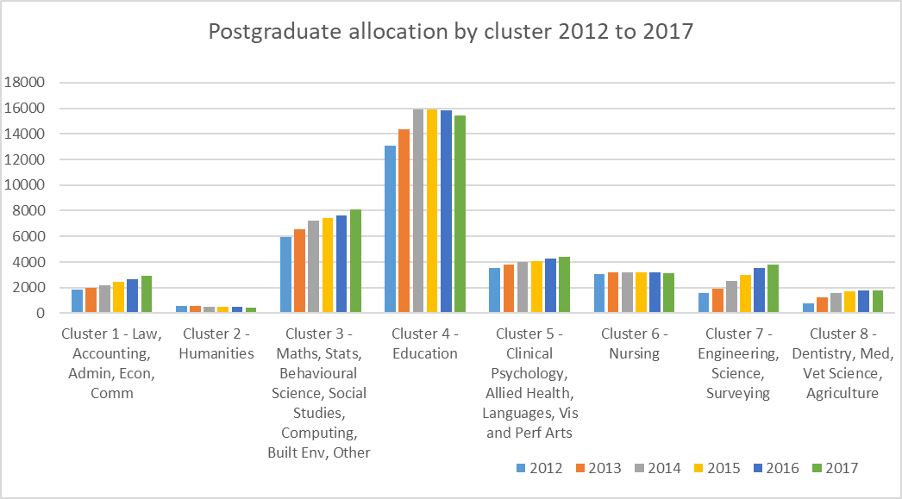

Table 1 below shows the 2018 distribution of allocated Commonwealth supported sub-bachelor and postgraduate places across funding clusters. Nearly 30% of sub-bachelor places are in funding Cluster 3 which encompasses courses in Maths, Statistics, Behavioural Science, Social Studies, IT, Built Environment and Other Health. There are also significant proportions of sub-bachelor places allocated to courses in Cluster 1 (Law, Accounting, Administration, Economics and Commerce) and Cluster 5 (Clinical Psychology, Allied Health, Languages, Visual and Performing Arts). The pattern of allocation of postgraduate places is somewhat different with nearly 40% of the places allocated to courses in Education (Cluster 4) with a further significant proportion being allocated to courses in Cluster 3 and Cluster 7 (Engineering, Science, Surveying).

Table 1: Allocated Commonwealth supported sub-bachelor and postgraduate places for 2018 (EFTSL)

|  | Table A sub‑bachelor (including enabling)* | Postgraduate Coursework (All)** |
| --- | --- | --- |
| Cluster 1 - Law, Accounting, Administration, Economics, Commerce | 2859 | 2702 |
| Cluster 2 - Humanities | 1304 | 450 |
| Cluster 3 - Maths, Stats, Behavioural Science, Social Studies, IT, Built Environment, other Health | 5575 | 7631 |
| Cluster 4 - Education | 1341 | 14504 |
| Cluster 5 - Clinical Psychology, Allied Health, Languages, Visual & Performing Arts | 4237 | 3665 |
| Cluster 6 - Nursing | 195 | 2863 |
| Cluster 7 - Engineering, Science, Surveying | 3151 | 3443 |
| Cluster 8 - Dentistry, Medicine, Veterinary, Agriculture | 185 | 1657 |
| **TOTAL** | **18847** | **36914** |

* Additional to this, non-Table A provider UNDA also receives a designated allocation of 4494 undergraduate places that includes largely bachelor places. Within this undergraduate allocation, there is an unspecified number of enabling places, however the university receives enabling loading for 416 places.

**excludes medical places

Chart 5 and Tables 2 and 3 below show university under and over enrolments, illustrating that allocations may not reflect the pattern of actual enrolments. There is currently little basis to the allocation of CSPs to ensure places are allocated to providers that are delivering the best outcomes for students, taxpayers and employers.

Chart 5: 2016 Over and under enrolments, Table A providers

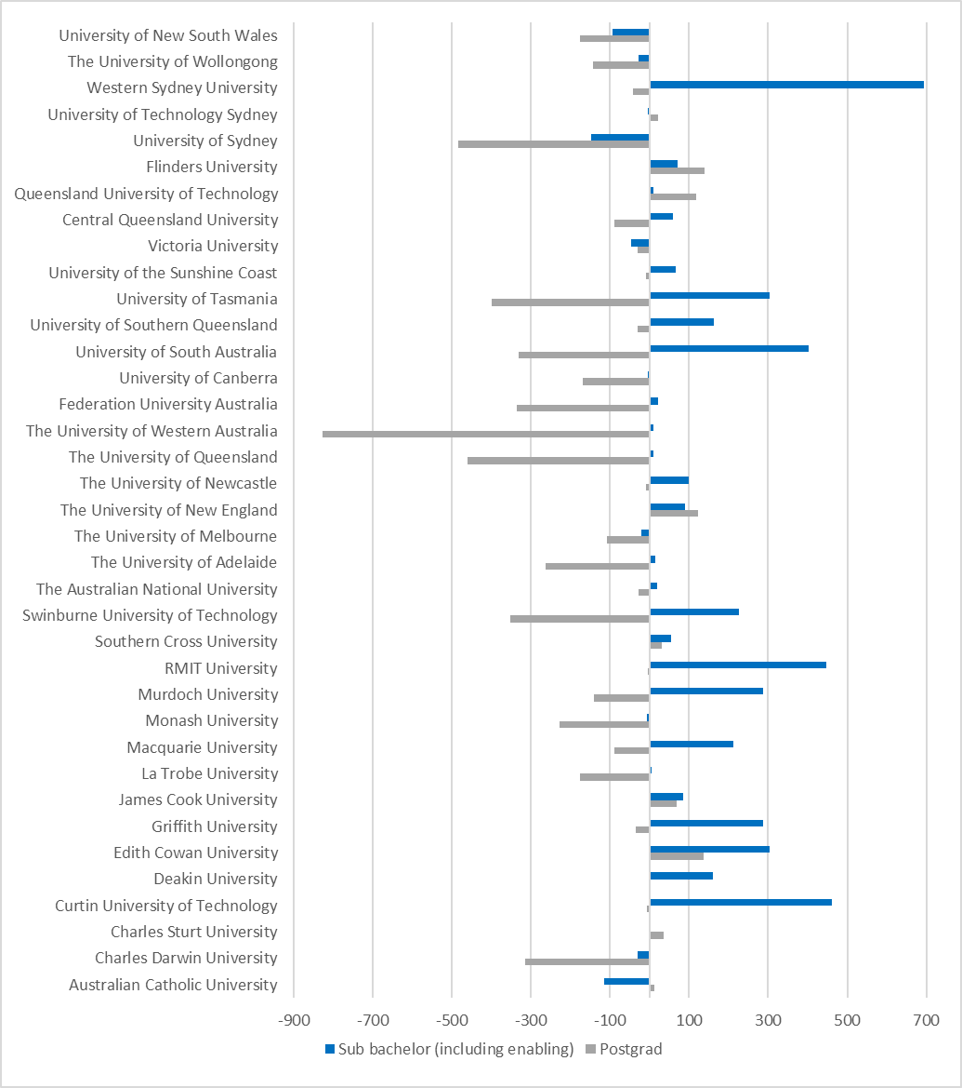

Table 2: Allocated vs actual Commonwealth supported sub-bachelor places

|  |  |  |  |
| --- | --- | --- | --- |
|  | **Allocated** | **Actual** | **Variation** |
| 2018 | 19,263 |  |  |
| 2017 | 19,778 | 23,210 | 3,432 |
| 2016 | 19,462 | 22,614 | 3,153 |
| 2015 | 19,435 | 20,407 | 972 |
| 2014 | 19,579 | 19,606 | 27 |
| 2013 | 19,464 | 18,768 | -696 |
| 2012 | 18,179 | 16,835 | -1,345 |

Note: Includes enabling places at the University of Notre Dame.

Table 3: Allocated vs actual Commonwealth supported postgraduate places

|  |  |  |  |
| --- | --- | --- | --- |
|  | **Allocated** | **Actual** | **Variation** |
| 2018 | 36,914 |  |  |
| 2017 | 40,200 | 35,762 | -4,438 |
| 2016 | 39,534 | 35,009 | -4,525 |
| 2015 | 38,456 | 34,584 | -3,872 |
| 2014 | 37,429 | 36,462 | -967 |
| 2013 | 33,764 | 35,304 | 1,540 |
| 2012 | 30,664 | 34,445 | 3,782 |

This paper sets out options for Australian Government allocation of enabling, sub-bachelor and postgraduate courses and seeks feedback from stakeholders on, which courses should be funded and why. The Government has stated its commitment to a world-class higher education system that provides appropriate support for students, and removes barriers for under-represented groups that is also sustainable for future generations. To this end, the Government is seeking to ensure there is a robust rationale and framework for Government investment in enabling, sub-bachelor and postgraduate places that provides capacity to respond to changing demands and priorities.

Enabling and sub-bachelor places provide greater options for students so they can study at a level suitable to their academic preparation or labour force need. This has flow-on benefits for students, who are provided with a pathway into university through a course that articulates into a bachelor level course, and for the system through greater efficiency.

There are unique characteristics of enabling programs that warrant a separate approach to allocation of places compared to sub-bachelor courses. Enrolment in enabling programs is not linked to a higher education qualification and so enabling programs are outside the TEQSA Higher Education Standards Framework. Universities receive an enabling loading in lieu of a student contribution ($3,271 per EFTSL in 2018) and unlike sub-bachelor courses universities have access to fee-paying enabling programs. For Government, students and employers therefore, the emphasis on allocation criteria should be on ensuring that enabling programs are of high academic quality and students have a high likelihood of progressing to further study at tertiary level.

For sub-bachelor places, distortion caused by demand driven bachelor level funding has meant that there has been only limited evolution of courses to meet the changing workforce requirements of the future. For example, as workforces become transformed by increasing automation and digitalisation there will be an increasing employer demand for students with Industry 4.0 competencies at both the sub-bachelor and bachelor level.

The case for public subsidies of postgraduate courses requires careful consideration. As higher education providers have the option of providing these courses on a fee-paying basis, it is important any Government investment is appropriately targeted to ensure benefits to the broader community are also achieved. However, defining parameters around ‘community benefit’ is not straightforward. Issues to consider include whether there is a genuine requirement for the increasing number of postgraduate level professional entry courses, how such arrangements interact with requirement of professional bodies and whether ‘professional development courses’ should be subsidised.

What is clear, is that there needs to be better correlation between the allocation and utilisation of designated places at all levels:

*Enabling courses*

Across the sector in 2016, 22 providers were over-enrolled and 11 were under-enrolled. Some providers over-enrolled by up to five times more than their allocated enabling CSPs, while others delivered as few as half of their allocated enabling CSPs. The extent to which this reflects student demand or institutional strategies around student recruitment is unknown.

*Sub-bachelor courses*

In 2016, public universities were allocated a total of 19,046 sub-bachelor places. A total of 22,117 sub‑bachelor places (including enabling courses) were delivered. Many sub-bachelor places are re‑purposed to allow more enabling places to be offered, albeit without the loading. This is inefficient because some universities are under‑enrolled by up to 74 per cent, while others are over‑enrolled by as much as 123 per cent.

*Postgraduate courses*

In 2016, public universities were allocated a total of 39,534 postgraduate places and a total of 35,009 were delivered. A large proportion of places are allocated to a small number of universities and the take-up rates of these places can be variable. Some universities were over-enrolled by up to 104 per cent while others delivered as low as 63 per cent of their allocated Commonwealth supported places.

To ensure the Government is supporting courses that meet the needs of students and deliver graduates for the changing workforce, the Government will establish new arrangements for allocating CSPs for enabling, sub‑bachelor and postgraduate courses. To ensure there is adequate time to seek feedback from the higher education sector and ensure the new arrangements result in a robust, clear framework that will provide clarity for higher education providers into the future, the new framework will be implemented from 2020. This will not include medical places, which will continue to be allocated separately.

The revised postgraduate allocations, which were implemented from 2018 to more accurately reflect utilisation of places, will remain in place until the new arrangements are implemented.

In the 2018-19 Budget, the Government announced an additional 500 commencing sub-bachelor and enabling places to be allocated through a competitive process to universities in regional areas. Allocation of these places is being managed separately.

The Government also announced additional bachelor places for students at Regional Study Hubs. Bids for those places are being managed separately through the Regional Study Hub application process.

# Consultation and issues for feedback

## 2.1 Principles for allocation of places

This paper seeks input from higher education stakeholders on the process for reallocating these CSPs, informed by the following broad principles:

* Enabling courses — places will be allocated to universities that achieve high standards of academic preparation and strong student outcomes.
* Sub-bachelor courses — priority will be given to courses that focus on industry needs and/or fully articulate into a bachelor degree.
* Postgraduate courses — places will be allocated to providers on criteria informed by professional requirements and community benefit.

Across the board, criteria for allocation will include measures of performance, as appropriate to the level of study, utilisation of existing places and student demand. Regular review of criteria, most likely on a three yearly basis in line with funding agreements, should be built into new arrangements to ensure that they remain relevant and in line with Government priorities over time.

Stakeholder views are also sought on whether geographical distribution of places should be a consideration for future allocations. Key questions to consider include to what extent considerations such as population growth would need to be balanced against other priorities like emerging workforce need or relative socio-economic disadvantage across regions. As illustrated in Charts 6 and 7 below, there are some significant variations in the current distribution per capita.

Chart 6: 2017 Distribution of sub-bachelor places

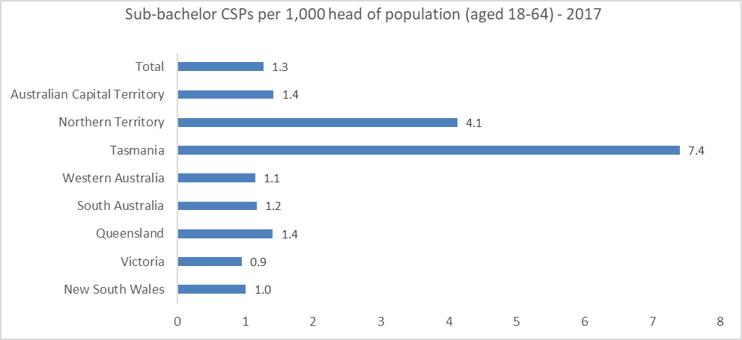

Chart 7: 2017 Distribution of allocated postgraduate places

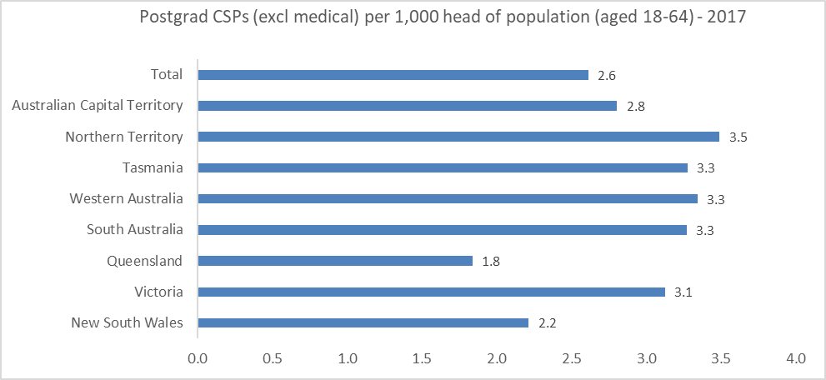

## 2.2 Process and Implementation

Feedback is sought on the process for the reallocation of places:

Frequency of reallocation:

* Annual: a reallocation process could occur before each grant year. This would ensure that allocation processes are highly responsive to emerging needs or innovations; or
* Aligning the reallocation process with funding agreements. This would give providers greater planning certainty and reduce regulatory burden. The initial reallocation would be for the 2020 grant year with subsequent reallocations aligning with the duration of new agreements.

While the preferred approach is the second option of aligning reallocation with timing of funding agreements, consideration would need to be given to a process for managing reallocation of unused places from year to year.

The policy intent of the proposed reallocation is to provide for evolutionary change in allocations over time rather than a zero based allocation of places. Applying a five per cent reduction in commencing places across all clusters would be a simple and straightforward approach to reallocation. Table 4 below sets out a derived estimate of the number of places each university would be likely to contribute under such an arrangement.

The approach taken should balance the needs of students and providers. While a larger reallocation may create greater incentives for improved outcomes and could enable and encourage greater innovation in course development and delivery, it may pose significant challenges for planning. For this reason, a smaller reallocation would seem to be a more appropriate option as it would give providers more time to plan and respond to allocation changes. A smaller reallocation base would be less likely to have a significant impact on any individual provider and consideration would need to be given to ongoing viability of programs.

The department is interested in providers’ views on the most appropriate proportion of places to be reallocated into a national pool and the frequency with which this should occur.

Table 4: Indicative contribution of sub-bachelor and postgraduate commencing places (EFTSL)

|  |  |  |  |
| --- | --- | --- | --- |
| **Institution** | **Enabling loading places** | **Sub-bachelor (Excluding Enabling)** | **Postgraduate Coursework** |
| Christian Heritage College | 0.0 | 0.0 | 0.7 |
| The University of Notre Dame Australia | 20.8 | 0.0 | 2.6 |
| Australian Catholic University | 0.0 | 3.4 | 25.4 |
| Charles Darwin University | 27.2 | 2.0 | 9.9 |
| Charles Sturt University | 10.0 | 4.1 | 24.9 |
| Curtin University | 33.4 | 6.0 | 10.6 |
| Deakin University | 0.0 | 7.0 | 23.4 |
| Edith Cowan University | 27.3 | 3.5 | 19.4 |
| Griffith University | 0.3 | 0.2 | 29.2 |
| James Cook University | 2.9 | 9.2 | 11.7 |
| La Trobe University | 3.6 | 4.3 | 22.4 |
| Macquarie University | 0.0 | 2.6 | 14.0 |
| Monash University | 0.2 | 9.7 | 43.9 |
| Murdoch University | 10.9 | 0.0 | 5.4 |
| RMIT University | 0.0 | 59.7 | 23.5 |
| Southern Cross University | 19.3 | 11.9 | 6.3 |
| Swinburne University of Technology | 0.0 | 9.1 | 8.0 |
| The Australian National University | 0.0 | 2.5 | 3.4 |
| The University of Adelaide | 4.5 | 3.3 | 17.7 |
| The University of Melbourne | 1.1 | 9.4 | 131.3 |
| The University of New England | 13.7 | 5.1 | 35.2 |
| The University of Newcastle | 80.7 | 0.0 | 7.1 |
| The University of Queensland | 3.9 | 12.9 | 23.2 |
| The University of Western Australia | 3.2 | 3.5 | 82.3 |
| Federation University Australia | 6.5 | 0.7 | 13.2 |
| University of Canberra | 9.1 | 2.5 | 13.1 |
| University of South Australia | 17.2 | 12.5 | 37.7 |
| University of Southern Queensland | 36.9 | 34.8 | 18.8 |
| University of Tasmania | 24.0 | 87.2 | 28.3 |
| University of the Sunshine Coast | 23.8 | 3.0 | 5.1 |
| Victoria University | 14.6 | 5.8 | 15.3 |
| Queensland University of Technology | 0.0 | 0.0 | 26.1 |
| Tabor Adelaide | 0.0 | 0.0 | 0.6 |
| Central Queensland University | 41.2 | 7.4 | 4.9 |
| Flinders University | 16.0 | 0.7 | 21.9 |
| University of Sydney | 0.3 | 2.7 | 49.0 |
| University of Technology Sydney | 4.1 | 0.0 | 11.1 |
| Western Sydney University | 9.6 | 28.3 | 43.0 |
| The University of Wollongong | 2.9 | 0.2 | 17.9 |
| Avondale College Ltd | 0.0 | 0.0 | 1.2 |
| Eastern College Australia Inc | 0.0 | 0.0 | 0.3 |
| University of New South Wales | 6.5 | 4.1 | 33.8 |
| **Grand Total** | 475.1 | 359.2 | 922.8 |

## 2.3 Consultation issues – enabling places

Enabling programs have operated since 1990 to give students the requisite background skills and knowledge to undertake further tertiary education. These courses are targeted at students who enter university through non‑traditional pathways, particularly those without an ATAR.

Providers offer enabling courses to underprepared learners to assist them in undertaking future higher education qualifications. These courses can be undertaken as a preparatory or concurrent study option. Enabling courses provide students with numerous benefits including general study skills and discipline‑specific knowledge. Their role as a preparation tool for students with socio-economic or educational disadvantage was recognised in the 2011 Base Funding Review. Chart 8 below highlights the relatively higher representation of equity groups in enabling courses relative to other course levels.

Chart 8: Representation of Equity Groups1 by Course level (2016)

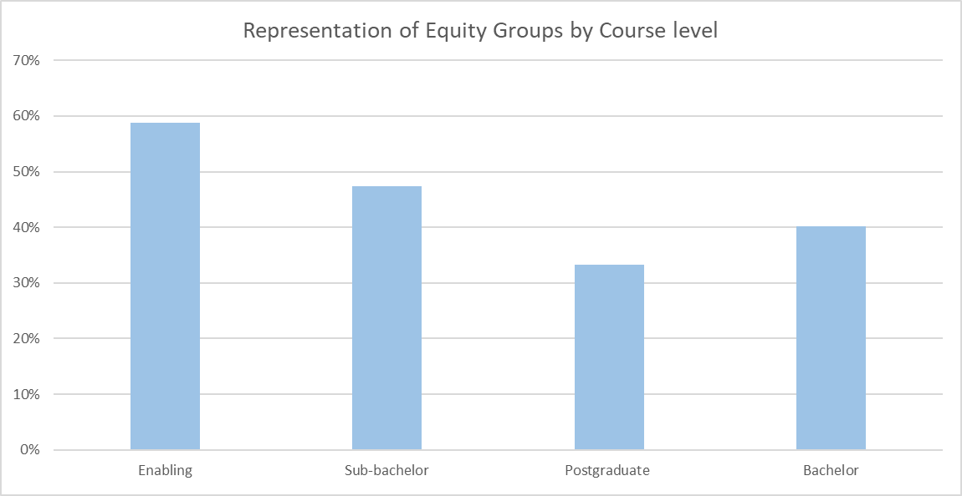

1. Lower Socio Economic Status (SES) groups, Regional and Remote address, Non English Speaking Background, Indigenous students and students with a disability.

The VET sector also offers students a pathway into higher education. In 2016, approximately 12 per cent of bachelor degree commencers were admitted to higher education based on prior VET study.

In 2015, the VET sector had 6,000 enrolments in accredited tertiary preparation courses (e.g. diplomas and certificate IV)[1]. The Certificate IV in Tertiary Preparation, which provides a similar offering to an enabling course, costs between $700 and $2000 in a government subsidised place.

In 2016, 33 higher education providers were allocated some 9686 enabling places[2] but delivered 12,500 places which allowed them to provide enabling courses to almost 31,700 Commonwealth supported students. Some 10 providers provided full fee-paying programs to 3300 students.

**Consultation and issues for feedback**

Feedback is sought on the following criteria for the reallocation of enabling places:

* *Student progression to further study at tertiary level:* this will help determine which providers have engaged with students to finish their course and move on to further study at a tertiary level. The existing student data collection could be used to examine the proportion of students that are enrolled in an enabling course in one year and are then enrolled in a tertiary level program one year later. Overall student progression from an enabling program into study in the subsequent year is currently just over 50 per cent.
* *Existing utilisation of places:* this could be measured by historical over and under enrolment, comparing allocations with actual use. Significant over-enrolments at an institution may indicate that there is strong demand and students would benefit from continued or expanded Government support. Issues include how to avoid creating an incentive to fill places with uncommitted students in order to maintain an allocation of places.
* *Profile of commencing students:* this would consider the characteristics of an institution’s commencing student cohort. Analysing the characteristics of the commencing student population from the previous year could identify the prevalence of any equity groups who may require support to participate in higher education. Providers would be required to demonstrate how they would engage with and support students from these disadvantaged groups. Places would then be allocated to institutions most able to assist these students to access further education. An alternative criterion could instead consider the profile of the institution’s catchment area.
* *Innovative teaching models:* universities should be encouraged to develop innovative approaches to delivering enabling courses, particularly as such courses should be designed to support students that are under-prepared for tertiary education and which prepare students to undertake study at a range of tertiary institutions.

Issues to be considered include what weighting should be given to these criteria (or other criteria that emerge in consultations). Given the current uneven distribution of enabling places, it will also be important to ensure that criteria do not effectively lock out institutions with no, or very small current allocations and there may be value in considering whether all institutions should be entitled to a minimum number of places.

## 2.4 Consultation issues – sub-bachelor places

The department previously sought feedback on proposed arrangements for sub-bachelor courses in the context of the previous policy, which would have seen demand driven funding arrangements for sub‑bachelor courses that met certain eligibility criteria. While the Government is no longer pursuing demand driven funding for sub-bachelor places, it remains committed to ensuring that sub-bachelor places deliver for the needs of students, taxpayers and employers.

While the Government acknowledges that sub-bachelor courses provide a valuable qualification in themselves, the prioritisation of courses that fully articulate from sub-bachelor to bachelor-level study promotes the most efficient pathway for students wishing to continue with their study. However, as identified in the previous consultation, this prioritisation potentially excludes cognate diplomas, such as the Diploma of Languages. For this reason, the Government is intending to require courses to either have full articulation to bachelor-level study or be open only to students that are concurrently enrolled in a bachelor degree program at the same institution.

**Consultation and issues for feedback**

Feedback is sought on the following criteria for the reallocation of sub-bachelor places:

* *Courses address industry needs*: this criterion could consider which courses the university intends to or has previously offered. Preference could be given to courses that address industry needs through one or more of the following:
  + For a professional course, the sub-bachelor course (or the related bachelor course/s into which it articulates) is accredited by the appropriate professional body or association; or
  + The course was developed in consultation with industry or employers, with documented evidence of employer support for the course; or
  + The course includes substantive work-integrated learning or work experience in industry components; or
  + The course has demonstrated excellent employment outcomes for students over time; or
  + The course relates to emerging industries or occupations, where related industries are not yet mature but are strategically important for the economy (such as Industry 4.0 competencies). Initially this will include science, technology, engineering, and mathematics courses; or
  + The course addresses local or regional skills shortages; and
  + The course does not duplicate courses being funded by the VET sector.
* *Existing utilisation of places*: this could be measured by historical over and under enrolment, comparing allocations with actual use. Significant over-enrolments at an institution may indicate that there is strong demand. Issues include how to avoid creating an incentive to fill places with uncommitted students in order to maintain an allocation of places.
* *Completions and transition to further study at tertiary level*: places could be prioritised to those institutions that can demonstrate a strong track record in supporting students through to completion or into further study at tertiary level.
* *Attrition*: this would need to be designed to take into account variation in institutional mission and the characteristics of their student cohort. However, demonstrably poor and/or increasing attrition outcomes would see places returned to the reallocation pool.
* *Demonstrated demand*: this could be assessed in relation to local population growth and/or youth population.
* *Demonstrated need*: this could be assessed in relation to current post-secondary provision in the region relative to national average

An issue to consider is how would universities without existing allocations demonstrate performance in these criteria. Unlike enabling and postgraduate courses, public universities may not enrol domestic students in fee‑paying places in a sub-bachelor course. Consideration could be given to developing a process whereby all universities, including those without an existing allocation, can seek to request further places based on their proposed approach.

## 2.5 Consultation issues – postgraduate places

Universities can negotiate cost-neutral changes to their profile of postgraduate CSPs and such requests are assessed against criteria, which were announced in April 2011. Approval is granted on the basis that the university is able to demonstrate that the course:

* is moving towards, being an accepted entry level for a profession; or
* meets an identified need in an area of skills shortage; or
* is of national significance (i.e. foster high level skills relevant to Australia’s research and innovation needs, national interests or cultural development, for example, a specialist postgraduate mathematics course).

Most universities under-enrol their postgraduate places, although some do over-enrol. The reduction of underutilised places that was given effect in 2018 funding agreements will substantially address this.

The Government has been using the ‘interim’ criteria for the allocation of new or reallocation of existing postgraduate CSPs – professional entry, skills shortage or national significance – since the 2011 postgraduate places consultation process. The consultation paper released at that time noted that there are some inherent difficulties in assessing whether courses meet any of these criteria. These include difficulties in defining a profession (which is straightforward in some cases but not others), deeming which sources of information regarding skills shortages are appropriate, and most notably, how to define national significance. Generally, a nationally significant course has been described as fostering high-level skills relevant to Australia’s research and innovation needs, national interests or cultural development, for example, a specialist postgraduate mathematics course.

While the criteria are used to assess requested changes to profiles, they have not been used to reassess the existing profiles. For instance, there is no process to cyclically reassess skill shortages and whether places remain allocated where skill shortages may have been resolved. The new arrangements would include cyclical review of course and allocation criteria in consultation with the sector and other stakeholders including employers and professional accreditation bodies.

**Consultation and issues for feedback**

Feedback is sought on the following criteria for the reallocation of postgraduate places:

* *Which courses are subsidised:* It is important that the Government continues to support the delivery of postgraduate qualifications where these are necessary for professional entry, to support rapid retraining in areas of workforce shortage or meet other national priorities. However, it is not in the interests of students or the public to see an unjustifiable increase in initial entry requirements, because it increases forgone income and requires taxpayers to fund longer periods of study. In that context, preference could be given to courses that address one or more of the following:
  + the course delivers significant community benefit where private benefits may be more limited and where graduate salaries may be comparatively lower while demand for skills is high (for example in selected health professions); or
  + the qualification is a minimum requirement for professional registration/accreditation by a recognised professional body (e.g professional organisations covered by Universities Australia agreement on Principles for Professional Accreditation Australasian such as Australian Dental Association, Charted Accountants Australia New Zealand, CPA Australia) or the minimum qualification legally required for practice in a profession.
  + the qualification is the shortest possible pathway to a professional qualification; or
  + the qualification meets an identified skills shortage. Issues to consider include how this should be defined and whether it provides for sufficient flexibility to respond to emerging skills needs. One approach might be that the profession appears on the Department of Jobs and Small Business Skills Shortages List (e.g architect, veterinarian, radiographer, optometrist).
* *Existing utilisation of places*: this could be measured by historical over and under enrolment, comparing allocations with actual use. Significant over-enrolments at an institution may indicate that there is strong demand. Issues include how to avoid creating an incentive to fill places with uncommitted students in order to maintain an allocation of places.
* *Student satisfaction*: as measured and reported through current processes, this would provide some weighting to the quality of teaching and learning in consideration of the allocation of places.
* *Graduate employment outcomes*: as measured and reported through current processes. The department acknowledges that consideration will need to be given to the range of external factors which influence graduate employment. Nonetheless, as employment outcomes are a key underlying rationale for Government investment in postgraduate education, they should be a consideration in the allocation of places and the likelihood that many postgraduate students are already employed, many in industries relevant to their qualification.
* *Representation of equity groups*: as collected and measured through current processes, this would provide an indication of the proportion of postgraduate students at that institution that would benefit most from a subsidised place.

**Transitional arrangements**

It is proposed that any reallocation of places will be with respect to commencing places only. This will provide certainty for current students and ensure they are not disadvantaged by a change in policy arrangements. It will also allow universities scope to better manage any transition arrangements and help with forward planning.

# Summary of issues/questions

Views are sought on the following issues and questions canvassed above

* Should geographical representation be a consideration in distribution of places?
* What is the minimum viable allocation for enabling, sub-bachelor and postgraduate places?
* How often should places be re-distributed? Should this vary for enabling, sub-bachelor and postgraduate places?
* What proportion of places should be reallocated? Should this vary for enabling, sub-bachelor and postgraduate places?
* What are stakeholders’ views on the allocation criteria suggested above? Are there other criteria which should be considered?
* How should criteria be configured to ensure that institutions’ do not become ‘locked out’ of future reallocations, especially where they have a limited track record in delivery?

# Next steps

The department seeks stakeholders’ written submissions and also welcomes input on issues or approaches not specifically canvassed here. Input will inform the criteria for allocation of enabling, sub-bachelor and postgraduate places from 2020 which will be published in 2019, at the same time applications for the process open.

# Submissions

Please send submissions to the Department of Education and Training at [CGS@education.gov.au](mailto:CGS@education.gov.au). The closing date for submissions is **5pm on 15 February 2019**.

1. Reflects the minimum number of VET enrolments in tertiary preparation courses. Courses that are non-accredited or provide broader pathways have not been included in this count.
2. These include 185 places that terminated at the end of 2017, returning the annual allocation to 9501 places from 2018. These places were part of a non-ongoing measure announced in the 2013–14 Budget.