|  |  |
| --- | --- |
| National School Reform Agreement | |
|  |  |
| Council of Australian Governments | |
|  |  |

Table of Contents

PRELIMINARIES 3

PART 1 — PARTIES AND OPERATION 5

Parties 5

Term 5

Variations 5

Withdrawal of Parties 5

Dispute resolution 6

Review 6

Part 2 – Objectives, Outcomes, TARGETs and measures 6

Objectives 6

Outcomes 6

Targets 7

National measures 7

Part 3 — REFORM ACTIVITY 8

Reform directions 8

National policy initiatives 8

State-specific reform initiatives 10

Part 4 — REPORTING AND PUBLIC TRANSPARENCY 10

PART 5 — RESPONSIBILITIES 11

Shared responsibilities of the Commonwealth and the States and Territories 11

Responsibilities of the Commonwealth 12

Responsibilities of the States and Territories 13

PART 6 — ROLE OF THE NON-GOVERNMENT SECTOR 14

PART 7 — SIGNATURES 15

PART 8 — SCHEDULES 16

National School Reform Agreement

# PRELIMINARIES

1. All Governments have agreed common goals for schooling in Australia through the *Melbourne Declaration on Educational Goals for Young Australians*. These shared goals provide that schooling in Australia will be founded on the twin principles of equity and excellence. While school education is delivered in diverse contexts across eight States and Territories in government and non-government schools, our common aspiration is that all young Australians will become successful learners, confident and creative individuals and active and informed citizens.
2. A high quality school education will equip Australians to succeed in an increasingly complex world. Australia’s future stability and economic prosperity is reliant on an equitable and inclusive school system that instils in our children and young adults the values, knowledge and skills required to be active, informed citizens and prepares them for the challenges of tomorrow.
3. The Parties recognise that the constitutional responsibility for school education lies with States and Territories and that each State and Territory as well as non-government schools have in place their own regulatory frameworks, local policies and priorities intended to maximise local students’ educational outcomes.
4. Working together, the Parties have already established a number of key strategic initiatives in areas where national collaboration provides the best means to achieve outcomes. Jurisdictions have collaborated to produce a national curriculum that provides the core knowledge that students need to succeed. National teaching standards underpin reforms across the country to support the highest quality teaching profession. A program of national assessments and a common reporting framework provides the means for measuring progress against our national goals. Ongoing implementation of these shared commitments remains a condition of funding under the *Australian Education Act 2013* (the Act).
5. Reflecting the long-standing practice of collaboration between all governments to deliver school education reform, the Council of Australian Governments (COAG) has established the National School Reform Agreement (the Agreement). This Agreement outlines a set of strategic reforms in areas where national collaboration will have the greatest impact, builds on current national reform efforts, complements State and Territory leadership in each jurisdiction and supports local implementation. The Education Council[1] of COAG is responsible for overseeing implementation of this Agreement.
6. This Agreement replaces all previous agreements.
7. This Agreement operates in the context of, and gives effect to, requirements under the Act. The Act sets out conditions on States and Territories for grants of financial assistance. This Agreement and its Schedules satisfy the requirements of subsection 22(2)(a) and (b) of the Act in respect of Commonwealth school funding for the period this agreement is in operation.
8. This Agreement has been guided by COAG’s ‘Closing the Gap’ agenda, including the *National Aboriginal and Torres Strait Islander Education Strategy 2015* and the *National Indigenous Reform Agreement* and sets out actions that will support efforts to lift outcomes for Aboriginal and Torres Strait Islander students. It has been informed by the findings of the *Review to Achieve Educational Excellence in Australian Schools,* the *Independent Review into Regional, Rural and Remote Education,* the *Review to Achieve Educational Excellence in Australian Schools through Early Childhood Interventions* and the STEM Partnerships Forum.
9. The wellbeing of all students is fundamental to successful education outcomes. Parties recognise the critical importance of supporting and facilitating the achievement of priority equity cohorts, including Aboriginal and Torres Strait Islander students, students living in regional, rural and remote locations, students with a disability and students from educationally disadvantaged backgrounds.
10. Parties also recognise the crucial role that teachers play in preparing young people to lead successful and productive lives. This agreement recognises the competing demands on teachers’ and school leaders’ time and provides support for them to focus on high quality teaching and leading, maximising student-learning growth. The reforms allow teachers to build on their professional judgement and implement high-impact teaching and learning practices that benefit all students. A high quality schooling system is also supported through partnerships with the broader community and employers, extra-curricular activities, volunteering and parent engagement.
11. This Agreement sets out long-term national outcomes for school education in Australia and national targets and sub-outcomes to track progress towards these. To achieve the outcomes, the Agreement sets out reform directions supported by national policy initiatives and bilateral actions that are based on evidence of what works.
12. The Parties recognise that achieving the outcomes of this Agreement requires sustained reform effort and the actions set out in the Agreement will pave the way for future arrangements. The Parties acknowledge the different local contexts and starting points of each jurisdiction.
13. The Commonwealth provides funding to States and Territories to distribute to all eligible schools through the Act, based on the [Schooling Resource Standard (SRS)](https://www.education.gov.au/what-schooling-resource-standard-and-how-does-it-work). The SRS is made up of a base funding amount for every student plus six additional loadings that provide extra funding to meet the needs of all students.
14. Parties recognise that States and Territories provide the majority of public funding for school education. As specified in the Act, the Commonwealth will contribute at least 20 per cent of the SRS for all government schools by 2023, and at least 80 per cent of the SRS for all   
    non-government schools (Catholic and independent schools) by 2023. For most non-government schools, the base per student SRS amount is reduced by the anticipated capacity of their school community to financially contribute towards the school’s operating costs.
15. The Parties recognise the important role of the non-government sector in school education outlined in Part 6, including non-government school approved authorities and the non-government representative bodies that represent them, and commit to working with the non-government sector to implement bilateral agreements as detailed and agreed at Schedule E.
16. Except where otherwise expressly indicated, this Agreement and all schedules to the Agreement are not intended to limit the operation of the Act and the *Australian Education Regulation 2013* (the Regulation), including decisions made under that legislation.

# PART 1 — PARTIES AND OPERATION

## Parties

1. The Parties to this Agreement (the Parties) are:
   1. the Commonwealth of Australia (the Commonwealth); and
   2. the States and Territories, being:
      1. the State of New South Wales;
      2. the State of Victoria;
      3. the State of Queensland;
      4. the State of Western Australia;
      5. the State of South Australia;
      6. the State of Tasmania;
      7. the Australian Capital Territory; and
      8. the Northern Territory.

## Term

1. This Agreement and any schedule (except Schedule E) to the Agreement will commence on 1 January 2019 and will expire on 31 December 2023.
2. Bilateral agreements between the Commonwealth and a State or Territory (which will be included at Schedule E) will commence on 1 January 2019, and expire on 31 December 2023 unless otherwise specified in the agreement.

## Variations

1. This Agreement may be varied or extended at any time with the agreement in writing of First Ministers and with terms and conditions as agreed by all the Parties.
2. Unless otherwise specified, the schedules to this Agreement (except Schedule E) may be varied or revoked, and new schedules may be added, at any time with the agreement of the relevant portfolio Commonwealth Minister and all relevant State and Territory Ministers for school education. New schedules will be developed through the Education Council in line with Education Council decision-making protocols.
3. Bilateral agreements between the Commonwealth and a State or Territory (included at Schedule E) may be varied with the written agreement of the relevant portfolio Commonwealth Minister and the State or Territory Minister for school education for the State or Territory to which the bilateral agreement relates.
4. Where variations impact the non-government sector, Parties agree to consult with relevant   
   non-government representative bodies on proposed variations on a national or state level, as appropriate.

## Withdrawal of Parties

1. A Party to the Agreement may terminate its participation in this Agreement at any time by notifying all the other Parties in writing. If a Party intends to withdraw, it should provide as much notice as possible before withdrawing and a minimum of three months.

## Dispute resolution

1. Any Party may give notice to the other Parties of a dispute under this Agreement or any schedule to the Agreement, except Schedule E.
2. Officials of relevant Parties will attempt to resolve any dispute under this Agreement in the first instance. If a dispute cannot be resolved by officials it may be escalated to the relevant school education portfolio Ministers, and if necessary, to the Education Council. If a dispute cannot be resolved by the relevant school education portfolio Ministers, it may be referred to the relevant First Ministers and, if necessary, to COAG for consideration.
3. In the case of a dispute related to a bilateral agreement between the Commonwealth and a State or Territory, officials of relevant Parties will attempt to resolve any dispute relating to this Agreement in the first instance. If a dispute cannot be resolved by officials, it may be escalated to the relevant school education portfolio Ministers and, if necessary, to relevant First Ministers.
4. A dispute does not, of itself, constitute failure to implement the Agreement.

## Review

1. An independent review will be commissioned on behalf of Education Council to assess:
   1. the effectiveness of the national policy initiatives outlined in Part 3, recognising that national reform takes time to implement and mature, and for the effects of nationally coordinated reform efforts to materialise
   2. the appropriateness of the National Measurement Framework for Schooling (Measurement Framework) in measuring progress towards achieving the outcomes of this Agreement.
2. The review will not include any assessment of compliance with section 22A of the Act.
3. The reviewer(s) and the terms of reference for the review are to be agreed by the Education Council. The review will be completed by 31 December 2022 for consideration of Education Council and COAG to inform the development of a new national reform agreement.
4. The reviewer(s) will present the report to Education Council prior to publication.
5. The Commonwealth will commission the National School Resourcing Board to review the SRS indexation arrangements. The terms of reference for the review are to be agreed by the Education Council. The review will be completed and presented to Education Council in 2023.

# Part 2 – Objectives, Outcomes, TARGETs and measures

## Objectives

1. The Parties commit this Agreement should contribute to the following objective:
   1. Australian schooling provides a high quality and equitable education for all students.

## Outcomes

1. The Parties commit to the following outcomes, which collectively articulate Parties’ high ambition for Australian school education:
   1. Academic achievement improves for all students, including priority equity cohorts;
   2. All students are engaged in their schooling; and
   3. Students gain the skills they need to transition to further study and/or work and life success.

## Targets

1. The Parties have previously agreed to the following national targets which are critical to the achievement of the outcomes:
   1. Australia considered to be a high quality and high equity schooling system by international standards by 2025;
   2. lift the Year 12 (or equivalent) or Certificate III attainment rate to 90 per cent by 2020; and
   3. at least halve the gap for Aboriginal and Torres Strait Islander students in Year 12 or equivalent attainment rates by 2020, from the 2006 baseline.

## National measures

1. The Parties will track progress against the following sub-outcomes. These incorporate, as well as build on and supersede existing COAG education targets and aim to promote a culture that strives for continuous improvement in the performance of Australia’s schooling system.

| **Outcome** | **Sub-outcome** |
| --- | --- |
| **Academic achievement improves for all students, including priority equity cohorts.** | Lower the proportion of students in the bottom levels and increase the proportion of students in the top levels of performance (bottom two and top two bands) in the National Assessment Program–Literacy and Numeracy (NAPLAN) Literacy and Numeracy, of Years 3, 5, 7 and 9. |
| Lower the proportion of Australian students in the bottom levels and increase the proportion of students in the top levels of performance (proficiency Levels 1 and 2 and proficiency Levels 5 and 6) for the Organisation for Economic Cooperation and Development’s (OECD) Programme for International Student Assessment (PISA) testing in reading, mathematics and science. |
| Lower the proportion of students from priority equity cohorts in the bottom levels and increase the proportion of students in the top levels of performance (bottom two and top two bands) in NAPLAN Literacy and Numeracy, for Years 3, 5, 7 and 9. |
| Reduce the gap in achievement between students from various socio-economic backgrounds in Australia’s PISA educational performance compared to other countries and the OECD average. |
| Increase the proportion of young people from priority equity cohorts, who have completed year 12 or equivalent or gained a qualification at the Australian Qualifications Framework (AQF) Certificate III or above. |
| **All students are engaged in their schooling.** | Increase the proportion of students attending school 90 per cent or more of the time, including students from priority equity cohorts |
| **Students gain the skills they need to transition to further study and/or work and life success.** | Increase the proportion of young people who have completed year 12 or equivalent or gained a qualification at AQF Certificate III or above. |

1. For the purpose of this Agreement, priority equity cohorts include Aboriginal and Torres Strait Islander students, students living in regional, rural and remote locations, students with a disability and students from educationally disadvantaged backgrounds. All Parties agree that sub-outcomes will be disaggregated by cohorts where available.
2. All Parties agree to consider improvements to these outcomes and sub-outcomes over time, including enhancements to the existing performance measures and developing further performance measures reflecting priority areas, such as measures of learning gain, early years foundation skills and student engagement. All Parties agree to adopt updated COAG targets should they be endorsed by COAG during the life of the Agreement.
3. All Parties agree to the public reporting of progress towards achievement of the above outcomes and sub-outcomes through agreed COAG performance reporting arrangements.
4. All Parties are responsible for working together to achieve the objectives and outcomes of this Agreement. While the Parties are collectively committed to the achievement of the objectives, outcomes and targets outlined above, Commonwealth school funding to States and Territories under the Act is not conditional on the achievement of these objectives, outcomes and targets.

# Part 3 — REFORM ACTIVITY

## Reform directions

1. Parties agree to build on existing efforts in each of the following reform directions, and implement national policy initiatives as agreed in Schedule B and state-specific activities as agreed in Schedule E:
2. Supporting students, student learning and student achievement;
3. Supporting teaching, school leadership and school improvement; and
4. Enhancing the national evidence base.

## National policy initiatives

1. The reform directions will be progressed nationally through national policy initiatives that:
   1. recognise and build on existing national, State and Territory and sectoral reform activities that are proven to be lifting outcomes for students
   2. have a robust and evidence-based rationale for how national policy initiatives will directly or indirectly improve outcomes through national coordinated effort
   3. concentrate reform efforts on the key enablers that drive improvement in educational outcomes
   4. take into account jurisdictional and sectoral context and allow for jurisdictional and sectoral flexibility in implementation of national policy initiatives, including in resource allocation.
2. The Parties agree to the following national policy initiatives that support the three reform directions:
3. Supporting students, student learning and student achievement
   1. Enhancing the Australian Curriculum to support teacher assessment of student attainment and growth against clear descriptors
   2. Assisting teachers monitor individual student progress and identify student learning needs through opt-in online and on demand student learning assessment tools with links to student learning resources, prioritising early years foundation skills
   3. Reviewing senior secondary pathways into work, further education and training
4. Supporting teaching, school leadership and school improvement
5. Reviewing teacher workforce needs of the future to attract and retain the best and brightest to the teaching profession and attract teachers to areas of need
6. Strengthening the initial teacher education accreditation system
7. Enhancing the national evidence base
8. Implementing a national unique student identifier (USI) that meets national privacy requirements in order to support better understanding of student progression and improve the national evidence base
9. Establishing an independent national evidence institute to inform teacher practice, system improvement and policy development
10. Improving national data quality, consistency and collection to improve the national evidence base and inform policy development.
11. The implementation of these national policy initiatives as outlined in Schedule B is a condition of Commonwealth funding to States and Territories under section 22(2) of the Act. It is anticipated that Education Council will vary Schedule B over time as national policy initiatives are further developed and considered.
12. The cost of national policy initiatives will be met by Parties according to the cost sharing principles outlined in Schedule C.
13. If the Education Council agrees in future, to any new national policy initiatives as related to sections 22(1)(a) and 77(2A) of the Act, these will be separately progressed through Education Council processes.
14. Existing initiatives will continue to progress through Education Council processes, but are not considered national policy initiatives for the purposes of section 22 of the Act. This includes, but is not limited to, the National STEM School Education Strategy, the National Career Education Strategy, the National Aboriginal and Torres Strait Islander Education Strategy 2015, the Nationally Consistent Collection of Data on School Students with Disability, work to combat bullying and cyberbullying and consideration of the recommendations of the Royal Commission into Institutional Responses to Child Sexual Abuse.

## State-specific reform initiatives

1. Bilateral agreements in Schedule E recognise that constitutional responsibility for school education rests with each State or Territory. The bilateral agreements take into account the specific contexts, existing reform efforts and starting points for the relevant State or Territory and set out:
   1. reform initiatives the State or Territory agrees to take to progress the national reform directions, in government and non-government sectors, including actions to support the implementation of agreed national policy initiatives
   2. any commitments of the Commonwealth to support the State or Territory to progress national reform directions, including reporting obligations of the Commonwealth as set out in the relevant bilateral agreement
   3. existing and/or new reforms to lift outcomes for priority equity cohorts including Aboriginal and Torres Strait Islander students, students living in regional, rural and remote locations, students with a disability and students from educationally disadvantaged backgrounds, as agreed by Parties
   4. State or Territory funding contributions where arrangements vary from the default in section 22A of the Act.
2. The implementation of bilateral agreements is a condition of Commonwealth funding to States and Territories under section 22(2) of the Act. The Commonwealth will not impose sanctions on States or Territories for a failure by the non-government school sector to comply with the requirement in section 77(2A) of the Act to cooperate with this Agreement or the applicable bilateral agreement. Nor will the Commonwealth impose sanctions on the non-government school sector for a failure of a State or Territory to implement this Agreement.

# Part 4 — REPORTING AND PUBLIC TRANSPARENCY

1. Shared accountability through reporting and public transparency are key mechanisms to give the community confidence that outcomes are being achieved and reforms to improve the quality and equity of Australia’s schooling system are being implemented by all Parties.
2. Parties agree this Agreement and its Schedules, including bilateral agreements at Schedule E, will be made publicly available.
3. Parties further agree the following reporting and public transparency arrangements:
   1. an annual public report from Education Council to COAG outlining Education Council’s progress towards implementing the national policy initiatives against agreed milestones as detailed in Schedule B and outlined in Schedule D
   2. an annual report from each State or Territory to the Commonwealth outlining progress towards implementing state-specific reform initiatives against agreed milestones as detailed in the relevant bilateral agreement at Schedule E for the purposes of assessing compliance with section 22(2)(c) of the Act
   3. continuing public accountability on progress towards meeting targets through existing COAG performance reporting arrangements
   4. publication of the report of the independent review set out at clause 32 on the effectiveness of the national policy initiatives.
4. Recognising that the constitutional authority for school education lies with States and Territories, parties agree that as far as practical reporting requirements under this Agreement and the Act will leverage existing reporting processes and data sources and minimise reporting burdens on school systems and individual schools. Requests to provide data and information to support public reporting will provide reasonable timeframes to respond and ensure the accuracy and integrity of data provided.
5. Requirements for annual reporting to the Commonwealth on State and Territory funding for government and non-government schools for the purposes of assessing compliance with section 22A of the Act, including timelines, will be set out in the relevant State or Territory’s bilateral agreement.

# PART 5 — RESPONSIBILITIES

## Shared responsibilities of the Commonwealth and the States and Territories

1. The Commonwealth and the States and Territories commit to:
   1. continue to work together through Education Council, recognising their complementary roles in the federation
   2. commission the national education agencies and bodies (ACARA, AITSL and ESA) to assist in delivery of national policy initiatives as appropriate, noting that States and Territories will not be held accountable for a failure of a national agency to deliver agreed actions
   3. ensure consultation as appropriate with education stakeholders in the development and implementation of national policy initiatives
   4. work together to improve the quality and timeliness of the data that supports the achievement of the outcomes
   5. share best practice and school improvement strategies to support continuous improvement of school systems and individual schools
   6. provide public leadership that encourages the community to recognise and embrace the importance of the national school reform agenda to improve outcomes for Australia’s children and young people.
2. The Act provides that schools currently below the consistent Commonwealth share will transition within six years to the final Commonwealth share, while those above will transition over ten years. Parties agree that States and Territories should consider a needs-based approach as the guiding principle for the allocation of any additional funds to schools and systems as a result of their bilateral agreement or requirements under the Act.

## Responsibilities of the Commonwealth

1. The Commonwealth will:
   1. maintain and administer the Act and associated legislative instruments
   2. consult, collaborate and seek agreement from Education Council, as the key body for making decisions and in recognition of the significant impact of new Commonwealth funding arrangements on State and Territory investment, about:
   3. amendments to the Act, Regulation and policy guidelines that underpin the operation of the Regulation and Act
   4. terms of reference for reviews by the National School Resourcing Board established under section 128 of the Act
   5. any changes that impact the operation and calculation of the SRS
   6. provide assistance as required to support the operation of the National School Resourcing Board
   7. provide timely access to Commonwealth funding and SRS data to assist States and Territories to meet the requirements of section 22A of the Act
   8. support the non-government school sector to work with each State or Territory Government to implement national policy initiatives under this Agreement
   9. continue to monitor the non-government school sector’s compliance with the Act and the Regulation
   10. facilitate Australia’s international engagement on educational matters, including the international assessment programs of the OECD
   11. continue to lead and meet milestones of the national policy initiatives for which the Commonwealth has primary responsibility.
2. Where the Commonwealth proposes to take a compliance response in relation to a State or Territory under the Act, the Commonwealth will ensure that the terms of that proposed response are provided to the State or Territory concerned and the views of that State or Territory are sought and taken into consideration prior to any final decision.
3. The Australian Government has established a National School Resourcing Board to provide greater independent oversight over Commonwealth school funding and the operation of the Act. The Act provides a legislative relationship with the Commonwealth. Given the significance to all jurisdictions of the advice provided by the Board, the Board will consult with the COAG Education Council, in addition to requirements for consultation with states and territories in undertaking each review.
4. In the event of a change to any of the following components of the SRS arising as a direct result of amendments to the Act or Regulation after January 2018, the Commonwealth will ensure State and Territory shares under section 22A of the Act and agreed in Schedule E will not be impacted by the following, unless otherwise agreed:
   1. the SRS indexation factor (see section 11A of the Act);
   2. the SRS base and funding amounts (see section 33 and 34 of the Act);
   3. the Commonwealth’s and states’ annual shares (see section 35A and 22A of the Act);
   4. the student with disability loading (see section 36 of the Act);
   5. the Aboriginal and Torres Strait Islander loading (see section 37 of the Act);
   6. the socio-educational disadvantage loading (see section 38 of the Act);
   7. the low English proficiency loading (see section 39 of the Act);
   8. the location loading (see section 40 and 41 of the and Act);
   9. the size loading (see section 42 – 51 of the Act); and
   10. the methodology for calculation of SES scores and capacity to contribute settings (see section 23 of the Regulation and section 54 of the Act).
5. The Commonwealth will provide an annual report to the Federal Parliament on Commonwealth funding for government and non-government approved authorities as required under section 127 of the Act.

## Responsibilities of the States and Territories

1. States and Territories are responsible for schooling in their State or Territory, including the regulatory framework for all schools. States and Territories are also responsible for developing policy, delivering services, monitoring and reporting on performance and the employment conditions of teachers in the government school sector.
2. In this context, States and Territories will:
   1. deliver state-specific reform initiatives, including actions to support the implementation of agreed national policy initiatives, as agreed in bilateral agreements, and monitor progress of state-specific reform implementation and report against agreed milestones
   2. work with the Commonwealth to encourage participation of the non-government school sector in relevant aspects of this Agreement
   3. cooperate with the non-government school sector in their jurisdiction in implementation of national policy initiatives as agreed in bilateral agreements, noting that States and Territories will not be held accountable for a failure of a non-government school or sector to implement, or report on, national policy initiatives as agreed in bilateral agreements
   4. engage with Aboriginal and Torres Strait Islander communities regarding the implementation of national and state-specific reform initiatives, as appropriate
   5. provide financial and student data from government systems to the relevant national education body and ensure that it is of the quality and within the timelines agreed by the Education Council.

# PART 6 — ROLE OF THE NON-GOVERNMENT SECTOR

1. Parties recognise that the participation of the non-government sector will be important in achieving progress against the reform directions outlined in this agreement.
2. The Act sets out ongoing policy requirements for all approved authorities for the schools for which an authority is approved. These include requirements to implement the Australian Curriculum, participate in the national assessment program and provide information in accordance with the Regulation.
3. In addition to these requirements, under section 77 (2A) of the Act non-government approved authorities are required to cooperate with their local State or Territory government in the implementation of this agreement and the relevant bilateral agreement at Schedule E.
4. The Commonwealth provides funding to approved non-government representative bodies to support non-government schools in the implementation of these agreements.
5. Non-government representative bodies are required to develop a work plan each year in consultation with the State or Territory and to be approved by the Commonwealth Minister. The work plan should align to the national reform directions and include non-government actions identified in the relevant bilateral agreement.
6. Non-government representative bodies will be required to contribute to the State and Territory reports to the Commonwealth on progress against milestones in the relevant bilateral agreement and report against the work plan to the Commonwealth.

# PART 7 — SIGNATURES

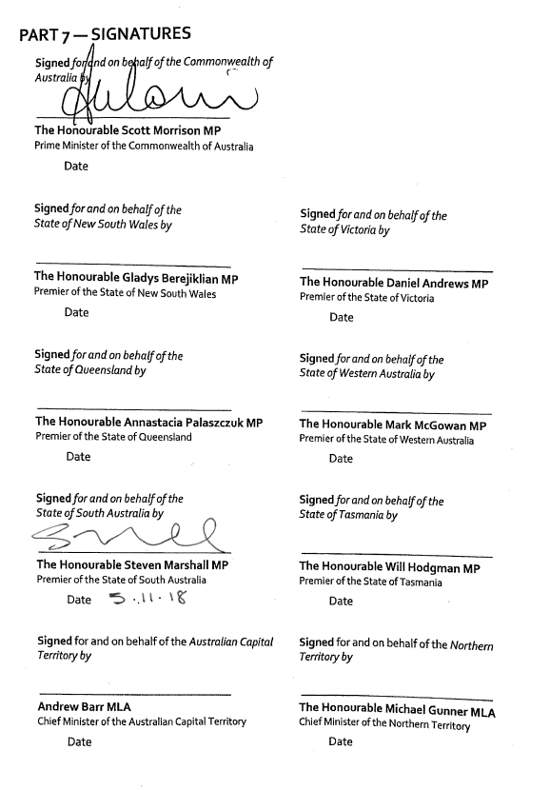

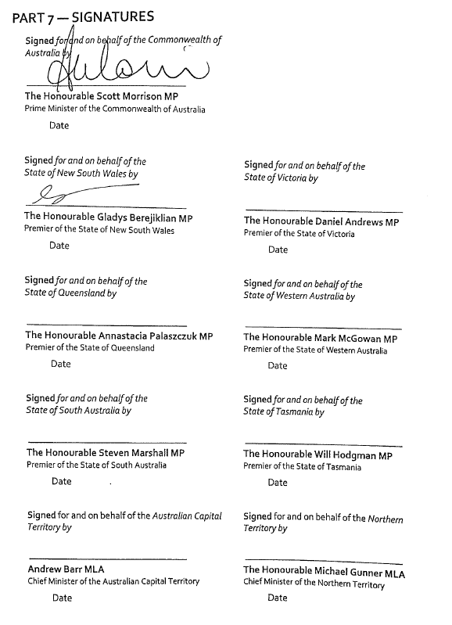

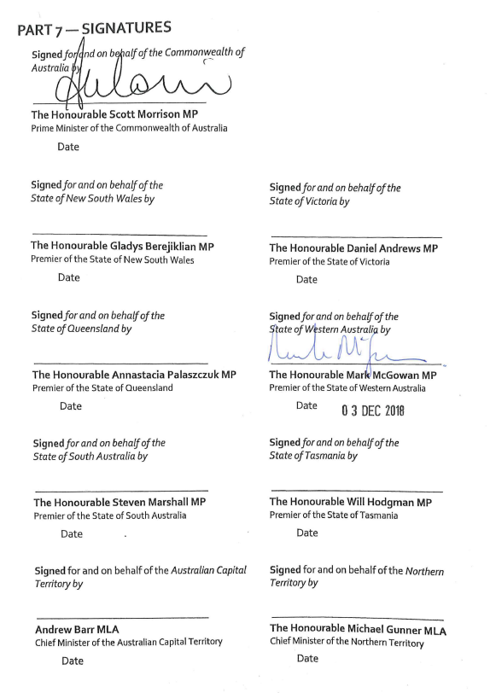

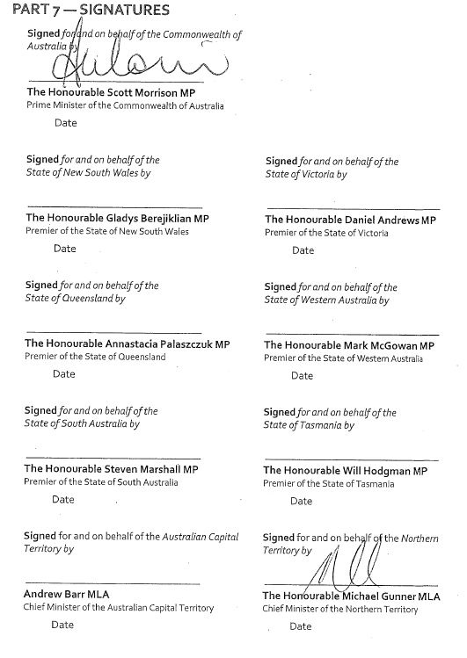

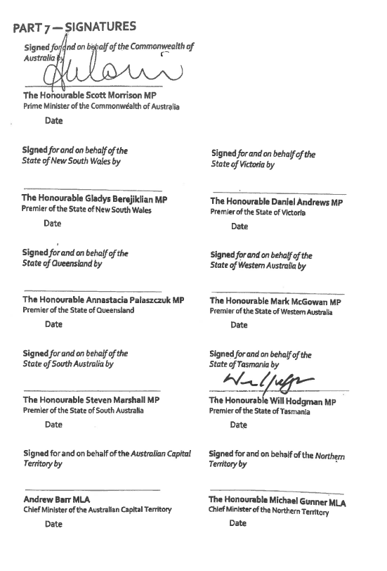

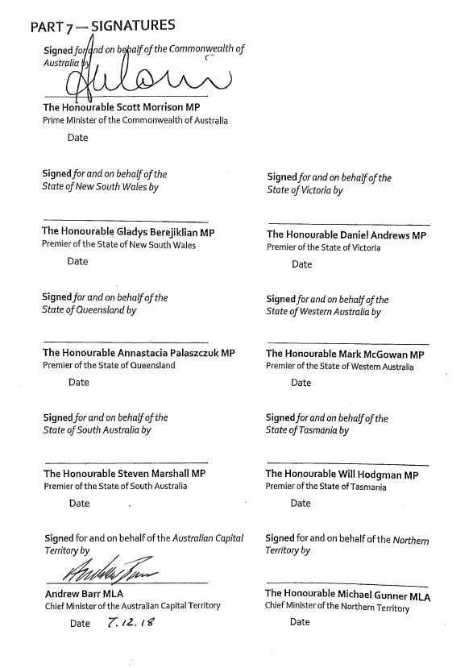



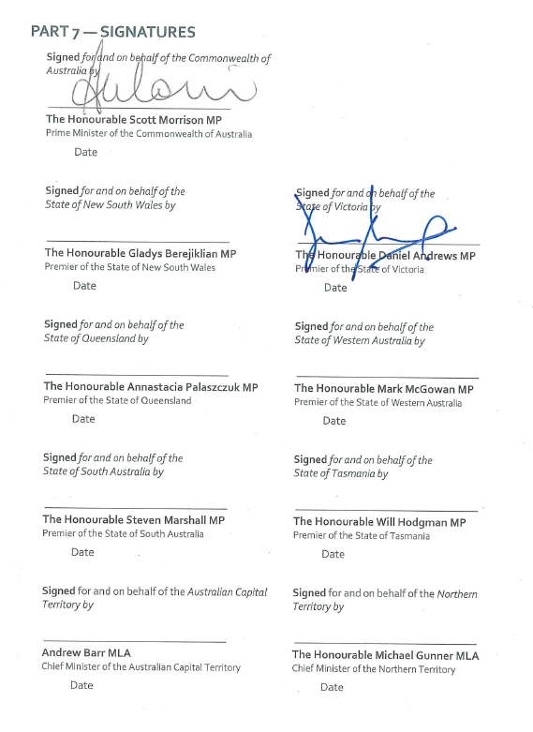

# PART 8 — SCHEDULES

Schedule A – Definitions

Schedule B – National Policy Initiatives

Schedule C – Cost Sharing Principles

Schedule D – Reporting on National Policy Initiatives

Schedule E – Bilateral reform agreements

Schedule F – Targets

|  |  |
| --- | --- |
| Schedule A:  Definitions | |
|  |  |
|  |  |
|  |  |
|  |  |
|  |  |

|  |  |
| --- | --- |
| **Approved authority** | An approved authority is a legal entity that the Commonwealth has approved to receive and administer Commonwealth funding for one or more schools. The approved authority for a government school is its relevant State or Territory government. The approved authority for a non-government school is the body corporate approved by the Minister for that school. |
| **Australian Curriculum, Assessment and Reporting Authority (ACARA)** | ACARA is the independent authority responsible for the development of a national curriculum (Kindergarten to Year 12), and a national assessment program, including managing the National Assessment Program Literacy and Numeracy (NAPLAN). ACARA also manages the *My School* website ([www.myschool.edu.au](http://www.myschool.edu.au)). |
| **Australian Institute for Teaching and School Leadership (AITSL)** | A Commonwealth controlled company that provides national leadership for the Australian, State and Territory Governments in promoting excellence in the teaching and school leadership profession. |
| **Council of Australian Governments (COAG)** | The Council of Australian Governments, being the peak intergovernmental forum in Australia, comprising the Prime Minister, State Premiers, Territory Chief Ministers and the President of the Australian Local Government Association (ALGA). |
| **Education Council** | Education Council was established under Council of Australian Governments (COAG) arrangements. Membership includes State, Territory, Australian Government and New Zealand Ministers with portfolio responsibility for school education, early childhood and/or higher education, as nominated by their respective First Ministers. It provides a forum through which strategic policy on school education, early childhood and higher education can be coordinated at the national level and through which information can be shared, and resources used collaboratively, to address issues of national significance. |
| **Education Services Australia (ESA)** | A company whose members consist of all State, Territory and Federal Education Ministers. It supports delivery of national priorities and initiatives in schools, training and higher education sectors. |
| **First Ministers** | The Premiers of each Australian State and the Chief Ministers of the Northern Territory and the Australian Capital Territory. |
| **National policy initiative** | A matter set out in the national school reform agreement for which Education Council has agreed an approach and timetable for national implementation and is overseeing its implementation. Implementation of national policy initiatives in the national school reform agreement is a condition of funding under sections 22(2) and 77(2A) of the Act. |
| **National policy initiative (new)** | Any future matter not set out in the national school reform agreement that Education Council agrees to explore and consider an approach and timetable for its national implementation. Implementation of new national policy initiatives agreed by Education Council subsequent to the national school reform agreement is a condition of funding under sections 22(1) and 77(2A) of the Act. |
| **National School Resourcing Board** | The Commonwealth has established a National School Resourcing Board (the Board) to provide greater independent oversight over Commonwealth school funding. The Board will undertake reviews of different parts of the funding model under section 128(1) of the Act. |
| **Non-government representative body** | Non-government representative bodies are bodies corporate approved by the Minister for Education and Training under section 91 of the Act to receive funding to support the implementation of the Commonwealth’s school education reform priorities in non-government schools. |
| **State-specific reform** | A matter without Education Council oversight for which a State has agreed to develop an approach and timetable for its local implementation, and/or is in the process of implementing locally. |
| **State** | Where the term State is used, it is should be taken to apply to both a State and Territory. |

|  |  |
| --- | --- |
| Schedule B:  National Policy Initiatives | |
|  |  |
|  |  |
|  |  |

Under clauses 43-48 of the Agreement, parties commit to implement the following set of evidence-based reforms within the terms of this Agreement to achieve the long-term outcomes of this Agreement. These reforms complement the extensive local and national reform efforts underway across States and Territories.

The national policy initiatives will be developed in consideration of the reviews outlined in clause 8 of the Agreement and in close consultation and collaboration with government and non-government education authorities and broader education stakeholders including, but not limited to teachers, school leaders and parents.

Parties note that, under clause 21 of the Agreement, schedules to the Agreement may be varied or revoked, and new schedules may be added, at any time with the agreement of the relevant portfolio Commonwealth Minister and all relevant State and Territory Ministers for school education. Variations to Schedule B will include the addition or amendment of milestones as national policy initiatives are further developed and considered and decisions are made through Education Council[2].

Implementation and timing of milestones is subject to Education Council considering and agreeing the cost and cost sharing arrangements, scope and governance of each national policy initiative, acknowledging the different local contexts and starting points of each jurisdiction.

| **National Policy Initiative** | **Milestone** | **Timing** |
| --- | --- | --- |
| A (i) Enhancing the Australian Curriculum to support teacher assessment of student attainment and growth against clear descriptors | 1. Education Council consider proposal(s) for the development of learning progressions across the Australian Curriculum learning areas and general capabilities, including consideration of existing progressions and development stages, timelines and estimated costs. | Early 2019 |
| 1. Subject to Education Council agreement at a), develop and trial learning progressions and formative assessment capability for learning areas and general capabilities, with priority on literacy and numeracy in the early years of schooling. | Early 2021 |
| 1. Subject to Education Council agreement to a) and b) above, existing and new learning progressions and formative assessment capability for agreed Australian Curriculum learning areas and general capabilities are progressively made available. | From 2022 |
| A (ii) Assisting teachers monitor individual student progress and identify student learning needs through opt-in online and on demand student learning assessment tools with links to student learning resources, prioritising early years foundation skills | 1. Education Council consider a proposal for the enhancement of formative assessment capabilities, including consideration of existing IT solutions, online assessment resources and digital learning resources and potential benefits to students, teachers and school leaders. It is expected the proposal will include development stages, timelines, governance arrangements and estimated costs. | Early 2019 |
| 1. Subject to Education Council agreement at a), Education Council commission the:  * design, build and piloting of an opt-in formative assessment facility with priority on early years literacy and numeracy. Assessments should be matched to agreed learning progressions (such as English, mathematics, science and critical and creative thinking), and * the development of supporting professional learning modules to build teacher and school leader capacity and capability to use effective formative assessment practices. | Early 2021 |
| 1. Subject to Education Council agreement at a) and b), progressively develop and release nationally available online on-demand formative assessment resources (linked to the development schedule for learning progressions across Australian Curriculum learning areas and general capabilities), refine the online formative assessment facility based on feedback from the pilot and align digital teaching resources to the learning progressions. | From 2022 |
| A (iii) Reviewing senior secondary pathways into work, further education and training | 1. Education Council agree panel membership and terms of reference for a review of senior secondary education, pathways to work, further education and training and consideration of prerequisites for university entry. | Early 2019 |
| 1. Subject to Education Council agreement at a), Education Council receive review report and consider recommendations for any national initiatives to strengthen student pathways, with States and Territories to independently consider recommendations for local response. | June 2020 |
| 1. Subject to Education Council agreement at a) and b), Education Council has implemented, or is progressing, agreed recommendations as appropriate. | End of the agreement |
| B (i) Reviewing teacher workforce needs of the future to attract and retain the best and brightest to the teaching profession and attract teachers to areas of need | 1. Education Council consider an implementation strategy for the recommendations of the National Review of Teacher Registration. | Early 2019 |
| 1. Education Council begin to develop options for a national teacher workforce strategy | Mid 2019 |
| 1. Subject to b), Education Council agree to an option for a national teacher workforce strategy to support decision making of teacher employers and initial teacher education (ITE) providers. It is anticipated the strategy would identify requirements to address workforce issues of supply, demand, retention, attrition, hard to staff schools, specialisation, teaching out of field, rural and remote workforce and any gaps in data identified by Parties and sectors. | September 2020 |
| 1. Subject to Education Council agreement at b) and c), Education Council implement a national teacher workforce strategy to respond to teacher workforce needs of the future and support decision making of teacher employers and ITE providers. | From December 2020 |
| B (ii) Strengthening the initial teacher education accreditation system | 1. States and Territories ensure that accredited initial teacher education programs require pre-service teachers to have successfully completed an endorsed final-year teaching performance assessment prior to graduation. | From January 2019 |
| 1. Commence national quality assurance activities in cooperation with all jurisdictional authorities. | From January 2019 |
| C (i) Implementing a national unique student identifier (USI) that meets national privacy requirements in order to support better understanding of student progression and improve the national evidence base | 1. Education Council consider: 2. a proposal for a national USI to enhance school and system self-review and external quality assurance, including proposed approach and compatibility with existing USIs 3. governance, privacy protections, national data access protocols and protections and estimates and proposed allocations of costs. | Late 2019  September 2020 |
| 1. Subject to Education Council agreement at a), implement the institutional arrangements necessary to support the implementation of a national USI. | March 2021 |
| 1. Subject to Education Council agreement at a) and b), and subject to meeting national privacy requirements, schools and systems to progressively work to create a national USI for each student from 2021. | All students to have a USI by the end of the agreement |
| C (ii) Establishing an independent national evidence institute to inform teacher practice, system improvement and policy development | 1. Education Council consider options for an independent national evidence institute, including scope of functions, potential for expansion of existing capabilities, interaction with existing national bodies, funding and governance arrangements. | Late 2019 |
| 1. Subject to Education Council agreement to an option at a), implement the institutional arrangements necessary to support an independent national evidence institute. | Mid 2020 |
| 1. Subject to Education Council agreement at a) and b), the national evidence institute commences operations from 2020, and inter alia, develops and implements a national research and evidence plan. | From 2020 |
| C (iii) Improving national data quality, consistency and collection to improve the national evidence base and inform policy development. | 1. Education Council agree equity and proficiency standards (for numeracy and literacy assessed by NAPLAN) as part of the scheduled review of the National Measurement Framework for Schooling. | December 2018 |
| 1. Education Council consider strategic opportunities to enhance the national evidence base, including options for measures of child development status at school entry, student learning gain, general capabilities, post-school destination information, attainment, retention, wellbeing, post-school outcomes. | Life of the agreement |

Schedule C:

Cost Sharing Principles

1. The Parties recognise that the agreed national policy initiatives will likely require investment by the parties to meet our national reform ambitions. Parties will consider the fully costed initiatives when finalised, along with anticipated benefits, before implementation.
2. The Parties also recognise that existing investments in national infrastructure will be utilised wherever possible to most efficiently implement the reforms.
3. The Parties acknowledge that final costs incurred by Parties will include ongoing funding for implementation and possible future work arising from the national policy initiative, which cannot yet be determined.
4. The cost of the national policy initiatives borne by the State or Territory count towards the State contribution to school funding, for the purpose of s22A of the *Australian Education Act 2013*.
5. The cost sharing arrangements for each of the national policy initiatives will be considered and agreed by the Education Council as part of the initial milestone for each reform. Parties will consider the final cost sharing arrangements before implementation.
6. Cost-sharing arrangements will consider previous precedents for investment in national reform, including the existing Education Council cost sharing formulae.
7. The Parties recognise that costs for implementation and ongoing costs will differ significantly between jurisdictions (for example costs of some reforms could be higher in rural and regional areas).

|  |  |
| --- | --- |
| Schedule D:  Reporting on National Policy Initiatives | |
|  |  |
|  |  |
|  |  |
|  |  |

Under clauses 51-55 of the Agreement, parties commit to reporting on the progress of implementing agreed national policy initiatives outlined in Schedule B to give the community confidence that Education Council is making efforts to improve the quality and equity of Australia’s schooling system.

This template will be used to report to COAG.

|  |  |  |  |  |
| --- | --- | --- | --- | --- |
| **National Policy Initiative** | **Milestone** | **Timing** | **Has the milestone been met? Y/N** | **If no, the reason is:** |
|  |  |  |  |  |
|  |  |  |  |  |

|  |  |
| --- | --- |
| Schedule E: Bilateral reform agreements | |
|  |  |
| Council of Australian Governments | |
|  |  |
|  |  |
|  |  |

**Appendices**

The following bilateral reform agreements have been agreed:

Appendix 1—South Australia agreed 5 November 2018

Appendix 2—New South Wales agreed 7 November 2018

Appendix 3—Western Australia agreed 3 December 2018

Appendix 4—Northern Territory agreed 5 December 2018

Appendix 5— Tasmania agreed 6 December 2018

Appendix 6— Australian Capital Territory agreed 6 December 2018

Appendix 7—Queensland agreed 13 December 2018

Appendix 8—Victoria agreed 17 December 2018

|  |  |
| --- | --- |
| Schedule F: Targets | |
|  |  |
|  | |
|  |  |

Consistent with clause 39 of the Agreement, on 11 December 2020 Education Ministers:

**noted** the adoption of the updated national target for school education endorsed by State and Territory First Ministers through the *National Agreement on Closing the Gap*[3];

**agreed** that the ‘Closing the Gap’ target be adopted under the terms of the Agreement; and

**agreed** to extend the population wide ‘parity’ inherent in the National Agreement on ‘Closing the Gap’ to the attainment target.

The following amendments to the Agreement give effect to Education Ministers’ decisions:

Sub-paragraphs 36 b. and c. are replaced by:

36.b. by 2031, increase the proportion of people (age 20-24) attaining Year 12 or equivalent qualification to 96 per cent; and

36.c. by 2031, increase the proportion of Aboriginal and Torres Strait Islander people (age 20-24) attaining year 12 or equivalent qualification to 96 per cent.

Notes

1. As per the *National Agreement on Closing the Gap*, Year 12 or equivalent refers to a school qualification of Year 12 or equivalent, or a non-school qualification at Certificate level III or above based on the Australian Qualifications Framework.
2. The revised target at 36.b. of the Agreement takes effect from 2021.

1. Ministerial Council arrangements may change from time to time. Education Council represents the council arrangement for Ministers from the Commonwealth and States and Territories with responsibility for school education.
2. On 4 September 2020, variations to Schedule B milestones were approved by the Commonwealth Minister and all relevant State and Territory Ministers for school education.
3. *National Agreement on Closing the Gap* (July, 2020, page 21) <https://www.closingthegap.gov.au/sites/default/files/files/national-agreement-ctg.pdf>