 

# Task card

How to update business details for StartingBlocks.gov.au via the Provider Entry Point

## Overview

Your service fees, vacancies, quality ratings and inclusions are published on [StartingBlocks.gov.au](https://www.startingblocks.gov.au/). Having this information in one place helps parents to choose the best early childhood education and care for their family.

You must report fees and information required by Family Assistance Law through the Provider Entry Point (PEP) or third-party software.

When reporting fees, you must report:

* current hourly or session fees before Child Care Subsidy (CCS), discounts, or reductions
* any changes to fees, within 14 days of the fee change.

Information relating to your services contact details and operating hours will be updated by the Australian Children’s Education and Quality Authority (ACECQA) on StartingBlocks.gov.au.

The following screen shots provide an overview of how to add and update your business details information for Starting Blocks via the PEP.

Important sections or words in each image are outlined with a yellow box and a description of each of these is provided below each image.

### Log into PEP

Log into the PEP using your username and password.

This is the username and password you created for your PRODA account. If you have forgotten your username, click on the hyperlink to recover this information. If you have forgotten your password, click on the hyperlink to reset your forgotten password.

* Click ‘Sign In’.  The Provider/Service summary page will open.
* Once logged in, select the relevant service that needs to be updated.

### 2(a) Updating Details

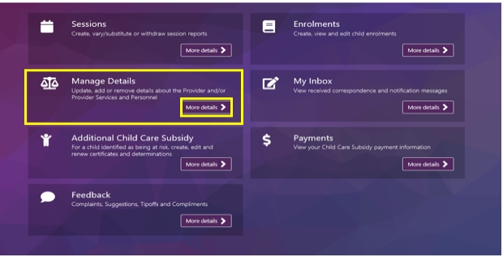

If you are a service, select ‘More details’ in the ‘Manage Details’ box of the PEP.

### 2(b). Accessing Business Details

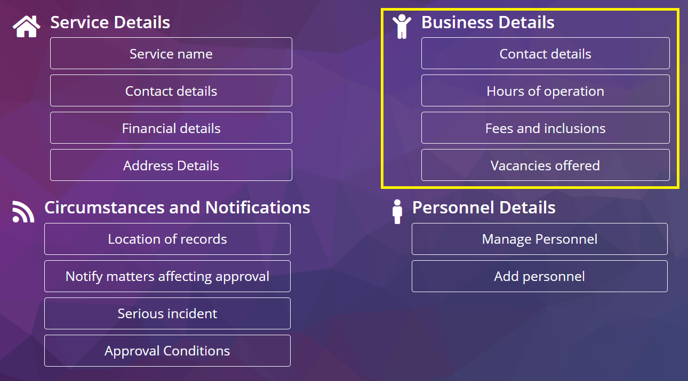

**Business details**: Select the information you wish to update:

* Contact details
* Hours of operation
* Fees and inclusions
* Vacancies offered

### 3(a). Updating contact details

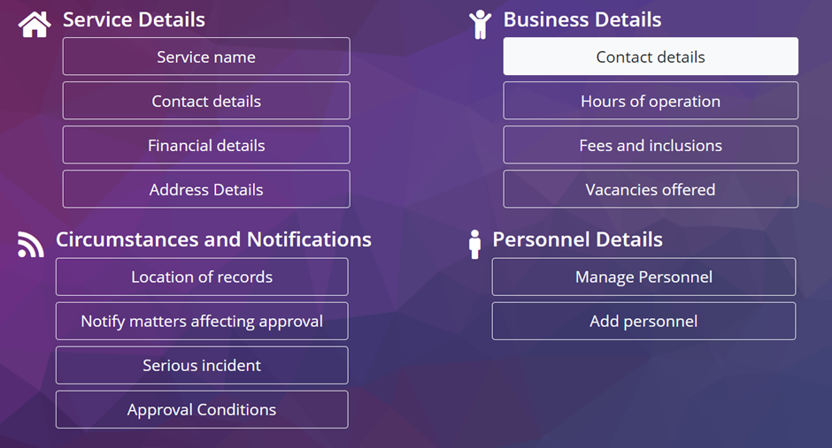

### 3(b). Updating contact details

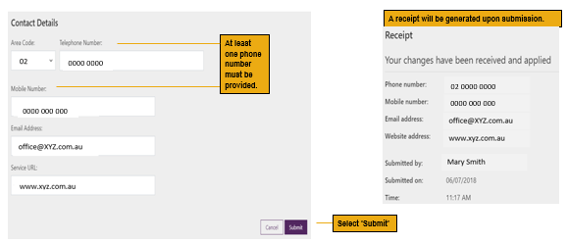

* **Area code and Telephone number:** insert new details here
* **Mobile number:** insert new details here
* **Email address:** insert new details here
* **Service URL:** insert web address here
* Select the submit button once completed
* A receipt will be generated upon submission.

### 4(a). Hours of operation

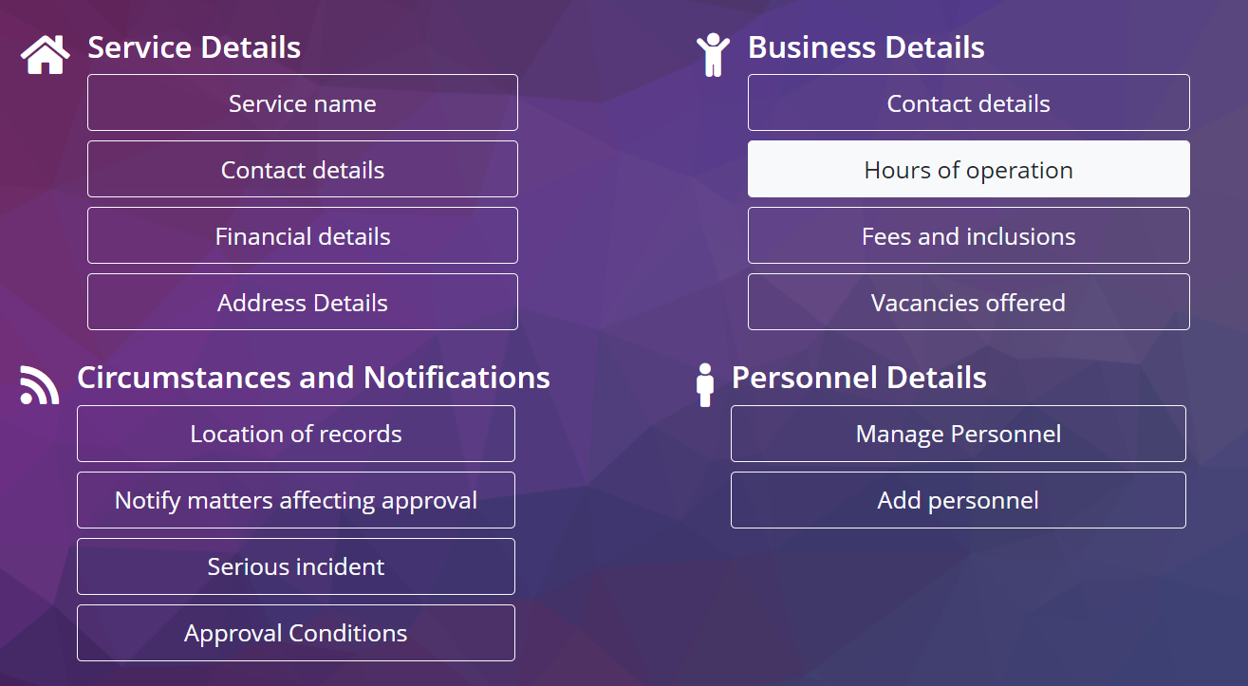

Select the hours of operation button to update hours of operation.

### 4(b). Updating Hours of Operation

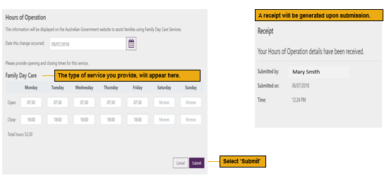

* **Date this changed occurred:** insert date here
* **Days of the week:** insert new details here for open and close fields for each day of the week
* Select the submit button once completed
* A receipt will be generated upon submission

### 5(a). Fees and inclusions

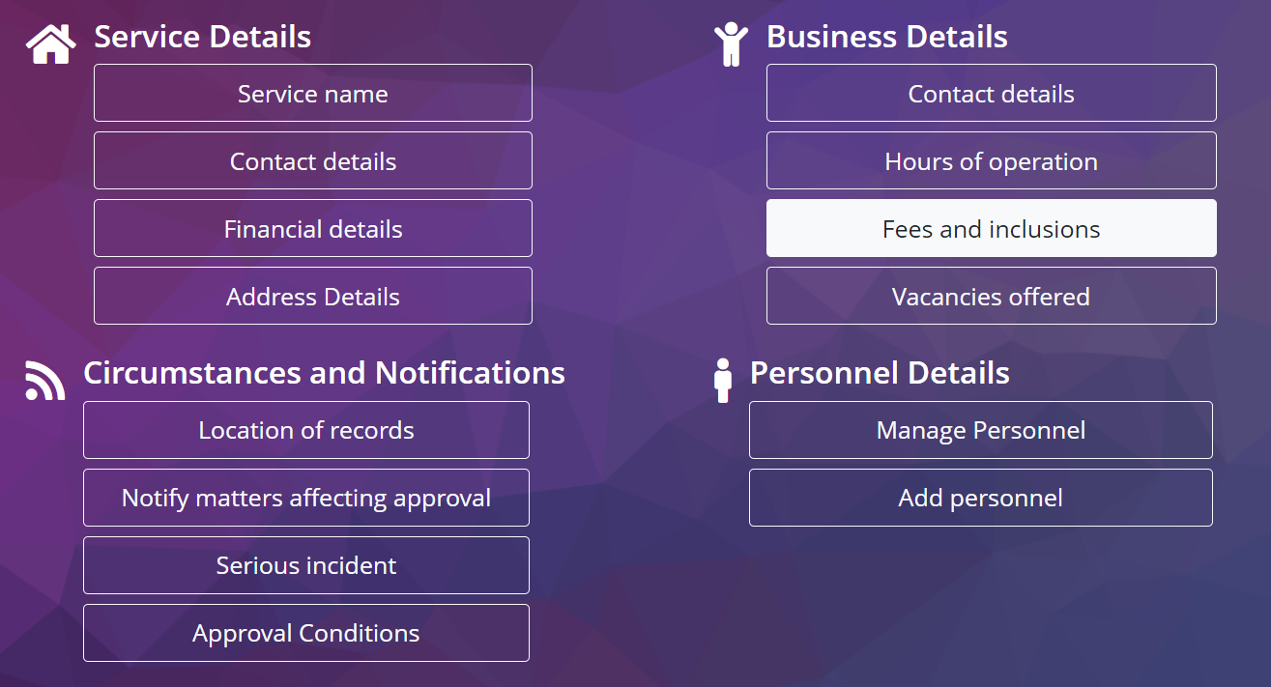

Select the fees and inclusions button to update fees and inclusion information.

### 5(b). Fees and inclusions

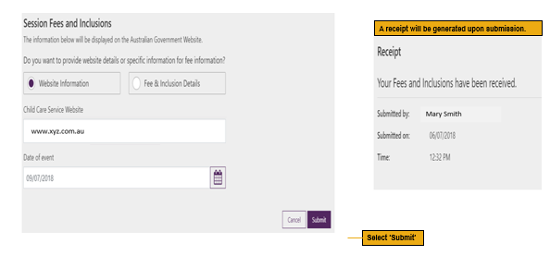

* **Website information:** select the button next to website information.
* **Child Care Service Website:** enter your website URL.
* **Date of event:** enter the date.
* Select the submit button once completed
* A receipt will be generated upon submission

### 5(c). Fees and inclusions

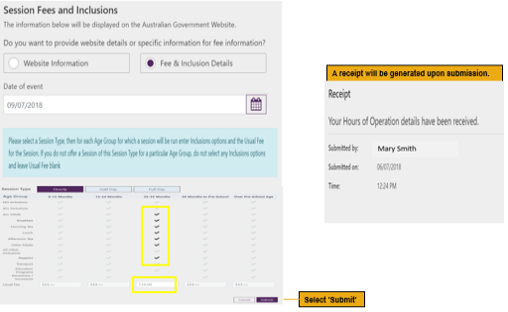

* **Fee and inclusion details:** select the button next to fee and inclusion details.
* **Date of event:** enter the date.
* **Child Care Service Website:** enter your website URL.
* Select the submit button once completed
* A receipt will be generated upon submission

### 6(a). Vacancies Offered

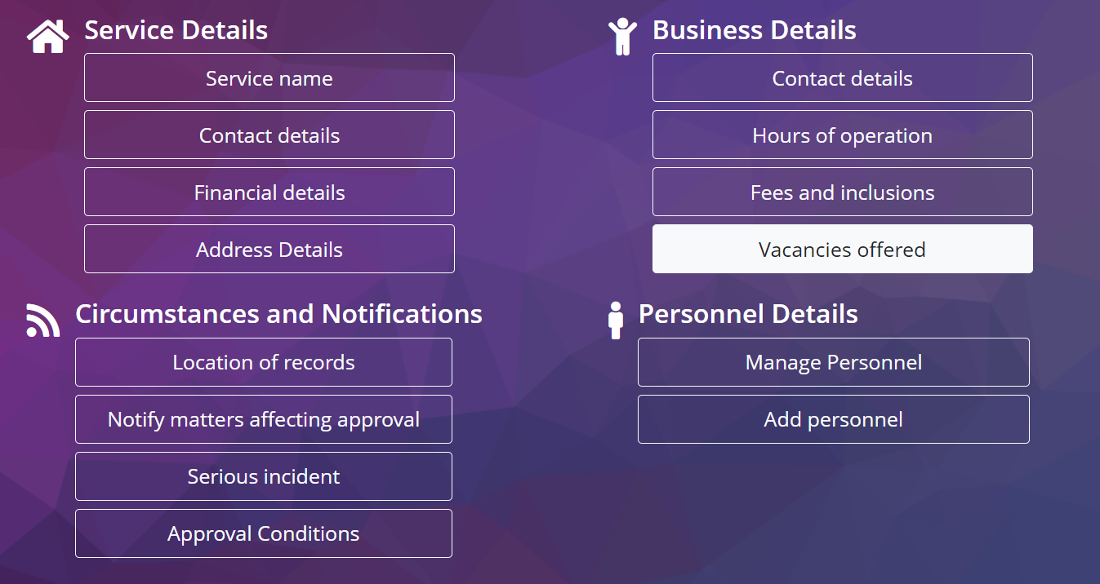

Select the Vacancies offered button to update vacancies information.

### 6(b). Updating Vacancies Offered

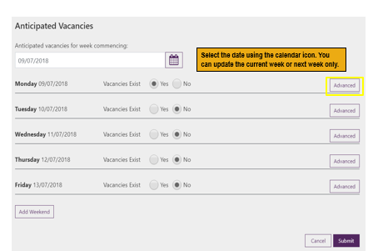

* **Select** either ‘Yes’ or ‘No’ for each day in the week to indicate if you have a vacancy for that date.
* **Select** the date using the calendar icon. You can update the current week or next week only.
* **Select** ‘Advanced’ if you want to provide additional details for vacancies you have on that date.

### 6(c). Vacancies Offered

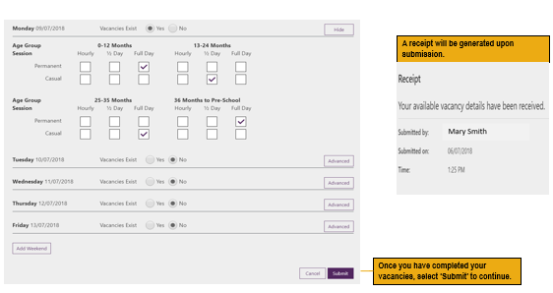

* **Selected ‘Advanced’** for a date, tick the vacancies you have for the relevant age groups.
* Select the submit button once completed
* A receipt will be generated upon submission