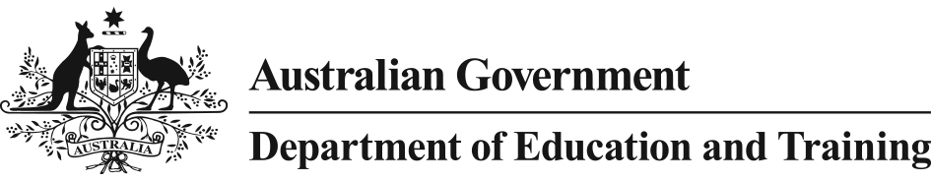

AMOUNTS FOR 2019

## Total resourcing for a Commonwealth supported place by discipline - 2019

The below table shows Government contributions under the Commonwealth Grant Scheme and maximum student contribution amounts for a student place (equivalent full-time student load).

| **Funding cluster** | **Part of funding cluster** | **Maximum student contribution amounts** | **Australian Government contribution** | **Total resourcing** |
| --- | --- | --- | --- | --- |
| **Funding cluster 1**  Law, accounting, commerce, economics, administration |  | $10,958 | $2,160 | $13,118 |
| **Funding cluster 2**  Humanities |  | $6,566 | $6,008 | $12,574 |
| **Funding cluster 3**  Mathematics, statistics, behavioural science, social studies, computing, built environment, other health | Mathematics, statistics, computing, built environment or other health | $9,359 | $10,630 | $19,989 |
| Behavioural science(1) or social studies | $6,566 | $17,196 |
| **Funding cluster 4**  Education |  | $6,566(3) | $11,061 | $17,627 |
| **Funding cluster 5**  Clinical psychology, allied health, foreign languages, visual and performing arts | Clinical psychology(2), foreign languages, or visual and performing arts | $6,566 | $13,073 | $19,639 |
| Allied health | $9,359 | $22,432 |
| **Funding cluster 6**  Nursing |  | $6,566(3) | $14,596 | $21,162 |
| **Funding cluster 7**  Engineering, science, surveying | Engineering, science, surveying | $9,359 | $18,586 | $27,945 |
| **Funding cluster 8**  Dentistry, medicine, veterinary science, agriculture | Dentistry, medicine or veterinary science | $10,958 | $23,590 | $34,548 |
| Agriculture | $9,359 | $32,949 |

**Notes:**

1. Excluding clinical psychology, which is in cluster 5.
2. Clinical psychology units of study are postgraduate coursework psychology units of study (Field of Education code 090701) that contribute to courses that are accredited for the purposes of professional registration by the Australian Psychological Society (APS) College of Clinical Psychologists, the APS College of Clinical Neuropsychologists, the APS College of Counselling Psychologists, the APS College of Educational & Developmental Psychologists, the APS College of Forensic Psychologists, the APS College of Health Psychologists, the APS College of Sport Psychologists and the APS College of Community Psychologists. Other units of study in psychology are in cluster 3.
3. For students who commenced their course of study before 1 January 2010, the maximum annual student contribution amount that may be charged for Education and Nursing units is $5,254. Students who started their course of study on or after 1 January 2010 are subject to the maximum student contribution amount specified in the above table.

**FEE-HELP limit**

The FEE-HELP limit is the maximum amount that a person can borrow under FEE-HELP over their lifetime. This limit excludes any loan fee.

Following the passage of the Higher Education Support Legislation Amendment (Student Loan Sustainability) Act 2018, the FEE-HELP limit in 2019 is **$150,000** for medicine, dentistry and veterinary science students (as defined in the *Higher Education Support Act 2003*) and **$104,440** for all other students.

## Maximum OS-HELP amount

The maximum OS-HELP amount is the maximum amount that a student can borrow under OS‑HELP for a given period of six months. The maximum OS-HELP amount in 2019 is **$6,791** if the student will not be studying in Asia or **$8,149** if the student will be studying in Asia and an additional **$1,085** if the student

will be undertaking Asian language study in preparation for study in Asia.

## Maximum SA-HELP fee

The maximum Student Services and Amenities Fee for 2019 is **$303.**

## Minimum indicative course fees for fee-paying overseas students in 2019

Chapter 6 of the *Higher Education Provider Guidelines* details the requirements with which higher education providers must comply in imposing fees for fee-paying overseas students. The following table shows the minimum indicative course fees for 2019.

|  |  |  |  |
| --- | --- | --- | --- |
| **COURSE CATEGORIES** | | **Total without capital component** | **Total with capital component** |
| **ON CAMPUS** | | | |
| **Fees weekly** | | | |
| **1.** | English Language Intensive Courses for Overseas Students | $309 | $337 |
| **Fees per year**  **(Equivalent Full-time)** | | | |
| **2.** | Law, Economics, Business, Humanities, Maths/Statistics, Social Science, Education, Computing, Architecture, Design, Nursing, Arts, Science (non-lab-based) | $10,747 | $12,822 |
| **3.** | Science (lab-based), Paramedical, Engineering, Pharmacy, Agriculture | $16,226 | $19,177 |
| **4.** | Medicine, Dentistry, Veterinary Science | $22,441 | $26,413 |
| **EXTERNAL** | | | |
| **Fees weekly** | | | |
| **E1.** | English Language Intensive Courses for Overseas Students | $309 | $337 |
| **Fees per year**  **(Equivalent Full-time)** | | | |
| **E2.** | Law, Economics, Business, Humanities, Maths/Statistics, Social Science, Education, Computing, Architecture, Design, Nursing, Arts, Science (non-lab-based) | $10,747 | $11,326 |
| **E3.** | Science (lab-based), Paramedical, Engineering, Pharmacy, Agriculture | $16,226 | $17,016 |