

# Task card

How to view entitlements and payments in the Provider Entry Point

Overview 1

Logging in 2

Viewing your entitlements 3

Viewing your payments 6

Action a fee reduction 9

## Overview

This task card outlines how to:

* view entitlements
* view payment summaries and overviews
* action fee reductions.

This task card is for providers that use the Provider Entry Point (PEP). If you use third-party software, contact your software provider for help.

Find more [task cards](https://www.education.gov.au/child-care-package/provider-tool-kit#toc-task-cards) for the PEP on our website.

If you need further assistance, contact the Child Care Subsidy Helpdesk on 1300 667 276 9am to 5pm AEST or [via email](mailto:CCSHelpdesk@education.gov.au) anytime.

## Logging in

Step 1

Log in to the [Provider Entry Point (PEP)](https://proda.humanservices.gov.au/prodalogin/pages/public/login.jsf?TAM_OP=login&ERROR_CODE=0x00000000&URL=%2Fmga%2Fsps%2Foauth%2Foauth20%2Fauthorize%3Fscope%3Dopenid%26state%3DalN0hw9ovD%26client_id%3DGTzCa6CRNfBsRTdfljBa%26redirect_uri%3Dhttps%253A%252F%252Fbusinessonline.humanservices.gov.au%252Fmga%252Fsps%252Foidc%252Frp%252Fchildcaresubsidy%252Fredirect%252Fproda%26response_type%3Dcode&OLDSESSION=).

## Viewing your entitlements

Step 1

From the PEP home page, select **More details** under **Enrolments**.

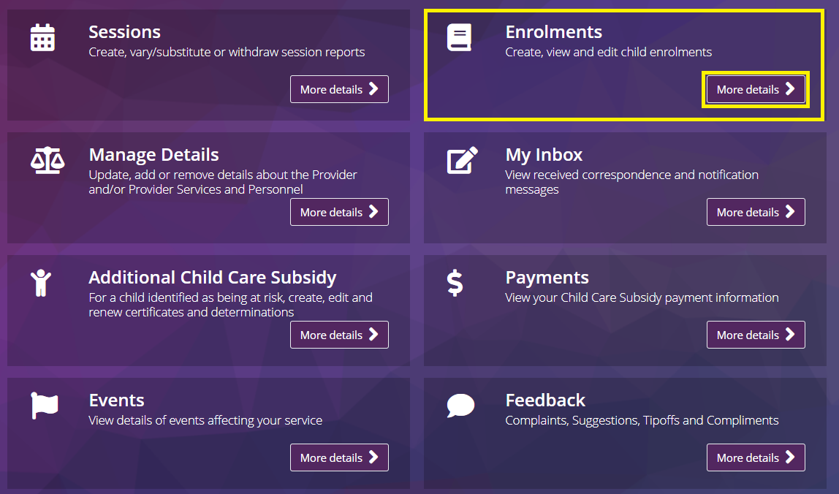

Step 2

A list of enrolments will be displayed. Click on **Select** for the child you wish to view an entitlement.

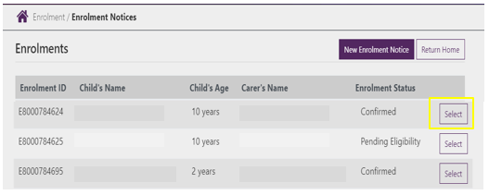

Step 3

Select **Entitlement** from the **Actions** drop-down menu.

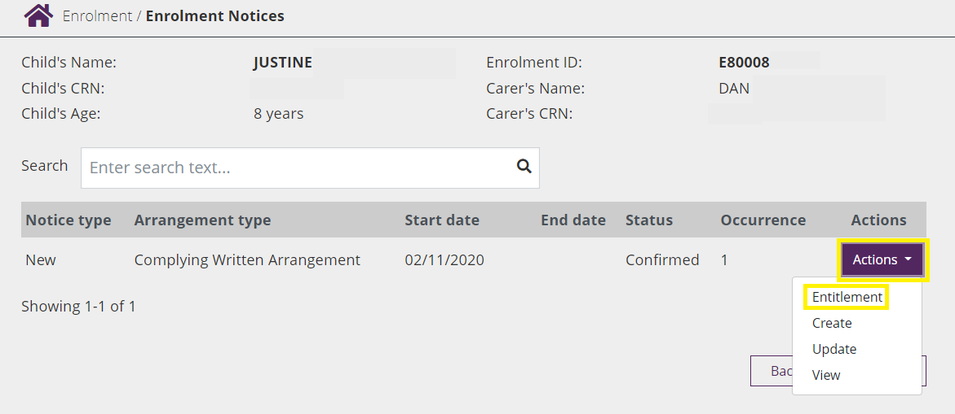

Step 4

The **General Entitlements** screen will display:

* **Total Hours per fortnight**: Displays the parents fortnightly subsidised hours (activity test results)
* **Apportioned Hours per fortnight**: This facility will be available soon
* **Child Care Subsidy %:** Displays the Child Care Subsidy percentage the individual is entitled to
* ***Withholding %:*** Displays the families Withholding percentage (5 percent default for all families)
* **Absence Sessions**: Displays the total absence count for the financial year

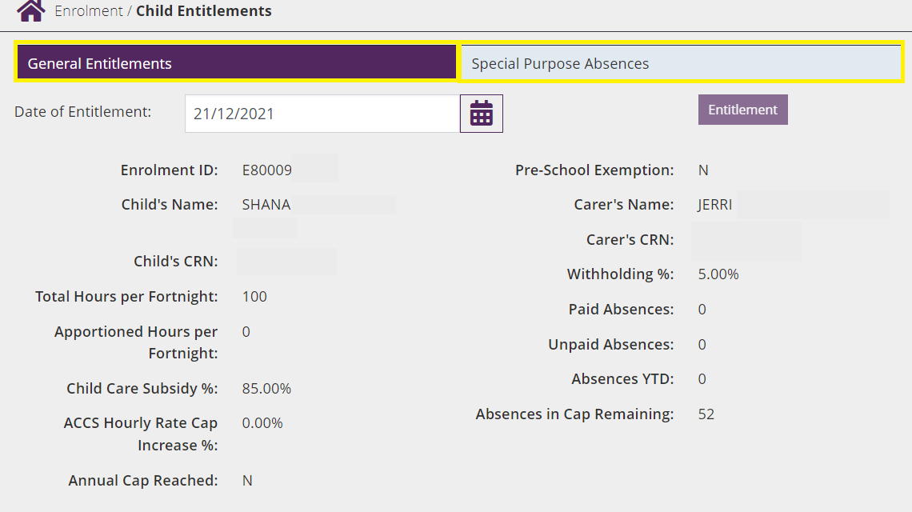

Select **Special Purpose Absences** to see an overview of Special Purpose Absences linked to this child.

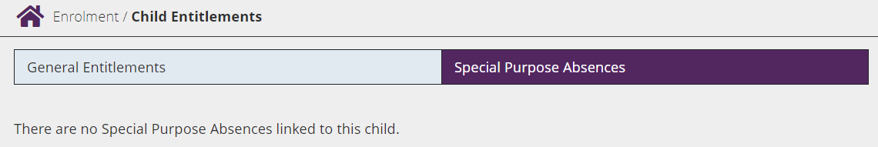

## Viewing your payments

Step 1

From the PEP home page, select **More details** under **Payments**.

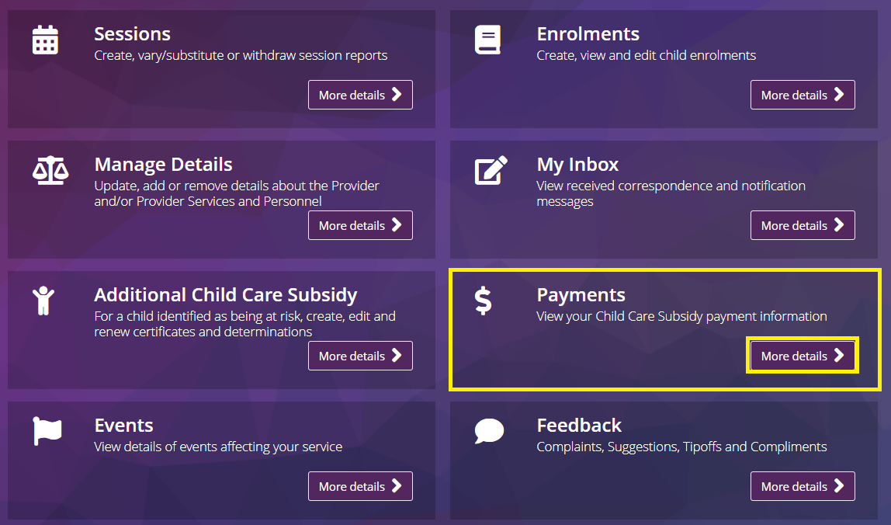

Step 2

The **Payments Summary** page will be displayed.

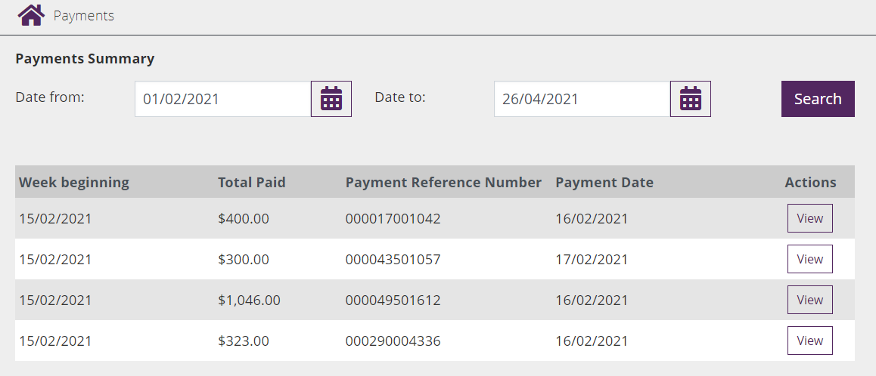

Step 3

Enter the start date of the period who wish to search in the **Date from** field.

Screenshot of date from field.

Step 4

Enter the end date of the period you wish to search in the **Date to** field.

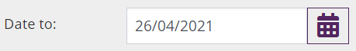

*Note: You can only search for periods within 90 days. You will need to adjust the ‘date to’ and date from’ when searching.*

Step 5

Search

Once the **From** and **To** dates have been entered, select **search** to view the corresponding payments.

* **Week beginning:** This is start of the session week for the relevant payment.
* **Total paid:** This is the total amount paid to your service.
* **Payment reference number:** This is the unique identifier of the payment. This will appear on your bank statement.
* **Payment date:** This is the date DHS sent the payment to the reserve bank.

Step 6

Select **View** to display more detail about the payment on the **Payment Overview** screen.

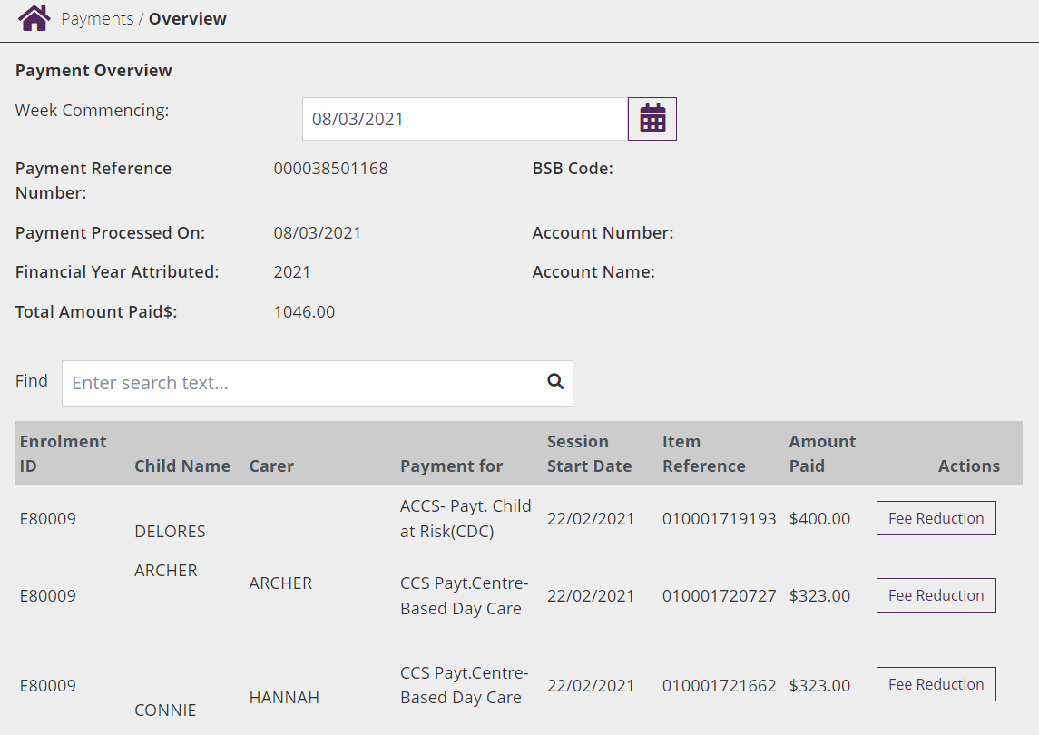

* **BSB Code:** The is the BSB of the account the total amount paid has been paid into
* **Account number:** The is the account number the total amount paid has been paid into
* **Account name:** The is the name of the account the total amount paid has been paid into
* **Total amount paid $:** This is the combined total for the amounts listed in the table blow
* **Find:** You can search by ‘Enrolment ID’, ‘Child’s Name’, ‘Carer’ or ‘Payment for’
* **Enrolment ID:** This is the unique Enrolment ID for the child
* **Item reference:** This is the unique reference number for the Enrolment

## Action a fee reduction

The **Fee Reduction** button in the **Actions** column allows you to return CCS/ ACCS payments which you were unable to pass onto a family.

For example, if they moved interstate before you could credit their final CCS payment and you are unable to contact them.

Step 1

Select **Fee Reduction** from the **Actions** column

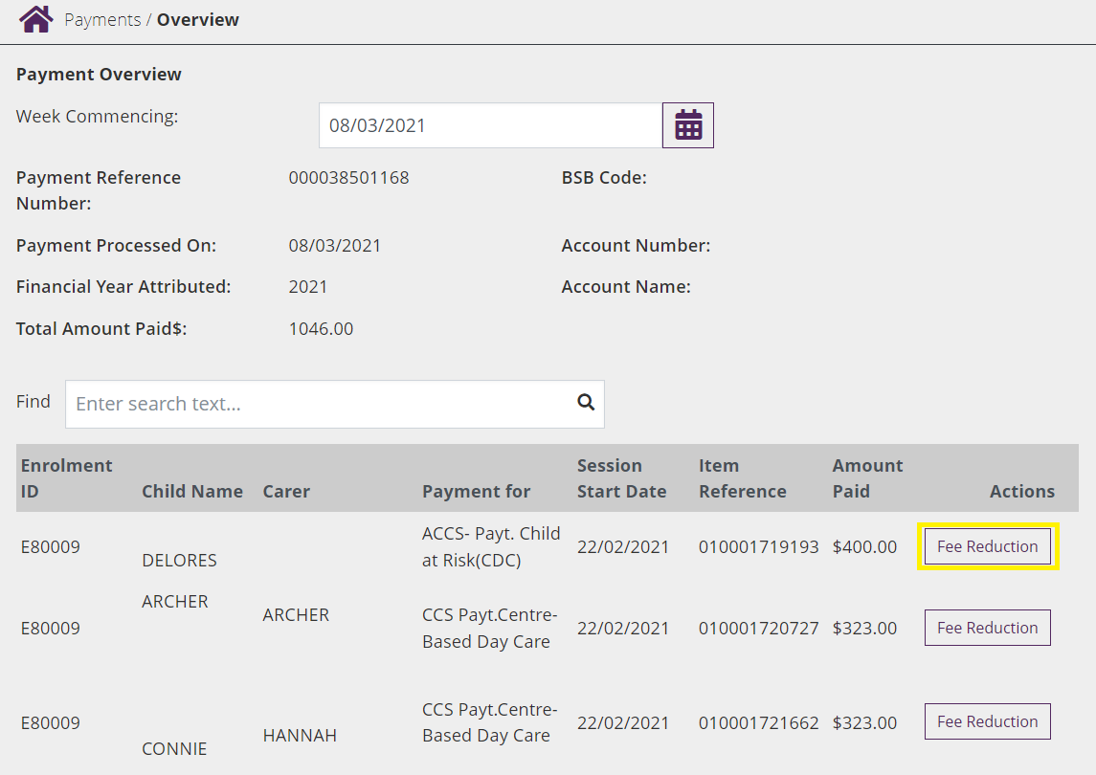

Step 2

Complete all fields presented:

* **Amount paid to the Carer $:** This is the amount of subsidy already applied to the carer/ parent
* **Amount not passed to the Carer $:** This is the amount of subsidy unable to be applied to the carer/ parent
* **Total Fee reduction for Week $:** This should be the same amount of subsidy not passed to the carer/ parent
* **Reason for Fee Reduction:** This is the reason for returning Fee Reduction

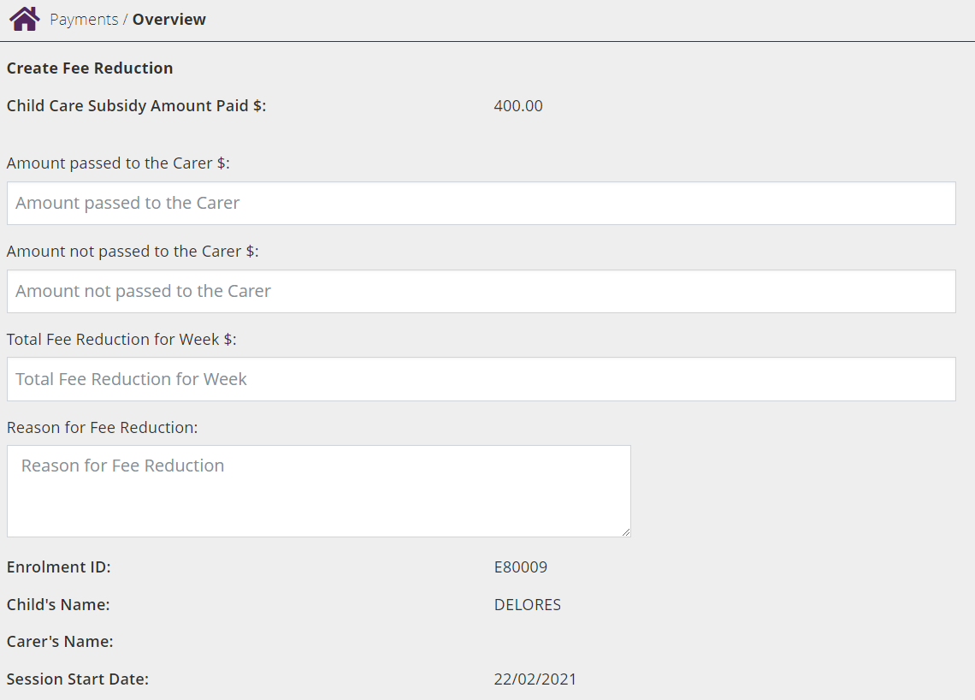

Step 3

Select the **Submit** button to complete the transaction.

A **receipt** will be generated upon submission.