

# Task card

How to create a new Additional Child Care Subsidy certificate in the Provider Entry Point

## Overview

The following task card will provide an overview of how to create a new Additional Child Care Subsidy (ACCS) (child wellbeing) certificate via the Provider Entry Point (PEP).

A description of the fields and important information is outlined above each image.

Overview 1

Step 1: Opening the Additional Child Care Subsidy menu 2

Step 2: Searching for the child 3

Step 3: Entering in the start date 3

Step 4: Read and accept the Minister’s Rules 2017, then select “Next” to proceed 4

Step 5: Enter the details of the Certificate 4

Step 6: Evidence Requirements 6

Step 7: Summary of the Certificate 8

Step 8: Declaration 10

Step 9: Receipt 10

Step 1: Opening the Additional Child Care Subsidy menu

After signing into the PEP (using your username and password you created for your PRODA account), select the **‘More details’** button from the **‘Additional Child Care Subsidy’ tile**.

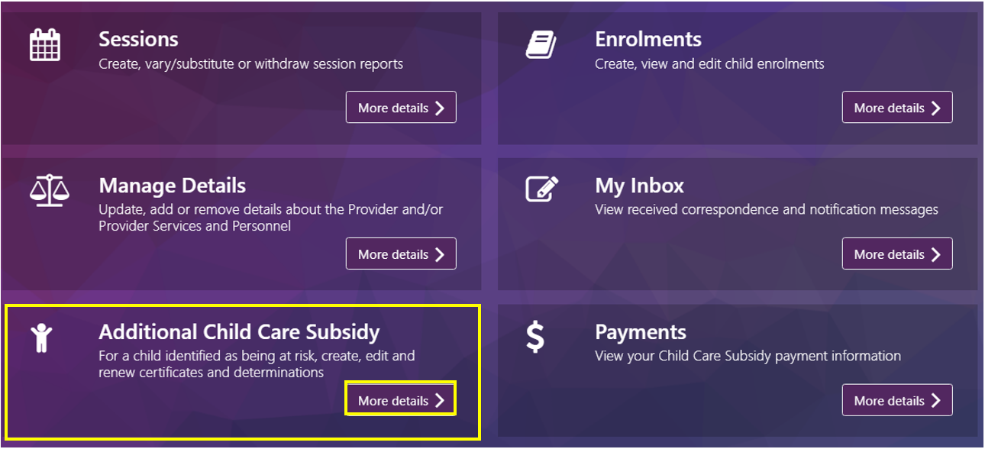

#### The Additional Child Care Subsidy screen

This screen details any children identified as being “at risk” by the service within the last 12 months. If no certificates or determinations have been created, the message ‘No children have been identified as ‘at risk’ at this service in the last 12 months’ will appear.

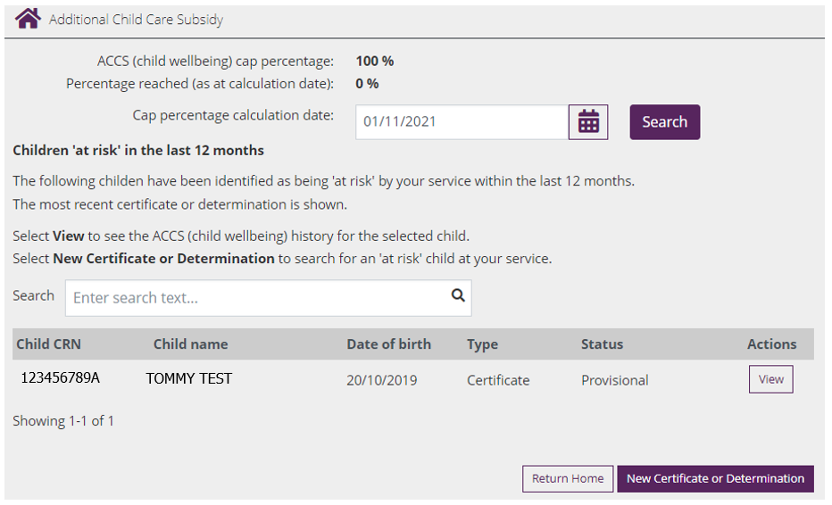

* **ACCS (child wellbeing) cap percentage:** Previously this was 50%, now will show as 100% unless a lower percentage has been imposed on the service.
* **Percentage reached (as at calculation date):** This field is no longer in use, unless the service has a percentage cap less than 100%
* **Cap percentage calculation date:** View and calculate the ACCS cap for the service by inputting a calculation date. You can use the calendar icon to select the date.
* **Search function:** The search text allows you to filter to individual children
* **View**: Selecting this button will allow you to see the ACCS (Child wellbeing) history for the child
* **New Certificate or Determination:** Select this button to create a new certificate for a child.

Step 2: Searching for the child

In the PEP, search for the child you wish to create a certificate for by entering in the childs CRN and clicking on the magnifying glass:

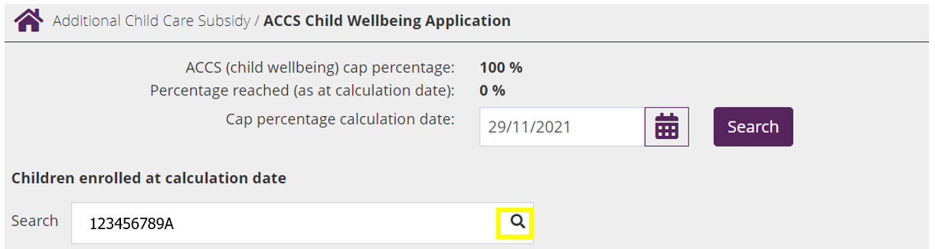

Step 3: Entering in the start date

Update the “**Cap percentage calculation date**” field to the date you’re wanting the certificate to start from and click ‘**Search’**. The day the certificate takes effect must be a Monday under Family Assistance Law. Certificates can be backdated up to 28 days, or up to 13 weeks where services can demonstrate exceptional circumstances. Use the “**select**” button to select the appropriate child

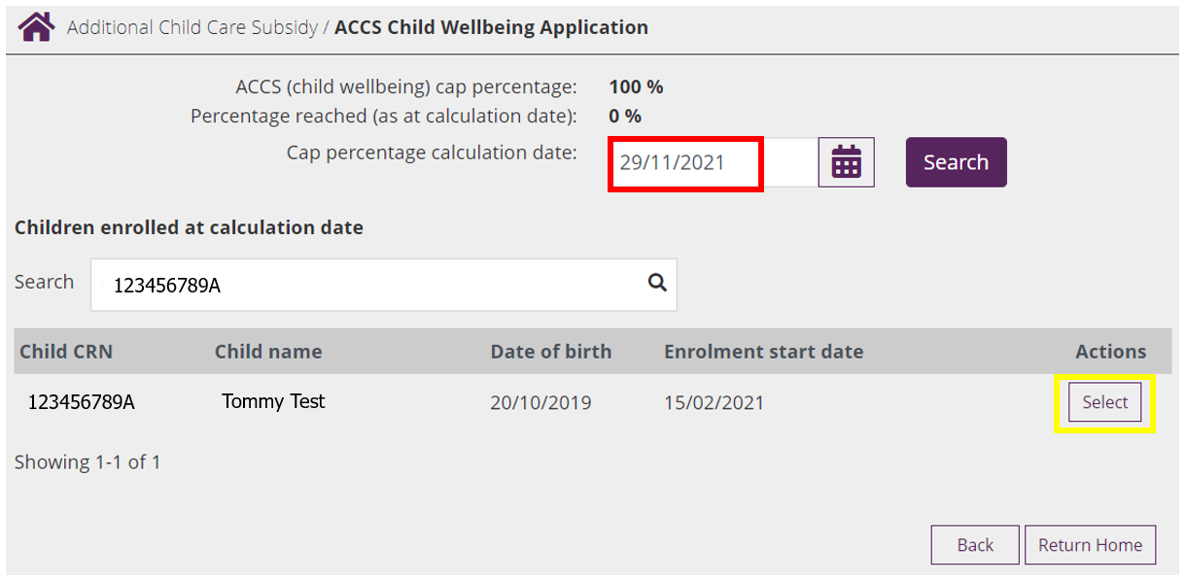

Step 4: Read and accept the Minister’s Rules 2017, then select “Next” to proceed

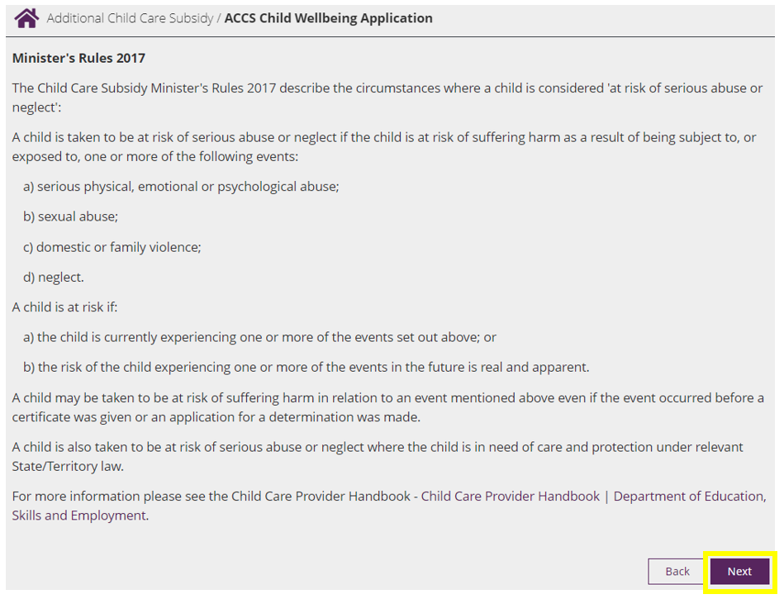

Step 5: Enter the details of the Certificate

The screens presented will vary, dependant on how you respond to the questions.

Question: Child under the care and protection of the State/Territory and in formal foster/kinship question

If you answer **YES** to this question, You need to upload supporting evidence.

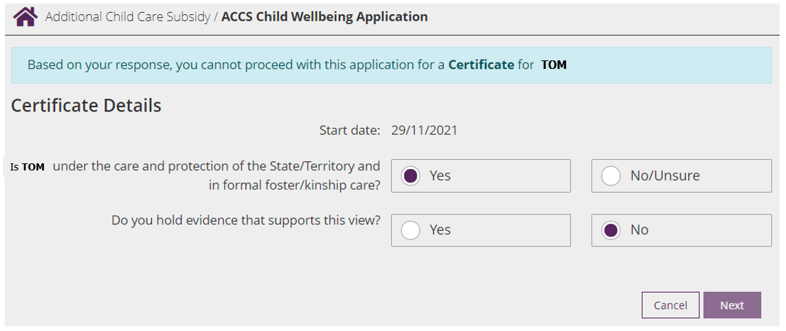

If you answer **NO/Unsure** to this question, You mustnotify an appropriate Support Agency within the relevant timeframes. For more information, refer to the [Guide to ACCS (child wellbeing).](https://www.dese.gov.au/additional-child-care-subsidy/resources/guide-accs-child-wellbeing) You are able to submit this information at a later stage, refer to the “*Changes to Certificates and Determinations*” task card for instructions on how to complete this function.

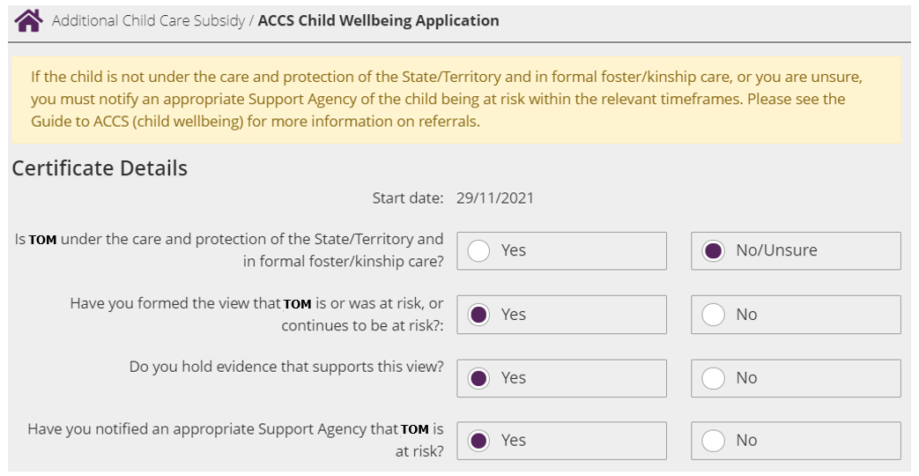

Question: Number of weeks considered to be at risk & Risks identified:

Providers may issue certificates covering up to six weeks in any 12 month period. Once the six-week limit is reached, providers must apply for a determination. For this question, use the drop down box to select between 1-6 weeks.

Next, select the risks you have identified by clicking on the box next to each one.

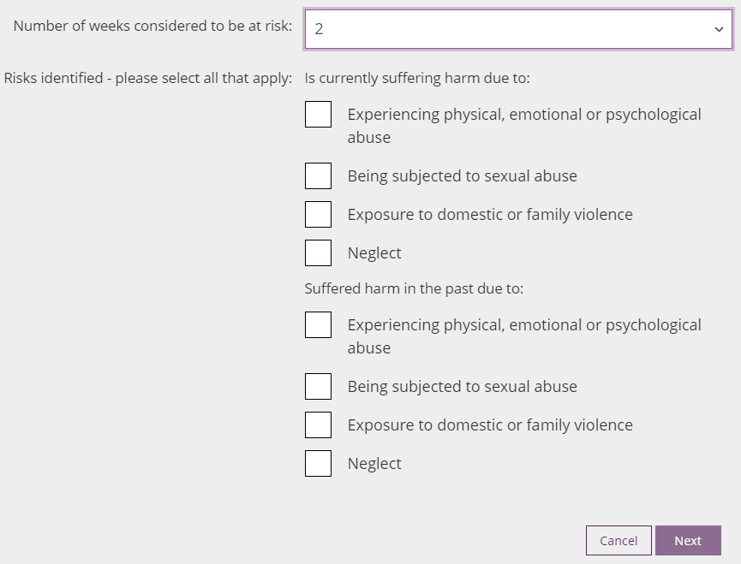

Question: Please select reason for backdating child wellbeing more than 28 days

This question will appear if at Step 3 you keyed in a date which is more than 28 days. If ACC008 – Evidence of exceptional circumstance is not attached to the certificate, when attempting to submit you will receive an error.

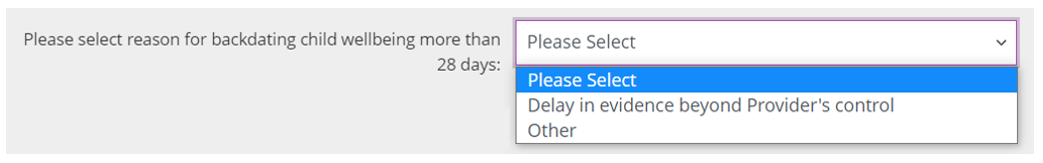

Step 6: Evidence Requirements

Providing evidence is optional at the certificate stage, aside from where a certificate is being backdated for more than 28 days. *When applying to backdate an ACCS (child wellbeing) certificate up to 13 weeks**the**evidence* ***must*** *demonstrate the relevant exceptional circumstance. This is* ***in addition*** *to the evidence required to show that a child is considered at risk. Refer to* [*the Guide to ACCS (child wellbeing)*](https://www.dese.gov.au/additional-child-care-subsidy/resources/guide-accs-child-wellbeing?utm_source=ECCC%20newsletter&utm_medium=email&utm_campaign=newsletter%20traffic) *on backdating in exceptional circumstances.*

A list of evidence requirements will display based on the responses you selected.

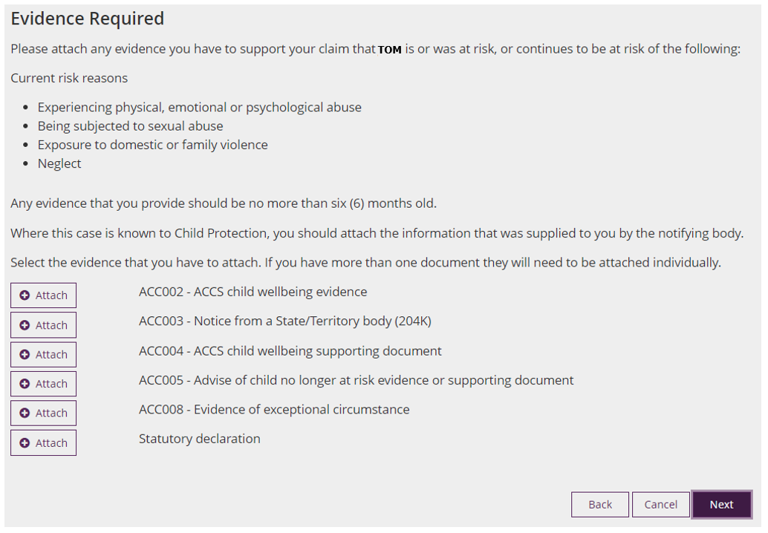

As evidence is not mandatory, if there is no evidence to be supplied, click ‘next’.

If evidence needs to be supplied, click on the  button next to the evidence you are wanting to include and click ‘**next’**. To select the documents to be uploaded, click on ‘**Choose a file’**

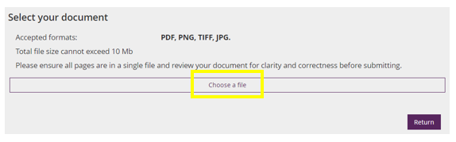

Navigate through your folders to find the file you’re wanting to attach. The file must be an accepted format (PDF, PNG, TIFF or JPG) and not exceed 10 MB.

Once you have located the evidence, click “**Open**”.

You will know the evidence is attached when you see a green tick next to the document name:

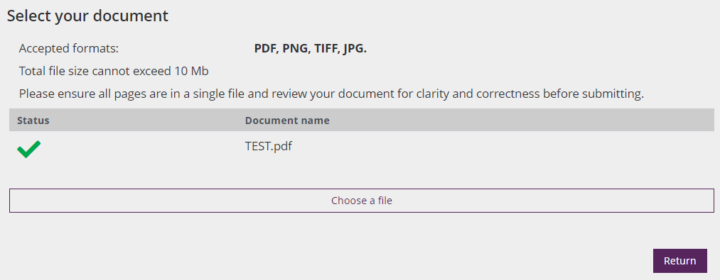

Select “**Return**”

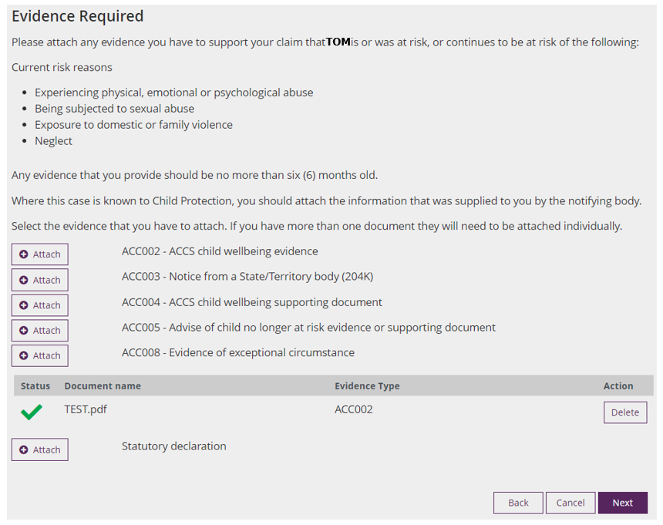

This will take you back to the “Evidence Required” screen. From here you can “**Delete**” any evidence which was added incorrectly, or select “**Next**” to progress.

Step 7: Summary of the Certificate

Here you will be presented with a summary of all the selections you have made for the certificate. Review the information and hit “Edit” to amend any information which isn’t correct.

If all sections are accurate, click “**Next**” to progress.

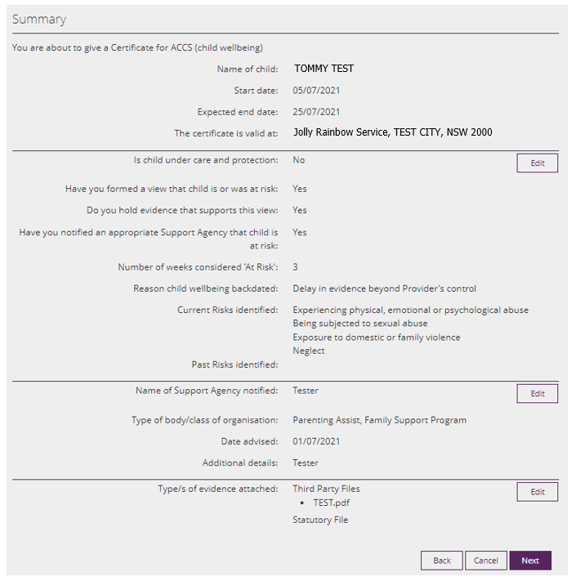

Step 8: Declaration

When the certificate declaration is displayed, review for accuracy, before checking the checkbox and clicking “**Submit**”.

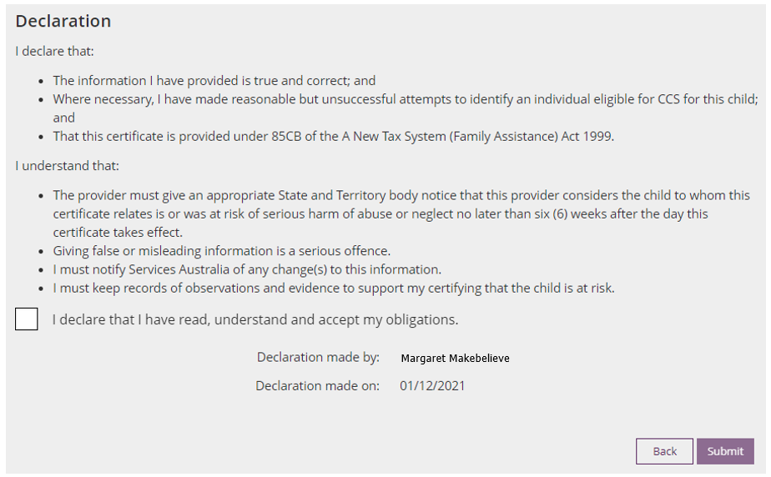

Step 9: Receipt

A receipt will display, notifying you of the outcome of your update. For cases of backdating more than 28 days, you will receive a message to say that you will be ‘notified of the outcome’ and the certificate will show as provisional on the Additional Child Care Subsidy screen in the PEP. A provisional status means the Certificate is being assessed by the relevant team.

