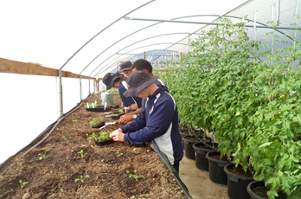 | 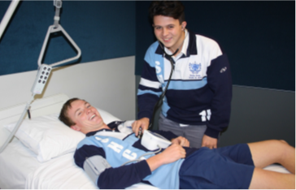
New South Wales – Agriculture | Victoria – Allied Health
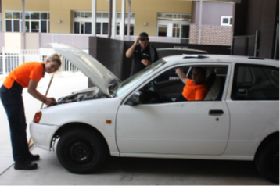 | 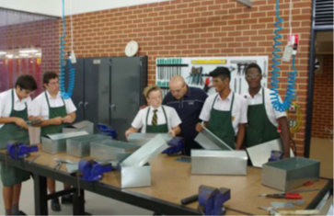
Queensland – Automotive | Western Australia – Engineering
TRADE TRAINING CENTRES in SCHOOLS PROGRAM
2015 PROGRESS REPORT
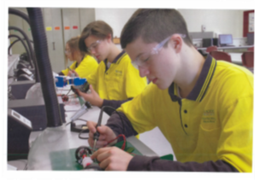 | 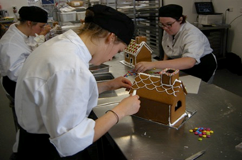
South Australia – Electronics | Tasmania – Baking
 | 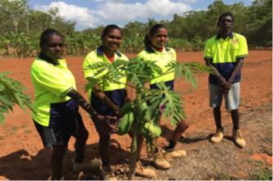
Australian Capital Territory – Child Care | Northern Territory – Conservation & Land Management

Table of Contents
1 Background 3
2 Investment 3
3 Participation 3
4 Enrolments 4
4.1 Enrolments by Certificate Levels 5
4.2 Enrolments by Fields of Study 5
4.3 Clustering and Stand Alone Projects 7
4.4 Enrolments by Gender 9
4.5 Australian School Based Apprenticeships or Traineeships 9
5 Outcomes 10
5.1 Completions 10
5.1.1 Completions by Certificate Levels 11
5.1.2 Completions by Fields of Study 11
5.2 Statements of Attainment 12
5.2.1 Statements of Attainment by Certificate Levels 12
5.2.2 Statements of Attainment by Fields of Study 13
5.3 Indigenous participation 13
5.3.1 Indigenous participation by Certificate Levels 14
5.3.2 Indigenous participation by Fields of Study 14
5.4 Regionality 14
5.4.1 Regionality by Fields of Study 15
5.4.2 Regionality by Gender by Fields of Study 16
6 Benefits 17
7 Challenges 17

Background
The Australian Government has approved funding of $1.4 billion over 2008 – 2016 through the Trade Training Centres in Schools Program (the Program) to enable secondary school students in Australia to have access to modern trade training facilities.
In consultation with their education authorities, eligible schools could access Program funding to build new, or upgrade existing trade or vocational education and training facilities, and to equip those facilities with industry standard equipment. Eligible secondary schools could apply for funding under the Program either individually or in groups, called clusters.
The objectives of the Program seek to help:
- support the achievement of a national Year 12 or equivalent attainment rate of 90 per cent by 2015
- address skills shortages in traditional trades and other eligible occupations by:
- improving student access to trade training facilities that meet industry standards
- improving the quality of schooling offered to secondary students undertaking trade related pathways
- assisting young people to make a successful transition from school to work or further education or training
- support the Council of Australian Government’s ‘Closing the Gap’ initiative to halve the gap between Aboriginal and Torres Strait Islander and other students in Year 12 or equivalent attainment rates by 2020.
The source for all data in the 2015 Progress Report is the annual Activity Reports submitted by each Trade Training Centre (TTC) and Trade Skills Centre (TSC) operating in 2015.

Investment
The investment of $1.4 billion will establish 511 projects involving 1,289 schools (375 TTCs involving 1,067 schools and 136 TSCs involving 222 schools).
The Program encouraged cooperation between schools to form clusters to develop shared facilities. There are 218 TTC projects with cluster arrangements involving 910 schools and 30 TSC projects with cluster arrangements involving 116 schools.
The average investment per TTC is $3.2 million and per TSC is $1.5 million. The average investment per contracted school for TTCs is $1.1 million and for TSCs is $0.9 million.

Participation
A total of 410 projects (368 TTCs and 42 TSCs) reported as operational in 2015. There were 14 TTCs that reported no enrolments in 2015.
For the 396 TTC/TSCs which had enrolments:
- the TTC/TSCs enrolled students from 1,429 schools consisting of 903 contracted schools and 526 schools that were not contracted to the TTC/TSCs
- there were 731 sites where facilities were either constructed or refurbished and equipped and 663 of these sites had enrolments in 2015. The total time spent teaching Approved Training Courses (ATCs) was 443,150 hours with the average time being approximately 32 hours a week per TTC/TSC.
The number of operational TTC/TSCs has progressively increased since 2010. This will plateau in 2017 when all TTC/TSCs are expected to be operational and will decrease from 2020 when the initial TTCs will have completed their 10 year Training Obligation period.

Figure 1: Number of operational TTC/TSCs by Year
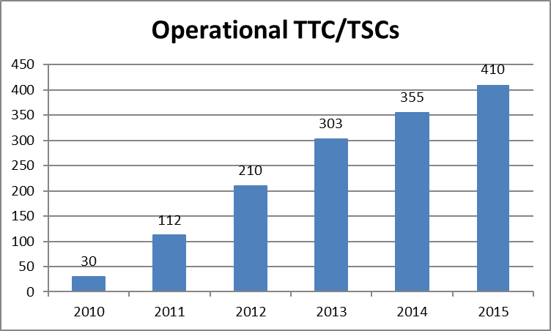

Enrolments
As the number of operational TTC/TSCs have increased in each successive year from 2010 to 2015 so to have the total number of enrolments (refer Table 1). Note: in 2017, all years for Annual Reporting were collated into an Access Database and some of the data may differ from those reported in previous Progress Reports as a result of this data cleansing.
Data collected through the annual Activity Report identifies the number of enrolments in ATCs, and students can be enrolled in more than one ATC. ATCs are the VET courses that the TTCs/TSCs are contracted to deliver.
Table 1: Enrolments in TTCs/TSCs
Enrolments | 2010 | 2011 | 2012 | 2013 | 2014 | 2015
Certificate I | 574 | 3649 | 5612 | 7638 | 8875 | 9553
Certificate II | 859 | 5339 | 14386 | 17875 | 19623 | 23544
Certificate III | 237 | 700 | 1070 | 1078 | 1663 | 2223
Certificate IV | 0 | 0 | 0 | 0 | 14 | 2
Pre-vocational | 0 | 0 | 0 | 31 | 56 | 86
Total | 1670 | 9688 | 21068 | 26622 | 30231 | 35408
Male | 1406 | 7433 | 15654 | 19642 | 21545 | 25002
Female | 264 | 2255 | 5414 | 6980 | 8686 | 10406
Indigenous | 151 | 964 | 1712 | 2137 | 2817 | 2880
Non-Indigenous | 1519 | 8724 | 19356 | 24485 | 27414 | 32528

Figure 2: TTC/TSC Enrolments by State since 2010
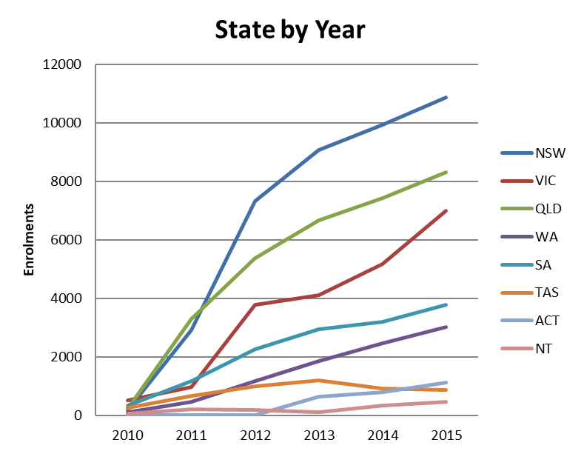

4.1 Enrolments by Certificate Levels
Figure 3: Enrolments in TTCs/TSCs by Certificate Level by Year
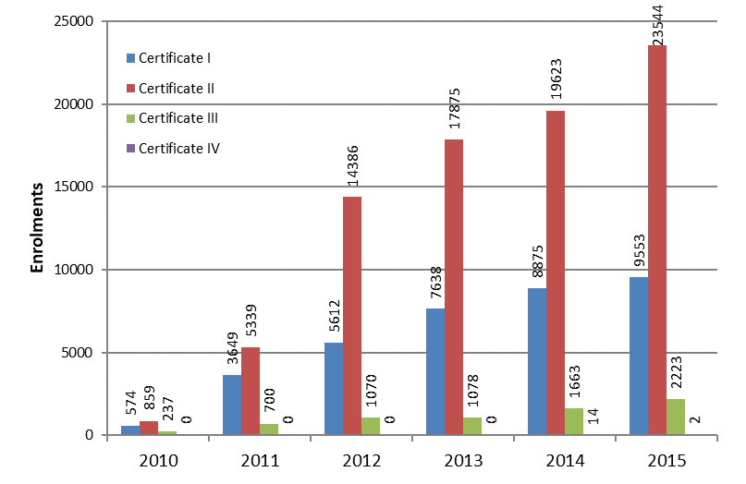

4.2 Enrolments by Fields of Study
For the purpose of this report some Fields of Study have been combined:
- Agriculture – includes Fisheries, Horticulture, Viticulture, Environmental Studies and Animal Studies
- Engineering – includes Aerospace, Civil Engineering, Maritime Engineering, Process and Resource Engineering and Transport and Logistics
- Food and Hospitality – includes Food Processing, Hospitality and Tourism
- Personal Services – includes Beauty Services, Hairdressing and Personal Training
- Science – includes Natural Sciences and Information Systems
- Manufacturing – includes Furniture Making and Graphic and Design Services.
Figure 4: National TTC/TSC Enrolments by Fields of Study followed by Top Five Fields of Study per State and Territory
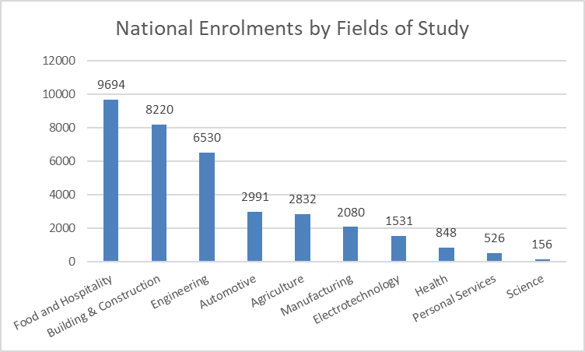

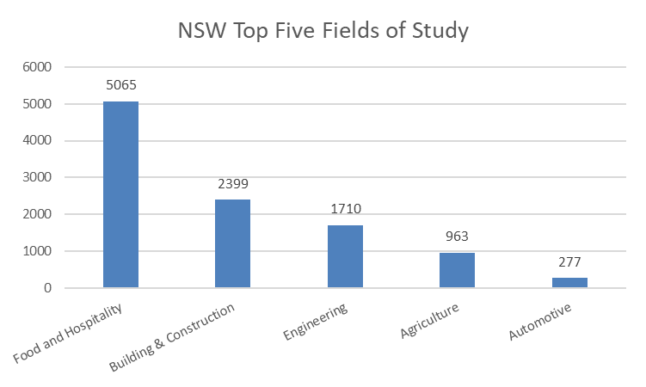 | 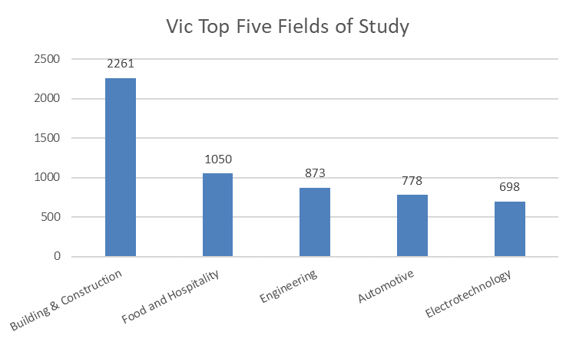
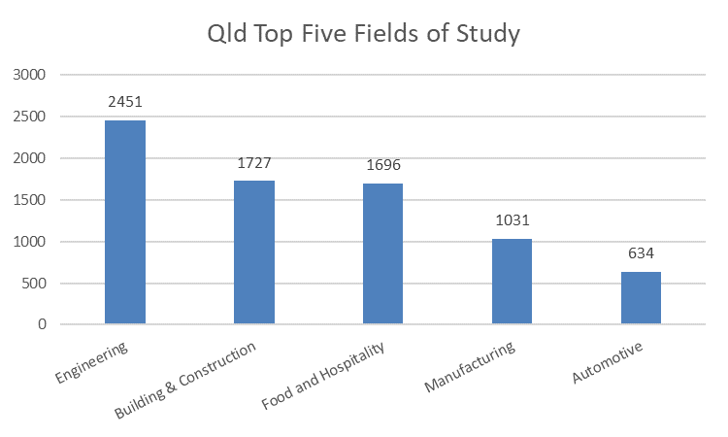 | 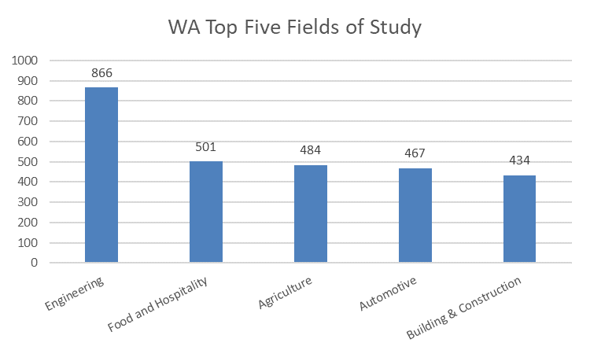
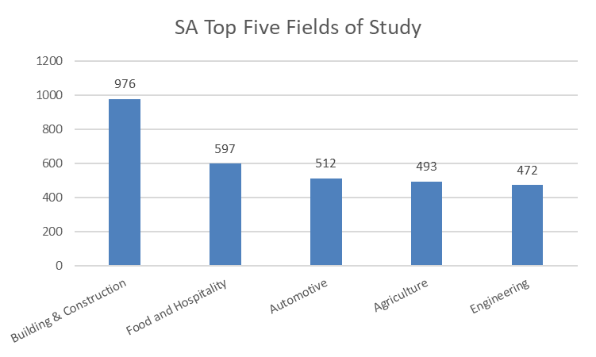 | 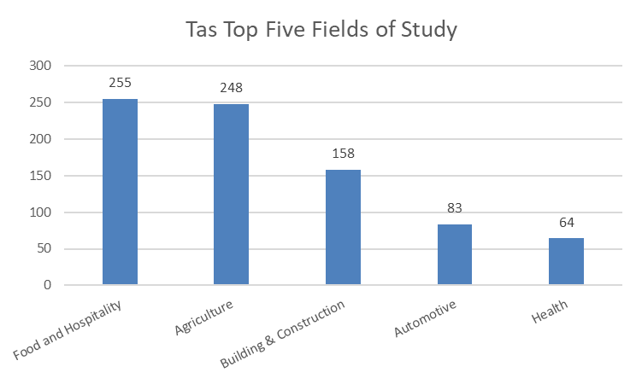
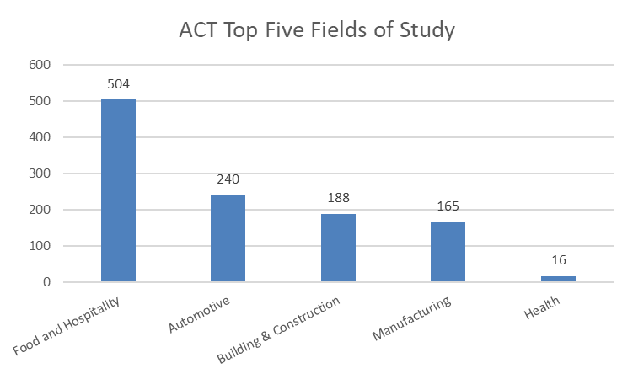 | 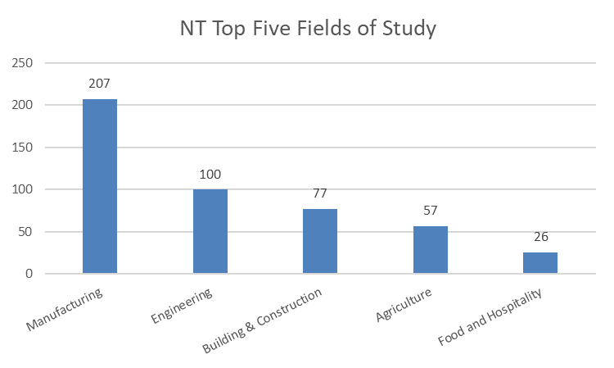

4.3 Clustering and Stand Alone Projects
There were 181 stand-alone projects and 215 cluster projects that reported enrolments in 2015.
The 181 stand-alone projects also had enrolments from students from 162 schools that were not contracted to the TTC/TSC.
The 215 cluster projects had 911 schools contracted to the TTC/TSC with students from 722 of those schools enrolling at the TTC/TSC and students from an additional 364 non contracted schools also enrolled in the TTC/TSC.
Clustering arrangements can attract a higher enrolment due to the larger pool of students available from the contracted schools.
Figure 5: TTC/TSC Enrolments per TTC/TSC project
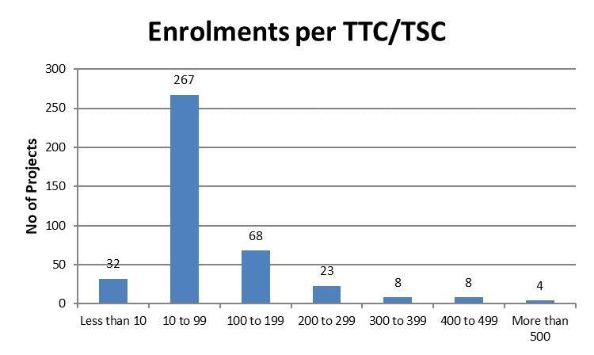
Figure 6: TTC/TSC Enrolments per TTC/TSC Stand Alone project
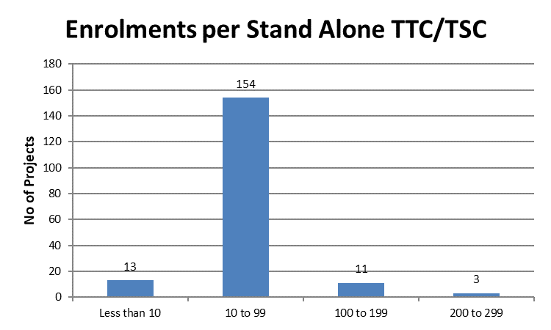

Figure 7: TTC/TSC Enrolments per TTC/TSC Cluster project
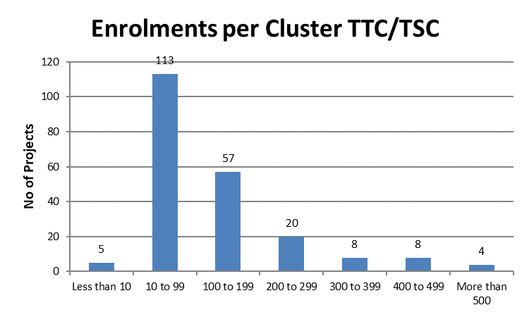

4.4 Enrolments by Gender
The Program aims to address skills shortages in traditional trades and occupations in local demand. Skills shortages tend to occur in traditionally male dominant industries such as engineering, automotive trades and construction.
Enrolment data for 2015 show that females make up 29 per cent of all TTC/TSC enrolments, predominantly in the fields of Food and Hospitality and Agriculture (refer Figure 8).
By contrast males make up 71 per cent of TTC/TSC enrolments and are mainly enrolled in the fields of Building and Construction and Engineering (refer Figure 8).
Figure 8: Male/Female TTC/TSC Enrolments by Fields of Study
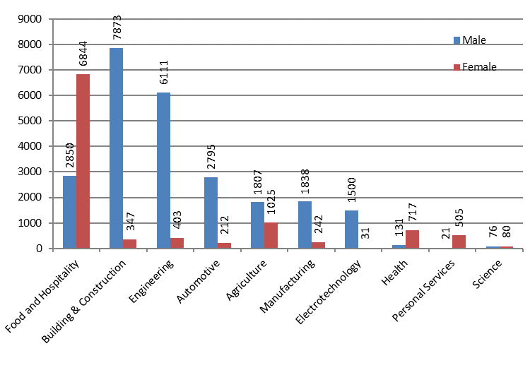

4.5 Australian School Based Apprenticeships or Traineeships
1,258 TTC/TSC students were enrolled in either Australian School Based Apprenticeships or Traineeships. This represents 4 per cent of total enrolments.

Outcomes
‘Completions’ denotes that the enrolment achieved a full Certificate and ‘Statement of Attainment’ denotes that the enrolment completed one or more units of study (competency) within a Certificate. This does not include Pre-Vocational courses as these are not courses under the Australian Qualification Framework and are not accredited courses.
The level of achievement in the training courses is provided in Table 2. Due to the complexity and number of units of competencies involved, there are only a small proportion of Certificate III training courses that can be completed in the two year period of senior secondary study and it is not possible to complete a Certificate IV in the secondary school environment.
Table 2: Proportion of achievement in TTCs/TSCs
Certificate  Level | %  Completions | %  Statement of Attainment | %  No Outcome
Certificate I | 43 | 44 | 13
Certificate II | 36 | 54 | 10
Certificate III | 35 | 57 | 8
Certificate IV | 0 | 100 | 0

5.1 Completions
The number and level of ATC completions are provided in Table 3 and Figure 9. The Fields of Study for Completions is provided at Figure 10.
Table 3: Completions in TTCs/TSCs
Completions | 2010 | 2011 | 2012 | 2013 | 2014 | 2015
Certificate I | 172 | 1847 | 2038 | 3014 | 4046 | 4084
Certificate II | 234 | 2939 | 3351 | 4739 | 7235 | 8435
Certificate III | 2 | 302 | 224 | 216 | 587 | 782
Total | 408 | 5088 | 5613 | 7969 | 11868 | 13301
Male | 279 | 3771 | 4104 | 5958 | 8314 | 8982
Female | 129 | 1317 | 1509 | 2011 | 3554 | 4319
Indigenous | 63 | 470 | 346 | 470 | 973 | 923
Non-Indigenous | 345 | 4618 | 5267 | 7499 | 10895 | 12378

Completions by Certificate Levels
Figure 9: Completions at TTCs/TSCs by Certificate Level
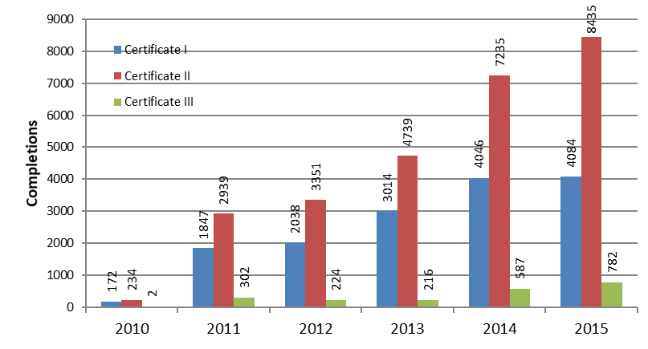

5.1.2 Completions by Fields of Study
Figure 10: Completions at TTC/TSCs by Fields of Study
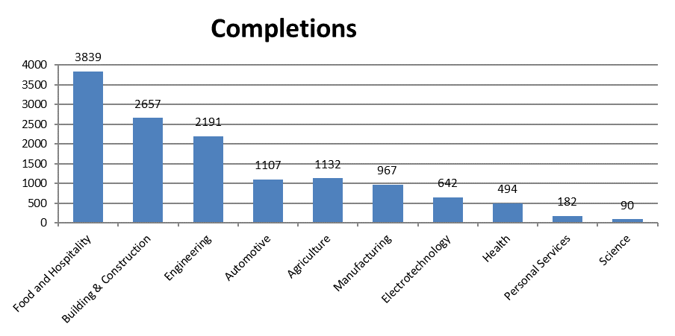

5.2 Statements of Attainment
Table 4 and Figure 11 indicate how many enrolments achieved a Statement of Attainment within a Certificate during 2015. Figure 12 notes the Fields of Study for Statements of Attainment.
Table 4: Number of TTC/TSC Enrolments that received a Statement of Attainment by Certificate Level
Statement of Attainment | 2010 | 2011 | 2012 | 2013 | 2014 | 2015
Certificate I | 0 | 144 | 1575 | 2388 | 3022 | 4181
Certificate II | 41 | 465 | 8356 | 10052 | 9862 | 12770
Certificate III | 0 | 96 | 669 | 694 | 994 | 1273
Certificate IV | 0 | 0 | 0 | 0 | 14 | 2
Total | 41 | 705 | 10600 | 13134 | 13892 | 18226
Male | 40 | 576 | 7792 | 9458 | 10093 | 13266
Female | 1 | 129 | 2808 | 3676 | 3799 | 4960
Indigenous | 26 | 45 | 861 | 941 | 1285 | 1479
Non-Indigenous | 15 | 660 | 9739 | 12193 | 12607 | 16747

5.2.1 Statements of Attainment by Certificate Levels
Figure 11: Number of TTC/TSC Enrolments that achieved a Statement of Attainment by Certificate Level
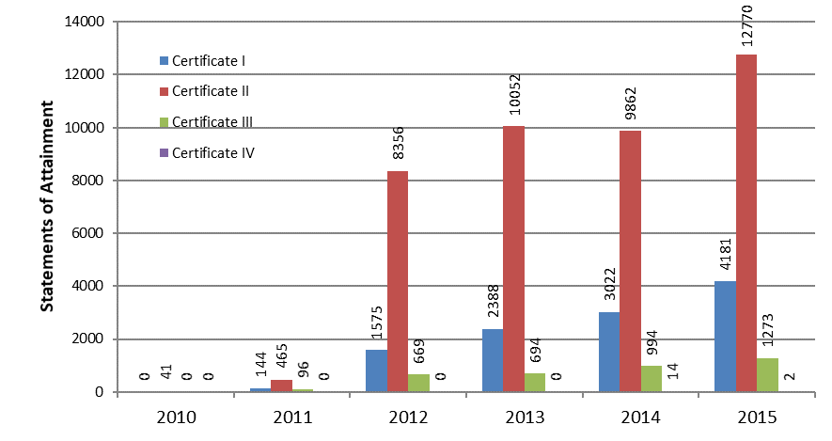

5.2.2 Statements of Attainment by Fields of Study
Figure 12: TTC/TSC Enrolments that achieved a Statement of Attainment by Fields of Study
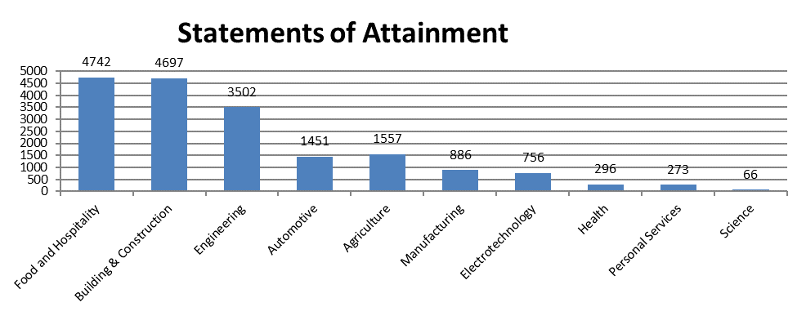
A comparison of the number of enrolments in a Fields of Study with the number of Completions and the number of students who achieved a Statement of Attainment is shown at Figure 13.
Figure 13: Number of TTC/TSC Enrolments/Completions and Statements of Attainment by Fields of Study
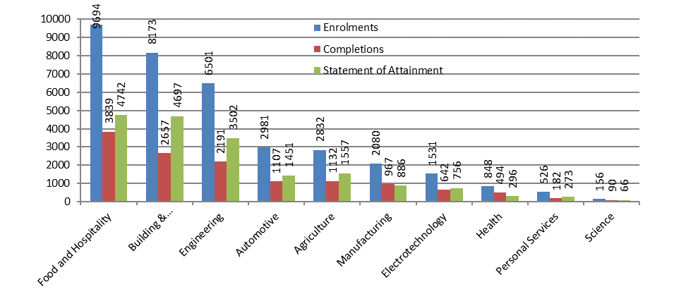

5.3 Indigenous participation
One of the aims of the Program was to support COAG’s ‘Closing the Gap’ initiative to halve the gap between Aboriginal and Torres Strait Islander and other students in Year 12 or equivalent attainment rates by 2020.
8 per cent of TTC/TSC enrolments identify as Indigenous. Of those, 32 per cent gained a Completion and
51 per cent gained a Statement of Attainment.

5.3.1 Indigenous participation by Certificate Levels
Table 5: Percentage of Indigenous achievement by Certificate Level in TTCs/TSCs
Certificate  Level | %  Completed | %  Statement of Attainment | %  No Outcome
Certificate I | 32 | 50 | 28
Certificate II | 32 | 52 | 16
Certificate III | 30 | 59 | 11

5.3.2 Indigenous participation by Fields of Study
Figure 14: Number of TTC/TSC Enrolments/Completions and Statements of Attainment by Fields of Study
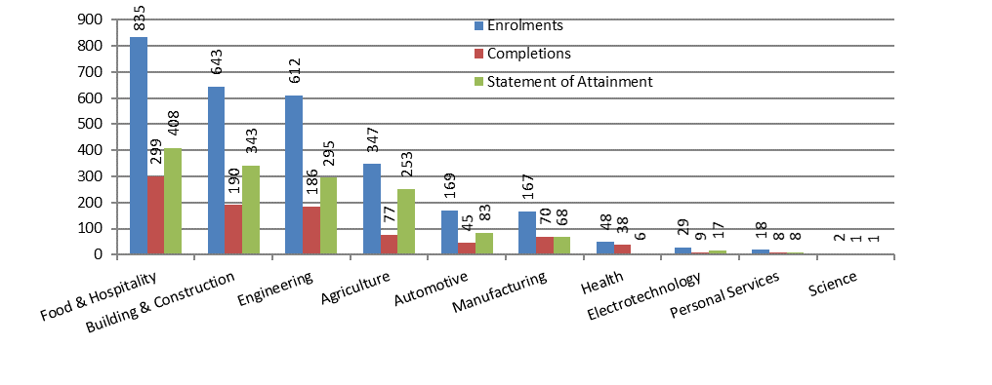

5.4 Regionality
One of the priorities for the Program was to support students in regional and rural locations. In 2015, the enrolments for TTC/TSCs by region (where the region is denoted by the site of the TTC/TSC) are noted in Table 6.
Table 6: Number of TTC/TSC Enrolments/Completions/Statement of Attainment in Approved Training Courses by Region
Region | Enrolments | Completions | % | Statement of Attainment | %
Major Capital Cities | 16,283 | 5,830 | 36 | 8,784 | 54
Inner Regional | 10,348 | 3,998 | 39 | 5,278 | 51
Outer Regional | 6,960 | 2,826 | 41 | 3,217 | 46
Remote | 1,159 | 454 | 39 | 641 | 55
Very Remote | 572 | 193 | 34 | 306 | 53
National | 35,322 | 13,301 | 38 | 18,226 | 52

5.4.1 Regionality by Fields of Study
Figure 15: TTC/TSC Enrolments by Fields of Study – Major Capital Cities
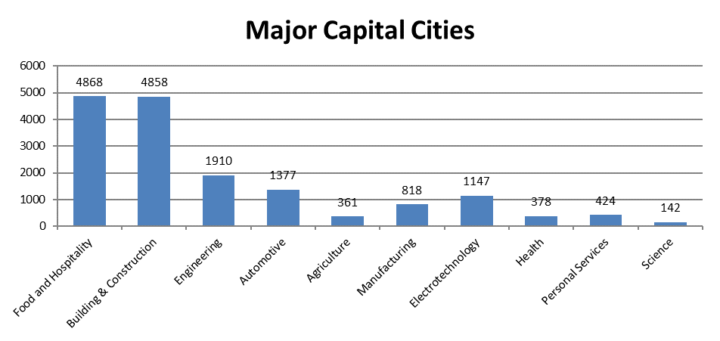
Figure 16: TTC/TSC Enrolments by Fields of Study – Regional Australia
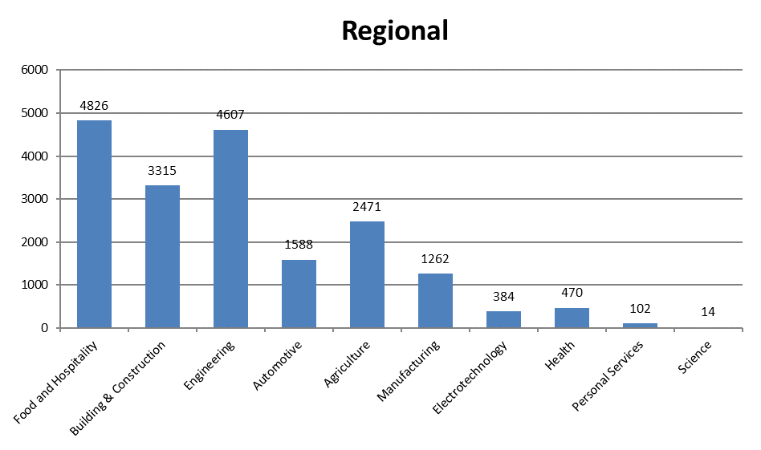

5.4.2 Regionality by Gender by Fields of Study
The comparison of Enrolments, Completions and Statements of Attainment by gender and region are shown in Figures 17 to 19.
Figure 17: Male/Female TTC/TSC enrolments by Fields of Study by Region
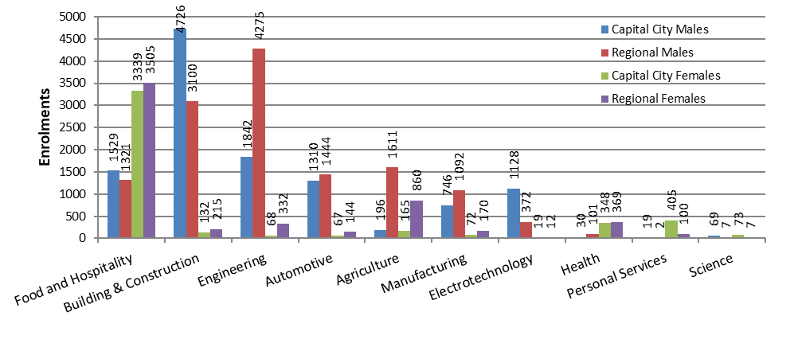
Figure 18: Male/Female TTC/TSC Completions by Fields of Study by Region
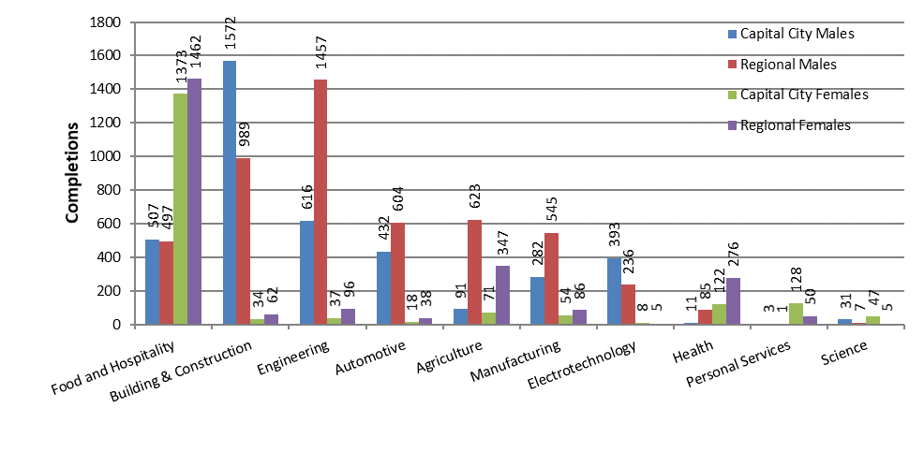
Figure 19: Male/Female TTC Statements of Attainment by Fields of Study by Region
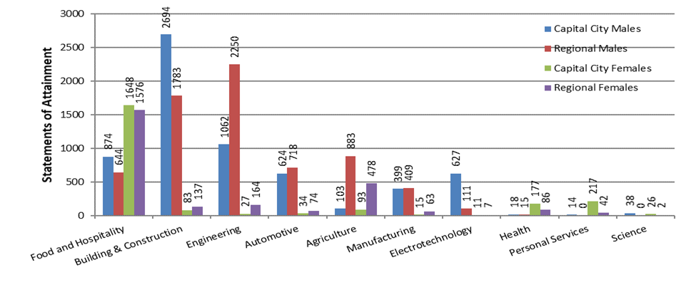

Benefits
The annual Activity Reports seek input on the influence of the TTC/TSC on outcomes.
Of the 396 TTC/TSCs reporting enrolments:
- 97 per cent reported improved engagement of students generally or students in particular
- 87 per cent reported that the TTC/TSC improved school enrolments and/or retention rates
- 94 per cent reported that the TTC/TSC has improved the behaviour or enthusiasm of students
- 92 per cent reported that they had received feedback from families or the communities about the TTC/TSC
- 89 per cent reported that local industry and employers were engaged with and/or supported the TTC/TSC
- 93 per cent reported that the TTC/TSC had improved the transition into the workforce/tertiary education for students
- 4,238 students (12 per cent of total enrolments) that were enrolled in the TTC/TSCs in 2015 have gone into jobs in the industry or industries associated with their training.
In 2015, the TTC/TSCs were also used for training other than the ATCs:
- 359 TTC/TSCs reported utilisation by students for activity other than the delivery of ATCs for a total of 270,661 hours (average 754 hours per TTC/TSC)
- 263 TTC/TSCs reported utilisation by staff for activity other than the delivery of ATCs for a total of
41,572 hours (average 158 hours per TTC/TSC)
- 216 TTC/TSCs reported utilisation by local community and /or industry for activity other than the delivery of ATCs for a total of 45,565 hours (average 211 hours per TTC/TSC)

Challenges
In 2015, a number of challenges to the successful delivery of Approved Training Courses (ATCs) were identified where ATCs were not delivered at a TTC/TSC or at one or more sites for a TTC/TSC. Table 7 details the reasons why courses were not delivered. The data is split in to Major Capital Cities and Regional TTC/TSCs.
Note: There can be more than one reason that an individual ATC was not delivered at a site.
Table 7: Reasons for Non-delivery of an Approved Training Course
Reason for Non-Delivery | No of Major Capital City ATCs | No of Regional ATCs
Unable to get a qualified teacher | 23 | 79
Insufficient student interest | 58 | 263
RTO Difficulties | 15 | 18
First year of operation | 1 | 4
Other | 24 | 91

The department is working with Education Authorities to respond to these issues.
For more information visit the Trade Training Centres in School Program webpage.

