
Australian Government


Through Growth to Achievement
Report of the Review to Achieve Educational Excellence in Australian Schools
March 2018

Through Growth to Achievement
Report of the Review to Achieve Educational Excellence in Australian Schools
March 2018
Review Panel
Mr David Gonski AC
Mr Terrey Arcus AM
Dr Ken Boston AO
Ms Valerie Gould
Ms Wendy Johnson
Dr Lisa O'Brien
Dr Lee-Anne Perry AM
Mr Michael Roberts


Report of the Review to Achieve Educational Excellence in Australian Schools
© Commonwealth of Australia 2018
ISBN
978-1-76051-421-1 [PRINT] 978-1-76051-419-8 [PDF] 978-1-76051-420-4 [DOCX]
With the exception of the Commonwealth Coat of Arms, the department's logo, any material protected by a trade mark and where otherwise noted, all material presented in this document is provided under a Creative Commons Attribution 4.0 International licence.
The details of the relevant licence conditions are available on the Creative Commons website (https://creativecommons.Org/licenses/by/4.0/) as is the full legal code (https://creativecommons.org/licenses/by/4.0/legalcode)
The Department of Education and Training must be attributed as the author of the material. As far as practicable, material for which the copyright is owned by a third party will be clearly labelled. The department has made all reasonable efforts to ensure that this material has been reproduced in this document with the full consent of the copyright owners.
Copyright requests and enquiries concerning further authorisation should be addressed to:
The Copyright Officer, Department of Education and Training, Location code
C50MA10
GPO Box 9880 Canberra ACT 2601 or emailed to copyright@education.gov.au.
Where a copyright owner, other than the Commonwealth, is identified with respect to this material, please contact that third party copyright owner directly to seek permission.
Disclaimer
As this is an independent review, the report does not necessarily reflect the views of the Australian Government.
This document when attributed must be titled as Through Growth to Achievement: The Report of The Review to Achieve Educational Excellence in Australian Schools.

Contents
Acronyms v
List of exhibits vi
Executive summary viii
Australian education faces challenges to achieving educational excellence viii
Recommendations for school education x
Recommendations xiii
Findings xv
Introduction 1
Improving education outcomes is critical to future economic and social opportunity 2
A fine educational heritage, but declining performance 5
Many Australian schools are cruising, not improving 10
Overview of the strategy to achieve educational excellence 12
Acting on the Review's recommendations 13
Strategy for achieving educational excellence in Australian schools 15
Chapter one: Laying the foundations for learning 16
- High-quality early childhood education sets children up for success at school... 16
- Enabling parents and carers to be partners in their child's learning 20
- Engaging students as partners in learning will help them reach their full potential 25
Chapter two: Equipping every student to grow and succeed in a changing world 27
- School education needs to maximise individual learning growth and attainment 27
- Assessment and reporting needs to provide insight into a student's learning growth and learning achievements 30
- Introducing learning progressions will support teachers to cater for the diverse levels of achievement in their classroom 31
- Learning progressions for literacy and numeracy need to be implemented in a way that builds a solid foundation to help students advance in their learning... 34
- Every student needs to be equipped with the skills and knowledge to navigate
a rapidly changing world 36
- General capabilities need to be at the core of our curriculum and teaching practice 38
- Effective school-community engagement unlocks a world of applied learning and development opportunities for students 41
- Schools need support to build quality partnerships to deepen community engagement 46
- The proportion of students completing senior secondary and the world they enter on completion, have both changed significantly 47
- Despite these profound changes, senior secondary education models have remained substantially the same 49
- There is a strong case for a national review of senior secondary schooling 53

Chapter three: Creating, supporting and valuing a profession of expert educators 56
- Systems need to create the conditions and culture to enable and encourage more collaboration 58
- Teachers need a new tool for formative assessment of student learning 61
- Professional learning needs to enable tailored teaching for maximum impact……..66
- A comprehensive national workforce strategy will better develop and match
the teaching workforce to meet Australia's needs 69
- Further embedding recent reforms is essential to produce better trained, classroom-ready teaching graduates 73
- Better induction for early career teachers will improve their transition into the profession and promote retention and professional growth 74
- Expert teachers need to be better cultivated, recognised and utilised 77
- Teachers deserve greater recognition and higher esteem 80
Chapter four: Empowering and supporting school leaders 82
4.1 Empowering and supporting principals to focus on instructional leadership
can drive school performance 83
- Other obligations crowd out the principal's instructional leadership 84
- The primary role of the principal needs to be instructional leadership 86
- Structural autonomy alone is not sufficient to improve school performance 89
- Aspiring leaders need a clear pathway to follow 91
- Targeted preparation and support is essential for new principals 93
- Principals need to be able to participate in structured professional learning opportunities once in the role 95
Chapter five: Raising and achieving ambitions through innovation and continuous
improvement 97
5.1 Great school systems have high aspirations for students and schools and act
to deliver on them 98
- Innovation and continuous improvement are key drivers of ongoing change and reform 98
- Continuous improvement needs high-quality evaluation and quality assurance processes 100
- Better data at a student level from a Unique Student Identifier will improve student and school outcomes 101
- Establishing a national research and evidence institute will drive better practice and innovation 103
Call to action 112
Appendix A - Terms of reference 113
Appendix B - Review process 115
Appendix C- Consultations 117
Appendix D - Public submissions 121
Appendix E -Glossary 127
Appendix F - References 131

Acronyms

Acronym | Full term
ACARA | Australian Curriculum, Assessment and Reporting Authority
ACER | Australian Council for Educational Research
AEDC | Australian Early Development Census
AITSL | Australian Institute for Teaching and School Leadership
ATAR | Australian Tertiary Admission Rank
ESCS | Economic, Social and Cultural Status
F-10 | Foundation to Year 10
HALT | Highly Accomplished and Lead Teacher
ITE | Initial teacher education
NAPLAN | National Assessment Program - Literacy and Numeracy
OECD | Organisation for Economic Co-operation and Development
PISA | Programme for International Student Assessment
SEIFA | Socio-Economic Indexes for Areas
STEM | Science, technology, engineering and mathematics
TALIS | Teaching and Learning International Survey
TEMAG | Teacher Education Ministerial Advisory Group
TIMSS | Trends in International Mathematics and Science Study
USI | Unique Student Identifier
VET | Vocational education and training

List of exhibits

Exhibit number | Title | Page
1 | Australia's international ranking has noticeably dropped since 2000 | 3
2 | Australia's performance has declined in absolute terms between 2003 and 2015 | 6
3 | There has been a decline in Australia's performance in mathematics across all socio-economic quartiles between 2003 and 2015 | 7
4 | There has been a decline in Australia's performance in mathematics across all school sectors between 2003 and 2015 | 8
5 | In 2015, there was a significant achievement gap between Australia and the highest performing country in both reading literacy and mathematics | 9
6 | Australia is lagging behind the world's top performers and falling towards the OECD average | 10
7 | Around 30 per cent of primary schools are 'cruising' | 11
8 | Children who do not attend preschool are more likely to be developmentally vulnerable, in advantaged and disadvantaged communities | 18
9 | Students from disadvantaged backgrounds benefit most if they continue to receive support through childhood and adolescence | 19
10 | Australian students from low socio-economic backgrounds are less likely to have growth mindsets | 21
11 | There is a wide spread of achievement in Years 3, 5, 7 and 9 | 29
12 | Example of how spelling develops within the literacy progression | 33
13 | The performance gap between students with low and high levels of parental education widens significantly | 35
14 | Non-routine occupations are an increasing proportion of Australia's workforce | 37
15 | The current Australian Curriculum has three dimensions | 38
16 | The proportion of students continuing through to Year 12 and attending university immediately after school has trended upwards | 48
17 | The proportion of young people not in full-time education and working full-time is decreasing, while part-time workers are slowly growing | 52
18 | There is a continuum of assessment and reporting options | 55
19 | What does the evidence say works best in teaching? | 62
20 | Overview of the proposed formative assessment tool | 65
21 | More schools report vacancies in mathematics and science than any other subject | 72
22 | Singapore has three career tracks for teachers | 78
23 | There are three phases of leadership development | 83
24 | The Australian Professional Standard for Principals leadership lenses | 87
25 | The top and bottom three elements current school leaders believe are required to attract and retain their replacements | 93
26 | The UK's leadership development system supports aspiring and serving leaders with formal qualifications | 94
27 | Attributes of an innovative education system | 99
28 | Dimensions of a successful research and evidence organisation | 104
29 | Principles for a national education research and evidence institution | 109

The Hon Malcolm Turnbull MP
Prime Minister
Parliament House
CANBERRA ACT 2600
Senator the Hon Simon Birmingham
Minister for Education and Training
Parliament House
CANBERRA ACT 2600

Dear Prime Minister and Minister
In July 2017, the Australian Government established the Review to Achieve Educational Excellence in Australian Schools (the Review) to provide advice on how to improve student achievement and school performance.
The terms of reference require the Review Panel to report to the Prime Minister and Commonwealth Minister for Education and Training. Accordingly, on behalf of the Review Panel, I am pleased to present our final report, Through Growth to Achievement: Report of the Review to Achieve Educational Excellence in Australian Schools.
The Review Panel has consulted with a broad range of stakeholders and experts, and received nearly 300 submissions from teachers, principals, professional associations, teachers unions, parents and carers, school systems, state and territory governments, researchers, universities, community organisations, and business and industry.
I take this opportunity to thank everyone who contributed to the Review, particularly the stakeholders and experts who were so generous with their time in meeting the Review Panel.
Many of these stakeholders and experts urged the Review Panel to focus on maximising the learning growth of every student every year. With that in mind the Review Panel has identified a set of impactful and practical reforms to be put in place across Australia. The Review Panel believe these reforms need to be supported by a sustained, long-term and bipartisan commitment to their implementation.
The Review Panel commends its recommendations to you. We are strongly of the view that the proposed reforms outlined in the report are required to improve school performance and student achievement. Further, they have been designed as a package where each reform is necessary to support the overall ambition.
I thank my colleagues on the Review Panel, MrTerrey Arcus AM, Dr Ken Boston AO,
Ms Valerie Gould, Ms Wendy Johnson, Dr Lisa O'Brien, Dr Lee-Anne Perry AM and
Mr Michael Roberts, for their contribution to our deliberations leading to the final report.
I also thank Ms Renae Houston and the other members of the secretariat who worked long and hard to assist the Review Panel.

Mr David Gonski AC
Chair
Yours sincerely,

Executive summary
In a world where education defines opportunity, schooling must support every one of Australia's 3.8 million school students to realise their full learning potential and achieve educational excellence.
Australian students should receive a world-class school education, tailored to individual learning needs, and relevant to a fast-changing world. They should be challenged and supported to progress and excel in learning in every year of school, appropriate to each student's starting point and capabilities.
Schooling should enrich students' lives, leaving them inspired to pursue new ideas and set ambitious goals throughout life.
Australia has a strong educational heritage and committed educators. Since 2000, however, academic performance has declined when compared to other Organisation for Economic Co-operation and Development (OECD) countries, suggesting that Australian students and schools are not improving at the same rate and are falling short of achieving the full learning potential of which they are capable.
As a nation, we need to act now to raise our aspirations and make a renewed effort to improve school education outcomes.
Recognising excellence in education as a national priority, the Australian Government established the Review to Achieve Educational Excellence in Australian Schools (the Review) in July 2017. Mr David Gonski AC chaired the Review, supported by an independent panel of experts drawn from different states, school systems and sectors.
The Review Panel was asked to recommend ways that Australia could improve student outcomes, return to being one of the top education systems in the world, and ensure that school systems and schools truly prepare Australia's young people for an ever-changing world.
The Review has focused on identifying impactful and practical reforms that build on existing improvement efforts. Its recommendations and findings reflect extensive and valuable contributions to the Review from stakeholders and experts, through consultations and nearly 300 submissions. These stakeholders included teachers, principals, professional associations, teacher unions, parents and carers, school systems, state and territory governments, researchers, universities, community organisations and business and industry. Critically, the key reforms recommended in the Report featured strongly in the proposals put forward by these groups. Nationally, there is a very strong mandate and desire for change.
Australian education faces challenges to achieving educational excellence
There are a number of challenges that require a sustained national response if Australian students and schools are to reach the goal of achieving educational excellence.
Declining academic performance is jeopardising the attainment of Australia's aspiration for excellence and equity in school education. Since 2000, Australian student outcomes

have declined in key areas such as reading, science and mathematics. This has occurred in every socio-economic quartile and in all school sectors (government, Catholic and Independent). The extent of the decline is widespread and equivalent to a generation of Australian school children falling short of their full learning potential. There is also a wide range of educational outcomes in the same classroom or school, with the most advanced students in a year typically five to six years ahead of the least advanced students. Such disparity in learning outcomes means that, within our current model of school education, some students are being left behind while others are not being adequately challenged.
School education must also prepare students for a complex and rapidly changing world. As routine manual and administrative activities are increasingly automated, more jobs will require a higher level of skill, and more school leavers will need skills that are not easily replicated by machines, such as problem-solving, interactive and social skills, and critical and creative thinking.
Australia anticipated this shift 10 years ago in the Melbourne Declaration, which called on schools to help young Australians 'become confident and creative individuals, and active and informed citizens' as well as 'successful learners'. The Australian Curriculum, Foundation to Year 10 (F-10), which combines both general capabilities, such as critical and creative thinking, and learning areas, such as science and history, is designed to achieve the Melbourne Declaration vision. However, the presentation, implementation and focus of the curriculum and senior secondary schooling models could be improved to ensure they prepare students for life beyond school.
Finally, Australia needs to review and change its model for school education. Like many countries, Australia still has an industrial model of school education that reflects a 20th century aspiration to deliver mass education to all children. This model is focused on trying to ensure that millions of students attain specified learning outcomes for their grade and age before moving them in lock-step to the next year of schooling. It is not designed to differentiate learning or stretch all students to ensure they achieve maximum learning growth every year, nor does it incentivise schools to innovate and continuously improve.
Although this problem is widely recognised by teachers and educators, schools' attempts to address the issue are hampered by curriculum delivery, assessment, work practices and the structural environments in which they operate.
The constraints include inflexibility in curriculum delivery, reporting and assessment regimes, and tools focussed on periodic judgements of performance, rather than continuous diagnosis of a student's learning needs and progress. This is compounded by a lack of research-based evidence on what works best in education, the absence of classroom applications readily available for use by teachers, multiple calls on the time of teachers and school leaders, and a lack of support for school principals to develop their professional autonomy and prioritise instructional leadership.

Recommendations for school education
Maximising every student's learning growth every year requires a set of shifts across Australian education systems, and a sustained, long-term and coordinated improvement effort based on shared ambition, action and accountability.
The Review Panel acknowledges the achievements of school systems and schools to date and their ongoing commitment to improvement.
This report seeks to build on this effort by recommending priorities and interventions necessary to enable educators and schools and their communities to help all students to reach their full potential.
Priority one: Deliver at least one year's growth in learning for every student every year
Student growth is a measure of the individual progress a student makes over time along a defined learning progression. Focusing on student growth matters because it enables every student to progress regardless of starting point or capabilities.
The Review Panel heard from a range of stakeholders that the fundamentals for supporting all students do not change. Personalised learning and teaching—based on each child's learning needs, and informed by iterative evaluation of the impact of those strategies— are effective at improving education outcomes for all students. This holds regardless of a student's circumstances, whether they are students with disability, students in rural or remote locations, Aboriginal and Torres Strait Islander students, those from non-English speaking backgrounds, low socio-economic backgrounds, gifted and talented students, or any combination of these.
To accelerate individual learning growth at scale, Australia needs to commit to the goal of growth, and to undertake long-term, consistent and coordinated action throughout all school systems and schools to enable schools and educators to meet it.
To achieve this shift to growth, the Review Panel believes it is essential to move from a year-based curriculum to a curriculum expressed as learning progressions independent of year or age. Underpinning this, teachers must be given practical support by creating an online, formative assessment tool to help diagnose a student's current level of knowledge, skill and understanding, to identify the next steps in learning to achieve the next stage in growth, and to track student progress over time against a typical development trajectory.
These reforms also depend on creating the conditions that will enable teachers and schools to successfully adopt practices that support tailored teaching for growth, such as collaborative planning, teaching and assessment, and personalised learning for students.
Delivering the maximum individual learning growth for every student every year is the key to reversing the decline in Australia's education outcomes. The greater the number of students who realise their full learning potential, the greater the cumulative lift will be in our overall national performance.
Priority two: Equip every child to be a creative, connected and engaged learner in a rapidly changing world
Every young Australian should emerge from schooling as a creative, connected, and engaged learner with a growth mindset that can help to improve a student's educational achievement over time. They should also gain the right mix of knowledge, skills, and

understanding for a world experiencing significant economic, social and technological change.
Shifts in technology and jobs are changing the balance, type and proficiency levels of the knowledge, skill and understanding students need to develop through school. Ensuring that curriculum, learning and pedagogical models can respond to these changing needs must be a key goal of the Australian education system in the next decade.
The Review Panel therefore recommends placing increased emphasis on teaching general capabilities in the F-10 Australian Curriculum.
It also recommends a nationally coordinated review of the purpose, content and structure of senior secondary education to make sure it is contemporary, and adequately prepares students for post-school employment, training, higher education and to live and prosper in a rapidly changing world.
Priority three: Cultivate an adaptive, innovative and continuously improving education system
To support excellence in education, school systems and schools need to adapt to changing contexts and needs. There must be continuous improvement across each part of the education system, from curriculum, reporting and assessment models to workforce development and community and parent and carer engagement. School systems and schools must maintain a focus on innovation and improvement to ensure results move upwards and Australian students catch up to their global peers.
Australia needs to start by setting higher expectations for students, educators and schools, and rejecting the idea that there are natural performance plateaus. We must help our school systems and schools to adapt and innovate in response to changes in their environment or performance, and transparently report progress against outcomes. We must limit the burden of non-core activities, such as administrative tasks, on schools and their leaders, so they can concentrate on instructional leadership and help teachers to maximise the learning growth of their students.
The Review Panel recommends supporting continuous innovation in schools by introducing a national evidence institute to share best-practice and evidence-based innovations faster and more widely.
It also recommends introducing a Unique Student Identifier to better track outcomes, and updating evaluation frameworks and practices to reflect expectations of accelerating individual learning growth and continuous school improvement.
Finally, as the quality of schools is dependent on the quality and commitment of the people who work in them, the Review Panel recommends strengthening the attractiveness of the teaching and school leadership professions by creating clearer career pathways, better recognising expertise, and strengthening workforce planning and development.
Further transformation of Australian schooling will be challenging, particularly in Australia's federated education model. However, we cannot let the challenge of delivery daunt our ambition. To aim lower would unfairly limit the life opportunities of young Australians and the prosperity of Australia as a whole.
Instead, we should set our ambitions high, confident that we have the resources and talent to be a world-leading school education system that enables every student and every school to achieve educational excellence.

Report on a page
We have identified three priorities ...
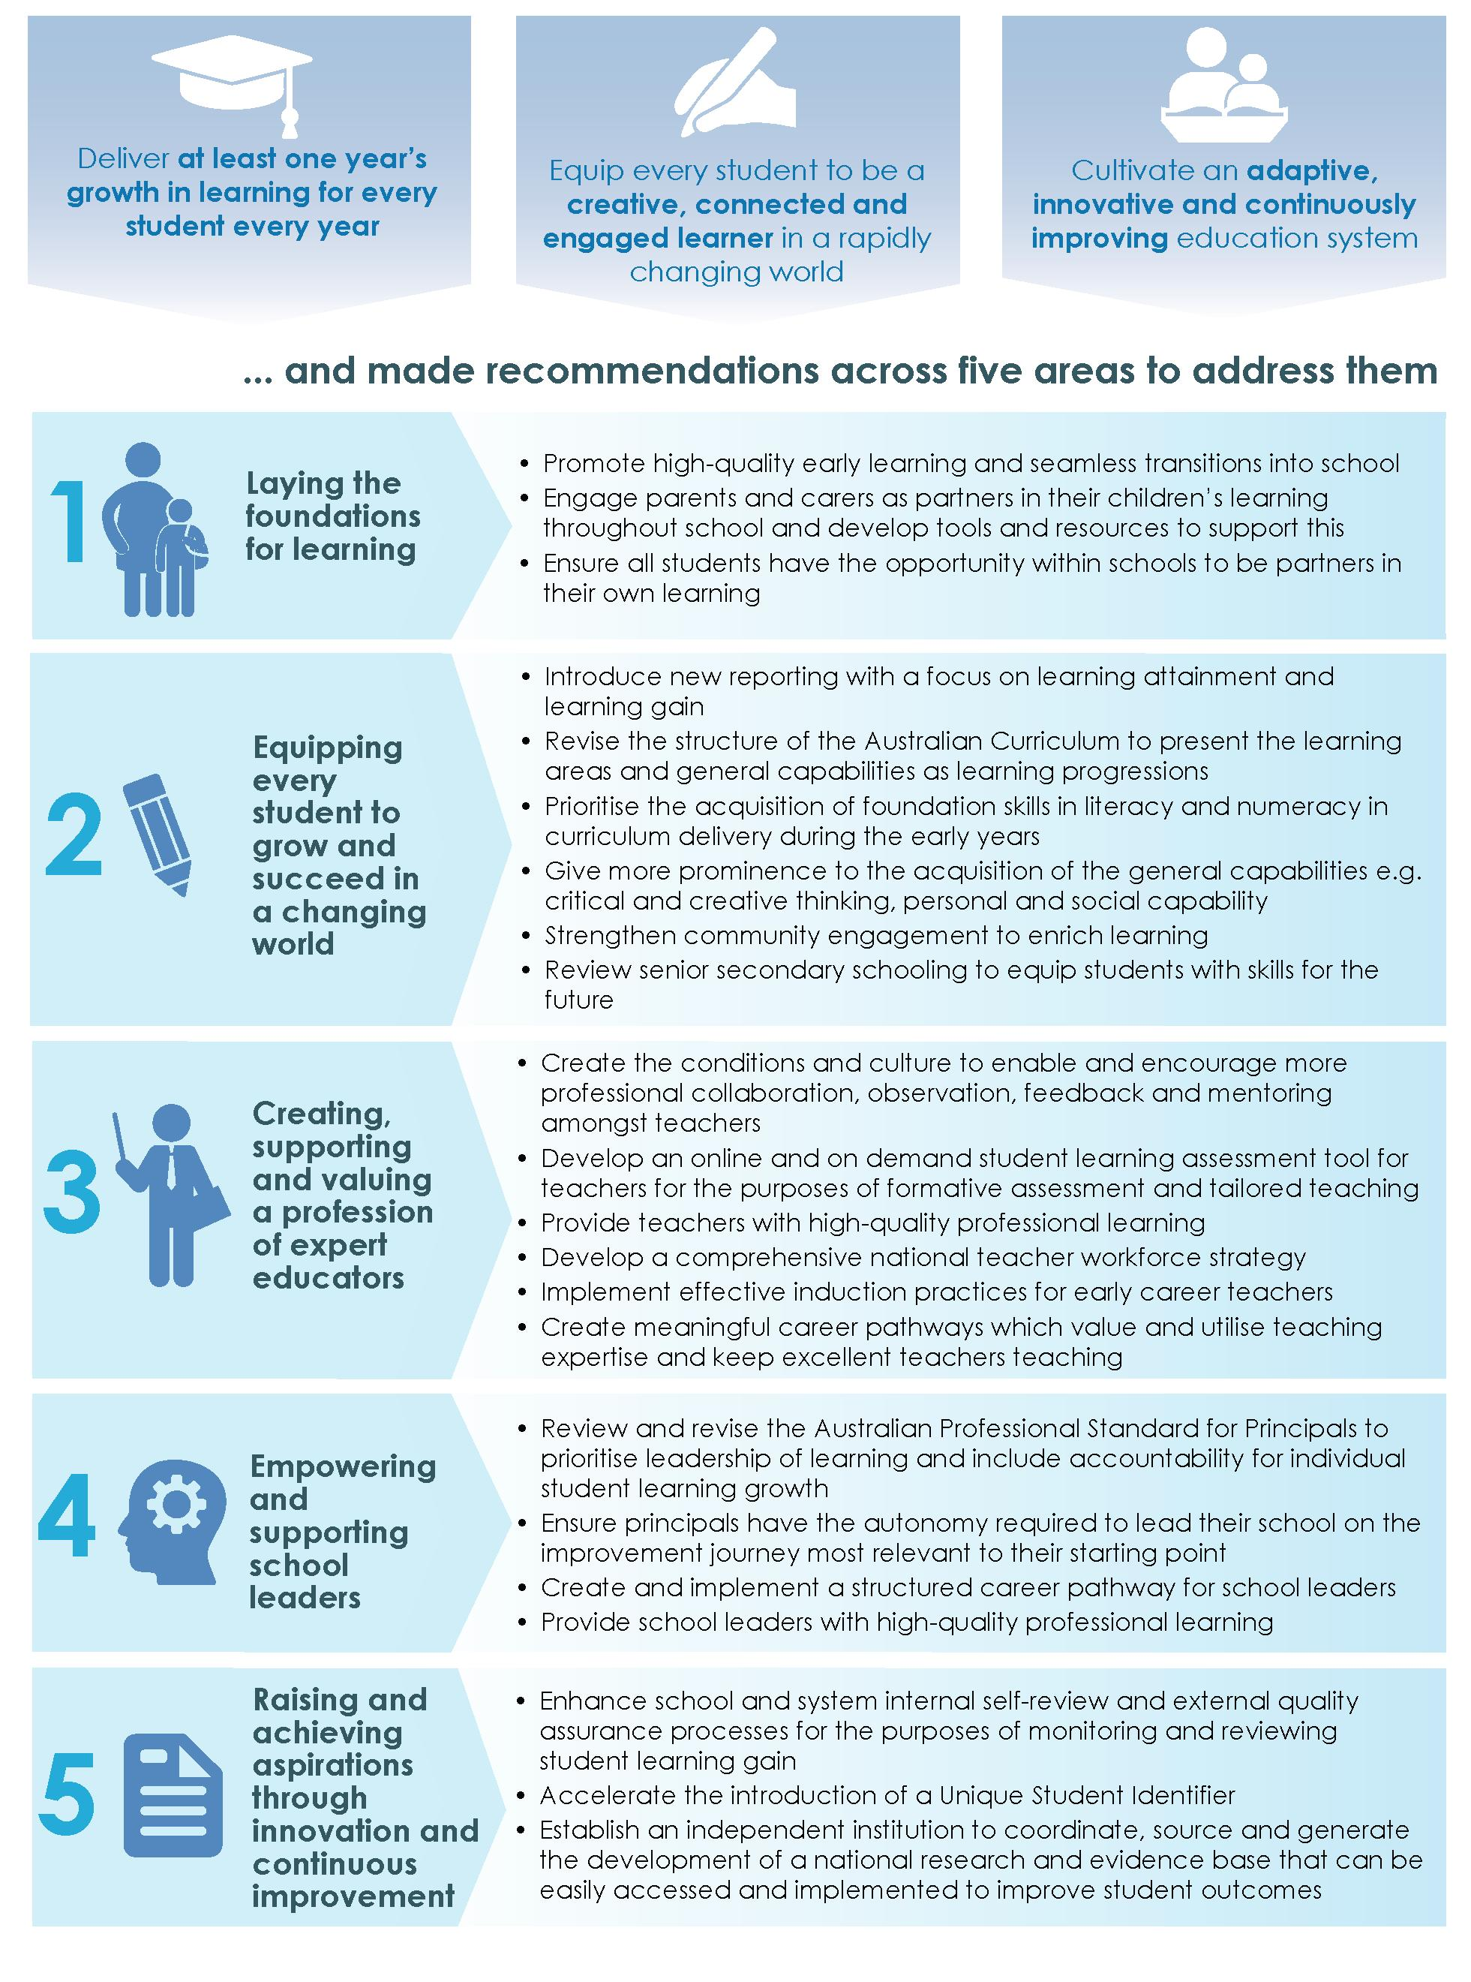

Recommendations

Recommendation 1
Embed a focus on individual student achievement through continuous learning progress in the policies and practices of all schools and systems, with the expectation that each student should achieve at least one year's growth throughout each year of schooling.
Recommendation 2
Develop and disseminate evidence-based tools and resources to assist early childhood education providers, primary, and secondary schools to implement best practice approaches to supporting parents and carers to engage in their children's learning throughout their education.
Recommendation 3
Ensure all students have the opportunity within schools to be partners in their own learning.
Recommendation 4
Introduce new reporting arrangements with a focus on both learning attainment and learning gain, to provide meaningful information to students and their parents and carers about individual achievement and learning growth.
Recommendation 5
Revise the structure of the Australian Curriculum progressively over the next five years to present the learning areas and general capabilities as learning progressions.
Recommendation 6
Prioritise the implementation of learning progressions for literacy and numeracy in curriculum delivery during the early years of schooling to ensure the core foundations for learning are developed by all children by the age of eight.
Recommendation 7
Strengthen the development of the general capabilities, and raise their status within curriculum delivery, by using learning progressions to support clear and structured approaches to their teaching, assessment, reporting and integration with learning areas.
Recommendation 8
Strengthen school-community engagement to enrich student learning through the establishment of mechanisms to facilitate quality partnerships, including engagement in mentoring, volunteering and extra-curricular activities, between schools, employers, members of the community, community organisations and tertiary institutions.
Recommendation 9
Establish a comprehensive, national and independent inquiry to investigate and review the objectives, curriculum, assessment provisions and delivery structures for senior secondary schooling, to report within 12 months.
Recommendation 10
Accelerate the development of contemporary pedagogy through the use of collaboration, mentoring, observation and feedback, including from colleagues and students, by incorporating these practices into the core role of teachers and creating the conditions to enable teachers to engage in them.
Recommendation 11
Develop a new online and on demand student learning assessment tool based on the Australian Curriculum learning progressions.

Recommendation 12
Create the conditions necessary to enable teachers to effectively engage and benefit from professional learning in the use of the Australian Curriculum learning progressions, the new online formative assessment tool and tailored teaching practices to maximise student learning growth.
Recommendation 13
Create a continuously improving profession through the provision of high-quality professional learning for teachers; appropriate to their career stage, development needs and the changes rapidly occurring in society.
Recommendation 14
Develop a comprehensive national teacher workforce strategy to better match supply with workforce demands, including skill and capability requirements.
Recommendation 15
Create the conditions to enable teachers to engage in effective induction practices aligned with the nationally endorsed Graduate to Proficient: Australian guidelines for teacher induction and monitor and evaluate the effectiveness of the practices implemented by schools.
Recommendation 16
Create and provide opportunities for implementation of structured career pathways for teachers with clearly defined roles and development streams that allow for accelerated progression and provide the opportunity for remuneration, recognition and allocation of responsibilities based on expertise.
Recommendation 17
Review and revise the Australian Professional Standard for Principals to prioritise leadership of learning and make maximising the learning growth of every student every year the key focus.
Recommendation 18
Ensure principals have the professional autonomy and accountability required to lead their school on the improvement journey most relevant to their starting point.
Recommendation 19
Create and provide opportunities to implement a structured career pathway for school leaders which articulates clearly defined roles and development streams for middle leaders through to experienced principals and provides the opportunity for remuneration, recognition and allocation of responsibilities appropriate to the role.
Recommendation 20
Provide school leaders with access to a variety of professional learning opportunities appropriate to their career stage and development needs and recognise and harness the skills and experience of high-performing principals by enabling them to share their expertise across schools and throughout the system.
Recommendation 21
Enhance school and system internal self-review and external quality assurance processes, for the purposes of monitoring and reviewing student learning gain and achievement.
Recommendation 22
Accelerate the introduction of a national Unique Student Identifier for all students to be used throughout schooling.
Recommendation 23
Establish an independent institution to coordinate the strategic development of a national research and evidence base through the sourcing and generating of research, and the synthesising and promotion of educational evidence that can be easily accessed and implemented to improve student outcomes.

Findings

Finding 1
Achieving educational excellence in Australian schools will require a focus on achievement through learning growth for all students, complemented by policies which support an adaptive, innovative and continuously improving education system.
Finding 2
Early childhood education makes a significant contribution to school outcomes. The transition between preschool and school education should be seamless. Ongoing reforms that lay the foundations in the early years for future learning, and close the learning differential between advantaged and disadvantaged students, are essential to ensure all children have the best start in life.
Finding 3
There is strong and developing evidence of the benefit of parent engagement on children's learning. This will be further enhanced through the work currently underway to develop an evidence-informed definition of parent engagement, which will allow for a core set of agreed measures aligned to the definition to be established and used to drive improvements in policies and practice.
Finding 4
Teaching curriculum based on year or age levels rather than levels of progress leaves some students behind and fails to extend others, limiting the opportunity to maximise learning growth for all students.
Finding 5
Reporting against year-level achievement standards hides both progress and attainment for some students and does not amount to a diagnostic assessment of real learning needs which—if met—would lead to growth in learning.
Finding 6
Fit for purpose school-community engagement undertaken to respond to identified student needs is an effective way to improve the relevance of learning, and to support personal development and student learning growth. School-industry collaboration, mentoring, volunteering and extra-curricular activities are effective forms of engagement to help achieve this.
Finding 7
There is compelling evidence, in Australian schools and internationally, that tailored teaching based on ongoing formative assessment and feedback are the key to enabling students to progress to higher levels of achievement.
Finding 8
Research and experience internationally confirms that ongoing professional development for teachers—some mandated by the school or system, and some through participation in professional learning communities—is an essential part of a teacher's workload in high-performing education systems.
Finding 9
To continue to grow student outcomes, we need to attract and retain the best and most effective teachers in the profession. Teaching must become a high-status profession of expert educators.
Finding 10
There has been significant national progress made towards achievement of the Teacher Education Ministerial Advisory Group reforms to improve the quality of Australian initial teacher education. It will be important, however, to maintain an unrelenting focus on the rigour of their implementation to achieve the goal of raising the quality of our initial teacher preparation and improving the classroom readiness of graduate teachers.

Finding 11
Implementation of effective induction practices and appropriate conditions are critical to support the transition from initial teacher education into the profession for early career teachers, and play an important role in promoting retention and professional growth.
Finding 12
Certification at the Highly Accomplished and Lead levels of the Australian Professional Standards for Teachers recognises and promotes the development of collaborative learning professionals who strive to continually reflect upon and improve their practice and that of their colleagues. Such acknowledgement can play a key role in keeping excellent teachers working with students and helping to improve colleagues' pedagogical practices.
Finding 13
Aspiring school principals require clear pathways leading to the role, and comprehensive training and preparation to a quality standard before their appointment.
Finding 14
To have an impact, strategies for school leadership development need to be aligned to the nationally endorsed Australian guidelines for school leadership development with implementation approaches monitored and evaluated for their effectiveness.
Finding 15
School leaders are called upon to play a variety of roles, including leaders of learning, business administrators, and culture setters. Participation in ongoing quality professional learning is essential to help school leaders to continue to develop across each of these dimensions, with a particular focus on their role as leaders of learning.
Finding 16
As Australian schools transition to diagnostic assessment and differentiated teaching within the framework of learning progressions, there will be increasing opportunities for, and benefits to be gained from, external quality review processes at school and system level. Continuous improvement in Australian education will be supported by the variety of quality assurance processes increasingly utilised by Australian school systems and schools.
Finding 17
To sustain continuous improvement, Australian schools need access to: valid and reliable evidence of effective teaching practice; independent and rigorous evaluations of commercial and other teaching and educational interventions; and the most recent findings on educational innovation and research—in an accessible format that can be readily translated into classroom use.

Introduction


Improving education outcomes is critical to future economic and social opportunity
Australia can and should aspire to provide every school student with a world-leading education. This is an ambitious but achievable goal, given Australia's prosperity and our educational heritage. It is also a critical goal as work becomes more highly skilled, and education increasingly determines lifetime opportunity.
Australia has a fine educational heritage, but its academic performance has declined since 2000 as measured by the Organisation for Economic Co-operation and Development's (OECD) Programme for International Student Assessment (PISA) test (see Exhibit 1). In 2000, only a few countries materially ranked higher; in 2015 Australia's ranking dropped to the middle of the pack. Moreover, Australian student achievement has stagnated in the last decade, measured by the National Assessment Program - Literacy and Numeracy (NAPLAN), and has declined relative to its past performance in PISA.
Academic achievement is only one dimension of education and not the sole measure of success. Proficiency across the curriculum, however, and especially in areas such as literacy and numeracy, which PISA and NAPLAN assess, matters deeply to economic and social opportunity. That is why turning around the slippage in student outcomes, and regaining Australia's standing as a world-leader in schooling, must be a priority for Australia and all its educators.

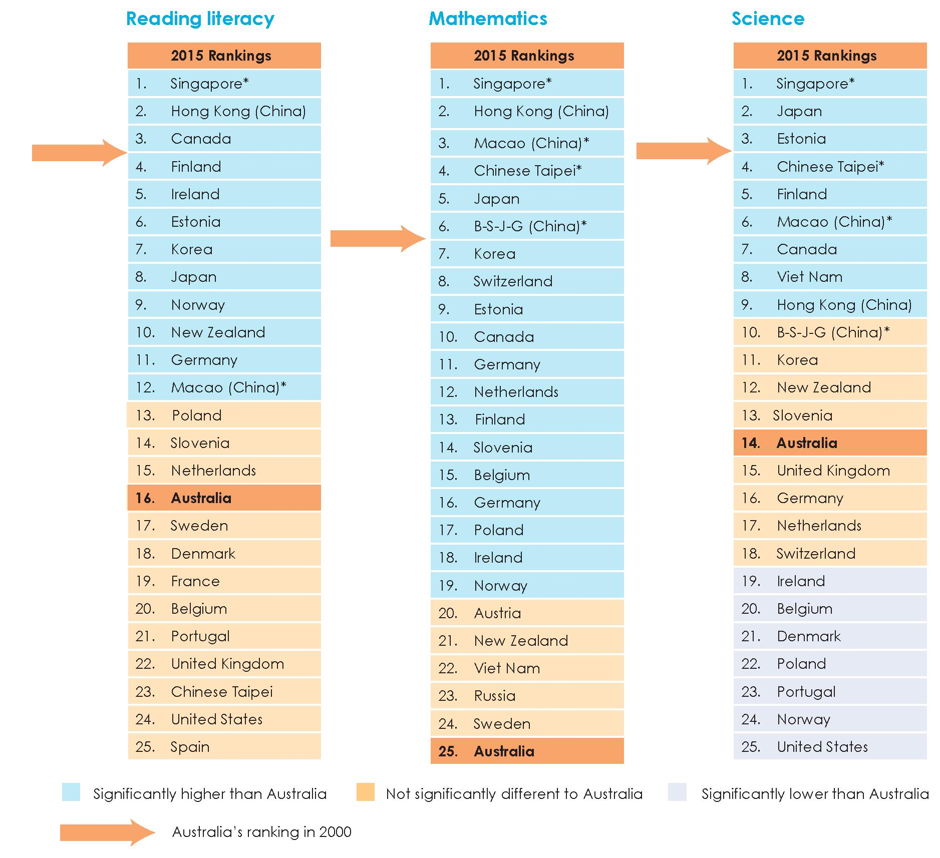
Exhibit 1. Australia's international ranking has noticeably dropped since 2000
Source: Derived from Organisation for Economic Co-operation and Development (OECD), PISA 2000 database; and OECD, PISA 2015 database.
Notes: The exhibit compares PISA rankings for the years 2000 and 2015.
* Singapore and Chinese provinces (other than Hong Kong) did not participate in the 2000 study. B-S-J-G refers collectively to the Chinese provinces Beijing, Shanghai, Jiangsu and Guangdong. In 2015, 72 countries and economies took part in PISA; in 2000, 32 countries and economies took part in PISA.
Education is critical to Australia's standard of living. While our resource-rich economy has achieved 26 years of continuous economic growth, in the future our economy will need to draw on broader sources of wealth, including knowledge-based industries.
Australian jobs and industries will be reshaped by revolutionary technologies, such as artificial intelligence and automation. These technologies will decrease the need for lower-skill, routine work, and increase the importance of problem-solving, collaboration and interpersonal skills. This will make work safer, smarter and more stimulating, and require

more highly-skilled workers. We need a world-leading school education to equip Australian students to take advantage of these opportunities.
Providing a world-leading education for every student is also important to ensure that Australia is a fair and equitable society. Australia has a diverse population and our schools accommodate a wide variety of students. The Review Panel heard from a range of stakeholders that there are common fundamentals needed to support all students—those in capital cities in all states and territories, those in rural or remote locations, students with disability, Aboriginal and Torres Strait Islander students, students from non-English speaking backgrounds, students from low socio-economic backgrounds, gifted and talented students, academically advanced or less-advanced students, or any combination of these.

In my experience the key to engaging students and improving their outcomes is high expectations relationships in which teaching is personalised to students' needs. This means matching professional rhetoric with professional actions so that children can meet the high expectations set and teachers can cater to individual students' needs, instead of teaching to the middle. Educators must remember that Aboriginal and Torres Strait Islander students in our schools are as hungry to learn as any other learner.
Professor Chris Sarra, University of Canberra, Co-Chair, Prime Minister's Indigenous Advisory
Council

Since most students with disability are educated in regular classes, all teachers need skills in differentiating instruction, providing adjustments, and monitoring student progress.
Australian Association of Special Education – Submission

Students start school with very significant variations in their knowledge, skills and capabilities. Our current model of school education is focused on each student achieving a minimum standard in learning outcomes based on year and age-levels and is poorly equipped to respond to different initial levels of student achievement. This can lead to less advanced students falling further behind others, with the progress they make being largely unrecognised, and more advanced students not being stretched to reach their full potential, and at risk of becoming complacent if the good progress for which they are praised is actually well below their real learning capacity.
Aspiring to achieve excellence in learning outcomes for every student, and to regain Australia's position as a world-leading system, it is crucial to maximise each student's learning growth each year, rather than simply supporting each student to attain the minimum proficiency for the year level.
The Review Panel acknowledges the significant work already being undertaken by Commonwealth, state and territory governments to address declining results, and the school leaders and teachers who work tirelessly for the students and communities they serve. Many important improvements have already been made, and other reviews are identifying further vital reforms and improvement opportunities.
The Review of Funding for Schooling in 2011 recommended a national commitment to address educational disadvantage which is now leading to the phased implementation of a needs-based funding model to ensure adequate financial resources for all schools.

Seven years on, we need a similar national commitment to address the performance slippage that is affecting every Australian student cohort. We need to reset our expectations: from helping each student reach a minimum standard, to helping every student achieve at least one year's growth in learning for every year of schooling. We need to invest our resources in the interventions that will enable students to achieve concrete gains across school systems and sectors—government, Catholic and Independent—in all levels of student capability, and in all geographies. We need to harness the support and efforts of people across school systems and schools—from school principals to teachers, parents and carers, and the broader community—given the national importance of the need to improve.
This is a long-term project, however if we stay the course, with strong, sustained bipartisan support, we will look back in a decade to a transformed school education system. We will have a system designed to ensure that all Australian students reach their full learning potential in each year of schooling, rather than meet—or fail to meet—a minimum proficiency standard. We will have a school system that enables high-achieving students to excel and ensures all students make the maximum progress of which they are capable. We will see an increase in Australian student achievement compared with global peers, and consequently an increase in the life opportunity of each Australian. In an era where education determines opportunity, we cannot let these chances pass.
A fine educational heritage, but declining performance
Education needs to prepare students across a range of dimensions. Students must master the basic building blocks of knowledge, skill, and understanding, most notably in literacy and numeracy, and acquire the personal and social capability to succeed in an increasingly connected and complex world and workplace. Students need to develop a growth mindset and a passion for learning and be inspired to aim high and pursue bold goals. The most effective way to inculcate this is by school systems and schools placing the learning growth of each student at the centre of their education model. By doing this, education can better enrich every element of a student's life and future career.
This section focuses on academic performance, as data on learning outcomes in areas outside core academic areas are currently limited.
The dramatic decline in Australian student results over the last decade and a half belies Australia's fine educational heritage. Results on OECD PISA tests for 15-year-old Australians went backwards between 2003 and 2015 in absolute terms (see Exhibit 2). The whole distribution has slipped to lower levels, most significantly in mathematics.
The importance of this point can hardly be overstated. In 2015, Australian 15-year-olds as a group scored significantly lower than 15-year-olds in 2003 on an equivalent test.

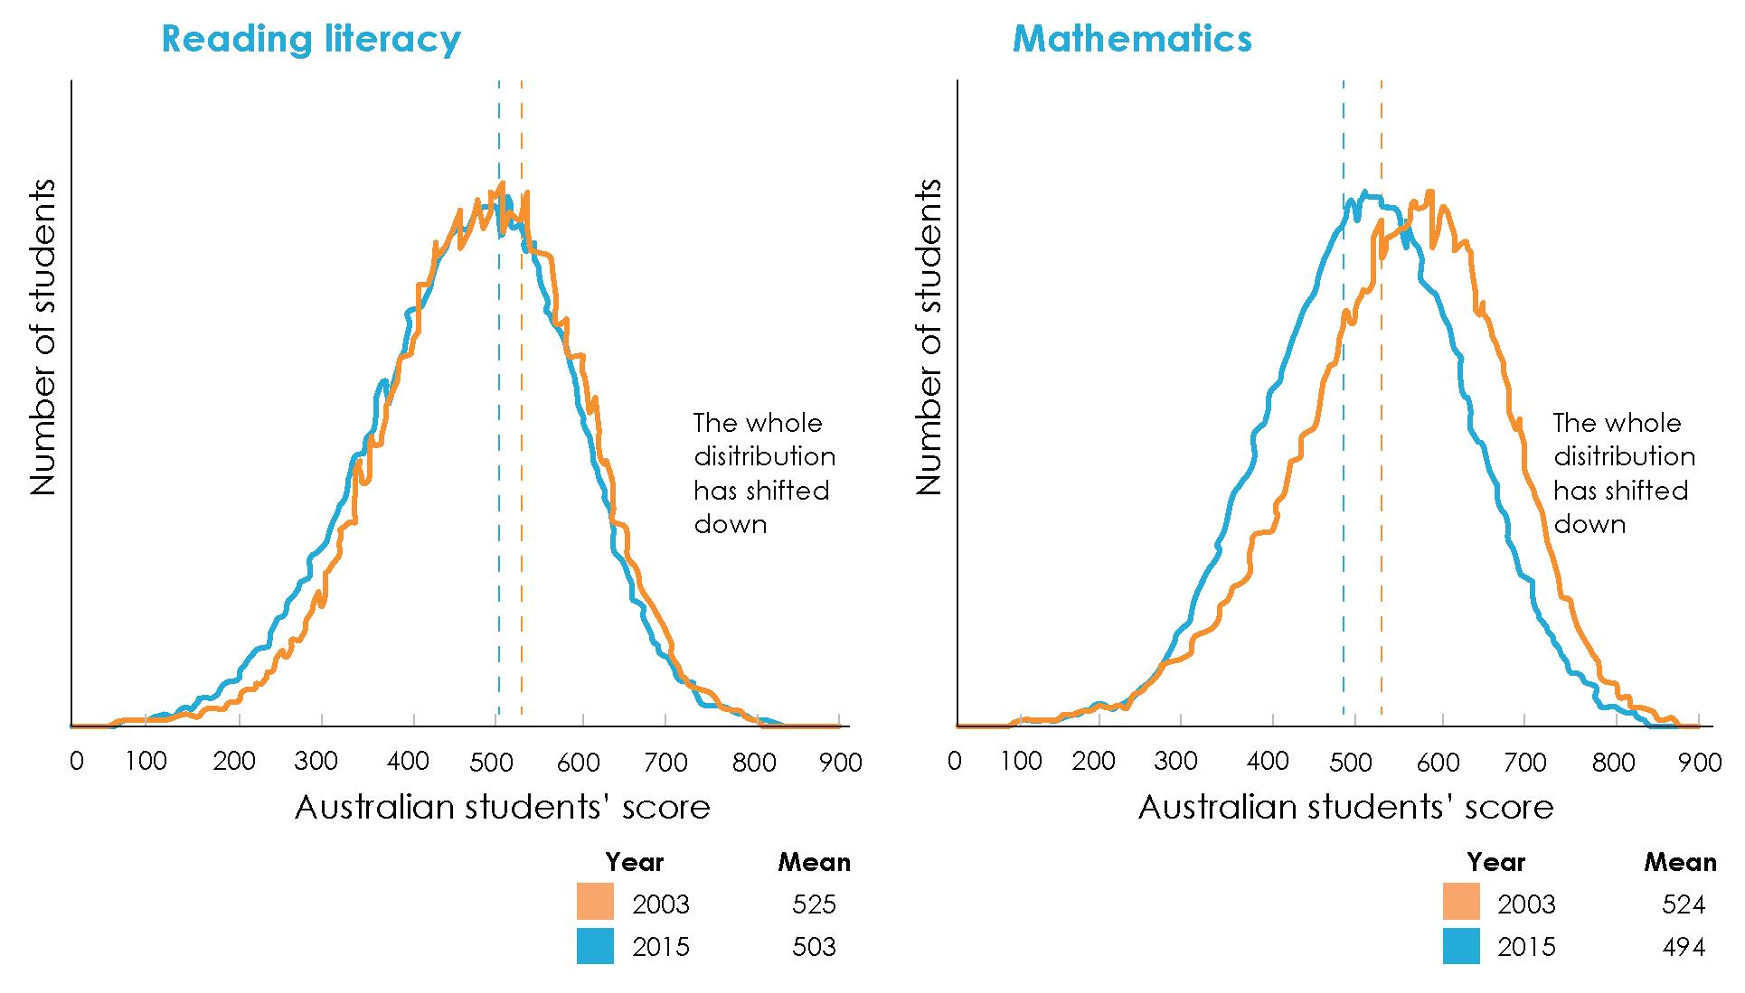
Exhibit 2. Australia's performance has declined in absolute terms between 2003 and 2015
Source: Derived from Australian Council for Educational Research (ACER), National PISA data 2003; and ACER, National PISA data 2015.
Note: The exhibit compares the frequency of students' scores for Australian students participating in PISA for reading literacy and mathematics in the year 2003 and 2015.
One driver of this decline is variations in early childhood learning that result in very different starting points of children entering school. Unless these learning gaps are addressed early they increase over the course of a student's schooling. The gap between students from an advantaged background and those from a disadvantaged background grow from 10 months in Year 3 to around two-and-a-half years by Year 9. While shifting to needs-based funding is levelling the playing field on which schools operate, the choices made about the way funding is used are also critically important to lifting outcomes.
In the last five years, attention has focused on the unacceptably large group of Australian children who are not attaining proficiency in key learning areas. Socio-economic and other disadvantage factors are not the only cause. The decline in Australian student performance is broad-based, occurring across all socio-economic groups, and declines are somewhat larger in higher socio-economic quartiles. Exhibit 3 shows there has been a decline in the proportion of students in the top levels of PISA since 2003 and an increase in the proportion of students in the lower levels, across every socio-economic quartile, indicating declines are a much broader issue than socio-economic inequality.

Exhibit 3. There has been a decline in Australia's performance in mathematics across all socio-economic quartiles between 2003 and 2015

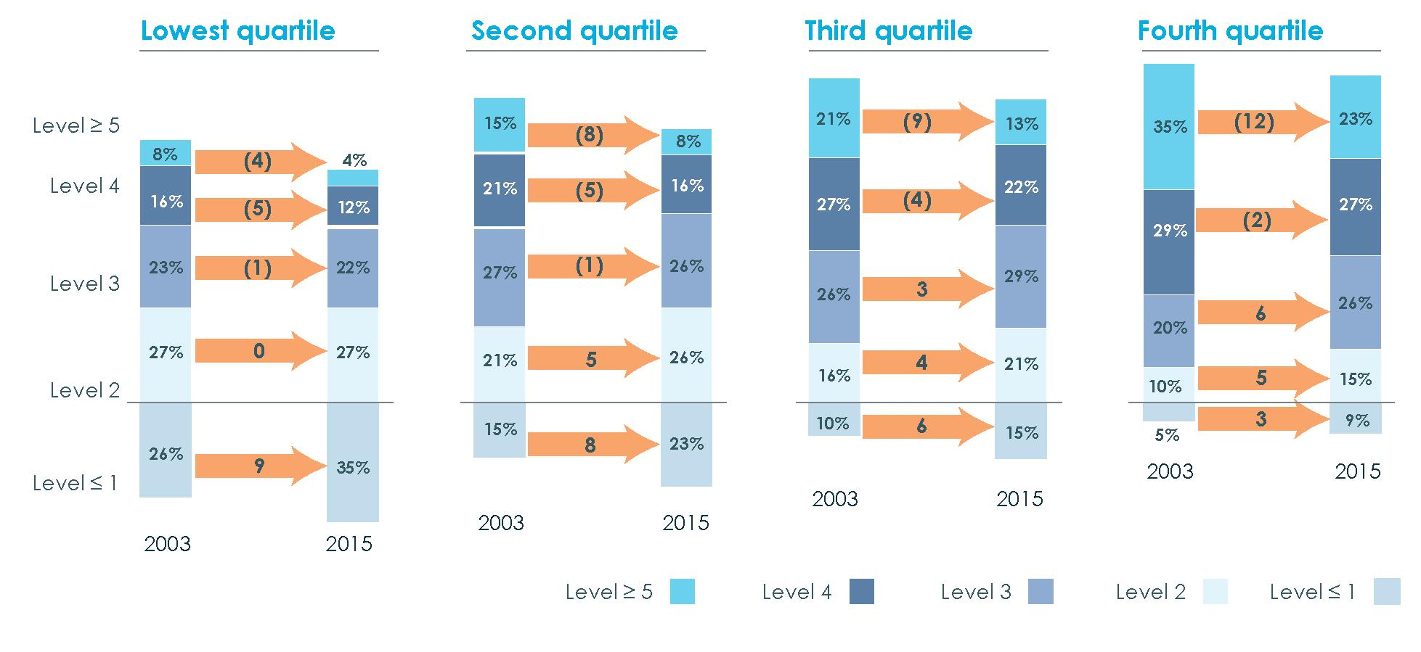

Source:
Derived from ACER, National PISA data 2003; and ACER, National PISA data 2015.

Note: This exhibit uses mathematics performance results from the percentage of 15-year-old Australian
students who participated in PISA testing in 2003 and 2015.
The measure of socio-economic background is based on the index of Economic, Social and Cultural Status (ESCS). While an ESCS index was included in all past PISA databases, the components of ESCS and the scaling model have changed over cycles, meaning that the ESCS scores are not directly comparable across cycles. An ESCS-trend variable index has been computed using similar methodology for the current cycle and for previous cycles in order to enable a trend study. Numbers may not equal 100 per cent for each quartile due to rounding.
Declines in student performance are also evident across all school sectors, including government, Catholic and Independent schools. Exhibit 4 shows that since 2003 there have been declines in the proportion of students in the higher achieving PISA levels, with increases in the proportion of students in lower achieving PISA levels. This indicates that there has been a significant decline in student performance across all schooling sectors since 2003.

Exhibit 4. There has been a decline in Australia s performance in mathematics across all school sectors between 2003 and 2015
Change in Australian children's poficiency distribution - mathematics, between 2003 and 2015, by sector.

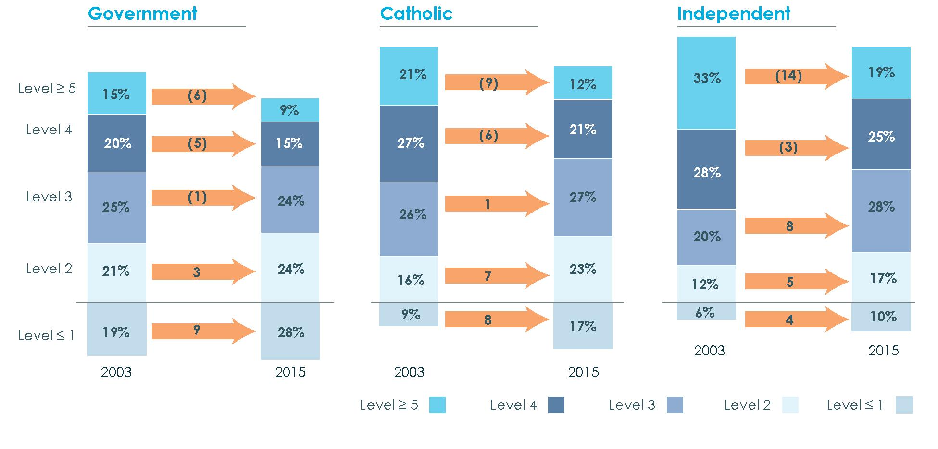

Source:
Derived from ACER, National PISA data 2003; and ACER, National PISA data 2015.

Note: This exhibit uses mathematics performance results from the percentage of 15-year-old Australian students who participated in PISA testing in 2003 and 2015.
The slippage is national and widespread. Its extent indicates that Australian education has failed a generation of Australian school children by not enabling them to reach their full learning potential. Dealing with this situation requires a significant shift in aspirations, approach, and practice, to focus on and accelerate individual learning growth for all students, whether they are lower performers, middle ranking or academically advanced.

As for all other students, academically advanced/gifted students need to be given access to those educational provisions that address their specific needs.
Dr Jae Yup Jung – Submission

Australia's achievement distribution sits well below leading systems. In 2011, the top 10 per cent of Australian students in mathematics performed at about the same level as the top 50 per cent of students in Singapore, Korea and Chinese Taipei. There is also a significant achievement gap between Australia and top performing education systems, such as Singapore. Exhibit 5 presents the comparative distribution for Singapore and Australia in 2015, demonstrating that Singapore's education now yields substantially higher outcomes than Australia.

Exhibit 5. In 2015, there was a significant achievement gap between Australia and the highest performing country in both reading literacy and mathematics

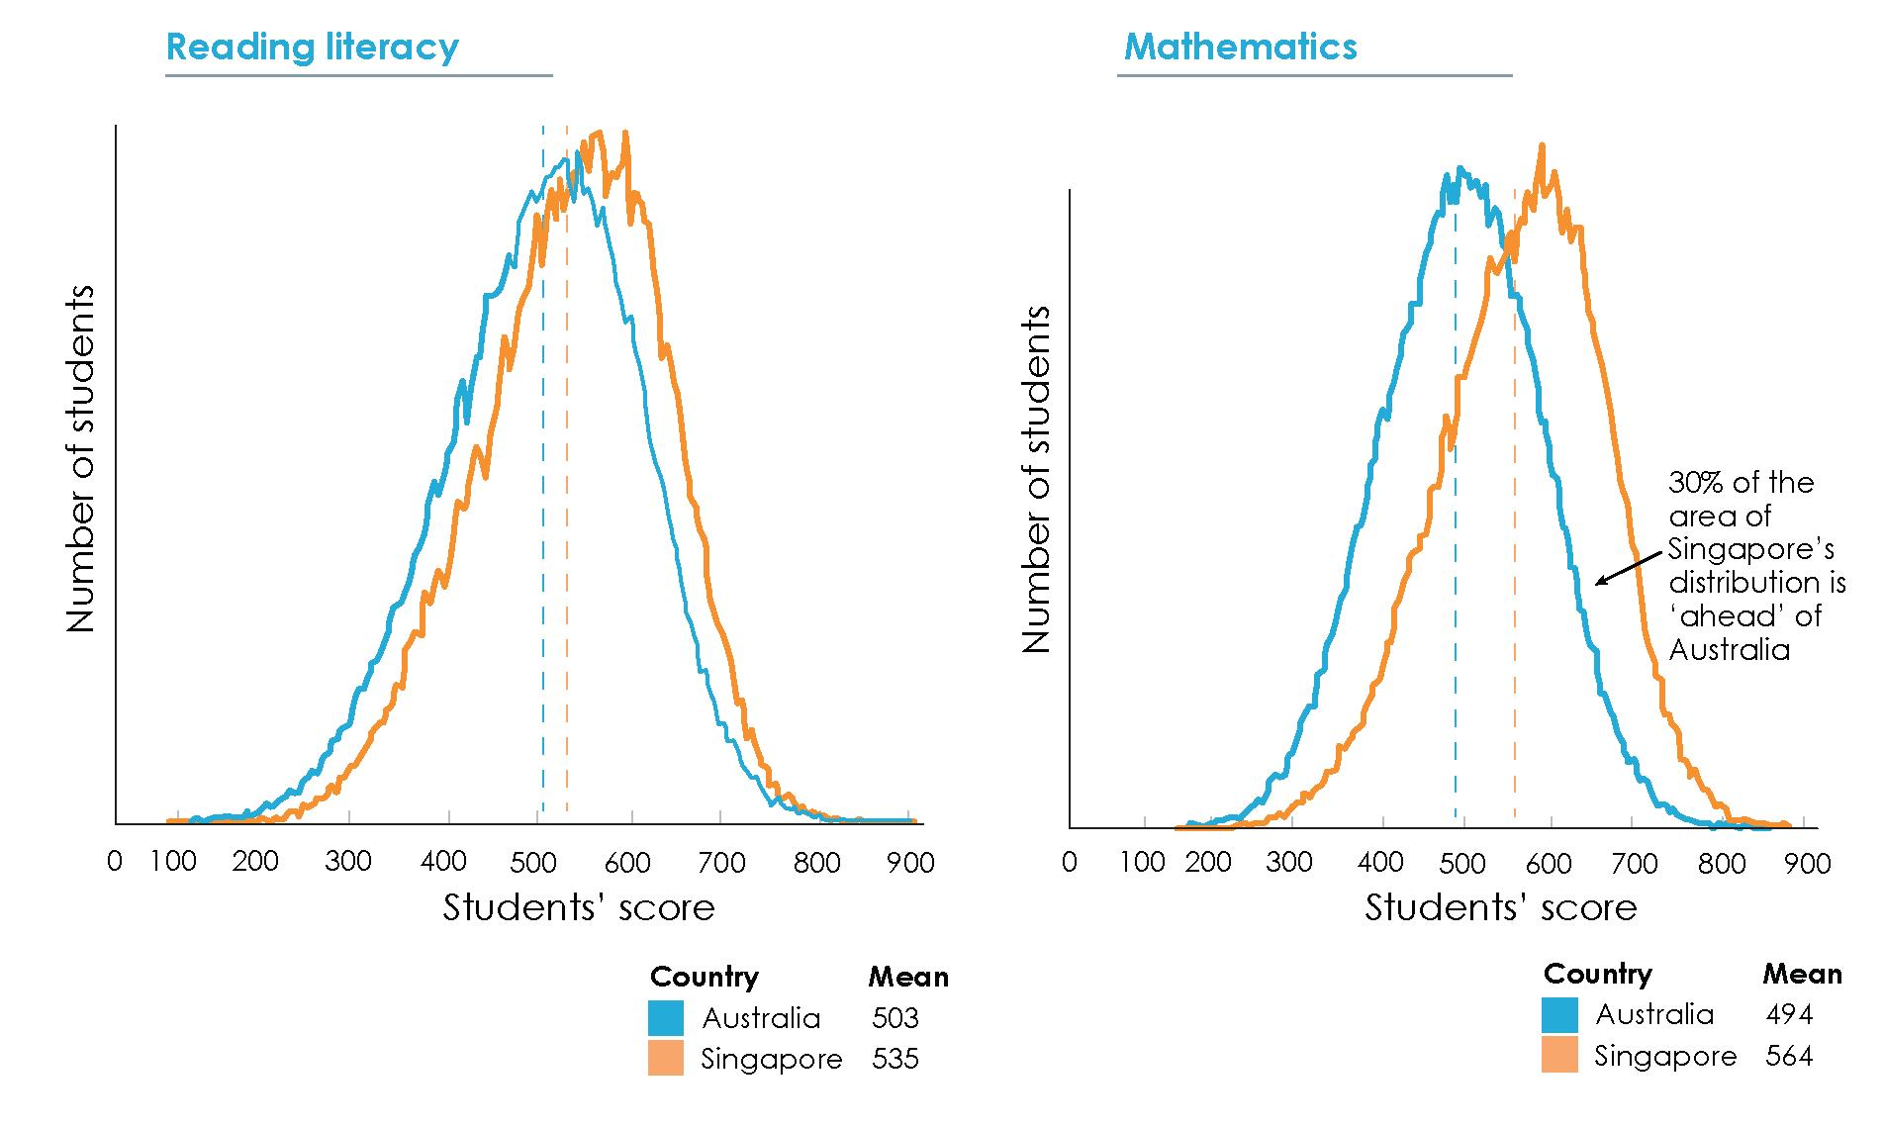

Source:
Derived from OECD, PISA 2015 database.

Note: The exhibit compares the frequency of students' scores for Australian and Singaporean students
participating in PISA for reading literacy and mathematics in the year 2015.
While this gap might suggest improvements are possible, the relative trends in performance between Australia and leading jurisdictions are of great concern. In the OECD PISA tests, Singaporean students have consistently achieved means around 540/560 for literacy/mathematics respectively since 2009, when they were first included in PISA. In contrast, Australia has been on a steady slide from means of 525/524 for literacy/mathematics in 2003 to means of 503/494 in 2015.
The example of Singapore is indicative of a widening achievement divide between Australian students and their highest-performing overseas peers. The gap between Australian students and the top five systems has doubled for mathematics and science over the last decade. Meanwhile, Australian students' lead over the OECD average has shrunk by 80 per cent in mathematics, 40 per cent in science and 50 per cent in reading (see Exhibit 6).

Exhibit 6. Australia is lagging behind the world's top performers and falling towards the OECD average

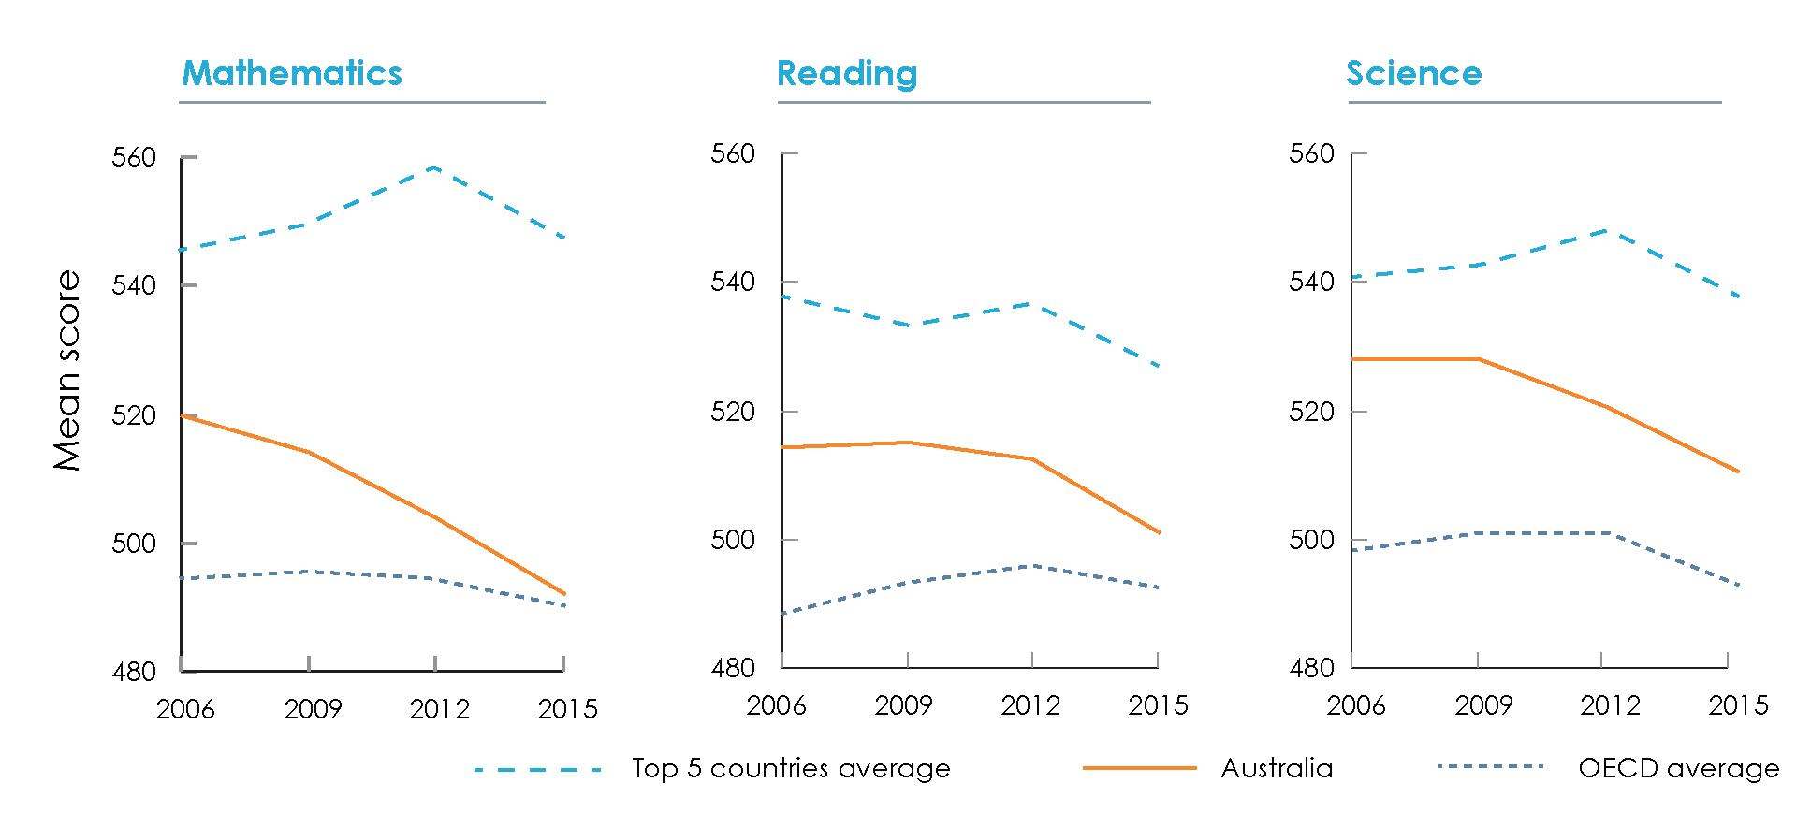

Source:
Derived from OECD, PISA database 2006-2015.

Note: The top five countries average uses the scores of the top 5 performing countries participating in PISA for each subject in each PISA year.
Many Australian schools are cruising, not improving
Stagnating student results are also a result of 'cruising' Australian schools: schools that maintain average achievement from year to year, but do not improve. As Exhibit 7 shows, this is a significant issue, with approximately 30 per cent of primary schools 'cruising' from year to year rather than improving results between years at the same rate as similar schools. Cruising schools achieve outcomes above minimum standards, but deliver lower rates of learning growth than comparable schools where students have similar backgrounds in terms of parental occupation and education.

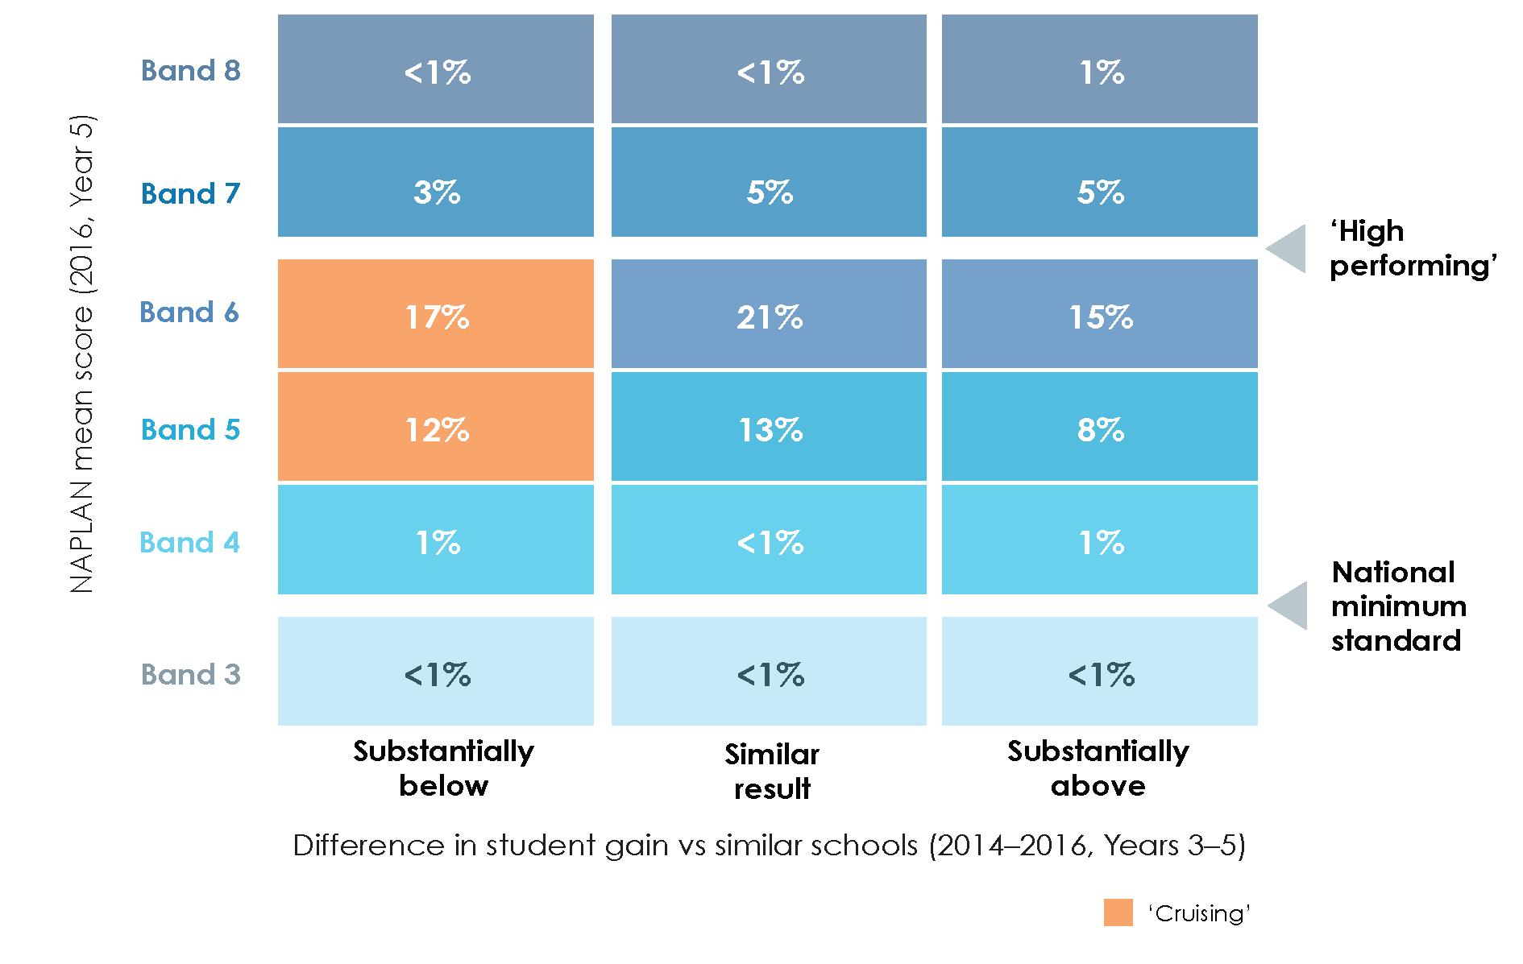
Exhibit 7. Around 30 per cent of primary schools are 'cruising'
Source: NAPLAN student gain results 2008-2016. Developed by the Review to Achieve Educational Excellence in Australian Schools in collaboration with ACARA.
Note: Student gain is the absolute NAPLAN points difference between Year 5 and Year 3 results for primary schools. 'Similar result' is when the difference in student gain vs similar schools is within the margin of error for the similar school scores; 'substantially above/substantially below' is when the difference versus similar schools is outside the margins of error. Exhibit based on the analysis of primary schools' numeracy NAPLAN student gain results.
There is no reason why schools should not keep improving each year, even from a good base. A sample of 50 schools with similar Index of Community Socio-Educational Advantage profiles and NAPLAN results in Year 3 showed that some schools added close to double the amount of learning growth for their students by Year 5. If this can be achieved by some schools, it should be possible for others. The explanation might be that Australian teachers, schools systems and schools are not equipped to identify and effectively support cruising students and schools to improve. International testing has shown that Australia's strongest students are not being stretched to achieve in the top levels of proficiency in mathematics, reading and science. The Trends in International Mathematics and Science Study (TIMSS) identified that more than 25 per cent of Year 8 science teachers and 20 per cent of Year 8 mathematics teachers rated their confidence as low or medium in providing challenging tasks for the highest achieving students. At a systems level, interventions are most frequently targeted at helping poor performing schools, meaning 'cruising' schools might not be identified for intervention, and systems might not have the range of interventions to apply to a cruising school situation.

An emphasis on the goal of student growth ensures that all students reach their full learning potential, regardless of the starting point and pace of learning compared to others. It extends academically advanced students to the limits of their potential regardless of age or year level. It ensures that the potential of initially less advanced students is revealed and built upon, so that they make steady progress towards academic achievement levels as high as those of any other student with similar innate capacities.
Recommendation 1
Embed a focus on individual student achievement through continuous learning progress in the policies and practices of all schools and systems, with the expectation that each student should achieve at least one year's growth throughout each year of schooling.
Overview of the strategy to achieve educational excellence
International research shows that great school systems keep improving by changing the mix of interventions they employ at different stages of their improvement journey. They set high expectations for students, and do not accept that there are natural plateaus to improvement at a school or system level. Instead, they encourage every student and school to grow and improve regardless of the starting points.
Setting high aspirations is imperative to regain Australia's position as a world-leading system and to maximise learning growth for each student in order to attain the highest levels of which each is capable. The Review Panel has identified three priorities that are crucial to realising this vision:
- deliver at least one year's growth in learning for every student every year
- equip every student to be a creative, connected and engaged learner in a rapidly changing world
- cultivate an adaptive, innovative and continuously improving education system.
To support the three priorities for achieving educational excellence identified by the Review Panel, the report makes recommendations across five focus areas for improvement, detailed in the following chapters of the report:
1. Laying the foundations for learning
Australia needs to create the pre-conditions for excellence in school education by increasing access to high-quality early learning, and engaging parents, carers and students as partners in learning from a child's early years. This will narrow the variation in student achievement levels when starting school and help to close the differential in achievement levels within schools.
2. Equipping every student to grow and succeed in a changing world
Australia can improve student achievement by maximising individual learning growth. To enable this, the Australian Curriculum must be presented in a way that allows teachers to tailor it to different learning needs.
Throughout schooling, students need to be equipped with an education fit for the future. To ensure a relevant balance of skills and knowledge, education should prioritise the

acquisition of foundational skills in literacy and numeracy in the early years and the general capabilities throughout schooling. Senior secondary schooling should be reviewed to ensure it equips all students for the future. Learning should be enriched through improved community engagement.
3. Creating, supporting and valuing a profession of expert educators
Quality teaching is the key to accelerating student learning growth and helping all students reach their full potential. A high-quality teaching profession is essential. Australia can elevate the teaching profession by seeking the right candidates for admission to the profession, giving them appropriate professional learning opportunities, assisting them to be inducted into their jobs effectively, providing access to quality tools and support to focus on growth and tailored teaching, giving them continuing professional learning opportunities and time to engage in team-based collaborative teaching practices, and by providing meaningful career paths which value and utilise teaching expertise and keep excellent teachers teaching.
4. Empowering and supporting school leaders
School leaders need to be instrumental in raising individual achievement through continuous learning growth. They need the mandate to make achieving educational excellence their primary focus, and support to develop their expertise as leaders of learning. For principals to maximise their contribution to school and system improvement, they need to be empowered as instructional leaders, and supported to develop at each stage of their career.
5. Raising and achieving ambitions through innovation and continuous improvement
The best education systems encourage innovation and improvement in schools over the long term. Increasing Australia's ability to do this rigorously and at scale will help schools across the country improve. The critical actions required to facilitate the shift to a continuously improving school education model include having high expectations for students and schools; driving ongoing change and reforms through innovation and continuous improvement; ensuring high-quality evaluation and quality assurance; introducing a Unique Student Identifier; and establishing a national research and evidence institute which drives better practice and innovation.
Finding 1
Achieving educational excellence in Australian schools will require a focus on achievement through learning growth for all students, complemented by policies which support an adaptive, innovative and continuously improving education system.
Acting on the Review's recommendations
The Review's recommendations will inform the development of a new national schooling agreement between the Commonwealth and states and territories. The schooling agreement is a crucial foundation of school education, as it sets national aspirations, common goals and commitments to action across Commonwealth, state and territory governments.
Under the federated model, national education policy is decided by all governments working together through the Council of Australian Governments. Funding responsibility is shared by the states and territories and the Commonwealth.

The recommendations of this Review have been framed within this context. They reflect actions that can be commenced and/or implemented within the timeframe of the national schooling agreement. They are conceived for action throughout Australia and the Review Panel encourages the Commonwealth Government to work with states and territories and the non-government sector to that end. They also include actions, however, that can be tailored to fit within the unique context and circumstance of individual school systems and schools.
The Review Panel acknowledges the broad range of other national reviews occurring in school education including the Independent Review into Regional, Rural and Remote Education; Closing the Gap Refresh; Innovation and Science Australia Strategic Plan; and House of Representatives Standing Committee on Indigenous Education inquiry into educational opportunities for Aboriginal and Torres Strait Islander students. This Review has sought to complement them, rather than go over the same ground. Our specific focus has been on improving school education outcomes for all students across Australia.
The Review Panel also recognises many reform efforts already underway at the Commonwealth, state, and territory levels and in the non-government sector. The Review Panel's recommendations are intended to complement these efforts by galvanising school systems and schools around an integrated strategy for a bipartisan, sustained and national approach to achieve educational excellence in all Australian schools.
While implementing these reforms will take time and commitment, the Review Panel was heartened by the significant support expressed in consultations for the strategy for improvement outlined in this report. Translating this strategy into action will transform school education in Australia and enable generations of school students to achieve their full potential in learning and in life.

Strategy for achieving educational excellence in
Australian schools


Chapter one: Laying the foundations for learning
Summary
Stakeholders who contributed to the Review emphasised that a child's development and mindset prior to entering school have a significant bearing on future performance and achievement at school. To contextualise this report's recommendations, the Review Panel believes it is necessary to acknowledge that there are critical pre-conditions for success in school. This includes the role of high-quality early childhood education, and the engagement of parents and carers and students as partners in learning from a child's early years. These areas, however, are not the primary focus of this report. This Review's scope was concentrated on identifying the most effective and efficient use of school funding to improve student outcomes and achievement, and the terms of reference (see Appendix A) do not formally include early childhood education. Identifying opportunities to improve early childhood education as a means of lifting excellence in school education was the subject of a separate review.
The foundations for excellence in learning are laid early in life. Parents and carers who engage children in high-quality learning experiences from a young age make a significant difference to a child's educational success at school. Their support can foster a child's confidence and motivation, early literacy and numeracy skills, and the social and emotional capacity to do well when starting school and beyond. Enabling students to be partners in learning, and supporting them to develop a growth mindset, positions them for success throughout education and life.
Creating strong foundations for learning is essential if Australia wants to give every student the best chance to excel. Currently, children begin school with significantly different levels of foundational skills, knowledge and emotional readiness. These differences often lead to disparities in learning outcomes throughout schooling. Narrowing these gaps through high-quality early childhood learning is an equitable and cost-effective way to improve each child's learning outcomes. It will also make the task of accelerating individual student growth easier for schools.
1.1 High-quality early childhood education sets children up for success at school
Children who start school with strong learning foundations are more likely than others to be motivated and successful learners at school. The brain develops rapidly during the first five years of a child's life and the cognitive abilities acquired over this time form the foundation for lifelong learning. This foundation includes basic language, early literacy and numeracy communication, and social and emotional skills.

However, significant differences remain in the preparedness of Australian children when transitioning from early learning and child care settings into full-time school. While over three-quarters of Australian children start school with a solid learning foundation, nearly a quarter are developmentally vulnerable when they enter school.
Disparities in school readiness can have long-term effects on the learning outcomes of school-age children—and consequently challenge efforts to improve educational achievement in Australian school systems and schools. Developmentally vulnerable children are more likely to face difficulties settling into school. Unless they receive additional support early, this impedes a child's long-term ability to learn and to achieve strong educational outcomes.
Investing in early childhood education is generally more effective and economic than trying to close developmental gaps later. It makes a meaningful difference in building the capabilities and confidence a child needs to transition smoothly from early childhood education into school. Data from the Australian Early Development Census (AEDC) show that in both advantaged and disadvantaged communities, children who attend preschool are less likely to be developmentally vulnerable than children who did not attend preschool (see Exhibit 8). Children attending preschool typically outperform peers in physical, social, cognitive, communicative and adaptive development, known as the five developmental domains.

ACPPA recommends that all children, regardless of location or socio-economic status, have access to, and experience of, early childhood education and the support needed in the successful transition to school.
Australian Catholic Primary Principals Association – Submission

Exhibit 8. Children who do not attend preschool are more likely to be developmentally vulnerable, in advantaged and disadvantaged communities

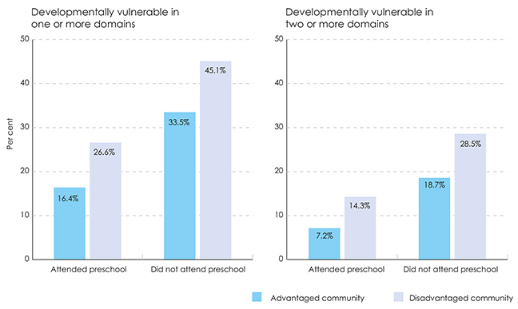

Source:
AEDC 2015 data collection.

Note: 1. The AEDC uses the Australian Bureau of Statistics (ABS) Socio-Economic Indexes for Areas (SEIFA)
- Index of Relative Socio-Economic Disadvantage, a ten decile system, to classify disadvantaged and advantaged communities. The AEDC combines the lowest two SEIFA deciles to form quintile 1 that indicates disadvantaged communities and the highest two deciles into quintile 5 to indicate advantaged communities.
2. Preschool attendance includes only children who teachers knew attended a preschool or kindergarten in the year before entering full-time school.

Recognising the role early childhood education plays, leaders of government departments from all states and territories commissioned the Review to Achieve Educational Excellence in Australian Schools through Early Childhood Interventions. The final report Lifting our Game was publicly released in January 2018. The report makes 17 recommendations related to early childhood education interventions and funding for the years before school (0-5 years) for Australian governments to consider. It confirms the importance of early childhood education and parent and carer engagement in providing a strong foundation for learning for every child. The Independent Review into Regional, Rural and Remote Education made a similar finding for regional, rural and remote children.

Helping children transition smoothly from early childhood learning to school is also crucial. Collaboration between early childhood education providers, schools and families is key to positive transitions. This also helps schools identify future students early and build positive relationships with parents and carers.
A cooperative effort is particularly beneficial for developmentally vulnerable children, as they face the greatest risk of falling behind when transitioning into school. High-quality early learning is especially important in the year before full-time school for developmentally vulnerable children and for children from disadvantaged backgrounds, although students from disadvantaged backgrounds benefit most if they then continue to receive support through childhood and adolescence (see Exhibit 9).

Exhibit 9. Students from disadvantaged backgrounds benefit most if they continue to receive support through childhood and adolescence

 | High school  graduation  rates (%) | University  enrolment  (%) | Use of welfare (%) | Criminal  conviction  (%)
No intervention (Baseline) | 41 | 4 | 18 | 23
Early childhood intervention only | 66 | 13 | 9 | 17
Adolescent intervention only | 64 | 12 | 10 | 18
Balanced intervention across full life-cycle of a child | 91 | 38 | 3 | 11
Source: Cunha, F. & Heckman, J (2006) Investing in our young people, working paper 16201, National Bureau of Economic Research: Cambridge, p. 64 & 140; see also Cunha, F., & Heckman, J. (2007) The technology of skill formation', American Economic Review, 97(2), pp. 31-47; see also The Smith Family (2016) Improving the educational outcomes of disadvantaged young Australians: The Learning for Life program, The Smith Family: Sydney, p. 14.

Note: This exhibit classifies disadvantaged children as children from a background where mothers are in the first decile in the distribution of skills.
Balanced intervention is defined as the constant flow of investment expenditure with the same present value of costs as the adolescent-only intervention.

Other agencies, including health, welfare, and housing services, can also improve the circumstances and school readiness of developmentally vulnerable children. Early childhood education providers and schools should continue to collaborate with these services and the wider community. Arrangements are best made at the local level so they reflect different care models and the diverse circumstances and needs across Australian communities.

Finding 2
Early childhood education makes a significant contribution to school outcomes. The transition between preschool and school education should be seamless. Ongoing reforms that lay the foundations in the early years for future learning, and close the learning differential between advantaged and disadvantaged students, are essential to ensure all children have the best start in life.
1.2 Enabling parents and carers to be partners in their child's learning
Parents, carers, other family members and guardians have a significant influence on a student's success at school. Their involvement in the school community can create a caring and supportive environment that has a positive effect on student wellbeing. Lack of involvement represents a lost opportunity, and can be as detrimental to a student's outcome as taking a more active role in a child's learning is beneficial.

Parents are leaders and experts in their children's learning. The degree of family engagement in children's learning is known to have a strong relationships with childhood vulnerability, developmental outcomes, and post-school destinations.
Tasmanian Council of Social Services – Submission

Greater parent and carer involvement in their child's learning has been shown to improve students' cognitive and non-cognitive skills. The more parents and carers engage in learning, the greater the chance that their children are engaged, motivated and confident learners.
Parent and carer's aspirations and expectations for their child's educational success are one of the strongest drivers of student achievements. Parents and carers also influence whether their child develops a 'growth mindset', which is an important factor for success at school and can provide a strong foundation for learning. Research shows students who have a growth mindset—that is, a belief that they can succeed if they work hard—fare better than peers who believe their intelligence and capabilities are fixed. Recent analyses of global Programme for International Student Assessment (PISA) data found that, 'after controlling for all other factors, student mindsets are twice as predictive of students' PISA scores as their home environment and demographies'. Students with 'growth mindsets' and a mindset of 'motivation calibration' (understanding what activities exemplify motivation in day-to-day life) are most likely to be high performers.
Socio-economic factors influence the probability that a student will develop a growth

mindset. PISA data show that students from high socio-economic backgrounds are more than twice as likely to have a strong growth mindset than students from low socio-economic backgrounds, and students from low socio-economic backgrounds are close to twice as likely to have a fixed mindset than students from high socio-economic backgrounds (see Exhibit 10). In Australia, the relationship between mindsets and socio-economic backgrounds is stronger than in comparable countries, suggesting this situation can be improved. This presents an opportunity for schools, parents and carers to help students, regardless of their background, to shift from a fixed mindset to a growth mindset to make the most of their education.

Exhibit 10. Australian students from low socio-economic backgrounds are less likely to have growth mindsets
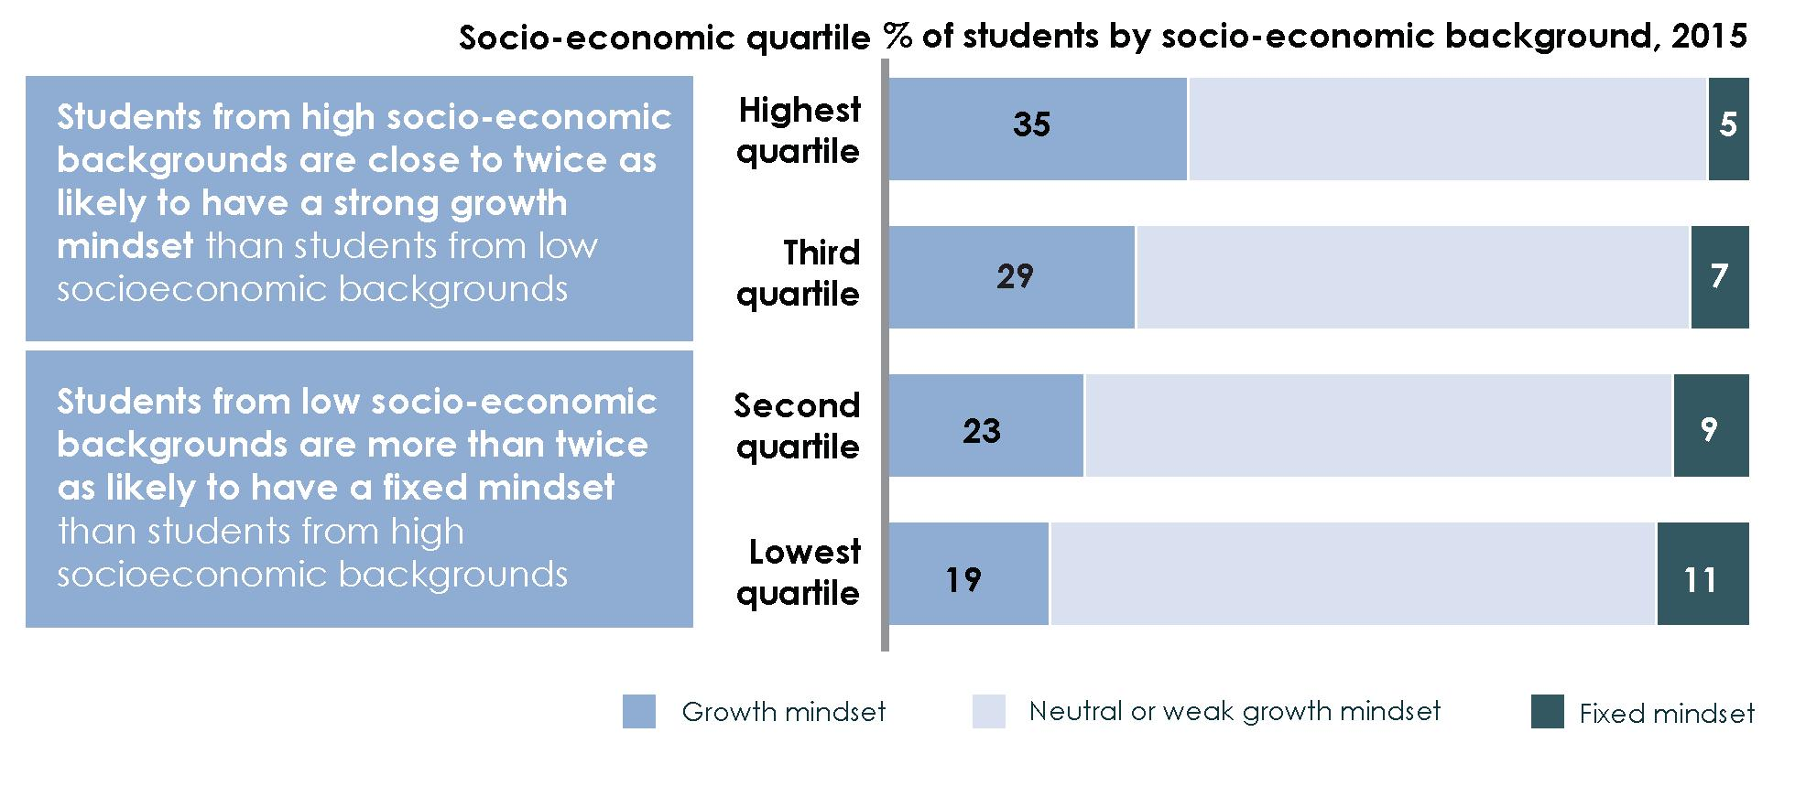
Source: Derived from OECD, 2015 PISA database.

Note: In PISA, a student's socio-economic background is measured by the Index of Economic, Social and Cultural Status (ESCS), which is based on the highest level of the occupation of the students' parents or guardians, the highest level of parents' education, and an index of home possessions, which includes educational resources, cultural possessions and other items in the home.

Parent and carer engagement typically takes different forms over time as students advance in their learning. Most parents and carers are heavily involved in the early schooling years and less engaged in later years of primary and secondary schooling.
Children's home environment shapes their early learning. Research shows that the quality of learning experiences during the first three years of a child's life has a significant impact on the cognitive skills of a child at four to five years of age. It also affects a student's ability to be a lifelong learner. Children who have been exposed to an engaging home learning environment in the early years are also more likely to achieve significantly higher National

Assessment Program - Literacy and Numeracy (NAPLAN) results. Parents and carers can play an active role in helping children develop the skills and capabilities needed to start school through developmental activities such as cooking and playing, including board and card games (to develop communication and mathematical skills), and reading (which influences reading competency, vocabulary comprehension and expressive language skills). The availability of reading materials at home is recognised as an important predictor of children's early cognitive development.
Case study
The Families as First Teachers program
The Families as First Teachers program provides quality early child and family support programs for children aged from birth to five years and their families. The program commenced in 2009 and is currently operating in 32 sites across the Northern Territory (30 remote and two urban sites). In 2016-17, 1887 children and 1792 parents/carers participated in the program at an average of one day a week.
Families as First Teachers works in partnership with a range of early childhood education and care, health and family support programs to ensure parents and carers are engaged in and support their children's learning and development from birth.
The program promotes children's early development and enhances their lifelong education, health and wellbeing outcomes. The program uses the Abecedarian Approach Australia, a set of evidence-based teaching and learning strategies through play-based LearningGames®, conversational reading, language priority and enriched caregiving to maximise children's learning outcomes. This early learning approach focuses on children and families playing and interacting to improve learning outcomes.39
While parent and carer support is particularly important in the early years of a child's learning development, it is vital for them to remain engaged partners in learning throughout a child's entire schooling period. In these later years, parents and carers can encourage their children to reach their full potential by promoting a positive learning environment at home. During later primary and secondary schooling, they can help their child navigate choices between different subjects and academic or vocational pathways, and post-school training and employment pathways.
Parent, carer and school engagement also has a significant impact during transition points throughout schooling. Transition points present students with a set of opportunities and challenges as they grow and progress in their learning. The three critical transition points in education are:
- from early childhood education and care into formal schooling
- from primary school into secondary school
- from secondary school into senior secondary, further education, training or employment.
It is important for students to feel supported and secure during these transitions; a positive transition experience can have an equally positive impact on future educational
outcomes and a student's personal development. Parents and carers are best able to support students through these transitions if school environments are supportive and they receive clear and practical information on how to best engage with their child's learning, particularly information about the way their support may need to change across the different stages of education.
Education providers and other stakeholders can do more to engage parents and carers in their child's learning, and support children to transition from early childhood settings to school and beyond
Parents and carers need more guidance on how to be effective partners in learning. Current observations indicate that many parents and carers are not fully aware of the critical role they play in fostering their children's success in education, nor how to exercise that role effectively. Schools can help by clearly mapping out ways to engage parents and carers as partners in learning to build a shared understanding of how to improve student outcomes over the entire course of the schooling period. School systems and schools can help by clarifying the most effective engagement models.

However conceptualised, parent engagement is typically thought of as an "external factor" - a student/family variable that is beyond the control of schools. But, in reality, this is not so. Schools, teachers, policy makers and other invested stakeholders have considerable capacity to support, influence and facilitate effective parent engagement in young Australians' formal schooling and informal learning. Parent engagement, including through the committed development of home-school partnerships focused on learning, should be considered core school/teacher practice. Policy effort and funding needs to be directed at parent engagement in learning and school leaders and teachers need to be cognisant of what it is, what benefits can accrue and how to support, facilitate and leverage it.
Australian Parents Council Inc. – Submission

A wide range of views exists in Australia on what constitutes effective engagement. This partly reflects the fact that there is no one-size-fits-all approach for engaging parents and carers in student learning; schools and early childhood education providers need to use different strategies and communication channels suited to different contexts. There are common themes in successful partnerships, however, and a more standardised framework could help guide education providers in their efforts to engage parents and carers in a way that is most conducive to a student's success at school.
Finding 3
There is strong and developing evidence of the benefit of parent engagement on children's learning. This will be further enhanced through the work currently underway to develop an evidence-informed definition of parent engagement, which will allow for a core set of agreed measures aligned to the definition to be established and used to drive improvements in policies and practice.
Progress has been made in improving school and parent and carer engagement in recent years. Many schools are already effectively engaging with parents and carers. There has been significant work done to understand how schools can effectively engage with parents and carers to help their child's education. The Australian Research Alliance for
Children and Youth has been commissioned by the Australian Government to undertake a Parent Engagement Project, which aims to develop a shared definition of what parent engagement is, why it matters, and how to measure its impact. In its submission to the review, Catholic Schools Parents Australia acknowledged that the parent engagement measurement tool, being developed as part of the Parent Engagement Project, could become a vital gauge of parent engagement as a key precursor to educational success. The Parent Engagement Project also explores the most effective ways of building and sharing evidence around effective strategies and activities.

The most effective strategy to ensure the embedding of family engagement into school culture and practice is to provide a systemic approach. It needs to be a consistent two-way approach based on the evidence and research.
Family engagement is not an "add on" program but instead it should be embedded in all planning (school, state and national level). Schools and systems should be accountable, and measurable standards (both qualitative and quantitative) should be developed to assist with reporting.
Australian Council of State School Organisations – Submission

Case study
Parent and carer engagement
Alfred Deakin High School in the ACT improved parent and carer engagement in their school by using school survey results to implement better engagement strategies.
School survey results had shown some parents and carers did not feel as involved in decision-making and learning with their child as they wanted to. Since then the school has worked tirelessly to build a culture of engagement, offering avenues for parents and carers to be regularly informed about what is happening at school and how they can engage in their child's learning. This has borne fruit as survey results track upwards and opportunities for engagement grow.
Critical factors in building engagement with parents and carers at Alfred Deakin High School included:
- Linking parent and carer engagement to the school strategy and tracking how the school is going against this. This signified a commitment and value placed on parent and carer engagement and ensured it became embedded into the school's operational plan.
- Engaging from the outset, as soon as or before students and their parents/carers enter the school. This has been facilitated through forums and the establishment of relationships through the phone home initiative. Building trust and rapport from day one has helped build three way conversations between school, student and parent/ carer.
- Setting clear, realistic protocols for the school's staff that are achievable. Being realistic in how much teachers can communicate with parents and carers and setting protocols in terms of type and frequency of engagement. Allowing staff the time to communicate with parents and carers on a weekly basis has been essential.
- Being dynamic and flexible in communication. Things change and parents and carers interact with the school in different ways. Providing multiple points of interaction and regular dissemination of information helps to manage the natural course of events in a busy, diverse high school.43

This recent work, including the Parent Engagement Project, has been useful in determining what constitutes effective parent and carer engagement and identifying where schools should direct their effort. The focus of this work should now shift to determining practical and actionable steps: such as developing evidence-based tools and resources to support schools in implementing proven strategies to engage parents and carers and improve student outcomes. Better models are also needed to share successful practices to help schools learn from the leaders.
Recommendation 2
Develop and disseminate evidence-based tools and resources to assist early childhood education providers, primary, and secondary schools to implement best practice approaches to supporting parents and carers to engage in their children's learning throughout their education.
1.3 Engaging students as partners in learning will help them reach their full potential
Encouraging students to be partners in their own learning increases agency (ownership and responsibility) and achievement and creates positive long-term learning habits. It also builds student engagement with schooling, which is associated with positive outcomes in most facets of life.

Student agency and voice plays a major role in engagement and self-reflection, therefore it is imperative student agency and a voice in learning and assessment is recognised. At the same time schools should look at the actual engagement of their students in learning. Research suggests large numbers of students not engaged in learning, and while compliant, certainly not meeting what should be high expectations.
Association of Independent Schools of Western Australia – Submission

Schools can engage students as partners in learning through feedback; by involvement in decision making; and by using new ways of learning.
Allowing students to exercise some autonomy and ownership over what they learn and how they learn helps develop a growth mindset and positive lifelong learning habits. As education researcher Professor John Hattie has noted, the 'biggest effects on student learning occur when teachers become learners of their own teaching, and when students become their own teachers'. This develops positive learning behaviours, such as 'self-monitoring, self-evaluation, self-assessment, and self-teaching.'
Learning these behaviours is a crucial life skill. Lifelong learning and upskilling are important to help make successful career and employment transitions in rapidly evolving education and workforce settings. Schools, parents and carers can help to support students adapt to these changes by helping them become informed about expectations for learning; encouraging students to take ownership of their learning; setting improvement goals and providing evidence of progress; and instilling in them the confidence to engage with new technologies, teaching strategies, and collaborative practices. Teachers and schools have

a role in cultivating confident and curious learners who take risks, and who learn from mistakes.
Giving students a 'voice' in their learning by seeking and valuing their feedback is a second method schools can use to increase engagement and learning effectiveness. Tailored teaching and learning strategies for different students are needed to accelerate individual student learning growth, which requires a deep understanding of individual learning needs. Frequent and real-time student feedback can help teachers to assess the impact of their teaching practices on each student and modify approaches to better suit different student learning needs. Seeking student feedback is also helpful to understand levels of student engagement. Establishing continuous feedback loops between students and teachers is therefore vital to strengthen and tailor learning and teaching.
Achievement and engagement are higher at schools that allow students to voice their opinions in decision making about their education. Involving students in decision making establishes a positive and engaged learning culture in schools. Encouraging student agency through decision making can improve the wellbeing of students at school by providing them with communication channels to engage with teachers on things that matter to them.

When students feel cared for and noticed at school, their confidence and motivation increases, they develop better learning strategies, are more cooperative in the classroom, have a greater sense of belonging, and more positive perceptions of school.
Dr Carmel Hobbs – Submission

Recommendation 3
Ensure all students have the opportunity within schools to be partners in their own learning.

Chapter two: Equipping every student to grow and succeed in a changing world
Summary
Today's school students have inherited a rapidly changing world where education outcomes have a significant impact on opportunity. Maximising the learning growth and attainment of every student every year is essential to improve student outcomes and increase lifetime opportunities. Equipping young people with the right knowledge, skills and mindset is essential for them to thrive in an uncertain world of work, and to find fulfilment in all aspects of their lives.
While these aspirations were widely shared by the stakeholders contributing to the Review, achieving them in practice is challenging. Aspects of Australia's school education system are not designed to accommodate individual student learning growth or rapidly evolving ways of learning.
There is a tremendous opportunity to change our education policies and practices to tackle these challenges. The Review Panel has identified several areas for action to better equip young people to grow and succeed in a changing world:
- Updating the design of curriculum, assessment and reporting models: To accelerate individual student's learning growth and attainment, we need to shift from presenting the Australian Curriculum as a prescriptive set of yearly targets, and instead use the curriculum as a roadmap of long-term learning progress. Learning progressions that enable teachers to focus on the learning readiness and individual progress of students need to become the new benchmark for monitoring success. The further development and implementation of progressions should prioritise foundation skills in literacy and numeracy during the early years of learning.
- Prioritising support for teaching the skills of the future: The general capabilities need to be more effectively translated from the Australian Curriculum into the classroom, so students acquire the full set of knowledge, skills and capabilities to succeed in the rapidly changing world of work.
- Enriching learning through community engagement: Australia's school education system needs to offer broader experiences and support beyond the classroom to foster a generation of connected, engaged and creative learners, embracing more diverse learning opportunities through deeper community engagement.
- Reviewing secondary schooling for potential reform: The content of senior secondary education and the models for delivery need to be updated to give young people the best preparation for their future.
2.1 School education needs to maximise individual learning growth and attainment
Australia needs to shift from the current, industrial model of schooling to a model focused on individual student growth and achievement to regain its standing among the world's leading education nations.
The evidence supporting the link between learning growth and achievement is not new: it has been widely accepted in educational theory since the 1970s that learning is most

effective when students are presented with challenging tasks just beyond their immediate comfort zone, but achievable with application and hard work.
This approach relies on teacher assessment of each student's current stage of knowledge, skill and understanding in a particular area of the curriculum, so that the next challenging steps can be tailored to advance learning. To do this, there needs to be professional agreement on how to measure individual progress, how to accurately identify the points a student has reached in learning, and how to set ambitious stretch-targets for further learning. Once teachers are aware of the relative positions of the students in their class, they can develop and provide tailored teaching to move each student to the next level of achievement.

Our high expectation should be that every student will make excellent progress every year.
Australian Council for Educational Research – Submission

The reality in Australia's busy classrooms often lags behind this ideal, leaving teachers unable to consistently put individualised growth-focused teaching and learning into practice. Many students in our schools are not realising their full potential because our current school education system is limiting opportunities for teachers to tailor learning to individual developmental needs.
A major constraint is the rigidity of curriculum delivery, and assessment and reporting models. The current model for presenting the Australian Curriculum is for all students to receive the same fixed year-level diet of knowledge, skill and understanding. However, each year of school, and each class, contains students at different points in achievement. Mixed-ability classes are not inherently bad: evidence shows they are preferable to alternatives such as streaming by ability, which has little effect in improving student outcomes and profoundly negative equity effects. However, having students of mixed abilities in the same year means it is impractical to expect that the same curriculum content can adequately cater to each student's different learning needs.
Homogenous delivery of the curriculum is also ineffective because of the significant gaps that already exist when children in Australia start school. These gaps are exacerbated over time if efforts are not made to help poorly prepared students catch up to their peers. National Assessment Program - Literacy and Numeracy (NAPLAN) results in Years 3, 5, 7 and 9 show that the most advanced 10 per cent of students are, on average, five to six years ahead of the least advanced 10 per cent (see Exhibit II).

Exhibit 11. There is a wide spread of achievement in Years 3, 5, 7 and 9

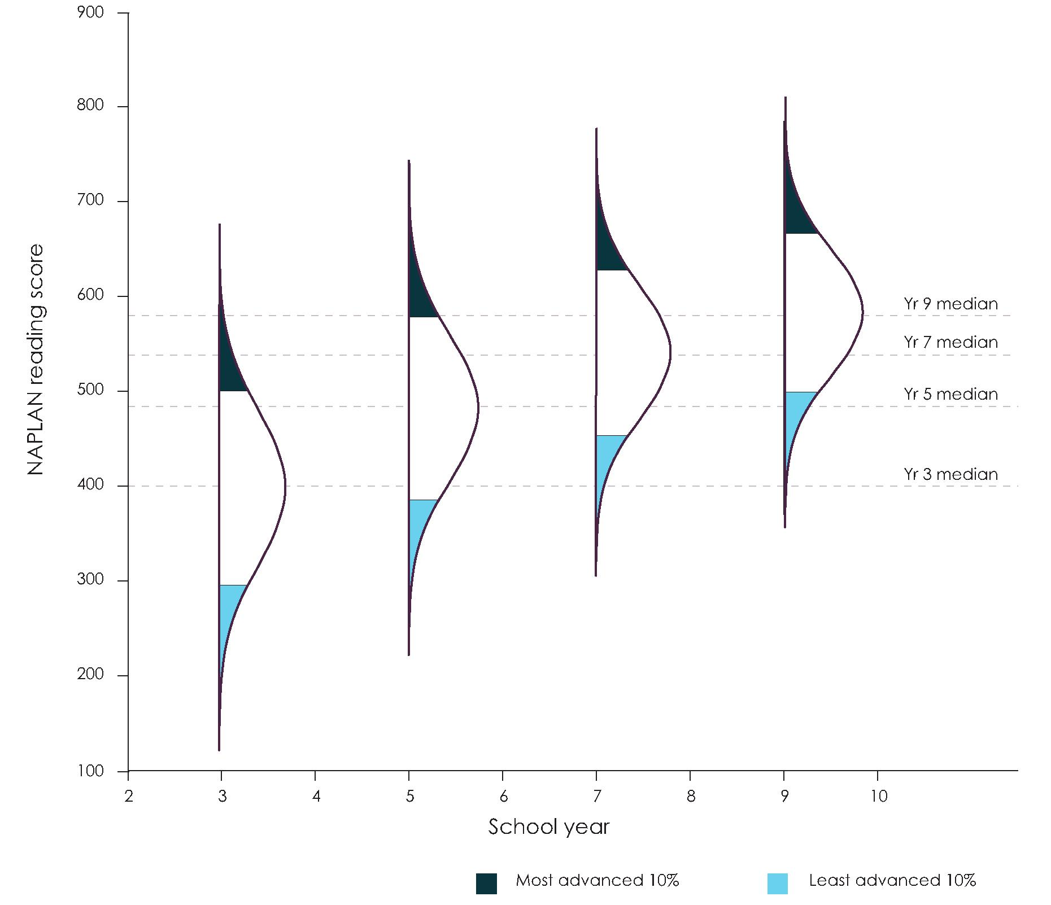

Source: Based on data from the NAPLAN National Report published by the Australian Curriculum, Assessment and Reporting Authority, https://www.nap.edu.au/results-and-reports/national-reports.

Note:
Exhibit prepared by Geoff Masters, Australian Council for Educational Research.

The lockstep delivery of the year-level based curriculum makes it difficult to develop teaching and learning programs for students who are above or below year-level expectations. The content teachers present may be beyond some students. These students may need significant support to make more than 12 months progress in learning in some years simply to reach the same attainment levels as their peers. At the other end of the spectrum, some students may not be challenged enough, needing to be stretched well beyond the year-level standard. This restricts the ability to maximise the learning growth of every student every year.
Finding 4
Teaching curriculum based on year or age levels rather than levels of progress leaves some students behind and fails to extend others, limiting the opportunity to maximise learning growth for all students.

2.2 Assessment and reporting needs to provide insight into a student's learning growth and learning achievements
Achievement in learning is a key indicator of student and system performance. However, current assessment and reporting models assess, judge and grade student performance against year-level achievement standards (using A to E reporting) which only reveal in very general terms a student's absolute learning outcomes. They do not show the extent of a student's learning growth. This can lead to a situation where a student who receives a 'D' year after year is perceived as making no progress at all when, in reality, the student might be making as much annual improvement as a student who consistently receives an 'A'.

A to E assessments are not able to provide context. Nor can they convey the crucial detail that parents and students require to understand the strengths and weaknesses of that student.
Tasmanian Government – Submission

This can have a negative impact on students' learning aspirations. Less-advanced students who manage to improve significantly over the course of a school year are likely to become demotivated when their efforts are not adequately recognised. Similarly, academically advanced students may become demotivated if not challenged. This attitude is likely to be reinforced in a 'cruising' school with no impetus to improve results.
Assessment and reporting arrangements must be updated to accurately describe the progress a student has made in the acquisition of knowledge, skill, and understanding over time, and the level of achievement that has been reached, regardless of how other students are performing or what the standards may be for a certain age or year level. A prerequisite for such arrangements is a sound understanding of what long-term learning progress across the curriculum looks like, informed by student performance data. This will allow the creation of a long-term picture of how learning occurs in practice.
Finding 5
Reporting against year-level achievement standards hides both progress and attainment for some students and does not amount to a diagnostic assessment of real learning needs which—if met—would lead to growth in learning.
Adopting assessment and reporting models that can describe both achievement and learning growth does not mean accepting a lower standard for achievement. On the contrary, assessing and reporting that encompasses both is more likely to encourage students to strive for greater achievement.
For more advanced students, monitoring a student's rate of progress and attainment ensures adequately challenging learning targets are being set, rather than assuming year-level achievement standards are sufficient. For less advanced students, reporting arrangements focusing on learning attainment and learning gain provide encouragement to improve, while acknowledging that moving closer to their peers may require a sustained higher rate of improvement over many years.

Learning growth measures will provide evidence of the effectiveness of programs, support and drive the school improvement agenda and provide meaningful information to parents and policy makers.
Northern Territory Government – Submission

Continuing to focus on year-level achievement standards without a better understanding of long-term learning progress and an acknowledgment of growth limits incentives for students to reach to their full learning potential, and can shape student, parent, carer and community beliefs about successful learning in unintended ways.
Recommendation 4
Introduce new reporting arrangements with a focus on both learning attainment and learning gain, to provide meaningful information to students and their parents and carers about individual achievement and learning growth.
2.3 Introducing learning progressions will support teachers to cater for the diverse levels of achievement in their classroom
Learning progressions for key components of the Foundation to Year 10 (F-10) Australian Curriculum need to be phased in to support the shift to growth-centred teaching and learning. The need for this shift was echoed by many stakeholders, experts and submissions to the Review that advocated for an increased emphasis on, and support for, student progress and learning growth. Introducing learning progressions is a critical reform that will see key parts of the curriculum presented as levels of increasing proficiency through which students progress in their school years, independent of year level or age. This will enable teachers to focus on the learning readiness and individual progress of students with limited or no reference to their age or year-level expectations. It will change the presentation of the curriculum from one organised around year-level packages of content and achievement standards to a structured roadmap of long-term learning progress. Such a shift will better support meaningful discussions about appropriate expectations of individual learning progress and achievement.

Maps of long-term progress recognise that students of the same age/year level are at very different points in their learning and usually require different, well-targeted teaching and learning opportunities.
Australian Council for Educational Research – Submission

Learning progressions are an alternative approach to presenting the general capabilities and learning areas within the Australian Curriculum. Once levels of progression are determined for key curriculum areas, students advance incrementally through them by demonstrating proficiency in specific knowledge, skills and understandings. All levels are defined by criteria that describe what a child knows, understands and can do at the time of assessment. These behaviours are observable, allowing teachers to diagnose the stage of learning reached by the student, and to plan the next challenging but achievable step to progress learning. Low-stakes, low-key, and regular assessment of this nature, followed by

teaching tailored to challenge the student to reach the next level of achievement, is the key to maximising the learning growth of every student every year, and to raising the quality of Australian education.
Across the learning progressions there will be varying numbers of proficiency levels, depending on the nature of each learning area or general capability. It is important to note that determining the number of levels within each progression, and their design and presentation, requires further work, drawing upon the expertise of the national, state and territory curriculum authorities, and other experts in the field. While there is a significant body of evidence on how literacy and numeracy develop, additional work will be needed to support the development of the progressions in other areas of the curriculum.
Exhibit 12 is a conceptual example of how to observe the knowledge, skills and understandings at each level within a learning progression, and how to use those observations to maximise individual learning. This example shows how spelling develops over time within the literacy learning progression. The level descriptions on the right show, for four of the levels, the criteria teachers, parents and carers can use to identify the level of proficiency reached by a student and plan the next challenging but achievable step in learning. Overtime, data collected through regular assessments against the learning progression will make it possible to establish typical trajectories and rates of spelling development.

Students need to know where they are on their personal learning journey. Parents need to know if their child is learning at the rate and level expected. Teachers need to know if their teaching practices are well-focused and effective.
Queensland Association of State School Principals – Submission

Exhibit 12. Example of how spelling develops within the literacy progression
This example of how spelling develops within the literacy learning progression describes how a student becomes increasingly proficient in selecting and arranging letters to form accurately spelt words, and uses spelling as a tool to understand and create meaning in texts. At higher levels of the progression, students monitor their own spelling and explain how spelling impacts upon meaning.
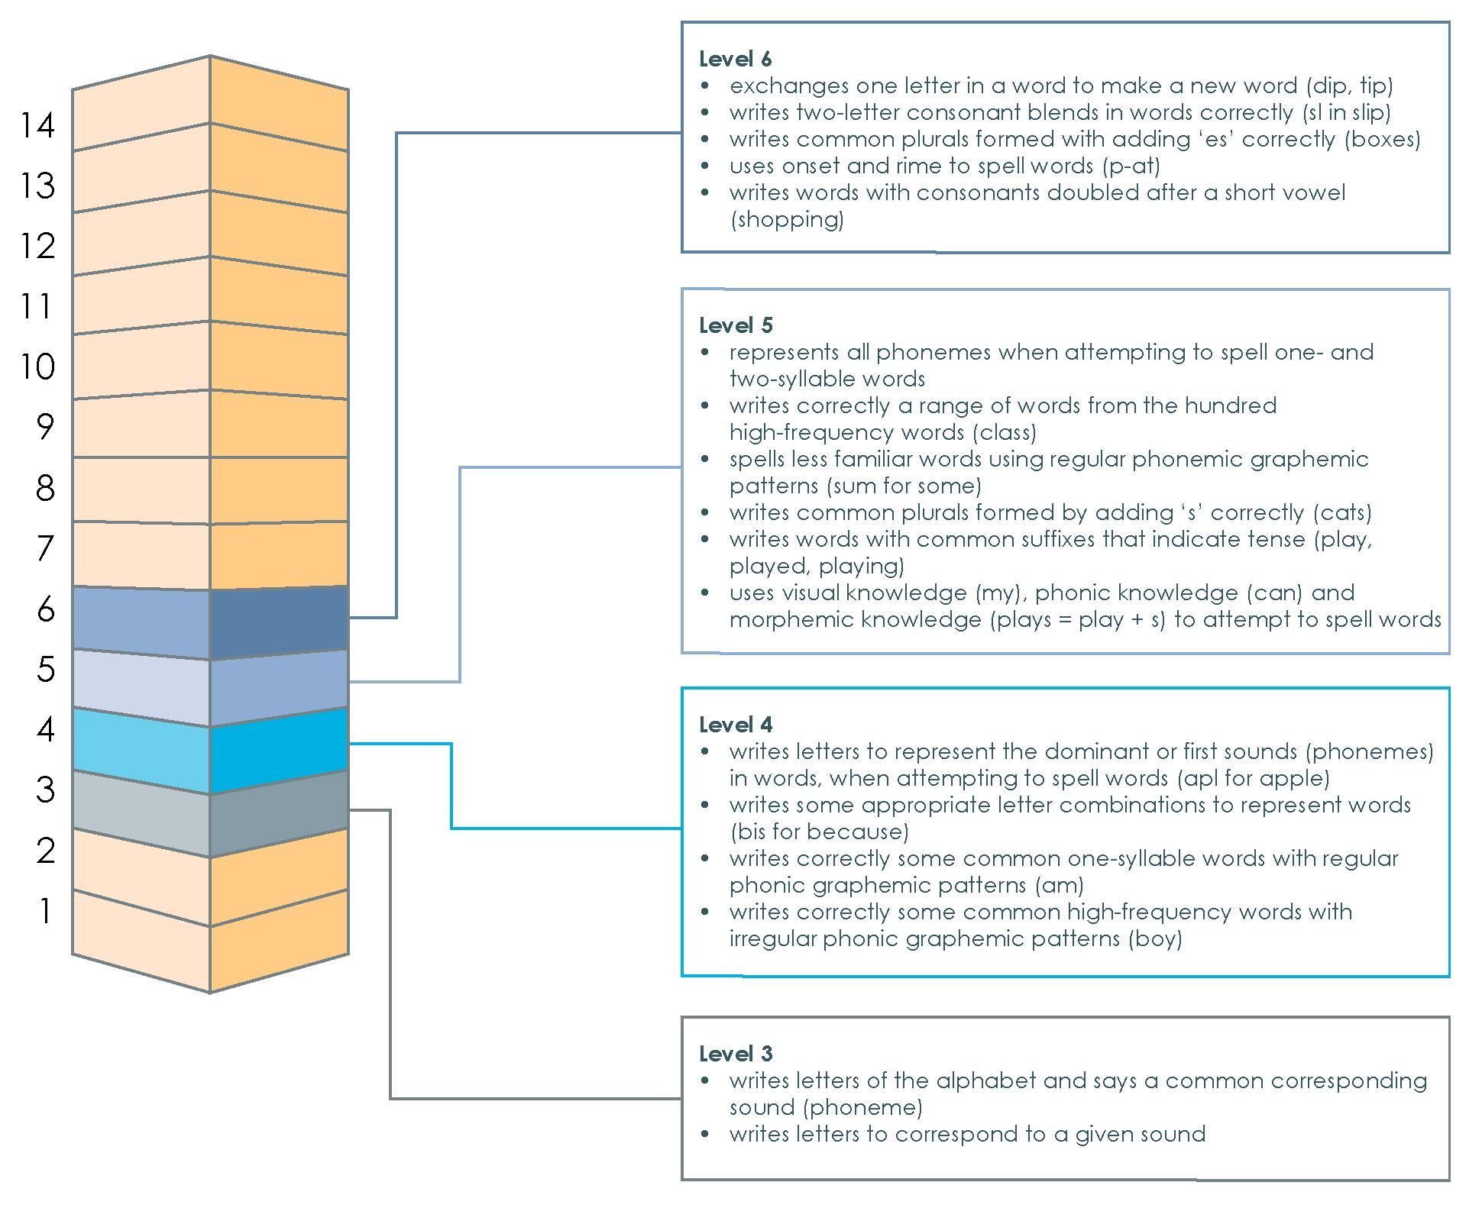
Source: Diagram developed by the Review to Achieve Educational Excellence in Australian Schools in collaboration with ACARA and ACER

All Australian education ministers agreed to collaborative action to develop national literacy and numeracy learning progressions in December 2015. Since then, learning progressions in literacy and numeracy have been developed for use in some states and territories. These were created by the Australian Curriculum, Assessment and Reporting Authority (ACARA) in partnership with the NSW Department of Education. Further work has also been undertaken by the Australian Council for Educational Research (ACER) in partnership with the UNESCO Institute for Statistics to develop common learning metrics to describe and quantify learning progress in reading and mathematics. The Review Panel recognises the work of both organisations as a very important step forward and urges it to be followed by further development, leading to the adoption of learning progressions in schools across Australia.

The Review Panel believes that there are six fundamental requirements for the development and introduction of learning progressions:
- the reform be developed for implementation in stages over the next five years
- learning progressions be developed for each of the general capabilities and learning areas in the Australian Curriculum
- each progression be comprised of increasingly challenging levels of proficiency independent of age or year level
- each attainment level in the progression be defined by criterion-referenced descriptions of the knowledge, skills and understandings typical of that level
- the number and type of criteria defining each level should enable teachers to make valid and reliable assessments of student attainment, and should not be adopted before this has been proven by extensive trial
- the learning progressions be national, and described and applied consistently across states and schools.
Recommendation 5
Revise the structure of the Australian Curriculum progressively over the next five years to present the learning areas and general capabilities as learning progressions.
2.4 Learning progressions for literacy and numeracy need to be implemented in a way that builds a solid foundation to help students advance in their learning
With the introduction of learning progressions over the next five years, prioritising the adoption of progressions for foundation areas of learning is a critical first priority. Prioritising their implementation will help teachers make sure every student finishes the early years of schooling with a sufficiently solid foundation for later education. Children need to master basic literacy and numeracy—the building blocks for learning—before progressing to more challenging content. In his submission to the Review, University of Melbourne Professor Field Rickards highlighted that children who have not developed these core foundations for learning by age eight struggle to catch up for the rest of their schooling. A child must learn to read before being able to read to learn. If a child is spending most of the time in the later years of primary school still battling with phonic structure and 'sounding out' words, learning in all subjects will fall rapidly behind.

To help ensure students have the skills they need for future employment, further training or higher education we must first ensure they have the most basic and fundamental skill required for success; the ability to read and write.
Dyslexia SA – Submission

Helping all children develop strong foundations for later learning is critical because nearly one-quarter of children in Australia are developmentally behind when they enter school. These developmentally vulnerable children are more likely than other students to be in the

bottom 20 per cent of NAPLAN scores in Years 3, 5 and 7. If not addressed, gaps between students with low and high levels of achievement in the early years significantly widen throughout schooling, highlighting the importance of addressing these gaps early (see Exhibit 13).

Exhibit 13. The performance gap between students with low and high levels of parental education widens significantly
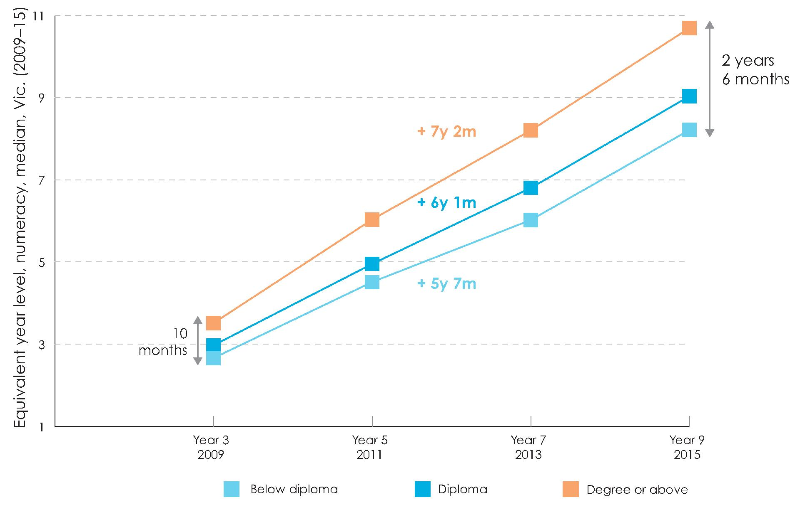
Source: Reproduced from Goss, P., Sonnemann, J., Chisholm, C. & Nelson, L. (2016) Widening gaps: What NAPLAN tells us about student progress, Grattan Institute, (Figure 10), p. 26, using Grattan analysis of 2015 VCAA de-identified linked student level NAPLAN data, and 2014 ACARA de-identified student level NAPLAN data.

Note: Results show the estimated progress of students grouped by their parents' highest level of education
as a proxy for socio-economic status. Black values are the gap between highest and lowest groups. Coloured values are the years of progress gained from Year 3.

In all Australian states and territories, efforts are being made to ensure every child is proficient in the foundation skills of literacy and numeracy. The implementation of learning progressions in these areas will play a fundamental role in reinforcing such efforts. However, teachers also need the flexibility to devote the right emphasis and time to teaching foundation skills in the early years, particularly for those students who need accelerated learning to attain these skills by age eight. This means a re-prioritisation of curriculum focus where necessary. This is supported, for example, by ACER'S National School Improvement

Tool that encourages school leaders to focus their attention and energy on ensuring that all students are proficient in the basics, as well as in the other learning areas.
Recommendation 6
Prioritise the implementation of learning progressions for literacy and numeracy in curriculum delivery during the early years of schooling to ensure the core foundations for learning are developed by all children by the age of eight.
2.5 Every student needs to be equipped with the skills and knowledge to navigate a rapidly changing world
Australian students are living in a world of profound change. New revolutionary technologies, including automation and artificial intelligence, are reshaping our economy and society, changing the way students will live, work, and interact. Schooling in Australia needs to be responsive to these shifts.
By the end of schooling, every Australian child needs to emerge as a connected and engaged learner, prepared to succeed in and contribute to a rapidly changing world. This means students must have acquired the basic building blocks of learning, in particular literacy and numeracy skills. They must also have a range of skills providing the job resilience required to be able to adapt and respond to fast-shifting education and workforce needs.
The Australian economy is relying more and more on skilled workers. This is being driven by a decline in the share of routine jobs, both manual and cognitive, as a proportion of all jobs since the mid-1980s (see Exhibit 14). A key driver of this trend is the increasing capacity of technology to automate routine work. This work is found in industries across the economy. It can be predominantly cognitive in nature with a high proportion of repetitive administrative tasks, such as bookkeeping, clerical work, or manual work that features a high component of precise, well-understood procedures or 'routines', such as a production worker in a manufacturing plant. Non-routine jobs, on the other hand, involve abstract problem solving, organisational and managerial activities or activities that involve physical adaptability and social interactions, which are less able to be replicated by technology. Advances in automation technology will continue to drive this trend away from routine tasks and towards interactive, highly skilled work, which in turn will have an impact on the type of skills a worker needs to increase the chance of employment.

Exhibit 14. Non-routine occupations are an increasing proportion of Australia's workforce

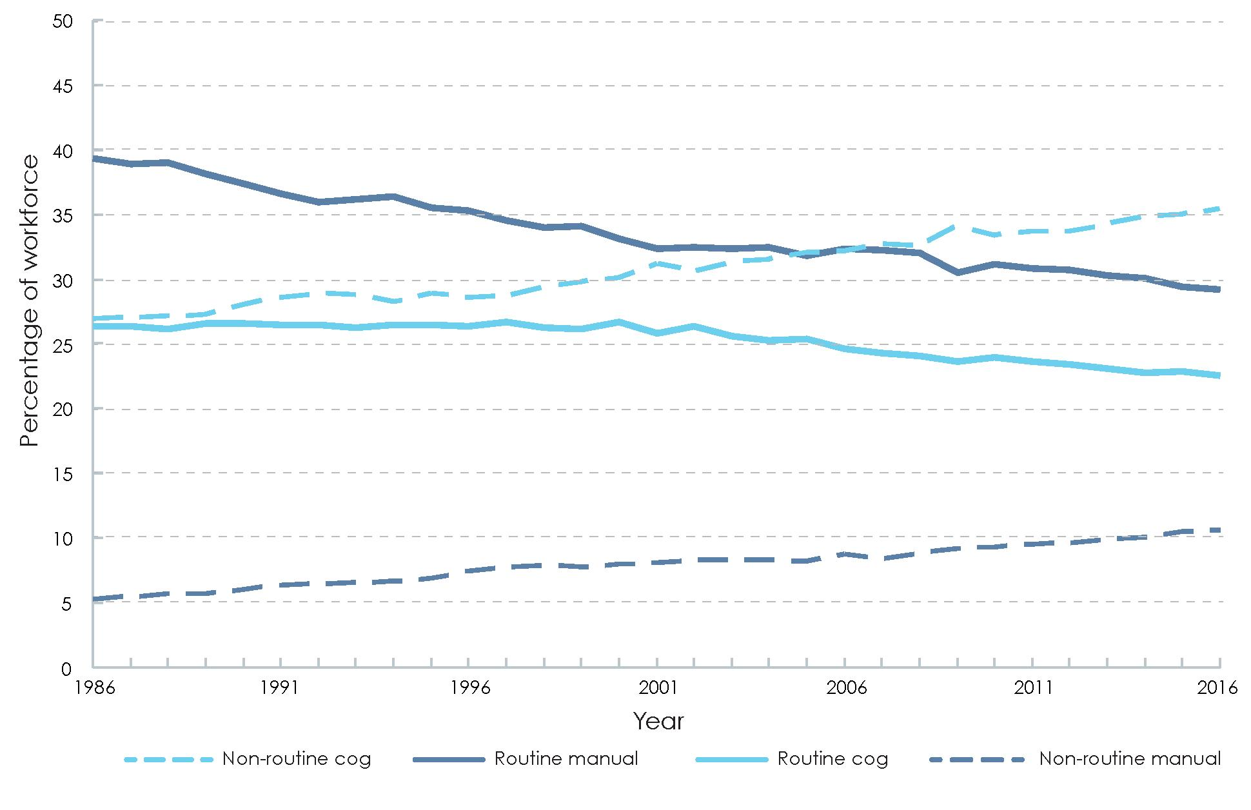

Source: Reproduced from Heath, A. (2016) 'Speech: The changing nature of the Australian workforce', in Reserve Bank of Australia (graph 1), using ABS catalogue 6291.0.55.003, Labour Force, Australia, Detailed, Quarterly.

Note:
Non-seasonally adjusted.

Across Australia, there has been a range of efforts to prepare students for these changes. One high-profile endeavour has been the increased focus on science, technology, engineering and mathematics education (STEM), of which the National STEM school education strategy 2016-2026 is the centrepiece. The strategy seeks to lift students' foundational skills in STEM learning areas, improve Australia's STEM performance in international comparative assessments, reverse the declining number of skilled graduates in STEM-related subjects, and address the under-representation in STEM of girls, of students from low socio-economic status backgrounds, of Aboriginal and Torres Strait Islander students, and of students from non-metropolitan areas.
Beyond lifting skills in the STEM learning areas, the STEM education strategy encourages a cross-disciplinary approach to teaching that develops students' problem-solving and critical analysis skills. The cross-disciplinary aspects of STEM education have brought a key component of the Australian Curriculum to the fore—the interweaving of general capabilities throughout the learning areas. In line with curriculum reform emerging globally, this focus is helping to equip students to live and work successfully in a changing world. This approach is increasingly being used in a range of other learning areas, such as in the Arts,

to help students develop and apply both knowledge and skills in varying and complex circumstances.
2.6 General capabilities need to be at the core of our curriculum and teaching practice
The Australian Curriculum can be depicted as a cube of three dimensions: disciplinary knowledge, skills and understanding in learning areas such as English, mathematics and science; general capabilities such as personal and social capability; and cross-curriculum priorities such as Asia and Australia's engagement with Asia (see Exhibit 15).

Exhibit 15. The current Australian Curriculum has three dimensions
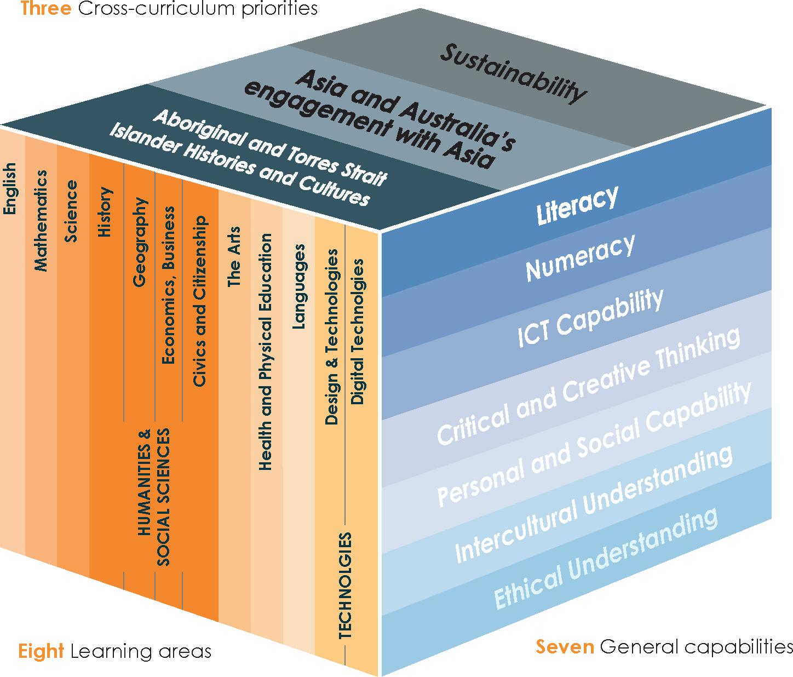
Source: Reproduced from the Australian Curriculum, Assessment and Reporting Authority, 'Structure', in Australian Curriculum

The general capabilities dimension was raised repeatedly in stakeholder consultations and public submissions as critical to preparing students fora future of interactive, non-routine work. There has been growing interest, for some time, in how these capabilities might be assessed and linked into school programs. For example, in 2009 Microsoft, Intel and Cisco jointly funded an international project (Assessment and Teaching of Twenty First Century Skills) chaired by Professor Barry McGaw to develop a framework to assess the skills needed for the knowledge economy and digital workplaces of the21st century.

The general capabilities are an integrated and interconnected set of knowledge, skills, behaviours and dispositions that apply across learning areas. There are seven general capabilities in the curriculum: literacy; numeracy; information and communication technology capability; critical and creative thinking; personal and social capability; ethical understanding; and intercultural understanding. Literacy and numeracy serve as foundational skills considered essential for further learning. The other general capabilities enable individuals to collaborate and to translate knowledge into meaningful analysis and action, and are increasingly sought after by employers.
How should we refer to the skills and capabilities needed for the future
While there is a solid, shared idea of the types of skills and capabilities needed to thrive in our rapidly changing world, there is no definitive list or title to describe them collectively. ‘21st century skills’ is a common title given, but many argue that the skills and capabilities referred to were important before the 21st century, while also noting that with rapid change, century-long milestones are inappropriate. ‘Interactive skills’ has also been used, with the view that most of the skills and capabilities involve an interaction of some sort, but the term is criticised for lacking resonance. ‘Knowledge economy skills’ implies a closer link with the popular term ‘knowledge economy’, but critics say that it is too close to ‘knowledge’ itself, and so implies almost the opposite to what is meant. The term ‘enterprise skills’ is also proposed, but arguably has a narrow business or entrepreneurial connotation, when these skills are needed in all forms of work.
Recognising that there is no perfect answer, this report uses the title ‘general capabilities’, as they refer to a clear list that has been nationally agreed and established as part of the Australian Curriculum. While it will be important to keep up to date with the contemporary thinking surrounding these skills and capabilities, the title we give them is less important than the focus we need to place on their teaching and development
Despite the attention and importance given to the general capabilities, teachers and schools are insufficiently supported to teach and assess them.

The emphasis and resources to develop the skills and capabilities are insufficient to strengthen the practice of teachers, for whom the comfort of content is a default. Teachers are expected to teach and assess general capabilities to the extent that they are incorporated within learning area content, but there are few evidence-based best practice models of 'how' to go about this and it is often left up to the individual teacher.
Independent Schools Victoria – Submission

Teachers seek better professional development in teaching and assessing general capabilities, and the provision of more information on where to find resources related to their application across the learning areas. An Organisation for Economic Co-operation and Development (OECD) survey revealed that only around one-third of Australian lower-secondary teachers recently participated in professional development aimed at teaching cross-disciplinary capabilities like problem solving, and only one in 10 participated

in training to help students develop transferable capabilities for future work or study. In both cases, Australian teachers were less likely than other OECD countries to report a positive impact of the professional development on their teaching. Other studies indicate that many teachers are unaware of available resources to develop the general capabilities and how they might use them in conjunction with learning area materials.

Strengthening the development of the general capabilities is critical to the national innovation and skills agenda. Further work to identify effective teaching strategies must be underpinned by sound measures and assessments of the full range of the skills covered by the curriculum is needed.
South Australian Department of Education and Child Development – Submission

One reason for the lack of support surrounding the general capabilities is that there is no consistent method of assessment, apart from literacy and numeracy. Currently, each jurisdiction itself determines the extent to which they are assessed and reported. Some states and territories have made progress in this area. The Victorian Government in its submission to the Review, for example, described their development of achievement and reporting standards for the four capability areas outlined in the Australian Curriculum: critical and creative thinking, personal and social development, ethical understanding and intercultural understanding.
In addition, teachers are expected to embed teaching of the general capabilities into subject-based learning areas (such as English and mathematics). In practice, teaching and assessing the general capabilities, particularly in an embedded form, is a highly complex task. It requires teachers to have a sound understanding of how to teach these capabilities and to design engaging material which advances both learning areas and general capabilities. It takes deep expertise to know how best to interweave the teaching of the general capabilities into different learning areas, as general capabilities vary in their relevance to each learning area. Some general capabilities are associated with relatively well-defined pathways of learning, such as literacy and numeracy, while defining and assessing other general capabilities, such as social skills, is at a more nascent stage. This increases the difficulty of teaching, assessing and reporting general capabilities.
As ACARA noted in its submission to the Review, this embedded model carries the risk that general capabilities are treated as a secondary aspect of learning, relative to subject-based knowledge. To prevent general capabilities from becoming buried in the delivery of content-based learning, many submissions argued for the curriculum to place a greater emphasis on the general capabilities relative to the learning areas and for further development of the pedagogical approaches required to achieve this.

Just as our nation needs to transform from a traditional economy to one that is innovative and progressive, our education system needs the enabling conditions to transform from the traditional subject based orientation to an explicit focus on the teaching, assessing and reporting of the Australian Curriculum general capabilities.
Australian Secondary Principal's Association – Submission

The Review Panel sees an opportunity to better support teachers to deliver and raise the priority of the general capabilities by putting them at the core of our curriculum and teaching practice. This necessarily involves a structured and consistent approach to the way the general capabilities are taught, and how students' proficiency in them is measured, reported and built upon. Such an approach requires developing the general capabilities into learning progressions that will provide a detailed picture of students' increasing proficiency, in order to support subject-based teaching and learning. Learning progressions are different from the general capabilities continua already developed by ACARA—they are much more fine-grained and are not organised by year-levels or stages of schooling.
Further work is required to understand the best way to implement the general capabilities, within and across learning areas, as they cannot be taught in isolation. ACARA is re-examining the balance between learning areas and the general capabilities and developing more specific support for teachers. Given that the general capabilities within the curriculum were defined a decade ago, the Review Panel is of the view that ACARA should consider the adequacy of the current list in light of contemporary thinking.
The Review Panel welcomes the development of learning progressions in literacy and numeracy for trial in some states and territories and sees an opportunity to prioritise the development of additional learning progressions for other general capabilities, in particular in critical and creative thinking and personal and social capability.
Recommendation 7
Strengthen the development of the general capabilities, and raise their status within curriculum delivery, by using learning progressions to support clear and structured approaches to their teaching, assessment, reporting and integration with learning areas.
2.7 Effective school-community engagement unlocks a
world of applied learning and development opportunities for students
Schools help students achieve a range of education goals beyond just academic achievement. Focussing on broader areas of student growth is important in building an engaged mindset and positive disposition towards schooling and lifelong learning. Harnessing learning opportunities in the community helps support students' progress through schooling, and provides them with rich and engaging learning, personal development and citizenship opportunities.
School-community engagement helps students broaden their knowledge and develop new skills. It provides access to new networks—broadening a student's outlook, understanding

of community, and future employment opportunities; and encouraging a positive attitude to life. Students from disadvantaged backgrounds particularly gain from community engagement, as they might have only limited access to employment networks, career advice, positive role models and enrichment activities.
School-community engagement supports a student's learning growth and future preparedness by improving attendance, engagement and academic outcomes, particularly for disadvantaged students; and by providing teachers and schools with a rich and more diverse array of learning experiences to engage individual students and meet individual learning needs. It supports an adaptive education model by enabling students to learn what is happening outside the school gates; to apply the knowledge and skills acquired at school in a range of contexts outside the classroom; and to prepare students for the needs of a rapidly changing workforce by exposing them to work-related knowledge and skills that the curriculum does not cover.
Finding 6
Fit for purpose school-community engagement undertaken to respond to identified student needs is an effective way to improve the relevance of learning, and to support personal development and student learning growth. School-industry collaboration, mentoring, volunteering and extra-curricular activities are effective forms of engagement to help achieve this.
There are many examples of effective school-community engagement in Australia including school-business collaborations, mentoring, volunteering and access to extra-curricular activities. Strong partnerships are central to these engagements. They can be built on formal structures, such as vocational education and training (VET) embedded in schools, or more informal arrangements, such as schools partnering with local industry or organisations.
School-industry collaborations
School-industry collaborations improve education and employment outcomes. They demonstrate the value of learning to students by engaging them in situations where they can apply the knowledge learnt at school. Research shows that students who had a chance to develop networks with potential employers have a broader understanding of the labour market, working life and career planning.
Students also have higher career aspirations and find it easier to transition into work or university after school when involved in such collaborations. British researchers found that students who frequently participated in school-mediated employer engagement programs were nearly twice as likely to be in education, employment or training as comparable peers who had no such interactions.
Professor Halsey, in the Independent Review into Regional, Rural and Remote Education, also highlights the importance of school-industry collaborations. He calls for an increase in the number of people with industry/business experience working closely

with schools and students to provide vocational pathways advice and to assist students to negotiate the training and/or employment pathway they want.
Case study
Pathways in Technology (P-TECH) Pilot
The Pathways in Technology (P-TECH) model is being piloted by the Australian Government at 14 sites across the nation as part of its strategy to improve Australia's STEM capability. Central to the P-TECH model is engaging industry as active partners in education—as contributors and influences in the learning and development of their future workforce. P-TECH provides a framework for establishing long-term partnerships between schools, tertiary education providers, and industry. This enables employers and tertiary providers to work alongside schools in preparing young people for success in further study and work.
P-TECH offers secondary school students an industry supported STEM learning program, incorporating a nationally recognised VET qualification as part of their secondary school experience. With continued industry support, P-TECH students extend their education beyond Year 12 to achieve a STEM related post-school qualification.
Since August 2015, Newcomb Secondary College—a pilot site in Geelong, Victoria—and its education and industry partners have been working together to design and deliver a P-TECH learning program tailored to the local community.
The P-TECH model has been a catalyst for broader change in the way Newcomb Secondary College operates and interacts with the community. For example, the importance of general capabilities has been elevated and is a priority across the school, and all students are engaging in learning to enhance their ICT skills. Perhaps most importantly, the College has increased its capacity to engage with its community, independently securing four additional industry partners to support the P-TECH program in 2018. While Government seed funding for the Geelong P-TECH site ceased in June 2017, the P-TECH learning program continues to evolve for the benefit of students, industry partners and the school.84
Mentoring
Youth mentoring programs can have powerful and lasting positive effects on students. A young person's connection with a caring adult can generate a range of developmental benefits, including higher self-esteem, greater engagement and performance in school, reduced delinquency and better mental health. Such programs can also build strong connections between the mentors, the school, and the wider community by creating a shared understanding of how to meet student needs.
The success of these programs depends on the program structure and the relationship between mentor and mentee. Successful youth mentoring programs incorporate a set of best practice principles, including:
- effective recruitment and training of mentors
- a strategic process and mechanism for matching mentors and mentees

- appropriate length of time spent between mentor and mentee
- clear program policies and procedures, including monitoring and evaluation.

In-school student mentoring programs address student resilience, self-worth and self-confidence and promote connectedness and re-engagement at the individual student level without increasing pressure on limited teaching resources.
Raise Foundation – Submission

Mentoring is most effective when offered in addition to, rather than instead of, regular classroom instruction. When done well, youth mentoring is a holistic solution to re-engage young people facing a wide range of adversities, because it gives them an opportunity— often for the first time—to confide in an independent and trusted support person. Similarities in backgrounds can assist in building relationships between a mentor and mentee.

Relationship formation is central to the engagement pathway for students. Without this, excellence in pedagogy, curriculum flexibility, and policy-while necessary - will not be sufficient to re-engage the disengaged or disengaging student
ARC Centre of Excellence for Children and Families over the Life Course – Submission

Volunteering
Volunteering can promote social inclusion, enhance future employability and help develop values of generosity and civic responsibility. It allows students to acquire social capital, open-mindedness and an ability to interact with adults, which can be difficult to develop in the classroom. Such skills are transferrable to the workplace and are often valued by prospective employers.
Research indicates that volunteering programs can particularly help disadvantaged students. Through volunteering, these students learn how to make a positive contribution to their communities and how to develop a more positive attitude towards their abilities as a learner. Young Australians from disadvantaged backgrounds, however, are reported to be less likely to volunteer than their peers. These students may feel that their contribution would not be valued, or may not know how to get involved. Structural barriers also exist— including a lack of time, money or suitable transport to volunteering activities. Increasing the participation of students from disadvantaged backgrounds in volunteering, including by designing approaches that overcome the particular barriers they face, is important to enrich learning, increase work readiness, give them a broader network and expand their understanding of potential work opportunities.

The social capital derived from volunteer engagement is also of profound benefit to both volunteers and the wider community. Volunteers can play a uniquely important role in assisting people they engage with to develop meaningful relationships, and in reducing social isolation.
Volunteers Australia – Submission

Similar benefits can be realised through well-structured and robust in-school volunteering by community members. This can help build connections between the school and the wider community by sharing knowledge and experiences, and by making links across generations and cultures.
Extra-curricular activities
Participation in extra-curricular activities, including creative arts and sports, leadership and culture, has a significant impact on a student's learning growth in the cognitive, affective and physical domains of learning. Although conventionally called 'extra-curricular' because they are not always explicit within the Australian Curriculum, these activities are a very important part of learning and should not be regarded as extra, but rather as integral.

... the integration of physical, psychological, cognitive and social capabilities ... help us live active, healthy and fulfilling lives.
Australian Sports Commission – Submission

These activities help build social, emotional and physical skills; they teach independence, resilience and teamwork; they build initiative and creativity; they teach persistence, problem-solving, communication and collaboration. Longitudinal research from Australia suggests that students who participate in a greater variety of activities have higher levels of academic and social self-concept, and general self-worth.
As with volunteering, disadvantaged students experience the greatest benefits from participating in extra-curricular activities but are the least likely to have access to them. This is because activities are less available and because the cost is often prohibitive. School-community partnerships can assist in creating more accessible opportunities and provide additional resources for participation.

Studies have found that structured extra-curricular activities are important for development and growth, especially during adolescence, and are associated with lower rates of antisocial and risky behaviour, lower rates of academic failure and lower dropout rates.
Independent Schools Council of Australia – Submission

For extra-curricular programs to be successful, activities should be well-structured around clearly defined goals, run by capable adult leaders, and focused on continuous skills development. Activities should develop a sense of belonging in students, foster social networks, use positive reinforcement, provide opportunities for leadership roles, and set age-appropriate expectations and goals.
2.8 Schools need support to build quality partnerships to deepen community engagement
While many models of school-community engagement exist in Australia, school-community engagement to improve student learning is not common practice and implementation can be ad hoc. Consultations undertaken as part of the Review found that schools can be constrained by risks around off-site student learning and a lack of resources to hire or train specialised staff, meaning student participation is uneven across different student groups. Some schools face challenges in developing quality programs that meet their students' specific needs.

Finding potential partners and resources, knowing who might have the professional expertise to advise and guide program development, gathering information about an area of identified need, knowing how to monitor and evaluate the impact of a collaboration all take time and require different kinds of knowledge and skills.
Michèle Lonsdale and Michelle Anderson, Australian Council for Educational Research

There is an opportunity to provide a more consistent system-wide approach to developing strong school-community partnerships focused on enhancing student learning growth.
One way to encourage the uptake of school-community engagement is the use of brokers to overcome the resource intensity of bilateral engagement arrangements. Brokers provide support in making connections, building networks, developing partnering skills, and providing tailored support as partners move through the various stages of partnership development. Brokers can play a particularly valuable role in communities that lack the networks, connections and infrastructure needed to support young people—including in Aboriginal and Torres Strait Islander, rural, remote, and low socio-economic status communities.
There are a range of potential providers who can take on an intermediary role, including tertiary education providers, industry associations, non-government organisations and school-industry partnership bodies. The STEM Partnerships Forum is an existing mechanism trying to increase the structure and consistency of school-industry engagements—away from short-term piecemeal solutions and towards lasting partnerships.
Schools would also benefit from support to identify best-practice models, streamline the process of engaging with partners, and create opportunities for all students, particularly for those from disadvantaged backgrounds.

Recommendation 8
Strengthen school-community engagement to enrich student learning through the establishment of mechanisms to facilitate quality partnerships, including engagement in mentoring, volunteering and extra-curricular activities, between schools, employers, members of the community, community organisations and tertiary institutions.
2.9 The proportion of students completing senior secondary and the world they enter on completion, have both changed significantly
Senior secondary education, which covers Years 11 and 12, plays an important role in preparing students for the world beyond school. Students who complete senior secondary education have a greater likelihood of continuing with further study, entering into the workforce, and improved living conditions. Recent increases in the proportion of students completing senior secondary schooling have been dramatic. Between 2009 and 2013 the Year 12 attainment rate increased by 10 percentage points (from 64 percent to 74 per cent). Over a longer time scale the proportion of young people continuing through to Year 12 has also increased substantially, as have the types of post-school jobs and study opportunities. Australia, however, still has a substantial number of students who do not complete Year 12 and these young people, on average, have less successful transitions from education to work. At the same time, senior secondary schooling models have been largely static, remaining focused on academic knowledge and preparing students for university. It is essential that these models are reviewed to make sure they are giving every student the best preparation for life.
The proportion of Australian students who continue through to Year 12, and go on to tertiary study, has increased significantly in the last three decades. Between 1988 and 2017, the share of Australian students who continue through to Year 12 increased from 58 per cent to 85 per cent (see Exhibit 16). This sharp increase was driven by changes in the minimum school leaving age, changes in workforce requirements and changes in social attitudes towards education. Today, around half the students finishing Year 12 transition to university and 15 per cent enroll in other training. For around one-third of Year 12 completers, senior secondary is their last formal education. This raises important questions about the effectiveness of senior secondary schooling to cater for a much larger cohort of students and their post-school pathways.

Over 50 per cent of Baby Boomers diet not complete senior secondary school, as it was primarily a pathway to higher learning. Now all young Australians are expected to engage with it, but it is not designed for all young Australians.
Business Council of Australia

Exhibit 16. The proportion of students continuing through to Year 12 and attending university immediately after school has trended upwards
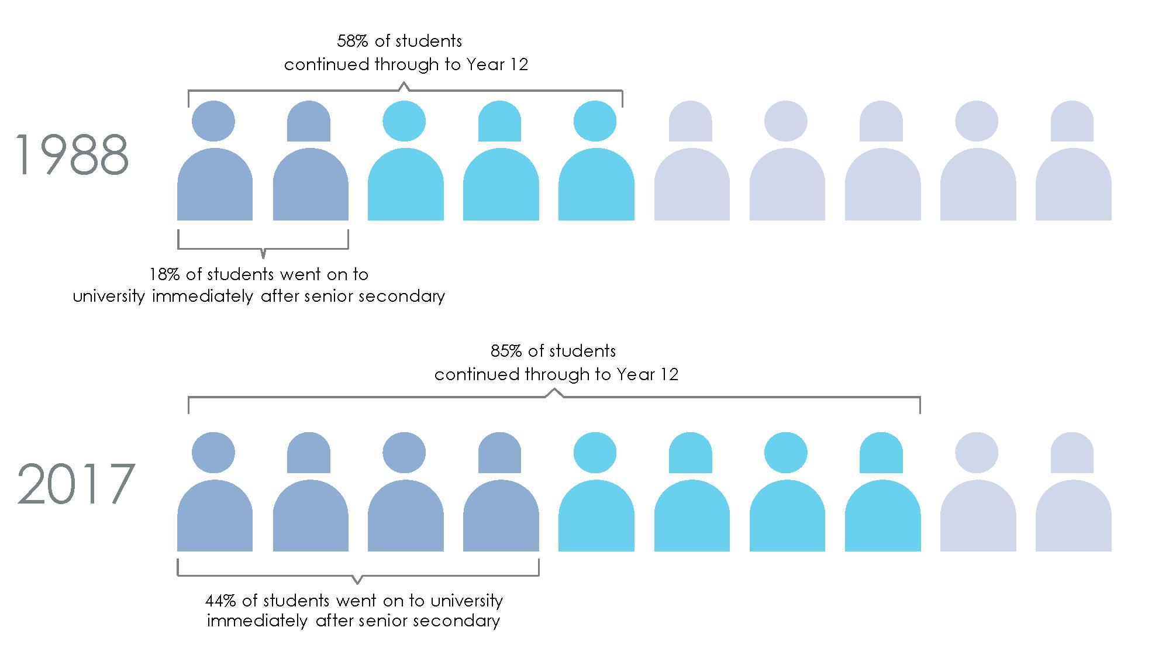
Source: Australian Bureau of Statistics (1991) Schools, Australia, 1990, cat. no. 4221.0, ABS: Canberra; Australian Bureau of Statistics (1999) Australian Social Trends 1999, cat. no. 4102.0, ABS: Canberra; Australian Bureau of Statistics (2017) Education and Work, Australia, May 2017, cat. no. 6227.0, ABS: Canberra; Australian Bureau of Statistics (2018), Schools Australia, 2017, cat. no. 4221.0, ABS: Canberra.

Note: The percentage of students continuing through to Year 12 represents the apparent retention rate. The apparent retention rate is calculated by dividing the number of students in Year 12 by the number of students in the base year (Year 7/8) and converting the figure into a percentage.

The world of work students face after senior secondary school is changing fast. Trends such as flexible employment models, greater technological sophistication and intensity, and globalisation will accelerate this transformation. As a result, young Australians need to be prepared for far less linear career paths than their parents. A 15-year-old today will likely have a working life spanning five different careers and around 17 employers. Today's Year 12 students also need a broader and different mix of skills compared to previous generations, including stronger problem-solving, communication, digital skills, and creative thinking, due to the rise in interactive, service industry jobs—which now account for almost

80 per cent of jobs in the Australian economy—and the decline in routine, manual and administrative roles.
2.10 Despite these profound changes, senior secondary
education models have remained substantially the same
Privileging university pathways
Senior secondary education models follow a separate curriculum to the F-10 curriculum covered in the Australian Curriculum. They focus mainly on academic disciplines, and learning is generally more theoretical than applied, with assessment and reporting geared towards university entrance. This focus on academic disciplines in senior secondary schooling can crowd out broader educational outcomes. During the 1990s, there was an expansion in vocational offerings in senior secondary schooling. This was in response to an increase in the range of needs of the expanding senior secondary cohort. In many schools, however, alternative vocational subjects were considered to be less prestigious than an academic pathway Rather than being valued for creating opportunities to grow minds and stimulate imaginations and engagement through a quality vocational curriculum, vocationally-based education was, and often continues to be, focussed on training and consequently is perceived as narrow and limiting.
Though some states and territories have made advancements in the uptake of VET courses, overall enrolments of 15 to 19-year-old students in school-based VET fell by 11 percent between 2012 and 2016. In a culture that privileges pathways to university, schools may also deprioritise VET in internal resourcing decisions.

VET courses in schools need to be better supported publicly and locally, including through the provision of the necessary resources to: recognise the increased numbers of students staying on to year 12 and their learning needs; have VET seen as a pathway for disengaged students; attract new graduate teachers into VET; make VET subjects attractive to students and recognised as an additional pathway other than university.
Independent Education Union of Australia – Submission

Despite this drop in school-based VET enrolments, and the increased participation in higher education, post-school transitions to higher education only account for around half of senior secondary school completers. It is vital that a focus on university entrance does not overshadow a focus on vocationally-based education, including preparing young people for employment or for a combination of work and training.
Participation in VET while at school can help improve transitions to work or further study. It provides opportunities for students to apply their knowledge and skills in real-world situations. It also offers flexible 'stackable' modules that combine different skills to build a

student's readiness fora particular job. Such flexibility is a powerful feature that can help students respond to rapidly changing workforce demands.
School VET programs must be well-designed and delivered to increase students' engagement in learning and employment opportunities. This means ensuring VET in schools programs are coherent, robust, are not tokenistic, and deliver core competencies required by industry to help VET school leavers gain employment. There is also potential to consider a broader range of measures for VET programs beyond 'satisfactory' or 'not completed' that can assess learners' achievements and capabilities, and that set higher benchmarks to increase a student's sense of pride and ambition.
Case study
Vocational pathways in Switzerland
In Switzerland, students finishing primary school are sorted by their schools into different lower secondary schools based on academic ability. From the age of around 15 to 16, when compulsory schooling ends, two-thirds of all students choose to take the pathway to vocational upper secondary schools, while only 20 per cent choose to go to academic upper secondary schools offering a pathway to university. Young people entering vocational upper secondary undertake a three to four year apprenticeship program at a company and spend up to two days per week at a vocational school. At the end of their apprenticeship they can sit an exam for the Federal VET Diploma. Despite early streaming, one of the strengths of the Swiss system is the permeability of pathways which enables students to shift between vocational and academic systems. Students who perform well in vocational learning commonly enrol in universities of applied sciences following the completion of their apprenticeships, enabling them to specialise further and progress to managerial levels in the workplace. The vocational system is regarded as a high-quality, rigorous pathway that is as prestigious, or more, than an academic pathway.123
General capabilities do not extend into senior secondary school
Another concern with the capacity of senior secondary schooling to provide work and world-ready graduates is that the general capabilities are not part of the curriculum. As discussed earlier in this chapter, the general capabilities are critical to equipping students with the skills necessary to successfully live and work in a changing world and are increasingly sought after by employers. Despite the inclusion of the general capabilities in the F-10 curriculum and the generally positive attention they receive from education stakeholders, they do not extend into senior secondary school.
In senior secondary schooling, attention shifts to discipline knowledge, with teachers operating in silos and less consideration is given to the development of an integrated and interconnected set of knowledge, skills, behaviours and dispositions that apply across learning areas. This lack of consideration of capabilities such as personal and social capability, and critical and creative thinking, is accompanied by a strong focus on 'rating' or 'ranking' students to facilitate competition around university admissions. There is a risk that

schools focus too much on identifying candidates for higher education and lose sight of the skills required by employers.
Limitations of current assessment models
The Australian Tertiary Admission Rank (ATAR) provides students with a rank/score. Assessment models in Australian states and territories use a similar system. However, these assessments are of limited use to students who do not study after Year 12. They provide limited help to employers assessing prospective candidates because they communicate little about the specific skills, potential or learning growth of a student. For example, they do not capture a student's abilities in general capabilities, even though employers value these skills highly.
ATAR results also play a disproportionate role as a yardstick for overall school performance. School performance data are now widely available and discussed in Australia, which reinforces an emphasis on academic activity in schools. Anecdotal evidence suggests this might be leading to a culture where schools are persuading some less advanced students not to seek an ATAR or directing them towards alternative pathways to maximise school results. The Mitchell Institute comments that without wider educational measurements, ATAR (and NAPLAN) may be given 'disproportionate emphasis' which results in 'the tail wagging the dog … driving the priorities of teachers, school leaders and education departments'. This weakness is now being recognised: for example universities across Australia are increasingly turning to non-academic tests or interviews, which assess student resilience, judgment and empathy, in addition to ATAR, to select candidates for teaching degrees.
Dated career education and rising youth unemployment
While many schools have been reviewing their career education programs, it remains another area of senior secondary schooling that needs revisiting. Career education is a key part of senior secondary schooling as it prepares students for the transition into employment. In many senior secondary schools, however, career education reflects old paradigms of work. It predominantly focuses on identifying a linear pathway that allows students to pursue a single career or profession. It can be transactional, asking students to select specific subjects and courses, rather than encouraging them to take a broader career outlook. In a world where traditional employment models and occupations are rapidly evolving, narrow career education is unnecessarily limiting the employment potential of senior students.
Despite 26 years of continuous economic growth, youth unemployment is on the rise in Australia. Updating senior secondary schooling to make it more relevant to students and employers is critical to increase employment and education opportunities for young Australians. Although more students recently have been completing senior secondary education, almost 12 per cent of all 15 to 29-year-olds in Australia, or 580,000 young people,

were not in education, employment or training in 2015. A growing proportion of young people not in full-time education are only working part-time (see Exhibit 17). As full-time employment is also falling, this trend could indicate underemployment or employment with low security or certainty.

Exhibit 17. The proportion of young people not in full-time education and working full-time is decreasing, while part-time workers are slowly growing
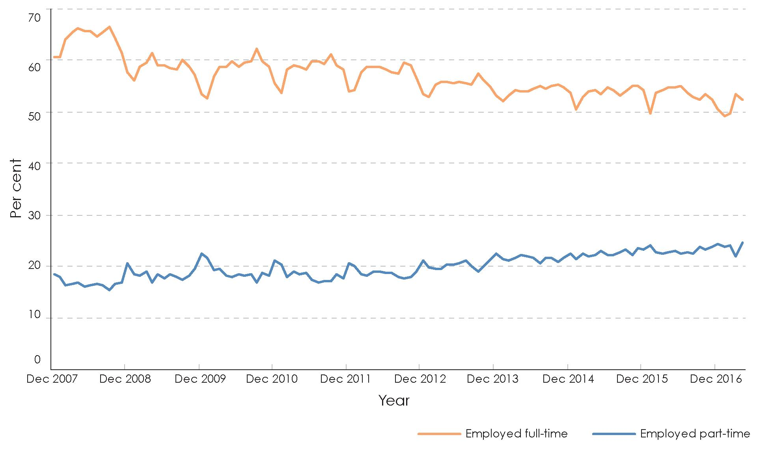
Source: Australian Bureau of Statistics (2018) Labour Force, Australia, Dec 2017, cat. no. 6202.0, ABS: Canberra

Most youth employment occurs in industries providing entry-level jobs and employing lower skilled people. These more 'routine' jobs are highly susceptible to automation, which could affect around 40 per cent of Australian jobs in the next 10 to 15 years. But even for academically more capable students, education no longer provides a clear positioning to succeed in a changing economy, with around 30 per cent of students not in full-time employment four months after they have graduated from university. The economic cost of not addressing these trends is high. If youth unemployment and underemployment rates matched the rest of Australia, they would have generated up to $11.3 billion in additional gross domestic product in 2015.

Limited change in senior secondary models, despite the growing cohort served and the changing world of work they will enter, combined with alarming levels of youth unemployment, mean it is time to review senior secondary models.
There have been pockets of innovation in Australia's senior secondary education and some independent providers are already offering alternative qualifications, such as Steiner and the International Baccalaureate. At a state and territory level, Tasmania and Queensland recently both completed reviews of their senior secondary systems, although proposed changes are incremental rather than transformative.
Case study
Big Picture learning design
Big Picture is a learning design intended to improve engagement by students and is currently being used in 44 schools.135 In its submission to the Review, Big Picture describes its role in reconnecting students through highly personalised learning plans, which are informed by students' passions, as well as an interest-based internship (two days per week) for Year 9 to 12 students to learn from a mentor in the community. These internships are designed to develop experience learnt outside the classroom, including general workplace knowledge, and presentation skills—the students are assessed on presentations of what they have learned. Big Picture design is implemented in different ways at different schools, ranging from whole-school conversion (e.g. Yule Brook College in WA), academies within schools, to students taking Big Picture as an elective or program. Big Picture students have high attendance rates and improved results, and it achieves this across a diverse range of schools and students—catering for previously disengaged students and those who are academically able.
2.11 There is a strong case for a national review of senior secondary schooling
Despite many attempts, over several decades, by the Commonwealth and states and territories to address the issues around the curriculum and delivery structure for Years 11 and 12, the situation remains unsatisfactory. There has been very limited change in curriculum purpose and content, or in the models for providing senior secondary education, despite considerable growth in the student cohort; the large numbers of young people who start secondary school but do not make it into senior secondary; profound changes in the world of work students are being prepared to enter; and growing levels of youth unemployment and underemployment. There is a compelling case for ministers in all states, territories and the Commonwealth to mount an urgent national review.
A national approach is important because:
- reform needs to include a meaningful conversation with industry; and Australia's economy and labour market is not divided between states and territories
- providing a path into university will remain part of senior secondary school education. Universities are funded by the Australian Government, and compete for students nationally
- ACARA already has an established program working with Australian senior secondary

curriculum and certification authorities on senior secondary expectations and options for further development of senior secondary curriculum in partnership with interested jurisdictions. There may be opportunities to leverage this work.
An appropriately in-depth review of the Australian senior secondary schooling model is beyond the scope of this Review. The Review Panel recommends, however, undertaking a national, dedicated review of senior secondary schooling focussing on three areas. Such a review needs to be informed by a robust consultation and co-design process with a wide range of stakeholders.
First: a review should consider the kind and quality of educational experiences provided in senior secondary. In the context of the broad population they serve and the challenges those students will face when leaving school, there is scope to consider:
- more flexible/customised curricula that are more sensitive to student growth and preferences
- increased use of alternative pedagogies including apprenticeship/internship/work experience models, as well as inquiry-based, cross-subject learning
- ways for senior secondary education to incorporate and prioritise the general capabilities identified in the Australian Curriculum
- the provision of informed and consistent careers advice to students determining their next move into the workforce
- a stronger engagement with industry, within and beyond VET—following the example of successful apprenticeship systems in Germany and Denmark that rely on shared responsibility between schools and employers.
Second: a review should examine whether the organisation of senior secondary education in Australia is still adequate and beneficial for the employment outlook of students. For example, there is a long running debate about the virtues of:
- separating senior secondary from other education, or organising it within secondary schools that also serve younger students
- systems with 'comprehensive' schools versus systems where different institutions exist for different pathways (academic/vocational/specialist).
Australian states and territories have incorporated a range of approaches, but these tend to support limited specialisation. Tasmania, for example, has recently decided to merge senior and other secondary schooling. Meanwhile, other jurisdictions around the globe distinguish between academic and vocational pathways and/or provide pathways that offer more or less accelerated progress into higher education.
Beyond this debate, there is also an opportunity to consider a broader reconceptualisation of schools. Some stakeholder consultations advocated that senior secondary schooling should be reinvented as a gateway into the real world. An example is learning from existing initiatives where schools act not just as education providers, but as service hubs offering a multitude of experiences—from industry work placements to volunteering opportunities and extra-curricular activities—in partnership with expert organisations. In the future, a typical week in the life of a senior secondary student could involve an internship for two days, a

mathematics course via distance learning on another day, and two days attending a local school for more traditional learning.
Third: a review should consider how student achievements are assessed and reported. There is a continuum of options for assessing student achievements (see Exhibit 18). These options reflect different purposes and range from clearly communicating standardised information for university admissions to describing a student's capabilities in résumé style.

Exhibit 18. There is a continuum of assessment and reporting options
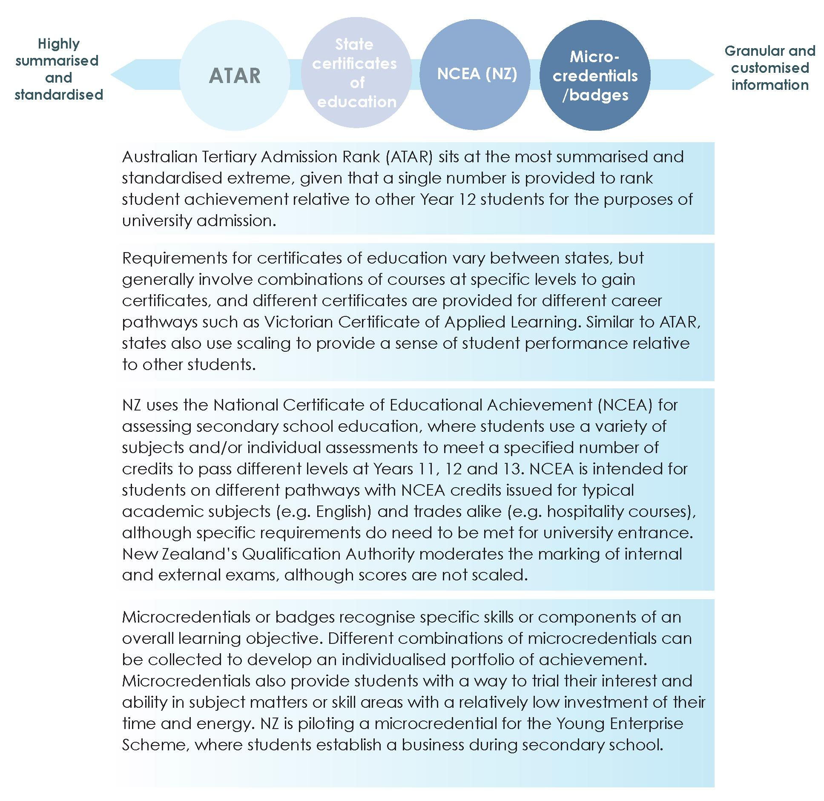
Source: Analysis and exhibit prepared by dandolopartners.

Recommendation 9
Establish a comprehensive, national and independent inquiry to investigate and review the objectives, curriculum, assessment provisions and delivery structures for senior secondary schooling, to report within 12 months.

Chapter three: Creating, supporting and valuing a profession of expert educators
Summary
Teachers are central to a high-performing education system. They are critical to the attainment and acceleration of learning because they are the most significant in-school influence on student achievement. An excellent teacher—with strong professional skills, motivation and commitment—can account for up to 30 per cent of the difference in achievement between students.
Shifting to an education model focused on attainment through maximising the learning growth of every student every year requires teachers to embrace changes to their planning, teaching and assessment practice. For example, they need to understand individual students' starting points; create multi-streamed, differentiated lesson plans for each class; adjust their pedagogy to the different needs of individual students based on evidence about the most effective interventions; seek and act upon feedback from students and provide more nuanced reporting on assessments of students' performance and the next steps in their learning; ensure their growth in learning is appropriate given the student's potential; and identify 'flight paths' for where the student needs to be to maximise learning growth each year.
While teachers recognise the benefits of these methods for student outcomes, and some are already applying them through the use of increasingly available technology, many find them challenging to implement. Most Australian school education is based on a 20th century model that aims to provide a standard, mass education. It does not support the widespread implementation of contemporary teaching methods, such as tailored teaching. The shift required for teachers to focus on the goal of achievement through individual student learning growth is complex and sophisticated and requires significant support, different types of expertise and greater collaboration compared with traditional education models.
In a growth-based learning environment, teachers need to upgrade their professional practices to accommodate the changes required. School systems and schools need to promote a profession of expert educators who foster the learning growth of their students through collaboration, mentoring and continuous learning. This means 'Every teacher needs to improve, not because they are not good enough, but because they can be even better.'
Many attempts have been made to reform education and teaching policies at the state and federal level to improve teaching quality. Some efforts have generated lasting impact and some are ongoing. The Review Panel believes, however, that there are still opportunities for Australia's education system to better support and encourage teachers' practice, underpinned by contemporary research, and to use technology more effectively to enable personalised learning. These include greater use of collaborative teaching models, more insightful formative assessment tools and better access to effective professional learning. It also includes prioritising high-impact teaching and professional learning practices.
As exceptional teachers make such a difference to student outcomes, it is also important to attract the best talent to teaching. Once in the system, teachers need meaningful career

pathways that cultivate and recognise expertise through appropriate remuneration and role allocation. Teachers must be valued for the critical role they play in educating young Australians.
Enabling excellence in classroom practice
Australia has many exceptional educators who strive every day to equip young people with the skills and knowledge needed to thrive in a rapidly changing and interconnected world. However, their ability to enrich and maximise individual learning growth for every student every year will be limited if the education system remains attached to old paradigms. Pedagogical practices must be contemporary and evidence-based, and teachers must have the resources and expertise to update their methods to those practices proven effective by current research, and aligned with leading education nations globally. In addition, students and their parents and carers must partner with teachers in the learning process.
Many teachers report difficulties that challenge their ability to teach to their best effect, including competing demands on their time, lack of tools to support modern evidence-based pedagogical practices, and lack of access to relevant professional learning. It is essential to overcome these challenges to maximise individual student learning growth. The Review Panel has identified three actions that are key to support a growth focus:
- embedding professional collaboration as a necessity in everyday teaching practice
- developing a formative assessment tool that measures individual student growth and enables teachers to assess where individual students are on the various learning progressions, monitor student progress against expected outcomes and tailor teaching practices to maximise student learning growth
- providing a professional learning environment to enable, support and improve teaching practice that promotes individual student learning growth.
Crucially, schools need to help teachers seize any opportunity to work collaboratively and review their own teaching practices. This will require a rethink of time use and work practices in many Australian schools, where the average teacher is often burdened with administrative tasks and finds little time to develop new teaching skills.
On average, Australian teachers spend less time on professional learning and collaboration than teachers across Organisation for Economic Co-operation and Development (OECD) countries. Australian teachers also spend considerably less time on professional learning than teachers in the world's best performing school systems, and more time face-to-face teaching.
School systems and schools should strive to optimise their teachers' schedules so they can better balance teaching obligations, administrative tasks and effective professional learning. This could involve considering different and innovative ways to free up teacher time, for example using more paid paraprofessionals and other non-teaching personnel, including trained volunteers, to assist with non-teaching tasks such as lunchtime or assembly supervision or administrative tasks.

Many schools use parent and carer volunteers in some of these roles, most commonly to facilitate early primary students reading aloud. There are opportunities to extend this model to further support teachers, recognising that teaching reading is a specialist skill, and that not all schools have parents and carers who are willing or able to assist in this way. Broadening the base of potential volunteering contributors to appropriately checked and trained members of the community could assist teachers with the non-pedagogical aspects of their role, and increase community involvement in schools. This might include drawing on professional skills within the parent body or community, such as information technology or finance skills, to assist to relieve the administrative burden on schools and improve the overall school experience for teachers, students, parents and carers.
For teachers to fulfil their role as expert educators, schools need to be seen as professional learning organisations. They need to develop a culture that values continuous learning where teachers, as well as students, can feel safe to admit gaps in knowledge and understanding.
3.1 Systems need to create the conditions and culture to enable and encourage more collaboration
There is growing evidence that a 'de-privatisation' of teaching—moving away from teachers being solely responsible for their own teaching practice, and working alone in front of the class—has a positive effect on student learning. Research supports a new conceptualisation of a school as a learning organisation with a high level of collaboration and shared practice among teachers, and coherent activities for professional learning. There is nothing new about teachers working together, but the impact of collaboration can be maximised if school systems and schools adopt effective collaborative practices and create the right conditions for these collective engagements.

Improvements to education in Australia could be enhanced if the focus moved to measurements that recognised that system-wide factors impact upon school and student success and failure. The education system needs to find ways to encourage more cooperation across and between schools. Australia should seek to create educational communities larger than the local school and find means to facilitate teachers sharing and learning from the practices and experiences of fellow professionals.
Deakin University – Submission

Collaboration is increasingly valued in the education sector because it offers three key benefits. First, collaborative structures allow teachers to coordinate shared activities more efficiently than centralised bureaucratic organisational structures, which are often costly and rigid.
Second, collaboration can lead to a more authentic engagement of teachers because it allows them to build voluntary, reciprocal relationships. Such relationships can create a greater sense of belonging for teachers in a system where a strong fragmentation into

disciplines causes many to feel isolated. This level of collaboration also enables teachers to challenge each other to further improve practice and allows collaborative moderation that can address differences between classes.
Third, collaboration can provide teachers with flexible and differentiated professional support tailored to their specific needs and objectives.

Collaboration between schools and across all schooling sectors is one of the keys to sharing knowledge and best practice so that all schools benefit. Maximising the learning outcomes and wellbeing of all students and providing access to a high-quality education is the responsibility of all schools. Systemic improvements in school education requires a long-term commitment to collaboration and continuing the reform agenda.
Independent Schools Queensland – Submission

Teacher collaboration occurs in many forms, however not all types are equally effective. Active collaboration—such as peer observation and feedback, coaching, mentoring, team teaching and joint research projects—allows teachers to learn from each other and typically has a positive impact on students. In contrast, collaboration that concentrates on simply sharing resources, planning activities or administrative issues has little or no positive effect on student achievement.
Active collaboration is particularly important for creating a growth-based learning environment and for increasing student learning progress. Research shows that teachers who work together and learn from each other are more successful in improving student outcomes than those who work alone. Feedback, new information and ideas largely spring from dialogue and interaction with other people, rather than from individual learning.
Collaborative practices can involve not only collaboration between teachers, but also teachers engaging students as collaborative partners and seeking student feedback on how well the teaching process is meeting individual learning needs. When teachers are open to feedback from students, teaching and learning can be synchronised and powerful.
A culture of collaboration enables teachers to adjust and adapt their methods as new research-based practice become available. Teacher collaboration—when strongly related to daily classroom practices and pupil learning—has strong positive effects on professional learning and change. Professional Learning Teams and Professional Learning Communities—organisational units in which teachers collaborate in teams and make decisions about differentiated teaching and instructional interventions that focus on scaffolding learning for students—are two examples showing the power of collaboration among teachers.

Case study
Teacher collaboration at Bray Park State High School, Queensland
A 2014 internal review of Bray Park State High School identified a need to improve teaching quality and student outcomes. In response, the school introduced new pedagogical approaches supported by better opportunities for teacher collaboration.
Professional learning communities meet fortnightly to discuss student achievement data and share strategies to better support learning. Another group of six staff meet fortnightly to identify and support professional learning opportunities that are targeted to staff need. Information on staff learning needs is gathered through surveys.
Teachers regularly undertake informal classroom walk-throughs to learn more about each other's practice and provide feedback. Formal classroom observations occur at least once per term for teachers to receive feedback on specific areas they have nominated. A leadership coach works with senior staff to advise on coaching colleagues and working towards improvement goals.
Since the new initiatives were implemented, the share of English, science and mathematics students gaining a C grade or better has increased from 65 per cent to 85 per cent. Student disciplinary absences have reduced from one of the highest in the region, to the lowest. The school staff opinion survey shows an increase of staff morale from 40 per cent to 95 per cent. The school was awarded State School of the Year in 2017 as acknowledgement of all its work.154
Submissions to the Review argued that teachers want to focus on teaching and need to be able to set aside time for high-impact activities such as collaboration, while minimising time spent on low-impact activities. Teachers in Australia currently have limited scope to participate in formally structured professional cooperation outside professional subject associations, which have only small active memberships.
To match high-performing countries, Australia needs to enable school leaders to reshuffle priorities and focus on embedding collaboration, observation and feedback into their teachers' core schedule. Strong school and system leadership is essential to create opportunities for teachers to undertake high-impact activities, such as collaboration, moderation, observation of other practitioners and quality professional learning. School leaders should also provide opportunities for their teachers to access coaching or mentoring from expert teachers to refine their teaching skills.

As a certified [Highly Accomplished] teacher I have built strong professional relationships, through a practice-focused mentoring approach, to support and challenge teachers to improve their classroom practice. I have effectively mentored a range of early career and experienced teachers by concentrating on diagnosing learning needs, improving subject-specific pedagogical knowledge as well as strengthening classroom management strategies.
Melinda Haskett (Highly Accomplished Teacher, NSW)

School system and school leaders should promote the idea that teaching is a continuous-learning profession. They should facilitate the access of teachers to high-quality professional learning, so teachers can better use collaboration as a means to accelerate and enrich student learning. While some teachers will find it easier to collaborate than others, collaboration is a skill that can and should be practised and refined.
Recommendation 10
Accelerate the development of contemporary pedagogy through the use of collaboration, mentoring, observation and feedback, including from colleagues and students, by incorporating these practices into the core role of teachers and creating the conditions to enable teachers to engage in them.
3.2 Teachers need a new tool for formative assessment of student learning
There is compelling evidence in Australia and internationally that differentiated teaching based on ongoing formative assessment of a student's learning progress significantly boosts student achievement.
To focus on student growth at an individual level, teachers need a common understanding of what constitutes a level of achievement and progress. This is the purpose of the learning progressions detailed in Chapter 2. Once the progressions have been developed and implemented, there will be a common understanding among teachers of levels of achievement and of what additional learning constitutes progress. The learning progressions will establish a shared language to facilitate discussion and collaboration between teachers in the same school about individual students and groups of students, and in professional learning communities and networks beyond the school.
This will mean when students move from one teacher to another, or from one school to another, their stage of learning will be clear, letting the new teacher immediately plan the best way to build on the student's current level of attainment. The progressions will also enable teachers to engage in discussion with parents and carers using far richer evidence of achievement than in the past.
Accompanying the introduction of the learning progressions, the Review Panel believes that support should be provided to teachers in the form of an online formative assessment tool. The tool would assist them to readily identify the stage of learning a student has reached and to provide a choice of possible appropriate interventions from which the teacher could select to provide the next challenging but achievable learning task.

Assessment is an intrinsic element of good teaching practice and should provide teachers, students and parents with information about the progress and achievements of students. Therefore systems must ensure teachers are deeply involved in developing and reviewing curriculum and assessment at all levels and; that assessment is authentic and integrated with teaching and learning.
Australian Education Union – Submission

Using formative assessment, teachers can work together to assess a student's existing knowledge, develop personalised learning plans, set goals for where the student needs to be in one year's time and track the student's progress over time, intervening if progress stalls or regresses. They will be able to analyse the impact of their teaching, the interventions they applied and identify what has been most effective and discard what has not. Timely and rich data will help teachers make responsive and informed decisions about how to most effectively support individual student growth and achievement. The most advanced students will be extended even further, and the less advanced students will steadily progress towards high achievement.

Exhibit 19. What does the evidence say works best in teaching?
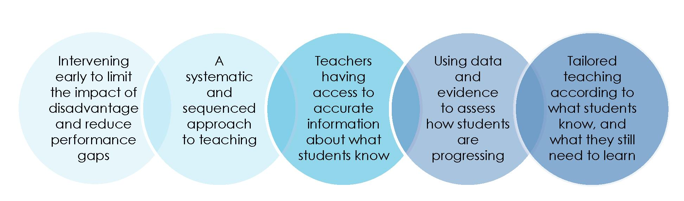
Source: NSW Department of Education (2018) presentation to Directors, The Literacy and Numeracy Strategy2017-2020, unpublished.

Few assessment tools or tests currently exist in Australia to measure an individual student's learning growth over time. The available assessments do not provide teachers with real-time or detailed data on a student's growth, nor do they provide teachers with information or resources about suggested next steps to improve student outcomes. Tests such as the National Assessment Program - Literacy and Numeracy (NAPLAN) and Programme for International Student Assessment (PISA) provide a useful 'big picture' view of student learning trends across Australia and the world, but have limitations at the classroom level: they report achievement rather than growth and, in the case of NAPLAN at present, the results are six months old by the time they are released and the test is only administered at Years 3, 5, 7 and 9.
This means teachers need significant time and expertise to assemble and assess data on student growth. Once the data are assembled, teachers need support to understand the evidence and determine the most appropriate teaching response. Teachers need to have useable data about each student at their fingertips as the basic prerequisite for improving learner outcomes.

There is scope for new, consistent, high quality and easily deliverable formative assessment tools to help drive improvement in the outcomes of students in classrooms across Australia by providing teachers with access to real-time achievement data to inform their teaching ...
Currently, there is uneven access to validated formative assessment tools across Australia. Instead, teachers often need to rely on a mix of locally developed (often by individual teachers) idiosyncratic tools that do not provide the most reliable measure of absolute or relative learning progress. This limits our teachers' ability to measure and monitor student achievement against key skills.
Victorian Department of Education and Training – Submission

Teachers in Australia would benefit from a new online formative assessment tool—calibrated against the learning progressions—that measures student attainment and growth in attainment levels over time. The tool could also suggest, for consideration by the teacher, potential interventions to build further progress. Such a diagnostic tool would help teachers tailor teaching to maximise student learning growth without adding to their administrative burden. Many submissions supported the development and use of such a tool.

Teachers need to have the tools, knowledge and ability to assess the learning needs of each of their students and to put in place and execute plans that maximise the learning growth for each student.
Teachers require practical support to assist them in their work with students. For example, improving the national repository of formative assessment resources and tools will provide substantial benefits, particularly for smaller jurisdictions.
Tasmanian Government – Submission

Formative assessment at the school level (assessment for learning) is essential to inform learning programs for individuals and groups of students. A national computer-based 'assessment and learning' system that allows teachers to assess a wide range of learning in a 'just in time' way, and then provides links to high impact teaching strategies based on the student's responses would be of immeasurable benefit as teachers, schools and systems seek to increasingly personalise learning for maximum learning benefit.
Australian Capital Territory Government – Submission

Finding 7
There is compelling evidence, in Australian schools and internationally, that tailored teaching based on ongoing formative assessment and feedback are the key to enabling students to progress to higher levels of achievement.
Exhibit 20 provides an overview of the proposed formative assessment tool. The tool would assist teachers to personalise learning to maximise student learning, and to provide more meaningful information to students, their parents and carers about the student's individual progress and the next steps in learning.
The tool should be accessible as frequently as required by teachers and measure and track student growth and progress across a year and between years. It should be readily available to teachers on a variety of electronic devices.

Critically, the tool should hold a large store of validated assessment items and tasks in multiple learning areas, mapped across the learning progressions to enable teachers to measure a student's attainment. Teachers could select items of their choice from the pool of appropriate assessment tasks, in order to identify the level of attainment of a student in a particular subject or learning area prior to tailoring teaching or developing their learning unit. The student would then undertake those tasks, either electronically or as an open-ended task set by the teacher. The task could be marked via the online tool, or the teacher could validate or mark the task and enter the scores. On the basis of the evidence provided about the student's current level of attainment, the teacher could then personalise the next challenge in learning for the student, assisted by suggestions made by the learning tool.
The tool must also be able to report the current level of student achievement, report progress against the previous assessment and provide tailored advice to teachers by suggesting options and curriculum resources for the next step in learning.
The availability and use of the tool would not diminish in anyway the professional responsibility of the teacher to make evidence-informed decisions and to respond to individual learning needs, but it would efficiently assist the delivery of diagnostic assessment and differentiated teaching in the classroom.

Students need to know where they are on their personal learning journey. Parents need to know if their child is learning at the rate and level expected. Teachers need to know if their teaching practices are well-focused and effective. Greater respect for formative and qualitative assessment is needed, with opportunities for teachers to moderate and share effective practice.
Australian Government Primary Principals Association – Submission

Exhibit 20. Overview of the proposed formative assessment tool
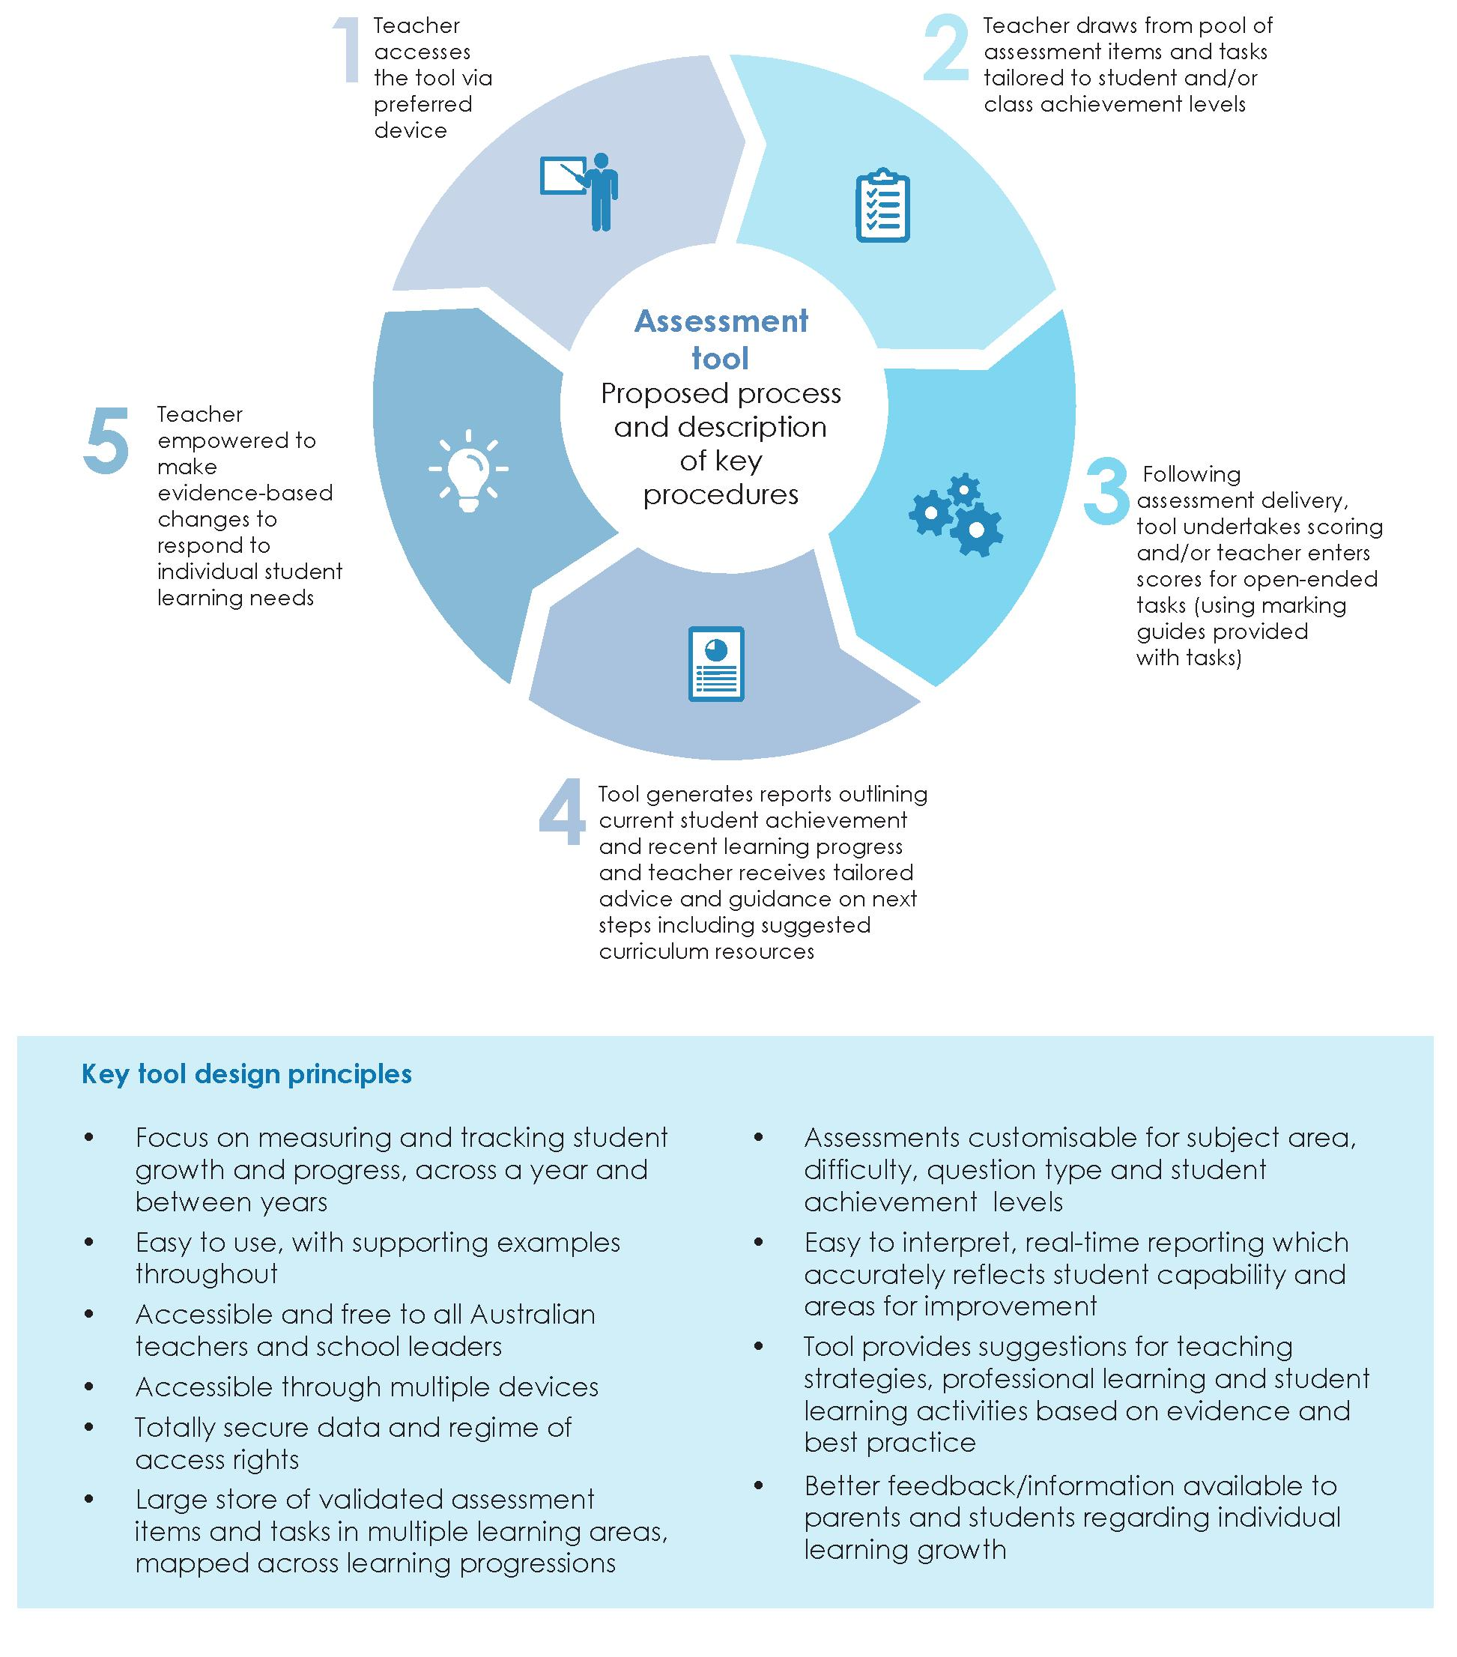
Source: Adapted from KPMG (2017) Understanding progress to improve teaching: A tool for teachers and school leaders, Business Case, AITSL: Melbourne, unpublished.

Recommendation 11
Develop a new online and on demand student learning assessment tool based on the Australian Curriculum learning progressions.
The Review Panel recognises that a shift to a learning model focused on achievement through growth involves a number of significant changes in the nature of teachers' work. These include:
- basing the learning program on learning progressions not on an annual package of curriculum content
- changing the nature of assessment and the way in which progress and attainment are reported
- using the formative assessment tool and adopting tailored teaching in order to personalise learning
- engaging in ongoing professional learning and collaboration
- working in partnership with parents and carers to a much greater degree than is currently the case.
All these activities should be core components of a teacher's workload.
The success of these reforms depends upon the concurrent provision of a suite of professional learning resources and tools for teachers, implemented over several years as the progressions and the online learning tool become available. It is likely that there will be a need to reduce teaching contact time to enable this to occur.
Recommendation 12
Create the conditions necessary to enable teachers to effectively engage and benefit from professional learning in the use of the Australian Curriculum learning progressions, the new online formative assessment tool and tailored teaching practices to maximise student learning growth.
3.3 Professional learning needs to enable tailored teaching for maximum impact
In recent years there has been an explosion of knowledge about the way children learn and how to teach them effectively. As teaching practice becomes more complex, the expectations placed on teachers have similarly increased. To ensure teachers can apply teaching methods that are evidence-based and meet the needs of students in a learning model focused on achievement through growth, teachers must increasingly embrace ongoing learning as integral to their profession. For this to occur, teachers need greater opportunities to access professional learning, and time to do so.
Professional learning is a key feature of high-performing education systems internationally. For example, in Shanghai's teacher development scheme, in-service training is one of the basic requirements for promotion. Ongoing professional development is conceived as integral to a teacher's lifelong learning.

Finding 8
Research and experience internationally confirms that ongoing professional development for teachers—some mandated by the school or system, and some through participation in professional learning communities—is an essential part of a teacher's workload in high-performing education systems.
Not all types of professional learning are equally effective. Professional learning is most impactful when it is relevant, collaborative, future-focused, and when it supports teachers to reflect on, question and consciously improve their practice.
Professional learning programs should be adaptive, responsive, and draw on global best practice in effective adult learning. High-quality teacher professional learning includes opportunities for active learning and interaction with colleagues; takes place over an extended period of time; and comprises collective learning activities (for example, communities of practice) or joint research with other teachers. Overall, professional learning should build a teacher's capability to tailor teaching for individual students for maximum impact, and in particular focus on teachers' ability to:
- select, adapt and apply appropriate assessments to determine their students' current levels of attainment in particular learning areas
- use assessment outcomes and data to diagnose and evaluate the diverse capabilities and learning needs of individual students in a classroom
- analyse and use data and evidence about student learning to select appropriate resources and activities to tailor teaching to meet the personalised learning needs of students
- collaborate with, and support, colleagues to implement teaching methods that maximise individual student learning growth.
International studies show that traditional forms of professional learning, such as short workshops and seminars, are more prevalent in the education sector than innovative and high-quality approaches that are more likely to lead to a change in teaching practice. Innovative and high-quality types of professional learning include networking, mentoring, classroom observations and building professional learning communities.
High-quality professional learning programs, however, that continually improve learning and teaching are time-intensive and require considerable resources. While many school leaders and systems are open to providing more professional learning opportunities, too often they cannot find the time or resources to do so.

There is no magic bullet, no one-size-fits-all set of actions that will improve practice and outcomes. Educators need principled methods for undertaking a comprehensive analysis of the learning needs of individual students and of particular student profiles in specific contexts. Educators can then draw on their repertoire of practices and strategies to design programs that address these needs. To support this approach, teachers need to be provided with systematic and sustained professional development, as well as with well-designed and targeted resources, they can draw on to plan customised programs differentiated to meet the diverse learning needs of their student cohort. Teachers should be provided with training and expertise, and then that training and expertise needs to be trusted and respected, and teachers given the space to make professional decisions based on their knowledge of the students, the teaching situation and the community context.
Primary English Teaching Association Australia – Submission

To support the shift to a growth-centred learning environment, the Review Panel considers it critical to provide better access to high-quality professional learning and greater encouragement for teachers to undertake it. There should be a focus on effective research-based teaching methods and building teachers' capability to analyse data and use evidence about student learning to tailor teaching more precisely to student learning needs. Professional learning should also prioritise developing teachers' capacity and capability to collaborate with colleagues using feedback from students and colleagues to continuously improve their pedagogical practices, and learning about workforce structures, such as multi-teacher teams, that make effective use of expert teachers.
Participation in high-quality and effective professional learning among all teachers should occur at all schools and across all schooling systems in Australia. School systems need to provide clear guidance on how to ensure that professional learning conducted in schools is effective, and schools need to monitor whether all teachers are provided with and are embracing opportunities. Systems should also create the conditions necessary for teachers to engage in quality professional learning. School systems and schools must be held accountable for the effectiveness of their professional learning programs. They must promote learning that drives teacher expertise, supports student growth and contributes to a continuously improving education system.
Recommendation 13
Create a continuously improving profession through the provision of high-quality professional learning for teachers; appropriate to their career stage, development needs and the changes rapidly occurring in society.
Valuing and growing career opportunities for teachers
To create a world-class teaching workforce in Australia, teaching needs to be an appealing and valued profession that attracts and retains the best candidates, and that supports and develops them at every stage of their career.
Enhancing and valuing the teaching profession is a critical part of Australia's journey towards educational excellence. Shanghai's improvement in educational outcomes has been attributed to the creation of a high-quality teacher workforce in which teaching is promoted as a desirable and prestigious lifelong career requiring professionals to continually

improve. Australia can cultivate a profession of expert educators by creating meaningful career pathways for teachers and strongly valuing their expertise and impact.
Improving the efficiency and equity of schooling largely depends on ensuring that competent people want to work as teachers, that their teaching is of high quality, that they are committed to continuous improvement and keeping their practices up to date, and that all students have access to high-quality teaching.
To drive excellence in Australia's teaching workforce, as well as improve the status of the teaching profession and strengthen retention rates, the Review Panel suggests:
- undertaking better workforce planning through a comprehensive national workforce strategy
- further embedding recent reforms to initial teacher education (ITE) to produce better trained, classroom ready teaching graduates
- better induction for early career teachers to improve their transition into the profession and promote retention and professional growth
- better cultivation, recognition and utilisation of expert teachers
- greater recognition and higher esteem for the teaching profession.
Finding 9
To continue to grow student outcomes, we need to attract and retain the best and most effective teachers in the profession. Teaching must become a high-status profession of expert educators.
3.4 A comprehensive national workforce strategy will better develop and match the teaching workforce to meet Australia's needs
Attracting and retaining excellent teachers is one of the most important drivers of a well-functioning education system that prepares diverse students with complex needs to participate in today's knowledge-driven economy.
Early career attrition—teachers who leave the profession within the first five years—clearly reduces the talent pool in schools, which in turn can hinder efforts to develop a strong workforce of experienced, high-calibre educators. As no reliable data are available, estimates of current attrition rates among teachers in Australia vary substantially, ranging from eight per cent to 50 per cent.
Factors driving attrition include unstable employment patterns, and a heavy and increasingly complex workload. Research suggests that teachers are less likely to leave the profession early in their career if they work in a supportive school environment, see

themselves as adequately prepared for classroom practice, and can find stable, permanent employment.
To create meaningful career opportunities and reduce attrition, Australia needs to address mismatches in the supply and demand of teachers. Such mismatches can lead to excess demand for teachers in some areas, and critical shortages in others. For example, in a 2013 survey, four per cent of primary principals and eight per cent of secondary principals said that over the past 12 months they experienced major difficulties filling vacancies with suitable candidates. A further 27 per cent of secondary principals and 17 per cent of primary principals reported moderate difficulties with recruiting staff.
Principals at 'hard-to-fill schools', such as those in rural and remote and low socio-economic status areas, also report difficulties filling vacancies and attracting high-quality teachers. This aligns with the findings of the Independent Review into Regional, Rural and Remote Education that reports attracting and retaining teachers for regional, rural and remote schools continues to be one of the most persistent challenges on the education agenda. Teachers may consider schools in regional areas and in locations of lower socio-economic status to be less desirable placements. These schools may offer reduced access to educational facilities and personal amenities, making recruiting more difficult. Other complicating factors include a greater sense of social isolation and sometimes unsatisfactory living arrangements.

Case study
National Exceptional Teaching in Disadvantaged Schools program
The National Exceptional Teaching for Disadvantaged Schools Program (NETDS) was designed and founded by Professors Bruce Burnett and Jo Lampert in 2009 as a means of identifying, preparing and deploying high-performing pre-service teachers for work in the challenging setting of low socio-economic status schools. NETDS is an overt attempt to correct the inequitable distribution of high performing teacher graduates and is structured around the following five related issues:
- Attracting the highest achieving pre-service teachers into a specific program targeting poverty
- Creating a modified curriculum within existing Bachelor of Education units centred on unpacking disadvantage and promoting key notions of social justice
- Mentoring NETDS pre-service teachers' exposure to challenging high poverty professional experience placements
- Engaging the profession in strategic partnerships that ensure NETDS graduate employment, and
- Further researching the outcomes and impact of NETDS in terms of quality teaching within low socio-economic status schools.
Support from the philanthropic community (Origin Foundation, Vincent Fairfax Family Foundation and the Eureka Benevolent Foundation) has enabled NETDS to expand into eight Australian universities (Australian Catholic University, Deakin University, University of Newcastle, University of South Australia, University of Western Sydney, Victoria University, University of New England and QUT) with approximately 90 per cent of NETDS graduates choosing to work in low socio-economic status schools (QUT data). The program has produced critical new theoretical understandings regarding teacher education for disadvantaged schools and shown the importance of scaffolding the exposure of pre-service teachers to low socio-economic status schools.
Professor Jo Lampert (La Trobe University) and Professor Bruce Burnett (Australian Catholic University) continue to work and collaborate across the national network of partner university NETDS programs listed above.176
New teachers are often concerned they may be employed in casual roles for many years or required to teach subjects they are not familiar with, which can add to their planning and preparation workload. Recent research shows that teachers in their first two years of teaching were more likely to be teaching out-of-field than those with more experience. The concerns are particularly justified in critical subject areas such as mathematics and science, where an undersupply of teachers forces too many students to be taught by teachers out-of-field. As highlighted in Exhibit 21, the two subjects that the most schools report having unfilled teacher vacancies in are mathematics and science, with nine per cent of secondary schools reporting unfilled teacher positions in mathematics and six per cent in science. Yet mathematics and science are critical proficiencies in an increasingly technology-dependent workplace and Australian student outcomes are declining in both areas. A high-quality supply of specialist mathematics and science teachers is essential to turn this situation around.

Exhibit 21. More schools report vacancies in mathematics and science than any other subject
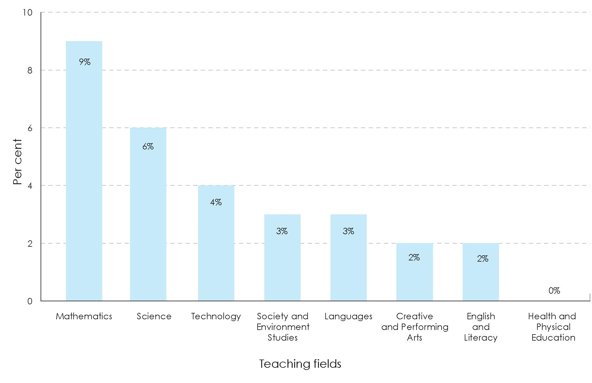
Source: McKenzie, P., et al. (2014) Staff in Australia's Schools 2013: Main report on the survey, ACER: Melbourne, pp. 126-127.

An analysis of data from the OECD's Teaching and Learning International Survey (TALIS) 2013 shows that an estimated five per cent of those teaching mathematics and six per cent of those teaching science in Australia are teaching out-of-field. Other research based on data from the Australian Government's Staff in Australian Schools survey 2013 suggests that between 20 and 40 percent of those teaching mathematics are teaching out-of-field.
It is important that teacher shortages are addressed to ensure all classrooms are fronted by teachers with the skills and knowledge required to promote student growth. Some jurisdictions have created targeted programs in an attempt to attract new teachers to work in schools with persistent vacancies. For example, the NSW Teach Rural Scholarship offers university students in teacher education courses a subsidy to study and a full-time job after graduation, on the condition they teach in a public school in rural or remote parts of NSW for at least three years.
Creating alternative pathways into teaching is another way teacher shortages can be addressed. Alternative pathways refer to non-traditional routes into teaching, which are often employment based, accelerated and/or recognise existing teacher expertise. They can make a pathway into teaching realistic and appealing to a wider range of candidates, and bring new or specific skills into the teaching profession. The Review Panel understands this is an area the National Review of Teacher Registration is investigating and endorses

this work noting that, as a profession, teaching requires a level of qualification that must be achieved irrespective of which pathway is taken by the new teacher.
The retention of high-quality teachers needs to be a critical component of a teaching workforce strategy. To attract and retain teachers starting at, or moving to hard-to-staff schools, these teachers must be well supported. Retention is more likely in a school where a teacher encounters supportive relationships and practices, such as through induction and mentoring programs.
Data will soon be available from the Australian Teacher Workforce Data on teacher demographics, qualifications, registration status and current employment. To ensure all schools are staffed with teachers with the skills and capabilities required to improve student outcomes, the Australian Teacher Workforce Data should be used to inform discussions between providers of ITE and school systems and schools.
The data will facilitate a national teacher workforce strategy, which should be developed by the Commonwealth, in partnership with states, territories and the non-government sector. Schools and education authorities can use the data to more accurately model the supply and demand of teachers and plan future workforce needs. A national teacher workforce strategy could also equip states and territories with information to implement streamlined recruitment practices, for example, through a centralised online portal. At a minimum, the strategy needs to ensure that:
- graduate supply from ITE programs better match with workforce demands including skill and capability requirements
- there are strategies in place to incentivise entry into ITE by high-quality candidates from required disciplines in priority areas, in particular mathematics and science, and to eliminate out-of-field teaching
- there are strategies in place to incentivise the attraction and retention of high-quality, experienced and expert teachers in difficult to staff schools including in regional, rural and remote areas and low socio-economic status schools
- diversity in the classroom is encouraged (for example through increasing Aboriginal and Torres Strait Islander teachers) as it promotes student creativity, motivation, deeper learning and problem-solving skills.
Recommendation 14
Develop a comprehensive national teacher workforce strategy to better match supply with workforce demands, including skill and capability requirements.
3.5 Further embedding recent reforms is essential to produce better trained, classroom-ready teaching graduates
The Teacher Education Ministerial Advisory Group (TEMAG) was established by the Commonwealth to provide advice on how to improve the training of Australian teachers and ensure the best candidates are attracted. TEMAG identified several problems, including

deficits in the ITE quality and selection processes and shortcomings in subject and content preparation (particularly related to embedding literacy and numeracy as core elements of primary teaching, and the need for science and mathematics specialists in primary school). TEMAG also reported that new teachers often lack classroom readiness and need more support at the start of their career.
In response, the Government introduced multiple reforms. They include:
- suitability for teaching: a requirement for transparent selection frameworks that assess an applicant's academic capability and personal suitability for teaching prior to admission
- classroom readiness: a performance assessment in the final year of teaching to demonstrate students have met the national Graduate Teacher Standards and are ready for the classroom
- personal literacy and numeracy skills: a national literacy and numeracy test requiring all pre-service teachers to demonstrate they are in the top 30 per cent of the adult population for literacy and numeracy, which was introduced in 2016
- ITE accreditation: a stronger regulatory regime with new standards and procedures to achieve accreditation to improve the quality of ITE programs
- subject specialisation: requirements for all primary teaching students to complete a subject specialisation, prioritising subjects of high demand such as science and mathematics.
The Review Panel acknowledges that a number of TEMAG reforms have commenced implementation and the early achievements are encouraging. These include the introduction and roll-out of the literacy and numeracy test for ITE students from 2016 and the introduction of mandatory subject specialisation for primary pre-service teachers commencing no later than 2019. There has also been a decrease in the number of ITE programs as a result of changes to accreditation, from over 450 in 2014 at the time of the TEMAG report to 345 at the beginning of 2018. Developing a comprehensive workforce strategy will allow further assessment of the impact of the TEMAG reforms and identification of a forward agenda of next generation reforms to consider.
Finding 10
There has been significant national progress made towards achievement of the Teacher Education Ministerial Advisory Group reforms to improve the quality of Australian initial teacher education. It will be important, however, to maintain an unrelenting focus on the rigour of their implementation to achieve the goal of raising the quality of our initial teacher preparation and improving the classroom readiness of graduate teachers.
3.6 Better induction for early career teachers will improve their transition into the profession and promote retention and professional growth
The early years in the classroom are among the most critical for a teacher's development. Many struggle with the transition from the safety and security of being a pre-service teacher to becoming a fully-fledged classroom teacher. To support this transition, induction is an essential process. Induction refers to a formal program and other support provided to assist

early career teachers to learn, practise and refine the elements of teaching practice that are best acquired while in the classroom.
School-based induction is a comprehensive process. When done effectively, it can lead to higher retention rates of new teachers and improve student learning. In the United States, a review of 15 empirical studies showed overwhelming evidence of the benefits of induction. For example, beginning teachers who participate in some sort of induction are generally more satisfied and committed to their job, and less willing to leave. Research also shows that induction can improve a teacher's classroom practice and pedagogical methods, leading to better performing students.
Case study
South Australian new teacher induction program
The Department for Education and Child Development in SA provides an Early Career Teacher Development Program—a professional development pathway that guides beginning teachers' transition into the profession and supports their development from the Graduate to the Proficient career stage of the teacher standards.
The program provides online resources and face-to-face workshops for beginning teachers, in addition to guidelines for school and preschool leaders and mentors. It enables early career teachers to take a lead in their own induction with the support of their professional network and colleagues from their school or preschool. Funding is provided to schools and preschools that employ early career teachers to cover release time so that new teachers are able to participate in workshops, online learning, mentoring and induction activities. The funding also contributes to release time for beginning teachers' mentors to access professional learning.
Mentors are identified locally by the school or preschool leader, and are often one of the school leadership team or a teacher-leader such as a nationally certified teacher. The mentor provides support, observation, clarification and ideas.
Highly Accomplished and Lead Teacher positions were recently established in the system, and a small number of positions have been filled by nationally certified teachers at specific schools and preschools in SA. One of the requirements of the position is that these teachers inspire colleagues to improve their own professional practice, and are skilled in mentoring and developing others.
At one of the large, low socio-economic status schools for example, the Highly Accomplished teacher collaborates with other teacher leaders to provide additional support sessions and resources to complement the centrally provided Early Career Teacher Development program. They align local delivery of the program to their school priorities and expectations. Funding is used to release these teachers from the classroom one day per week to implement the program for three new graduates and four other teachers in their early years of teaching. Delivery includes modelling lessons, facilitation of workshops and guidance in collecting and analysing evidence of practice to support early career teachers' understanding of the requirements to progress from Graduate to Proficient.185
There is broad agreement in the Australian education sector that induction is valuable for beginning teachers. It is also generally accepted that effective induction can optimise the impact of early career teachers on student learning. The Australian Institute for Teaching

and School Leadership (AITSL) has established clear evidence-based guidelines for teacher induction to support the transition from the Graduate to the Proficient Career Stage. These guidelines offer an outline for improving the consistency and quality of induction practices across Australian schools.
Implementation of induction strategies underpinned by best practice and aligned to the guidelines, however, is inconsistent across school systems and schools and not sufficiently embedded in everyday teaching practice. Surveys of early career teachers indicate that induction at Australian schools could be more consistent and more effectively meet the needs of beginning teachers.
The Review Panel notes that the National Review of Teacher Registration will consider how registration can support teachers to attain classroom proficiency. Better induction programs, for both new teachers and their mentors, is another important way to ease the transition of new teachers into the classroom.
Finding 11
Implementation of effective induction practices and appropriate conditions are critical to support the transition from initial teacher education into the profession for early career teachers, and play an important role in promoting retention and professional growth.
Induction practices should be underpinned by teacher collaboration. This provides an additional level of support to beginning teachers and instils in them a growth mindset and positive commitment to continual learning and professional growth.
The best induction programs include practice-focused mentoring, leadership contact, participation in collaborative networks, targeted professional learning, observation and reflection on teaching, practical information and time allocation. Practice-focused mentoring, by one or more expert colleagues, is particularly powerful in supporting the transition of early career teachers. Practice-focused mentoring involves a strong professional relationship that attends to the professional development of early career teachers through ongoing observation, conversations, evidence about and assessment of practices, goal-setting aligned with standards of quality teaching, and technical and emotional support.
Effective induction activities require both mentors and early career teachers to take time out from their regular obligations, and schools should support these efforts.
High-quality induction is essential to give teachers the best start to their career. Induction aligned to the AITSL Graduate to Proficient: Australian guidelines for teacher induction into the profession should be prescribed and monitored by school systems and schools as a mandatory component for early career teachers to ensure they are best placed to provide excellent teaching.

Recommendation 15
Create the conditions to enable teachers to engage in effective induction practices aligned with the nationally endorsed Graduate to Proficient: Australian guidelines for teacher induction and monitor and evaluate the effectiveness of the practices implemented by schools.
3.7 Expert teachers need to be better cultivated, recognised and utilised
To be a world-leading education system, Australia needs to better encourage, support and recognise teaching expertise. Expert teachers possess deep knowledge of pedagogical content and subject discipline, which they can employ flexibly and innovatively in their classroom teaching. Expert teachers understand reasons for individual student success, can anticipate student difficulties, can adapt with confidence in unexpected situations, and in doing so promote a student's learning growth.
Growing the pool of expert teachers in Australia is critical to creating an education system that strives to support every student's individual learning growth through tailored teaching practices.
High-performing education systems, such as Shanghai and Singapore, place strong emphasis on creating a cohort of expert educators who can tailor their career via prescribed pathways that suit their own interests, skills and abilities. The teacher development scheme in Shanghai has three components: the teacher career ladder, in-service training and development, and performance appraisal. The Singapore education system has established clear career pathways for teachers and experts, which sits alongside career pathways for aspiring principals, (see Exhibit 22). These career pathways incentivise, motivate and reward teachers throughout their careers.

Exhibit 22. Singapore has three career tracks for teachers
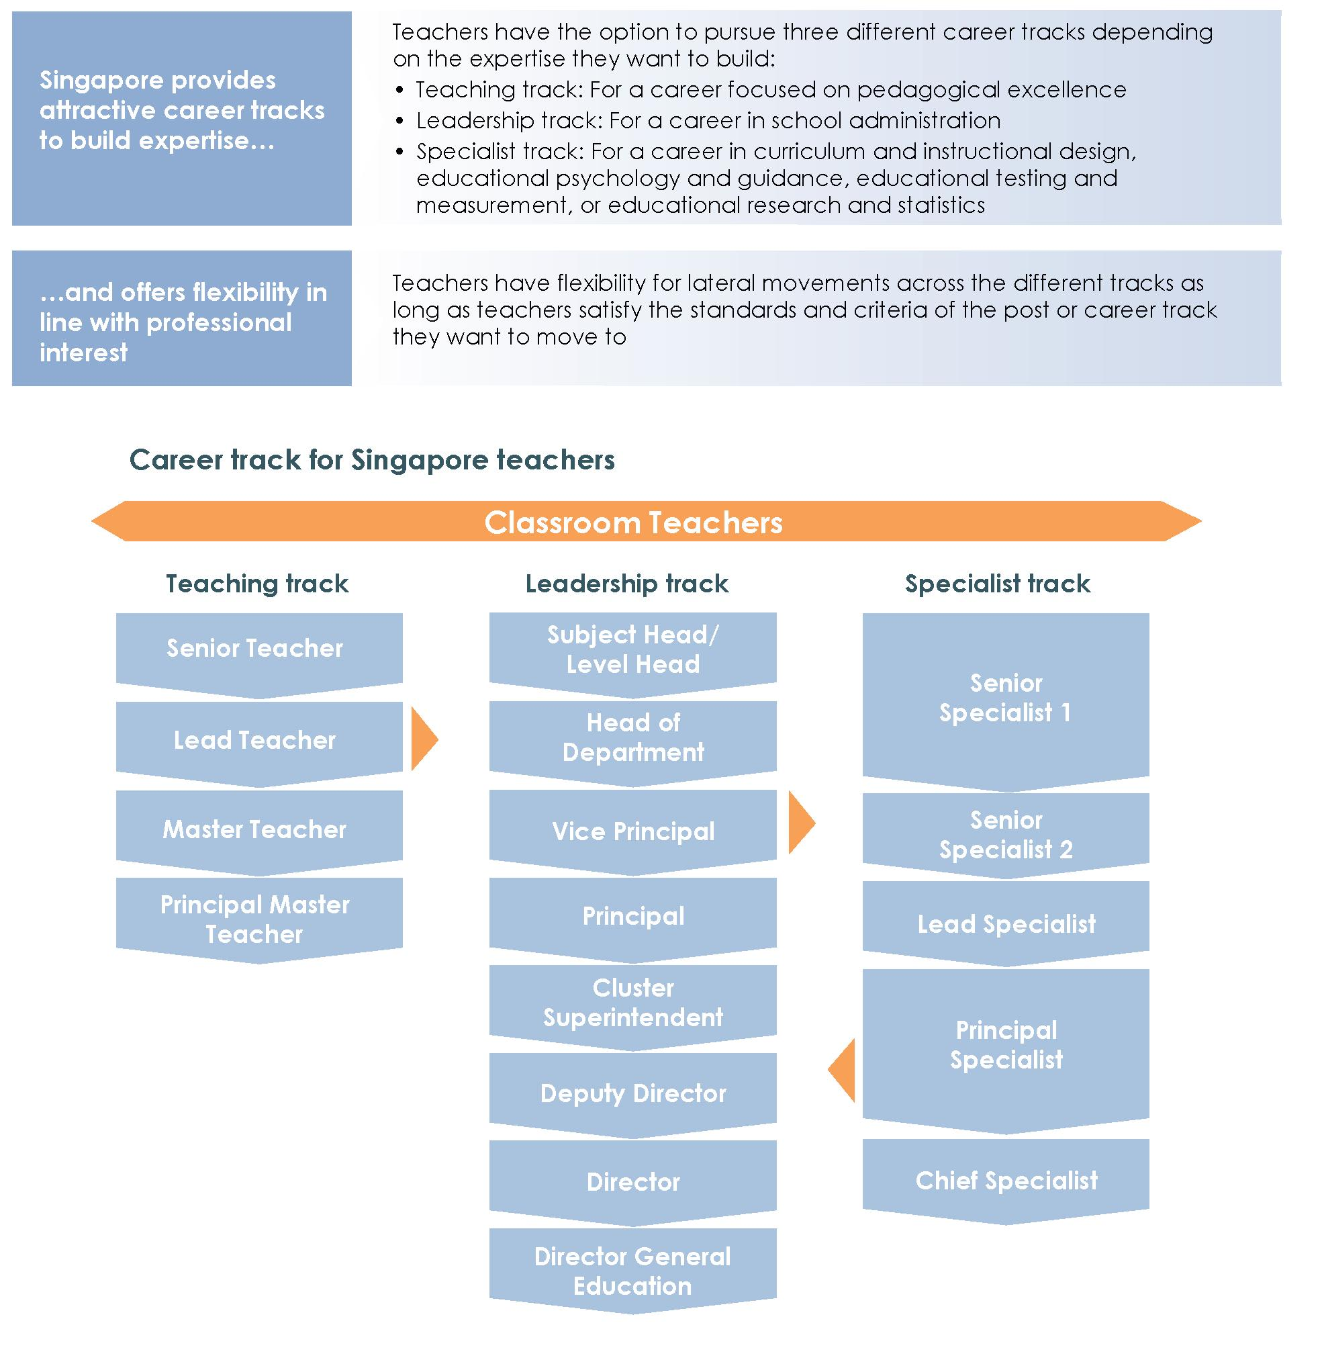

Source: Adapted from Singapore Ministry of Education, 'Career Information', viewed on 22 February 2018, https://www.moe.gov.sg/careers/teach/career-information.

Australian teachers have opportunities to deepen and demonstrate their expertise. The Highly Accomplished and Lead Teacher (HALT) levels of the Australian Professional Standards for Teachers specify standards for expert teachers, and a national HALT certification process was endorsed by all Australian Education Ministers in 2012.
Certification can promote high-quality teaching and help raise the status of the profession. National HALT certification uses the Australian Professional Standards for Teachers as a basis for making rigorous and consistent judgements to certify that teachers have met the standards expected of expert teachers. While the HALT Standards are available for all

Australian teachers as a guide to what makes an expert, certification at HALT levels of the Teacher Standards is a voluntary evaluation process and not all states and territories and sectors participate.

The certification process enhances the professionalism of teachers; it will encourage teachers to contribute to the advancement of schools whilst being in the classroom — there's not that need to have to move out of the classroom to do that.
Tracey Peden (Lead Teacher, Atherton State School & Tolga State School, QLD)

The Review Panel sees an opportunity to utilise HALT expertise in a more systematic fashion, particularly by drawing on a HALT teacher's instructional leadership and in-classroom expertise. HALT teachers should be viewed as role models for excellence in the teaching profession. Their expertise could be utilised more widely through professional learning, collaboration, mentoring and other high-impact activities. This could encourage other teachers to strive to reach the HALT levels themselves.
/ became a nationally certified Lead Teacher to expand the impact I could have from one classroom to many. My mission was to engage colleagues in collective teacher efficacy to make a school wide commitment to improvement. My strategy for achieving this was to embark on a whole school action inquiry research project so we could develop a shared understanding of what was going to have the most impact on our students' engagement and success in learning.
Marilyn Morris (Lead Teacher, Monash Primary School, ACT)
Strategies that encourage HALT certified teachers to teach in regional areas could improve the overall experience and expertise of teachers in regional schools. This was an opportunity identified by the Independent Review into Regional, Rural and Remote Education.
Finding 12
Certification at the Highly Accomplished and Lead levels of the Australian Professional Standards for Teachers recognises and promotes the development of collaborative learning professionals who strive to continually reflect upon and improve their practice and that of their colleagues. Such acknowledgement can play a key role in keeping excellent teachers working with students and helping to improve colleagues' pedagogical practices.
Australia could establish pathways of teaching expertise similar to those in Singapore. This would grow the pool of high-calibre teaching staff, spread the reach of expertise, and enhance the reputation of the teaching profession.

Implementing structured career pathways for Australian teachers will further professionalise the workforce, leading to improvements in self-efficacy, confidence, work satisfaction and the status of the profession. As teachers progress through their careers, our collective expectation must be that they increase their expertise and impact, and are recognised for doing so. This recognition should be done at both the school and jurisdiction level, with clearly defined roles and development streams, allowing for accelerated development and more effective management of the workforce. A structured approach to workforce management should also be underpinned by remunerating more teachers based on their expertise and impact on learning, rather than tenure.
Australian Institute of Teaching and School Leadership – Submission

Establishing pathways of teaching expertise would create meaningful career options that direct all teachers towards classroom excellence, while catering for different interests and skills. More delineated career pathways would enable all teachers to progress within the profession based on their level of skill and expertise, not just those interested in leadership. Teachers whose passion is classroom teaching should be encouraged to increase their expertise in this area and remain in the classroom to continue working with students and helping to improve colleagues' pedagogical practices. This should sit alongside a pathway to school leadership for teachers who are interested in and suited to pursuing a career in school leadership (see Chapter 4). Each of these pathways can articulate clearly defined roles and development streams for accelerated development and provide a basis for school systems and schools to tailor remuneration and allocation of responsibilities based on teacher expertise.
Opportunities could also be made to fast-track outstanding candidates to roles in which they could influence teaching and effect change within their school and across their communities, further supporting Australia's aspiration to achieve excellence in teaching and learning.
Recommendation 16
Create and provide opportunities for implementation of structured career pathways for teachers with clearly defined roles and development streams that allow for accelerated progression and provide the opportunity for remuneration, recognition and allocation of responsibilities based on expertise.
3.8 Teachers deserve greater recognition and higher esteem
To attract and retain the best teachers in schools, the Review Panel believes more needs to be done to raise the public esteem of the teaching profession and celebrate its merits and its contribution to Australian society. Less than one in three teachers in the OECD's TALIS 2013 believe that the teaching profession is valued by society. However, teachers in the world's top-performing education systems tend to see their profession as valued by society. There is also a positive correlation between teachers' perception of value and student outcomes: research finds that the more teachers see themselves valued by society, the higher students in their country rank among the top performers in mathematics in the international PISA survey.

In Australia, we know we have great teachers that make a positive contribution to the lives and opportunities of young Australians and this should be recognised within and outside the education community. We also know that there is still a need to stem attrition, improve retention and to recruit the best and brightest to the teaching profession. To achieve this we need to elevate the profile and promote the value of teaching. We must support, recognise and esteem our teachers.
Australian Institute of Teaching and School Leadership – Submission

More needs to be done to improve the esteem of teachers in Australia. School systems and schools, communities, and teachers need to promote teaching expertise and excellence. The Review Panel supports all efforts that esteem teachers and publicly recognise teaching excellence, including existing teaching awards (such as Schools Plus and Commonwealth Bank Teaching Awards) and honours, and the nomination of teachers through broader national honours programs, such as the Order of Australia. The naming of mathematics teacher Eddie Woo as the 2018 Local Hero at the Australian of the Year Awards is one example of the way the excellent work of teachers can be publicly recognised. We need to continue to raise the public perception of teachers as professionals who make a vital contribution to Australia's future.

Chapter four: Empowering and supporting school leaders
Summary
School leaders are crucial to delivering the change required to lift student outcomes in Australian schools. As leaders of learning in their school, they heavily influence their school's culture, learning and pedagogical approaches, including the way the school maximises the learning growth of every student, every year. As the school's operational leader, the principal makes critical decisions about resourcing and staffing. In this chapter, the term 'school leaders' primarily refers to principals.
School leaders have an important role to play in bringing about the changes discussed earlier in the report. They must support parents and carers to engage in their children's learning throughout education, lead changes to student learning that support growth and the acquisition of foundation skills, and strengthen school-community engagement. As the leader of teachers in their school, principals need to set priorities and allocate resources in a way that builds collaboration, observation and feedback into teachers' schedules. Similarly, principals must support and challenge teachers to access and engage in effective professional learning to expand practices that maximise the learning growth of every student every year.
Currently, Australian principals are under pressure to perform a range of different roles, and are not always supported to perform them effectively.
For principals to maximise their contribution to school performance they need to be empowered and supported to develop themselves at each stage of their career.

When principals are empowered, they create a school culture in which teachers are intrinsically motivated, satisfied and perform at their best.
Western Australian State Government – Submission

Great school systems carefully plan for and develop their school leadership workforce. This begins with identifying and cultivating suitable leadership candidates, continues through intensive support for new leaders, and includes ongoing development and support for principals as they develop as leaders. The recent Independent Review of Regional, Rural and Remote Education also found identifying, preparing, and supporting school leaders to be crucial.
Exhibit 23 illustrates the key reasons and mechanisms for developing a leadership pool at three different stages of principals' professional evolution. This model has informed the recommendations and findings in this chapter.

Exhibit 23. There are three phases of leadership development
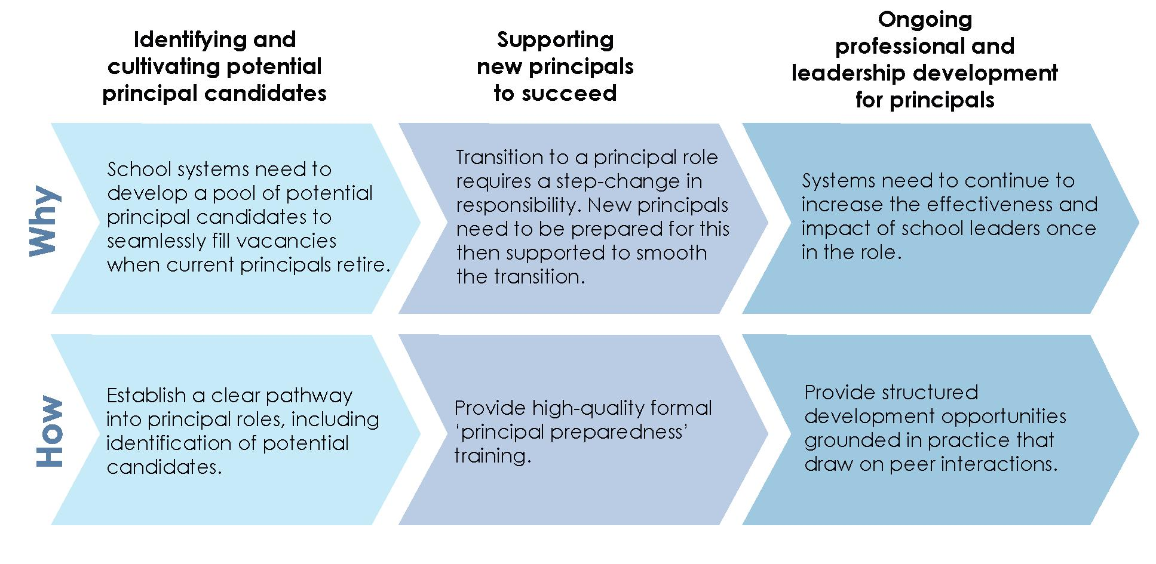
Source: Developed by the Review to Achieve Educational Excellence in Australian Schools in collaboration with dandolopartners.

This chapter outlines two key areas to maximise the impact of school leaders on education outcomes:
- empowering them to be leaders of learning to maximise the learning growth of every student every year
- providing support and career pathways to develop every level of leadership.
4.1 Empowering and supporting principals to focus on instructional leadership can drive school performance
School leadership is critical to student outcomes. High-performing school leaders add between two and seven months' worth of growth in student learning in a single year. To maximise their impact on student outcomes, school leaders need to be able to devote time to the activities in their job that have the greatest influence on student outcomes.
Principals have the greatest impact on student outcomes when they focus on their role as instructional leaders. This entails:
- putting improving student outcomes at the centre of their role, and viewing all activities through this lens
- focussing on the impact of teaching on learning and how this can be maximised
- shaping and driving the school's approach to pedagogy

- influencing and improving the performance of their teachers through coaching, formal and informal professional learning, mentoring, internal and external moderation, and development and supporting collaborative teaching practices
- promoting a positive school climate for teachers and students.
The impact on student outcomes depends on the coordination of the efforts of a broader leadership group than just an individual principal. Leadership in schools is distributed among a group of senior and middle leaders. These staff in turn have responsibility for groups of teachers and work directly and closely with them, focusing on student learning and achievement. This distributed leadership facilitates increased teacher trust and buy-in for change initiatives, which is essential for fostering a collaborative culture that improves student growth. In any school, leadership must be carefully planned and deliberately orchestrated by the principal.
Principals need to actively support the adoption of teaching practices to maximise attainment through student learning growth. This includes valuing collaboration and making the time for it to occur, examining and adjusting classroom timetables, and changing the allocation of professional learning resources. Similarly, by clarifying priorities for the students, for the school, and for individual teachers through appraisal and feedback practices, principals can ensure that professional learning undertaken by teachers meets the needs of the school.
4.2 Other obligations crowd out the principal's instructional leadership
The present reality is that principals do not always have the mandate and scope to focus on instructional leadership. Principal roles have become multi-faceted and demanding, with a growing focus on financial and resource management, alongside leadership of learning. Surveys show that the average Australian secondary principal spends 47 per cent of the time on administrative tasks and 17 percent on teaching-related activities. This compares to 39 per cent of time on administration and 26 per cent on teaching, in some leading jurisdictions. In addition, Australian principals identify the sheer quantity of work and the lack of time to focus on teaching and learning as their greatest sources of stress. The issue

of excessive administrative load on principals and the impact on learning and teaching was also identified in the Independent Review of Regional, Rural and Remote Education.
The large amount of time Australian principals spend on administrative tasks coupled with the breadth of their responsibilities suggests that they are over-stretched, rather than that they are neglecting their instructional leadership role. Submissions to the Review said that to lift student outcomes, school systems and schools need to allow principals to spend less time on administrative tasks in favour of higher-value activities.

The principal as the "Instructional Leader" needs to be emphasised. As the educational leader in the school, the principal needs to be able to focus on the pedagogy, student and school improvement and the professional development of staff so as to ensure increased learning outcomes for students and increased capacity of staff.
NSW Primary Principals' Association – Submission

In some cases, the increased proportion of time required for administrative activities has been inadvertently reinforced by increasingly devolved responsibility to schools for a range of tasks.
Giving schools autonomy over decisions, in the right context, and over the right things can improve school performance. It can, however, also increase the administrative burden as administrative tasks that were previously undertaken centrally are devolved to school leaders. Principals in most systems exercise greater local discretion than a decade ago, but the amount of information required by the system about the management of the school has also increased. The NSW Government has acknowledged that greater school autonomy has likely increased the administrative burden on principals and announced it will invest $50 million to offset this, for example, by employing additional administrative staff. When surveyed, 96 per cent of Australian primary principals agreed with the statement that 'employer and government accountability requirements are an increasing proportion of my workload.'
This issue is exacerbated when accountability models are not focussed on improving student outcomes. Principals in school systems and schools in Australia have been given increased levels of autonomy with a view to improving student performance. However, accountability mechanisms associated with this autonomy continue to focus on compliance with management requirements, rather than maximising student growth. Genuine delegation of responsibility to principals should be accompanied by an accountability framework that judges their performance on the basis of student learning growth, not on confirmation of compliance with head office requirements.

Our contention is that we do not need more governance, we simply need better governance. Essentially, we need a governance model that focuses on what really matters (student development of the General Capabilities, teacher capacity building and leadership development) so that long term planning and strategic actions can be realised.
South Australian Secondary Principals' Association – Submission

To maximise the value of school leaders in school systems and schools, Australia needs to reduce the administrative load on principals, focus on instructional leadership as the key role of the principal, and change the accountability framework to one based on student outcomes. There are two ways to achieve this: through revising the professional standards for principals, and by providing a form of autonomy that maximises their ability to work as instructional leaders.
4.3 The primary role of the principal needs to be instructional leadership
Principals need clarity that their primary role is instructional leadership of their school, and their primary objective is supporting the growth of every student in their school. This will help principals prioritise and explain this focus in the face of competing demands, expectations and stakeholders.
The Australian Professional Standard for Principals defines the components and expectations of leadership for school principals. As such, it is the ideal vehicle to clarify the role of principals.
The Leadership Profiles in the Professional Standard describe 'leadership actions that effective principals implement as they progress to higher levels of proficiency', 'that guide school leaders in their learning pathway', 'that empower school leaders ... to develop and support teaching that maximises their impact on student learning', and that 'sets out what principals are expected to know, understand and do to succeed in their work'.
The standard describes three leadership requirements—vision and values; knowledge and understanding; personal qualities, social and interpersonal skills—and five professional practice requirements—leading teaching and learning; developing self and others; leading improvement, innovation and change; leading the management of the school; engaging and working with the community. Full achievement of the standard is dependent upon a learning process involving five stages—awareness, attitude, knowledge, action, behaviour change—to be followed progressively by each principal on the basis of experience and professional development. This is widely and properly recognised as an excellent and important document.
The Standard is supported by a set of Leadership Profile Statements. These are interpreted through three 'leadership lenses': a 'professional practice lens'; a 'leadership requirements lens'; and a 'leadership emphasis lens'. The Review Panel fully endorses the first two lenses; some discussion of the third is necessary.

Exhibit 24. The Australian Professional Standard for Principals leadership lenses
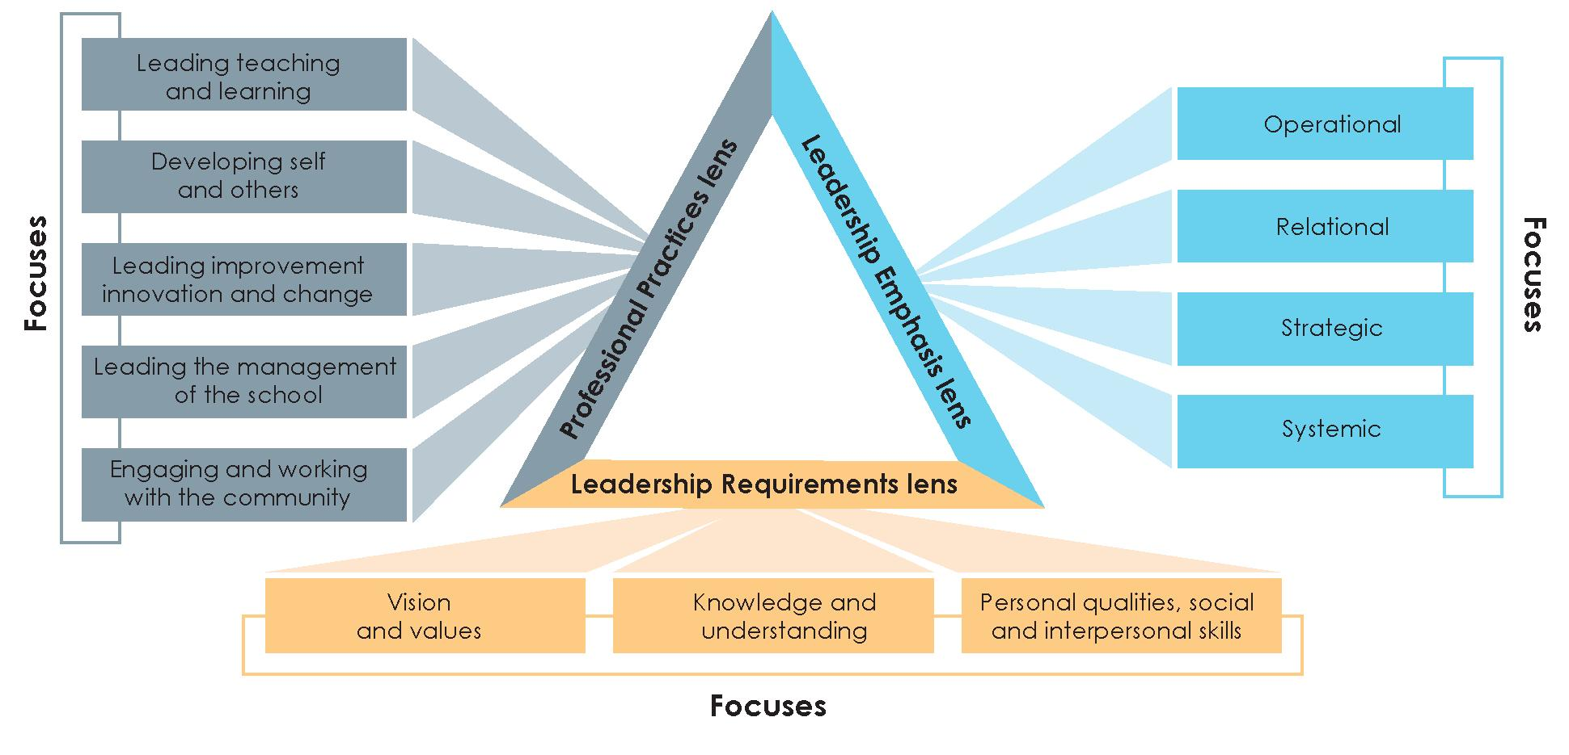
Source: Australian Institute for Teaching and School Leadership (2014) Australian Professional Standard for Principals and the Leadership Profiles, ESA: Melbourne.

The leadership emphasis lens is divided into four 'focuses': operational (with a focus on 'the smooth and effective running of day-to-day operations'); relational (with a focus on 'consultation and feedback', 'relationships with students, staff, community and other stakeholders', and ensuring 'a shared culture and vision'); strategic (with a focus on 'relational, organisational and management thinking to effect and monitor change, in order to realise short and long term school goals'); and systemic (with a focus on 'school effectiveness' and working 'to build networks, collaborate with educational groups, and make connections beyond their own school and system to influence and lead educational impact'). The choice of focus through the leadership emphasis lens is left to the principal, on the grounds that this 'enables principals to locate and understand their practice according to their career stage, capability and context'.
The Review Panel's view is that the leadership emphasis lens is a weakness in the Professional Standard, and makes the fundamental accountability unclear. The standard states that 'effective principals will apply the appropriate leadership emphasis that a school context demands'. But all four emphases are integral parts of the role of the principal, not alternative choices.
The fundamental responsibility of each principal should be maximising the learning growth of every student every year, through instructional leadership of the students, staff and school community.
The establishment of the Australian Institute for Teaching and School Leadership (AITSL) and the publication of standards for teachers and principals are important developments. Great progress has been made in clarifying the role and expectations of the principal, in focussing on the task of school leadership, in the provision of professional support through publications and the website, and in building a professional ethos.

Nevertheless, the AITSL Professional Standard for Principals and the Leadership Profiles are essentially about input and process, not the achievement of specified learning outcomes. The online self-assessment tool asks principals to rate themselves against statements such as 'I have frequent conversations with staff about what high-quality teaching looks like' and 'Staff members regularly approach me for advice on how to improve their pedagogical knowledge and skills'. This is an assessment of input and process, not an assessment of whether or not there has been growth in student learning as a result of these interactions.
The Leadership Profiles are intended to be used for 'self-reflection, professional growth, professional learning, selection and recruitment, talent development and succession, and performance review'. They are excellent for all purposes but the last. Performance review based on the standards and profiles can be no more than the monitoring of compliance with certain processes and models of behaviour. With the implementation of learning progressions and the resulting emphasis on maximising learning growth, performance review should focus on the fundamental role of the principal—to maximise the learning growth of every student every year.
Recommendation 17
Review and revise the Australian Professional Standard for Principals to prioritise leadership of learning and make maximising the learning growth of every student every year the key focus.
While the role of the principal needs to be focussed on growth, the school must also be managed as an organisation. The Review Panel's view is that, although principals must be ultimately accountable for the management and administration of the people, resources and facilities within or available to the school, much greater assistance could be given to reduce their hands-on administrative workload, particularly in schools that are part of a larger system.
This assistance includes: exploring reduction and/or simplification in administrative burdens placed on schools and their reporting requirements (including simplification of work health and safety requirements); appointing more dedicated administrative resources to schools; identifying quality external providers to which schools may be able to outsource some administrative responsibilities; and exploring new models for school management including chief operating officers or business managers accountable to the principal. Examples of these models can be found in some schools where principals have extensive administrative support.
Principals would support such moves. Victorian principals ranked simplified compliance requirements and more administrative support as two of the factors most likely to reduce their workload.

4.4 Structural autonomy alone is not sufficient to improve school performance
As discussed above, giving school leaders autonomy—or decision-making responsibility—in particular areas can help them lift student outcomes and drive continuous improvement in their school by empowering them to introduce innovations and make better decisions for their schools around learning, teaching and resourcing. Autonomy, however, can have a negative impact on school and student outcomes if principals are given too many management responsibilities that do not relate to instructional leadership or impact on student learning (as this fragments their focus and time) or if the responsibilities do not take into account the capability of the school and school leader to manage them effectively.
In a school context, there are two types of autonomy: structural autonomy and professional autonomy. Structural autonomy refers to policies, regulations and procedures that determine the areas where school leaders do and do not have discretion to make their own decisions based on their circumstances. The capability of school leaders to make the right decisions is referred to as professional autonomy or professional capital. Professional autonomy is not something that can be provided or granted by systems; it is a capability that must be cultivated by school systems and schools and developed by school leaders over time.
No school in Australia has full structural autonomy. School principals in the non-government sector have traditionally had greater structural autonomy, but all schools must still meet government registration requirements, account for their use of public funds, satisfy certain obligations under legislation, and account to their board of directors (if they have one).
Many schools are part of a school system, which is a government, church or other organisation responsible for overall policy, the distribution of funding, and administration. Systems have systemic missions, goals, priorities and strategies (such as statewide literacy and numeracy strategies), which are delivered through schools as the arms of the organisation. They seek to provide education of a universally high quality in every school in the system. They provide schools with curriculum materials, administrative services, buildings and other facilities, and—in some cases—they select, employ, pay the workforce, and manage the terms and conditions of employment.
To be effective, structural autonomy needs to be granted over the right decisions, it needs to be accompanied by the appropriate levels of administrative support and accountability, and it needs to take into account the school leader's capability to manage it for the benefit of the school and students. Without this capability, there is a risk that structural autonomy provided by systems may have no impact, or a negative impact.

Principal autonomy by itself will not guarantee improved student outcomes. Autonomy is a powerful tool in the hands of the highly effective principal who has a focus on improved student outcomes and the resources to implement an ongoing cycle of collaboratively developed evidence based planning and review.
Australian Secondary Principals' Association – Submission

... not only must schools have the freedom to continue to innovate they must also have the autonomy to determine the focus of improvement initiatives
Association of Heads of Independent Schools of Australia – Submission

Evaluations of the effectiveness of programs of higher levels of structural autonomy are mixed. Studies examining independent public schools, charter schools in the USA and academies in the UK have found instances of high performance were often attributable to the nature of the school intake rather than levels of structural autonomy. Moreover, Canada significantly outperforms Australia in Programme for International Student Assessment results but has a much lower level of structural autonomy.
To effectively empower principals, structural autonomy needs to be managed in three key ways.
First: provision of structural autonomy needs to be sensitive to the context of individual schools. International evidence shows there is no one-size-fits-all approach. Rather, high-performing systems grant different degrees of structural autonomy depending on the level of professional autonomy of the principal. Without professional autonomy, structural autonomy is no guarantee of improved results.

Principal autonomy will only result in improved student outcomes if principals have the capabilities, mindset, focus and resources to use it effectively.
Australian Secondary Principals' Association – Submission

Second: as discussed earlier, structural autonomy for some things is more valuable than for others. The most powerful factors in raising student achievement are: the work of principals and other school leaders in building professional capacity through staff selection, professional development and appraisal; setting priorities on the basis of data about performance; strategic resourcing; and communication of purpose, process, and performance. By contrast, autonomy is least critical for routine administration practices and decisions, such as basic procurement. If autonomy is provided in less valuable areas, it can dilute the principal's focus on instructional leadership.
Third: where greater structural autonomy is granted over decisions related to maximising student learning growth it should be accompanied by greater accountability for achieving this growth.

This:
- makes expectations explicit, and sharpens focus on student growth
- is preferable to input or process driven forms of accountability that create administrative burden and may be viewed primarily as compliance exercises
- allows for consideration of whether the level of autonomy provided is appropriate to the circumstances of an individual school, and its performance.
Where structural autonomy is provided, it must be accompanied by support for school leaders to continue to develop their professional autonomy.
Recommendation 18
Ensure principals have the professional autonomy and accountability required to lead their school on the improvement journey most relevant to their starting point.
4.5 Aspiring leaders need a clear pathway to follow
As discussed above, developing a strong pool of high-performing, passionate school leaders who have the capability to exercise the structural autonomy they are provided with is critical to lifting Australian student outcomes. Australia needs urgently to expand the pool of future school leaders as there is a looming shortage due to retirement. Almost three in four Australian principals are over 50 years old and the proportion of principals in the 60 and overage bracket increased by 10 percentage points (to 18 percent) between 2008 and 2013. Already, there is a scarcity of qualified and experienced applicants to fill available school leadership positions.
The attractiveness of principal roles will be improved by providing a clearer pathway. There is a disjuncture, however, between the competencies prescribed for teachers and those for principals. The Australian Professional Standards for Teachers set out competencies for four distinct career stages: graduate, proficient, highly accomplished, and lead. As discussed earlier, the Australian Professional Standard for Principals details competencies fora single career stage, across five professional practices: leading teaching and learning; developing self and others; leading improvement, innovation and change; leading the management of the school; and engaging and working with the community.
Although the teacher standards provide a benchmark for tracking how well teachers develop the relevant competencies to become lead teachers, they do not establish clear career pathways for outstanding teachers who aspire to become principals. There is no established link between the professional profiles in the teacher standards and the principal standard. For aspiring principals, the pathways to become lead teacher—as outlined in the teacher standards—are insufficient for early identification of the skills that are required of a principal in addition to being an outstanding teacher.
The principal standard does not allow for identification of leadership qualities early in a teacher's career. It does not define characteristics or competencies for early identification of outstanding teachers with the potential for leadership to be put on an aspiring principal's pathway.

Australia can learn from the experience of high-performing systems overseas that have grown a pool of school leadership talent by providing clarity and support on the career path from teaching to leadership roles. In an international study, more than three-quarters of high performing leaders said that being identified as a potential leader was a major contributor to their development.

There must be differentiation of professional learning for practitioners at all stages of their careers.
Australian Government Primary Principals Association – Submission

As discussed in the previous chapter, teachers in Singapore can choose a leadership track in consultation with their principal in their third year on the job, and then advance to department head and vice principal. The Singapore system then progresses teachers along the leadership track through the provision of milestone courses to equip teachers for leadership roles by ensuring they meet quality standards. Teachers can also elect to move across the different career tracks, as long as they satisfy the standards and criteria of the job/career track they choose.
Finding 13
Aspiring school principals require clear pathways leading to the role, and comprehensive training and preparation to a quality standard before their appointment.
Australian school systems and schools should adopt a proactive approach to leadership talent development and offer a distinct and structured pathway to becoming a principal.
Amending the principal standard to provide a clear pathway to leadership would facilitate the career progression of school leaders, and could provide more clarity about career progression for early career teachers interested in school leadership. For example, the standard could be modified to enable talented early career teachers to be identified and placed on a distinct aspiring principal pathway. This pathway should outline quality standards that need to be met in order to progress through each of the streams.
The recently released Australian Institute for Teaching and School Leadership's Leading for Impact: Australian guidelines for school leadership development provide guidance on how to enhance current approaches. The guidelines build on the Australian Charter for Professional Learning of Teachers and School Leaders and the Australian Teacher Performance and Development Framework. They emphasise the importance of career pathways and identifying and attracting talent. The guidelines were endorsed by education ministers in December 2017.
Finding 14
To have an impact, strategies for school leadership development need to be aligned to the nationally endorsed Australian guidelines for school leadership development with implementation approaches monitored and evaluated for their effectiveness.
A major benefit of this revised approach to standards would be to encourage potential leaders to actively consider their ambitions and to support the identification and cultivation of outstanding teachers who demonstrate leadership potential.

4.6 Targeted preparation and support is essential for new principals
New school leaders assume a series of multi-faceted and complex responsibilities that often represent a significant increase in responsibility. Supporting leaders' development during this critical transition is key to setting them up for long-term success.
Attracting school leadership talent is not easy. Prospective leaders do not view leadership positions as attractive. Current school leaders believe the public image of their position is poor and their workload too high (see Exhibit 25).

Exhibit 25. The top and bottom three elements current school leaders believe are required to attract and retain their replacements
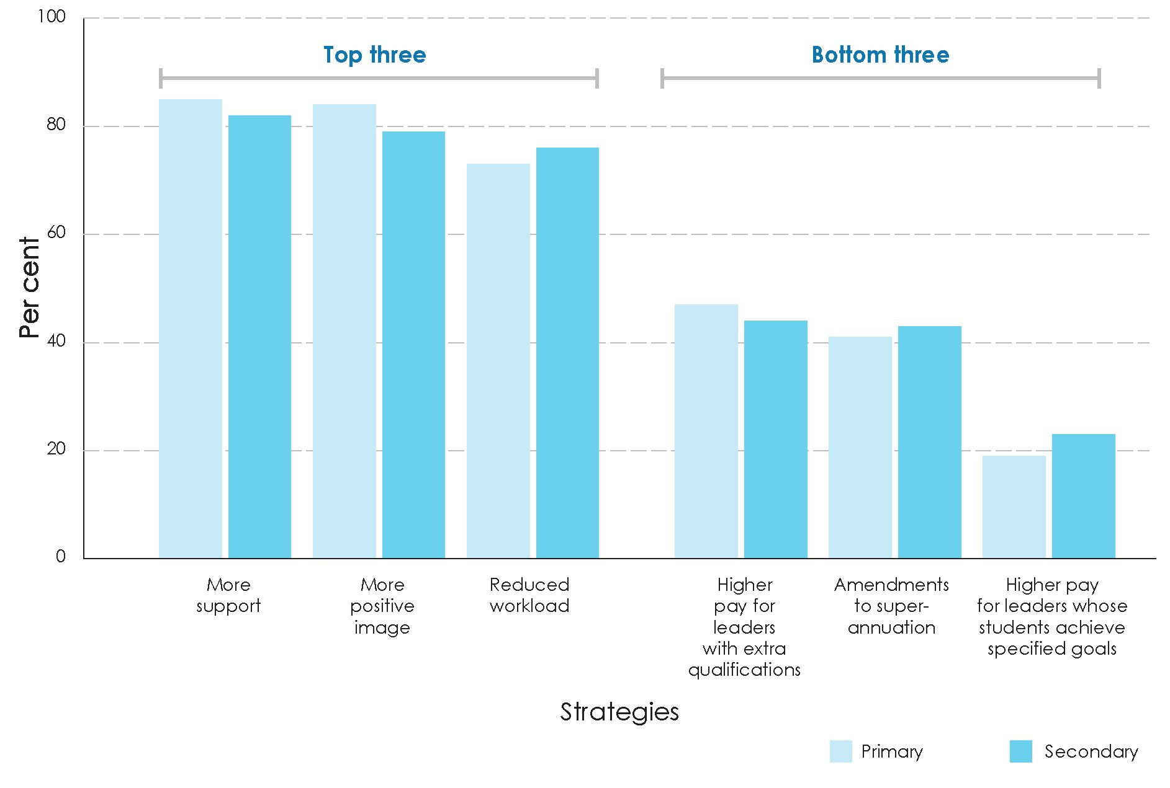
Source: McKenzie, P., et al. (2014) Staff in Australia's Schools 2013: Main report on the survey, ACER: Melbourne, p. 120.

Surveys show that many school leaders in Australia undertake less training prior to appointment compared to other leading countries. Just 23 per cent of Australian principals complete principal training pre-appointment and only 20 per cent complete instructional training pre-appointment.

The career development of primary school principals across Australia is haphazard and lacks coordination
Australian Primary Principals Association – Submission

High-quality formal principal preparedness training is an opportunity to support new leaders to transition into principal roles. Principal preparedness training provides aspiring leaders with the skills and knowledge they need for each facet of their role. There is an opportunity for Australia to build on the experience of other high-quality programs, for example the UK leadership development framework.
Case study
UK leadership development framework
The UK leadership development framework supports aspiring and current leaders through nationally consistent formal qualifications. The qualifications focus on development of knowledge and skills across specific content areas, and the development of leadership behaviours, with a final assessment required to gain the qualification. The structure and teaching methods include elements of on-the-job training, coaching and mentoring, and professional development.229

Exhibit 26. The UK's leadership development system supports aspiring and serving leaders with formal qualifications
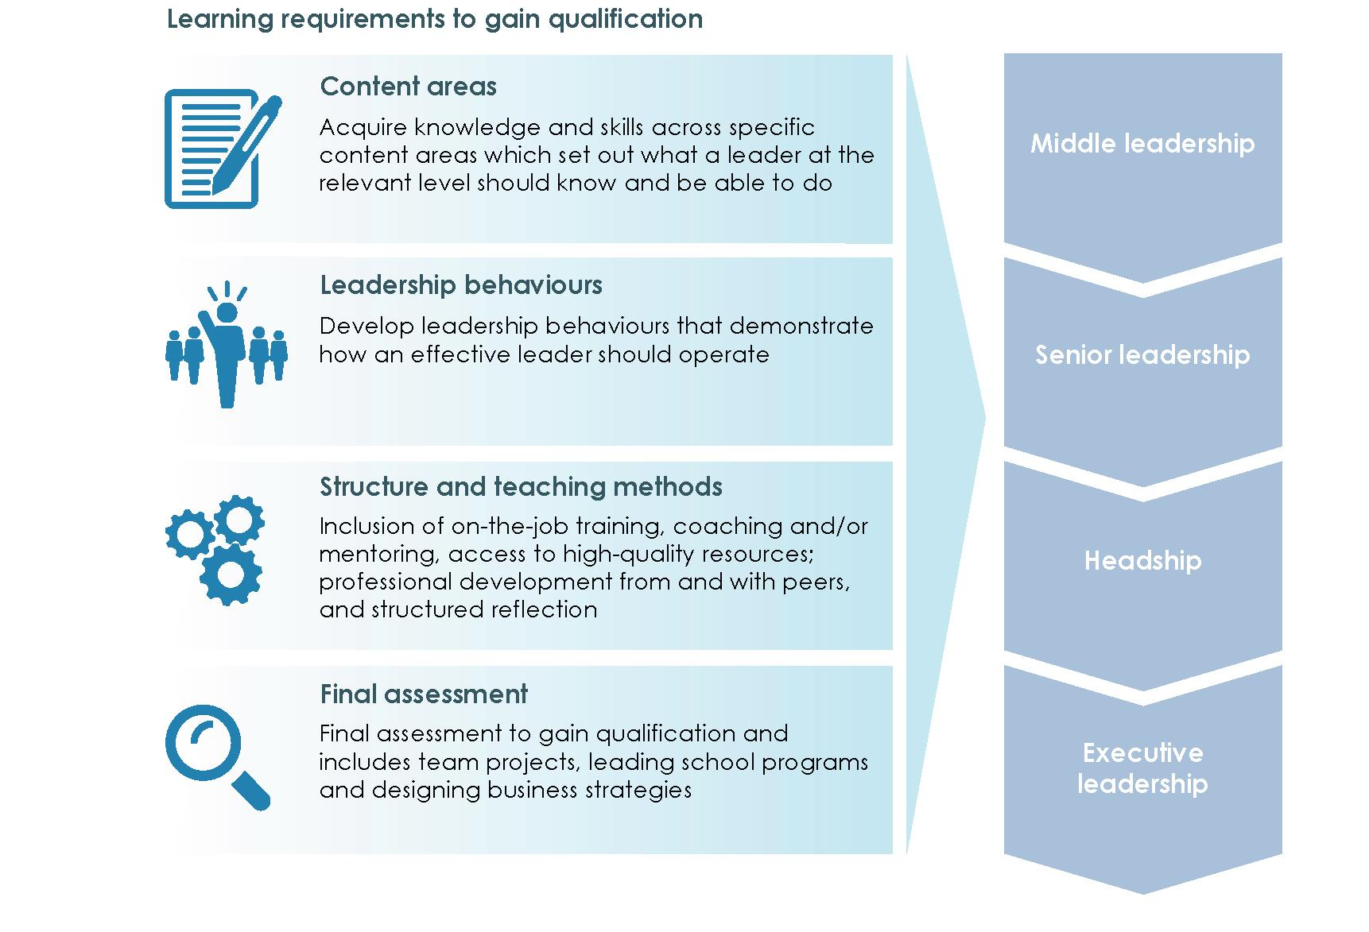
Source: Adapted from UK Department of Education, 'National professional qualifications: frameworks', viewed on 19 February 2018, https://www.gov.uk/government/publications/national-professional-qualifications-frameworks.

Recommendation 19
Create and provide opportunities to implement a structured career pathway for school leaders which articulates clearly defined roles and development streams for middle leaders through to experienced principals and provides the opportunity for remuneration, recognition and allocation of responsibilities appropriate to the role.
4.7 Principals need to be able to participate in structured professional learning opportunities once in the role
Professional support and development should not conclude on appointment or once an individual is established as a school leader. Rather, it should be an ongoing process designed to increase the impact and effectiveness of school leaders. Experienced principals are a key resource in the continued development of others and participation in mentoring/coaching has benefits for both participants. In recognition of these benefits, the expansion of mentoring and coaching by experienced principals was identified as an action in the recent Independent Review into Regional, Rural and Remote Education.
Finding 15
School leaders are called upon to play a variety of roles, including leaders of learning, business administrators, and culture setters. Participation in ongoing quality professional learning is essential to help school leaders to continue to develop across each of these dimensions, with a particular focus on their role as leaders of learning.
The ongoing development of school leader expertise is not currently recognised in the formalised professional standard for principals. Introducing multiple levels (between middle leaders and expert principals) would be useful in describing a trajectory of ongoing development and in recognising the role experienced principals play beyond their school boundaries.
Shanghai has developed a career ladder for principals that has five levels within the principal role. To become a principal, a candidate must first reach certain senior professional levels on the teacher career ladder to demonstrate teaching skills and professional dedication. Principals with positive evaluations can apply to move up the ranking structure once they have been in the role for a minimum period of time and demonstrated proficiency to practise at the next level.
Successful principal development is grounded in practice and draws on peer interactions that provide ongoing support. Principals' networks, study groups, mentoring and peer coaching allow highly proficient leaders to transfer their knowledge, skill and wisdom to junior leaders while gaining insight into their own practice and rejuvenation. Australia's many excellent principals are a resource that can benefit a broader cohort than a single school. For this reason, opportunities for professional learning should include peer collaboration and learning, mentoring and coaching.

Schools don t work in isolation, but are more successful when they are involved with professional learning communities. These communities don't need to be geographical, but can be arranged around interests, "like schools", joint research projects or programs. Sharing within these professional networks where there are common goals, plans, expertise and professional learning should be highly encouraged.
NSW Primary Principals Association – Submission

The broader reach of a principal is also relevant to the school's engagement with the local community. Effective principals build partnerships with the local community and external stakeholders to raise awareness of the vision and values of the school and to ensure they can contribute to the school's success. Principals draw on expertise from other organisations to enhance and enrich learning experiences, and gather regular feedback from families and the local community that is used methodically to review school practices and inform decision-making. It is noteworthy that AITSL research highlights that working with the community is a challenge for new principals in Australia. This demonstrates the need to have a tailored approach to professional learning that reflects career stages.

... principals have a vital role in leading learning through collaborative decision making with their community.
Australian Primary Principals Association – Submission

Engagement with their professional community is an important part of principal development. Adults learn more effectively when learning involves collaboration with peers, and when they can apply their knowledge and receive feedback on their behaviour and learning. Although collaboration is important, the rate of collaboration with peers for Australian principals is relatively low. Only 59 percent of principals reported collaborating with principals from other schools in the last 12 months. This may be partially addressed by reducing administrative burden on principals (see above), but it is likely that formal networks need to be established to embed peer collaboration into day-to-day principal practices.
Recommendation 20
Provide school leaders with access to a variety of professional learning opportunities appropriate to their career stage and development needs and recognise and harness the skills and experience of high-performing principals by enabling them to share their expertise across schools and throughout the system.

Chapter five: Raising and achieving ambitions through innovation and continuous improvement
Summary
Australian schooling is designed around a 20th century, industrial education model. Each year approximately 3.8 million young Australians move in lockstep through a thirteen-year program based on a year-level curriculum. Each element of schooling—from the curriculum, to assessment, teaching practices and school administration—is designed to support this education model.
To accelerate student learning growth and improve Australian education outcomes, school systems and schools need to shift from an industrial education model to one that is adaptive, continuously improving, and focused on ensuring that each individual student achieves the maximum potential growth in learning each year.
Adopting the strategy and recommendations set out in this report will help with this shift, provided the change is made across education systems. This requires changes to be made by Commonwealth, state and territory governments, school systems and schools, by the teaching profession, by parents and carers, and by business and industry and the community as a whole.
As a nation, we must create the conditions for continuous improvement. This means welcoming and supporting innovations, learning from them whether successful or not, and nurturing a culture of evaluation and evidence-based continuous improvement. International experience shows that successful education systems can plateau after a period of improvement because the most effective measures to drive improvement vary depending on where school systems and schools sit in their improvement journey. To avoid plateauing, school systems and schools need to encourage innovation, and to adapt their approach, to ensure their performance continues to improve.
This chapter proposes five critical actions that school systems and schools should take to create a cycle of continuous improvement:
- having high aspirations for students and schools, and taking action to achieve them
- driving ongoing change and reform by actively encouraging innovation and requiring continuous improvement
- implementing high-quality evaluation and quality assurance processes
- introducing a Unique Student Identifier (USI) to track individual student performance within school and from one school to the next, to support the student and provide better data to support innovation and improvement in school systems and schools
- establishing a national research and evidence institute to drive better practice and innovation.

5.1 Great school systems have high aspirations for students
and schools and act to deliver on them
School systems and schools have a critical role to play in improving education outcomes. International experience shows that highly effective systems are aspirational for their students and their schools. They reject the assumption that schools have natural plateaus in performance, and strive instead for continuous improvement.
Australian school systems and schools need to be similarly ambitious, and commit explicitly to accelerating each student's learning growth, and embedding continuous improvement in schools. School systems and schools will take different approaches to meeting these goals. Research into transformation programs, however, has found that there are common characteristics of successful programs. Transformations that combine a clear aspiration and change story—in which there is consistent role-modelling by leaders, which focus on capability building, and which embed formal reinforcing mechanisms—are nearly eight times more likely to succeed than transformations using just one of these elements.
School systems have a critical role to play in supporting schools to achieve these transformations. High-performing international systems use accountability mechanisms to support continuous improvement. For Australia, this means setting high expectations of school leaders and teachers. It also means carefully monitoring student growth and achievement outcomes against these expectations, while allowing school leaders and teachers to use their professional judgement to identify the most effective way to deliver the required outcomes. Real improvement also requires that school systems and schools have high expectations of themselves, transparently reporting their operational targets and outcomes as a form of accountability. School systems and schools cannot expect schools to change without modelling the changes themselves. This means visibly valuing adaptation, innovation and continuous improvement, so that teachers and school leaders see the shift in emphasis.
5.2 Innovation and continuous improvement are key drivers
of ongoing change and reform
High-performing education systems encourage continuous improvement across all elements of the system, of which schools are the most important but not the only part. School systems' scale means they are a powerful force—able to assemble evidence on effective teaching practice (and ineffective practice), and share and coordinate improvement efforts across all schools within their jurisdiction and beyond. This is particularly valuable in the evaluation of innovations in education, which is a key part of continuous improvement and promotes a culture of professional learning and collaboration.
Truly innovative education systems do not see innovation as an 'added extra' but as a core part of their operations. They share common, interlinked features as shown in the exhibit below. It is not sufficient for a single element of the education system, such as the teaching workforce, to be expected to innovate; every element of a school system (finance, budget, personnel, management, buildings and facilities, information technology, industrial relations,

legal, curriculum consultancy) should be coherently managed to support innovation, with every element of the system focussed on the common purpose of finding better ways to ensure that every student achieves at least one year's growth in learning every year.
It is critical that this focus on innovation be supported by data, research and evidence. Research and evidence of what has, or has not, worked is key to informing the design of innovations and to ensuring they have the greatest chance of improving student outcomes. Just as important is the reliability of data on the impact of innovations so further research and evidence can inform future innovations. This data, research and evidence needs to be in the hands of decision-makers at all levels of education.
It is the responsibility of every person and element within head, regional and diocesan offices, and other non-school locations, to support the principals and teachers in schools to achieve this systemic goal. There is no more important yardstick to measure the performance of each and every systemic employee than the progress of each individual student.

Exhibit 27. Attributes of an innovative education system
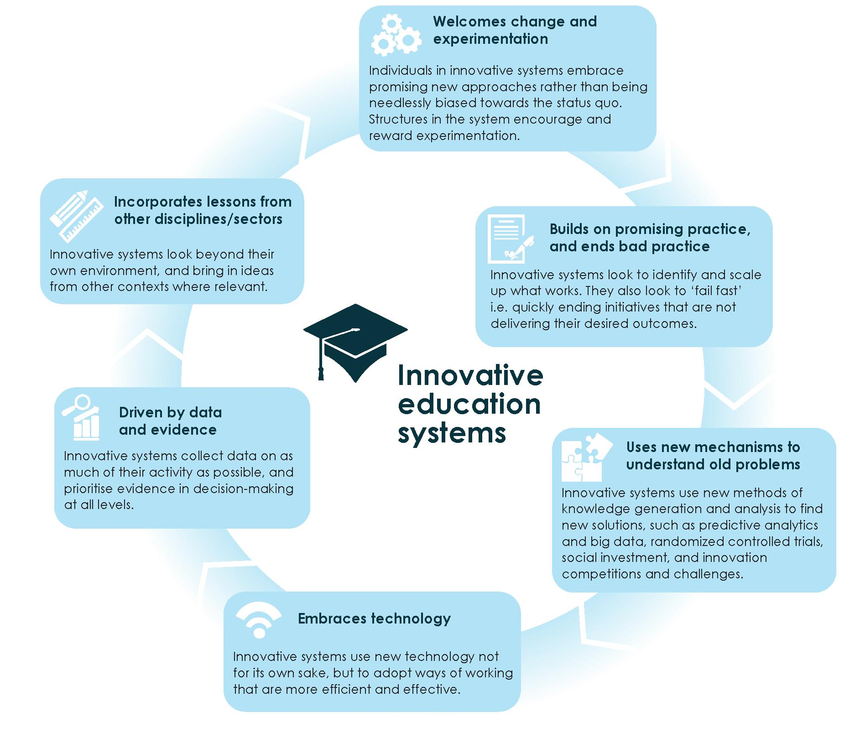
Source: Developed by the Review to Achieve Educational Excellence in Australian Schools in collaboration with dandolopartners.

5.3 Continuous improvement needs high-quality evaluation and quality assurance processes
Evaluation is critical to continuous improvement and meeting the high aspirations great systems set for themselves. The Organisation for Economic Co-operation and Development (OECD) notes authentic evaluation leading to improvement in educational practices is 'central to establishing a high-performing education system' and 'instrumental in recognising and rewarding the work of educational practitioners.' For this reason, high-performing education systems globally are taking more sophisticated approaches to evaluation, shifting from relying on standardised testing to using a mix of external school and teacher evaluation and school and teacher self-evaluation.
School systems and schools in Australia can help foster improvement in student outcomes by ensuring that evaluation and quality assurance frameworks are updated to reflect contemporary practices that support a focus on student growth, and by adopting a mix of external- and self-evaluations.
Most Australian school systems and schools have school improvement and quality assurance frameworks that inform continuous improvement. They are applied during periodic reviews using tools such as the National School Improvement Tool developed by the Australian Council for Educational Research (ACER). These frameworks need to be adapted to include a focus on accelerating student growth so that every student demonstrates at least one year's growth for one year's teaching. In future, evaluations will need strong ownership by teachers, and strong links to classroom practice, as they have no value if they do not lead to improvements in practice and student learning.
Finding 16
As Australian schools transition to diagnostic assessment and differentiated teaching within the framework of learning progressions, there will be increasing opportunities for, and benefits to be gained from, external quality review processes at school and system level. Continuous improvement in Australian education will be supported by the variety of quality assurance processes increasingly utilised by Australian school systems and schools.
Self-evaluation of schools by teachers and school leaders, supported by regular external evaluations and quality assurance, is a key practice that drives improvement. Ensuring evaluations focus in particular on student growth and achievement means emphasising the use of teacher appraisals for the continuous improvement of teaching practices; involving teachers in self-reflection and school self-evaluation; ensuring teachers are seen as the main experts in instructing and assessing their students; building teacher capacity for data analysis and student formative assessment; and building teachers' ability to assess against educational standards.
Adapting frameworks and then putting them into practice during evaluations will support teachers to make judgments about student growth against learning progressions. This will complement professional learning for teachers and help verify student progress. Samples of individual student work could be checked as part of these reviews by representatives

from the system or by teacher consultants brought in from outside the school, to confirm that progression levels are being assigned correctly. This form of quality assurance would be constructive and entirely informative, providing a feedback loop to enable continuous improvement. It would not, and could not, be used to create a consolidated measure of growth at the system, sector, state or national level: experience in Australia and internationally has shown that it is not feasible to develop reliable measures of growth of this type.
Australian school systems and schools could also improve the effectiveness of external school evaluations in school improvement by targeting them on the basis of risk-to-school quality. This approach concentrates external school evaluation on the schools that most need support and tailors evaluations to focus on specific pedagogical areas that need most attention, rather than treating them as a routine exercise.
School systems and schools adopting such a differentiated approach seek to balance utility with comprehensiveness. To ensure all schools are included they typically adopt a policy of undertaking evaluation within an agreed time period—usually between five to 10 years, or every four years in the case of Queensland and South Australian schools, for example. They focus most effort on more frequent external school evaluations where particular concerns have been identified using a desk-based assessment of risks. This might include factors such as parent and carer complaints, high staff turnover, and weak or weakening student outcomes. School evaluations can also differentiate the criteria of focus, concentrating on factors of concern, for example, rather than the full set of factors identified in the evaluation framework.
Given the broad range of starting points for Australian schools, it will be important to identify the measures relevant to each school. It will also be important to ensure evaluations continue to incorporate measures of school health beyond academic achievement, such as school culture, pedagogical practices, and school-community partnerships.
Recommendation 21
Enhance school and system internal self-review and external quality assurance processes, for the purposes of monitoring and reviewing student learning gain and achievement.
5.4 Better data at a student level from a Unique Student Identifier will improve student and school outcomes
Measuring current student growth and school improvement is vital to design the right mix of interventions, and to understand the impact of those interventions. A critical barrier to measuring progress, however, is that individual student data is not consistently captured and reported over time. Federal, state and territory governments should prioritise introducing a national USI to address this gap.
Currently, there is no standardised, national method of allocating, managing and maintaining unique student identifiers in schooling, which limits the utility of data on student outcomes. In some states, such as Victoria, a unique identifier is allocated to every student regardless of sector. However, in other states unique identifiers are only provided in the government system. Students participating in National Assessment Program - Literacy and Numeracy (NAPLAN) are allocated identifiers, but they take different forms depending on

the jurisdiction. Further, while these identifiers are unique in any single year, they are not always consistent over time, even when a student remains within the same school or system. When students move between schools, sectors or interstate, their identifiers change. This means policy-makers and researchers are not able to develop and analyse longitudinal datasets about student learning growth over time, which impacts the development of a comprehensive and robust evidence base of education data.
The absence of a national, persistent USI is a barrier to creating national education data sets that would assist in developing a comprehensive understanding of the impact of policy or partnership efforts. Without the USI, the numerous existing data sets are disconnected and analysis of these can only provide limited insight. This has particular implications for areas such as science, technology, engineering, and mathematics education and the foundational skills of literacy and numeracy, where there are calls to increase the relative priority of specific skills and subjects but the impact of previous and future policy changes are uncertain.
For students and their parents and carers, there is an even more important problem. In the absence of a USI, the educational history of the student does not transfer automatically from one school to another, meaning that the new school is starting from scratch in attending to that individual's learning needs.
The lack of a national USI for schooling contrasts with vocational education and training and higher education, where frameworks for nationally consistent, enduring unique student identifiers are already in place.
Many submissions to the Review recommended addressing this gap by introducing a USI and collecting longitudinal student data.

Tools for tracking individuals through the education system both within and across jurisdictions would inform policy and program development and measurement. Policy makers and educators lack the measurements and data needed to monitor and boost progress against educational goals, and to critically appraise which programs and interventions work best for which students and the circumstances in which they work best.
The Mitchell Institute – Submission

... a unique student identifier presents an opportunity for longitudinal data that could provide insights across the life cycle of learning, from early childhood to post-school pathways.
The National Catholic Education Commission – Submission

Other submissions, such as from the Community Council for Australia, advised a USI would benefit both student wellbeing and policy outcomes, facilitating a smoother transition to a new school for students with less impact on their learning development, and helping to understand young people's pathways through education to better assess 'what works, and for whom'.
Australian governments unanimously endorsed establishing a USI for school education in 2009. Progress implementing it, however, has been slow. The benefits of implementing the USI justify the effort required, and this should be prioritised by Commonwealth, state and territory governments.

The technology to deploy a USI has advanced significantly in the last decade and should no longer be a barrier to progress. With a growing amount of data being generated and collected, a USI would provide the critical backbone around which data could be aggregated and analysed.
When introducing a national USI, governments should prioritise ongoing work to safeguard data and update privacy regimes and legislation. Management of data needs to be carefully handled, and should respect existing obligations applying to personal information collected by agencies to ensure:
- parents and carers are aware of the purpose of collection of information, and who will hold it
- the new system is protected by adequate security safeguards
- information connected with the USI is used only for the purposes for which it was collected.
Recommendation 22
Accelerate the introduction of a national Unique Student Identifier for all students to be used throughout schooling.
5.5 Establishing a national research and evidence institute will drive better practice and innovation
Reliable data on bottom-up innovations is critical to support schools and teachers to improve student outcomes. Commonwealth, state and territory governments should promote and accelerate school innovations by creating a national body responsible for 'bottom-up' evaluation of effective education policies, programs and teaching practices and for translating this into practical advice for teachers, school leaders and decision makers.

National level data plays a key role in top-down monitoring, benchmarking and accountability processes, but alone are insufficient to achieve improved outcomes. They need to be complemented by a bottom-up approach
The 2016 inquiry report on the National Education Evidence Base

Having a single national independent body would most effectively and efficiently fulfil the key functions of a successful research and evidence organisation. As Exhibit 28 shows, these functions are:
- generating and sourcing relevant research and evidence
- synthesising evidence
- transferring, brokering and managing knowledge
- accelerating and mediating the practical utilisation of knowledge.

Exhibit 28. Dimensions of a successful research and evidence organization
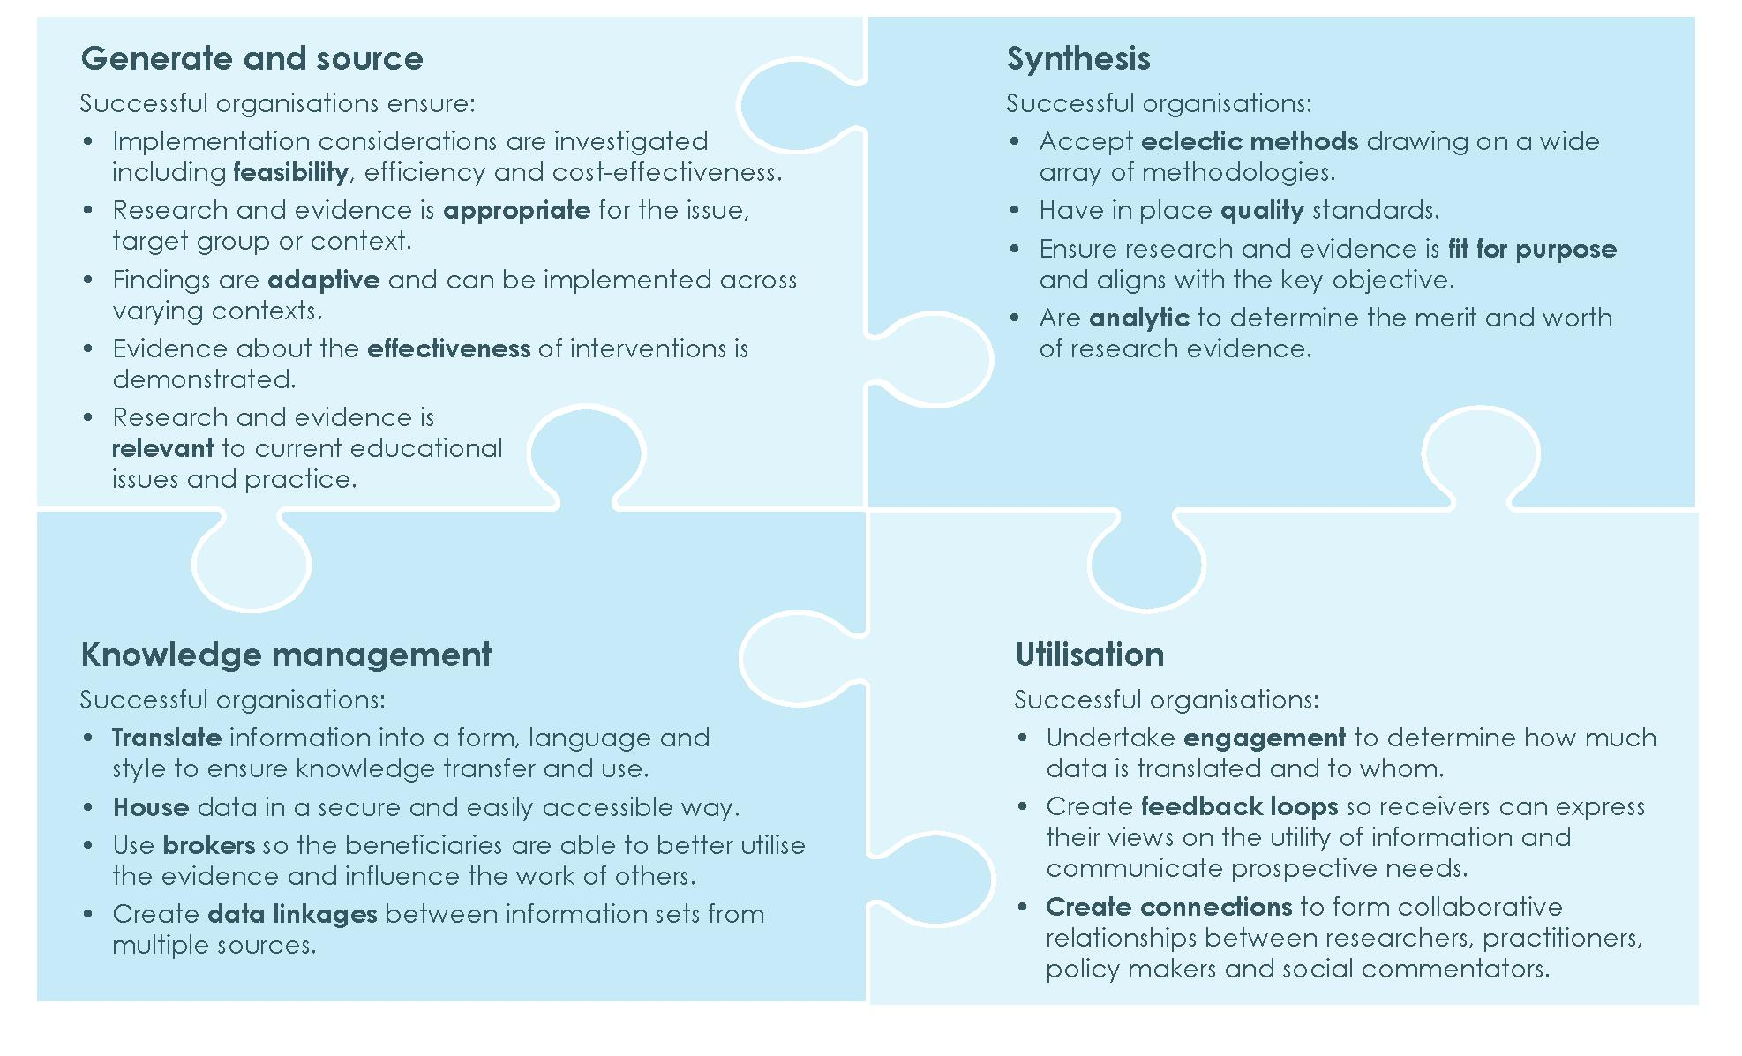
Source: Adapted from Clinton, J.M., Aston, R. & Quach, J. (2018) Promoting evidence uptake in schools: A review of the key features of research and evidence institutions, Report prepared for: Education Excellence Review Secretariat, Department of Education and Training, Australian Government; University of Melbourne: Melbourne.

Multiple organisations perform some, but not all, of these functions in Australia. This includes state based organisations such as the NSW Centre for Education Statistics and Evaluation (CESE) in the NSW Department of Education which provides advice across three of these functions: generating and sourcing relevant evidence; synthesising evidence; and transferring, brokering and managing knowledge. CESE has a focus on quality practice in NSW government schools and informing NSW education policy, with priority work areas being largely policy and program driven. At the national level, there are organisations like the ACER, a major research body, which undertakes much work of this type under contract to governments. It was partly set up in 1930 to perform such functions, but it is now a fully commercial operation with an international reach.
Crucially however, no national body is expressly charged by governments with the task of delivering into teachers' hands the practical results of this evidence and research. This is a vital 'missing link' which a new national evidence and research institute will remedy. Many submissions and consultations called for just such a national research and evidence institute to be established to address this gap.

Australia must... improve our 'learning productivity' with continuous improvement models supported by a new national and independent evidence broker.
Social Ventures Australia – Submission

We advocate for the establishment of a national evidence body, supported by an independent governance structure, responsible for commissioning high quality research, amalgamating the international evidence, translation and implementation so that educators are equipped to make evidence based decisions.
The Commonwealth Bank of Australia – Submission

Schooling in Australia would benefit from a single, national institution that could share evidence on effective practice and innovations. The body's development should be properly resourced and staged, to allow for planning, execution and evaluation. The institution's scope should include the full breadth of issues that impact education outcomes across schools, including what and how students learn and their transition to further training, study and employment. It means looking at more than the drivers of student achievement in a narrow academic sense, and extends well beyond classroom practice. It would also mean looking at innovations such as the role of information technology.
Finding 17
To sustain continuous improvement, Australian schools need access to: valid and reliable evidence of effective teaching practice; independent and rigorous evaluations of commercial and other teaching and educational interventions; and the most recent findings on educational innovation and research—in an accessible format that can be readily translated into classroom use.
Potential roles of a national innovation institution
Generating relevant research and evidence
A critical function of research and evidence institutions is gathering and commissioning research in a manner that is feasible, appropriate, meaningful, effective and relevant. This means gathering evidence in a way that:
- involves effective collaboration with the intended end-user across all stages of the research process
- has a focus on generating 'actionable', evidence-based knowledge
- includes practical steps, such as the development of guidelines articulating how evidence can be operationalised into practice or policy change.
As the Productivity Commission notes, 'in recent years many institutions have undertaken some education research of the required kind, but it is being done in an ad hoc and largely unguided way.' The result is that these arrangements have not delivered the type of education research the Productivity Commission considered necessary to improve outcomes. A national education institution would mean actionable evidence could be commissioned and gathered more systematically to share with schools.
Case study
Clinically relevant evidence—The Centre for Community Child Health [Murdoch Children's Research Institute]
The Centre for Community Child Health is a research centre focused on supporting evidence-based policy, service delivery and professional practice to improve outcomes for Australian children. The centre generates evidence that is applicable to policy and practice.245
At the centre, all health and education research is designed and conducted to ensure the knowledge generated is applicable to real-world contexts. Research outputs include a translation of the findings and identify implications for policy and practice.246 Many researchers at the centre also work as health professionals and in public policy settings, bringing first-hand, frontline experience to their role of evidence evaluators. The co-leader of the centre was the Chief Medical Officer at the Victorian Department of Education and Training.
In addition to generating actionable knowledge, the centre is also committed to minimise inequalities by taking a population approach to research which is not sector-specific.247 One example of this is the Raising Children Network, which is supported by the Australian Government. The network is a website that targets parents and carers, and provides current, evidence-based information that is relevant for parents and professionals who work with parents and carers.248 The information is delivered in an accessible manner with plain language short summaries of synthesised research that highlight areas where there is conflicting evidence. The network also ensures that information is accessible to users with low literacy, or language backgrounds other than English. Some resources have also been developed specifically for Aboriginal and Torres Strait Islander parents and carers, however this is an area of ongoing development.249
Synthesising evidence
A second role for a national research and evidence institution is collating and synthesising existing research. This could involve sourcing and synthesising evidence using eclectic methods; appraising evidence quality, merit, worth and significance; and considering the forms of evidence that can best inform policy and practice change. It could also involve developing standards for quality research in education in Australia, where criteria and standardised checklists are yet to be established.
A national research and evidence institute could also assess the scalability of interventions to help schools and school leaders decide whether the intervention is appropriate for their setting. Scalability refers to the capacity of interventions that have demonstrated efficacy in small settings, or under controlled conditions, to be expanded to real-world conditions and reach a broader population, while retaining effectiveness. This might include advising on whether a reading intervention that has improved student reading in one local government area could achieve similar benefits if implemented in a higher number of schools from

different areas. Advising on scalability is important because not all promising interventions are transferable: their impact is influenced by context-specific factors unique to their original setting, such as funding availability, strategic alignment, differential expertise, or existing infrastructure.
Case study
Evidence synthesis—Education Endowment Foundation
The Education Endowment Foundation is a UK-based foundation that has created toolkits to translate findings of evidence syntheses to educators. They have developed a Teaching and Learning Toolkit targeting primary and secondary educators, and an Early Years Toolkit targeting early childhood educators.
The Toolkits include syntheses of evidence on 46 education practices and provide concise summaries of evidence for each practice. These summaries are organised by practice in the Toolkit, and they are also categorised by implementation cost, evidence strength and impact on achievement.
A technical appendix is also provided, which details the search terms utilised to source evidence, the number of studies (primary and secondary research) synthesised, a statement about the recency of the research, and an overall judgement of the evidence quality.252 This judgement is informed by the study design and the technical design characteristics, including risk of bias and effect-size magnitude. Using all this information, an overall rating is given for the quality of the evidence (strong, moderate, weak). An estimated cost of implementation per student is also provided for some practices with an accompanying judgement of the size of the cost, considering the magnitude of impact this practice has been shown to yield. Links to current research projects funded by the Education Endowment Foundation that are related to these practices are also provided in the evidence summaries.
Finally, for each practice summary linked resources are also listed which could include videos of interviews with researchers, seminal reports, and existing literature reviews. Full evidence reviews conducted by Education Endowment Foundation to develop the evidence summaries are also published on the website. Users therefore have access to the primary evidence, techniques and criteria used to synthesise this evidence, and the complete report that the practice evidence summaries are developed from.253
Knowledge transfer, brokering and management
A third role for the institution would be managing and transferring research knowledge. This might involve interactive and active knowledge translation developed with the involvement of the intended end-user(s), effective knowledge storage, and creating data linkages. This could help overcome barriers to the translation and dissemination of knowledge by individuals, such as limited time or opportunities to share knowledge; poor contextualisation or awareness of other practitioners' needs; and practitioners' lack of training in evidence-informed policy and practice.
The national research and evidence institution could also broker collaboration between institutions, practitioners and researchers to work on knowledge translation and

dissemination. This should involve the production of evidence resources where practitioners are involved in the design and implementation of the resource to ensure the output reflects their on-the-ground experience. It could also involve acting as knowledge brokers who tailor the dissemination of knowledge to different end-user groups.
Case study
Knowledge Brokering—Australian Institute of Teaching and School Leadership (AITSL)
AITSL is an education knowledge broker for educators across Australia. The knowledge brokering practices at AITSL illustrate the way to incorporate technology and the end-user in the evidence translation process, and the value of producing resources to assist the implementation of evidence-informed practice. AITSL's work is based on policy priorities, as they are responsible to the Commonwealth Minister of Education.
At a strategic level, one of the goals identified in AITSL's 2017-2020 strategic plan is to 'use evidence to inform practice and improve learner outcomes.' AITSL addresses documented gaps by mobilising education research and translating the research in a way that can inform practice and maximise ease of implementation.254
Research mobilisation includes evidence synthesis. This is conducted in partnership with Evidence for Learning, part of Social Ventures Australia, and the recently developed Spotlight evidence summaries, which include fact sheets, animations and a space for educators to share their implementation stories and feedback.
Knowledge translation products are developed and aligned with current education policy frameworks based on the information generated through evidence synthesis. For example, the MyStandards mobile application was developed to support teachers to collect and curate evidence of their practice in line with the Australian Professional Standards for Teachers.
Finally, the dissemination of these knowledge translation products is supported by a significant online social influence. According to AITSL, the organisation is in the top 5 percent of social media influences globally based on a 'Klout' score of approximately 67.255 In addition to an online presence, AITSL also engages in large-scale stakeholder consultation and regularly communicates with educators across the system, as well as state and territory governments and Catholic and Independent Education offices.
Accelerating the utilisation of knowledge
Evidence institutions must work to accelerate research utilisation. This includes engaging with end-users, systematising feedback mechanisms and creating connections with current debates in policy and practice. A key aspect of encouraging the utilisation of knowledge is ensuring that the institute can create and maintain engaging, user-centric knowledge infrastructure that is delivered into the hands of teachers, school leaders and decision-makers via easy to use information technology. This includes:
- User-centric design of knowledge infrastructure, such as the ability to tailor content to the individual user, and ease of use features such as help boxes, search tips, relevant case examples, and easy access to technical support.

- Incorporation of feedback loops into the design of knowledge infrastructure, allowing users to suggest ways to improve the design, improve the content/evidence, and share their knowledge with other users.
- Sustained funding to enable ongoing functionality and forecasting, given the pace of technological change, the institution will need to maintain the infrastructure to keep pace with updated technology specifications and enable the publishing of content in a timely fashion.
- A quality knowledge management strategy, a transparent strategy that is used to underpin a technological infrastructure or platform for research utilisation and must incorporate both the technical and social processes involved in knowledge translation.
Design considerations for a national research and evidence institution
Nine principles are suggested as a guide fora national research and evidence institution's establishment and operation (see Exhibit 29).

Exhibit 29. Principles for a national education research and evidence institution
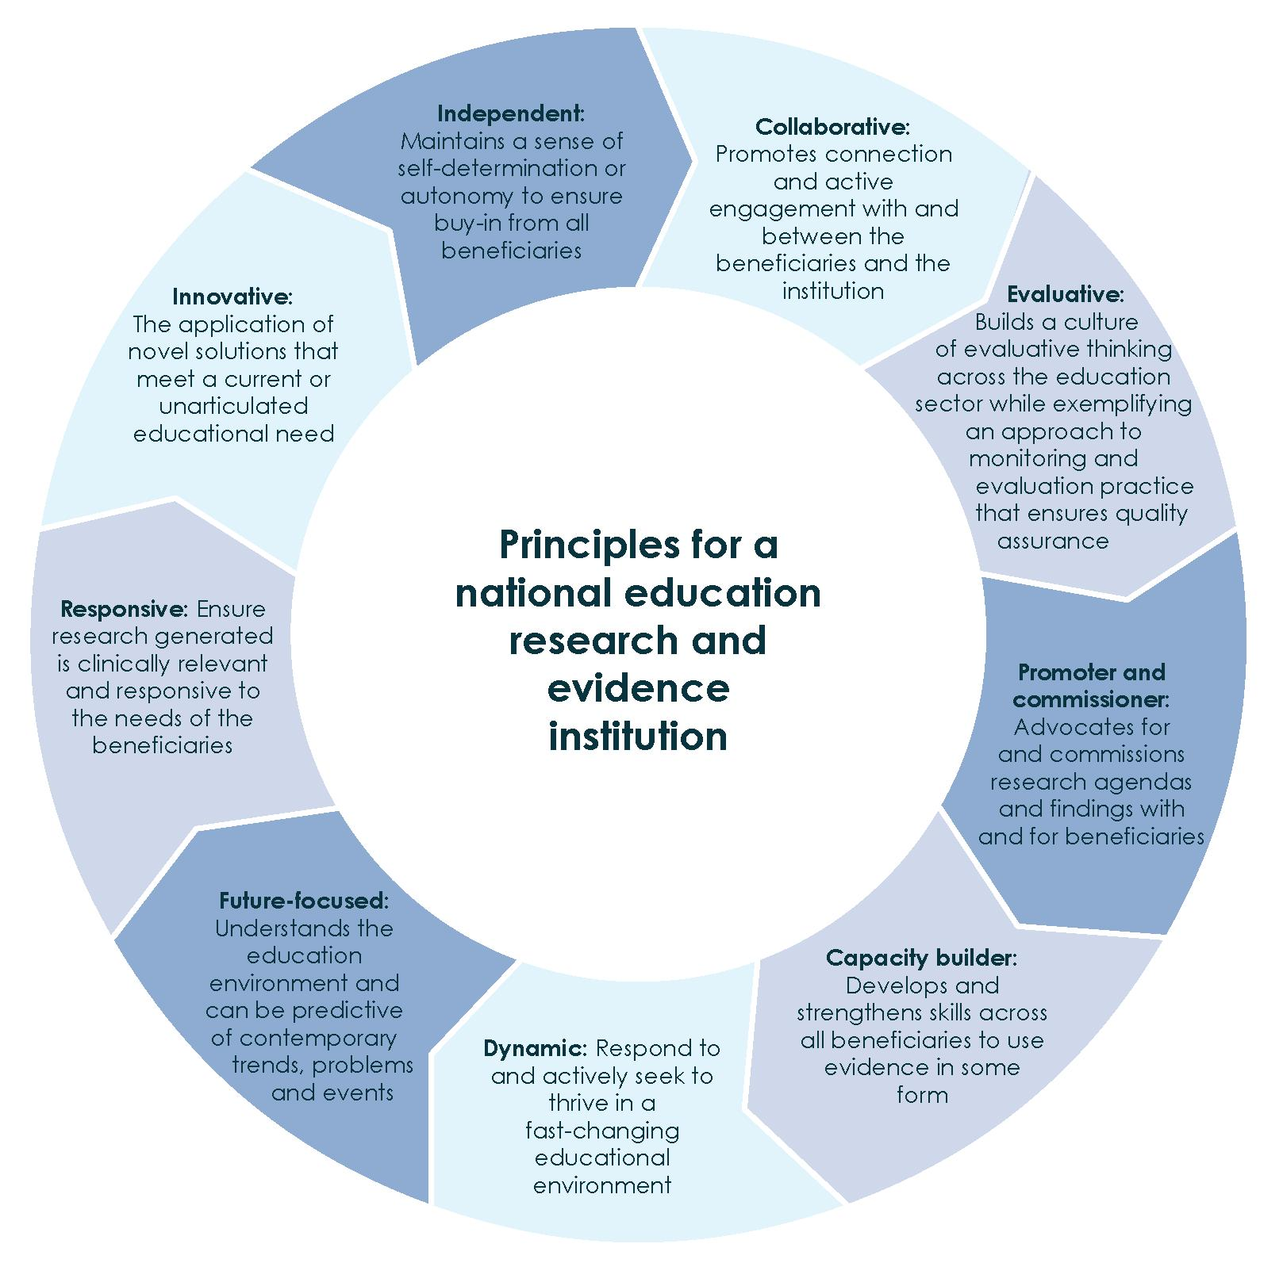
Source: Adapted from Clinton, J.M., Aston, R. & Quach, J. (2018) Promoting evidence uptake in schools: A review of the key features of research and evidence institutions, Report prepared for: Education Excellence Review Secretariat, Department of Education and Training, Australian Government; University of Melbourne: Melbourne.

The institute's governance and connection with the existing national education infrastructure are also important design choices. Research and evidence institutions are most effective if they remain independent while retaining a connection to government decision-makers. Independence will help ensure that outputs are considered trustworthy and objective. Maintaining closeness to governments facilitates collaboration with policy makers and results in more relevant and useful evidence generation and synthesis.
A national research and evidence institution will require government funding. The corporate governance model will need to ensure this does not prejudice the institution's independence in decision-making and analysis. An independent, functional board will be key to this model. International examples include the Education Endowment Foundation in the UK, which operates independently from the Department of Education and is accountable to its own board. Such leadership and governance structures help mitigate the potential disconnect between funder goals and end-user needs while maintaining independence and receiving necessary funding for sustainable functioning. Transparent stakeholder participation, evaluation and accountability can also ensure independence is maintained.
The board should be made up of appropriately qualified stakeholders and be able to represent the breadth of areas the research and evidence institute will consider as well as potential users of the research. It should have balanced representation across states and territories and government and non-government systems, although not all need be represented on it. To attain this breadth, the format could be modelled on the UK's Citizens' Council which supports the National Institute for Health and Care Excellence. The institute receives annual funding from the Department of Health but operates independently with priorities and decisions made by a functional board with advisory input from the Citizens' Council. The Citizens' Council is comprised of members from the sector and public.
States and territories
The role of state and territory governments in a national research and evidence institution will be critical. State and territory governments need to be involved to ensure national consistency and to accommodate the significantly different contextual characteristics of each state and territory. Similarly, Independent and Catholic education should also have a role to play given their importance as providers of school education. The decision about who should provide funding for the body is a matter for governments, it is noted that as the research, evidence and advice generated by the institution are intended to be beneficial to all states and territories, funding responsibilities could be spread between the Commonwealth and states and territories, in a similar way to existing Council of Australian Governments' bodies such as the Australian Curriculum, Assessment and Reporting Authority.

Implementation
Establishing a national research and evidence institution is a significant undertaking. A staged approach to implementation planning and execution will be needed, including strategy development and appropriate capacity building. Adequate investment coupled with realistic expectations will be critical for the institution's success and by extension for improved student learning outcomes.
Recommendation 23
Establish an independent institution to coordinate the strategic development of a national research and evidence base through the sourcing and generating of research, and the synthesising and promotion of educational evidence that can be easily accessed and implemented to improve student outcomes.

Call to action
Enabling all Australian students to realise their full learning potential, and re-establishing Australia's education system as world-leading, is an ambitious but achievable goal, which requires a commitment to sustained, long-term reform.
The strategy set out in this report, and articulated in the 23 recommendations, will transform Australian school education.
The Review Panel recognises that the scale of these reforms is ambitious, particularly given Australia's federated education model. The challenges, however, cannot become an excuse for inaction. The evidence is clear; the reforms embedded in the strategy are necessary to achieve educational excellence in Australian schooling.
Taken together, and implemented in a sustained way, these reforms will reverse the decline in student outcomes in recent decades, and prepare current and future generations of school students to succeed in life and 21st century careers.
These reforms will enable teachers to better tailor teaching to the needs of individual students, and will elevate the standing of the teaching profession. Teachers will be given the assessment tools to assist them in their role of promoting and encouraging progress, as well as the access they require to current evidence and research. Professional collaboration and mentoring will be supported and teachers will have a clear and valued career pathway, achieving career satisfaction without having to leave the profession.
School leaders will have, as their primary focus, individual student achievement through learning growth. They will be supported in this goal by the reforms set out in this report, and by investment in the building of their professional autonomy and standing as leaders of learning throughout their career.
For parents and carers, these reforms strengthen their relationship with schools. They will receive clearer and more frequent information on their child's current levels of attainment and progress, and the next steps in their learning. Teachers will have the skills and knowledge to build effective relationships with students' families. This will enable parents and carers to become true partners in learning with their child, the teachers and the school.
Australia's school systems and schools will become more innovative and adaptive, setting high expectations, and delivering continuous improvement, informed by data and evidence, helping Australia regain its standing as a world-leading education system.
The reforms recommended by this review are an integrated package, not discrete ideas to be adopted in isolation. The recommendations in the strategy are inter-related and inter-dependent. They received significant support from a wide cross-section of stakeholders—including teachers, school leaders, schools and school systems, researchers, community organisations, unions, and the business community. The reforms should be implemented as a whole and undertaken collaboratively across governments and sectors with bipartisan support, or their impact will be diminished.
Governments have the mandate to make these changes to help Australian students and schools achieve educational excellence. The Review Panel calls upon them to partner with schools and school systems, school leaders, teachers and students, with employers and business, with unions, with parents and carers and with the community, to set high expectations for schooling and translate those expectations into action.
Our students deserve nothing less than our full national focus, commitment and effort.
The future of all young Australians and our nation's prosperity depend on it.

Appendix A – Terms of Reference


Terms of reference
Evidence from organisations such as the Organisation for Economic Co-operation and Development (OECD) is clear that simply providing more funding for schools does not in itself improve student outcomes. To achieve the best educational return on investment we must look at how money is best used, and not just how much is spent.
This is borne out in Australia, where total government funding for schools has doubled since 1988, yet Australian students' performance in national and international assessments has declined in real and relative terms.
The Turnbull Government's school funding reforms guarantee ongoing, record levels of Commonwealth Government investment in schools, growing recurrent funding from $17.5 billion in 2017 to $22.1 billion in 2021, and $30.6 billion by 2027. This includes more than $2.2 billion in new funding over the first four school years in the 2017-18 budget, which is in addition to generous indexation of 3.56 per cent and follows on from $1.2 billion in new funding budgeted in 2016-17
The Turnbull Government has established the Review to Achieve Educational Excellence in Australian Schools, to be chaired by Mr David Gonski AC, to provide advice on how this extra Commonwealth funding should be used by Australian schools and school systems to improve school performance and student achievement.
The Review will report to the Prime Minister and Commonwealth Minister for Education and Training. It will examine evidence and make recommendations on the most effective teaching and learning strategies and initiatives to be deployed. In particular the Review will focus on the effective and efficient use of funding to:
- Improve student outcomes and Australia's national performance, as measured by national and international assessments of student achievement.
- Improve the preparedness of school leavers to succeed in employment, further training or higher education.
- Improve outcomes across all cohorts of students, including disadvantaged and vulnerable students and academically-advanced students ('gifted' students).
To support these recommendations, the Review will also:
- Provide advice on related institutional or governance arrangements to ensure the ongoing identification and implementation of evidence based actions to grow and sustain improved student outcomes over time.
- Propose related transparency and accountability measures that support the effective monitoring, reporting and application of investment.
The Review will not reconsider the calculation of Commonwealth or state funding for schools, which was the subject of the 2011 Review of Funding for Schooling, also chaired by Mr Gonski. The Turnbull Government has accepted the fundamental recommendations of the 2011 Review regarding needs based distribution of funding and is now acting on the advice that further work be undertaken on quality reforms.
Mr Gonski will chair an independent panel, and will draw on education experts, academics and practitioners with experience in education systems and teaching and learning methodologies, both internationally and within Australia, as well as states and territories and non-government school authorities.

Appendix B – Review process

Review process
On 2 May 2017, Senator the Hon Simon Birmingham, Minister for Education and Training announced The Review to Achieve Educational Excellence in Australian Schools (the Review) which would examine evidence and make recommendations about how school funding should be used to improve school performance and student outcomes.
The Panel for the Review, announced on 12 July 2017, was conducted by a panel of eight members.
Review Panel Members
Mr David Gonski AC, Chair
MrTerrey Arcus AM
Dr Ken Boston AO
Ms Valerie Gould
Ms Wendy Johnson
Dr Lisa O'Brien
Dr Lee-Anne Perry AM
Mr Michael Roberts
On 11 September 2017, the Review Panel released an issues paper, Review to Achieve Educational Excellence in Australian Schools - Issues paper, and invited teachers, schools, parents, students, education experts, stakeholders and all other interested parties to put forward ideas about the reforms needed to drive improved student outcomes. The submission process was the primary form of consultation for the Review. The Review received 279 written submissions and conducted a number of targeted consultations with governments, peak bodies and experts in education.
The Review Panel delivered their report to the Australian Government in March 2018.
Secretariat
A secretariat from the Department of Education and Training supported the Review Panel and the Review process. The Secretariat operated independently of the department.
The Secretariat team
Ms Renae Houston, Head of Secretariat
Mr Jason Dymowski, Director
Mr Liam Smyth, Director
Ms Jessie Batterham, Assistant Director
Ms Alexandra Gosling, Assistant Director Mrs Lauren Kennedy, Assistant Director
Mr Michael Currie, Project Officer
Ms Kathleen Tully, Project Officer
Commissioned work
The Review Panel commissioned one research project to inform the consideration of a national research and evidence institute in Chapter 5. The University of Melbourne -Commercial Limited was commissioned in November 2017 to research the development and implementation of research and evidence bodies for the Review's final report.

Appendix C – Consultations


Consultation meetings
Association of Heads of Independent Schools Australia
Australian Association of Special Education
Australian Capital Territory Education and Training Directorate
Australian Council for Educational Research
Australian Council of Deans of Education
Australian Council of State School Organisations
Australian Curriculum, Assessment and Reporting Authority
Australian Education Union
Australian Government Department of Education and Training
Australian Institute for Teaching and School Leadership
Australian Parents Council
Australian Primary Principals Association
Australian Secondary Principals Association
Australian Special Education Principals Association
Catholic School Parents Australia
Catholic Secondary Principals Australia
Disability Discrimination Commissioner
Dr Alan Finkel - Australia's Chief Scientist
Dr Jae Yup Jung - Gifted Education Research and Resource Centre Senior Research Fellow, UNSW
Dr Peter Goss - Grattan Institute
Education Services Australia
Foundation for Young Australians
Independent Education Union of Australia
Independent Schools Council of Australia
Innovation and Science Australia
Isolated Children's Parents' Association
Mr Andreas Sleicher- Organisation for Economic Co-operation and Development- Directorate of Education and Skills
Mr Bill Ferris - Innovation Science Australia
Ms Jennifer Westacott - Business Council of Australia
Ms Julie Sonnemann - Grattan Institute
Ms Susan Pascoe-The Review to Achieve Educational Excellence in Australian Schools through Early Childhood Interventions

Consultation meetings
Ms Yvette Berry M LA- ACT Minister for Education and Early Childhood Development
National Aboriginal and Torres Strait Islander Principals Association
National Catholic Education Commission
New South Wales Department of Education and Communities
Northern Territory Department of Education
Prime Minister's Indigenous Advisory Council
Professor Claire Wyatt-Smith - Professor of Educational Assessment and Literacy; Institute Director of the Learning Sciences Institute Australia, Australian Catholic University
Professor Deborah Brennan - The Review to Achieve Educational Excellence in Australian Schools through Early Childhood Interventions
Professor Donna Cross - Head, Health Promotion and Education Research; Director, Early Childhood Development and Learning Collaboration, Telethon Kids Institute
Professor John Halsey - Independent Review into Rural, Regional and Remote Education
Professor John Hattie - Melbourne Graduate School of Education, The University of Melbourne
Professor Patrick Griffin - Melbourne Graduate School of Education, The University of Melbourne
Queensland Department of Education and Training
Senator the Hon Simon Birmingham - Federal Minister for Education and Training
Social Ventures Australia
South Australia Department of Education and Child Development
Tasmania Department of Education
The Hon Eva Lawler MLA - NT Education Minister
The Hon Grace Grace MP - QLD Education Minister
The Hon James Merlino MP - VIC Minister for Education
The Hon Jeremy Rockliff MP-TAS Minister for Education
The Hon Rob Stokes MP - NSW Minister for Education
The Hon Sue Ellery MLC - WA Minister for Education
The Hon Susan Close MP - SA Education Minister
The Hon Tanya Plibersek MP - Shadow Minister for Education and Training
UK Education Endowment Foundation
Victoria Department of Education and Training
Western Australia Department of Education

This page has been left blank intentionally

Appendix D – Public submissions

Public submissions
The submission process opened on 11 September 2017 and received a total of 279 submissions. The Review received submissions from peak bodies, teachers and academics, a variety of other stakeholder groups including students, parent and community groups as well as state and territory governments.
Authors who gave permission for their submission to be published are listed below. Those who authored multiple submissions are listed once. Names in this list appear as submitted.

Submissions
"Maths Unlimited! A collaboration between Maths and Industry"
AAAE - Australian Alliance of Associations in Education
ACARA
Accessible Publishing Systems Pty Ltd
ACT Government
ahmad, tufail
AIS NSW Institute
AITSL
All Means All -The Australian Alliance For Inclusive Education
Anderson, Gail
APRAAMCOS
ARC Centre of Excellence for Children and Families over the Life Course
ARC Linkage Project Chief Investigators and Partner Investigators
Ashenden, Dean
Ashman, Greg
Asialink - The University of Melbourne
ASLIA National
Association of Catholic School Principals in NSW Inc
Association of Heads of Independent Schools of Australia (AHISA)
Association of Independent Schools of South Australia
Association of Independent Schools of Western Australia, Inc.
Australian Association for the Teaching of English (AATE)
Australian Association of Christian Schools
Australian Association of Special Education Inc.
Australian Catholic Primary Principals Association
Australian Catholic University (ACU)
Australian College of Educators
Australian Council for Educational Research
Australian Council of State School Organisations
Australian Council of TESOL Associations (ACTA)
Australian Education Union
Australian Federation of Modern Language Teacher Associations
Australian Film Television and Radio School
Australian Government Department of Education and Training
Australian Government Primary Principals Association
Australian Learning Lecture
Australian Major Performing Arts Group
Australian Mathematical Sciences Institute
Australian Parents Council Inc.
Australian Primary Principals Association
Australian Psychological Society

Submissions
Australian Publishers Association
Australian Research Alliance for Children and Youth
Australian School Library Association
Australian Schools Plus
Australian Schools Plus/2017 Teaching Fellows
Australian Secondary Principals' Association
Australian Sports Commission
Australian Teacher Education Association
Barker, Barbara
Barrett, Gerard
Baulch, Kirsten
Baumann, Chris
Beaumont, Martine
Beveridge, Lorraine
Beyond the Bell Great South Coast Ltd
Big Picture Education Australia
Bloomfield, John
Bradley, Kerry
Brady, Laura
Brisbane Catholic Education
BROTHERHOOD OF ST LAURENCE
Burgess, Karen
Calvert, Andrew
Catholic Diocese of Broken Bay
Catholic Education Commission NSW
Catholic Education Western Australia
Catholic School Parents Australia
Catholic School Parents Victoria
Centre for Multicultural Youth
Champions Educational Gaming
Children and Young People with Disability Australia
Commonwealth Bank of Australia
Community Council for Australia
Computerbasedmath.org
Cosser, Robina
Council of Catholic School Parents NSW/ACT
Custance, William
Daly, Brigid
Deakin University
Department of Educational Studies, Macquarie University
Department of the Prime Minister and Cabinet
Disability Discrimination Legal Service
Dixon-Scheirich, Berys
Doe, Tim
Dunn, Louise
Dyslexia SA
Dyslexia-SPELD Foundation
Education Standards Institute
English, Rebecca

Submissions
Essential Education Economics (E3)
Ewing, Robyn
Family Advocacy
Federation of Parents and Citizens of New South Wales
Flanagan, Michael
Fluck, Andrew
Fogarty Foundation
Foundation for Young Australians
GAME PLAY LEARN
Geraldton Grammar School
GERRIC, School of Education, The University of New South Wales
Gill, Richard
Girls Invent
Graham, Linda
Grattan Institute
Greenwell, Tom
Hansberry, Bill
Harvey, Kerry
Haseloff, Milton
Heffernan, Amanda
Hempenstall, Kerry
Henderson, Lesley
Highly Accomplished and Lead Teacher Network Steering Group
Hobbs, Carmel
HORNER, ROSS
Hunter, Jane
Independent Education Union of Australia
Independent Schools Council of Australia
Independent Schools Queensland
INDEPENDENT SCHOOLS VICTORIA
Ingvarson, Lawrence
Isolated Children's Parents' Association of Australia, ICPA (Aust)
Jackson, Daniel
Johnson, Paul
Kids Giving Back
Korodaj, Lori
Kwok, Ther L
La Trobe University
Lawless, Danielle
Learning Difficulties Coalition of NSW
Lennard, Marianne
L'Estrange, Marcus
Lierse, Sharon
Malaquias, Catia
Marien, Brian
Mathematical Association of NSW Inc
McGinness, Laurence
McGrath, Jason
MCHF

Submissions
Mckenzie, Feliana
McKinnon, Michael
McMorrow, James
Menzies Research Centre
Missing School Inc.
Mission Australia
Mitchell Institute
Mitchell, Martin
Moore, Darcy
Mularczyk, John
MULHOLLAND, sylvia
National Catholic Education Commission
Northern Sydney District Council of P&C Associations
Norton, Stephen
Norwood, Amelia
NSW Department of Education
NSW Parents Council
NSW Primary Principals' Association
NSW Secondary Principals' Council Inc.
NT Department of Education
NTCOGSO
O'Brien, Mark
OnDigital Australia
Origin Foundation
Owens, Penelope
Parentshop Pty Ltd
Paul Ramsay Foundation
Peace, David
Phelan, Liz
Phillips, Julie
Playgroup Victoria
Podesta, Lesley
Presbyterian Ladies College (PLC) Sydney
Preston, Barbara
Primary English Teaching Association Australia
Principals Institute Australia
Queensland Action Group for LGBTIQ+ Students
Queensland Association of State School Principals
Queensland College of Teachers
Queensland Government
Raise Foundation
researchED
Richardson, Phil
Rickards, Field
Rooty Hill High School
Royal Institute for Deaf and Blind Children
Ryan, Margaret
SACE Board of South Australia
Sandral, Felicity

Submissions
Sawyer, Phoebe
Schouten, Robert
Slater, Allen
Snow, Pamela
Social Ventures Australia
South Australian Department of Education and Child Development
South Australian Primary Principals Association
South Australian Secondary Principals' Association
Speech Pathology Australia
St Anthony's School Noble Park
Steiner Education Australia
Stevens, Carl
Sweller, John
Sydney Catholic Schools
Tasmanian Council of Social Service (TasCOSS)
Tasmanian Government
Teach For Australia
Teachers and Teaching Research Centre, The University of Newcastle
The Association of Independent Schools of NSW
The Australian Academy of Science
The Australian Association of Mathematics Teachers Inc. (AAMT)
The Boston Consulting Group
The Centre for Independent Studies
The Centre for Policy Development
The Excellence Centre
The Isolated Children's Parents' Association Qld Inc.
The National Advocates for Arts Education (NAAE)
The Parenthood
The Science of Learning Research Centre, a Special Research Initiative of the Australian Research Council (slrc.org.au)
The Smith Family
Thomas, John
Tripp, David
Tulip Education
Victorian Association of State Secondary Principals
Victorian Government
Victorian School Policy and Funding Advisory Council
Volunteering Australia
WA Council of State School Organisations Inc. (WACSSO)
Webb, Ivan
Western Australian State Government
Wheeler, Kim
Wheldall, Kevin
White, Brenton
Wilson, Rachel
Witten, Pete
X, Pardiyono
Z, Linda

Appendix E – Glossary


Glossary
Australian Curriculum | Sets out, through content descriptions and achievement standards, what students should be taught and achieve as they progress through school. The Foundation to Year 10 Australian Curriculum is made up of eight learning areas, seven general capabilities and three cross-curriculum priorities. It has been endorsed by education ministers from the federal, state and territory governments. State and territory curriculum and school authorities are responsible for the implementation of the Australian Curriculum in their schools, in line with system and jurisdictional policies and requirements.
Australia's school education system | The collective term to describe primary and secondary schools in the government, Catholic and Independent sectors, and the systems that support many of them.
Australian Tertiary Admissions Rank (ATAR) | Allows tertiary admissions centres to compare students from across Australia when they apply for tertiary places. The ATAR is a number between 0 and 99.95, in increments of 0.05.
Beginning teacher | A teacher who has recently graduated from an initial teacher education program and has commenced employment.
Cross-curriculum priorities | Gives students the tools and language to engage with and better understand their world on a range of levels. The priorities provide national, regional and global dimensions which will enrich the curriculum through development of considered and focused content that fits naturally within learning areas. The three cross-curriculum priorities are:  • sustainability  • Asia, and Australia's engagement with Asia  • Aboriginal and Torres Strait Islander histories and cultures.
Developmentally vulnerable | Children are considered to be developmentally vulnerable in the Australian Early Development Census if their score is below the 10th percentile score (in the lowest 10 per cent) of the 2009 collection.
Early childhood education and care | The formal care and early learning provided by preschools and kindergartens, long day care centres, family day care, occasional care services and some crèches in the years before children go to school.
Formative assessment | The wide variety of methods that teachers use to conduct in process evaluations of student comprehension, learning needs, and academic progress. This includes diagnostic tools to determine what students already know and where there are gaps and misconceptions. Formative assessments help teachers identify concepts that students are struggling to understand, skills they are having difficulty acquiring, or learning standards they have not yet achieved so that adjustments can be made to lessons, instructional techniques, and academic support.
Foundational skills | Literacy and numeracy serve as foundational skills as they are considered essential for further learning.

Glossary
General capabilities | Encompasses the knowledge, skills, behaviours and dispositions that, together with curriculum content in learning areas and the cross-curriculum priorities, assist students to live and work successfully in the 21st century. The seven general capabilities are:  • literacy  • numeracy  • information and communication technology capability  • critical and creative thinking  • personal and social capability  • ethical understanding  • intercultural understanding.
Graduate teacher | A teacher who has successfully completed a qualification that meets the requirements of a nationally accredited initial teacher education program.
Initial teacher education (ITE) | Tertiary level education that prepares pre-service teachers to teach in Australian schools.
Instructional leadership | Instructional leadership involves:  • placing the improvement of student outcomes at the centre of a  teacher's role, and viewing all activities through this lens  • focusing on the impact of teaching on learning and how this can be  maximised  • shaping and driving the school's approach to pedagogy  • influencing and improving the performance of teachers through  coaching, formal and informal professional learning, mentoring,  internal and external moderation, and the development and support  of collaborative teaching practices  • promoting a positive school climate for teachers and students.
Learning areas | Comprise the disciplinary knowledge, skills and understanding described in the Australian Curriculum. In each learning area, content descriptions specify what young people will learn, and achievement standards describe the depth of understanding and the sophistication of knowledge and skill expected of students at the end of each year level or band of years. The eight learning areas are:  • English  • mathematics  • science  • health and physical education  • humanities and social sciences  • the arts  • technologies  • languages.
Learning progression | Outlines a sequence of observable and increasingly demanding levels of knowledge, skills and understanding. All levels are defined by criteria that relate to what a child knows, understands and can do at the time of assessment, independent of year level or age.
National Assessment Plan - Literacy and Numeracy (NAPLAN) | An annual national assessment for students in Years 3, 5, 7 and 9. NAPLAN tests skills in literacy and numeracy that are developed over time through the school curriculum.

Glossary
Parents and carers | Describes the primary caregivers to students and young people. This may include parents, other family members and carers who perform a primary care role.
Pedagogy | Discipline that deals with the theory and practice of teaching. Pedagogy informs teaching strategies, teacher actions, and teacher judgments and decisions by taking into consideration theories of learning, knowledge of students and their needs, and the backgrounds and interests of individual students.
Pre-service teachers | Students undertaking initial teacher education programs delivered by higher education providers.
Professional collaboration | Encompasses ongoing observation and feedback among colleagues where a culture of professional sharing, dialogue, experimentation and critique becomes commonplace. It connects teachers and leaders to their colleagues and students within and across schools and to external experts. Collaboration can encompass a range of activities, from teachers working together in an informal, unplanned way to the implementation of more formal collaborative approaches.
Professional learning | The formal or informal learning experiences undertaken by teachers and school leaders that improve their individual professional practice, and a school's collective effectiveness, as measured by improved student learning, engagement with learning and wellbeing. At its most effective, professional learning develops individual and collective capacity across the teaching profession to address current and future challenges.
Programme for International Student Assessment (PISA) | A triennial international survey conducted by the Organisation for Economic Co-operation and Development that evaluates education systems worldwide by testing the skills and knowledge of 15-year-old students.
School systems and schools | Refers to the central organisations which administer affiliated schools, and individual schools that are not part of an affiliated system. All government schools are part of their state or territory's system. Some schools in the nongovernment sector are also part of a system, e.g. many Catholic schools are part of state Catholic systems.
Senior secondary schooling | Years 11 and 12, the final years of schooling.
Tailored teaching | Involves adapting the way the curriculum and learning activities are presented and adjusting pedagogy to the different needs of students based on evidence about the most effective interventions, gained from an understanding of individual students' starting points and their growth in learning. Tailored teaching is also known as differentiated teaching or targeted teaching.
Teacher induction | A phase of structured guidance, support and professional learning for beginning teachers.
Trends in International Mathematics and Science Study (TIMSS) | An international assessment of student achievement in mathematics and science in Years 4 and 8, conducted every four years.

Appendix F – References


References
Australian Bureau of Statistics (1991) Schools, Australia, 1990, cat. no. 4221.0, ABS: Canberra, viewed on 19 February 2018, http://www.ausstats.abs.gov.au/ausstats/free.nsf/0/145B42AA4A0D4C12CA25744000199F79/$File/42210_1990.pdf.
Australian Bureau of Statistics (1999) Australian Social Trends, 1999, cat. no. 4102.0, ABS: Canberra, viewed on 19 February 2018, http://www.ausstats.abs.gov.au/ausstats/subscriber.nsf/0/CA25687100069892CA25688800285CA6/$File/41020_1999.pdf.
Australian Bureau of Statistics (2011) Australian Social Trends March 2011, cat. no. 4102.0, ABS:Canberra, viewed on 21 March 2018, http://www.ausstats.abs.gov.au/ausstats/subscriber.nsf/0/272D473F7AD28D68CA25785B000E01D8/$File/41020_year12_mar2011.pdf.
Australian Bureau of Statistics (2017) Education and Work, Australia, May 2017, cat. no. 6227.0, ABS: Canberra, viewed on 19 February 2018, http://www.abs.gov.au/ausstats/abs@.nsf/mf/6227.0.
Australian Bureau of Statistics (2018) Labour Force, Australia, Dec 2017, cat. no. 6202.0, ABS: Canberra, viewed on 19 February 2018, http://abs.gov.aU/AUSSTATS/abs@.nsf/DetailsPage/6202.0Dec%202017?OpenDocument.
Australian Bureau of Statistics (2018) Schools, Australia, 2017, cat. no. 4221.0, ABS: Canberra, viewed on 19 February 2018, http://www.abs.gov.au/ausstats/abs@.nsf/mf/4221.0.
Australian Council for Educational Research, National PISA data (2000-2015J[Data sets], viewed on 21 March 2018, https://www.acer.org/ozpisa/publications-and-data.
Australian Council for Educational Research (2012) National School Improvement Tool, ACER: Melbourne.
Australian Curriculum, Assessment and Reporting Authority (2017) NAPLAN achievement in reading, writing, language conventions and numeracy: National report for 2017, ACARA: Sydney.
Australian Curriculum, Assessment and Reporting Authority, 'Structure', in Australian Curriculum, viewed on 21 February 2018, https://www.australiancurriculum.edu.au/f-10-curriculum/structure/.
Australian Curriculum, Assessment and Reporting Authority, 'The General Capabilities', in Australian Curriculum, viewed on 21 February 2018, https://www.australiancurriculum.edu.au/f-10-curriculum/general-capabilities.
Australian Curriculum, Assessment and Reporting Authority, 'Year 12 Certification Rates', in Australian Curriculum, viewed on 21 March 2018, https://www.acara.edu.au/reporting/national-report-on-schooling-in-australia-data-portal/year-12-certification-rates#dataset.
Australian Early Development Census (2015) 'Early childhood education and care and the transition to school', AEDC Research Snapshot.
Australian Early Development Census (2015) 'Factors found to affect children's success at school', AEDC fact sheet.
Australian Early Development Census (2015) Australian Early Development Census National Report 2015: A snapshot of early childhood development in Australia, Commonwealth of Australia: Canberra.
Australian Early Development Census, 'Findings from the AEDC, viewed on 21 February 2018, http://www.aedc.gov.au/parents/findings-from-the-aedc.
Australian Government Department of Education, Employment and Workplace Relations for the Council of Australian Governments (2009) Belonging, Being & Becoming: The Early Years Learning Framework for Australia, Commonwealth of Australia: Canberra.
Australian Institute for Teaching and School Leadership (2014) Australian Professional Standard for Principals and the Leadership Profiles, ESA: Melbourne.
Australian Institute for Teaching and School Leadership (2014) Disciplined collaboration in professional learning, AITSL: Melbourne.

References
Australian Institute for Teaching and School Leadership (2015) Preparing future leaders: Effective preparation for aspiring future leaders, AITSL: Melbourne.
Australian Institute for Teaching and School Leadership (2016) Annual Report 2015-16, AITSL: Melbourne.
Australian Institute for Teaching and School Leadership (2016) Graduate to Proficient: Australian guidelines for teacher induction into the profession, AITSL: Melbourne.
Australian Institute for Teaching and School Leadership (2016) Spotlight: What do we know about early career teacher attrition rates in Australia?, AITSL: Melbourne.
Australian Institute for Teaching and School Leadership (2017) Australian guidelines for school leadership development, AITSL: Melbourne.
Australian Institute for Teaching and School Leadership (n.d.) Induction of beginning teachers in Australia - What do early career teachers say?, AITSL: Melbourne.
Australian Institute for Teaching and School Leadership (n.d.) Increasing our Impact: AITSL Strategic Plan 2017-2020, AITSL: Melbourne.
Australian Institute for Teaching and School Leadership, ' Feedback Case Study: Collaborating to Support Improved Practice', viewed on 7 March 2018, https://www.aitsl.edu.au/docs/default-source/feedback/aitsl-feedback-casestudy-braypark.pdf.
Australian Institute for Teaching and School Leadership, 'The essential guide to professional learning: collaboration', viewed on 23 February 2018, https://www.aitsl.edu.au/tools-resources/resource/the-essential-guide-to-professional-learning-collaboration.
Australian Institute of Health and Welfare (2015) Literature review of the impact of early childhood education and care on learning and development: working paper, cat no. CWS 53, AIHW: Canberra.
Australian Primary Principals Association (2017) Back to balance: how policy and practice can make primary principals highly effective, Australian Primary Principals Association.
Autor, D.H. & Price, B.M. (2013) The changing task composition of the US labor market: An update of Autor, Levy, and Murnane (2003), MIT Press: Cambridge.
Bain, A. & Swan, G. (2011) 'Technology enhanced feedback tools as a knowledge management mechanism for supporting professional growth and school reform'. Educational Technology Research and Development, vol. 59(5), pp. 673-685.
Barber, M., Whelan, F. & Clark, M. (2010) Capturing the leadership premium: How the world's top school systems are building leadership capacity for the future, McKinsey & Company.
Basford, T., Schaninger, B. & Viruleg, E., 'The science of organizational transformations', in McKinsey & Company, viewed on 14 March 2018, https://www.mckinsey.com/business-functions/organization/our-insights/the-science-of-organizational-transformations.
Bendikson, L., Robinson, V. & Hattie, J. (2012) 'Principals' instructional leadership and secondary school performance'. Research Information for Teachers, vol. 1(1), pp. 2-8.
Bentley, T. & Butler, S. (2017) 'Collaboration in pursuit of learning', in Educating Australia, Bentley, T. & Savage, G. (eds), Melbourne University Publishing Limited: Victoria, pp. 196-206.
Bentley, T. & Cazaly C. (2015) The shared work of learning: Lifting educational achievement through collaboration, Mitchell Institute for Health and Education Policy and the Centre for Strategic Education: Melbourne.
Big Picture Education Australia, 'Our Purpose', in Big Picture Education Australia, viewed on 21 February 2018, https://www.bigpicture.org.au/about-us/our-purpose.
Blomfield, C. & Barber, B. (2011) 'Developmental experiences during extracurricular activities and Australian adolescents' self-concept: Particularly important for youth from disadvantaged schools'. Journal of Youth and Adolescence, vol. 40(5), pp. 582-594.

References
Blomfield, C, Barber, B. & Modecki, K. (2013) 'Does Australian adolescents' breadth of participation in extracurricular activities predict their sense of self trajectory'. Society for Research in Child Development Conference paper: Seattle.
Borgonovi, F. & Montt, G. (2012) 'Parental involvement in selected PISA countries and economies', OECD Education Working Papers, No. 73, OECD Publishing: Paris.
Branch, G., Hanushek, E. & Rivkin, S. (2013) 'School leaders matter'. Education Next, vol. 13(1), pp. 63-69.
Broadbent, R. & Papadopoulos, T. (2009) 'Community education and youth mentoring: How to build good practice', Australian Journal of Adult Learning, vol. 49(2), pp. 318-351.
Burger, K. (2010) 'How does early childhood care and education affect cognitive development? An international review of the effects of early interventions for children from different social backgrounds', Early Childhood Research Quarterly vol. 25(2), pp. 140-165.
Business Council of Australia (2017) Future-proof: Protecting Australians through education and skills, BCA: Melbourne.
Business-School Connections Roundtable (2011) Realising potential: Business helping schools to develop Australia's future, Department of Education, Employment and Workplace Relations: Canberra.
Caldwell, B. (2014) Impact of school autonomy on student achievement in 21st century education: A review of the evidence, Educational Transformations.
Caldwell, B. (2016) The Autonomy Premium: Professional Autonomy and Student Achievement in the 21st Century, ACER Press: Melbourne.
Caldwell, B. (2017) Strategic alignment and professional autonomy in high-performing school systems, Educational Transformations, pp. 72-75.
Claro, S., Paunesku, D. & Dweck, C. (2015) 'Growth mindset tempers the effects of poverty on academic achievement'. Proceedings of the National Academy of Science, vol. 113(31), pp. 8664-8668.
Clinton, J.M., Aston, R. & Quach, J. (2018) Promoting evidence uptake in schools: A review of the key features of research and evidence institutions, Report prepared for: Education Excellence Review Secretariat, Department of Education and Training, Australian Government; University of Melbourne: Melbourne.
Cook, H. & Jacks, T., 'They thought I'd become a tradie': Why schools lock students out of VCE', in The Age, viewed on 20 February 2018, https://www.theage.com.au/national/victoria/they-thought-id-become-a-tradie-why-schools-lock-students-out-of-the-vce-20170220-gugpmm.html.
Costello, L. & Thomson, M. (2011) Youth mentoring. Research synthesis, Australian Housing and Urban Research Institute: Melbourne.
Crump, S. & Slee, R. (2015) School transitions for vulnerable young people: Re-engaging students through local initiatives, The Victoria Institute for Education, Diversity and Lifelong Learning: Melbourne.
Cunha, F. & Heckman, J. (2006) Investing in our young people, working paper 16201, National Bureau of Economic Research: Cambridge.
Cunha, F. & Heckman, J. (2007) 'The technology of skill formation', American Economic Review, vol. 97(2), pp. 31-47.
Deloitte Access Economics (2012) The socio-economic benefits of investing in the prevention of early school leaving, Deloitte Access Economics: Kingston.

References
Department of Education and Training & Department of Employment (2017) Joint submission to the Standing Committee on Employment, Education and Training Inquiry into School to Work Transition (submission 76), Department of Education and Training & Department of Employment: Canberra.
Department of Education and Training (2017) Optimising STEM industry-school partnerships: Inspiring Australia's next generation - Issues paper, Department of Education and Training: Canberra.
Dobbins, M., DeCorby, K., Robeson, P., Husson, H., Tirilis, D. & Greco, L. (2010) 'A knowledge management tool for public health: health-evidence.ca', BMC Public Health, vol. 10(496), pp. 1-16.
Durlak, J.A. & Weissberg, R.P. (2007) The impact of after-school programs that promote personal and social skills, Collaborative for Academic, Social, and Emotional Learning: Chicago.
Durrant-Whyte, H., McCalman, L, O'Callaghan, S., Reid, A. & Steinberg, D. (2015) 'The impact of computerisation and automation on future employment', in Australia's future workforce?, CEDA: Melbourne pp. 56-64.
Dweck, C. (2015) 'Discussant: Growth', British Journal of Educational Psychology, vol. 85(2), pp. 242-245.
Eccles, J.S., Barber, B.L., Stone, M. & Hunt, J. (2003) 'Extracurricular Activities and Adolescent Development', Journal of Social Issues, vol. 59(4), pp. 865-889.
Education Council (2015) National STEM School Education Strategy, 2016 -2026, Education Council.
Education Endowment Fund, 'Evidence Reviews', viewed on 2 March 2018, https://educationendowmentfoundation.org.uk/evidence-summaries/evidence-reviews/.
Education Endowment Fund, 'Technical Appendix: Feedback', viewed on 2 March 2018, https://educationendowmentfoundation.org.uk/evidence-summaries/teaching-learning-toolkit/feedback/technical-appendix.
Emerson, L, Fear. J., Fox, S. & Sanders, E. (2012) Parental engagement in learning and schooling: Lessons from research, ARACY: Canberra.
Families ACT (2017) In their words: ACT schools share their parent engagement practice, Families ACT: Canberra.
Foundation for Young Australians (2016) Renewing Australia's Promise - Report card 2016, FYA: Melbourne.
Fox, S. & Olsen, A. (2014) Education Capital: Defining parental engagement, ARACY: Canberra.
Freeman, C, O'Malley K. & Eveleigh, F. (2014) Australian teachers and the learning environment: An analysis of teacher response to TALIS 2013: Final Report, ACER: Melbourne.
Fullan, M., Hill, P. & Crevola, C. (2006) Breakthrough, Corwin Press: Thousand Oaks.
Geijsel, F., Sleegers, P., Stoel, R. & Kruger, M. (2009) 'The effect of teacher psychological and school organizational and leadership factors on teachers' professional learning in Dutch schools'. The Elementary School Journal, vol. 109(4), pp. 406-427.
Gemici, S., Bednarz, A., Karmel, T. & Lim, P. (2014) The factors affecting the educational and occupational aspirations of young Australians, NCVER: Adelaide.
Gonski, D., Boston, K., Greiner, K., Lawrence, C, Scales, B. &Tannock, P. (2011) Review of funding for schooling - Final report, Australian Government: Canberra.
Goss, P., Hunter J., Romanes, D. & Parsonage, H. (2015) Targeted teaching: How better use of data can improve student learning, Grattan Institute.
Goss, P., Sonnemann, J. & Griffiths, K. (2017) Engaging students: Creating classrooms that improve learning, Grattan Institute.
Goss, P., Sonnemann, J., Chisholm, C. & Nelson, L. (2016) Widening gaps: What NAPLAN tells us about student progress, Grattan Institute.

References
Griffin, P., Graham, L, Harding, S., Nibali, N., English, N. & Alam, M. (2017) 'The changing role of the teacher in a knowledge economy', in Educating Australia, Bentley, T. & Savage, G. (eds), Melbourne University Publishing Limited: Victoria, pp. 31-45.
Griffin, P., McGaw, B., & Care, E. (Eds) (2012) Assessment and Teaching of 21st Century Skills, Springer: Dordrecht.
Gruen, D., 'Dr David Gruen's speech to the 2017 Economic and Social Outlook Conference', viewed on 21 February 2018, https://www.pmc.gov.au/news-centre/domestic-policy/dr-david-gruens-speech-2017-economic-and-social-outlook-conference.
Haimovitz, K. & Dweck, C. (2017) 'The origins of children's growth and fixed mindsets: new research and a new proposal'. Child Development, vol. 88(6), pp. 1849-1859.
Halsey, J. (2018) Independent Review into Regional, Rural and Remote Education - Final Report, Department of Education and Training: Canberra.
Hampson, M., Patton, A. & Shanks, L. (2017) 10 ideas for 21st Century education, Innovation Unit: London.
Hargreaves, A. & Fullan, M. (2012) Professional capital: Transforming teaching in every school, Teachers College Press: NY and Ontario Principals' Council: Toronto.
Hattie, J. (2003) Teachers make a difference, what is the research evidence?, ACER: Melbourne.
Hattie, J. (2009) Visible learning, Routledge: Oxford.
Hattie, J. (2015) 'High impact leadership'. Educational Leadership, vol. 72(5), pp. 36-40.
Hattie, J., 'We need to change the conversation around NAPLAN - let's talk about progress', in Education HQ Australia, viewed on 13 March 2018, https://au.educationhq.com/news/45236/exclusive-we-need-to-change-the-conversation-around-naplan-lets-talk-about-progress/#.
Hawkins, B. & Parkhurst, J. (2016) 'The "good governance" of evidence in health policy'. Evidence & Policy: A Journal of Research, Debate and Practice, vol. 12(4), pp. 575-592.
Heath, A., 'Speech: The changing nature of the Australian workforce', in Reserve Bank of Australia, viewed on 21 February 2018, https://www.rba.gov.au/speeches/2016/sp-so-2016-09-21.html.
Heckman, J., 'Four big benefits of investing in early childhood development', in Heckman: The economics of human potential, viewed on 21 March 2018, https://heckmanequation.org/resource/4-big-benefits-of-investing-in-early-childhood-development/.
Howes, L. & Goodman-Delahunty J. (2015) 'Teachers' career decisions: Perspectives on choosing teaching careers and on staying or leaving'. Issues in Educational Research, vol. 25(1), pp. 18-35.
Ingersoll, R. & Strong, M. (2011) 'The Impact of Induction and Mentoring Programs for Beginning Teachers: A Critical Review of the Research', Review of Education Research, vol. 81 (2), pp. 201-233.
Ithaca Group (2016) Everybody's core business: Research into the non-technical capabilities needed for successful participation in work or further study (Final Report), Ithaca Group.
Jensen, B. (2014) Making time for great teaching, Grattan Institute.
Jensen, B., Hunter, A., Lambert, T. & Clark, A. (2015) Aspiring principal preparation, AITSL: Melbourne.
Jensen, B., Hunter, A., Sonnemann, J. & Burns, T. (2012) Catching up: Learning from the best school systems in East Asia, Grattan Institute.
Jobs for NSW (2016) Jobs for the future: Adding I million rewarding jobs in NSW by 2036, Jobs for NSW: Sydney.
Kids Matter, '"I think it's important we get a say": KidsMatter and student voice', viewed on 27 February 2018, https://www.kidsmatter.edu.au/primary/KidsMatter-and-student-voice.
Kohl, R. & Cooley L., 'Scaling up - a conceptual and operational framework', viewed on 2 March 2018, http://vibrantcanada.ca/files/kohl_scaleup.pdf.

References
KPMG (2017) Understanding progress to improve teaching: A tool for teachers and school leaders, Business Case, AITSL: Melbourne, unpublished.
Kwakman, K. (2003) 'Factors affecting teachers' participation in professional learning activities', Teaching and Teacher Education, vol. 19(2), pp. 149-170.
Lamb, S., Jackson, J., Walstab, A. & Huo, S. (2015) Educational opportunity in Australia 2015: Who succeeds and who misses out, Centre for International Research on Education Systems, Victoria University, Mitchell Institute: Melbourne.
LaRocca, R., Yost, J., Dobbins, M., Ciliska, D. & Butt, M. (2012) 'The effectiveness of knowledge translation strategies used in public health: a systematic review (Structured abstract)', BMC Public Health, vol. 12:751, pp. 1-15.
Lonsdale, M. & Anderson, M. (2012) Preparing 21st century learners: the case for school-community collaborations, ACER: Melbourne.
Maeda, A., Harrit, M., Mabuchi, S., Siadat, B. & Nagpal, S. (2012) Creating Evidence for Better Health Financing Decisions, The World Bank: Washington DC.
Mann, A., Kashefpakdel, E., Rehill, J. & Huddleston, P. (2016) Contemporary transitions: Young Britons reflect on life after secondary school and college, Education and Employers Research: London.
Masters, G. (2016) Five challenges in Australian school education, ACER: Melbourne.
Masters, G, 'Monitoring student growth', in Teacher, viewed 28 February 2018, https://www.teachermagazine.com.au/columnists/geoff-masters/monitoring-student-growth.
Masters, G, 'Towards a growth mindset in assessment', in ACER Research developments, viewed 21 February 2018, https://research.acer.edu.au/cgi/viewcontent.cgi?article=1017&context=ar_misc.
Masters, G, 'Challenging our most able students', in Teacher, viewed 28 February 2018, https://www.teachermagazine.com.au/columnists/geoff-masters/challenging-our-most-able-students.
Mayer, D., Allard, A., Bates, R., Dixon, M., Doecke, B., Kline, J., Kostogriz, A., Moss, J., Rowan, L., Walker-Gibbs, B., White, S. & Hodder, R. (2015) Studying the effectiveness of teacher education -Final report, Deakin University: Geelong.
McCrindle, 'Job mobility in Australia' in The McCrindle Blog, viewed on 20 February 2018, http://mccrindle.com.au/the-mccrindle-blog/job-mobility-in-australia.
McFarland, L. & Fenton, A., 'Why it matters to transform parent involvement from early childhood to primary school', in The Conversation, viewed on 19 February 2018, https://theconversation.com/why-it-matters-to-transform-parent-involvement-from-early-childhood-to-primary-school-80144.
McKenzie, P., Weldon, P., Rowley, C, Murphy, M. & McMillan, J. (2014) Staff in Australia's Schools 2013: Main report on the survey, ACER: Melbourne.
McKinsey & Company, 'How to improve student educational outcomes: New insights from data analytics', in McKinsey & Company Social Sector, viewed on 19 February 2018, https://www.mckinsey.com/industries/social-sector/our-insights/how-to-improve-student-educational-outcomes-new-insights-from-data-analytics.
Mezzatesta, V., 'I was told I was lucky to be in 'the zone' - but it was a load of hot air'. The Sydney Morning Herald, viewed on 20 February 2018, https://www.smh.com.au/opinion/im-not-the-first-parent-to-be-duped-by-a-schools-atar-results-20170302-guparz.html.
Milat, A.J., King, L., Bauman, A.E. & Redman, S. (2013) 'The concept of scalability: Increasing the scale and potential adoption of health promotion interventions into policy and practice'. Health Promotion International, vol. 28(3), pp. 285-298.
Ministerial Council on Education, Employment, Training and Youth Affairs (2008) Melbourne Declaration on Educational Goals for Young Australians, MCEETCYA: Melbourne.

References
Mourshed, M., Chijioke, C. & Barber, M. (2010) How the world's most improved school systems keep getting better, McKinsey & Company.
Mulford, B. (2008) The leadership challenge: Improving learning in schools, ACER Press: Melbourne.
Murdoch Children's Research Institute (2017) Breakthrough: Annual Report 2016, Murdoch Children's Research Institute: Parkville.
NCVER (2017) Australian vocational education and training statistics: Data Slicer: VET in Schools, 2016, NCVER: Adelaide.
NSW Department of Education (2018) presentation to Directors, The Literacy and Numeracy Strategy 2017-2020, unpublished.
NSW Department of Education, 'Support for principals to focus on leadership', viewed on 21 February 2018, http://www.dec.nsw.gov.au/about-us/news-at-det/media-releases/minister-stokes/support-for-principals.
NT Department of Education (2017) Annual Report: 2016-17, Northern Territory Government: Darwin.
O'Connell, M. & Torii, K. (2016) 'Vocational learning in schools - an international comparison' in VET: Securing skills for growth, CEDA: Melbourne, pp. 69-82.
O'Connell, M. & Lucas, B., 'What if young people designed their own learning?', in The Conversation, viewed on 27 February 2018, https://theconversation.com/what-if-young-people-designed-their-own-learning-59153.
Organisation for Economic Co-operation and Development (2011) Teachers matter: Attracting, developing and retaining effective teachers, OECD Publishing: Paris.
Organisation for Economic Co-operation and Development (2013) Key findings from the Teaching and Learning International Survey (TALIS), OECD Publishing: Paris.
Organisation for Economic Co-operation and Development (2013) Synergies for Better Learning: An International Perspective on Evaluation and Assessment, OECD Publishing: Paris.
Organisation for Economic Co-operation and Development (2014) Teaching in focus: What helps teachers feel valued and satisfied with their jobs?, OECD Publishing: Paris.
Organisation for Economic Co-operation and Development (2016) Investing in Youth: Australia, OECD Publishing: Paris.
Organisation for Economic Co-operation and Development, PISA database (2000-2015) (Data sets), viewed on 21 March 2018, http://www.oecd.org/pisa/data/.
Organisation for Economic Co-operation and Development (2017) Promising Practices in Supporting Success for Indigenous Students, OECD Publishing: Paris.
Organisation for Economic Co-operation and Development (2017) Teaching in Focus: How can professional development enhance teachers' classroom practices?, OECD Publishing: Paris.
Pascoe, S. & Brennan, D. (2017) Lifting our Game: Report of the Review to Achieve Educational Excellence in Australian Schools through Early Childhood Interventions.
Podolsky A., Kini, T., Bishop, J. & Darling-Hammond, L. (2016) Solving the Teacher Shortage: How to Attract and Retain Excellent Educators (research brief), Learning Policy Institute: Palo Alto.
Polesel, J., Leahy, M., Rice, S., Gillis, S. & Clarke, K. (2017) 'What if you're not going to university?', in Educating Australia: Challenges for the decade ahead, Bentley, T. & Savage, G. (eds.), Melbourne University Press: Melbourne, pp. 122-130.
Polidano, C. & Zakirova, R. (2011) Outcomes from combining work and tertiary study, NCVER: Adelaide.
Pont, B., Nusche, D. & Moorman, H. (2008) Improving school leadership: Volume I: Policy and Practice, OECD Publishing: Paris.

References
PricewaterhouseCoopers (2017) Career and skills pathways: Research into a whole-of-system approach to enhancing lifelong career support mechanisms for all Australians (Final Report), PwC.
Productivity Commission (2012) Productivity Commission research report: Schools Workforce, Productivity Commission: Canberra.
Productivity Commission (2016) National Education Evidence Base, Report no. 80, Productivity Commission: Canberra.
Raising Children Network, Our philosophy: Raising Children Network website, viewed on 2 March 2018, http://raisingchildren.net.au/philosophy/philosophy.html.
Riley, P. (2018) The Australian principal occupational health, safety and wellbeing survey 2017 data, Australian Catholic University: Melbourne.
Ryan, C. (2011) Year 12 completion and youth transitions, NCVER: Adelaide.
Schleicher, A. (2011) Building a high-quality teaching profession: Lessons from around the world, OECD Publishing: Paris.
Schleicher, A. (2016) Teaching Excellence through Professional Learning and Policy Reform: Lessons from Around the World, OECD Publishing: Paris.
Singapore Ministry of Education, 'Career Information', viewed on 22 February 2018, https://www.moe.gov.sg/careers/teach/career-information.
Singh, S. & Tregale, R. (2015) 'From homeland to home: Widening Participation through the LEAP-Macquarie Mentoring (Refugee Mentoring) Program', International Studies in Widening Participation, vol. 2(1), pp. 15-27.
Social Research Centre (2018) Quality indicators for learning and teaching: 2017 Graduate Outcomes Survey - National Report, SRC: Canberra.
Sorenson, C, Drummond, M. & Kanavos, P. (2008) Ensuring Value for Money in Health Care: The role of health technology assessment in the European Union, World Health Organisation: Copenhagen.
Steams, E. & Glennie, E.J. (2010) 'Opportunities to participate: Extracurricular activities' distribution across and academic correlates in high schools'. Social Science Research, vol. 39(2), pp. 296-309.
The Mitchell Institute (2016) Education data: harnessing the potential, Mitchell Institute submission to the Productivity Commission Inquiry into the National Education Evidence Base, Mitchell Institute: Melbourne.
The Smith Family (2016) Improving the educational outcomes of disadvantaged young Australians: The Learning for Life program, The Smith Family: Sydney.
Thomson, S., De Bortoli, L. & Underwood, C. (2017) PISA 2015: Reporting Australia's results, ACER: Melbourne.
Thomson, S., Hillman, K., Wernert, N., Schmid, M. & Buckley, S. (2012) Highlights from TIMSS & PIRLS 2011 from Australia's Perspective, ACER: Melbourne.
Thomson, S., Wernert, N., O'Grady E. & Rodrigues, S. (2017) TIMSS 2015 Australian Year 8 Data [SAS & SPSS], ACER: Melbourne.
Torii, K. & O'Connell, M. (2017) Preparing Young People for the Future of Work, Mitchell Institute Policy Paper No. 01/2017, Mitchell Institute: Melbourne.
Trucano, M. & Dykes, G. (2017) Building and Sustaining National Education Technology Agencies: Lessons, Models and Case Studies from around the World, World Bank Group: Washington, DC.
UK Department of Education, 'National professional qualifications: frameworks', viewed on 19 February 2018, https://www.gov.uk/government/publications/national-professional-qualifications-frameworks.

References
United Nations Educational, Scientific and Cultural Organisation & European Commission (2010) National Bioethics Committees in Action, UNESCO: Paris.
Vieluf, S., Kaplan, D., Klieme, E. & Bayer, S. (2012) Teaching practices and pedagogical innovation: Evidence from TALIS, OECD Publishing: Paris.
Vygotsky, L. S. (1978) Mind in society: The development of higher psychological processes, Harvard University Press: Cambridge.
Walsh, L. & Black, R. (2015) Youth Volunteering in Australia: An evidence review, Report prepared for the Australian Research Alliance for Children and Youth, ARACY: Canberra.
Weldon, P. & Ingvarson, L. (2016) School staff workload study: Final report to the Australian Education Union - Victorian Branch, ACER Press: Melbourne.
Weldon, P. (2016) 'Out-of-field teaching in Australian secondary schools'. Policy Insights 6, ACER: Melbourne.
Weldon, P. (2018) 'Early career teacher attrition in Australia: evidence, definition, classification and measurement', Australian Journal of Education, (first published online), pp. 1-18.
Wells, A., Fox, L. & Cordova-Cobo, D. (2016) How Racially Diverse Schools and Classrooms can Benefit all Students, The Century Foundation.
Wiliam, D., 'SSAT National Conference 2012', in SSAT (The Schools Network), viewed on 3 February 2018, https://www.youtube.com/watch?v=r1LL9NX1hUw&feature=youtube&a.
Willms, J. D. (2003) Student engagement at school: A sense of belonging and participation, OECD: Paris.
Yu, M. & Daraganova, G. (2015) 'Children's early home learning environment and learning outcomes in the early years of school', in The Longitudinal Study of Australian Children Annual Statistical Report 2014, AIFS: Melbourne, pp. 63-82.
Zhang, M., Ding, X. & Xu, J. (2016) Developing Shanghai's Teachers, National Center on Education and the Economy: Washington DC.


ED17-0412

Thomson, S., De Bortoli, L. & Underwood, C. (2017) PISA20I5: Reporting Australia's results, ACER: Melbourne.
Masters, G. 'Towards a growth mindset in assessment' in ACER Research developments, viewed 21 February 2018, https://research.acer.edu.au/cgi/viewcontent.cgi?article=1017&context=ar_misc.
Autor, D.H. & Price, B.M. (2013) The changing task composition of the US labor market: An update of Autor, Levy, and Murnane (2003), MIT Press: Cambridge, p. 2.
Ministerial Council on Education, Employment, Training and Youth Affairs (2008) Melbourne Declaration on Educational Goals for Young Australians, MCEETCYA: Melbourne, p. 7.
Haimovitz, K. & Dweck, C. (2017) 'The origins of children's growth and fixed mindsets: new research and a new proposal', Child Development vol. 88(6), pp. 1849-1859, p. 1850.
Durrant-Whyte, H., et al. (2015) 'The impact of computerisation and automation on future employment', in Australia's future workforce?, CEDA: Melbourne, pp. 56-64, p. 61.
Australian Curriculum, Assessment and Reporting Authority (2017) NAPLAN achievement in reading, writing, language conventions and numeracy: National report for 2017, ACARA: Sydney, pp. 257-325.
Thomson, S., De Bortoli, L. & Underwood, C. (2017) PISA 2015: Reporting Australia's results, ACER: Melbourne, pp. xviii-xix.
Gonski, D., et al. (2011) Review of funding for schooling -Final report, Australian Government: Canberra.
Thomson, S., De Bortoli, L. & Underwood, C. (2017) pp. 112 & 167.
Goss, P., Sonnemann, J., Chisholm, C. & Nelson, L. (2016) Widening gaps: What NAPLAN tells us about student progress, Grattan Institute, p. 26.
Thomson, S., De Bortoli, L. & Underwood, C. (2017), p. xxxv.
Thomson, S., et al. (2012) Highlights from TIMSS &PIRLS20II from Australia's Perspective, ACER: Melbourne, p. 13.
This is defined as the number of NAPLAN points added between Years 3 and 5.
Goss, P., Hunter J., Romanes, D. & Parsonage, H. (2015) Targeted teaching: How better use of data can improve student learning, Grattan Institute, p. 5.
Thomson, S., Wernert, N., O'Grady, E. & Rodrigues, S. (2017) TIMSS2015 Australian Year8 Data [SAS & SPSS], ACER: Melbourne.
Mourshed, M., Chijioke, C. & Barber, M. (2010) How the world's most improved school systems keep getting better, McKinsey & Company.
Burger, K. (2010) 'How does early childhood care and education affect cognitive development? An international review of the effects of early interventions for children from different social backgrounds', Early Childhood Research Quarterly, vol. 25(2), pp. 140-165.
Australian Government Department of Education, Employment and Workplace Relations for the Council of Australian Governments (2009) Belonging, Being & Becoming: The Early Years Learning Framework for Australia, Commonwealth of Australia: Canberra, p. 5.
Australian Early Development Census (2015) Australian Early Development Census National Report 2015: A snapshot of early childhood development in Australia, Commonwealth of Australia: Canberra, p. 33.
Masters, G. (2016) Five challenges in Australian school education, ACER: Melbourne, p. 18.
Heckman, J., 'Four big benefits of investing in early childhood development', in Heckman: The economics of human potential, viewed on 21 March 2018, https://heckmanequation,ora/resource/4-bia-benefits-of-investina-in-earlv-childhood-development/,
Australian Institute of Health and Welfare (2015) Literature review of the impact of early childhood education and care on learning and development: working paper, cat no. CWS 53, AIHW: Canberra, p. 25.
Australian Early Development Census (2015) 'Early childhood education and care and the transition to school', AEDC Research Snapshot.
Pascoe, S. & Brennan, D. (2017) Lifting our Game: Report of the Review to Achieve Educational Excellence in Australian Schools through Early Childhood Interventions, pp. 12-13.
Halsey, J. (2018) Independent Review into Regional, Rural and Remote Education -Final Report, Department of Education and Training: Canberra, p. 56.
Masters, G. (2016), pp. 19-20.
Emerson, L, Fear. J., Fox, S. &Sanders, E. (2012) Parental engagement in learning and schooling: Lessons from research, ARACY: Canberra, p. 8.
Borgonovi, F. & Montt, G. (2012) 'Parental involvement in selected PISA countries and economies', OECD Education Working Papers, No. 73, OECD Publishing: Paris, p. 13.
Fox, S. & Olsen, A. (2014) Education Capital: Defining parental engagement, ARACY: Canberra, p. 16.
Hattie, J. (2009) Visible learning, Routledge: Oxford, p. 70: See also: Fox, S. & Olsen, A. (2014), p. 15.
Dweck, C. (2015) 'Discussant: Growth', British Journal of Educational Psychology, vol. 85(2), pp. 242-245, p. 243.
Dweck, C. (2015) p. 243: See also: Claro, S., Paunesku, D. & Dweck, C. (2015) 'Growth mindset tempers the effects of poverty on academic achievement', Proceedings of the National Academy of Science, vol. 113(31), pp. 8664-8668, p. 8664.
McKinsey & Company, 'How to improve student educational outcomes: New insights from data analytics', in McKinsey & Company Social Sector, viewed on 19 February 2018, https://www.mckinsev.com/industries/social-sector/our-insiahts/how-to-improve-student-educational-outcomes-new-insiahts-from-data-analytics.
McFarland, L. & Fenton, A., 'Why it matters to transform parent involvement from early childhood to primary school', in The Conversation, viewed on 19 February 2018, https://theconversation.com/whv-it-matters-to-transform-parent-involvement-from-earlv-childhood-to-primarv-school-80144.
Yu, M. & Daraganova, G. (2015) 'Children's early home learning environment and learning outcomes in the early years of school', in The Longitudinal Study of Australian Children Annual Statistical Report 2014, AIFS: Melbourne, pp. 63-82, p. 63.
Yu, M. & Daraganova, G. (2015) pp. 70-71.
Yu, M. & Daraganova, G. (2015) pp. 63-64.
NT Department of Education (2017) Annual Report: 2016-17, Northern Territory Government: Darwin, p. 24.
Gemici, S., Bednarz, A., Karmel, T. & Lim, P. (2014) The factors affecting the educational and occupational aspirations of young Australians, NCVER: Adelaide, p. 30.
Crump, S. &Slee, R. (2015) School transitions for vulnerable young people: Re-engaging students through local initiatives, The Victoria Institute for Education, Diversity and Lifelong Learning: Melbourne, pp. 17-18.
McFarland, L. & Fenton, A., 'Why it matters to transform parent involvement from early childhood to primary school.
Families ACT (2017) In their words: ACT schools share their parent engagement practice, Families ACT: Canberra, pp. 45-48.
Deloitte Access Economics (2012) The socio-economic benefits of investing in the prevention of early school leaving, Deloitte Access Economics: Kingston, p. 1.
Hattie, J. (2009), p. 22.
O'Connell, M. & Lucas, B., 'What if young people designed their own learning?', in The Conversation, viewed on 27 February 2018, https://theconversation.com/what-if-young-people-designed-their-own-learning-59153,
Goss, P., Hunter J., Romanes, D. & Parsonage, H. (2015) Targeted teaching: How better use of data can improve student learning, Grattan Institute, p. 17.
Goss, P., Sonnemann, J. & Griffiths, K. (2017) Engaging students: Creating classrooms that improve learning, Grattan Institute, p. 34.
Hampson, M., Patton, A. &Shanks, L. (2017) 10 ideas for2l^{st}Century education, Innovation Unit: London, p, 25.
Kids Matter, '"I think it's important we get a say": KidsMatter and student voice', viewed on 27 February 2018, https://www.kidsmatter.edu.au/primary/KidsMatter-and-student-voice,
Vygotsky, L. S. (1978) Mind in society: The development of higher psychological processes, Harvard University Press: Cambridge.
Fullan, M., Hill, P. & Crevola, C. (2006) Breakthrough, Corwin Press: Thousand Oaks, p. 34.
Fullan, M., Hill, P. & Crevola, C. (2006) p. 35.
Masters, G., 'Challenging our most able students', in Teacher, viewed 28 February 2018, https://www.teachermagazine.com.au/columnists/geoff-masters/challenging-our-most-able-students,
Hattie, J. (2009) Visible learning, Routledge: Oxford, p. 90.
Masters, G., 'Monitoring student growth', in Teacher, viewed 28 February 2018, https://www.teachermagazine.com.au/columnists/geoff-masters/monitoring-student-growth.
Masters, G., 'Towards a growth mindset in assessment' in ACER Research developments, viewed 21 February 2018, https://research.acer.edu.au/cgi/viewcontent.cgi?article=1017&context=ar_misc.
Masters, G., 'Monitoring student growth'.
Masters, G., 'Towards a growth mindset in assessment'.
Australian Early Development Census, 'Findings from the AEDC, viewed on 21 February 2018, http://www.aedc.gov.au/parents/findings-from-the-aedc.
Australian Early Development Census (2015) 'Factors found to affect children's success at school', AEDC fact sheet, p. 2.
Goss P., Sonnemann J., Chisholm C. & Nelson L. (2016) Widening gaps: What NAPLAN tells us about student progress, Grattan Institute, p. 26.
Australian Council for Educational Research (2012) National School Improvement Tool, ACER: Melbourne, p. 12.
Gruen, D., 'Dr David Gruen's speech to the 2017 Economic and Social Outlook Conference', viewed on 21 February 2018, https://www.pmc.gov.au/news-centre/domestic-policy/dr-david-gruens-speech-2017-economic-and-social-outlook-conference.
Autor, D.H. & Price, B.M. (2013) The changing task composition of the US labor market: An update of Autor, Levy, and Murnane (2003), MIT Press: Cambridge, p. 2.
Autor, D.H. & Price, B.M. (2013), p. 2.
Education Council (2015) National STEM School Education Strategy, 2016-2026, Education Council, p. 4.
Education Council (2015) p. 5.
Australian Curriculum, Assessment and Reporting Authority, 'Structure', in Australian Curriculum, viewed on 21 February 2018, https://www.australiancurriculum.edu.au/f-10-curriculum/structure/,
Griffin, P., McGaw, B., & Care, E. (Eds.) (2012) Assessment and Teaching of 21st Century Skills, Springer: Dordrecht.
Australian Curriculum, Assessment and Reporting Authority, 'Structure'.
The Mitchell Institute (2016) Education data: harnessing the potential, Mitchell institute submission to the Productivity Commission Inquiry into the National Education Evidence Base, Mitchell Institute: Melbourne, p. 25.
Table adapted from: Jobs for NSW (2016) Jobs for the future: Adding 1 million rewarding jobs in NSW by 2036, Jobs for NSW: Sydney, p. 49.
Freeman, C, O'Malley, K. & Eveleigh, F. (2014) Australian teachers and the learning environment: An analysis of teacher response to TAUS2013: Final Report, ACER: Melbourne, p .86.
Freeman, C, O'Malley, K. & Eveleigh, F. (2014) p. 86.
Ithaca Group (2016) Everybody's core business: Research into the non-technical capabilities needed for successful participation in work or further study (Final Report), Ithaca Group, p. 15.
Australian Curriculum, Assessment and Reporting Authority, 'The General Capabilities', in Australian Curriculum, viewed on 21 February 2018, https://www.australiancurriculum.edu.au/f-10-curriculum/general-capabilities.
Willms, J. D. (2003) Student engagement at school: A sense of belonging and participation, OECD: Paris, p. 8.
Ministerial Council on Education, Employment, Training and Youth Affairs (2008) Melbourne Declaration on Educational Goals for Young Australians, MCEETYA: Melbourne, p. 10.
Polidano, C. & Zakirova, R. (2011) Outcomes from combining work and tertiary study, NCVER: Adelaide, p. 38.
Business-School Connections Roundtable (2011) Realising potential: Business helping schools to develop Australia's future, Department of Education, Employment and Workplace Relations: Canberra, p. 10.
Mann, A., Kashefpakdel, E., Rehill, J. & Huddleston, P. (2016) Contemporary transitions: Young Britons reflect on life after secondary school and college, Education and Employers Research: London, p. 28.
Halsey, J. (2018) Independent Review into Regional, Rural and Remote Education -Final Report, Department of Education and Training: Canberra, p. 56.
Case study prepared by the Australian Government Department of Education and Training.
Broadbent, R. & Papadopoulos, T. (2009) 'Community education and youth mentoring: How to build good practice', Australian Journal of Adult Learning, vol. 49(2), pp. 318-351, p. 325.
Costello, L. & Thomson, M. (2011) Youth mentoring. Research synthesis, Australian Housing and Urban Research Institute: Melbourne, p. 15.
Costello, L. & Thomson, M. (2011) p. 18.
Organisation for Economic Co-operation and Development (2017) Promising Practices in Supporting Success for Indigenous Students, OECD Publishing: Paris, p. 123.
Singh, S. &Tregale, R. (2015) 'From homeland to home: Widening Participation through the LEAP-Macquarie Mentoring (Refugee Mentoring) Program', International Studies in Widening Participation, vol. 2(1), pp. 15-27, p. 24.
Walsh, L. & Black, R. (2015) Youth Volunteering in Australia: An evidence review, Report prepared for the Australian Research Alliance for Children and Youth, ARACY: Canberra, p. 20.
Walsh, L. & Black, R. (2015) p. 20.
Walsh, L. & Black, R. (2015) p. 8.
Walsh, L. & Black, R. (2015) p. 24.
Blomfield, C. & Barber, B. (2011) 'Developmental experiences during extracurricular activities and Australian adolescents self-concept: Particularly important for youth from disadvantaged schools', Journal of Youth and Adolescence, vol. 40(5), pp. 582-594, p. 582.
Eccles, J.S., Barber, B.L., Stone, M. & Hunt, J. (2003) 'Extracurricular Activities and Adolescent Development', Journal of Social Issues, vol. 59(4), pp. 865-889, p. 867.
Durlak, J.A. & Weissberg, R.P (2007) The impact of after-school programs that promote personal and social skills, Collaborative for Academic, Social, and Emotional Learning: Chicago, p. 19.
Blomfield, C, Barber, B. & Modecki, K. (2013) 'Does Australian adolescents' breadth of participation in extracurricular activities predict their sense of self trajectory', Society for Research in Child Development Conference paper. Seattle.
Blomfield, C. & Barber, B. (2011) p. 584
Steams, E. & Glennie, E.J. (2010) 'Opportunities to participate: Extracurricular activities' distribution across and academic correlates in high schools', Social Science Research, vol. 39(2), pp. 296-309.
Hattie, J. (2009) p. 158.
Lonsdale, M. & Anderson, M. (2012) Preparing 21st century learners: the case tor school-community collaborations, ACER: Melbourne, p. 3.
Business-School Connections Roundtable (2011) p. 21.
Business-School Connections Roundtable (2011) p. 21.
Department of Education and Training (2017) Optimising STEM industry-school partnerships: Inspiring Australia's next generation - Issues paper, Department of Education and Training: Canberra.
Australian Bureau of Statistics (2011) Australian Social Trends March 2011, cat. no. 4102.0 ABS: Canberra, viewed on 21 March 2018, http://www.ausstats.abs.gov.au/ausstats/subscriber.nsf/0/272D473F7AD28D68CA25785B000E01D8/$File/41020_year12_mar2011.pdf.
Australian Curriculum, Assessment and Reporting Authority, 'Year 12 Certification Rates', in Australian Curriculum, viewed on 21 March 2018, https://www.acara.edu.au/reporting/national-report-on-schooling-in-australia-data-portal/year-12-certificationrates#dataset.
Lamb, S., Jackson, J., Walstab, A. & Huo, S. (2015) Educational opportunity in Australia 2015: Who succeeds and who misses out, Centre for International Research on Education Systems, Victoria University, Mitchell Institute: Melbourne, p. 46.
Ryan, C. (2011) Year 12 completion and youth transitions, NCVER: Adelaide, p. 23.
Australian Bureau of Statistics (1991) Schools, Australia, 1990, cat. no. 4221.0, ABS: Canberra, viewed on 19 February 2018, http://www.ausstats.abs.gov.au/ausstats/free.nsf/0/145B42AA4A0D4C12CA25744000199F79/$File/42210_1990.pdf.
Australian Bureau of Statistics (2018) Schools, Australia, 2017, cat. no. 4221.0, ABS: Canberra, viewed on 19 February 2018, http://www.abs.gov.au/ausstats/abs@.nsf/mf/4221.0.
Australian Bureau of Statistics (2017) Education and Work, Australia, May 2017, cat.no. 6227.0, ABS: Canberra, viewed on 19 February 2018, http://www.abs.gov.au/ausstats/abs@.nsf/mf/6227.0,
Australian Bureau of Statistics (2017) Education and Work.
Business Council of Australia (2017) Future-proof: Protecting Australians through education and skills, BCA: Melbourne, p. 44.
McCrindle 'Job mobility in Australia' in The McCrindle Blog, viewed on 20 February 2018, http://mccrindle.com.au/the-mccrindle-blog/job-mobility-in-australia.
Heath, A. (2016) 'Speech: The changing nature of the Australian workforce', in Reserve Bank of Australia (graph 1), using ABS catalogue 6291.0.55.003, Labour Force, Australia, Detailed, Quarterly.
Torii, K. &0'Connell, M. (2017) Preparing Young People for the Future of Work, Mitchell Institute Policy Paper No. 01/2017, Mitchell Institute: Melbourne, p. 16.
NCVER (2017) Australian vocational education and training statistics: Data Slicer. VET in Schools, 2016, NCVER: Adelaide.
Polesel, J., et al. (2017) 'What if you're not going to university?', in Educating Australia: Challenges for the decade ahead, Bentley, T. & Savage, G. (eds.), Melbourne University Press: Melbourne, pp. 122-130, p. 124.
Ithaca Group (2016) p. 12.
Jobs for NSW (2016) Jobs for the future: Adding I million rewarding jobs in NSW by 2036, Jobs for NSW: Sydney, p. 56.
Polesel, J„ et al. (2017) p. 128.
O'Connell, M. &Torii, K. (2016) 'Vocational learning in schools - an international comparison' in VET: Securing skills for growth, CEDA: Melbourne, pp. 69-82, p. 79.
Case study adapted from O'Connell, M & Torii, K (2016) 'Vocational learning in schools - an international comparison' in VET: Securing skills for growth, CEDA: Melbourne, pp. 69-82, p. 74.
Ithaca Group (2016) p. 15.
Cook, H. & Jacks, T., "They thought I'd become a tradie': Why schools lock students out of VCE', in The Age, viewed on 20 February 2018, https://www.theage.com.au/national/victoria/they-thought-id-become-a-tradie-why-schools-lock-students-out-of-the-vce-20170220-gugpmm.html.
Mezzatesta, V., "I was told I was lucky to be in 'the zone' - but it was a load of hot air', The Sydney Morning Herald, viewed on 20 February 2018, http://www.smh.com.au/comment/im-not-the-first-parent-to-be-duped-by-a-schools-atar-results-20170302-guparz.html.
Torii, K. & O'Connell, M. (2017) p. 8.
PricewaterhouseCoopers (2017) Career and skills pathways: Research into a whole-of-system approach to enhancing lifelong career support mechanisms for all Australians (Final Report), PwC, p. 51.
Organisation for Economic Co-operation and Development (2016) Investing in Youth: Australia, OECD Publishing: Paris, p. 46.
Torii, K. &0'Connell, M. (2017) p. 11.
Department of Education and Training & Department of Employment (2017) Joint submission to the Standing Committee on Employment, Education and Training Inquiry into School to Work Transition (submission 76), Department of Education and Training & Department of Employment: Canberra, p. 13.
Durrant-Whyte, H., et al. (2015) 'The impact of computerisation and automation on future employment', in Australia's future workforce?, CEDA: Melbourne pp. 56-64, p. 58.
Social Research Centre (2018) Quality indicators for learning and teaching: 2017 Graduate Outcomes Survey - National Report, SRC: Canberra, p. ii.
Foundation for Young Australians (2016) Renewing Australia's Promise - Report card 2016, FYA: Melbourne, p. 1.
Big Picture Education Australia, 'Our Purpose', in Big Picture Education Australia, viewed on 21 February 2018, https://www.bigpicture.org.au/about-us/our-purpose.
Polesel, J., étal. (2017) p. 125.
Hattie, J. (2003) Teachers make a difference, what is the research evidence?, ACER: Melbourne, p. 3.
Wiliam, D., 'SSAT National Conference 2012', in SSAT (The Schools Network), viewed on 3 February 2018, https://www.youtube.com/watch?v=r1LL9NX1hUw&feature=youtu.be&a,
Organisation for Economie Co-operation and Development (2013) Key findings from the Teaching and Learning International Survey (TAUS), OECD: Paris, p. 3.
Jensen, B., Hunter, A., Sonnemann, J. & Burns, T. (2012) Catching up: Learning from the best school systems in East Asia, Grattan Institute, p. 9.
Jensen, B., Hunter, A., Sonnemann, J. & Burns, T. (2012) p. 14.
Hattie, J. (2009) Visible Learning, Routledge: Oxford, p. 239.
Bentley, T. & Cazaly, C. (2015) The shared work of learning: Lifting educational achievement through collaboration, Mitchel Institute for Health and Education Policy and the Centre for Strategic Education: Melbourne, p. 26.
Vieluf, S., Kaplan, D., Klieme, E. & Bayer, S. (2012) Teaching practices and pedagogical innovation: Evidence from TALIS, OECD Publishing: Paris, p. 26.
Australian Institute for Teaching and School Leadership (2014) Disciplined collaboration in professional learning, AITSL: Melbourne, p. 1.
Bentley, T. & Cazaly, C. (2015) p. 25.
Bentley, T. & Cazaly, C. (2015) p. 25.
Jensen, B. (2014) Making time for great teaching, Grattan Institute, p. 9.
Griffin, P., et al. (2017) 'The changing role of the teacher in a knowledge economy', in Educating Australia, Bentley, T. & Savage, G. (eds), Melbourne University Publishing Limited: Victoria, pp. 31-45, p. 35.
Kwakman, K. (2003) 'Factors affecting teachers' participation in professional learning activities', Teaching and Teacher Education, vol. 19(2), pp. 149-170, p. 152.
Hattie, J. (2009) p. 173.
Geijsel, F., Sleegers, P., Stoel, R. & Kruger, M. (2009) 'The effect of teacher psychological and school organizational and leadership factors on teachers' professional learning in Dutch schools', The Elementary School Journal, vol. 109(4), pp. 406-427.
Griffin, P., et al. (2017) p. 35.
Australian Institute for Teaching and School Leadership, 'Feedback Case Study: Collaborating to Support Improved Practice', viewed on 7 March 2018, https://www.aitsl.edu.au/docs/default-source/feedback/aitsl-feedback-casestudy-braypark.pdf.
Bentley, T. & Butler, S. (2017) 'Collaboration in pursuit of learning', in Educating Australia, Bentley, T. & Savage, G. (eds), Melbourne University Publishing Limited: Victoria, pp. 196-206, p. 200.
Goss, P., Hunter J., Romanes, D. & Parsonage, H. (2015) Targeted teaching: How better use of data can improve student learning, Grattan Institute, p. 25.
Australian Institute for Teaching and School Leadership (2014) Disciplined collaboration in professional learning, p. 8.
Goss, P., Hunter J„ Romanes, D. & Parsonage, H. (2015) p. 1.
Hattie, J., 'We need to change the conversation around NAPLAN - let's talk about progress', in Education HQ Australia, viewed on 13 March 2018, https://au.educationhq.com/news/45236/exclusive-we-need-to-change-the-conversation-around-naplan-lets-talk-aboutprogress/#.
Hattie, J., 'We need to change the conversation around NAPLAN - let's talk about progress'.
KPMG (2017) Understanding progress to improve teaching: A tool for teachers and school leaders, Business Case, AITSL: Melbourne, unpublished.
Zhang, M., Ding, X. & Xu, J. (2016) Developing Shanghai's Teachers, National Center on Education and the Economy: Washington DC, p. 21.
Australian Institute for Teaching and School Leadership (2014) Disciplined collaboration in professional learning, p. 1.
Organisation for Economic Co-operation and Development (2017) Teaching in Focus: How can professional development enhance teachers' classroom practices?, OECD Publishing: Paris, p. 1.
Freeman, C, O'Malley, K. & Eveleigh, F. (2014) Australian teachers and the learning environment: An analysis of teacher response to TALIS20I3: Final Report, ACER: Melbourne, p. 135: see also Schleicher, A. (2016) Teaching Excellence through Professional Learning and Policy Reform: Lessons from Around the World, OECD Publishing: Paris, p. 43.
Jensen, B. (2014) p. 5.
Jensen, B. (2014) p. 17.
Zhang, M„ Ding, X. & Xu, J. (2016) p. 21.
Organisation for Economic Co-operation and Development (2011) Teachers matter. Attracting, developing and retaining effective teachers, OECD Publishing: Paris, p. 5.
Podolsky, A., Kini, T., Bishop, J. & Darling-Hammond, L. (2016) Solving the Teacher Shortage: How to Attract and Retain Excellent Educators (research brief), Learning Policy Institute: Palo Alto, p. 1.
Weldon, P. (2018) 'Early career teacher attrition in Australia: evidence, definition, classification and measurement', Australian Journal of Education, (first published online), pp. 1-18.
Australian Institute for Teaching and School Leadership (2016) Spotlight: What do we know about early career teacher attrition rates in Australia?, AITSL: Melbourne, p. 12.
McKenzie, P., et al. (2014) Staff in Australia's Schools 2013: Main report on the survey, ACER: Melbourne, p. 128.
Halsey, J. (2018) Independent Review into Regional, Rural and Remote Education -Final Report, Department of Education and Training: Canberra, p. 38.
Productivity Commission (2012) Productivity Commission research report: Schools Workforce, Productivity Commission: Canberra, p. 92.
Case study provided by Professor Jo Lampert, La Trobe University and Professor Bruce Burnett, Australian Catholic University.
Weldon, P. & Ingvarson, L. (2016) School staff workload study: Final report to the Australian Education Union - Victorian Branch, ACER Press: Melbourne, p. 35.
Weldon, P. (2016) 'Out-of-field teaching in Australian secondary schools', Policy Insights 6, ACER: Melbourne, p. 9.
Freeman, C, O'Malley, K. & Eveleigh, F. (2014) p. 19.
McKenzie, P., et al. (2014) p. 128.
Howes, L. & Goodman-Delahunty, J. (2015) 'Teachers' career decisions: Perspectives on choosing teaching careers and on staying or leaving', Issues in Educational Research, vol. 25(1), pp. 18-35, p. 29; see also Mayer, D., et al. (2015) Studying the effectiveness of teacher education - Final report, Deakin University: Geelong, p. 20.
Wells, A., Fox, L. & Cordova-Cobo, D. (2016) How Racially Diverse Schools and Classrooms can Benefit all Students, The Century Foundation, p. 4.
Australian Institute for Teaching and School Leadership (2016) Graduate to Proficient: Australian guidelines for teacher induction into the profession, AITSL: Melbourne, p. 2.
Ingersoll, R. & Strong, M. (2011) 'The Impact of Induction and Mentoring Programs for Beginning Teachers: A Critical Review of the Research', Review of Education Research, vol. 81(2), pp. 201-233.
Case study provided by the South Australia Department for Education and Child Development
Australian Institute for Teaching and School Leadership (n.d.) Induction of beginning teachers in Australia - What do early career teachers say?, AITSL: Melbourne, p. 3.
Australian Institute for Teaching and School Leadership (2016) Graduate to proficient: Australian guidelines for teacher induction into the profession, p. 7.
Hattie, J. (2009) p. 261.
Zhang, M„ Ding, X. & Xu, J. (2016) p. 21.
Halsey, J. (2018) p. 42.
Organisation for Economic Co-operation and Development (2014) Teaching in focus: What helps teachers feel valued and satisfied with their jobs?, OECD Publishing: Paris, p. 1.
Organisation for Economic Co-operation and Development (2014) p. 1.
Halsey, J. (2018) Independent Review into Regional, Rural and Remote Education -Final Report, Department of Education and Training: Canberra, p. 49.
Branch, G., Hanushek, E. & Rivkin, S. (2013) 'School leaders matter', Education Next vol. 13(1), pp. 63-69, p. 63.
Hattie, J. (2015) 'High impact leadership', Educational Leadership, vol. 72(5), pp. 36-40.
Barber, M., Whelan, F. & Clark, M. (2010) Capturing the leadership premium: How the world's top school systems are building leadership capacity for the future, McKinsey & Company, p. 7.
Australian Institute for Teaching and School Leadership (2017) Australian guidelines for school leadership development, AITSL: Melbourne, p. 4.
Pont, B., Nusche, D. & Moorman, H. (2008) Improving school leadership: Volume I: Policy and Practice, OECD Publishing: Paris, p. 9.
Mulford, B. (2008) The leadership challenge: Improving learning in schools, ACER Press: Melbourne, p. 43.
Bendikson, L, Robinson, V. & Hattie, J. (2012) 'Principals' instructional leadership and secondary school performance', Research Information for Teachers, vol. 1(1), pp. 2-8, p. 3.
Australian Institute for Teaching and School Leadership, 'The essential guide to professional learning: collaboration', viewed on 23 February 2018, https://www.aitsl.edu.au/tools-resources/resource/the-essential-guide-to-professional-learning-collaboration.
Australian Institute for Teaching and School Leadership, 'The essential guide to professional learning: collaboration'.
Schleicher, A. (2011) Building a high-quality teaching profession: Lessons from around the world, OECD Publishing: Paris, p. 25.
Pont, B., Nusche, D. & Moorman, H. (2008) p. 9.
Freeman, C, O'Malley, K. & Eveleigh, F. (2014) Australian teachers and the learning environment: An analysis of teacher response to TALIS2013: Final Report, ACER: Melbourne, p. 41.
Riley, P. (2018) The Australian principal occupational health, safety and wellbeing survey 2017 data, Australian Catholic University: Melbourne, p. 100.
Halsey, J. (2018) p. 37.
Freeman, C, O'Malley, K. & Eveleigh, F. (2014) p. 41.
Pont, B., Nusche, D. & Moorman, H. (2008) p. 9.
NSW Department of Education, 'Support for principals to focus on leadership', viewed on 21 February 2018, http://www.dec.nsw.gov.au/about-us/news-at-det/media-releases/minister-stokes/support-for-principals,
Australian Primary Principals Association (2017) Back to balance: how policy and practice can make primary principals highly effective, Australian Primary Principals Association, p. 4.
Australian Institute for Teaching and School Leadership (2014) Australian Professional Standard for Principals and the Leadership Profiles, ESA: Melbourne, p. 3.
Weldon, P. & Ingvarson, L. (2016) School staff workload study: Final report to the Australian Education Union - Victorian Branch, ACER Press: Melbourne, p. 12.
Caldwell, B. (2016) The Autonomy Premium: Professional Autonomy and Student Achievement in the 21st Century, ACER Press: Melbourne, p. 4.
Caldwell, B. (2016) p. 4.
Hargreaves, A. & Fullan, M. (2012) Professional capital: Transforming teaching in every school, Teachers College Press: NY and Ontario Principals' Council: Toronto.
Caldwell, B. (2016) p. 11.
Caldwell, B. (2017) Strategic alignment and professional autonomy in high-performing school systems, Educational Transformations, pp. 72-75.
Caldwell, B. (2016) p. 60.
Caldwell, B. (2014) Impact of school autonomy on student achievement in 21st century education: A review of the evidence, Educational Transformations, p. 14.
Freeman, C, O'Malley, K. & Eveleigh, F. (2014) p. 49.
Australian Institute for Teaching and School Leadership (2015) Preparing future leaders: Effective preparation for aspiring future leaders, AITSL: Melbourne, p. 10.
Australian Institute for Teaching and School Leadership (2014) Australian Professional Standard for Principals and the Leadership Profiles, p. 10.
Barber, M„ Whelan, F. & Clark, M. (2010) p. 12.
Singapore Ministry of Education, 'Career Information', viewed on 22 February 2018, https://www.moe.gov.sg/careers/teach/career-information.
McKenzie, P., et al. (2014) Staff in Australia's Schools 2013: Main report on the survey, ACER: Melbourne, p. 119.
McKenzie, P., et al. (2014) p. 120.
Freeman, C, O'Malley, K. & Eveleigh, F. (2014) p. 53.
UK Department of Education, 'National professional qualifications: frameworks', viewed on 19 February 2018, https://www.gov.uk/government/publications/national-professional-qualifications-frameworks.
Halsey, J. (2018) p 49.
Zhang, M., Ding, X. & Xu, J. (2016) Developing Shanghai's Teachers, National Center on Education and the Economy: Washington, DC, p. 13.
Pont, B., Nusche, D. & Moorman, H. (2008) p. 113.
Australian Institute for Teaching and School Leadership (2014) Australian Professional Standard for Principals and the Leadership Profiles, p. 19.
Australian Institute of Teaching and School Leadership, unpublished.
Jensen, B., Hunter, A., Lambert, T. & Clark, A. (2015) Aspiring principal preparation, AITSL: Melbourne, p. 36.
Freeman, C, O'Malley, K. & Eveleigh, F. (2014) p. 44.
Jensen, B., Hunter, A., Lambert, T. & Clark, A (2015) p. 36.
Mourshed, M., Chijioke, C. & Barber, M. (2010) How the world's most improved school systems keep getting better, McKinsey & Company, p. 50.
Mourshed, M„ Chijioke, C. & Barber, M. (2010) p. 50.
Basford, T., Schaninger, B. & Viruleg, E., 'The science of organizational transformations', McKinsey & Company, viewed on 14 March 2018, https://www.mckinsey.com/business-functions/organization/our-insights/the-science-of-organizational-transformations.
Organisation for Economic Co-operation and Development (2013) Synergies for Better Learning: An International Perspective on Evaluation and Assessment, OECD Publishing: Paris, p. 118.
Organisation for Economic Co-operation and Development (2013) Synergies for Better Learning: An International Perspective on Evaluation and Assessment, p. 119.
Productivity Commission (2016) National Education Evidence Base, Report no. 80, Canberra, p. 67.
Productivity Commission (2016) p. 230.
Murdoch Children's Research Institute (2017) Breakthrough: Annual Report 2016, Murdoch Children's Research Institute: Parkville.
Murdoch Children's Research Institute (2017).
Murdoch Children's Research Institute (2017).
Raising Children Network, 'Our philosophy: Raising Children Network website', viewed on 2 March 2018, http://raisingchildren.net.au/philosophy/philosophy.html.
Raising Children Network, 'Our philosophy: Raising Children Network website'.
Milat, A.J., King, L, Bauman, A.E. & Redman, S. (2013) 'The concept of scalability: Increasing the scale and potential adoption of health promotion interventions into policy and practice', Health Promotion International, vol. 28(3), pp. 285-298.
Kohl, R. & Cooley, L, 'Scaling up - a conceptual and operational framework', viewed on 2 March 2018, http://vibrantcanada.ca/files/kohl_scaleup.pdf.
Education Endowment Fund, 'Technical Appendix: Feedback', viewed on 2 March 2018, https://educationendowmentfoundation.org.uk/evidence-summaries/teaching-learning-toolkit/feedback/technical-appendix,
Education Endowment Fund, 'Evidence Reviews', viewed on 2 March 2018, https://educationendowmentfoundation.org.uk/evidence-summaries/evidence-reviews/.
Australian Institute for Teaching and School Leadership (n.d.) Increasing our Impact: AITSL Strategic Plan 2017-2020, AITSL: Melbourne.
Australian Institute for Teaching and School Leadership (2016) Annual Report 2015-16, AITSL: Melbourne, p. 52.
Bain, A. & Swan, G. (2011) 'Technology enhanced feedback tools as a knowledge management mechanism for supporting professional growth and school reform', Educational Technology Research and Development, vol. 59(5), pp. 673-685: see also Dobbins, M., et al. (2010) 'A knowledge management tool for public health: health-evidence.ca', BA/IC Public Health, vol. 10(496), pp. 1-16: see also LaRocca, R., et al. (2012) 'The effectiveness of knowledge translation strategies used in public health: a systematic review (Structured abstract)', BA/IC Public Health, vol. 12:751, pp. 1-15.
Trucano, M. & Dykes, G. (2017) Building and Sustaining National Education Technology Agencies: Lessons, A/lode/s and Case Studies from around the World. World Bank Group: Washington, DC.
United Nations Educational, Scientific and Cultural Organisation & European Commission (2010) National Bioethics Committees in Action, UNESCO: Paris.
Maeda, A., et al. (2012) Creating Evidence for Better Health Financing Decisions, The World Bank: Washington DC.
Sorenson, C, Drummond, M. & Kanavos, P. (2008) Ensuring Value for Money in Health Care: The role of health technology assessment in the European Union, World Health Organisation: Copenhagen.
Hawkins, B. & Parkhurst, J. (2016) 'The "good governance" of evidence in health policy', Evidence & Policy: A Journal of Research, Debate and Practice, vol. 12(4), pp. 575-592.
Sorenson, C, Drummond, M. & Kanavos, P. (2008).

