

# Task card

How to obtain child care software activation codes

Overview 1

Obtaining your CCS Provider ID 2

Obtaining your CCS Person ID 2

Obtaining child care software activation codes 2

## Overview

### What is this task card for?

This task card explains how to obtain your child care software activation code which is required to connect your child care software to the Child Care Subsidy System (CCSS). These instructions can also be used if the original code has expired, been misplaced or if additional codes are required for software instances within your organisation.

### Who will need this task card?

Child Care Subsidy (CCS) approved child care providers who need to activate their child care software product.

Before you can connect to the child care Software, you will need to provide the following information to your CCS software provider:

1. CCS Provider ID
2. CCS Person ID
3. Software Activation Code.

Once you have lodged an online application and become an approved provider, these three key pieces of information can be obtained as follows.

### Need help?

Contact the **PRODA Helpdesk** on **1800 700 199** (8am and 5pm) or [via email](mailto:proda@humanservices.gov.au) with questions relating to PRODA and difficulties with generating an access code.

Contact your[child care software provider](https://www.education.gov.au/child-care-package/child-care-subsidy/it-system/list-registered-child-care-software)for questions relating to registering software and whether multiple software instances are required.

## Obtaining your CCS Provider ID

This is your new CCS Provider Identity Number. This ID is found in your letter of approval which can be viewed in “**My Inbox**” in the Provider Entry Point (PEP).

The following is an example of the “**Submission Successful**” page from your online application.

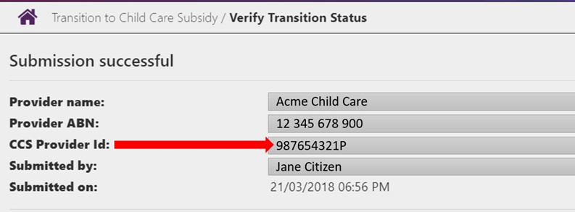

## Obtaining your CCS Person ID

This is your individual identity number in the Provider Entry Point (PEP). Your CCS Person ID can be found in the banner when logged into the PEP and also in your letter of approval which can be viewed in “**My Inbox**” in the PEP.



## Obtaining child care software activation codes

If you registered a software instance after registering your organisation in PRODA, the activation code would have been presented on screen. The PRODA system refers to software instances as Business to Business Devices (B2B).

Follow these steps if you wish to:

* register a new software instance, noting to skip Steps 5 & 6, then continue up to Step 9
* regenerate a lost or expired code, noting to complete up to Step 5 only
* extend the activation period for an existing period for an existing active and unexpired software instance.

Step 1: Log in to PRODA

Go to the [Services Australia PRODA website](https://www.humanservices.gov.au/organisations/business/your-business-sector/child-care-providers) and Log in to your PRODA Account. This can be accessed from:

[www.servicesaustralia.gov.au/child-care-providers](http://www.servicesaustralia.gov.au/child-care-providers)

Step 2: Select Organisations

Once you log in, click ‘**Organisations**’ located on the right hand side of the banner.

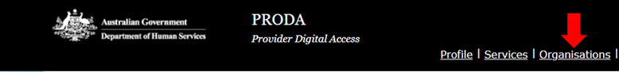

Step 3: Linked Organisations

All providers (organisations) you are linked to will display in a list.

Click on the organisation name that you wish to register a software instance and generate an activation code for, or generate a new activation code for a software instance already registered

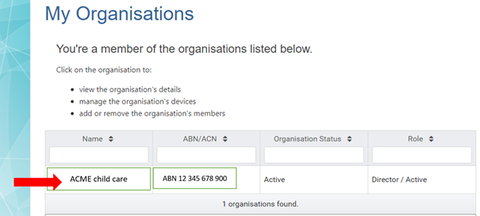

Step 4: View Details

Details of the organisation will display, including Members, Service Providers and B2B Devices registered to the organisation.

Scroll to the bottom of the page and click “B2B Devices”. Any child care software instance already registered will appear in this table with its device name and status.

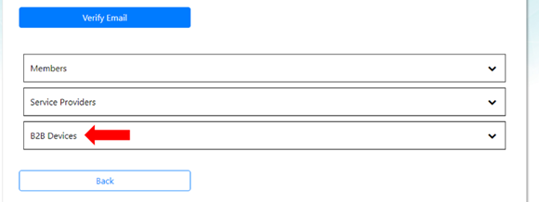

Step 5: New Device Activation Code

To regenerate a new code for an existing **Inactive** or **Disabled** software instance, or lost or expired code, click on the name of the software instance and click “**New Device Activation Code**” then confirm the action by clicking “**Generate New Device Activation Code**”.

Go to **Step 9**.

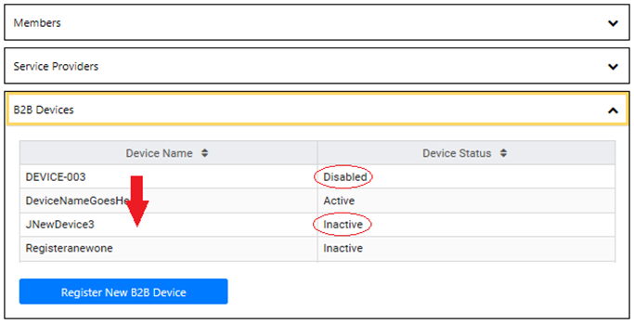

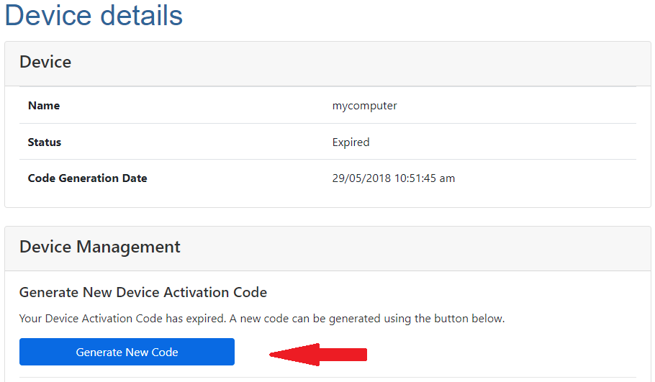

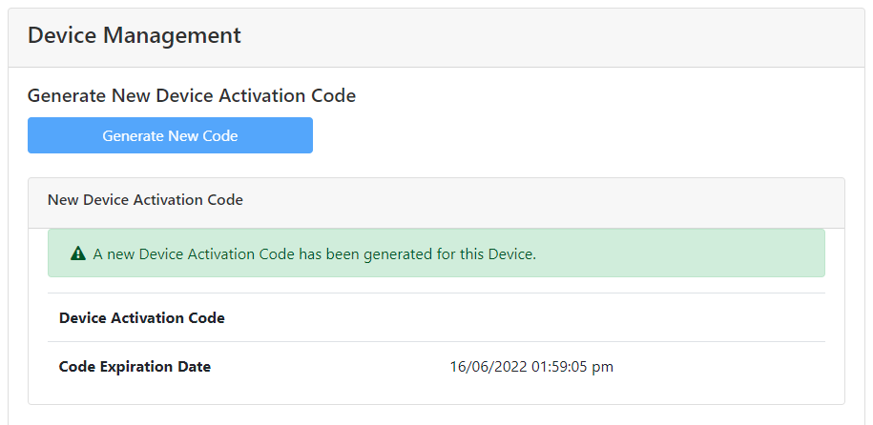

Step 6: Extending the Activation Code

To extend the activation period for an existing **Active** and unexpired software instance, click on the name of the software instance and click “**Disable B2B Device**”, then follow **Step 5** to regenerate a new device activation code.

**Note:** your CCS Software Provider or PRODA Helpdesk may direct you to instead click “Remove B2B Device” then register a new software instance as shown at **Step 7**.

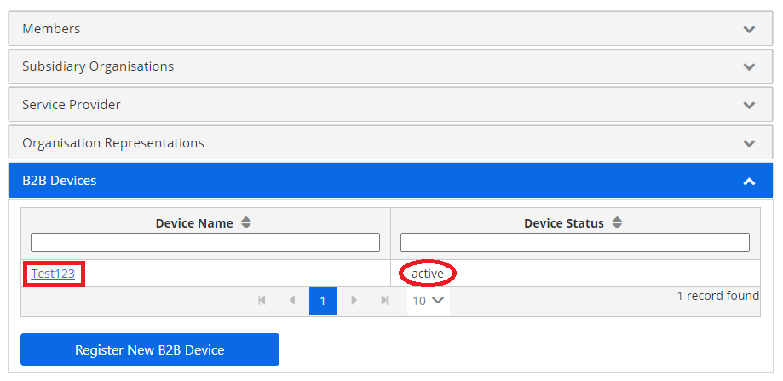

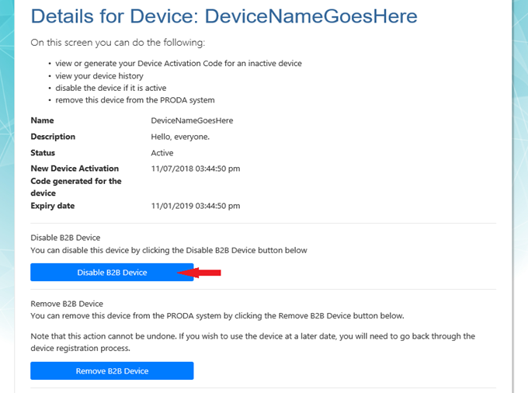

Step 7: Register a new B2B Device

To register a new software instance, click on the “**Register New B2B Device**” button.

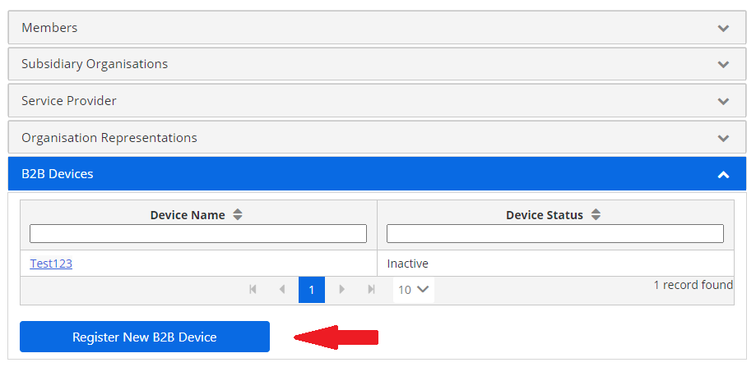

Step 8: Naming the Device

Enter the name you want to use for this software instance in the ‘**Device Name**’ field.

**Note:** make sure this name is unique within your organisation and is descriptive enough for you to recognise the location/s where the software instance will be used. The name must contain acceptable characters only, and no spaces. Acceptable characters are alphabetic (abc), digits (123), underscores (_), hyphens (-), and full stops (.)

Once the software instance is named, click ‘**Register Device**’ to obtain an activation code.

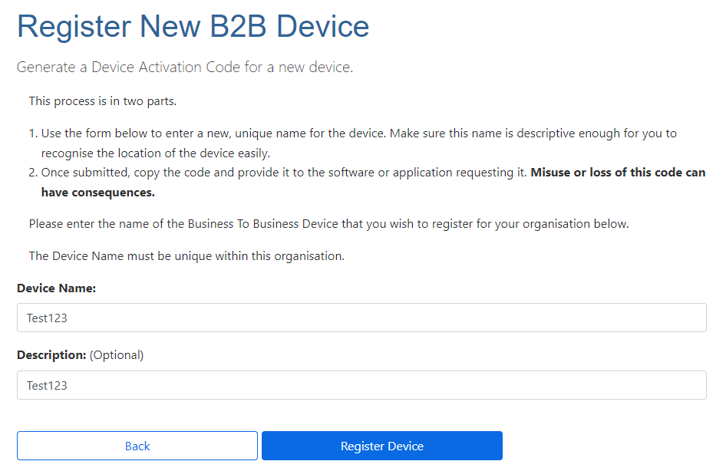

Step 9: Device Activation Code

The code generated will be presented on screen (for security reasons it is not stored and expires in 7 days). Record and provide this code along with your CCS Provider ID, CCS Person ID and the Device Name to your CCS Software Provider.

Note: the Device Activation Code and Device Name is ‘case sensitive’. When entering this in software, or providing this to your CCS Software Provider, please record this exactly as it displays on the screen.

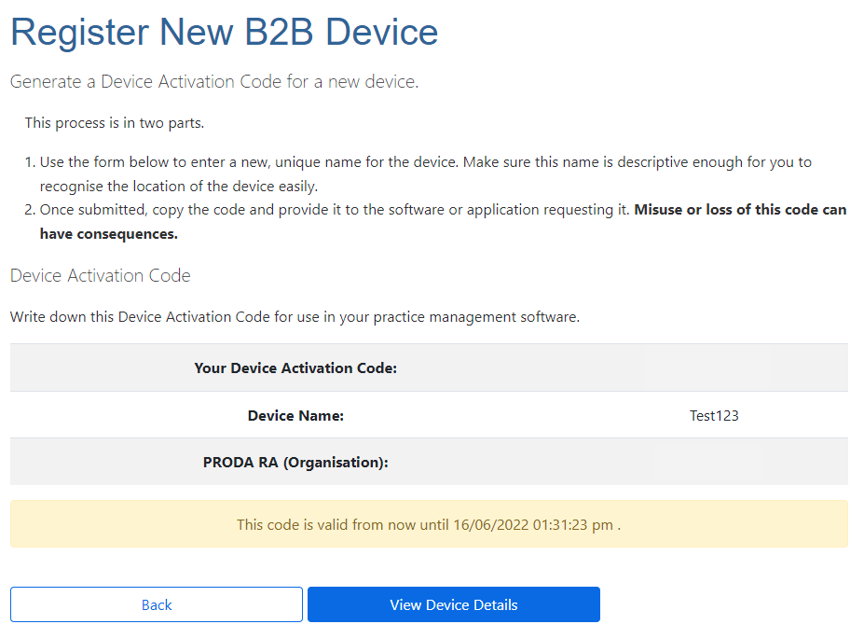

Step 10: B2B Device List

The names of all software instances will display in the B2B Device list. Repeat steps 7 to 9 for however many software instances that will be registered for the organisation.

