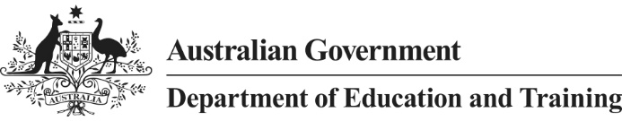

**For students**

**Q: What does this mean to me?**

**A:** The changes relate to the current tuition assurance arrangements. The 2018 interim arrangements will ensure your continued protection and support under tuition assurance.

If your provider ceases to deliver a course of study in 2018, the interim arrangements will ensure that you will be supported to continue your study with another provider in a similar course. If a similar course is not available, you may be eligible for a re-credit for units of study commenced but not complete.

If you are concerned about what this may mean to you, please contact the department at:

FEE-HELP students: [FEE-HELPTuitionAssurance@education.gov.au](mailto:FEE-HELPTuitionAssurance@education.gov.au) or

VET FEE-HELP and VET Student Loans students: [VETTuitionAssurance@education.gov.au](mailto:VETTuitionAssurance@education.gov.au).

**Q: My provider has closed – who do I contact to support me under tuition assurance?**

**A:** The current tuition assurance operators will continue to support students impacted by a closure in 2017 or earlier. If your provider has ceased to deliver a course or has closed, you should contact the tuition assurance operator directly.

The tuition assurance scheme is operated by either the Australian Council for Private Education and Training (ACPET) or TAFE Directors Australia (TDA). The contact details are below.

ACPET: [acpet@acpet.edu.au](mailto:acpet@acpet.edu.au), phone 03 9412 5900 or 1800 657 644 or [www.acpet.edu.au](http://www.acpet.edu.au/).  
TDA: [memberservices@tda.edu.au](mailto:memberservices@tda.edu.au), phone 02 9217 3180, or [www.tda.edu.au](http://www.tda.edu.au/).

**For providers**

**Q: What does it mean to me?**

**A**: The department appreciates that providers may be feeling uncertain about their tuition assurance arrangements for 2018. The department will ensure that there are interim tuition assurance arrangements in place while the Government considers tuition assurance for beyond 2018.

In 2018, it is intended to exempt providers from tuition assurance requirements, subject to certain conditions relating to course assurance and financial requirements to cover fee assurance.

The department has written to providers about these changes and will write to providers again in late November providing detailed information about the requirements for the 2018 interim arrangements.

**Q: What does this mean for the remainder of 2017?**

Providers should continue to rely on their current tuition assurance arrangements for the remainder of 2017.

Any provider that is currently assisting students as a second provider should continue to work with their current tuition assurance operator to support these students.

**Q: What happens for providers who have been given in principle approval to offer VET Student Loans?**

**A**: Providers who have been given in principle approval to offer VET Student Loans will also be considered under the Government’s 2018 interim tuition assurance arrangements.

The department will communicate the details and requirements for the interim arrangements directly to all approved providers (including those with in principle approval) in the near future.