EVALUATION OF THE EARLY LEARNING LANGUAGES AUSTRALIA APPS

Final Report to the Australian Government  
Department of Education and Training

Swinburne Babylab  
Swinburne University of Technology

February 2017



ACKNOWLEDGEMENTS

The authors would like to thank the parents and children who participated in the study, the educators who took part in interviews, and all of the Swinburne Babylab members for their support and hard work. The authors would also like to thank Education Services Australia (ESA) and Deloitte Access Economics for their support. The authors would like to thank Kim Woodland Editing and Mr Allan Kaufman for editing and proofreading.

ABOUT THE AUTHORS

The Swinburne Babylab is a research facility situated in the Brain and Psychological Sciences Research Centre (BPsyC) at the Swinburne University of Technology in Melbourne. The Swinburne Babylab utilises innovative techniques to explore cognitive, social and brain development in infants and young children. The impact of the use of technology (such as video chat and touchscreen applications or ‘apps’) amongst children aged two to five is a key area of study. The primary objective of the Swinburne Babylab is to publish high-quality, evidence-based research that is of value to early childhood programs and educators.

Lead author, Associate Professor Jordy Kaufman, is the Director of the Swinburne Babylab and a Senior Research Fellow and Lecturer in the areas of developmental psychology, cognitive neuroscience and educational technology. His research uses a multi-faceted approach which includes: electroencephalography (EEG) to measure brain activity related to cognitive processing, infrared eye-tracking to examine spatial sequence learning, behavioural methods including measuring infant’s and children’s responses to various stimulus types (e.g., actual objects, computer animations, videotaped recordings), and thorough literature reviews to form specific and testable hypotheses.

The research team also includes Associate Professor Conrad Perry, Dr Kate Highfield, Dr Sumie Leung, Dr Joanne Tarasuik, Ms Jessica Guy and the Babylab team. The Babylab team includes Ms Deborah Loats, Ms Megan James, Ms Luisa Varcoe, Ms Allison Steane, Ms Molly McQueen, Ms Jessica Kerr, Mr Tom Clarke and Mr Benjamin Carter.

PUBLICATION DETAILS

The Department supports and encourages the dissemination and exchange of information. All material produced by the Department constitutes Commonwealth copyright material.

The Department has applied the Creative Commons Attribution 3.0 Australia Licence to this report.

This report was prepared by Swinburne University of Technology on behalf of the Australian Government Department of Education and Training (Department).

Enquiries

Requests and enquiries concerning the Department’s copyright material should be addressed to:

The Copyright Officer

Department of Education and Training   
Location code C10MT1  
GPO Box 9880 Canberra ACT 2601  
Or emailed to [copyright@education.gov.au](mailto:copyright@education.gov.au)

Photographs in this report are courtesy of the project participants. Consent for using the photographs has been obtained from parents/guardians.

Disclaimer

The views expressed in this report are solely the authors and do not necessarily reflect the views of the Swinburne University of Technology or people consulted during the research project.

This document is provided as a reference guide only; while all care is taken, the Department makes no representation or warranty with respect to the accuracy, reliability or completeness of the information contained in this report. Additionally, the Commonwealth disclaims all liability to a person in respect of anything, and of the consequence of anything, done or omitted to be done by any such person in reliance, whether wholly or partially, upon any information presented in this document. Material in this document is made available on the understanding that the Commonwealth is not providing professional advice

For further information

Associate Professor Jordy Kaufman  
Swinburne Babylab, Swinburne University of Technology, Melbourne, Australia  
T: +61 3 9214 8822  
[babylab@swin.edu.au](mailto:babylab@swin.edu.au)   
<http://www.swinburne.edu.au/lss/bsi/babylab/>

Suggested citation

Kaufman, J., Leung, S., Perry, C., Tarasuik, J., Highfield, K., Guy, J., & the Swinburne Babylab team. (2017). *Evaluation of the Early Learning Languages Australia apps: Final report to the Australian Government Department of Education and Training*. Melbourne, Australia: Swinburne University of Technology.

Evaluation of the Early Learning Languages Australia apps: Final report to the Australian Government Department of Education and Training [PDF] ISBN: 978-1-76051-076-3

Evaluation of the Early Learning Languages Australia apps: Final report to the Australian Government Department of Education and Training [DOCX] ISBN: 978-1-76051-077-0

CONTENTS

EXECUTIVE SUMMARY 6

TERMS AND ACRONYMS 8

INTRODUCTION 10

The Early Learning Languages Australia (ELLA) Program 10

The Evaluation Project 10

Research Hypotheses 10

Study Design 10

METHODS AND RESULTS 14

Lab-based Experiments 14

1) Behavioural Word Test 14

2) Eye-tracking Word Test 15

3) Electroencephalogram (EEG) 18

4) Wearable Eye-tracking Test 22

5) Pegboard Task 23

Home-based Activities 24

1) Home-usage Log 24

2) Engagement Log 25

Interviews 25

1) Educator Interviews 25

2) Parent Interviews 31

ELLA App Analysis 35

SUMMARY AND IMPLICATIONS 36

RECOMMENDATIONS 39

BIBLIOGRAPHY 40

APPENDICES 41

Appendix 1: Screenshots of the Flash Card apps 41

Appendix 2: Detailed methodology of lab visit procedures 42

Appendix 3: Semi-structured interview questions for ELLA educators 44

Appendix 4: Semi-structured interview questions for parents of children who participated in the Babylab study 46

Appendix 5: Engagement and Home-usage Log 47

Appendix 6: Educator interview analysis 48

Appendix 7: Literature review 58

TABLES

Table 1: Participant demographics for the Behavioural Word Test 15

Table 2: Participant demographics for the Eye-tracking Word Test 16

Table 3: Participant demographics for the EEG experiment 20

Table 4: Participant demographics for the Wearable Eye-tracking Test 23

Table 5: Participant demographics for the Pegboard Task 24

Table 6: Participant demographics for the Home-usage Log 24

Table 7: Participant demographics for the Engagement Log 25

Table 8: Number of touchscreen tablets and children per classroom 49

FIGURES

Figure 1: Example of a 'Junior Scientist Diploma’ sent to child participants 12

Figure 2: Schematic map of the study design 14

Figure 3: Behavioural Word Test example 15

Figure 4: Behavioural Word Test performance 15

Figure 5: Child completing wall-mounted eye-tracking task 16

Figure 6: The Total Fixation Duration (in seconds) on the target and non-target pictures for Lab Visits 1 and 2 for the ELLA and Flash Card participants 17

Figure 7: Heat map for the word “broccoli” 17

Figure 8: Heat map for the word “kerang” 17

Figure 9: The Time to First Fixation (in seconds) on the target pictures for Lab Visits 1 and 2 for the ELLA and Flash Card participants 18

Figure 10: Examples of the participants wearing EEG nets 19

Figure 11: The ELLA group’s average brain responses to the 'taught' and 'not-taught' words in the centro-posterior region of the brain 20

Figure 12: The Flash Card group’s average brain responses to the ‘taught’ and ‘not-taught’ words in the centro-posterior region of the brain 20

Figure 13: The ELLA group’s average topographic maps for the early components 20

Figure 14: The Flash Card group’s average topographic maps for the early components 21

Figure 15: The average amplitude of the early component responses to the ‘taught’ and ‘not-taught’ words for the ELLA and Flash Card group participants 21

Figure 16: The ELLA group’s average topographic maps for the late components 21

Figure 17: The Flash Card group’s average topographic maps for the late components 21

Figure 18: The average amplitude of the late component responses to the ‘taught’ and ‘not-taught’ words for the ELLA and Flash Card group participants 22

Figure 19: Child wearing the eye-tracking device 22

Figure 20: A screenshot from a video taken while a participant played the ELLA maze game 22

Figure 21: Child completing the Pegboard Task 23

Figure 22: Number of completed trials of the Pegboard Task for the ELLA and Flash Card groups during both lab visits 24

Figure 23: Mean usage of ELLA and Flash Card apps during the two weeks of home use 25

Figure 24: The engagement scores from parents’ reports of the ELLA and Flash Card participants over the two weeks of home use 25

Figure 25: Flash Card app before tapping on picture 41

Figure 26: Flash Card app after tapping on picture (sound file plays and word visible) 41

Figure 27: An example of the EEG recording software 43

# EXECUTIVE SUMMARY

The Early Learning Languages Australia (ELLA) program is a set of language-learning touchscreen applications (apps) designed to enhance interest in language learning amongst children in preschool services. The Swinburne Babylab at the Swinburne University of Technology was engaged to examine the effectiveness of the ELLA program, and specifically, to determine whether young children are learning from the ELLA apps, and whether the ELLA apps promote an appreciation of a new language. The research team used a multi-faceted approach that included cognitive, behavioural and qualitative measures.

## Summary of findings from cognitive and behavioural measures

* Children in both the ELLA and Flash Card groups demonstrated significant learning in this trial.
* The performance of children in the ELLA group matched or exceeded their peers in the Flash Card (comparison) group in nearly all key cognitive measures.
* After two weeks of practice, children who used ELLA were 11% faster at looking at a picture corresponding to an audibly played Indonesian word, compared to their first lab visit. By comparison, children who used Flash Cards were 15% slower after two weeks.
* Brain activity indicated that the ELLA group were more likely to remember the context of the learnt words than the Flash Card group. For example, 77% of the ELLA group showed a typical brain response consistent with automatic association of word-meaning with word-sound, whereas only 33% of the Flash card group showed such response. This kind of learning may lead to longer-lasting gains in vocabulary for the ELLA group.
* Children in both groups were initially reported by parents to be highly engaged in learning. By the last five days of home use, this engagement score was 26% higher for the children in the ELLA group.
* Activity duration was 2.58 times longer for the ELLA group than for the Flash Card group, indicating greater interest in ELLA apps rather than Flash Card apps.
* Some wearable eye-tracking data suggested children aged between four and five years of age used the ELLA apps differently and more effectively than children below four years of age, who at times struggled to maintain attention or understand a task’s objective. This affirmed the Department of Education and Training’s guidelines stating that the ELLA apps are recommended for use by preschool children typically aged four to five.

## Summary of findings from qualitative measures

Educator interviews revealed that the ELLA program has been implemented in a variety of ways relating to when, how, and how long for children are accessing the ELLA apps at different preschool services. They also revealed children have enjoyed ELLA, and that language learning outcomes have exceeded educators’ expectations.

In interviews with parents of children who participated in the Babylab ELLA study, the parents shared evidence of language learning and stories of enhanced interest in language and culture after two weeks of ELLA app use.

These interviews:

* confirmed the effectiveness of the ELLA apps; and
* indicated that a large majority of preschool children learnt and gained interest in learning a new foreign language from using the ELLA apps.

The ELLA app analysis showed that nearly all of the individual ELLA app activities employ many features that can direct children to learn. Specifically, the apps:

* allow children to learn actively;
* encourage children to stay engaged in the learning process;
* allow children to find meaning that goes beyond the apps; and
* encourage children to be engaged in high-quality social interaction with others while playing with the apps.

Based on our scientific evaluation, we concluded that after two weeks of use at home, children learnt from the ELLA apps. Importantly, the ELLA program was effective in introducing new languages to preschool children, in raising their awareness of other cultures, and in engaging their interest in learning different languages. Given that the ELLA program is still a relatively new program, and that the Australian Government has expanded the footprint of ELLA to enable more children in preschool services to access the ELLA apps over 2017-2018, the long-term impacts and effectiveness of the ELLA program should be re-visited at a later date.

# TERMS AND ACRONYMS

**Baseline (in EEG)**: The time-period of an electroencephalogram (EEG) before an event occurred, usually used as a control period.

**Bilingual**: Being able to speak two languages.

**Ecological validity:** the extent to which the research findings are able to be generalized to real-world settings.

**Electroencephalogram (EEG)**: A method that records electrical activity of the brain.

**ELLA apps**: The Early Learning Languages Australia (ELLA) apps are a set of language-learning touchscreen applications (apps) designed to enhance interest in language learning amongst children in preschool services.

**ELLA Family App**: A publically accessible app that was created in each of the ELLA languages to enable families to understand the ELLA program undertaken in preschool services, and to help them support their child’s language learning.

**ELLA language**: The language that the content of the ELLA apps is teaching. In 2016 these were Arabic, Chinese (Mandarin), French, Indonesian and Japanese.

**Engagement:** Someone who is engaged in an activity is enthusiastic about the activity and takes positive action towards it.

**Event-related potentials:** Event-related potentials (ERPs) are an example of a ‘time-locked’ electroencephalogram (EEG), which is brain activity related to a specific event such as the presentation of a sensory stimulus.

An ***early component*** in our sample of children refers to brain activation that occurs at less than 300 milliseconds (ms) after the presentation of a word. It reflects the processing of the physical characteristics of the word (e.g., the auditory sound), and the use of attention that allows the processing of the word to occur after that.

A ***late component*** in our sample of children refers to brain activation that occurs at more than 300 milliseconds (ms) after the presentation of a word. From about 300-500ms, it reflects the processing of the meaning of the particular word. After 500ms, it represents different things that the child can do with the word, such as visualise it and integrate its meaning into a broader context.

**Executive functioning**: Higher-level cognitive skills necessary for the control of cognitive abilities and behaviours.

***Inhibitory control***: A component of executive functioning responsible for self-control, e.g., resisting temptations and acting on impulses.

***Attentional control***: A component of executive functioning responsible for choosing what to pay attention to and what to ignore.

**Flash Cards (digital):** A set of cards (slides) presented digitally. Each slide contains a picture and a word sound file. A finger tap is used to play each sound file.

**Linguistic processing**:The way people process language, including the following stages, in time sequence order:

***Acoustic processing*:** A very early stage of sound processing when the brain processes the low-level characteristics of a sound.

***Phonetic processing*:** An early stage of language processing that occurs after acoustic processing when the brain analyses and manipulates the physical properties of speech sounds.

***Phonological processing*:** A stage of language processing where the brain breaks words down and manipulates the discrete categorical sounds units that words consist of (e.g., the “d”, “o”, and “g” in *dog*).

***Meaning processing*:** A stage of language processing where the brain processes the meanings of words.

**Paired t-tests**: A statistical way to examine if the difference between two data sets is significant.

A ***one-tailed paired t-test*** uses the prior assumption that one group is likely to be different to another in a particular way (e.g., slower or faster than).

A ***two-tailed paired t-test*** is used when there is no prior assumption about how the two groups might differ from each other.

**Polyglot characters**: Characters in the ELLA apps—called ‘polyglot’ because they usually speak more than one language.

**Preschool-aged children**: Children who would be the appropriate age to begin primary school the following year.

**Scaffold**: Instructional, developmentally appropriate support given during the learning process to assist in learning progression.

**Semantics**: The meaning of a word, phrase or text.

**Significant difference**: A difference that is not attributed to chance.

**Tablet**: Mobile touchscreen tablet computer, e.g., an iPad.

**Temporal resolution**: The precision of a measurement with respect to time.

**Topographic maps**: In this report, topographic maps show the mean amplitudes of event-related potentials (ERPs) for the whole head.

**Transfer of learning**: Applying knowledge or skills learned on a touchscreen to the physical world.

**Wall-mounted Eye-tracker**: An eye-tracker used to observe what a child as looking at on the test screen, when responding to word recognition tests (for an example see Figure 3).

**Wearable Eye-tracker**: An eye-tracker used to observe how a child viewed ELLA as the child worked with the apps (for an example see Figure 17).

The following acronyms and abbreviations are used throughout the report:

**Apps**: Applications

**CALD**: Culturally and linguistically diverse

**ECEC**: Early childhood education and care

**EEG**: Electroencephalogram

**ELLA**: Early Learning Languages Australia

**ERPs**: Event-related potentials

**EYLF**: Early Years Learning Framework

# INTRODUCTION

## The Early Learning Languages Australia (ELLA) Program

The Early Learning Languages Australia (ELLA) program[1] is a set of language-learning touchscreen applications (apps) designed to enhance interest in language learning amongst children in preschool services. This Australian Government initiative was implemented as part of an investment in supporting language learning in the early years, and was established in alignment with the Early Years Learning Framework (EYLF).[2],[3]

The program was initially created in five languages—Arabic, Chinese (Mandarin), French, Indonesian and Japanese—and consists of seven apps which feature characters called ‘polyglots’, so named because each character is multilingual. Each polyglot character is involved in four to six language-learning activities.

**THE ELLA APPS** App 1: The Polyglots in the Playroom  
 App 2: The Polyglots at the Beach  
 App 3: The Polyglots at the Birthday Party  
 App 4: The Polyglots at the Zoo  
 App 5: The Polyglots at the Circus  
 App 6: The Polyglots at the Park  
 App 7: The Polyglots in the Town

In 2015, ELLA was distributed for trial use by 1,868 children from 41 preschool services, and was evaluated via surveys and site visits which focused on how the ELLA program was delivered, as well as children’s participation and usage of the apps.[4] Results were promising and a program evaluation concluded that ELLA provided a model for achieving language exposure in preschool services without the need for a proficient language teacher. Therefore, in 2016, ELLA was made available more broadly. Almost 300 preschool services across Australia participated in the ELLA program during 2016. During this time the program evaluation continued.

To complement this program evaluation, and to provide empirical learning data, the Australian Government Department of Education and Training contracted the Swinburne Babylab at the Swinburne University of Technology to undertake an evaluation of the ELLA apps, as a play-based, child-centred, teaching device for language learning.

## The Evaluation Project

The aim of this evaluation project was to examine the effectiveness of the ELLA program, and, specifically, to determine whether young children are learning from the ELLA apps, and whether the ELLA apps promote an appreciation of a new language. The research team used a multi-faceted approach that included cognitive, behavioural and qualitative measures.

### Research Hypotheses

The research project was designed to test two key hypotheses:

1. The ELLA apps will have learning benefits that exceed those of using more traditional methods such as flash cards.
2. There will be fundamental differences in how preschool services use the ELLA apps in ways that could impact their effectiveness.

### Study Design

This study used cognitive, behavioural and qualitative measures to assess individual learning outcomes. The data we collected included:

* lab-based research in the Babylab where children individually played with one or more of the apps under the guidance of a trained experimenter;
* home-based app use, a period of 14 days where children played with one or more of the apps under the guidance of a parent/guardian in their own home, where information was collected via home-usage and engagement logs completed by parents/guardians;
* a qualitative assessment of how the apps were being used in preschool services and homes, via interviews with educators and parents/guardians conducted across multiple sites by a Babylab team member; and
* an analysis of each of the apps based on knowledge of learning principles, also known as the Pillars of Learning rubric.[5]

The research focused on one of the ELLA languages—Indonesian—for the lab-based visits and the home-based app use, in order to collect enough data to provide meaningful results.

The study was approved by the Human Research Ethics Committee at the Swinburne University of Technology, and written informed consent was obtained from the parents/guardians of all child participants.

Each data collection approach is summarised below, and the methodologies and findings are discussed in further detail in Methods and Results.

#### Lab Visits and Home App Use

##### Lab Visit 1

Preschool-aged children (aged 3.5–5), who had no known previous exposure or background to Indonesian language, attended the Swinburne Babylab with their parent or guardian for two visits. During Lab Visit 1, the children played on either an ELLA app (App 1) or a digital Flash Card (App 1) on an iPad for up to 20 minutes (or less if the children did not want to continue).

The digital flash cards were made and presented on an app called FC Maker on an iPad. FC Maker is similar to a Microsoft PowerPoint presentation, with an Indonesian word sound file embedded in each slide which is activated by a finger tap on the slide. The words and pictures used in the Flash Card apps were drawn from the ELLA apps. The word lists used in the Flash Card apps were words that could easily be associated with pictures, for example, “ball” and “ice-cream” rather than “Hi, my name is …” (See Appendix 1 for screenshot examples of the Flash Card apps.)

The researchers also asked children participating in the ELLA group if they were willing to wear a pair of infrared eye-tracking headsets, which allowed us to examine exactly what the children were looking at in the app environment.

Following the ELLA or Flash Card activity, the children were asked to complete a few tasks with the researchers. The tasks included:

* a Behavioural Word Test designed to test the children’s knowledge of their newly-learnt words by asking them directly;
* an Eye-tracking Word Test designed to see what the children had just learnt using a wall-mounted eye-tracker;
* a Wearable Eye-tracking Test that allowed observation of exactly what the children were looking at in the app space in real time;
* a Pegboard Task to measure motivation;[6] and
* the Peabody Picture Vocabulary Test IV (PPVT-IV),[7] which was used to control for differences in language aptitude.

##### Home App Use

After Lab Visit 1, the children assigned to the ELLA app group took home an iPad loaded with two apps: the first app was ELLA App 1, and the second app was one of ELLA Apps 2, 3 or 4. The children assigned to the Flash Card group took home an iPad loaded with two ‘decks’ of digital flash cards containing words and pictures from the same two apps that the ELLA children took home. It should be noted that the list of words in the Flash Card apps was not as long as the list of words in the ELLA apps, as phrases such as greetings could not be displayed as a flash card.

Parents of both groups were given the same instructions: to ask their child to play on the apps (ELLA app or Flash Card app, as appropriate) for 15-20 minutes per day for approximately two weeks. The parents were asked to complete a Home-usage Log (see Appendix 5) to record how much time their child spent playing on the apps on the iPad.

##### Lab Visit 2

After two weeks of home-based learning, children were invited back to the Babylab to repeat a number of tasks, including the:

* Behavioural Word Test;
* Eye-tracking Word Test (wall-mounted); and
* Pegboard Task.

In addition, a subset of children had their brain activity measured using a high-density electroencephalogram (EEG) system.[8] As described in Methods and Results, the EEG data provided information concerning brain processing during recognition of words that children learnt from the ELLA and Flash Card apps, and also allowed the researchers to distinguish between different types of brain processing. These tests also gave an indication as to whether transfer of learning took place and whether the children could apply what they learned in one modality (iPad app) to another context (see Appendix 7 for the importance of transfer of learning.)

Upon completion of the two lab visits, participants were reimbursed AUD $50-$100 for their time and travelling costs. Children were also mailed a ‘Junior Scientist Diploma’ which included their first name and a photo (see Figure 1 for an example).

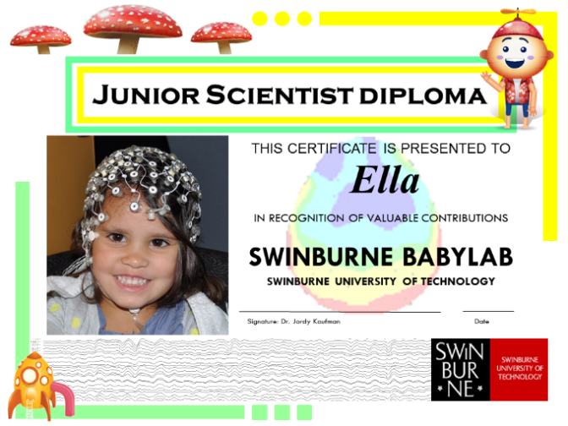

Figure : Example of a 'Junior Scientist Diploma’ sent to child participants

##### Evaluative methods for the lab visits and home app use

Data collected in the lab and during the home app use was evaluated in two main ways:

1. Comparing data from Lab Visit 1 to Lab Visit 2 to examine the effectiveness of two weeks of ELLA use in the home.
2. Comparing data from participants who used the ELLA apps with those who used the control Flash Card apps.

#### Interviews

The research included semi-structured interviews with preschool service educators who were using ELLA in their classrooms, as well as with parents/guardians involved in the Babylab study.

Educator interviews aimed to obtain greater insight into how the ELLA program was being implemented in different preschool services.

Interviews with parents involved in the Babylab study whose children were using the ELLA apps and the digital Flash Card apps at home aimed to allow comparisons between how ELLA was used in home and education settings, and thus to assess the extent to which the Babylab study findings would be applicable to the education setting. The parent interviews also allowed the researchers to compare parents’ perceptions of the ELLA apps with the Flash Card group.

##### Evaluative methods for the interviews

Data collected during the interviews was evaluated in two main ways:

1. Thematic analysis.
2. Illustrative quotes.

#### ELLA App Analysis

The suite of ELLA apps was assessed with respect to the Pillars of Learning rubric.[9] This rubric assessed the apps in four dimensions:

1. Active learning.
2. Engagement.
3. Meaningfulness.
4. Social interaction.

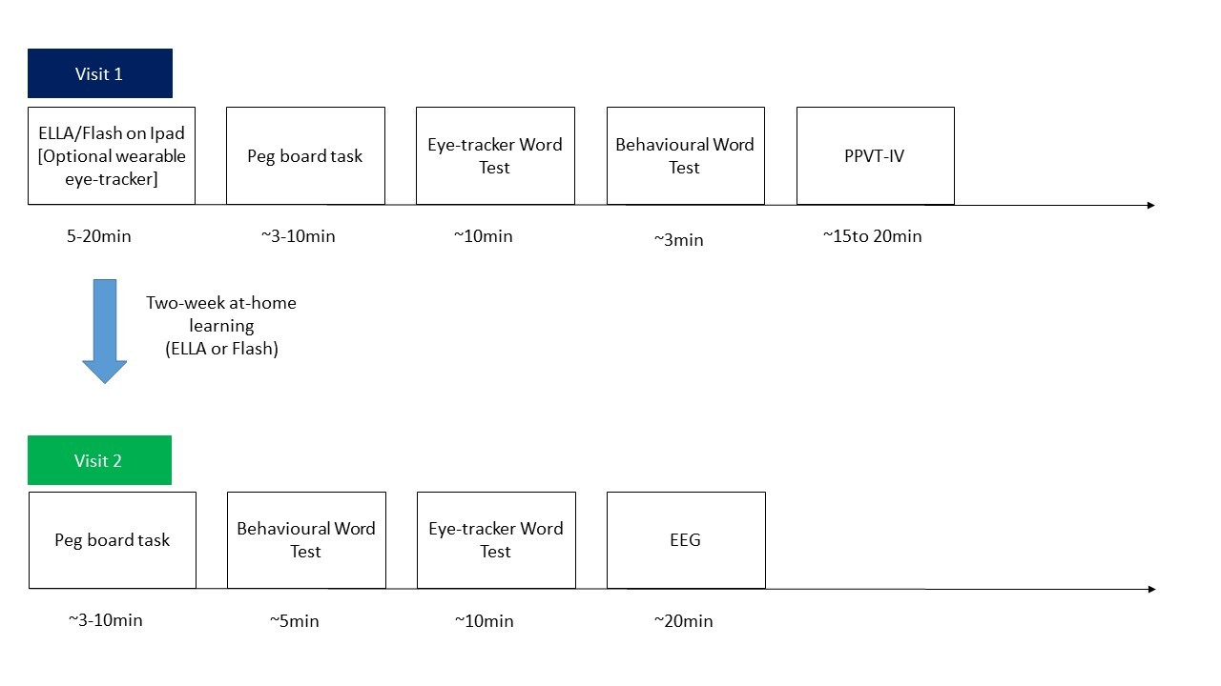

Figure : Schematic map of the study design

Figure 2, above, provides a schematic map of the overall study design.

# METHODS AND RESULTS

## Lab-based Experiments

Including the pilot tests, a total of 71 participants attended Lab Visit 1. Sixty-five of these children returned for Lab Visit 2, with only three children from each group dropping out. In other words, a very high return rate (92%) was achieved.

All children completed at least one component of the lab-based experiments. According to the results from the Peabody Picture Vocabulary Test IV (PPVT-IV), the verbal ability of these children was assessed and any below the average range for their age (i.e., <15 points below the standard score) were omitted from further analysis.

The lab-based experiments were as follows:

1. Behavioural Word Test.
2. Eye-tracking Word Test.
3. Electroencephalogram (EEG).
4. Wearable Eye-tracking (ELLA functionality from a child’s perspective).
5. Pegboard Task.

The sections below describe the methods used for each of the lab-based experiments, the number of participants, and the results.

### Behavioural Word Test

The Behavioural Word Test was used to determine how many words the children learnt from using the ELLA or Flash Cards apps. We hypothesised that this test would also reveal that participants in both groups would learn Indonesian words.

#### Method

In the Behavioural Word Test, the researcher would say an Indonesian word and show the participant four pictures on an A4-sized card (see Figure 3 for an example). One of the four pictures corresponded to the word that the researcher said, and the participant was asked to point out this ‘target’ picture.

Including the pilot tests, a total of 71 participants attended Lab Visit 1. Sixty-five of these children returned for Lab Visit 2. In other words, a very high return rate (92%) was achieved.

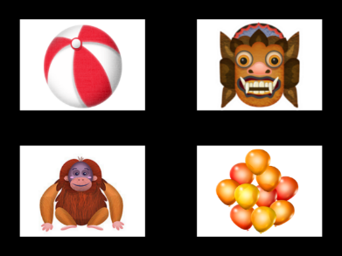

Figure : Behavioural Word Test example

Figure 3 note: Figure 3 shows an example from the Behavioural Word Test. In this example, the researcher would say “topeng” which means “mask” in Indonesian. Participants were asked to point out which picture was “topeng”.

The Behavioural Word Test was conducted during each participant’s first lab visit (following a maximum of 20 minutes’ play on either the ELLA or Flash Card apps) and was repeated during their second visit, after they had two weeks of in-home exposure to either the ELLA or Flash Card apps.

#### Participants

Data from 41 participants were included in the data analysis for this test. Data from an additional five participants were excluded because of non-compliance in the task.

Table : Participant demographics for the Behavioural Word Test

|  | Gender | Number of Participants | Average Age |
| --- | --- | --- | --- |
| ELLA | F | 9 | 4 years 1 month |
|  | M | 14 | 4 years 1 month |
| FLASH | F | 13 | 4 years 2 months |
|  | M | 5 | 4 years 1 month |
| Total |  | 41 | 4 years 1 month |

#### Results

Figure 4 shows that participants from both the ELLA and Flash Card groups correctly identified significantly more words than would have occurred by chance (i.e., 25% correct rate). This means both groups had learnt words during Lab Visit 1, and during their home use.

Behavioural word test performance for visit 1 and visit 2 for the ELLA group and Flash Card group. This is further explained in the report.


Figure : Behavioural Word Test performance

At Lab Visit 2, the Flash Card group performed better in the Behavioural Word Test than the ELLA group did when tested on the first app (i.e., App 1) material. The two groups performed comparably when they were tested on material from the second app (i.e., either App 2, 3 or 4).

The better performance on the App 1 material by the Flash Card group is not surprising given that they had an advantage, that is, their learning material was exactly the same as the test material. On the other hand, the ELLA group might not have been exposed to all of the words that they were tested on, as it would depend on the activities in the app they had been using.

Comparable performance by the two groups when testing the second app material was due to the Flash Card group not learning the material from the second app as well as they learnt words from the first app. **The ELLA group, however, demonstrated consistent performance across the two apps.** This finding is also consistent with children losing interest in learning from the flash cards after the first lab visit (also see the Home Usage and Engagement Log sections).

### Eye-tracking Word Test

An eye-tracker provides a physiological measure of children’s performance, and has been shown to be suitable for investigating young children’s learning performance.[10] This method was included to complement the behavioural measures used.

Previous research has shown that preschool children are aware of their knowledge and uncertainty,[11] and when asked to provide an answer, they may choose to withhold their answer if they are not confident that they are correct. Accordingly, one child might appear more knowledgeable than another, not because they know more, but simply because they are more willing to respond as they are more confident.

In this experiment, children would hear words that they had been exposed to via the apps, and at the same time see pictures corresponding to the words (‘target’ pictures), as well as pictures that did not correspond to words (‘non-target’ pictures). The eye-tracker identified which pictures the children looked at, how quickly they looked at each picture, and how long they looked, independent of the children’s willingness to respond, related to their certainty about their answers.

This provided insight into children’s knowledge that they may not have shared if they were uncertain about their answers. This test thus provided additional data beyond the behavioural measures, discussed previously.

We hypothesised that:

1. Children would look at the target pictures for a longer period of time in Lab Visit 2 compared to Lab Visit 1.
2. Children would look at the target pictures faster in Lab Visit 2 compared to Lab Visit 1.

#### Method

The Eye-tracking Word Test used a wall-mounted eye-tracker.[12] Children participated in the Eye-tracking Word Test after they had used the ELLA or Flash Card apps. The eye-tracker screen displayed four pictures at a time, for four seconds, while an audio file of the word was played by the computer. Children were asked to look at the picture which corresponded to the word in Indonesian that they heard. Only one of the four pictures corresponded to the word that the child heard (‘target’ picture), whereas the other three pictures did not correspond (‘non-target’ pictures). The photo in Figure 5 shows one of the children completing this task.

The Eye-tracking Word Test was conducted during each participant’s first lab visit and was repeated during their second lab visit, after they had two weeks of in-home exposure of either the ELLA or Flash Card apps. (Appendix 2 provides more detail about the Eye-tracking Word Text methodology.)

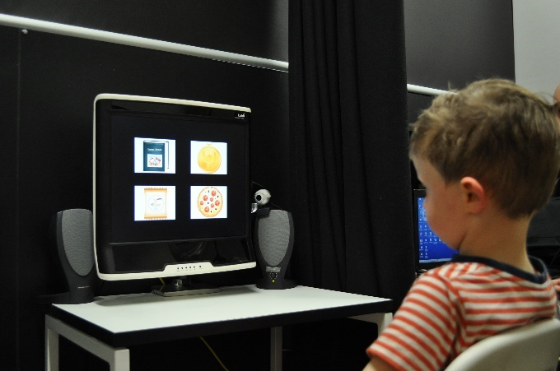

Figure : Child completing wall-mounted eye-tracking task

#### Participants

Data from 43 participants was suitable for analysis. An additional eight children participated but their eye-gaze was not detected by the eye-tracker because they moved around too much.

Table : Participant demographics for the Eye-tracking Word Test

|  | Gender | Number of Participants | Average Age |
| --- | --- | --- | --- |
| ELLA | F | 12 | 4 years 0 month |
|  | M | 16 | 4 years 2 months |
| FLASH | F | 11 | 4 years 3 months |
|  | M | 4 | 4 years 4 months |
| Total |  | 43 | 4 years 2 months |

#### Results

Both groups of children (the ELLA and Flash Card groups) looked at the target pictures for significantly longer than they looked at the non-target pictures—in both lab visits. This indicates that both groups of children learnt words during Lab Visit 1 and during their home use.

##### Fixation Duration

**Participants in the ELLA apps group fixated on the target pictures for a significantly longer period of time** in Lab Visit 2 compared to Lab Visit 1 (on average about 0.3 seconds longer). This longer fixation time suggests that the ELLA group had learnt words from the apps during the two-week home usage. This significant difference is denoted by an asterisk (*) on the bar graph in Figure 6. There was no significant improvement for the Flash Card group.

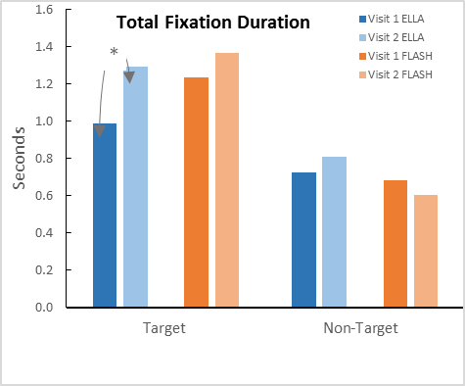Figure : The Total Fixation Duration (in seconds) on the target and non-target pictures for Lab Visits 1 and 2 for the ELLA and Flash Card participants

Figure 6 note: The asterisk (*) denotes a statistically significant improvement between Lab Visits 1 and 2 for the ELLA participants.

##### Area of Focus

Eye-tracking identifies the objects on which the children focused their attention. Figures 7 and 8 show examples of the heat-maps generated by the children during Lab Visit 1. The image uses a ‘heat-map’ with the red colour indicating that the children spent more time looking on average.

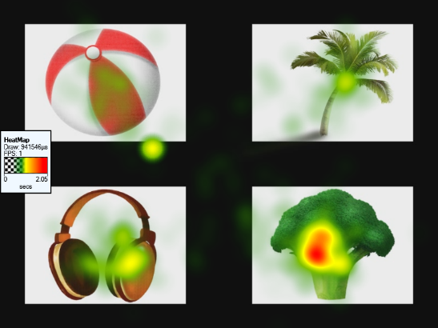

Figure : Heat map for the word “broccoli”

Figure 7 note: This heat-map was generated after the word “broccoli” was presented during Lab Visit 1, which is one of the many words the children heard in the test. The data are from all participants in the Eye-tracking Word Test. Given that the word “broccoli” in Indonesian is adapted from English and sounds very similar, most participants looked at the target picture for a longer period, even if they had only been exposed to the apps for a short period of time. The other three pictures are the non-target pictures.

Figure : Heat map for the word “kerang”

Figure 8 note: This heat-map was generated after the word “kerang” was presented during Lab Visit 1—“kerang” means “shell” and is one of the many words the children heard in the test. The data are from all participants in the Eye-tracking Word Test. The target picture is on the bottom left. The warm spots from the eye-tracking appear in most pictures, suggesting that participants did not know what “kerang” meant.

##### Time to First Fixation

Before Lab Visit 2, children had the opportunity to use the ELLA and Flash Card apps at home for two weeks. During Lab Visit 2, ELLA children were 11% faster in looking at the target pictures than they were in Lab Visit 1. This difference was significant.

Flash Card children, on the other hand, were 15% slower to respond to the target words than they were in Lab Visit 1. The significant changes in performances are denoted by asterisks (*) in Figure 9.

This suggested that the ELLA children became more confident in this test after using the apps at home for two weeks. Conversely, the confidence of children from the Flash Card group reduced from Lab Visit 1 to Lab Visit 2. This is consistent with children losing interest in learning from the flash cards after the first lab visit (also see results from the Home Usage section).

These results are in line with the results from the Behavioural Word Test in which children in the ELLA group demonstrated more consistent performance across the two apps than did the children in the Flash Card group (see the Behavioural Word Test section).

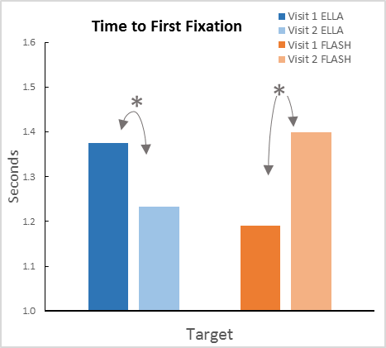Figure : The Time to First Fixation (in seconds) on the target pictures for Lab Visits 1 and 2 for the ELLA and Flash Card participants

Figure 9 note: The asterisk (*) denotes statistically significant differences between Lab Visits 1 and 2.

### Electroencephalogram (EEG)

Electroencephalogram (EEG) was used to provide brain activity information on how well children learnt from the ELLA apps and the Flash Card apps. EEG was used to provide information about different types of brain processing that the other techniques did not provide.

As the ELLA apps provide an immersive environment, we would expect that as children learnt words, they would do so along with a better connection to other contextual information (e.g., actions, objects, and all the other things that words appear with), than would occur through other presentation methods such as flash cards. It is well known that words learned in a rich context are not only likely to be remembered for longer periods of time, but they are also used more appropriately once children move past single word utterances.[13]

There is a long history of using EEG to examine learning, and much information about how to interpret the data which it produces.[14] The simplest method is to examine event-related potentials (ERPs); changes in the level of electrical activity which the brain produces after being exposed to a stimulus—in our case, words. Depending on where in the brain and when a change occurs, it is possible to infer what types of mental processing have occurred.

A number of different types of ERPs are commonly used to examine language processing. In this experiment, we examined two types of ERPs in the centro-posterior region of the brain (around the back of the head): 1) early components that index ‘acoustic’ processing; and 2) late components that index ‘meaning’ processing.

Early acoustic processing refers to the components elicited in the first 300 milliseconds (ms) after hearing a word. Early components are a measure of the extent to which important acoustic features for phonological and phonetic processing have been extracted.[15] In other words, the early components reflect the processing of the sounds of the word and the use of attention that then allows the word to be processed after that.

In this experiment, the EEG showed how children were processing the sounds of words. That is, based on the pattern of brain activation and how it differed over time, we were able to infer the extent to which children processed different types of information from the words. This is a very important step in becoming bilingual, because the sounds of languages vary enormously, and it is often very difficult to perceive and produce some of them (for benefits of bilingualism see Appendix 7).

This is why people have foreign accents, and why, in some cases, it is not possible to hear some sounds of words at all. A well-known example of this problem is Japanese speakers not being able to learn the difference between “r” and “l” sounds, however anyone trying to learn a language with tones such as Chinese will realise that this type of problem is not restricted to any particular language group. If children have learnt this important information in the new words, we would expect larger amplitude in the early components for learned words compared to words they have not learned.

Late components refer to the components elicited more than 300 milliseconds (ms) after hearing a word. Late components are used to examine the extent to which children have learned the semantics of words—that is, the types of things with which the word is associated, and not just the actual sounds of the word.[16] In general, brain activity from about 300-500ms reflects the processing of the meaning of the particular word. After 500ms, the brain activity represents other things that the children can do with the word, such as visualise it and integrate its meaning into a broader context. As with the component analysis, the best way to assess late components is to compare activity to words that the children heard during the trial to ‘non-taught’ new words.

In summary, we examine: 1) whether children are able to process the sounds of the new words; and 2) the extent to which they readily retrieve contextual information.

#### Method

During Lab Visit 2 a subset of children was asked to wear an EEG net which contained 124 sensors (see Figure 10: E). These children were asked to play a matching game in which they listened to a series of words to which they had previously been exposed (from here on referred to as ‘taught’), along with words to which they had not been exposed (from here on referred as ‘not-taught’). After hearing each word, children saw a picture that was either congruent or not congruent to the word. After each word-picture pair, children told the researcher if the word matched the picture.

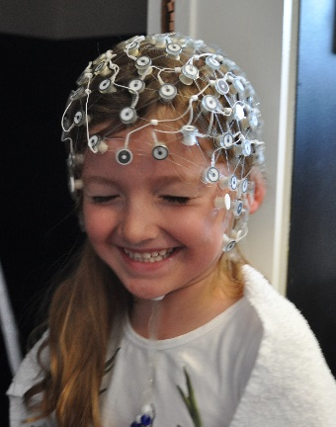 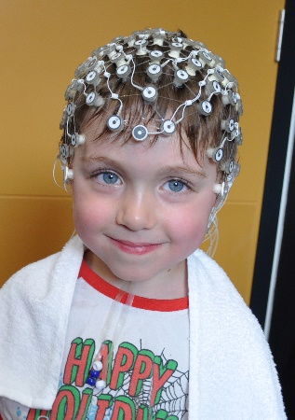

Figure : Examples of the participants wearing EEG nets

We used the Behavioural Word Test scores to confirm that the children in the EEG study had learnt the ‘taught’ words. The ELLA and Flash Card children that participated in the EEG experiment scored an average of 67% and 74% respectively on the Behavioural Word Test. (Appendix 2 provides more detail about the EEG methodology.)

#### Participants

EEG data was collected from 32 participants. Data from seven participants was excluded in the analysis stage, due to excessive movement during the recording which resulted in unusable data.

Table : Participant demographics for the EEG experiment

|  | Gender | Number of Participants | Average Age |
| --- | --- | --- | --- |
| ELLA | F | 6 | 4 years 2 months |
|  | M | 7 | 4 years 2 months |
| FLASH | F | 7 | 4 years 3 months |
|  | M | 5 | 4 years 1 month |
| Total |  | 25 | 4 years 2 months |

#### Results

Figures 11 and 13 show that participants in the ELLA group generated an early ERP component response to the ‘taught’ words, which was a positive response in comparison to the ‘not-taught’ words. Figures 12 and 14 show that participants in the Flash Card group did not generate this higher early response to ‘taught’ words compared to ‘not-taught’ words. Figure 15 shows the amplitude of the early component to ‘taught’ and ‘not-taught’ words for the ELLA and Flash Card groups, drawn from the numerical values in Figures 11 and 12. This difference in EEG patterns between the ELLA and Flash Card groups suggests that the ELLA children were able to phonetically process the words very early in the acoustic processing, and that they processed their ‘taught’ words much better at the phonetic level than did their peers in the Flash Card group.

Figures 11 and 12 show that children in both the ELLA and Flash Card groups generated higher late components in response to the ‘taught’ words than to the ‘not-taught’ words, suggesting that both groups had been able to process the meanings of the ‘taught’ words (see also the topographic maps in Figures 16 and 17).

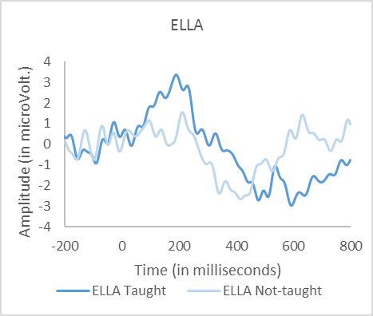Figure : The ELLA group’s average brain responses to the 'taught' and 'not-taught' words in the centro-posterior region of the brain

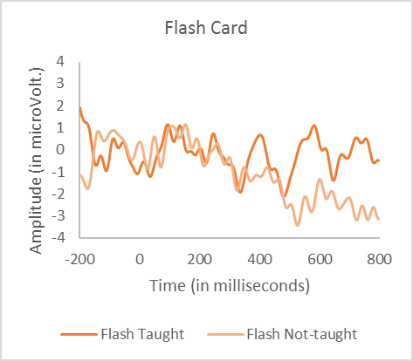Figure : The Flash Card group’s average brain responses to the ‘taught’ and ‘not-taught’ words in the centro-posterior region of the brain

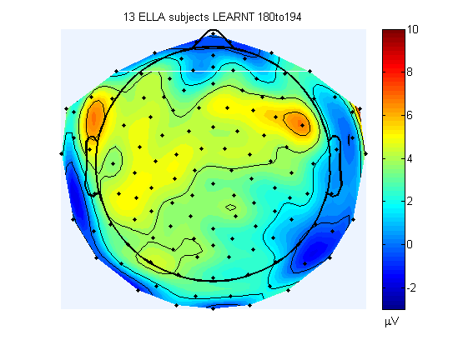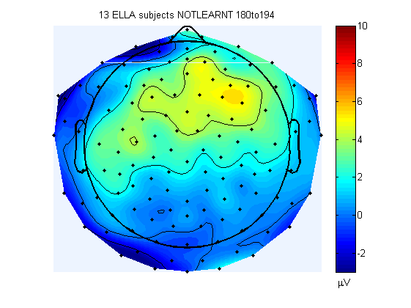

ELLA Group

Early Components of Brain Response

Taught Words Not-taught Words

Figure : The ELLA group’s average topographic maps for the early components

Figure 13 note: Darker colours (red or blue) represent higher brain response activity.

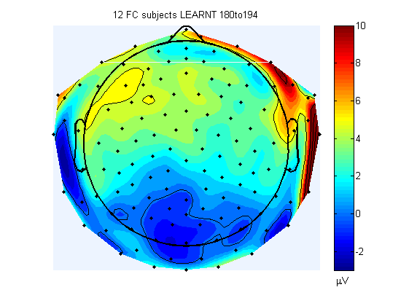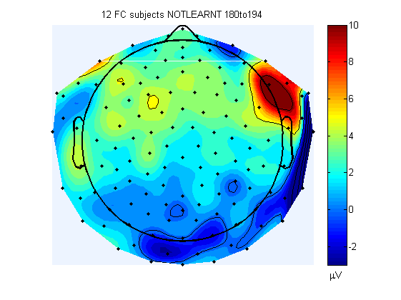

Flash Card Group

Early Components of Brain Response

Taught Words Not-taught Words

Figure : The Flash Card group’s average topographic maps for the early components

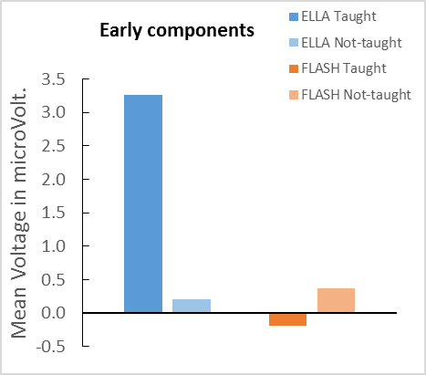Figure : The average amplitude of the early component responses to the ‘taught’ and ‘not-taught’ words for the ELLA and Flash Card group participants

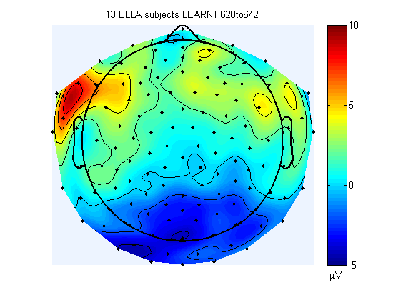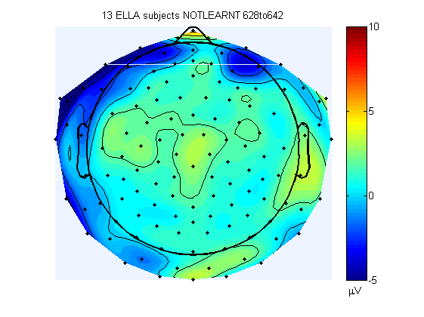

ELLA Group

Late Components of Brain Response

Taught Words Not-taught Words

Figure : The ELLA group’s average topographic maps for the late components

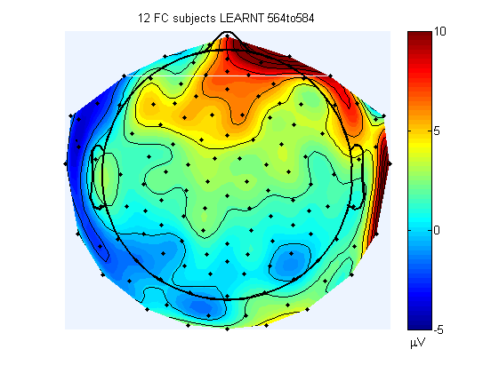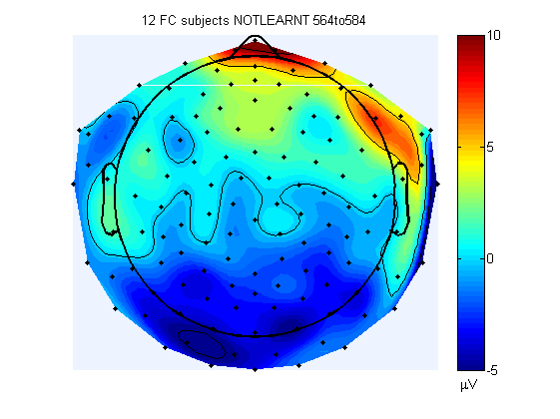

Flash Card Group

Late Components of Brain Response

Taught Words Not-taught Words

Figure : The Flash Card group’s average topographic maps for the late components

Figure 18 shows the amplitude of the late component to ‘taught’ and ‘not-taught’ words for the ELLA and Flash Card groups, drawn from the numerical values in Figures 11 and 12. Figure 18 shows that response patterns are reversed between the two groups. The reversed response pattern of the late components to the ‘taught’ words suggests that the two groups varied in how they thought about the words. Upon hearing the 'taught’ words, 77% of the ELLA children in this study exhibited a negative brain response, which is consistent with the typical brain response generated by hearing learnt words. In contrast, only 33% of the Flash Card children exhibited such response. Our data is consistent with the interpretation that the ELLA group associated more contextual information for each learnt word than did the Flash Card group.

In summary, the EEG data for the ELLA group—when shown words to which they had been exposed—revealed both earlier (acoustic) and later (understanding) stages of linguistic processing. This suggests that **the ELLA group processed the sounds of the words well, and that they also were able to retrieve the context of the words**. It appears, however, that the Flash Card group may not have processed the sounds of these words as well as the ELLA group did.

The brain patterns in retrieving contextual information may suggest that the ELLA group’s learning could be longer-lasting than that of the Flash Card group. This notion will need to be tested by a future study that includes a long-term recall component.

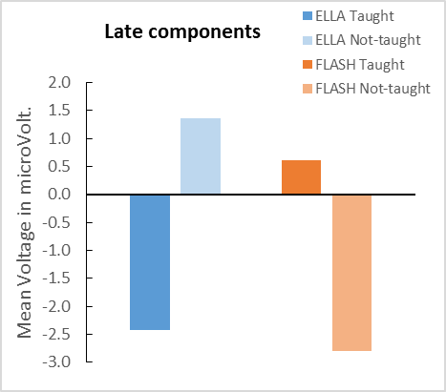Figure : The average amplitude of the late component responses to the ‘taught’ and ‘not-taught’ words for the ELLA and Flash Card group participants

### Wearable Eye-tracking Test

Wearable eye-tracking allowed the examination of what children were looking at on the ELLA app in real time. This allowed us to determine if any elements within the apps that may have been designed for learning were in fact distracting children or were being ignored by them.

#### Method

A subset of children was asked to wear an eye-tracking headset[17] while they were playing on the ELLA apps during either the first or second lab visit. The eye-tracking headset contains an infrared ‘eye’ camera positioned at the bottom right of the visual field which records the eye’s movements, as well as a second ‘scene’ camera attached at eyebrow level which faces out and records the world from the child’s perspective (see Figure 19).

Videos from the two cameras were transmitted to a computer running Yarbus software,[18] which calculated gaze direction in real time. Using the information from the eye camera, the software superimposed a pointer that indicated the participant’s eye gaze on the scene camera video (see Figure 20).

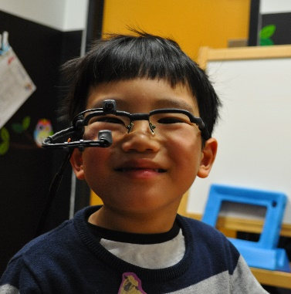

Figure : Child wearing the eye-tracking device

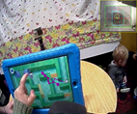

Figure : A screenshot from a video taken while a participant played the ELLA maze game

Figure 20 note: The magenta dots and lines denote the location of the participant’s eye gaze while they were playing the game.

#### Participants

Data from 15 participants was included for analysis. An additional two participants were excluded due to reflection from the ceiling light which meant there was excessive glare in the videos.

Table : Participant demographics for the Wearable Eye-tracking Test

|  | Gender | Number of Participants | Average Age |
| --- | --- | --- | --- |
| ELLA | F | 9 | 4 years 0 months |
|  | M | 6 | 4 years 3 months |
| Total |  | 15 | 4 years 1 month |

#### Results

Upon analysing data from the Wearable Eye-tracking Test we observed that there was a possible age effect. Children less than four years of age tended to play a lot more activities than did children aged over four, however children over four years of age spent longer working on one activity. This was not surprising given that children’s attention span increases as they get older.

Given that most of the videos captured children playing the maze game in App 1: The Polyglots in the Playroom, we decided to focus on the maze activity.

The main findings from the Wearable Eye-tracking Test were:

* Participants under four years of age were somewhat unsure of what to do when beginning the maze activity. When the pop-up maze character appeared, they did not wait for the character to finish talking; instead they attempted to drag the maze character to continue with the maze.
* Most of the participants over four years of age looked around the maze before they dragged the maze character along, and they completed the maze more quickly after a few trials. This indicated that they were able to plan ahead and learn quickly.
* Participants over four-and-a-half years of age appeared to be able to manoeuvre through the maze straight away. In addition, when the pop-up maze character appeared, these children tended to pause and wait for the character to finish talking before trying to drag it along to continue with the maze. This indicated that they listened to the maze character’s talk.

This age effect affirms the Department of Education and Training’s guidelines stating that the ELLA apps are recommended for use by preschool children typically aged four to five.

### Pegboard Task

The researchers attempted to measure children’s motivation for learning new words, based on a task developed and described in a newly published paper—the Pegboard Task.[19]

#### Method

In this experiment, children were asked to complete a boring task (i.e., putting 25 golf tees onto a pegboard), and then rewarded with a new experience (watching a short video clip about Indonesia) after they finished each trial. Based on the published paper17, the number of trials (i.e., the number of times participants finished putting all 25 golf tees into the pegboard) would provide an indication of how motivated the children were to learn new words.

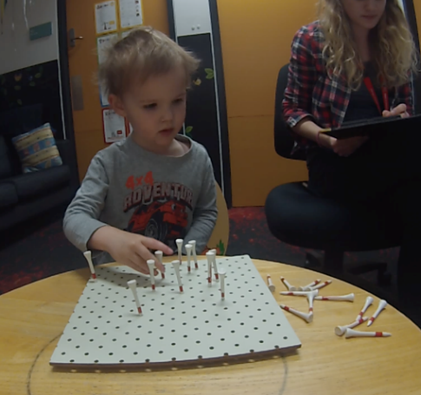

Figure : Child completing the Pegboard Task

#### Participants

Table : Participant demographics for the Pegboard Task

|  | Gender | Number of Participants | Average Age |
| --- | --- | --- | --- |
| ELLA | F | 13 | 4 years 0 months |
|  | M | 19 | 3 years 11 months |
| FLASH | F | 14 | 4 years 3 months |
|  | M | 8 | 4 years 2 months |
| Total |  | 54 | 4 years 0 months |

#### Results

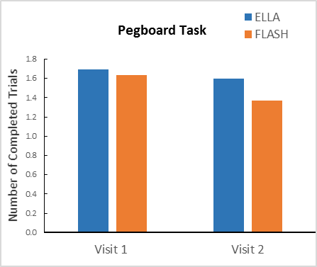Figure : Number of completed trials of the Pegboard Task for the ELLA and Flash Card groups during both lab visits

The ELLA and Flash Card groups completed a similar number of trials during both lab visits. The Pegboard Task, however, may not be a sensitive measure for examining children’s motivation for new words, due to a number of reasons:

* The task was carried out straight after the children played on the iPad during Lab Visit 1. This order effect could be a confounding factor because some children may have found the ELLA apps interesting and were thus reluctant to move on to the Pegboard Task (which may have seemed more interesting after learning from the flash cards, for example).
* The children might not have established the association between learning new Indonesian words and a subsequent reward (i.e., watching the video clips of Indonesia), especially during Lab Visit 1.
* There were many variables in performance among the children. Some children found a way to make the Pegboard task interesting, such as pretending to build a fence, or making a tree-shape using the pegs on the board, whereas other children saw this task as boring. It also depended on the children’s mood on the testing day.

The parental report engagement data may provide a better indication of the children’s motivation, as explained in the next section on engagement.

## Home-based Activities

In order to make comparisons between children’s use of the ELLA and Flash Card apps, the researchers asked parents to:

1. document their child’s time usage of the apps at home, and
2. rate their engagement in playing the apps during the two weeks of home usage.

### Home-usage Log

Parents were asked to record their child’s daily app usage over the two weeks between lab visits (see Appendix 5 for an example of the Engagement and Home-usage Log). Although instructions were given to parents for children to use the apps for 15-20 minutes daily for two weeks, Home-usage Log data indicated wide variation in usage across time and groups.

#### Participants

Table : Participant demographics for the Home-usage Log

|  | Gender | Number of Participants | Average Age |
| --- | --- | --- | --- |
| ELLA | F | 8 | 4 years 0 months |
|  | M | 17 | 4 years 0 months |
| FLASH | F | 8 | 4 years 3 months |
|  | M | 5 | 4 years 1 month |
| Total |  | 38 | 4 years 1 month |

#### Results

The most important finding from these data is that although both groups of children spent less time on the apps during the middle and end of the two-week period, **children in the ELLA group spent on average two to three times longer than did children in the Flash Card group on the apps in any of these periods, supporting the finding that the ELLA apps were more enjoyable for the children.**

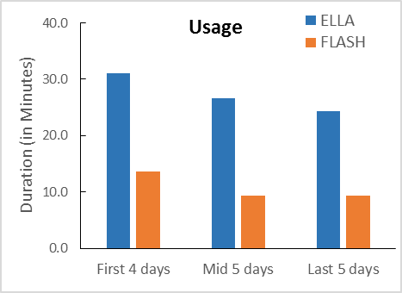

Figure : Mean usage of ELLA and Flash Card apps during the two weeks of home use

### Engagement Log

Motivated by unsolicited parental feedback, for subjects tested in the last few weeks of the project, the researchers asked parents to rate their child’s engagement level (from 0 to 10—with 0 indicating “Not engaged at all” and 10 indicating “Very engaged”) during the two weeks of home usage (see Appendix 5 for an example of the Home-usage and Engagement Log).

#### Participants

Table : Participant demographics for the Engagement Log

|  | Gender | Number of Participants | Average Age |
| --- | --- | --- | --- |
| ELLA | F | 5 | 4 years 2 months |
|  | M | 8 | 3 years 8 months |
| FLASH | F | 4 | 4 years 3 months |
|  | M | 2 | 4 years 10 months |
| Total |  | 19 | 4 years 0 months |

#### Results

For the initial four days of the two-week home use, children in the ELLA and Flash Card groups did not score differently in the parent-rated engagement scale. From Day 5 onwards, children from the Flash Card group showed signs of reduced engagement, whereas children from the ELLA apps group retained their level of engagement. Towards the end of the two-week period, the engagement level of children from the Flash Card group had substantially reduced, whereas the engagement level of children from the ELLA group remained high.

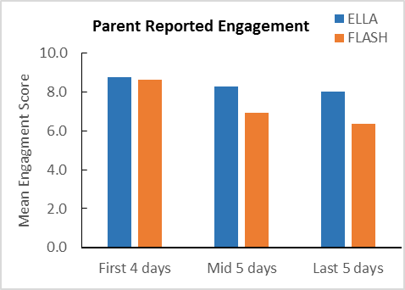Figure : The engagement scores from parents’ reports of the ELLA and Flash Card participants over the two weeks of home use

This data showed the **ELLA participants remained engaged in playing with two apps over a two-week period, while the Flash Card participants did not retain their engagement level**. This is also reflected by the difference in reported home-usage time for the two groups, as explained in the next section (Interviews) comparing children’s usage of ELLA versus Flash Card apps.

## Interviews

The research project contained three qualitative components:

1. Interviews with educators at preschool services (standalone and long day care centres) that have been involved in the ELLA program in 2016.
2. Interviews with parents of children who used two ELLA apps at home over a two-week period.
3. Interviews with parents of children who used digital flash cards containing the learning content of two ELLA apps at home over a two-week period.

### Educator Interviews

Forty-four preschool services in Victoria were using the ELLA program during 2016, which included standalone preschools, preschools within a school, and long day care centres with a preschool program. All 44 centres were invited by email to participate in this component of the ELLA program evaluation.

#### Method

Educators were invited to participate in interviews with either a visit from the researcher (if located in a metropolitan area) or a telephone conversation (if not metropolitan). Educators that the researcher visited completed a consent form, and educators who completed the interview over the telephone gave verbal consent. Approximately one-third (36%) of all centres implementing ELLA in Victoria were involved in the interviews, with participation from every educator who volunteered.

Interviews occurred between September and November 2016; half (n=10) the staff were interviewed in person and the remainder (n=10) over the phone due to either the distance of the centre from the researcher, or for the convenience of centre staff.

All interviews were undertaken by the same postdoctoral researcher and they ran for a mean duration of 27 minutes 17 seconds (range: 12 minutes 48 seconds to 1 hour 14 minutes 46 seconds). All interviewees agreed to have their interview recorded, and the interviews were later transcribed and entered into the qualitative data analysis software NViVo 11.[20] (The semi-structured interview questions are presented in Appendix 3.)

#### Participants

In total, 20 educators from 16 centres participated in the research project. The educators that were interviewed consisted of 15 preschool teachers, one room assistant and four centre directors.

Three educators were from standalone preschools, and two were from a preschool located on a school campus. The remainder worked in long day care centres that ran a registered preschool program, eight of whom educated a classroom exclusively containing preschool children (typically aged four), while seven educated a classroom of both three-year-old preschool children and preschool-aged children.

There was a representation of metropolitan, suburban and regional preschool services. Only one centre had been involved in the 2015 trial; the remaining centre had introduced the ELLA program to their class in early 2016.

Centres using four of the five ELLA languages were represented, while the sole Victorian centre using the Arabic ELLA apps did not volunteer to participate in this study. Nine of the interviewed educators had experience with the ELLA apps in Mandarin, four in Indonesian, five in French and two in Japanese.

All interviews were conducted one-to-one, with the exception of a small number (n=5) where educators elected to include a colleague in the discussion.

#### Results

Important themes drawn from the educator interviews are presented in categories below. Particularly interesting information from the interviews are also highlighted. (More detailed analysis of the educator interviews can be found in Appendix 6.)

##### Educators’ reaction to the ELLA program

###### Themes

* Most educators were excited about the ELLA program.
* Most were comfortable introducing language and cultural learning via ELLA app-based delivery.
* Educators were happy to learn the language concurrently with the class.
* There was initially some scepticism about learning a language from an app.
* The success of the program has exceeded educators’ expectations.
* There was variability in educators’ previous experience in using technology in the classroom.
* Most inexperienced educators became comfortable with the tablets once introduced to the ELLA apps.

###### Interesting note

* At one centre only one educator interacted with the ELLA apps because the other educators did not wish to use the tablets.

##### Parents’ reaction to the ELLA program

###### Themes

* Educators reported that some parents were initially opposed to the ELLA program because of the use of tablets, screen time at preschool, or worries about technology replacing traditional learning methods.
* Almost all parents were comfortable with their child participating after discussing concerns with an educator including being reassured about structured and timed use.
* Educators also said that the ELLA program didn’t appear to concern parents once they saw it in practice and observed their child’s learning progress.
* Educators reported that no parents objected to their child being exposed to an additional language, but a small number of parents did not consent to their child participating because it was an app-based activity.

##### How the ELLA apps were used in the preschool classrooms

###### Themes

* Implementation of the ELLA program varied across the classrooms.
* Factors influencing implementation included the child-to-tablet ratio, centre and classroom type, and educators’ comfort with and interest in the program.
* Most educators were content with the number of tablets available to their class, but some educators said they would benefit from having more tablets.
* Some centres endeavoured to keep exposure to the ELLA apps comparable amongst children in the class whilst others encouraged participation but as a self-selected activity.
* Most commonly children used the ELLA apps in 15-minute intervals, weekly or more regularly.
* Scheduling techniques varied, including educators creating a list or children using a sign-up list, and there was a mix of using timers and allowing children to self-regulate.
* The amount of exposure was influenced by individual or group use.
* In some classrooms children wore headphones to provide an individual learning experience and to reduce distraction.
* Generally children used the ELLA apps individually, but sometimes other children watched or multiple children concurrently engaged in the same app activity.
* There was generally teacher involvement when the ELLA program was first introduced to the classroom, and again upon app release.
* Group use was mainly to introduce children to the concept of using apps without verbal English instructions.
* Educators allowing children to use their ELLA app of choice found children were keen to try the most recently released app.

###### Interesting notes

* The child-to-tablet ratio varied greatly between classrooms, ranging from one tablet for every two children to one tablet for an entire class of 18 children.
* An educator who had just one tablet for the class stated that even one additional tablet would have been advantageous as being able to use the ELLA apps concurrently would provide a more social learning experience.
* One centre limited each child’s exposure to 10 minutes per week.
* One educator extended sessions from 5-10 to 15-20 minutes to allow children to become more engaged.
* In a classroom that allowed self-regulated app time, the educator found the children did this independently and were confident in passing the tablet on to others.
* When the app sounds came from tablet speakers rather than headphones, children who were walking by would sometimes repeat the words, adding to their language exposure.
* In centres where ELLA apps were used under supervision, this was to either scaffold children’s learning, or to ensure children did not access staff documents saved on the tablets.
* One centre created a collaborative learning environment by mirroring the classroom’s tablet content onto a large screen and loudspeaker so the entire class was exposed to the content as one child used an ELLA app.

##### Favoured apps

###### Themes

* Most children had a favourite ELLA app.
* The most popular apps amongst children were App 5: The Polyglots at the Circus and App 3: The Polyglots at the Birthday Party.
* Other classroom favourites were App 2: The Polyglots at the Beach and App 4: The Polyglots at the Zoo.
* Sorting activities (e.g., the rocket task in App 1: The Polyglots in the Playroom and the submarine task in App 2: The Polyglots at the Beach) and food preparation (e.g., baking a cake in App 3: The Polyglots at the Birthday Party and the juice bar task in App 4: The Polyglots at the Zoo) were favoured.

###### Interesting notes

* The topic and learning content of App 3: The Polyglots at the Birthday Party contributed to its popularity—children loved the idea of a party and more comments were made about children enjoying the cake-making than any other activity across the entire suite of ELLA apps.
* One educator theorised that App 5: The Polyglots at the Circus was popular because of children’s love of science and the human body.
* The presence of the ‘Heads, Shoulders, Knees and Toes’ song in App 5: The Polyglots at the Circus encouraged children to do the actions as they sang along, and the children could then identify each body part in the physical world when asked, indicating transfer of learning (see Appendix 7).

##### Culturally and linguistically diverse (CALD) children and educators

###### Themes

* Many preschools had at least one educator and/or student that already spoke their ELLA language.
* A number of educators were fluent in their ELLA language which allowed them to extend learning with less effort than for other educators.
* In classrooms where a child spoke the ELLA language, other children consulted that child for assistance.
* Children already fluent in their centre’s ELLA language benefited from the program with enhanced confidence, and social and communication skills.
* Educators reported that children who already spoke a language other than English that was not the classroom ELLA language learned the ELLA language at a comparable pace to children who did not speak a language other than English at home.

###### Interesting note

* The ELLA program assisted an educator to communicate with parents who had limited English language skills.

##### Classroom design and inclusivity

###### Themes

* Inclusivity was an issue predominantly for educators in multi-age settings (that is, classes with both preschool-aged and three-year-old preschool-aged children in the one room). Teachers reported unease in running a program that some children in the classroom were not eligible to participate in.
* Educators reported that it was difficult and seemed unfair to exclude children who were not eligible to use the ELLA apps. It was unanimous amongst educators who taught in a classroom that included three-year-old preschool-aged children that the ELLA program would be more beneficial if the entire class could be involved.
* Some educators established strategies to minimise a sense of exclusion amongst children who were not eligible to use the ELLA apps—the most common strategy was to allow the ineligible children to either use the ELLA apps in demonstration mode or to use other apps.
* When there were children who were not enrolled in the ELLA program, educators reported that it was difficult to plan and integrate extension activities into their curriculum.

##### Language and cultural extension activities

* Most extension activities were reported by educators that taught in a room solely comprising children eligible to participate in the ELLA program.
* Many educators indicated that they had intended to run more extension activities than they actually did, although now they were familiar with the program, they would implement more in future if their centre continued to deliver the ELLA program. In some cases, the slower integration was related to the educators’ confidence in using the language.
* The most commonly reported extension activities were singing as a class (using songs taught in the ELLA apps such as ‘Happy Birthday’ in the ELLA language), and practicing words together as a class, either during circle time or as part of daily activities such as counting, labelling colours, and greetings.
* In some classrooms, purposefully connected activities were set up to encourage use of the ELLA language, for example, numerous educators reported setting up a hospital role-play area to extend upon the body part content within App 5: The Polyglots at the Circus.
* Cultural extension activities were mainly undertaken in classrooms with a native speaker of their ELLA language amongst the staff or students, or if the centre had organised a one-off or regular visits from a native speaker.
* A large number of centres had bilingual children in their class, and for various reasons, the child’s other language most often matched the centre’s ELLA language.
* When asked whether the ELLA program had influenced the promotion of cultural awareness, most educators reported that the impact had been minimal because multiculturalism was already part of their practices. However, this varied depending on factors such as diversity of individual centres, geographical location, and what the individual centres taught.
* As the 2016 ELLA cohort appeared to have an atypically high rate of cultural diversity, we were not able to attain a true indication of the impact that the ELLA program might have had on cultural awareness.

###### Interesting notes

* At a centre where there was a Chinese child who had limited spoken English when he first attended, the educators had introduced Mandarin to the class to help that child’s integration. This later became the centre’s ELLA language. The educators also played Chinese music in the classroom and introduced the class to other aspects of Chinese culture, which helped validate the child’s home language and cultural practices.
* Interestingly, the cultural discussion at one centre just prior to introducing the first ELLA app revealed that a number of children in that classroom were unaware that people could speak a language other than English.

##### Demonstrations of learning

###### Themes

* Children demonstrated that they had learnt the content of the ELLA apps during many of the extension activities. As they could have been learning during those activities already, however, we cannot definitively state whether the learning had come from the ELLA apps, from the extension activities themselves, or from both.
* Some educators reported that they would hear children saying words in their ELLA language when they were not using the ELLA apps, for example, in general conversation or during imaginative play. Counting was a commonly reported example of this.
* Some educators also indicated that parents had informed them that their child had been uttering what were presumed to be words in their ELLA language.
* When demonstrating learning of the ELLA content when away from the tablets, children are likely to receive positive reinforcement which builds their confidence, and an educator suggested that this would encourage children to continue using the language in real-life settings (for more information see Appendix 6).

###### Interesting note

* A parent shared an example with an educator of her child using the ELLA language outside the classroom. The child, who had some language delays, reportedly spoke in Mandarin, unprompted and in appropriate context. While shopping, the child responded when the shop assistant handed her an item, and when the parent asked what her child had said, the Chinese shop assistant informed the parent that her child had said “thank you” in Mandarin.

##### Children’s engagement in the ELLA apps

###### Themes

* According to educator reports, the ELLA apps create fun learning experiences that engage children.
* Educators reported that with minimal exceptions, all children were happy to use the ELLA apps, and many children would proactively seek out an additional turn.
* Some educators did not perceive particular characteristics amongst children most interested in the ELLA apps whilst others thought that there was greatest interest amongst the older and/or intellectually stronger children.
* Educators reported various behaviours that demonstrated the children’s excitement, such as crowding around others having their turn, keeping track of when their next turn would be, debating the pronunciation of words, and helping to teach other children to learn the words that they had already mastered.
* In some centres, the tablets that the ELLA apps were installed on also had other apps installed. Even when children were given the option to use other apps, they usually remained on the ELLA apps. Educators specifically commented that the ELLA apps held the children’s attention for a long time.
* Some educators reported that they often heard the children saying words in their ELLA language whilst using the apps. It was also reported that children using the app with other children would sometimes say the words to each other and help each other with pronunciation.

###### Interesting note

* A child with a hearing impairment successfully participated in the ELLA program. Utilising his Radio Frequency Assistive Listening Device, the sound from the apps was transmitted directly to the receiver in his ear. The educator reported that the child engaged well with the ELLA apps and it has consequently enhanced his English language skills.

Educators report that the ELLA apps have had widespread benefits for all the children involved, even those with language delays, hearing impairments, and other diverse needs.

##### Home/family ELLA app use

###### Themes

* Most educators had received reports from some parents that they had downloaded the ELLA Family App for their centre’s ELLA language for their child to use at home, or that they planned to do so.
* Some parents had communicated their disappointment to the educators about the limitations of the ELLA Family App, such as not being able to embrace their child’s interest to the degree they had anticipated the app would allow them to.
* Educators also reported their own disappointment that the families could not access the full suite of ELLA apps.
* It was noted that the sound library was a sensible inclusion and strength of the ELLA Family App.
* Educators reported that some parents had shown great enthusiasm for the ELLA program, and even introduced other activities relating to language acquisition at home. Some educators had heard from parents that their child had greater interest in alternate languages and cultures generally.

###### Interesting note

* Parents of one child were initially opposed to their child’s participation, but later agreed with the knowledge that ELLA app use would be limited to 15-20 minutes a week. Later in the year, these same parents were so excited by the program that they downloaded an ELLA Family App for their child to use at home to complement the child’s ELLA language learning at preschool.

Many parents reported they were initially opposed to or sceptical about their child learning a language from an app, but changed their mind after realising the utility of the ELLA apps.

##### Educator workshop and resources

* All educators who attended the ELLA workshop reported that it was a valuable component of the ELLA program.
* The workshop was reported to cement educators’ understanding of the program and numerous educators thought it would be beneficial for all educators who work in ELLA classrooms to attend a workshop.
* Both the official training content and networking with other ELLA educators were reported to boost enthusiasm and confidence amongst attendees. Educators left with insight on implementation and extension activities, and a sense of confidence and excitement about involvement in the ELLA program.
* Some educators felt there should have been professional development prior to commencing the ELLA program as they did not feel comfortable with implementing the program initially.
* Most educators found attending the ELLA program workshop helpful, although some had an issue with the timing (mid-year 2016). Specifically, some educators said they did not properly implement the program until after they attended the workshop, when they had gained more knowledge and confidence in delivering it.
* Most educators indicated they were aware of the online resources. Many had accessed the resources and some had downloaded songs and printed pictures to display in their classrooms.
* It was recommended by more than one educator that there should be resources to use alongside the ELLA apps for first-time users.
* Not all educators had been using the ELLA educator Facebook page or forum.
* Those who had visited the ELLA educator Facebook page and/or forum reported doing so to see how the ELLA program was being implemented in other classrooms and to seek inspiration for their own classrooms.
* Upon hearing at the ELLA workshop about some extension activities other centres had undertaken, educators were empowered and inspired to implement such concepts in their own classrooms.
* Only a small proportion of educators reported utilising the software analytics function accessible via the ELLA educator app login. Most were unsure of how to use the analytics or why they should do so, and a couple of the educators indicated that they were not aware that they could access software analytics.
* Some educators examined the analytic data to ensure all children were getting a turn, and a few examined the Early Years Learning Framework (EYLF) outcomes.
* Some educators suggested that the software analytics training had been insufficient and that they would benefit from more guidance.
* More than one educator reported that they would like to be able to access a session-by-session breakdown of each child’s use of the ELLA apps in addition to average time per session, overall total time, and total time per outcome.
* A few educators reported that the program had not run as smoothly as expected due to technical problems. None of the reported problems had occurred while the ELLA apps were being used on an iPad, which may indicate that required tablet specifications should be communicated to centres.
* For preschool services co-located within a school or other venue, a document to forward to the IT department would be beneficial to prevent network access problems.
* It was also stated that educators should not be expected to implement the ELLA program with only one tablet for a class. In future, different implementation strategies should be recommended based around the number of tablets a classroom has access to.
* If ELLA apps are to be run on tablets that are also used for other purposes, it is important that educators know how to lock the tablets to prevent children accessing other apps, thus educators would only need to be present when they want to scaffold the children’s learning rather than to provide constant monitoring.
* Educators felt that centre management should consult educators about introducing the ELLA program, and that this was most pertinent to classrooms that include both preschool-aged and three-year-old preschool-aged children.
* Educators teaching in classrooms with some ineligible children struggled to embrace the ELLA program to the level that they wanted to and found it difficult to prevent a sense of exclusion amongst the children not eligible to participate.

### Parent Interviews

Parents of the children who had participated in the Babylab study at the time of the interviews being scheduled were sent an email inviting them to participate in a brief interview about their child’s participation in the study; specifically, the use of the iPad-based language learning programs in the home over the two-week period between the two lab visits.

#### Method

The response rate was greater from the ELLA parents than from the Flash Card parents. Retrospectively, the greater enjoyment reported by ELLA parents than Flash Card parents may have influenced their motivation to speak to us about the experience.

Two interviews were conducted in person (at the parents’ requests) and the remainder were conducted by telephone. Nine of the interviews were recorded and they ran for a mean duration of 11 minutes 31 seconds. The transcription and qualitative data analysis process was comparable to the educator interviews. (The semi-structured interview questions are presented in Appendix 4.)

#### Participants

A total of 17 parents were interviewed: comprising nine parents whose children had been allocated to the ELLA group (from here on referred to as ELLA parents), and eight parents whose children had been allocated to the Flash Card control group (from here on referred to as Flash Card parents).

#### Results

Important themes drawn from the parent interviews are presented in categories below, along with illustrative quotes from parents. The themes and quotes are based on reports from parents of children who used two of the ELLA apps at home for two weeks.

##### How the ELLA apps were used in the home

ELLA app use varied across people’s homes in the following ways:

###### Individual and joint use

* Some children used apps by themselves.
* Some parents and grandparents joined in at the beginning and after that they more commonly monitored and helped if needed.
* Both older and younger siblings were keen to join in.

###### Sound

* Some used headphones, but using the inbuilt tablet speakers was more common.
* Tablet speakers encouraged joint participation with others.

###### Duration

* Some parents ensured children limited use to 15-20 minutes, guided by the study instructions.
* The ELLA apps were used for longer periods when others were participating with the child.
* Unrestricted app time resulted in intense use for the first week which slowed during the second week; perhaps as children had more fully explored the two apps by then.
* Usage of 20-30 minutes a day was the most common duration reported.

“It was really interesting to watch the three of them [participant with 6- and 8-year-old sisters] bending their heads together, and problem solving together, and sort of saying what do you think this means, and what do you think that means, oh but remember we saw that word, we heard that word earlier, it’s this ... so it certainly works really well as a focal point.”

“She loved to tell people about the apps … we’d be at the shops and she’d be telling random strangers she’s using the iPad to learn Indonesian.”

##### Children’s engagement with the ELLA apps

* Parents reported that their children looking forward to using the apps.
* Most children remained engaged for the two-week period.
* Most children did not need to be asked to use the apps each day.
* Children were proud of what they achieved on the ELLA apps.
* Those without experience using a tablet also enjoyed working out how to do so.
* Some children were keen to show the apps to everyone who visited their home and told others that they were using the ELLA apps to learn Indonesian.
* One family downloaded the ELLA Family App so the child would continue after the study.

“She was very sad when it was over, she really liked that way of learning and she wanted to keep going.”

##### Demonstrations of learning

Numerous parents reported that their child had demonstrated learning from the ELLA apps. Reported incidents of learning included:

* Singing along with the app.
* Saying the Indonesian words at the same time as the characters whilst using the ELLA apps.
* Translating the word into English when the mother said the ELLA app words in Indonesian.
* Teaching friends some Indonesian words.
* A younger sibling who had been watching the ELLA apps being used was also saying words.
* During the study, and weeks later, a child would see an object that she had learnt the Indonesian word for, and say the Indonesian word.

“He says goodbye in Indonesian a lot.”

“Interestingly our two year old would hang around [whilst his sibling used the ELLA apps] and for weeks after the trial he was loudly saying things in Indonesian.”

##### Interest in and knowledge of language and culture

Using the ELLA apps influenced children’s interest and knowledge in other languages and cultures.

* Some children had previous exposure to other languages and cultures, including parents that spoke other languages in their presence and children who had travelled.
* Whilst some children showed interest in other countries and cultures after using the ELLA apps, other children did not understand the concept of countries, only that some people spoke languages other than English.
* Some children were reported to pay attention to their surroundings, listening out for people speaking languages other than English.
* A family downloaded the ELLA Family App in all available languages after the study concluded.
* Upon first accessing the ELLA apps, a child asked where that language (Indonesian) was spoken and the family looked for Indonesia on a map, and its position relative to Australia.

“He did ask me at the start, the first night we got it home, what language is what and what country it came from, so we got out our map and had a look where it was compared to where we were.”

“He understood that concept that Indonesian is a language, it is a different language, that we use the colour red, it is red in English and ‘merah’ in Indonesian; it’s different.”

“Before this iPad, when I used to speak Telugu [native language] he did not understand, ‘what is that?’ you know? But [after] he understood the concept of languages, by doing this one [program].”

[Since Using the Indonesian ELLA app for the study] “He’s got the Indonesian app on there, and he’s also got the French app, the demo [family] versions.”

“I think he has a bit more of an interest in learning new things since that experience.”

“… can see how it can have merit educationally.”

##### Parents’ attitudes to tablets as a learning tool

Participating in the study appeared to positively impact parents’ attitudes to their children using tablets as a learning tool.

* The ELLA apps made most parents more confident that tablets could be used as a learning tool.
* There was surprise that learning a language could happen through playing games such as on the ELLA apps.
* Exposure to the ELLA apps encouraged one family to use other early learning apps.
* A parent commented how great it would be to use ELLA apps alongside face-to-face language lessons.
* A parent who had been hesitant to introduce her child to tablets saw his learning curve and after the study continued to allow some tablet use.

“I was sceptical at the start, but impressed by how quickly [child] was engaged and interest was gained.”

“[The iPad] can be used as a learning tool, but it can’t overtake, it has to be complemented by other stuff.”

“It changed a little bit of my idea. I thought that it’s … more like entertainment, I would think that it will help in [the] learning process, but I was not thinking to that extent.”

“I’m very positive now that it can be used as a learning tool.”

##### ELLA and the Early Years Learning Framework

The ELLA apps were designed to be aligned with the Early Years Learning Framework’s[21] five learningoutcomes, and parents made the following associations between these and their child’s app use.

###### Outcome 1: Children have a strong sense of identity

* Realisation that English is their language but not the language that everyone speaks.

###### Outcome 2: Children are connected with and contribute to their world

* Knowledge that a variety of languages are spoken around the world.
* Interest in learning about different countries, including collecting stickers about different countries.
* Based on the ‘polyglot’ characters, realisation that children in different countries like different things.

“He seemed to be paying more attention to other languages … I think it has increased his attentiveness.”

“And if you’re out on a train with her now and she hears another language, she’ll sort of stop and think. It’s obviously understanding, and it has opened her eyes and opened her ears, so she’ll really stop and really concentrate on the other language, even though she has no idea what they’re saying.”

“When you’re out and about with the children and they hear a different language … now she tries to listen to it, and she’ll say ‘what language are they talking?’.”

###### Outcome 3: Children have a strong sense of wellbeing

* Overcoming a sense of frustration, when first unsure how to manoeuvre though the ELLA apps.

###### Outcome 4: Children are confident and involved learners

* Increased confidence from using the ELLA apps made children more interested in learning new things.
* Confidence was enhanced by children realising that they could use a tablet and learn things on their own.
* Children felt involved in the learning process because they were controlling what activities they were doing.
* Confidence was evident when children showed parents and siblings how to use the ELLA apps.

“He’s proud to tell others that he knows Indonesian.”

“He was engaged when he was using it, and I think he has a good sense of achievement when he navigated his way through things.”

“She was doing it on her own; she was teaching Nanna how to do it.”

“[He was] keen to show it to others, not just his little brother but his dad, the app in general but also the results of his interaction with it, so what he managed to do with it, I think he was quite proud of himself, gave him a sense of satisfaction.”

###### Outcome 5: Children are effective communicators

* Some children’s communication was enhanced by telling people about the ELLA apps.
* A child was reported to notice benefits from expressing himself.

“She loved to tell people about the apps … we’d be at the shops and she’d be telling random strangers she’s using the iPad to learn Indonesian.”

#### Engagement: ELLA versus Flash Cards Apps

##### Flash Card parents

Interviews undertaken with parents of children who were asked to use the Flash Card apps to learn Indonesian rather than the ELLA apps allowed a comparison of engagement across the two language learning techniques.

###### Children’s engagement with the Flash Card apps

* The excitement of the Flash Card apps was generally limited to a few days.
* Most children used the Flash Card apps for only 5-10 minutes at a time.
* After the initial excitement eased, some children considered using the Flash Card apps to be a chore or even refused to use them.

###### Comparisons of children’s engagement with the ELLA apps and the Flash Card apps

Comparing reports from parents of children who used the two different language learning apps revealed that children enjoyed the ELLA apps much more and children tired of the Flash Card apps more quickly.

## ELLA App Analysis

In this section, the suite of ELLA apps is assessed with respect to the Pillars of Learning rubric.[22] This rubric was published in the *Psychological Science in the Public Interest* journal, one of the highest-impact psychology journals. The rubric involves assessing apps on four dimensions based on decades of science relating to how children learn. The four pillars are:

1. **Active Learning**: Is the child engaged in the learning experience and remaining on-task?
2. **Engagement in the Learning Process**: Does the content encourage engagement with the content and not distract from it?
3. **Meaningful Learning**: Is the child finding meaning that goes beyond the app?
4. **Social Interaction**: Is the child engaged in high-quality social interaction with others while playing with the app?

**Active Learning**: The key to an active learning assessment is to determine the extent to which an app requires children to actively think about the content in order to progress in the app. Progression can occur in a number of ways, including moving to a new level, being rewarded (e.g., with praise, congratulations or virtual trophies), or being offered a new and more advanced activity. Therefore, apps deemed to foster active learning are typically those that require the child to demonstrate that they actively thought about the learning material before they can progress. In contrast, apps negatively assessed in this area are those that allow progression even when a child mindlessly taps until they randomly make a correct response.

Assessing each of the activities in the ELLA apps with respect to active learning was an interesting exercise. Our initial assessment of the ELLA activities revealed that children are essentially free to enter and exit any activity as they please and that there is rarely an explicit learning goal in any of the activities. Instead, the ELLA apps were designed to provide an experience akin to immersion . That is, an experience similar to if one was living where the language is spoken and learning the language in a similar manner to how a native speaker would. This means that children generally were never ‘tested’ on the material by the apps and so we could not easily judge whether children were required to actively attend to the material.

While immersion has been shown to be a very effective tool for teaching new languages, it did require us to develop a different strategy for assessing the apps with respect to active learning. Instead of determining if the apps *required* active learning, we focused on whether the apps *encouraged* active learning. Fortunately, because we conducted extensive vocabulary testing ourselves, we were able to make this determination on the basis of whether most children did learn from their gameplay. As shown by the results of the Behavioural Word Test and the Eye-tracking Word Test, **children showed clear significant gains after two weeks of gameplay, indicating that they were indeed actively learning from the ELLA apps**.

**Engagement**: The key to an assessment of engagement is to determine how well the app keeps the children engaged with the learning content rather than with extraneous “bells and whistles” that distract from learning.

Four members of the Swinburne Babylab team individually assessed each activity to determine the extent to which they included content that was likely to distract from the learning goals. This exercise revealed that the apps were largely free of extraneous distracting content. Distracting content, when it did appear, appeared to stem from suboptimal implementation rather than by design. For example, the sandpit activity (in App 1) reveals the name of an object only after a child taps it in the sandpit, but does not reveal the name of the object when it is initially touched and dragged. This implementation will result in many children never hearing the word during this activity as there is no obvious reason why they should tap an object after placing it in the sandpit.

The rocket activity in the same app also includes many elements that do not clearly relate to the learning content, and thus could distract from it. For example, unlike other ELLA app activities that use the microphone (e.g., feeding fish in App 2), the microphone in this app is not employed in such a way as to encourage the child to speak in the target language. Additionally, many of the buttons simply make things happen without resulting in any new opportunities to learn. In summary, however, most of the activities are presented in a simple manner without a great deal of unrelated sounds and visuals to distract children from learning.

**Meaningfulness**: A typical assessment of meaningfulness involves determining whether the app makes the learning content meaningful to its users. For example, flash cards can be considered to be an example of an activity that holds little meaning for children. Unless the children are intrinsically motivated to learn the flash card content, there is nothing about a flash card learning experience that leads the child to see the activity as interesting or relevant to their life.

In contrast, learning experiences that revolve around child-centric stories or that allow the child to be creative can provide more meaning. **One of the strengths of the ELLA approach is that children have a wide variety of activities from which to choose in each of the seven apps to match their interests**. Children, therefore, are very likely to find at least a few activities in each app that revolve around activities that have personal relevance to them. For example, children who appreciate space adventures should find the spaceship activity in App 1 meaningful; and if they do not find space interesting, they may gravitate towards another activity such as the cake-making activity in App 3.

**Social Interaction**: Activities that involve social interaction are well-established to foster deeper learning in comparison to activities that are carried out solo. Even parasocial interaction (i.e., with a character presented via video or in an app) with a familiar character has advantages over no social interaction.

The ELLA apps score very well in social interaction for three reasons. First, children are exposed to the same set of characters who talk to the children constantly throughout gameplay in nearly all apps. Second, and more importantly, when used as intended, children will engage with material in a social environment with an educator and/or peers. This should enhance learning as children demonstrate and consolidate their understanding through their interactions with others. Third, we collected evidence (see Parent Interviews) that many parents were also keen to be involved in this learning process and that some children were motivated to learn because they appreciated that learning a new language can result in new social experiences.

# SUMMARY AND IMPLICATIONS

Overall, our findings suggest that children in the ELLA group demonstrated deeper and more engaged learning than did their peers in the Flash Card group.

In the Eye-tracking Word Test, children who used the ELLA apps were 11% faster to look at a picture corresponding to an audibly played Indonesian word after two weeks of practice. By comparison, children who used the Flash Card apps were 15% slower after two weeks. **This indicates that children using the ELLA apps became more confident with their answers** after a mere two weeks of app use.

In contrast, children in the Flash Card group were slower to look at the pictures after using the Flash Card apps for two weeks, suggesting that they were less confident with their answers. This could be due to their reduced interest in learning from the Flash Card apps over time.

In the Behavioural Word Test, children in the ELLA group performed as well as their peers in the Flash Card group did for the second app, even though they did not do so for the first app. Supporting the results from the Eye-tracking Word Test, the Flash Card group had a high initial gain, which was not sustained to the second app, whereas the ELLA group’s performance was steady in both apps.

The results of these two Word Tests confirmed **not only that the children in the ELLA group were able to learn from the ELLA apps, they were also more confident with their answers than were their Flash Card group peers**.

The electroencephalogram (EEG) results showed that the ELLA group and the Flash Card group exhibited a different brain response pattern to words that they had been exposed to versus those words they had not heard. Upon hearing the 'taught’ words, 77% of the ELLA children exhibited the typical brain response that is usually generated by hearing learnt words. In contrast, only 33% of the Flash Card children exhibited such response. This suggests that **the ELLA group processed the sounds of the words well, and they also were able to retrieve the context of the words**. On the other hand, it appears that the Flash Card group might not have processed the sounds of the words as well as the ELLA group did, and they might use a different strategy to retrieve the contextual information than the ELLA group.

From the results of the parent-reported Engagement Log, children in both groups initially were reported by parents to be highly engaged in learning. By the last five days of home use, this engagement score was 26% higher for children in the ELLA group. As for the results of the parent-reported Home-usage Log, activity duration was 2.58 times longer for the ELLA group than for the Flash Card group. **These results confirmed that the ELLA children’s interest in learning the language from the apps remained higher than for their peers in the Flash Card group.** This is supported by the interview results (qualitative data). This also supports the results from the Word tests and the brain responses.

The Wearable Eye-tracking Test showed an age effect that is consistent with the Department of Education and Training’s guidelines stating that the ELLA apps are recommended for use by preschool children typically aged four to five.

It is notable that the lab-based tests examined the children’s performance in ‘ideal’ learning situations, as the children were using the app under the guidance of a trained researcher or motivated parent. While this loses something in ecological validity, **our lab-based results confirmed that preschool children learnt and more importantly gained interest in learning a new foreign language from using the ELLA apps.**

The interviews with educators involved in the ELLA program, and with parents of children that participated in the Babylab study, revealed great similarities in patterns of use in classrooms and in homes. Just as there was variation in how the ELLA apps were used across preschool classrooms, there was also variation in how the ELLA apps were used in homes. There was a mix of individual and joint use, sound coming from inbuilt speakers and headphones, and parents that limited children’s time using the ELLA apps and others that allowed usage to be self-regulated by the children.

Engagement was high amongst children using the ELLA apps at preschool as well as those using the apps in their home. Despite the brief period of time that lab-experiment children were able to access the ELLA apps, parents reported their children learning, as did the educators about the preschool children. **Both groups of children (those using the ELLA apps at home and those using the apps at a preschool service) developed an interest in, and awareness of, other cultures and languages.**

The similarities in reports from educators involved in the ELLA program in a preschool service, and the parents of children who used the ELLA apps at home for two weeks as part of the lab-based experiment, demonstrate generalisability from our lab studies to ELLA app use in preschool services.

Overall, our evaluation indicates that the ELLA program was effective in introducing new languages to preschool children, in raising their awareness of other cultures, and in engaging their interest in learning different languages. The ELLA program gives young children the opportunity to benefit from the cognitive advantages that bilingualism has on their developmental process.

# RECOMMENDATIONS

The data presented in this report provide clear support for continued use of the ELLA apps with young children, both in preschool service settings and home environments.

These data lead the research team to suggest the following recommendations:

1. Continued support for ELLA implementation in a broader range of early childhood contexts. This includes formal educational settings as well as other services such as family day care.
2. Given the appeal of the ELLA apps, it is recommended that further support is provided for parents and educators in managing digital devices, including strategies to integrate on- and off-screen engagement.
3. Further research is needed to explore sustained engagement with these tools—this could include a longer sampling period or a longitudinal study to examine early exposure to languages through ELLA and later educational interest in languages other than English. In addition to this, a broader research base is needed to explore the impact of multi-language tools on family engagement in educational contexts. For example: “Does the availability of ELLA encourage parents from a non-English speaking background to participate?”
4. Development of further ELLA apps such as the addition of an ELLA app for Indigenous languages, or an English app to improve English literacy. Given the success of ELLA, this has potential for Aboriginal and Torres Strait Islander communities where home language use may be affected, and where English is not the primary language.
5. Development of further age appropriate apps to expand ELLA to the early years of schooling (e.g. K-2). This is in light of the finding that the ELLA apps are effective in introducing languages in preschool aged children and that currently children do not commence language learning until grade three in primary school.

# BIBLIOGRAPHY

Adesope, O.O., Lavin, T., Thompson, T., & Ungerleider, C. (2010). A systematic review and meta-analysis of the cognitive correlates of bilingualism. Review of Educational Research, 80(2), 207-245.

Adi-Japha, E., Berberich-Artzi, J., & Libnawi, A. (2010). Cognitive flexibility in drawings of bilingual children. *Child Development, 81*(5), 1356-1366.

Alvarez, A.L., & Booth, A.E. (2014). Motivated by meaning: Testing the effect of knowledge-infused rewards on preschoolers’ persistence. *Child Development, 85*(2), 783-791. doi:10.1111/cdev.12151

American Academy of Pediatrics. (2010). Media Education, *Pediatrics, 126*, 1012-1017.

American Academy of Pediatrics. (2013). Children, adolescents and the media. *Pediatrics, 132*, 958-961.

Australian Government Department of Education, Employment and Workplace Relations. (2009). *Belonging, Being & Becoming: The Early Years Learning Framework for Australia*. Commonwealth of Australia. Retrieved from https://www.education.gov.au/early-years-learning-framework

Ben-Zeev, S. (1977). The influence of bilingualism on cognitive strategy and cognitive development. *Child Development, 48*(3), 1009-1018.

Bialystok, E., Craik, F.I. M., Binns, M.A., Ossher, L., & Freedman, M. (2014). Effects of bilingualism on the age of onset and progression of MCI and AD: Evidence from executive function tests. *Neuropsychology, 28*(2), 290-304. doi:10.1037/neu0000023

Costa, A., Hernandez, M., Costa-Faidella, J., & Sebastian-Galles, N. (2009). On the bilingual advantage in conflict processing: Now you see it, now you don’t. *Cognition, 113*, 135–149.

Deloitte Access Economics. (2016). *Evaluation of the Early Learning Languages Australia 2015 trial final report*. Prepared for the Australian Government Department of Education and Training.

Dickinson, D.K., Cote, L., & Smith, M.W. (1993). Learning vocabulary in preschool: Social and discourse contexts affecting vocabulary growth. *New Directions for Child and Adolescent Development Part Two: Literacy Skills in Context, 61*, 67-78. doi:10.1002/cd.23219936106

Dunn, L.M., & Dunn, D.M. (2007). *Peabody Picture Vocabulary Test* (4th ed.). (PPVT™-IV). Pearson Education.

Ginsburg, K.R. (2007). The importance of play in promoting healthy child development and maintaining strong parent-child bonds. *Pediatrics, 119*(1), 182-191.

Hirsh-Pasek, K., Zosh, J.M., Golinkoff, R.M., Gray, J.H., Robb, M.B., & Kaufman, J. (2015). Putting education in ‘educational’ apps: Lessons from the science of learning. *Psychological Science in the Public Interest, 16*(1), 3-34. doi:10.1177/1529100615569721

Huber, B., Tarasuik, J., Antoniou, M.N., Garrett, C., Bowe, S.J., Kaufman, J., & the Swinburne Babylab team. (2016). Young children’s transfer of learning from a touchscreen device. *Computers and Human Behaviour, 56*, 56-64.

Kutas, M., & Federmeier, K.D. (2011). Thirty years and counting: Finding meaning in the N400 component of the event-related brain potential (ERP). *Annual Review of Psychology, 62*, 621-647. doi:10.1146/annurev.psych.093008.131123

Lyons, K.E., & Ghetti, S. (2013). “I don't want to pick!” Introspection on uncertainty supports early strategic behavior. *Child Development*. doi:10.1111/cdev.12004

Martin-Rhee, M.M., & Bialystok, E. (2008). The development of two types of inhibitory control in monolingual and bilingual children. *Bilingualism: Language and Cognition, 11*(1), 81–93. doi:10.1017/S1366728907003227

Neumann, M.M., & Neumann, D.L. (2014) Touchscreen tablets and emergent literacy. *Early Childhood Educational Journal, 42*(4), 231-239.

Ozonoff S., & Jensen, J. (1999). Brief report: Specific executive function profiles in three neurodevelopmental disorders. *Journal of Autism and Developmental Disorders, 29*, 171-179.

Ozonoff, S., Pennington, B.F., & Rogers, S.J. (1991). Executive functioning deficits in high-functioning autistic individuals: Relationship to theory of mind. *Journal of Child Psychology and Psychiatry and Allied Disciplines, 32*(7), 1081-1105

Paulus, M., Proust, J., & Sodian, B. (2013). Examining implicit metacognition in 3.5-year-old children: An eye-tracking and pupillometric study. *Frontiers in Psychology*. doi.org/10.3389/fpsyg.2013.00145

Reinke, K.S., He, Y., Wang, C., & Alain, C. (2003). Perceptual learning modulates sensory evoked response during vowel segregation. *Cognitive Brain Research, 17*(3):781-791.

Romero-Rivas, C., Martin, C.D., & Costa. A. (2015). Processing changes when listening to foreign-accented speech. *Frontiers in Human* *Neuroscience*. doi.org/10.3389/fnhum.2015.00167

Vatavu, R.D., Cramariuc, G., & Schipor, D.M. (2015). Touch interaction for children aged 3-6 years: Experimental findings and relationship to motor skills. *International Journal of Human-Computer Studies, 74*, 54-76.

Wang, F., Heping, X., Wang, Y., Hao, Y., & An, J. (2016). Using touchscreen tablets to help young children learn to tell the time. *Frontiers in Psychology*. doi.org/10.3389/fpsyg.2016.01800

Zack, E., & Barr, R (2016). The role of interactional quality in learning from touch screens during infancy: Context matters. *Frontiers in Psychology.* doi:[10.3389/fpsyg.2016.01264](https://dx.doi.org/10.3389%2Ffpsyg.2016.01264)

# APPENDICES

## Appendix 1: Screenshots of the Flash Card apps



Figure : Flash Card app before tapping on picture

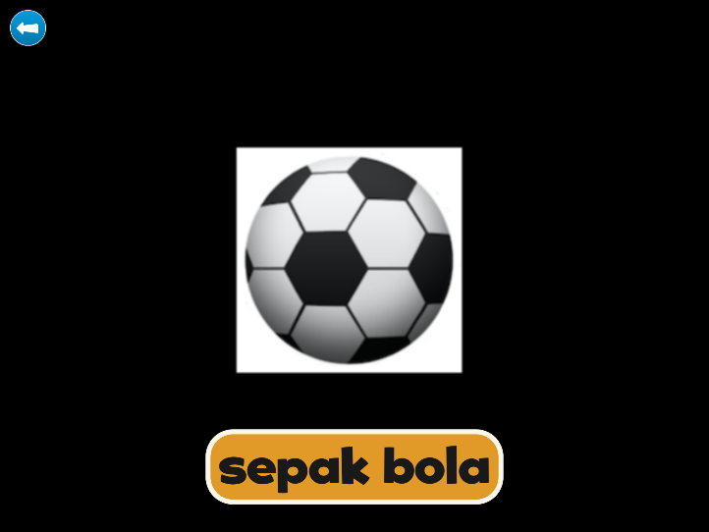

Figure : Flash Card app after tapping on picture (sound file plays and word visible)

## Appendix 2: Detailed methodology of lab visit procedures

Eye-tracking Word Test

Paradigm

The Eye-tracking Word Test was conducted using a wall-mounted eye-tracker.[23] The eye-tracker was mounted on an adjustable arm, which allowed adjustment according to the height of child. Each screen (displaying four pictures) was presented on the eye-tracker for four seconds, which was followed by a fixation cross in the middle of the screen for two seconds. Participants were asked to look at the picture which corresponded to the word that they heard. In each lab visit, participants were presented between 23 to 40 words, depending on which apps they took home.

Data Analysis

Data were exported using the Tobii Studio 3.4.5. Areas of Interest (AOIs) were set up around each of the target and non-target pictures. Data of two variables: 1) Time to First Fixation (the time from the start of the stimulus display until the participant fixates on the AOI for the first time); and 2) Total Fixation Duration (the duration of all fixations within an AOI) for each screen were exported. Means of these two variables were then computed for target and non-target pictures separately for each participant.

To determine whether there was any difference in terms of how *long* the children looked at the pictures between the two lab visits (Lab Visit 1 versus Lab Visit 2), one-tailed paired t-tests were employed on the Total Fixation Duration, for the target and the non-target pictures, and for each of the groups (ELLA and Flash Card).

To determine whether there was any difference in terms of how *fast* the children looked at the target pictures between the two lab visits (Lab Visit 1 versus Lab Visit 2), one-tailed paired t-tests were employed on the Time to First Fixation, for the target pictures, and for each of the groups (ELLA and Flash Card).

Electroencephalogram (EEG)

Data Acquisition

During this part of the study, one researcher would sit in a dimly-lit electrically-shielded room with the participant, and ask the participant to play a matching game on the computer. EEG was recorded with Netstation 4.4.2 acquisition software, a NA300 amplifier and a Hydrocel Geodesic Sensor Net comprised of 124 sensors (see Figure 27).[24] Online, EEG data were sampled collected at 500Hz (i.e., 1 data point per 2 milliseconds) and were referenced to the vertex electrode on the top of the head. Children’s behaviour was monitored and simultaneously videorecorded with the EEG data.

Paradigm

A word-picture pair paradigm was presented to the participants. Each participant heard a series of words that they had been exposed to and that they had not been exposed to. One second after each word was played, a picture would be presented on the screen and it was either congruent or incongruent to the word. The picture was presented on the screen for 1.5 seconds. The gap between each word-picture pair was two seconds. After each word-picture pair, participants told the researchers if the word matched the picture. This was designed to get the participants to attend to the words.

At the start of the experiment, participants would be given three word-picture pairs to practice. These three pairs of words would not be included in the analysis. After the practice, a total of 95 word-picture pairs were presented to the participants. The total time of the presentation was approximately nine minutes.

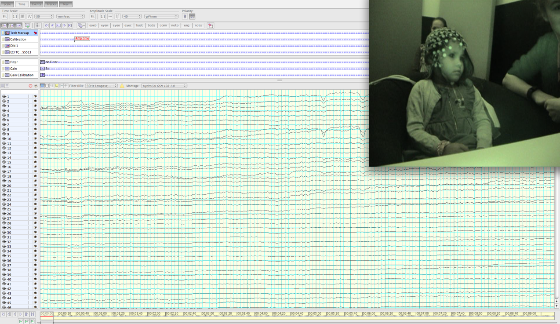

Figure : An example of the EEG recording software

Data Analysis

EEG data were bandpass filtered (1-30Hz), and bad channels were interpolated (using the data from surrounding good channels to reconstruct data for bad channels mathematically). EEG data were then segmented from -200ms to 800ms to the onset of the sound files, and were baseline corrected to -200ms to 0ms. The segments containing voltage changes larger than 200 µV for 35 sensors in the posterior region and the mastoids were removed from further analysis. Data were re-referenced to mastoids. In simpler terms, irrelevant data were first filtered out, data from the bad sensors were recalculated based on data from the good sensors, and then very noisy data were removed from further analysis.

Segments to the two groups (‘taught’ words and ‘not-taught’ words) were averaged separately for the ELLA and Flash Card groups. Data from 11 sensors in each of the three regions (left-posterior, centro-posterior, right-posterior) were then grouped together to create grand mean average waveforms. In simpler terms, this standard procedure was to average the responses to ‘taught’ and ‘not-taught’ words separately for each subject, in order to increase the brain signal quality. To obtain the numerical values for statistical analysis, mean amplitudes of the early (100-300ms) and late (300-750ms) components were then obtained in the appropriate time-windows according to the grand mean average waveforms for each group for each group.

Statistical analysis: to determine whether there was any difference between the two groups (‘taught’ versus ‘not-taught’), a repeated-measures analysis of variance (ANOVA) was employed on the mean amplitudes for each of the components (early and late) and for each of the groups (ELLA and Flash Card).

## Appendix 3: Semi-structured interview questions for ELLA educators

1. **General understanding of ELLA app use**

* When did they start the ELLA program?
* Number of tablets and number of children? And appropriateness of this ratio?
* Used at specific time?
* One child at a time, or shared?
* Their initial thoughts
  + Excited? Apprehensive? Enthusiastic? Daunted?
  + Comfort using iPad as a learning delivery tool?
  + Comfort with additional language?
* And have these thoughts changed over time?

1. **Technology as a learning tool**

* General comfort with technology?
* Have they used iPads in the classroom prior to the ELLA program?
* Do they currently use iPads in the classroom for any other reasons?
* Have they been scaffolding children’s learning on the ELLA apps?
* Comfort with technology as a learning tool?

1. **ELLA app use and children’s development?**

* Apart from learning words in another language and having interest in the culture where that language is spoken, what other ways did you feel that the ELLA program has impacted your class? Skills? Concepts? Interests?
* Do you plan how the ELLA program can address the EYLF outcomes, or retrospectively mark off if/when/how they do?

1. **Communication with parents**

* Consent: What was the initial response from parents, and was it hard to convince them to allow their child to partake?
* Are parents reporting that their child is talking in other language/s at home?
* Do parents enquire specifically about the program?
* How are parents updated about learning the language and knowledge about the other country? ELLA analytics? Information sheets? Social media? Communication board in centre? Other means?

1. **Inclusivity**

* Are there any children in the class whose parents did not consent to their participation?
* Are there any children in the class who are not eligible to participate?
* How do you deal with such situations?
* What factors have made children more or less likely to engage with the ELLA apps?
* Are there any multilingual children in the class? And has the program been different for them, and/or different for the rest of the class for having a multilingual classmate?
* To what degree did you discuss other cultures/cultural practices prior to the introduction of ELLA into your classroom?
* Since the introduction of ELLA, has there been any change in the amount that you discuss cultures, other than that focused on in your ELLA apps? If so, has this been child and/or educator led? And examples?

1. **Resources**

* How much do the resources guide how the ELLA program influences your classroom?
* How did you introduce the ELLA program/language and new culture learnings to your class?
* Which resources do you use?
* Do you feel adequately supported in the program?

1. **Beyond the apps**

* What type of extension activities have you undertaken? Did they feel genuine? Or tokenistic?
* How do you promote the transfer of learning from the apps? Singing? Promote language use?
* What evidence has there been of transfer of learning? Within the classroom or reports from parents?

1. **Specific comments about each app**

* What are the most popular ELLA apps in your classroom? Do you personally have a favourite?
* Is there anything specific that you recall or want to make a comment about concerning each of the apps?
  + App 1:The Polyglots in the Playroom—Greetings
  + App 2: The Polyglots at the Beach—Colours
  + App 3: The Polyglots at the Birthday Party—Numbers
  + App 4: The Polyglots at the Zoo—Fruits and drinks
  + App 5: The Polyglots at the Circus—Body parts
  + App 6: The Polyglots at the Park—Action words
  + App 7: The Polyglots in the Town—Previously learnt words

1. **Any other comments, benefits or challenges?**

## Appendix 4: Semi-structured interview questions

**Parents of children who participated in the Babylab study were asked these questions.**

1. When: Same time each day, or whenever child requested?
2. Did they use it with anyone?

* Alone?
* With parents?
* With siblings?
* With other?

1. Child requests to use app or parents suggest?
2. Child asks to continue using app after it’s time to stop?
3. Parental attitudes to their child using an iPad and whether their perception of using an iPad as a learning tool has been impacted by the project? And did child already use an iPad?
4. Did child use the language?

* Speaking out loud whilst using the app?
* When not using the app?

1. Did the child previously have exposure to languages other than English, and/or cultural practices?
2. Did child have an interest in Indonesia? Or other countries/languages generally?
3. [Note: Only asked to parents of children allocated to the ELLA group.]  
   The ELLA apps program was designed to incorporate the Early Years Learning Framework’s five learning outcomes. Explain what the EYLF outcomes are and ask the parents if they were aware that the apps addressed them. And once aware of them, are they aware of how the apps address them.

Outcome 1: Children have a strong sense of identity

Outcome 2: Children are connected with and contribute to their world

Outcome 3: Children have a strong sense of wellbeing

Outcome 4: Children are confident and involved learners

Outcome 5: Children are effective communicators

1. Has child mentioned the app since they finished participating in the study?

## Appendix 5: Engagement and Home-usage Log

Language Learning App Training

In order to locate these apps—go to the folder named ELLA on the main screen of the iPad and open them from there. The passcode for the iPad is 000000.

Please allow between 15 and 20 minutes per day of using the apps. However, if your child expresses a desire to stop playing before this time, you can cease the session.

Home-usage Log

| Date | Time spent playing (minutes) | App/s used e.g., playmat, zoo | Engagement during session (out of 10 where 0= “not engaged at all” and 10= “very engaged” |
| --- | --- | --- | --- |
|  |  |  |  |
|  |  |  |  |
|  |  |  |  |
|  |  |  |  |
|  |  |  |  |
|  |  |  |  |
|  |  |  |  |
|  |  |  |  |
|  |  |  |  |
|  |  |  |  |
|  |  |  |  |
|  |  |  |  |
|  |  |  |  |
|  |  |  |  |

Should you need any assistance or have any queries at any stage throughout the two-week learning phase, please do not hesitate to get in contact. You can reach us Monday–Friday by calling 9214 8822, or emailing [babylab@swin.edu.au](mailto:babylab@swin.edu.au)

## Appendix 6: Educator interview analysis

Educators’ reaction to the ELLA program

Most educators reported that they were excited about the ELLA program and comfortable with introducing language and cultural learning via app-based delivery. Of the educators that did not speak their classroom’s ELLA language, most were happy to learn the new content as each new app was released or concurrently with their class. An educator, who now considers the program beneficial, shared her initial doubt that children would not acquire a second language without there already being an educator in the classroom who spoke that language for children to engage with for face-to-face learning. She was not the only educator who admitted initially being sceptical but then said that children’s ability to learn a language from apps has exceeded their expectation.

There was great variation amongst educators’ attitudes towards the role of technology in the classroom and as to how much they had utilised technology as a teaching tool prior to introducing the ELLA program into their classrooms. One educator reported using an interactive whiteboard in her classroom with one of its uses being to involve the children in researching topics. Another educator that was supportive of technology in the classroom stated that she considered technology to be a tool for presenting learning content in different modalities to suit different children’s needs. The use of technology in the classroom was stated by another educator to be an important component of learning as long as it was not used in an isolated manner.

The ELLA apps were reported to have influenced some educators’ perceptions of tablets as a learning tool, and some educators believed that the children also identified the tablets to be a learning tool rather than merely a toy. Although tablets were already being used in some classrooms to access music, images and videos on topics of classroom discussion, there were limited reports of app use prior to the ELLA program or the use of other apps during the ELLA program. In most classrooms that had not previously used tablets as a learning tool, the tablets were solely used for the ELLA apps.

Although a number of educators did not have any experience using a tablet, all centres had at least one person who was comfortable with them. Most inexperienced educators soon became comfortable with the tablets once introduced to the ELLA apps, although there was one centre where only one educator interacted with the ELLA apps because the other educators did not wish to use the tablets.

Parents’ reaction to the ELLA program

Educators reported that whilst some parents were initially opposed to the ELLA program because it involved the use of tablets, almost all were comfortable with their child participating after discussing their concerns with an educator. Some of the initial concerns expressed were that parents did not want their child using a tablet generally, whilst others objected to screen time at preschool. Reassurance was generally obtained after explaining that the tablets were being used in a structured manner, only for ELLA apps, and for a limited period of time.

In addition to specifically objecting to screen time, there was a report that parents were uneasy with technology taking the place of traditional learning methods such as pen- and paper-based learning activities, although the ELLA program did not appear concerning once the parents saw it in practice and observed their child’s learning progress. There were no parents reported to object to their child being exposed to an additional language.

How the ELLA apps were used in the preschool service classroom

Implementation of the ELLA program varied across the different preschool service classrooms. Factors influencing implementation included: the number of children in the classroom, the number of tablets and thus the child-to-tablet ratios, the centre and classroom type, and educators’ comfort with and interest in the program.

Child-tablet ratio

The child-to-tablet ratio varied greatly between classrooms (Range 2:2 to 1:18) for individual classroom numbers, ranging from one tablet for every two children to one tablet for an entire class of 18 children. Whilst most educators reported that they were content with the number of tablets available to their class, some educators stated that they would have benefited from having more tablets. Interestingly, this was not only reported by educators who had functioned with the lowest child-to-tablet ratios, but also by some with the highest. An educator who had just one tablet for the class stated that even one additional tablet would have been advantageous, reasoning that using the ELLA apps concurrently would have provided a more social learning experience.

Table : Number of touchscreen tablets and children per classroom

| Touch screen tablets | 5 | 2 | 2 | 3 | 5 | 1 | 1 | 1 | 7 | 1 | 6 | 2 | 6 | 7 | 4 |
| --- | --- | --- | --- | --- | --- | --- | --- | --- | --- | --- | --- | --- | --- | --- | --- |
| Preschool children | 22 | 12^ | 20 | 14^ | 18 | 16^ | 18 | 15 | 30 | 15 | 20/30* | 24 | 11 | 30 | 33 |

^ Class also contained three-year-old preschool-aged children.  
* Two separate preschool classes.

Educators of one learning centre who were not aware that the ELLA apps could be used offline reported that ELLA was consuming too much of their data and when the children were using the apps the speed of the Internet in the office slowed down. For these reasons the idea of adding more tablets into the classroom had not been considered.

One educator reported that she had in fact elected to reduce from four tablets to one in the classroom, perceiving that tablet use was “eating too much into [their] time”. There was also concern amongst the educators of that classroom about the amount of screen time the children were having, as children were not only exposed to screens during their own turn, but were also often engaged by the ELLA apps whilst other children had a turn.

The child-tablet ratio was relevant to some but not all of the variations in how the ELLA apps were used in different classrooms.

Regularity and duration of exposure

Children at different centres received differing amounts of exposure to the ELLA apps. Furthermore, some centres endeavoured to keep exposure comparable amongst all children in the class whilst others encouraged all children to participate but said that ELLA app use was a self-selected activity which resulted in variation within the classroom.

Most commonly, educators reported that children used the ELLA apps in 15-minute intervals, weekly or more regularly—depending on the days of the week that the child attended the centre. Only two centres opted for a longer exposure once a fortnight.

In a couple of centres children used the app for 5-10 minutes at a time, and one centre limited each child’s exposure to 10 minutes per week. An educator that originally limited children to 5-10 minutes each turn perceived that this was not long enough for the child to become engaged in the session. As such, they extended the sessions to 15-20 minutes each turn, which they felt resolved this issue. Another educator reiterated this sentiment stating that less than 15 minutes at a time on the ELLA apps did not appear to be long enough for children to learn much.

Scheduling

In some classrooms there was a schedule organised by the educators so that all children were allocated a time and day/s and children were made aware of their time slot. Other classrooms had a sign-up list that children added their name to if they wanted a turn, which was reported to also function as the motivation for some children to learn to write their name.

Some classrooms used a timer (either built in to the tablet or stand-alone) to indicate when it was time for the child to finish their turn. In other classrooms it was self-regulated by the children who were generally left to play for as long as they wanted, after which they would place the tablet down and another child would have their turn. An educator reported that the children in her class did this independently and were confident in passing the tablet around to others.

Where and when

Some centres decided to allocate a specific desk, chair or area for children to sit while using the ELLA apps; some of these were decorated in themes relevant to their ELLA culture and/or contained supplementary learning material. One centre assigned an outdoor area for ELLA app use as a means of reducing disturbance to the remainder of the class.

ELLA app use was also kept to a specific time of the day at some centres. For example, one centre provided the tablets for children to use in the mornings, then each afternoon they would discuss the content as a class. Another centre included ELLA app use as one of the options available for children to undertake during their structured activity time each afternoon.

Individual or group learning

Another factor influencing the amount of exposure was whether the ELLA apps were being used individually or in a group. In a number of classrooms, children wore headphones some or all of the time. The use of headphones not only provided an individual learning experience, but also overcame the problem of children who were undertaking other activities nearby being distracted by the sounds coming from the ELLA app. One centre implemented a headphone jack splitter so that two children could use the ELLA apps together but without distracting other children. Headphones were not used in the majority of centres, and the educators of such centres reported that distraction had not been an issue. In fact, when the sounds were coming out of the tablet speakers rather than headphones, children would sometimes repeat the words that they heard as they walked by a child using an ELLA app, adding to their language exposure.

It was most commonly reported across the centres that children used the ELLA apps individually. However, it was found that this did not always mean the child was alone while having their individual turn. Several centres reported it to be common for other children to sit with the child having their turn, or that multiple children with tablets engaged concurrently in the activity of an app and discussed it as a group, creating open, social and collaborative experiences. One educator observed that tablet sharing encouraged the children to help each other through the tasks and she perceived that it was beneficial to learning outcomes. Another collaborative learning environment was created by mirroring the classroom’s tablet content onto a large screen and loudspeaker so the entire class was exposed to the content as one child used an ELLA app.

Teacher involvement

There was also variation across centres as to whether the children were permitted to use the ELLA apps independently or solely when there was a teacher present which also influenced the amount of exposure. There was generally some teacher involvement when the ELLA program was first introduced to each classroom, and again on release of each app, for example, a group discussion between the educator and the class whilst they familiarised themselves with the ELLA apps. Outside these scenarios, the actual amount of independent use by children varied across centres.

In some classrooms, the ELLA apps were initially used in a group, but eventually the children started using them individually. It was reported that group use was mainly carried out to introduce the children to the concept of using apps without verbal English instructions. It was also reported that educators sat with some of the children not previously exposed to tablets to provide initial guidance on tablet operation.

In a number of centres, the children only used the ELLA apps under supervision. In one centre it was to ensure that children did not access staff documents that were also saved on the tablets. In others it was so the educators could scaffold the children’s learning, and this was normally undertaken in small groups.

Educator or child selects app?

Exposure to each ELLA app also varied both across and sometimes within a classroom. For example, some educators allowed the children to select which apps they would use whereas others provided their class with access to only one app at a time. Reasons for limiting access to one app at a time included consistency between children in the class, and matching the app to the program in the room.

Educators that allowed the children to use their ELLA app of choice found that children were always keen to try the newest app when it was released. A common approach by educators was to ask the children to begin using the most recent ELLA app, and then allowing them to use others. Some children would always begin using their favourite ELLA app but would generally explore other apps. Children using apps in a small group would often select a particular app because the other children were using it.

Favoured apps

Most educators reported that the children at their centre had a favourite ELLA app. Others reported particular types of activities that were favourites. Overwhelmingly, the most popular apps amongst students, according to the educators, were App 5: The Polyglots at the Circus and App 3: The Polyglots at the Birthday Party.

One educator theorised that App 5: The Polyglots at the Circus was very popular because of children’s love of science and the human body. The presence of the ‘Heads, Shoulders, Knees and Toes’ song in App 5 also appeared to contribute to the children’s enjoyment. Children were reported to do the actions as they sang along, and in doing so could identify each body part when asked.

Both the topic and the learning content of App 3: The Polyglots at the Birthday Party were reported to contribute to its popularity. Children loved the idea of a party, and more comments were made about children enjoying the cake-making than any other activity across the entire suite of ELLA apps.

App 2: The Polyglots at the Beach and App 4: The Polyglots at the Zoo were also mentioned by some educators as favourites in their classrooms.

Sorting activities were reported to be favoured, specifically, the rocket task in App 1: The Polyglots in the Playroom and the submarine task in App 2: The Polyglots at the Beach. Similarly, educators mentioned the popularity of the cake-baking task in App 3: The Polyglots at the Birthday Party and the juice-bar task in App 4: The Polyglots at the Zoo—both tasks that are based on food preparation.

Culturally and linguistically diverse (CALD) children and educators

A large proportion of educators reported that there was at least one educator and/or student that already spoke their ELLA language. The impact of this varied from one classroom to the next.

A number of educators were fluent in their ELLA language; either Mandarin or French. Fluency in the language and familiarity with the culture allowed such educators to extend the learning throughout the classroom with much less effort than for other educators. Fluent educators also reported that children would approach them when using the ELLA apps, and also at other times to check pronunciation of a word, or ask how to say other words.

One educator reported that a student teacher who spoke their ELLA language undertook a teaching round in their centre, which had a very positive impact on the class’s conceptual understanding of other languages. The student teacher incorporated words and songs of the ELLA language into lesson plans, after which the children were much better engaged with the ELLA apps.

In classrooms where a child spoke the ELLA language, the other children were reported to consult that child/those children for assistance. Manners in which this occurred included the fluent child saying the words in front of the class for others to copy, and children asking the fluent speaking child whether they were correctly pronouncing the word that they had learnt from the ELLA apps. One fluent child was especially glad to ‘be the teacher’ and gave the educator an unimpressed expression when the educator pronounced words in their ELLA language incorrectly.

Whilst the children already fluent in their centre’s ELLA language were not learning a language from the ELLA program, they benefited nonetheless. Benefits included creating better connections with other children in the class (especially in cases where the child was not fluent in English), developing enhanced confidence in realising that they were able to do something that the other children in the class could not, and a sense of pride in their culture being broadly accepted. The ELLA program was also credited with assisting an educator to communicate with parents who had limited English language skills.

There were also children in many of the ELLA classrooms that spoke a language other than English that was not their classroom’s ELLA language. Although such children began the ELLA program with a better conceptual understanding of alternate languages and cultures than other children, there was consensus from educators that they learned their ELLA language at a comparable pace to children who did not speak a language other than English at home.

Classroom design and inclusivity

Most of the ELLA classrooms discussed in the interviews were in an early childhood education and care (ECEC) centre (n=15), rather than a preschool that was standalone (n=3) or on a school campus (n=2). Of those in an ECEC centre, some were standard preschool classrooms (n=8) and others included preschool-aged children, and three-year-old preschool-aged children (n=7), i.e., those who would be preschool aged the following year.

Inclusivity was an issue brought up predominantly by educators of both preschool-aged children and three-year-old preschool-aged children together in a classroom, where there were children in their classroom who were not eligible to participate in the ELLA program. Another cohort that was noted to be ineligible were preschool-aged children that casually attended an ECEC centre running the ELLA program, but the centre was not their registered preschool. There was also the very limited number of children whose parents had not consented to them participating in the ELLA program.

Preschool educators’ practice is guided by the Early Years Learning Framework (EYLF),[25] and the restrictions of ELLA participation were incongruent with the EYLF approach that “learning experiences should be inclusive of all children”. They reported that it was difficult and seemed unfair to exclude the children who were not eligible to use the ELLA apps. It was almost unanimous amongst the educators who taught in a classroom that included three-year-old preschool-aged children that the ELLA program would be more beneficial if the entire class could be involved. There was no doubt amongst such educators that the three-year-old preschool-aged children would enjoy using the ELLA apps and would engage with the ELLA program. The general perception was that it was not age inappropriate for the three-year-old preschool-aged children. Only one centre reported they thought the younger children would struggle with the ELLA apps, although it should be noted that in that particular centre exposure to the ELLA apps was limited to one fortnightly session, and no extension activities were undertaken.

In a couple of classrooms, the educators had explicitly stated to the class that the tablet was only for preschool children, and that the three-year-old preschool-aged children would have their turn when they were the preschool children. However, in all of these centres the three-year-olds were permitted to sit with and watch other children use the ELLA apps. Other educators established strategies to minimise a sense of exclusion amongst the children in their class who were not eligible to use the ELLA apps. The strategy used in one classroom was to separate the class into two rooms for a period of time each afternoon. Children enrolled in the ELLA program were allocated to one room and the ELLA apps were only used in that room at those times.

The most common strategy amongst classrooms that included three-year-old preschool-aged children was to allow the ineligible children to either use the ELLA apps in demonstration mode, or other apps that the educators had installed on the tablets.

A final but pertinent comment communicated by educators was that when there were children in the class who were not enrolled in the ELLA program who thus did not have the opportunity to learn the content from the ELLA apps, it was difficult to plan and integrate extension activities into their curriculum. Educators in this scenario stated that they would have conducted more extension activities and further embraced the ELLA program if the whole class had been involved.

Language and cultural extension activities

The degree to which extension activities were reported to occur within the classrooms varied greatly from the aforementioned classroom comprising both three-year-old preschool-aged children and preschool children, amongst which extension activities were not often included, to classrooms that fully embraced their ELLA language and the culture of the country/countries where it is spoken. A larger number of educators also indicated that they had intended on running more extension activities but that this had not come to fruition, although now they were familiar with the program, they said they would implement more extension activities in future if their centre continued to deliver the ELLA program. In some cases, the slower integration was related to the educators’ confidence in the language, particularly in centres learning Mandarin as their ELLA language, which was reported by some to be difficult to articulate. Such struggles were reported to deter some educators from leading their class in singing songs in the ELLA language.

The most commonly reported extension activity was singing as a class. The songs taught in the ELLA apps were reported to be a great occasion to practice singing ‘Happy Birthday’ in their ELLA language when children in the class had birthdays. Many educators also reported practicing words together as a class, either at circle time or incorporating the words in daily classroom activities including counting, labelling colours, and greetings.

In some classrooms, purposefully connected activities were set up to encourage the use of the ELLA language. Numerous educators reported setting up a hospital role-play area to extend upon the body part content within App 5: The Polyglots at the Circus. Other activities implemented to extend the apps included baking a cake at the time the children were engaged with App 3: The Polyglots at the Birthday Party, and learning about healthy eating when engaged with App 4: The Polyglots at the Zoo, which included content about fruit.

A few centres extended cultural learning with activities that did not directly connect to the content of the ELLA apps such as reading picture books in their ELLA language or learning to play Chinese jump rope. Cultural extension activities were mainly undertaken in classrooms that had a native speaker of their ELLA language amongst the staff or students, or if the centre had organised for a one-off or regular visits from a native speaker.

A large number of centres had bilingual children in their class, and for various reasons, the child’s other language most often matched the centre’s ELLA language. At a centre where there was a Chinese child that had limited spoken English when he first attended, the educators had introduced Mandarin to the class to help the child’s integration. This later became the centre’s ELLA language. The educators also played Chinese music in the classroom and introduced the class to other aspects of Chinese culture, which helped validate the child’s home language and cultural practices. Another centre had a Chinese teacher and children who holidayed in China to visit relatives, and were thus aware of Chinese cultural practices and shared this knowledge with other children in their class.

A Japanese exchange student visited an ELLA classroom and brought origami cranes in for display in their classroom, and also helped them to set up a Japanese restaurant in their room. A French-learning class had a discussion of different countries that speak French, a celebration of Bastille Day, and listened to CDs of songs and read books in French. One centre reported that they had a native language speaker of their ELLA language attend their centre for face-to-face language lessons to complement the children’s learning from the ELLA apps. Cultural activities were outsourced to the external person rather than undertaken by the regular educators of that class. All children in the centre across the age range were receiving lessons from the native language speaker. Accordingly, children currently at the centre who enrol in the ELLA program in the future will have already had exposure to the centre’s ELLA language.

The cultural learning and native speaking visitors appeared to assist both educators and students in various ways. One educator reported that it was with the assistance of a Chinese student teacher who visited that she was able to incorporate Chinese words and songs into lesson plans. Another educator indicated that some children in her class were having difficulty with the concept of culture until they received a visit from a native speaker of their ELLA language. Most pertinent to the ELLA project, the cultural discussion at one centre just prior to introducing the first ELLA app revealed that a number of children in that classroom were unaware that people could speak a language other than English.

Most of the aforementioned extension activities were reported by educators that taught in a room solely comprising children eligible to participate in the ELLA program. In one classroom comprising three-year-old preschool-aged children and preschool children however, the teacher involved the younger children when learning and practicing counting in their ELLA language.

When asked whether the ELLA program had influenced the promotion of cultural awareness, most educators reported that the impact had been minimal because multiculturalism was already in their practices. Predictably, the self-selection process to enrol in this pilot program naturally drew educators with a keen interest in language and culture learning. As the 2016 ELLA cohort appeared to have an atypically high rate of cultural diversity, we were not able to attain a true indication of the impact that the ELLA program might have on cultural awareness.

It was therefore not surprising that activities relating to cultures other than those of the ELLA languages were also occurring. Prior to taking part in the ELLA program, a centre with an educator who was a native Spanish speaker had taught her class some Spanish words, and although this was not the centre’s ELLA language, it provided these children with prior exposure to an alternative language. Many centres offered exposure to many different cultures by celebrating multicultural events or holding a monthly culture day, with cultural exposure even greater during the Olympic Games.

Demonstrations of learning

The aforementioned section explains that teaching from the ELLA apps was complemented by the educator in some but not all centres. As the ELLA apps themselves aim to teach via a digital modality, educators were asked to report evidence that children were able to apply such skills during subsequent interaction with the physical world.

Children demonstrated that they had learnt the content of the ELLA apps during many of the extension activities. As they may have been already learning during those activities, however, we cannot definitively state whether the learning had always occurred from the ELLA apps, during the extension activities, or during both.

Some educators reported that they would hear children saying words in their ELLA language when they were not using the ELLA apps, such as in general conversation or during imaginative play. Counting was a commonly reported example of this. In other classrooms children were reported only to demonstrate their learning when prompted by the teacher with questions such as, “Do you know any Indonesian words?”

When demonstrating learning of the ELLA content away from the tablet, children are likely to receive positive reinforcement and thus build their confidence, and an educator suggested that this would encourage children to continue using the language in real-life settings. An educator reported a specific example of this occurring that a parent had shared with her. The child, who had some language delays, had reportedly spoken in Mandarin, unprompted and in appropriate context. While shopping, the child responded when the shop assistant handed her an item, and when the parent asked what her child had said, the Chinese shop assistant informed the parent that her child had said “thank you” in Mandarin. Other educators also indicated that parents had informed them that their child had been uttering what they presumed to be words in their ELLA language. There was also a report from one educator that her colleague had reported children also attending the ECEC centre to be saying words in the ELLA language that their older siblings, who were in the ELLA classroom, had taught them.

Children’s engagement with the ELLA apps

Although engagement does not automatically equate to learning, engagement in a task is key to learning. According to educator reports, the ELLA apps create fun learning experiences that engage children. Educators reported that with minimal exceptions, all children were happy to use the ELLA apps, and many children would proactively seek out an additional turn. Some educators did not perceive particular characteristics amongst children most interested in the ELLA apps whilst others thought that there was greatest interest amongst the older and/or intellectually stronger children. There was also a report that the boys appeared to be more excited than the girls to have their turn and would crowd around the other children having their turn, although it was acknowledged that the behaviour could alternatively be interpreted as the girls being more patient to wait for their turn.

Educators reported various behaviours that demonstrated the children’s excitement, including crowding around other children having their turn, keeping track of when their next turn would be, debating the pronunciation of words, and helping to teach other children learn the words that they had mastered.

In some centres, the tablets that the ELLA apps were installed on also had other apps installed. Even when children were given the option to use other apps, they usually remained on the ELLA apps. Educators specifically commented that the ELLA apps held the children’s attention for a long time. One educator, however, stated that despite children being engaged with the apps, they would still sometimes abort the tablet before their allocated time had ended, because they want to join in with their friends who they could see enjoying another activity.

A child with a hearing impairment has successfully participated in the ELLA program. Utilising his Radio Frequency Assistive Listening Device, the sound from the apps was transmitted directly to the receiver in his ear. The educator reported that the child engaged well with the ELLA apps and it has consequently enhanced his English language skills.

The ELLA program was also reported to be embraced by a child who had not been engaged in most reading and writing activities at preschool. Consequential to the child’s involvement in the ELLA program, his educator reports that he has developed an ‘obsession’ with his centre’s ELLA language. In another example of the enthusiasm surrounding the ELLA apps, a parent had reported to the educator that when their child was unwell and not able to attend preschool, he cried because being absent meant that he didn’t get to use the ELLA app.

Talking out loud whilst using the apps

Some educators reported that they often heard the children saying words in their ELLA language whilst using the apps, whereas others do not recall hearing the children doing so. It was reported that children using the app with other children sometimes say the words to each other and sometimes help each other with pronunciation.

Home/family ELLA app use

Parents of one child were initially opposed to their child’s participation, but agreed with the knowledge that the ELLA app use would be limited to 15-20 minutes a week. Later in the year, these same parents were so excited by the program that they downloaded an ELLA Family App for their child to use at home to complement the child’s ELLA language learning at preschool.

Most educators had received reports from some parents that they had downloaded the ELLA Family App for their centre’s ELLA language for their child to use at home, or that they planned to do so. One educator estimated that parents of half the children in her class had downloaded the ELLA Family App. Some parents had communicated their disappointment to the educators about the limitations of the ELLA Family App, for example, some parents were disappointed that they could not embrace their child’s interest to the degree that they had anticipated the app would allow them to. It was noted that the sound library was a sensible inclusion and strength of the ELLA Family App. Educators also reported their own disappointment that the families could not accesses the full suite of ELLA apps. This sentiment was not surprising as the Early Years Learning Framework[26] states that “connections and continuity between learning experiences in different settings make learning more meaningful and increase children’s feelings of belonging”. One educator suggested that children would benefit from being able to use the ELLA apps at home for longer uninterrupted periods, whereas another educator shared concern that children would not receive appropriate parental monitoring if they used an app that had been approved for use within the preschool curriculum.

A recognised benefit of the ELLA Family Apps expressed by parents was that they can preview what their child is learning in preschool, and thus have better awareness of it. An additional benefit was that the learning can more easily continue into the home environment.

Educators reported that some parents had shown great enthusiasm for the ELLA program, and even introduced other activities relating to language acquisition at home. Some educators had heard from parents that their child had greater interest in alternate languages and cultures across the board and a parent of a child whose background was congruent with the ELLA language was very happy that the child enjoyed the ELLA program and it enhanced the child’s interest in parent-child dyadic interaction in that language. An educator recognised that the ELLA program had the potential to encourage families with a language background other than English to teach their young children their language and culture.

Educator workshop and resources

All educators that attended the ELLA workshop reported that it was a valuable component of the ELLA program. Numerous educators thought that it would be beneficial for all educators who work in ELLA classrooms to attend a workshop, and were glad to hear that the slides from the workshop were available via the ELLA educator forum for all ELLA educators to access. The workshop was reported to cement educators’ understanding of the program.

Both the official training content and networking with other ELLA educators were reported to boost enthusiasm and confidence amongst the attendees. Educators left with insight on implementation and extension activities, and a sense of confidence and excitement about involvement in the ELLA program.

Some educators thought that the timing of workshop was appropriate (mid-year), as it allowed them to become familiar with the ELLA program to be able to understand the workshop content. Others, however, reported that there should have been some professional development prior to commencing the program as they did not feel comfortable with the ELLA program until the workshop and in effect only properly began implementation after attending the workshop.

Most educators indicated that they were aware of the online resources and many of them had accessed them and some educators had downloaded songs and printed pictures to display in the classroom.

It was recommended by more than one educator that there should be resources to be used alongside the ELLA apps for first-time users. This could perhaps be a version of App 1: The Polyglots in the Playgroup that has some instructions/explanation in English, or a video demonstration showing that you can click on different activities.

Not all educators had been using the ELLA educator Facebook page or forum. A couple of educators who were fluent in their centre’s ELLA language felt that they did not need the forums for ideas, and some others reported that they did not know about the forum or had forgotten about it. At one centre the educators were not permitted to have the Facebook app on their work tablets as it was considered too great a temptation for staff to use for personal reasons. Those who had visited the ELLA educator Facebook page and/or forum reported doing so to see how the ELLA program was being implemented in other classrooms and to gain inspiration for this own implementation. When asked about sharing their extension activity ideas with other centres participating in the ELLA program, both educators that had extended upon the ELLA program and those not undertaking many, if any, extension activities were open to it. Upon hearing at the ELLA workshop about some extension activities other centres had undertaken, educators felt empowered and inspired to implement such concepts in their own classrooms.

Software analytics

Only a proportion of the educators reported utilising the software analytics function accessible via the ELLA educator app login. Most were unsure of how to use them or why they should do so and a couple of the educators indicated that they were not aware that they could access software analytics. Educators examined the analytics data to ensure that all children were getting a turn, and a few teachers examined the Early Years Learning Framework (EYLF) outcomes. Educators suggested that the software analytics training had been insufficient and that they would benefit from more guidance as to how to use the analytics and when and why they should. Whilst there was some feedback concerning analytics usability, some educators expressed uncertainty about what functions were available in this feature, as well as how to access and best use them. More than one educator reported that they would like to be able to access a session-by-session breakdown of each child’s use of the ELLA apps in addition to average time per session, overall total time, and total time per outcome.

Providing pre-implementation guidance

Finally, some educators made recommendations for additional guidance to centres to help with smoother implementation in the future.

A few educators reported that the program had not run as smoothly as expected due to technical problems. None of the reported technical problems had occurred when the ELLA apps were being used on a standard iPad, which appeared to be the most common tablet, which may indicate that required tablet specifications should be communicated to preschools. For preschools co-located within a school or other venue, a document to forward to the IT department would also be beneficial to prevent network access problems, as were reported to have occurred at one preschool.

It was also stated that educators should not be expected to implement the ELLA program with only one tablet for a class. In future different implementation strategies should be recommended based around the number of tablets the classroom would have access to. Furthermore, there were reports that children could only use the tablets when being supervised to prevent them accessing other apps. If the ELLA apps are going to be run on tablets that are also used for other purposes, then it is important that educators know how to lock the tablets to prevent children accessing other apps. Accordingly, educators would only need to be present when they want to scaffold the learning, rather than needing to provide constant monitoring.

The final pre-implementation suggestion was that centre management should consult the educators about introducing the program. This is most pertinent to classrooms that include both preschool and three-year-old preschool-aged children. Without an implementation strategy in place to ensure that the program is embraced by the educators and the eligible children, and techniques used to prevent segregation of children not eligible to participate, educators can struggle to engage the eligible children and embrace the ELLA program.

## Appendix 7: Literature review

Touchscreen learning

The ubiquitousness of touchscreen devices and their resultant use among young children has raised many questions about their utility as educational tools. Touchscreens do not require the same level of fine motor skills as traditional computers; so predictably, the idea of utilising touchscreen technology for educational purposes in very young children has gained momentum.[27]

Naturally, though, many parents and educators hold concerns over their utility as educational tools. There might be several reasons for this. First, ‘screen time’ is largely negatively portrayed in both the media and guidelines. For example, the American Academy of Pediatrics (AAP) guideline released in 2010 regarding children’s daily screen time outlined strict limits relating to young children’s media use.[28] Further, these blanket recommendations did not meaningfully differentiate between passive and active use, and were based mostly on passive television-viewing research. The AAP has since revised these recommendations, conceding that blanket time limits do not make sense anymore. Accordingly, new guidelines differentiate between screen time for entertainment purposes versus other uses (e.g., online homework).[29]

This does not mean the guidelines are still without problems though. For one, play is considered essential in the development of a child’s cognitive, physical, social, and emotional wellbeing.[30] Additionally, it is still assumed that apps that fall into the category of recreational or entertaining are void of educational content. As rings true in the physical world, play and education are not necessarily mutually exclusive so we cannot assume that this would also be the case when using touchscreens.

Yet another barrier to the acceptance of touchscreens as educational tools is the currently available apps that purport to be educational; many are lower quality and/or lack an evidence base. There does not appear to be strict criteria or independent assessment available before allowing an app to be labelled as ‘educational’. Nonetheless, many apps are categorised as educational on app purchasing platforms. Given these apps may be the only experience some parents and educators have had with using a touchscreen device as an educational tool, it is not surprising that many hold an overall negative view of educational apps and potentially touchscreen use in general.

Although research in this area still remains in its infancy, studies suggest very young children and even infants are able to learn from touchscreens and are capable of applying the knowledge they have learned on a touchscreen device to the physical world (‘transfer of learning’).[31],[32] Evidence of transfer of learning has been found for puzzle games,[33] learning to tell the time,[34] and imitating actions.[35]

Interactivity appears to be important, and is a common thread throughout these studies; they all chose tasks with high levels of interactivity. One study found that not only did children improve in performance across trials regardless of modality, but additionally that children could successfully transfer what they had learned on a touchscreen to the physical version of the task.[36] Another study found their touchscreen condition produced a greater improvement in pre- to post-test scores than did the drawing on paper learning condition.[37] Although just one study, this may suggest in certain situations or with certain content, touchscreens could actually be a better choice.

In light of this research, and the increasing prevalence of touchscreen use among young children, it would be more prudent to focus on developing and implementing apps that foster learning in creative, interactive and engaging ways.

Benefits of bilingualism

A considerable body of evidence suggests bilingualism carries with it many cognitive benefits, not only confined to linguistic tasks but also related to enhanced executive functioning processes in multiple domains. It is suggested that these advantages can be attributed to the generalisation of executive functioning processes that are needed in order to learn and use multiple languages,[38] for example, inhibitory and attentional control,[39] cognitive flexibility,[40],[41] and monitoring.[42]

Importantly, inefficient executive functioning and, in particular, inhibitory control has been linked to various developmental disorders that can emerge in early childhood such as attention deficit hyperactivity disorder, obsessive-compulsive disorder, Tourette syndrome, and autism spectrum disorders.[43], [44] Further, the benefits of bilingualism are not just restricted to childhood, as evidence has found that bilingualism delays the age at onset of Alzheimer’s Disease (AD) and Mild Cognitive Impairment (MCI).[45] If bilingualism really does have a positive impact on the development of these wide-ranging executive functions, this is an important finding in both understanding developmental processes as well as providing a good reason to implement second-language learning as early as possible.

1. Further information about the ELLA program is available at the ELLA website: www.ella.edu.au
2. Australian Government Department of Education, Employment and Workplace Relations. (2009). *Belonging, Being & Becoming: The Early Years Learning Framework for Australia*. Commonwealth of Australia. Retrieved from https://www.education.gov.au/early-years-learning-framework
3. Adesope, O.O., Lavin, T., Thompson, T., & Ungerleider, C. (2010). A systematic review and meta-analysis of the cognitive correlates of bilingualism. Review of Educational Research, 80(2), 207-245
4. 4 Deloitte Access Economics. (2016). *Evaluation of the Early Learning Languages Australia 2015 trial final report.* Prepared for the Australian Government Department of Education and Training.
5. Hirsh-Pasek, K., Zosh, J.M., Golinkoff, R.M., Gray, J.H., Robb, M.B., & Kaufman, J. (2015). Putting education in ‘educational’ apps: Lessons from the science of learning. *Psychological Science in the Public Interest, 16*(1), 3-34. doi:10.1177/1529100615569721
6. Alvarez, A.L., & Booth, A.E. (2014). Motivated by meaning: Testing the effect of knowledge-infused rewards on preschoolers’ persistence. *Child Development, 85*(2), 783-791. doi:10.1111/cdev.12151
7. Dunn, L.M., & Dunn, D.M. (2007). *Peabody Picture Vocabulary Test* (4th ed.). (PPVT™-IV). Pearson Education.
8. Electrical Geodesics Inc.
9. Hirsh-Pasek, K. et al. (2015). Putting education in ‘educational’ apps. (See footnote 5.)
10. Paulus, M., Proust, J., Sodian, B. (2013). Examining implicit metacognition in 3.5-year-old children: An eye-tracking and pupillometric study. *Frontiers in Psychology.* doi.org/10.3389/fpsyg.2013.00145
11. Lyons, K. E., & Ghetti, S. (2013). “I don’t want to pick!” Introspection on uncertainty supports early strategic behavior. *Child Development.* doi:10.1111/cdev.12004
12. Tobii, T120.
13. Dickinson, D.K., Cote, L., & Smith, M.W. (1993). Learning vocabulary in preschool: Social and discourse contexts affecting vocabulary growth. *New Directions for Child and Adolescent Development Part Two: Literacy Skills in Context, 61*, 67-78. doi:10.1002/cd.23219936106
14. For example: Romero-Rivas, C., Martin, C.D., & Costa, A. (2015). Processing changes when listening to foreign-accented speech. *Frontiers in Human Neuroscience*. doi.org/10.3389/fnhum.2015.00167
15. Reinke, K.S., He, Y., Wang, C., & Alain, C. (2003). Perceptual learning modulates sensory evoked response during vowel segregation. *Cognitive Brain Research, 17*(3), 781-791.
16. For example: Kutas, M., & Federmeier, K.D. (2011). Thirty years and counting: Finding meaning in the N400 component of the event-related brain potential (ERP). *Annual Review of Psychology, 62*, 621-647. doi:10.1146/annurev.psych.093008.131123
17. Positive Science: <http://www.positivescience.com/>
18. Ibid.
19. Alvarez, A.L., & Booth, A.E. (2014). Motivated by meaning. (See footnote 6.)
20. QSR International Pty. (2015).
21. Department Of Education, Employment and Workplace Relations. (2009). *Belonging, Being & Becoming.* (See footnote 2.)
22. Hirsh-Pasek, K. et al. (2015). Putting education in ‘educational’ apps. (See footnote 5.)
23. Tobii, T120.
24. Electrical Geodesics, Inc.
25. Australian Government Department of Education, Employment and Workplace Relations. (2009). *Belonging, Being & Becoming.* (See footnote 2.)
26. Department of Education, Employment and Workplace Relations. (2009). *Belonging, Being & Becoming*, p. 33*.* (See footnote 2.)
27. Vatavu, R.D., Cramariuc, G., & Schipor, D.M. (2015). Touch interaction for children aged 3-6 years: Experimental findings and relationship to motor skills. *International Journal of Human-Computer Studies*, *74*, 54-76.
28. American Academy of Pediatrics. (2010). Media Education, *Pediatrics*, *126*, 1012-1017.
29. American Academy of Pediatrics. (2013). Children, adolescents and the media. *Pediatrics*, *132*, 958-961.
30. Ginsburg, K.R. (2007). The importance of play in promoting healthy child development and maintaining strong parent-child bonds. *Pediatrics*, *119*(1), 182-191.
31. Huber, B., Tarasuik, J., Antonious, M.N., Garrett, C., Bowe, S.J., Kaufman, J. & the Swinburne Babylab team. (2016). Young children’s transfer of learning from a touchscreen device. *Computers and Human Behaviour, 56*, 56-64.
32. Wang, F., Heping, X., Wang, Y., Hao, Y., & An, J. (2016). Using touchscreen tablets to help young children learn to tell the time. *Frontiers in Psychology*. doi.org/10.3389/fpsyg.2016.01800
33. Huber et al. (2016). Young children’s transfer of learning. (See footnote 31.)
34. Wang et al. (2016). Using touchscreen tablets. (See footnote 32.)
35. Zack, E., & Barr, R. (2016). The role of interactional quality in learning from touch screens during infancy: Context matters. *Frontiers in Psychology.* doi: [10.3389/fpsyg.2016.01264](https://dx.doi.org/10.3389%2Ffpsyg.2016.01264)
36. Huber et al. (2016). Young children’s transfer of learning. (See footnote 31.)
37. Wang et al. (2016). Using touchscreen tablets. (See footnote 32.)
38. For a review see: Adesope, O.O., Lavin, T., Thompson, T., & Ungerleider, C. (2010). A systematic review and meta-analysis of the cognitive correlates of bilingualism. *Review of Educational Research*, *80*(2), 207-245.
39. Martin-Rhee, M.M., & Bialystok, E. (2008). The development of two types of inhibitory control in monolingual and bilingual children. *Bilingualism: Language and Cognition*, *11*(1), 81–93. doi:10.1017/S1366728907003227
40. Adi-Japha, E., Berberich-Artzi, J., & Libnawi, A. (2010). Cognitive flexibility in drawings of bilingual children. *Child Development*, *81*(5), 1356-1366.
41. Ben-Zeev, S. (1977). The influence of bilingualism on cognitive strategy and cognitive development. *Child Development*, *48*(3), 1009-1018.
42. Costa, A., Hernandez, M., Costa-Faidella, J., & Sebastian-Galles, N. (2009). On the bilingual advantage in conflict processing: Now you see it, now you don’t. *Cognition*, *113*, 135–149.
43. Ozonoff, S., Pennington, B.F., & Rogers, S.J. (1991). Executive functioning deficits in high-functioning autistic individuals: Relationship to theory of mind. *Journal of Child Psychology and Psychiatry and Allied Disciplines*, *32*(7), 1081-1105.
44. Ozonoff S., & Jensen, J. (1999). Brief report: Specific executive function profiles in three neurodevelopmental disorders. *Journal of Autism and Developmental Disorders, 29*, 171-179.
45. Bialystok, E., Craik, F.I.M., Binns, M.A., Ossher, L., & Freedman, M. (2014). Effects of bilingualism on the age of onset and progression of MCI and AD: Evidence from executive function tests. *Neuropsychology, 28*(20, 290-304. doi:10.1037/neu0000023