Case Study: Sackville Street Public School

Family-School Partnerships Framework

A guide for schools and families

Sackville Street Public School is a primary school with over 500 students in Ingleburn, South Western Sydney. The school’s strong traditions and high expectations of quality academic, cultural and social programs are actively supported by students, staff and parents.

The school’s vision is for learning to be underpinned by formative assessment practices and innovative teaching in modern spaces throughout the school.

Sackville Street Public School increased parent engagement through initiatives ranging from physical display boards to social media and software apps, resulting in improved student outcomes.

| Project snapshot  Sackville Street Public School considered whether increased communication with parents through a variety of means would improve student achievement.  The project links to six of the key dimensions of the *Family-School Partnerships Framework*:   * Communicate * Connect learning at home and at school * Recognise the role of the family * Consultative decision-making * Collaborate beyond the school * Participating |
| --- |

Project overview

The aim was to explore ways of increasing the engagement of parents and the school community to better support student outcomes.

The project was cyclical, first focusing on changing teaching methods, then encouraging active parent engagement, and finally auditing and reviewing, which lead to further changes and improvements.

Project focus and key steps

Sackville Street Public School examined teaching methodology across its teacher workforce, which included a mix of experienced and beginning teachers. This informed the school’s approach to teaching, curriculum, syllabus and modern learning.

There was a clear focus on improving literacy and using formative assessment processes to adjust teaching and learning in the classroom. This presented an opportunity to include parents and the school community—promoting real partnerships for greater inclusion, understanding and celebration.

The school recognised the use of social media in bringing parents into everyday classroom learning, providing greater access to and understanding of their child’s learning goals and, importantly, how as parents they could support this.

Evidence base

School staff and leadership determined a starting point for the project using the *School Assessment Tool* with support from the Family-School & Community Partnerships Bureau. This identified community and parent engagement a key focus area.

School staff visited other schools already engaging in formative assessments, particularly those reporting student learning success with the Early Action for Success Program(EAS). Staff attended professional learning and collaborated with these schools to increase their knowledge.

Project stages

Stage 1

* Teachersresearched self-directed learning, reflecting on programs and using data to inform teaching.
* Teachers communicated with parents about class activities, special events, progress and achievements using the Class Dojo app, and encouraged parents to talk to their child about their learning.
* Meetings were held within the school to show how formative assessment works in the classroom.
* Parents were welcomed into the classrooms to see how their children were progressing.

Stage 2

* Teachers adopted a project-based learning methodology. Parents were informed about what students were doing in class and how parents could assist at home.
* Parents were invited to visit the classroom to see the projects and listen to student presentations.
* The school focused on celebrating achievements and encouraging positive behaviour, with letters sent to parents when students performed well in class.

Stage 3

* Teachers connected with parents through Class Dojo, email, phone calls, face-to-face meetings and the school Facebook page.
* Afternoon social gatherings with families were introduced each term, which were well attended by students and their families.
* Teachers used the Showbie app to upload learning experiences for students to work on at school and home, which enabled teachers to provide immediate feedback and support. Parents were able to view their child’s work and teacher feedback, and become more involved in the learning process.

Communication strategies

* The school Facebook pageprovided a forum for parents and the community.
* Focus groups enabled parents, students and teachers to share their aspirations.
* Professional and organisational development was teacher-driven, with Professional and Organisational Development Groups enabling staff to test and use formative assessment in their classrooms.
* A visual display wall in the staffroom with all K–6 students placed in their cluster of current achievement served as a reminder to teachers of the importance of a whole community approach.

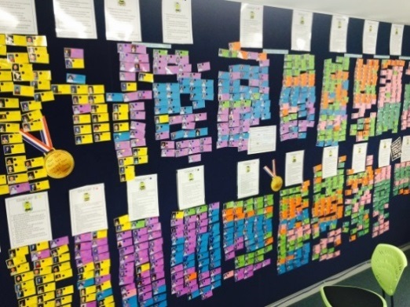

* Visual display learning walls in classrooms encouraged students to visualise their own learning and celebrate achieving their learning goals.

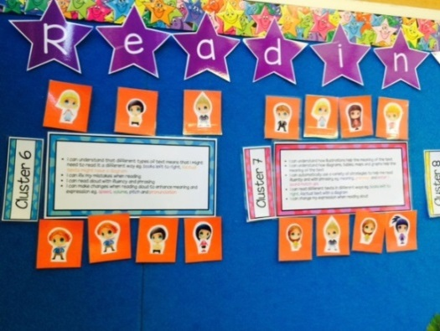

* Teachers used the Class Dojo app to share information with parents about events and student achievements, to answer questions and share photos.
* The Skoolbag app alerted parents to information such as newsletters and notes, and enabled parents to notify the school when their child was absent.

Keen Kinders

The ‘Keen Kinders’ kindergarten transition program included afternoon tea for parents to meet school staff and other parents, and fortnightly sessions for parents and their children to join the current kindergarten classes. A Keen Kinders email address was created so parents and families could communicate directly with school staff.

Coffee, Cake & Chat (3Cs) and Multicultural Parent Meetings

3Cs provided an opportunity for parents to be involved in school policy and decision-making in an informal setting. At 3Cs parents discussed a variety of topics such as the use of Mathletics and Reading Eggs programs, strategies to support K–2 literacy development, what formative assessment looks like in the classroom, consultation on the school’s three-year strategic plan and consultation on the school’s anti-bullying policy. There was also a Multicultural Parent Meeting each term, based on the same topics.

Project outcomes

The school monitored its initiatives through a variety of means, both quantitative and qualitative.

A ‘Community Engagement Committee’ was formed to track data and reflect on the effectiveness of the strategies.

Evaluation and monitoring tools included the *School Assessment Tool and Matrix*, surveys, a project website to document the journey, data collection on parent attendance at events and student learning achievement.

Outcomes included:

* The school’s Facebook page received more than 660 ‘likes’, with one post reaching over 7,000 people.
* Focus groupsprovided a forum to inform the creation of the three-year school plan.
* Professional and organisational developmentprovided opportunities for more tailored learning and development for teachers.
* Visual displays provided a representation of student progress, encouraged conversations on improving educational outcomes, and provided a focus for teachers, students and parents to recognise and celebrate achievements.
* The Class Dojo app was used by 20 teachers and the Skoolbag app was downloaded by 400 parents, enabling regular communication between the school and families. One parent said ‘I get so excited at work when a Dojo message comes through from the teacher about my son’s achievements’.
* Keen Kinders had 35 participants each week and parents commented on how much this helped with the transition. Kindergarten enrolments rose from 55 in 2015 to 87 in 2016.
* 3Cs and Multicultural Parent Meetingsreceived positive feedback from parents. In particular they appreciated the opportunity to learn new ways to support their child’s learning, access to school leaders and staff, and forming new friendships with other parents.

Student outcomes

Since introducing the various strategies to improve parent to school contact, the school has had a dramatic downturn in suspensions and other serious incidents of negative behaviours. School data showed a significant decrease in negative behaviours from 38 incidents in 2014 to 10 in 2015 (as at October).

The school attributes this result to the intentional focus of the introduction of formative assessment practices and communication with parents.

*‘We are getting on top of our behaviour issues through a number of ways but one of the most effective has been the Class Dojo app. It gives me a direct line to parents, which the child is aware of and vice versa’*.

There has also been an encouraging improvement in literacy data at the school.

Challenges

A key challenge was the number of changes in the leadership team and frequent movement of staff which caused concern about stability and consistency, and presented a challenge when building relationships with parents and families.

Collecting qualitative community feedback was also a challenge. Responses to surveys and other data collection remained low despite promotion via social media and the school newsletter but the school is committed to continuing work to improve this.

| **Project success factors**  One of the most significant changes the school made was the use of technology, which improved communication between the school, families and the community.  The use of Class Dojo provided immediate and personal two-way contact between the teacher and home, enabling parents to ask the teacher questions and teachers to share information about their child’s learning journey through messages, photos and videos.  The focus on using data to determine student learning goals and achievement enabled teachers to keep track of progress. |
| --- |

Lessons learnt

* Stability in school leadership supports relationship building with parents and the community.
* The establishment of a Community Engagement Team was an effective strategy to improve parent engagement.
* Tracking student behaviour, achievement outcomes and transition data, is crucial in providing appropriate support to students.
* *The Family-School Partnership Framework* and *School Assessment Tool* were helpful in supporting family engagement.
* Achieving outcomes for all students is a community responsibility and support for stronger relationships between schools and community is paramount.

Future directions

The School Strategic Plan includes strategies to build family and community partnerships and outlines the processes to engage parents and the community as partners in learning. It places a priority on communication as a two-way exchange between families and the school, and on staff actively communicating and engaging parents and the wider community.

Developed by the Family-School and Community Partnerships Bureau. The Bureau is a partnership between the Australian Council of State School Organisations and the Australian Parents Council, with support from the Australian Government. Visit [the](http://www.education.gov.au/parent-information) [Department of Education and Training](https://www.education.gov.au/node/14766) website for more information.