**Fact Sheet: Partnerships**

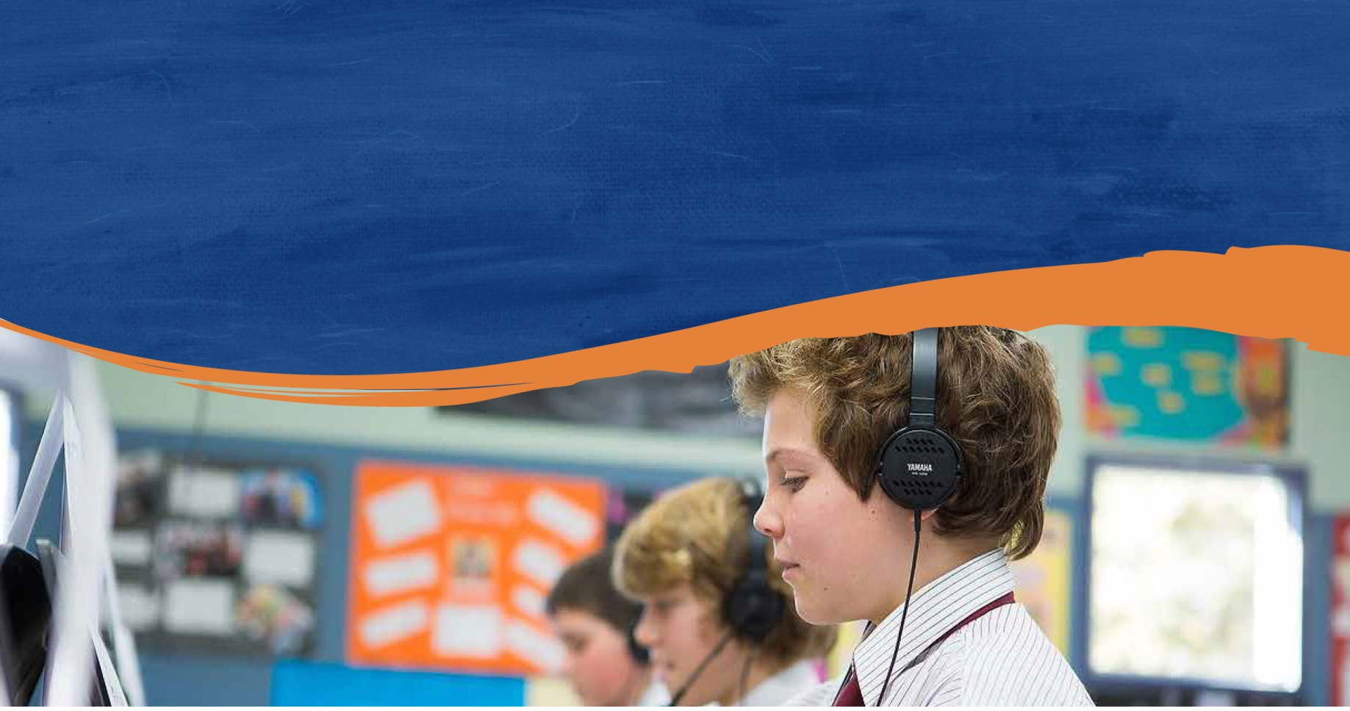Family-School Partnerships Framework

A guide for schools and families

Supporting positive parent engagement in learning

Partnerships are an effective way to support and empower positive parent engagement, and bring together family and community resources to enrich student learning and wellbeing.

Family-school partnerships

Family-school partnerships are collaborative relationships between families and school staff, focused on student learning and development.

Through these partnerships, parents and families can participate in purposeful and productive relationships that expand their interests, knowledge, needs and resources.

Family-school partnerships may be created at a whole school, year or class level, for a particular learning or subject area, or to support an individual student. They connect home to school and might focus on students in transition, student and family wellbeing, a particular topic like science.

Family-school and community partnerships are re-defining the boundaries and functions of education. They enlarge parental and community capacity; they create conditions in which children learn more effectively. In these ways, they take education beyond the school gates (Family-School and Community Partnerships Bureau, 2009, p. 6).

School-community partnerships

Similar to family-school partnerships, school-community partnerships are underpinned by shared and sincere interest in improving student learning, wellbeing, opportunities and outcomes. Students, families, schools, community members and organisations can all benefit from these partnerships.

Engaging with the community is not just about school-directed efforts to develop partnerships. It involves the broader community, including businesses and other organisations, working with schools, parents and students to create and expand networks to build capacity.

To the extent that schools develop respectful, caring alliances with stakeholders, learn from and with them in dialogue, and include their voices in setting agendas, there will be progress toward sharing power (Auerbach, 2012, p.39).

Partnerships are effective when the different strengths of partners are valued and used to best advantage. A collective effort to improve student learning and wellbeing can provide a positive outcome for the whole community.

Building effective partnerships

Whether informal or formal, simple or complex, effective partnerships draw on the knowledge, expertise and resources that partners bring to the relationship. These partnerships help to create an environment where children can be supported to reach their full potential.

We believe that when schools and families effectively partner across contexts of development and domains of learning, our children will truly be on a path to academic, social and emotional success (Albright & Weissberg, 2010, p. 261).

The *Family-School Partnerships Framework* provides information and resources to support schools to build and sustain effective partnerships with families and communities. This includes core principles, key dimensions and characteristics of effective partnerships, as well as practical tools to help create, evaluate and improve partnerships. These materials can help school communities reflect on their current culture and practices, and plan for further improvements.

Core principles for developing partnerships

The core principles that underpin effective partnerships are:

parents and families are the first and continuing educators of their children

learning is lifelong and occurs in multiple settings

partnerships and school communities flourish when the diversity and strengths of families are valued and leveraged

community engagement expands responsibility and resources

partnerships grow from mutual trust, respect and responsibility

partnerships need committed, collaborative and creative leadership.

Key dimensions of family-school partnerships

The *Family-School Partnerships Framework* identifies the seven key dimensions that frame the elements of relationship and partnership building. These dimensions are:

communicate

connect learning at home and school

build community and identity

recognise the role of the family

consult on decision-making

collaborate beyond the school

participate.

Characteristics of effective partnerships

Effective partnerships display the following characteristics:

responsive to student and family needs and aspirations

purposefully co-design with clear goals

commitment to collaboration

mutual trust and respect

equal valuing of the different roles in the partnership

sharing of responsibility and influence

open dialogue and effective communication

appropriate and adequate resources.

Developed by the Family-School and Community Partnerships Bureau. The Bureau is a partnership between the Australian Council of State School Organisations and the Australian Parents Council, with support from the Australian Government. Visit the [Department of Education and Training website](https://www.education.gov.au/node/14766) for more information.