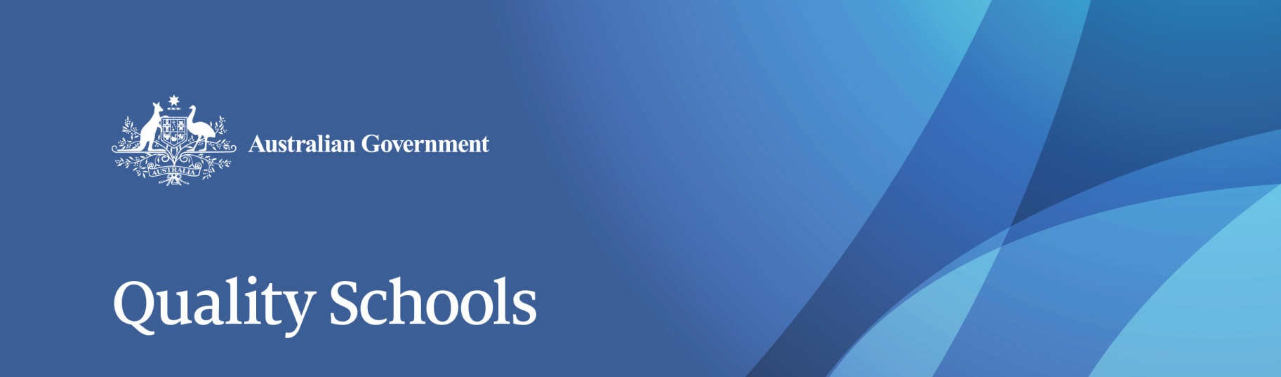

The case for change

# While schools funding has been growing, results are declining

The Government is growing its record levels of recurrent funding for schools from $17.5 billion in 2017 to $30.6 billion in 2027. Total combined Commonwealth and state Government funding has grown in real terms by 15.4 per cent per student over the 10 year period from 2005-06 to 2014-15.

Over this period, Commonwealth funding per student has increased in real terms by 72.4 per cent for government schools and 25.7 per cent for non-government schools while comparable state and territory funding has grown by only 9.4 per cent to their own government schools and by 10.6 per cent to non-government schools.

According to independent analysis, Australia is now among the highest investors in school education in the Organisation for Economic Co-operation and Development (OECD). However, Australia’s performance in international testing has declined both relative to other countries and in real terms.

The 2015 Programme for International Student Assessment (PISA) report showed that:

* Australian science students are seven months behind where they were in 2006
* Australian maths students are a year of schooling behind where they were in 2003
* Australian students’ reading abilities have dropped a year since 2000

Evidence from the OECD is clear that simply providing more funding does not in itself improve student outcomes. The OECD has found that for high-income countries like Australia it matters more how money is spent, than how much is spent.

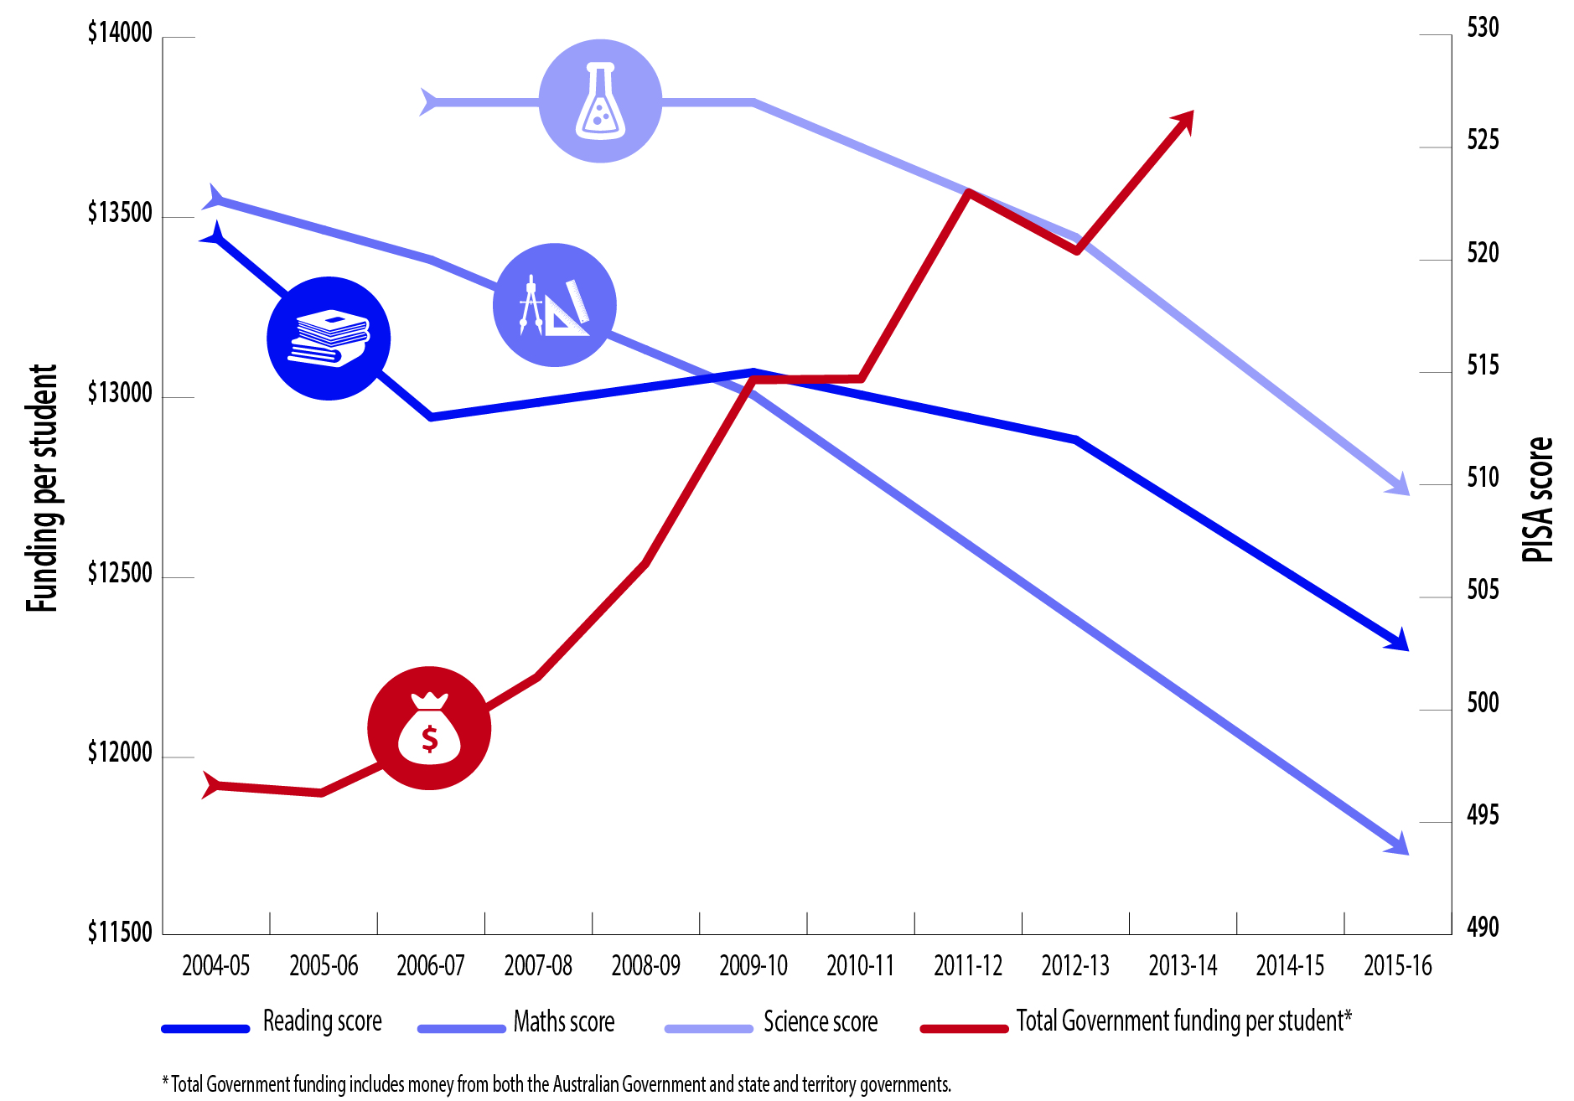

*Source:  PISA 2015: Reporting Australia’s results (ACER) Report on Government Services, (1999 –2017), Australian Productivity Commission*

# Current school funding arrangements are not fair and must change

Commonwealth funding for schools is currently determined based on history and special deals.

As a result, a student with the same need in the same sector attracts a different amount of Commonwealth funding in each state.

For example, a government school in South Australia gets around two-thirds of what the same school would get from the Commonwealth if it was just over the border in the Northern Territory.

This inequity affects all sectors. For example, Commonwealth funding for an independent school in Tasmania is less than 90 per cent of what its funding would be for an identical school in Victoria.

If current arrangements were to continue, by 2019 it is estimated that there would have been:

* only 116 schools that had managed to reach 100 per cent of the Schooling Resource Standard, with 9,018 schools still being funded below
* 5,524 schools still left below the funding target of 95 per cent of the Schooling Resource Standard by 2019, underfunded by an average of almost $458,000 for every school
* around 256 schools receiving more than the full Schooling Resource Standard by an average of $1.2 million

By 2027, 6,966 schools would still have been below the full Schooling Resource Standard by an average of approximately $690,000.

Under current arrangements, even the most overfunded of schools get a guaranteed three per cent growth in funding each and every year under the current arrangements, regardless of need. Many of these schools will remain overfunded for decades – more than 150 years in the worst case. This is not sustainable.

# The Australian Government is moving to a fair, needs-based funding model that is tied to reforms

From 2018, the Government will be introducing new arrangements for funding schools which will be fair, transparent and tied to reforms that will boost education outcomes—moving all schools and states to truly needs based funding in just ten years.

To support efforts to lift outcomes, the Government has also commissioned a *Review to Achieve Educational Excellence in Australian Schools*, to be chaired by Mr David Gonski AC.

The Review will provide advice on how the extra Commonwealth funding provided in the 2017 Budget should be invested to improve Australian schools’ performance, and grow student achievement.