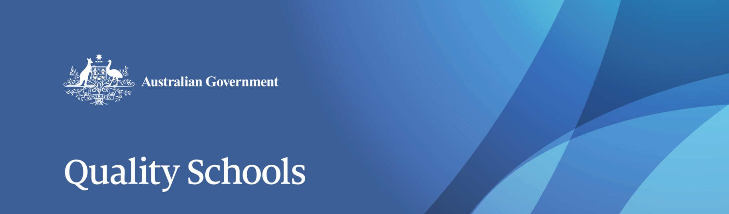

# Review to Achieve Educational Excellence in Australian Schools

The *Review to Achieve Educational Excellence in Australian Schools,* to be led by Mr David Gonski AC, has been commissioned to build the evidence base needed to ensure the additional funding provided by the Australian Government is spent on proven initiatives that make a difference to student outcomes.

**The Australian Government is committed to evidence-based reform**

Australia has an excellent education system but our plateauing or declining results highlight that while strong levels of investment are important, it’s more important to ensure that funding is being used on evidence-based initiatives that are proven to boost student results.

The Australian Government is committed to practical, meaningful reform of our education system—using strategies shown to work and improve student outcomes. We know that high quality teaching is one of the keys to driving improved student outcomes. This is why it has been such an important focus for the Australian Government.

Through the implementation of the Teacher Education Ministerial Advisory Group recommendations, we now have revised and strengthened course accreditation standards, as agreed by all education ministers in December 2015. These changes will ensure graduate teachers will study a quality teacher education program that ensures they enter the classroom prepared to have an immediate impact on student learning.

The Australian Government’s *Quality Schools, Quality Outcomes* plan includes more than a dozen initiatives backed by expert evidence. Quality focused and evidence-based priority reforms will ensure Commonwealth needs-based funding is used most effectively and efficiently to improve outcomes in Australian schools.

**An even stronger national evidence base will help lift outcomes**

Last year’s Productivity Commission Inquiry into the National Education Evidence Base shows Australia has a significant gap in its understanding of what works best, for whom and in what circumstances in our schools.

The *Review to Achieve Educational Excellence in Australian Schools* has been commissioned to build the evidence base needed to ensure the additional funding provided by the Australian Government is spent on proven initiatives that make a difference to student outcomes.

The Review will not rehash funding calculations and distribution, but focus on practical measures that work, from Australia and around the world, to improve results for Australia’s children.

**An expert panel will conduct the Review**

The Review will be led by Mr David Gonski AC and he will be supported by an expert panel. Mr Gonski is passionate about education and his extensive knowledge and experience make him well placed to lead the Review.

The final report and recommendations will be provided to Government by March 2018.

**The Review will make sure national reform action is based on solid foundations**

The Review will be finalised by March 2018 to inform the Australian Government’s new approach to schools funding. The findings will inform the Australian Government’s national agreement and the bilateral reform plans with states and territories, and inform all governments on how to get the best outcomes from schools and systems.

Most importantly our principals, teachers, schools and educators will gain the benefit of education research and the application of best practice methods. The Review will help identify the highest priorities for school reform.

**Stakeholder Consultation**

The Review Panel will consult widely with the education community to inform its advice to the Australian Government. States, territories and the non-government sector will all be consulted regarding the quality reforms that are needed to drive improved student outcomes.

For more information, including the Terms of Reference for the Review, visit   
[www.education.gov.au /review-achieve-educational-excellence-australian-schools](http://www.education.gov.au/qualityschools)