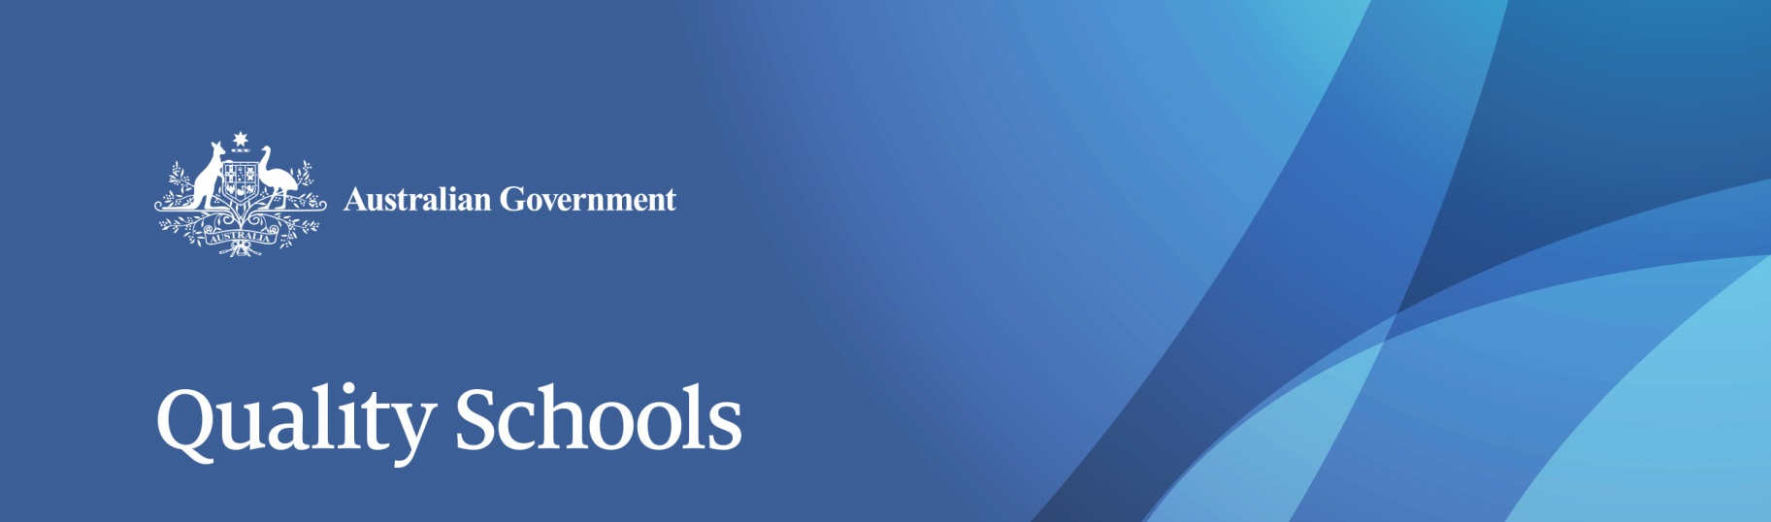

# Review to Achieve Educational Excellence in Australian Schools

## Terms of Reference

Evidence from organisations such as the Organisation for Economic Co-operation and Development (OECD) is clear that simply providing more funding for schools does not in itself improve student outcomes. To achieve the best educational return on investment we must look at how money is best used, and not just how much is spent.

This is borne out in Australia, where total government funding for schools has doubled since 1988, yet Australian students’ performance in national and international assessments has declined in real and relative terms.

The Turnbull Government's school funding reforms guarantee ongoing, record levels of Commonwealth Government investment in schools, growing recurrent funding from $17.5 billion in 2017 to $22.1 billion in 2021, and $30.6 billionby 2027.  This includes more than $2.2 billion in new funding over the first four school years in the 2017-18 budget, which is in addition to generous indexation of 3.56 per cent and follows on from $1.2 billion in new funding budgeted in 2016-17.

The Turnbull Government has established the Review to Achieve Educational Excellence in Australian Schools, to be chaired by Mr David Gonski AC, to provide advice on how this extra Commonwealth funding should be used by Australian schools and school systems to improve school performance and student achievement.

The Review will report to the Prime Minister and Commonwealth Minister for Education and Training. It will examine evidence and make recommendations on the most effective teaching and learning strategies and initiatives to be deployed. In particular the Review will focus on the effective and efficient use of funding to:

* Improve student outcomes and Australia's national performance, as measured by national and international assessments of  student achievement.
* Improve the preparedness of school leavers to succeed in employment, further training or higher education.
* Improve outcomes across all cohorts of students, including disadvantaged and vulnerable students and academically-advanced students (‘gifted’ students).

To support these recommendations, the Review will also:

* Provide advice on related institutional or governance arrangements to ensure the ongoing identification and implementation of evidence based actions to grow and sustain improved student outcomes over time.
* Propose related transparency and accountability measures that support the effective monitoring, reporting and application of investment.

The Review will not reconsider the calculation of Commonwealth or state funding for schools, which was the subject of the 2011 *Review of Funding for Schooling*, also chaired by Mr Gonski.  The Turnbull Government has accepted the fundamental recommendations of the 2011 Review regarding needs based distribution of funding and is now acting on the advice that further work be undertaken on quality reforms.

MrGonski will chair an independent panel, and will draw on education experts, academics and practitioners with experience in education systems and teaching and learning methodologies, both internationally and within Australia, as well as states and territories and non-government school authorities.