|  |
| --- |
| Cost of delivery of higher education  Australian Government Department of Education and Training  Finalreport  December 2016 |

DAE.jpg

Contents

Glossary i

Executive Summary iv

1 Background 1

1.1 The context to this report 1

1.2 Trends in higher education delivery 7

2 Data compilation and moderation 20

2.1 Data collection and sector engagement 20

2.2 Participating universities 23

3 Teaching and Scholarship costs 34

3.1 Summary of teaching and scholarship costs 35

3.2 Summary of qualitative information provided 41

4 Understanding reasonable cost 46

4.1 The broader policy and institutional context 47

4.2 The concept of ‘reasonable cost’ 48

4.3 An analytical framework for informing an estimate of reasonable costs 49

5 Measuring reasonable cost 56

5.1 Modelling results 57

5.2 Obtaining indications of reasonable cost 65

6 International benchmarking 74

6.1 International funding systems: a brief overview 74

6.2 International costing systems: a brief overview 76

6.3 Comparison methodology 77

6.4 Results 81

7 Findings and conclusions 86

7.1 Key findings and conclusions 86

7.2 Directions for further work 91

References 93

Appendix A : Approaches to analysing reasonable costs 96

Previous approaches in the literature 96

Exploratory analysis using DEA 97

Limitations of the analysis 101

Appendix B : Fields in data collection template and qualitative questions 106

Limitation of our work 111

Charts

Chart 1.1 : Student enrolments over time, by field of education (count) 8

Chart 1.2 : Student enrolments over time, by state (count) 8

Chart 1.3 : Share of domestic students by liability status (comparison of 2011 and 2015) 9

Chart 1.4 : Share of student enrolments by delivery mode 10

Chart 1.5 : International student enrolment counts, by field of education and year 11

Chart 1.6 : Enrolment counts of domestic and overseas students 11

Chart 1.7 : Academic pay ranges 12

Chart 1.8 : Student-to-staff ratio 12

Chart 1.9 : Total expenses and net operating result for Australian public universities, by category (2010-2015), $billions 14

[Chart 1.10 : Total revenue for Australian public universities, by category (2010-2015), $billions   
………… 14](#_Toc469927354)

Chart 1.11 : Average growth in expenses per EFTSL (2010-2015) 15

Chart 1.12 : Average growth in revenue per EFTSL (2010-2015) 15

Chart 1.13 : Cost and EFTSL growth (2010-2015) 16

Chart 1.14 : Cost and FTE growth (2010-2015) 17

Chart 2.1 : Australian universities by affiliation and geography 25

Chart 2.2 : Australian universities by remoteness and EFTSL 25

Chart 2.3 : Australian universities by 2015 enrolments (count) 26

Chart 2.4 : Australian universities by ranking 27

Chart 2.5 : Australian universities by dual sector status 28

Chart 2.6 : Australian universities by number of campuses 28

Chart 2.7 : Australian universities by external or mixed-mode share of attendance 29

Chart 2.8 : Participating universities by share of international students 30

Chart 2.9 : Australian universities by share of revenue allocated to maintenance costs 31

Chart 2.10 : Participating universities share of total enrolment 32

Chart 2.11 : Participating universities share of postgraduate coursework enrolment 32

Chart 2.12 : Participating universities share of sub-bachelor enrolment (incl. enabling) 33

Chart 3.1 : Bachelor costs per EFTSL, 2010 vs 2015 35

Chart 3.2 : Postgraduate costs per EFTSL, 2010 vs 2015 36

Chart 3.3 : Total cost per EFTSL (bachelor level, outliers removed) 37

Chart 3.4 : Total cost per EFTSL (postgraduate level, outliers removed) 38

Chart 3.5 : Total cost per EFTSL (sub-bachelor, outliers removed) 38

Chart 3.6 : Cost-funding comparison with 2010 (bachelor level, outliers removed) 39

Chart 3.7 : Cost-funding per EFTSL (bachelor level, outliers removed) 40

Chart 3.8 : Total number of teaching and scholarship staff (FTEs) per EFTSL, by field 40

Chart 3.9 : Labour costs as a share of total costs, by FOE 41

Chart 3.10 : Example mapping cost (via EFTSL) from Colleges to FOEs 43

Chart 5.1 : The relative effect of cost drivers by variation from the 25th to 75th percentile (averaged across all fields of education, OLS model, bachelor level) 63

Chart 5.2 : Cost estimates - Total cost per EFTSL (bachelor level, 2015) 68

Chart 5.3 : Reasonable cost - Cost drivers vs Field effects by field (bachelor level) 70

Chart 5.4 : Cost estimates - Total cost per EFTSL (Management and Commerce, bachelor level, 2015) 71

Chart 6.1 : Higher education funding by benchmark countries 76

Chart 6.2 : Average teaching and scholarship costs by field of education (Cost of Management and Commerce = 1) 82

Chart 6.3 : Average teaching and scholarship costs by field of education (Cost of Management and Commerce *undergraduate* = 1) 84

Chart 6.4 : Average costs by funding cluster (Cost of Funding Cluster 1 = 100%) 85

Chart A.1 : DEA result visualisation by field, benchmark model 98

Chart A.2 : Scatter plot of Cost per EFTSL and SESCEQ by FOEs 99

Chart A.3 : DEA result visualisation by field using SESCEQ as output 100

Tables

Table 2.1 : The participant subset of Australian universities 24

Table 3.1 : FOE-weighted average costs per EFTSL 36

Table 4.1 : Potential cost drivers 51

Table 5.1 : Fixed effects results: Total cost per EFTSL (bachelor level) 58

Table 5.2 : Descriptive statistics: Cost drivers by RUN status (bachelor level) 61

Table 5.3 : OLS results: Total cost per EFTSL (bachelor level) 62

Table 5.4 : Descriptive statistics - Cost drivers (bachelor level) 64

Table 5.5 : Reasonable vs raw cost by field (bachelor level) 69

Table 6.1 : Summary of international cost data sources 78

Table 6.2 : Mapping between HESA and DET clusters 79

Table 6.3 : 2016 Australian funding clusters 80

Table A.1 : Descriptive statistics: Cost drivers by field (bachelor level) 102

Table A.2 : OLS results: Total cost per EFTSL 103

Table B.1 : Definitions and explanations 106

Table B.2 : Overview of input fields in data collection template 108

Figures

Figure 6.1 : Costs captured under international benchmarks 77

Glossary

|  |  |
| --- | --- |
| ABC | Activity Based Costing |
| ARC | Australian Research Council |
| ASCED | Australian Standard Classification of Education |
| CEQ | Course Experience Questionnaire |
| CGS | Commonwealth Grant Scheme |
| CSP | Commonwealth Supported Place |
| DEA | Data Envelopment Analysis |
| DET | Department of Education and Training |
| EFTSL | Equivalent Full Time Student Load |
| FOE | Field of Education |
| FTE | Full-Time Equivalent |
| HDR | Higher Degree Research |
| HECS | Higher Education Contribution Scheme |
| HEFCE | Higher Education Funding Council for England |
| HEIMS | Higher Education Information Management System |
| HELP | Higher Education Loan Program |
| IQR | Interquartile Range |
| NZBT | New Zealand Benchmarking Tool |
| OLS | Ordinary Least Squares |
| RFM | Relative Funding Model |
| SAC | Student Achievement Component |
| SES | Student Experience Survey |
| SFA | Stochastic Frontier Analysis |
| TEQSA | Tertiary Education Quality and Standards Authority |
| TRAC | Transparent Approach to Costing |

|  |
| --- |
| Key points  Deloitte Access Economics was commissioned by the Australian Department of Education and Training to estimate and analyse the reasonable cost of higher education teaching and scholarship. This report contains the results of this research.  Understanding the current cost of university teaching is important   * As with any organisation, **universities respond to incentives**. The funding universities receive influences both the scope and scale of the teaching and research activities they undertake. Optimal funding arrangements will be driven by a range of factors, one of which is the cost of provision. * Despite its importance, **there is relatively little contemporary evidence on the cost of teaching** at Australian universities. In fact, the leading source of evidence is an analysis based on data from eight universities conducted by Deloitte Access Economics for the Department in 2011. * A number of **trends are likely to have driven changes in costs** over the intervening period: * The demand driven system has increased student numbers and changed the composition of the student mix. * Technology has continued to transform the way higher education is accessed and delivered. * Cost growth – such as growth in salaries – has seen unit costs grow at or above the rate of inflation. * A robust and contemporary analysis of teaching costs is therefore needed to assist in optimising funding settings and to ensure universities continue to face incentives that encourage the sector to meet the ever-changing demands of students and industry.   The data used in this report   * The analysis in this report is based on cost data provided by 17 universities. This is more than twice the number in the 2011 exercise and represents half of the sector by enrolments. Participating universities were emailed a costing spreadsheet asking them to divide costs into salary and non-salary costs by field of education (FOE). * This is necessarily a complex exercise and various assumptions were made by universities in order to make the provision of data tractable. These assumptions were documented alongside the provision of the data and discussed and explored during consultations with each participating university. This process limited the extent to which results are influenced by differences in approach, but some approach-driven differences may nevertheless remain.   There are a wide range of costs across universities and FOEs   * The data reveals a relatively wide range of reported costs, both across the 19 FOEs, and across universities within each FOE (see the chart below). * **Veterinary Studies has the highest mean cost** of bachelor provision across all FOEs, at around $49,000 per EFTSL. This is followed by Dental Studies at around $46,000, with those **FOEs with lower non-salary costs, such as Education, at the lower end** of the cost range (around $12,000-15,000). * At the postgraduate level (not shown), Dental Studies, Other Agricultural and Environmental Studies and Veterinary Studies display the highest average costs, with the range of costs within each FOE being generally greater at the postgraduate level. * The relative ranking of FOEs is largely unchanged from the 2011 analysis – using 2010 data – at both the bachelor and postgraduate level. However, the relatively small (and different) sample used in the 2011 study makes accurate comparisons infeasible. * The existence of a range of costs across universities within each FOE should not be interpreted as indicating differing levels of efficiency. Costs may legitimately vary based on a range of factors: * **Various contextual factors**, such as student intake characteristics, may alter the costs of providing higher education. * Universities may **choose to offer varying degrees of quality**, such as through a higher ratio of students to staff, with this driving cost variances in the data. * Once these factors have been accounted for, the **residual variance in costs may be an indicator of efficiency** at the institutional level to be reflected in funding decisions.   **Chart: Total cost per EFTSL (bachelor, outliers removed)**  Distribution of total cost per EFTSL at the bachelor level, by FOE  Source: Deloitte Access Economics analysis  Arriving at ‘reasonable costs’   * Because these costs reflect, in part, various contextual factors over which universities may have little control, as well as possibly varying levels of quality, the ‘reasonable cost’ of teaching and scholarship need not be the average cost observed through the data collection. * Instead, it should reflect the expectations that society has in relation to the quality of teaching and support that students receive, and the costs associated with achieving these outcomes. The unique contextual factors each university faces will also mean that this reasonable cost may differ across institutions of different attributes. * Recognising these considerations, **there is no single reasonable cost of delivery that can be estimated through analysis of the data alone**. Nonetheless, the data can inform the extent to which various factors drive costs, and identify a range of reasonable costs associated with different levels of quality, other contextual factors, and various levels of target efficiency. The modelling in this report demonstrates, *inter alia*, that: * Most of the variation in observed costs across universities can be explained by contextual and quality factors. In particular, reasonable costs are materially impacted by factors such as: * the staff to student ratio; and * the proportion of casual teaching staff. * There is also a degree of variation in costs that is attributable to underlying differences in costs for different fields of education, which exists even after controlling for the impact of cost drivers. * The chart below shows both median actual costs and estimates of reasonable costs based on the median characteristics of universities in a given field of education. Reasonable costs are estimated using three different models: OLS, quantile regression at the 25th percentile, and Stochastic Frontier Analysis (SFA). Going from an OLS approach, to quantile regression, then to the SFA approach, the estimates of reasonable cost move closer to an efficiency frontier. The results of reasonable cost analysis indicate that: * Estimates of reasonable cost vary considerably across different fields of education - this reflects differences in both the median value cost drivers (particularly staff to student ratios) as well as differences in underlying costs across fields of education. * As a greater level of efficiency is applied, the estimate of reasonable cost falls accordingly. For example, in the Mathematical Science field, the mean actual cost per EFTSL is $14,428. The OLS estimate of reasonable cost is $14,004 but the estimate of reasonable cost using quantile regression at the 25th percentile falls to $12,991 and to $12,004 when SFA is applied.   **Chart: Total ‘reasonable’ cost per EFTSL (bachelor level)**  Comparison between the total 'reasonable' cost per EFTSL at the bachelor level, by FOE  Source: Deloitte Access Economics analysis   * Ultimately, what constitutes ‘reasonable’ in the context of cost derivation hinges on a defined construct of quality and the efficient cost at which this can be achieved. * Any estimate of reasonable costs is sensitive to the chosen level of staff to student ratios, the proportion of casual teaching staff and the relative level of efficiency applied. |

Executive Summary

Ensuring university resources continue to be appropriately directed to teaching and scholarship activities that support Australia’s long term skills and learning requirements is crucial to the higher education sector’s effective ongoing contribution to the nation’s economic and social development.

As with any organisation, universities respond to incentives. Funding that is inconsistent with incentivising the efficient and effective provision of higher education risks distorting the decisions that universities make and increases the likelihood that these decisions fail to align with the nation’s economic and social interests. It is therefore crucial that funding appropriately relates to the cost of higher education provision such that the signals that funding sends – to both students and providers – positively influence decision making.

The determination of appropriate cost measures for the purposes of informing funding rates is made challenging by a raft of factors including those associated with observing and measuring concepts like quality, efficiency and the outcomes of university activities. It is also made challenging by the complexity of university operations and the inter-woven nature of their activities across teaching, research and engagement. Examining these activities, and the strategic considerations their linkages and co-production imply, is important in understanding how costs are incurred across universities and to the determination of an appropriate higher education funding framework.

The current funding arrangements for teaching and scholarship, as part of the Commonwealth Grant Scheme (CGS), find their legacy in the Relative Funding Model (RFM) designed in the mid-1990s. Both the original RFM and the subsequent CGS funding clusters were designed to allocate aggregate base funding amounts to universities that fairly reflected their respective discipline mixes. This model did not rely on a precise measure of cost at a discipline level, rather it focused on capturing relative average costs across disciplines. Since the development of this model, there has been periodic research into the cost of teaching at universities, with the most recent analysis conducted in 2011. The sector has continued to evolve since.

Recognising the importance of costs to the funding of higher education teaching and scholarship, and acknowledging the prospect that the current evidence base has lost its currency, this study aims to examine efficient cost of quality teaching by analysing financial data drawn from a sample of Australian universities and benchmarked against a series of comparator international jurisdictions.

Approach to evidence collection

All public universities that receive CGS funding were invited to participate in the data provision exercise. Universities were provided with a costing template by the Australian Department of Education and Training on 1 September 2016 and were required to populate and submit the template by 24 October 2016. Deloitte Access Economics was commissioned to assist in the collection and analysis of this template data.

Of the universities given the opportunity to participate, 18 – or around half – chose to submit data, of which 17 submitted a full dataset. The sample of participating universities was broadly representative across dimensions such as university size, affiliation, research intensity, geography, campus numbers, enrolments by discipline and modes of enrolment. In this sense, it provided a robust foundation for analysing the level of and variation in costs across the sector.

Deloitte Access Economics consulted all participating universities over the course of the project to ensure that the template was completed appropriately and in a way that was as consistent as possible across institutions. Following the submission of the template, the data was moderated and synthesised, with follow-up discussions with universities where outliers or other uncertainties were identified.

Consultations with the participating universities reiterated the complexities associated with attempting to accurately assign costs at a field of education (FOE) level and highlighted the diversity of commercial practices and business models present across the sector. Among the university characteristics identified as impacting on the cost analysis were:

* Differing degrees of centralisation of university functions, with some institutions undertaking finance, human resources, staff support and IT functions at a central level and others devolving these functions to their various faculties.
* Linkages with partner institutions – some of which provided teaching for the university’s students – with commensurate transactions between the partners.
* Significant and growing costs associated with clinical placements and other work integrated learning practices.
* Variations in average student loads across universities leading to difference in the ratio of student headcount to EFTSL (with this ratio tending to be higher in universities that teach a greater proportion of online courses).

Participating universities vary in the sophistication of their data collection and reporting ability. Some employ sophisticated Activity Based Costing (ABC) models that are capable of reporting costs at a granular level based on pre-existing data structures such as the general ledger, payroll, timetabling, asset registers, among others. Others collect aggregated information in their finance functions for reporting purposes, but without the ease or sophistication that more detailed models are capable of providing.

However, where ABC models are employed, the assumptions on which they are based are not necessarily more realistic than those adopted by institutions that collate data in the absence of such models. Overall, the consultations with the participating universities indicated that broadly similar approaches were used to allocate both budgetary unit level and central costs to individual FOEs. However, despite the focus on maximising the   
cross­-institution consistency in the dataset, some differences in approach remained. These are outlined below.

* The greatest difference in approaches across institutions was the allocation of staff time across teaching and research activities.
* This was in part because these activities were seen by some to be inextricably linked, with research activities supporting teaching and scholarship requirements.
* Regardless of the sophistication of the approach used, many universities indicated that they did not routinely collect or report data on an FOE basis.
* As such, additional assumptions were required in transcribing existing data into this form.
* Because universities provide courses, which are more granular than FOEs, the composition of a given FOE varies from university to university.
* To the extent that the costs of teaching vary across these courses, so too will – the weighted average – cost of a given FOE.
* Concerns were also raised regarding the focus on a single calendar year of observations, noting that costs vary year-to-year in a fashion that is inconsistent across institutions. The most common aspects of this concern related to:
* general trends in the sector that were leading to increasing costs on a per-EFTSL basis, including rising real salary costs and costs associated with increasingly mixed-mode delivery;
* structural reorganisation of support services, or a major alteration of delivery (such as ceasing operations at a campus);
* rising costs associated with clinical placements; and
* costs associated with the replacement of (possibly fully depreciated) capital, which could be lumpy over time.

The research and empirical methods employed here are directly geared toward minimising the impact of these factors on the robustness of the findings of this analysis. The degree to which this has been confidently achieved is outlined at various points of the results discussion below.

Evidence of underlying costs of delivery

Chart i below shows the spread of the estimated cost per EFTSL across FOEs at the bachelor level[1]. Veterinary Studies is estimated to have the largest mean cost of provision per EFTSL, at around $49,000, as well as one of the largest spread of values, with an interquartile range of around $35,000 to $79,000.[2]

* + 1. : Total cost per EFTSL (bachelor, outliers removed[3])

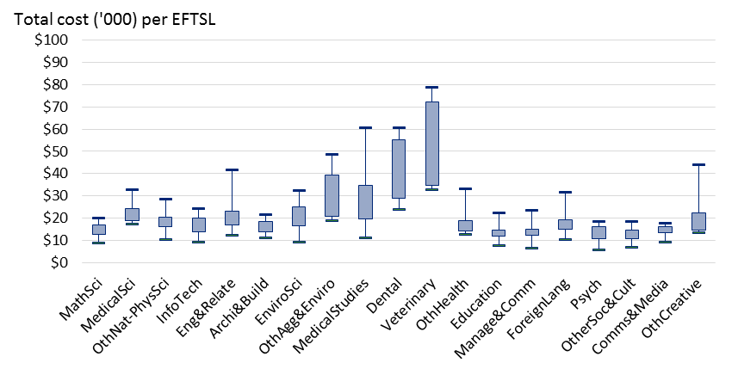

Source: Deloitte Access Economics analysis.

Dental Studies, Medical Studies and the Other Agriculture and Environmental Studies fields round out the top four fields by estimated cost per EFTSL. The remaining fields are generally estimated to be delivered at a cost of between $10,000 and $20,000 per EFTSL. Education, and Other Society and Culture have the lowest costs per EFTSL at around $12,000 to 15,000 per EFTSL.

As is readily observed from Chart i, the data shows that there is material cost variation not just across FOEs, but within FOEs across universities. Indeed, ten of the 19 FOEs have costs with an interquartile range of greater than 100% of the median.

Similar results are observed at the postgraduate level (Chart ii), although with greater variation in the cost per EFTSL across FOEs. Postgraduate teaching is found, on average, to be more costly than its undergraduate counterpart. Dental Studies, Veterinary Studies, and Other Environmental Studies have the highest average costs.

* + 1. : Total cost per EFTSL (postgraduate level, outliers removed)

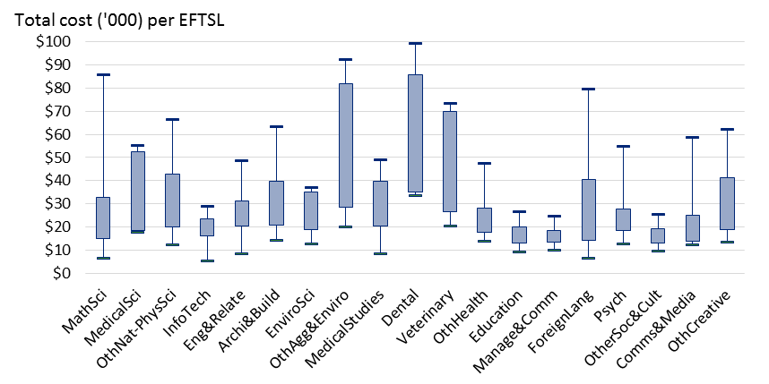

Source: Deloitte Access Economics analysis.

In contrast, at the sub-bachelor level (Chart iii) there is considerably more variation in costs per EFTSL within each FOE. These results are likely reflective of a combination of the greater variation of FOEs offered by different universities at the sub-bachelor level and the relatively small sample of universities offering sub-bachelor qualifications. Higher per-EFTSL costs are also likely to be driven by low EFTSL counts in sub-bachelor courses.

* + 1. : Total cost per EFTSL (sub-bachelor, outliers removed)

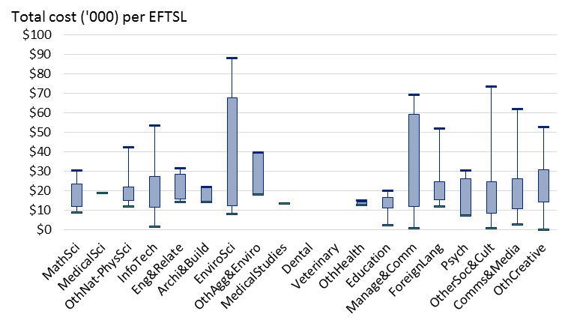

Source: Deloitte Access Economics analysis.

A somewhat more advanced approach to identifying the relative impact of FOEs on costs is to undertake simple regression analysis where the cost per EFTSL is regressed first against the FOE (indicator) variables only and then against a set of variables that capture the characteristics of the university. This simple analysis demonstrates the extent to which a cost observation is explained by the FOE, relative to the university it is taken from.

The results at the bachelor level indicate that FOE variables alone explain 48% of the observed variation in costs across observations and that university characteristics explain only 10% of the variation. This means that while there are differences in costs within FOEs (that is, across universities) this is not systematically explained by fixed attributes of the universities themselves (across FOEs) and is instead due predominantly to other factors that are specific to given FOEs within given universities. A much deeper investigation of cost drivers is provided in later sections of this summary.

*Comparison to 2011 estimates*

As noted in the introduction, the most detailed contemporary work on university teaching costs was conducted for the (then) Department of Employment, Education and Workplace Relations by Deloitte Access Economics in 2011. The study collected primary cost data for the 2010 calendar year from a set of eight Australian universities. It identified the average cost of provision, and the relative costs across FOEs and universities, as well as identifying some of the key drivers of these costs and their variation.

The 2015 results presented above are broadly similar to the findings from the 2011 study. Chart iv below compares the mean cost estimates across the two studies and shows that for most FOEs the estimate of mean costs across the sample of universities is relatively close. Broadly, there are small changes in costs (either positive or negative) across FOEs between the two studies. The growth in (mean) Agriculture and Environmental Studies has further increased its position as the highest cost field. At the other end of the scale, Society and Culture is ranked as the lowest cost field at $12,600 per EFTSL, albeit only marginally lower than several other fields. The broad FOE data collected in 2011 did not itemise Veterinary Studies and Dental Studies; these were aggregated into Health overall.

* + 1. : Total cost per EFTSL (bachelor, outliers removed)

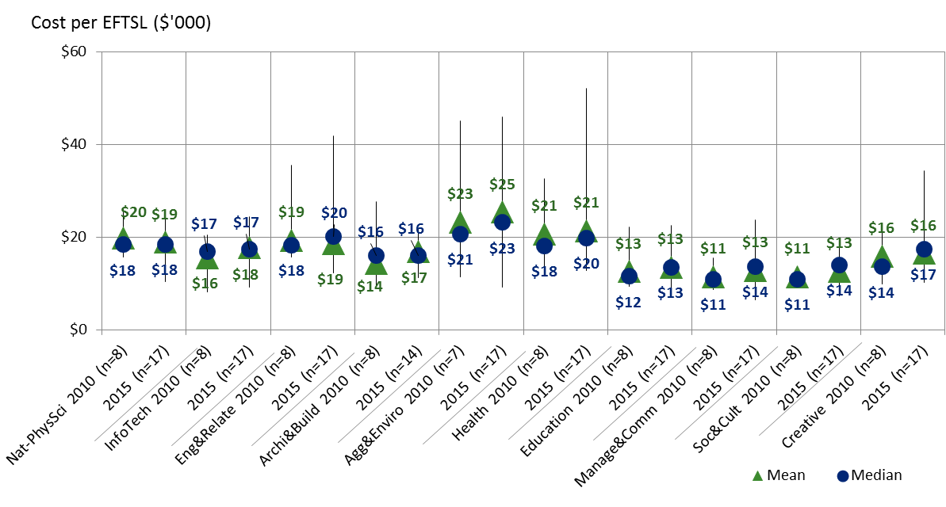

Source: Deloitte Access Economics analysis.

The spread of reported costs across universities has also been relatively consistent over time, although the increased sample size in the current study makes direct comparisons of spread more difficult. The variation in undergraduate cost observations across universities has increased most for Health in absolute terms, as well as Management and Commerce, and Society and Culture in relative terms. Costs for postgraduate courses appear to have increased by relatively more than bachelor costs over this period, as shown in Chart v below. This is particularly the case for Architecture and Building, Health, and Engineering and Related Studies.

* + 1. : Total cost per EFTSL (postgraduate, outliers removed)

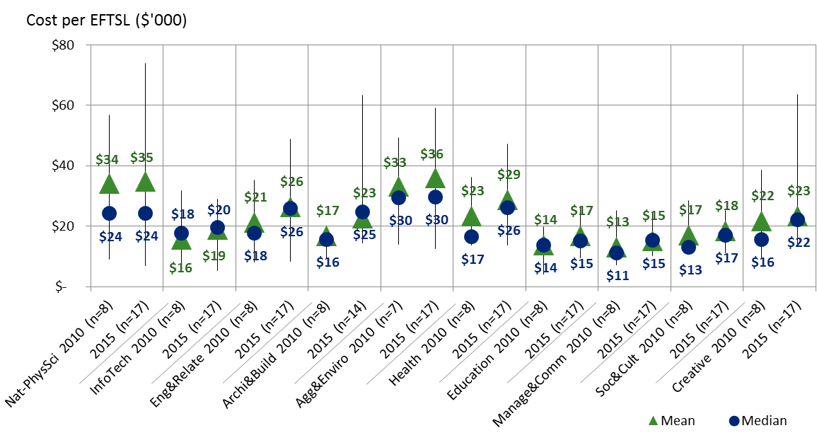

Source: Deloitte Access Economics analysis.

Given the variation in sample size, sample representativeness, and in approach between the current study and the 2011 study, it is not appropriate to attempt to determine precise cost growth over this period from a direct comparison of the two studies.

The issue of sampling representativeness can be mitigated, by creating sector-wide weighted cost averages based on field of education and award level. The FOE-weighted average costs per EFTSL are given in Table ii below. The broad increase in costs at the postgraduate level has also made the cost differential between undergraduate and graduate FOEs more pronounced across the studies, with the average cost for a postgraduate EFTSL at around $20,050, compared to $16,025 for an undergraduate EFTSL. The 2010 average for a postgraduate EFTSL was around $16,972, along with $15,021 for an undergraduate EFTSL.

Though this figure includes research and commercial activities, data reported by the Department on the financial position of the sector overall shows that ongoing expenses growth per EFTSL has been 16% from 2010 to 2015, or around 3% per year. Broadly, the difference between this 16% growth, and the 10% growth per EFTSL observed across the two costing surveys, could be due to either growth in commercial and research costs, issues of representativeness, and/or measurement uncertainty on behalf of participants.

* 1. : FOE-weighted average costs per EFTSL

|  |  |  |
| --- | --- | --- |
|  | **2010 data** | **2015 data** |
| **Undergraduate** | $15,021 | $16,025 |
| **Postgraduate** | $16,972 | $20,050 |
| **Total** | $15,375 | $16,839 |

Source: Deloitte Access Economics analysis.

Examining cost differentials between 2010 and 2015, and linking this to growth in EFTSL over that period, provides a complex picture. There are examples of low growth fields that have a high cost differential, such as Creative Arts. There are cases of high EFTSL growth fields that have high cost differentials, such as Management and Commerce. Conversely, Agriculture and Environmental Studies is a low EFTSL growth, low cost differential field. Patterns of scale efficiencies cannot be seen across the studies at the broad field of education level. This points to three implications: 1) the differences between the studies means inferences cannot be drawn about the evolution of teaching cost on a field-by-field basis, 2) there are other dynamics of costs per EFTSL besides scale, and 3) much of the cost differential occurs within fields, rather than across them.

**Gauging reasonable cost**

The analysis above reports the results from the data collection and analysis in a relatively ‘raw’ form, presenting the data in simple summary statistics with a focus on variation across FOE and university. In practice, some of the remaining variation will be explained by observable university-specific characteristics that drive costs at the institutional level. This includes factors such as student intake and staff characteristics and decisions around teaching quality (as reflected, for example, in staff-to-student ratios). Such factors are important in understanding the notion of reasonable costs, as they inform the cost that an institution could reasonably be expected to meet given the various exogenous factors it faces.

***Motivations for considering reasonable cost***

The design of an appropriate higher education funding framework – and, ultimately, the determination of appropriate funding rates – requires an understanding of the cost associated with efficient achievement of the policy outcome that government is seeking to support. In this sense, it must transcend notions of average cost. Indeed, it must be underpinned by an understanding of the efficient cost – and any variation therein – of delivering a university education to a standard that equips students to be productive participants in the workforce (and society). It is with these considerations in mind that the construct of ‘reasonable cost’ is introduced.

While this study cannot make determinations over the appropriate value of parameters like quality – these are ultimately policy decisions – it can provide a framework and a level of empirical analysis to support such considerations. Within the limits of the available data, it can seek to demonstrate the bases upon which unit costs vary and the relationship between this variation and the measurable constructs of efficiency, quality and outcomes – as the underpinnings of reasonableness.

Among the factors such analysis must be mindful of is the policy and regulatory environment in which universities operate and its impact on the incentives they face and the latitude they are afforded. As a precursor to the findings of this analysis, two specific areas warrant particular mention:

* While CSPs for bachelor degrees are uncapped (as part of the ‘Demand Driven System’), sub-bachelor and postgraduate CSPs are restricted by Government. Similarly, total contributions (by students and government) towards CSPs are constrained through Government funding regulation.
* These funding constraints, as well as quality standards established as part of the TEQSA Act and accompanying legislation and regulation (such as the Higher Education Standards Framework), in turn influence the costs universities incur towards different teaching, research and broader engagement activities.
* In general, Australian universities are autonomous, self-accrediting, public institutions that serve a diverse range of communities and have unique founding charters and missions. These varying contexts and areas of strategic focus result in a natural degree of variation in cost structures, from a given base of (largely) regulated inputs.
* This envelope of variation in activities and costs is in line with the broad intent of public funding, which (for a given threshold standard of quality in the activities that are undertaken) does not prescribe specific patterns of expenditure for given teaching and scholarship, or research activities.
* Funding arrangements based on a notion of reasonable cost of delivery would appropriately recognise this inherent value of autonomy, along with the varying contexts and social missions of Australian universities.

***Defining reasonable cost***

In line with this motivation, and its inherent complexities, the goal of this analysis is to explore the concept of reasonable cost for teaching and scholarship such that it:

* reflects typical contextual factors faced by universities (such as size and location) and accounts for variation in these factors where appropriate;
* is sufficient to provide a typical, contemporary, level of quality in teaching and scholarship (as defined by government policy, including the standards framework regulated by TEQSA); and
* given the varying strategic goals and missions of universities, reflects a level of efficiency in achieving benchmark quality standards.

This framework recognises that an appropriate measure of relative cost controls for (or moderates the effects of) the contextual characteristics and varying strategies of different institutions. As such, an appropriate measure of cost relies on ‘like’ comparisons of institutions when determining relative costs, and assesses these costs on a universal basis of institutional characteristics.

Importantly, this universal basis of cost comparison necessarily captures a benchmark level of quality for teaching and scholarship and research activities, with reference to the intended outcomes of public funding towards teaching and scholarship activities; while simultaneously acknowledging that variations in institutional strategies and objectives are inherent to a system that recognises universities as autonomous institutions.

This framework also recognises that the current concordance between funding and costs (across all institutions) is not necessarily reflective of the underlying necessary costs that are attributable to specific teaching and scholarship activities that would eventuate independently of the incentives caused by current funding arrangements. The implication of this is that observations of current attributable costs are, to some extent, circularly related to historic funding arrangements and an examination of reasonableness should seek to decouple this relationship.

***Measuring reasonable cost***

There are significant limitations to empirically applying a framework capable of reliably determining reasonable cost in line with the characterisation provided above. In particular, universities’ underlying cost functions are complex, and not comprehensively identified by the sample sizes of universities that exist in Australia, or the observable attributes available for this study.

Further, notions of quality established in government legislation are not explicitly defined for the purposes of empirical measurement, analysis and evaluation. Quality or outcome measures that are empirically defined (such as graduate destination outcomes) suffer from significant measurement error and cannot easily be compared on a like-for-like basis across university institutions, due to systematic variations in cohort intake.

The significant complexity introduced by jointly produced higher education teaching and research activity, and in some cases vocational education activity, impacts the tractability of assessments of efficiency (in the context of universities’ varying missions and strategic goals). In general terms, this can only be addressed through the application of judgements regarding the intent of teaching and scholarship activities in supporting the research mission of universities and, subsequently, the definition of costs associated with research, as opposed to teaching and scholarship.

Notwithstanding these limitations, the application of well-established empirical methods can provide valuable insights into how reasonable costs may be determined, in line with the three key features outlined above. To this end, an extensive array of empirical models have been estimated in an attempt to bring the clearest possible understanding to the concept of reasonable cost and its underpinnings.

From an analytical perspective, the approaches undertaken here go considerably beyond the 2011 study. This is a result of the expansion of data from 8 to 17 universities, and 10 to 19 fields of education. Hence the number of university-field observations has grown fourfold from the previous study. This additional data has provided the additional degrees of freedom allowing concepts like reasonable cost to be explored via more data-intensive regression techniques.

***The measurable contributors to the construct of reasonable cost***

Having recognised that reasonable costs may legitimately vary across universities given the various contextual factors they face, the first stage of empirical analysis is to understand how these various observable drivers influence the cost of provision.

Ordinary Least Squares (OLS) regression analysis of university costs, by field of education and level, is used to reveal the factors of universities that are systematically associated with higher (or lower) costs. This analysis effectively provides insights into the underlying drivers of cost, particularly with respect to universities’ contextual attributes. The results of this analysis indicate that:

* As with the 2011 costing study, staff-student ratios are positively correlated with higher costs, while FOE cohort size is weakly negatively correlated—indicating some scale efficiencies at the FOE level;
* The proportion of regional students is associated with higher average costs, even after controlling for scale;
* Greater proportions of casual teaching staff and external delivery students are associated with lower average costs;
* The level of HDR research in a FOE, as a measure of associated research intensity, is positively associated with higher levels of average cost;[4] and
* The proportion of fee paying students is not statistically associated with variations in cost, after controlling for other factors.

Importantly, even after controlling for systematic differences between fields, the statistical significance and the magnitude of these effects are broadly unchanged. This suggests that these are common cost drivers to higher education across all fields of education (rather than idiosyncratic differences in delivery associated with a given field).

Noting this, after controlling for a number of characteristics of universities that are found to drive differences in costs (as outlined above), most of the measured FOE variables (that is, indicator variables for each FOE) remain statistically and materially significant. This suggests that while there are observable parameters that predict variations in cost across fields of education, differences also remain at the field level.

The FOEs where these remaining discipline-specific effects are greatest (that is, most costly) include: Dental Studies, Veterinary Studies, Medical Studies and Agriculture and Related Studies. In contrast, Management and Commerce is found to have a highly significant negative effect on estimated costs, after controlling for other observable cost drivers.

The model specification developed as part of this study explains up to 78% of the observed variation in costs across fields of education and universities at a bachelor level, with a similar fit for postgraduate courses, and slightly lower fit at the sub-bachelor level. This relatively high level of fit of observed cost data indicates that much of the observed variation in cost across universities and fields of education can be explained by observable, universal, contextual characteristics (such as scale), and discipline-specific fixed effects.

The results from this analysis can be used to inform the definition of reasonable cost for each field of education based on the notion of a ‘typical’ university’s characteristics, and removing the variations in cost that are not related with underlying contextual, or discipline specific drivers of cost. These unexplained variations may be interpreted as being more closely linked to the inefficiency of individual universities, which a measure of reasonable cost may seek to remove.

By applying the median of certain university characteristics for each field of education to the fitted model of cost, it is possible to estimate the average ‘typical’ underlying cost by field of education, when comparing universities on the basis of like, observable characteristics. The results of this analysis are outlined in Chart vi below. This chart shows that the range of typical cost by field of education is very close to actual observed cost (as predicted by the high degree of model fit).

Quantile regression estimates (which model observations of the 25th percentile of cost by FOE rather than the average cost) are incorporated similarly into Chart vi in an attempt to introduce a stylised representation of efficiency. These measures attempt to go beyond a measure of differentials in cost at the median or typical university and estimate a lower bound of cost that may represent a reasonable cost frontier. Nonetheless, this lower bound is to some extent arbitrarily chosen by focussing on the 25th percentile and is used as an indication only of relatively more efficient costs.

These quantile regression estimates, as expected, are consistently lower than the actual observed cost and the OLS cost model predictions. This suggests that the reasonable costs for a university operating efficiently are on average below actual costs. Variation across fields in the distance between the predicted cost (OLS model) and lower cost bounds suggests that some fields are on average further from the cost frontier (for example, Dental Studies and Veterinary Studies) while others appear to be relatively close to the frontier.

* + 1. : Reasonable cost estimates - Total cost per EFTSL (bachelor level, 2015)

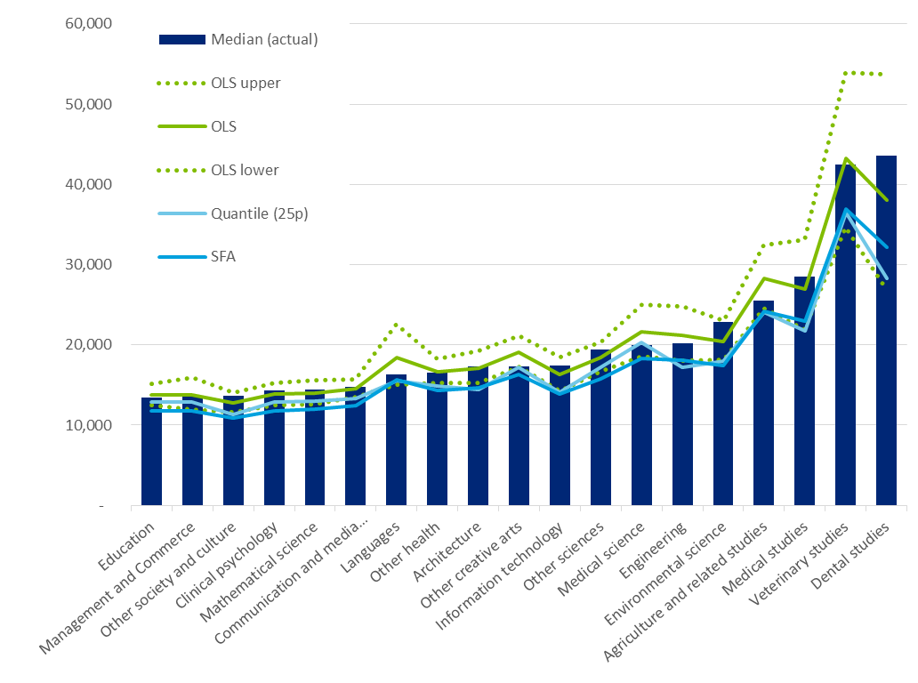

Source: Deloitte Access Economics analysis.

Note: Varied ‘contextual’ cost drivers include proportion of regional EFTSL and field fixed effects. Fixed cost drivers (set to median by FOE) include staff student ratio (log, teaching staff), proportion of casual teaching staff, and proportion of international EFTSL.

The drivers of this process of moderation towards reasonable cost (or ‘typical cost’) are observable contextual characteristics defined at a FOE and university level. The application of this model for the purposes of establishing possible funding levels would necessarily require a set of characteristics of the ‘typical’ university to be defined. For example, given that cost is found to vary on the basis of staff-student ratios (as a proxy of scale efficiency) a typical staff-student ratio may be set to define typical cost.

While costs are likely to differ across FOEs due to differences in the underlying cost drivers, even within a given field there is often significant variation in costs across different universities.

By way of illustration, Chart vii presents actual and reasonable costs estimated using OLS and quantile regression for each university in the Management and Commerce field of education at the bachelor level. Each of the predicted cost lines (aside from actual costs) is estimated using fixed values of cost drivers, while allowing for the proportion of regional EFTSL to vary (as this is likely to reflect contextual factors). Hence, the variation in predicted costs by university is limited to differences in regional students. These models of cost are thus relatively stable across universities. Equivalent measures are developed for each of the 19 FOEs included in this study.

* + 1. : Cost estimates: Total cost per EFTSL (Management and   
       Commerce, bachelor level, 2015)

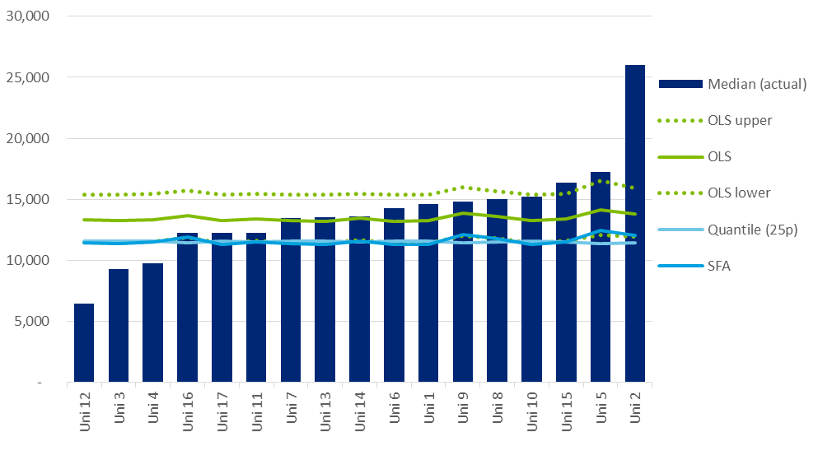

Source: Deloitte Access Economics analysis.

Note: Varied ‘contextual’ cost drivers include proportion of regional EFTSL and field fixed effects. Fixed cost drivers (set to median by FOE) include staff student ratio (log, teaching staff), proportion of casual teaching staff, and proportion of international EFTSL.

Chart vii demonstrates a significant degree of variation in actual costs across universities. Indeed, in some cases actual costs are substantially different to those predicted by each model. This could be driven by a given university having cost drivers which differ substantially from the median, unobserved factors or strategic decisions by a university to prioritise particular fields of education.

As the model shifts from OLS to a quantile regression model at the 25th percentile, the estimate of reasonable teaching and scholarship costs for a typical university delivering a Management and Commerce course falls accordingly, consistent with a move progressively closer to the bound of efficient cost. Nevertheless, the variation across these estimates of reasonable costs (OLS and quantile regression) is smaller than the range of actual costs.

The modelling conducted as part of this analysis allows for this process of moderation to be undertaken for a range of contextual factors, based on the application of defined ‘typical’ university characteristics. This allows for a like-for-like comparison to be made in defining underlying costs, to the extent that observable characteristics can sufficiently represent the cost context of a university.

In general terms, the results from the models illustrated above provide an empirical basis for generating estimates of reasonable cost for each FOE at Australian universities in 2015.

It should be emphasised that for each FOE, the resulting estimates of reasonable cost are determined by the particular value of the contextual variables used in the calculation:

* The fixed input values that are used to set the value of cost from the estimated underlying model of typical costs.
* For example, a set of staff to student ratios for each FOE must be pre-defined to reflect benchmark standards implicit in the definition of ‘reasonable cost’.
* The desired threshold of benchmark efficiency, to inform the choice of model used to determine underlying costs.
* For example, if a threshold level of efficiency is believed to be the 25th percentile of current observed cost by FOE, then the results from the quartile regression analysis may be used to define reasonable cost.

As noted, these parameters as currently set have been stylised for the purposes of this report and should be considered illustrative only. Ultimately, these assumptions must be determined by policymakers in the context of other considerations, including notions of benchmark quality in teaching and scholarship, as outlined further below.

The above analysis considers the use of a median university by field of education characteristics as ‘typical’ parameters for the purposes of illustrating how reasonable costs can be empirically derived. Other points may of course be used and, ultimately, any application of this concept must align with the underlying notion of what constitutes ‘reasonableness’.

Importantly, evidence of the effect of contextual characteristics (in particular, those which lie outside of a university’s explicit control and are not explicitly related to quality) imply that funding arrangements based on the notion of reasonable cost may appropriately vary on the basis of these contextual characteristics, as well as on the basis of FOE. Similar notions are applied to funding arrangements in schooling, where loadings are applied on the basis of higher reasonable costs faced by smaller schools, or schools located in regional or remote communities.

***Capturing quality and outcomes***

The analysis of reasonable costs presented above does not capture all of the ways in which costs may *reasonably* vary across fields of education and across universities. Indeed, unexplained variance in costs that is removed as part of this analysis may in fact be explained by important omitted variables, including those that capture variations in cost related to unobserved quality attributes (or issues associated with the co-production of research).

This is particularly important to the extent that quality may differ across universities, with this variance not perfectly accounted for by the analysis. The contextual measures considered in the above analysis can be considered partial measures of quality. For example, student-staff ratios, while being measures of scale efficiencies, also constitute an input-based measure of quality in teaching and scholarship. Similarly, in some instances, teaching and scholarship quality may be considered to be related to the co-production of research, which may occur more intensely in some disciplines than others (or in some universities over others).

In defining reasonable cost, it is necessary to define the benchmark level of quality with which it is associated. This can be done in terms of inputs, such as research intensity, staff-student ratios, or staff qualifications (for example, as defined by TEQSA’s Threshold Standards), or in terms of outcomes, such as rates of student attrition, and graduate employment and average salaries.

Similar to the approach above, benchmark standards may be defined for each FOE, in developing a measure of reasonable cost which accounts for variations in university context, while aligning cost with a benchmark standard of quality. Specific standards already exist for certain fields that are externally accredited, such as Actuarial Studies, though standards in other FOEs need not be as prescriptive. It is also important to highlight that the best understanding of quality often lies with teaching academics themselves.

Measures of cost that rely on input-based notions of quality do not guarantee alignment between cost (or any subsequent funding arrangements) and student outcomes. In principle, the notion of reasonable cost developed here would be grounded in a benchmark that relates to outcomes, as a direct measure of teaching and scholarship quality. From this, a typical cost that meets this benchmark standard may be derived. Such an approach is widely applied in other areas of education like schooling.

In practice, however, the inclusion of available outcome-based quality measures (such as graduate employment, salary outcomes and course experience questionnaires) in the OLS analysis outlined here demonstrates that there is no systematic relationship between average cost and observed outcomes, after controlling for other factors. This suggests that unexplained variance in costs cannot be attributed to available measures of outcomes, limiting the extent to which the cost data and analysis here can be further moderated to reflect typical costs towards achieving benchmark quality in outcomes.

This issue relates largely to the measurement of quality using available outcomes data from the Graduate Destinations and Experience Surveys. In particular:

* Graduate outcomes are not well defined at the FOE level, given they are measured at a course level.
* There is limited statistically significant variation in quality measures across universities.
* Small sample sizes (in particular the single year of data) limit the representativeness of university specific measures.
* Outcomes measures do not control for non-random student cohorts across universities and fields of education.
* Nor do those measures typically capture longer term dynamics in labour market outcomes.
* Favourable course experience measures have an ambiguous relationship with learning and vocational outcomes.

Noting the dearth of effective outcome-based measures of benchmark quality in defining reasonable cost, an input-based approach may be considered as an interim measure. Robust measures of outcomes would appropriately be incorporated into this analysis over time.

**Evidence from international jurisdictions**

As a final consideration when assessing reasonable costs of higher education for Australian universities, benchmark comparisons to international jurisdictions have been developed. These comparisons provide some level of insight into underlying efficient costs for different disciplines, in abstract to current funding arrangements incumbent to Australia.

Relative teaching cost comparisons in the UK, New Zealand and Australia are summarised in Charts vii and viii below. For both undergraduate and postgraduate courses, the ranking of costs by field of education is broadly consistent between these three countries:

* In particular, Health is the most expensive field of education for UK and NZ, followed by Agriculture, environmental and related studies, Engineering and related studies rounding out the top four.
* Similarly, on the other end of the spectrum, Management and Commerce, and Society and Culture have the lowest costs.
  + 1. : Average teaching and scholarship costs by field of education   
       (Cost of Management and Commerce = 1)

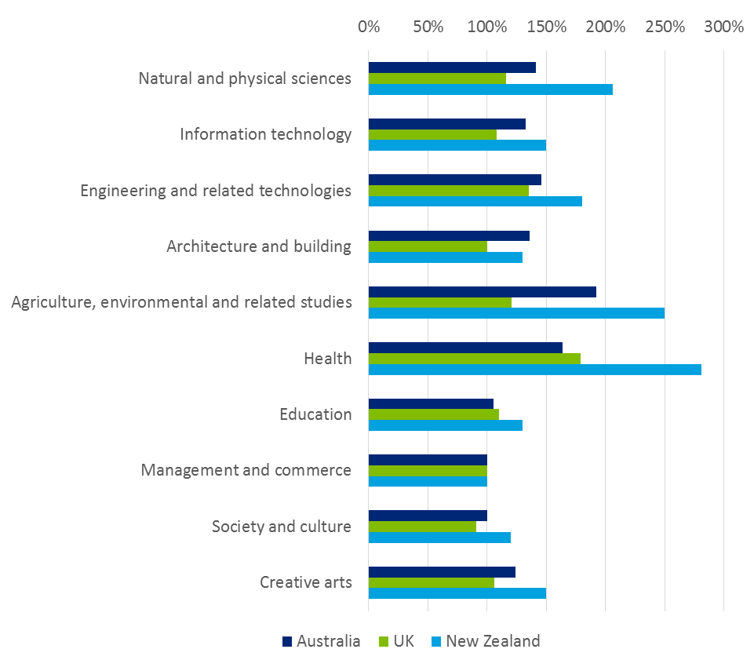

Source: Deloitte Access Economics analysis, TRAC(T) data, NZBT data.

However, the cost premium between undergraduate and postgraduate courses tends to vary between Australia and UK. In particular, postgraduate Management and Commerce and Information Technology are relatively more costly in the UK, whereas the differential is smaller in Australia. Overall, postgraduate teaching costs are higher than undergraduate costs.

In the UK, postgraduate costs are 15% to 90% higher than equivalent bachelor level costs. For Australia, this ranges between 7% (Information technology) to 90% (Natural and Physical Sciences).

* + 1. : Average teaching and scholarship costs by field of education   
       (Cost of Management and Commerce *undergraduate* = 1)

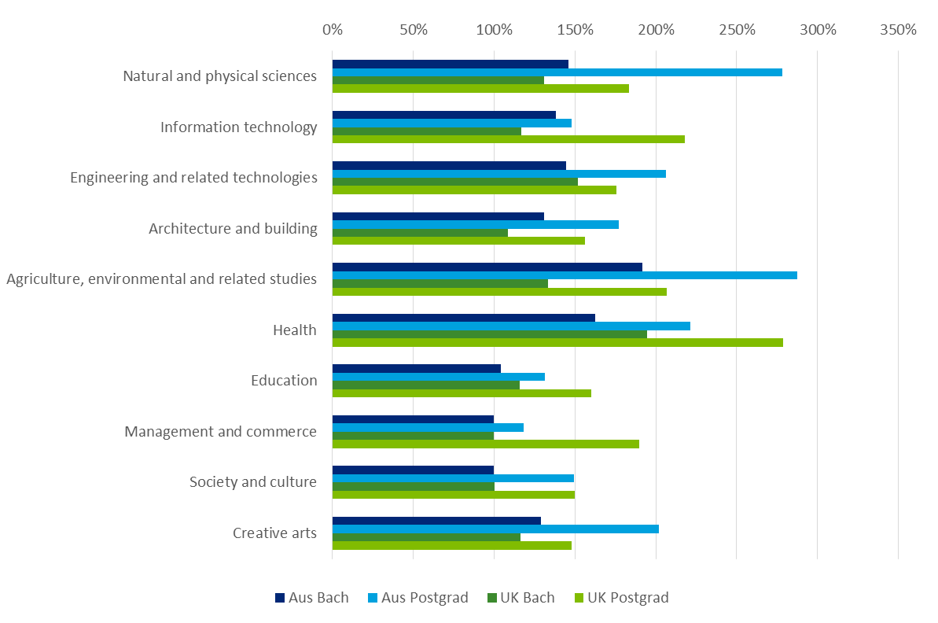

Source: Deloitte Access Economics analysis, TRAC(T) data, NZBT data.

**Implications for future higher education funding**

A future funding model for higher education teaching and scholarship must take account of a variety of considerations, of which costs of delivery are just one. However, recognising that they are among the relatively more important considerations, the discussion below outlines the implications of the analysis conducted here for future higher education funding.

*Observed cost to funding relativities*

As a measure of funding adequacy at the FOE level, the 2011 study represented the cost estimates within each broad FOE as a ratio to the base funding provided according to the CGS classification. Chart x provides a comparison between these earlier results and the comparable findings from the current study.

There are a handful of fields which recorded lower median cost/funding ratios in the current study than the previous study, such as Natural and Physical Science (0.75 compared to 0.86), Architecture and Building (0.86 compared to 0.99), and Information Technology (0.93 compared to 1.03). Two fields recorded materially higher cost/funding ratios than the previous study, being Management and Commerce (1.11 versus 1.03), and Society and Culture (1.00 versus 0.92). The spread of teaching cost to funding ratios is relatively consistent between the two studies, the main difference being the 2015 results for the moderated Architecture and Building observations are more clustered than 2010.

The bachelor teaching cost to CSP funding ratio for the 2015 data was 0.85, compared to 0.94 for the 2010 study. As noted previously, these figures cannot be compared as direct growth or decline in costs relative to funding over the five years to 2015, given the differences in the sample, and differences in cost collection approaches. Similarly, caution should be taken in drawing inferences about the sufficiency of CGS funding directly from these ratios. While not specifically stated in the *Higher Education Support Act* 2003, there is a general view that CGS funding is intended to cover some level of base research activity (which may be excluded from the definition of teaching and scholarship costs used in this study), and the cost of such research may vary as a proportion of teaching costs.

* + 1. : Cost per EFTSL relative to funding per EFTSL (bachelor level, outliers removed)

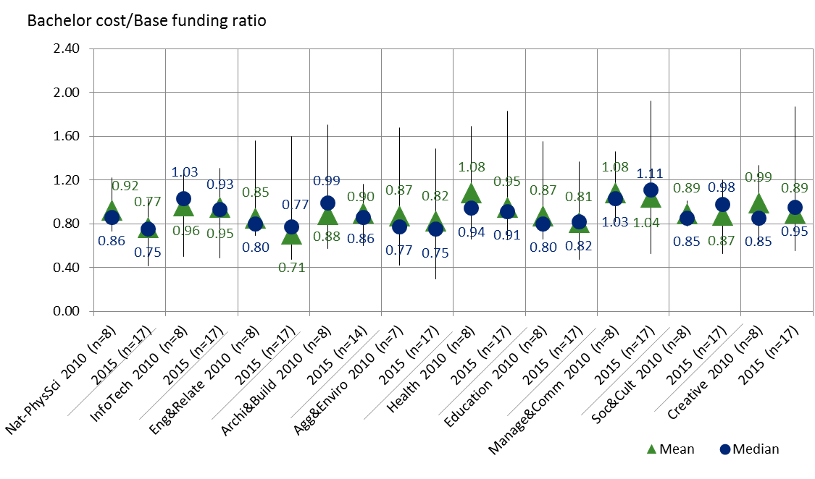

Source: Deloitte Access Economics analysis.

At the more disaggregated level, costs per EFTSL relative to CSP funding follows a similar broad pattern to the overall costs per EFTSL charts previously presented. At this disaggregated level, the two fields of education where recorded costs exceed funding at the 25th percentile are Veterinary Studies, and Management and Commerce. The 25th percentile cost for Dental Studies is close to the funding rate. The fields of education where recorded funding exceed costs at the 75th percentile are Mathematics, Medical Science, Other Natural and Physical Science, Engineering and Related Studies, Environmental Science, Other Health, Education, and Communications and Media.

* + 1. : Cost/funding relativity at 19 field of education level (bachelor level, outliers removed)

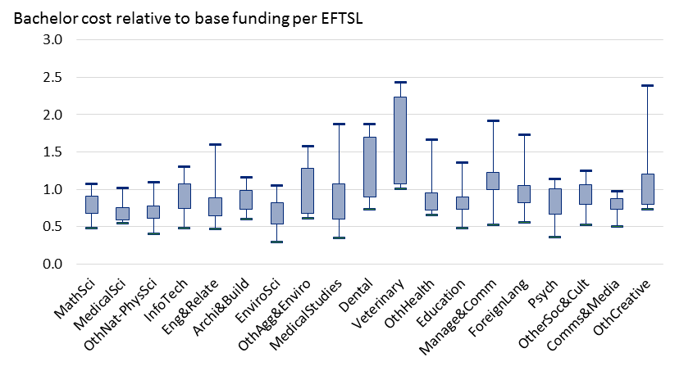

Source: Deloitte Access Economics analysis.

*Broader funding model design considerations*

As noted, the current funding arrangements for teaching and scholarship find their legacy in the Relative Funding Model (RFM) designed in the mid-1990s. Both the original RFM and the subsequent CGS funding clusters were designed to allocate aggregate base funding amounts to universities that fairly reflected their respective discipline mixes. Such a model was considered appropriate in a funding system where there was a fixed amount of funding available and targets were agreed for places to be offered in different disciplines.

However, as noted in the 2011 Base Funding Review, the introduction of the Demand Driven System has meant that universities are now responsible for decisions about the number of places they offer in each discipline at the bachelor degree level. Indeed, it is generally understood that university decisions regarding enrolment numbers (by discipline) are influenced, at least to some degree, by the extent to which discipline funding matches the costs of provision. This is not to discount the role that mission, strategy, and community responsibility play in determining course offerings.

In this context, the parameters underpinning the current RFM are not only dated, but potentially misaligned with how the approach to delivering teaching and scholarship has changed over time (and the implications of this for the associated costs).

The evidence developed as part of this study provides a contemporary basis for understanding relativities in costs across fields of education and qualification levels in Australian universities, with implications for the re-calibration of relative base funding. While its findings are not immediately and directly transferrable to funding calibration – which would take into account various other factors of funding design – they provide a rich base of evidence to inform these considerations (albeit one that might ideally be richer).

Empirical analysis of the cost information provided as part of this study has revealed the underlying drivers of cost across universities and fields of education. These drivers provide insights into the determination of reasonable cost measures across disciplines and FOE. Further, exploratory analysis of the underlying efficiency of universities by FOE gives some indication of the nature of reasonable cost towards achieving benchmark levels of quality, and how this appropriately varies across different contexts.

Importantly, while this study gives some insight into reasonable relative costs of higher education teaching and scholarship on the basis of observable characteristics, a robust (absolute) measure of reasonable cost relies on specific and measurable benchmark parameters relating to quality, to be defined by policymakers (a point emphasised by previous reviews of cost and funding in higher education, such as the 2003 Nelson review).

Further, the empirical analysis presented here is not without its limitations. Most notably, the possibility of omitted variables related to quality or other important contextual factors may mean that estimated underlying costs are subject to bias, with implications for interpretation for the purposes of funding calibration. It is also not necessarily straightforward to apply measures of reasonable cost, as outlined here, to relative funding rates of teaching and scholarship at Australian universities. In particular, funding calibration must also pay due regard to the benefits (especially the ‘external’ or ‘public’ benefits) associated with higher education teaching and scholarship, and the incentives established by funding arrangements with respect to the production of higher education in different fields and disciplines.

Consideration should also be given to how the cost evidence provided here is likely to change into the future, in both relative and absolute terms. Underlying trends in the costs of higher education staff, and changing models and structures to the delivery of teaching and scholarship imply that these costs are likely to change over time. In particular, consideration should be given to fields of education that are most likely to be disrupted by changes to technology and pedagogical approaches to teaching and scholarship (including more traditional lecture and tutorial based fields). The application of any construct of reasonable cost should explicitly consider these underlying changes to approaches to course delivery, particularly as they relate to standards and notions of quality that inform measures of reasonable cost.

**Concluding observations**

The evidence and analysis provided here will be a crucial element of a larger set of information that must be considered by policymakers and government in making changes to base funding arrangements for the Australian higher education sector, with the intent of driving improvements in overall system outcomes and enhancing the efficiency and effectiveness of public funding.

Looking forward, ongoing updates and refinement of the underlying data used for this analysis will play an important role in improving the robustness of the evidence used for policy purposes and the quality of insights available from research and analysis such as that presented here. Notable areas for further improvement include:

* development of a robust consensus definition of research costs (as distinct from teaching costs) to inform future collections of relative cost data and any associated changes to funding arrangements;
* a more formalised and ongoing process of data collection between government and universities, potentially linking in with existing statutory reporting arrangements;
* expanding the approach to data collection to incorporate a broader range of disciplines in order to reveal more meaningful clusters of like courses on the basis of unit level cost relativities;
* enhancing available outcome measures for the purposes of measuring the quality of teaching and scholarship; and
* the application of robust outcome measures to define benchmark standards of quality when measuring relative efficiency, to ultimately ensure an accurately estimated efficiency frontier is revealed.

Deloitte Access Economics

# Background

## The context to this report

Australian universities play a critical role in generating human capital and skills for Australia’s workforce, driving productivity growth through innovative research and development, and enriching local communities through engagement and outreach.

Australia’s university sector contributed around $25 billion to the Australian economy in 2013, accounting for over 1.5% of Australia’s GDP and 160,000 fulltime equivalent (FTE) jobs. In 2014–15, education related exports accounted for 5.7% of Australia’s total exports, representing the largest service export and the third largest export category overall. Higher education is the single biggest contributor to this, representing around two-thirds of the total value (Deloitte Access Economics, 2015).

In supporting this research and teaching activity, Australia’s universities receive more than 60% of their income directly from the government, mostly via teaching and research grants and HELP payments (for which domestic students are liable) (Department of Education and Training, 2015b). In broad terms, this funding recognises and supports the activities conducted by universities and the benefits they generate.

The way in which this funding is provided, in terms of the specific teaching and research activities it is intended to support, has the potential to influence the behaviour of university institutions, in particular when it comes to the number of places that are offered for students in given subject areas and disciplines. This influence is an important element of effective funding policy, as government provides support to universities to conduct certain activities on the basis of the relative private and public benefits that they generate in society, as emphasised by the federal Minister for Education and Training:

“a key part of what I’m thinking about during higher education policy discussions is about the incentives that exist, how universities respond to those incentives and if we are to ensure that we actually get universities thinking about numbers of students they enrol and the disciplines they enrol in, then we need to make sure that they are driven in their thinking by what is in the best interests of the student and the need of the national economy.”

Senator the Hon Simon Birmingham,   
Speech to ADC Forum Education Summit, 12 August 2016

Importantly, government funding arrangements are just one factor that affects the incentives and priorities of universities in delivery on their teaching, learning and research missions. Universities are predominantly self-accrediting, and largely autonomous public institutions, each with a different founding purpose and social mission. Within each of these social missions and unique community contexts, the delivery of teaching and scholarship programs in different fields of education, and towards different academic and vocational outcomes, can and does vary.

As such, it need not necessarily be expected that uniform funding arrangements for teaching and research create the same incentives and behaviours in every context. Nonetheless, the generalised effects of given funding arrangements are a critical consideration for government—in particular, when considering the broader context of economic development in the 21st century, and the increased reliance on the effective supply of higher education skills for industry.

In the context of current funding arrangements for university teaching and scholarship, where funding rates for a given course are in excess of actual costs, institutions may have an incentive to increase enrolments in that discipline, with the converse being true for relatively underfunded disciplines. In general terms, this may lead to a misallocation of higher education skills in the economy, leading to lost economic productivity and lower living standards. Further still, universities’ reputation and performance is driven primarily by measured success in academic research, and in practice, funding intended to support particular research and teaching activities is understood to support activities in other areas, in line with the strategic objectives of the individual institution.

Potential imbalances in funding relativities create a financial dilemma for universities that, as public institutions, intend to respond to student demand and the objectives of government implicit in relative funding rates (that reflect relative public benefits)—most significantly because of the pre-eminence of research outcomes as a measure of institutional success and reputation, and the subsequent financial benefits that this may generate (including through international student fees).

Appropriately calibrating the funding relativities between disciplines, qualification levels, and providers is therefore critical to supporting a higher education system which maximises the contribution made by higher education human capital in the labour market, and society more broadly.

**Such calibration is necessarily informed by robust measures of relative cost of delivery for institutions**. Indeed, current funding arrangements for teaching and scholarship (as part of the Commonwealth Grant Scheme (CGS)) find their legacy in the Relative Funding Model (RFM) designed in the mid-1990s. Both the original RFM and the subsequent CGS funding clusters were designed to allocate aggregate base funding amounts to universities that fairly reflected their respective discipline mixes. This model did not rely on a precise measure of cost at a discipline level, rather it focused on capturing relative average costs across disciplines. Such a model was considered appropriate in a funding system where there was a fixed amount of funding available and targets were agreed for places to be offered in different disciplines (Department of Education and Training, 2015a).

However, as noted in the Base Funding Review conducted in 2011, the introduction of the ‘Demand Driven System’ has meant that universities are now responsible for decisions about the number of places they offer in each discipline at the bachelor degree level. Indeed, it is generally understood that university decisions regarding enrolment numbers (by discipline) are influenced by the extent to which discipline funding matches the costs of provision.

In this context, the assumptions underpinning the current RFM are around two decades out of date, and the incumbent relativities between disciplines do not necessarily recognise how the approach to delivering teaching and scholarship has changed over time (and the implications of this for the associated costs).

Noting the significant growth and change experienced by the sector since current funding arrangements were established in the mid 1990s, it is a necessary and appropriate time to re‑evaluate the underlying variations in cost by field of education and qualification level for Australian universities, through a robust, comprehensive and collaborative study. The outcomes of this study will ultimately provide a contemporary measure of the relative costs of delivery of higher education to inform possible future higher education policy, including with respect to funding arrangements.

### This report

The most contemporary and detailed previous work on university teaching costs was conducted for the then Department of Employment, Education and Workplace Relations (the Department) by Deloitte Access Economics in 2011. The study collected primary cost data from a set of eight Australian universities to investigate the cost of provision by field of education. It identified both the average cost of provision, the relative costs across fields and universities in Australia, as well as identifying some of the key drivers of these costs.

However, ongoing trends in the higher education sector, both directly related to costs as well as expectations around course delivery (which will have implications for cost), are likely to have altered the reasonable cost of higher education teaching and scholarship. There is therefore a need for more up-to-date cost information on which to base policy.

Against this backdrop, Deloitte Access Economics has been commissioned by the Department to undertake new analysis of the cost of university teaching and scholarship based on data from the calendar year 2015. While in part an update of the 2011 study (which captured data from the 2010 calendar year), the findings of this current report differ somewhat from that work:

* as noted, the higher education sector itself has changed over this period, and will continue to evolve into the future: underlying costs in areas such as salaries and clinical placements have increased at a rate faster than inflation, and the uncapping of university places has altered the composition of student intake across the sector;
* the current study is based on data from approximately twice as many universities as the previous analysis, with increased numbers implying the likelihood of a more representative sample and more robust statistical analysis; and
* a more comprehensive consideration of the notion of ‘reasonable cost’ is considered in this study, recognising its relevance to possible changes to higher education funding policy.

This report has the following structure:

* The remainder of Chapter 1 summarises the findings from previous studies of the relative cost of higher education, and identifies some of the major trends relevant to the cost of higher education;
* Chapter 2 provides an overview of the process of data collection for this study, including the participating universities and representativeness of the available data;
* Chapter 3 summarises and describes the cost data collected as part of this study, and how it varies across fields of education, qualification levels and universities;
* Chapter 4 introduces the concept of reasonable cost, establishing a conceptual framework to inform a working definition for this study, and relevant empirical methods that may be applied;
* Chapter 5 presents findings with respect to measures of reasonable cost, including relative costs across fields of education, qualification levels and universities;
* Chapter 6 outlines the findings from research into comparable benchmark costs from international jurisdictions, including New Zealand and the United Kingdom (UK); and
* Chapter 7 completes this report with a summary of the study’s findings and key conclusions.

### Previous studies and reviews

A number of notable Australian studies and reviews have sought to understand and measure the relative cost of higher education teaching and scholarship, as well as research, at Australian universities. This section provides a brief overview of these studies.

Deloitte Access Economics’ 2011 study

In the context of transitioning to a student demand driven system, and following the recommendations of the 2008 Bradley Review, as part of the 2011 Base Funding Review Deloitte Access Economics was commissioned to determine the actual and relative costs of teaching and scholarship at Australian universities and identify any systematic cost drivers. Prior to this current study, this original analysis by Deloitte Access Economics remained *“the best published source on teaching and scholarship costs in Australia”* (Norton and Cherastidtham, 2015).

In the 2011 study, a data collection tool was developed and used to capture quantitative and qualitative costing and expenditure information from a strategic sample of eight Australian universities.[5] Broadly, the quantitative collections covered enrolments, staff sizes, budgetary unit-level costs, central costs and allocation of costs, whilst the qualitative components were themed on approaches to allocating and estimating costs by universities, specifics regarding the university funding model, and pressure points in funding current teaching and scholarship costs.

In summary, this study found that:

* research represented, on average, around 20% of reported mean cost per EFTSL; with this cross-subsidisation varying across disciplines, levels (with greater research cost for postgraduates) and institutions themselves;
* teaching and scholarship cost per EFTSL for given fields of education (i.e. disciplines) varies considerably across institutions, and the degree of variation is more significant for certain disciplines (most notably: Agriculture, Environment and Related Studies; and Health); and
* there is some evidence to suggest under and over funding relative to costs is present for particular disciplines, however these appear to vary across institutions due to unobserved institutional characteristics and strategies.

The report recognised that the analysis conducted was an accounting exercise and a snapshot of university expenses, and that future research should seek to understand the true economic costs in order to reveal a more complete picture of university teaching and scholarship.

In particular, higher postgraduate coursework enrolments, higher proportions of fee-paying students, higher staff-student ratios and greater research intensity were associated with higher teaching and scholarship costs. However, the analysis was unable to identify ‘causal effects’ and it is not explicitly clear whether the relationship between each of these characteristics and teaching costs are direct, or whether these higher costs are indirectly induced as a result of co-related revenue levels.

Further examination of the data collected as part of this study—including through regression analysis, face-to-face meetings and case studies—suggested that universities largely were tailoring their courses to reflect, or in response to, the funding they received (with some exceptions). The results from the Deloitte Access Economics study supported the Base Funding Review in developing its findings and recommendations with respect to the efficacy of current funding arrangements for higher education teaching and scholarship.

The Base Funding Review concluded that the current funding model design did not reflect the efficient cost of delivery, and thus a high degree of cross-subsidisation across disciplines had become the norm and necessary. In line with this finding, specific changes to student and government contribution rates were recommended by the Review; however these changes were not ultimately implemented by Government.

Norton and Cherastidtham’s 2015‘Cash nexus’ report

The key principle which informed the Base Funding Review was that the purpose of base funding was to “*support universities in their fundamental role of providing teaching and scholarship informed by scholarship and a base capability in research”*. Notably, this explicitly assumes that some sufficient level of research is required for quality higher education teaching, and that at least some part of student base funding should reflect this.

While this conclusion is founded in an observation that current funding for teaching and scholarship captures costs related to university research, this *purpose* of government funding has been examined by some researchers, most notably the Grattan Institute in its report *The cash nexus: how teaching funds research in Australian universities* (Norton and Cherastidtham, 2015).

Norton and Cherastidtham note that there is increasing pressure for universities to direct more spending to research, drawing on observations from the limited numbers and coverage of research grants, academic preferences, and stated university performance strategies; whilst the incentives to spend more on teaching appear to be more limited.

Critically, the authors note that while students may benefit in part from reputational effects of universities—that are the result of successful research outcomes—the empirical evidence suggests (both in Australia and internationally) that differences in research reputation across universities (and non-university higher education providers) have little apparent relationship with the quality of teaching and scholarship programs, in terms of observable student outcomes.

Given these patterns, Norton and Cherastidtham posit that additional money for higher education is unlikely to improve student learning and outcomes, and that more information is required to understand and realise the incentives for universities to spend funding on students. In order to drive this, the authors recommend the introduction of activity-based costing and to shift the focus on *why* money is spent, rather than *what* it is spent on.

Norton and Cherastidtham’s study draws explicitly on the findings of the Deloitte Access Economics (2011) study discussed here. Using the findings from this analysis, the authors identify specific disciplines and fields of education where levels of funding exceed, and fall below, measured costs of delivery, and that a significant degree of teaching and research cross-subsidisation across university faculties is present. In particular, they conclude that much of the surplus from teaching is generated by Commerce faculties, but the additional research spending is mainly in other faculties. An important difference between the Norton and Cherastidtham finding, and those contained within this work, is that the teaching surplus is generated from full-fee paying students, including domestic postgraduate students, and international students.

Deloitte Access Economics’ 2014 study

In order to inform undergraduate funding policy for non-university higher education providers (NUHEPs) and sub-bachelor degrees, Deloitte Access Economics (2014) was commissioned to examine the differences in efficient cost between (1) university and NUHEPs, in the context of bachelor places; and (2) bachelor and sub-bachelor places for all higher education institutions.

While this study did not consider the relative cost of higher education teaching and scholarship in terms of disciplines, original cost data was collected through a targeted survey of universities and NUHEPs to estimate the difference in efficient cost between providers, and for sub-bachelor places, relative to bachelor places, across both institutions. The findings from this study have not been made public, however they have informed and largely validate the findings of the research conducted as part of this current study.

In the 2014 study, consideration was also given to the role of funding for teaching and scholarship to support research activity at universities. This study confirmed the finding of Deloitte Access Economics (2011)—and subsequently, Norton and Cherastidtham (2015)—that funding provided specifically for the purpose of supporting research activity falls below the attributable cost of that research activity.

Importantly however, this study also found that the operating surplus from other university activities (in some instances) covers the shortfall between funding and cost for research. This suggests that CGS funding is not necessarily used (universally) to fund research activity.

Ultimately, this study concluded that an understanding of the policy intent of government, and the subsequent strategic decisions made by universities in response to this intent, plays a critical role in assessing the appropriate universal efficient cost attributable to teaching and scholarship activity at Australian universities.

Overall, these studies have provided evidence to suggest that current funding arrangements do not accurately reflect relative costs for delivery, in terms of disciplines, qualification levels and across provider types. While the evidence collected through these studies gives some indication as to the limitations of current funding arrangements, it is neither detailed enough, sufficiently comprehensive, nor appropriately contemporary, to allow for funding policy changes to be made with regard to current funding arrangements. Further detailed data collection, careful research and analysis is necessary, and therefore provides further motivation for the evidence collected as part of this study.

## Trends in higher education delivery

### Changes in student load

Chart 1.1 shows enrolment count by field of education (FOE) by year, from 2011 to 2015. Management and Commerce is the field with the highest enrolment (370,000 in 2015), while the categories of Mixed Field Studies (11,100 in 2015) and Food Hospitality (600 in 2015) have the lowest enrolment. The average annual growth across all FOEs over this period was 3%. Mixed Field Programs (8% growth), Health (6% growth) and Natural Physical Sciences (5% growth), were the FOEs with the highest average annual growth, while Non-award courses (decline of 1%) and Agriculture Environment (0% growth) experienced the lowest average annual growth. The remaining FOEs tracked at an average annual growth rate within the 2% to 4% range.

Chart 1.2 shows changes in student load by jurisdiction, from the period of 2011 to 2015. New South Wales is the State with the highest enrolment (430,000 in 2015) while the Northern Territory had the lowest enrolment numbers (12,000 in 2015). Tasmania (7% growth), Northern Territory (8% growth) and Multi-State institutions (9% growth) saw annual growth percentages higher than average. The remaining regions had an average annual growth rate within 2% to 4%.

: Student enrolments over time, by field of education (count)

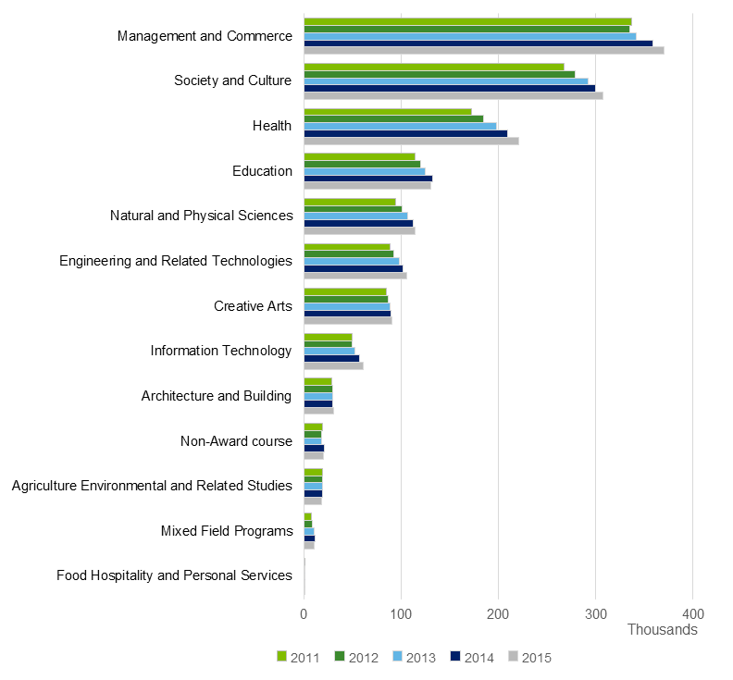

Source: Department of Education and Training

: Student enrolments over time, by state (count)

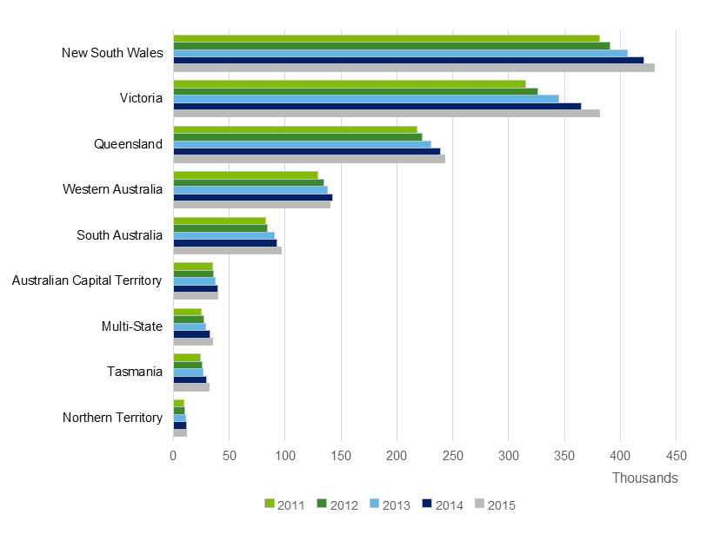

Source: Department of Education and Training

As shown in Chart 1.3, the distribution of students by liability status effectively stayed consistent between 2011 and 2015. Within the domestic fee-paying students, there was a slight increase in the count of FEE-HELP students as well as a slight decrease in the count of full fee paying students.

: Share of domestic students by liability status (comparison of 2011 and 2015)

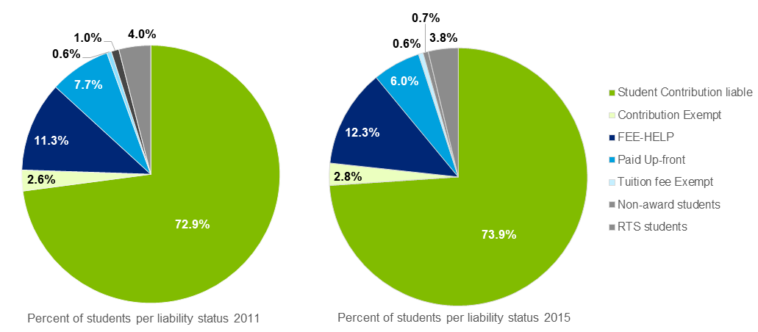

Source: Department of Education and Training

### Mode of delivery

The mode of delivery compares enrolment counts of students attending classes on campus (internal) relative to students attending courses online (external). Multi-modal indicates a combination of internal and external. Between 2011 and 2015, the share of internal student enrolments has decreased (from 80% to 75%) while the shares of external and multi-modal student enrolments has increased (from 13% to 15%, and 7% to 11%, respectively).

As noted in Chart 1.4, the Northern Territory is the region with the largest percentage of external students (57% in 2015) and multi-modal students (18% in 2015). Between 2011 and 2015, Tasmania saw an increase in the percent of external students; increasing from 17% to 38% of total Tasmanian student enrolments. While Victoria has the highest percentage of internal students, the percentage of internal students decreased from 87% in 2011 to 79% in 2015.

: Share of student enrolments by delivery mode

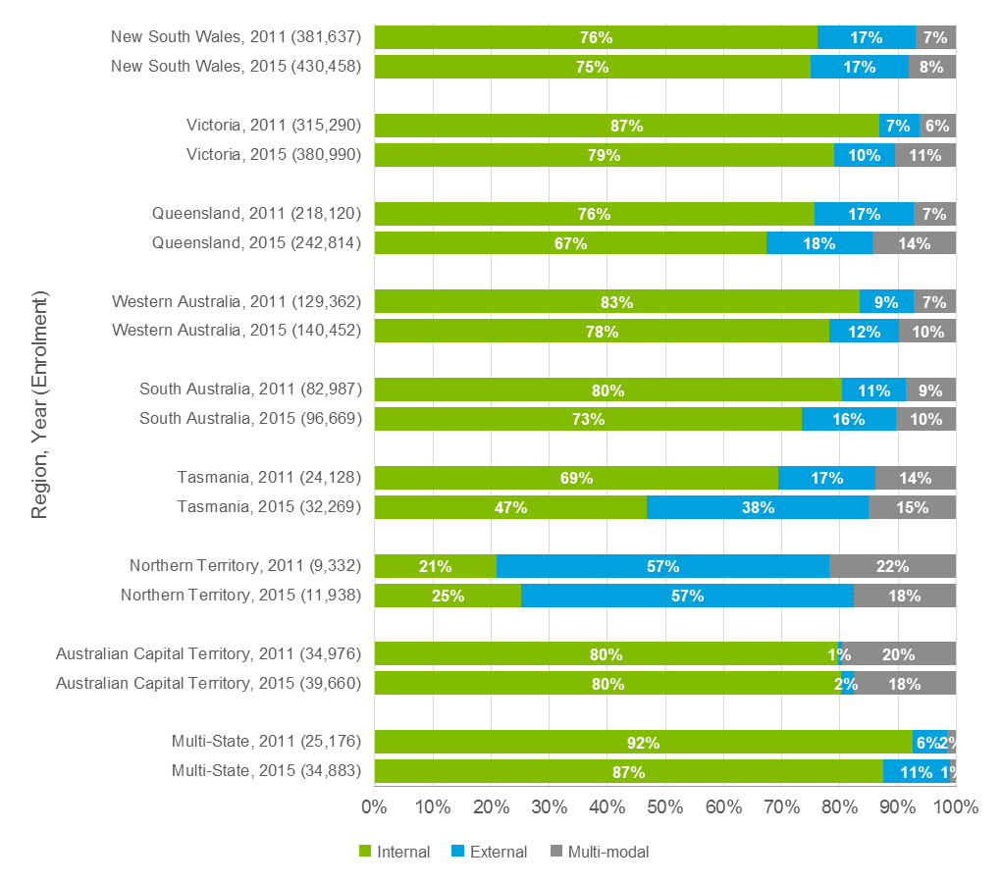

Source: Department of Education and Training

Note: External students’ state location is determined by their university, not where they live. That is, students may live in a different state to where they are studying externally.

### International student enrolments

Chart 1.5 shows international student enrolment count by field of education (FOE) by year, from the period of 2011 to 2015. Management and Commerce is the field with the highest enrolments (180,000 in 2015). Enrolment for Management and Commerce is 4.7 times higher than the second highest field, Engineering and Related Technologies (38,000 in 2015). The categories of Mixed Field Programs (11,000 in 2015) and Food Hospitality (300 in 2015) have the lowest enrolments.

The average year-on-year growth across all FOEs was 2%. Mixed Field Programs (7% growth), Engineering and Related Technologies (7%) and Agriculture Environmental and Related Studies (7% growth), were the FOEs with the highest average annual growth. Creative Arts (decline of 3%), Education (decline of 2%) and Food Hospitality (decline of 11%) were the FOEs with the lowest average annual growth. The remaining FOEs tracked at an average annual growth rate within 0% to 4%.

: International student enrolment counts, by field of education and year

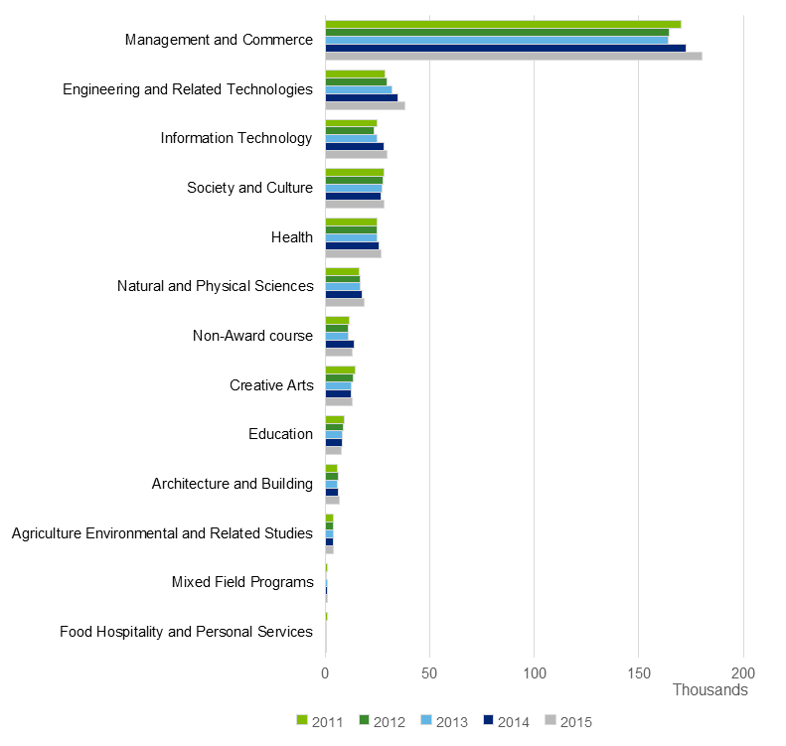

Source: Department of Education and Training

As shown in Chart 1.6, the year over year growth of international student enrolment counts slowed in 2012 (decline of 3%) and 2013 (1% growth), however they increased again in 2014 (6% growth) and 2015 (4% growth). Between 2011 and 2016, overseas student enrolment fluctuated between 23% to 25% of total student enrolments.

: Enrolment counts of domestic and overseas students

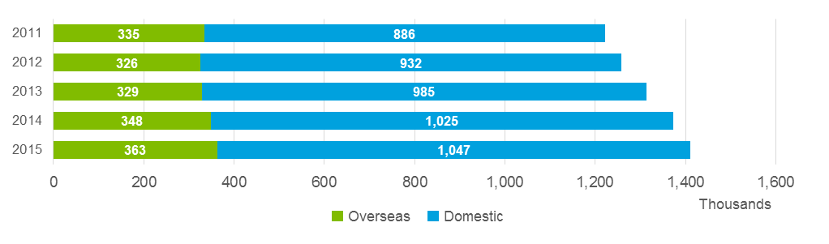

Source: Department of Education and Training

### Key cost escalators

As shown in Chart 1.7, all academic ranks saw a pay increase within the 6% to 8% range between 2014 and 2016. Norton and Cakitaki (2016) analysed enterprise bargaining agreements (EBAs) and found that the majority of individuals undertaking academic work did so on a fixed-term or casual contract, despite those EBAs restricting the use of fixed-term contracts. In 2013, 35% of the total of full-time equivalent academic staff were on a fixed-term contract and this increased to 40% in 2015.

: Academic pay ranges

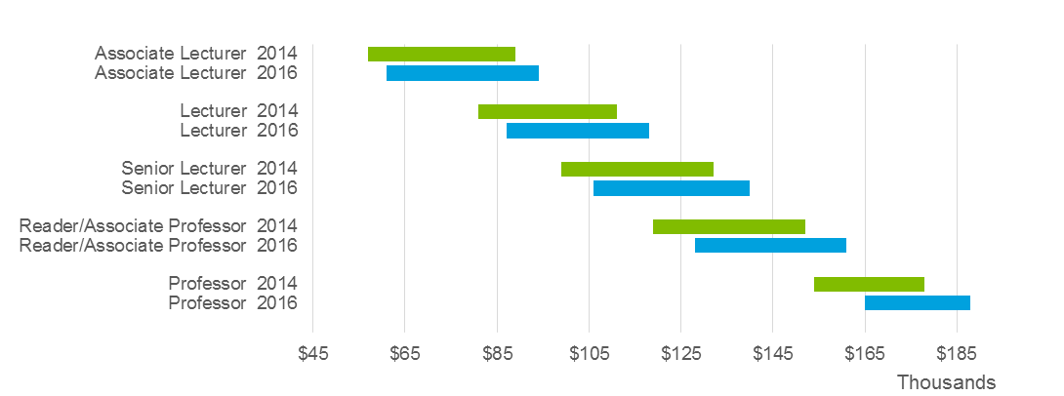

Source: Norton and Cakitaki (2016)

The student-to-staff ratio for Australian higher education has increased by approximately 4.7% on average over the past four years (Chart 1.8). The combined international and domestic student enrolments grew faster than the number of university staff, from 11.1 in 2011 to 11.6 in 2014. Meanwhile university staff on permanent and fixed term contracts have grown from approximately 110,000 in 2011 to 118,000 in 2014. Note, the university staff figures do not include casual employees.

: Student-to-staff ratio

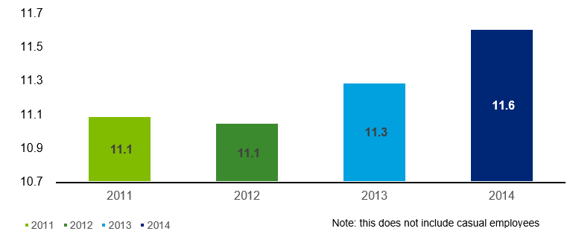

Source: Norton and Cakitaki (2016)

Between 2009 and 2013, there was a 25% increase in the number of full time students in health related courses (Bowles et al, 2014). This increase in students has created an increased need for clinical placements and their costs. At the same time, the National Health Reform Agreement (NHRA) was signed in 2011 which transitioned the public health system for activity based funding (ABF). The result of this transition was to bring increased focus on the costs for clinical placements incurred by the host organisation and invoiced to the higher education provider (Bowles et al, 2014).

In response to the increasing costs to universities of these clinical placements, some states have developed frameworks to standardise the costs and facilitate management of placements. Examples include the Victorian Clinical Placement Councils fee schedule (VCTC, 2013) and the Health Practitioners (Queensland Health) Certified Agreement (Bride et al, 2015).

### Benchmarking cost growth

Incorporating a robust benchmark of cost growth over time is an important consideration for this study, which seeks to capture a contemporary view of relative costs of higher education at Australian universities based on a survey of data. Drawing on the financial performance data reported by Table A higher education providers to the Australian Government (largely comprising Australian public universities), an analysis of growth in costs for universities has been undertaken. This is an instructive point of reference, given these data are sourced directly from audited accounts, and so are highly credible.

In 2015, the total expenditure of Australia’s public universities was around $26.4 billionincluding all research and commercial costs, representing a 35% increase (around 7% annually) from 2010 levels. Total operating revenue in 2015 was recorded at just over $28.1 billion, up 31% in absolute terms from 2010 (around 6% annually).

This increase in total revenue and cost coincided with a 16% increase in total student load (around 3% annually). As such total expenses (costs) in per EFTSL terms grew 16% from 2010 to 2015, while total revenue per EFTSL grew 12%, or around 3% and 2.5% in average annual growth for total costs and revenue, respectively. It is important to note here that since costs include all research and commercial operations, these figures are not directly comparable to the data collected from participants presented in Chapter 3.

The difference between total revenue and total costs is the overall net operating result for Australian public universities. In 2015, the total net operating position of these universities was around $1.7 billion, equivalent to 6% of total revenue. This is down from 9% of total revenue in 2010.

Chart 1.9 and Chart 1.10 below summarise total expenses and revenue at all Australian public universities by category from 2010 to 2015. Employee related expenses represent the largest component of total expenses at universities, with these costs split relatively evenly between academic and non-academic employees.

Over 60% of total revenue for these universities come from government (predominately Commonwealth government), with the next most significant category of income being fees and charges for students, in particular fee paying overseas students (which accounted for around 19% of total revenue in 2015).

: Total expenses and net operating result for Australian public universities,   
by category (2010-2015), $billions

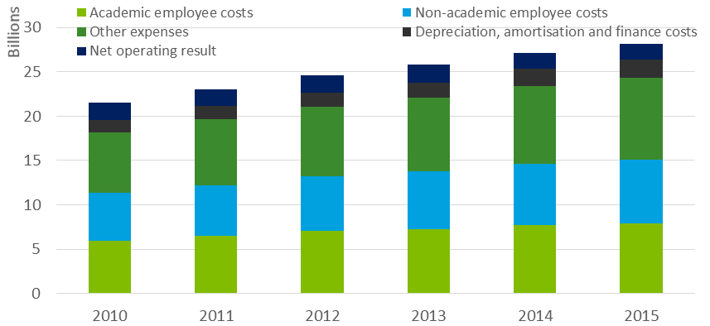

Source: DET university financial performance data.

: Total revenue for Australian public universities,   
by category (2010-2015), $billions

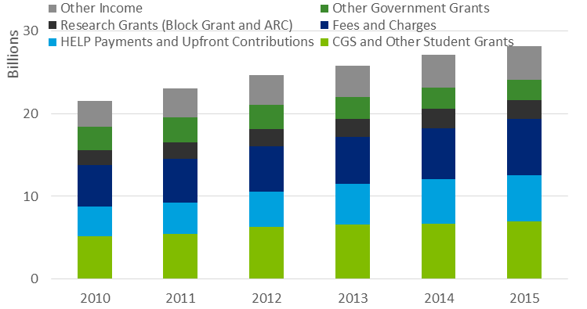

Source: DET university financial performance data.

Expanding on the above data, the key components of growth in cost from 2010 to 2015 can be apportioned between academic and non-academic staff costs, depreciation and amortisation and other expenses, in per EFTSL terms. As shown in Chart 1.11, the rate of growth in proportional terms was highest for depreciation and amortisation expenses (illustrative of capital deepening occurring in the sector over this period).[6] In absolute terms, the largest contributor to cost growth was growth in other expenses, driven in part by growth in the cost of grants and scholarships.

: Average growth in expenses per EFTSL (2010-2015)

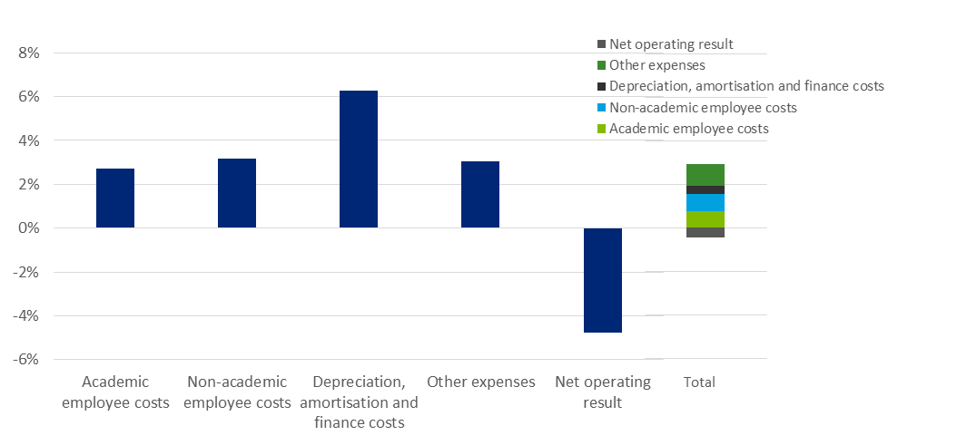

Source: DET university financial performance data.

: Average growth in revenue per EFTSL (2010-2015)

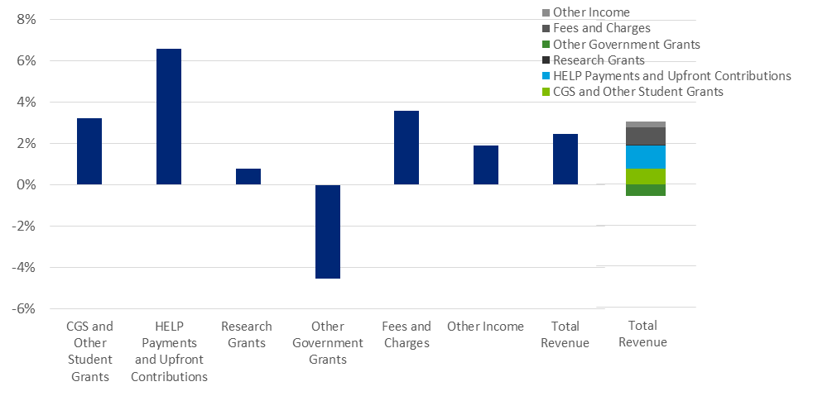

Source: DET university financial performance data.

A disaggregation of average revenue growth from 2010 to 2015 shows the largest contributors to growth were HELP payments and upfront student contributions, and income from student fees and charges. As shown in Chart 1.12, growth in CGS and Other Student Grants was only slightly above the average growth in revenue. Revenue growth from Research Grants was relatively modest over this period, while income from Other Government Grants fell considerably.

Overall cost growth can also be split between growth in total EFTSL, and per-EFTSL cost growth (See Chart 1.13). In general, across each year, there is an inverse relationship between EFTSL growth and cost per EFTSL growth, suggesting the presence of fixed (in EFTSL terms) factors of cost growth which lead to scale economies in cost being realised in years with higher load growth. Among other factors, this may be the result of relatively fixed staff and employee cost profiles in a given year, indicating that cost per EFTSL efficiencies are realised in the form of lower staff to student ratios.

: Cost and EFTSL growth (2010-2015)

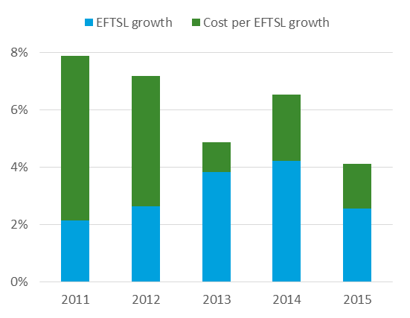

Source: DET university financial performance data.

Chart 1.14 below similarly breaks down cost growth between growth in total staff (FTE) numbers, and average costs per FTE. A broadly inverse relationship between EFTSL growth and FTE growth (on a year by year basis) is apparent over this period. This may further explain the variations in cost per EFTSL growth observed over this period.

: Cost and FTE growth (2010-2015)

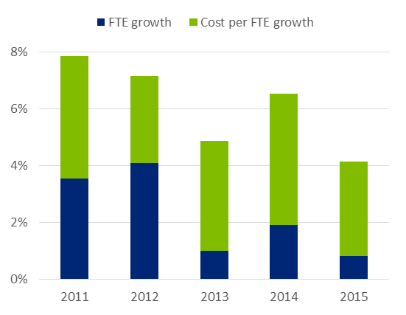

Source: DET university financial performance data.

The above chart shows that average growth in cost per FTE has been relatively stable over this period (ranging between 3.1% and 4.6%). This growth also exceeds the average overall annual increase in costs (and revenue) per EFTSL over this period. Critically, at an aggregate level, increases in per FTE costs have been offset by growing student load, which have allowed universities to maintain a stable financial position despite relatively moderate revenue growth. It is important to note that these cost per FTE fluctuations may reflect compositional changes in staff mix, between casual and academic, and research and teaching staff.

To further illustrate this point, over the period 2010-2015, average employee costs per EFTSL grew by 15%, or around 3% annually. This was despite total employee costs growing by around 7% annually over this same period.

Employee cost per EFTSL can be decomposed into changes in average staff costs and the ratio of staff to students. Between 2010 and 2015, average costs per staff member (academic and non-academic) grew by 3.7% annually, while staff to student ratios (total FTE per EFTSL) fell by 0.7% annually, resulting in the total employee costs per EFTSL growing at 3% annually.

By way of illustration, assuming that the staff to student ratios had remained unchanged since 2015, at current average costs and EFTSL levels, total costs from 2010 to 2015 would have increased by almost 38%, equating to an additional $500 million over this five year period.

This implies that universities have offset growing costs in employee wages by realising scale efficiencies and lowering the number of staff per EFTSL. While this represents prima facie evidence of scale efficiencies in the system resulting in proportionally lower rates of per EFTSL cost growth, it is not clear the extent to which these scale economies can continue to be realised post the implementation of the demand driven system, or the impact that changes to staff to student ratios has on the quality of teaching and scholarship, and ultimately student outcomes. These observations should be considered carefully when making general assessments of cost growth from survey data over the period 2010 to 2015.

### Operations

The use of Activity Based Costing (ABC) accounting systems and models have continued to gain traction in the Australian higher education sector. A number of benefits are associated with Activity Based Costing (Norton and Cherastidtham, 2015), including:

* Allowing for more detailed analysis of performance against benchmarks, outcomes and standards as opposed to purely historical expenditure.
* Higher education providers can better understand where there are genuine cost differences (for example online versus on-campus delivery, better support of regional campuses and providers with academically disadvantaged students).
* Allowing for greater transparency of teaching and research spending (including verification of appropriate use of funding).

While it is difficult to accurately quantify the number of universities and higher education providers that are currently using Activity Based Costing, higher education providers are broadly moving towards improving their understanding of how their money is used, rather than just tracking current expense categories.

Support function rationalisation and centralisation has also been a key theme amongst Australian higher education providers. Much of the impetus for centralisation has been driven by changes to funding, and particularly the 2012 set of reforms. The result of this has been greater industry competition and additional cost pressures (Austin, 2015).

Centralisation stems from the recognition that operational efficiencies, synergies and additional value may be unlocked when decisions about the work or common tasks (such as financial reporting or HR activities) are undertaken by a ‘central’ division whose primary role is to perform these tasks. The concept of shared services stems from centralisation and is typically categorised by common functions providing services across multiple business units, departments or divisions (Victorian Public Sector Commission, 2015).

There are many recent examples of Australian universities implementing and undergoing shared service transformations. Five years on from first commencing their finance transformation journey, Monash University notes that cost savings through the implementation of shared services have seen a 20% reduction in finance function costs as well as an increased internal customer satisfaction rating from 55% to 80%. Whilst finance areas are a common support function that are centralised in higher education, other support functions commonly centralised include Human Resources, IT services, facilities and logistics (Higher Education Services Transformation, 2016).

### Implications for this study

The higher education system has evolved over time, and will continue to do so into the future. This is driven in part by the changing demands placed on the sector, both by students and the expectations of industry. This has in turn manifested in evolving trends in delivery and pedagogy and the increased use of ICT, among other factors.

Costs will also be driven by other external trends, such as salary inflation and supply issues associated with placements. Enrolments and the student mix also continue to change over time, and will have implications for the various aspects of support that universities will be called upon to provide.

These trends mean that a study providing the best current estimates of the costs of higher education is timely. Further, policy decisions based on notions of costs will have implications into the future, meaning that considerations should be based not just on contemporary estimates of costs, but on what current trends may mean for these costs going forward.

Finally, the impact of these observable trends on higher education costs will depend on the relative extent to which each factor drives cost at the university or FOE level. A clear understanding of these cost drivers is therefore important in appropriately designing policy that accounts for the impacts these trends may have. A key focus of this report is identifying such drivers and the relative magnitudes of their impacts.

# Data compilation and moderation

This chapter outlines the process taken to collect information from universities, and the composition of the participant group relative to universities overall. It also discusses the process of engagement and data moderation that has occurred to ensure the data set of costs is as robust and consistent as possible.

## Data collection and sector engagement

The primary data used in this study was collected though a Microsoft Excel-based template that allowed universities to input data electronically and subsequently be collated and analysed by Deloitte Access Economics. The costing template was broadly similar to one prepared for the 2011 higher education costing study.

The template was emailed to all universities on 1 September 2016. A stakeholder reference group was then established by Universities Australia, with the participation of the Department, to assist with the coordination and facilitation of the data collection. Deloitte Access Economics was subsequently commissioned to assist with this process, and to analyse the data once submitted.

This section provides an overview of the data collection and the sector engagement process. It provides a brief overview of the data collation and moderation that has been undertaken upon the received data, and further details of the qualitative feedback received through the exercise is provided in Chapter 3.2.

The data collection template

The data collection template aimed to collect information that would allow the estimation of total teaching and scholarship costs at the university level by field of education. While it would be possible to simply ask universities to provide this final figure, the data template facilitates the estimation by breaking costs by FOE into various subcategories that align to information that universities already collect. This template-based approach also assists in the moderation exercise performed upon receipt of the data, and in ensuring consistency in approach and responses across universities.

The template breaks university costs by FOE and level (sub-bachelor, bachelor, and postgraduate) down into the following categories:

* Budgetary unit level staff costs:
* Costs and number (FTE) of academic staff
* Costs and number of casual academic staff
* Costs and number of non-academic staff
* Other budgetary unit level costs:
* Costs of materials, utilities and equipment
* Expenses that relate to laboratory or practicum work
* Any other budgetary unit level expenses
* Central (non-budgetary unit level) costs:
* Costs and number of central administration staff
* Other costs, including depreciation, repairs or borrowing costs.

Universities differ according to the extent to which various functions are undertaken (and expensed) centrally or at the budgetary unit level. Some reported a wide range of functions, including finance, human resources, IT, and marketing all occurring at the central level, while at other universities these were primarily devolved to the faculty level. Although this will change the split of costs for each FOE that are attributed to the faculty or central level, the total cost for each FOE should in principle be largely independent of the degree of centralisation relative to faculty localisation. In practice the attribution of central costs to FOEs may be based on a different approach to the attribution of budgetary unit level costs, meaning that this may drive some differences in reported costs.

The exercise seeks to isolate the cost of teaching and scholarship, separately from other university activities. Partly because scholarship is difficult to define or attribute costs to, universities were directed as to which costs to exclude from this calculation. These exclusions were:

* research activities;
* research training;
* offshore activities; and
* commercial activities (such as student accommodation).

While offshore and commercial activities are relatively simple to exclude from the data, the intrinsic links between research and teaching activities made the separation of the costs associated with each difficult. This reflects in part that research undertaken by academics flows into teaching, and partly due to the lack of accurate time-sheeting to reveal the proportion of time spent on teaching relative to research. This, and other issues identified in the completion of the template, are discussed further in Chapter 3.2.

Universities used various approaches to divide non-salary costs across the different FOEs. The approaches tended to be based on the drivers that were judged to be most appropriate for each cost category. Some of the common drivers used included:

* floor space – used to apportion building (depreciation or maintenance) costs across FOEs;
* FTEs – used to apportion staff support services (such as a university’s finance function);
* EFTSL – used to apportion non-salary costs driven by students (such as student support services); and
* enrolment headcount – used to apportion those costs driven by student numbers rather than load intensity (such as IT or enrolment costs).

The template also included various cells aimed at reconciling the cost information provided against separate data provided to the Department as part of other data collection processes, including HEIMS. This included the number of FTE staff across the organisation, total salary costs (including on-costs) and total expenses from continuing operations[7].

The primary results in this report are costs expressed on a per-EFTSL basis as a way of normalising the results across universities, and because Government funding is allocated to universities on this basis for each field of education. The translation of the costs reported in the template to a per-EFTSL amount is a simple calculation and based on student load data provided by the Department for each university.

Sector engagement

Of the 37 universities that were invited to participate in the data collection exercise, 18 chose to participate, and 17 submitted a full costing template. To assist with the data collection, Deloitte Access Economics consulted (face-to-face where possible) with each of the participating universities. The goal of these meetings was to identify and resolve, to the extent possible, any questions that a university had in relation to the process or template.

To assist with this process, all universities were emailed a brief consultation paper ahead of the meetings. The paper included a series of discussion questions aimed at drawing out the specific nature of the university and its approach to the data provision. The paper, and the sessions themselves, broadly covered the following areas:

* the template itself, including: any specific queries on it, the approach used to allocate unit-level and central costs, and any FOE specific factors that were used when apportioning costs across fields;
* university decision-making in relation to teaching and engagement: whether and how the contribution market of a course affected decision making and whether the current ASCED composition of funding clusters reflects the structure of costs by school or degree at universities; and
* any other general issues the institutions wished to convey through this exercise, including: issues associated with the use of 2015 as a reference year, and general trends in the sector that may affect costs into the future.

There was general consistency across universities, both with respect to the approach to completing the costing spreadsheet and with the broader issues or trends identified. Further details of the approach, including identified difficulties in undertaking the exercise and the general themes raised in the consultations, are provided in Chapter 3.2.

Universities were also provided the opportunity to attach a qualitative statement with their data submission. These statements covered details of the approach taken to completing the spreadsheet, university-specific factors that should be taken into account when using the data provided, as well as the various other qualitative themes identified above. While this submission was not a requirement of participating in the exercise, all participating universities chose to provide a submission.

Universities were also given an opportunity to review the relevant EFTSL data held by the Department, and provide alternative figures if this was justified. This was ensure that Cost per EFTSL benchmarks were using a consistent basis.

Data moderation

A summary of moderation exercise was undertaken for each university upon receipt of the data. The goal of this exercise was to identify:

* any data entries that indicated an error had been made;
* any outliers across FOEs or universities that should be further investigated; and
* broad indicators of the results (such as relativities across FOEs, and spreads within FOEs) that may guide the analysis of the data.

The data was assessed for errors using standard data validation techniques. This included identifying any instances of negative costs or cost shares implied by the data, cost shares exceeding 100%, or salary costs exceeding threshold bounds. Where such issues were identified, universities were followed up with to resolve the issue. The information provided in the qualitative submissions was also reviewed and used to inform the moderation process.

Ultimately, following conversations and validation with participants, some costs observations remained outliers. Observations that were excluded, included outliers with EFTSL counts of less than one, or costs per EFTSL greater than $100,000 and EFTSL counts less than 10. Additionally, one observation with a cost per EFTSL greater than $300,000 was removed. In total, 58 observations were removed from the sample, across 14 universities and all 19 fields – that is, 4% of the total sample. Notably, 46 of these observations were at the sub-bachelor level.

Subsequent to this process of excluding ‘global’ outliers, FOE-specific moderation was undertaken for the purposes of presenting descriptive statistics. This involved top-coding and bottom-coding any observations that lay outside a range, according to the following rules:

* **FOE-specific upward outliers:** three times the interquartile range above the 75th percentile for a given FOE; and
* **FOE-specific downward outliers:** three times the interquartile range below the 25th percentile for a given FOE.

This winsorizing treatment is conducted for the descriptive statistics only, given outliers generally affect the standard errors rather than point estimates of the regression analysis.

## Participating universities

The robustness of the findings of this work relies on the set of institutions participating in the data collection being representative of Australian universities. With this in mind, this section describes the key dimensions of interest insofar as university characteristics are concerned and analyses the implications for the set of participating universities.

### Participating universities

A total of 18 universities participated in this exercise, as shown in Table 2.1 below. 17 completed a full costing template. The extent to which this sample is representative across a number of dimensions is described in Section 2.2.2 below.

: The participant subset of Australian universities

|  |  |  |  |  |  |
| --- | --- | --- | --- | --- | --- |
| **Name** |  | **Name** |  | **Name** |  |
| **Australian Catholic University** | **✓** | **Monash University** | **✓** | The University of Western Australia |  |
| Central Queensland University |  | Murdoch University |  | **The University of Wollongong** | **✓** |
| Charles Darwin University |  | **Queensland University of Technology** | **✓** | University of Canberra |  |
| **Charles Sturt University** | **✓** | RMIT University |  | University of South Australia |  |
| **Curtin University of Technology** | **✓** | **Southern Cross University** | **✓** | **University of Southern Queensland** | **✓** |
| **Deakin University** | **✓** | Swinburne University of Technology |  | **University of Sydney** | **✓** |
| Edith Cowan University |  | The Australian National University |  | University of Tasmania |  |
| Federation University Australia |  | The University of Adelaide |  | University of Technology Sydney |  |
| Flinders University |  | **The University of Melbourne** | **✓** | **University of the Sunshine Coast** | **✓** |
| **Griffith University** | **✓** | **The University of New England** | **✓** | **Victoria University** | **✓** |
| **James Cook University** | **✓** | The University of New South Wales |  | Western Sydney University |  |
| La Trobe University |  | **The University of Newcastle** | **✓** |  |  |
| Macquarie University |  | **The University of Queensland** | **✓** |  |  |

Source: Universities Australia. Table A universities shown only. Note one university provided partial data.

### Dimensions of representativeness

Nine university characteristics or attributes are identified as relevant to the determination of representativeness for the purposes of ascertaining the cost of higher education provision and understanding the factors that drive its variation. These characteristics have been based on the findings of previous analysis – principally Deloitte Access Economics’ 2011 study – and based on a wider review of university costs and cost drivers/indicators. Each of these characteristics is analysed in the sub-sections below.

Characteristic #1 – Affiliation and geography

Affiliations are not direct drivers of cost, but are important signals of other attributes, such as size, metro-rural location, and research intensity. Geography is an important factor in determining the cost base, as well as the ability to attract well-qualified academic staff (which in turn impacts costs).

Chart 2.1 shows the affiliation and geography of participating universities. The ATN affiliation is represented by Curtin University, and Queensland University of Technology. The Group of Eight affiliation is represented by Monash, University of Melbourne, University of Sydney, and University of Queensland. The IRU affiliation is represented by Griffith, and James Cook University. RUN universities include University of New England, University of Southern Queensland, University of the Sunshine Coast, and Southern Cross University. Unaligned universities include Charles Sturt, Deakin, The University of Newcastle, The University of Wollongong, and Victoria University, and Australian Catholic Universities.

The Eastern States are well-represented, with Victoria, New South Wales and Queensland exemplified by four participants each. Neither the ACT, Northern Territory, South Australia nor Tasmania are represented. Western Australia only has one institution on the participant list. Australian Catholic University has campuses throughout the country, but predominantly in the Eastern States.

: Australian universities by affiliation and geography

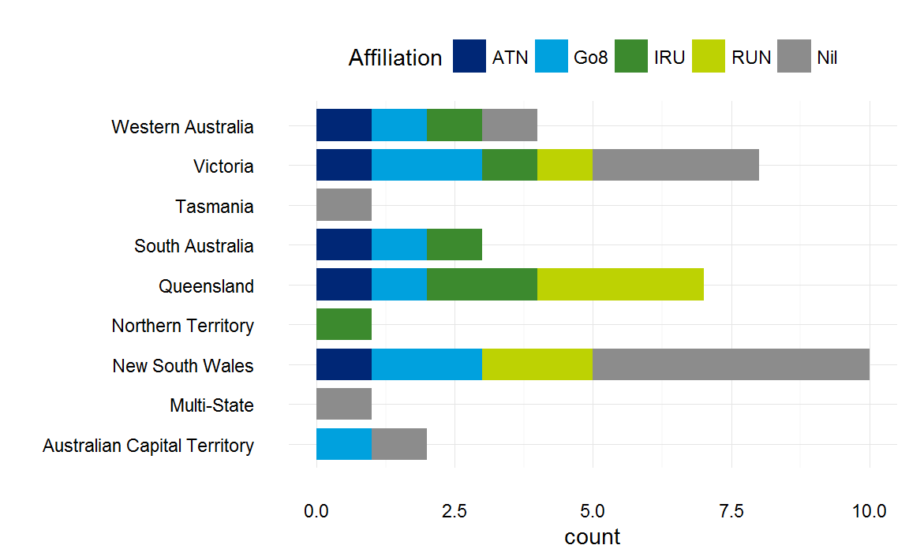

Source: Deloitte Access Economics analysis

: Australian universities by remoteness and EFTSL

Comparison of Australian universities by remoteness and EFTSL 

Source: Deloitte Access Economics analysis, Department of education and Training

There is also consistent representation in terms of the remoteness of student (EFTSL) enrolments, with 54% of metropolitan EFTSL participating in this study, and 58% of regional EFTSL participating (Chart 2.2).

Characteristic #2 - Size

Size is a clear driver of unit cost, given the presence of economies of scale and scope within these institutions. Chart 2.3 shows 2015 student enrolments per university. The box plot on the right hand side shows that there is a reasonable level of representation of universities across the scale of enrolments in the current set of participating universities. However, the second and third quartiles are relatively underrepresented, with only two of nine universities in each, including Victoria University, University of South Australia, The University of Newcastle, and Charles Sturt University.

: Australian universities by 2015 enrolments (count)

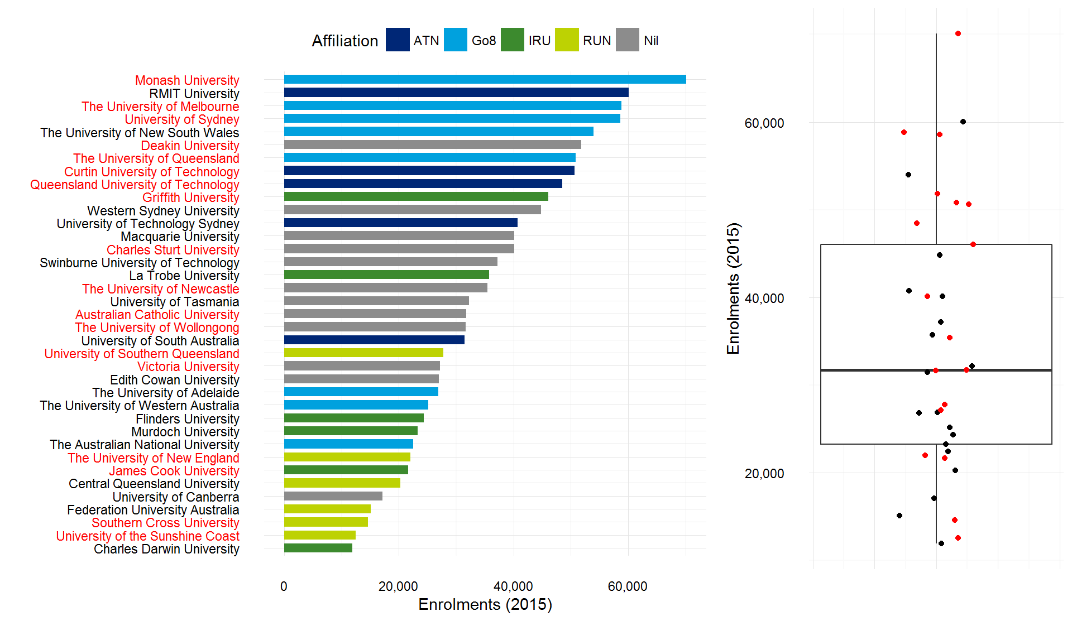

Source: Department of Education and Training. A red label indicates that the institution participated in the collection process.

Characteristic #3 – Research intensity and ranking

Research ranking is an important consideration in the study, given that research incurs a cost, and universities jointly produce teaching and research. Despite the data collection tool being designed to isolate the costs of teaching and scholarship, it is important to capture teaching cost observations across the spectrum of research intensity and ranking. Chart 2.4 below shows two 2015 university rankings. There is a broad representation of participating universities across both dimensions of rankings.

: Australian universities by ranking

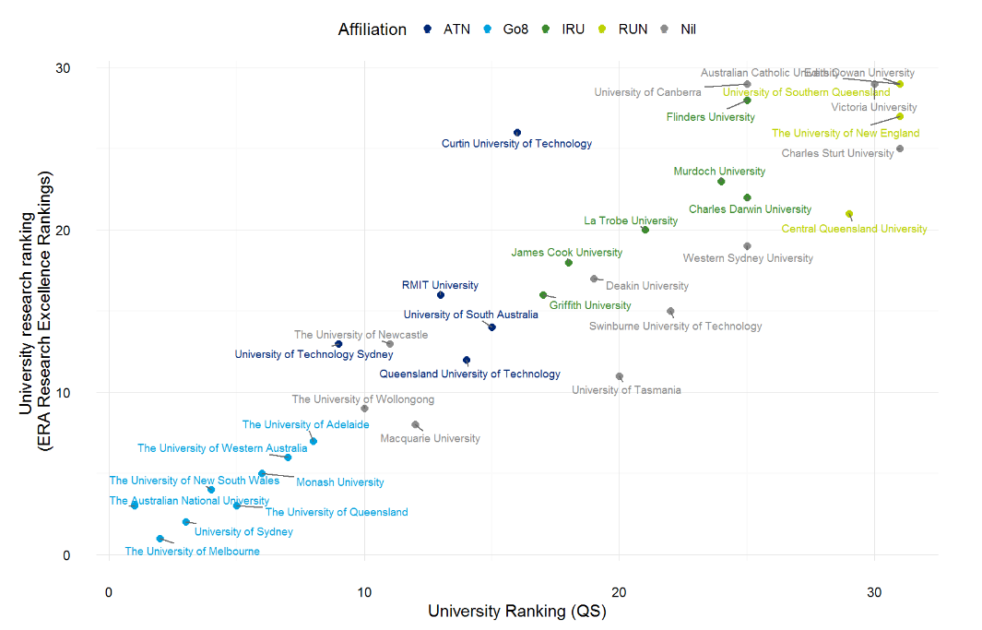

Source: Times Higher Education Supplement, Quacquarelli Symonds, ARC Excellence in Research for Australia

Characteristic #4 – Single versus dual sector

Dual sector institutions are those which have a significant vocational education and training component, as well as the higher education component. This can affect economies of scale and scope as well as the characteristics of the student cohort. In particular, the ability for dual sector institutions to transition students through VET into higher education may lead to different student attraction and retention costs.

Deloitte Access Economics understands that there are six institutions commonly defined as dual sector: RMIT, Swinburne University of Technology, Federation University, Central Queensland University, Charles Darwin University, and Victoria University. Of these, only Victoria University participated in this study. Other universities may have RTO affiliates or may have smaller VET operations that would not lead them to be classified as dual sector.

: Australian universities by dual sector status

Comparison of australian university dual sector status in WA, VIC, TAS, SA QLD, NT. NSW. Multi-State and ACTComparison of australian university dual sector status in WA, VIC, TAS, SA QLD, NT. NSW. Multi-State and ACT 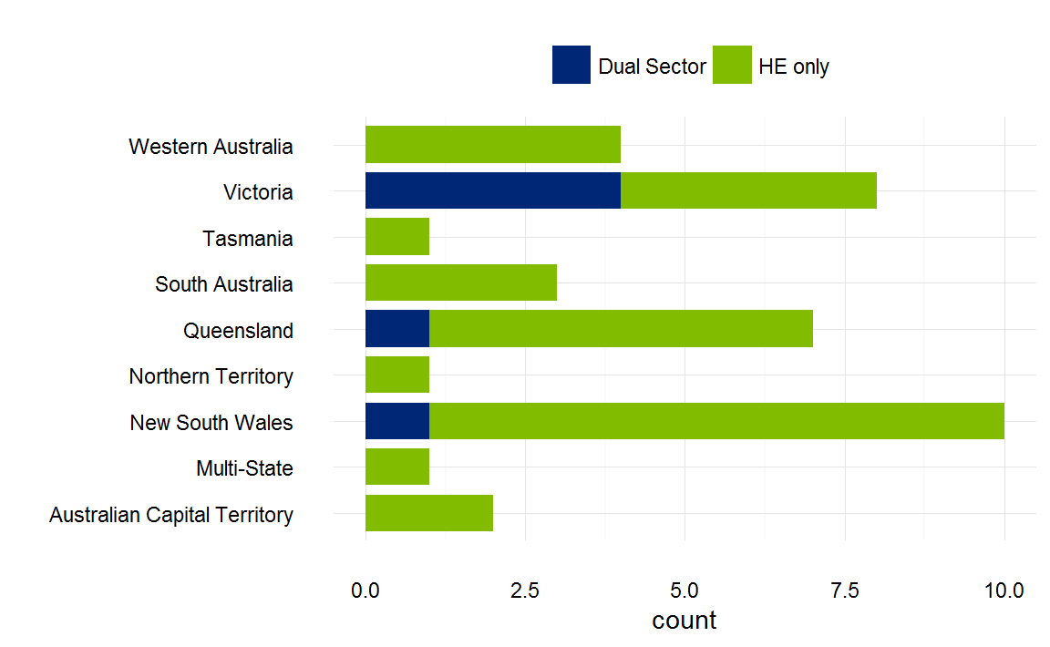

Source: Deloitte Access Economics analysis, Department of Education and Training.

Characteristic #5 – Single versus multi-campus

The number of campuses is also a relevant consideration in cost determination, given there are costs which are likely denominated on a per-campus basis: this may include building costs, maintenance, and security staff, for example. Chart 2.6 describes the number of campuses per university. The box plot on the right hand side shows that there is a reasonable level of representation of universities with multiple campuses, but the first quartile is relatively underrepresented.

: Australian universities by number of campuses

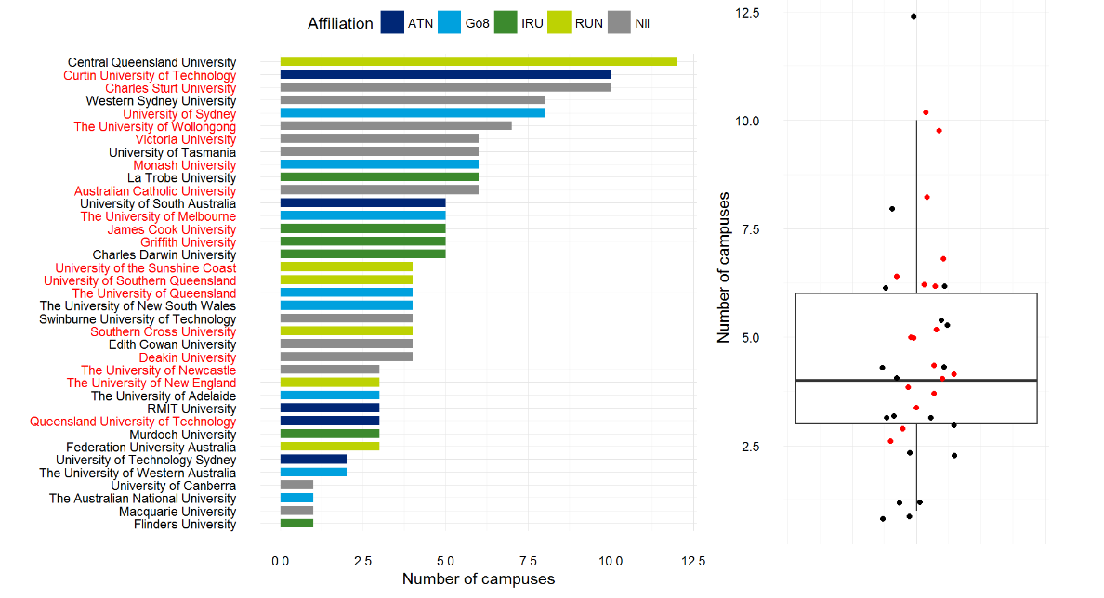

Source: Deloitte Access Economics analysis, Department of Education and Training. A red label indicates that the institution participated in the collection process.

Characteristic #6 – Mode of enrolment

The mode of enrolment[8] is a strong driver of costs, given it determines the inputs that are used to deliver tuition. Chart 2.7 below shows the share of enrolments at each university that are external or mixed-mode. The box plot on the right hand side shows that there is a reasonable level of representation of universities across the mode of enrolment.

: Australian universities by external or mixed-mode share of attendance

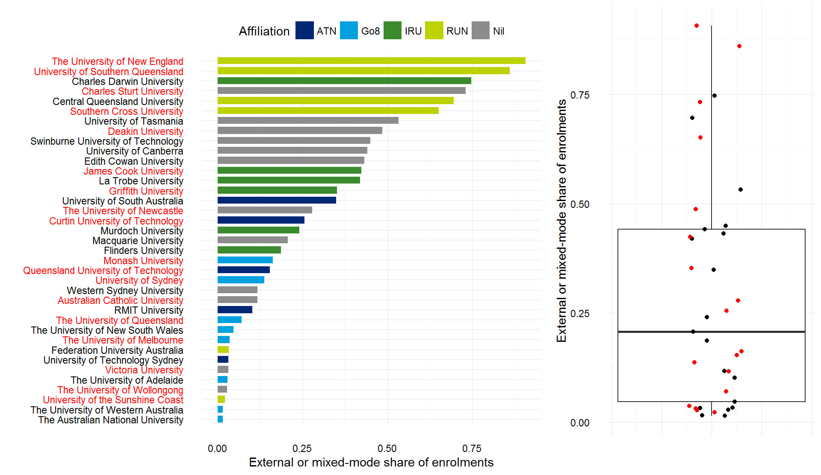

Source: Deloitte Access Economics analysis, Department of Education and Training. A red label indicates that the institution participated in the collection process.

Characteristic #7 – International share of enrolments

International students may involve higher costs for universities, due to student attraction, orientation, and student support costs. Chart 2.8 below shows the share of enrolments at each university that are international. The box plot on the right hand side shows that there is a reasonable level of representation of universities across the scale; however, the third quartile is relatively underrepresented, with the University of Sydney and University of Queensland the only two institutions currently participating, out of a total of nine institutions.

: Participating universities by share of international students

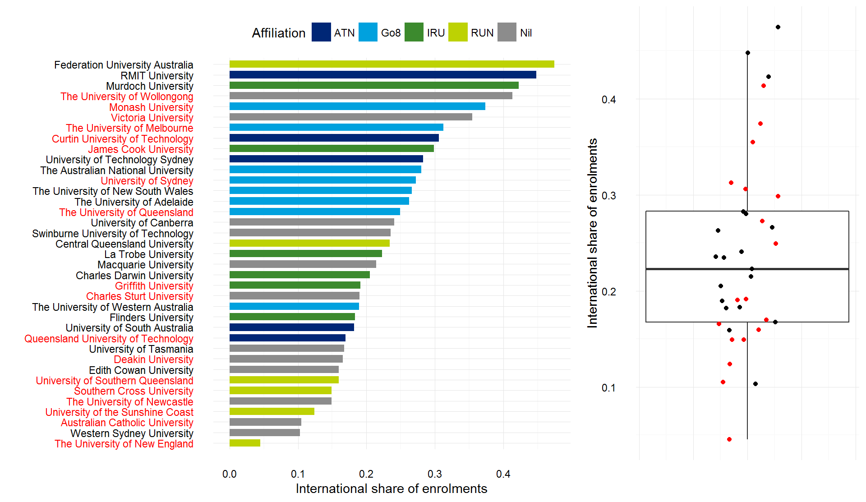

Source: Deloitte Access Economics analysis, Department of Education and Training. A red label indicates that the institution participated in the collection process.

Characteristic #8 – Maintenance costs as a share of total revenue

Maintenance and repair costs are not strategic costs, given universities do not compete on levels of maintenance. Hence, the maintenance and repair cost as a share of total revenue can be seen to reflect the ongoing liability of maintaining assets. Without any prior expectations on a reasonable level of maintenance cost for universities to incur, the burden of maintenance costs may be a reflection that universities have reduced or delayed the maintenance program as a cost-saving measure. Alternatively, it may be a measure of the efficiency of built assets held by universities. Campus locations and buildings are key assets for institutions, and cannot be relocated as other businesses have the option to do.

Chart 2.9 shows the share of revenue that is allocated to maintenance costs. The box plot on the right hand side shows that the first quartile has been supplemented by the addition of University of Wollongong and University of Southern Queensland, with Curtin University participating (out of nine in the quartile).

: Australian universities by share of revenue allocated to maintenance costs

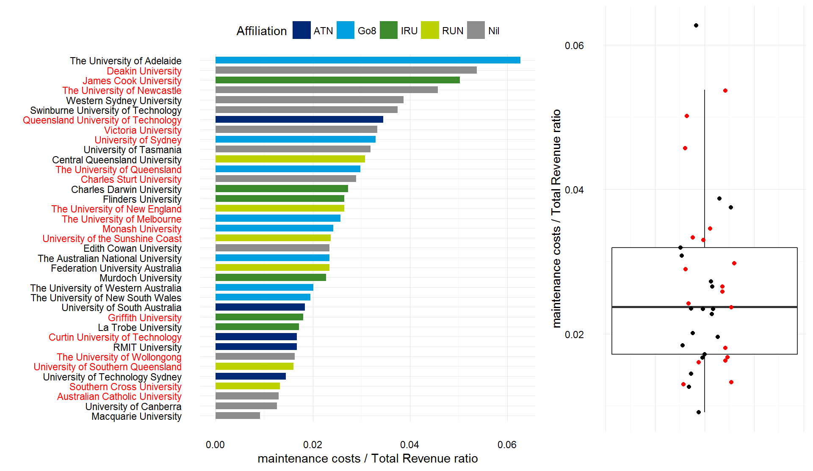

Source: Deloitte Access Economics analysis, Department of Education and Training. A red label indicates that the institution participated in the collection process.

Characteristic #9 – Enrolments by discipline

Given the focus of this study on the relative costs by discipline, it is important to ensure that all disciplines are sufficiently represented in the sample of institutions. The green bars in Chart 2.10 below show the shares of students in each discipline that are enrolled in participating institutions. This shows strong representation across all fields, owing to the generalist nature of universities in Australia.

The blue bars represent the Hirschman Herfindahl Index (HHI), which is a measure of concentration[9].

: Participating universities share of total enrolment

Comparison of share of total enrolment by FOE

Source: Source: Deloitte Access Economics analysis, Department of Education and Training. HHI calculated in share, rather than percentage point, form.

Similarly for Chart 2.11, postgraduate coursework fields are well represented, and not dominated by individual universities. With respect to sub-bachelor (including enabling) enrolments, as shown in Chart 2.12, the coverage is less comprehensive.

: Participating universities share of postgraduate coursework enrolment

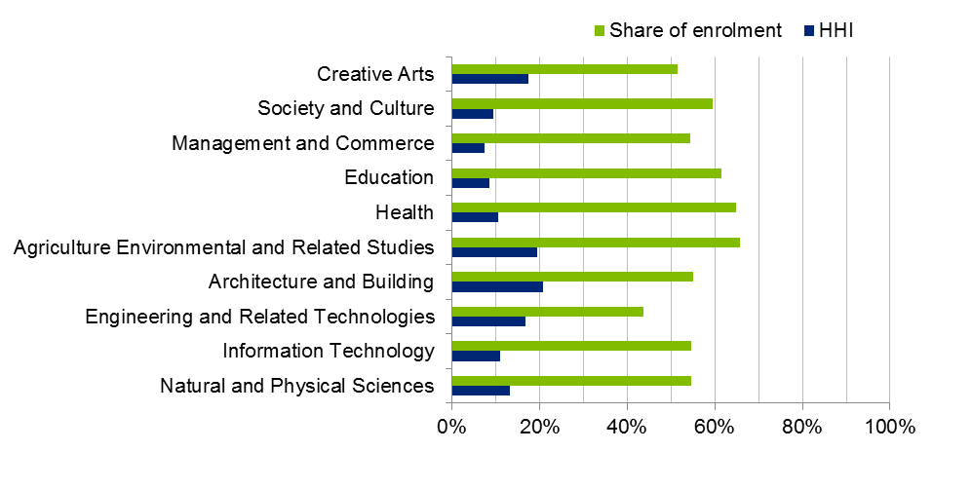

Source: Deloitte Access Economics analysis, Department of Education and Training. HHI calculated in share, rather than percentage point, form.

: Participating universities share of sub-bachelor enrolment (incl. enabling)

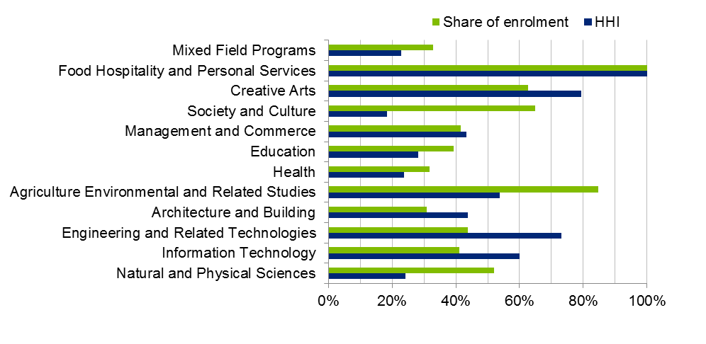

Source: Deloitte Access Economics analysis, Department of Education and Training. HHI calculated in share form, rather than percentage point form.

Overall the sample is a reasonable reflection of the variety of university characteristics. However, the sample set of universities could have been rendered more robust with the addition of one to two more universities that have a focus on sub-bachelor students.

# Teaching and Scholarship costs

|  |
| --- |
| **Key points: Teaching and scholarship costs**   * While direct comparison with the 2011 results are difficult given the smaller – and different – sample in the previous work, the cost relativities across FOEs have largely been preserved. * Agriculture and Environmental Studies and Health remain the highest cost FOEs at the two digit level. * Those FOEs with a lower proportion of non-salary costs have lower costs per EFTSL. * At the four digit FOE level Veterinary and Dental Studies have the highest costs out of bachelor level courses, with mean reported costs of $49,000 to $45,000, respectively. * Management and Commerce has the lowest mean reported cost at around $12,000, with several other courses having mean costs below the $15,000 mark. * There is significant variation in reported costs across these average values in each FOE. The variance tends to be proportional to the average, with greater variation for the higher cost courses. * Variations around the average costs will have two broad drivers: * University costs are a function of various unique contextual (such as student intake characteristics) and strategic factors (such as staff to student ratios) that will mean the cost of provision will vary across institutions. * Differences in approaches to allocating costs to each FOE may drive some of the variation. While it appeared that broadly similar assumptions and approaches were used by universities, it is difficult to tell how much the differences that remained drove the results reported in this chapter. * Universities identified several reasons for realised, and ongoing, cost growth in the sector. These reasons principally related to rising salary costs, and rising placement costs. These mean that the results reported may represent a point in time estimate only, and may not be representative of future costs. |

This chapter provides a summary of the evidence collected as part of this study. It begins by setting out the key summary statistics from the data collected from participating universities. Key statistics such as the mean, median and spread of reported costs by field of education are provided. The following chapters of this report provide more detailed analysis of this data, indicating the extent to which the observed costs can be explained by observable factors, and the extent to which unexplained differences in costs across universities may be tied to notions of efficiency.

This chapter also includes a summary of the qualitative information that participants provided as part of this study. This includes insights on the difficulties in undertaking the data collection exercise (and associated implications for the accuracy of the findings) as well as their perspectives on the key trends that may drive costs into the future.

## Summary of teaching and scholarship costs

This section provides a high level comparison of the data collected in the 2011 Deloitte Access Economics study and this study to understand the consistency of the data collected and changes over time, and provides descriptive and summary statistics of the data collected as part of this study.

### Comparison of 2010 and 2015 data

The results from the current study are broadly similar to the findings from the 2011 study, which used 2010 data. Chart 3.1 below compares the mean cost estimates and distributions across the two studies for bachelor degrees. Broadly, there are only relatively small changes in costs (either positive or negative) across FOEs between the two studies.

However, for a number of fields, the reported costs across universities has increased across the studies. The relatively sharp increase in costs for Agriculture and Environmental studies has extended its top rank over the remaining fields. Significant cost increases were also present in Architecture. At the other end of the scale, Society and Culture is the least costly per EFTSL, albeit not significantly behind several other fields.

: Bachelor costs per EFTSL, 2010 vs 2015

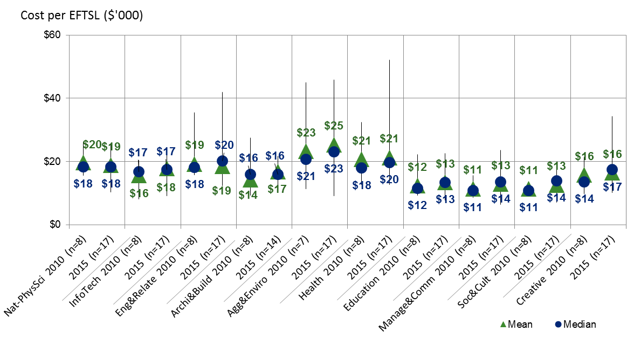

Source: Deloitte Access Economics analysis.

Given the variation in sample size, sample representativeness, and in approach between the current study and the 2011 study, it is not appropriate to attempt to determine precise cost growth over this period from a direct comparison of the two studies.

The costs for postgraduate courses have increased by relatively more than bachelor costs over this period, as shown in Chart 3.2 below. This is particularly the case for Architecture and building, Health, and Engineering and related Studies. This broad increase in costs at this level has also made the cost differential between undergraduate and graduate FOEs more pronounced across the studies, with the average cost for a postgraduate EFTSL at $20,050, compared to $16,025 for an undergraduate EFTSL. The 2010 average for a postgraduate EFTSL was around $16,972, along with $15,021 for an undergraduate EFTSL.

: Postgraduate costs per EFTSL, 2010 vs 2015



Source: Deloitte Access Economics analysis.

One source of sampling bias in this measurement can be mitigated, by creating weighted cost averages based on field of education and award level. The FOE-weighted average costs per EFTSL are given in Table 3.1 below. Though this figure includes research and commercial activities, data reported by the Department on the financial position of the sector shows that ongoing expenses growth per EFTSL has been 16% from 2010 to 2015, or around 3% per year. Broadly, the difference between this 16% growth and the 10% growth observed across the two costing surveys could be due to either differential growth in commercial and research costs, issues of representativeness, and/or measurement uncertainty on behalf of participants.

: FOE-weighted average costs per EFTSL

|  |  |  |
| --- | --- | --- |
|  | **2010 data** | **2015 data** |
| **Undergraduate** | $15,021 | $16,025 |
| **Postgraduate** | $16,972 | $20,050 |
| **Total** | $15,375 | $16,839 |

Source: Deloitte Access Economics analysis.

### Total cost by FOE and qualification level

Chart 3.3 shows the spread of the estimated cost per EFTSL across FOEs at the bachelor level.[10] Veterinary Studies has the largest mean cost of provision per EFTSL, at around $49,000, as well as a large spread of values from around $35,000 to $79,000.[11]

: Total cost per EFTSL (bachelor level, outliers removed)



Source: Deloitte Access Economics analysis.

Dental Studies, Medical Studies, and the Agriculture and Environmental Studies fields follow to round out the top four fields. The remainder of fields are predominately costed between $10,000 and $20,000 per EFTSL.

This data shows that there is significant cost variation not just across FOEs, but within FOEs across universities. Indeed, 4 of the 19 fields of education have an interquartile range of costs that is greater than 50% of the median FOE cost.

Similar results are observed at the postgraduate level (Chart 3.4), with significant variation in the cost per EFTSL. Postgraduate studies are on average more costly than their undergraduate counterparts, Other Environmental Studies, Dental Studies and Veterinary Studies are estimated to have the highest average costs.

: Total cost per EFTSL (postgraduate level, outliers removed)

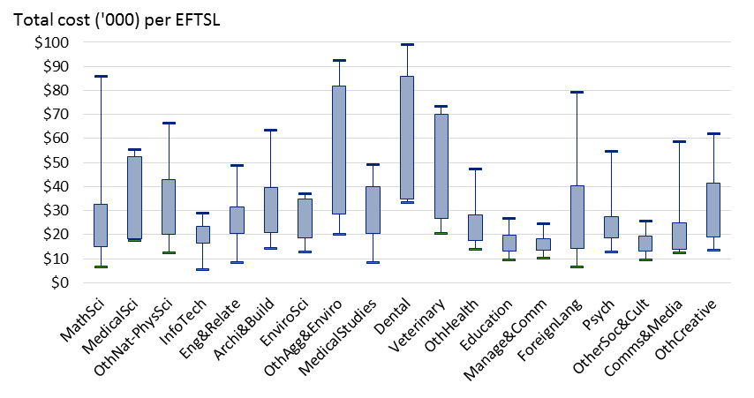

Source: Deloitte Access Economics analysis.

In contrast, at the sub-bachelor level (Chart 3.5) there is significantly more variation in costs per EFTSL within each FOE. These results may reflect the greater variation of FOEs offered by different universities at the sub-bachelor level, or the relatively small sample of universities offering sub-bachelor qualifications. Higher per EFTSL costs are also likely to be driven by low EFTSL counts in sub-bachelor courses.

: Total cost per EFTSL (sub-bachelor, outliers removed)



Source: Deloitte Access Economics analysis.

### Cost and funding relativity

The 2011 study represented the costs within each broad field of education field as a ratio to the base funding provided according to the CGS classification. Chart 3.6 provides a comparison between the two studies. There are a handful of fields which recorded lower median costs in the current study than the previous study, such as Natural and Physical Science (0.75 compared to 0.86), Architecture and Building (0.86 compared to 0.99), and Information Technology (0.93 compared to 1.03). Two fields recorded materially higher median cost/funding ratios than the previous study, being Management and Commerce (1.11 versus 1.03), and Society and Culture (0.98 versus 0.85). The spread of teaching cost to funding ratios is relatively consistent between the two studies, the main difference being the 2015 results for the moderated Architecture and Building observations are more clustered than 2010.

The bachelor teaching cost to CSP funding ratio for the 2015 data was 0.85, compared to 0.94 for the 2010 data. As noted previously, these figures cannot be compared as direct growth or decline in costs relative to funding over the five years to 2015, given the differences in the sample, and differences in cost collection approaches. Similarly, caution should be taken in drawing inferences about the sufficiency of CGS funding directly from these ratios. While not specifically stated in the *Higher Education Support Act* 2003, there is a general view that CGS funding is intended to cover some level of base research activity (which may be excluded from the definition of teaching and scholarship costs used in this study), and the cost of such research may vary as a proportion of teaching costs.

: Cost-funding comparison with 2010 (bachelor level, outliers removed)



Source: Deloitte Access Economics analysis.

At the more disaggregated level, costs per EFTSL relative to CSP funding follows a similar broad pattern to the overall costs per EFTSL, as shown in Chart 3.7. At this disaggregated level, the two fields of education where recorded costs exceed base funding at the 25th percentile are Veterinary Studies, and Management and Commerce. The 25th percentile cost for Dental Studies is close to the funding rate. The fields of education where recorded base funding exceed costs at the 75th percentile are Mathematics, Medical Science, Other Natural and Physical Science, Engineering and Related Studies, Environmental Science, Other Health, Education, and Communications and Media.

: Cost-funding per EFTSL (bachelor level, outliers removed)



Source: Deloitte Access Economics analysis.

### Teaching staff by field

The number of EFTSL per teaching staff (in FTE terms) varied significantly by field of education (Chart 3.8), with an overall mean of 19 EFTSL per FTE teaching staff (and median of 22 EFTSL per FTE). Dental Studies and Veterinary Studies had substantially lower ratios, while Management and Commerce and Other Society and Culture had the higher ratios.

: Total number of teaching and scholarship staff (FTEs) per EFTSL, by field

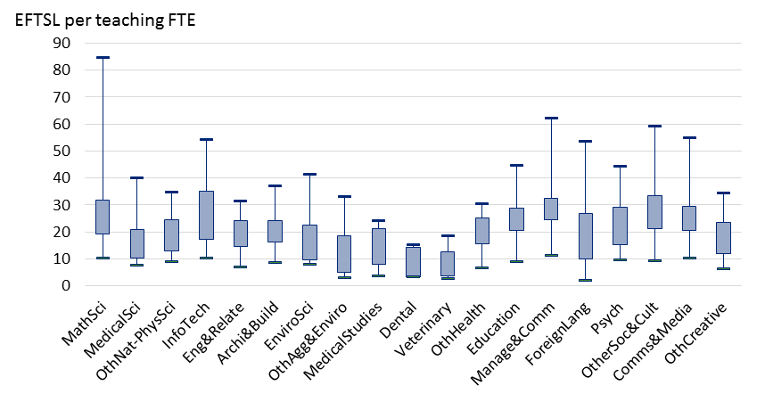

Source: Deloitte Access Economics analysis.

### Labour versus non-labour costs by field

Labour’s share of total costs is shown by FOE in Chart 3.9 below. The mean labour cost share is estimated to be 58%, while the median is 61%. This varied across fields of education, with Information Technology having the lowest mean and median labour cost share (56% and 57%, respectively), and Dental Studies having the highest mean and median labour cost share (65% and 68%, respectively).

: Labour costs as a share of total costs, by FOE

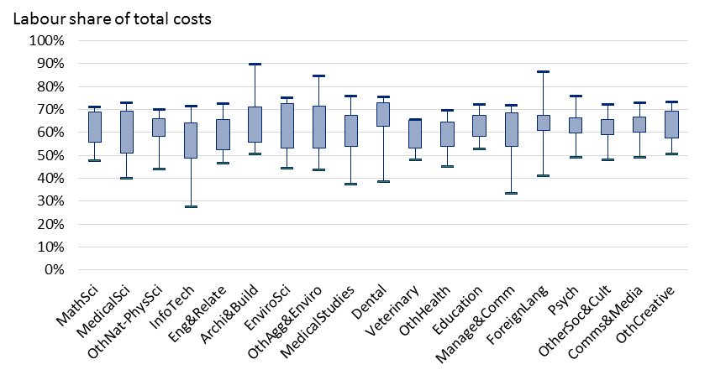

Source: Deloitte Access Economics analysis. Note two universities were excluded from this analysis.

The analysis in this section reports the results from the data collection in a relatively ‘raw’ form, presenting the data in simple summary statistics with a focus on variation across FOE, qualification level and university. In practice, some of the observed variation will be explained by university-specific characteristics that drive costs at the institutional level. This includes factors such as student intake and staff characteristics and decisions around teaching quality (as reflected, for example, in staff-to-student ratios). Such factors are important in understanding universal or reasonable costs across the higher education sector, for the purpose of informing funding policy.

The analysis in Chapter 4 refines the analysis above by identifying and measuring the effects that these observable drivers have, and analysing the implications of these effects for the estimation of ‘reasonable’ costs of delivery.

## Summary of qualitative information provided

The consultations with universities, and subsequent written submissions, identified a range of issues in relation to difficulties with providing accurate data in the fields required by the template, and relating to the use of a single reference year for the study. These issues can be summarised under the following themes, and are outlined further in this section:

* Difficulties in assigning values to the template, either due to a lack of relevant data or university-specific features.
* Issues with using 2015 as a representative year given costs that were or were not present that calendar year that are not reflective of the ‘typical’ year.
* Broader trends in the sector that mean the costs estimated from a single calendar year may not be representative of future costs.

The issues presented in this section reflect the concerns of the sector in participating in this exercise and provide an indication of the context within which the results set out above should be interpreted. They also indicate areas that future data collection processes could seek to resolve.

Difficulties in assigning values to the template

The majority of participating universities identified concerns with at least some aspects of the data collection exercise. These concerns included varying focusses on:

* The short time period over which participants were asked to complete the template, and that the time period coincided with university budgeting processes, further reducing the resources available for the exercise.
* The non-standard information that was requested, particularly around the allocation of costs to FOEs, which meant that existing systems or models were not well placed to directly inform the exercise.
* Various assumptions that needed to be made in order to provide the data, again reflecting the largely one-off nature of the exercise.
* Specific features of the university or particular budgetary units that were not able to be sufficiently reflected in the template.
* Where courses are taught by partners, meaning that there is little or no direct oversight of the teaching costs involved.

Of the difficulties encountered in providing the data, two stood out as the most commonly reported: the requirement to split staff time between teaching and research activities, and the need to report data on an FOE basis. The split of staff time between teaching and research activities[12] was perhaps the area where the approach differed most across universities. While some universities had staff survey data that allowed a relatively detailed split of staff time, others made more high level assumptions in the absence of similar data. In some cases this was based on estimates at the faculty level, while others based estimates on agreements specifying a division of time, which may vary in accuracy across staff levels and disciplines.

Universities also questioned the ability to split staff time between teaching and research activities at a conceptual level. This tended to be based on the notion that research and teaching are intrinsically linked, and that time spent on research was reflected in the quality of teaching. Some noted that regulatory requirements under the Threshold Standards placed requirements on research in order to teach.

The requirement to report results at the FOE level also caused difficulties for most participants. While universities have relatively refined data on teaching costs at the faculty or school level, mapping this to individual FOEs proved difficult and various assumptions were made in making this mapping. Further, because universities provide courses, which are more granular than FOEs, there will be some variation in the offerings (that is, differences in the weightings of particular courses) included within an FOE across institutions. Chart 3.10 below contains data from one participant university as an example of this issue. The chart shows how costs that may be well-observed and understood at the college level on the left hand side, become more assumption driven, as these costs are allocated to FOEs according to EFTSL.

: Example mapping cost (via EFTSL) from Colleges to FOEs

Demonstration of mapping costs via EFTSL drivers, from 8 colleges to 19 FOEs


Source: Deloitte Access Economics analysis, participant data.

Equivalently, allocating costs across sub-bachelor, bachelor, and postgraduate levels proved difficult for some universities. Many allocated costs across levels within an FOE according to EFTSL, meaning that the estimated cost per EFTSL was equal. This was generally seen to provide a downwards biased estimate of postgraduate costs, and upwardly biased estimate of sub-bachelor costs, due to the staff-student ratios, contact time, and seniority of staff generally associated with postgraduate coursework classes. According to supplementary data provided by one university, this approach across levels produces a 10% underestimate in salary costs for postgraduate activity across the university.

More generally, participating universities varied in the sophistication of their data collection and reporting ability. Some universities have developed relatively sophisticated Activity Based Costing (ABC) models that are capable of reporting costs at a granular level, based on pre-existing data structures, such as the general ledger, payroll, timetabling, and asset registers. Others collect aggregated information in their finance functions for reporting purposes, but without the ease or sophistication that more detailed models are capable of providing.

Nonetheless, where ABC models were used, the assumptions on which they were based were not necessarily more granular or robust than those of institutions that collated data in the absence of such models. Overall, the consultations with the sector indicated that broadly similar approaches were used to allocate both budgetary unit level and central costs to individual FOEs. The consultations with universities aimed at furthering the consistency of approaches and assumptions used.

Finally, some universities noted that where courses were provided by partner institutions, they had little oversight over the cost of provision. While the costs to the participating university will generally be reflected in the data provided, these simply represent a transfer of the fee paid for the course and may not reflect the true cost of teaching at the partner institution.

Issues with using 2015 as a representative year

Some universities identified issues with using 2015 as the representative year given specific events or expenditure items that mean the reported costs were not representative of those incurred in a typical year. These concerns almost entirely related to specific instances of capital expenditure, either occurring in 2015, or expected to occur in the near term and therefore not be reflected in the data collection.

A number of universities also reported that a proportion of their capital stock had been fully depreciated, and was therefore excluded from the cost data provided. The need to replace this capital in the future, however, implied that accounting depreciation was not reflective of the true costs that were implied by the ongoing need to invest in new or replacement capital.

The concerns identified above, while potentially reducing the representativeness of the reported costs for some institutions, are unlikely to detract from the accuracy of the findings overall:

* They are likely to even out to some degree across universities.
* They are largely independent of other drivers of costs, and therefore will not affect findings of the extent to which these other drivers impact on reported costs in the statistical analysis reported below.

Nonetheless, other trends identified by participants are likely to have more material impacts on university costs across the sector going forward. The main trends identified through submissions are outlined below, and broadly accord with the trends outlined in Chapter 1.

Broader cost trends in the sector

While not all institutions identified broader cost trends, three themes were identified relatively consistently across institutions:

* The increasing cost and supply issues associated with placements, particularly courses requiring clinical placements.
* Cost pressures associated with salary increases.
* Cost implications from changes to the composition of delivery modes.

Of these themes, concerns associated with clinical placements were most prevalent in the consultations and submissions. Almost all universities noted various difficulties in finding or paying for placements, with the key issues relating to:

* The reduction of Health Workforce Australia (HWA) funding to cover, or partially cover, the cost of clinical placements.
* A reduction in the number of placements provided free of charge to the university.
* A general increase in competition for placements as demand exceeds supply, particularly in geographies where multiple universities compete for the same places.

Universities also noted that wage increases under Enterprise Bargaining Agreements had seen salary costs increase at a rate faster than inflation over time. This was seen as increasing costs further into the future, particularly for relatively staff-intensive programs.

Evolving delivery models were also seen to be adding to costs over time. This involved mixed mode delivery, blended learning and less reliance on lectures, and providing greater online access to teaching material. This evolution, and expected future evolution, of higher education pedagogy was seen as requiring, among other things, significant ICT investment. It was also noted that a move to increasingly online delivery would not reduce costs as the existing physical infrastructure would still be required.

Some universities also noted that greater access to higher education under the demand driven system meant that students that would not otherwise have entered universities are now doing so, increasing the demand for appropriate support services and more intensive teaching approaches.

# Understanding reasonable cost

|  |
| --- |
| **Key points: Understanding reasonable cost**   * The summary statistics above provide an indication of the current costs of university teaching and scholarship. However, these simple averages should not be interpreted as estimates of reasonable costs. A concept of reasonable cost should acknowledge that: * The link between costs and funding is somewhat circular: universities will in aggregate tend to spend what they receive. A notion of reasonable cost should seek to disentangle funding and costs, and identify what it costs universities to provide a typical, contemporary, standard of education for each FOE. * This will vary by institution given the various contextual factors that universities face, such as student intake characteristics and localised cost factors. * The reasonable costs of providing an FOE may therefore vary across university characteristics and across different levels of quality that universities should be expected to provide. The latter is ultimately a decision for policymakers and cannot be made through an assessment of the data alone. * It is reasonable to expect universities to achieve some benchmark level of efficiency. Hence, having controlled for the various cost drivers, reasonable costs should be set towards the ‘frontier’ of efficiency observed across the universities in the sample. * There are different ways to define this frontier; this report identifies several such approaches. * Decision makers will also need to decide on a ‘reasonable’ efficiency expectation: should universities be expected to perform equally with the most efficient university in the sample, or somewhere close to but inside the frontier? |

The current cost of higher education teaching and scholarship in Australia is influenced by current funding rates as well as the strategic decisions undertaken by different institutions. The challenge in developing an estimate of the reasonable cost of teaching and scholarship is to develop an estimate that is independent of the incentives created by current funding arrangements and can be applied universally to different institutions, but that also recognises the differing circumstances in which the institutions operate.

This chapter sets out the broader policy context, to motivate this study’s exposition of ‘reasonable cost’ for teaching and scholarship activities at Australian universities, before moving to provide a definition of this concept. The chapter concludes by setting out an empirical framework to inform the assessment of the reasonable costs of teaching and scholarship across different fields of education. The results from the empirical framework are presented in Chapter 5.

## The broader policy and institutional context

The cost of higher education teaching and scholarship in Australia is, *inter alia*, a function of:

* The current policy settings in relation to funding rates.
* The strategic objectives pursued by public universities, each of which has their own unique founding charters and missions.

Each of these components, and their implications for assessing reasonable cost, is discussed in further detail below in order to motivate the definitions and analysis that follow.

### The current funding and regulatory environment

Universities operate in a constrained funding and regulatory environment. In particular, while CSPs for bachelor degrees are uncapped (as part of the ‘Demand Driven System’), sub-bachelor and postgraduate places are restricted by the Commonwealth. Similarly, total contributions (by students and government) towards Commonwealth supported higher education places are constrained through Government funding regulation.

These funding constraints, as well as quality standards established as part of the TEQSA Act and accompanying legislation and regulation (such as the Standards Framework), play an important role in influencing the costs that universities incur towards different teaching, research and broader engagement activities.

A consequence of the current funding environment is that the current concordance between funding and costs (across all institutions) is not necessarily reflective of the underlying costs that are attributable to specific teaching and scholarship activities and that would eventuate independently of the incentives caused by those funding arrangements.

The fact that current contributions towards Commonwealth supported places are constrained through Government funding regulation does not imply that costs need to match funding levels for each field of education. Indeed, universities have some scope to reallocate funding across different fields of education (which may itself provide an indicator of whether current funding rates by discipline are reasonable). However, current costs of teaching and scholarship in aggregate will be circularly related to historic funding arrangements.

As a result, overall costs of teaching and scholarship may more closely reflect current funding arrangements, rather than the reasonable cost of achieving teaching and scholarship outcomes. If universities are prevented from fully reallocating funding across fields of education to reflect the reasonable cost of teaching and scholarship in each discipline, costs of teaching and scholarship in each field of education will also be partially driven by current funding arrangements.

### Institutional context

Australian universities are predominantly autonomous, self-accrediting, public institutions that serve a diverse range of communities and have unique founding charters and missions. From a given base of (largely) regulated inputs, these varying contexts and areas of strategic focus result in a natural degree of variation in cost structures.

In particular, different universities seek to achieve (to varying degrees) a range of objectives beyond teaching and scholarship. Those objectives include:

* Research and development
* Community (and social) engagement
* The provision of broader experiences for students beyond the classroom.

In general, the variation in activities undertaken by different universities is in line with the broad intent of public funding, which (for a given threshold standard of quality in the activities that are undertaken) does not prescribe specific patterns of expenditure for given teaching and scholarship, or research, activities.

This institutional context has two important implications for assessing reasonable cost. The first is that the current costs of teaching and scholarship will in part reflect differences in the strategic priorities given to different fields across institutions. The second is that the costs of teaching and scholarship across institutions may to some extent reflect factors that influence what may be considered to be efficient cost, including issues with respect to scale economies, and differences in the characteristics of the underlying student population.

## The concept of ‘reasonable cost’

Understanding the broader policy and institutional context is important for developing a robust measure of reasonable cost that recognises:

1. Current reported costs for specific disciplines of teaching and scholarship are, at least in part, driven by the current funding levels for these disciplines (due to the nature of institutional finance and budgeting processes); and that reasonable costs should be measured independently of the incentives caused by current funding arrangements.
2. Current reported costs across universities and disciplines are a function of institutionally specific strategies and objectives with respect to activities of teaching and scholarship and research across disciplines and qualification levels.

In light of these considerations, the goal of this analysis is thus to identify a reasonable cost for teaching and scholarship which:

* reflects contextual factors faced by universities (such as size and location), which are embedded in the mission of a university;
* is sufficient to provide a reasonable, contemporary, level of quality in teaching and scholarship (as defined by government policy, including the Threshold Standards regulated by TEQSA); and
* given the varying strategic goals and missions of universities, reflects a level of efficiency in achieving benchmark quality standards.

This goal recognises that an appropriate measure of reasonable cost allows for the contextual characteristics and strategies that can be expected to vary across institutions. As such, an appropriate measure of cost relies on comparisons across institutions to determine relative costs, and assesses these costs on a common or universal basis, rather than an institution-specific basis.[13]

Importantly, this universal basis of cost comparison necessarily captures a benchmark level of quality for teaching and scholarship and research activities, with reference to the intended outcomes of public funding towards teaching and scholarship activities; while simultaneously recognising that variations in institutional strategies and objectives are inherent to a system which recognises universities as autonomous institutions.[14]

What is meant by ‘a benchmark level of quality’ is difficult to specify. Ideally, a typical level of teaching quality would be specified with reference to specific longer term graduate outcomes, recognising that universities may seek to achieve this in different ways (including through different combinations of inputs). Such a benchmark would necessarily ensure that reasonable costs are driven by a clear notion of teaching and scholarship outcomes, and the costs associated with achieving these, rather than incentives created by current funding levels which centre on historically defined input-based notions of quality.

## An analytical framework for informing an estimate of reasonable costs

This section outlines how empirical analysis can be used to provide evidence on the reasonable costs of teaching and scholarship in Australian universities, based on the definition of reasonable cost articulated in Chapter 4.2 above.

In principle, there are two different approaches that can be used to inform an estimate of reasonable costs. The first involves specifying a benchmark level of teaching and scholarship quality and estimating the efficient costs for meeting this benchmark. An advantage of this approach is that it can be applied empirically in a way that recognises that universities may allocate resources in different ways to achieve specific teaching and scholarship outcomes. However, a challenge in applying this approach in the current context is that it is difficult to find robust measures of teaching and scholarship quality and outcomes at a field of education level. Such outcomes should also ideally be adjusted for differences in student intake (such that the quality of the education can be distinguished from the quality of the students).

An alternative approach is to identify the main cost drivers that explain differences in cost across universities and fields of education. These cost drivers include:

* the choice of inputs such as staff to student ratios;[15]
* the environment in which a university operates including student demographics, location and the way courses are delivered; and
* indirect measures of teaching and scholarship quality or other outputs such as research which may impact the cost of delivery.

This second approach seeks to measure the relative impact of these cost drivers and thus develop an estimate of the reasonable costs of teaching and scholarship for a university with typical (or specified) levels of each of these cost drivers. While this second approach can incorporate different levels of efficiency, unlike the first approach it does not directly estimate the minimum cost required to achieve a benchmark level of teaching and scholarship quality. In particular, the level of inputs (or cost drivers) required to achieve benchmark levels of teaching and scholarship quality may differ from the typical levels of these cost drivers in Australian universities.

In the absence of robust measures of teaching and scholarship quality and/or outcomes, the second approach is used in this report and seeks to provide an estimate of reasonable costs for a university with typical characteristics in a given field of education. This approach recognises that the estimate of reasonable costs will vary depending on what policymakers assess to be an appropriate level of investment in specific cost drivers such as staff to student ratios. To develop a robust assessment of the reasonable costs of teaching and scholarship it is important to, first, empirically identify the key cost drivers (both contextual and strategic) that impact teaching and scholarship costs and the relative impact of each cost driver on teaching and scholarship costs; and, second, use this understanding of cost drivers to develop an estimate of what the reasonable cost of teaching and scholarship might be based on.

### Identifying the key cost drivers of teaching and scholarship

In principle, there are a number of reasons why aggregate costs differ between universities. For the same level of activity, universities may:

* face different prices due to different input markets; for example, the price of utilities may differ or wages of staff may vary;
* have different levels of efficiency in delivering teaching and scholarship programs;
* choose to provide different levels of the quality of teaching and scholarship;
* choose to make other strategic decisions not related to teaching and scholarship quality; and
* have other non-teaching cost obligations, such as scholarships, which are funded through teaching revenue.

Table 4.1 presents a list of drivers that could potentially affect the cost of teaching and scholarship, and the reasons they have been considered. Costs are measured as cost per EFTSL.

Note that variables that accurately reflect these cost drivers are not always readily available in the higher education context. For example, the Student Experience Survey provides variables that seek to capture the outcomes of investments by universities in teaching and scholarship quality (outside staff hiring decisions). But the available variables are likely to be relatively ‘noisy’ indicators of teaching and scholarship quality. This highlights the importance of undertaking a longer term data gathering process to better understand university investment in teaching and scholarship and the subsequent impact on student outcomes.

Potential cost drivers

|  |  |
| --- | --- |
| Cost driver | Expected relationship to costs per EFTSL |
| Scale factors | Higher student numbers and/or larger campus sizes are expected to deliver scale efficiencies, reducing average costs. |
| Student characteristics | Average teaching costs are expected to rise as the proportion of (more expensive to teach) postgraduate students increases.  A higher proportion of fee-paying students in a course may increase costs, through raised expectations for quality and by enabling higher education providers to spend more on delivery.  Students from disadvantaged or low socio-economic backgrounds may entail additional support costs. Similarly, students in regional areas may on average come from lower socio-economic backgrounds. |
| Staffing | Increased use of (cheaper) casual staff is expected to reduce average costs. A higher staff to student ratio is also likely to raise the costs of teaching and scholarship. |
| Geography | Regional location and/or large distances between campuses may raise average costs of teaching and scholarship. |
| Discipline mix/mode of delivery | Some disciplines involve more expensive activities, or require more contact hours, raising the average cost for a FOE. The mode of delivery of different disciplines is an important determinant of these differences. Disciplines that include supervised work placements, a relatively high number of contact hours, smaller class sizes or more resource-intensive delivery (e.g. laboratories, seminars or workshops) are likely to be more expensive to teach. By comparison, disciplines or universities that teach a high proportion of students externally through online or distance education may have lower teaching and scholarship costs. |
| Research intensity | A focus on research activities in the overall mission of an institution is expected to raise costs. Research activities are often undertaken by more senior (and more expensive) academic staff. Higher teaching and scholarship costs may result when these resources that are used for research are shared with teaching. |
| Investment in teaching quality and student experience | Some universities may choose to invest more in activities such as: the student experience outside the classroom, student career development and work experience opportunities, professional development for teaching staff or central administration services, all of which may improve a student’s learning experience or outcomes after graduating. |

Source: Deloitte Access Economics

### Empirical approaches for identifying cost drivers

Academic researchers have employed a range of approaches to identify the relative impact of different cost drivers on the costs of teaching and scholarship. A detailed discussion of some of these approaches is set out in Appendix A.

This section outlines three statistical approaches:

* Ordinary Least Squares (OLS);
* quantile regression; and
* Stochastic Frontier Analysis (SFA).

Ordinary least squares involves applying a linear regression model to estimate the impact of different cost drivers on teaching and scholarship costs. The analytical approach in this study uses two different OLS models. The general form of the model is

$$log⁡Cost_{ij}=α+βX_{ij}+ϵ_{ij}$$

where $Cost$ is cost per EFTSL by university (*i*) and field of study (*j*), and X is a vector of explanatory variables (or cost drivers). Log means natural logarithm and costs are as measured by the data submitted by the universities.[16]

The first OLS model involves estimating an OLS regression in which the explanatory variables include only sets of indicators for the fields of education and the universities (referred to here as a ‘fixed effects’ model). By definition, this model does not shed light on the specific cost drivers, but does provide a simple indication of the proportions of the variation in costs per EFTSL that can be attributed to differences across field of education versus university. This can help to explain the degree to which reasonable costs may be driven by these field and institution-specific factors.

The second OLS model seeks to assess the strength of individual cost drivers. This approach was used in the 2011 study.

In the current study, the following explanatory variables or cost drivers are candidates for inclusion in the model:

* total teaching staff in FTEs to EFTSL ratio;
* total EFTSL;
* field of education indicators;
* ARC Excellence in Research for Australia rankings;
* proportion of higher degree research students to total postgraduate students;
* proportion of international students;
* proportion of regional students;
* proportion of casual teaching staff;
* proportion of students studying externally; and
* student assessments of teaching quality from the student experience survey and graduate wage and employment outcomes.

Intuitively, this approach recognises that costs are a function of a range of factors, and seeks to measure the extent to which each of the observable factors listed above determines the costs that universities face. The factors will not explain all of the variation in costs across universities, and any unexplained variation may be a function of, amongst other things, the exclusion of variables that drive costs (because they are not observed) or universities differing in the efficiency with which they offer units (given the contextual factors under which they operate).

Quantile regression analysis can be used to gain a better understanding of the role of cost drivers *across the cost distribution*. An assessment of costs at, say, the 25th percentile of the cost distribution can provide an indication of the costs at the lower end of the cost distribution and thus may be more reflective of a relatively efficient organisation, holding all else constant. The precise percentile applied is arbitrary and ultimately based on a policy consideration depending on the level of relative efficiency that has been sought for the purposes of estimating underlying efficient cost.

Stochastic Frontier Analysis (SFA) is an alternative approach to assessing the relative efficiency of organisations – universities in the current study. The key difference between a standard OLS approach and SFA is that in SFA, the model includes a specific term that reflects inefficiency. This allows for a measure of underlying efficient cost to be revealed from observed cost data, rather than by relying on an arbitrarily defined quantile of cost, as in quantile regression.[17]

SFA, like OLS, requires the modeller to assume that organisations are behaving in a particular way (in this case seeking to minimise costs) and to apply a specific functional form for how inputs are translated to outputs[18]. Data envelopment analysis (DEA), does not specify a particular production technology; this is discussed further in Appendix B.

### How the analysis of cost drivers can be used to assess reasonable costs

The results from the three parametric approaches outlined in Chapter 4.3.2 above can be used to inform a definition of reasonable cost for each field of education based on the notion of ‘typical’ university characteristics, and by removing variations in cost that are not related to underlying contextual, or discipline-specific drivers of cost.

The typical university characteristics are represented by the median of those characteristics for each field of education. Points on the distribution other than the median could also be considered in such an analysis. For example, industry benchmarks or benchmarks from high performing institutions could also be applied.

Estimates of the costs are obtained from the models using median values of the characteristics. The OLS model estimates target average costs, the quantile model targets the lower quartile of costs and the SFA model targets the most cost efficient organisation (all given the definition of the typical characteristics).

It is important to note that any approach taken at this step will reflect an underlying consideration of what is a ‘typical’ level of teaching and scholarship quality and what is a ‘reasonable’ cost. This is ultimately determined by policymakers, depending on the intent of any funding policy which the defined notion of reasonable cost is intended to support.

The remainder of this section expands on some of these points.

Incorporating contextual characteristics

In defining the concept of reasonable cost, it is important for such an estimate to take into account the role of contextual characteristics (namely those which universities cannot control and are not explicitly related to quality). Differences in contextual characteristics imply that funding arrangements based on the notion of reasonable cost may appropriately vary on the basis of these factors.[19] This can be achieved by estimating a level of reasonable cost that varies based on estimates of how these contextual cost drivers impact average cost.

Incorporating a benchmark level of teaching and scholarship quality

The notion of reasonable cost also implies the achievement of a benchmark level of teaching and scholarship quality. While input based measures (such as staff to student ratios) provide an indirect measure of quality, ultimately quality should be assessed on the basis of actual student outcomes. From this, the typical cost required in order to meet this benchmark standard can be defined. The analysis in this report is able to draw on some measures of teaching and scholarship quality from the Student Experience Survey and graduate wage and employment outcomes to estimate reasonable cost. However, there are a number of limitations associated with the use of these measures:

* graduate outcomes are not well defined at the Field of Education level, given they are measured at a course level;
* there is limited variation in quality measures across universities;
* small sample sizes (in particular the single year of data) limit the representativeness of university specific measures;
* outcomes measures do not control for student intake characteristics across universities and fields of education;
* nor do those measures typically capture longer term dynamics in labour market outcomes, including controlling for differences in occupation choices; and
* favourable course experience measures have an ambiguous relationship with learning and vocational outcomes.

Further research should ideally seek to develop better measures of teaching and scholarship outcomes over a longer time frame after graduation. Such research will provide policymakers with a better understanding of the typical costs involved in attaining benchmark teaching and scholarship outcomes and would have benefits outside of the current study.

Efficiency

The notion of reasonable cost is premised on universities achieving a certain level of efficiency in achieving a benchmark level of quality. In the current funding model, universities’ costs align closely with funding levels, meaning that true efficient costs for a given field of education, in an ‘unconstrained’ environment, may not be easily identified. Nevertheless, it is possible to estimate a potential efficiency frontier for universities after comparing observable characteristics and different costs across universities.

To understand how reasonable costs may differ at different points in the cost distribution, it is possible to estimate underlying drivers of cost in terms of the first quartile (or other reference point) of observed cost by field of education (as a measure of benchmark efficiency as is estimated in a quantile regression model). Alternatively, SFA may be applied to benchmark universities in terms of their inputs and observed costs, and derive a measure of relative efficiency. These approaches can be used to provide an indication of the relative level of efficient costs where a university has the typical characteristics of the sample in each field of education.

The precise level of benchmark efficiency is ultimately a question for policymakers and needs to involve a consideration of the range of objectives universities seek to achieve. Given that quality, related to efficient cost, is poorly measured in this analysis, the results of this modelling may understate the reasonable costs required to achieve currently implicit benchmark levels of quality. That is, some universities may appear to be inefficient based on current data simply because they decide to offer a higher level of quality to students.

As noted in the discussion of previous approaches in the academic literature (see Appendix A), non-parametric approaches such as DEA can also be used to assess the efficient cost of achieving specific teaching and scholarship outcomes. One challenge of carrying out DEA at a field of education level is the relatively small sample size of universities collected for this study. This is an issue for all analytical techniques used there, but DEA is relatively more   
data-exigent than others. The results of some exploratory analysis using DEA is discussed in Appendix A. The analysis of reasonable cost in Chapter 5 is based on the three parametric approaches discussed above.

# Measuring reasonable cost

|  |
| --- |
| **Key points: Measuring reasonable cost**   * This section provides a stylised representation of reasonable cost for each FOE for a university with ‘typical’ characteristics and different target levels of quality and efficiency. It does this as follows: * econometric analysis is used to identify the extent to which different factors drive costs of provision. These factors include the FOEs themselves, as well as the contextual and quality factors discussed previously; * this analysis provides a cost equation and parameterisation of cost drivers, whereby values of each driver can be ‘plugged in’ to estimate a resulting cost; and * what values should be plugged in to represent the ‘reasonable’ cost? This section uses the median values observed across FOEs to estimate the cost for a university with typical characteristics, but ultimately the values used to provide a measure of reasonable cost should represent those commensurate with the expected level of quality. * The estimated equation has a relatively good fit to the data, or in other words, it is able to explain most of the variation across universities and FOEs described in Chapter 3. Further, the direction and magnitude of cost drivers broadly align with expectations: * higher staff to student ratios significantly increase the cost of teaching; * greater use of casual staff significantly reduces costs; and * greater proportion of regional students increases costs. * Not all of the variation in costs across universities can be explained by this model. This ‘residual’ variation in costs is, in part, likely due to varying levels of efficiency. A number of models are able to be estimated to reflect how achieving greater efficiency changes the estimate of reasonable cost. * These largely differ according to how close to the cost ‘frontier’ decision makers may ask universities to operate. Nonetheless, it is difficult to estimate how much of the unexplained variation in costs is due to efficiency, and this may temper the extent to which universities should be asked to operate at the estimated frontier. |

This section outlines the results of the empirical analysis undertaken to inform an understanding of the key cost drivers for higher education teaching and scholarship (section 5.1) and uses this to provide a stylised representation of the reasonable cost of teaching and scholarship for a typical university in each field of education (section 5.2). This stylised estimate recognises that ultimately what is encompassed in the notion of reasonable costs is a question for policymakers.

The analysis in this report builds on that in the previous 2011 report in a number of ways. In particular, this study is able to make use of data from a larger sample of 19 universities (compared to eight), and further disaggregates the data into finer fields of education and three levels of higher education.

This additional data relative to the 2011 report has allowed for:

* more cost drivers to be included in the analysis, building on the regression analysis contained in the 2011 report; and
* additional regression specifications to be run such as Quantile Regression and SFA which incorporate a notion of efficiency in the estimate of costs;

The additional analysis which could be performed on the data in this study has been used to provide an estimate of reasonable costs which was not included in the 2011 report. Notwithstanding the new analysis and findings, this study remains constrained by breadth and depth in data, and identifies a number of extensions from which future studies may benefit.

## Modelling results

The discussion of empirical approaches in section 4.3.2 above, considered a number of statistical approaches:

* Ordinary Least Squares (OLS)
* Based on a model specified to assess the degree of variation in costs which are attributable to fields of education and universities.
* Based on a model specified to more explicitly examine the impact of different cost drivers on overall costs per EFTSL.
* Quantile Regression; and
* Stochastic Frontier Analysis (SFA).

The last two approaches build on the second OLS model to provide alternative estimates of reasonable cost, by incorporating a degree of efficiency into the estimate of reasonable costs.

The results presented in this section focus on the bachelor level. Results for other levels and for all students are provided in Appendix A. The dependent variable used in all regressions is the natural logarithm (log) of the total cost per EFTSL, i.e. both labour and non-labour costs. Taking the log of costs is a standard approach to improve the accuracy, or fit, of the estimated models and does not influence the key findings of the analysis.

### Understanding the degree of variation explained by fields of education

Table 5.1 shows the results from the models containing only indicators for field of education and/or university indicator variables. This initial analysis is designed to identify systematic differences in costs at either the field or university level. That is, to answer the question: are there common cost differentials which are specific to certain fields or universities?

The coefficients reflect the extent to which costs per EFTSL for the fields of education and universities vary from the omitted (control) field or university, and the R2 gives the proportion of the variation in costs per EFTSL explained by the model.

Column 1 includes only field of education indicators, column 2 includes only university indicators, while column 3 includes both indicators (as a simple test of relative strength). In terms of the fit of the models (the R2):

* Variation across universities explains a relatively small proportion (10%) of the total variation in costs per EFTSL;
* In contrast, variation across fields of education alone explain 48% of the total variation in costs per EFTSL; and
* Variation in both university and field of education explain 56% of the total variation in costs per EFTSL.[20]

This simple analysis demonstrates that more of the variation in costs per EFTSL appears to be driven by differences between fields of education rather than systematic differences in costs per EFTSL across universities. However, while there is limited evidence of systematic differences in overall cost per EFTSL across universities taken across all fields of study, the analysis in Chapter 3 indicates that there remains significant variation between universities at the field of education level.

In some ways, this finding is unsurprising. In a regulated funding environment there may be limited scope for universities to have substantially higher overall costs per EFTSL across all fields of education.[21] However, individual universities may choose to invest differently across individual fields of education, meaning that at the field level there may still be significant variations in cost across universities.

The coefficient estimates for fields of education in Table 5.1 reflect the pattern in cost per EFTSL observed in, for example, Chart 3.3. Notably, the coefficient estimates for most universities move closer to zero in column 3, which suggests that some differences in average costs across universities may be driven by differences in field enrolments.

: Fixed effects results: Total cost per EFTSL (bachelor level)

|  | Field only  (1) | | Uni only  (2) | | Field and Uni  (3) | |
| --- | --- | --- | --- | --- | --- | --- |
| *Field fixed effects: omitted category Mathematical science* | | | |  | |
| Medical science | 0.400*** | |  | | 0.391*** | |
| Other sciences | 0.268*** | |  | | 0.268*** | |
| Information technology | 0.158 | |  | | 0.158 | |
| Engineering | 0.396*** | |  | | 0.396*** | |
| Architecture | 0.249** | |  | | 0.248** | |
| Environmental science | 0.373*** | |  | | 0.373*** | |
| Agriculture and related studies | 0.678*** | |  | | 0.669*** | |
| Medical studies | 0.656*** | |  | | 0.659*** | |
| Dental studies | 1.074*** | |  | | 1.083*** | |
| Veterinary studies | 1.226*** | |  | | 1.224*** | |
| Other health | 0.188* | |  | | 0.188* | |
| Education | -0.0545 | |  | | -0.0567 | |
| Management and Commerce | -0.0559 | |  | | -0.0559 | |
| Languages | 0.289*** | |  | | 0.289*** | |
| Clinical psychology | -0.0877 | |  | | -0.0899 | |
| Other society and culture | -0.113 | |  | | -0.113 | |
| Communication and media studies | 0.00647 | |  | | 0.00647 | |
| Other creative arts | 0.309*** | |  | | 0.309*** | |
|  |  | |  | |  | |
| *University fixed effects: omitted category Uni1* | |  |  | |
| Uni2 |  | | 0.221 | | 0.0225 | |
| Uni3 |  | | 0.0859 | | -0.0215 | |
| Uni4 |  | | -0.0241 | | -0.147 | |
| Uni5 |  | | 0.274* | | 0.0761 | |
| Uni6 |  | | 0.208 | | 0.137 | |
| Uni7 |  | | 0.159 | | 0.0607 | |
| Uni8 |  | | 0.232 | | 0.168 | |
| Uni9 |  | | 0.185 | | 0.0972 | |
| Uni10 |  | | 0.523*** | | 0.326*** | |
| Uni11 |  | | 0.220 | | 0.0731 | |
| Uni12 |  | | -0.0278 | | -0.221* | |
| Uni13 |  | | 0.361** | | 0.164 | |
| Uni14 |  | | 0.205 | | 0.120 | |
| Uni15 |  | | 0.220 | | 0.149 | |
| Uni16 |  | | 0.124 | | 0.0365 | |
| Uni17 |  | | 0.150 | | 0.0793 | |
|  |  | |  | |  | |
| Constant | 9.556*** | | 9.605*** | | 9.490*** | |
|  |  | |  | |  | |
| *Observations* | 281 | | 281 | | 281 | |
| *R2* | 0.48 | | 0.10 | | 0.56 | |

Source: Deloitte Access Economics analysis.

Note: Coefficient estimates can be approximately interpreted as percentage deviations from the omitted category, holding all else constant, on average – for example, medical science is approximately 40% higher cost than mathematical science, across universities on average. *,**,*** indicate statistical significance at the 10%, 5% and 1% level respectively. Unless otherwise specified, the unit of observation is by level, field and university. The dependent variable used was the log of total costs per EFTSL.

### Analysis of cost drivers

The following OLS regression analysis extends the previous analysis by more explicitly examining the impact of different cost drivers on overall costs per EFTSL, independently of differences across field of education. That is, this analysis examines variation in cost drivers both within and between fields. The results from this analysis are shown in Table 5.3.

The model in column 1 includes the ratio of teaching staff to EFTSL (in log form), total EFTSL (as a measure of scale, in log form), an indicator for whether a university field has higher degree research EFTSL and the proportion of higher degree research EFTSL to total EFTSL.[22]

Column 2 adds field of education indicator variables to this specification, while column 3 includes variables reflecting the proportion of international and regional students respectively, the proportion of casual teaching staff and the proportion of students studying externally.

Column 4 then extends the model to include variables that attempt to reflect teaching quality. These include the average of student satisfaction and experience survey scores, the proportion of graduates in full time employment and the median salary of graduates (in log form).

This section looks at the implication of the coefficient estimates across each of the four models. This is followed by a discussion of the relative size of the key cost drivers and a discussion of the results from other specifications.

The results suggest there are a number of important cost drivers of higher education teaching and scholarship costs. In particular, increases in teaching staff to student ratios significantly increase costs per EFTSL. Based on the coefficient estimate in column 3, a 1% increase in staff to student teaching ratios is associated with a 0.42% increase in costs per EFTSL.

While total EFTSL has a statistically significant negative relationship with cost per EFTSL in column 1, this significance disappears once additional controls are included in the model, implying that economies of scale are relatively weak after controlling for other variables in the analysis. The relationship between scale and costs is discussed in further detail in the box below.

|  |
| --- |
| **Box 5.1: The relationship between scale and costs**  The presence of fixed costs in the university operating context suggests that increasing scale leads to efficiencies in per EFTL teaching cost. As scale increases, fixed costs are spread over a larger volume of student load.  This analysis tests a number of different measures of scale, including total EFTSL per university, EFTSL per campus, EFTSL by level, and EFTSL by field, as well as quadratic terms. In general, it finds that greater scale is associated with lower costs per EFTSL, with no evidence of diminishing marginal effects.  EFTSL by university level-field is chosen as the preferred specification as it is the most consistent, significant, and intuitive form of the scale variable. It is important to note that the relationships between costs and other measures of scale are statistically significant, and this may have consequences for funding design.  After controlling for additional variables, such as research intensity, the statistical significance of scale is diminished. However, this is consistent for all scale measures tested. As scale is known to be correlated with other cost drivers, it may be that some of the effects of scale are being identified by other cost driver variables. |

The presence of higher degree research students is associated with higher costs per EFTSL in column 1, but this association was reversed and found to be no longer statistically significant after controlling field of education. This implies that impact of higher degree research students partly reflected differences in costs across fields of education.

Having a higher proportion of casual teaching staff is found to be associated with lower costs per EFTSL, which is consistent with the expectation that casual teaching staff are likely to be a less expensive resource for universities. To provide an indication of the relative size of this effect, a shift from having no casual teaching staff to having exclusively casual teaching staff in a field of education, is associated with approximately a 19% fall in costs per EFTSL.

Having a higher proportion of students who are taught externally was associated with lower levels of cost per EFTSL. By comparison, having a higher proportion of international students was associated with higher costs per EFTSL, although both these effects were not statistically significant.

An increase in the proportion of regional EFTSL is found to increase costs per EFTSL. The variable is based on the home postcode of students and thus captures regional students at both regional and metropolitan universities. The results of column 3, indicate that teaching and scholarship costs are 17% higher for regional students, holding all else constant.[23]

Since the proportion of regional students is higher on average for universities with campuses in regional areas (see Table 5.2 below), this finding suggests that teaching and scholarship costs are likely to be higher at regional campuses. However, it is not possible to distinguish whether this effect is due to regional students being more expensive to teach wherever they choose to study or whether it is due to regional campuses having higher underlying costs independently of other cost drivers.

Table 5.2 shows how the value of some key cost drivers differ from university fields in the Regional Universities Network (RUN) relative to other universities. In addition to having a greater proportion of regional students, RUN universities have higher staff-student ratios and lower utilisation of casual staff, which are likely to driver higher costs. However, the impact of these cost drivers is moderated by RUN universities having a higher proportion of mixed and external enrolments.

: Descriptive statistics: Cost drivers by RUN status (bachelor level)

|  |  |  |
| --- | --- | --- |
| Cost Driver (median field of education) | RUN | Other |
| Log staff-student ratio (Teaching staff FTE / total EFTSL) | -3.220 | -3.411 |
| Student-staff ratio (inv. of staff-student ratio) | 25.0 | 30.3 |
| Proportion of regional EFTSL | 50% | 12% |
| Proportion of casual teaching staff | 26% | 37% |
| Proportion of external (including multimodal) EFTSL | 54% | 1% |

Source: Deloitte Access Economics analysis. Note the values are university-field of education median observations.

The fourth column in Table 5.3 includes some measures of teaching and scholarship quality from the Student Expenditure Survey. These variables are not found to be statistically significant, a finding which is consistent with the known limitations of these particular measures. These variables were also not available for all universities, reducing the sample by almost a quarter. For this reason column 3 is the preferred specification for providing indications of reasonable costs in this study.

: OLS results: Total cost per EFTSL (bachelor level)

|  | Base  (1) | Add fields  (2) | Add further controls  (3) | Add teaching quality  (4) |
| --- | --- | --- | --- | --- |
| Log staff-student ratio (Teaching staff FTE / total EFTSL) | 0.589*** | 0.474*** | 0.416*** | 0.335*** |
| Log Total EFTSL (by field) | -0.0239** | 0.00155 | 0.0223 | -0.0239 |
| Indicator for HDR EFTSL | -0.0426 | -0.0399 | -0.0613 | -0.202* |
| Proportion of HDR EFTSL to total field EFTSL (university level) | 0.721** | -0.0609 | -0.152 | -0.478 |
| Proportion of international EFTSL |  |  | 0.284 | 0.255 |
| Proportion of regional EFTSL |  |  | 0.165** | 0.114 |
| Proportion of casual teaching staff |  |  | -0.191** | -0.202* |
| Proportion of external (including multimodal) EFTSL |  |  | -0.149 | -0.0768 |
| Average student experience survey score (SES, CEQ) |  |  |  | -0.000899 |
| Proportion of graduates in fulltime employment |  |  |  | 0.00101 |
| Log Median salary of graduates |  |  |  | 0.0643 |
|  |  |  |  |  |
| *Field fixed effects: omitted category Mathematical science* | |  |  |  |
| Medical science |  | 0.189 | 0.268*** | 0.235*** |
| Other sciences |  | 0.145*** | 0.135** | 0.264*** |
| Information technology |  | 0.137** | 0.126** | 0.165* |
| Engineering |  | 0.260*** | 0.266*** | 0.227** |
| Architecture |  | 0.150 | 0.114** | 0.119 |
| Environmental science |  | 0.182** | 0.237*** | 0.281*** |
| Agriculture and related studies |  | 0.341*** | 0.433*** | 0.426*** |
| Medical studies |  | 0.364*** | 0.387*** | 0.534*** |
| Dental studies |  | 0.543*** | 0.686*** | 0.728*** |
| Veterinary studies |  | 0.687*** | 0.679*** | 0.751*** |
| Other health |  | 0.0586 | 0.0712 | 0.149* |
| Education |  | -0.0722 | -0.0147 | -0.0214 |
| Management and Commerce |  | 0.00525 | -0.0147 | 0.0126 |
| Languages |  | 0.00363 | 0.0473 | -0.0737 |
| Clinical psychology |  | -0.0953** | -0.0488 | -0.0284 |
| Other society and culture |  | -0.0812 | -0.0955 | -0.0504 |
| Communication and media studies |  | -0.0531** | -0.0147 | 0.021 |
| Other creative arts |  | 0.0746* | 0.152*** | 0.269** |
|  |  |  |  |  |
| Constant | 11.92*** | 11.28*** | 10.95*** | 10.48*** |
|  |  |  |  |  |
| *Observations* | 281 | 281 | 280 | 201 |
| *R2* | 0.53 | 0.66 | 0.72 | 0.78 |

Source: Deloitte Access Economics analysis.

Note: *,**,*** indicate statistical significance at the 10%, 5% and 1% level respectively. Unless otherwise specified, the unit of observation is by level, field and university. The dependent variable used was the log of total costs per EFTSL. Standard errors are clustered at the university institution level. Unless otherwise specified, the unit of observation is by level, field and university.

The relative size of cost drivers

The below charts examine the relative importance of cost drivers by showing the impact on cost per EFTSL after varying the values of each cost driver. Chart 5.1 shows the change in estimated cost associated with an increase from the first to third quartile of a given cost driver (holding all else constant).[24] Confidence bands are also included (represented by the green lines) to provide an indication of the precision of each estimate.

The chart effectively incorporates both the estimated effect and observed variation of a given cost driver to provide a measure of ‘how material’ each input is to the cost model. Chart 5.1 demonstrates that an increase in the staff to student ratio from the first to third quartile is associated with an average increase in costs per EFTSL of nearly $4,000. Similarly, a likewise first to third quartile increase in the proportion of casual staff is associated with a reduction in average costs of approximately $700.

This analysis shows clearly that staff to student ratios are the largest contributors to variation in cost, which is consistent with expectations, given the importance of labour costs to teaching.

: The relative effect of cost drivers by variation from the 25th to 75th percentile (averaged across all fields of education, OLS model, bachelor level)

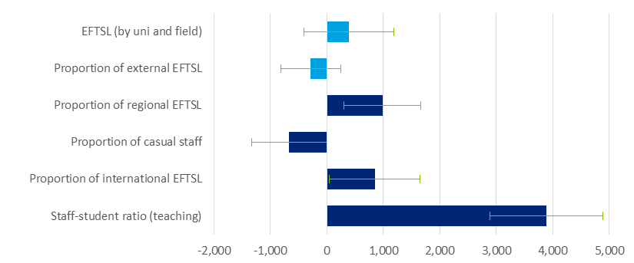

Source: Deloitte Access Economics analysis.

Note: Confidence bands at the 90% level. ‘EFTSL’ and ‘Proportion of external EFTSL’ are not statistically significant from zero, and are indicatively included.

In summary, it is clear that some cost drivers, such as staff to student ratios (and to a lesser extent the proportion of casual teaching staff and student demographics) have a material impact on teaching and scholarship costs, while the impact of other cost drivers is relatively small.

To provide further details on the relative spread and mean and median values of each of the cost drivers, Table 5.3 shows the mean and median of each cost driver, its minimum and maximum value and the size of the interquartile range (which is used as the basis for Chart 5.1).

: Descriptive statistics - Cost drivers (bachelor level)

|  |  |  |  |  |  |
| --- | --- | --- | --- | --- | --- |
| Cost Driver | Mean | Median | Min | Max | IQR |
| Log staff-student ratio (Teaching staff FTE / total EFTSL) | -3.30 | -3.37 | -4.61 | -1.05 | 0.60 |
| Staff-student ratio | 0.04 | 0.03 | 0.01 | 0.35 | 0.02 |
| Student-staff ratio (inverse of Staff-student ratio) | 25 | 33.3 | 100 | 2.9 | 50 |
| Log Total EFTSL (by field) | 7.11 | 7.40 | 1.18 | 9.90 | 1.89 |
| Total EFTSL (by field) | 2954 | 1632 | 3 | 19888 | 3243 |
| Indicator for HDR EFTSL | 0.86 | 1.00 | 0.00 | 1.00 | 0.00 |
| Proportion of HDR EFTSL to total field EFTSL (university level) | 0.03 | 0.02 | 0.00 | 0.35 | 0.03 |
| Proportion of international EFTSL | 0.12 | 0.09 | 0.00 | 0.82 | 0.14 |
| Proportion of regional EFTSL | 0.28 | 0.16 | 0.01 | 0.96 | 0.37 |
| Proportion of casual teaching staff | 0.43 | 0.36 | 0.00 | 1.88 | 0.34 |
| Proportion of external (including multimodal) EFTSL | 0.16 | 0.02 | 0.00 | 1.00 | 0.21 |
| Average student experience survey score (SES, CEQ) | 82.81 | 83.25 | 59.50 | 96.80 | 7.57 |
| Proportion of graduates in fulltime employment | 62.74 | 60.10 | 26.70 | 100.00 | 25.10 |
| Median salary of graduates | 54539 | 55000 | 38000 | 92000 | 9000 |
|  |  |  |  |  |  |

Source: Deloitte Access Economics analysis. See Appendix A for descriptive statistics by field.

Other specifications

Quantile regression results and results from the SFA analysis are set out in Appendix A. The results from these models are broadly similar to the OLS regression in terms of identifying the main cost drivers of teaching and scholarship costs. The coefficient estimates themselves vary across models, but it is not straightforward to interpret the differences directly. The implications of the differences in terms of costs per EFTSL are shown in the next section.

## Obtaining indications of reasonable cost

This section discusses how the results of the regression analysis can be used to inform an assessment of reasonable cost for a typical university. As noted previously, what is considered reasonable cost is ultimately a question for policymakers. The objective of this section is not to provide a single estimate of reasonable cost, but rather to provide evidence about how the notion of reasonable cost varies based on the assumed values of different cost drivers and relative efficiency.

The results in section 5.1 inform the assessment of reasonable cost for each field of education, based on the notion of ‘typical’ university characteristics and by removing variations in cost that are not related to underlying contextual, or field of education specific, drivers of cost. In particular, following the discussion in section 4.3.3, this may be done by:

* Applying the median characteristics of the sample universities in that field of education to each of the specifications discussed in Section 4.3.2; or alternatively,
* Splitting the explanatory variables into two types: (1) choice or strategic variables and (2) contextual variables which universities have limited scope to vary, then applying the median characteristics of the sample universities in that field of education to each of the former and the actual university characteristics to the latter.

The second of these two approaches is taken in the analysis here, but as indicated it is just one such possible approach. The variable which is considered to be contextual in this analysis is the proportion of regional EFTSL, with all other variables assumed to be choice or strategic variables. In each case, the model is used to obtain predicted values of cost per EFTSL by field of education.

### Reasonable cost assessment by field of education

Applying the algorithm just outlined, Chart 5.2 compares the median actual costs (per EFTSL) in different fields of education with indications of reasonable costs based on estimates from the model estimated by OLS, the quantile regression model (at the 25th percentile) and SFA model. Table 5.5 shows the precise values for each field of education from these different models.

The lines labelled ‘OLS upper’ and ‘OLS lower’ show confidence intervals for the estimates from the OLS model. Some caution is needed in interpreting these confidence intervals. If longitudinal data was available it may be possible to account for university specific field of education effects, which may lead to smaller confidence intervals. Thus the confidence intervals presented here may be somewhat conservative, but nonetheless indicate that there is a degree of uncertainty around the estimate of reasonable cost developed through this approach.

The variation in the cost measures across fields of education reflect systematic differences in the characteristics and delivery of education across fields including:

* Differences in the value of cost drivers across different fields of education; and
* Unobserved factors that lead some disciplines to be more expensive than others, even after accounting for the value of the cost drivers (demonstrated by the significant variations in the coefficient estimates on the field of education indicators in the OLS results shown in Table 5.2).[25]

Quantile regression (at the 25th percentile) cost estimates are incorporated similarly, and attempt to ‘go beyond’ a measure of differentials in cost at the median or typical university, and estimate a lower bound of cost that may be interpreted as better representing the reasonable cost frontier, albeit with this frontier being chosen somewhat arbitrarily here as the 25th percentile.

These quantile regression estimates, as expected, are generally lower than the median actual cost and always lower than the OLS cost model predictions. Results from SFA, which apply an even more stringent definition of efficiency, always lie below both actual costs and reasonable costs based on an OLS model.This suggests that the reasonable costs for a university operating efficiently is below average actual costs.

Furthermore, there is some variation across fields in the distance between the reasonable cost estimate from the OLS model and lower cost bounds.[26] This suggests that some fields are on average ‘further’ from the cost frontier – for example, Dental Studies and Veterinary Studies – while others appear to be relatively close to the frontier. This variation may reflect:

* Greater differences in efficiency levels in particular fields of education;
* Different strategic decisions being made in particular fields of education; or
* The influence of other unobserved factors impacting cost differentially across universities.[27]

In summary, the analysis in Chart 5.2 demonstrates that reasonable costs for a typical university vary considerably across different fields of education, reflecting differences in cost drivers such as staff to student ratios. Moreover, the notion of reasonable cost is very much dependent on the particular point in the cost distribution chosen to reflect the relative level of efficiency.

Chart 5.3 builds on the analysis in Chart 5.2 by decomposing each cost estimate into common cost drivers and field-specific effects. The dark blue lower sections represent the impact of cost drivers, which are set to their median value in each field. Notably, there is only moderate variation in cost per EFTSL associated with differences in underlying cost drivers.

The light blue upper sections in Chart 5.3 show the degree of cost variation due to field specific or fixed effects. Shading is used to represent field specific effects that are not statistically different from the omitted base category (Other Society and Culture). A significant degree of variation is observed to be field specific, after controlling for observed cost drivers. This suggests that there are likely unobserved differences at the field level, which could include factors such as laboratories or work placements, which have a significant impact on cost, in addition to the included cost drivers.

The green line shows total costs (including field specific effects) where the staff to student ratio is set at a common value of 30 students per teaching staff member, compared to the median 26.8 students per teaching staff. This new total cost is higher for low cost fields, which suggests these fields have higher staff to student ratios (than the median), and vice versa for high cost fields.

The total variation in costs between fields moderates after setting a common staff to student ratio, which indicates that a significant proportion of costs may be attributable to decisions on staff to student ratios. Notably, this is most apparent for the highest cost courses (Veterinary Studies, Dental Studies), which suggests their cost differentials are driven to a substantial degree by staffing costs.

: Cost estimates - Total cost per EFTSL (bachelor level, 2015)

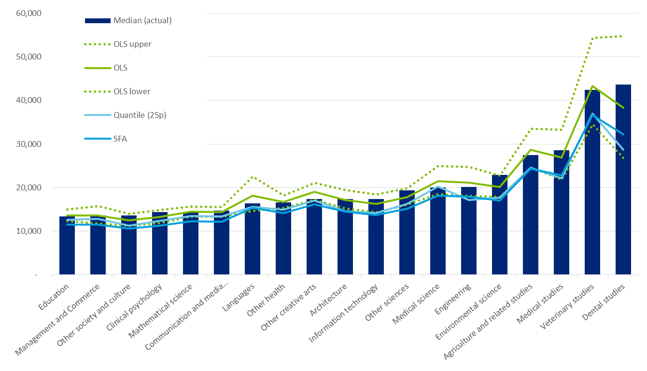

Source: Deloitte Access Economics analysis.

Note: Varied ‘contextual’ cost drivers include proportion of regional EFTSL and field fixed effects. Fixed cost drivers (set to median by FOE) include staff student ratio (log, teaching staff), proportion of casual teaching staff, and ratio of HDR to postgraduate coursework EFTSL.

: Reasonable vs raw cost by field (bachelor level)

|  |  |  |  |  |  |  |  |  |
| --- | --- | --- | --- | --- | --- | --- | --- | --- |
| Field | Median | Mean | Min | Max | IQR | OLS | Quantile (25p) | SFA |
| Mathematical science | 14,388 | 14,428 | 9,038 | 20,008 | 3,627 | 14,004 | 12,991 | 12,004 |
| Medical science | 20,014 | 21,734 | 17,501 | 32,949 | 4,791 | 21,131 | 20,298 | 17,948 |
| Other sciences | 19,380 | 18,910 | 10,494 | 28,527 | 3,135 | 17,540 | 15,942 | 14,992 |
| Information technology | 17,408 | 17,066 | 9,085 | 24,432 | 4,600 | 15,774 | 13,835 | 13,483 |
| Engineering | 20,146 | 22,514 | 12,303 | 55,165 | 4,316 | 20,650 | 16,336 | 17,697 |
| Architecture | 17,384 | 22,460 | 11,208 | 109,988 | 5,036 | 16,411 | 14,256 | 14,035 |
| Environmental science | 22,876 | 21,443 | 9,193 | 32,564 | 6,855 | 19,690 | 17,475 | 16,840 |
| Agriculture and related studies | 27,443 | 29,657 | 18,975 | 48,600 | 16,134 | 27,791 | 22,157 | 23,922 |
| Medical studies | 28,543 | 29,213 | 11,371 | 60,606 | 14,656 | 26,512 | 24,004 | 22,678 |
| Dental studies | 43,619 | 42,799 | 23,771 | 60,663 | 25,987 | 38,072 | 28,618 | 32,287 |
| Veterinary studies | 42,452 | 51,305 | 32,632 | 78,788 | 28,482 | 44,881 | 42,032 | 38,799 |
| Other health | 16,533 | 17,577 | 12,682 | 35,856 | 4,294 | 16,544 | 15,248 | 14,185 |
| Education | 13,364 | 13,845 | 7,843 | 22,507 | 2,758 | 13,139 | 12,060 | 11,254 |
| Management and Commerce | 13,586 | 13,904 | 6,431 | 26,033 | 2,737 | 13,359 | 11,547 | 11,481 |
| Languages | 16,322 | 21,964 | 10,288 | 68,091 | 3,633 | 17,749 | 15,121 | 15,139 |
| Clinical psychology | 14,322 | 13,528 | 5,809 | 18,413 | 4,887 | 12,817 | 12,490 | 10,966 |
| Other society and culture | 13,609 | 12,974 | 7,091 | 18,669 | 3,684 | 12,213 | 10,737 | 10,462 |
| Communication and media studies | 14,746 | 14,440 | 9,230 | 17,882 | 2,602 | 14,197 | 13,042 | 12,178 |
| Other creative arts | 17,361 | 20,349 | 13,430 | 43,987 | 7,362 | 18,869 | 16,462 | 16,144 |

Source: Deloitte Access Economics analysis.

Note: Median, mean, min, max and IQR are calculated for the raw data. Reasonable cost estimates for OLS, quantile and SFA are measured for each field and university, and presented at the median value.

: Reasonable cost - Cost drivers vs Field effects by field (bachelor level)

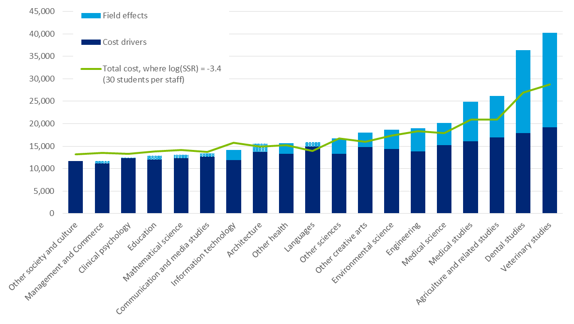

Source: Deloitte Access Economics analysis. The omitted field is other society and culture. Field effects are statistically insignificant for Management and Commerce, Education, Mathematical Science, Clinical Psychology, Communication and Media Studies, Architecture and Languages. Cost drivers are calculated at median values, and include staff student ratio (log), proportion of regional EFTSL, proportion of casual staff, proportion of external EFTSL and a common constant. Field effects are calculated multiplicatively, that is, as a multiple of the cost drivers and constant term. The median log staff student ratio (SSR) across fields is -3.29, which translates to 26.8 students per teaching staff.

### Cost within a field of education

While costs are likely to differ across fields of education due to differences in the underlying cost drivers across universities, there is often significant variation in costs across different universities within a given field of education.

Chart 5.5 presents, for the Management and Commerce field of education at the bachelor level, actual costs and the three measures of reasonable costs based on typical university characteristics – OLS, quantile regression and SFA-based – across the seventeen universities in the sample. Each of the predicted cost lines (aside from actual costs) are estimated using the median values of the choice or strategic cost drivers, while allowing for the proportion of regional EFTSL to take its actual value (as this is likely to reflect contextual factors that are less able to be controlled by the university). Hence the variation in predicted costs by university is determined only by differences in regional students. These measures of cost are thus relatively stable across universities.

: Cost estimates - Total cost per EFTSL (Management and Commerce, bachelor level, 2015)



Source: Deloitte Access Economics analysis.

Note: Varied ‘contextual’ cost drivers include proportion of regional EFTSL. Fixed cost drivers (set to median by FOE) include staff student ratio (log, teaching staff), proportion of casual teaching staff, and ratio of HDR to postgraduate coursework EFTSL.

Chart 5.5 demonstrates a significant degree of variation in actual costs between universities. In some cases actual costs are substantially different to those predicted by each model. This could be driven by a given university having cost drivers which differ substantially from the median, unobserved factors, or strategic decisions by a university to prioritise particular fields of education.

The 25% quantile and SFA measures are below the OLS measures, again reflecting moves towards the efficient cost. Interestingly, some universities continue to have actual costs below this level, which results from such universities having ‘weaker’ cost drivers relative to the median (such as smaller staff-student ratios) or unobserved factors which reduce their actual costs. The lower confidence interval of the OLS estimate of reasonable costs for a typical university is broadly in line with estimates of the SFA model. The width of the confidence interval here provides an indication of the relative range into which reasonable costs could fall.

### Interpretation of reasonable cost estimates

In general terms, the results from these models can be interpreted as measures of reasonable cost for a university with typical characteristics (in 2015). At the same time, it should be emphasised that the estimates of reasonable cost are determined by the particular values of the variables used in the calculation, and the choice of the typical university inputs may not be representative of the inputs which policymakers may choose for their assessment of reasonable cost. Estimates of reasonable cost differ depending on:

* The values of the choice, or strategic, and contextual variables that go into the underlying estimated models of costs.
* For example, the staff to student ratios for each FOE must be pre-defined to reflect benchmark standards implicit in the definition of reasonable cost. Changes in assumed staff to student ratios can have large impacts on the estimated level of reasonable costs.
* Similarly, changes to other variables such as the proportion of casual teaching staff can have a material impact on teaching and scholarship costs, although the impact of other variables is relatively smaller than staff to student ratios.
* The specific field of education being considered.
* There are significant differences in estimated reasonable costs by field of education even after controlling for differences in the underlying cost drivers.
* The desired threshold of benchmark efficiency, to inform the choice of model used to determine underlying costs.
* For example, if a threshold level of efficiency is believed to be at the 25th percentile of costs by FOE, then the results from the quartile regression analysis may be used to define reasonable cost.

Critically, these parameters are chosen in order to present a stylised representation of reasonable costs for the purposes of this report and should be considered as illustrative only. Ultimately these assumptions must be determined by policymakers in the context of other considerations, including notions of benchmark quality in teaching and scholarship.

There are a number of ways in which the robustness of the results provided in this study could be enhanced in future research:

**Sampling error -**The data collected for this study is from a sample of all comprehensive universities in Australia. However, even if data were available for all universities, there would still be a degree of sampling error in the results. While the results on such data would exactly reflect behaviour in 2015 (ignoring that there may be measurement errors in the reported data), using the results going forward must acknowledge that natural variations in costs from one year to the next. In other words, a hypothetical dataset containing all universities should still be treated as a sample. Results from a sample of universities over a number of years (that is, a panel data approach) could help minimise sampling error by accounting for university specific field of education effects. Such effects may reflect strategic prioritisation or resourcing decisions by universities that are correlated over time.

**Specification of functional form -**While various tests of the functional form of the model were carried out in the course of the analysis (resulting in some refinements to the functional form), there is scope for further refinement of the model. In particular, the functional form could potentially include more complex forms of non-linearity, as well as interaction terms, although the inclusion of additional terms is somewhat limited by the sample size of the current study. Again a panel data set would assist in considering these effects.

**Additional variables -**It is possible that the model suffers from omitted variables (as does any econometric model), which may lead to incorrect conclusions being drawn about the relative efficiency of different universities. In particular, there may be omitted variables relating to teaching quality and the trade-offs between teaching and research. This highlights the importance of developing robust long term measures of learning outcomes.

**Efficiency*****-***The relative efficiency of different universities can be manifested out in a number of different ways. For example, some universities may have higher fixed costs (e.g. administration costs), represented by a larger constant term in the model. Inefficiency may also be present through differences in the slope of cost drivers. While panel data could help to some extent in disentangling these effects, there could exist another form of inefficiency in which universities use their inputs efficiently, but apply more inputs that is strictly required to meet benchmark teaching and scholarship standards. The ability of the data in this study to identify this latter form of inefficiency is relatively limited. Identifying this form of inefficiency requires reliable data on teaching and scholarship outcomes across universities and is an important area for future research.

# International benchmarking

This chapter compares the relative costs of teaching in Australia across disciplines with costs in comparable international jurisdictions, namely the UK and New Zealand. Given the available data and inconsistencies in the scope of costs captured across countries, the results are presented as relative to the average teaching cost in Management and Commerce in each country. This provides a benchmark against which observed costs in the Australian context can be moderated, independently of the effects of existing funding arrangements in Australia.

## International funding systems: a brief overview

United Kingdom

The higher education funding framework in the United Kingdom is broadly comparable to the Australian system. University revenue is a combination of tuition fees, teaching grants from the Government via the Higher Education Funding Council for England (HEFCE), and grants to cover other activities (both research and non-research).

The United Kingdom underwent funding reform in 2012, with tuition fees set by individual institutions subject to a cap. In England, fees are capped at £9,000 a year (for students from the UK and EU), with around 76% of all institutions charging the full amount in 2015-16. This reform led to a shift towards students contributing much of the cost of their education themselves, with access to publicly funded loans that are generally repayable after the student has finished their studies. Before the reform, 35% of total teaching funds in 2010-11 were through HEFCE teaching grants. This decreased to 12% by 2014-15 (HEFCE, 2015).

New Zealand

New Zealand’s university system forms one component of a national tertiary funding program administered by the Tertiary Education Commission on behalf of the Ministry of Education.

The Student Achievement Component (SAC) is the mechanism through which the Government funds teaching and scholarship. SAC funding rates are set on an Equivalent   
Full-time Student Load (EFTSL) basis, and differ depending on the level of study and 18 fields of study. SAC funding is supplemented by student private contributions through an   
interest-free student loan scheme. In 2010, tertiary education students contributed 27% towards the direct cost of tertiary education, while Government funding accounted for the remaining 73% (Baxter, 2012).

Chart 6.1 compares income sources for the higher education sector in Australia (2014), UK (2012-13) and New Zealand (2012).[28] The Australian and New Zealand Governments provide similar levels of non-research support (35%) for the higher education sector. In particular, this includes Government funding for teaching, scholarships, capital grants and other financial assistance.

Australia and New Zealand have relatively high levels of Government non-research funding compared to the UK. UK funding bodies (including HEFCE) contribute 24% of the sector’s income. However, this includes grants for teaching as well as for research.

Student fees make up the largest source of higher education income for Australia (42%) and the UK (40%). This includes tuition fees by both international and domestic students. For Australia, 41% of total student fees is made up of Australian Government payments for   
HECS-HELP, FEE-HELP and SA-HELP. This funding has been included under student fees for consistency with the other jurisdictions, where funding from public student loan programs is not explicitly counted as funding from the Government. In contrast, student fees make up 29% of total provider income in New Zealand.

Australian higher education providers receive a relatively lower share of income from research funding (8%) compared to New Zealand (23%) and the UK (16%). This includes research grants and contracts from both public (such as the Australian Research Council and Australian Government research block grants) and private institutions. The lower level of funding for research in Australia could potentially lead to greater degree of   
cross-subsidisation between departments and activities.

: Higher education funding by benchmark countries

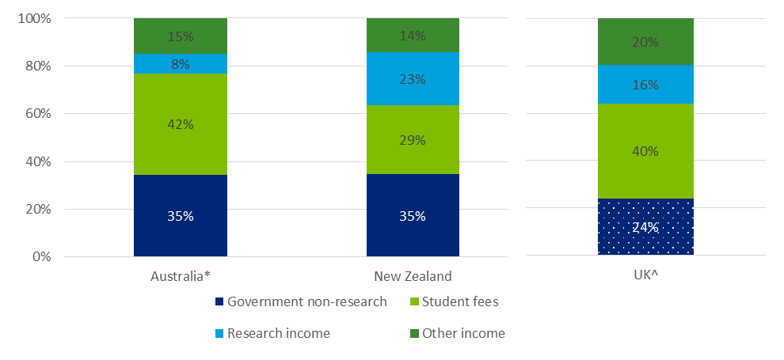

Source: Department of Education and Training, 2015b; Tertiary Education Commission, 2016; Higher Education Statistics Agency, 2016.

* Australian Government payments for HECS-HELP, FEE-HELP and SA-HELP is included under student fees as students are assumed to repay the Government over time. This is consistent with attribution in New Zealand and UK.

^ UK funding bodies also contribute to research (in addition to teaching). However, this cannot be separated from teaching funding due to data limitations.

These funding differences could potentially contribute to differences in the relative costs of teaching between countries.

## International costing systems: a brief overview

United Kingdom

The UK uses an activity-based costing system, the Transparent Approach to Costing (TRAC), to attribute costs and income of higher education providers across the three core activities of teaching, research and other. Building on the TRAC principles, TRAC for Teaching (TRAC(T)) is a framework for costing *publicly funded teaching* for different subjects. These costs are then used to derive the subject-related Full Average Cost of Teaching a Student   
(Subject-FACTS). The relative teaching costs of subjects are used to review the assignment of subjects into five broad price groups, and determine the allocation of HEFCE funding for these subjects (HEFCE, 2012).

TRAC(T) data does not represent the total cost of teaching a student as non-subject costs are excluded. This includes bursaries to support student living costs, costs to widen participation, and work placement years. Further, the costs funded by the tuition of overseas students, and non-HEFCE funding for specific courses (such as by the Department of Health) are also excluded from TRAC(T) data. To the extent that the excluded costs are proportional to TRAC(T) costs, TRAC(T) data gives a reliable indication of the relative costs between subjects.

New Zealand

In order for providers to be eligible for SAC funding, they must participate in the annual benchmarking of revenue and costs. This is done through the New Zealand Benchmarking Tool (NZBT), which collates data on the income, expenditure and equivalent full-time students of providers. Using NZBT data, average ‘direct operational costs’ per EFTSL can be identified across departments. Overhead costs such as student support services and capital costs are excluded. Consequently, the tool is not well-placed to quantify the total delivery costs for a particular course.

This data has been used to help New Zealand Ministry of Education identify areas of under- and over-funding and align cost and funding relativities. For instance, decisions taken in Budgets 2013 and 2014 reduced many of these imbalances.

## Comparison methodology

Acknowledging that the international benchmarks are capturing different costs and may not be easily comparable (Figure 6.1), the relative costs of teaching across different fields of education in the UK and New Zealand are compared to Australia based on the national approaches identified above.

: Costs captured under international benchmarks

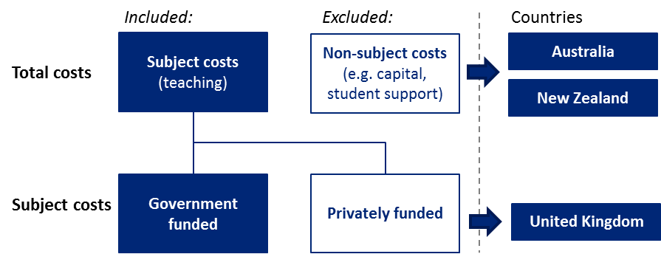

Source: Deloitte Access Economics analysis.

Data sources

Deloitte Access Economics is unable to directly access primary data at the institutional level in each of these countries. Instead, it has compared Australian survey results from the 18 participating institutions (17 of which provided full data) to the following international secondary data sources:

* **United Kingdom:** KPMG (2014) collected data from 22 higher education institutions that broke down their 2012 TRAC(T) costs by postgraduate and undergraduate studies. The postgraduate students at these institutions covered 22% of the postgraduate EFTSL population in England; and
* **New Zealand:** The Ministry of Education (2015) used NZBT data from 2012 to benchmark teaching costs for the fields of study and compare relative costs to SAC funding rates.

Key differences between the data sources, including the level of disaggregation at the field of education and level of study are summarised in Table 6.1.

: Summary of international cost data sources

|  |  |  |  |
| --- | --- | --- | --- |
|  | **Australia** | **United Kingdom** | **New Zealand** |
| **Source** | Survey | TRAC(T) | NZBT |
| **Coverage** | 18 institutions representing 54% of EFTSL population | 22 institutions[29] representing 22% of EFTSL population | All 8 institutions |
| **Year of data** | 2015 | 2012-13 | 2012 |
| **Absolute costs / student data** | ✓ | ✓ | × |
| **Field of education detail** | 10 fields of education (ASCED 2-digit) | 45 cost centres | 10 fields of education (ASCED 2-digit)[30] |
| **Level of study detail** | ✓ | ✓ | × |

Source: Deloitte Access Economics analysis. Note one institution provided partial data in current study.

Methodology

Given differences in approaches across the international data sources, the most useful comparison would be based on the relative, rather than absolute, cost of teaching across the countries. As funding arrangements in these countries are influenced or determined based on the costs of delivery and has notable differences to funding in Australia (Chart 6.1), this offers a costing benchmark independent of existing funding arrangements in Australia.

The average cost of teaching a Management and Commerce EFTSL in each country is used as the benchmark unit to compare average costs in other fields of education. It has been chosen as it typically has a low cost compared to other subjects.

To make costs comparable, the following steps have been taken:

* the international fields of education have been mapped to the 10 Australian Standard Classification of Education (ASCED) 2-digit fields of education. United Kingdom cost centres (45 subjects) are mapped one-to-one to Australian fields of education. See Table 6.2 for the full mapping;
* where total cost and student data are available, total teaching related costs for each country has been aggregated under the appropriate field of education. This is then divided by the EFTSL to calculate the average teaching cost per EFTSL for each field of education; and
* this is then divided by the average teaching cost in Management and Commerce to calculate the relative costs of delivery in other fields of education and funding clusters.

: Mapping between HESA and DET clusters

| **HESA cost centre** | **FOE mapping** | **Funding clusters** |
| --- | --- | --- |
| Clinical medicine | Health | 8a |
| Clinical dentistry | Health | 8a |
| Nursing and allied health professions | Health | 6 |
| Psychology and behavioural sciences | Society and culture | 5a |
| Health and community studies | Health | 3a |
| Anatomy and physiology | Natural and physical sciences | 7 |
| Pharmacy and pharmacology | Health | 7 |
| Sports science and leisure studies | Society and culture | 3b |
| Veterinary science | Health | 8a |
| Agriculture, forestry and food science | Agriculture, environmental and related studies | 8b |
| Earth, marine and environmental sciences | Agriculture, environmental and related studies | 8b |
| Biosciences | Natural and physical sciences | 7 |
| Chemistry | Natural and physical sciences | 7 |
| Physics | Natural and physical sciences | 7 |
| General engineering | Engineering and related technologies | 7 |
| Chemical engineering | Engineering and related technologies | 7 |
| Mineral, metallurgy and materials engineering | Engineering and related technologies | 7 |
| Civil engineering | Engineering and related technologies | 7 |
| Electrical, electronic and computer engineering | Engineering and related technologies | 7 |
| Mechanical, aero and production engineering | Engineering and related technologies | 7 |
| Information technology, systems sciences and computer software engineering | Information technology | 3a |
| Mathematics | Natural and physical sciences | 3a |
| Architecture, built environment and planning | Architecture and building | 3a |
| Geography and environmental studies | Agriculture, environmental and related studies | 8b |
| Area studies | Society and culture | 3b |
| Archaeology | Society and culture | 2 |
| Anthropology and development studies | Society and culture | 2 |
| Politics and international studies | Society and culture | 3b |
| Economics and econometrics | Society and culture | 1 |
| Law | Society and culture | 1 |
| Social work and social policy | Society and culture | 3b |
| Sociology | Society and culture | 3b |
| Business and management studies | Management and commerce | 1 |
| Catering and hospitality management | Management and commerce | 1 |
| Education | Education | 4 |
| Continuing education | Education | 4 |
| Modern languages | Society and culture | 5a |
| English language and literature | Society and culture | 2 |
| History | Society and culture | 2 |
| Classics | Society and culture | 2 |
| Philosophy | Society and culture | 2 |
| Theology and religious studies | Society and culture | 2 |
| Art and design | Creative arts | 5a |
| Music, drama, dance and performing arts | Creative arts | 5a |
| Media studies | Creative arts | 5a |

Source: Deloitte Access Economics analysis.

A similar approach has also been undertaken to benchmark across the 2016 Australian funding clusters. In particular, the average international teaching *costs* have been compared to the *total* *maximum* *funding* received for each cluster in Australia.[31] This captures cost variations within broad fields of education. For instance, whereas both mathematics and physics fall under Natural and Physical Sciences, mathematics is likely to have lower teaching costs as it is classroom-based.

Funding cluster 1, which includes courses in law, accounting, administration, economics, commerce, is used as the benchmark cluster. Table 6.3 lists the full set of funding clusters. Due to limitations in data availability, a one-to-one match from field of education to funding cluster is not always possible. In particular, NZBT data is unable to capture differences between narrow fields of education outside of those in Health and Natural and Physical Sciences.

: 2016 Australian funding clusters

|  |  |  |
| --- | --- | --- |
| **Funding Cluster** | **Description** | **Total funding ($)** |
| Funding cluster 1 | Law, accounting, administration, economics, commerce | 12,499 |
| Funding cluster 2 | Humanities | 11,980 |
| Funding cluster 3a | Mathematics, statistics, computing, built environment or other health | 19,044 |
| Funding cluster 3b | Behavioural science or social studies | 16,383 |
| Funding cluster 4 | Education | 16,793 |
| Funding cluster 5a | Clinical psychology, foreign languages, or visual and performing arts | 18,711 |
| Funding cluster 5b | Allied health | 21,372 |
| Funding cluster 6 | Nursing | 20,161 |
| Funding cluster 7 | Science, engineering or surveying | 26,623 |
| Funding cluster 8a | Dentistry, medicine or veterinary science | 32,912 |
| Funding cluster 8b | Agriculture | 31,389 |

Source: Department of Education, 2016.

## Results

Overall (field of education)

International benchmarking shows that relative teaching costs are ranked similarly across the three countries (Chart 6.2). Management and Commerce has the lowest average subject teaching costs in New Zealand and Australia, and the second lowest (9th) in the UK. Similarly, average teaching costs in Society and Culture are among the lowest, ranked 10th in the UK, 9th in New Zealand, and 7th in Australia. This is followed by Education, and Architecture and Building.

These courses tend to have lower average costs due to:

* **high staff to student ratios:** Australian universities have on average 55 EFTSL for every one full-time equivalent (FTE) staff in Management and Commerce, compared to 35 on average across the full sample of courses (DET, 2016); and
* similarly, Education and Society and Culture also have above average EFTSL to staff ratios
* **classroom based subjects** (such as Mathematical Science) tend tohavelowercosts.

Health has the highest average teaching costs in the UK and US, and second highest in Australia. In Australia, it costs 1.6 times as much to teach an EFTSL in Health than Management and Commerce. In New Zealand and UK, it costs 2.8 times and 1.8 times more than teaching Management and Commerce in the respective countries.

Agriculture, Environmental and Related Studies, and Engineering and Related Studies also consistently round out the top four highest cost fields of education across the three countries. These courses tend to have high costs as they have low staff to student ratios, requirements for industry placements or clinical training, and laboratory-based learning.

The relative costs differences between countries can be explained by a number of factors. First, differing focus (quality) of subjects across countries explains variations in cost. Costs of Agriculture, Environmental and Related studies in New Zealand and Australia are respectively 2.5 and 1.9 times that of costs in Management and Commerce. In comparison, Agriculture costs in the UK is only 1.2 times higher. This could be because Australia and New Zealand have large agriculture sectors, and so the focus for the curriculum is on research-related activities using new technologies. In contrast, Agriculture in the UK focusses on business aspects, such as farm business planning that would have lower costs. This difference in focus is reflected in Australia and New Zealand having a higher proportion of universities ranked higher in Agriculture, Environmental and Related Studies.[32]

The variation between countries also likely reflects differences in the measurements. In particular, UK costing only includes the HEFCE funded component. It is likely that this underestimates overall costs, particularly in priority areas such as health that receive alternative sources of funding from the Department of Health. If non-HEFCE funding varies between the fields of education, the above results would understate the variability in subject costs in the UK.

UK average teaching costs calculated using TRAC(T) data show less variation compared to Australia and New Zealand results. By contrast, average *department costs* per EFTSL in the UK displays greater variation.[33] For instance, average department expenditure in Health is 2.0 times higher than the department expenditure in Management and Commerce, compared to 1.8 times higher under TRAC(T). This suggests that TRAC(T) data has a narrower definition of what types of expenditure are considered under subject costs.

Variability in costs between courses could also reflect student numbers (particularly at the institution level) and differing economies of scale associated with teaching between countries. For instance, New Zealand, which has the lowest enrolment numbers, tends to display the greatest variability between courses. In contrast, results in the UK tend to be clustered.

: Average teaching and scholarship costs by field of education (Cost of Management and Commerce = 1)

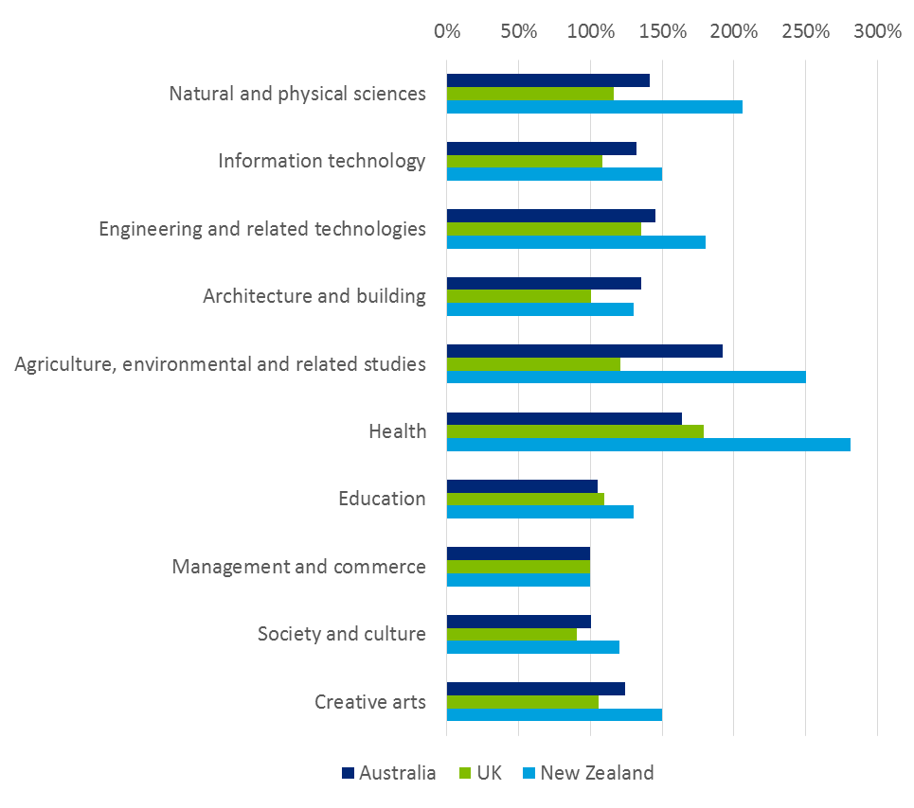

Source: Deloitte Access Economics analysis; New Zealand Ministry of Education, 2015; HEFCE, 2014.

Postgraduate relative to undergraduate (field of education)

It is also possible that differences in costs are driven by the distribution of postgraduate and undergraduate students within each country. As teaching costs for postgraduate students in each course tend to be higher than their undergraduate counterparts, reflective of smaller class sizes, a higher proportion of postgraduate students in one country would influence the results.

Consequently, the average teaching costs per EFTSL by field of education (relative to costs in undergraduate Management and Commerce) have been disaggregated for Australia and the UK in Chart 6.3. NZBT data from the study cannot be disaggregated by level of study.

In the UK, the average cost of teaching a HEFCE funded postgraduate student is 47% higher than undergraduate teaching. This ranges from 15% higher in Engineering and Related technologies to 90% for Management and Commerce. In Australia, the average cost of teaching postgraduate is 31% higher than teaching for undergraduate. This ranges from 7% higher in Information Technology to 90% higher in Natural and Physical Sciences.

The ranking of relative costs is broadly consistent between undergraduate and postgraduate courses. For instance, Agriculture, Environmental and Related Studies, and Heath are among the most costly disciplines in the UK and Australia, at both the undergraduate and postgraduate levels. Postgraduate Health is 1.4 times higher than compared to undergraduate Health in Australia, and is broadly consistent with differentials in the UK.

However, there are some fields of education with notable differences. For instance, in the UK, the cost of teaching a postgraduate Information Technology student is 86% higher than teaching an undergraduate student in the same field. This differs to Australia, where there is only a 7% difference. Similarly, postgraduate Management and Commerce costs 90% more in the UK, compared to 18% more in Australia.

Differences such as this could be again due to differences in the scope of costs covered. The UK estimates only cover the costs of taught postgraduate provision and possibly do not incorporate the cost of postgraduate research or other costs such as non-capitalised equipment. Consequently, postgraduate costs in Natural and Physical Sciences are only 40% higher than undergraduate costs – compared to a 90% difference in Australia.

: Average teaching and scholarship costs by field of education (Cost of Management and Commerce *undergraduate* = 1)

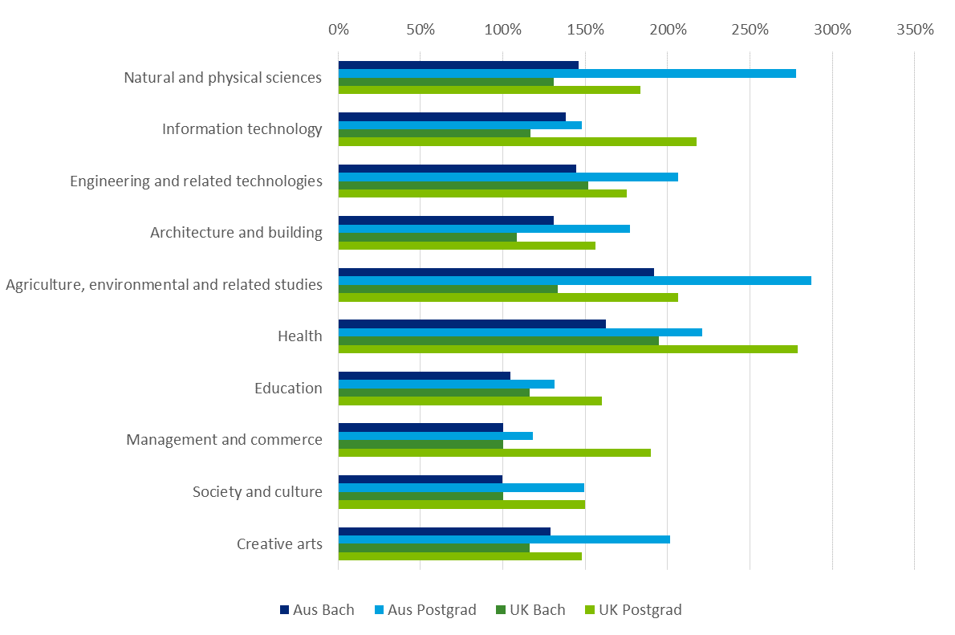Source: Deloitte Access Economics analysis; HEFCE, 2014.

Overall (funding cluster)

Total funding per funding cluster is compared in this section to the estimated international costs identified above. Chart 6.4 presents the relative cost (funding) of the clusters relative to Funding Cluster 1.

Funding Cluster 8a (Dentistry, Medicine or Veterinary Science) has the highest average costs internationally, and receives the most total funding in Australia. There is variability in relative cost of Funding Cluster 8 relative to cluster 1. The average cost of teaching these courses in Australia is 2.6 times higher than cluster 1, compared to 5.3 times higher in New Zealand and 2.0 times higher in UK.

This is followed by Funding Clusters 7 (Engineering, Science, Surveying) and 8b (Agriculture), albeit in different orders between countries. Funding for Agriculture in Australia is 2.5 times higher than cluster 1. However, teaching costs in Agriculture in Australia among the surveyed institutions are 1.9 times higher than teaching in Management and Commerce (which approximately correspond to Funding Cluster 1).

Similarly, average funding received by Engineering and Related technologies and Education (2.1 and 1.3 times respectively) is higher than its costs relative to Management and Commerce (1.5 and 1.0 times respectively).

: Average costs by funding cluster (Cost of Funding Cluster 1 = 100%)

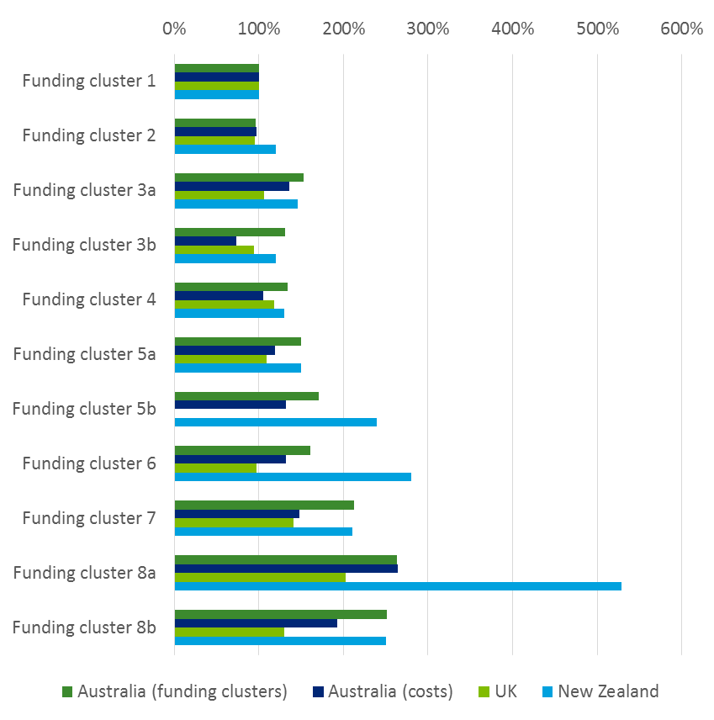

Source: Deloitte Access Economics analysis; New Zealand Ministry of Education, 2015; HEFCE, 2014.

Benchmarking across international jurisdictions may not be perfectly comparable given differences between funding systems and the scope of measurements between countries. However, evidence suggests that the relative rankings of delivery costs across the fields of education are broadly consistent across countries. While this may result from similar funding systems, to the extent that these benchmarks align with an underlying measure of relative reasonable costs, it supports the validity of the results of the Australian costing exercise.

# Findings and conclusions

The evidence developed as part of this study provides a contemporary basis for understanding relativities in costs across fields of education and qualification levels in Australian universities, with possible implications for the recalibration of relative base funding.

This section reflects on the findings and the analysis that has been conducted, and makes some concluding comments regarding the direction of future policy and research in this area.

## Key findings and conclusions

A robust and contemporary source of underlying cost data

The data collected as part of this study covers around 700,000 university enrolments, or 54% of Table A universities. This cost data is the most detailed and comprehensive set of information on higher education costs that has been made available in Australia and will be a critical source of evidence for policy and analysis purposes into the future.

This evidence demonstrates that costs across fields of education remain broadly similar to those estimated as part of the 2011 costing study to inform the Base Funding Review, and that at a sectoral level these costs have remained stable across the two studies. The data also shows that there is significant cost variation not just across FOEs, but within FOEs across universities, demonstrating that underlying differences in organisational structures and approaches to teaching and scholarship for given FOEs result in variations in average teaching and scholarship costs.

This evidence also demonstrates important cost variation within the previously analysed 10 broad FOEs. Across the 19 FOEs considered in this study, there is a notable degree of variation in average teaching and scholarship costs. It also reinforces the finding from consultations with universities that the greatest variation of costs occurs at the individual course or unit level, which is the level at which most universities measure the relative cost (and efficiency) of their teaching and scholarship activities.

The scale and scope of data made available for this study allows for a deeper analysis of the underlying drivers of cost, and associated analysis with respect to notions of moderated, typical or ‘reasonable’ measures of cost in different contexts, and under different assumptions. This level of analysis has been inaccessible up to this point due to the small sample sizes of previous data collections.

Finally, the process of accompanying the collection of data from universities with detailed consultations has allowed for inconsistencies and limitations with respect to this ‘raw’ evidence to be effectively mitigated and accounted for to the greatest extent possible. These consultations also provided key insights into the methods and assumptions used to measure underlying costs which informed the approach to the analysis conducted here and, ultimately, the findings of this study.

Key insights into universities organisational structures and methods for accounting for cost and revenue

The data collection exercise has revealed some important insights regarding the underlying cost structures and processes of Australian universities.

* Universities continue to allocate funding resources internally largely on the basis of the activities that attract this funding, confirming previous observations that in many cases observations of relative costs are circularly dependent on relative funding levels.
* This phenomenon is most pronounced across university faculties, colleges or schools (which vary in form across universities). Outside of funding retained at a central level, there is limited movement of revenue (and associated variations in cost) across these organisational structures, which in many cases align approximately with broad fields of education.
* Within schools or faculties there is more variation in the notional allocation of revenue towards certain activities, and therefore less apparent presence of circular cost and funding relationships. However, the richness of this evidence is largely only present at a course or degree level, and not readily revealed from the FOE based measures of relative cost used as part of this study.
* Universities measure costs at an activity level with varying degrees of sophistication. Varying assumptions are used when determining drivers of cost at a budgetary unit or central cost level, with the most mature approaches relying on assumptions that have been developed in collaboration with relevant faculties and business units throughout the organisation.
* The most challenging aspect of collecting underlying data on teaching and scholarship cost is separating the time (and therefore cost) of staff between teaching and scholarship and research activities. This complication has two central components:
  1. There is no universally accepted definition of what constitutes time that can be notionally considered as contributing towards teaching and scholarship, as opposed to research. The interpretations of this dichotomy vary across and within universities. In some instances general rules are applied based on notional allocations in staff contracts or EBAs, in other cases time-use surveys are used and subjective views of academics relied upon.
  2. In practical terms, few universities seek to systematically collect evidence of time use at an individual staff level. The use of time-sheets to account for staff time on component activities is not a widely accepted practice in Australian universities and few if any universities are understood to be in a position to implement such processes in the near future.

These observations have important implications for the interpretations of the results from this study. In particular, it may be the case that measures of efficiency derived as part of this study are in fact revealing the frontier of reported costs associated with assumptions that relate to the narrowest conceptions of teaching and scholarship costs, rather than actual efficient costs on a ‘like-for-like’ basis.

Similarly, the notion of the *intent* of funding towards teaching and scholarship relative to research costs plays an important role in guiding the allocations of time spent on each of these activities. To the extent that universities or faculties use notional drivers to apportion staff time between teaching and scholarship and research, these drivers may be determined on the basis of assumptions relating to the allocations of funding between teaching and scholarship and research activities, which are known to vary across and within universities. This observation has implications for the interpretation of the results of this study, as it is not generally possible to account for these underlying premises in the determination of cost drivers in a systematic fashion.

Critical analysis and evidence on the underlying drivers of cost

Empirical analysis of the cost information provided as part of this study has revealed the underlying drivers of cost across universities and fields of education. These drivers provide key insights into the determination of reasonable cost measures across disciplines and fields of education.

Simple regression-based models with a number of contextual variables explain a high degree of variation in observed costs across universities, fields of education and qualification levels. This suggests that observed costs can be described well using a simple underlying, and universal, relationship between key drivers and cost per EFTSL. In particular:

* Teaching staff to student ratios explain a significant degree of variation in average costs, suggesting that scale is a key factor in determining costs across universities and FOEs. Importantly, staff to student ratios are also considered to be an input-based measure of quality in teaching and scholarship programs, implying that notions of typical or ‘reasonable’ costs must account for both the scale efficiency, and strategic quality nature of this core cost driver.
* A greater share of students from regional areas is associated with higher costs, suggesting that universities that serve rural and remote student communities face higher costs for delivering teaching and scholarship than universities with a mainly metro-based student intake.
* FOE specific effects are significant for several FOEs even after controlling for other factors (including staff to student ratios). This suggests that there are specific associated non-staff (volume) related costs that are universal across certain FOEs.
* The level of HDR research in an FOE, as a proxy measure of associated research intensity, is positively associated with higher levels of average cost. While it is difficult to ascertain the causal nature of this observation, a possible interpretation is that some degree of co-produced research costs is being captured in teaching and scholarship costs reported by universities, possibly as a result of higher average staff salaries in these instances.
* Importantly, however, this associated research intensity may also imply a higher degree of quality in the teaching and scholarship in these instances, particularly in the case of postgraduate coursework. Given that universities are not required to undertake research in every area that they undertake teaching and scholarship, this may result in structural differences in costs that are (at least in part) captured as part of this analysis.
* Student outcome-based measures (including graduate employment and student experience measures) do not predict variations in cost between universities or FOEs. This may suggest a degree of uniformity in the outcomes being generated across institutions and FOEs, but is also likely due to significant limitations in the outcome measures available for this study.

In conclusion, this structural model of underlying cost in Australia’s higher education system is critical for understanding notions of typical or ‘reasonable’ cost, particularly for the purposes of designing system wide funding arrangements.

The unexplained variation that remains after the application of the estimated model can be considered as *prima facie* evidence of variations in the efficiency by which universities produce teaching and scholarship, relative to the underlying structural model estimated here. The application of methods that seek to estimate the frontier of this efficiency demonstrates that an underlying efficient cost structure may be revealed from the reported cost data, with implications for understanding ‘reasonable’ cost as it relates to possible funding arrangements.

However, this unexplained variation may be explained by otherwise unaccounted for differences in the method of data collection (as discussed above), or omitted quality or outcome-based variables, and so judgements with respect to relative efficiency based on these findings should be made with a significant degree of caution.

Instrumental investigation into measures of reasonable cost across fields of education, qualification levels and university contexts

Universities operate in a constrained funding and regulatory environment. In particular, while CSPs for bachelor degrees are uncapped, Commonwealth supported sub-bachelor and postgraduate places are restricted by the Government. Similarly, total contributions (by students and government) towards CSPs are constrained through Government funding regulation. These funding constraints, as well as quality standards established as part of the TEQSA Act and accompanying legislation and regulation (such as the Standards Framework), play an important role in influencing the costs universities incur towards different teaching, research and broader engagement activities.

Acknowledging this regulatory context, it is also important to recognise that Australian universities are predominantly autonomous, self-accrediting, public institutions that serve a diverse range of communities and have unique founding charters and missions. These varying contexts and areas of strategic focus result in a natural degree of variation in cost structures, from a given base of (largely) regulated inputs.

In general, this envelope of variation in activities and costs is in line with the broad intent of public funding, which (for a given threshold standard of quality in the activities that are undertaken) does not prescribe specific patterns of expenditure for given teaching and scholarship, or research activities. Funding arrangements based on a notion of reasonable cost of delivery would appropriately recognise this inherent value of autonomy, along with the varying contexts and social missions of Australian universities.

In line with this motivation, and its inherent complexities, the goal of this analysis is to identify a reasonable cost for teaching and scholarship which:

* reflects typical contextual factors faced by universities (such as size and location);
* is sufficient to provide a typical, contemporary, level of quality in teaching and scholarship (as defined by government policy, including the Threshold Standards regulated by TEQSA); and
* while acknowledging the varying strategic goals and missions of universities, reflects a level of efficiency in achieving benchmark quality standards.

The underlying cost model developed as part of this study provides a robust basis upon which reasonable cost may be determined on the basis of this definition. In particular, applying the definition of reasonable cost to the parameters of this model, reasonable cost may be expected to:

* account for variations in scale and regional student populations, recognising the effects these contextual factors on efficient costs;
* be determined by an explicit benchmark measure(s) of quality across FOEs, particularly with respect to input-based measures such as staff to student ratios (noting their co-related relationship with scale efficiencies);
* potentially reflect variations in research intensity in some instances, depending upon related principals or notions of any funding arrangements this measure is intended to support; and
* reflect a level of underlying efficiency in the average cost of delivery that has been revealed by the envelope of observed operating costs.

Importantly, while this study gives some insight into reasonable relative costs of higher education teaching and scholarship on the basis of observable characteristics, a robust (absolute) measure of reasonable cost relies on specific and measurable benchmark parameters relating to quality, and clear statements of intent regarding the use of government funding for specific purposes related to teaching and scholarship, and research. These notions are to be defined by policymakers through funding and quality regulation, including relevant standards put in place as part of the TEQSA Act, and associated legislation (a point emphasised by previous reviews of cost and funding in higher education, such as the 2003 Nelson review).

Important limitations of this study and implications for funding policy

The empirical analysis presented here is not without its limitations. Most notably, the possibility of omitted variables related to quality or other important contextual factors may mean that estimated underlying costs are subject to bias, with implications for interpretation for the purposes of funding calibration. Further, notwithstanding the rigorous data collection processes utilised in this study, inconsistencies in the methods for providing the data used as part of this study limit its accuracy, as outlined in detail above.

It is not also not necessarily straightforward to apply measures of reasonable cost, as outlined here, to relative funding rates of teaching and scholarship at Australian universities. In particular, funding calibration must also pay due regard to the benefits (especially the ‘external’ or ‘public’ benefits) associated with higher education teaching and scholarship, and the incentives established by funding arrangements with respect to the production of higher education in different fields and disciplines. Further funding considerations would also likely include the regulatory and funding relationship between vocational education and higher education, and neutrality in operating positions between university and non-university higher education providers.

Consideration should also be given to how the cost evidence provided here is likely to change over time, in both relative and absolute terms. Underlying trends in the costs of higher education staff, and changing models and structures to the delivery of teaching and scholarship imply that these costs are likely to change over time. In particular, consideration should be given to fields of education that are most likely to be disrupted by changes to technology and pedagogical approaches to teaching and scholarship (including more traditional lecture and tutorial based fields). Notions of reasonable cost should explicitly consider these underlying changes to approaches to course delivery, particularly as they relate to standards and notions of quality that define measures of reasonable cost.

In conclusion, the evidence and analysis provided here will be a crucial element of a larger set of information that must be considered by policy maker and government in making changes to base funding arrangements for the Australian higher education sector, with the intent of driving improvements in overall system outcomes and enhancing the efficiency and effectiveness of public funding.

## Directions for further work

Looking forward, ongoing updates and refinement of the underlying data set used for this analysis may play an important role in improving the robustness of the evidence used for policy purposes, and the quality of insights available from research and analysis such as that presented here. Notable areas for further improvement include:

* Development of a robust consensus definition of research costs (as distinct from teaching costs) to inform future collections of relative cost data and any associated changes to funding arrangements.
* A more formalised and ongoing process of data collection between government and universities, potentially linking in with existing statutory reporting arrangements. This process would:
* provide more time for universities to develop the method and processes to collect accurate data, and introduce a standardised approach for measuring costs across the sector to ensure its consistency;
* build on existing approaches used overseas, such as the TRAC in the UK and activity based costing methods currently established by Australian universities; and
* ensure a more comprehensive time series measurement to the analysis to ensure that estimates more fully capture cost dynamics that eventuate over time.
* Expanding the approach to data collection to incorporate a broader range of disciplines in order to reveal more meaningful clusters of like courses on the basis of unit level cost relativities.
* this process may leverage the richness of evidence available from course level cost estimates developed by universities across their full range of activities to isolate common course characteristics that are associated with variations in reasonable cost, and thereby define a robust set of course clusters that may inform future funding arrangements.
* Enhancing available outcome measures for the purposes of measuring the quality of teaching and scholarship.
* as part of a robust measure of reasonable cost, carefully developed measures of student outcomes will play a critical role in assessing the effectiveness and efficiency of existing university teaching and scholarship programs into the future; and
* these measures would appropriately be adjusted for contextual university characteristics, and the effects of variations in cohort intake accounted for in assessments of relative quality.
* The application of robust outcome measures to define benchmark standards of quality when measuring relative efficiency, to ultimately ensure an accurately estimated efficiency frontier is revealed.

1. References

Abbott M and Doucouliagos C 2003, ‘The efficiency of Australian universities: A data envelopment analysis’, *Economics of Education Review*, 22(1) 89-97

Athanassopoulos AD and Shale E 1997, ‘Assessing the comparative efficiency of higher education institutions’, *Education Economics*, 5(2), 117-134

Austin J 2015, ‘Shared services in Australian higher education’, <http://www.highered-servicestransformation.com.au/media/1003888/73200.pdf>, accessed October 2016.

Australian Government 2016, ‘Redesigning VET FEE-HELP: Discussion Paper’, <https://docs.education.gov.au/system/files/doc/other/redesigning_vet_fee-help_-_discussion_paper_0_0.pdf>, accessed October 2016

Australian Government, Department of Education and Training 2016, ‘VET FEE-HELP Reform Factsheet’, <https://docs.education.gov.au/system/files/doc/other/160901_vet_fee-help_reform_factsheet.pdf>, accessed November 2016

Baxter, B., 2012, ‘Sharing the Private and Public costs of Tertiary Education’, <http://ips.ac.nz/publications/files/4295b3c417c.pdf>, accessed October 2016

Bowles K, Haines T, Molloy E, Maloney S, Kent F, Sevenhuysen S, Tai J 2014, ‘The costs and benefits of providing undergraduate student clinical placements for a health service organisation: A rapid review’, <http://www.heti.nsw.gov.au/Global/ICTN/Hunter%20and%20Coast%20ICTN/The%20Cost%20and%20Benefits%20of%20CP%20for%20HSP.pdf>, Accessed October 2016

Bradley D, Noonan P, Nugent H and Scales B 2008, Review of Australian higher education: Final report, Department of Education, Employment and Workplace Relations, Accessed October 2016

Cave MH, Henkel S and Kogan M 1991, ‘The use of performance indicators in higher education’

Charnes A, Cooper WW and Rhodes E 1981, ‘Evaluating program and managerial efficiency: an application of data envelopment analysis to program follow through’, *Management science*, 27(6), 668-697

Deloitte Access Economics 2011a, ‘Examining the full cost of research training’, Department of Innovation, Industry, Science and Research

Deloitte Access Economics 2011b, ‘Higher education teaching and learning costs’, Department of Education, Employment and Workplace Relations

Deloitte Access Economics 2014, ‘Funding implications in expanding access to Commonwealth supported Higher Education places’, Australian Department of Education

Deloitte Access Economics 2015, ‘The importance of universities to Australia’s Prosperity’, Universities Australia

Department of Education and Training 2015a, ‘Higher Education in Australia: A review of reviews from Dawkins to today’*,* Department of Education and Training*,* Canberra 2015

Department of Education and Training 2015b, 2014 ‘Finance Publication’, <https://docs.education.gov.au/node/38416>, Accessed October 2016

Department of Education and Training 2016, ‘Staff data’*,* https://www.education.gov.au/selected-higher-education-statistics-2015-staff-data, Accessed October 2016

Fersht P, Filippone T, Aird C, Sappenfield D 2011, ‘The evolution of global business services: Enhancing the benefits of shared services and outsourcing’, <https://www.pwc.com/us/en/outsourcing-shared-services-centers/assets/hfs-report-pwc-developing-framework-global-services.pdf>, accessed October 2016

HEFCE, 2015, ‘Guide to funding 2015-16: How HEFCE allocates its funds’, <http://www.hefce.ac.uk/media/HEFCE,2014/Content/Pubs/2015/201504/2015_04.pdf>, Accessed October 2016

HEFCE, 2012, ‘High cost subjects analysis using TRAC(T) data: detailed commentary’ http://www.hefce.ac.uk/data/Year/2012/High,cost,subjects,analysis,using,TRACT,data,detailed,commentary/Title,93106,en.html, Accessed October 2016

Higher Education Services Transformation, 2016, <http://www.highered-servicestransformation.com.au/mediacenter>, accessed October 2016

Higher Education Statistics Agency (HESA), 2016, ‘TEI financial performance’, <http://www.tec.govt.nz/Tertiary-Sector/Performance-information/TEI-financial-performance/>, accessed September 2016

Horne, Jocelyn and Hu, Baiding, (2008), Estimation of cost efficiency of Australian universities, *Mathematics and Computers in Simulation (MATCOM)*, 78, issue 2, p. 266-275.

IBISWorld 2016, ‘IBISWorld Industry Report P8101: Technical and vocational education and training in Australia’

Johnes G and Johnes J 1993, ‘Measuring the research performance of UK economics departments: an application of data envelopment analysis’, *Oxford Economics papers*, 332-347

Johnes G, Johnes J, and Thanassoulis E 2008, An analysis of cost in institutions of higher education in England, *Studies in Higher Education*, 33(5), 527-549

Johnes J 2006, ‘Data envelopment analysis and its application to the measurement of efficiency in higher education’, Economics of Education Review, 25(3), 273-288

Johnes J and Johnes G 2013, ‘Efficiency in the higher education sector: A technical exploration’, BIS Research Paper No. 113, Department for Business Innovation and Skills

Johnes J and Taylor J 1991, ‘Non-completion of a degree course and its effect on the subsequent experience of non-completers in the labour market’, *Studies in Higher Education*, 16(1), 73-81

Lomax-Smith J, Watson L and Webster B 2011, ‘Higher Education Base Funding Review: Final Report’, Department of Education, Employment and Workplace Relations

Marshman I, Larkins F 2016, ‘Financial Health of Australian Universities, ‘LH Martin Institute for Tertiary Education Leadership and Management

McBride L, Fitzgerald C, Morrison L, Hulcombe J 2015, ‘Pre-entry student clinical placement demand: can it be met?’ *Australian Health Review 39(5) 577-581*

Norton A and Cherastidtham I 2015, ‘The cash nexus: How teaching funds research in Australian universities’, Grattan Institute

Norton A, Cakitaki B 2016, ‘ Mapping Australian higher education 2016’, Grattan Institute

Pastor JT, Ruiz JL and Sirvent I 2002, ‘A statistical test for nested radial DEA models’, *Operations Research*, 50(4), 728-735

Tertiary Education Commission (TEC), 2016, ‘Finance data’, https://www.hesa.ac.uk/data-and-analysis/publications/finances-2014-15/introduction

Thanassoulis E, Kortelainen M, Johnes G, Johnes J 2011, ‘Costs and efficiency of higher education institutions in England: A DEA analysis’, *Journal of the Operational Research Society*, 62(7), 1282-1297

The Australian 2016, ‘Activity-based costing could solve uni funding conundrum’, <http://www.theaustralian.com.au/higher-education/activitybased-costing-could-solve-uni-funding-conundrum/news-story/49997e000a5c90b6b32a3d9cbbd15064>, accessed October 2016.

Tomkins C and Green R 1988, An Experiment in the use of data envelopment analysis for evaluating the efficiency of UK university departments of accounting, *Financial Accountability & Management*, 4(2), 147-164

Victorian Clinical Training Council 2013, ‘Standardised schedule of fees for clinical placement of students in Victorian Public Health Services’

Victorian Public Sector Commission 2015, ‘Organisational design’, http://vpsc.vic.gov.au/html-resources/organisational-design/centralisation-versus-decentralisation/, accessed October 2016

Worthington AC and Higgs H 2011, Economies of scale and scope in Australian higher education 1998-2006, *Higher Education*, 61(4), 387-414

1. : Approaches to analysing reasonable costs

Previous approaches in the literature

An extensive body of empirical academic literature has sought to estimate the underlying costs and efficiencies of universities, recognising the varying complexities of funding inputs, institutional characteristics and measures of outcomes that are present.

The methodologies in the literature typically involve either (1) estimating parametric cost functions using standard econometric methods that focus on economies of scale and scope, and the fixed effects of other observable characteristics; or (2) using parametric or   
non-parametric efficiency benchmarking methods (i.e. productive frontier analysis), such as data envelopment analysis (DEA) or stochastic frontier analysis (SFA), to reveal the frontier of efficient costs.

Most existing studies of the relative efficiency of the university sector have used either SFA or DEA methods depending on the available data and the research question of interest.

DEA is a non-parametric non-statistical method for assessing the efficiency of decision making units – universities in this case. The method involves the use of linear programming methods to construct a surface (or frontier) over the data. It can be used to construct either a production possibility frontier, showing the maximum that can be produced for given inputs; or a cost frontier, showing the minimum inputs used to produce a given amount of the outputs. The method is non-parametric – it does not require assumptions about the functional form of the production function for teaching and scholarship at universities. The extent to which a university is not on the frontier is represented by an efficiency score.

DEA models are used extensively in the academic literature to account for the significant strategic heterogeneity across university institutions. These methods capture multiple inputs and (importantly) multiple outputs to moderate and account for the different institutional missions, strategic decisions and comparative strengths of university institutions. Notable international studies that utilise these methods include Johnes (2006), Pastor et al. (2002) and Charnes et al. (1981). It also does not require specific assumptions about the behaviour of universities, such as cost minimisation or profit maximisation – it simply finds the best performing of the universities in the sample and compares other universities to those.

By comparing inputs and outputs across universities, DEA can reveal cases where, based on the performance of other universities, a university could potentially achieve the same outcomes with fewer inputs or better outcomes with existing inputs. This can provide a measure of the efficient costs of achieving specified teaching and scholarship quality targets.

The main disadvantage of DEA, and where it differs from other approaches such as SFA or the quantile regression, is that it does not allow for noise (randomness) in the data – so any randomness in the behaviour of universities may be assigned to the efficiency score – and it does not allow for straightforward statistical inferences.[34]

While the analysis in this report is based on OLS, quantile regressions and SFA; the following section provides some results based on some exploratory analysis using DEA on the data collected for this study.

Exploratory analysis using DEA

Unlike in many other production settings, the outputs from higher education institutions are not explicitly defined – outputs include student numbers, learning outcomes and research output, but how these are defined and how quality is taken into account is subject to debate. See Thanassoulis et al. (2011) for discussion.

Some exploratory analysis using DEA was undertaken for this project using total EFTSL and the Student Experience Survey Course Experience Questionnaire (SESCEQ) score as proxies of outputs in visualising our DEA analysis. The objective of this exploratory analysis is not to provide any definitive results to inform reasonable cost but rather to demonstrate the potential applicability to considering issues of reasonable cost for universities.

Using results for students studying at the bachelor level, the initial DEA model uses log of Total Cost as the single input and log of total EFTSL as the single output. The input variables in the analysis should be discretionary variables for the university, so separate DEAs are run for each field. The DEAs allow variable returns to scale. Chart A.1 below shows the fitted frontier for each FOE along with the scatter points for each university. It can be seen that most observations are relatively close to the frontier – all of the DEA efficiency scores, which reflect the distance between the points and the frontier, exceed 0.9.

* + 1. : DEA result visualisation by field, benchmark model

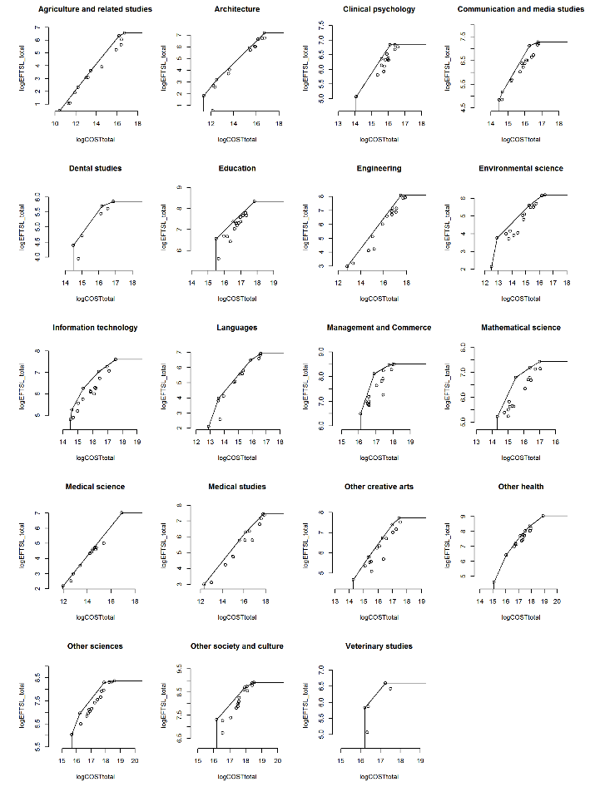

Next, SESCEQ is included as the output variable. To be consistent with the OLS, quantile and SFA models, the input variable is log of total cost per EFTSL.[35] Chart A.2 provides a scatter plot of cost per EFTSL and SESCEQ by FOEs. While in some FOEs, higher costs per EFTSL is associated with higher student experience scores, this is not the case in all FOEs. For example, this relationship is not clearly apparent in fields of education such as Agriculture and Related Studies, Architecture, Engineering, Environmental Science, Information Technology, Languages, Medical Studies, Other Creative Arts and Veterinary Studies. This suggests that there is scope for some of the universities to improve their student experience (to the extent that SESCEQ is a good measure of that) without increasing cost per EFTSL.

This is also consistent with the observation from Chart A.3 below which shows a weak relationship between SESCEQ and cost per EFTSL in the aforementioned FOEs, with many observations sitting below the efficiency frontier.

* + 1. : Scatter plot of Cost per EFTSL and SESCEQ by FOEs

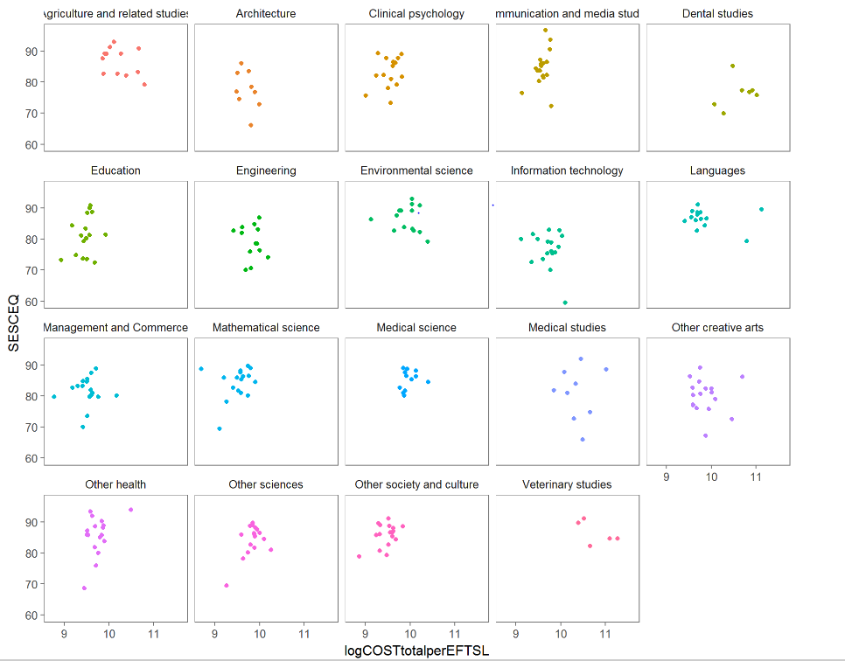

Source: Deloitte Access Economics analysis

* + 1. : DEA result visualisation by field using SESCEQ as output

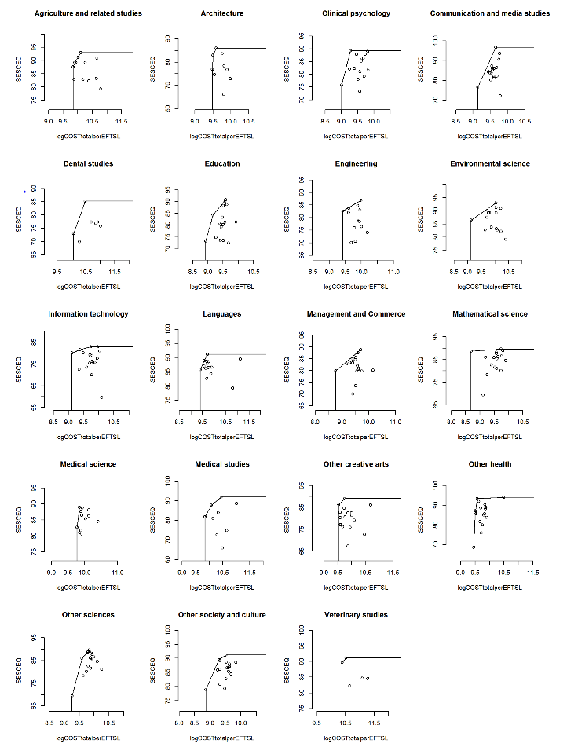

Source: Deloitte Access Economics analysis

Limitations of the analysis

The results from our DEA models are exploratory in nature and need to be interpreted with caution. In particular, there are a number of limitations associated with the measure of teaching quality used here. Most notably:

* SESCEQ is an imperfect measure of teaching quality;
* SESCEQ respondents may be a small and self-selected proportion of the student population;
* The extent to which SESCEQ scores can be compared across universities is questionable (each student respondent would have not experienced the teaching quality other than the university/FOE they have enrolled; thus, the scores only reflects their experience with respect to their expectation); and
* the long-term relationship between cost input and quality output cannot be reflected in a snapshot from an arbitrary year.

To the extent that measures of teaching and scholarship quality are subject to measurement error, this will impact the extent to which DEA can be used to measure relative efficiency across universities.

While there are some limitations associated with the interpretation of results from DEA using data available for the present study, DEA does offer an alternative method of assessing reasonable costs which could potentially be used in future research. Ideally such analysis would draw on time series data and a number of robust measures of teaching and scholarship outcomes to help inform an assessment of the efficient cost of meeting specified teaching and scholarship benchmarks.

Additional analysis and results

* 1. : Descriptive statistics: Cost drivers by field (bachelor level)

|  |  |  |  |  |  |  |  |  |  |  |
| --- | --- | --- | --- | --- | --- | --- | --- | --- | --- | --- |
| **Field (median)** | **Average student experience survey score (SES, CEQ)** | **Indicator for HDR EFTSL** | **Proportion of graduates in fulltime employment** | **Proportion of HDR EFTSL to total field EFTSL (university level)** | **Log staff-student ratio (Teaching staff FTE / total EFTSL)** | **Median salary of graduates** | **Proportion of casual teaching staff** | **Proportion of external (including multimodal) EFTSL** | **Proportion of international EFTSL** | **Proportion of regional EFTSL** |
| Mathematical science | 85.9 | 1 | 50 | 0.012 | -3.580 | 55000 | 0.291 | 0.010 | 0.113 | 0.177 |
| Medical science | 85.825 | 1 | 47.7 | 0.032 | -3.137 | 53000 | 0.168 | 0.000 | 0.067 | 0.157 |
| Other sciences | 85.9 | 1 | 50 | 0.039 | -3.405 | 55000 | 0.265 | 0.020 | 0.063 | 0.187 |
| Information technology | 77.45 | 1 | 67 | 0.024 | -3.642 | 58000 | 0.297 | 0.008 | 0.217 | 0.132 |
| Engineering | 78.65 | 1 | 76.5 | 0.048 | -3.318 | 63600 | 0.277 | 0.000 | 0.151 | 0.189 |
| Architecture | 76.95 | 1 | 65.8 | 0.014 | -3.286 | 50000 | 0.390 | 0.140 | 0.083 | 0.175 |
| Environmental science | 86.97501 | 1 | 57.4 | 0.011 | -3.231 | 53000 | 0.279 | 0.048 | 0.081 | 0.167 |
| Agriculture and related studies | 85.375 | 1 | 61.5 | 0.077 | -2.893 | 54000 | 0.207 | 0.089 | 0.045 | 0.384 |
| Medical studies | 81.9 | 1 | 98.9 | 0.037 | -3.015 | 60000 | 0.188 | 0.000 | 0.108 | 0.171 |
| Dental studies | 76.8 | 1 | 85.3 | 0.016 | -2.733 | 77500 | 0.306 | 0.000 | 0.089 | 0.082 |
| Veterinary studies | 84.65 | 1 | 81.3 | 0.037 | -2.650 | 48000 | 0.090 | 0.017 | 0.180 | 0.308 |
| Other health | 85.95 | 1 | 68.95 | 0.011 | -3.344 | 55250 | 0.456 | 0.070 | 0.082 | 0.206 |
| Education | 81.1 | 1 | 75.6 | 0.019 | -3.573 | 58000 | 0.463 | 0.051 | 0.011 | 0.199 |
| Management and Commerce | 82 | 1 | 75.2 | 0.010 | -3.724 | 50000 | 0.507 | 0.025 | 0.284 | 0.135 |
| Languages | 86.85001 | 1 | 57.95 | 0.000 | -3.106 | 54250 | 0.430 | 0.004 | 0.237 | 0.099 |
| Clinical psychology | 83.75 | 1 | 50.45 | 0.019 | -3.549 | 52000 | 0.365 | 0.029 | 0.037 | 0.133 |
| Other society and culture | 86.55 | 1 | 58.6 | 0.017 | -3.671 | 55000 | 0.380 | 0.102 | 0.076 | 0.153 |
| Communication and media studies | 84.45 | 1 | 52.35 | 0.007 | -3.455 | 45000 | 0.474 | 0.060 | 0.096 | 0.146 |
| Other creative arts | 80.65 | 1 | 43.3 | 0.032 | -3.125 | 40000 | 0.429 | 0.030 | 0.066 | 0.177 |

* 1. : OLS results: Total cost per EFTSL

|  |  |  |  |  |  |  |  |  |  |  |  |
| --- | --- | --- | --- | --- | --- | --- | --- | --- | --- | --- | --- |
|  | Base  (1) | Add fields  (2) | Further controls  (3) | Base  (4) | Add fields  (5) | Further controls  (6) | Base  (7) | Add fields  (8) | | Further controls  (9) | |
|  | **Sub-Bachelor** | | | **Bachelor** | | | **Postgraduate** | | | | |
| Log staff-student ratio (Teaching staff FTE / total EFTSL) | 0.554*** | 0.461*** | 0.551*** | 0.589*** | 0.474*** | 0.416*** | 0.548*** | 0.450*** | | 0.558*** | |
| Log Total EFTSL (by field) | -0.130 | -0.0273 | 0.0128 | -0.0239** | 0.00155 | 0.0223 | -0.0313 | 0.0656** | | 0.0644** | |
| Indicator for HDR EFTSL | 0.434*** | 0.0198 | -0.0159 | -0.0426 | -0.0399 | -0.0613 | 0.196 | 0.236** | | 0.140* | |
| Proportion of HDR EFTSL to total field EFTSL (university level) | -0.187 | -8.408 | -3.986 | 0.721** | -0.0609 | -0.152 | 1.033 | -0.629 | | -0.590 | |
| Proportion of international EFTSL |  |  | 1.824*** |  |  | 0.284 |  |  | | 0.135 | |
| Proportion of regional EFTSL |  |  | -0.453 |  |  | 0.165** |  |  | | 0.0332 | |
| Proportion of casual teaching staff |  |  | -0.00810*** |  |  | -0.191** |  |  | | -0.0508*** | |
| Proportion of external (including multimodal) EFTSL |  |  | -0.197 |  |  | -0.149 |  |  | | 0.0394 | |
|  |  |  |  |  |  |  |  |  | |  | |
| *Field fixed effects: omitted category Mathematical science* | | | | | | | | |  | |
| Medical science |  | -0.110 | -0.0778 |  | 0.189 | 0.268*** |  | 0.596* | | 0.551** | |
| Other sciences |  | 0.324 | 0.210 |  | 0.145*** | 0.135** |  | 0.00661 | | -0.00976 | |
| Information technology |  | 0.304 | 0.0666 |  | 0.137** | 0.126** |  | -0.0376 | | -0.0260 | |
| Engineering |  | 0.856* | 0.777* |  | 0.260*** | 0.266*** |  | 0.130 | | 0.143 | |
| Architecture |  | -0.368 | -0.158 |  | 0.150 | 0.114** |  | 0.0836 | | 0.0999 | |
| Environmental science |  | 0.67 | 0.222 |  | 0.182** | 0.237*** |  | 0.273* | | 0.125 | |
| Agriculture and related studies |  | 0.759 | 0.549 |  | 0.341*** | 0.433*** |  | 0.575*** | | 0.438** | |
| Medical studies |  | -0.857 | -0.329* |  | 0.364*** | 0.387*** |  | 0.14 | | 0.149 | |
| Dental studies |  | -- | -- |  | 0.543*** | 0.686*** |  | 0.679** | | 0.593** | |
| Veterinary studies |  | -- | -- |  | 0.687*** | 0.679*** |  | 0.568** | | 0.409* | |
| Other health |  | 0.973 | 0.625 |  | 0.0586 | 0.0712 |  | -0.148 | | -0.117 | |
| Education |  | 0.07 | -0.314 |  | -0.0722 | -0.0147 |  | -0.326*** | | -0.252** | |
| Management and Commerce |  | -0.0407 | -0.057 |  | 0.00525 | -0.0147 |  | -0.245* | | -0.184* | |
| Languages |  | -0.0657 | 0.0646 |  | 0.00363 | 0.0473 |  | -0.102 | | 0.00813 | |
| Clinical psychology |  | 1.039* | 0.720 |  | -0.0953** | -0.0488 |  | -0.0536 | | 0.00688 | |
| Other society and culture |  | -0.109 | -0.295 |  | -0.0812 | -0.0955 |  | -0.355*** | | -0.302** | |
| Communication and media studies |  | 0.0347 | -0.147 |  | -0.0531** | -0.0147 |  | -0.113 | | -0.0983 | |
| Other creative arts |  | 0.478 | 0.145 |  | 0.0746* | 0.152*** |  | 0.0185 | | 0.0134 | |
|  |  |  |  |  |  |  |  |  | |  | |
| Constant | 12.50*** | 11.76*** | 11.84*** | 11.92*** | 11.28*** | 10.95*** | 11.75*** | 10.75*** | | 11.11*** | |
|  |  |  |  |  |  |  |  |  | |  | |
| *Observations* | 131 | 131 | 127 | 281 | 281 | 280 | 243 | 243 | | 241 | |
| *R2* | 0.459 | 0.539 | 0.776 | 0.534 | 0.658 | 0.723 | 0.604 | 0.692 | | 0.751 | |

Source: Deloitte Access Economics. Note: *,**,*** indicate statistical significance at the 10%, 5% and 1% level respectively. Unless otherwise specified, the unit of observation is by level, field and university. The dependent variable used was the log of total costs per EFTSL. Standard errors are clustered at the university institution level. Unless otherwise specified, the unit of observation is by level, field and university.

* 1. **: Comparing regression estimates: Log total cost per EFTSL**

|  | **OLS**  **(1)** | **Quantile (25p)**  **(2)** | **Frontier**  **(3)** | **OLS**  **(4)** | **Quantile (25p)**  **(5)** | **Frontier**  **(6)** | **OLS**  **(7)** | **Quantile (25p)**  **(8)** | **Frontier**  **(9)** | |
| --- | --- | --- | --- | --- | --- | --- | --- | --- | --- | --- |
|  | **Sub-Bachelor** | | | **Bachelor** | | | **Postgraduate** | | |
| Log staff-student ratio (Teaching staff FTE / total EFTSL) | 0.551*** | 0.700** | 0.570*** | 0.416*** | 0.389*** | 0.481*** | 0.558*** | 0.545*** | 0.639*** | |
| Log Total EFTSL (by field) | 0.0128 | -0.0235 | -0.102 | 0.0223 | -0.00859 | 0.0221 | 0.0644** | 0.0623 | 0.0690*** | |
| Indicator for HDR EFTSL | -0.0159 | 0.0550 | 0.0575 | -0.0613 | 0.0553 | -0.0387 | 0.140* | -0.00639 | 0.0668 | |
| Proportion of HDR EFTSL to total field EFTSL (university level) | -3.986 | -1.859 | -0.991 | -0.152 | -0.320 | -0.187 | -0.590 | 0.359 | -0.494 | |
| Proportion of international EFTSL | 1.824*** | 0.940 | 1.311*** | 0.284 | 0.607*** | 0.450** | 0.135 | 0.0603 | 0.0811 | |
| Proportion of regional EFTSL | -0.453 | -0.158 | -0.428 | 0.165** | 0.179 | 0.195* | 0.0332 | 0.0647 | -0.0629 | |
| Proportion of casual teaching staff | -0.00810*** | -0.00220 | -0.00897** | -0.191** | -0.208 | -0.150*** | -0.0508*** | -0.0517*** | -0.0574*** | |
| Proportion of external (including multimodal) EFTSL | -0.197 | -0.151 | -0.174 | -0.149 | -0.150 | -0.0812 | 0.0394 | -0.0257 | -0.00903 | |
|  |  |  |  |  |  |  |  |  |  | |
| *Field fixed effects: omitted category Mathematical science* | | | | |  |  |  |  |  | |
| Medical science | -0.0778 | 0.00133 | -0.424 | 0.268*** | 0.282*** | 0.238*** | 0.551** | 0.123 | 0.495*** | |
| Other sciences | 0.210 | 0.190 | 0.215 | 0.135** | 0.133* | 0.133* | -0.00976 | -0.0782 | -0.0312 | |
| Information technology | 0.0666 | -0.0511 | 0.109 | 0.126** | 0.0488 | 0.108 | -0.0260 | 0.0249 | 0.00970 | |
| Engineering | 0.777* | 0.235 | 0.686** | 0.266*** | 0.147* | 0.245*** | 0.143 | 0.00979 | 0.153 | |
| Architecture | -0.158 | -0.0506 | -0.345 | 0.114** | 0.0671 | 0.0864 | 0.0999 | 0.0242 | 0.0610 | |
| Environmental science | 0.222 | -0.199 | 0.0833 | 0.237*** | 0.175* | 0.221*** | 0.125 | 0.0810 | 0.113 | |
| Agriculture and related studies | 0.549 | -0.413** | 0.0633 | 0.433*** | 0.335** | 0.402*** | 0.438** | 0.139 | 0.378*** | |
| Medical studies | -0.329* | -0.431 | -0.518 | 0.387*** | 0.307 | 0.361*** | 0.149 | 0.114 | 0.132 | |
| Dental studies | - |  | - | 0.686*** | 0.499** | 0.622*** | 0.593** | -0.00443 | 0.421*** | |
| Veterinary studies | - |  | - | 0.679*** | 0.635*** | 0.641*** | 0.409* | 0.379* | 0.259* | |
| Other health | 0.625 | 0.0953 | 0.693** | 0.0712 | 0.0982 | 0.0567 | -0.117 | -0.0726 | -0.125 | |
| Education | -0.314 | -0.169 | -0.175 | -0.0147 | 0.00504 | -0.0151 | -0.252** | -0.213 | -0.242** | |
| Management and Commerce | -0.0570 | -0.0350 | 0.0983 | -0.0147 | -0.0959 | -0.0411 | -0.184* | -0.123 | -0.140 | |
| Languages | 0.0646 | -0.0402 | 0.0126 | 0.0473 | -0.0268 | -0.00418 | 0.00813 | -0.00541 | 0.0163 | |
| Clinical psychology | 0.720 | 0.0981 | 0.677** | -0.0488 | -0.0308 | -0.0460 | 0.00688 | -0.104 | -0.0283 | |
| Other society and culture | -0.295 | -0.119 | -0.103 | -0.0955 | -0.0813 | -0.0915 | -0.302** | -0.320** | -0.280*** | |
| Communication and media studies | -0.147 | -0.117 | -0.0282 | -0.0147 | 0.0227 | -0.0169 | -0.0983 | -0.196*** | -0.110 | |
| Other creative arts | 0.145 | 0.0317 | 0.0905 | 0.152*** | 0.137 | 0.124* | 0.0134 | 0.0116 | -0.00581 | |
|  |  |  |  |  |  |  |  |  |  | |
| Constant | 11.84*** | 12.22*** | 12.27*** | 10.95*** | 10.85*** | 10.96*** | 11.11*** | 11.10*** | 11.12*** | |
|  |  |  |  |  |  |  |  |  |  | |
| *Observations* | 127 | 127 | 127 | 280 | 280 | 280 | 241 | 241 | 241 | |
| *R2* | 0.78 | 0.64 | -- | 0.72 | 0.70 | -- | 0.75 | 0.72 | -- | |

Source: Deloitte Access Economics (2016).

Note: *,**,*** indicate statistical significance at the 10%, 5% and 1% level respectively. Standard errors are clustered at the university institution level for OLS and Quartile regressions. Unless otherwise specified, the unit of observation is by level, field and university.

1. : Fields in data collection template and qualitative questions

Data definitions

* 1. : Definitions and explanations

| Field | Definition / Explanation |
| --- | --- |
| **Discipline** | |
| Discipline | Discipline are defined as the narrow, or in some cases detailed, fields of education in the Australian Standard Classification of Education (ASCED). |
| **Budgetary unit-level costs** | |
| Sub-bachelor | Sub-bachelor covers all courses delivered at the diploma, advanced diploma, associate degree level and other undergraduate courses. |
| Bachelor | Bachelor covers all courses delivered at a Bachelor degree level. This includes Bachelor's Pass, Bachelor's Honours and Bachelor's Graduate Entry. |
| Postgraduate coursework | Postgraduate coursework includes all postgraduate degrees that are delivered predominantly through coursework, including Masters and coursework PhDs. Where a coursework postgraduate degree includes a research component, this should be included as postgraduate coursework. |
| Academic staff | Members of staff, whether full-time or part-time, who are employed wholly or principally in teaching and/or research or to whom such persons are responsible in relation to their teaching or research. It excludes members of staff (e.g. technicians, research assistants, etc.) employed wholly or principally in support of other members of staff who are employed in research. It also excludes casual academic staff. |
| Casual academic staff | Casual academic teaching staff are employed on an hourly basis (e.g. tutors). |
| Non-academic staff | Members of staff who are not academic staff, e.g. administrative staff or IT staff. Should amount to total staff minus academic staff and casual academic staff. |
| Teaching | Teaching time includes all of the following: lecturing, tutoring, demonstrating, reading and preparation for classes (lecture and tutorial content, handouts, workbooks, placing material on the Web, laboratories), all forms of marking and assessment, discussion and feedback to students (both face-to-face and electronically), administration of subjects, course advice and enrolment, organisation and supervision of practicum (including work experience and excursions), supervision of Honours students and committee work related to teaching. 100% of the time spent by staff members involved in teaching and scholarship is linked to teaching and scholarship activities. |
| Teaching & Research | Time spent by staff members that are involved in both teaching and research activities. This category recognises that staff may be involved in a variety of activities including teaching, supervising research students and engaging in research and scholarship. |
| Proportion of FTEs time spent on teaching (excluding research) | The proportion of time spent on teaching activities should be greater than 0% and less than 100%, otherwise these FTEs would be captured by other categories. |
| Employee benefits and on-costs (i.e. total wage bill) | All staff-related expenses. The wage bill should include all expenditure on staff compensation including gross salaries and salary on-costs such as superannuation and leave entitlements (i.e. annual leave, personal leave and long service leave). |
| Cost of materials, utilities, equipment | Cost of teaching-related expenses such as materials, utilities and equipment at the budgetary unit level by discipline |
| Expenses that relate to labs/practicum/field work | Cost of teaching-related expenses associated with the applied, practical component of courses by discipline. |
| Other budgetary unit-level expenses | All remaining budgetary level unit costs by discipline, i.e. costs not captured by 'budgetary level staff costs', 'cost of materials, utilities and equipment' and 'expenses relating to labs/practicum/field work'. |
| **Central costs[36]** |  |
| Central admin staff costs | As in the case of budgetary level unit staff costs, the wage bill should include all expenditure on staff compensation including gross salaries and salary on-costs such as superannuation and leave entitlements (i.e. annual leave, personal leave and long service leave). |
| Depreciation, amortisation, repairs, maintenance, borrowing, bad debts | Cost associated with asset and capital management. |
| Other central costs | All remaining central costs, i.e. costs not captured in 'central staff costs' or 'depreciation, amortisation, repairs, etc' |

Data collection template

* 1. : Overview of input fields in data collection template

|  | Field |
| --- | --- |
| **Budgetary unit-level costs** |  |
| **Number of staff (in Full-Time Equivalents (FTEs))** |  |
| ***Academic staff*** |  |
| *Number of academic staff, Teaching only (100% of time spent on Teaching) (FTEs)* | --- |
| Share of these FTEs related to sub-bachelor teaching activities (%) | --- |
| Share of these FTEs related to bachelor teaching activities (%) | --- |
| Share of these FTEs related to coursework postgraduate teaching activities (%) | --- |
| *Number of academic staff, involved in both Teaching & Research (FTEs)* | --- |
| ***Casual academic staff (i.e. research assistants, tutors)*** |  |
| *Number of casual academic staff, Teaching only (100% of time spent on Teaching) (FTEs)* | --- |
| *Number of casual academic staff, involved in both Teaching & Research (FTEs)* | --- |
| ***Non-academic staff (i.e. admin staff, IT staff, etc)*** |  |
| *Number of non-academic staff, Teaching only (100% of time spent on Teaching) (FTEs)* | --- |
| *Number of non-academic staff, involved in both Teaching & Research (FTEs)* | --- |
| **Staff Costs - Employee benefits and on-costs (i.e. total wage bill)** |  |
| ***Academic staff costs*** |  |
| Academic staff costs, Teaching only ($) | --- |
| Academic staff costs, Teaching & Research ($) | --- |
| ***Casual academic staff costs*** |  |
| Casual academic staff costs, Teaching only ($) | --- |
| Casual academic staff costs, Teaching & Research ($) | --- |
| ***Non-academic staff costs*** |  |
| Non-academic staff costs, Teaching only ($) | --- |
| Non-academic staff costs, Teaching & Research ($) | --- |
| **Other Budgetary Unit-Level Costs** |  |
| *Cost of materials, utilities, equipment ($)* | --- |
| Share of above attributable to sub-bachelor teaching activities (%) | --- |
| Share of above attributable to bachelor teaching activities (%) | --- |
| Share of above attributable to coursework postgraduate teaching activities (%) | --- |
| *Expenses that relate to labs/practicum/field work ($)* | --- |
| Share of above attributable to sub-bachelor teaching activities (%) | --- |
| Share of above attributable to bachelor teaching activities (%) | --- |
| Share of above attributable to coursework postgraduate teaching activities (%) | --- |
| *Other budgetary unit-level expenses ($)* | --- |
| Share of above attributable to sub-bachelor teaching activities (%) | --- |
| Share of above attributable to bachelor teaching activities (%) | --- |
| Share of above attributable to coursework postgraduate teaching activities (%) | --- |
| **Central costs** |  |
| **Number of admin staff (in FTEs)** |  |
| *Number of admin staff relating to teaching (e.g. student enrolments, learning assistance etc.) (FTEs)* | --- |
| Share of these FTEs related to sub-bachelor teaching activities (%) | --- |
| Share of these FTEs related to bachelor teaching activities (%) | --- |
| Share of these FTEs related to coursework postgraduate teaching activities (%) | --- |
| **Admin staff costs - Employee benefits and on-costs (i.e. total wage bill)** |  |
| Central admin staff costs (total wage bill) ($) | --- |
| **Other Costs** |  |
| *Depreciation, amortisation, repairs, maintenance, borrowing, bad debts ($)* | --- |
| Share of above attributable to sub-bachelor teaching activities (%) | --- |
| Share of above attributable to bachelor teaching activities (%) | --- |
| Share of above attributable to coursework postgraduate teaching activities (%) | --- |
| *Other central costs ($)* | --- |
| Share of above attributable to sub-bachelor teaching activities (%) | --- |
| Share of above attributable to bachelor teaching activities (%) | --- |
| Share of above attributable to coursework postgraduate teaching activities (%) | --- |

Qualitative questions

First, do you have current uncertainties about terminology or approach to completing the data collection tool?

*Contextual points specific to your university:*

* How are budgetary unit-level[37] costs allocated?
* Which cost allocation proxies (e.g. student numbers, staff numbers, square metre, etc) are used?
* Or instead, do you have a specific funding formula and what is it?
* How are central costs[38] allocated?  I.e. how do you allocate central costs (1) between teaching, research training and research and (2) across fields of education (FoEs)?
* Which cost allocation proxies (e.g. student numbers, staff numbers, square metres, etc) are used?
* Or instead, do you have a specific funding formula?
* Does the data collection template cover all teaching related costs? E.g. for medicine, how do you deal with the costs of teaching provided by hospitals?
* If you have used average faculty or school costs to derive FoE-specific costs and have no additional data to adjust estimates to reflect the actual costs of individual FoEs, can you provide qualitative and quantitative information to explain significant cost differences between FoEs?
* Are there any other contextual factors that we should be aware of?

*Decision-making relating to the cost of teaching and scholarship:*

* Are there any FoEs where costs differ widely from current funding levels?
* What are the implications of this from a management perspective?
* If so, how can it be observed in the recorded cost data provided as part of this study?
* Would you group the FoEs differently?  If so, why?
* Do the current funding levels influence internal allocations in your institution? For example, if standard subjects are taught using a two hour lecture and two hours of tutorials each week, are there subjects with fewer/more hours because of what the funding formula dictates? If so, which FoEs are affected by this?

*General discussion questions:*

* Is there volatility in costs over time that we should be aware of when taking a snapshot of a single year’s data?
* What are the main points we should be aware of when benchmarking these costs against similar international jurisdictions?
* How have key cost drivers evolved since 2011?

Do you have any further observations on the cost collection exercise?

Limitation of our work

General use restriction

This report is prepared solely for the use of the Australian Government Department of Education and Training. This report is not intended to and should not be used or relied upon by anyone else and we accept no duty of care to any other person or entity. The report has been prepared for the purpose of analysing the relative and reasonable cost of delivery of higher education. You should not refer to or use our name or the advice for any other purpose.

**Contact us**

Deloitte Access Economics  
ACN: 149 633 116  
  
Level 2  
8 Brindabella Circuit

Brindabella Business Park  
Canberra Airport ACT 2609  
  
Tel: +61 2 6263 7000  
  
[www.deloitteaccesseconomics](http://www.deloitteaccesseconomics).com.au

Deloitte Access Economics is Australia’s pre-eminent economics advisory practice and a member of Deloitte's global economics group. For more information, please visit our website www.deloitteaccesseconomics.com.au

About Deloitte

Deloitte refers to one or more of Deloitte Touche Tohmatsu Limited, a UK private company limited by guarantee, and its network of member firms, each of which is a legally separate and independent entity. Please see www.deloitte.com/au/about for a detailed description of the legal structure of Deloitte Touche Tohmatsu Limited and its member firms.

Deloitte provides audit, tax, consulting, and financial advisory services to public and private clients spanning multiple industries. With a globally connected network of member firms in more than 150 countries, Deloitte brings world-class capabilities and deep local expertise to help clients succeed wherever they operate. Deloitte's approximately 200,000 professionals are committed to becoming the standard of excellence.

About Deloitte Australia

In Australia, the member firm is the Australian partnership of Deloitte Touche Tohmatsu. As one of Australia’s leading professional services firms. Deloitte Touche Tohmatsu and its affiliates provide audit, tax, consulting, and financial advisory services through approximately 6,000 people across the country. Focused on the creation of value and growth, and known as an employer of choice for innovative human resources programs, we are dedicated to helping our clients and our people excel. For more information, please visit our web site at [www.deloitte.com.au](http://www.deloitte.com/dtt/home/0%2C1044%2Csid%25253D5518%2C00.html).

Liability limited by a scheme approved under Professional Standards Legislation.

Member of Deloitte Touche Tohmatsu Limited

© 2017 Deloitte Access Economics Pty Ltd

1. Specifically, the chart shows the minimum and maximum values for each FOE (as the extremes of each box and whisker plot), the middle 50% of estimates (that is, the 25th percentile through to the 75% percentile, as the ‘box’ in each plot).
2. Mean values are not shown in the chart, and may differ from the median values that are shown. This is particularly the case for FOEs with a relatively large spread of estimated costs.
3. Observations that were excluded include outliers with EFTSL counts of less than one, or costs per EFTSL greater than $100,000 and EFTSL counts less than 10. Additionally, one observation with a cost per EFTSL greater than $300,000 was removed. In total, 58 observations were removed from the sample, across 14 universities and all 19 fields – that is, 4% of the total sample. Notably, 46 of these observations were at the sub-bachelor level.
4. While it is difficult to ascertain the causal nature of this observation, a possible interpretation is that some degree of co-produced research costs is being captured in teaching and scholarship costs reported by universities, possibly as a result of higher average staff salaries in these instances.
5. Selection was based on: location of main campus, number and geographical spread of campuses, enrolments, number of faculties, and whether the institution undertook dual-sector teaching (i.e. TAFE).
6. Because universities are non-profit entities, surplus from operations is generally re-invested in the form of capital deepening, or other investments in capacity (e.g. research staff). In this regard, a deterioration in average net operating position over this time does not necessarily represent a decline in the financial health of public universities (see: Marshman and Larkins, 2016). To illustrate this point, an alternative measure of operating position—earnings before interest, tax, depreciation and amortisation (EBIDTA)—has grown over the period of 2010-2015 at an average annual rate of 2.9%.
7. These figures include aggregates for the higher education proportion of dual sector institutions.
8. Mode of enrolment determines whether course materials are delivered primarily in-person, online, or a mixture of both.
9. HHI is measured on a scale of zero (least concentrated, many providers) to 100% (most concentrated, a single provider). For most disciplines, the HHI measure is low at around 10%, indicating that teaching is dispersed across a range of universities, not concentrated in a few. HHI is calculated here in share form, rather than percentage point form. In this form the HHI is a measure of concentration, ranging from zero (negligible concentration) to 1 (monopoly or full concentration). The HHI formula for a market with *N* firms is $HHI=\sum_{n=1}^{N}{S_{n}^{2}}$, where $S_{n}^{}$ is the market share of firm *n*. A market with 10 firms, with 10% market share each, will have a HHI of $\sum_{n=1}^{10}{{0.1}_{n}^{2}}=0.10$ or 10%. As can be seen from the formula, a market of 10 firms, some with large market share than others, will lead to a higher HHI, reflecting the higher degree of concentration.
10. Specifically, the chart shows the minimum and maximum values for each FOE as the extremes of each box and whisker plot (after the top and bottom coding has been applied), the middle 50% of estimates (that is, the 25th percentile through to the 75% percentile, as the ‘box’ in each plot) and the median estimate (the vertical line within the box).
11. Mean values are not shown in the chart, and may differ from the median values that are shown. This is particularly the case for FOEs with a relatively large spread of estimated costs.
12. For those academic staff classified as ‘teaching and research’ as well as non-academic staff tasked with supporting teaching and research academic staff.
13. This does not necessarily suggest that institution specific characteristics (like location) may not also be a determinant of appropriate funding arrangements based on reasonable cost. Indeed, such variations based on institutional characteristics (to the extent that they are exogenously determined) may be appropriately estimated and incorporated into revised funding arrangements.
14. For example, the optimal combination of inputs (i.e. academics) for a university that equally prioritises the quality of teaching and scholarship and research activity may differ from the optimal combination of inputs for a university that places a lower relative weight on research activities.
15. Staff to student ratios are both an input and an indirect measure of teaching and scholarship quality.
16. The log transformation is common in the analysis of cost data, the distribution of which can be skewed to the right. The log transformation makes the cost data ‘more normal’.
17. Deviations from the portion of costs that is explained by the model is separated into two components: one which reflects inefficiency and one which reflects random components.
18. The analysis here does not strictly use SFA to minimise costs but allows some inputs to be included as controls in the SFA regression.
19. Similar notions are applied to funding arrangements in schooling, where loadings are applied on the basis of higher reasonable costs faced by smaller schools, or schools located in regional or remote communities.
20. The coefficients on the field of education variables change little if at all from column 1 to column 3 suggesting that fields of education and university are close to orthogonal.
21. To the extent that universities differ in the degree to which they use other funding sources outside revenue from Commonwealth supported places to increase spending on teaching and scholarship, there is some scope for certain universities to have higher teaching and scholarship costs.
22. The log of teaching staff to EFTSL was found to provide a better fit in explaining the log of costs per EFTSL than the ratio of teaching staff to EFTSL in levels. The use of log variables in regression models means that coefficient estimates are interpreted as marginal effects on variables in percentage (proportional) terms.
23. A rough approximation of the coefficients for linear variables in a log model is that they represent a percentage change i.e. 16.9% in this case. The actual impact is equal to exponential (0.169) -1 or 18.4% here.
24. More specifically, the impact is calculated based on the marginal effect of changing the value of a variable from the first to third quartile of its distribution assuming all other variables are at their median values across all fields of education.
25. Future analysis would benefit from attempting to separate revenue effects from these differentials. That is, in part, differences in cost by field of education are likely to reflect differences in revenue, which are likely to influence costing decisions by universities.
26. Another indicator of relative variation across fields is the width of the confidence intervals which are related to the standard error on the corresponding FOE indicator, which is in turn related to the spread of costs and number of universities in that field.
27. The precision with which the coefficient on the field of education indicator is estimated is also a factor.
28. The years were chosen for consistency with the years with costing data.
29. Only 17 institutions were able to disaggregate their postgraduate and undergraduate costs. Another 5 pure postgraduate institutions were also included in the analysis.
30. Further disaggregation also available for natural and physical sciences, and health.
31. Total maximum funding defined as maximum student contribution amounts + Commonwealth contribution amounts
32. In the 2016 QS rankings, 6 Australian universities and 1 New Zealand university is ranked in the top 50 for agriculture and forestry, compared to 2 for the UK.
33. ‘Academic department expenditure’ includes academic staff costs, other staff costs, and other operating expenses. While it excludes expenditure for activities funded by research grants and contracts, it does include other research activity undertaken by the academic staff. Consequently, these costs are not fully reflective of teaching costs. Average department costs are calculated as total academic department expenditure divided by the EFTSL within a department.
34. For these reasons, some studies such as Horne and Hu (2008) argue in favour of the use of SFA rather than DEA in studying the efficiency of different Australian universities.
35. An alternative is simply to add SESCEQ to the model as an output.
36. Note: Central costs should include all teaching & learning related costs (both staff costs and capital costs) that are not already captured by budgetary unit-level costs. This includes costs arising from the provision of teaching (such as student enrolments, scholarships, learning assistance and student welfare, marketing, recruitment and admission of students) as well as other costs such as HR, governance and management and libraries. Universities may have different approaches for allocating central costs. Hence, individual cost categories may differ. In such cases, the focus should be on providing total central costs by discipline by student type (i.e. undergraduate, postgraduate coursework and other). If central costs are not assumed to differ by discipline or student type, universities should provide an average cost per student and explain the underlying approach (e.g. allocation by student load, gross revenue split, etc.).
37. Budgetary unit-level costs are defined as costs incurred directly by the relevant field of education. this includes staff costs (academic, casual, non-academic staff), and non-staff costs (materials, utilities and equipment, practicum payments etc.) and other budgetary unit-level expenses.
38. Central costs are defined as university costs incurred centrally which are attributable to the field of education this includes staff costs, and non-staff central costs: (maintenance, repair, finance, insurance, depreciation, amortisation, accommodation costs, etc.).