National Year 1 Literacy and Numeracy Check – Expert Advisory Panel

Dr Jennifer Buckingham, Senior research fellow and director, The Centre for Independent Studies

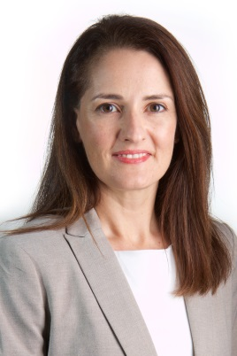 | Dr Jennifer Buckingham is a senior research fellow and director of the FIVE from FIVE project at The Centre for Independent Studies. She has been researching and writing about education for almost two decades and has published numerous reports and journal articles. Jennifer’s PhD research was on effective instruction for young and struggling readers. She is a board member of the Australian Institute for Teaching and School Leadership (AITSL) and an associate investigator at the ARC Centre for Excellence in Cognition and Its Disorders.
Ms Mandy Nayton OAM, Chief Executive Officer, Dyslexia SPELD Foundation, Western Australian President AUSPELD

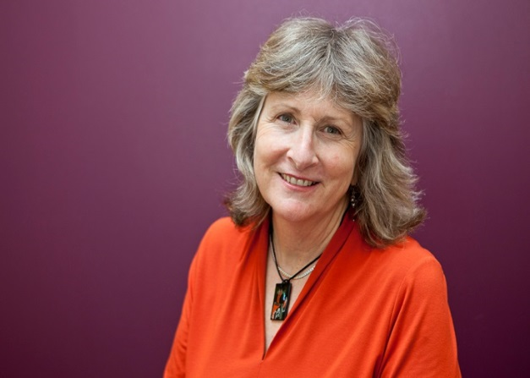 | Mandy Nayton is the CEO of DSF Literacy and Clinical Services and President of AUSPELD (the Australian Federation of Specific Educational Learning Difficulties Associations). She is an educational and developmental psychologist and qualified primary school teacher with extensive experience in the field of literacy education. Mandy supports schools with literacy planning and provides professional development in the areas of literacy acquisition, vocabulary development, working memory, learning difficulties and the assessment of learning disorders. She was a member of the Federal Government’s Dyslexia Working Party in 2009/2010 and a member of the Schools Disability Advisory Council in 2012/2013. Mandy is an Adjunct Research Fellow at Curtin University’s School of Psychology and Speech Pathology, has conducted research in collaboration with UWA, Curtin and Macquarie Universities, and was recently awarded an OAM for her services to education
Professor Pamela Snow, Head of the La Trobe Rural Health School

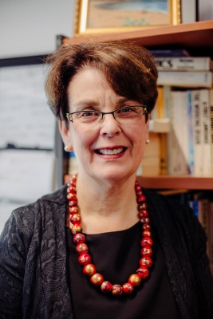 | Pamela Snow is a Professor and Head of the Rural Health School at the Bendigo campus of La Trobe University. Pamela has taught a wide range of undergraduate and postgraduate health professionals and also has experience in teacher education.  Pamela is a registered psychologist, having qualified originally in speech pathology. Her research has been funded by nationally competitive schemes such as the ARC Discovery Program, ARC Linkage Program, and the Criminology Research Council, and spans various aspects of risk in childhood and adolescence:  - the oral language skills of high-risk young people (youth offenders and those in the state care system), and the role of oral language competence as an academic and mental health protective factor in childhood and adolescence;  - applying evidence in the language-to-literacy transition in the early years of school;  - linguistic aspects of investigative interviewing with children / adolescents as witnesses, suspects, victims in criminal investigations;  Pamela has research links with the education, welfare and justice sectors, and her research has been published in a wide range of international journals. She is frequently called upon to address education, health, welfare, and forensic audiences. She is a Fellow of the Speech Pathology Association of Australia and is a past Victorian State Chair of the Australian Psychological Society. She has over 120 publications, comprising refereed papers, book chapters, monographs and research reports.
Mr Steven Capp, Principal, Bentleigh West Primary School

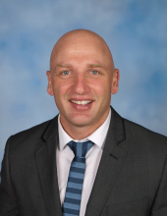 |  | Steven Capp has worked across the Primary and Secondary School sectors as an educational leader in Victoria for the past 10 years.  Steven is currently Principal of Bentleigh West Primary School where the vision is to implement evidence based best practice in teaching across the school  Steven has had significant experience in leading the change of reading instruction, particularly in the area of synthetic phonics, to build highly effective reading programs.
Professor Geoff Prince, Director, Australian Mathematical Sciences Institute

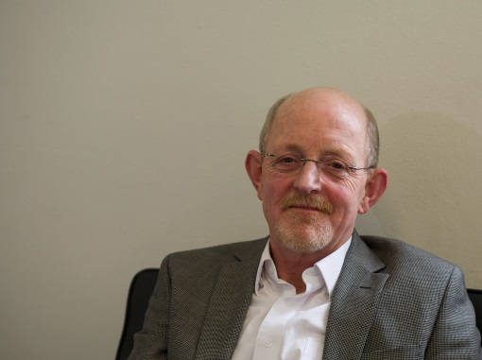 |  | Geoff Prince has been the Director of the Australian Mathematical Sciences Institute (AMSI) since 2009. With 40 members drawn from universities, government agencies and learned societies, AMSI is the principal national voice for the mathematical sciences discipline. Its programs cover research and higher education, school education and industrial and commercial engagement. AMSI is recognised by government and industry as a leading provider of policy advice, services, programs and strategic initiatives.  Geoff has a long academic career as a teacher and researcher at RMIT, the University of New England and La Trobe University where he was Head of Department. He works in differential geometry, differential equations and their application. Geoff holds a BSc honours and a Dip Ed from Monash University and PhD from La Trobe University.
Ms Allason McNamara, Mathematics Teacher at Trinity Grammar in Victoria, and President, Australia Association of Mathematics Teachers

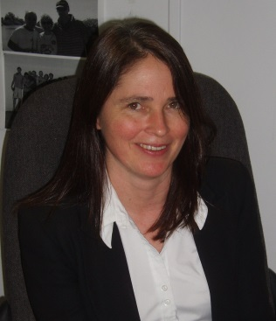 |  | Allason has been teaching mathematics for more than twenty years and was the Head of Mathematics at Mount Scopus Memorial College in Burwood for more than ten years. As well as holding a Degree in Agricultural Science she has also pursued higher studies, completing Graduate Diplomas in Education and Mathematical Methods, as well as a Master’s Degree in Mathematical Modelling and Data Analysis.  Allason is currently a senior mathematics teacher at Trinity Grammar School in Kew and President of the Australian Association of Mathematics Teachers (AAMT). She has been President of The Mathematical Association of Victoria (MAV), a co-author of senior mathematics textbooks for the Australian curriculum and Chief Assessor and examination writer for the Victorian Curriculum and Assessment Authority (VCAA). She is married with three children and lives in Brunswick, Victoria.

