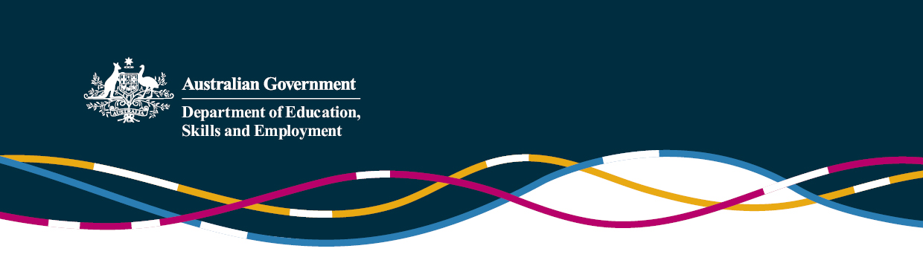

Questions and Answers - Early Learning Languages Australia

## What is Early Learning Languages Australia (ELLA)?

ELLA is a fun and easy digital language program for use on tablet devices by children in preschool. The program is an Australian Government initiative aimed at encouraging more students to study language in later school years.

The ELLA applications (apps) have been developed in consultation with experts in languages, early childhood and technology. The apps are also known as *The Polyglots*, which are a cast of characters who introduce the children to words, sentences and songs in another language through play-based learning. The apps draw on the interests and activities of young children, such as celebrations, cooking experiences, art activities, building and role play.

## What are the eligibility criteria for preschool services?

Preschools will need to agree to terms and conditions in order to be part of the program, and must offer a preschool/kindergarten program provided primarily to children in the year before school, delivered by a degree-qualified early childhood educator, and have internet/Wi-Fi connection. Only children enrolled in a preschool/kindergarten program in the year before full-time school are eligible to use the apps.

## Is ELLA free?

Yes, the apps are free, although tablet devices and an ongoing WiFi/internet connection are required to use ELLA.

## Which languages are available for the ELLA program?

Preschools can choose from the following languages in 2018: Arabic, Chinese (Mandarin), French, Italian, Indonesian, Japanese, Spanish, Modern Greek and Hindi.

## Are the apps easy to use? What supports are in place for educators?

The apps are simple to use and can be easily incorporated into a preschool program. Educators will also be supported by a liaison officer, a step-by-step program guide, an educator app providing implementation advice, an online support group, optional assessment tools and a responsive helpdesk.

## Do educators need to know the language being taught?

No, educators will not need to have prior knowledge of the language being taught. Educators will be able to learn the language alongside the children in a collaborative way, at the same pace.

## What are the screen time limits for young children?

The children are expected to spend up to a maximum of 40 minutes per week on the ELLA apps across multiple small sessions. This aligns with the Australian Government’s screen time recommendations for young children.

## What are the benefits of using ELLA?

Research shows that young children can learn several languages at once, and that this leads to positive long-term learning outcomes. If a child speaks another language at home, they can continue to learn their home language, English and the ELLA program language all at once. There are intellectual, literacy, social and cultural benefits to learning multiple languages.

ELLA creates opportunities to celebrate culture and diversity and to strengthen links between families and preschool services.

## Is children’s privacy protected?

The children’s privacy will be protected when using ELLA. While the data on usage of the apps will be captured and stored securely, the children will not be identifiable outside their preschool. The apps are not available to the public and are not able to be used to communicate with anyone.

## What is the data captured used for?

The data captured is used to check how often preschool services use the apps on a regular basis, such as daily/weekly/monthly, and the duration of app usage.

## Can children’s families participate in ELLA?

Families can download the Family App from the App store for Apple devices or Google Play for Android devices to try one of the learning experiences at home and to learn more about ELLA.

## I’ve heard of ELSA and ELLA, what is the difference?

The Early Learning Languages Australia (ELLA) program focuses on building an interest in language learning from a young age. ELLA is designed to be implemented in preschool services with a qualified early childhood educator, not requiring prior knowledge of the language chosen.

ELLA includes the teaching of concepts for preschoolers aligned to the Early Years Learning Framework, such as communicating, understanding and making meaning of the world, whilst learning concepts in a foreign language.

The Early Learning STEM Australia (ELSA) program is a new series of digital play-based apps designed and developed for preschool children to promote curiosity and learning about science, technology, engineering and mathematics (STEM) concepts. The ELSA program is being piloted in 100 selected preschool services from Term 1, 2018. For more information on the ELSA program, please visit [www.elsa.edu.au](http://www.elsa.edu.au).

Preschools are welcome to use either or both programs whilst implementing complementary activities and monitoring student screen time.

## How can I register my preschool?

The 2018 ELLA application round closed on 15 December 2017. For more information on the ELLA program, please visit [www.ella.edu.au](http://www.ella.edu.au).