

Completion Rates of Higher Education Students-

Cohort Analysis, 2005-2014



ISBN  
978-1-76028-844-0 [PDF]

978-1-76028-845-7 [DOCX]

Creative Commons

With the exception of the Commonwealth Coat of Arms, the Department’s logo, any material protected by a trade mark and where otherwise noted all material presented in this document is provided under a [Creative Commons Attribution 3.0 Australia](http://creativecommons.org/licenses/by/3.0/au/) (http://creativecommons.org/licenses/by/3.0/au/) licence.

The details of the relevant licence conditions are available on the Creative Commons website (accessible using the links provided) as is the full legal code for the [CC BY 3.0 AU licence](http://creativecommons.org/licenses/by/3.0/au/legalcode) (http://creativecommons.org/licenses/by/3.0/au/legalcode).

The document must be attributed as the ‘Completion Rates of Higher Education Students- Cohort Analysis, 2005-2014’.

For questions regarding higher education data or for further information, please email

[university-statistics@education.gov.au](mailto:university-statistics@education.gov.au).

**Contents**

Key messages 4

Background 5

Current analysis 5

Cohort analysis for commencing domestic bachelor students at Table A institutions 6

Nine year outcomes for the 2005 and 2006 cohorts 6

Linear regression analysis 7

Four year outcomes - influence of the demand driven system 9

Completion rates by institution 11

Cohort analysis for Non-University Higher Education Institution commencing domestic undergraduate students 11

Four year outcomes 11

Six year outcomes 16

General consistency across Table A institution and NUHEI cohort analyses 16

Completion rates by institution 16

Direct comparison of Table A institution and Non-University Higher Education Institution bachelor students 17

International comparisons of completion rates 19

Data notes 19

Appendix - detailed tables and charts 21



# Key messages

* Nine year completion outcomes for the 2006 cohort of domestic bachelor students commencing at Table A institutions were very similar to nine year outcomes for the 2005 cohort (previously published). Nine years after the 2006 cohort commenced, 73.5% of students had completed a course, compared with 73.6% for the 2005 cohort.
* A regression analysis was performed for the first time to assess the relative influence of different student characteristics on the likelihood of completing a degree. The analysis found that type of attendance (full-time/part-time) and the age of a student had a greater influence on completing than a student’s Australian Tertiary Admission Rank (ATAR) score.
* The previous cohort analysis report showed that, nationally, and across many student characteristics, the 2010 Table A institution commencing domestic bachelor student cohort (the first student group influenced by the demand driven system) had marginally lower four year completion rates than for previous cohorts. The four year completion rate for the 2010 cohort was 45.1%, compared with an average of 46.6% for the 2005 to 2009 cohorts. New data shows that the four year completion rate for the 2011 commencing cohort is very consistent with the 2010 cohort, at 45.0%.
* The proportion of 2011 cohort students who were ‘engaged’ with Higher Education (had either completed a course after four years or were still enrolled) was similar to previous years.
* Additional four year cohort outcomes will continue to be assessed as data becomes available to monitor any future changes related to bachelor degree study at Table A institutions.
* Student outcomes for domestic undergraduates at Non-University Higher Education Institutions (NUHEIs) are published for the first time in this report.
* For the most recent cohort available (2011 cohort), four years after commencement, 39.2% of students had completed a course, 19.1% were still enrolled, and the remainder had either re-enrolled, but dropped out before 2014 (18.4%) or never returned after 2011 (23.2%).
* The overall completion rate shifted from 38.9% after four years to 45.7% after six years for the 2009 cohort (the most recent available).
* Outcomes for domestic commencing bachelor students at Table A institutions and NUHEIs were directly compared for the 2007 student cohort. The proportion of students who had completed a course was very similar after three years for Table A institution students and NUHEI students. Subsequently, however, the completion rate for NUHEI students slowed compared with Table A institution students. The lower completion rate for bachelor students at NUHEIs compared with Table A institutions was related to the high rate. After the first year, 27.7% of NUHEI students did not return to study, nearly double the rate for Table A institutions (14.7%).

# Background

This report is the latest offering in a series of Department of Education and Training publications tracking outcomes for higher education student cohorts. Previous reports[1] tracked all domestic bachelor students commencing at Table A institutions[2], using student ID (within institution) and Commonwealth Higher Education Student Support Number, CHESSN[3] (across institutions). The results provided an overview of student outcomes four, six, eight and nine years after students commenced a course. That is, how many students had completed their studies[4], how many were still studying, and how many were neither studying nor had completed an award and therefore were no longer at the original institution or the institution to which they had transferred.

In previous reports, cohorts of domestic bachelor students commencing at Table A institutions from 2005 to 2010 were analysed. The analyses also summarised student outcomes by different student characteristics, for example by age group, basis of admission to university or field of education.

The tracking of cohorts over time enables a better understanding of the progression of students through the higher education system. Tracking outcomes also assists in understanding student performance and is a useful tool for identifying students with specific characteristics who are more likely to drop out and may benefit most from early assistance.

# Current analysis

The current report builds on the assessment of Table A institution commencing domestic bachelor student outcomes in the previous reports, by incorporating additional student data from the 2014 *Higher Education Statistics Collection*.

The most recent cohort analysis report (*Completion Rates of Domestic Bachelor Students- A Cohort Analysis, 2005-2013*) established that the vast majority of students who complete a course have done so after nine years. Tracking students beyond nine years adds little value to the assessment of student outcomes. In the previous report, nine year outcomes for the 2005 student cohort were presented (outcomes by 2013). The current report compares these results with nine year outcomes for the 2006 cohort (outcomes by 2014). Over time, as nine year outcome data becomes available for additional cohorts, any trends in changing student outcomes will become clear.

In addition to reviewing cohorts nine years after commencement, this report provides information on student cohorts four years after starting their course. Although the proportion of students who have completed a course after four years is less than 50%, this data allows for an early outcome assessment of two cohorts under the demand driven system (2010 and 2011 cohorts), compared with cohorts prior to the transition to the demand driven system.

Student outcomes for Non-University Higher Education Institutions (NUHEIs) are published for the first time in this report. Outcomes after four and six years have been assessed. A direct comparison of outcomes for bachelor students at NUHEIs and Table A institutions is also outlined.

Detailed tables and charts of outcomes for cohorts can be found in the Appendix, including the publication of completion rates by institution for the first time. This includes Table B institutions (Bond University, University of Divinity and The University of Notre Dame Australia), although they are not included in the main analysis[5].

# Cohort analysis for commencing domestic bachelor students at Table A institutions

## Nine year outcomes for the 2005 and 2006 cohorts

Nine year outcomes for the 2006 cohort were very similar to nine year outcomes for the 2005 cohort (see Table 2 and Chart 3 in the Appendix for a comparison). This result is in line with the similar completion profiles for these two cohorts six and eight years after commencement, as published in the previous report.

Nine years after the 2006 cohort of Table A institution commencing domestic bachelor students enrolled, 73.5% of students had completed a course, compared with a nine year completion rate of 73.6% for the 2005 cohort. The proportion of students who were still enrolled; re-enrolled, but dropped out before nine years; or never returned, was also similar across the 2005 and 2006 student groups. In addition, the pattern of completion information by various student characteristics was comparable between the two cohorts. As previous reports published by the Department have shown, lower completion rates are seen for those students who study externally; are part-time; are older; are admitted to higher education on a basis other than secondary education; have lower Australian Tertiary Admission Rank (ATAR) scores[6]; are indigenous; have a lower socio-economic status or come from a regional area of Australia. Completion rates also vary across different fields of education.

## Linear regression analysis

Previous studies have identified that there are a range of factors associated with attrition and completion. For example, the *Student Experience Survey*, when asking students their reasons for considering early departure, finds there are a mix of personal and educationally relevant reasons for attrition[7]. As noted above, while previous studies have shown that students from lower socio-economic backgrounds and lower ATAR scores are less likely to complete, a pertinent issue is how important is each factor in explaining completion. For example, there may be a large difference in completion rates between low and high socio-economic status students, but socio-economic status maybe less important than other factors in explaining completion and therefore less reason to act on as a means of improving completion. A regression analysis is one way of approaching the issue of gauging the relative importance of factors impacting on completion.

The current report summarises the results of applying linear regression analysis to completion rate data for the first time[8]. The analysis was performed on the nine year completion rates for the 2005 and 2006 cohorts of domestic commencing bachelor students from Table A institutions to show the influence of a range of student characteristics on the likelihood of completing a degree. The full model, including all the student characteristics listed in Table 1 (overpage), explained 12.16% of the variation in completion rates (adjusted R2). There are two points to note about this result. First, the relatively low proportion of variance explained by the full model is not uncommon in cross-sectional models such as the completion rate estimates presented here. Second, given the relatively low proportion of variance explained, this suggests there are likely to be many other factors not captured by the model that might account for completion. For example, student traits such as motivation and resilience, not measured by the model, might be thought to contribute to the likelihood of completing studies.

The approach taken here was a series of bivariate linear regressions to examine the relationship between each of the explanatory variables and completion rates. This shows that type of attendance, among measured variables, appears to have most influence on student completion. Part-time students were less likely to complete their studies and full-time students more likely to complete their studies. Overall, type of attendance explained around 6.31% of the variation in completion rates, as shown in Table 1. While type of attendance appears to account for a relatively small amount of the overall variation in completion rates, what is of particular interest here are the relative orders of magnitude of variation in completion rates explained by each factor.

Age also appears to have a relatively large influence on completion in comparison with other variables. Older students were less likely and younger students more likely to complete their studies, explaining 3.87% of the variation in completion rates. It is important to note that Table 1 only shows bivariate relationships and therefore may be overstating the strength of the relationship between particular factors and completion. For example, it is known that older age groups are more likely to study part-time and therefore some of the variation in completion rates explained by age might actually be accounted for by the influence of type of attendance, and vice-versa. Thus the results shown in Table 1 are likely to represent the ‘upper bound’ of the influence of each factor on completion. This is also the reason that the sum of the adjusted R2 from the bivariate linear regressions shown in Table 1 is greater than the adjusted R2 of the full model (12.16%).

A student’s ATAR score, as measured by ATAR decile band or other basis of admission, explains 3.86% of the variation in completion rates. First, ATAR or basis of admission represents or explains only a small part of the completion story, suggesting there are many other factors that contribute to a student completing their degree. Second, ATAR is less important than type of attendance or age in explaining completion. Third, ATAR appears more important than other factors such as mode of attendance, field of education or socio-economic status in accounting for completion. While mode of attendance and field of education explain 3.65% and 2.08% respectively of the variation in completion rates, this appears to be much larger, in relative terms, than the influence of socio-economic status, Indigenous status, regional classification, gender and non-English-speaking background on completion.

Table 1: Linear regression analysis (full model and bivariate linear regressions by student characteristics) for nine year completion rates for the 2005 and 2006 cohorts of commencing domestic bachelor students at Table A institutions

|  |  |
| --- | --- |
| **Student Characteristic** | **Adjusted R2  (variation explained), %** |
| Type of attendance (full-time, part-time) | 6.31 |
| Age group | 3.87 |
| ATAR decile band versus other basis of admission | 3.86 |
| Mode of attendance (internal/external/multi-modal) | 3.65 |
| Field of education | 2.08 |
| Socio-economic status (SES)[9] | 0.57 |
| Indigenous | 0.45 |
| Regional classification (metropolitan/regional/remote)[10] | 0.36 |
| Gender | 0.25 |
| Person from a Non-English speaking background[11] | 0.05 |
| **Full model including above variables** | **12.16** |

In summary, there appear to be a range of factors that impact on completion, some of which are measurable and others which are likely to be less amenable to measurement or unmeasurable. Of the measurable factors, type of attendance appears to have the largest influence on completion followed by age. It is well known that part-time older students have the greatest difficulty in successfully completing their degree. While a student’s ATAR score or basis of admission also influences the likelihood of completion, this appears less important than the impact of type of attendance or age on completion. Factors such as socio-economic status, Indigenous status, regional classification, gender and non-English-speaking background appear to have much less impact on completion.

## Four year outcomes - influence of the demand driven system

From 1 January 2012, the Australian Government lifted limits on the number of Commonwealth Supported Places for domestic bachelor degree students at public universities (excluding medical places) under the ‘demand driven system’. Although the demand driven funding system was fully implemented in 2012, it was preceded by a transition period whereby the previous 5% over-enrolment cap increased to 10% for 2010 and 2011.

The 2010 and 2011 cohorts provide an early indication of how Table A institution commencing domestic bachelor[12] student outcomes under the demand driven system compare with outcomes for commencing students prior to the demand driven system. The previous cohort analysis report showed that, nationally and across many student characteristics, four year outcome data for the 2010 cohort (outcomes by 2013) showed marginally lower completion rates than for other years (2005 to 2009 cohorts). Additional cohort outcomes were required to confirm if this was related to the introduction of the demand driven system (as opposed to other factors which lead to small fluctuations in results from year to year). Four year outcomes for the 2011 Table A institution commencing domestic bachelor student cohort have now been assessed and are shown in Table 3 and Chart 4. Comparative cohorts prior to the demand driven system include four year outcomes for the 2005, 2006, 2007, 2008 and 2009 cohorts.

Four year outcomes for the 2011 commencing cohort were very consistent with outcomes for the 2010 cohort. For the 2011 cohort, 45.0% of students had completed a course after four years, compared with a completion rate of 45.1% for the 2010 cohort. The proportion of the 2011 student cohort who had completed a course or who were still enrolled (defined as ‘engaged’ with higher education) was 79.5%. This rate was slightly lower than for the 2010 cohort (79.8%), but higher than for the 2005 cohort (77.5%) and similar to the 2006 cohort (79.4%).

Although the pattern of four year completion outcomes was stable between the 2010 and 2011 cohorts, there were some minor differences:

* The completion rate for students undertaking a Bachelor’s Honours course increased from 74.5% for the 2010 cohort to 77.0% for the 2011 cohort[13], although this percentage was similar to the rate for the 2007 and 2008 cohorts.
* The completion rate for Bachelor’s Graduate Entry courses decreased from 68.3% for the 2010 cohort to 64.7% for the 2011 cohort13. This decrease, however, was in line with the trend for completion rate decline for Bachelor’s Graduate Entry courses over time. Since 2005, the number of domestic commencing students in Bachelor Graduate courses has also declined (from approximately 5,150 students to 3,000 students nationally).
* For students studying by multi-modal means (a mixture of external and internal study), the completion rate dropped from 49.5% for the 2010 cohort to 48.2% for the 2011 cohort.
* Between the 2010 and 2011 cohorts there were a few changes to completion rates at various ATAR levels:
  + for students with ATARs between 30 and 49, the proportion of students who had completed a course after four years was 27.2% for the 2011 cohort compared with 28.6% for the 2010 cohort13. Despite completion rate fluctuation across the 2005 to 2011 cohorts, the 2011 cohort completion rate is the lowest on record;
  + for students with an ATAR between 50 and 59 and between 70 and 79 the completion rate increased across the 2010 and 2011 cohorts. The 2011 cohort rates, however, were less than the maximum rates recorded for these ATAR bands;
  + there was an increase in the completion rate for students with an ATAR between 95 and 100 from 49.4% to 51.2%, for the 2010 and 2011 cohorts respectively. The completion rate for the 2011 cohort was the highest recorded since the time series began in 2005.
* The decline in completion rates for students from a low socio-economic background continued between the 2010 and 2011 cohorts (from 41.8% to 41.0%).
* The completion rate increased across the 2010 and 2011 cohorts for remote students (from 35.2% to 36.7%)13, but decreased for regional students (from 43.8% to 42.8%).
* Completion rates across cohorts fluctuate to some extent within fields of education, however notable outcomes include:
  + the completion rate for the 2011 cohort of Health students (52.1%) was lower than for the 2010 cohort (54.5%), continuing the decline over time of four year outcomes for Health students;
  + the four year completion rate for education was steady at 42.9% for the 2010 and 2011 cohorts. This result suspends the trend for declining four year completion rates for education students since the time series began in 2005.

Additional four year cohort outcomes will continue to be assessed as data becomes available to monitor any future changes related to bachelor degree study at Table A institutions. The next report will contain data for the 2012 cohort, the first cohort under the fully implemented demand driven system.

Outcomes for student cohorts after six years by student characteristic were published in the previous cohort analysis report. This detail has not been presented in the current report, as the six year completion profile for the 2009 cohort (the most recent cohort available) was very consistent with previous data.

## Completion rates by institution

Completion rates for commencing domestic bachelor students after four, six and nine years by Table A and B institutions are shown in Tables 4 to 6. It should be noted that some of the variation across higher education institutions relates to the student profile at each provider.

# Cohort analysis for Non-University Higher Education Institution commencing domestic undergraduate students

Student outcomes for NUHEIs are published for the first time in this report. The analysis of outcomes for NUHEI students has been extended to commencing domestic undergraduates, rather than just bachelor students as presented above for Table A institutions. This modification is due to the large number of students at NUHEIs studying courses below the bachelor level (including a Diploma, Advanced Diploma or Associate Degree). Data reported for NUHEIs is therefore not comparable with the data for Table A institutions. A direct comparison, however, is presented below for bachelor student outcomes at NUHEIs and Table A institutions.

Student cohorts from 2007 onwards have been analysed for NUHEIs, due to a break in time series between the 2006 and 2007 data. From 2007 onwards private providers were required to report all of their students, not just those receiving FEE-HELP. Completion outcomes for cohorts have been analysed four and six years after commencement, including analysis by different student characteristics[14].

## Four year outcomes

Four year student outcomes for commencing domestic undergraduates at NUHEIs have been assessed for cohorts from 2007 to 2011 (Table 7 and Chart 5). The size of these cohorts ranged from approximately 9,000 students in 2007 to approximately 16,000 students in 2011. For the most recent cohort available (2011 cohort), four years after commencement, 39.2% of students had completed a course, 19.1% were still enrolled, and the remainder had either re-enrolled, but dropped out before 2014 (18.4%) or never returned after 2011 (23.2%). This equates to 58.4% of the cohort being engaged with higher education (completed or still enrolled) and 41.6% disengaged (re-enrolled, but dropped out, or never came back after the first year). These outcomes were similar across all cohorts analysed.

A distinct cohort of international undergraduate students was constructed for comparison purposes. It is not possible, however, to determine what percentage of international students may have completed their studies at another institution because they do not have a CHESSN. The completion rate for international undergraduate students for the 2011 cohort was 62.8% after four years, considerably higher than the completion rate for domestic undergraduate students.

### Outcomes by course level

Student outcomes showed high variation across course levels and between cohort years[15]. For the 2011 domestic commencing cohort, Bachelor’s Pass courses had the lowest completion rate after four years (32.1%). This is partly a function of the longer length of these courses compared with other undergraduate courses. In addition, however, a little under half (45.9%) of Bachelor’s Pass students were disengaged after four years, with a quarter (24.9%) of students dropping out after the first year. The proportion of Bachelor’s Pass students who had completed a course after four years ranged from 31.0% for the 2008 cohort to 33.9% for the 2010 cohort.

The completion rate for Bachelor’s Graduate Entry courses averaged 47.7% across the 2007 to 2011 cohorts, although rates varied considerably between cohorts. This variation is in part influenced by the small number of students studying at this level. Completion rates also varied across cohorts for Associate Degrees from a high of 61.5% for the 2007 cohort, to 40.3% for the 2010 cohort. The average four year completion rate for Associate Degree students was 50.7%.

Students studying at the Advanced Diploma level had the highest four year completion rate (69.4% on average across the cohorts analysed), ranging from 52.4% for the 2007 cohort to 79.2% for the 2009 cohort[16]. Diploma students had a completion rate of 52.4% for the 2011 cohort, a rate fairly consistent with previous years.

### Mode of attendance

NUHEI domestic undergraduate students who studied internally had a significantly higher completion rate for each cohort analysed, compared with multi-modal and external students. Internal students had an average completion rate across the cohorts of 46.0% after four years, double the completion rate of multi-modal students (an average of 23.3%) and almost five times the completion rate of external students (an average of 9.7%). In addition, the proportion of internal students engaged in higher education after four years was much higher than for external students (across all cohorts an average of 63.4% compared with 33.4%, respectively).

### Type of attendance

A little over half of full-time 2011 domestic commencing undergraduate students (51.3%) had completed a course four years after commencement. Part-time students were less likely to complete a course within four years. For the 2011 cohort, 16.5% of part-time students had completed a course within four years. The completions rates for full-time and part-time students were fairly consistent across all cohorts analysed.

The lower completion rate for part-time students is partly a function of extending a course over a longer period. However, part-time students also have a higher drop-out rate, evident through lower engagement rates. The proportion of full-time students engaged in higher education after four years was much higher than for part-time students (an average of 68.3% across all cohorts compared with 41.5%, respectively).

### Gender

Male domestic undergraduate NUHEI students had a higher four year completion rate (43.3% on average), compared with female students (36.2% on average). There has been a slight trend in recent years, however, for a decrease in male completion rates and an increase in female completions rates.

The data indicates that females take longer to complete a course, as the proportion of still enrolled students out of all *engaged* students is 37.0% on average for females across the cohorts and 27.6% on average for males.

For each cohort analysed, a slightly higher proportion of females did not come back after the first year (an average of 23.9% across the cohorts), compared with males (an average of 21.8% across the cohorts).

Differences in outcomes between males and females may be influenced by the type of study females and males are undertaking at NUHEIs. Many NUHEIs by their nature offer field of education specific courses and, as such, a large number of institutions have a disproportionate number of females or males[17].

### Age

Analysis shows a correlation between four year domestic undergraduate NUHEI completion rates and student age, with older students having lower completion rates. The youngest age group (19 years and under) had an average four year completion rate of 50.0% across cohorts, compared with just 20.5% for students aged 30 and over. This trend is partly associated with the tendency for older students to study part-time, taking longer to complete a course. The level of engagement for students also declines with age, however, from an average of 68.0% for the 19 and under age group across cohorts to 44.2% for the 30 years and over group.

### Basis of admission to NUHEI courses

The four year completion rate for domestic undergraduate NUHEI students varied across different admission streams[18]. There were also fluctuations for each admission basis across the years analysed. Students admitted on the basis of secondary education, however, had the highest average four year completion rate across the cohorts (48.4%), followed by a previous higher education course[19] (44.4%). Other basis of admission categories had a four year completion rate of 40.5% on average for entry based on a TAFE award course19; 33.1% on average for admission on an ‘Other basis’[20] and just 23.5% on average for entry based on mature age special entry provisions. Mature age special entry provision commencing students also had the highest first year drop-out rate of 32.1% on average across cohorts.

### Non-English speaking background

Commencing domestic undergraduate students from a Non-English speaking background had a

higher four year completion rate for each cohort year, compared with students from an English speaking background. The size of this difference fluctuated across years (see Chart 5), with a maximum difference of 14.4% (for 2007) and a minimum difference of 1.1% (for 2008). The variation is partly due to the relatively low number of students from a Non-English speaking background studying at a NUHEI.

### Socio-economic status

Analysis shows a correlation between four year domestic undergraduate NUHEI completion rates and a student’s socio-economic status, with students from lower SES backgrounds having lower completion rates. Students from a low SES background had an average four year completion rate of 33.6% across cohorts, compared with 37.4% for medium SES students and 43.6% for high SES students. The first year drop-out rate was also highest for low SES students, 25.9% on average across cohorts, compared with 23.7% for medium SES students and 20.7% for high SES students.

### Regional/remote

Students are classified as having a background in a metropolitan, regional or remote area of Australia. For the purpose of the NUHEI cohort analysis, students from a regional or remote background have been combined into one group, due to the small number of remote students studying at a NUHEI. Domestic undergraduate NUHEI students from metropolitan background had a higher four year completion rate (39.6% on average), compared with students from a regional or remote area (35.9% on average). The first year drop-out rate was also higher for regional and remote students, 26.9% on average across cohorts, compared with 22.3% for metropolitan students.

### Liability category

Commencing domestic undergraduate students who were Commonwealth Assisted[21] had a slightly lower four year completion rate (38.8% on average across the cohorts), compared with Non-Commonwealth Assisted students (41.8% on average). Non-Commonwealth Assisted students, however, had a higher first year drop-out rate (30.2% on average across the cohorts), compared with Commonwealth Assisted students (21.1%).

### Field of education

Completion information by field of education was averaged over the five cohorts (see Table 7 and Chart 5), due to a high level of outcome fluctuation across the different cohorts. This allows for a clearer picture of outcomes between different fields of education. The variation is in part due to the small number of students within some fields of education, including Natural and Physical Sciences; Information Technology; Engineering and Related Technologies; Architecture and Building; Agriculture, Environment and Related Studies; and Food, Hospitality and Personal Services.

Notable four year outcomes by field of education for commencing domestic undergraduate NUHEI students were:

* Agriculture, Environment and Related Studies had a completion rate far higher than any other field of education (82.3%), although small student numbers had some influence on this result. Management and Commerce and Creative Arts had the next highest completion rates, at 51.6% and 50.6% respectively.
* Aside from Agriculture, Environment and Related Studies, Education had the highest level of students engagement after four years (75.4%).
* The lowest completion rate was for Health (22.1%), followed closely by Society and Culture (24.4%). These two fields also had the highest rate of disengagement after four years, with around half of students no longer studying (49.3% of students for Health and 51.4% of students for Society and Culture).

## Six year outcomes

Six year student outcomes for commencing domestic undergraduates at NUHEIs are outlined in Table 8 and Chart 6 for cohorts from 2007 to 2009. For the 2009 cohort, the most recent available, the overall completion rate shifted from 38.9% after four years to 45.7% after six years. That is, 6.8% of the student cohort completed a course between four and six years after commencement. Across the same time period, an additional 2.8% of the 2009 cohort became disengaged.

Six year student outcomes by different student characteristics are shown in Table 8 and Chart 6 and show a similar pattern of results to the four year data. As field of education data is an average across five cohorts for the four year outcome data and an average across three cohorts for the six year outcome data, field of education information cannot be directly compared between the four and six year analyses.

## General consistency across Table A institution and NUHEI cohort analyses

Although Table A institution domestic bachelor data cannot be compared directly with NUHEI domestic undergraduate data, many of the outcomes are similar across both student groups. Both groups have lower completion rates for those students who study externally; are part-time; are older; are admitted to higher education on a basis other than secondary education; have a lower socio-economic status or come from a regional or remote area of Australia. The only major difference noted between Table A institution students and NUHEI students, was that the completion rate for females was lower than for males at NUHEIs, with the reverse true at Table A institutions. This difference may be influenced by the type of study females and males are undertaking at NUHEIs compared with Table A institutions, as previously outlined.

## Completion rates by institution

Completion rates for commencing domestic undergraduate students after four and six years by NUHEI are shown in Tables 9 and 10.

# Direct comparison of Table A institution and Non-University Higher Education Institution bachelor students

Outcomes for domestic commencing bachelor students[22] at Table A institutions and NUHEIs have been directly compared for the 2007 student cohort. The 2007 cohort gives the longest time series of available data for the purpose of comparing the two sectors. Chart 1 (overpage), shows that the proportion of students who had completed a course was very similar after three years (by the end of 2009) for both Table A institutions and NUHEIs. After this time, however, the completion rate for NUHEI students slowed compared with Table A institution students. Between five and eight years after commencement (outcomes between 2011 and 2014), an additional 13.2% of Table A institution students completed a course, double the rate for NUHEI students (7.3%). By the end of the time series, after eight years, 71.8% of Table A institution bachelor students had completed a course, compared with 47.1% for NUHEI students.

The lower completion rate for the cohort of 2007 bachelor students at NUHEIs compared with   
Table A institutions, was related to the high drop-out rate (Chart 2, overpage). After the first year, 27.7% of NUHEI students did not return to study, nearly double the rate for Table A institution students (14.7%). The rate of around double the drop-out at NUHEIs compared with Table A institutions remained consistent for all years that the 2007 cohort was tracked. From 2011 onwards (five years after commencement), for both cohorts, the percentage of bachelor students who had attrited remained fairly static, at just under half of all students for NUHEIs and just under a quarter for Table A institution students.

Evaluation of the pattern of completion rates and drop-out rates shows that the results for the 2007 cohort of students is consistent with other cohorts.

**Chart 1. The cumulative percentage of bachelor students at Table A institutions and NUHEIs who had completed each year, for the 2007 domestic commencing cohort**

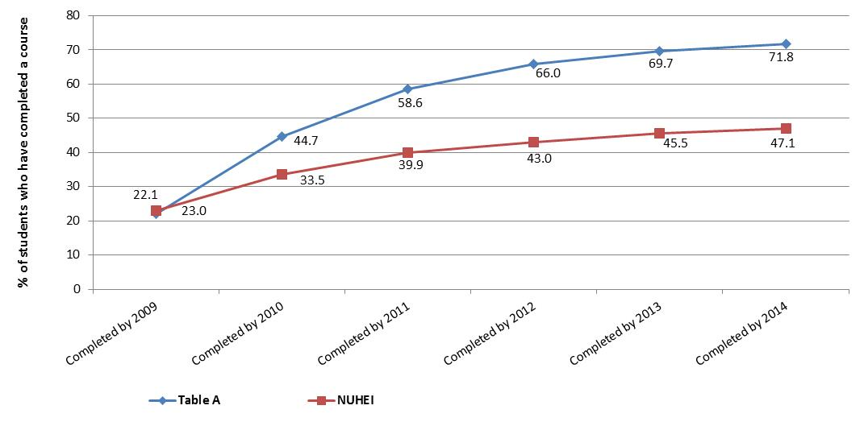

**Chart 2. The cumulative percentage of bachelor students at Table A institutions and NUHEIs who had dropped out each year, for the 2007 domestic commencing cohort**

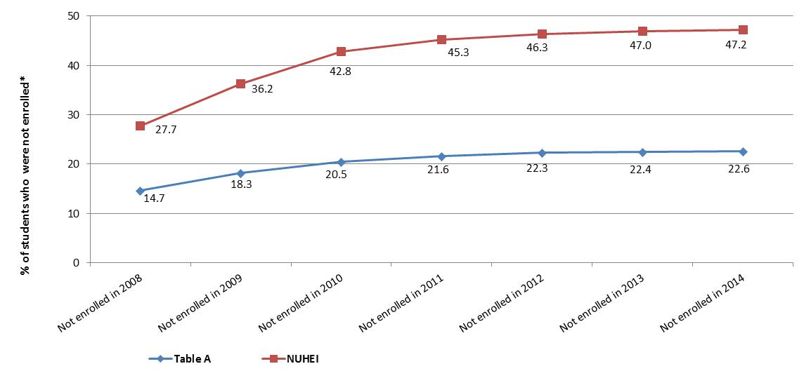*’Not enrolled’ excludes those students who have completed a course and are therefore no longer enrolled.

# International comparisons of completion rates

The Organisation for Economic Cooperation and Development (OECD) measure international completion rates on a semi-regular basis, with the last publication in 2013[23], [24]. International comparisons need to be used with caution due to differences in the nature and duration of degrees across countries as well as the different methodologies used in measuring completion rates[25].

The latest OECD data showed that Australia's completion rates for Bachelor degree programmes was 82 per cent in 2011, well ahead of the OECD average of 70 per cent and third highest in the OECD (behind Japan 91 per cent and Turkey 88 per cent). Australia’s result also compared favourably to other countries with similar tertiary systems. For example, Australia’s completion rate was higher than the United Kingdom on 79 per cent, New Zealand on 66 per cent and the United States on 64 per cent[26].

Women had higher completion rates than men in every country except Sweden, where men and women’s completion rates were the same. In Australia, the completion rate for women in 2011 was 88 percent, compared with an OECD average of 74 per cent. For men, the Australian completion rate was 74 per cent, compared with an OECD average of 65 per cent.

# Data notes

* This publication is based on data compiled from the *Higher Education Student Collection* maintained by the Department of Education and Training.
* Students have been tracked using their CHESSN. The analysis defines students as Table A institution or NUHEI students based on the institution where they commenced their course. Students are still included in the analysis if they changed institution types (for example a student who moved from a Table A institution to a NUHEI).
* Distinct cohorts of international students have been constructed for comparison purposes (see Appendix for data). It is not possible however to determine what percentage of international students may have completed their studies at another institution because international students do not have a CHESSN.
* Data presented in this report detail the relationship between completion rates and a number of student characteristics. No allowance is made for inter-relationships between student characteristics. For example, older students may have lower completion rates as they are more likely to be part-time students, who also have lower completion rates.
* Where referenced, Commonwealth Assisted students include Commonwealth Supported students and students receiving FEE-HELP. Non-Commonwealth Assisted Students are all other students. There was a break in time series for Non-Commonwealth Assisted students in 2009 for Table A institutions. From 1 January 2009, under HESA, domestic fee-paying places for commencing undergraduate students were no longer offered except in limited circumstances. This change resulted in a significant reduction in the number of fee-paying domestic undergraduate students and influenced completion information for Non-Commonwealth Assisted students at Table A institutions.
* Completion rates for those students studying a course in Food, Hospitality and Personal Services at Table A institutions are highly variable across years, due to very small numbers in each cohort.
* Since the publication of last cohort analysis report, minor methodology changes have been introduced, which have resulted in a small number of revisions to proportions at the decimal place level.

# Appendix - detailed tables and charts

Table 2: Cohort Analysis for Table A institution commencing domestic Bachelor students over a nine year period, 2005-2013 and 2006-2014

|  |  | **Completed  (in any year)** | **Still enrolled at the end of the 9 year cohort period** | **Re-enrolled, but dropped out** | **Never came back after the first year** |
| --- | --- | --- | --- | --- | --- |
| **National Total**  **(Domestic students)** | 2005 | 73.6% | 4.2% | 14.0% | 8.2% |
| 2006 | 73.5% | 4.2% | 14.5% | 7.8% |
| **Comparison figure for Overseas students** | 2005 | 74.2% | 0.1% | 15.1% | 10.5% |
| 2006 | 77.1% | 0.2% | 12.7% | 10.0% |
| **Course Level** | | | | | |
| **Bachelor's Graduate Entry** | 2005 | 82.4% | 1.9% | 7.6% | 8.0% |
| 2006 | 82.5% | 2.1% | 8.0% | 7.3% |
| **Bachelor's Honours** | 2005 | 86.1% | 1.5% | 5.1% | 7.3% |
| 2006 | 88.0% | 1.2% | 4.4% | 6.3% |
| **Bachelor's Pass** | 2005 | 73.1% | 4.3% | 14.3% | 8.2% |
| 2006 | 73.0% | 4.3% | 14.8% | 7.9% |
| **Mode of Attendance** | | | | | |
| **Internal** | 2005 | 76.6% | 3.8% | 12.7% | 6.9% |
| 2006 | 76.3% | 3.9% | 13.2% | 6.7% |
| **External** | 2005 | 46.6% | 8.1% | 25.0% | 20.4% |
| 2006 | 46.3% | 7.3% | 26.4% | 20.0% |
| **Multi-modal** | 2005 | 70.6% | 4.3% | 16.7% | 8.4% |
| 2006 | 70.1% | 4.8% | 17.4% | 7.7% |
| **Type of Attendance** | | | | | |
| **Full-time** | 2005 | 78.8% | 3.5% | 11.9% | 5.8% |
| 2006 | 78.3% | 3.7% | 12.4% | 5.6% |
| **Part-time** | 2005 | 49.2% | 7.4% | 24.0% | 19.5% |
| 2006 | 49.0% | 7.2% | 25.1% | 18.8% |
| **Gender** | | | | | |
| **Males** | 2005 | 70.9% | 4.4% | 15.9% | 8.8% |
| 2006 | 70.9% | 4.5% | 16.2% | 8.3% |
| **Females** | 2005 | 75.5% | 4.0% | 12.7% | 7.8% |
| 2006 | 75.2% | 4.0% | 13.3% | 7.5% |
| **Age** | | | | | |
| **19 and under** | 2005 | 80.3% | 3.7% | 11.0% | 4.9% |
| 2006 | 80.0% | 3.8% | 11.4% | 4.8% |
| **20-24** | 2005 | 70.3% | 4.3% | 16.0% | 9.4% |
| 2006 | 69.3% | 4.4% | 16.9% | 9.3% |
| **25 and over** | 2005 | 58.5% | 5.4% | 20.1% | 16.0% |
| 2006 | 58.1% | 5.4% | 21.2% | 15.2% |

|  |  | **Completed  (in any year)** | **Still enrolled at the end of the 9 year cohort period** | **Re-enrolled, but dropped out** | **Never came back after the first year** |
| --- | --- | --- | --- | --- | --- |
| **Basis for Admission** | | | | | |
| **Other basis for admission** | 2005 | 69.4% | 4.4% | 16.0% | 10.2% |
| 2006 | 68.6% | 4.4% | 16.9% | 10.0% |
| **Secondary education** | 2005 | 78.7% | 3.9% | 11.6% | 5.8% |
| 2006 | 78.7% | 4.0% | 11.9% | 5.4% |
| **ATAR (for school leavers)** | | | | | |
| **30-49** | 2005 | 51.4% | 5.0% | 26.0% | 17.6% |
| 2006 | 50.6% | 5.6% | 27.8% | 16.1% |
| **50-59** | 2005 | 56.1% | 6.3% | 21.8% | 15.8% |
| 2006 | 53.4% | 6.6% | 25.3% | 14.7% |
| **60-69** | 2005 | 65.4% | 5.5% | 18.6% | 10.5% |
| 2006 | 65.0% | 5.4% | 19.7% | 9.9% |
| **70-79** | 2005 | 73.5% | 4.9% | 14.7% | 6.9% |
| 2006 | 75.1% | 4.7% | 14.2% | 5.9% |
| **80-89** | 2005 | 82.8% | 3.7% | 9.8% | 3.7% |
| 2006 | 83.2% | 3.9% | 9.8% | 3.1% |
| **90-94** | 2005 | 89.8% | 2.4% | 5.9% | 1.9% |
| 2006 | 90.8% | 2.4% | 5.2% | 1.6% |
| **95-100** | 2005 | 94.5% | 1.6% | 3.1% | 0.8% |
| 2006 | 94.9% | 1.4% | 2.9% | 0.7% |
| **ATAR not provided or not required** | 2005 | 69.3% | 4.5% | 16.0% | 10.2% |
| 2006 | 69.0% | 4.5% | 16.6% | 9.8% |
| **Indigenous Indicator** | | | | | |
| **Indigenous** | 2005 | 46.6% | 8.1% | 25.0% | 20.4% |
| 2006 | 47.3% | 6.8% | 28.4% | 17.5% |
| **Not Indigenous** | 2005 | 73.9% | 4.2% | 13.9% | 8.1% |
| 2006 | 73.9% | 4.2% | 14.3% | 7.6% |
| **NESB Indicator** | | | | | |
| **Person from non-English speaking background** | 2005 | 78.7% | 3.6% | 11.7% | 6.1% |
| 2006 | 78.2% | 3.2% | 13.4% | 5.3% |
| **Person from English speaking background** | 2005 | 73.4% | 4.2% | 14.1% | 8.3% |
| 2006 | 73.3% | 4.3% | 14.5% | 7.9% |
| **Socio-Economic Status(a)** | | | | | |
| **Low SES** | 2005 | 68.9% | 4.8% | 16.3% | 9.9% |
| 2006 | 67.9% | 4.9% | 17.4% | 9.8% |
| **Medium SES** | 2005 | 72.6% | 4.3% | 14.4% | 8.6% |
| 2006 | 72.3% | 4.3% | 15.0% | 8.3% |
| **High SES** | 2005 | 77.7% | 3.7% | 12.1% | 6.5% |
| 2006 | 77.8% | 3.8% | 12.3% | 6.1% |
|  |  | **Completed  (in any year)** | **Still enrolled at the end of the 9 year cohort period** | **Re-enrolled, but dropped out** | **Never came back after the first year** |
| **Regional Classification (MCEETYA(b))** | | | | | |
| **Metropolitan** | 2005 | 75.0% | 4.1% | 13.5% | 7.5% |
| 2006 | 74.7% | 4.1% | 14.0% | 7.1% |
| **Regional** | 2005 | 69.8% | 4.6% | 15.6% | 10.1% |
| 2006 | 69.0% | 4.7% | 16.1% | 10.1% |
| **Remote** | 2005 | 59.5% | 5.7% | 19.9% | 14.8% |
| 2006 | 60.1% | 4.7% | 20.3% | 14.9% |
| **Liability Category** | | | | | |
| **Commonwealth Assisted students** | 2005 | 73.6% | 4.2% | 14.0% | 8.1% |
| 2006 | 73.4% | 4.3% | 14.6% | 7.8% |
| **Non- Commonwealth Assisted students** | 2005 | 72.4% | 1.4% | 12.9% | 13.3% |
| 2006 | 78.8% | 2.2% | 11.0% | 8.0% |
| **Broad Field of Education(c)** | | | | | |
| **Natural and Physical Sciences** | 2005 | 77.5% | 4.6% | 12.3% | 5.6% |
| 2006 | 78.1% | 4.2% | 12.5% | 5.2% |
| **Information Technology** | 2005 | 63.3% | 4.9% | 20.7% | 11.1% |
| 2006 | 62.5% | 4.9% | 21.5% | 11.0% |
| **Engineering and Related Technologies** | 2005 | 74.7% | 5.4% | 14.2% | 5.7% |
| 2006 | 75.6% | 5.3% | 14.1% | 5.0% |
| **Architecture and Building** | 2005 | 79.1% | 3.0% | 12.3% | 5.6% |
| 2006 | 79.2% | 3.5% | 11.4% | 6.0% |
| **Agriculture, Environmental & Related Studies** | 2005 | 66.9% | 4.8% | 17.3% | 11.0% |
| 2006 | 67.0% | 5.4% | 17.9% | 9.8% |
| **Health** | 2005 | 81.6% | 2.6% | 9.5% | 6.3% |
| 2006 | 81.3% | 3.0% | 9.8% | 5.9% |
| **Education** | 2005 | 74.7% | 3.3% | 12.8% | 9.1% |
| 2006 | 73.1% | 3.6% | 14.0% | 9.2% |
| **Management and Commerce** | 2005 | 72.3% | 4.1% | 14.8% | 8.7% |
| 2006 | 72.1% | 4.1% | 15.6% | 8.2% |
| **Society and Culture** | 2005 | 71.8% | 5.1% | 14.7% | 8.4% |
| 2006 | 70.7% | 5.2% | 15.8% | 8.3% |
| **Creative Arts** | 2005 | 75.6% | 3.5% | 13.7% | 7.3% |
| 2006 | 75.7% | 3.5% | 13.7% | 7.0% |
| **Food, Hospitality and Personal Services** | 2005 | 88.0% | 4.0% | 4.0% | 4.0% |
| 2006 | 62.5% | 6.3% | 31.3% | 0.0% |

(a) SES is based on the students' postcode of permanent home residence, with the SES value derived from the 2006 Socio-Economic Indexes for Areas (SEIFA) Education and Occupation Index for postal areas, where postal areas in the bottom 25% of the population aged 15-64 are classified as low SES.

(b) The student’s postcode of permanent home residence is mapped to a regional category using the Ministerial Council on Education, Employment, Training and Youth Affairs (MCEETYA) classification. The MCEETYA codes are derived from the Australian Standard Geographical Classification with some adjustments to cater for the Department’s special needs.

(c) Field of Education is based on the Australian Standard Classification of Education (ASCED) 2001.

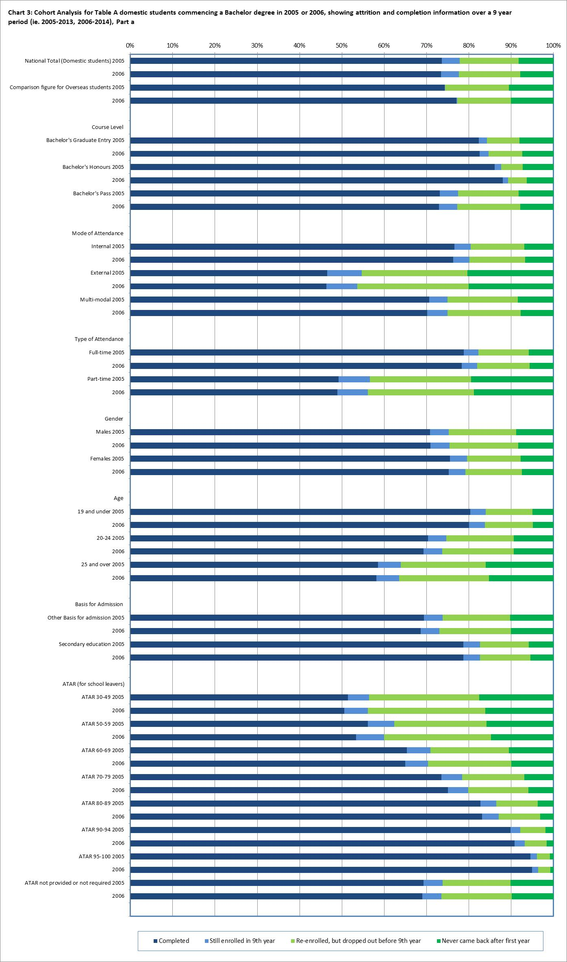

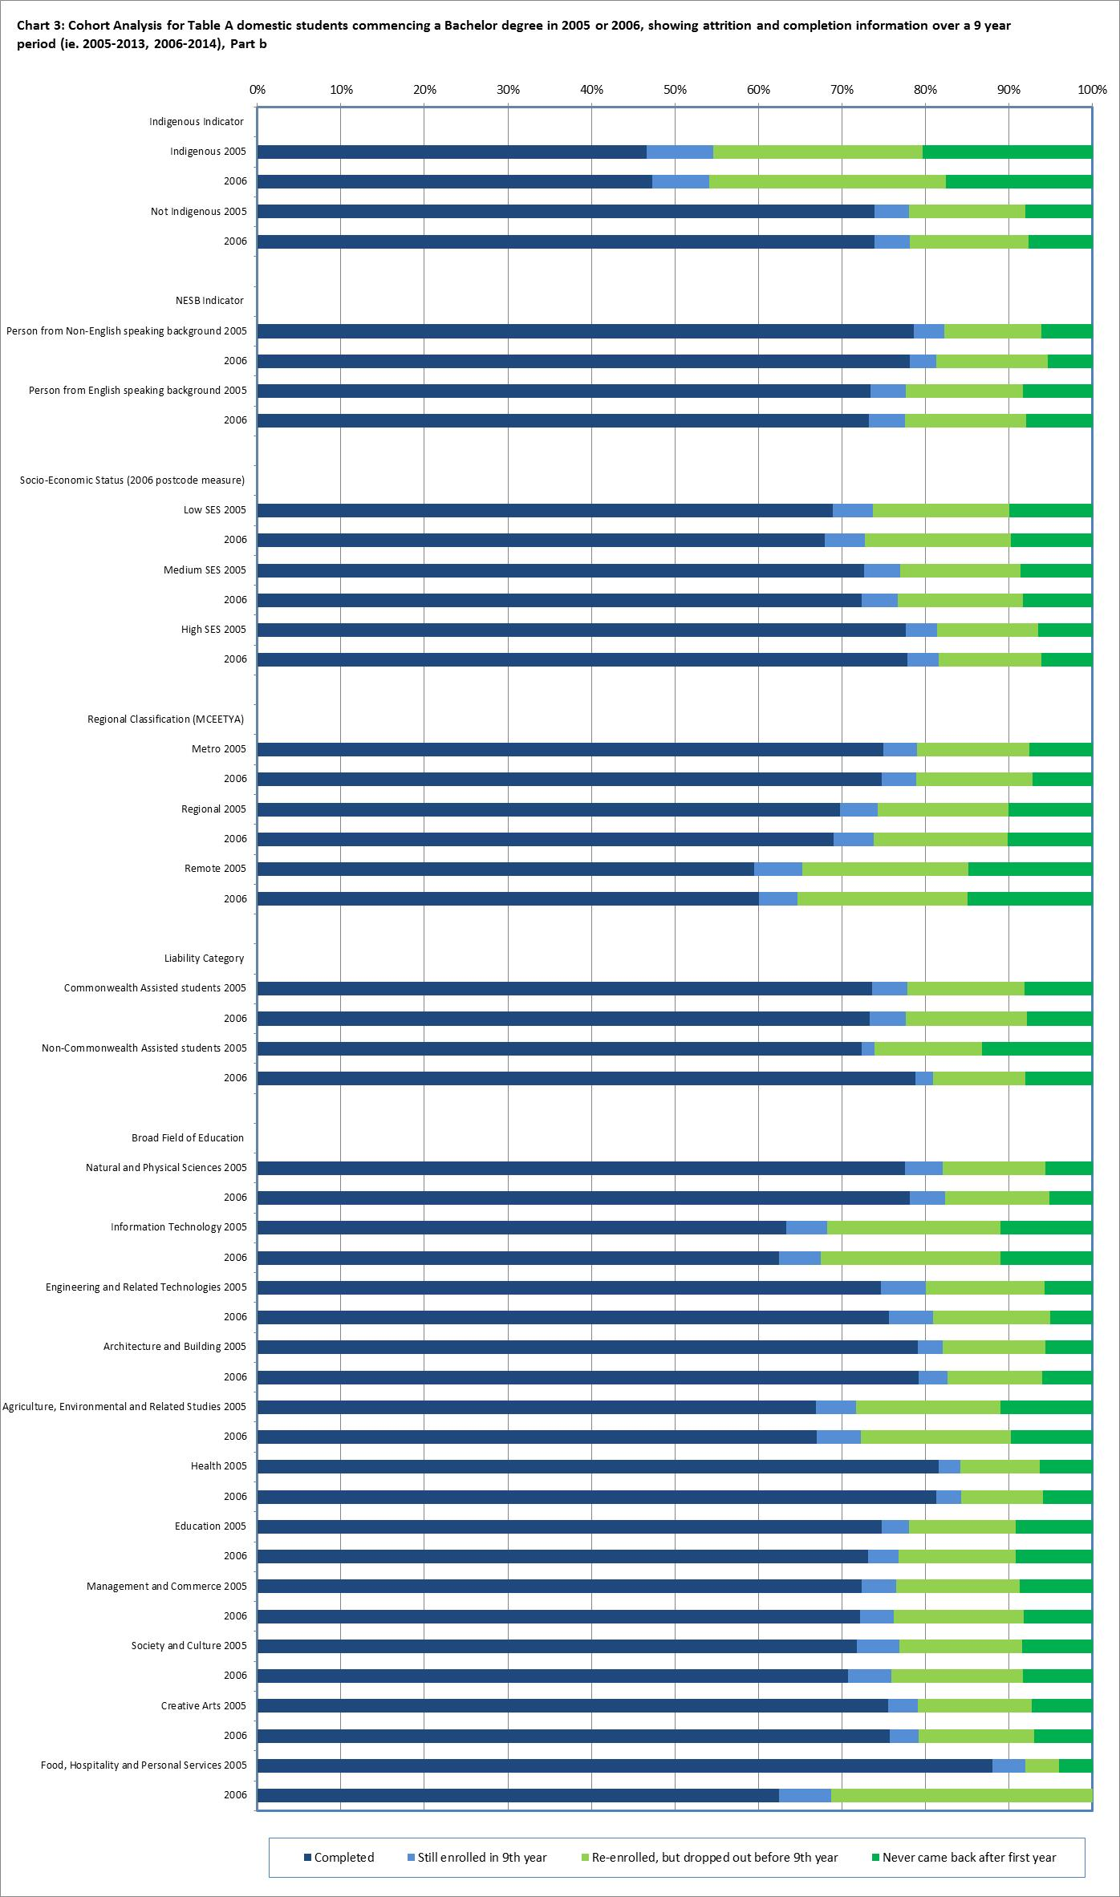

Table 3: Cohort Analysis for Table A institution commencing domestic Bachelor students over a four year period, 2005-2008, 2006-2009, 2007-2010, 2008-2011, 2009-2012, 2010-2013 and 2011-2014

|  |  |  |  |  |  |
| --- | --- | --- | --- | --- | --- |
|  |  | **Completed  (in any year)** | **Still enrolled at the end of the 4 year cohort period** | **Re-enrolled, but dropped out** | **Never came back after the first year** |
| **National Total**  **(Domestic students)** | 2005 | 47.3% | 30.2% | 11.5% | 11.0% |
| 2006 | 46.7% | 32.7% | 10.6% | 10.0% |
| 2007 | 45.9% | 33.8% | 10.4% | 9.9% |
| 2008 | 46.7% | 33.5% | 10.9% | 8.9% |
| 2009 | 46.1% | 34.3% | 11.1% | 8.5% |
| 2010 | 45.1% | 34.7% | 11.2% | 9.0% |
| 2011 | 45.0% | 34.5% | 11.7% | 8.8% |
| **Comparison figure for Overseas students** | 2005 | 64.9% | 11.4% | 13.0% | 10.7% |
| 2006 | 67.5% | 11.7% | 10.6% | 10.2% |
| 2007 | 68.4% | 12.2% | 10.4% | 9.0% |
| 2008 | 70.0% | 11.2% | 10.4% | 8.4% |
| 2009 | 71.3% | 10.6% | 10.3% | 7.7% |
| 2010 | 71.2% | 10.5% | 10.5% | 7.7% |
| 2011 | 70.8% | 10.7% | 10.1% | 8.4% |
| **Course Level** | | | | | |
| **Bachelor's Graduate Entry** | 2005 | 73.1% | 9.6% | 7.0% | 10.3% |
| 2006 | 72.4% | 12.2% | 6.0% | 9.3% |
| 2007 | 70.7% | 11.9% | 7.2% | 10.2% |
| 2008 | 69.5% | 14.0% | 6.8% | 9.7% |
| 2009 | 67.0% | 16.5% | 7.9% | 8.6% |
| 2010 | 68.3% | 15.3% | 7.4% | 9.0% |
| 2011 | 64.7% | 17.8% | 7.8% | 9.8% |
| **Bachelor's Honours** | 2005 | 78.9% | 6.7% | 4.6% | 9.9% |
| 2006 | 81.0% | 8.6% | 3.0% | 7.3% |
| 2007 | 77.8% | 8.7% | 5.4% | 8.1% |
| 2008 | 77.8% | 9.0% | 5.4% | 7.9% |
| 2009 | 81.4% | 7.6% | 4.8% | 6.3% |
| 2010 | 74.5% | 14.4% | 4.6% | 6.4% |
| 2011 | 77.0% | 12.9% | 4.3% | 5.8% |
| **Bachelor's Pass** | 2005 | 46.0% | 31.2% | 11.7% | 11.0% |
| 2006 | 45.5% | 33.7% | 10.8% | 10.1% |
| 2007 | 44.7% | 34.8% | 10.6% | 9.9% |
| 2008 | 45.6% | 34.3% | 11.1% | 8.9% |
| 2009 | 44.9% | 35.2% | 11.3% | 8.5% |
| 2010 | 43.9% | 35.6% | 11.4% | 9.1% |
| 2011 | 43.9% | 35.3% | 12.0% | 8.8% |

|  |  | **Completed  (in any year)** | **Still enrolled at the end of the 4 year cohort period** | **Re-enrolled, but dropped out** | **Never came back after the first year** |
| --- | --- | --- | --- | --- | --- |
| **Mode of Attendance** | | | | | |
| **Internal** | 2005 | 49.5% | 30.6% | 10.5% | 9.4% |
| 2006 | 48.7% | 33.1% | 9.7% | 8.6% |
| 2007 | 47.8% | 34.2% | 9.4% | 8.5% |
| 2008 | 48.7% | 33.9% | 9.8% | 7.6% |
| 2009 | 48.0% | 34.7% | 10.1% | 7.2% |
| 2010 | 47.0% | 35.2% | 10.2% | 7.7% |
| 2011 | 46.9% | 35.0% | 10.7% | 7.4% |
| **External** | 2005 | 24.8% | 29.4% | 19.6% | 26.2% |
| 2006 | 24.4% | 32.1% | 18.6% | 24.9% |
| 2007 | 24.3% | 33.3% | 19.0% | 23.3% |
| 2008 | 24.9% | 32.6% | 20.1% | 22.4% |
| 2009 | 25.5% | 33.6% | 19.5% | 21.4% |
| 2010 | 25.9% | 33.2% | 18.9% | 22.0% |
| 2011 | 25.6% | 33.2% | 19.3% | 21.9% |
| **Multi-modal** | 2005 | 50.4% | 24.8% | 13.6% | 11.2% |
| 2006 | 49.1% | 28.1% | 12.7% | 10.1% |
| 2007 | 50.6% | 27.7% | 12.4% | 9.4% |
| 2008 | 50.5% | 28.3% | 12.8% | 8.4% |
| 2009 | 50.1% | 28.9% | 13.1% | 7.9% |
| 2010 | 49.5% | 30.5% | 12.7% | 7.4% |
| 2011 | 48.2% | 30.3% | 14.0% | 7.5% |
| **Type of Attendance** | | | | | |
| **Full-time** | 2005 | 52.2% | 29.7% | 9.9% | 8.1% |
| 2006 | 51.3% | 32.2% | 9.1% | 7.4% |
| 2007 | 50.4% | 33.2% | 9.0% | 7.3% |
| 2008 | 51.3% | 32.9% | 9.3% | 6.5% |
| 2009 | 50.5% | 33.8% | 9.6% | 6.1% |
| 2010 | 49.3% | 34.3% | 9.7% | 6.6% |
| 2011 | 49.1% | 34.1% | 10.3% | 6.4% |
| **Part-time** | 2005 | 24.0% | 32.3% | 18.8% | 24.9% |
| 2006 | 23.5% | 35.4% | 17.9% | 23.2% |
| 2007 | 23.1% | 36.6% | 17.7% | 22.6% |
| 2008 | 22.9% | 36.6% | 19.1% | 21.5% |
| 2009 | 23.0% | 37.0% | 19.1% | 21.0% |
| 2010 | 22.7% | 36.7% | 18.8% | 21.8% |
| 2011 | 22.5% | 36.6% | 19.3% | 21.6% |

|  |  | **Completed  (in any year)** | **Still enrolled at the end of the 4 year cohort period** | **Re-enrolled, but dropped out** | **Never came back after the first year** |
| --- | --- | --- | --- | --- | --- |
| **Gender** | | | | | |
| **Males** | 2005 | 42.4% | 33.4% | 12.7% | 11.5% |
| 2006 | 42.1% | 35.8% | 11.7% | 10.4% |
| 2007 | 41.3% | 37.1% | 11.3% | 10.3% |
| 2008 | 42.3% | 37.0% | 11.6% | 9.1% |
| 2009 | 41.6% | 37.7% | 12.1% | 8.6% |
| 2010 | 40.6% | 38.1% | 12.1% | 9.2% |
| 2011 | 40.8% | 37.8% | 12.6% | 8.8% |
| **Females** | 2005 | 50.8% | 28.0% | 10.6% | 10.6% |
| 2006 | 50.0% | 30.6% | 9.7% | 9.7% |
| 2007 | 49.1% | 31.5% | 9.8% | 9.6% |
| 2008 | 49.7% | 31.0% | 10.4% | 8.8% |
| 2009 | 49.2% | 32.0% | 10.4% | 8.4% |
| 2010 | 48.3% | 32.3% | 10.5% | 8.9% |
| 2011 | 48.0% | 32.1% | 11.1% | 8.7% |
| **Age** | | | | | |
| **19 and under** | 2005 | 48.1% | 35.4% | 9.4% | 7.2% |
| 2006 | 47.4% | 37.6% | 8.5% | 6.5% |
| 2007 | 46.6% | 38.6% | 8.2% | 6.5% |
| 2008 | 47.9% | 38.0% | 8.5% | 5.6% |
| 2009 | 47.1% | 38.8% | 8.7% | 5.4% |
| 2010 | 45.9% | 39.4% | 8.9% | 5.8% |
| 2011 | 45.7% | 39.2% | 9.4% | 5.7% |
| **20-24** | 2005 | 52.9% | 21.1% | 13.1% | 12.8% |
| 2006 | 51.8% | 24.2% | 12.2% | 11.9% |
| 2007 | 51.3% | 25.0% | 12.2% | 11.5% |
| 2008 | 51.6% | 24.9% | 12.7% | 10.8% |
| 2009 | 51.2% | 26.0% | 13.0% | 9.8% |
| 2010 | 50.6% | 26.4% | 12.8% | 10.3% |
| 2011 | 50.6% | 26.1% | 13.3% | 10.0% |
| **25 and over** | 2005 | 39.5% | 25.2% | 15.6% | 19.7% |
| 2006 | 39.1% | 27.4% | 15.1% | 18.4% |
| 2007 | 37.9% | 28.2% | 15.3% | 18.6% |
| 2008 | 37.5% | 28.3% | 16.6% | 17.5% |
| 2009 | 37.4% | 29.6% | 16.3% | 16.7% |
| 2010 | 37.1% | 29.3% | 16.3% | 17.3% |
| 2011 | 36.5% | 29.1% | 17.2% | 17.1% |

|  |  | **Completed  (in any year)** | **Still enrolled at the end of the 4 year cohort period** | **Re-enrolled, but dropped out** | **Never came back after the first year** |
| --- | --- | --- | --- | --- | --- |
| **Basis for Admission** | | | | | |
| **Other basis for admission** | 2005 | 49.0% | 24.6% | 13.0% | 13.3% |
| 2006 | 48.2% | 27.2% | 12.1% | 12.5% |
| 2007 | 47.0% | 28.2% | 12.4% | 12.4% |
| 2008 | 46.5% | 28.8% | 13.0% | 11.7% |
| 2009 | 46.1% | 29.7% | 13.2% | 11.0% |
| 2010 | 45.4% | 29.7% | 13.2% | 11.7% |
| 2011 | 45.1% | 29.7% | 13.8% | 11.3% |
| **Secondary education** | 2005 | 45.3% | 36.9% | 9.7% | 8.2% |
| 2006 | 45.2% | 38.7% | 8.9% | 7.3% |
| 2007 | 44.9% | 39.3% | 8.5% | 7.4% |
| 2008 | 46.9% | 38.1% | 8.9% | 6.2% |
| 2009 | 46.1% | 39.1% | 8.9% | 5.9% |
| 2010 | 44.9% | 39.8% | 9.0% | 6.3% |
| 2011 | 44.9% | 39.4% | 9.6% | 6.1% |
| **ATAR (for school leavers)** | | | | | |
| **30-49** | 2005 | 35.7% | 24.7% | 18.1% | 21.5% |
| 2006 | 28.5% | 32.8% | 18.8% | 19.9% |
| 2007 | 35.9% | 26.3% | 20.0% | 17.8% |
| 2008 | 29.5% | 32.0% | 20.8% | 17.8% |
| 2009 | 34.2% | 33.3% | 18.3% | 14.1% |
| 2010 | 28.6% | 31.0% | 19.5% | 20.8% |
|  | 2011 | 27.2% | 32.0% | 24.7% | 16.1% |
| **50-59** | 2005 | 31.5% | 30.3% | 17.5% | 20.6% |
| 2006 | 31.7% | 31.1% | 17.6% | 19.6% |
| 2007 | 30.4% | 35.2% | 15.2% | 19.2% |
| 2008 | 34.5% | 33.2% | 15.7% | 16.5% |
| 2009 | 33.1% | 36.7% | 16.5% | 13.7% |
| 2010 | 29.3% | 39.1% | 17.2% | 14.4% |
| 2011 | 31.2% | 36.8% | 18.3% | 13.6% |
| **60-69** | 2005 | 37.9% | 33.5% | 14.4% | 14.2% |
| 2006 | 37.1% | 35.7% | 14.2% | 13.0% |
| 2007 | 36.7% | 36.2% | 13.4% | 13.8% |
| 2008 | 38.6% | 35.6% | 14.1% | 11.8% |
| 2009 | 36.6% | 38.2% | 13.8% | 11.5% |
| 2010 | 35.8% | 37.9% | 14.8% | 11.5% |
| 2011 | 36.0% | 37.0% | 15.8% | 11.1% |

|  |  | **Completed  (in any year)** | **Still enrolled at the end of the 4 year cohort period** | **Re-enrolled, but dropped out** | **Never came back after the first year** |
| --- | --- | --- | --- | --- | --- |
| **ATAR continued…..** | | | | | |
| **70-79** | 2005 | 43.2% | 34.6% | 12.1% | 10.1% |
| 2006 | 45.0% | 36.5% | 10.2% | 8.2% |
| 2007 | 43.5% | 37.9% | 10.1% | 8.4% |
| 2008 | 44.5% | 37.9% | 10.6% | 7.0% |
| 2009 | 43.7% | 38.3% | 11.6% | 6.3% |
| 2010 | 41.3% | 39.8% | 11.3% | 7.6% |
| 2011 | 42.9% | 38.5% | 11.4% | 7.2% |
| **80-89** | 2005 | 49.8% | 36.2% | 8.4% | 5.6% |
| 2006 | 49.6% | 38.4% | 7.4% | 4.6% |
| 2007 | 49.1% | 39.4% | 6.9% | 4.7% |
| 2008 | 50.4% | 38.6% | 7.3% | 3.7% |
| 2009 | 49.3% | 39.8% | 7.3% | 3.6% |
| 2010 | 48.0% | 40.8% | 7.5% | 3.7% |
| 2011 | 48.0% | 41.1% | 7.4% | 3.5% |
| **90-94** | 2005 | 50.7% | 41.3% | 5.0% | 3.0% |
| 2006 | 51.9% | 41.3% | 4.6% | 2.2% |
| 2007 | 51.3% | 42.2% | 4.4% | 2.1% |
| 2008 | 54.0% | 40.2% | 4.1% | 1.7% |
| 2009 | 52.0% | 41.6% | 4.6% | 1.8% |
| 2010 | 52.0% | 41.5% | 4.5% | 1.9% |
| 2011 | 52.6% | 41.0% | 4.5% | 1.8% |
| **95-100** | 2005 | 46.5% | 48.4% | 3.7% | 1.3% |
| 2006 | 47.0% | 49.3% | 2.7% | 1.0% |
| 2007 | 47.1% | 48.9% | 2.7% | 1.3% |
| 2008 | 50.2% | 46.3% | 2.7% | 0.8% |
| 2009 | 50.4% | 46.1% | 2.3% | 1.1% |
| 2010 | 49.4% | 46.5% | 2.9% | 1.2% |
| 2011 | 51.2% | 45.3% | 2.6% | 0.9% |
| **ATAR not provided or not required** | 2005 | 48.2% | 25.4% | 13.0% | 13.4% | |
| 2006 | 47.2% | 28.5% | 12.0% | 12.3% | |
| 2007 | 46.3% | 29.3% | 12.2% | 12.2% | |
| 2008 | 46.3% | 29.7% | 12.7% | 11.3% | |
| 2009 | 46.1% | 30.4% | 12.8% | 10.7% | |
| 2010 | 45.2% | 30.6% | 12.9% | 11.3% | |
|  | 2011 | 44.7% | 31.1% | 13.4% | 10.8% | |

|  |  | **Completed  (in any year)** | **Still enrolled at the end of the 4 year cohort period** | **Re-enrolled, but dropped out** | **Never came back after the first year** |
| --- | --- | --- | --- | --- | --- |
| **Indigenous Indicator** | | | | | |
| **Indigenous** | 2005 | 28.3% | 27.6% | 18.4% | 25.7% |
| 2006 | 30.5% | 28.2% | 19.6% | 21.7% |
| 2007 | 26.9% | 31.8% | 18.4% | 22.9% |
| 2008 | 29.8% | 30.0% | 20.2% | 20.0% |
| 2009 | 27.1% | 32.7% | 20.3% | 19.9% |
| 2010 | 25.5% | 33.5% | 20.2% | 20.8% |
| 2011 | 26.3% | 33.1% | 19.8% | 20.8% |
| **Not Indigenous** | 2005 | 47.5% | 30.3% | 11.4% | 10.8% |
| 2006 | 47.1% | 32.8% | 10.5% | 9.7% |
| 2007 | 46.2% | 33.8% | 10.3% | 9.7% |
| 2008 | 46.9% | 33.6% | 10.8% | 8.7% |
| 2009 | 46.4% | 34.4% | 10.9% | 8.3% |
| 2010 | 45.5% | 34.7% | 11.0% | 8.8% |
| 2011 | 45.4% | 34.6% | 11.5% | 8.5% |
| **NESB Indicator** | | | | | |
| **Person from non-English speaking background** | 2005 | 50.5% | 32.4% | 9.5% | 7.6% |
| 2006 | 50.2% | 34.6% | 8.9% | 6.3% |
| 2007 | 49.2% | 35.4% | 8.9% | 6.4% |
| 2008 | 48.7% | 36.0% | 9.1% | 6.3% |
| 2009 | 48.7% | 36.6% | 9.0% | 5.7% |
| 2010 | 47.6% | 35.7% | 9.9% | 6.8% |
|  | 2011 | 47.0% | 35.9% | 11.0% | 6.2% |
| **Person from English speaking background** | 2005 | 47.2% | 30.1% | 11.5% | 11.1% |
| 2006 | 46.6% | 32.7% | 10.6% | 10.1% |
| 2007 | 45.8% | 33.7% | 10.5% | 10.0% |
| 2008 | 46.6% | 33.4% | 11.0% | 9.1% |
| 2009 | 46.0% | 34.2% | 11.2% | 8.6% |
| 2010 | 45.0% | 34.6% | 11.2% | 9.1% |
| 2011 | 45.0% | 34.5% | 11.7% | 8.9% |

|  |  | **Completed  (in any year)** | **Still enrolled at the end of the 4 year cohort period** | **Re-enrolled, but dropped out** | **Never came back after the first year** |
| --- | --- | --- | --- | --- | --- |
| **Socio-Economic Status(a)** | | | | | |
| **Low SES** | 2005 | 45.5% | 28.9% | 12.6% | 12.9% |
| 2006 | 44.0% | 31.3% | 12.3% | 12.4% |
| 2007 | 43.8% | 32.5% | 11.8% | 11.9% |
| 2008 | 43.5% | 32.7% | 12.7% | 11.2% |
| 2009 | 42.8% | 33.7% | 13.1% | 10.4% |
| 2010 | 41.8% | 34.3% | 12.9% | 11.0% |
| 2011 | 41.0% | 34.2% | 14.0% | 10.9% |
| **Medium SES** | 2005 | 47.1% | 29.5% | 11.8% | 11.5% |
| 2006 | 46.5% | 32.1% | 10.9% | 10.6% |
| 2007 | 45.5% | 33.1% | 10.9% | 10.6% |
| 2008 | 46.4% | 32.9% | 11.3% | 9.4% |
| 2009 | 45.8% | 33.7% | 11.4% | 9.1% |
| 2010 | 44.6% | 34.3% | 11.6% | 9.5% |
| 2011 | 44.5% | 34.1% | 12.2% | 9.3% |
| **High SES** | 2005 | 48.8% | 31.8% | 10.4% | 9.0% |
| 2006 | 48.4% | 34.5% | 9.2% | 7.9% |
| 2007 | 47.6% | 35.6% | 9.1% | 7.8% |
| 2008 | 48.8% | 34.7% | 9.4% | 7.1% |
| 2009 | 48.2% | 35.7% | 9.5% | 6.6% |
| 2010 | 47.8% | 35.5% | 9.5% | 7.1% |
| 2011 | 48.0% | 35.5% | 9.7% | 6.7% |
| **Regional Classification (MCEETYA(b))** | | | | | |
| **Metropolitan** | 2005 | 47.9% | 30.9% | 11.1% | 10.1% |
| 2006 | 47.2% | 33.5% | 10.2% | 9.2% |
| 2007 | 46.4% | 34.5% | 10.0% | 9.2% |
| 2008 | 47.2% | 34.1% | 10.5% | 8.2% |
| 2009 | 46.5% | 35.0% | 10.7% | 7.8% |
| 2010 | 45.5% | 35.2% | 10.8% | 8.5% |
| 2011 | 45.6% | 35.2% | 11.2% | 8.0% |
| **Regional** | 2005 | 46.1% | 27.7% | 12.7% | 13.4% |
| 2006 | 45.1% | 30.1% | 11.9% | 12.8% |
| 2007 | 44.5% | 31.2% | 12.0% | 12.2% |
| 2008 | 45.3% | 31.2% | 12.3% | 11.2% |
| 2009 | 44.9% | 31.7% | 12.6% | 10.8% |
| 2010 | 43.8% | 33.0% | 12.4% | 10.8% |
|  | 2011 | 42.8% | 32.3% | 13.6% | 11.2% |

|  |  | **Completed  (in any year)** | **Still enrolled at the end of the 4 year cohort period** | **Re-enrolled, but dropped out** | **Never came back after the first year** |
| --- | --- | --- | --- | --- | --- |
| **Regional Classification continued…..** | | | | | |
| **Remote** | 2005 | 37.5% | 27.8% | 15.9% | 19.0% |
| 2006 | 36.4% | 30.9% | 14.5% | 18.2% |
| 2007 | 36.9% | 33.8% | 13.1% | 16.2% |
| 2008 | 34.3% | 32.1% | 15.8% | 17.8% |
| 2009 | 35.9% | 33.5% | 15.4% | 15.1% |
| 2010 | 35.2% | 34.7% | 14.0% | 16.1% |
| 2011 | 36.7% | 32.6% | 14.0% | 16.7% |
| **Liability Category** | | | | | |
| **Commonwealth Assisted students** | 2005 | 47.2% | 30.3% | 11.5% | 11.0% |
| 2006 | 46.6% | 32.8% | 10.6% | 10.0% |
| 2007 | 45.8% | 33.9% | 10.4% | 9.9% |
| 2008 | 46.6% | 33.5% | 10.9% | 8.9% |
| 2009 | 46.0% | 34.4% | 11.1% | 8.5% |
| 2010 | 45.1% | 34.7% | 11.2% | 9.0% |
| 2011 | 45.0% | 34.5% | 11.7% | 8.8% |
| **Non-Commonwealth Assisted students** | 2005 | 52.3% | 22.3% | 11.4% | 14.0% |
| 2006 | 55.4% | 26.5% | 9.4% | 8.7% |
| 2007 | 52.3% | 27.7% | 10.4% | 9.5% |
| 2008 | 52.6% | 28.8% | 8.8% | 9.8% |
| 2009 | 63.3% | 16.3% | 11.6% | 8.9% |
| 2010 | 66.7% | 13.6% | 9.7% | 9.9% |
| 2011 | 57.2% | 18.0% | 16.3% | 8.5% |
| **Broad Field of Education(c)** | | | | | |
| **Natural and Physical Sciences** | 2005 | 47.3% | 34.6% | 10.0% | 8.1% |
| 2006 | 47.5% | 36.7% | 8.9% | 6.8% |
| 2007 | 45.5% | 38.7% | 8.8% | 7.0% |
| 2008 | 47.4% | 37.1% | 9.4% | 6.1% |
| 2009 | 48.8% | 36.2% | 9.2% | 5.7% |
| 2010 | 47.5% | 37.4% | 9.1% | 5.9% |
| 2011 | 48.9% | 35.8% | 9.6% | 5.7% |
| **Information Technology** | 2005 | 36.1% | 34.1% | 15.7% | 14.1% |
| 2006 | 35.8% | 35.0% | 15.3% | 13.9% |
| 2007 | 35.1% | 37.6% | 14.2% | 13.1% |
| 2008 | 37.6% | 35.0% | 14.9% | 12.5% |
| 2009 | 37.0% | 36.6% | 15.1% | 11.3% |
| 2010 | 37.8% | 36.8% | 14.4% | 11.0% |
| 2011 | 35.7% | 38.2% | 15.8% | 10.3% |

|  |  | **Completed  (in any year)** | **Still enrolled at the end of the 4 year cohort period** | **Re-enrolled, but dropped out** | **Never came back after the first year** |
| --- | --- | --- | --- | --- | --- |
| **Broad Field of Education(c) continued…….** | | | | | |
| **Engineering and Related Technologies** | 2005 | 26.2% | 55.3% | 10.8% | 7.7% |
| 2006 | 25.5% | 58.8% | 9.4% | 6.3% |
| 2007 | 24.9% | 59.8% | 9.3% | 6.0% |
| 2008 | 25.7% | 58.6% | 10.2% | 5.5% |
| 2009 | 25.8% | 59.2% | 9.5% | 5.4% |
| 2010 | 25.0% | 59.6% | 9.8% | 5.6% |
| 2011 | 26.5% | 58.5% | 10.0% | 5.0% |
| **Architecture and Building** | 2005 | 48.2% | 35.1% | 8.9% | 7.8% |
| 2006 | 50.1% | 34.5% | 8.2% | 7.2% |
| 2007 | 47.3% | 35.5% | 8.8% | 8.4% |
| 2008 | 43.7% | 38.4% | 10.3% | 7.6% |
| 2009 | 43.6% | 39.1% | 10.0% | 7.3% |
| 2010 | 44.0% | 37.9% | 10.0% | 8.1% |
| 2011 | 44.4% | 37.4% | 10.1% | 8.1% |
| **Agriculture, Environmental & Related Studies** | 2005 | 42.8% | 29.3% | 13.4% | 14.5% |
| 2006 | 43.5% | 31.4% | 13.0% | 12.2% |
| 2007 | 44.1% | 30.1% | 12.9% | 12.9% |
| 2008 | 45.3% | 31.8% | 12.7% | 10.2% |
| 2009 | 43.6% | 31.6% | 13.6% | 11.2% |
| 2010 | 42.0% | 33.3% | 12.8% | 11.9% |
| 2011 | 42.2% | 33.1% | 13.7% | 11.0% |
| **Health** | 2005 | 59.0% | 24.2% | 8.3% | 8.4% |
| 2006 | 58.1% | 26.2% | 7.9% | 7.7% |
| 2007 | 55.9% | 28.5% | 7.8% | 7.8% |
| 2008 | 55.9% | 28.8% | 8.2% | 7.1% |
| 2009 | 54.8% | 29.6% | 8.5% | 7.1% |
| 2010 | 54.5% | 29.4% | 8.6% | 7.4% |
| 2011 | 52.1% | 30.5% | 9.8% | 7.6% |
| **Education** | 2005 | 55.5% | 21.8% | 10.8% | 11.9% |
| 2006 | 53.1% | 24.8% | 10.5% | 11.6% |
| 2007 | 51.4% | 25.9% | 10.7% | 12.1% |
| 2008 | 49.0% | 27.8% | 11.5% | 11.6% |
| 2009 | 45.5% | 30.2% | 12.8% | 11.5% |
| 2010 | 42.9% | 32.6% | 12.4% | 12.2% |
| 2011 | 42.9% | 32.4% | 13.0% | 11.7% |

|  |  | **Completed  (in any year)** | **Still enrolled at the end of the 4 year cohort period** | **Re-enrolled, but dropped out** | **Never came back after the first year** |
| --- | --- | --- | --- | --- | --- |
| **Broad Field of Education(c) continued…….** | | | | | |
| **Management and Commerce** | 2005 | 44.1% | 33.0% | 11.8% | 11.1% |
| 2006 | 43.6% | 35.3% | 11.0% | 10.1% |
| 2007 | 43.2% | 36.6% | 10.6% | 9.6% |
| 2008 | 45.1% | 35.8% | 10.9% | 8.2% |
| 2009 | 45.0% | 36.1% | 10.8% | 8.0% |
| 2010 | 43.5% | 36.7% | 11.2% | 8.5% |
| 2011 | 44.6% | 35.6% | 11.5% | 8.3% |
| **Society and Culture** | 2005 | 40.1% | 35.9% | 12.2% | 11.8% |
| 2006 | 38.6% | 39.3% | 11.1% | 10.9% |
| 2007 | 38.2% | 39.9% | 11.3% | 10.6% |
| 2008 | 39.7% | 38.9% | 11.6% | 9.7% |
| 2009 | 39.7% | 39.7% | 11.8% | 8.8% |
| 2010 | 39.2% | 39.2% | 11.9% | 9.7% |
|  | 2011 | 39.6% | 38.8% | 12.3% | 9.2% |
| **Creative Arts** | 2005 | 53.6% | 24.2% | 12.0% | 10.3% |
| 2006 | 53.5% | 26.6% | 10.6% | 9.3% |
| 2007 | 53.3% | 27.0% | 10.3% | 9.4% |
| 2008 | 54.5% | 25.3% | 10.9% | 9.3% |
| 2009 | 53.2% | 27.0% | 11.3% | 8.6% |
| 2010 | 52.0% | 27.4% | 11.8% | 8.8% |
| 2011 | 51.8% | 27.3% | 12.0% | 9.0% |
| **Food, Hospitality and Personal Services(d)** | 2005 | 80.0% | 4.0% | 8.0% | 8.0% |
| 2006 | 43.8% | 31.3% | 18.8% | 6.3% |
| 2007 | 58.8% | 41.2% | 0.0% | 0.0% |
| 2008 | 61.9% | 14.3% | 9.5% | 14.3% |
| 2009 | 55.6% | 16.7% | 22.2% | 5.6% |

(a) SES is based on the students' postcode of permanent home residence, with the SES value derived from the 2006 Socio-Economic Indexes for Areas (SEIFA) Education and Occupation Index for postal areas, where postal areas in the bottom 25% of the population aged 15-64 are classified as low SES.

(b) The student’s postcode of permanent home residence is mapped to a regional category using the Ministerial Council on Education, Employment, Training and Youth Affairs (MCEETYA) classification. The MCEETYA codes are derived from the Australian Standard Geographical Classification with some adjustments to cater for the Department’s special needs.

(c) Field of Education is based on the Australian Standard Classification of Education (ASCED) 2001.

(d) There were no students studying Food, Hospitality and Personal Services at Table A institutions in 2010 or 2011.

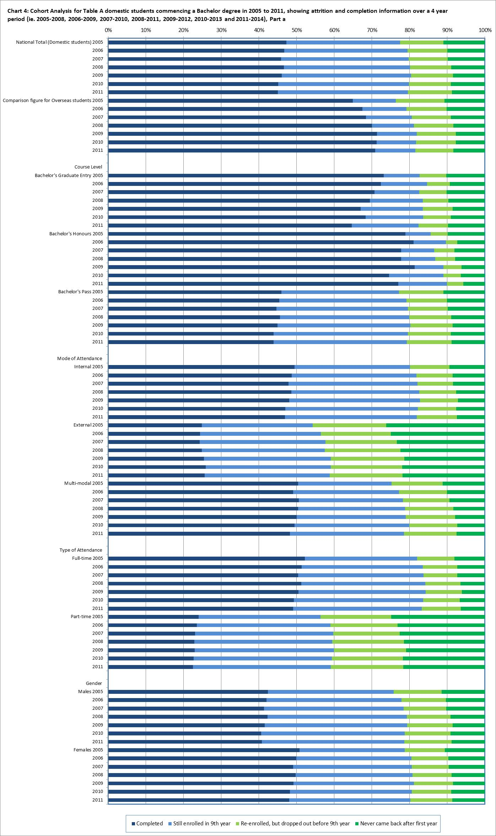

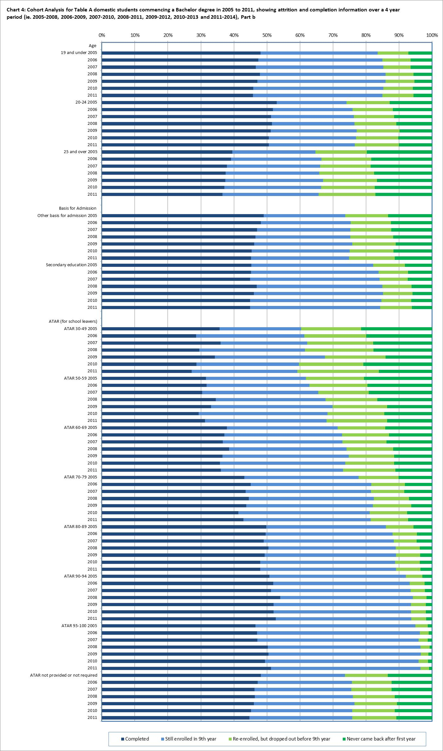

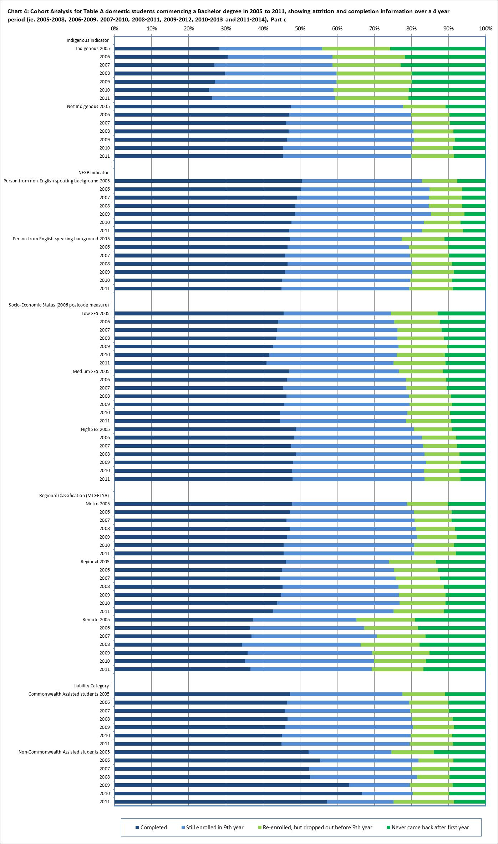

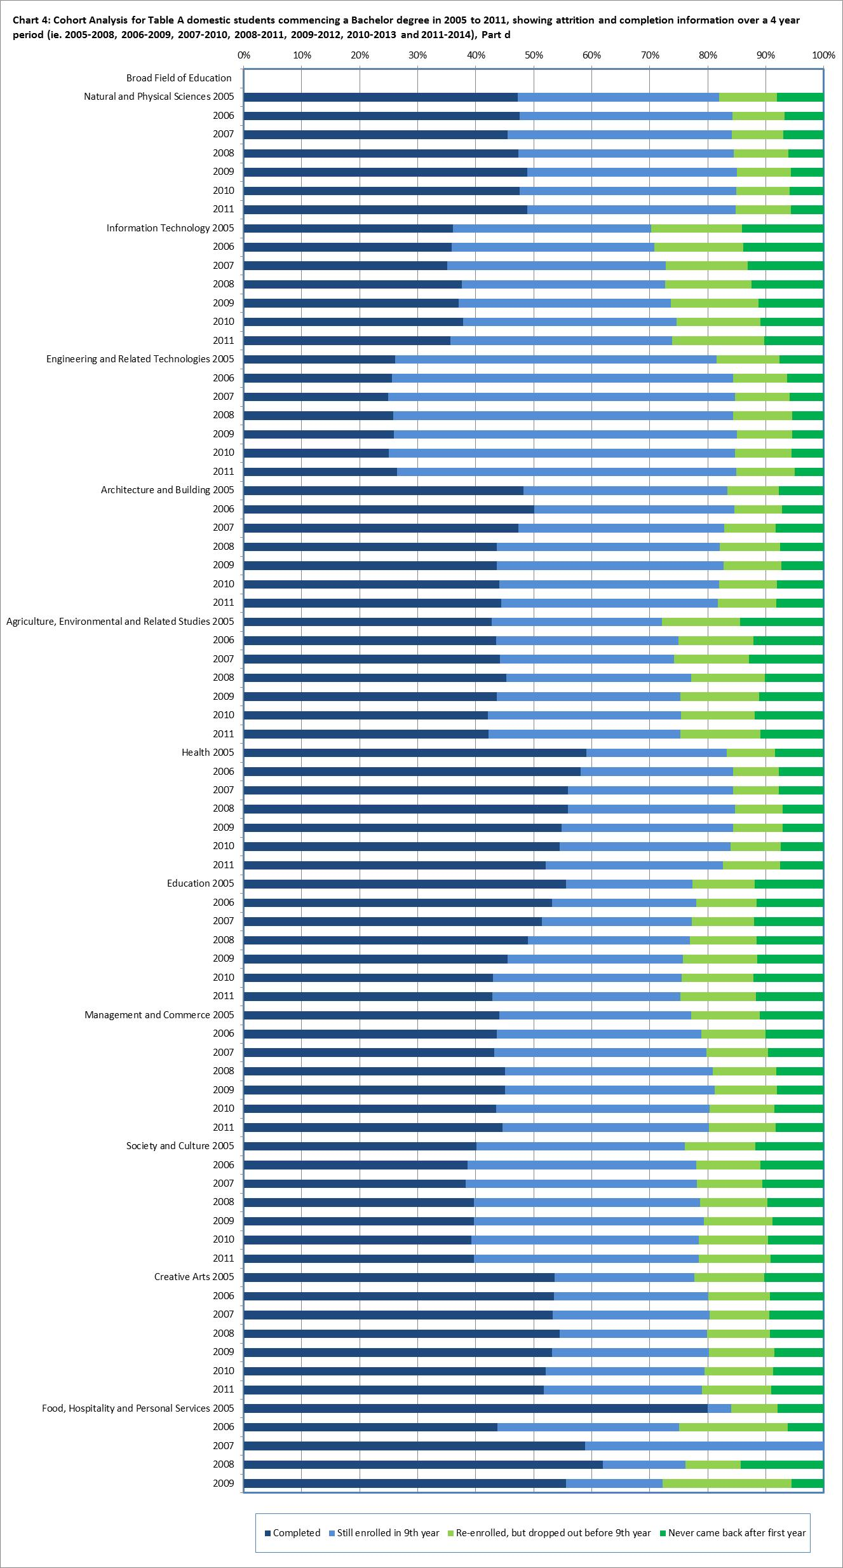

Table 4: Four year completion rates for commencing domestic Bachelor students by Table A Institution and Table B Institution, %

|  |  |  |  |  |  |  |  |  |
| --- | --- | --- | --- | --- | --- | --- | --- | --- |
|  | | **2005-08** | **2006-09** | **2007-10** | **2008-11** | **2009-12** | **2010-13** | **2011-14** |
| **Table A Institutions** | | | | | | | | |
| **New South Wales** | Charles Sturt University | 43.7 | 41.3 | 41.1 | 41.2 | 37.7 | 39.1 | 38.9 |
| Macquarie University | 47.1 | 48.2 | 48.7 | 49.9 | 46.9 | 43.1 | 43.0 |
| Southern Cross University | 37.9 | 39.9 | 40.2 | 38.9 | 38.5 | 40.6 | 38.7 |
| The University of New England | 37.0 | 36.2 | 35.3 | 35.9 | 31.7 | 28.6 | 29.9 |
| The University of New South Wales | 44.4 | 45.1 | 43.6 | 42.2 | 45.7 | 47.9 | 48.9 |
| The University of Newcastle | 52.3 | 51.9 | 48.6 | 43.6 | 43.6 | 40.9 | 42.0 |
| The University of Wollongong | 54.8 | 53.5 | 56.1 | 55.7 | 55.5 | 54.5 | 51.9 |
| University of Sydney | 64.4 | 63.5 | 62.7 | 63.6 | 64.3 | 63.9 | 60.2 |
| University of Technology Sydney | 52.3 | 50.4 | 51.3 | 50.6 | 51.2 | 51.2 | 51.2 |
| Western Sydney University | 51.8 | 51.6 | 45.4 | 45.3 | 41.9 | 40.2 | 40.5 |
| **Victoria** | Deakin University | 46.8 | 46.4 | 47.6 | 50.6 | 52.6 | 52.3 | 51.2 |
| Federation University Australia | 48.6 | 48.6 | 48.5 | 44.5 | 40.7 | 25.5 | 20.5 |
| La Trobe University | 50.8 | 50.9 | 48.1 | 50.4 | 48.3 | 49.0 | 48.8 |
| Monash University | 50.4 | 53.5 | 52.0 | 54.4 | 54.9 | 54.3 | 55.5 |
| RMIT University | 51.5 | 50.0 | 51.9 | 52.2 | 55.8 | 57.4 | 57.0 |
| Swinburne University of Technology | 47.5 | 48.5 | 47.3 | 46.0 | 44.4 | 45.9 | 43.5 |
| The University of Melbourne | 53.4 | 55.8 | 54.4 | 66.7 | 71.4 | 74.9 | 78.0 |
| Victoria University | 46.7 | 46.0 | 43.4 | 48.9 | 44.6 | 40.3 | 42.4 |
| **Queensland** | Central Queensland University | 31.7 | 28.3 | 28.4 | 28.3 | 28.0 | 30.8 | 29.4 |
| Griffith University | 44.1 | 45.0 | 45.8 | 48.0 | 47.4 | 44.2 | 46.4 |
| James Cook University | 27.8 | 25.8 | 25.2 | 28.4 | 25.5 | 27.6 | 29.8 |
| Queensland University of Technology | 49.3 | 46.1 | 45.0 | 46.3 | 47.5 | 46.6 | 46.8 |
| The University of Queensland | 46.5 | 41.9 | 42.8 | 44.1 | 40.8 | 39.7 | 40.1 |
| University of Southern Queensland | 30.2 | 26.0 | 28.3 | 26.6 | 29.2 | 27.8 | 26.4 |
| University of the Sunshine Coast | 31.2 | 29.9 | 34.1 | 38.2 | 36.2 | 37.6 | 36.2 |
| **Western Australia** | Curtin University of Technology | 45.4 | 45.7 | 43.3 | 45.6 | 43.6 | 40.0 | 40.6 |
| Edith Cowan University | 42.9 | 42.6 | 43.3 | 42.3 | 39.8 | 38.7 | 37.5 |
| Murdoch University | 31.1 | 24.0 | 25.2 | 27.7 | 28.0 | 29.1 | 27.3 |
| The University of Western Australia | 44.8 | 44.8 | 42.0 | 40.4 | 41.2 | 41.6 | 46.9 |
| **South Australia** | Flinders University | 52.3 | 51.7 | 51.2 | 49.1 | 45.0 | 44.9 | 43.0 |
| The University of Adelaide | 50.1 | 51.3 | 48.2 | 47.4 | 42.6 | 40.4 | 39.9 |
| University of South Australia | 46.3 | 47.1 | 47.8 | 48.1 | 48.7 | 47.2 | 45.2 |
| **Tasmania** | University of Tasmania | 50.1 | 46.8 | 43.9 | 42.3 | 45.5 | 45.9 | 42.4 |
| **Northern Territory** | Batchelor Institute of Indigenous Tertiary Education | 37.8 | 33.3 | 23.6 | 21.9 | 33.0 | 17.2 | 31.8 |
| Charles Darwin University | 33.2 | 29.4 | 26.8 | 27.0 | 28.5 | 25.9 | 26.1 |
| **Australian Capital Territory** | The Australian National University | 52.5 | 52.0 | 48.0 | 49.6 | 55.1 | 54.5 | 55.5 |
| University of Canberra | 52.2 | 50.1 | 48.9 | 46.5 | 49.8 | 43.9 | 41.6 |
| **Multi-state** | Australian Catholic University | 61.9 | 61.9 | 60.6 | 59.3 | 52.9 | 53.7 | 49.1 |
| **Total for Table A institutions** | | **47.3** | **46.7** | **45.9** | **46.7** | **46.1** | **45.1** | **45.0** |
| **Table B Institutions** | | | | | | | | |
| **Victoria** | University of Divinity | 25.9 | 12.5 | 16.4 | 17.7 | 21.4 | 23.8 | 31.0 |
| **Queensland** | Bond University | 51.8 | 52.8 | 52.8 | 53.7 | 54.4 | 57.8 | 54.9 |
| **Western Australia** | The University of Notre Dame Australia | 50.1 | 50.2 | 53.4 | 56.0 | 52.9 | 51.6 | 51.0 |
| **Total for Table A and B institutions** | | **47.4** | **46.8** | **46.0** | **46.8** | **46.2** | **45.3** | **45.1** |

Table 5: Six year completion rates for commencing domestic Bachelor students by Table A Institution and Table B Institution, %

|  |  |  |  |  |  |  |
| --- | --- | --- | --- | --- | --- | --- |
|  | | **2005-10** | **2006-11** | **2007-12** | **2008-13** | **2009-14** |
| **Table A Institutions** | | | | | | |
| **New South Wales** | Charles Sturt University | 56.0 | 54.2 | 53.7 | 55.9 | 53.5 |
| Macquarie University | 71.9 | 71.9 | 73.2 | 73.0 | 71.3 |
| Southern Cross University | 52.6 | 54.7 | 52.7 | 52.1 | 52.5 |
| The University of New England | 52.9 | 51.6 | 49.4 | 50.8 | 49.0 |
| The University of New South Wales | 75.8 | 74.7 | 75.5 | 75.9 | 78.1 |
| The University of Newcastle | 71.0 | 70.7 | 67.1 | 64.7 | 64.1 |
| The University of Wollongong | 76.0 | 75.0 | 77.4 | 76.5 | 76.7 |
| University of Sydney | 84.4 | 84.2 | 82.8 | 81.6 | 81.9 |
| University of Technology Sydney | 77.1 | 76.3 | 77.0 | 77.1 | 77.1 |
| Western Sydney University | 68.4 | 67.7 | 64.4 | 63.9 | 63.1 |
| **Victoria** | Deakin University | 64.6 | 64.9 | 65.9 | 68.6 | 70.5 |
| Federation University Australia | 65.4 | 57.7 | 56.7 | 53.2 | 51.3 |
| La Trobe University | 70.4 | 70.7 | 69.7 | 70.1 | 69.5 |
| Monash University | 74.2 | 77.1 | 78.2 | 79.7 | 79.3 |
| RMIT University | 68.5 | 68.7 | 70.3 | 72.4 | 74.8 |
| Swinburne University of Technology | 65.6 | 66.8 | 66.1 | 64.1 | 65.5 |
| The University of Melbourne | 83.9 | 84.7 | 86.4 | 87.7 | 88.0 |
| Victoria University | 60.9 | 62.4 | 60.2 | 62.3 | 57.4 |
| **Queensland** | Central Queensland University | 43.9 | 41.8 | 42.2 | 43.6 | 42.5 |
| Griffith University | 62.7 | 62.9 | 63.3 | 64.8 | 64.1 |
| James Cook University | 51.9 | 51.4 | 53.1 | 56.1 | 55.6 |
| Queensland University of Technology | 67.7 | 65.5 | 65.6 | 66.9 | 69.3 |
| The University of Queensland | 73.1 | 70.2 | 69.8 | 72.7 | 71.3 |
| University of Southern Queensland | 43.4 | 39.7 | 41.9 | 42.4 | 44.4 |
| University of the Sunshine Coast | 48.5 | 46.8 | 49.7 | 54.5 | 53.2 |
| **Western Australia** | Curtin University of Technology | 66.6 | 65.8 | 65.3 | 65.5 | 64.2 |
| Edith Cowan University | 56.8 | 56.7 | 57.7 | 57.5 | 55.4 |
| Murdoch University | 54.1 | 53.0 | 50.0 | 51.6 | 49.6 |
| The University of Western Australia | 76.9 | 75.8 | 76.3 | 75.6 | 74.5 |
| **South Australia** | Flinders University | 68.1 | 67.3 | 65.8 | 65.1 | 62.5 |
| The University of Adelaide | 73.1 | 74.5 | 72.4 | 71.8 | 70.5 |
| University of South Australia | 62.2 | 62.6 | 63.7 | 63.6 | 65.8 |
| **Tasmania** | University of Tasmania | 64.5 | 62.3 | 61.7 | 59.5 | 62.7 |
| **Northern Territory** | Batchelor Institute of Indigenous Tertiary Education | 43.9 | 35.8 | 32.6 | 30.8 | 36.9 |
| Charles Darwin University | 46.0 | 44.0 | 42.4 | 43.3 | 41.8 |
| **Australian Capital Territory** | The Australian National University | 79.8 | 80.6 | 77.8 | 79.8 | 81.0 |
| University of Canberra | 68.7 | 67.4 | 64.7 | 62.8 | 65.5 |
| **Multi-state** | Australian Catholic University | 75.1 | 75.0 | 73.3 | 73.3 | 69.5 |
| **Total for Table A institutions** | | **67.0** | **66.8** | **66.6** | **67.1** | **66.7** |
| **Table B Institutions** | | | | | | |
| **Victoria** | University of Divinity | 44.4 | 33.0 | 32.1 | 37.5 | 45.9 |
| **Queensland** | Bond University | 71.0 | 73.3 | 71.3 | 73.1 | 72.8 |
| **Western Australia** | The University of Notre Dame Australia | 68.3 | 71.4 | 74.4 | 77.3 | 75.2 |
| **Total for Table A and B institutions** | | **67.0** | **66.8** | **66.6** | **67.2** | **66.8** |

Table 6: Nine year completion rates for commencing domestic Bachelor students by Table A Institution and Table B Institution, %

|  |  |  |  |
| --- | --- | --- | --- |
|  | | **2005-13** | **2006-14** |
| **Table A Institutions** | | | |
| **New South Wales** | Charles Sturt University | 62.3 | 61.3 |
| Macquarie University | 78.7 | 77.7 |
| Southern Cross University | 59.3 | 60.7 |
| The University of New England | 61.3 | 59.5 |
| The University of New South Wales | 82.5 | 81.9 |
| The University of Newcastle | 77.4 | 77.0 |
| The University of Wollongong | 82.1 | 80.9 |
| University of Sydney | 89.1 | 88.6 |
| University of Technology Sydney | 84.5 | 83.7 |
| Western Sydney University | 74.4 | 73.7 |
| **Victoria** | Deakin University | 70.9 | 71.2 |
| Federation University Australia | 67.8 | 61.4 |
| La Trobe University | 76.2 | 76.5 |
| Monash University | 81.2 | 84.3 |
| RMIT University | 75.0 | 76.2 |
| Swinburne University of Technology | 70.8 | 71.4 |
| The University of Melbourne | 90.1 | 90.3 |
| Victoria University | 66.3 | 66.9 |
| **Queensland** | Central Queensland University | 51.0 | 48.2 |
| Griffith University | 69.9 | 69.9 |
| James Cook University | 60.7 | 60.6 |
| Queensland University of Technology | 74.7 | 73.0 |
| The University of Queensland | 80.6 | 79.3 |
| University of Southern Queensland | 52.3 | 49.2 |
| University of the Sunshine Coast | 56.6 | 55.2 |
| **Western Australia** | Curtin University of Technology | 73.7 | 71.9 |
| Edith Cowan University | 63.5 | 63.2 |
| Murdoch University | 63.4 | 62.2 |
| The University of Western Australia | 86.6 | 86.2 |
| **South Australia** | Flinders University | 74.3 | 72.7 |
| The University of Adelaide | 79.9 | 81.1 |
| University of South Australia | 68.6 | 68.7 |
| **Tasmania** | University of Tasmania | 69.1 | 67.3 |
| **Northern Territory** | Batchelor Institute of Indigenous Tertiary Education | 52.4 | 46.9 |
| Charles Darwin University | 53.5 | 52.0 |
| **Australian Capital Territory** | The Australian National University | 86.9 | 86.6 |
| University of Canberra | 73.9 | 73.3 |
| **Multi-state** | Australian Catholic University | 79.3 | 79.5 |
| **Total for Table A institutions** | | **73.6** | **73.5** |
| **Table B Institutions** | | | |
| **Victoria** | University of Divinity | 61.7 | 44.3 |
| **Queensland** | Bond University | 75.4 | 77.4 |
| **Western Australia** | The University of Notre Dame Australia | 74.7 | 76.6 |
| **Total for Table A and B institutions** | | **73.6** | **73.5** |

Table 7: Cohort Analysis for NUHEI commencing domestic undergraduate students over a four year period, 2007-2010, 2008-2011, 2009-2012, 2010-2013 and 2011-2014

|  |  |  |  |  |  |
| --- | --- | --- | --- | --- | --- |
|  |  | **Completed  (in any year)** | **Still enrolled at the end of the 4 year cohort period** | **Re-enrolled, but dropped out** | **Never came back after the first year** |
| **National Total**  **(Domestic students)** | 2007 | 39.5% | 20.7% | 17.9% | 21.9% |
| 2008 | 39.2% | 18.1% | 19.3% | 23.4% |
| 2009 | 38.9% | 18.9% | 18.4% | 23.8% |
| 2010 | 40.1% | 18.8% | 18.8% | 22.4% |
| 2011 | 39.2% | 19.1% | 18.4% | 23.2% |
| **Comparison figure for Overseas students** | 2007 | 65.8% | 1.2% | 17.1% | 15.9% |
| 2008 | 70.7% | 1.3% | 13.1% | 14.9% |
| 2009 | 68.1% | 1.4% | 13.1% | 17.4% |
| 2010 | 65.1% | 2.0% | 14.1% | 18.8% |
| 2011 | 62.8% | 2.4% | 15.5% | 19.2% |
| **Course Level(a)** | | | | | |
| **Bachelor's Graduate Entry** | 2007 | 29.3% | 24.5% | 25.2% | 20.9% |
| 2008 | 39.0% | 10.3% | 29.8% | 20.9% |
| 2009 | 70.1% | 10.3% | 15.0% | 4.7% |
| 2010 | 48.5% | 21.2% | 14.3% | 16.0% |
| 2011 | 51.4% | 19.3% | 11.2% | 18.1% |
| **Bachelor's Pass** | 2007 | 33.5% | 23.7% | 20.4% | 22.5% |
| 2008 | 31.0% | 21.9% | 22.0% | 25.2% |
| 2009 | 31.2% | 22.3% | 20.4% | 26.1% |
| 2010 | 33.9% | 21.4% | 21.0% | 23.7% |
| 2011 | 32.1% | 22.0% | 21.0% | 24.9% |
| **Associate Degree** | 2007 | 61.5% | 9.5% | 15.7% | 13.3% |
| 2008 | 55.3% | 10.8% | 15.8% | 18.0% |
| 2009 | 48.7% | 14.0% | 17.5% | 19.9% |
| 2010 | 40.3% | 15.2% | 19.7% | 24.8% |
| 2011 | 47.7% | 15.7% | 16.0% | 20.5% |
|  | 2007 | 52.4% | 10.7% | 5.7% | 31.2% |
|  | 2008 | 74.2% | 6.3% | 6.8% | 12.6% |
| **Advanced Diploma** | 2009 | 79.2% | 3.0% | 8.1% | 9.7% |
|  | 2010 | 70.2% | 8.6% | 8.2% | 13.1% |
|  | 2011 | 70.8% | 10.7% | 6.6% | 11.9% |
|  | 2007 | 50.5% | 16.0% | 12.7% | 20.8% |
|  | 2008 | 55.2% | 11.7% | 12.2% | 20.9% |
| **Diploma** | 2009 | 54.1% | 12.0% | 13.8% | 20.1% |
|  | 2010 | 54.2% | 13.3% | 13.3% | 19.3% |
|  | 2011 | 52.4% | 13.2% | 13.9% | 20.5% |

|  |  | **Completed  (in any year)** | **Still enrolled at the end of the 4 year cohort period** | **Re-enrolled, but dropped out** | **Never came back after the first year** |
| --- | --- | --- | --- | --- | --- |
| **Mode of Attendance** | | | | | |
| **Internal** | 2007 | 44.2% | 19.0% | 16.8% | 20.1% |
| 2008 | 47.1% | 16.1% | 17.3% | 19.6% |
| 2009 | 45.9% | 17.2% | 16.7% | 20.2% |
| 2010 | 47.1% | 16.9% | 17.2% | 18.9% |
| 2011 | 46.0% | 17.4% | 17.2% | 19.4% |
| **External** | 2007 | 12.8% | 25.9% | 22.5% | 38.8% |
| 2008 | 5.9% | 23.1% | 27.1% | 44.0% |
| 2009 | 8.7% | 23.4% | 25.7% | 42.2% |
| 2010 | 10.4% | 23.2% | 25.2% | 41.2% |
| 2011 | 10.7% | 22.8% | 23.4% | 43.1% |
| **Multi-modal** | 2007 | 18.3% | 34.2% | 25.7% | 21.9% |
| 2008 | 18.6% | 32.8% | 26.5% | 22.0% |
| 2009 | 26.2% | 31.2% | 22.0% | 20.6% |
| 2010 | 25.1% | 32.1% | 23.0% | 19.8% |
| 2011 | 28.4% | 29.9% | 21.4% | 20.4% |
| **Type of Attendance** | | | | | |
| **Full-time** | 2007 | 50.9% | 17.8% | 15.5% | 15.8% |
| 2008 | 54.9% | 14.4% | 15.3% | 15.4% |
| 2009 | 51.5% | 15.7% | 15.9% | 16.8% |
| 2010 | 52.2% | 16.1% | 16.2% | 15.6% |
| 2011 | 51.3% | 16.5% | 16.0% | 16.1% |
| **Part-time** | 2007 | 18.0% | 26.1% | 22.5% | 33.4% |
| 2008 | 17.8% | 23.1% | 24.6% | 34.4% |
| 2009 | 15.5% | 24.9% | 22.9% | 36.6% |
| 2010 | 17.2% | 24.1% | 23.6% | 35.1% |
| 2011 | 16.5% | 24.1% | 23.0% | 36.4% |
| **Gender** | | | | | |
|  | 2007 | 44.3% | 16.9% | 17.4% | 21.3% |
|  | 2008 | 44.4% | 15.3% | 18.5% | 21.8% |
| **Males** | 2009 | 43.8% | 15.9% | 18.2% | 22.1% |
|  | 2010 | 42.6% | 17.4% | 18.6% | 21.4% |
|  | 2011 | 41.3% | 17.1% | 19.4% | 22.2% |
|  | 2007 | 35.7% | 23.7% | 18.3% | 22.3% |
|  | 2008 | 35.2% | 20.2% | 19.8% | 24.7% |
| **Females** | 2009 | 34.9% | 21.4% | 18.5% | 25.1% |
|  | 2010 | 37.8% | 20.1% | 18.9% | 23.2% |
|  | 2011 | 37.5% | 20.9% | 17.6% | 24.0% |

|  |  | **Completed  (in any year)** | **Still enrolled at the end of the 4 year cohort period** | **Re-enrolled, but dropped out** | **Never came back after the first year** |
| --- | --- | --- | --- | --- | --- |
| **Age** | | | | | |
| **19 and under** | 2007 | 49.4% | 20.0% | 14.5% | 16.2% |
| 2008 | 52.2% | 15.2% | 15.5% | 17.1% |
| 2009 | 50.1% | 18.1% | 14.8% | 17.0% |
| 2010 | 49.7% | 18.2% | 15.7% | 16.4% |
| 2011 | 48.3% | 18.6% | 16.5% | 16.6% |
| **20-24** | 2007 | 44.2% | 16.5% | 18.2% | 21.1% |
| 2008 | 44.7% | 16.3% | 18.8% | 20.3% |
| 2009 | 43.4% | 16.5% | 18.9% | 21.2% |
| 2010 | 43.4% | 16.9% | 19.8% | 20.0% |
| 2011 | 41.5% | 17.1% | 18.6% | 22.9% |
|  | 2007 | 30.8% | 22.4% | 21.6% | 25.2% |
|  | 2008 | 29.9% | 19.2% | 22.3% | 28.7% |
| **25-29** | 2009 | 29.2% | 20.2% | 21.5% | 29.2% |
|  | 2010 | 31.7% | 19.0% | 21.8% | 27.4% |
|  | 2011 | 30.5% | 18.9% | 21.4% | 29.1% |
|  | 2007 | 21.3% | 25.6% | 21.9% | 31.2% |
|  | 2008 | 18.5% | 23.8% | 24.1% | 33.6% |
| **30 and over** | 2009 | 18.8% | 22.8% | 22.5% | 35.9% |
|  | 2010 | 21.6% | 22.8% | 21.4% | 34.2% |
|  | 2011 | 22.5% | 23.3% | 20.5% | 33.6% |
| **Basis for Admission(b)** | | | | | |
| **Other basis for admission** | 2007 | 34.4% | 24.2% | 19.3% | 22.1% |
| 2008 | 33.1% | 19.1% | 22.1% | 25.7% |
| 2009 | 28.0% | 26.7% | 21.2% | 24.1% |
| 2010 | 34.6% | 22.9% | 18.6% | 23.8% |
| 2011 | 35.6% | 22.6% | 19.0% | 22.7% |
| **Higher education course** | 2007 | 42.3% | 17.4% | 12.9% | 27.4% |
| 2008 | 41.1% | 16.3% | 19.6% | 23.0% |
| 2009 | 31.9% | 17.4% | 19.0% | 31.8% |
| 2010 | 54.2% | 15.1% | 15.2% | 15.5% |
| 2011 | 52.7% | 16.1% | 13.8% | 17.5% |
| **Secondary education** | 2007 | 51.7% | 17.0% | 14.9% | 16.4% |
| 2008 | 53.3% | 14.7% | 14.7% | 17.2% |
| 2009 | 51.1% | 15.3% | 15.4% | 18.1% |
| 2010 | 43.4% | 18.2% | 17.4% | 21.0% |
| 2011 | 42.4% | 17.5% | 18.2% | 22.0% |
|  | 2007 | 39.7% | 19.4% | 20.0% | 20.9% |
|  | 2008 | 43.4% | 19.0% | 21.3% | 16.3% |
| **TAFE award course** | 2009 | 40.4% | 20.4% | 21.3% | 17.9% |
|  | 2010 | 39.7% | 15.3% | 21.6% | 23.4% |
|  | 2011 | 39.3% | 18.2% | 20.5% | 22.0% |
|  |  | **Completed  (in any year)** | **Still enrolled at the end of the 4 year cohort period** | **Re-enrolled, but dropped out** | **Never came back after the first year** |
| **Basis for Admission(b) continued…….** | | | | | |
| **Mature age special entry provisions** | 2007 | 19.3% | 23.9% | 25.6% | 31.2% |
| 2008 | 21.2% | 23.5% | 22.4% | 33.0% |
| 2009 | 31.2% | 19.2% | 19.3% | 30.3% |
| 2010 | 24.3% | 20.4% | 24.5% | 30.9% |
| 2011 | 21.7% | 21.1% | 21.9% | 35.3% |
| **NESB Indicator** | | | | | |
| **Person from non-English speaking background** | 2007 | 53.5% | 13.9% | 15.2% | 17.5% |
| 2008 | 40.4% | 15.1% | 22.5% | 22.1% |
| 2009 | 40.4% | 19.6% | 18.4% | 21.6% |
| 2010 | 47.9% | 12.2% | 19.4% | 20.5% |
| 2011 | 42.2% | 18.3% | 18.3% | 21.3% |
| **Person from English speaking background** | 2007 | 39.1% | 20.9% | 18.0% | 22.0% |
| 2008 | 39.2% | 18.2% | 19.2% | 23.4% |
| 2009 | 38.9% | 18.9% | 18.4% | 23.8% |
| 2010 | 39.8% | 19.0% | 18.7% | 22.4% |
| 2011 | 39.1% | 19.2% | 18.4% | 23.2% |
| **Socio-Economic Status(c)** | | | | | |  |  |  |  |  |
| **Low SES** | 2007 | 37.2% | 23.4% | 17.9% | 21.6% |
|  | 2008 | 31.9% | 19.2% | 22.1% | 26.8% |
|  | 2009 | 31.2% | 20.1% | 19.8% | 28.8% |
|  | 2010 | 34.0% | 20.0% | 19.3% | 26.7% |
|  | 2011 | 33.5% | 21.1% | 19.5% | 25.9% |
| **Medium SES** | 2007 | 38.0% | 20.7% | 18.5% | 22.7% |
|  | 2008 | 36.1% | 20.1% | 19.5% | 24.3% |
|  | 2009 | 37.2% | 20.1% | 18.7% | 24.1% |
|  | 2010 | 38.5% | 19.2% | 19.2% | 23.1% |
|  | 2011 | 37.3% | 19.4% | 19.2% | 24.0% |
| **High SES** | 2007 | 42.2% | 19.8% | 17.3% | 20.7% |
|  | 2008 | 43.8% | 15.8% | 18.8% | 21.5% |
|  | 2009 | 43.8% | 17.1% | 17.8% | 21.3% |
|  | 2010 | 44.1% | 17.9% | 18.1% | 19.8% |
|  | 2011 | 44.1% | 19.1% | 16.9% | 19.9% |

|  |  | **Completed  (in any year)** | **Still enrolled at the end of the 4 year cohort period** | **Re-enrolled, but dropped out** | **Never came back after the first year** |
| --- | --- | --- | --- | --- | --- |
| **Regional Classification (MCEETYA(d))** | | | | | |
| **Metropolitan** | 2007 | 39.4% | 21.0% | 18.0% | 21.7% |
| 2008 | 39.3% | 18.2% | 19.6% | 23.0% |
| 2009 | 39.7% | 18.9% | 18.7% | 22.8% |
| 2010 | 40.5% | 18.7% | 18.9% | 21.9% |
| 2011 | 39.5% | 19.8% | 18.5% | 22.2% |
| **Regional and remote** | 2007 | 41.5% | 18.7% | 17.4% | 22.2% |
| 2008 | 33.5% | 18.8% | 19.9% | 27.7% |
| 2009 | 32.0% | 19.2% | 17.7% | 31.1% |
| 2010 | 35.8% | 19.3% | 18.5% | 26.3% |
| 2011 | 36.5% | 18.0% | 18.0% | 27.4% |
| **Liability Category** | | | | | |
|  | 2007 | 39.2% | 24.0% | 18.3% | 18.5% |
| **Commonwealth Assisted students** | 2008 | 37.8% | 20.1% | 20.1% | 22.1% |
| 2009 | 38.8% | 20.5% | 19.3% | 21.4% |
|  | 2010 | 39.8% | 20.1% | 19.0% | 21.1% |
|  | 2011 | 38.5% | 20.3% | 19.1% | 22.2% |
|  | 2007 | 40.4% | 12.4% | 17.0% | 30.2% |
| **Non-Commonwealth Assisted students** | 2008 | 43.8% | 11.9% | 16.7% | 27.6% |
| 2009 | 39.3% | 12.1% | 14.3% | 34.2% |
|  | 2010 | 41.4% | 11.9% | 17.2% | 29.5% |
|  | 2011 | 44.2% | 12.1% | 14.3% | 29.5% |
| **Broad Field of Education(e)** | | | | | |
| **Natural and Physical Sciences** | Average | 49.3% | 21.7% | 11.7% | 17.3% |
| **Information Technology** | Average | 47.7% | 15.8% | 18.5% | 18.0% |
| **Engineering and Related Technologies** | Average | 35.6% | 19.9% | 21.1% | 23.4% |
| **Architecture and Building** | Average | 44.6% | 15.7% | 16.7% | 22.9% |
| **Agriculture, Environmental and Related Studies** | Average | 82.3% | 5.8% | 3.8% | 8.2% |
| **Health** | Average | 22.1% | 28.6% | 22.6% | 26.6% |

|  |  | **Completed  (in any year)** | **Still enrolled at the end of the 4 year cohort period** | **Re-enrolled, but dropped out** | **Never came back after the first year** |
| --- | --- | --- | --- | --- | --- |
| **Broad Field of Education(e) continued…….** | | | | | |
| **Education** | Average | 47.5% | 28.0% | 11.9% | 12.7% |
| **Management and Commerce** | Average | 51.6% | 12.9% | 15.9% | 19.5% |
| **Society and Culture** | Average | 24.4% | 24.3% | 20.6% | 30.8% |
| **Creative Arts** | Average | 50.6% | 13.0% | 17.9% | 18.5% |
| **Food, Hospitality and Personal Services** | Average | 40.9% | 15.9% | 19.8% | 23.3% |

(a) Data cannot be published for Bachelor’s Honours or Other Undergraduate award courses, as numbers are too small for analysis.

(b) Data cannot be published for basis of admission based on a professional qualification, as numbers are too small for analysis.

(c) SES is based on the students' postcode of permanent home residence, with the SES value derived from the 2006 Socio-Economic Indexes for Areas (SEIFA) Education and Occupation Index for postal areas, where postal areas in the bottom 25% of the population aged 15-64 are classified as low SES.

(d) The student’s postcode of permanent home residence is mapped to a regional category using the Ministerial Council on Education, Employment, Training and Youth Affairs (MCEETYA) classification. The MCEETYA codes are derived from the Australian Standard Geographical Classification with some adjustments to cater for the Department’s special needs.

(e) Field of Education is based on the Australian Standard Classification of Education (ASCED) 2001.

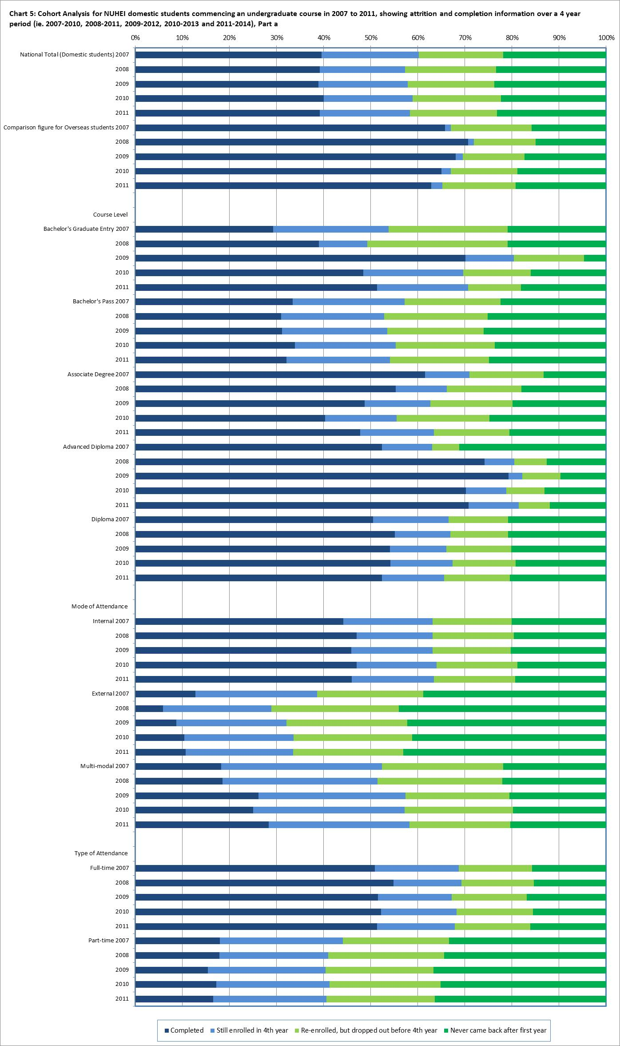

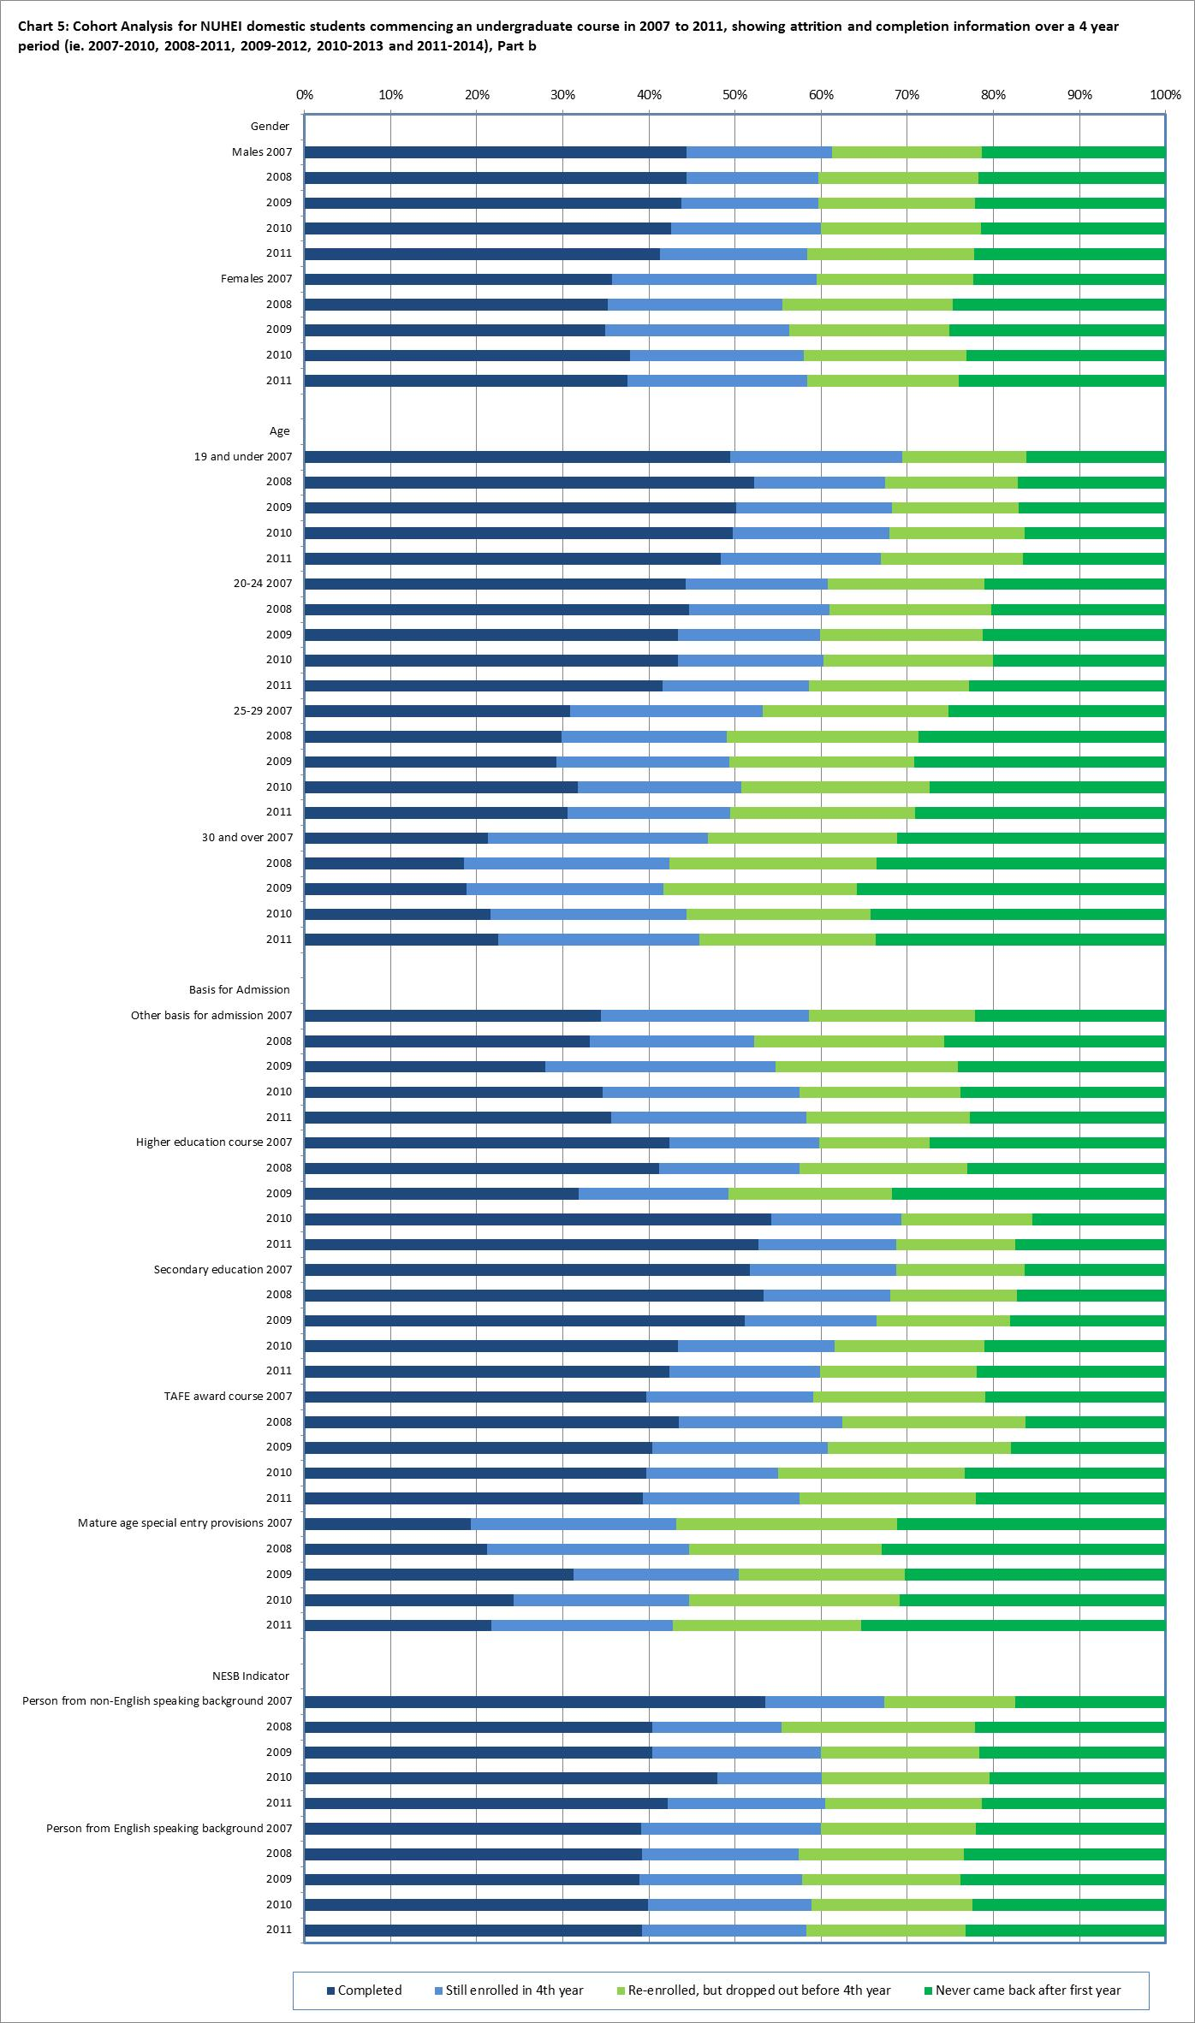

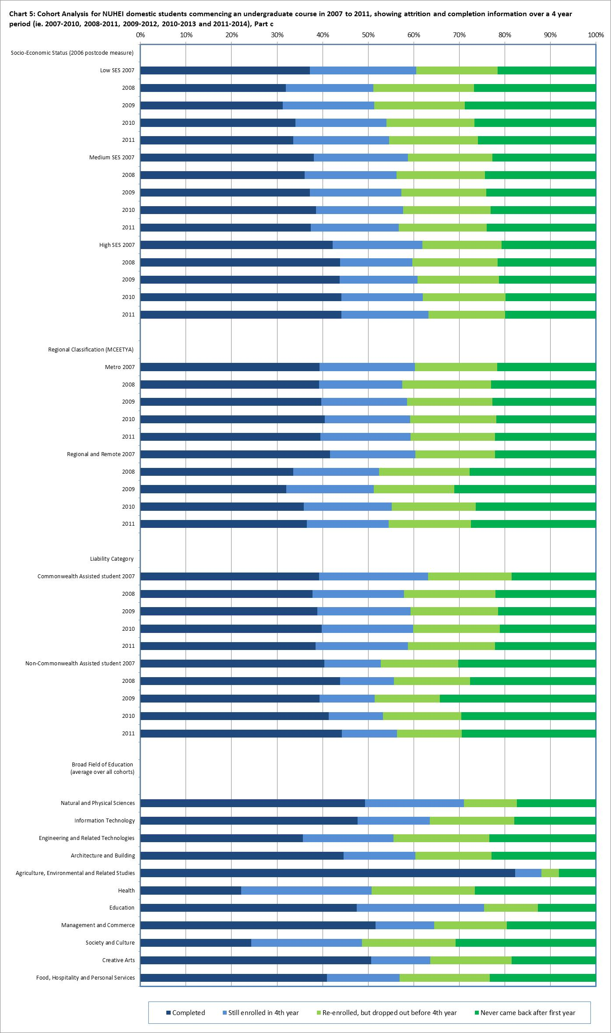

Table 8: Cohort Analysis for NUHEI commencing domestic undergraduate students over a six year period, 2007-2012, 2008-2013 and 2009-2014

|  |  |  |  |  |  |
| --- | --- | --- | --- | --- | --- |
|  |  | **Completed  (in any year)** | **Still enrolled at the end of the 6 year cohort period** | **Re-enrolled, but dropped out** | **Never came back after the first year** |
| **National Total**  **(Domestic students)** | 2007 | 47.6% | 9.2% | 22.6% | 20.5% |
| 2008 | 45.8% | 8.7% | 23.5% | 21.9% |
| 2009 | 45.7% | 9.4% | 22.9% | 22.1% |
| **Comparison figure for Overseas students** | 2007 | 66.3% | 0.2% | 17.6% | 15.8% |
| 2008 | 71.2% | 0.2% | 13.8% | 14.8% |
| 2009 | 68.6% | 0.2% | 13.9% | 17.3% |
| **Course Level(a)** | | | | | |
| **Bachelor's Graduate Entry** | 2007 | 37.6% | 4.5% | 38.5% | 19.4% |
| 2008 | 42.5% | 2.4% | 34.9% | 20.2% |
| 2009 | 72.9% | 5.6% | 16.8% | 4.7% |
| **Bachelor's Pass** | 2007 | 43.0% | 10.7% | 25.3% | 21.0% |
| 2008 | 39.2% | 10.1% | 27.1% | 23.6% |
| 2009 | 39.4% | 10.5% | 25.8% | 24.4% |
| **Associate Degree** | 2007 | 65.4% | 4.7% | 17.5% | 12.4% |
| 2008 | 58.6% | 5.3% | 18.6% | 17.5% |
| 2009 | 54.6% | 7.2% | 20.0% | 18.2% |
|  | 2007 | 57.7% | 5.0% | 7.9% | 29.3% |
| **Advanced Diploma** | 2008 | 76.3% | 3.7% | 8.4% | 11.6% |
|  | 2009 | 79.7% | 3.0% | 8.5% | 8.9% |
|  | 2007 | 56.2% | 8.0% | 16.0% | 19.8% |
| **Diploma** | 2008 | 59.1% | 6.7% | 14.9% | 19.3% |
|  | 2009 | 58.0% | 7.3% | 16.6% | 18.1% |
| **Mode of Attendance** | | | | | |
| **Internal** | 2007 | 52.0% | 8.4% | 20.7% | 18.9% |
|  | 2008 | 53.4% | 7.5% | 20.8% | 18.4% |
|  | 2009 | 52.6% | 8.1% | 20.7% | 18.6% |
| **External** | 2007 | 20.7% | 13.8% | 29.2% | 36.3% |
|  | 2008 | 12.3% | 12.5% | 33.8% | 41.4% |
|  | 2009 | 15.0% | 13.1% | 31.9% | 40.0% |
| **Multi-modal** | 2007 | 30.2% | 12.9% | 36.9% | 20.0% |
|  | 2008 | 29.8% | 15.6% | 34.3% | 20.2% |
|  | 2009 | 36.2% | 17.1% | 27.4% | 19.4% |

|  |  | **Completed  (in any year)** | **Still enrolled at the end of the 6 year cohort period** | **Re-enrolled, but dropped out** | **Never came back after the first year** |
| --- | --- | --- | --- | --- | --- |
| **Type of Attendance** | | | | | |
| **Full-time** | 2007 | 59.0% | 7.5% | 18.9% | 14.6% |
| 2008 | 60.9% | 6.4% | 18.4% | 14.3% |
| 2009 | 57.5% | 7.3% | 19.8% | 15.5% |
| **Part-time** | 2007 | 26.2% | 12.5% | 29.6% | 31.7% |
| 2008 | 25.2% | 11.9% | 30.5% | 32.4% |
| 2009 | 23.8% | 13.3% | 28.6% | 34.3% |
| **Gender** | | | | | |
| **Males** | 2007 | 50.9% | 8.4% | 20.7% | 19.9% |
| 2008 | 49.8% | 7.8% | 22.0% | 20.4% |
| 2009 | 49.6% | 8.1% | 21.7% | 20.5% |
| **Females** | 2007 | 45.0% | 9.9% | 24.1% | 21.0% |
| 2008 | 42.8% | 9.4% | 24.7% | 23.1% |
| 2009 | 42.5% | 10.4% | 23.8% | 23.3% |
| **Age** | | | | | |
|  | 2007 | 57.8% | 8.6% | 18.7% | 14.9% |
| **19 and under** | 2008 | 58.4% | 7.8% | 18.2% | 15.6% |
|  | 2009 | 57.5% | 8.8% | 18.4% | 15.2% |
|  | 2007 | 50.6% | 7.8% | 21.9% | 19.7% |
| **20-24** | 2008 | 50.9% | 7.6% | 22.5% | 19.1% |
|  | 2009 | 49.3% | 7.8% | 23.0% | 19.9% |
|  | 2007 | 38.7% | 10.4% | 27.2% | 23.7% |
| **25-29** | 2008 | 35.7% | 9.7% | 27.6% | 27.0% |
|  | 2009 | 34.7% | 10.7% | 27.7% | 26.9% |
|  | 2007 | 30.8% | 11.2% | 28.1% | 29.9% |
| **30 and over** | 2008 | 26.6% | 10.7% | 30.8% | 32.0% |
|  | 2009 | 26.4% | 11.5% | 27.9% | 34.1% |
| **Basis for Admission(b)** | | | | | |
| **Other basis for admission** | 2007 | 43.3% | 10.1% | 25.6% | 21.0% |
| 2008 | 39.4% | 9.5% | 26.9% | 24.3% |
| 2009 | 37.9% | 12.1% | 27.5% | 22.5% |
|  | 2007 | 50.4% | 7.2% | 16.3% | 26.1% |
| **Higher education course** | 2008 | 47.0% | 8.7% | 22.4% | 21.9% |
|  | 2009 | 37.2% | 9.3% | 23.7% | 29.9% |
|  | 2007 | 58.6% | 7.8% | 18.5% | 15.2% |
| **Secondary education** | 2008 | 59.1% | 7.3% | 17.9% | 15.6% |
|  | 2009 | 57.5% | 7.5% | 18.7% | 16.4% |
|  | 2007 | 48.4% | 8.4% | 23.8% | 19.4% |
| **TAFE award course** | 2008 | 50.7% | 6.1% | 27.4% | 15.8% |
|  | 2009 | 47.1% | 8.3% | 27.9% | 16.7% |

|  |  | **Completed  (in any year)** | **Still enrolled at the end of the 6 year cohort period** | **Re-enrolled, but dropped out** | **Never came back after the first year** | |
| --- | --- | --- | --- | --- | --- | --- |
| **Basis for Admission(b) continued…….** | | | | | | |
| **Mature age special entry provisions** | 2007 | 28.5% | 12.4% | 30.1% | 29.0% | |
| 2008 | 29.9% | 10.6% | 28.6% | 30.9% | |
| 2009 | 36.7% | 11.7% | 23.3% | 28.3% | |
| **NESB Indicator** | | | | | | |
| **Person from non-English speaking background** | 2007 | 58.1% | 4.6% | 20.8% | 16.5% | |
| 2008 | 44.9% | 8.1% | 26.3% | 20.7% | |
| 2009 | 48.5% | 6.1% | 24.0% | 21.3% | |
| **Person from English speaking background** | 2007 | 47.3% | 9.4% | 22.7% | 20.7% | |
| 2008 | 45.9% | 8.7% | 23.5% | 22.0% | |
| 2009 | 45.6% | 9.4% | 22.8% | 22.1% | |
| **Socio-Economic Status(c)** | | | | | | |  |  |  |  |  |
|  | 2007 | 46.4% | 9.7% | 23.8% | 20.0% | |
| **Low SES** | 2008 | 38.4% | 8.9% | 27.1% | 25.6% | |
|  | 2009 | 37.5% | 10.4% | 25.0% | 27.1% | |
|  | 2007 | 46.6% | 9.5% | 22.6% | 21.3% | |
| **Medium SES** | 2008 | 43.8% | 9.7% | 23.9% | 22.6% | |
|  | 2009 | 44.8% | 9.9% | 22.9% | 22.3% | |
|  | 2007 | 49.1% | 8.3% | 22.7% | 19.8% | |
| **High SES** | 2008 | 49.6% | 7.7% | 22.6% | 20.1% | |
|  | 2009 | 50.1% | 8.3% | 22.0% | 19.5% | |
| **Regional Classification (MCEETYA(d))** | | | | | |
|  | 2007 | 47.3% | 9.2% | 23.0% | 20.5% | |
| **Metropolitan** | 2008 | 46.2% | 8.8% | 23.5% | 21.5% | |
|  | 2009 | 46.6% | 9.3% | 23.0% | 21.1% | |
|  | 2007 | 50.0% | 7.9% | 21.6% | 20.5% | |
| **Regional and remote** | 2008 | 39.5% | 8.8% | 25.9% | 25.9% | |
|  | 2009 | 38.7% | 10.0% | 22.5% | 28.8% | |
| **Liability Category** | | | | | |
| **Commonwealth Assisted students** | 2007 | 48.6% | 10.8% | 23.9% | 16.8% | |
| 2008 | 45.1% | 9.9% | 24.7% | 20.2% | |
| 2009 | 46.2% | 10.3% | 24.1% | 19.5% | |
| **Non-Commonwealth Assisted students** | 2007 | 45.3% | 5.3% | 19.5% | 29.9% | |
| 2008 | 48.1% | 4.9% | 19.8% | 27.2% | |
| 2009 | 43.7% | 5.4% | 17.5% | 33.5% | |

|  |  | **Completed  (in any year)** | **Still enrolled at the end of the 6 year cohort period** | **Re-enrolled, but dropped out** | **Never came back after the first year** |
| --- | --- | --- | --- | --- | --- |
| **Broad Field of Education(e)** | | | | | |
| **Natural and Physical Sciences** | Average | 55.4% | 13.7% | 15.1% | 15.8% |
| **Information Technology** | Average | 49.1% | 8.2% | 27.5% | 15.2% |
| **Engineering and Related Technologies** | Average | 50.0% | 18.9% | 16.0% | 15.2% |
| **Architecture and Building** | Average | 44.2% | 10.6% | 22.4% | 22.8% |
| **Agriculture, Environmental and Related Studies** | Average | 88.7% | 1.0% | 3.9% | 6.3% |
| **Health** | Average | 27.9% | 13.0% | 32.5% | 26.5% |
| **Education** | Average | 66.6% | 8.6% | 13.8% | 11.0% |
| **Management and Commerce** | Average | 61.0% | 6.1% | 17.5% | 15.3% |
| **Society and Culture** | Average | 32.9% | 11.5% | 26.3% | 29.3% |
| **Creative Arts** | Average | 56.4% | 6.3% | 20.0% | 17.4% |
| **Food, Hospitality and Personal Services** | Average | 51.8% | 5.5% | 19.1% | 23.6% |

(a) Data cannot be published for Bachelor’s Honours or Other Undergraduate award courses, as numbers are too small for analysis.

(b) Data cannot be published for basis of admission based on a professional qualification, as numbers are too small for analysis.

(c) SES is based on the students' postcode of permanent home residence, with the SES value derived from the 2006 Socio-Economic Indexes for Areas (SEIFA) Education and Occupation Index for postal areas, where postal areas in the bottom 25% of the population aged 15-64 are classified as low SES.

(d) The student’s postcode of permanent home residence is mapped to a regional category using the Ministerial Council on Education, Employment, Training and Youth Affairs (MCEETYA) classification. The MCEETYA codes are derived from the Australian Standard Geographical Classification with some adjustments to cater for the Department’s special needs.

(e) Field of Education is based on the Australian Standard Classification of Education (ASCED) 2001.

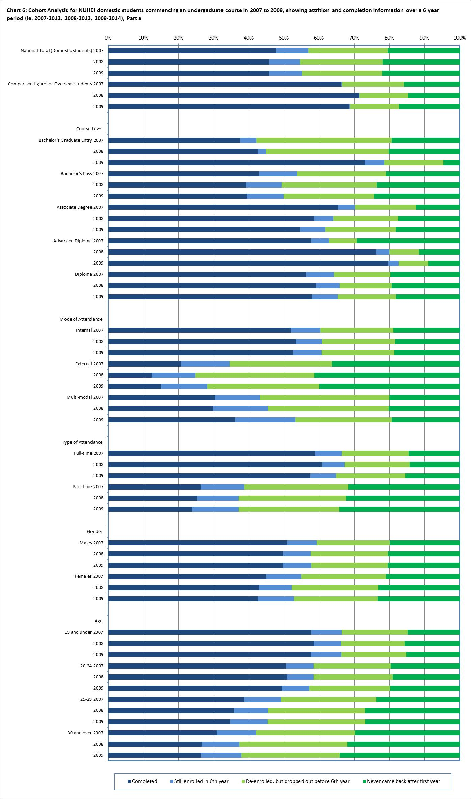

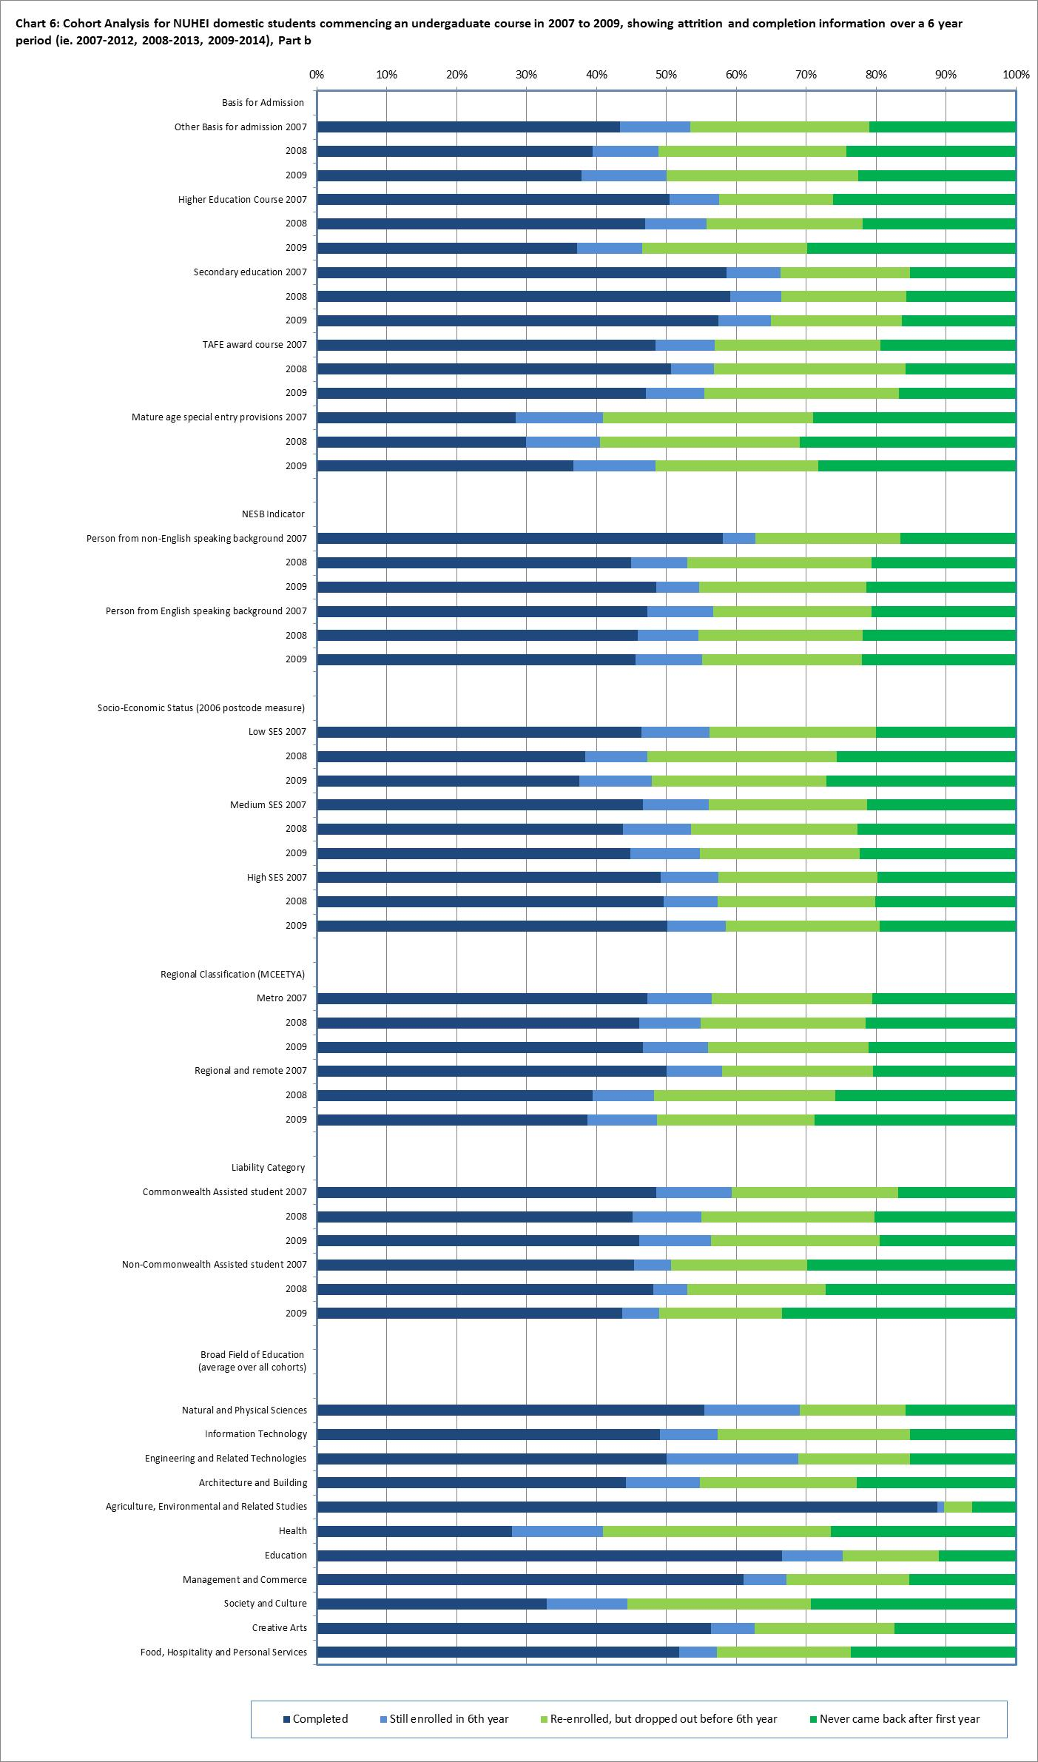

Table 9: Four year completion rates for commencing domestic undergraduate students by NUHEI, 2007-2010, 2008-2011, 2009-2012, 2010-2013 and   
2011-2014, %

|  |  |  |  |  |  |  |
| --- | --- | --- | --- | --- | --- | --- |
|  | | **2007-10** | **2008-11** | **2009-12** | **2010-13** | **2011-14** |
| **New South Wales** | Academy of Information Technology Pty Ltd | - | - | - | - | 50.0* |
| Alphacrucis College Limited | - | - | - | 48.0 | 32.0 |
| Australian College of Applied Psychology | 6.3 | 6.9 | 7.9 | 8.9 | 12.9 |
| Australian Film, Television and Radio School | - | - | 98.0 | 98.2 | 97.4 |
| Australian Institute of Music | 45.8 | 39.7 | 35.8 | 37.4 | 32.2 |
| Avondale College of Higher Education | 51.7 | 51.7 | 42.4 | 57.4 | 48.8 |
| Blue Mountains Intl Hotel Management School | 89.0 | 86.5 | 88.3 | 83.9 | 72.9 |
| Campion Institute Limited | 43.8 | 76.2 | 76.5 | 65.2 | 82.6 |
| Excelsia College | 69.9 | 66.7 | 60.0 | 62.8 | 66.1 |
| Group Colleges Australia Pty Ltd | - | - | - | 0.0* | 20.0 |
| Insearch Ltd | 30.2 | 58.6 | 65.4 | 69.2 | 73.3 |
| International College of Management, Sydney (ICMS) | 56.6 | 54.2 | 50.9 | 48.4 | 57.6 |
| International Conservatorium of Music (Aust) | 88.9 | 97.1 | 24.4 | 22.9 | 42.4 |
| Jansen Newman Institute Pty. Limited | 47.5 | 46.5 | 45.2 | 0.0* | 50.0* |
| Kaplan Business School Pty Ltd | 22.7 | 60.0 | 70.4 | 45.5 | 28.6 |
| Macleay College | 77.0 | 77.4 | 65.3 | 71.0 | 66.1 |
| Moore Theological College Council | 60.5 | 84.2 | 83.1 | 55.3 | 68.3 |
| Morling College Ltd | - | - | - | 55.6* | 41.7 |
| Nature Care College | 9.3 | 12.2 | 16.7 | 0.0* | - |
| Open Colleges Pty Limited | - | 0.0 | 8.1 | 5.9 | 6.7 |
| Raffles College of Design and Commerce | 55.6 | 53.3 | 44.3 | 57.0 | 50.9 |
| SAE Institute | 36.1 | 53.8 | 46.2 | 38.1 | 36.1 |
| Study Group Australia Pty Ltd | - | - | - | - | 0.0* |
| Sydney College of Divinity | 24.5 | 28.6 | 26.4 | 18.4 | 25.3 |
| Sydney Institute of Business and Technology | 76.4 | 74.2 | 80.2 | 74.6 | 68.3 |
| TOP Education Group Pty Ltd | - | - | - | - | 50.0* |
| Tabor College NSW | 46.4 | 12.9 | 17.4 | 12.5 | - |
| Technical and Further Education Commission NSW | - | - | - | - | 72.7 |
| The Australian College of Physical Education | 57.1 | 50.1 | 41.3 | 39.2 | 32.2 |
| The JMC Academy | 46.2 | 45.3 | 53.7 | 56.6 | 53.3 |
| The National Institute of Dramatic Art | 100.0 | 94.4 | 87.8 | 96.2 | 94.2 |
| Think Education | 68.6 | 67.7 | 47.7 | 32.9 | 26.5 |
| UOW College | 70.5 | 57.4 | 77.8 | 43.5 | 48.3 |
| Whitehouse Institute Pty Ltd | - | 84.5 | 66.3 | 66.7 | 64.2 |
| **Victoria** | Academy of Design Australia Limited | - | 73.7 | 55.8 | 50.8 | 59.0 |
| Australian Guild of Music Education Inc | 35.5 | 44.4* | 7.7 | 15.4 | 36.4 |
| Box Hill Institute | 28.0 | 26.2 | 22.2 | 12.0 | 11.4 |
| Carrick Higher Education Pty Ltd | - | - | 0.0* | 68.4 | 98.6 |
| Chisholm Institute | - | - | - | - | 44.0 |
| Deakin College | 59.4 | 62.6 | 63.8 | 64.6 | 58.7 |
| Gordon Institute of TAFE | 37.5 | 28.6 | 23.5 | 44.4 | 100.0* |
| Harvest Bible College Inc | 13.3 | 24.8 | 37.2 | 25.9 | 29.1 |
| Holmes Institute | 39.1 | 42.9 | 42.3 | 23.8 | 17.4 |
| Holmesglen Institute of TAFE | 52.4 | 48.5 | 27.3 | 56.2 | 38.9 |
| Marcus Oldham College | 94.6 | 100.0 | 100.0 | 100.0 | 96.3 |
| Melbourne Institute of Technology | 50.0 | 0.0* | 61.1 | 47.8 | 41.9 |
| Melbourne Polytechnic | 58.6 | 47.4 | 39.4 | 43.7 | 35.3 |
| Monash College | 57.8 | 48.0 | 45.8 | 52.1 | 59.4 |
| Navitas College of Public Safety Pty Ltd | 57.4 | 39.0 | 34.0 | 50.4 | 46.3 |
| Oceania Polytechnic | 19.1 | 15.4 | 45.7 | 100.0 | 5.3 |
| Tabor College Victoria Inc | 15.5 | 27.9 | 25.8 | 17.1 | 17.0 |
| The Southern School of Natural Therapies Ltd | 16.4 | 8.7 | 3.4 | - | - |
| William Angliss Institute of TAFE | 21.4 | 33.9 | 30.0 | 15.4 | 13.8 |

|  |  |  |  |  |  |  |
| --- | --- | --- | --- | --- | --- | --- |
| **Continued…….** | | | | | | |
| **Queensland** | Australian Institute of Professional Counsellors | - | - | 25.0 | 19.6 | 17.1 |
| Brisbane College of Theology | 25.0 | 22.9 | - | - | - |
| Christian Heritage College | 27.0 | 32.0 | 31.6 | 27.3 | 40.3 |
| Endeavour College of Natural Health | 15.0 | 12.8 | 12.3 | 12.0 | 10.9 |
| Jazz Music Institute | - | - | - | 71.0 | 61.9 |
| Qantm | - | 50.5 | 36.0 | - | - |
| Queensland Institute of Business and Technology | 54.6 | 51.2 | 47.2 | 45.2 | 50.5 |
| Shafston Institute of Technology Pty Ltd | 4.7 | - | - | - | - |
| TAFE Queensland - Brisbane | - | - | - | 22.0 | 35.7 |
| **Western Australia** | Curtin College | 74.1 | 71.4 | 50.9 | 64.4 | 67.1 |
| Harvest West Bible College Inc | - | - | 17.2 | 23.8 | 9.1 |
| Perth Bible College Inc | 38.1 | 36.0 | 28.6 | 33.3 | 27.3 |
| Perth Institute of Business and Technology | 42.9 | 32.0 | 58.3 | 48.4 | 69.6 |
| Polytechnic West | - | 100.0* | 46.2 | 40.0 | 45.2 |
| **South Australia** | Adelaide Central School of Art Incorporated | - | 23.8 | 18.8 | 32.0 | 21.4 |
| Adelaide College of Divinity Inc | 22.4 | 22.7 | 12.9 | 21.9 | 25.0 |
| Australian Lutheran College | 34.3 | 36.1 | 34.1 | 40.0 | 49.1 |
| Eynesbury | - | 45.5 | 58.3 | 58.3 | 83.3 |
| International College of Hotel Management | - | - | 100.0 | 86.7 | 100.0* |
| South Aust Institute of Business & Technology | 54.8 | 53.9 | 47.8 | 41.3 | 39.4 |
| Tabor Adelaide | 42.5 | 33.5 | 28.3 | 33.0 | 30.3 |
| **Tasmania** | Tabor College Tasmania Inc | 17.4 | 14.6 | 8.3 | 15.8 | 26.3 |
| **Australian Capital Territory** | Canberra Institute of Technology | - | - | - | 57.4 | 55.3 |
| **Multi-state** | Australian College of Theology | 31.7 | 30.1 | 29.9 | 33.3 | 26.6 |
| **Total for NUHEIs** | | **39.5** | **39.2** | **38.9** | **40.1** | **39.2** |

*Calculation is based on less than 10 students.

Table 10: Six year completion rates for commencing domestic undergraduate students by NUHEI, 2007-2012, 2008-2013, 2009-2014 and 2010-2015, %

|  |  |  |  |  |
| --- | --- | --- | --- | --- |
|  | | **2007-12** | **2008-13** | **2009-14** |
| **New South Wales** | Australian College of Applied Psychology | 16.7 | 15.2 | 14.5 |
| Australian Film, Television and Radio School | - | - | 98.0 |
| Australian Institute of Music | 50.0 | 46.7 | 42.9 |
| Avondale College of Higher Education | 66.1 | 66.3 | 57.8 |
| Blue Mountains Intl Hotel Management School | 91.2 | 87.5 | 89.0 |
| Campion Institute Limited | 50.0 | 85.7 | 76.5 |
| Excelsia College | 75.7 | 73.6 | 70.5 |
| Insearch Ltd | 44.2 | 63.5 | 70.2 |
| International College of Management, Sydney (ICMS) | 59.0 | 61.9 | 58.9 |
| International Conservatorium of Music (Aust) | 88.9 | 97.1 | 34.2 |
| Jansen Newman Institute Pty. Limited | 47.5 | 48.8 | 46.4 |
| Kaplan Business School Pty Ltd | 27.3 | 70.0 | 70.4 |
| Macleay College | 77.0 | 78.2 | 66.8 |
| Moore Theological College Council | 65.8 | 88.0 | 88.0 |
| Nature Care College | 19.6 | 14.4 | 16.7* |
| Open Colleges Pty Limited | - | 4.8 | 9.9 |
| Raffles College of Design and Commerce | 61.5 | 59.8 | 54.3 |
| SAE Institute | 37.3 | 55.5 | 48.7 |
| Sydney College of Divinity | 33.7 | 35.0 | 31.0 |
| Sydney Institute of Business and Technology | 77.9 | 74.7 | 81.2 |
| Tabor College NSW | 53.6 | 25.8 | 21.7 |
| The Australian College of Physical Education | 70.4 | 65.7 | 59.5 |
| The JMC Academy | 48.9 | 48.2 | 56.0 |
| The National Institute of Dramatic Art | 100.0 | 94.4 | 87.8 |
| Think Education | 70.7 | 71.4 | 52.4 |
| UOW College | 75.0 | 59.6 | 77.8 |
| Whitehouse Institute Pty Ltd | - | 86.7 | 71.2 |
| **Victoria** | Academy of Design Australia Limited | - | 75.0 | 65.5 |
| Australian Guild of Music Education Inc | 41.9 | 44.4* | 15.4 |
| Box Hill Institute | 34.3 | 30.5 | 26.5 |
| Carrick Higher Education Pty Ltd | - | - | 0.0* |
| Deakin College | 62.9 | 65.3 | 65.7 |
| Gordon Institute of TAFE | 50.0 | 28.6 | 41.2 |
| Harvest Bible College Inc | 24.0 | 38.5 | 42.3 |
| Holmes Institute | 43.5 | 46.4 | 46.2 |
| Holmesglen Institute of TAFE | 54.8 | 49.5 | 34.0 |
| Marcus Oldham College | 94.6 | 100.0 | 100.0 |
| Melbourne Institute of Technology | 54.2 | 0.0* | 61.1 |
| Melbourne Polytechnic | 68.6 | 57.9 | 47.0 |
| Monash College | 63.0 | 58.2 | 56.3 |
| Navitas College of Public Safety Pty Ltd | 60.4 | 43.4 | 40.9 |
| Oceania Polytechnic | 28.6 | 18.0 | 52.2 |
| Tabor College Victoria Inc | 27.2 | 39.9 | 40.7 |
| The Southern School of Natural Therapies Ltd | 27.6 | 16.7 | 19.2 |
| William Angliss Institute of TAFE | 40.5 | 42.4 | 42.5 |
| **Queensland** | Australian Institute of Professional Counsellors | - | - | 30.0 |
| Brisbane College of Theology | 34.4 | 28.6 | - |
| Christian Heritage College | 41.7 | 48.2 | 48.5 |
| Endeavour College of Natural Health | 27.6 | 22.1 | 23.6 |
| Qantm | - | 53.6 | 38.5 |
| Queensland Institute of Business and Technology | 57.7 | 55.7 | 51.4 |
| Shafston Institute of Technology Pty Ltd | 17.9 | - | - |
| **Western Australia** | Curtin College | 74.1 | 71.4 | 54.5 |
| Harvest West Bible College Inc | - | - | 24.1 |
| Perth Bible College Inc | 38.1 | 40.0 | 32.1 |
| Perth Institute of Business and Technology | 57.1 | 40.0 | 58.3 |
| Polytechnic West | - | 100.0* | 46.2 |
| **South Australia** | Adelaide Central School of Art Incorporated | - | 28.6 | 25.0 |
| Adelaide College of Divinity Inc | 30.6 | 34.1 | 29.0 |
| Australian Lutheran College | 44.1 | 44.4 | 43.5 |
| Eynesbury | - | 45.5 | 58.3 |
| International College of Hotel Management | - | - | 100.0 |
| South Australian Institute of Business & Technology | 56.2 | 60.0 | 51.6 |
| Tabor Adelaide | 51.1 | 41.7 | 42.9 |
| **Tasmania** | Tabor College Tasmania Inc | 30.4 | 22.9 | 8.3 |
| **Multi-state** | Australian College of Theology | 43.3 | 42.8 | 42.1 |
| **Total for NUHEIs** | | **47.6** | **45.8** | **45.7** |

*Calculation is based on less than 10 students.

1. *Completion Rates of Domestic Bachelor Students- A Cohort Analysis, 2005-2012* and *Completion Rates of Domestic Bachelor Students- A Cohort Analysis, 2005-2013*
2. Public universities, plus the Batchelor Institute of Indigenous Tertiary Education. For a list of institutions included under ‘Public universities’, see ‘2014 List of higher education institutions’ at <https://education.gov.au/selected-higher-education-statistics-2014-student-data>.
3. The CHESSN was first implemented in the Higher Education Student Data Collection in 2005 under new policy initiatives introduced through the *Higher Education Support Act 2003* (HESA).
4. Students who completed an award course. The award course may not necessarily be the same course that the student initially enrolled in. For example, a student who commenced a Bachelor’s Pass degree in 2005 and by 2013, their award course completion could be for a Bachelor’s Honours degree. Similarly for field of education, a student may have commenced a Science degree but completed an Arts degree. Likewise, a student may have commenced study at one institution, but completed their study at a different institution.
5. Table C institutions (University College London and Carnegie Mellon University) have not been included in the institution tables as all enrolments are at the postgraduate level and are therefore outside the scope of the cohort analysis.
6. In this report, analysis of ATARs only includes scores for those students admitted to higher education on the basis of secondary education.
7. *2015 Student Experience Survey National Report* p.24
8. The approach follows that taken in *Characteristics and Performance Indicators of Australian Higher Education Institutions, 2000*. Where the dependent variable lies within the range of 0.1 to 0.9, as is the case with the completion rate, then Ordinary Least Squares estimates will give broadly similar results to those generated by logit or probit estimation techniques.
9. SES in this report is based on the students' postcode of permanent home residence, with the SES value derived from the 2006 Socio-Economic Indexes for Areas (SEIFA) Education and Occupation Index for postal areas, where postal areas in the bottom 25% of the population aged 15-64 are classified as low SES.
10. In this report, the student’s postcode of permanent home residence is mapped to a regional category using the Ministerial Council on Education, Employment, Training and Youth Affairs (MCEETYA) classification. The MCEETYA codes are derived from the Australian Standard Geographical Classification with some adjustments to cater for the Department’s special needs.
11. For the purpose of this report, a person who has a Non-English speaking background (NESB) is one who meets all these criteria: they are a domestic student; they arrived in Australia less than 10 years prior to the year they commenced their course; and a language other than English is spoken at home.
12. Cohort data presented here includes all bachelor level courses (Bachelor’s Pass, Bachelor’s Honours and Bachelor’s Graduate Entry), rather than just Bachelor’s Pass courses, which are the focus of the demand driven system. The number of Graduate Entry and Honours students are small, however, making up 4.6% of the 2010 cohort and 4.2% of the 2011 cohort.
13. Variation was in part influenced by the small number of students.
14. Data cannot be published by Indigenous status, as numbers are too small for analysis.
15. Data cannot be published for Bachelor’s Honours or Other Undergraduate award courses, as numbers are too small for analysis.
16. Variation was in part influenced by the small number of students.
17. A breakdown of male and female student numbers by NUHEI for 2014 can be found in table ‘Appendix 6.4’ on the department’s website: <http://docs.education.gov.au/node/38153>.
18. Data cannot be published for basis of admission by professional qualification, as numbers are too small for analysis.
19. A course that is either complete or incomplete.
20. ‘Other basis’ is determined by the institution.
21. Commonwealth Assisted students include Commonwealth Supported students and students receiving FEE-HELP. Non-Commonwealth Assisted Students are all other student types.
22. Includes Bachelor’s Pass students only and excludes Bachelor’s Honours and Bachelor’s Graduate Entry.
23. OECD (2013), *Education at a Glance 2013: OECD Indicators*, OECD Publishing, indicator A4, pp 64-72.
24. The OECD will publish updated completion rates for the reference year of 2014 in September 2016.
25. OECD member countries used a variety of methods to measure completion rates in 2011: Cross-Section, True Cohort and Longitudinal Surveys.
26. Education at a Glance 2013, Table A4.1. Australian data was based on a cross-section methodology in 2011 – the average completion rate of countries using the cross-section method was 72 per cent. The completion rate calculation for Australia used a different methodology to the Department’s standard calculation presented in this report.