The Impact Management Planning and Evaluation Ladder (IMPEL)

The IMPEL model provides a framework for describing different types of change that can be achieved through educational development projects. Each stage, or ladder rung, is incrementally broader in impact than the last. These rungs are:

1. Changes for project team members
2. Changes by project team members leading to changes for students who are directly influenced
3. Contributions to knowledge in the field; growth or spread of disseminated ideas; serendipitous adoption/adaptation by people beyond the project’s intended reach
4. Changes by opportunistic adopters at participating institutions leading to changes for students who are directly influenced
5. Systemic changes at participating institutions leading to changes for all relevant students
6. Changes by opportunistic adopters beyond participating institutions leading to changes for students who are directly influenced
7. Systemic changes beyond participating institutions leading to changes for all relevant students.

The model offers both a prompt for project teams in the planning, execution and reflection stages of educational development projects, as well as a cogent frame for funding agencies to enunciate expectations, make funding decisions and evaluate the efficacy of funding schemes in facilitating strategic educational change.

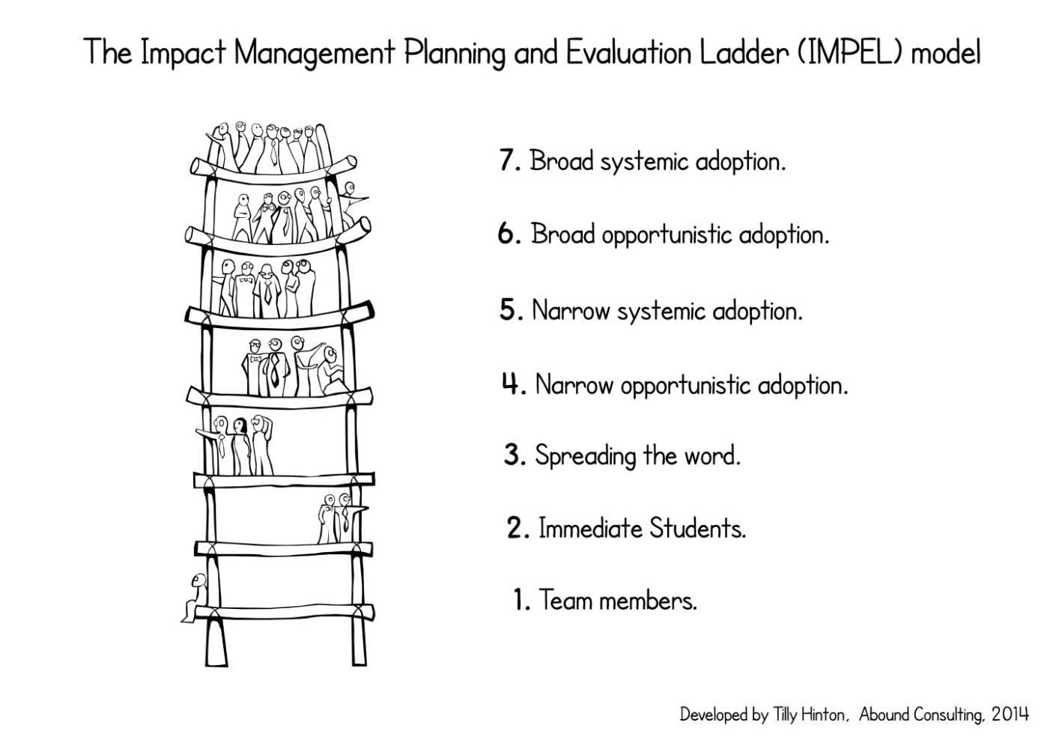

Project Impact Plan

Impact is the difference that a project makes in its sphere of influence, both during and after the funding period. Maximising impact requires forecasting and planning. The questions and matrix below provide a structure to prompt active and ongoing consideration and re-evaluation of impact and how it may be maximised given the evolution of the project. Maintaining updated responses to the template is not intended to be a reporting requirement, rather a strategic steering tool for the project. The responses to the questions below, including input to the matrix, are expected to change over the life of the project as the work and results progress. The Department will be interested in discussing evolving projections of impact at key points during the project, including at progress and final reporting points.

|  |  |  |  |  |
| --- | --- | --- | --- | --- |
|  | **Anticipated changes at:**  *NB: these are approximations & text is not expected in every cell* | | | |
|  | **Project completion** | **Six months post-completion** | **Twelve months post-completion** | **Twenty-four months post-completion** |
| 1. **Team members** |  |  |  |  |
| 1. **Immediate students** |  |  |  |  |
| 1. **Spreading the word** |  |  |  |  |
| 1. **Narrow opportunistic adoption** |  |  |  |  |
| 1. **Narrow systemic adoption** |  |  |  |  |
| 1. **Broad opportunistic adoption** |  |  |  |  |
| 1. **Broad systemic adoption** |  |  |  |  |

* 1. What indicators exist that there is a climate of readiness for change in relation to your intended project?
  2. In brief and indicatively, what impacts (changes and benefits) do you expect your project to bring about, at the following levels and stages of the Impact Management Planning and Evaluation Ladder (IMPEL)?[1]
  3. What are your strategies for engaging with stakeholders throughout the project?
  4. How will you enable transfer[2] that is ensuring that your project remains impactful after the funding period?
  5. What barriers may exist to achieving change in your project?
  6. How will you keep track of the project’s impact? What analytics may be useful?
  7. How will you maintain relevant project materials for others to access after the project is completed?

Examples of project impact mapped to the IMPEL Model

|  |  |
| --- | --- |
| 1. Team members | * **Recognition** of project participants’ contributions to learning and teaching through promotion and awards |
| 1. Immediate students | * Project team members’ students report benefits of being **more networked** through an online tool * Changes to curriculum by project team members equip students to feel **more work-ready** |
| 1. Spreading the word | * Special issues of **journals** that further explore themes of the grant * Publications from a grant **cited fifty-eight times** in other publications * An updated online resource to support **robust curriculum planning** for teaching of Australian literature * Materials used to promote teaching quality to **international prospective students and partner universities** * **Cascading influence** through engagement with the early childhood sector and relevant government departments * Receipt of national and international **awards** recognising outstanding practice along with sustained high rates of **downloads**, views and linking |
| 1. Narrow opportunistic adoption | * Education students **supported to develop resilience**, a factor in retaining staff in the teaching profession |
| 1. Narrow systemic adoption | * Online graduate attributes system **deeply embedded** across an entire school * Almost **three quarters of a million dollars** of industry and philanthropic funds secured for the lead institution to further the work started by the grant * University-wide academic leadership program with **ongoing funded** based on the success of the grant project |
| 1. Broad opportunistic adoption | * Professional development delivered to an estimated **20% of science academics** in Australia * An estimated **2,500 students benefited** from active learning materials in undergraduate science programs |
| 1. Broad systemic adoption | * Report cited as key evidence for a **wage increase across the profession** * Changes to professional accreditation requirements ensuring **students are better equipped** for study and employment |

These examples were gathered from completed projects by Tilly Hinton while seconded to the Office for Learning and Teaching in 2012–13.

Reflections on achieving change in nationally funded grants

An enquiry underpinning each research conversation was the exploration of what participants understood about the factors that enabled or inhibited impact in educational research projects. Here’s what they had to say:

**Reflections on the human dimension**

* Diverse project teams: One of the reasons identified for the success of the project was the rich variety amongst the project team. In one project, the team was intentionally selected to have a mix of experienced and newer academics: *I’m a believer that you need fresh blood*. In another, the team included senior and junior staff in a broad range of roles at their home institutions. This allowed the team to collaborate as each person brought particular strengths to the project: *you can’t just get a grant, sit there and spend every cent of it on one’s own narrow perspective*.
* Enthusiasm matters:The contributions of the project team members were described as *blood out of stone in terms of how much more can we do with it without ongoing resourcing*. The reason that was possible was the *personal enthusiasm* of the team, each of whom made substantial contributions to project activities and deliverables.
* Influence can be exponential: The team used a generative approach to enable science academics to improve their laboratory teaching practices: *We [didn’t] set out to develop a suite of new experiments for other people to use. We set out to enable staff to do that themselves*.
* Roles shift over time: During the project the project team took a strong leadership role, but they realised that to continue to do so after the project would disempower others: *you’ve got a community set up for PhD students, and then some great big professor comes and galumphs all over the place and flattens discussion. Nobody wants to say anything in case they’re wrong. So I haven’t actually posted on there for … I almost never do.*
* Flexibility and responsiveness: One of the intended outputs was an online community but during the project it became apparent that despite *lot of time trying to get that going and trying to seed a lot of conversations*, targeted potential adopters were time poor and resistant to participating in a new online community. Instead, the team used social media tools, existing online professional groups and Open Educational Resource repositories. By taking the time to get involved in these existing online networks, the team enabled people to test the ideas presented in the resource within a safe and familiar group of peers, after which they could recommend what they thought was relevant to their own discipline and epistemological practices.
* Choose enthusiastic adopters:The project team found that by bringing *enthusiastic academic colleagues into the fold* they could achieve more substantial change than struggling to engage more resistant, uninterested or cautious staff members.
* Online resources:This project demonstrates the wealth of information that is available when resources are shared online. The team has used Google Analytics, Gephi, Google Alerts, Survey Monkey and the analytical functionality available within YouTube and iTunes to better understand the reach of the resources: *...all things leave footprints if you know where to look*.

**Reflections on the organisational dimension**

* Status quo:A significant barrier to change is that there are limited incentives for leaders in higher education to be innovative, so the priority seems to be maintaining the status quo and avoiding significant change. Such cultural barriers militate against certain types of curriculum transformation: *[the] current status quo is guarded carefully*.
* Embedding in an existing organisation: The project co-leaders always intended their major deliverable – the website – to come under the auspices of the established discipline organisation. This appears to have been a very successful approach in terms of maintaining the website well beyond the projects funded life.
* Institutional readiness: The uptake of ideas, and the willingness to embrace change, hinges on the climate being sufficiently ready for those changes to occur: *I was able to move forward because the support structures were there. People were interested. There was some involvement. We were able to get funds. You know, everything aligned and we were able to take it forward, but other people I’ve spoken to in other institutions, it was like hitting a brick wall. Although they could influence what happened in their own subject, they couldn’t make institutional change.*
* Structural constraints:Change occurs within structural constraints and is difficult when *the breadth and scope of the problem is just very big, and its entrenched*. One of the strategies the team used to address this was to engage with key stakeholders. While this was *partly successful*, the project affirmed that decades-old systemic barriers would take much more than this to dismantle.
* Making use of challenging contexts:In times of change, project teams are well-placed to inject their perspectives into discussions: *It’s a really good place … to keep the conversation alive … because everyone is rethinking what they do, then there are more possibilities of things like this being embedded than perhaps there are in a program where people are, well this is my unit, this is how it’s been for 10 years, this is how it’s going to stay.*
* Alignment: The project approach and software functionality met both the accreditation requirements and regulatory frameworks, meaning that *everything was aligned* and the approach became more readily embedded.
* Change requires leadership: The project team learned that more is needed than simply creating or promoting a new teaching approach, realising that it was *naïve* to think that *if you build it, they will come*.
* Enlist a champion: The Deputy Vice-Chancellor (Academic) was *very aware of what’s going on*, including hosting meetings with the scholars twice annually. At the faculty level, there was also extensive support. Leadership support was identified as a critical success factor.
* The importance of the evaluator:Insightful formative evaluation was pivotal and *helped us guide and shape and change our direction so we could achieve what we wanted to*. The evaluator, and lessons learnt during the project regarding project management empowered the team in *balancing achieving the outcomes with what was humanly possible*.
* Institutions don’t change, people do: Multi-institution projects spread the ability to influence change very thinly if project leaders are working in isolation. Projects need to focus on influencing people at all levels, and creating a ripple effect of change. Projects that are tokenistically multi-institution consume the limited resources available: *... management and documentation and communication and workshops and you don’t really get a lot done. You don’t get into the culture of the different organisations, you’re only really dealing with one person who’s the spokesperson and interprets what’s going on.*

**Reflections on change**

* Embracing complexity: The project operated in a complex, changing environment that made it feel *just like spaghetti*. This has meant accepting that the work is inherently complicated, and that it is sometimes impossible to *know whether we’ve got it right*.
* Change can sustain itself: To make change self-sustaining, stakeholders need to be convinced of the benefits through presentations, publications and networking: *if they have been convinced ... then they would work within their units, within their departments and within their schools to make that happen ... it will sustain itself*.
* Clarity: This was identified as *the strength of the project*. Project activities were underpinned by a *clear conceptualisation of what we were doing and why*.
* Change needs to be opportunistic:A grant-funded project adds extra layers of work to already-crowded institutional roles: *you’ve got projects and then you’ve got all the internal projects and all your daily work. So you don’t have dedicated time and energy ... So what you’ve got is energy to ... be opportunistic about it*. Given competing priorities, there is a risk that project team members can *rapidly wear out your welcome talking about something that actually isn’t currently part of the culture of readiness of the organisation*.
* Project relevance: Projects may not necessarily have enduring relevance, but they are nevertheless important to the sector. In this project, once the approach had been embedded, members of the project team moved on to further, related work, and the more recent work formed a more pertinent point of reference for others wishing to adopt or adapt the project ideas.
* Familiarity:The close involvement that a project necessitates makes it difficult to discern influence because it becomes inherently part of your ongoing academic work: *its a bit like having a cardigan that you wear all the time. You don’t think about it anymore because it’s just there*.
* Impact can snowball: Exposure to the website can lead to transformative shifts in thinking that early childhood educators then embed in their practice and take back into early childhood settings, going on to influence others, in other words: *the impact of that could go on and on.*
* Raising awareness: Scholars are coached to think about how to *bring others along in the journey*. They build awareness in their work through *think tanks or talking in groups, having focus groups or something, or running some sort of PD event, or presenting their results, or putting up posters*.
* Projects can be sustained long term: An ambitious national project that can have a long-term, ongoing influence on the quality of learning and teaching in the sector, during both funded and unfunded periods of operation.

These reflections were gathered from completed projects by Tilly Hinton while seconded to the Office for Learning and Teaching in 2012–1

1. The IMPEL model was developed by Tilly Hinton while on secondment to the Office for Learning and Teaching.
2. Transfer in this context means ‘the processes undertaken to maintain momentum and impact beyond the funded life of the project and beyond the project team’, Hinton, T., Gannaway, D., Berry, B., & Moore, K. (2011). The D-Cubed Guide: Planning for Effective Dissemination. Sydney: Australian Teaching and Learning Council.