

HIGHER EDUCATION STANDARDS PANEL Consultation on the Transparency of Higher Education Admissions Processes

# Context

The Minister for Education and Training has asked the Higher Education Standards Panel to advise him on options to improve the transparency of higher education student admissions policies, while minimising regulatory impact. The Minister intends to improve the accessibility and comparability of information about the diversity of course entry pathways by ensuring greater transparency of admissions processes and standards. He is concerned about the capacity of some students to complete their courses. The Minister has asked the Panel for advice on what more needs to be done.

The Panel welcomes the opportunity to explore these issues and potential solutions with stakeholders, including prospective students and their families, schools, careers advisers, as well as higher education students and their institutions.

# Pathways to higher education

Higher education institutions use a variety of mechanisms to determine which applicants are accepted to study the undergraduate courses they offer. The mechanisms vary according to the institution, the course, and the applicant. *Figure 1* below shows the bases used for selecting students into undergraduate courses in 2014.

It is perhaps surprising that more than half the students admitted in 2014 were accepted on the basis of previous vocational or higher education study, mature age entry special provisions and the like. Only 44 per cent of students were admitted on the basis of their secondary education – and only 70 per cent of these on the basis of an Australian Tertiary Admissions Rank (ATAR).

**Figure 1: Basis of admission for higher education undergraduate commencements 2014**

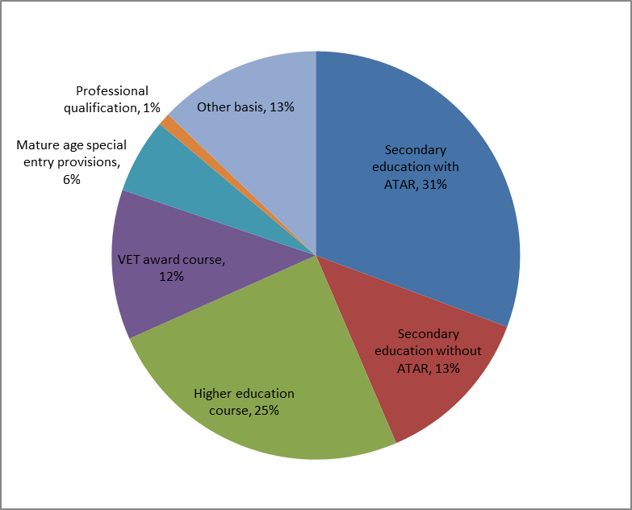

Source: Department of Education and Training

# What is the ATAR?

The ATAR is a number out of 100 that ranks students across each state based on their upper secondary school subject results. It is not itself an absolute ‘mark’ but rather an indicator of students’ relative academic standing among their peers. ATARs awarded in one state are recognised by the other states[1].

The ATAR approach allows the making of mass decisions about many students competing for admission to particular courses at the same time on a relatively low-cost basis.

Over recent years, in part driven by government policy, there has been a greater desire by higher education institutions to admit students from a wider range of social and academic backgrounds. This has seen the development of ‘bonus points’ and other strategies enabling ‘raw’ ATAR scores to be adjusted to take account various equity or other opportunity-related characteristics- e.g. disability, low SES, regional location, Indigenous background or elite sports participation. In South Australia, bonus point ‘rules’ are applied consistently across all institutions, but in other states and territories bonus point schemes differ by institution. Partly as a result of these practices, the proportion of disadvantaged students gaining access to higher education has increased.

Other strategies have included institutions making ‘early entry’ offers outside the usual offer rounds; the making of ‘forced offers’ to nominated students, regardless of their ATAR; or offers being made in subsequent offer rounds at ATARs much lower than those used in the first round. Too often this process remains opaque. It is poorly understood.

Institutions are also extending their admissions criteria to draw on interviews with applicants, additional tests, and evidence of other experience to complement or replace the ATAR scores.

In essence, the ATAR was devised as a rationing device to allocate places in courses with limited numbers of places. With the lifting of caps on places in most courses, this rationing imperative no longer applies in the same way. However, two things remain important. First, the process of student admissions to higher education needs to be transparent. Second, the students accepted need to have the capacity and be provided with the support to ensure that they can benefit from their education and complete their studies.

# Higher Education Standards Framework

The Higher Education Standards Framework has an important policy influence on admissions transparency. The current (2011) Standards set broad requirements for information that should be made available to prospective students. However, they provide little guidance on how detailed or transparent the information available to prospective students about course entry requirements must be. Appendix A lists the relevant standards which must be met by all institutions.

The Tertiary Education Quality and Standards Agency (TEQSA) is the national regulator for higher education. It currently scrutinises evidence submitted by non-self-accrediting institutions in their course accreditation applications related to these standards and calculates risk indicators based on the ATAR profile admitted to them. Self-accrediting institutions, including all universities, assure their own compliance with the course accreditation standards.

The new (2015) Higher Education Standards, which will take effect from 1 January 2017, include several standards that address the issue of transparency of admissions policies. These are reproduced at Appendix B. The new Standards include a stronger focus on student experience from pre-admission through to qualification and prospective employment.

# Proposed principles

The provision of higher education is increasingly competitive. If students are to be able to make informed choices, however, they need to have easy access to comparable data on what individual institutions offer. It is crucial to their decision making that they are given a clear understanding of how universities and non-university providers select students, and what educational support they offer.

Of course, there is an important nexus between admissions, subject prerequisites, student attrition, completions and graduate outcomes. All are factors which influence student choice. The Panel’s initial focus is on how information that is currently available or could readily be published can be made more accessible and useful to prospective students as an aid to choosing the most appropriate course and institution. The Panel will separately consider issues related to admissions basis and completions, but would welcome stakeholders’ views on all matters related to admissions as part of this consultation.

From its initial consideration of admissions transparency matters, the Panel has identified ten principles that should underpin its advice and any initiatives to improve transparency in admissions policies and practices:

1. A student-centred approach to transparency should be central to any solution.
2. All students, no matter what their backgrounds, should have the same knowledge of how admissions arrangements work.
3. The broad autonomy of institutions over their admissions policies should be accepted, providing that these policies are compliant with the Higher Education Standards.
4. The revised Higher Education Standards, which will take effect from 1 January 2017, should provide the operating framework: they contain clearly articulated requirements in relation to admissions transparency, the provision of information for prospective students, and the quality of learning environments.
5. Any new requirements or changes should apply equally to all higher education institutions, universities and non-university higher education institutions alike.
6. Consistently presented and comparable information on all entry pathways and requirements should be available for each institution by discipline or by course.
7. A guide to admissions policies and student enrolments should be made available through a single online platform for ease of access.
8. Universities Australia and other higher education peak bodies should publicly support clarity on how ATARs scores are used and the manner in which alternative admissions pathways and policies are applied.
9. It should be made clear that ATAR thresholds do not operate as a strict ‘cut-off’; that thresholds generally apply to (bonus point) adjusted ATARs; and that prior year ATAR thresholds are provided only as a guide to prospective students.
10. Higher education institutions should be held accountable for public claims against their stated entry policies.

# Feedback and ideas on principles and possible initiatives

A range of interventions could be considered to improve or promote transparency in higher education admissions policies and practice.

The Minister has requested advice on options that do not unnecessarily increase regulation. This could include self-regulatory commitments or principles adopted by higher education institutions and other sector bodies. This would be consistent with the principle of recognising institutional autonomy. It could also entail leveraging existing information resources to enhance the public availability of comparative information. This might be made available on institution, Tertiary Admissions Centre, TEQSA, or Australian Government websites, or some combination. Models that apply overseas could be considered. Guidance on demonstrating compliance with new information-related standards in the revised Higher Education Standards Framework could also be considered.

The Higher Education Standards Panel welcomes input to its consideration of these matters. Appendix C lists the current Panel members.

In framing your thoughts, you may wish to consider the questions below. However, all responses in whatever format received will be considered. It is not necessary to prepare a long, detailed submission; it is perfectly acceptable to address just a few key issues that you believe to be important.

Input to the Panel’s consideration should be sent **by close of business Friday 27 May 2016** to

**Higher Education Standards Panel Secretariat,   
C50MA7, GPO Box 9880  
Canberra ACT 2601**

**Email:** [**HigherEd@education.gov.au**](mailto:HigherEd@education.gov.au)

Please note that all submissions will be published on the Department of Education and Training website, unless clearly indicated that the author wishes their contribution to remain confidential.

## Questions

1. Based on your experience, what is the most important information needed to help potential higher education students determine which course to study and which institution to apply for? Please feel free to rank the different types of information in order of importance.
   * Examples could include information about course prerequisites, ATAR cut-offs, other non-ATAR-related entry options or requirements, possible career pathways and qualification requirements, institution reputation, campus facilities, course cost, student peer cohort characteristics, family history or other connections to a particular institution, accreditation of a course by a professional body or association, graduate employment and earnings outcomes, student reviews or surveys of teaching quality, recommendations from friends or family.
2. Is knowledge about how the ATAR rankings are calculated and published ‘cut-off’ thresholds a significant influencing factor on course and institution preferences? How could this information be made more accessible and useful?
3. Is there sufficient information about how ‘bonus points’ are awarded and used to adjust ‘raw’ ATARs sufficiently understood? Should the application of bonus points be more consistent across different institutions? Is the current variety of different bonus point rules appropriate to meet the needs of individual students and institutions?
4. Is there sufficient knowledge of the range of alternative admissions procedures employed by higher education institutions?

* Examples could include ‘early’ offers on the basis of previous year’s cut-off or school recommendations.

1. Should there be an annual report of the proportion of students accepted into courses by each higher education institution on the basis of their ATARs and/or what the median ATARs was for each course?
2. Do the current state-based Tertiary Admissions Centre arrangements adequately cope with students’ desire for mobility to institutions across state borders? Would a more national approach to managing applications across borders be beneficial?
3. Is there an understanding of how such mechanisms as early offers, second round offers and forced offers affect the transparency of higher education entry? How, if at all, should these factors be dealt with for the purposes of transparency?
4. What information or enhancements do you think should be added to the Australian Government’s [Quality Indicators for Learning and Teaching](https://www.qilt.edu.au/) (QILT) website?
5. How best should comparable information on student admissions procedures be made available to the public? What is the most appropriate and effective way to communicate information to students? What information or enhancements do you think should be added to Tertiary Admission Centre websites, university and non-university institution websites, and/or Australian Government websites such as QILT and Study Assist?
6. What special measures are needed to ensure equity of access for disadvantaged students?
7. Can you suggest any other changes that would improve public awareness and understanding of tertiary admissions processes?

# Appendix A

# Current Higher Education Standards

# relating to admissions transparency

## Requirements of the current (2011) Higher Education Standards

There are no standards specific to the ATAR. There are three standards that have relevance. Provider Registration Standard 6.3 notes the requirement for openly accessible information for prospective and enrolled students on admission criteria. Provider Course Accreditation Standard 2.4 requires accurate and current information and advice about the course of study be provided to prospective students. Qualifications Standard 3.1 requires education providers to have clear, accessible and transparent policies and processes to provide award pathways. This last standard is really only relevant to alternative modes of entry.

Provider Registration Standard 6.3

The higher education provider and its agents and other entities with which it has arrangements for the delivery of a course of study provide current, accurate, adequate, and openly accessible information for prospective and enrolled students on all matters relating to their studies for higher education awards offered by the higher education provider, including information on:

...

* admission criteria, recognition of prior learning and credit and articulation to and from other studies;

...

Provider Course Accreditation Standard 2.4

The higher education provider demonstrates that accurate and current information and advice about the course of study is provided to prospective and current students.

Qualifications Standard 3.1

The higher education provider has clear, accessible and transparent policies and processes to provide award pathways and credit arrangements for students.

# Appendix B

# Revised (2015) Higher Education Standards

# (in effect from 1 January 2017)

## Admissions

Under Standard 1.1 of the revised Standards, institutions will be required to ensure that admissions policies, requirements and procedures are documented, are applied fairly and consistently, and are designed to ensure that admitted students have the academic preparation and proficiency in English needed to participate in their intended study, and no known limitations that would be expected to impede their progression and completion.

The admissions process will need to ensure that, prior to enrolment and before fees are accepted, students are informed of their rights and obligations, including: all charges associated with their proposed studies as known at the time and advice on the potential for changes in charges during their studies; policies, arrangements and potential eligibility for credit for prior learning; and, policies on changes to or withdrawal from offers, acceptance and enrolment, tuition protection and refunds of charges.

Admission and other contractual arrangements with students, or where legally required, with their parent or guardian, are in writing and include any particular conditions of enrolment and participation for undertaking particular courses of study that may not apply to other courses more generally, such as health requirements for students undertaking clinical work, requirements for security checks, particular language requirements and particular requirements of work placements.

## Learning environment

Standard 2.2 of the revised Standards will require institutions to ensure that institutional policies, practices and approaches to teaching and learning are designed to accommodate student diversity, including the under-representation and/or disadvantage experienced by identified groups, and create equivalent opportunities for academic success regardless of students’ backgrounds.

Specific consideration will be given to the recruitment, admission, participation and completion of Aboriginal and Torres Strait Islander peoples.

Participation, progress, and completion by identified student subgroups are monitored and the findings are used to inform admission policies and improvement of teaching, learning and support strategies for those subgroups.

## Institutional quality assurance

Standard 5.3 of the revised Standards requires institutions to ensure that the results of regular interim monitoring, comprehensive reviews, external referencing and student feedback are used to mitigate future risks to the quality of the education provided and to guide and evaluate improvements, including the use of data on student progress and success to inform admission criteria and approaches to course design, teaching, supervision, learning and academic support.

## Representation, information and information management

Standard 7.2 of the revised Standards states that institutions will be required to ensure that information for students is available prior to acceptance of an offer, written in plain English where practicable, accompanied by an explanation of any technical or specialised terms, and includes information to give access to current academic governance policies and requirements including admission, recognition of prior learning, transition, progression, assessment, grading, completion, qualifications, appeals, academic integrity, equity and diversity, intellectual property and withdrawal from or cancellation of enrolment.

# Appendix C

# Higher Education Standards Panel Membership

The Higher Education Standards Panel is a legislative advisory body under the [Tertiary Education Quality and Standards Agency Act (2011)](https://www.legislation.gov.au/Details/C2015C00025) with responsibility related to Australia’s Higher Education Standards.

The current Higher Education Standards Panel members are:

**Chair:** Professor Peter Shergold AC

**Members:**

* Professor Greg Craven
* Dr Krystal Evans
* The Hon Phil Honeywood
* Emeritus Professor Alan Robson AO, CitWA
* Ms Karen Thomas

**Observers:**

* Professor Ian O’Connor
* Dr Don Owers AM

1. Queensland operates under the Overall Position (OP) system and the published cut offs generally refer to OPs and ranks. Queensland will adopt the ATAR for the cohort entering year 11 in 2018, removing the current need to translate between the OP score and ATAR for students moving across borders.