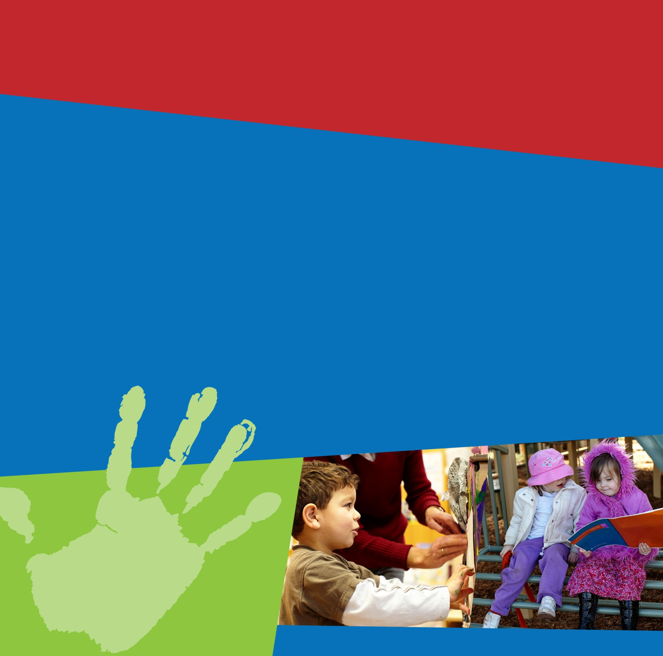

Child Care & Early Learning

in Summary

March quarter 2013

This publication provides information on children using approved child care services across Australia.

**Key findings for the March quarter 2013:**

* More than one million children (1,042,280) attended approved child care during the quarter, an increase of 6.8 per cent since the March quarter 2012.
* 729,780 families had at least one child in approved child care, an increase of 5.8 per cent since the March quarter 2012.
* 15,454 approved child care services operated in Australia, an increase of 4.1 per cent since the March quarter 2012.

The total estimated Child Care Benefit and Child Care Rebate entitlement was $1,084.6 million, up 14.8 per cent since the March quarter 2012.

# Introduction

This report presents information on the numbers of children and families using approved child care, the costs of care and the numbers and types of child care services in Australia. It includes data from the Child Care Management System (CCMS).

During the March quarter 2013, 729,780 families used approved child care services for their 1,042,280 children.

* In terms of affordability, over 90 per cent of these families are estimated to have received Child Care Rebate (CCR), with 50 per cent of their out-of-pocket costs covered by the Australian Government.
* In terms of availability, in the March quarter 2013, there were 15,454 services providing approved child care services across Australia with more than one third (5,262 or 34.0 per cent) of these located in New South Wales.

**Table 1: Child care children, families, services and estimated entitlements by state and territory,   
March quarter 2013**

| **State and territory** | **Number of  children using approved child care1** | **Number of  families using approved child care1** | **Number of  approved child care services** | **Estimated Child Care Benefit (CCB) entitlement ('000)** | **Estimated Child Care Rebate (CCR)  entitlement ('000)** | **Estimated number of families receiving CCR1** |
| --- | --- | --- | --- | --- | --- | --- |
| NSW | 335,410 | 241,890 | 5,262 | $166,538 | $186,220 | 217,230 |
| Vic. | 244,600 | 167,730 | 3,519 | $147,753 | $129,045 | 154,520 |
| Qld | 253,390 | 174,180 | 3,287 | $145,237 | $116,485 | 158,300 |
| SA | 78,130 | 53,320 | 1,221 | $35,239 | $28,138 | 49,440 |
| WA | 80,870 | 58,100 | 1,295 | $36,149 | $43,340 | 53,260 |
| Tas. | 22,470 | 15,350 | 373 | $10,504 | $7,759 | 14,010 |
| NT | 8,300 | 5,940 | 173 | $3,313 | $6,058 | 5,730 |
| ACT | 21,850 | 15,460 | 324 | $4,446 | $18,331 | 15,070 |
| **Australia** | **1,042,280** | **729,780** | **15,454** | **$549,178** | **$535,374** | **665,610** |

1As families and children may use services in more than one state or territory and due to rounding, the sum of the component parts may not equal the Total.

Source: Department of Education administrative data.

# Child Care Usage

## Children

During the March quarter 2013, 1,042,280 children used approved child care in Australia, up by 6.8 per cent since the March quarter 2012. For children aged 0–12 years using approved child care, this represents 27.7 per cent of the 3,731,080 children aged 0–12 years in Australia.

During March quarter 2013, children attended various services providing approved child care, including long day care (621,250 or 59.6 per cent), outside school hours care (327,220 or 31.4 per cent), family day care and in-home care (135,770 or 13.0 per cent), and occasional care (7,130 or 0.7 per cent).

**Table 2: Number of children using child care by service type, March quarter 2012 to March quarter 2013**

| **Service type** | **Mar. 12** | **June 12** | **Sept. 12** | **Dec. 12** | **Mar. 13** |
| --- | --- | --- | --- | --- | --- |
| Long day care | 598,450 | 587,100 | 615,630 | 623,980 | 621,250 |
| Family day care and In-home care | 117,790 | 118,700 | 125,230 | 128,930 | 135,770 |
| Occasional care | 6,130 | 6,510 | 6,950 | 7,230 | 7,130 |
| Outside school hours care | 299,420 | 304,120 | 315,220 | 303,210 | 327,220 |
| **Total1** | **976,230** | **986,280** | **1,030,970** | **1,033,150** | **1,042,280** |
| **Per cent of Australian population2** | **26.0%** | **26.3%** | **27.4%** | **27.5%** | **27.7%** |

1 As children may use more than one service type in any particular quarter and due to rounding, the sum of the component parts may not equal the Total. Totals include a very small number of children for whom other details are unknown.

2 Number of children aged 0–12 years using approved child care as a proportion of all Australian children aged 0–12 years

Source: Department of Education administrative data, ABS Cat. No. 2001.0 *Census 2011,* and ABS Cat. No. 3101.0 *Australian Demographic Statistics, Dec. 2012*.

In the March quarter 2013, the largest proportion of children attending long day care was in New South Wales   
(33.4 per cent), followed by Queensland (25.5 per cent) and Victoria (22.2 per cent).

**Figure 1: Children using long day care by state and territory, March quarter 2013**

Source: Department of Education administrative data.

**Table 3: Number of children using child care by service type and state and territory, March quarter 2013**

| **Service type** | **NSW** | **Vic.** | **Qld** | **SA** | **WA** | **Tas.** | **NT** | **ACT** | **Australia** |
| --- | --- | --- | --- | --- | --- | --- | --- | --- | --- |
| Long day care | 207,320 | 137,690 | 158,410 | 39,560 | 50,770 | 11,170 | 4,830 | 12,620 | **621,250** |
| Family day care and  In-home care | 41,990 | 42,230 | 27,350 | 8,550 | 9,440 | 5,360 | 470 | 1,140 | **135,770** |
| Occasional care | 2,440 | 2,520 | 700 | 120 | 990 | 140 | 0 | 220 | **7,130** |
| Outside school hours care | 98,710 | 72,620 | 79,140 | 33,190 | 24,300 | 7,470 | 3,340 | 8,720 | **327,220** |
| **Total1** | **335,410** | **244,600** | **253,390** | **78,130** | **80,870** | **22,470** | **8,300** | **21,850** | **1,042,280** |

1 As children may use more than one service type in more than one state or territory in any particular quarter and due to rounding, the sum of the component parts may not equal the Total.

Source: Department of Education administrative data.

While most children who used child care, used services located in major cities (789,610 children), one in four (257,720 or 24.7 per cent) children used child care services located in regional and remote areas.

**Table 4: Number of children using child care by region, March quarter 2013**

| **Service type** | **Major Cities of Australia** | **Regional and Remote Australia** | **Total** |
| --- | --- | --- | --- |
| Long day care | 465,390 | 157,630 | **621,250** |
| Family day care and In-home care | 91,640 | 44,750 | **135,770** |
| Occasional care | 4,450 | 2,680 | **7,130** |
| Outside school hours care | 262,870 | 64,930 | **327,220** |
| **Total1** | **789,610** | **257,720** | **1,042,280** |

1 As children may use more than one service type in more than one region in any particular quarter and due to rounding, the sum of the component parts may not equal the Total.

Source: Department of Education administrative data.

During the March quarter 2013, for all types of child care, the average time that a child spent in approved child care was 24.1 hours per week. This compares with children who used long day care who attended for an average of 27.4 hours per week.

**Figure 2: Children using long day care by average hours per week, March quarter 2013**

Source: Department of Education administrative data.

**Table 5: Average weekly hours in child care, March quarter 2012 to March quarter 2013**

| **Service type** | **Mar. 12** | **June 12** | **Sept. 12** | **Dec. 12** | **Mar. 13** |
| --- | --- | --- | --- | --- | --- |
| Long day care | 27.4 | 27.2 | 27.5 | 27.3 | 27.4 |
| Family day care and In-home care | 23.6 | 23.6 | 24.5 | 25.3 | 26.7 |
| Occasional care | 12.4 | 12.1 | 12.2 | 11.7 | 11.2 |
| Outside school hours care | 12.1 | 10.7 | 11.5 | 10.6 | 12.2 |
| **Total1** | **23.8** | **23.2** | **23.8** | **23.7** | **24.1** |

1 Totals include a very small number of children for whom other details are unknown.

Source: Department of Education administrative data.

## Families

During the March quarter 2013, there were 729,780 families using some form of approved child care for their children, an increase of 5.8 per cent since the March quarter 2012.

**Table 6: Number of families using child care, March quarter 2012 to March quarter 2013**

| **Service type** | **Mar. 12** | **June 12** | **Sept. 12** | **Dec. 12** | **Mar. 13** |
| --- | --- | --- | --- | --- | --- |
| Long day care | 479,530 | 479,830 | 499,470 | 504,240 | 500,180 |
| Family day care and In-home care | 77,420 | 77,940 | 80,890 | 82,230 | 84,930 |
| Occasional care | 5,030 | 5,370 | 5,710 | 5,910 | 5,930 |
| Outside school hours care | 213,330 | 217,720 | 225,780 | 217,880 | 231,970 |
| **Total1** | **689,790** | **700,600** | **726,130** | **727,030** | **729,780** |

1 As families may use more than one service type in any particular quarter and due to rounding, the sum of the component parts may not equal the Total. Totals include a very small number of families for whom other details are unknown.

Source: Department of Education administrative data.

In the March quarter 2013, 241,890 families had children attending approved child care in New South Wales, followed by Queensland (174,180) and Victoria (167,730). Across Australia, more than two-thirds (500,180 or 68.5 per cent) of all families had children in long day care and around one-third of families had children in outside school hours care (231,970 or 31.8 per cent).

**Table 7: Number of families using child care by service type and state and territory, March quarter 2013**

| **Service type** | **NSW** | **Vic.** | **Qld** | **SA** | **WA** | **Tas.** | **NT** | **ACT** | **Australia** |
| --- | --- | --- | --- | --- | --- | --- | --- | --- | --- |
| Long day care | 170,590 | 111,290 | 122,660 | 32,360 | 41,030 | 8,970 | 4,000 | 10,250 | **500,180** |
| Family day care and  In-home care | 29,070 | 22,660 | 17,660 | 5,230 | 5,890 | 3,590 | 380 | 900 | **84,930** |
| Occasional care | 2,050 | 2,090 | 580 | 100 | 810 | 120 | 0 | 190 | **5,930** |
| Outside school hours care | 70,830 | 52,360 | 54,980 | 23,010 | 17,040 | 5,200 | 2,410 | 6,330 | **231,970** |
| **Total1** | **241,890** | **167,730** | **174,180** | **53,320** | **58,100** | **15,350** | **5,940** | **15,460** | **729,780** |

1 As families may use more than one service type in more than one state or territory in any particular quarter and due to rounding, the sum of the component parts may not equal the Total.

Source: Department of Education administrative data.

## Indigenous children and families

During the March quarter 2013, 27,600 Indigenous children (2.6 per cent of all children) used approved child care in Australia. The number of Indigenous children using approved child care has increased slightly since the March quarter 2012 (up by 0.7 per cent).

**Table 8: Number of Indigenous children using child care, March quarter 2012 to March quarter 2013**

| **Service type** | **Mar. 12** | **June 12** | **Sept. 12** | **Dec. 12** | **Mar. 13** |
| --- | --- | --- | --- | --- | --- |
| Long day care | 18,170 | 17,990 | 18,730 | 18,910 | 18,100 |
| Family day care and In-home care | 3,610 | 3,570 | 3,500 | 3,580 | 3,600 |
| Occasional care | 190 | 200 | 210 | 210 | 200 |
| Outside school hours care | 6,640 | 6,590 | 6,820 | 6,370 | 6,810 |
| **Total1** | **27,410** | **27,490** | **28,420** | **28,300** | **27,600** |

1As children may use more than one service type in any particular quarter and due to rounding, the sum of the component parts may not equal the Total. Totals include a very small number of children for whom other details are unknown.

Source: Department of Education administrative data.

The largest proportion of Indigenous children attending long day care was in Queensland (39.3 per cent) and New South Wales (33.6 per cent). Compared with all children, a smaller proportion of Indigenous children aged 0–12 years attended approved child care, in each state and territory (16.0 per cent of Indigenous children aged 0–12 years, 27.7 per cent all children aged 0–12 years, nationally).

**Figure 3: Indigenous children using long day care by state and territory, March quarter 2013**

Source: Department of Education administrative data.

**Table 9: Number of Indigenous children using child care by state and territory, March quarter 2013**

| **Service type** | **NSW** | **Vic.** | **Qld** | **SA** | **WA** | **Tas.** | **NT** | **ACT** | **Australia** |
| --- | --- | --- | --- | --- | --- | --- | --- | --- | --- |
| Long day care | 6,090 | 1,350 | 7,120 | 760 | 1,490 | 610 | 530 | 180 | **18,100** |
| Family day care and  In-home care | 1,690 | 260 | 870 | 160 | 210 | 360 | 50 | 10 | **3,600** |
| Occasional care | 130 | 20 | 20 | 0 | 20 | 10 | 0 | <10 | **200** |
| Outside school hours care | 1,900 | 470 | 2,520 | 510 | 480 | 400 | 430 | 110 | **6,810** |
| **Total Indigenous children using approved child care1** | **9,410** | **2,050** | **10,180** | **1,380** | **2,100** | **1,280** | **980** | **300** | **27,600** |
| **Per cent of Indigenous population2** | *17.3%* | *17.5%* | *19.7%* | *22.9%* | *6.4%* | *21.2%* | *1.8%* | *66.9%* | *16.0%* |

1As children may use more than one service type and use services in more than one state or territory in any particular quarter and due to rounding, the sum of the component parts may not equal the Total.

2Number of Indigenous children aged 0–12 years using approved child care as a proportion of all Indigenous children aged 0–12 years

Source: Department of Education administrative data and ABS Cat. No. 2002.0 *Census 2011*.

More than half of all Indigenous children who attended child care did so in regional or remote Australia (14,970 children or 54.2 per cent).

**Table 10: Number of Indigenous children using child care by region, March quarter 2013**

| **Service type** | **Major Cities of Australia** | **Regional and Remote Australia** | **Total** |
| --- | --- | --- | --- |
| Long day care | 8,470 | 9,710 | **18,100** |
| Family day care and In-home care | 1,250 | 2,350 | **3,600** |
| Occasional care | 110 | 90 | **200** |
| Outside school hours care | 3,430 | 3,400 | **6,810** |
| **Total1** | **12,760** | **14,970** | **27,600** |

1As children may use more than one service type and use services in more than one region and due to rounding, the sum of the component parts may not equal the Total.

Source: Department of Education administrative data.

During the March quarter 2013, 18,880 Indigenous families used approved child care, a slight reduction (40 families or 0.2 per cent) since the March quarter 2012.

**Table 11: Number of Indigenous families using child care, March quarter 2012 to March quarter 2013**

| **Service type** | **Mar. 12** | **June 12** | **Sept. 12** | **Dec. 12** | **Mar. 13** |
| --- | --- | --- | --- | --- | --- |
| Long day care | 13,970 | 14,100 | 14,510 | 14,570 | 13,830 |
| Family day care and In-home care | 2,410 | 2,420 | 2,360 | 2,390 | 2,360 |
| Occasional care | 140 | 150 | 160 | 160 | 160 |
| Outside school hours care | 4,370 | 4,410 | 4,590 | 4,360 | 4,530 |
| **Total1** | **18,920** | **19,220** | **19,680** | **19,640** | **18,880** |

1As families may use more than one service type in any particular quarter and due to rounding, the sum of the component parts may not equal the Total. Totals include a very small number of families for whom other details are unknown.

Source: Department of Education administrative data.

Around one third (6,780 or 35.9 per cent) of Indigenous families had children in approved child care located in Queensland; another third (6,660 or 35.3 per cent) had children in approved child care located in New South Wales.

**Table 12: Number of Indigenous families using child care by state and territory, March quarter 2013**

| **Service type** | **NSW** | **Vic.** | **Qld** | **SA** | **WA** | **Tas.** | **NT** | **ACT** | **Australia** |
| --- | --- | --- | --- | --- | --- | --- | --- | --- | --- |
| Long day care | 4,820 | 1,050 | 5,230 | 590 | 1,110 | 480 | 430 | 140 | **13,830** |
| Family day care and  In-home care | 1,130 | 160 | 560 | 90 | 120 | 250 | 40 | 10 | **2,360** |
| Occasional care | 100 | 20 | 20 | 0 | 20 | 10 | 0 | <10 | **160** |
| Outside school hours care | 1,300 | 350 | 1,600 | 350 | 310 | 260 | 300 | 80 | **4,530** |
| **Total1** | **6,660** | **1,440** | **6,780** | **900** | **1,420** | **840** | **680** | **210** | **18,880** |

1As families may use more than one service type and use services in more than one state or territory in any particular quarter and due to rounding, the sum of the component parts may not equal the Total.

Source: Department of Education administrative data.

# Availability

## Services

During the March quarter 2013, 15,454 approved child care services operated in Australia, an increase of 4.1 per cent (603 services) since the March quarter 2012.

In the March quarter 2013, there were 8,551 outside school hours care services which accounted for 55.3 per cent of all services and 6,268 long day care services which accounted for 40.6 per cent of all services.

**Table 13: Number of child care services by service type, March quarter 2012 to March quarter 2013**

| **Service type** | **Mar. 12** | **June 12** | **Sept. 12** | **Dec. 12** | **Mar. 13** |
| --- | --- | --- | --- | --- | --- |
| Long day care | 6,133 | 6,156 | 6,192 | 6,271 | 6,268 |
| Family day care and In-home care | 434 | 441 | 460 | 486 | 517 |
| Occasional care | 80 | 80 | 82 | 94 | 118 |
| Outside school hours care | 8,203 | 8,342 | 8,413 | 8,405 | 8,551 |
| **Total1** | **14,851** | **15,020** | **15,147** | **15,256** | **15,454** |

1 Totals include a very small number of services for which other details are unknown.

Source: Department of Education administrative data.

A mix of approved child care services are located in all states and territories. In the March quarter 2013, around one third of services were located in New South Wales (34.0 per cent), with 22.8 per cent in Victoria and 21.3 per cent in Queensland.

**Figure 4: Number of approved services by service type and state and territory, March quarter 2013**

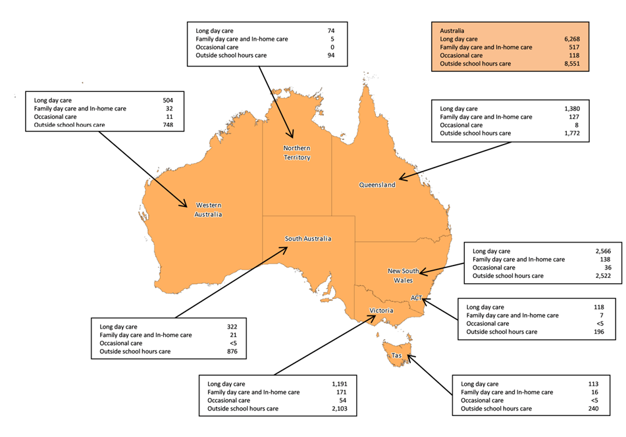

Source: Department of Education administrative data.

# Affordability

## Costs of care

The costs of child care are determined by a combination of the type of child care used, the fees services charge, the amount of care used by families for their children and the amount of Australian Government subsidies that families are entitled to.

The average hourly child care fee for all service types in the March quarter 2013 was $7.25, an increase of 7.0 per cent since the March quarter 2012. Fees varied across service types from a high of $8.75 per hour for occasional care services to a low of $5.85 per hour for outside school hours care services.

**Table 14: Average hourly fee by service type, March quarter 2012 to March quarter 2013**

| **Service type** | **Mar. 12** | **June 12** | **Sept. 12** | **Dec. 12** | **Mar. 13** |
| --- | --- | --- | --- | --- | --- |
| Long day care | $6.90 | $7.00 | $7.20 | $7.20 | $7.40 |
| Family day care and In-home care | $7.05 | $7.30 | $7.65 | $7.60 | $7.45 |
| Occasional care | $8.25 | $8.35 | $8.60 | $8.60 | $8.75 |
| Outside school hours care | $5.50 | $5.70 | $5.75 | $5.85 | $5.85 |
| **Total1** | **$6.75** | **$6.90** | **$7.10** | **$7.10** | **$7.25** |

1 Hourly fees for each service type are calculated by dividing the sum of all fee amounts by the sum of all hours for each service type.

Source: Department of Education administrative data.

The average hourly fee for long day care increased by 7.1 per cent from the March quarter 2012 to the March quarter 2013. This increase compares with the average annual percentage increase of 7.1 per cent for the period from the March quarter 2005 to the March quarter 2013.

**Figure 5: Average and annual percentage change to long day care hourly fees, March quarter 2005 to March quarter 2013**

Source: Department of Education administrative data.

The Australian Government subsidises the cost of child care for eligible families through the Child Care Benefit and the Child Care Rebate to help parents with the cost of approved child care. During the March quarter 2013, the total estimated expenditure on Child Care Benefit and Child Care Rebate was $1,084.6 million. The majority ($790.0 million or 72.8 per cent) of this was paid on behalf of families using long day care services.

**Table 15: Total estimated Child Care Benefit and Child Care Rebate entitlements by service type, March quarter 2013**

| **Service type** | **Child Care Benefit**  **(‘000)** | **Child Care Rebate**  **(‘000)** | **Total**  **(‘000)** |
| --- | --- | --- | --- |
| Long day care | $360,075 | $429,898 | **$789,973** |
| Family day care and In-home care | $140,026 | $48,493 | **$188,519** |
| Occasional care | $1,191 | $1,538 | **$2,729** |
| Outside school hours care | $47,886 | $55,445 | **$103,331** |
| **Total** | **$549,178** | **$535,374** | **$1,084,553** |

Source: Department of Education administrative data – based on estimated entitlements.

Before Australian Government child care subsidies were taken into account, out-of-pocket costs for families varied from 39.9 per cent of weekly disposable income for families earning a gross income of $35,000 per year, to 16.1 per cent for families earning a gross income of $150,000 per year.  After Australian Government child care subsidies, out-of-pocket costs were significantly reduced to around 9.0 per cent of disposable income across all income ranges.

**Figure 6: Out-of-pocket costs for one child in long day care before and after Australian Government subsidies, March quarter 2013**

1 Out-of-pocket costs (before and after Australian Government subsidies) are shown for families with one child using long day care for 50 hours of care per week.

# Source: Department of Education administrative data.

# Vacancies

Table 16 details the national trend in child care vacancies from the June quarter 2011 to the March quarter 2013 by service type.

It appears that vacancies in long day care services peak in the March quarter of each year (approximately 66,000 in March quarter 2010 and March quarter 2011, approximately 69,000 in March quarter 2012 and approximately 81,000 in March quarter 2013) and that the number of vacancies then declines throughout the year.

**Table 16: Child care vacancies by service type, June quarter 2011 to March quarter 2013**

| **Service type** | **June 11** | **Sept. 11** | **Dec. 11** | **Mar. 12** | **June 12** | **Sept. 12** | **Dec. 12** | **Mar. 13** |
| --- | --- | --- | --- | --- | --- | --- | --- | --- |
| **Long day care** | | | | | | | |  |
| Total number of services | 6,086 | 6,071 | 6,123 | 6,133 | 6,156 | 6,192 | 6,271 | 6,268 |
| Per cent of services reporting | 76% | 78% | 79% | 77% | 77% | 84% | 82% | 83% |
| Proportion with vacancies | 88% | 86% | 86% | 90% | 87% | 85% | 86% | 89% |
| Average number of vacancies | 61,620 | 53,950 | 51,930 | 68,750 | 60,540 | 61,660 | 58,190 | 80,630 |
| **Service type** | **June 11** | **Sept. 11** | **Dec. 11** | **Mar. 12** | **June 12** | **Sept. 12** | **Dec. 12** | **Mar. 13** |
| **Before and after school hours care** | | | | | |  |  |  |
| Total number of services | 5,604 | 5,697 | 5,732 | 5,956 | 6,020 | 6,036 | 6,057 | 6,219 |
| Per cent of services reporting | 64% | 62% | 65% | 63% | 65% | 66% | 64% | 63% |
| Proportion with vacancies | 87% | 88% | 87% | 86% | 85% | 86% | 87% | 87% |
| Average number of vacancies | 66,100 | 67,240 | 73,970 | 72,360 | 73,910 | 80,660 | 82,860 | 84,550 |
| **Service type** | **June 11** | **Sept. 11** | **Dec. 11** | **Mar. 12** | **June 12** | **Sept. 12** | **Dec. 12** | **Mar. 13** |
| **Family day care** | | | | | |  |  |  |
| Total number of services | 333 | 352 | 360 | 370 | 376 | 392 | 415 | 447 |
| Per cent of services reporting | 72% | 70% | 68% | 66% | 63% | 65% | 59% | 54% |
| Proportion with vacancies | 89% | 89% | 86% | 84% | 84% | 83% | 80% | 81% |
| Average number of vacancies | 6,200 | 6,020 | 5,450 | 6,490 | 5,980 | 6,040 | 6,230 | 6,980 |
| **Service type** | **June 11** | **Sept. 11** | **Dec. 11** | **Mar. 12** | **June 12** | **Sept. 12** | **Dec. 12** | **Mar. 13** |
| **Occasional care** | | | | | |  |  |  |
| Total number of services | 85 | 82 | 82 | 80 | 80 | 82 | 94 | 118 |
| Per cent of services reporting1 | 66% | 70% | 62% | 65% | 59% | 62% | 56% | 51% |
| Proportion with vacancies | 55% | 54% | 59% | 63% | 60% | 57% | 53% | 55% |
| Average number of vacancies | 320 | 310 | 280 | 300 | 240 | 220 | 220 | 320 |
| **Service type** | **June 11** | **Sept. 11** | **Dec. 11** | **Mar. 12** | **June 12** | **Sept. 12** | **Dec. 12** | **Mar. 13** |
| **Vacation care** | | | | | |  |  |  |
| Total number of services | 2,114 | 2,253 | 2,253 | 2248 | 2323 | 2,377 | 2,348 | 2,332 |
| Per cent of services reporting | 59% | 54% | 57% | 53% | 58% | 64% | 58% | 57% |
| Proportion with vacancies | 61% | 70% | 67% | 69% | 67% | 69% | 69% | 71% |
| Average number of vacancies | 14,670 | 20,630 | 20,080 | 19,740 | 21,410 | 27,370 | 21,480 | 23,860 |

1 A number of occasional care services were affected by a software reporting problem resulting in under reporting for the March quarter 2011. The values included in the table are for the services that were able to successfully provide data to the Department of Education.

Source: Department of Education administrative data.

# Technical Notes

## General counting rules

Use of child care services is counted for each individual child using approved child care services. An instance of child care usage is defined as at least one child care attendance per child care service for the quarter irrespective of duration or frequency. For example, a single hour at an occasional care centre or 40 hours per week throughout the quarter at a long day care centre, are both counted as an instance of child care usage.

Children and families are recorded for each of the service types that they use during the quarter. Children and families using more than one service type during the quarter or financial year are counted only once within each applicable service type category and only once within the ‘Total’ category for the relevant time period. Note that as children and families may use more than one service type in any particular time frame the sum of the component parts may not equal the ‘Total’ category.

Changes in service type numbers need to be understood in the context of counting rules. Prior to the implementation of the Child Care Management System (CCMS) all services with an ‘active’ status were included regardless of attendance. This resulted in a small number of services being included in the data that did not actually have any children in attendance. Under CCMS a service is counted as ‘active’ only if it had at least one child attending at some time during the quarter, thus aligning the counting rules for children, families and services.

## Data sources

Data included in this report comes from the following sources:

* From the September quarter 2011 the majority of data is extracted from the Child Care Data and Reporting System (CCDARS). CCDARS is a Department of Education based data storage system for data collected from approved child care services via the Child Care Management System.
* Supplementary data is sourced from the Department of Human Services.

**Revisions:** Due to changes in the administrative system, data may be revised to ensure the most accurate, up-to-date figures are published.

## Vacancy information

All Child Care Benefit approved services are required to regularly report their anticipated vacancies according to a standard definition, to the Department of Education. For most services, a vacancy is defined as a permanent full day vacancy that the service is willing to fill.

The information contained in this report (table 16) relates to specific reference weeks. As is standard practice, a reference week is used to represent the quarter and reduce errors due to potential inconsistencies in reporting. For the March quarter 2013, vacancies for long day care, before and after school hours care, occasional care and family day care are reported for the week 4 to 10 March 2013, while for vacation care it varies across the states and territories due to the different timing of school holidays.

# Definitions

**Approved care:** Care provided by long day care, family day care and in-home care, outside school hours care and occasional care services approved by the Australian Government to receive Child Care Benefit on behalf of families.

**Average number of vacancies**: As services report vacancies for each day of the week, the number of vacancies for each service is averaged out across the weekdays, that is, it is the sum of vacancies on each weekday divided by five. The total number of vacancies in an area is the sum of the average vacancies per service.

**Child Care Benefit (CCB):** A payment made by the Australian Government to families to assist with the cost of child care.

**Child Care Management System (CCMS):** This is the electronic system used for the administration of CCB. Under CCMS, approved child care services submit attendance information to the Department of Education over the internet. Data in this report are primarily sourced from the CCMS.

**Child Care Rebate (CCR):** A payment made by the Australian Government to assist eligible working families with the out-of-pocket cost of child care. CCR is calculated based on the gap between the fees charged by the child care service and the CCB paid in respect of fee relief. Families who satisfy the work/training/study test requirements may be entitled to receive CCR for 50 per cent of all out-of-pocket costs up to an annual cap.

**Family day care:** A family day care scheme is a network of experienced caregivers who provide care and development activities for other peoples young children in the caregiver’s own home. Schemes are administered and supported by central coordination units.

**In-home care:** A form of approved child care in which experienced caregivers provide care for children in their own home.

**Long day care:** This is a centre-based form of child care service. Long day care services provide quality all day or part-time care for children of working families and the general community.

**Occasional care:** This is a care type mainly for non-school aged children. These services cater mainly for the needs of families who require short-term care for their children.

**Outside school hours care:** Services provide care for school aged children before and/or after school during the school term. Some services also provide care on 'pupil free' days. Vacation care is also included in this category. Vacation care services provide care for school children during the school holidays. Vacancies are reported separately for before and/or after school hours care and vacation care.

**Reference week:** For long day care, family day care, before and/or after school hours care and occasional care services, the reference week for vacancy information is selected as one of the last available weeks that is not affected by school or other holiday periods and a week that provided a consistent (with other weeks in the quarter) level of services that had reported across the quarter. The reference week includes weekdays only as most services do not operate on weekends. The reference week for vacation care is based on each state and territory’s school holiday periods.

**Region:** Regions of Australia are classified according to the Australian Bureau of Statistics Australian Statistical Geography Standard (ASGS), July 2011. This classification divides each state and territory into several regions on the basis of their relative access to services.

**Reporting services:** The services that reported their vacancy information for the reference week. This includes a small number of services that reported vacancy information and indicated they were not operational for the week.

**Service:** Child care services are approved by the Australian Government to receive CCB on behalf of families. Most long day care, family day care, before and after school hours care, vacation care services and some in-home care and occasional care services are approved child care services. Private operators, local councils, community organisations, employers or non-profit organisations may run these services. The total number of services refers to the number of services that were active during the March quarter 2013, that is, they had at least one record of child care attendance in the quarter.

**Vacancy:** Anticipated availability that child care services are willing to fill for each week they are operational. This is an ongoing full day vacancy for long day care and family day care, full day vacancy for vacation care and occasional care services and an ongoing full session vacancy for before and/or after school hours care. Data relating to the small number of reporting services with all places not meeting the relevant vacancies definition have not been included in this report.

**© Commonwealth of Australia, 2013**

This work has been produced by the Department of Education on behalf of the Australian Government. Apart from any use permitted under the *Copyright Act 1968*, no part of this publication may be reproduced by any process without written permission from the Department of Education.

Cataloguing title: Child Care & Early Learning in Summary, March quarter 2013. ISBN: 978-1-74361-222-4

Comments and suggestions regarding this publication are welcomed and should be forwarded to the Department of Education.

Published by the Department of Education

ABN 87 007 967 311

Level 2, 17 Moore Street, Canberra ACT 2600

GPO Box 9880 Canberra ACT 2601, Australia

Web: [**http://education.gov.au/**](http://education.gov.au/)