ATSIHEAC Background Paper: Indigenous Science, Technology, Engineering, and Mathematics (STEM).

# Issue:

*In higher education*:  
Despite strong growth in recent years, Indigenous students’ participation in STEM subjects in higher education needs to accelerate rapidly to reach parity with other fields of study and with non-Indigenous students.

*Indigenous share of domestic enrolments by broad field of education: 2013 chart as described in the text
*  
*Source: Department of Education and Training: Higher Education Statistics*

Total Indigenous share of enrolments: 1.4%

*In schools:*  
Data from standardised testing shows Indigenous students in schools are performing significantly worse than their non-Indigenous peers. While the Government’s agenda for increasing school attendance for Indigenous school students is an important part of improving outcomes, there is more work to be done on improving what happens inside the schools to ensure better performance in STEM for Aboriginal and Torres Strait Islander school students. Teachers need to be better prepared for teaching maths and science to Indigenous school students, and more Indigenous teachers are essential.

*In the workplace:*We know that higher education is a key to economic development for Indigenous Australians. Employment outcomes are vastly better for Indigenous Australians with degree-level qualifications: *Employment status of Indigenous Australians by educational attainment chart as described in the text
*  
 *Source: ABS Cat 2076.0: Census of Population and Housing: Characteristics of Aboriginal and Torres Strait Islander Australians, 2011*

An important part of addressing the income disparities that exist between Indigenous and non-Indigenous Australians is to increase the size of the Indigenous professional class. A strong Indigenous presence in the professions will provide the role models for subsequent generations of Indigenous school students and the champions for future professional advancement by Indigenous graduates. Building the visibility pathways from school maths and science to real jobs that Indigenous people are excelling in will help to drive the pipeline forward.

# Recommendations:

## 1. The government should convene an a group of experts in Indigenous STEM education

* Indigenous enrolments in higher education have been increasing steadily. Over the period 2003 to 2013, enrolments increased by 53 per cent from 8,964 to 13,723:

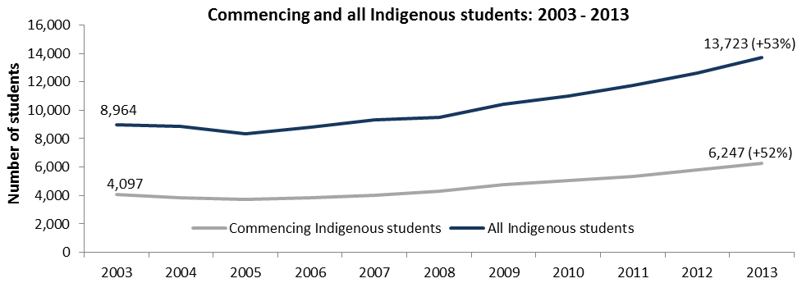

* This is strong growth, greater than the growth in all domestic students over the same period (37 per cent).
* However, in 2013 those 13,723 students represented just 1.4 per cent of all domestic enrolments:

Indigenous higher education students as a proportion of all domestic students chart as described above


(source: 2013 Equity Groups data set, available at <http://docs.education.gov.au/documents/2013-appendix-2-equity-groups>.)

* Indigenous students continue to prefer to study a small number of fields, particularly society and culture, health, and education:

*Award course completions for Indigenous Students by broad field of education chart as described in the text
*  
*Source: Department of Education and Training: Higher Education Statistics*

* The Indigenous share of enrolments in STEM subjects is lower still – under one per cent in the natural and physical sciences, IT, and engineering disciplines in 2013.
* Growth in Indigenous participation in STEM disciplines in higher education is strong but is coming off a very low base.
* Between 2001 and 2013, enrolments in STEM disciplines for Indigenous bachelor and postgraduate by coursework students increased by 146 per cent, from 473 to 1,163:

*Indigenous Enrolments, commencements, completions in STEM* fields as described above
*  
*\*Includes natural and physical sciences; IT; and engineering and related technologies, Bachelor and postgraduate by coursework students.*  
*Source: Department of Education and Training: Higher Education Statistics*

* This growth is higher than that for Indigenous students in all fields over the same period (101 per cent).
* However the number of Indigenous students required for population parity in these fields is around 5,000 so at the current rate of growth it will still require many years to reach this level.
* **It is therefore recommended that the government convene groups of experts in Indigenous STEM education**.
* The Expert Working Group would provide advice on:
  + Integration of Indigenous STEM priorities into the broader STEM agenda;
  + Strategies to make highly qualified STEM teachers available to schools with high numbers of Indigenous students; and
  + Opportunities to leverage efforts of bodies such as the Aboriginal and Torres Strait Islander Mathematics Alliance, and the Australian Council of Deans of Education.
* In line with the recommendations of the Review of Higher Education Access and Outcomes for Aboriginal and Torres Strait Islander people, and with the suggested actions from the STEM Roundtable, the group of experts could develop the following:
  + An articulation of pathways from school through to professions
  + strategies for the particular challenges of different localities with large Indigenous populations, i.e. regional/metropolitan and rural/remote;
  + developing strategies for Indigenous school students in specific achievement groups, ie low, middle and high performance bands; and
  + examining leading practice in Indigenous higher education to identify critical success factors and challenges.

## 2. The government should invest in informing evidence-based pedagogical practice

* A key to engaging Indigenous students in science and maths in classrooms is making science and maths exciting and relevant.
* There is a growing body of evidence on what works in Indigenous STEM education in the classroom.
* For example, the Australian Council of Learned Academies examined international experiences of Indigenous students[1], and found some common themes in what was effective:
  + Developing culturally responsive curriculum and teaching approaches: including specific attention to the learning needs of Indigenous students; integrating Indigenous knowledges; and assessment involving culturally valid ways of communication.
  + Developing support structures in higher education
  + Developing community outreach.
* Elements of this body of evidence dovetail with recent research at Monash University[2], which emphasised the importance of culturally sensitive methods of assessment.
* Recent research[3] showed that an innovative approach to science pedagogy had positive outcomes for Indigenous students, Approaches included:
  + Relationship building through cultural competency
  + Student ownership: presenters gave students the role of scientists (a student-led approach)
  + Focus on vocabulary building.
* This research is in line with the Chief Scientist’s 2014 report *Science, Technology. Engineering and Mathematics: Australia’s Future*, which recommended an inquiry-based approach to science education.
* However some other evidence conflicts with these findings, with different pedagogical approaches identified as effective in different studies.
* For example, Amanda Woods-McConney and Andrew McConney from Murdoch University were commissioned by ATSIHEAC to analyse Indigenous student academic performance in science, as measure by Programme for International Student Assessment (PISA) in 2006.
* Their paper provides an assessment of the statistical impact of non-school based interventions on Indigenous student outcomes. It showed that when SES and outside-of-school activities are controlled for, teacher-led strategies had a more positive association with science literacy than student-led (investigation) strategies[4].
* This shows that more research is needed to understand what works for Indigenous students in the maths and science classroom.
* There are existing research centres focussed on better equipping teachers for the challenges of STEM education. These centres would be well placed to pick up an Indigenous focus to their research and professional learning activities.
* For example, Monash University has established a National Institute for STEM Education, and University of Sydney maintains a STEM Teacher Enrichment Academy. These centres are focussed on building the evidence base in STEM education and providing professional learning material for teacher development.
* **It is therefore recommended that the group of experts consider partnering, through roundtable fora and other mechanisms, with existing STEM research centres to establish an Indigenous STEM education focus in research.**

## 3. More Indigenous content in curricula, and better cultural competency for teachers.

* Our extensive consultation with Deans of STEM faculties to date has identified a number of strategies that can make a difference for Indigenous students in STEM disciplines.
* The ATSIHEAC STEM Roundtable, held in December 2013, identified a number of actions for Deans of faculties that could improve access and outcomes. These included:
  + building the next generation of culturally competent and informed STEM faculty;
  + embedding Indigenous world views and knowledges into the curriculum and pedagogy for pre‑service STEM teachers;
  + providing second chance pathways into STEM education for Indigenous students;
  + supporting change through sharing resources and expertise across faculties and the sector as a whole, including through the utilisation of online technologies; and
  + embed Indigenous targets into faculty-level accountability mechanisms;
* ATSIHEAC consultation with Deans from STEM and Education faculties and other important stakeholders following the Roundtable sought to establish a dialogue on actions to improve Indigenous STEM outcomes.
* These consultations included discussions with Universities Australia (Feb 2014); Go8 and Deans of Engineering (May 2014); Australian Council of Deans of ICT (Jul 2014); Professor Ian Chubb AC, Chief Scientist for Australia (Jul 2014); Australian Mathematical Sciences Institute (Aug & Oct 2014); Australian Council of Deans of Education (Sep 2014); Australian Council of Deans of Science (Sep 2014); and Aboriginal and Torres Strait Islander Mathematics Alliance (Nov 2014).
* Great progress has been made in raising the profile of Indigenous STEM participation and success among a diverse group of stakeholders, but this is a long-term project and will require concerted effort by the Department to build the relationships necessary to make the case for change in faculties.

*A blueprint for reform exists in the work done in Indigenous medical education.*

* By 1995, there had only been 15 Aboriginal and Torres Strait Islander medical graduates. In 2011, 11 Indigenous medical students graduated, and 80 Indigenous students commenced in medical degrees[5].
* A key part of reforming medical curricula in Australian medical schools was the Indigenous Health Curriculum Framework project. The four key parts of that project, commissioned by the Australian Government in partnership with the Committee of Deans of Australian Medical Schools in 2002, were:
  1. An audit existing Indigenous health content in core medical education
  2. Development of a nationally agreed curriculum framework for the inclusion of Indigenous health in core medical curricula
  3. Development of a network of Indigenous and non-Indigenous medical educators concerned with Indigenous health (now the LIME Network)
  4. Accreditation of the curriculum framework by the Australian Medical Council (AMC).
* This four-pronged process of reform is ideal to build consensus on the need for change, and should be adopted in STEM education.
* **Therefore, it is recommended that the group of experts conduct an audit of Indigenous content and learning and teaching strategies in STEM curricula.** The results of the audit would inform best-practice models for inclusion in an **Indigenous** **STEM Curriculum Framework**.

1. Australian Council of Learned Academies, 2013, STEM: Country Comparisons
2. Personal correspondence with Professor Deb Corrigan
3. Hackling, Byrne, Gower, Anderson, 2015, *A pedagogical model for engaging Aboriginal children with science and learning*, Teaching Science Vol 61, number 1, pp27-39.
4. Woods-McConney, A, and McConney, A, 2015*, Indigenous Australian Student Success in Science*, Murdoch University, NP.
5. Submission from Medical Deans Australia and New Zealand to the Review of Higher Education Access and Outcomes for Aboriginal and Torres Strait Islander People.