Growing the Indigenous Academic Workforce: ATSIHEAC Recommendations to government

# Introduction and key issues

Over the course of its work, Council has consistently seen the Indigenous academic workforce emerge as a key enabler to broader improvements in Indigenous higher education outcomes. In that context, data and demographic analysis has been undertaken to help provide a better picture of the academic workforce landscape more generally and the implications for the Indigenous academic workforce in particular.

Academic careers and the pathways into those careers for Indigenous students and graduates is strongly influenced by the adage that “you can’t be what you can’t see”. Increasing the visible presence of Indigenous researchers and teachers in the academy will act to increase the visibility of the pathways into the academy and, in addition, other professions for Indigenous students.

There is an important opportunity that arises from the intersection between growing the pipeline into the academic workforce and building an Indigenous research agenda. Where universities take up the challenge to build a robust, rigorous Indigenous research strategy, it will create a powerful pull factor into the academic workforce for Indigenous scholars.

For a range of reasons, including the need for diversity of disciplines in which Indigenous academics are engaged, development of an Indigenous research strategy alone will not be sufficient and needs to be coupled with other policy and programme responses. These are outlined in more detail below but include changes to arrangements for Australian Postgraduate Awards (APAs) and the Research Training Scheme (RTS) scheme to create stronger pull factors, in particular by developing options for weighting the RTS and more effectively targeting APAs towards Indigenous students.

It will be important that Government and higher education providers work together to develop strategies across a range of priority areas. These include strategies for:

* credentialing the existing Indigenous workforce, including initiatives to better position university as an attractive destination and support mid-career professionals to take up academic positions
* improving completion rates and accelerating time to complete
* improving post-doctoral transitions
* leveraging the internationalisation agenda including by ensuring that the new International Education Strategy includes a strong Indigenous higher education focus. This could include establishing an Indigenous scholarships pool under the New Colombo Plan.

# Current state of play for the academic workforce

According to Hugo (2009, 2010), the academic workforce is ageing. Based on 2006 census data, sixty percent of the academic workforce was over fifty years of age. There are consequences arising from this claim for the academic workforce engaged in the teaching of future professionals: it is getting smaller at a rate faster than it can be replaced through the usual PhD pipeline. The outlook was, at that time, pessimistic with respect to the capacity to ensure the capability to educate the future professional workforce. The ageing of the Australian academic workforce is confirmed in Coates and Goedegebuure (2010), Edwards, Bexley and Richardson (2010) and Bexley, James and Arkoudis (2011). None of these studies compare Indigenous academics with non-Indigenous academics.

Recent data appears to indicate that the median and average ages of academics are under fifty. The current Indigenous academic workforce appears to be slightly older than the non-Indigenous academic workforce.

| **Indigenous** | | |  | **Non-Indigenous** | | |
| --- | --- | --- | --- | --- | --- | --- |
| Age | | | Age | | |
| N | Valid | 396 | N | Valid | 52104 |
| Missing | 0 | Missing | 0 |
| Mean | | 47.40 | Mean | | 46.24 |
| Median | | 48.00 | Median | | 46.00 |
| Std. Deviation | | 9.244 | Std. Deviation | | 11.195 |

Source: Department of Education and Training unpublished analysis May 2015.

The three year moving averages from 2009 to 2013 do not show much variability in either Indigenous or non-Indigenous male or female academics. There is some slow growth in median ages of Indigenous academics as compared to no measurable growth in median ages of non-Indigenous academics.

| 3yr moving average Age |  | 2009 | 2010 | 2011 | 2012 | 2013 |
| --- | --- | --- | --- | --- | --- | --- |
| Indigenous | Female | 45.24 | 45.65 | 45.97 | 46.44 | 47.04 |
|  | Male | 45.08 | 45.64 | 46.60 | 46.82 | 46.94 |
| Non-Indigenous | Female | 44.57 | 44.52 | 44.56 | 44.79 | 44.99 |
|  | Male | 47.19 | 47.10 | 47.04 | 47.13 | 47.14 |

Source: Department of Education and Training unpublished analysis June 2015.

| Median age |  | 2009 | 2010 | 2011 | 2012 | 2013 |
| --- | --- | --- | --- | --- | --- | --- |
| Indigenous | Female | 46 | 47 | 47 | 48 | 48 |
|  | Male | 45 | 46 | 47 | 45 | 47 |
| Non-Indigenous | Female | 45 | 45 | 45 | 45 | 45 |
|  | Male | 47 | 47 | 47 | 47 | 47 |

Source: Department of Education and Training unpublished analysis June 2015.

When looking at proportions of the workforce likely to retire in the near future, it is worth noting that age 55 is the minimum preservation age for superannuation to be accessed up until 2015. That is, academics aged 55 years and over who have superannuation pension entitlements could, in principle, retire anytime from now on. As the table below shows, the proportions of academics, except for non-Indigenous males, in the group able to retire at any point was around 20% in 2013.

| % aged 55 yrs and over |  | 2011 | 2012 | 2013 |
| --- | --- | --- | --- | --- |
| Indigenous | Female | 12.4 | 19.9 | 19.2 |
|  | Male | 22.0 | 19.4 | 19.3 |
| Non-Indigenous | Female | 17.8 | 18.7 | 19.4 |
|  | Male | 26.0 | 26.3 | 26.2 |

Source: Department of Education and Training unpublished analysis June 2015.

What all of these numbers mean is that there is room for the Indigenous academic workforce to grow without undue concern as to age of new entrants from professions or new PhD graduates for the next five to ten years at least. While there may be some marginal value for institutions in skewing recruitment to younger entrants in terms of potential length of service, recruitment from over forties professionals is also within scope for length of service and likely retirement options.

However, as outlined later, the nature of academic work is changing. There is increasing use of sessional and fixed term staff leading to claims of “casualization” and narrowing of careers. There is also increasing recognition of the narrowness of entry points and career pathways for mainstream academic careers – the PhD bottleneck. This will present its own problems in relation to recruiting, training and retaining Indigenous academics.

# Current state of play for the Indigenous academic workforce

Numbers of Indigenous academic staff, except for Level A staff, have trending upwards since 2001.

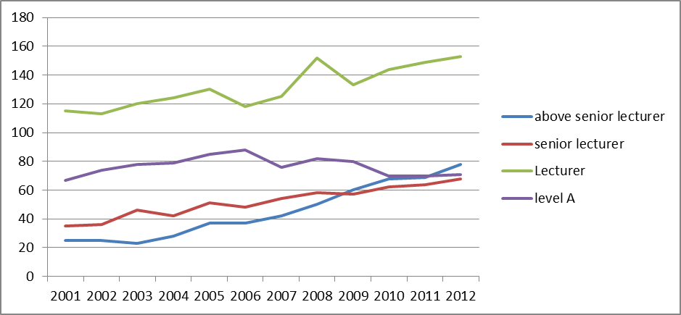

As a proportion of all academic staff at level, Indigenous academic staff are trending upwards at more senior levels (Level C-E and DVC+), more or less steady at the lecturer level (Level B) and downwards for Level A staff.

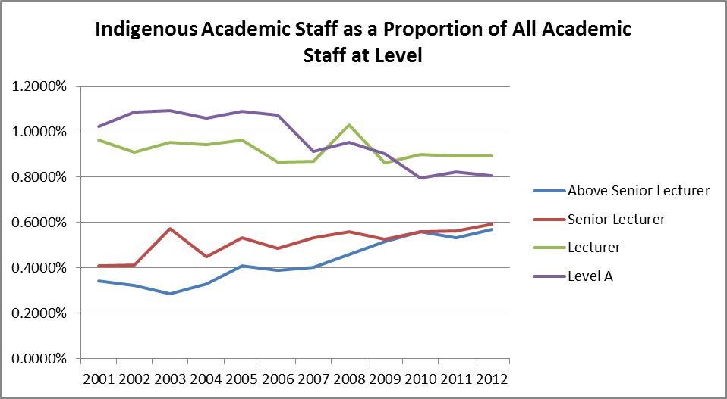

The rough distribution of Indigenous academics across Fields of Education based on analysis of Indigenous education statements is shown in the chart following.

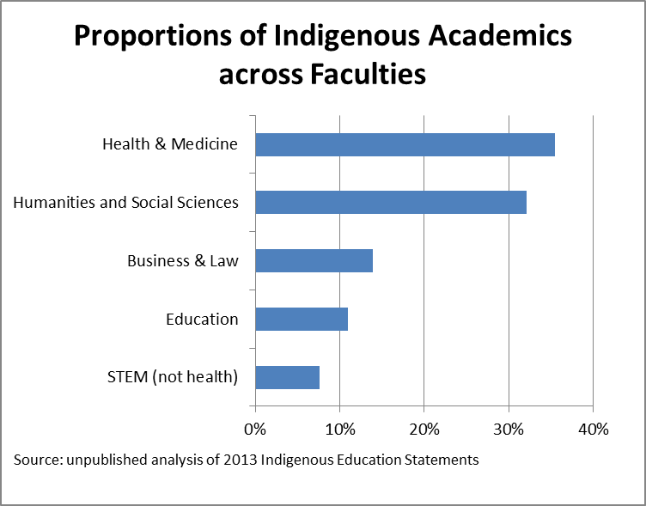

This is consistent with the distribution of Indigenous researchers across fields of research from unpublished data from the Australian Research Council (ARC). ARC data does show that there are more Indigenous researchers in the grant applications and funded grants in the Humanities and Social Sciences than in Health and Medicine. This distribution is also consistent with the distribution of Indigenous HDR students across fields of study as shown below.

# Pipeline (HDR)

The typical pathway into an academic career in 2015 is through completion of a Higher Degree by Research (HDR). HDRs are of two types, Doctors of Philosophy (PhD), the usual standard for entry, and a Masters degree by research (often a Master of Philosophy (MPhil)). HDRs are mostly funded under the RTS, which has as its objectives:

* enhance the quality of research training provision in Australia;
* improve the responsiveness of providers to the needs of their research students;
* encourage providers to develop their own research training profiles;
* ensure the relevance of research degree program to labour market requirements; and
* improve the efficiency and effectiveness of research training.

Many but not all HDR students apply for and are funded through an APA. An APA provides a stipend for the student plus allowances and conditions to help progress their research. Qualification for an APA is usually through an Australian Honours degree with results at the first class or upper second class level – roughly High Distinction or Distinction level average. There is scope for providers to assess students as having equivalent levels of achievement. As the process is competitive, there is variability across providers and disciplines as to what might be counted as equivalent. Institutions are required to maintain a policy that enables selection of recipients through a merit process. Indigeneity is not in and of itself addressed in the specified selection criteria.

Indigenous HDR commencements and completions have been trending upwards since 1989 both in numbers and as proportions of all domestic commencements and completions. There was a sharp downturn in both from 2011 to 2013.

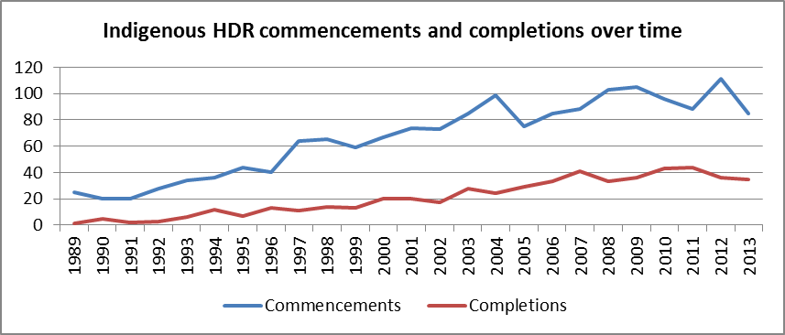

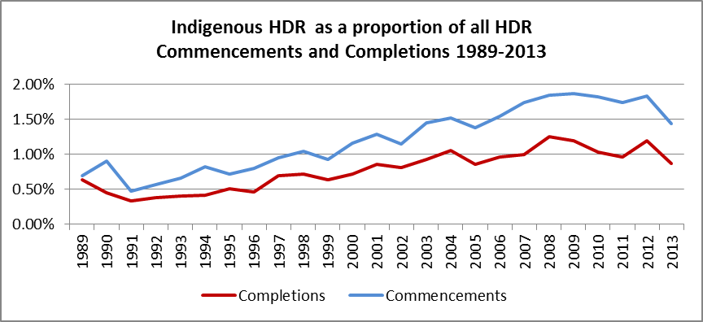

# Fields of Education

Indigenous HDR students are clustered in a narrow range of fields of education. This is consistent with similar narrow clustering at undergraduate levels and amongst Indigenous academics.

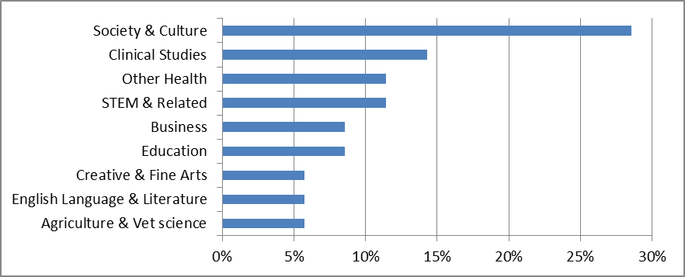

# Supervision

The stocktake of Indigenous Research Capacity for the *National Best Practice framework for Cultural Competency in Australian Universities* (Universities Australia, 2011) notes a total of eighteen out of thirty eight universities had processes in place to encourage research training by promising Indigenous students and staff (pp119ff). The report notes that Australian universities lag behind Canadian and New Zealand institutions in cultural competence in Indigenous research and culturally sound models and practices for research (pp184ff).

The *Review of Higher Education Access and Outcomes for Aboriginal and Torres Strait Islander People* (Behrendt, 2012) notes the under-representation of Indigenous students amongst HDR and APA students. Supervision is a key factor in attracting, retaining and graduating HDR students generally, and Indigenous HDR students in particular. There are concerns about the cultural competency of supervision for Indigenous HDR candidates expressed in Behrendt 2012. The report recommended programs to improve the cultural competence of supervisors of Indigenous HDR students.

# Student support – comparison of APAs and AbStudy

Student support, financial and supervisory, is a key consideration in recruiting, retaining and completing Indigenous HDR students. The two forms of financial support available for Indigenous students are ABSTUDY and APAs. The tables below compare the basic pay rates provided by ABSTUDY and APAs to students (over the age of 25) while undertaking study in 2015.

ABSTUDY & APA rates for PhD support

|  | Age | ABSTUDY | | APA | | | |
| --- | --- | --- | --- | --- | --- | --- | --- |
| fortnight | year | fortnight | | year | |
| Full time | Part time | Full time | Part time |
| Single | 25+ | 515.60 | 13,405.60 | 994.00 | 497.00 | 25,849.00 | 12,924.00 |
| Single with dependent | 25+ | 557.90 | 14,505.40 | 994.00 | 497.00 | 25,849.00 | 12,924.00 |
| Married/ couple no dependent | 25+ | 557.90 | 14,505.40 | 994.00 | 497.00 | 25,849.00 | 12,924.00 |
| Married/couple with dependent | 25+ | 465.50 | 12,103 | 994.00 | 497.00 | 25,849.00 | 12,924.00 |
| Dependent at home | 22+ | 515.60 | 13,405.60 | 994.00 | 497.00 | 25,849.00 | 12,924.00 |
| Dependent away from home | 22+ | 515.60 | 13,405.60 | 994.00 | 497.00 | 25,849.00 | 12,924.00 |
| Masters | 22+ | 991.50 | 25,779.00 | 994.00 | 497.00 | 25,849.00 | 12,924.00 |

APAs do not decrease with earnings. In all cases, institutions are required to monitor students’ workloads to ensure work does not interfere with completion prospects. For APA holders, casual teaching, marking and research assistant positions are a good fit. APAs are tax exempt and do not assess or adjust for partner income.

ABSTDUDY reduces at 50c/$ for earnings, by either the student or their partner, of over $914.00 per fortnight. For ABSTUDY, each case is developed with staff from CentreLink. Where Indigenous students do not secure an APA, ABSTUDY does not provide the kind of support needed for HDR study and progression to academic careers.

Behrendt recommends setting aside APA and HDR places specifically for indigenous students. There is a further need to improve supervision and support in order to accelerate completion times and better prepare Indigenous HDR students for careers both partially and wholly in the academy.

# The future academic workforce

The perception of academics and their roles as being solely about, ‘academics who conduct research, publish, and then perhaps convey the knowledge of what they have learned to students’ (Boyer, 1997) is no longer the case within Australia. The continual growth of universities, larger demands for professional qualifications and increasing student numbers have changed this old perception. Along with other countries, Australian universities have seen an increase in sessional, fixed term and other categories of contingent staff.

Coates and Goedegebuure (2010) approach the casualization of the academic workforce as instructive of the change in the nature and career paths of academics. Coates and Goedegebuure identify five typographical roles that combine in various ways according to the needs and capabilities of institutions and individuals to make up the characteristics of an academic appointment. Bexley, James and Arkoudis find similar emergent diversity in academic roles but argue that a typography of academic roles should not be imposed on the sector, rather diversity should be allowed to evolve in response to institutional, student and disciplinary drivers (p50ff).

## The future academic workforce

The future of the academic workforce can be split into a number of key categories, these are;

* shifting of the perception of past academic roles into future roles;
* attraction and retention of academic staff – ageing staff, training and opportunities for teachers/researchers
* a new academic workforce – sessional academics and long term staff, new technologies

## Shift in roles

From their analysis of the roles of sessional and casual academics, Coates and Goedegebuure (2010) extrapolate to roles of ongoing academics in universities. They identify a variety of combinations of teaching, research and leadership that might vary within and between institutions, faculties and departments. While there is a perception that academics are currently required to be proficient in research and discovery, integration and application of knowledge and teaching these to students, future academic roles may be more specialised or more diverse depending on institutional focus and individual preferences.

Currently, under the demand driven system and in response to international student markets, universities are increasing their focus on and resourcing for teaching. At the same time university reputations are driven by global rankings based primarily on research performance. The increasing focus on teaching is seen by some as reducing the capacity of academics to conduct research at a level previously required for promotion through to professorial levels. Promotion to professorial levels for teaching excellence is occurring but is relatively recent and lags promotion for research excellence. In a more diverse future, both roles and pathways will need to be more malleable and mutable for institutions and academics.

## Attraction and retention of academic staff

The Australian academic workforce is ageing and a number of new talented academics are finding work and research opportunities outside of Australia (Bexley, James, Arkoudis 2011). This raises a number of concerns. For example, how the current knowledge of academia is being passed on to new academics, and how is the loss of talented academics impacting on universities’ abilities to conduct their business.

To address the ageing academic population, universities will need to look at how they provide support and skills to new academic researchers and teachers (Bexley, James, Arkoudis 2011). Many new academics are looking to learn new skills and progress their career and academic portfolio. This could be accomplished through mentoring programs and career pathways that will allow talented academics to work closely with professorial and senior researchers to publish joint papers and build a research profile.

Universities will also need to look at developing new internal policies that support current academic staff to allow them to train new staff without exacerbating current overload concerns. This can be accomplished by clearer separation of roles between administration, research, service and teaching

Universities will also need to look at what areas new academics can work in and ensure that the right amount of support is in place to develop their professional portfolio. One part of this development in the contemporary university is international experience through scholarships, exchanges, collaborations and attending and presenting at international disciplinary and cross-disciplinary conferences and seminars.

Another critical aspect of developing new academics both in their PhD and post-doctoral periods is experience in high performing laboratories and research teams both in Australia and internationally. Incentives for training HDR students under the RTS, and, for post-doctoral placements, under the ARC and NH&MRC funding streams may be needed. These incentives could be extended to high performing laboratories and research teams under the general oversight of universities.

Indigenous academics must not be sidelined in meaningless roles that do not provide them the opportunity to develop and contribute to the academy to their full potential. This should be self-evident for all would-be academics, but there appear to be disciplinary and systemic drivers that serve to disproportionately push Indigenous academics and aspirants into roles and disciplines not considered high value in the academy generally.

## A new academic workforce

Australian universities are facing greater demand to provide highly qualified professionals (Hugo and Morriss, 2010). Universities in recent times have also seen increase number of enrolments from both local and international students.

The increasing demand for places in Australian universities will change the way the current academic workforce operates. For example universities are now using new technologies that enable students to access course materials online and allow researchers/professors to access information while in the field or at home.

This ability to access things online and while in the field or at home will require greater knowledge from academics of how to access/navigate online systems. It will also require universities to provide the necessary equipment for staff, researchers and students and to have professional staff that can provide assistance to people that are having difficulty in operating the systems e.g. Information and Technology teams (IT). Universities will need to provide adequate training to new academic staff so they can conduct their day to day work.

It is not necessarily the case that online students and academics cost less than those on campus. Online students still need online tutorial support through message boards, discussion boards, email and resources such as podcasts, lecture videos, and study materials. There is still marking of assignments, provision of advice and administering examinations. The load on academics is spread over 24 hours a day and seven days a week as students no longer follow a lecture, tutorial and advising schedule governed by campus rooms and offices. Investments in learning management systems, educational designers, media tools, IT support for academics and students, bandwidth and server space take the place of bricks and mortar building and maintenance and are not always cheaper. The skills required of academics are wider than content knowledge and basic educational techniques extending to educational design, technology platform knowledge, interface design and different approaches to student management and advising.

Similarly, virtual research spaces, digital humanities, virtual laboratories and data modelling all require new research skills, new accessibility modes and media, IT support, bandwidth, server space and ever increasing processing speeds. Interfaces between virtual and physical infrastructure across campuses and countries all contribute to a 24 hour, seven days a week research cycle with distributed teams, collaborative authoring and demanding publishing schedules. Here too, the skills for researchers broaden beyond content and inquiry skills to technological mastery and higher-level collaborative skills.

Another change in the academic work force is the increasing introduction of ‘sessional’ and ‘fixed or short term academic staff’ to meet the higher demand of teaching and professional research roles. For example, universities focusing their resources and staff into teaching new students may find that this greater demand on the teaching role then affects the ability of academics to conduct research.

Increasing sessional staff numbers for teaching is seen to improve flexibility and reduce costs, similarly fixed term appointments for specific research projects reduces long-term costs for the university. It also provides options for professional academics who might wish to offer their ability to conduct research or teach and prefer to work part time and entry positions for PhD students and graduates. However as Bexley et al point out, this trend may be affecting the satisfaction with and attractiveness of academic roles for those both occupying and on a pathway towards such roles: post doctoral and grants treadmills are not seen as positives.

One area of concern lies in the way that knowledge is obtained and maintained in the university. Without long term staff, new academics cannot access the skills and abilities built up over time and corporate knowledge is at risk. Further, sessional staff often do not have a say in the university and often have to work alone without much support from university.

## How it will impact on Indigenous academics

Universities need to set targets for training new Indigenous academics. This training could include opportunities that range from mentoring programs to pathways programs.

With the focus on teaching and few roles for research, Indigenous academic staff may find themselves more often in a teaching role than in the research field. However, universities should avoid corralling Indigenous academics into dead-end roles that may arise from confinement to a narrow research field, unsupported teaching-only positions or purely administrative roles. In particular, roles focused only on service teaching on Indigenous issues and cultural competency across professional programs such as medicine, law, teaching, and business disciplines are to be avoided.

The increase of workloads and higher demand for academic staff to do multiple research projects and teach in classes could reduce the capacity for new research on Indigenous issues. This could lead to situations where Indigenous academics who are seeking to engage in new research projects may receive less support by universities and other players in academe. Already stretched senior Indigenous academics may find it difficult to make time to mentor and advise new Indigenous academics on research methods, grant applications, funding and publication matters resulting in higher rates of attrition among new Indigenous researchers.

Indigenous academics will be affected by the introduction of new technologies as they will need access and training in new programs and software. For aspiring Indigenous academics wishing to conduct work or research from home or other locations, especially remote locations, they will have to purchase, rent or be provided with the necessary equipment to access online material and the training to use it effectively and efficiently. In some cases this could involve cultural and language issues for resolution.

The change in the role of long term and sessional staff can also impact on Indigenous academics. For example, universities can recruit more sessional Indigenous academics in predominantly teaching roles but this will not provide them with the opportunity to conduct research or develop their research and leadership skills. On the other hand, universities can recruit fixed term Indigenous staff in predominantly research roles but, again, these staff may not be given the adequate support in learning new skills and can be locked into Indigenous research fields only. The issue at heart is that being a “well-rounded” academic is a better basis for selecting, pursuing and developing an academic career in a changing environment than being locked into a narrow role using only a narrow skill-set.

Universities will need to look at how they engage with Indigenous academics and what roles they can play in universities in the course of research and teaching and how to support and develop these staff. This can be done by the use of mentors and pathways training that leads to long term employment and ability to publish research and develop and teach whole courses. Additional incentives for training Indigenous HDR students under the RTS, and, for Indigenous post-doctoral placements, under the ARC and NH&MRC funding streams, could be extended to high performing laboratories and research teams under the general oversight of universities. New Indigenous HDR students could provide a useful cohort to pilot and evaluate the impact on outcomes from these kinds of incentives.

Pathways and new types of academic roles provide options for reconfiguration of academic career paths for Indigenous students, professionals and academics as a lead innovation for renewal and revitalisation of the academic workforce. What is to be avoided is reconfiguring pathways and careers that involve longer periods in contingent and casual roles involuntarily and as a matter of course.

# Emergent issues for policy response

You can’t be what you can’t see: there is a crucial leadership role for Indigenous academics as trail-blazers for Indigenous higher education students, actual and potential. The traditional PhD pathway for academia is under strain and is unlikely to produce the kinds of academics required for the future in sufficient numbers to meet demand in key disciplines.

There is a new kind of academic found increasingly on campuses, both actual and virtual. This is the professional as academic. In particular in business, law and engineering disciplines, but also in ICT, journalism and health professions, full-time professionals take up part-time, after-hours roles, so-called “fractional appointments”, as well as professionals who spend alternating periods inside and outside the university. All of these academics may have a range of teaching and/or research responsibilities. As universities increase links with business and industry, these kinds of positions are likely to multiply. In the case of Indigenous academics and professionals, the pool of professionals provides the possibility for extending the Indigenous academic workforce across a broader range of disciplines. This will, however, require new thinking on credentialing of academics and how to manage both the rfactions of time and the transitions between the academy and the world of business and industry.

There is no longer scope for incrementalism and one thing at a time approaches to increasing the representation of Indigenous academics and HDR students in institutions or disciplines. The issues require a systemic approach that systematically addresses drivers and blockages along the pipeline and within the academy. The outcome to be sought needs to be conceptualised in terms of a “step-change” in short order so as to change the nature of the academic pipeline and career as perceived by both institutions and Indigenous people.

# Practical suggestions for action

In New Zealand the Performance-Based Research Fund[1] includes an equity weighting for Maori and Pacific Islander HDR completions (pp9-11). New Zealand also provide higher weighting for dissertations written in Maori, which may not be applicable in Australia due to limitations on numbers of reviewers able to read Aboriginal and Torres Strait Islander languages.

There is a trend in New Zealand for Maori PhD students to undertake studies, including PhDs in non-Maori specific disciplines. The view is that the Maori community provides the cultural and linguistic education for Maori students who then study in the broad science, business, health and humanities disciplines to bring those skills to the community. This may not be as applicable to the Australian Indigenous circumstances due to community needs for cultural and linguistic recovery and revitalisation. Nonetheless, broadening of disciplines at HDR level is as important as at undergraduate and postgraduate coursework levels.

# Recommendations

* Council to recommend the Minister for Education and Training introduce changes to the Australian Postgraduate Awards (APAs) and the Research Training Scheme (RTS) including:
  + earmark a portion of APAs for Indigenous students at national and/or institutional levels
  + review of APA rates for Indigenous HDR students in remote locations, with family responsibilities and with entry level professional jobs
  + reconfiguring the RTS to provide higher payment rates for Indigenous completions and to provide more extensive support
  + providing greater discretion against the selection criteria for institutions on enrolment of Indigenous students whilst maintaining research and completion standards
  + recognising qualifications other than an Australian first-class honours degree as proper preparation for HDR programs
  + early identification of high potential and high performing Indigenous students to encourage and facilitate access into academic workforce streams
* The Minister for Education and Training convene a group of experts to discuss and monitor progress, commencing with: work to identify what drives change at all points in the pipeline; and how to retain Indigenous academics in the academy through, for example:
  + Better support for cultural competency training for supervisors
  + restructuring of the traditional PhD to better meet the needs for teaching and research careers in professional fields for Indigenous professionals
  + fractional appointments of respected professionals into both teaching and research roles
  + use of Professional Doctorates for teaching centred roles
  + mobility programs within and between institutions to enable early career Indigenous academics to build repertoire and profile in both teaching and research
  + internships for early career professionals to explore research and teaching options under full, fractional or sessional appointments
  + greater acceptance and use of the graduate certificate of higher education as a teaching qualification for practising professionals seeking fractional and/or sessional appointments in their field
* Government to explore whether there is a need to align the conditions for ABSTUDY for students undertaking higher Degrees by Research with Australian Postgraduate Awards with respect to taxation treatment and as to the effect of earnings by the student and their partners and dependents, or to provide other support to Indigenous research students not in receipt of an APA.

1. Performance-Based Research Fund User Manual Version 3. December 2014