
National Evaluation for the
Low SES National Partnership and the
Literacy and Numeracy National Partnership - Impact Stage
Final Report
March 2014

Table of Contents
National Overview 3
Australian Capital Territory 23
New South Wales 49
Northern Territory 94
Queensland 120
South Australia 158
Tasmania 194
Victoria 223
Western Australia 260
Core Evaluation 302
References 317
Appendices 327

National Overview

The Smarter Schools National Partnerships
The improvement of the quality of educational systems is currently one of the most vital tasks of governments worldwide. International literature has validated the fact that education has a transformational effect on individuals and society. Individuals with higher levels of education are found to experience more favourable labour market outcomes, health levels and life satisfaction.
In Australia, there is a growing understanding that Commonwealth and State Governments share the objective of raising overall educational attainment so that all Australian school students acquire the knowledge and skills required to participate effectively in society. In November 2008, the Council of Australian Governments (COAG) established the National Education Agreement as an agenda to achieve the outcomes that are integral to boosting Australia’s labour force participation and productivity.
In this context, the Smarter Schools National Partnerships (SSNP) represented the largest ever direct school-resourcing intervention by the Australian Commonwealth Government. Aimed at addressing disadvantaged schools, improving teaching and raising student outcomes, the SSNP provided a total of approximately $2.5 billion in funding through three partnerships:
- $1.5 billion to the Smarter Schools National Partnership for Low Socio-economic Status School Communities (Low SES NP)
- $540 million to the Smarter Schools National Partnership for Literacy and Numeracy and (LNNP)
- $550 million to the Smarter Schools National Partnership for Improving Teacher Quality.
Further information on funding, specifically by jurisdiction and SSNP type (Low SES NP and LNNP), is presented in Appendix 1.
Government schools represented 74.3% of Low SES NP and LNNP schools, with Catholic and Independent schools accounting for 17.1% and 8.6% of participating schools respectively. The majority of selected schools participated in one of the two partnerships, as only 6.4% of schools participated in both the Low SES NP and LNNP (Appendix 2). Combined, the two NPs involved the participation of 24.6% of all Australian school students and 54.6% of all Indigenous students (Appendix 3, Table C). The proportion of students in participating schools varied across jurisdictions, ranging from 20.5% of all students in Victoria to 54.5% in the Northern Territory. The proportions of Indigenous students in participating schools showed significant variation, ranging from 25.7% of all Indigenous students in the ACT to 83.5% in the Northern Territory (Appendix 3, Table D).

Background to the Impact Evaluation of the Low SES NP and LNNP
The first phase of the evaluation of the Low SES NP and the LNNP focused on the implementation and sustainability of the partnerships. In March 2013, the Australian Government Department of Education (formerly the Department of Education, Employment and Workplace Relations (DEEWR)) commissioned Parkville Global Advisory (PGA) to undertake an evaluation of the impact of the Low SES NP and the LNNP. The main objectives of this Impact Stage are to synthesise existing information to determine the outcomes, effectiveness and unintended consequences of the two partnerships between 2009 and 2012, as well as to identify any gaps in existing data.
As part of this stage of the evaluation, PGA developed the National Evaluation Framework in line with the National Evaluation Strategy and in consultation with Australian Government Department of Education as well as representatives of all three education sectors in each of the eight Australian states and territories. A key component of the Framework was the development of individual program logic maps for each jurisdiction to guide the evaluation. This followed bilateral consultations with all jurisdictions, in addition to extensive discussion with members of the National Partnerships Implementation Working Group (NPIWG) Evaluation Sub-group. The program logic defines the inputs, activities, outputs and outcomes for the partnerships under evaluation. Individualised program logics were necessary since the intended focus of each partnership and the implementation of initiatives varied greatly between jurisdictions. This Impact Stage is primarily concerned with identifying outputs and measuring outcomes or leading indicators based on the program logics for schools which participated in either of the Low SES NP or LNNP.
The Scoping Paper developed by the NPIWG Evaluation Sub-group, and endorsed by the Australian Education, Early Childhood Development and Youth Affairs Senior Officials Committee (AEEYSOC), specifies that the main methodology to be used in the Impact Stage is the synthesis of existing information to determine the outcomes and effectiveness of the two partnerships between 2008 and 2012. With no provisions in the Strategy for additional data collection during this stage, all analyses were restricted to existing data. PGA has taken a broad definition of existing information, actively seeking data from all 24 education sectors across Australia to support the evaluation as well as the Australian Curriculum, Assessment and Reporting Authority (ACARA). This wide-ranging approach enabled the evaluator to identify gaps in the data for the purpose of designing an evaluation plan for a possible Core Evaluation stage.
PGA has utilised two main categories of information to evaluate the agreed outcomes in jurisdictions’ program logics. The first encompasses state literature including all progress and annual reports, reviews, surveys, case studies and evaluations of jurisdictions’ programs or initiatives. The second type of information is the jurisdictional data relating to each of the designated outcomes. These were obtained from jurisdictions directly or from the Australian Curriculum Assessment and Reporting Authority with the approval of the respective sectors. This section provides an overview of the main findings from this synthesis of existing information.

Summary of Initial Findings - A National Perspective

Activities and Outputs under the Low SES NP and the LNNP
The examination of the ways in which inputs were utilised under the two partnerships reveals important findings for policy-makers and educators. To begin with, the Low SES NP and the LNNP were unique in their approach of simultaneously offering direct funding with either relatively elevated autonomy or increased resources to which school autonomy applied. Facilitation funding did not require the implementation of specific activities, with participating schools choosing how to spend NP funds based on their unique needs. This is a growing field of analysis in education systems worldwide following decades of research which failed to establish a causal link between resourcing and student outcomes. The rationale and implementation of both partnerships offer insight into the impact of combining additional resources with relatively devolved decision-making.
In most jurisdictions, education authorities or agencies were found to have implemented a combination of initiatives at a systemic level along with school-, region- or student-level initiatives. Variation was found between sectors with Independent and Catholic sectors across Australia more likely to have adopted centralised initiatives, although nearly all sectors had some form of school-level programs. Examples of centralised initiatives included employing coaches and consultants to provide support for multiple schools. School-level initiatives were often determined at the school or region level to meet students’ needs best within the partnerships’ key reform areas. This created substantial variation in implementation amongst the 2,705 primary and secondary participating schools throughout Australia (Table A). Therefore, schools’ experiences as part of the SSNP are likely to differ both across and within states.
While names of particular activities varied amongst participants, the analysis found that the range of initiatives reported to have been implemented can be summarised by the matrix in Figure 1.
Figure 1: Characterising initiatives under the
Low SES and Literacy and Numeracy National Partnerships
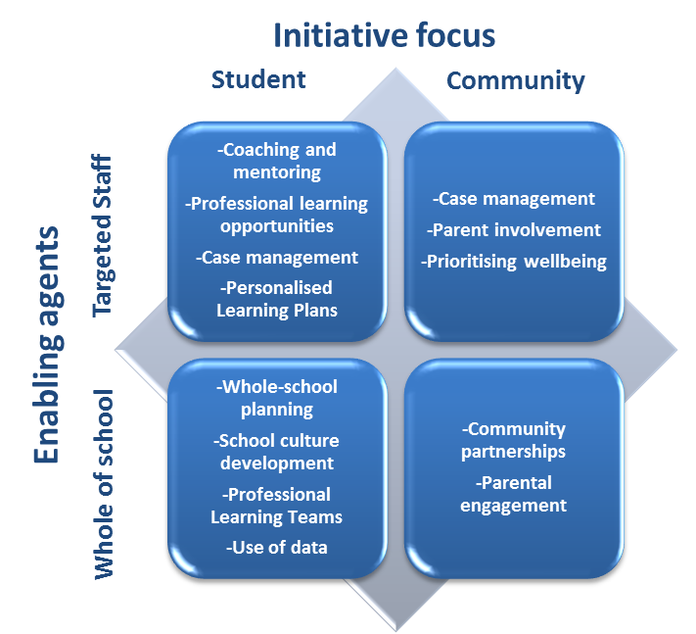
Enabling agents | Initiative focus
Enabling agents | Student | Community
Targeted Staff | - Coaching and mentoring  - Professional learning opportunities  - Case management  - Personalised Learning Plans | - Case management  - Parent involvement  - Prioritising wellbeing
Whole of school | - Whole-school planning  - School culture development  - Professional Learning Teams  - Use of data | - Community partnerships  - Parental engagement
Coaching and mentoring of principals or teachers was one of the most widespread initiatives throughout jurisdictions. This type of activity involved appointing coaches from within schools or hiring external coaches to work closely alongside staff to provide tailored advice and/or assistance. In some states, survey respondents identified coaching as one of the two most important aspects of the partnership. Professional learning opportunities enabled staff to undergo training in an area they identified in order to provide innovative instruction to students. Activities that included some form of case-management or the development of personalised learning plans were consistently reported as vital components of the partnership in numerous jurisdictions.
The flexibility of the NP, enabling schools to adopt whole-school strategies was often cited as another central feature. Forming professional learning teams and collaboratively using data were other school-wide initiatives which the NP is reported to have facilitated, with the latter a particularly widespread strategy.
In addition to helping establish a coherent and supportive school culture, the partnerships, particularly the Low SES NP, enabled schools to build relationships with their communities. This was not restricted to the Low SES NP as some schools in the LNNP were also found to have established sustained partnerships with the tertiary sector.
Priority areas for reform were identified in the Low SES NP and LNNP National Agreements. Representative national evidence on which particular reforms or initiatives worked best could not be found in this evaluation. Attribution of program effects was complicated by a number of factors, including a multitude of localised approaches to implementation of the NP and the absence of consistent information on schools’ take-up of various initiatives as well as insufficient information on potentially confounding non-NP initiatives. Thus establishing a link between activities, outputs and outcomes is not possible using existing data, yet unpacking this link remains vital for informing future interventions and underpins the proposed Core Evaluation phase. Some evidence of effective programs was found at the jurisdiction level as discussed in the final section of this national overview, though this varied from anecdotal reports or case studies to independent evaluations of specific initiatives. PGA has analysed this information and identified gaps in the existing literature relating to the success of the reforms as well as how best to sustain any positive impact of the reforms.

Outcomes under the Low SES NP and the LNNP
The Low SES NP was established to support a range of school level and broader reforms that address educational disadvantage associated with low socio-economic status school communities. In addition to helping to close the achievement gap for disadvantaged students, engagement is seen as an essential element for sustainable improvements in learning (Marzano 2013; Patterson 2006). The aim of this NP was for schools implementing reforms to become better equipped to address the complex and interconnected challenges facing students in disadvantaged communities. Under the Low SES NP, targeted outcomes include:
- All children are engaged in and benefiting from schooling
- Young people are meeting basic literacy and numeracy standards, and overall levels of literacy and numeracy achievement are improving.
- Schooling promotes the social inclusion and reduces the education disadvantage of children, especially Indigenous children.
- Australian students excel by international standards.
- Young people make a successful transition from school to work and further study.
The LNNP was initiated to put in place the infrastructure and practices that will deliver sustained improvement in literacy and numeracy outcomes for all students, especially those who are falling behind. It aimed to facilitate literacy and numeracy reform activities over two years from 2010-2011. An additional $350 million in conditional reward funding was made available in the following two years to reward achievement of agreed literacy and numeracy performance targets. Under the LNNP, targeted outcomes include:
- Young people are meeting basic literacy and numeracy standards, and overall levels of literacy and numeracy achievement are improving.
- Australian students excel by international standards.
This Impact Stage of the national evaluation of the Low SES and LNNP is guided by the National Evaluation Framework. The jurisdiction-specific program logics recognise the diverse initiatives applied throughout NP schools as well as the variety of intended outputs and outcomes.
Intended outcomes under both partnerships relate directly or indirectly to either student achievement or student engagement (see Figure 9.1 under the Core Evaluation section). Among the intended outcomes, student achievement is common to both partnerships and is the only outcome for which data is available at a national level in the form of NAPLAN results. No nationally comparable data is available on student engagement. Existing information and evidence vary widely across jurisdictions. They range from limited evidence based on aggregated summary data with anecdotal information to systematically robust evidence based on both quantitative and qualitative methods (see Figure 9.2 under the Core Evaluation section for more details). This affects the type of conclusions that can be made regarding the impact of the NP and the effectiveness of various programs.
Before analysing the outcomes of NP schools, three caveats need to be observed. The first is that several outcomes under both partnerships are long-term in nature. They represent aspirational targets intended over the lifetime of the partnerships and beyond. Therefore, while it may be possible to measure leading indicators of these outcomes, substantial changes in indicators relating to these long-term outcomes may take longer than six years to manifest (Atelier Learning Solutions 2012) and are not expected within the period under evaluation, namely 2009-2012. For example, the education literature suggests some outcomes targeted by the Low SES NP or LNNP may not immediately respond to interventions. It is therefore vital to consider that the measured impact of the partnerships is likely to be partially understated as a result of the limited number of years since they commenced. The final evaluation stage can provide a better understanding of the impact of implemented activities and the sustainability of observed outcomes over a prolonged period of time that is commensurate with the research on response to interventions.
The second important point to note is that the NPs did not operate in isolation at selected schools. Other reform activity is likely to have been in place or concurrently introduced in selected or unselected schools. It is further apparent through consultations with stakeholders in each jurisdiction that particular initiatives may have been shared with other NP such as the Improving Teacher Quality NP or the Closing the Gap NP. This is a significant external factor when considering the external validity of the two partnerships under evaluation or attempting to attribute any observed improvements to particular initiatives.
Finally, this evaluation has relied on existing information only as stipulated in the National Evaluation Strategy. While a multitude of interesting findings have emerged in this evaluation, vital information for educators and education officials can still be uncovered if gaps in current data are addressed. Moreover, the quality of existing data ranges from reliable and representative to case-specific and anecdotal. For example, the evaluation found that analysis of student achievement data is sensitive to the level of aggregation. As the subsequent section shows, school-level data cannot account for movements amongst students and may lead to different results compared to student-level or linked program data.

NP Impact on Student Achievement
As is the case with all program evaluations, determining the impact of the SSNP critically relies on access to appropriate data and usage of a suitable methodology. NAPLAN was first conducted as a uniform national measure of student achievement in 2008. Since for any student cohort only one year of NAPLAN data is available prior to the NP, it is only possible to causally evaluate the national impact of the SSNP by comparing the growth in student outcomes in participating schools to that made by students in similar schools that were not chosen for the NP.

Methodological Issues with Evaluating the Impact of the NP
The methodology required for robust impact evaluation of the NP is inextricably linked to the way in which schools were assigned into the Partnerships. Selection into either NP was not random, but instead targeted specific groups which, on average, started from a lower point compared to schools that were not selected. The analysis of national data presented in this section utilises models that account for this non-random assignment. Failing to model the selection process will bias the measured effect of the NP. By employing the method known as regression-discontinuity design (see Appendix 4), the results shown here provide the best estimates of the causal impact of the Low SES NP. However, it must be noted that within selected schools and in certain jurisdictions, the chosen initiatives often targeted a very small proportion for a given period of time. Moreover, the type of students targeted by these initiatives varied by jurisdiction. This poses a further challenge in detecting significant changes resulting from such initiatives.
In the absence of unit-record data from all jurisdictions, national analysis can only be conducted using the publicly available school-level data from the My School website. This analysis measures the observed association between participation in the Low SES NP and growth in NAPLAN scores over a two-year period. However, the results of such analyses should be interpreted with caution as they do not compare the same students over time. For instance, although increasing student attendance and NAPLAN participation were intended outcomes of the Low SES NP, this is likely to have a counter effect on aggregated achievement results since these students are likely to have lower achievement. In addition, aggregated school level data is insensitive to student movement in and out of schools. As a result, analysis of school-level data was found to yield different results to the more accurate analysis of unit-level data. This can be seen in the following example using data from an Australian jurisdiction where both unit-record data and school-level data were available.
Figure 2 shows estimates of the effect of the Low SES NP on growth in student achievement between 2009 and 2011 using data at the school and student level. This particular period of time is chosen as it allows for at least two years of Low SES NP participation, from an appropriate baseline of 2009. Low SES NP schools that did not commence participation in 2009 or 2010 were excluded from the analysis. The columns depict the additional contribution of participating in the Low SES NP, controlling for schools’ starting point, size and socioeconomic composition. The estimates imply that participating in the Low SES NP was not found to have any statistically significant association with growth in student achievement between Year 7 and Year 9 when school-level data was used. In contrast, analysis using matched student-level data showed that the Low SES NP was found to have contributed 5.4 points and 4.9 points to Numeracy and Reading growth respectively. Both estimates were found to be highly significant. The level of data aggregation is therefore an important consideration for evaluating the impact of the national partnerships.
Figure 2: Comparing Estimated Effects in One Australian Jurisdiction using School-Level and Student-Level Data
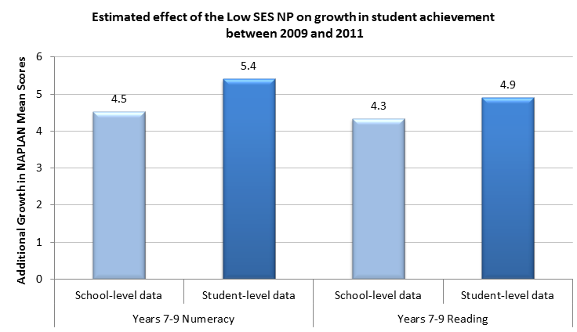
Additional Growth in NAPLAN Mean Scores
 | School-level data | Student-level data
Years 7 to 9 Numeracy | 4.5 | 5.4
Years 7 to 9 Reading | 4.3 | 4.9
Bars represented in dark colours (Numeracy and Reading: Student level data) are significant at the 5% confidence level while those in light colours (Numeracy and Reading: School level data) were not significantly different from zero at the 5% or 10% level.

Low SES NP – Overview of National Findings
Estimating a model to estimate the impact of the Low SES NP at a national level can currently only be conducted using aggregated school means data. Figure 3 presents the results of this analysis using school-level data from all sectors and jurisdictions in Australia. Only the Year 3 to Year 5 estimates include schools from across Australia since the two year levels are both within the primary education phase in all jurisdictions. Given differences in the structure of secondary schooling, the primary cohort is the only national sample for which growth analysis can be conducted. It must also be noted that primary schools constituted the majority of all schools participating in the SSNP.
The results show a small but statistically significant association between the Low SES NP and growth in student achievement between 2009 and 2011, though this varies by domain and grade level. The estimates suggest that participating in the Low SES NP, holding all else equal, was associated with an additional 5.5 points in average Numeracy growth on the NAPLAN scale from Year 3 in 2009 to Year 5 in 2011. This was even higher for the Year 7 to Year 9 cohort during the same period as the estimated additional growth was 7.7 points in the five jurisdictions where the analysis was feasible. While some positive estimates were found for Numeracy, negative yet smaller effects were identified in Year 3 to Year 5 Reading growth for Low SES NP schools. At these schools, the results show that average achievement in Reading was reduced by 4.3 points.
Figure 3: Estimating the Impact of the Low SES National Partnership
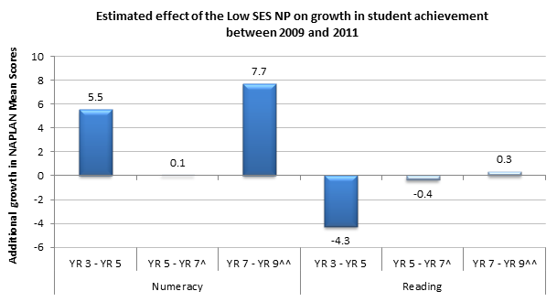
 | Year 3 to Year 5 Numeracy | Year 5 to Year 7 Numeracy* | Year 7 to Year 9 Numeracy^ | Year 3 to Year 5 Reading | Year 5 to Year 7 Reading* | Year 7 to Year 9 Reading^
Additional growth in NAPLAN mean scores | 5.5 | 0.1 | 7.7 | -4.3 | -0.4 | 0.3
^ Includes only QLD, SA and WA Government schools where secondary schooling commences in Year 8.
^^ Includes only NSW, VIC, TAS, NT and ACT where secondary schooling commences in Year 7.
Bars represented in dark colours (NUM: Yr3-Yr5; Yr7-Yr9; RDG:Yr3-YR5) are significant at the 5% confidence level.
As previously discussed and due to the use of aggregated school level data, the analysis cannot account for changes in the composition of cohorts sitting for NAPLAN. This results in previously disengaged students contributing to results in 2011 but not to the baseline year. For this and the other reasons described above, the national results using school-level data cannot be interpreted as the causal effect of the Low SES NP. Further investigation through unit-record data provided better estimates of the impact of participating in the partnerships by analysing results for students who were tested at two points in time in the same participating school.

LNNP – Overview of National Findings
It is not possible to conduct the analysis of the LNNP using regression-discontinuity design due to the considerable variation in selection criteria applied throughout jurisdictions. However, comparisons of achievement growth, referred to as apparent cohort gains, between LNNP schools and similar schools not treated by the NP can provide an indication of outcomes under this Partnership. Similar schools are defined as either schools with the same ICSEA decile or schools with the same initial achievement decile. The results of this analysis are shown in Figure 4 for 861 LNNP schools compared to non-NP schools, with LNNP schools representing 16% of all schools in Australia with primary level education and the data required to undertake this analysis.
Figure 4: Comparing Achievement in LNNP and Similar Untreated Schools
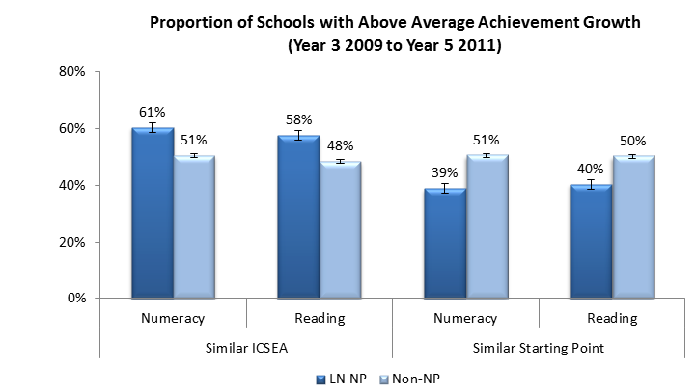
 |  | LNNP | Non-NP
Similar ICSEA | Numeracy | 61% | 51%
Similar ICSEA | Reading | 58% | 48%
Similar Starting Point | Numeracy | 39% | 51%
Similar Starting Point | Reading | 40% | 50%
The methodology used to construct this graph is outlined in Appendix 5.
LNNP schools are more likely to achieve above-average growth when compared to schools with similar a socioeconomic composition as measured by the Index of Community Socio-Educational Advantage (ICSEA). This is true for both domains as 61% of LNNP schools achieved Numeracy growth that exceeded the average growth for similar non-NP schools while this was seen in Reading for 58% of LNNP schools.
However, this does not account for variation in initial achievement levels between schools with similar ICSEA values. Analysis of NAPLAN data shows that apparent gains are generally larger for lower initial achievement levels. Therefore LNNP schools, which were selected into the program by definition due to lower achievement, are expected to have made greater gains. When LNNP schools are instead compared to non-NP schools with similar starting points, only 40% of LNNP schools were found to experience achievement growth exceeding the average for the comparison group in either Numeracy or Reading. Similar results were found for the Year 5 to Year 7 and Year 7 to Year 9 cohorts. This result highlights the fact that a major condition for LNNP selection was previously low achievement, which was not necessarily determined by socioeconomic status (SES).
Although this analysis has attempted to control for cohort effects by considering changes over two years, school level data is affected by the variability in aggregated NAPLAN data and cannot account for student movements. While a significant national impact on student achievement is not evident at this point in time for all treated schools on average, the above average improvements achieved by 40% of LNNP schools invite further investigation to identify how and why some LNNP schools achieved greater success than others.

NP Impact by Sector, Location and School Size
Further analysis of the impact of NP participation was conducted by school sector, location and size in line with the evaluation scope. Given that primary schools constituted the majority of all schools participating in the NP, this additional school-level analysis explored mean NAPLAN gains from Year 3 to Year 5. It is important to note that these results must be interpreted with caution since they aggregate data across jurisdictions with substantial differences in implementation and context. Moreover, as sector, location and size did not constitute real allocation criteria for either of the partnerships, the results should be seen as indications of association between these variables and participating in the Low SES NP or the LNNP, rather than exact causal estimates. Regression discontinuity design was used to estimate associations with participation in the Low SES NP, while the relationship between LNNP participation and these variables was estimated by comparing apparent cohort gains between LNNP schools and similar schools not treated by the NP.

Sector
The analysis of achievement by sector combines schools from eight different jurisdictions with the approach to the partnerships varying not only between these jurisdictions but often within states and territories as well. As a result, this analysis will only yield significant results if a national trend truly applied or if effects in one or more jurisdictions were large enough to outweigh average patterns elsewhere. Interestingly, participation in the Low SES NP was found to be associated with an additional 20.1 points in average NAPLAN Numeracy growth among the 2009-2011 student cohort in the Independent sector. This was found to be statistically significant. As anticipated, the results did not show significant effects associated with participating in the Low SES NP in the Government sector or the Catholic sector. The results do not suggest that achievement at Independent schools was positively impacted in every jurisdiction. However, on average, Independent schools across the country were likely to have had higher achievement as a result of participating in the Low SES NP compared to similar Independent schools that were not selected. Similarly, as the subsequent chapters show, there were significant positive effects found for Government and Catholic Low SES NP schools in certain jurisdictions despite the overall average effect not being significant.
In all three sectors and in both Reading and Numeracy, the proportion of LNNP schools that achieved above average growth was higher than that of non-NP schools with similar socioeconomic backgrounds. The most notable results were a 15% difference in Numeracy at Government schools (2009-2011 cohort), a 10% difference in Reading at Catholic schools (2009-2011 cohort) and a 7% difference in Numeracy at Independent schools (2010-2012 cohort). As with the analysis shown in Figure 4, this result did not hold when the comparing LNNP schools to non-NP schools with similar starting points, where the proportion of schools exhibiting above average growth was higher among non-NP schools, particularly in Reading.

Location
The analysis by school location suggests that the Low SES NP was more likely to impact metropolitan schools compared to those in a regional or remote location. In metropolitan locations, the gain in the average Numeracy score amongst the 2009-2011 cohort was found to be 4.1 points higher at Low SES NP schools than that in non-NP schools, a result that was found to be statistically significant. No difference in Numeracy growth was observed between Low SES NP and non-NP metropolitan schools among the 2010-2012 cohort while no significant effects were found for Reading among both cohorts. In comparison, no significant positive effects were found in either domain for schools at non-metropolitan locations.
At both metropolitan and non-metropolitan locations, the proportion of LNNP schools that achieved above average Reading and Numeracy growth among their primary cohort between 2009 and 2011 was higher than that of non-NP schools with similar socioeconomic backgrounds. These include differences of more than 8% in both domains at metropolitan locations and more than 11% in both domains at non-metropolitan locations. This was also observed, to a smaller extent, among the 2010-2012 cohort at non-metropolitan locations only. When the analysis compared LNNP schools to non-NP schools with similar starting points, the results showed that in both metropolitan and non-metropolitan schools, the proportion of schools who achieved above average growth in both Reading and Numeracy was higher among non-NP schools. However, non-metropolitan LNNP schools were more likely to exhibit growth patterns in Numeracy that were closer to those displayed at similar non-NP schools. On average, approximately 40% of non-metropolitan schools displayed above-average Numeracy growth when compared to non-NP schools with similar starting scores, while this proportion was 31% amongst metropolitan NP schools.
These results should also be interpreted carefully as the nature of non-metropolitan locations varies between jurisdictions. Furthermore, the approach to both partnerships, particularly the Low SES NP, was observed to have varied between some metropolitan and non-metropolitan locations. Given the lack of information on the multitude and complexity of implemented programs, it is not possible to attribute observed estimates to particular metropolitan or non-metropolitan initiatives.

School Size
Schools of different sizes may have different outcomes under both partnerships. This was explored by analysing results for primary schools with at least 400 students (large schools), compared to schools with less than 400 students (small schools). The results suggest greater gains among larger schools associated with participation in the Low SES NP. At large schools, participation in the Low SES NP was found to be associated with a 5.4 point increase in NAPLAN Numeracy gains among the 2009-2011 cohort and a
3.7 point additional gain among the 2010-2012 cohort. Consistent with the national findings in Figure 3, no significant effect was found for Reading. In comparison, participating in the Low SES NP was not estimated to have had a significant impact in either domain at schools with less than 400 students.
At both small and large schools in the 2009-2011 cohort, the proportion of LNNP schools who achieved above average Reading and Numeracy growth was higher than that of non-NP schools with similar socioeconomic backgrounds. These include differences of 11% in Numeracy at small schools and 12% in Reading at large schools. Only minor differences were observed among the 2010-2012 cohort. When the analysis compared LNNP schools to non-NP schools with similar starting points, the results showed that in both small and large schools, the proportion of schools who achieved above average growth in both Reading and Numeracy was higher among non-NP schools. This was found to be more prominent among the 2010-2012 cohort.

NP Impact on Indigenous Students
The impact of either NP on Indigenous students can only be assessed within states as the currently available national data does not contain indicators specifically relating to Indigenous students. NP participation was generally found to be associated with some improvements in achievement among Indigenous students, particularly in primary level Numeracy. In jurisdictions where there was a sufficient sample to undertake robust analysis of achievement among Indigenous students, unit-record analysis showed that participation in the Low SES NP was associated with additional growth in NAPLAN Numeracy scores between Years 3 and 5. This was also found to be true in the LNNP where Indigenous students at participating schools were more likely to exhibit above-average growth in Numeracy between the same year levels compared to students at similar schools.
Other interesting patterns of achievement were found in aggregated data from various jurisdictions. Between 2008 and 2011, year on year analysis shows the achievement gap between Indigenous students in New South Wales NP schools and those in other New South Wales schools was almost completely eliminated in Year 3 Numeracy. In the Northern Territory, the Indigenous cohort in some NP schools involved in the MILaN program was found to have outperformed comparative groups with respect to both Numeracy and Reading. A decrease in the proportion of students in the bottom two NAPLAN bands for Reading among Indigenous students was also found in Queensland and Tasmania. In addition, the individual targeting of Indigenous students is likely to have been successful, as it was associated with improvement in achieving literacy and numeracy targets in Western Australia.
NP participation was also associated with improved engagement amongst Indigenous students with notable examples including a substantial reported increase in attendance in South Australia for case-managed students or students provided with individual targeted support. Additional examples were found in Queensland, where carefully-designed intervention programs that focused on Indigenous culture were capable of yielding significant improvements in enrolment and attendance rates. The evaluator’s analysis of attendance data in NSW, Victoria and Queensland shows increased attendance at the secondary school level amongst Indigenous students associated with participation in Low SES NP, with this also found in NSW at the primary school level. Improved retention rates of Indigenous students completing Year 10 at Low SES NP schools were also notable in Western Australia, New South Wales and Tasmania, while retention from Year 7 to Year 10 was found to have improved at Low SES NP schools in Victoria. These improvements were found to be higher than observed changes at non-NP schools in each of these states.
In addition, NP schools were successful in increasing the involvement of Indigenous families and community members in student learning, including classroom activities and community events. In Victoria for example, Koorie Education Workers (KEW) have helped to increase participation of local Indigenous community members in teaching and learning forums, as well as guided teacher knowledge and appreciation of Indigenous cultures. This has reportedly provided early indications of improved student engagement in learning, mainly as a result of the KEW increased efficacy and confidence within schools.

NP Impact on Engagement and Other Outcomes
Raising student engagement was a critical partnership goal under the Low SES NP. As previously discussed, the data required for a national evaluation of this outcome were not available. Nevertheless, some jurisdictional evidence reveals patterns of interest.
Participation in the Low SES NP was found to be associated with localised improvements in student attendance, retention and high school completion in a majority of jurisdictions. This was particularly the case for Indigenous students as outlined in the above section as well as among previously disengaged students. In Queensland for example, improvements were found in partnership schools’ Years 8-10 apparent retention rates (ARR), while an increase in the Year 10-12 ARR was also observed among non-Indigenous students in Low SES NP schools in NT. Moreover, individually tracked and supported students in SA partnership schools as well as those participating in the EUS initiative in NT were found to have increased attendance rates. Improving attendance is a vital step towards the Low SES NP goal of reducing the impact of disadvantage. Like other long-term intended outcomes under this partnership, data from subsequent years will shed further light on the observed leading indicators.
Another aspect of engagement, student and parent satisfaction, was measured in a limited number of jurisdictions. Where this could be analysed, jurisdictions generally reported increased satisfaction among student, parents and teachers as a result of NP participation. In addition, the Low SES NP appeared to have been highly successful in increasing parental engagement in child learning with some examples of increased community partnerships.
Finally, other intended outcomes were specified in jurisdictions’ program logics as targets. These outcomes represent critical enablers of the sustainable improvements in learning and student outcomes that are envisaged in the National Partnership Agreements. Concerted capacity development efforts across jurisdictions were reported to have resulted in an increase in leadership capacity and an enhancement in teaching pedagogy. This appears to be occurring alongside collaboration amongst teachers both within and between partnership schools. Other notable outcomes at the school-level include a marked improvement in the usage of student data for planning and monitoring in all jurisdictions.

Discussion
Due to the nature of the Partnerships under evaluation, nationally representative outcomes are restricted to certain measures of student achievement. Like the national aggregated results presented here, unit-record analysis in a number of states and territories showed positive associations between the partnership and increased growth in achievement. In a majority of jurisdictions, students at Low SES NP schools achieved greater growth in NAPLAN Numeracy achievement between Years 3 and 5 compared to their peers in similar non-NP schools. This additional growth in a majority of jurisdictions at Low SES NP schools was also observed in both Reading and Numeracy between either Years 5 and 7 or Years 7 and 9. However, participation in the Low SES NP was unlikely to have improved student achievement in Reading between Years 3 and 5. These results are generally consistent with the national analysis of achievement using school-level data from all sectors and jurisdictions in Australia, as described in Figure 3. In jurisdictions where there was a sufficient sample to undertake robust analysis of achievement among Indigenous students, the results showed that participation in the Low SES NP was associated with additional growth in NAPLAN Numeracy scores between Years 3 and 5.
Changes in student achievement at LNNP schools relative to non-NP schools were found to vary by state. In NSW for example students participating in the LNNP were more likely to exhibit above-average growth in Numeracy scores. This result was replicated using school-level data in WA and SA. On the other hand, students in Queensland and ACT showed above-average Reading growth at participating schools, as was the case when school-level data was analysed in Tasmania. In addition, the proportion of Victorian and NT students who achieved above average growth was generally higher among LNNP schools than in non-NP schools at the secondary school level. Among Indigenous students and as in Low SES NP schools, participation in the LNNP was associated with above-average growth in Numeracy scores, particularly between Years 3 and 5. The estimated positive effects at LNNP schools were found when compared to non-participating schools with similar socioeconomic backgrounds. However, when starting scores were controlled for, only some LNNP schools were found to exhibit above-average growth. This emphasises the importance of selecting accurate comparison groups as it suggests that the higher apparent gains found at LNNP schools compared to non-NP schools with similar ICSEA may be driven by LNNP schools’ lower starting points. Nevertheless, given that approximately 40% of LNNP schools achieved higher achievement growth than non-NP schools with similar starting scores, further investigation is required to identify how and why the LNNP may have been more successful at some schools.
Evaluating the impact of the Low SES NP or the LNNP on achievement in NAPLAN by synthesising existing data presents an empirical challenge. The findings presented in this report represent the best estimates of the impact of both NPs given the level of data available. It is important to recognise the strengths and limitations of analysis using currently available data. This analysis firstly advances the summary findings using aggregated year-level means which are reported in SSNP Annual Reports. Where possible, extensive analysis has been undertaken using unit-record achievement data and detailed attendance data to account for cohort differences and time-trends which may affect observed patterns. The set of underlying models estimate the impact of the Low SES NP on achievement beyond expected growth in students skills over a two year period as measured by NAPLAN. Recognising prevalent concerns about the fluctuation in NAPLAN as a tool, a number of robustness checks ensure that this does not affect estimates. Results suggest that this variation is exogenous to the evaluated programs as they do not affect NP schools in a different manner compared to schools not selected for the partnership. Within the constraints of the selection criteria employed under the LNNP, the best available data was also utilised to compare the progress of students at treated schools to that achieved by students at similar non-NP schools.
As previously discussed, the timing of the evaluation may pose a limitation as significant improvement in overall achievement in response to systemic initiatives is not likely to manifest immediately following interventions. Moreover, Numeracy is expected to respond prior to Reading since the Numeracy skills measured in NAPLAN could be addressed through comparatively more formulaic means. This is supported by research findings of specific targeted interventions that resulted in improvements in basic student numeracy which could be measured over a short timeframe (Ball 2005; Melhuish 2008). Furthermore, reading is also known to have a comparatively stronger link to home learning activities (Burgess 2002; Dearing 2001; Melhuish 2008) which would not have seen substantial nationwide improvement in the short timeframe under analysis.
Measurable changes in achievement tend to occur gradually over a period of sustained intervention. Schools selected for the Low SES NP for example were often comprised of students facing multiple sources of disadvantage over an extended period of time. Addressing these entrenched disadvantages therefore required a focus on more vital issues such as attendance and engagement before student achievement could be lifted.
Any national evaluation is potentially confounded by simultaneous activities that may have been implemented outside the two National Partnerships at the state level. Targeting non-NP schools with additional support for example, may affect the estimated NP effects. Moreover, jurisdictional differences in context, starting points and implementation further complicate aggregated national analysis. This issue is less concerning when evaluating outcomes within most jurisdictions as demonstrated in subsequent sections. Other limitations include the binary use of NP participation due to the absence of complete information on intensity of treatment within each NP. This conceptualisation is likely to be inaccurate if variation existed in the investment received by schools or the intensity by which schools were treated.
Although it is a common aim of both NPs, achievement is only one of the intended outcomes of the Partnerships. Prior to changes in student test scores, educators are likely to observe leading indicators - improvements in teaching, learning and school operations that are likely to be associated with future improvement in achievement. These include increased student engagement and attendance, increased leadership and teacher capacity, better use of student data and increased involvement of parents and communities in student education. Therefore the remaining sections contain additional analysis of other related outcomes at a state or territory level in order to provide deeper insight into the impact of the Low SES NP and the LNNP. As the subsequent sections highlight, several indicators of positive change were found throughout jurisdictions.
As one of the largest national interventions in education, the Smarter Schools National Partnerships aimed to reduce the impact of disadvantage and raise the knowledge and skills of low achieving students. The funding provided was also intended to create an evidence base of effective practice that can be disseminated to support future improvements. However, it is not possible to create a solid evidence-base using existing data alone as it lacks the rigour and representative qualities required for robust evidence in line with international best practice (see for example the What Works Clearinghouse 2013).
Some localised evidence highlights avenues for further research in the Core Evaluation stage that will not simply refine findings around the impact of the partnerships but serve to provide a better understanding of what works. A number of broad strategies invite further inquiry as they have been linked to positive outcomes through often limited observational evidence from jurisdictions. These include coaches for teachers and school leaders, the enhanced use of student achievement data and case management or individual learning plans for at-risk students (ILP). Local evidence suggests ILP and case-management may be associated with improved engagement and attitudes to learning, with measurable benefits in achievement and attendance seen in cases where teachers used case-management to address individuals’ strengths and learning needs. A number of cases show teachers reporting that data analysis and planning had substantially enhanced their instructional leadership, teaching capacity and their ability to identify at-risk students. This group was reportedly found to be the greatest beneficiaries from the extent to which teachers were able to monitor and translate assessment data into instructional actions. Select qualitative evidence points to school-based coaching as a potentially beneficial method for enhancing leadership and teaching related to diverse student learning needs. Mentoring programs form another area in need of further investigation as isolated examples at Low SES NP schools suggest it may contribute to increasing student engagement and school completion. Similarly, there appear to be positive prospects for improved engagement, particularly among Indigenous students, through enhancing family and community participation in learning.
As this report highlights, some of the initiatives described above are backed by international education research literature though the evidence may be specific and contextual. Therefore, further research around their effectiveness in Australia can yield valuable lessons that cater for jurisdictions’ contexts. Although a number of years have passed since the commencement of the Low SES NP and the LNNP, the aims of enhancing engagement in education, reducing the impact of disadvantage – especially amongst Indigenous students – and ensuring that Australian students excel by international standards remain common to all jurisdictions. The current evaluation has collated extensive data, particularly relating to achievement and attendance, from all jurisdictions. Though this data remains informative and necessary to address the identified gap areas, it does not allow definitive identification of what constitutes good practice. In order for the strategies and initiatives described above, along with others facilitated by NP funding, to form transferrable lessons with details that can be used by education stakeholders, further research is needed to provide definitive links between activities, outputs and intended outcomes. By exploring the nature of activities implemented by schools and systems through a largely flexible resourcing program, the Core Evaluation can answer questions of why and how programs and activities shaped observed outcomes. This information can then provide valuable policy lessons from each NP to inform future directions. It will therefore allow identification of what works, for whom and in what context within the breadth of activities implemented under the NP. This is of vital importance due to its practical significance and application potential for teachers, principals and education policymakers in each jurisdiction. The final chapter of this report details a proposed plan for the final evaluation stage as well as the resources it can provide for education stakeholders to utilise.
The following sections of this document provide a summary of the synthesis of existing evidence for each state and territory. Due to the multitude of approaches adopted under the two partnerships, and in accordance with the National Evaluation Framework, the main findings for each state and territory are presented according to the respective program logics in individual chapters. The chapters synthesise findings from the evaluator’s analysis of jurisdictions’ raw data as well as analysis of summary data presented in the jurisdictions’ reporting. In addition, it examines findings from all reviews, evaluations and case studies conducted at the jurisdiction level.

Australian Capital Territory
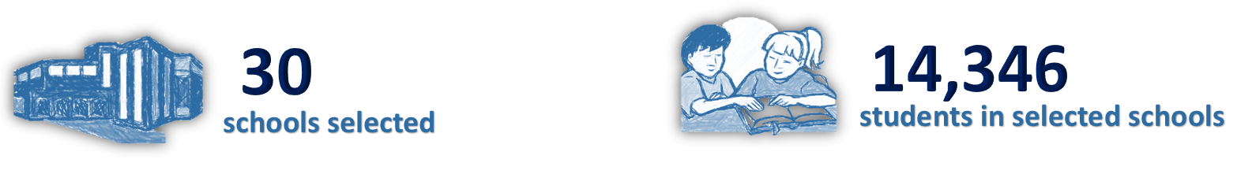
Low SES NP and LNNP
In the ACT, Low SES NP school initiatives included:
- Staff incentives
- Leadership development
- Flexible operations
- Tailored learning
- External partnerships
LNNP schools focused on:
- Enhancing teaching
- Developing leadership
- Improving student performance.
Targeted Outcomes
- An increase in NAPLAN mean scores in years 3 and 5 in reading and numeracy.
- A reduction in the achievement gap for Indigenous students in reading and numeracy
- Increased student attendance and engagement in school activities (particularly Indigenous students)
- Improved teacher satisfaction
- Increased parental engagement and involvement in assisting children with learning
- Increased number of accomplished and leading teacher position
Key findings from synthesis of existing data
Participation in the Low SES NP was associated with:
- Increased NAPLAN mean score gains in Year 3-5 Reading and Numeracy
- Above-average achievement growth in Year 3-5 Reading.
- Improvement in teacher satisfaction
- Increased parental engagement and involvement in their child’s learning
- Increased number of certified ‘Lead’ and ‘Highly Accomplished’ teachers
Participation in the LNNP was found to be associated with:
- Increased NAPLAN means score gains in Year 3-5 Reading and Numeracy
- An improvement in the proportion of Year 3 and 5 students at or above NMS in both Reading and Numeracy, particularly among Indigenous students

1.1 ACT ACTIVITIES & OUTPUTS

Overview
In the ACT, four schools took part in the Low SES NP between 2009 and 2012, implementing a range of activities which included a combination of staff incentives, leadership development, flexible operations, tailored learning and external partnerships. The 26 schools selected for the LNNP focused on the key areas of teaching, leadership and the effective use of student performance information to deliver sustained improvement in literacy and numeracy outcome. The LNNP targeted primary school students falling behind in literacy and numeracy. Schools were selected based on achievement data along with student demographic characteristics. The number of schools involved in the implementation of either the Low SES NP or the Literacy and Numeracy NP (LNNP), or both, are presented by sector in Table 1.1.
Table 1.1. Participating schools in National Partnerships by sector in the Australian Capital Territory (ACT)
 | Government | Catholic | Independent | Total
LNNP Only | 13 | 7 | 6 | 26
Low SES NP Only | 4 | 0 | 0 | 4
Both NPs | 0 | 0 | 0 | 0
ACT Total | 17 | 7 | 6 | 30
Source: Smarter Schools National Partnership National Evaluation Framework (2013a)

Low SES NP
The Low SES School Communities National Partnership (Low SES NP) supported a range of school reforms that are aimed at transforming the way schooling takes place in LSES school communities. The NP aimed to improve student engagement and educational attainment, while helping students begin to overcome some of the barriers to high educational achievement in these communities. Schools were selected for participation in the Low SES NP using a nationally agreed methodology that accounted for disadvantage within schools. The ACT had four National Partnership public primary schools participating in the Low SES NP from 2009 to 2012. These schools were Charnwood Dunlop Primary, Florey Primary, Kingsford Smith School (Primary) and Richardson Primary. The range of strategies and incentives implemented at the four Low SES NP schools included a combination of staff incentives, leadership development, flexible operations, tailored learning and community partnerships.

Incentives for attracting and retaining high quality principals and teachers
Incentives to support principals in Low SES NP schools included the ‘Principal Mentor Program’ in 2012, which engaged two new NP school principals. Each new principal was teamed with an experienced mentor, who supported them in their first 12 months (ACT DET 2013). In addition, a field officer was appointed at each of the four Low SES NP school to work with school Principals from 2009 onwards (ACT DET 2010; 2011; 2012). Field officers were involved in building teacher capacity through coaching, professional learning, mentoring and modelling. They worked collaboratively with teachers to develop their skills in using data effectively and developing appropriate classroom programs. In 2009, Literacy and Numeracy Coordinators were additionally appointed in all four Low SES NP schools. The Literacy and Numeracy Coordinators worked in a team with the field officers and project coordinator to enable better monitoring of progress against NP reform targets. In addition, the Literacy and Numeracy Coordinators and Field Officers worked with school leaders to develop programs and monitor school progress.

Adoption of best-practice performance management and staffing arrangements that articulate a clear role for principals
‘Empowering ACT schools’ provided principals with information, tools and flexibility to manage their schools to further improve teaching and learning. Since 2010, this has enabled all schools to implement new staff selection and recruitment processes at a local level (ACT DET 2011). Professional learning networks of principals and deputy principals were also established in these schools in 2012, with the aim of providing opportunities for school leaders to work on a number of projects to improve student outcomes in literacy and numeracy, increase student engagement and increase collaboration between schools and across networks (ACT DET 2013). An example of an initiative reported to have been successful under this reform area is ‘Dare to Lead’, a program aimed at developing a respect for and understanding of Indigenous people. Through this initiative, one principal was trained as a Dare to Lead Facilitator in 2012. In the same year, a Dare to Lead cross-sectoral conference was also held, with the attendance of principals, deputy principals and aspiring leaders (ACT DET 2013).

School operational arrangements which encourage innovation and flexibility
To encourage innovation and flexibility, Low SES NP schools worked on school operational arrangements by identifying areas of focus in the context of their school communities, and staff and leadership team composition and experience. For example, Richardson Primary developed a whole school coaching philosophy and program, strategic roles for the professional learning teams, staff ownership of decisions around student learning and staff professional learning, and a vibrant action learning cycle that is led by the field officer but owned by the teachers. To support this they adjusted organisational structures to accommodate allocated times for coaching within the school day (ACT DET 2012). Some key focus areas included teacher capacity building through coaching and mentoring, resource support, external partnerships and innovative and flexible staffing arrangements (ACT DET, 2011).
Changes in school operational arrangements also involved increasing flexible learning opportunities for students. This included extra release time to support action learning, lesson study, co-operative learning and coaching. For example, at Florey Primary School, additional Learning Support Assistants were employed to provide flexible learning programs and additional support for students to enable them to successfully engage with classroom programs. A number of before and/or after school programs were also provided in the four NP schools, which included a reading program for Kindergarten students at risk, homework clubs and breakfast clubs.

Providing innovative and tailored learning opportunities
Low SES NP schools in the ACT emphasised early learning initiatives under this reform area. In 2012, 15-hour preschool programs operated in all four NP schools (ACT DET 2013). This included the ‘Kindergarten Intervention’ reading program which aimed to increase the percentage of students in kindergarten who achieved average or above average value added in the Performance Indicators in Primary Schools (PIPS) in Reading. Other early intervention strategies included the Hub Community Plan, developed at one NP school in 2012 to link school and local service providers to a community-based intervention. Belconnen Child and Family Centre worked with the three schools in the Belconnen region to provide early childhood programs and health and family support programs. Further examples of innovative learning opportunities included technology-driven initiatives such as ‘IT Clubs’, IT skill building in students, the purchase of iPads to support individualised learning in the classroom and interactive whiteboards to facilitate on-line learning. In addition, one Low SES NP school (Charnwood Dunlop) introduced the School Band program to support students with different learning styles by providing opportunities through non-academic activities. The school also employed a behaviour therapist to support students with emotional and behavioural issues. Another important activity providing tailored learning was the establishment of the Children’s Opportunity for Resilience Education (CORE), a mental health program offered to students suffering from ongoing trauma. Other school-based support strategies in Low SES NP schools included learning support teachers and/or assistants who provided one-on-one and small group learning to support a variety of programs across the four schools. A speech therapist was also employed at one NP school to work with identified students on oral development.
The Low SES NP allowed a focus on providing tailored learning opportunities to identified groups, particularly Indigenous and EALD students. An ATSI transitions contact officer or team was appointed at each NP school in 2012, to support Indigenous students (ACT DET 2013). ‘Personalised Learning Plans’ (PLPs), negotiated with parents and caregivers, were developed for Indigenous students to support their individual learning goals, set targets and monitor performance goals. A ‘Personal Learning Strategy’ (PLS) was also developed by the teacher, parents/carers, student, school leader, and counsellor for all Indigenous students. One NP school employed trained EALD teachers and bilingual assistants to conduct classes to support students with minimal English through intensive language teaching prior to entry into mainstream schooling.
Innovative and tailored learning opportunities were also provided through the appointment of Field Officers, whose primary role was to build teacher capacity through coaching, professional learning, mentoring and modelling. For example, through the ‘Coach in a Box’ initiative, all Low SES NP principals and Field Officers underwent a series of five workshops on developing practical coaching skills (ACT DET 2011). In addition, Low SES NP schools received funding to support them in appointing designated Literacy and Numeracy Coordinators who spent 50% of their time coaching teachers and 50% supporting identified students (2010). Tailored coaching suites were developed by the four participating schools through the use of staff capability/capacity audits to suit staff needs (ACT DET 2013). In addition, initiatives that were used to develop school networks were adopted. These included collaboration and information sharing that were facilitated through field officers and with other schools through the network structure. Schools engaged with outside agencies and groups to enhance student learning, such as Canberra Institute of Technology, Red Cross, The Smith Family, Tuggeranong Community Health Centre, Belconnen Child and Family Centre, Salvation Army, the Australian Institute of Sport, Australian National University, University of Canberra and the YWCA (ACT Annual Report 2012). One Low SES NP school launched an ATSI partnership involving Indigenous elders and community members in significant events at the school, aiming at better engagement with Indigenous community through reconciliation activities.
Another important strategy used in NP schools was ‘Data Wall’, which enabled the display of student data using colour coded and annotated ‘tags’ (usually consisting of photographs of students or names) to represent individual students. This provided educators with whole school trends as well as the ability to identify individual students needing additional support, particularly those from EALD/LBOTE backgrounds in the four Low SES NP schools.

External partnerships with parents, other schools, businesses and communities and the provision of access to extended services
Partnerships with schools and communities included the appointment of the University of Canberra (UC) as an Academic Partner in 2009 to work with field officers on an audit of school practices and a needs analysis to enable them to address improvements in reform areas across the Low SES NP schools (ACT Annual Report 2009). In 2010, parent information sessions on topics including ‘Literacy and Numeracy’ and ‘Maintaining Positive Relationships’ were hosted, with information provided by staff and guest speakers (ACT DET 2011). Other strategies to engage parents with their children’s schooling included homework clubs, breakfast programs, mentoring programs and school/community events in which parents were actively involved. The ‘Skills for Life’ program offered language, literacy and numeracy and information communication and technology (ICT) skills to parents and full-time carers of children. This program was hosted at two of the four Low SES NP schools but was available to parents from all schools. The main goal of the program was to give participants the confidence to pursue further learning. n addition, parent information evenings and home liaison strategies were held at all NP schools to provide parents with information on teaching and learning programs, student support processes and to discuss student progress.

Literacy and Numeracy NP
The Literacy and Numeracy National Partnership (LNNP) focused on the key areas of teaching, leadership and the effective use of student performance information to deliver sustained improvement in literacy and numeracy outcomes. The target group for support in the ACT were primary school students who were falling behind in literacy and numeracy development. Participation in the program provided school leaders and teachers the opportunity to deliver and embed practices resulting in improvements to students’ literacy and numeracy outcomes.
LNNP schools in the ACT generally adopted a whole school approach focusing on children’s learning and teaching practices, with literacy and numeracy improvement identified in their individual school plans. Participating schools focused on developing effective and evidence-based teaching, school leadership and whole-school engagement as well as closely monitoring performance. A total of 26 schools (Government=13, Catholic=7, Independent=6) were selected to receive support under the LNNP. Schools were chosen for participation based on achievement data along with student demographic characteristics.

Effective and evidence-based teaching of literacy and numeracy
The major strategy employed at the 13 LNNP Government schools to facilitate effective and evidence-based teaching was the provision of Literacy and Numeracy Field Officers and Coordinators. The Field Officers spent 80% of their time coaching classroom teachers to improve learning practices in literacy and numeracy, while the Coordinators divided their time equally between teacher coaching and working with small groups or individual students (ACT DET 2011). In Catholic LNNP schools, professional learning enabled teachers to analyse and interpret data to inform teaching, primarily using SMART (School Measurement, Assessment and Reporting Toolkit) and Progressive Achievement Test (PAT) in Maths and Reading data. The ‘Yarning Strong Literacy Resource’ was also used by teachers in Catholic LNNP schools to better engage Indigenous students through deeper understanding of sensitive issues, correct use of terminology and comprehensive information. In the Independent sector, coordinators reviewed the professional learning needs of staff, while expert program facilitators were employed in 2010 to develop targeted strategies (ACT DET 2011).
A significant amount of professional learning was also delivered to LNNP schools through a number of Literacy and Numeracy programs. The ‘First Steps’ and ‘Count Me In Too’ suite of programs were a core resource used by LNNP schools across the three sectors to support teachers in developing pedagogical methods. These programs were also used to inform assessment, classroom teaching and student intervention approaches. Another widely used program was Reading Recovery, implemented in the Catholic and Independent sectors. This is an early intervention program for children who had the lowest achievement in literacy learning in the first grade.
CASE STUDY: Integrated Curriculum for Effective Reading Instruction at Orana Steiner School (ACT DET 2012)
Orana is an independent, co-educational and non-denominational school with 640 students enrolled from preschool to year 12 in 2011. Literacy and numeracy were taught through an integrated curriculum using co-teaching to provide small group learning; implementing programs that target specific areas for individual students or small groups; consultations to devise inclusive curricula and differentiated materials; regular progress monitoring through standardized diagnostic instruments; and peer tutoring.
Multilit program was introduced in 2011, and student progress was individually recorded in a way that makes it easy to monitor the child’s progress. Most students provided with this instruction made significant progress in reading.

Strong school leadership and whole school engagement with literacy and numeracy
A whole school approach focusing on children’s learning and teaching practices was seen as essential for improving outcomes in ACT LNNP schools. In the Government sector, a project coordinator and a data analyst were appointed in 2009 to coordinate activities against outcomes and work with school principals to monitor progress. A Principal’s Performance and Development Agreement was developed as the performance management framework for ACT principals (ACT Annual Report 2010). The Agreement included clearly articulated criteria to monitor a principal’s performance as agreed between the principal and school network leader. A ‘Leadership in ATSI Education in ACT Public Schools’ professional learning program was also provided to Government school leaders in 2010.
In the Catholic sector, data analysis was used to promote whole school engagement with literacy and numeracy. In 2009, schools completed a comprehensive school report based on NAPLAN data analysis, in addition to a self-evaluation process as part of Annual School Management Planning process (ACT DET 2010). The ‘Team Leadership for School Improvement Program’ offered a forum to specifically discuss literacy and numeracy. This provided a common understanding of whole school instructional approaches and a focus on the use of the data. School leaders promoted staff discussion and dialogue including discussions about successes in reading and numeracy and areas for development. In addition, relevant school staff completed training in the First Steps Reading and Numeracy Intervention Programs. Furthermore, the Cultural Immersion Program was designed for implementation in Catholic LNNP schools in 2010, allowing teachers to better respond to the needs of Indigenous students, parents and communities (ACT DET 2011).
Whole school engagement with literacy and numeracy in the Independent sector was primarily addressed through a number of activities that raised awareness about the importance of literacy and numeracy. For example, a daily Literacy Hour was added to the school timetable. Other activities additionally aimed to enhance reading enjoyment such as the ‘That is a Strange Place to Read’ activity - a school-wide photo competition designed to encourage students to read for fun. Photos of staff and students reading novels in strange and interesting places were displayed to show the importance of literacy but more importantly, the enjoyment of reading. Independent NP schools were also visited by the ACT Brumbies rugby players a number of times to promote the importance of reading among students (ACT DET 2012).
Another important initiative was the 2012 ‘Cross-sectoral Smarter Schools National Partnership Showcase’, which provided a platform for sharing examples of effective teaching. At this event, which was open to educators across all ACT schools, NP staff interacted with colleagues from other participating schools, shared work and learned about school programs, change strategies and successes (ACT DET 2013). This was attended by 230 staff, including those from 22 LNNP schools (11 Government, 9 Catholic, 2 Independent).

Monitoring student and school literacy and numeracy performance to identify where support is needed
One of the most important means for monitoring performance in ACT LNNP schools was Personalised Learning Plans (PLPs), which began in 2009 and were developed for students identified as requiring additional support across the sectors (ACT DET 2010). Since 2010, all Indigenous students had PLPs, formulated in consultation with teachers, parents and the student. These were used to identify students’ strengths and areas of need (ACT DET 2011; 2012; 2013). In Government schools, a case management approach was also adopted by the classroom teacher along with the literacy and numeracy team to discuss students’ needs and to create tailored learning plans.
Schools in the Government sector also used the Improve Diagnostic Tool (IDT) developed by Education Services Australia that was formatted to suit class, groups or individual assessment. IDT provided a bank of questions to track student performance and identify areas of strength or areas needing intervention. Schools also created Data Walls where information linked to individual students was displayed visually to allow easy identification of outlying students and trends in groups of students. A variety of tracking tools such as PM Reading Benchmarks, Schedule for Early Number Assessment (SENA), and First Steps Reading and Writing maps of development phases were used to create the Data Walls. Schools additionally developed criterion based assessment tools and rubrics to provide consistency in assessment practices.
In the Catholic sector, schools monitored student performance in literacy and numeracy through a variety of assessment instruments and recorded data, enabling teachers to target teaching programs more specifically to students’ needs and to identify at-risk students requiring intervention. In numeracy, they used the SENA from the Count Me In Too Framework and Nelson Assessment Kit to monitor students at risk. Progressive Achievement Tests (PAT) in Mathematics were also used to track student achievement and identify trends or patterns throughout all strands of mathematics. In literacy, student achievement was tracked using a combination of assessment data and observational evidence. This included First Steps student profiles, PAT Reading, Running Records, Kindergarten Assessments and Year 1 Observation Surveys. Students making slow progress were provided further literacy support. In addition, Catholic LNNP schools employed Aboriginal Contact Teachers to develop explicit programs and PLPs for Indigenous students (ACT DET 2013), while five of the six Catholic LNNP schools implemented a Numeracy Intervention Program (NIP) designed to target ‘at risk’ students who may be left behind (ACT DET 2011).
In the Independent sector, strategies used to identify where support was needed for students varied between the six LNNP schools in 2010. In 2011, ‘The Cars and Stars Reading and Comprehension Program’ was implemented in Years 5 and 6 to allow for development to be monitored and encouraged in a structured formalised way. Continued comprehension testing throughout this reading program allowed staff, students and parents to observe progress and identify individual needs. In addition, regular staff meetings and weekly curriculum meetings were held to discuss areas of concern with regard to students’ academic development in literacy and numeracy (ACT DET 2012). The literacy data-driven triage system was also introduced in 2012 as a means of prioritising teacher referrals to the learning support team (ACT DET 2013). Another important monitoring and support initiative comprised of regular support group meetings between teachers, learning support staff, relevant executive and the parents of students experiencing learning difficulties.
1.2 ACT IMPACT
The following section highlights the main findings from the synthesis of existing information on the Low SES NP and LNNP in ACT. Findings are reported under the agreed outcomes in the ACT program logic (Appendix 6).

Outcomes 1 and 2:
An increase in NAPLAN mean scores in years 3 and 5 in reading and numeracy; A reduction in the achievement gap for Indigenous students in reading and numeracy
Student achievement was mainly targeted through building teacher capacity. This involved the appointment of Field Officers and Literacy and Numeracy Coordinators who assisted teachers through coaching, professional learning, mentoring and modelling. Intervention programs and the analysis of student assessment data were also used to address student achievement. In addition, ATSI Transitions Contact Officers were employed to support Indigenous students, while ‘Personalised Learning Plans’ (PLPs) were developed to support the individual learning goals of Indigenous students, set targets and monitor their performance goals.

Achievement in Low SES NP schools
The increase in NAPLAN means scores in Low SES NP schools was examined by analysing the change in mean NAPLAN results for Year 3 Low SES NP students in 2009 who were in Year 5 in 2011 to compare apparent gains by cohort. The selection of the 2009-2011 cohort for analysis allowed for at least two years of Low SES NP participation, with 2009 being early enough to be considered as an appropriate baseline.
The available aggregated summary data showed that average apparent gains between Year 3 NAPLAN scores in 2009 and Year 5 NAPLAN scores in 2011 in both the Reading and Numeracy domains were higher for the four Low SES NP schools than the average apparent gain of all ACT schools (Figure 1.1). The data shows that Low SES NP schools achieved apparent gains that were 4.9 points and 12.5 points higher in Reading and Numeracy respectively than in all ACT schools. Among Language Background other than English (LBOTE) students, Low SES NP schools achieved greater apparent NAPLAN mean score gains of 12.4 points in Reading and 6.4 points in Numeracy than LBOTE students in all ACT schools.

Figure 1.1: Year 3 2009 to Year 5 2011 cohort apparent mean score apparent in NAPLAN, ACT
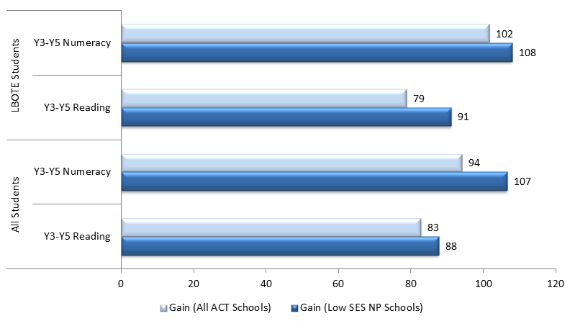
 |  | Gain (all ACT schools) | Gain (Low SES NP schools)
LBOTE Students | Year 3 to Year 5 Numeracy | 102 | 108
LBOTE Students | Year 3 to Year 5 Reading | 79 | 91
All students | Year 3 to Year 5 Numeracy | 94 | 107
All students | Year 3 to Year 5 Reading | 83 | 88
Source: PGA constructed chart using ACT DET (2012); ACARA (2012)
Despite revealing positive trends in the ACT, the data in Figure 1.1 cannot be used to determine whether observed gains can be directly attributed to the Low SES NP, as the analysis does not control for schools’ socioeconomic status and starting points, characteristics which were found to be important determinants of student progress. Unit-record achievement data in all ACT Government schools were therefore analysed to assess the progress of students in Low SES NP schools compared to that made by students in similar non-NP schools. Similar schools were grouped according to their students’ socioeconomic background as measured by the school ICSEA or their achievement prior to the commencement of the Low SES NP, with the analysis in both measures focusing on deciles which contained both Low SES NP and non-NP schools. When controlling for socioeconomic background, the proportion of students who achieved above average growth in Reading at Low SES NP schools was found to be notably higher than that in non-NP schools in both the 2009-2011 and 2010-2012 student cohorts (Figure 1.2). Mixed results were observed in Numeracy, where the proportion of Low SES NP students achieving above average growth was greater than that in non-NP schools in just the 2009-2011 cohort. In the analysis which controlled for similar starting scores based on previous achievement in NAPLAN, the proportion of Low SES NP schools with above average growth was lower than that in non-NP schools in both domains and across both student cohorts.

Figure 1.2: Proportion of Years 3-5 students in Low SES NP schools who achieved above average growth compared to that of students in non-NP schools with similar socioeconomic backgrounds, ACT Government sector
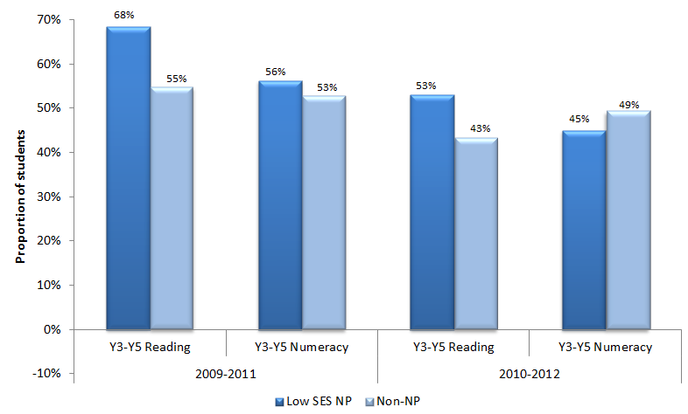
 |  | Low SES NP | Non-NP
2009-2011 | Year 3 to Year 5 Reading | 68% | 55%
2009-2011 | Year 3 to Year 5 Numeracy | 56% | 53%
2010-2012 | Year 3 to Year 5 Reading | 53% | 43%
2010-2012 | Year 3 to Year 5 Numeracy | 45% | 49%
Source: PGA constructed graph using data provided by ACARA
When achievement was analysed using NAPLAN bands (Figure 1.3), an increase in the proportion of students at or below NMS was observed as students moved from Year 3 to Year 5 across all ACT schools in both Reading and Numeracy. This is a nationally consistent result as historical NAPLAN data shows a greater proportion of students at or below NMS in higher grade levels. Among the four Low SES NP schools however, this figure was found to have relatively decreased by 13 percentage points in Numeracy. This important finding suggests that the observed improvement at ACT Low SES schools is driven by improved achievement amongst students in the lowest two bands.

NAPLAN Participation at Low SES NP schools
Analysis of NAPLAN participation rates in Low SES NP schools shows patterns that were similar to those observed in all ACT schools. Therefore it is unlikely that overall changes in achievement were affected by NAPLAN participation trends.

Figure 1.3: Proportion of students at or below NMS (Year 3 2009- Year 5 2011) in NAPLAN, ACT
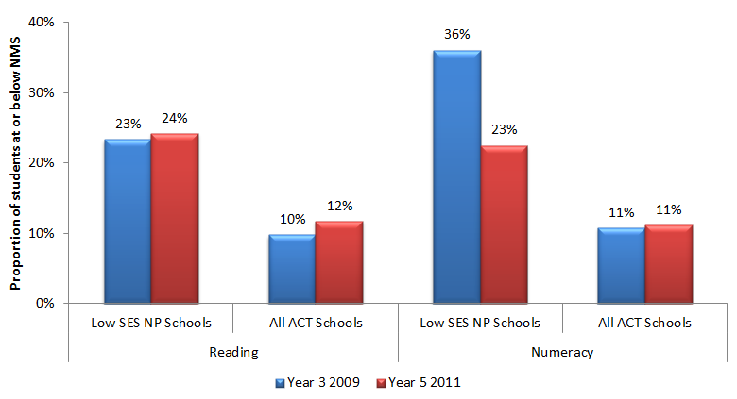
 |  | Year 3 2009 | Year 5 2011
Reading | Low SES NP Schools | 23% | 24%
Reading | All ACT Schools | 10% | 12%
Numeracy | Low SES NP Schools | 36% | 23%
Numeracy | All ACT Schools | 11% | 11%
Source: PGA constructed using ACT DET (2012); ACARA (2012)
It is important to note that schools selected for the Low SES NP in the ACT serve students facing multiple sources of disadvantage. Therefore, other fundamental outcomes in addition to achievement were also targeted in this partnership, such as student attendance and engagement.
CASE STUDY: A Whole School Focus on Cooperative Learning for Engagement and achievement at Richardson Primary School (ACT DET 2012)
In 2011, Richardson Primary had the highest proportion of Indigenous students of the four Low SES NP schools in ACT, with 33 out of 227 students enrolled at the school. A whole school focus on cooperative learning was adopted to increase student engagement at the classroom level. In a span of two years, this substantially increased student engagement and reduced behaviour issues in classes.
The school also developed a strategy to decrease absenteeism that involved the recognition of students who achieve 100% attendance, through presentation of a certificate at the school assembly and an honorary mention in the school newsletter. The number of certificates being awarded increased as did attendance rates across all year levels in 2011 when compared with 2010. Indigenous student results showed a 20% reduction in the proportion of students falling below the minimum national standard on NAPLAN tests for spelling and numeracy.
CASE STUDY: Collaborative Classrooms at Kingsford Smith School - (ACT DET 2013)
Kingsford Smith School is a P-10 school with an enrolment of 500 students with 4.6% Indigenous students and 17.4% LBOTE students in 2012.
The partnership operates in the P-6 section. The Collaborative Classrooms process was used to build and develop teacher capacity by requiring teachers to work collaboratively on lesson design, observe each other’s lessons and provide feedback for improvement. Students with mild to moderate learning difficulties were supported through three Learning Support Centres and two Learning Support Units.
A comparison of student performance at Kingsford Smith School between 2009 and 2012 using NAPLAN mean scores show significant improvement in the results for year 3 students in 2012.

Achievement in LNNP schools
Achievement in LNNP schools was analysed on a territory level, aggregating the results of all 26 LNNP schools. As undertaken for Low SES NP schools, the increase in NAPLAN means scores in LNNP schools was examined by analysing the change in mean NAPLAN results for Year 3 LNNP students in 2009 who were in Year 5 in 2011 to compare apparent gains by cohort. The 2010-2012 cohort was also analysed. The aggregated data showed that average apparent gains between the Year 3 and Year 5 mean NAPLAN scores in both student cohorts and for both Reading and Numeracy domains were higher for the LNNP schools than in non-LNNP schools (Figure 1.4). This was most prominent in Numeracy for the 2009-2011 cohort, where LNNP schools achieved an apparent gain of 8.1 points higher than in non-LNNP schools.

Figure 1.4: NAPLAN mean scale scores in ACT LNNP schools compared to non-LNNP schools
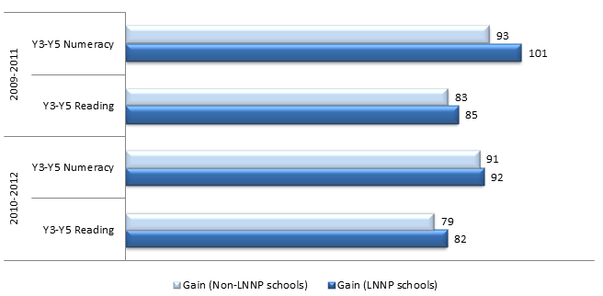
 |  | Gain (Non-LNNP schools) | Gain (LNNP schools)
2009 to 2011 | Year 3 to Year 5 Numeracy | 93 | 101
2009 to 2011 | Year 3 to Year 5 Reading | 83 | 85
2010 to 2012 | Year 3 to Year 5 Numeracy | 91 | 92
2010 to 2012 | Year 3 to Year 5 Reading | 79 | 82
Source: ACT DET
Analysing achievement data using NAPLAN bands provides additional information on progress at participating schools. In particular, it is important to consider patterns in the proportion of students who are at or below NMS due to their critically low skill levels. When this was analysed using NAPLAN bands (Figure 1.5), an increase in the proportion of students at or below NMS was observed across non-LNNP schools in Reading in both 2009-2011 (+1.7%) and 2010-2012 (+1.1%) student cohorts. Whilst this increase was even greater among LNNP schools for the 2009-2011 cohort (+2.4%), there was a slight decrease in the proportion of LNNP schools students in the lower two NAPLAN bands for the 2010-2012 cohort (-0.1%). The results in Numeracy show a positive trend for LNNP schools, where the proportion of students at or below NMS in the 2009-2011 cohort decreased by 5.7% compared to just 3.0% in non-LNNP schools. Although there was a slight increase in the proportion of LNNP schools students in the lower two NAPLAN bands for the 2010-2012 cohort (+0.3%), it was even higher in non-participating schools (+1.6%).

Figure 1.5: Students at or below National Minimum Standard in ACT LNNP schools
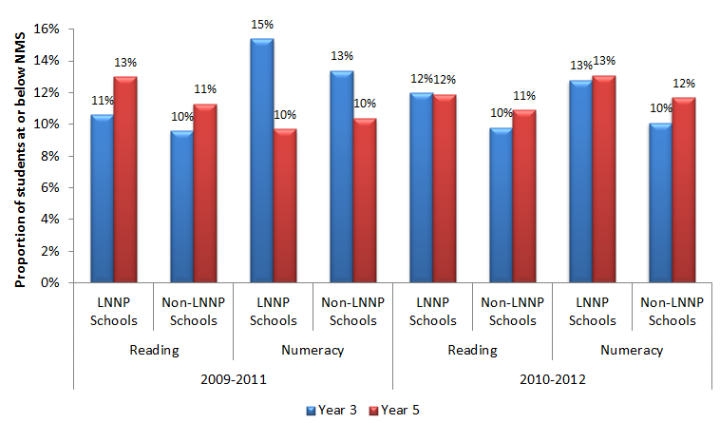
 |  |  | Year 3 | Year 5
2009 to 2011 | Reading | LNNP Schools | 11% | 13%
2009 to 2011 | Reading | Non-LNNP Schools | 10% | 11%
2009 to 2011 | Numeracy | LNNP Schools | 15% | 10%
2009 to 2011 | Numeracy | Non-LNNP schools | 13% | 10%
2010-2012 | Reading | LNNP Schools | 12% | 12%
2010-2012 | Reading | Non-LNNP Schools | 10% | 11%
2010-2012 | Numeracy | LNNP Schools | 13% | 13%
2010-2012 | Numeracy | Non-LNNP Schools | 10% | 12%
Source: ACT DET
Analysis of NAPLAN data against the LNNP targets set to acquire reward funding shows ACT LNNP schools consistently improved over the period between 2008 to 2011. Ten of the eleven targets were met or exceeded and progress was made towards one target. The proportion of Year 3 and 5 students at or above NMS for Reading and Numeracy improved by between 0.5 and 2.5 percentage points. In addition, the proportion of Year 3 and Year 5 Indigenous students at or above NMS for Reading and Numeracy improved by between 1.7 and 5.3 percentage points (COAG Reform Council 2012).
Achievement in ACT Government LNNP schools was also analysed using the same method shown in Figure 1.2. In both the 2009-2011 and 2010-2012 student cohorts, the proportion of students who achieved above average growth was higher in non-NP schools than in LNNP schools in three of the four measures (Figure 1.6). Although average NAPLAN growth rates may not have been as large in all LNNP schools as those in non-NP schools, at least 30% of students in LNNP schools achieved higher growth than their peers at similar starting points in non-LNNP schools. It is therefore recommended that further research be undertaken to determine why some students at LNNP schools achieved greater success than others.

Figure 1.6: Proportion of students in LNNP schools who achieved above average growth compared to that of students in similar non-NP schools, ACT Government sector
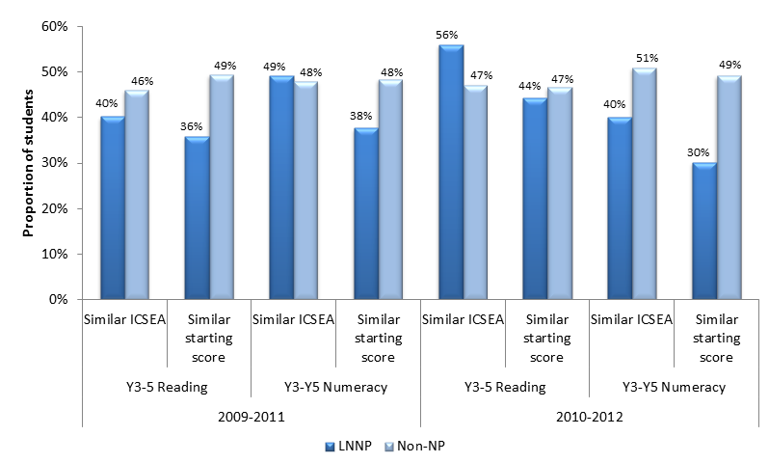
 |  |  | LNNP schools | Non-NP schools
2009 to 2011 | Year 3 to Year 5 Reading | Similar ICSEA | 40% | 46%
2009 to 2011 | Year 3 to Year 5 Reading | Similar starting score | 36% | 49%
2009 to 2011 | Year 3 to Year 5 Numeracy | Similar ICSEA | 49% | 48%
2009 to 2011 | Year 3 to Year 5 Numeracy | Similar starting score | 38% | 48%
2010 to 2012 | Year 3 to Year 5 Reading | Similar ICSEA | 56% | 47%
2010 to 2012 | Year 3 to Year 5 Reading | Similar starting score | 44% | 47%
2010 to 2012 | Year 3 to Year 5 Numeracy | Similar ICSEA | 40% | 51%
2010 to 2012 | Year 3 to Year 5 Numeracy | Similar starting score | 30% | 49%
Source: PGA constructed graph using data provided by ACARA
CASE STUDY: Overall Improvement in Literacy and Numeracy through a Three-Pronged Approach at Canberra Grammar School. (ACT DET 2013)
Canberra Grammar School adopted a three-pronged approach of professional learning for teachers, academic tracking, and learning support for students. It noted significant achievements in NAPLAN performances following engagement with LNNP. In 2012, 82-95% of students at CGS scored in the highest two bands in the Literacy areas in the Year 3 NAPLAN test. Similar achievements were also found in the Year 5 NAPLAN test, where 70-95% of students scored in the highest two bands in the Literacy areas and 60% scored in the top two bands in Numeracy. An average student growth in Year 5 literacy from 74 to 95 points was also noted. The School report overall improvement in the NAPLAN Year 3 and Year 5 results between 2011 and 2012.
At LNNP schools, it is not possible using existing information to identify which literacy and numeracy intervention programs, such as First Steps Reading or Count Me in Too, had the desired effects. Other key components of the LNNP in the ACT, including effective usage of student performance data from a range of sources to monitor progress may have had impact that cannot be measured in the basic skills captured by NAPLAN.

Outcome 3:
Increased student attendance and engagement in school activities (particularly amongst Indigenous students)
Enhancing student attendance and engagement were key intended outcomes under the Low SES NP. These were addressed primarily through Learning Support Assistants as well as a number of before- and after-school programs, such as a reading program for Kindergarten students at risk, homework clubs and breakfast clubs. In addition, Indigenous students were targeted by a partnership involving Indigenous elders and community members in significant school events. As a possible result of these initiatives, an increase in the number of students choosing to read and write for pleasure was reported, suggesting increased engagement in learning. Student satisfaction surveys also revealed highly positive results in student engagement (ACT DET 2012). In addition, a strategy to decrease absenteeism by recognising students who achieved 100% attendance was reported to have resulted in increases in attendance rates.
To better understand the impact of the Low SES NP on attendance, further analysis was undertaken comparing trends in student attendance at participating schools between 2010 and 2012 to those in non-NP schools. Following three years of NP participation, differences in attendance rates between Low SES NP schools and non-NP schools at the primary level (Figure 1.7) had almost been completely eliminated, although this difference was initially small. Amongst Indigenous students, attendance rates at the primary school level in Low SES NP schools were found to have improved significantly compared to non-NP schools. In fact, attendance rates at Low SES NP schools improved from being 3.2% lower than in non-NP schools to 4.3% higher following the partnership.
Figure 1.7: Primary school level attendance rates of all student and Indigenous students in ACT Low SES NP schools
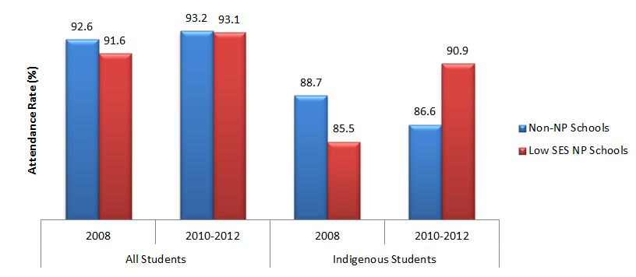
 |  | Non-NP Schools | Low SES NP Schools
2008 | All Students | 92.6 | 91.6
2008 | Indigenous Students | 88.7 | 85.5
2010-2012 | All Students | 93.2 | 93.1
2010-2012 | Indigenous Students | 86.6 | 90.9
Source: PGA constructed graph based on attendance data provided by ACT DET and DEEWR.
NB: Attendance figures exclude Grade prep

Outcome 4:
Improved teacher satisfaction
In the ACT, partnership schools aimed to raise levels of teacher satisfaction. Analysis of the Staff Satisfaction Surveys’ conducted at all four Low SES NP schools in 2010 and 2011 showed increases in teacher satisfaction. Figures suggest this was a result of changes in school operational arrangements which encouraged innovation and flexibility (ACT DET 2012). These arrangements included the employment of Field Officers who worked collaboratively with teachers to develop their skills in using data effectively and developing appropriate classroom programs.
Based on opinion surveys of school staff, Table 1.2 shows an improvement in teachers’ satisfaction across the four Low SES NP schools from 2010 to 2011, specifically regarding their practices and the belief that students were getting a good education. Kingsford Smith School and Charnwood Dunlop Primary School show that an increased proportion of staff agreed or strongly agreed with nearly all statements. These results suggest that the Low SES National Partnership at these schools may have contributed toward a greater level of satisfaction for staff. Though overall satisfaction levels declined in Richardson School and Florey Primary School, the two schools began with relatively high satisfaction against most statements. The overall decline appears to be driven by lower satisfaction with communication with school leaders as well as teachers’ opportunities to lead. This is the most recently available data and additional years may reveal the sustainability of effects achieved by these initiatives. Feedback from participants at the Smarter School National Partnership Cross Sectoral Showcase held in 2012 for LNNP additionally highlighted the valuable learning that took place as part of the NP.

Table 1.2. Proportion of staff who “agreed” or “strongly agreed” with statement by Low SES NP school, 2010 and 2011 (%)
 | Richardson  School |  | Kingsford  Smith |  | Charnwood  Dunlop |  | Florey
 | 2010 | 2011 | 2010 | 2011 | 2010 | 2011 | 2010 | 2011
My professional achievements are celebrated at this school | 82 | 75 | 53 | 67 | 41 | 80 | 76 | 71
I have opportunities to practise leadership | 88 | 80 | 71 | 77 | 50 | 80 | 82 | 67
I have opportunities to participate in decision making | 100 | 95 | 66 | 70 | 68 | 77 | 88 | 83
There is effective communication between teachers & executive staff | 94 | 80 | 54 | 69 | 50 | 64 | 88 | 77
There are processes in place that support my practice | 88 | 100 | 61 | 82 | 77 | 92 | 88 | 77
I get constructive feedback about my practice | 76 | 75 | 53 | 84 | 64 | 80 | 65 | 64
Innovative practice is encouraged | 71 | 80 | 75 | 82 | 82 | 80 | 88 | 72
Overall I am satisfied with my work at this school | 96 | 96 | 87 | 97 | 85 | 97 | 96 | 96
Overall I am satisfied with this school | 92 | 92 | 59 | 78 | 85 | 93 | 92 | 83
I am satisfied this school has high expectations in all that it does | 92 | 88 | 71 | 82 | 93 | 97 | 92 | 88
I am satisfied the students are getting a good education at this school | 84 | 92 | 76 | 78 | 96 | 93 | 92 | 96
Source: Staff Satisfaction Survey (ACT DET 2012)

Outcome 5:
Increased parental engagement and involvement in assisting children with learning
The importance of improving parents’ engagement and involvement in their children’s learning is receiving growing attention in the education literature. This was another intended outcome under the Partnerships in the ACT. Strategies to increase parental engagement with their children’s schooling included homework clubs, breakfast programs, mentoring programs and school/community events.
Evidence from the Low SES NP school satisfaction surveys conducted in 2012 showed improvements in communication between teachers and parents, in addition to greater satisfaction with the education provided (ACT DET 2013). The ‘Community Connections forum’ held at Florey Primary School was also reported to have enabled parents to connect with other EALD parents and EALD teachers to discuss a range of topics that were relevant to their child’s learning and the school community in an informal setting. A course for parents at Low SES NP schools in 2012 was further reported to have provided parents with additional skills and knowledge to assist them with their children’s learning.
Parents at three LNNP schools reported appreciation of the intensive reading intervention program that used Reading Recovery with intensive teacher support and mentoring. They also noted the levels of progress and increased confidence among their children as well as the improvements in school/home partnerships as a result of increased levels of communication via workshops, newsletters, reading diaries and the school website. This was observed to have improved their knowledge of student progress and reading requirements. Parents also reported that home reading was a more enjoyable activity due to reading guidance provided by the school children (ACT DET 2011).
CASE STUDY: Parent participation in Maths Bags at St Thomas the Apostle (ACT DET 2012)
St Thomas the Apostle, Kambah introduced Maths Bags to lift the profile and attitude of mathematics in both the student and parent body. Math Bags with Math tasks were sent home with students for a week at a time on alternate Mondays; and children and families were encouraged to do as much as they could. Parents were asked to record the activity names and to comment and rate the activities.
‘Maths Bags’ at St Thomas the Apostle was reported as encouraging positive parent engagement with their children’s learning. School surveys of parents (n=24) revealed that 83% of respondents used Maths Magic as a family (regularly or sometimes), 58% of parents believed their children enjoyed Maths Magic more than written homework and 83% of respondents thought the Maths Magic games were suitable for their children.

Outcome 6:
Increased number of accomplished and leading teacher position
Developing teacher capacity in senior roles such as accomplished and leading teachers was an intended outcome in the ACT with the potential to positively influence other important outcomes in the future. In 2012, six teachers in the ACT Government sector certified at the ‘Highly Accomplished’ level and three at the ‘Lead Teacher’ level (ACT DET 2013). These teachers are likely to provide expert knowledge to their schools, especially in regards to curriculum design, information sharing and modelling good teaching practices. Moreover, they have the potential to mentor and support new teachers on providing an inclusive learning environment for students with various learning needs.

1.3 ACT CONCLUSION
Participation in the Low SES NP in the ACT was limited to just four schools in the Government sector. At these schools, average gains in NAPLAN scores between Years 3 and 5 in both the Reading and Numeracy were higher than that in all ACT schools. Further analysis which assessed above average growth of students at Low SES NP schools compared to that of students in non-NP schools with similar socioeconomic backgrounds, found that participation in the Low SES NP was associated with higher achievement in Reading. In addition, evidence from student achievement bands shows a relative improvement in the proportion of students at or below NMS compared to non-NP schools. In ACT LNNP schools, average NAPLAN apparent gains between Years 3 and 5 in both Reading and Numeracy were higher in LNNP schools than in non-NP schools. These results were not replicated when unit-record data was used to compare achievement in LNNP schools to that in similar non-NP schools. However, at least 30% of students in LNNP schools exhibited above-average growth when compared to students at similar non-NP schools with the same achievement starting point. Moreover, as observed for students at Low SES NP schools, there was an improvement in the proportion of Year 3 and 5 students at or above NMS for both Reading and Numeracy at LNNP schools. This same improvement was also observed among Indigenous students (COAG Reform Council 2012).
Overall, there are therefore some indications that NP programs positively impacted student achievement. At Low SES NP schools, such impacts are likely to have been a result of the changes in school operational arrangements that encouraged innovation and flexibility, as these changes were widely reported to have contributed to teacher capacity development and satisfaction (ACT DET 2012). The key interventions undertaken under these changes included the employment of field officers, lead teachers and literacy and numeracy coordinators who were responsible for building teacher capacity and providing expert knowledge through coaching, professional learning, mentoring and modelling good practices. In addition, Learning Support Assistants were employed to provide individual or small group learning support for students requiring additional help. This is particularly important in Low SES NP schools where disadvantaged students may lack access to sufficient learning resources or support in their home environments.
Increased parental involvement in schooling is another feature of the Low SES NP that may have contributed to student achievement, as Low SES NP schools indicated improvements in communication between teachers and parents, in addition to greater parental satisfaction with the education provided (ACT DET 2013). Initiatives such as parent information evenings, home liaison strategies, consultations to negotiate PLPs and the ‘Skills for Life’ program that offered language, information communication and technology skills to parents are all likely to have increased parental involvement. At Low SES NP schools, this is particularly crucial given that students often came from disadvantaged backgrounds with parents likely to have low levels of education. Enhancing parents’ capacity to play an active role in their children’s education is likely to have contributed to the observed improvements.
It is important to note that the additional focus on forward-looking programs such as early childhood initiatives, as well as the use of student assessment data for planning and school improvement may have ongoing positive impacts in these schools. Similarly, at both Low SES NP and LNNP schools in the ACT, monitoring student achievement results in both NAPLAN and school-based assessments were reported to have facilitated improvements. By using up to date achievement data to plan for learning, teachers could accurately measure student progress. In addition, this enabled the identification of students at risk, for whom PLPs were developed.
In LNNP schools, the use of a ‘whole school approach’ implies that any improvements in student achievement are a likely result of a combination of initiatives, such as evidence-based reading and numeracy programs and interventions for at-risk students. The most notable of these initiatives included ‘First Steps Reading’, ‘The Cars and Stars Reading and Comprehension Program’, ‘Reading Recovery’, ‘Count Me in Too’, ‘Middle Years Mental Computation’, the use of student assessment data to monitor progress and PLPs for Indigenous students and students who required additional support. Positive outcomes for Indigenous students are most likely linked to the close support and follow up provided by PLPs as well as targeted initiatives such as the appointment of Aboriginal Contact Teachers, the ‘Yarning Strong Literacy Resource’ program and the ‘Cultural Immersion Program’ for teachers. As with Low SES NP schools, increased parental involvement may have also enhanced student achievement in LNNP schools, as parents reported improvements in their knowledge of student progress and reading requirements and found home reading activities more enjoyable (ACT DET 2012). This appears to have resulted from parent information sessions and their focus on encouraging parents to read with their children.
In addition to achievement, increased student engagement was another intended outcome of the National Partnerships, specifically at Low SES NP schools. As this report has outlined, attendance rates generally improved at Low SES NP schools, particularly for Indigenous students at the primary school level. Student satisfaction surveys also revealed highly positive results in student engagement (ACT DET 2012). Local evidence suggests that rewarding student attendance at Low SES schools may have been successful in raising engagement strategies. Other initiatives likely to have increased student engagement include increased parental involvement in schooling which was emphasised by all at Low SES NP schools in the ACT.
While the NPs appear to have had some positive impact on both student achievement and engagement, the effect of each initiative or activity cannot be causally evaluated. With the exception of achievement and attendance data, available evidence is mainly limited to qualitative case studies in individual schools. In addition, the diversity of program implemented makes it challenging to determine the intervention programs that best contributed to achieving intended outcomes. However, it is important to identify and analyse the activities that achieved their intended outcomes for the efficacy of future interventions. As outlined in the final chapter, such data can be collected through further research involving surveys and focus groups that can map data on specific activities to intended student achievement and engagement outcomes. This is essential for the purposes of informing policymakers’ and educators’ decisions around which programs are more successful than others in achieving the intended outcomes.

GLOSSARY
ATSI: Aboriginal and Torres Strait Islander
CORE: Children’s Opportunity for Resilience Education is a mental health program offered to students, particularly those suffering from ongoing trauma.
Dare to Lead: An initiative which aims at developing a respect for and understanding of Indigenous people.
Data Wall: Displays student data using ‘tags’ (usually consisting of photographs of students or names) which are colour coded for year level and annotated with additional information.
EALD: English as an Additional Language Dialect
First Steps Reading: A core resource used to support teachers in developing pedagogical methods, assessment, class teaching, home reading and student intervention approaches.
GRRM: Gradual Release of Responsibility Model is used in Catholic schools for explicit teaching, targeted assessment, scaffolding reading knowledge and skills, and differentiating teaching instruction.
LBOTE: Language Background Other Than English
Multilit: A program aimed at improving the literacy skills of low-progress readers through a focus on phonics, sight words recognition and supported book reading in a one on one situation.
NAPLAN: National Assessment Program Literacy and Numeracy is an annual assessment for students in Years 3, 5, 7 and 9, in the four areas (or ‘domains’) of Reading, Writing, Language Conventions and Numeracy.
PAT: Progressive Achievement Test is a thoroughly researched and normed test for measuring and tracking student achievement in reading comprehension, word knowledge and spelling.
PIPS: Performance Indicators in Primary Schools
PLP: Personalised Learning Plan developed for at-risk students to support their individual learning goals, set targets and monitor performance goals.
PLS: Personal Learning Strategy developed by the teacher, parents/carers, student, school leader, and counsellor for all Indigenous students.
Reading Recovery: A short-term intervention provided to children who had the lowest achievement in literacy learning in the first grade.
Skills for Life: A program offered to parents from the four Low SES NP schools to give participants the confidence to pursue further learning, and/or to better assist with their children’s learning.
SMART: School Measurement, Assessment and Reporting Toolkit is a powerful diagnostic tool that provides feedback on the NAPLAN results to schools and their communities.
SWAT: Student Writing Assistance Team focuses on developing oral language as a precursor to quality writing, an understanding of what a quality piece of writing looks like, building vocabulary, self-analysis of errors and possible improvements.
Therapy ACT Assistant Pilot Project: Provided to students with disabilities to access therapy support during school days.

New South Wales

Low SES NP and LNNP
In NSW, the Low SES NP and LNNP were implemented under various reform areas targeting:
- Staff incentivisation
- Innovative instruction
- Effective planning
- Structural enhancements
- Family and community partnerships
- Effective teaching
- Whole-school engagement
- Continuous student monitoring
Targeted Outcomes
- Improvements in NAPLAN literacy and numeracy achievement, particularly for Indigenous and disadvantaged students (Low SES NP & LNNP)
- Increased proportion of students enrolled in and attending school (particularly Indigenous students) and a higher proportion of Indigenous students completing year 10 (Low SES NP)
- Appropriate use of data by schools to plan, implement and evaluate programs (Low SES NP & LNNP)
- Increased proportion of students completing Year 12 or AQF Certificate II, including Indigenous and disadvantaged students or training (Low SES NP)
- Increased proportion of students participating in post-school education (Low SES NP)
- Increased capacity for school-based innovation focused on improving student outcomes (Low SES NP)
- Increased capacity of teachers to collaborate to deliver quality literacy/numeracy teaching (LNNP)
- Enhancement in teaching pedagogy (LNNP)

Key findings from synthesis of existing data
Participation in the Low SES NP was associated with:
- Greater NAPLAN gains in Years 3-5 Numeracy and Years 7-9 Reading and Numeracy.
- Growth in Years 3-5 Numeracy achievement among Indigenous students.
- Significant improvement in the attendance rates of Indigenous students at both the primary and secondary school levels.
- Significant improvement in the Years 10-11 and 10-12 apparent retention rates among Indigenous students at Government schools.
Participation in the LNNP was found to be associated with:
- Growth in Numeracy scores among disadvantages students, particularly Indigenous students.
- Improved access and usage of student data among teachers.
- Increased capacity for school-based innovation.
- Increased capacity of teachers to collaborate, complementing the fact that half the LNNP schools worked with other schools on partnership implementation.
- Enhancement in teaching pedagogy, with almost all schools holding the belief that the LNNP had impacted on the quality of the teaching and learning environment.

2.1 NSW ACTIVITIES & OUTPUTS

Overview
The Low SES NP in NSW involved 724 schools across the three sectors. Each school’s participation in the program consisted of a four-year period, with schools commencing in four separate cohorts from 2009 to 2012 respectively (Figure 2.1). The partnership was implemented under six areas of reform, targeting staff incentivisation, innovative instruction, effective planning, structural enhancements and family and community partnerships. The LNNP consisted of 147 primary schools, 102 of which chose to focus their initiatives on Literacy and 45 on Numeracy. In addition, 24 schools were chosen for a single year Literacy and Numeracy Addendum Program that commenced in July 2010. Of the 171 LNNP schools, 51 also participated in the Low SES NP. The LNNP was implemented under three priority areas emphasising effective teaching, whole-school engagement and continuous monitoring.
Figure 2.1: The Literacy and Numeracy and Low Socioeconomic Communities National Partnerships in NSW (including Reform Extension Initiative schools-REI)
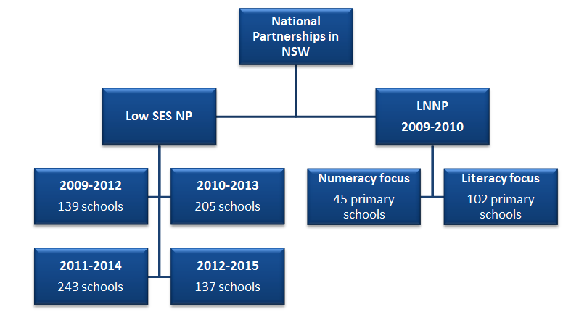
The National Partnerships in New South Wales consisted of the Low SES NP and the LNNP.
Under the Low SES NP:
2009 to 2012 there were 139 schools
2010 to 2013 there were 205 schools
2011 to 2014 there were 243 schools
2012 to 2015 there were 137 schools
The LNNP had a numeracy focus and a literacy focus.
Over 2009-2010:
- 45 primary schools with a Numeracy Focus participated in the LNNP
- 102 primary schools with a Literacy Focus participated in the LNNP

Low SES NP
NSW schools invited to participate in the Low SES NP were identified either through the national methodology based on school IRSED scores, or specific state-based criteria for Government and Catholic schools. The partnership was implemented under six areas of reform, targeting staff incentivisation, innovative instruction, effective planning, structural enhancements and community partnerships.

Reform 1: Incentives to attract high performing teachers and principals
Reform area 1 focused on the preparation of teachers to improve pedagogical practices in literacy and numeracy, mainly through the employment of professionals and paraprofessionals such as coaches and mentors. Enhanced school leadership was another focus of Reform 1. This involved the implementation of leadership programs and the employment of additional professional support for mentoring school staff. The following list summarises the outputs of the main activities implemented under this reform;
- 60 Government sector Highly Accomplished Teachers (HATs) were trained in the Microsoft Peer Coaching program.
- 146 Government and Catholic sector HATs were employed as expert teachers to model high quality teaching across their schools and lead the development and refinement of teaching practices.
- Additional executives were employed in 197 Government schools to support teaching with a further 220 schools hiring support to lead whole school professional learning.
- The introduction of rostered weekly release of classroom teachers to plan and work with numeracy leaders and to visit other classrooms to exchange pedagogical strategies.
- The ‘NSW DET Analytical Framework for Effective Leadership and School Improvement in Literacy and Numeracy’ was introduced in most Government schools.
- The ‘Team Leadership for School Improvement’ programs were implemented in Government schools.
- Various programs were implemented in the Catholic sector, including Emerging Leaders, Newly Appointed Leaders, Leading Learning, and Team Leadership for School Improvement K-12.
- The Independent Schools Leadership Centre (ISLC) implemented an annual leadership program for all principals of the 35 independent schools.

Reform 2: Adoption of best practice performance management and staffing arrangements that articulate a clear role for principals
Activities under this reform strategy concentrated on the employment of expert professionals to coach and mentor principals and teachers to develop quality teaching and Individual Learning Plans (ILP). A total of 490 government schools participated in processes for performance management, such as the Teachers Assessment Review Schedule (TARS), the Executive Assessment and Review Schedule (EARS) and the Principal Assessment and Review Schedule (PARS) programs. The main activities implemented under this reform in the Catholic and Independent sectors included the:
- engagement of external staff to facilitate professional development.
- introduction of release time for teaching principals and other teaching staff.
- employment of highly experienced staff to provide and lead professional development.
- assignment of senior staff to undertake coaching and mentoring roles.
Case Study: Chambers Public School Staffing and Management Initiatives (NSW DEC 2012b)
Chambers Public School is a K-6 public school catering for over 220 students in the New England Region. 29% of its students were Indigenous in 2010, and its Year 5 NAPLAN numeracy and reading scores were well below the state means. The school’s student attendance rate in 2010 was 92%, slightly below the state mean (94%). The school focused on a number of initiatives that included developing leadership capacity, improving staff performance, updating and improving staff skills, improving student welfare and discipline, and improving assessment and school planning.
NP funding was used to release executive staff members to oversee and monitor school programs, release teachers to engage in professional learning, employ an SAO to monitor enrolment and develop strategies to minimise absenteeism, employ an AEO, a speech pathologist, and an Indigenous SLSOs to assist students not meeting benchmark levels.
The school restructured the executive staff portfolio to enable the executive members to address the leadership dimensions outlined in the NSW Quality Teaching Model. Strategies to build leadership capacity included providing opportunities for members of staff to have periods acting as principal or deputy principal, undertake professional learning, and access mentoring support.
Executive staff members were allocated time to work with teachers in classrooms, providing mentoring support and guidance and modelling teaching and learning strategies. The professional learning strategy focused on building the capacity for teachers to achieve literacy and numeracy targets and to cater for diverse learners through individualised learning approaches. The school implemented a range of student welfare and student learning strategies.
As a result of these changes teachers described the school as a safer, happier, work oriented environment than prior to the implementation of the changes. School leaders reported that students were more engaged because the ‘right conditions for learning’ have been established.
Playground conflict and incidences decreased, and suspension rates decreased from 200 per annum (five years ago) to 50 per annum in 2011 despite the increase in student enrolment. In 2012, the school received the New England award for student wellbeing. The school believes that its new approaches to staffing and management in conjunction with its new policies on student behaviour and discipline have stabilised previously declining student enrolments; and that it has become a friendlier, and more work oriented environment for both students and teachers.

Reform 3: School operational arrangements that encourage innovation and flexibility
Reform 3 aimed at supporting learning and pedagogical practice through flexible operations, the use of new technology and the employment of paraprofessionals. In the Government sector, these activities resulted in the:
- introduction of new technologies in 373 schools, including the use of smartboards and wireless networks.
- implementation of flexible arrangements in 205 schools in 2011. This included additional leadership positions, team teaching, homework centres and out-of-school hours care.
- employment of 85 paraprofessionals in 2012, including 61 operational (specialist) paraprofessionals and 15 educational paraprofessionals.
In Catholic schools, the outputs of activities under this reform area included the;
- use of video conferencing, iPads and digital notebooks to develop effective clusters and facilitate access to and sharing of digital resources.
- creation of learning support teams.
Reform 3 also focused on the creation of networks across schools that optimised resources to better meet student needs through the sharing of information, programs, strategies and expertise. In the Government sector, 295 schools participated in these collaborative networks in 2010, with the number increasing to 425 schools in 2011. In the Catholic sector, collaborative efforts led to regular meetings between principals and diocesan coordinators to share information and develop partnerships between schools. Schools in the independent sector shared successful strategies and approaches as part of the sector’s annual Leadership Course.

Reform 4: Providing innovative and tailored learning opportunities
The activities under this reform focused on coaching and training teachers in different intervention programs to provide targeted support for student learning in literacy and numeracy. The intervention programs included Focus on Reading, Accelerated Literacy, Making Up Lost Time in Literacy (MULTILIT), Meeting Initial Needs in Literacy (MINILIT), LEXIA, Taking Off With Numeracy (TOWN) and Quicksmart. The interventions were complemented by strategies used to develop shared knowledge and understanding of second language acquisition through a range of programs for teaching English Language Learners such as ESL Matters and TELL.
In 2010, a range of literacy and numeracy programs were undertaken in 242 government schools, 39 Catholic schools and 15 Independent schools. The most frequently implemented programs included ‘Reading to Learn’ which was introduced in a total of 106 schools and ‘Accelerated Literacy’, adopted by 97 NP schools. Within these programs, cohort-specific intervention was a key strategy.
Since 2010, 120 Government schools have provided additional individualised intervention support for Indigenous students through the MULTILIT literacy program. Indigenous students were further supported through the employment of Indigenous professionals and paraprofessionals to support student learning. These activities led to the employment of 106 Indigenous Staff as School Learning Support Officers in 2012. Aboriginal Education Workers and community engagement officers were also employed to improve the relationship between teachers and parents. This aimed to enhance student retention and attendance through the development and ongoing review of ILP. Activities to support other disadvantaged cohorts were focused on the employment of additional staff with ESL expertise to provide intensive support for ESL students. Intervention programs specific to refugee students were also implemented. These included Teaching Refugees In My Classroom and an intensive English program for refugee students in Government primary schools.
Coaching teachers and staff in the use of student data was also a key priority in NSW which was addressed in this reform area. To assist them in the analysis of data, teachers were coached in the use of various programs such as Dynamic Indicators of Basic Early Literacy Skills (DIBELS) and School Measurement, Assessment, and Reporting Toolkit (SMART) data.
Case Study: Professional learning, key to School Improvement at St Patrick’s Primary (NSW DEC 2012)
St. Patrick’s is a Catholic primary school in Western Sydney in the Parramatta Diocese. In 2012 there were 557 students enrolled from a wide range of cultural backgrounds, with 90% of the student population from a non-English speaking background. There were 48 students who received funding for Special Education, and a further 97 students who participated in school based literacy intervention programmes. St. Patrick’s has used Low SES National Partnership funding to focus improving literacy levels of all students, with a particular focus on reading comprehension. Building teacher capacity to achieve this has been another school focus.
Strategies to enhance teacher capacity have included:
- the employment of highly skilled literacy teachers to work with the most vulnerable students in the school both in-class and in one-on-one or small group situations
- professional development for key literacy teachers including learning courses run by the Primary English Teaching Association Australia. These were attended by a total of 14 teachers over two separate sessions, in out-of-school hours
- a full day of professional development for all staff on the effective teaching of specific comprehension strategies in June 2012. Primary schools from within the Parramatta/Holroyd Network of Schools were also invited to send staff members
- professional learning opportunities focused on using interactive whiteboards to improve student learning across all Key Learning Areas was provided, with a particular focus on literacy.
Teachers have reported that they feel more capable to identify the specific needs of their students and plan their programming accordingly. Staff have also shown their commitment to improvement by engaging in meetings each term with the Principal and/or the Assistant Principal to discuss and evaluate the effectiveness of specific strategies.

Reform 5: Strengthen school accountability
Activities to strengthen school accountability were mostly focused on the development of comprehensive school plans through situational analysis and data analysis. Situational analysis used internal and external data sources, such as student achievement, attendance and retention. The administrative data was complemented by parent, staff and student focus group and survey data. This reform has resulted in published school plans for all Catholic sector NP schools on individual school web sites. In 2010, all 13 participating Independent schools developed school plans based on situational analysis. Government sector school plans were also made publicly available. Other successful initiatives to strengthen Government school accountability included the adoption of regional teams to develop processes to improve the quality of school planning, target setting and evaluative processes. This also involved moderation processes and professional learning for school leaders and teams to review and provide quality feedback and support to schools.
At the student level, ILP were developed for all Indigenous students in Catholic and Independent schools participating in the Low SES NP. Participating schools across the three sectors also developed ILP for ESL students and implemented the ESL Scales assessments to inform planning. DIBELS assessments were additionally used in several schools to monitor fluency and comprehension of ESL students.
Case Study: The Entrance Public School Strategies for Improved Outcomes for Indigenous Students. (NSW DEC 2012)
The Entrance Public School (TEPS) is a government K-6 school in the Hunter Central Coast region of NSW, attended by 615 students in 2011; 11% of whom are Indigenous and 9% of whom are from language backgrounds other than English. TEPS has a high mobility rate of 30%, and therefore face the challenge of managing the transition of a substantial proportion of new students.
Following a situational analysis, TEPS implemented strategies which included:
- strategic literacy and numeracy programs such as Accelerated Literacy; Language, Learning and Literacy (L3); Targeted Numeracy Teaching (TNT); and Quick Smart;
- analysing Best Start, Australian Early Development Index (AEDI) and NAPLAN data to differentiate the curriculum to meet the individual learning needs of Indigenous students;
- an after school Tuition Centre to provide targeted support for students;
- professional learning for staff via cultural immersion and Dare to Lead workshops;
- improving access to technology, with associated professional learning for staff;
- What Lies Ahead project to provide a real life context for learning.
TEPS worked closely with Kuriwa, the local Aboriginal Educational Consultative Group (AECG), to promote improved levels of student achievement, engagement and attendance.
TEPS also appointed a number of new staffing positions, addressing key Low SES NP Reforms:
- a Highly Accomplished Teacher (HAT), to mentor teachers in the development of quality explicit and systematic programs, and support teacher professional learning;
- an Indigenous Paraprofessional to work with parents and teachers to develop and review Personalised Learning Plans (PLPs) for students; support Indigenous families through the Young, Black and Ready for School program; liaise with the AECG; monitor student attendance; and coordinate cultural activities;
- an Aboriginal School Learning Support Officer (SLSO), to provide evidence-based support;
- a Community Engagement Officer (CEO), to build relationships with the wider community;
- an additional Assistant Principal and an additional classroom teacher.
The strategies resulted in improved educational outcomes for Indigenous students – evidenced in Best Start, L3 and NAPLAN data. The 2011 NAPLAN data, in particular, demonstrates that the school exceeded its targets: the percentage of Year 3 Indigenous students above the National Minimum Standard increased from 50% in 2010 to 78% in 2011 for Reading, and from 50% in 2010 to 89% in 2011 for Numeracy. Moreover, the average growth for Indigenous students between Years 3 and Year 5 was above the regional and state average in Reading, Spelling and Numeracy. Teachers also benefitted from Low SES NP strategies, reporting improved theoretical understanding of student learning in literacy and numeracy.

Reform 6: External partnerships with parents, other schools, businesses and communities and the provision of access to extended services (including through brokering arrangements)
A central aim of the Low SES NP in NSW was increasing the integration between schools and the community. Effective strategies used to develop external partnerships and the resulting outputs are summarised below;
- Parental education classes related to student learning were adopted in 224 NP schools across the three sectors in 2010. By 2012, over 390 NP schools were providing regular parent information sessions or workshops.
- Community-centred student wellbeing initiatives were implemented at 168 Government schools. These included programs building emotional intelligence, learning centres for disengaged students, healthy eating programs, breakfast clubs, transition programs and resilience building programs.
- Transition-to-school programs were adopted at 143 government schools working closely with local preschools to coordinate support strategies.
- Support services such as allied health were provided in all sectors. By 2012, schools from all sectors had integrated extended support services, such as educational psychologists, speech pathologists, counselling services and allied health practitioners into the school.
- Homework centres have been successfully functioning in 33 Government and 4 Independent schools since 2010.
- Before and after school care centres were introduced in 14 Government schools in 2011. Catholic schools in the Sydney Diocese provided before/after school care as well as bus transport to off-site care. Community engagement was further facilitated through brokered services such as those secured by youth workers at three Independent schools. Their role catered for disengaged students by establishing close relationships with local community youth support organisations.
- Partnerships also involved the university sector. These partnerships aimed to encourage primary and secondary school students to aspire to higher education by allowing students to explore the opportunities offered at university. Notable programs were the Compass program at the University of Sydney, In2Uni at the University of Wollongong and Making Educational Gains Sustainable (MEGS) at the University of Newcastle.
- The ‘Aboriginal Education and Training Strategy’ delivered professional learning to all teachers in the Government sector to support Indigenous students.
- 42 Government sector teachers and 10 principals participated in a cultural immersion course delivered by the Local Aboriginal Education Consultative Group, along with 98 Catholic sector staff.
Indigenous students and families were a particular focus through community activities that engaged parents, Indigenous Elders and community members to enhance home-school relationships and cultural awareness. The Government sector for example introduced a TAFE Certificate III program for parents and community members that focused on improving the understanding and involvement of community. The Catholic sector collaborated with Indigenous communities through strategies such as parent participation in the classroom, career development days involving professional and community partners, home visits, community dinners and staff participation in cultural awareness workshops. Refugee students were also supported under this reform. Catholic schools participating in this NP employed additional staff to work with cultural groups to engage families and encourage participation in school activities. Independent NP schools conducted parent workshops to support literacy and numeracy learning and prepare refugee children for Kindergarten.
Case Study: Partnership with Parents at Independent College (NSW DEC 2012c)
Independent College is a co-educational K-12 school of about 900 students in 2010, 88% of whom were LBOTE. In 2010, its NAPLAN results were below the state mean scores except for numeracy in Year 9 which was same as the state average score. The school had an attendance rate of 95% in 2010.
Through the Low SES SSNP external partnerships initiatives the school aimed to provide LBOTE families with tools to link school and home learning.
The school provided instructions to parents and communicated expectations of their role in the education of their children. Parents and members of the local community were encouraged to support the school through participation in school programs and events, and were provided with demonstration lessons for using specific resources at home with their children.
The school’s strategies and activities included encouraging parents to be involved in the preparation of their children for kindergarten; encouraging them to participate in the Parent and Community Committee, and provide input and feedback to the school. To assist parents to take on a stronger role in their children’s learning the school provided them with opportunities to learn about the school system and strategies for supporting their children to improve their performance. The school organised regular workshop sessions for this purpose. For instance, the school organised NAPLAN workshops to help parents understand student performance. Parents were also invited to participate in NAPLAN tutoring programs and encouraged to observe the school notices board and other information from the school.
An outcome of the parent engagement strategy was the change in parent expectations and their connection with school learning. The school reported a growing confidence in its partnerships with parents; and attributed it to a gradual approach to building openness and accessibility, responsiveness to parents’ concerns, and a strategy of more consistent and positive communication with families employing media such as the website, email and phone contacts.

Literacy and Numeracy NP
In New South Wales 147 primary schools participated in the Literacy and Numeracy National Partnership (LNNP), comprising of 114 government schools, 26 Catholic schools and seven independent schools. Of these 147 schools, 102 chose to focus their initiatives on Literacy and 45 on Numeracy (Figure 2.1). The selection of literacy or numeracy programs within schools was determined according to schools’ needs and the potential to achieve sustained improvements in student outcomes, especially for those falling behind. Schools in the three sectors were selected for the LNNP using a range of criteria including the proportion of students at or below national minimum standard in Reading and/or Numeracy using 2008 NAPLAN data. Additional criteria such as the schools’ suitability and readiness to be offered an opportunity to participate in the NP were also considered. In addition, 22 schools were chosen for a single year Literacy and Numeracy Addendum Program that commenced in July 2010. The LNNP was implemented under three priority areas emphasising effective teaching, whole-school engagement and continuous monitoring.

Priority 1: Effective and evidence-based teaching of literacy and numeracy
Activities under this priority area focused on the implementation of specific intervention programs to improve student learning outcomes, particularly their performance in NAPLAN. A total of 2734 teachers across all three sectors reported implementing whole-school or whole-class reading intervention programs. These included Focus on Reading (FoR) 3-6, Accelerated Literacy, Reading to Learn, Effective School Wide Reading Model, MULTILIT and SMART2. In 2009, 61 participants from 37 schools were trained to become FoR 3-6 certified trainers in their schools. Whole-school or whole-class numeracy programs were implemented by a total of 1139 teachers across all sectors, with the most notable programs including TOWN, Learning in Numeracy K-8 and SMART2. In November 2009, a two-day training conference was held for 126 teachers from 41 schools on TOWN. To better implement the intervention programs teachers, school staff, and even parents were coached in these programs. Two cross-sectoral professional learning workshops were additionally conducted for program facilitators, while Independent schools conducted parent workshops as a means to support students in the individual reading and numeracy programs identified in their school plans.

Priority 2: Strong school leadership and whole school engagement with literacy and numeracy
This priority area focused on improved leadership practices within the school. In 2009, all schools participating in the LNNP completed facilitation training for school improvement leadership teams. Schools also implemented leadership strategies informed by tools such as the NSW DET Analytical Framework for Effective Leadership and School Improvement in Literacy and Numeracy. Independent schools completed the Independent Schools Leadership Centre (ISLC) Course – Leadership for Enhancing Data Driven Reading and Numeracy Improvement. Related activities which specifically supported Indigenous students focused on implementing cultural immersion programs. In the two years of the program, more than 244 teachers and school executives participated in school-based or locally developed Indigenous cultural immersion programs. This allowed school staff to better understand Indigenous culture and to tailor learning activities sensitive to student needs and interests. In addition, it involved the support of parents and community to facilitate student learning.

Priority 3: Monitoring student and school literacy and numeracy performance to identify where support is needed
This priority area formed an integral part of how the Smarter Schools National Partnership were implemented in NSW. Activities under this priority area concentrated on the use of data analysis programs (mainly DASA and SMART2) to monitor students and identify their particular learning needs in order to develop specific and effective ILP that would be used to support their literacy and numeracy performance. ILP were developed for 8000 students that were identified to be at risk of achieving at or below national minimum standards.

2.2 NSW IMPACT
The following section highlights the main findings from the synthesis of existing information on the Low SES NP and LNNP in NSW. Findings are reported under the agreed outcomes in the NSW program logic (Appendix 6).

Outcome 1:
Improvements in NAPLAN literacy and numeracy achievement, particularly for Indigenous and disadvantaged students
A common outcome to both partnerships in NSW was the improvement of students’ literacy and numeracy achievement. This was targeted primarily through initiatives that provided coaching and training for teachers in different intervention programs to provide targeted support for student learning in literacy and numeracy.
Indigenous students were further supported through the employment of Indigenous professionals and paraprofessionals. Additionally, staff with ESL expertise were employed to provide intensive support for English as Second Language (ESL) students. Intervention programs specific to refugee students were also widely implemented.

Achievement in Low SES NP schools
To assess the intended outcome of improving student achievement, NAPLAN apparent gains at Low SES NP schools who commenced the NP in either 2009 or 2010 were compared to the apparent gains at all NSW schools. The gains were calculated using the average difference in means scores of the same student cohort between 2009 and 2011 (Figure 2.2). The selection of the 2009-2011 cohort for analysis was deemed the most suitable, given that the data was aggregated for schools who commenced the NP in both 2009 and 2010.
The results showed that among all students, Low SES NP schools achieved slightly higher apparent gains when compared to the rest of the state. However, these differences were not statistically significant and cannot be directly attributed to the Low SES NP since apparent gains tend to be higher when starting scores are low. Insignificant differences were also observed among Indigenous students, where apparent gains in Low SES NP schools were greater in Numeracy, particularly at the secondary school level. Among LBOTE students, Low SES NP schools achieved lower apparent gains than the rest of the state, though these differences were also insignificant.

Figure 2.2: Years 3-5 and Years 7-9 apparent cohort mean score gains (2009-2011) in NAPLAN, NSW schools commencing Low SES NP in 2009/2010
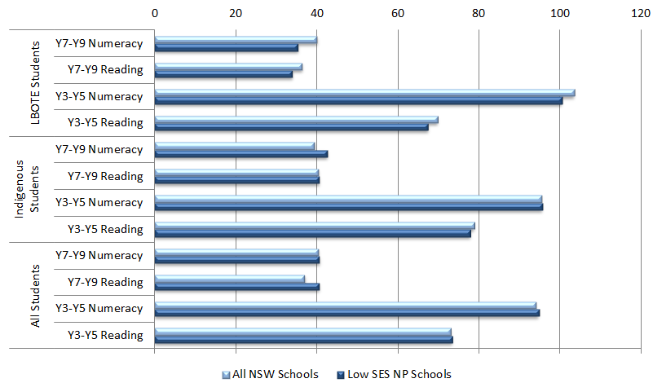
 |  | Gain (all NSW schools) | Gain (Low SES NP schools)
LBOTE Students | Year 7 to Year 9 Numeracy | 40 | 35
LBOTE Students | Year 7 to Year 9 Reading | 36 | 34
LBOTE Students | Year 3 to Year 5 Numeracy | 104 | 100
LBOTE Students | Year 3 to Year 5 Reading | 70 | 68
Indigenous students | Year 7 to Year 9 Numeracy | 39 | 43
Indigenous students | Year 7 to Year 9 Reading | 40 | 41
Indigenous students | Year 3 to Year 5 Numeracy | 95 | 96
Indigenous students | Year 3 to Year 5 Reading | 79 | 78
All students | Year 7 to Year 9 Numeracy | 40 | 41
All students | Year 7 to Year 9 Reading | 37 | 41
All students | Year 3 to Year 5 Numeracy | 94 | 95
All students | Year 3 to Year 5 Reading | 73 | 73
Source: PGA constructed using NSW DEC (2013); ACARA 2012
This aggregated analysis cannot be used to determine whether observed gains can be directly attributed to the Low SES NP, as it does not control for schools’ starting points and characteristics which were found to be important determinants of student progress. Additional analysis of achievement in NSW Low SES NP schools was therefore undertaken using regression discontinuity design modelling (see Appendix 4). This quasi-experimental form of analysis has gained wide recognition as a robust means of program evaluation when clear selection criteria are used to determine program entry. The results presented in this section arise from analysis of unit-record achievement data of students in both Government and Catholic schools. The use of student-level data is necessary to ensure results represent the best estimates of the impact of the Low SES NP on students who were at schools that participated in the partnership for at least two years. Results of the regression discontinuity (RD) analysis present the average estimated impact of participating in the Low SES NP on growth in student achievement. For the 2009-2011 student cohort, the results show small but statistically significant associations between participation in the Low SES NP and growth in student achievement in both domains and year levels (Figure 2.3). The estimates suggest that the additional growth associated with participating in the Low SES NP, holding all else equal, was approximately 2.3 points in Years 3-5 Reading, 3.2 points in Years 7-9 Reading, 4.3 points in Years 3-5 Numeracy and 3.0 points in Years 7-9 Numeracy. Significant additional growth in student achievement was also found for the 2010-2012 student cohort at Low SES NP schools. These included 1.9 points in Years 7-9 Reading, 2.0 points in Years 3-5 Reading and 6.5 points in Years 7-9 Numeracy.
Figure 2.3: Estimated effect of the Low SES NP on growth in student achievement in NSW Government and Catholic schools
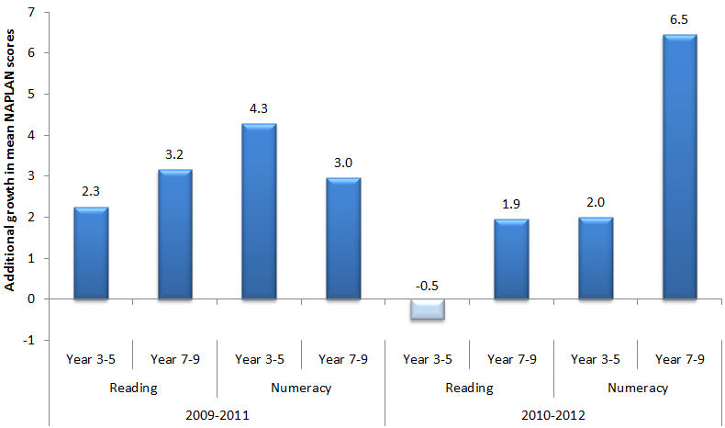
 |  | Year 3 to Year 5 | Year 7 to Year 9
2009 to 2011 | Reading | 2.3 | 3.2
2009 to 2011 | Numeracy | 4.3 | 3.0
2010 to 2012 | Reading | -0.5 | 1.9
2010 to 2012 | Numeracy | 2.0 | 6.5
Source: PGA constructed graph provided by NSW DEC and ACARA
Bars represented in dark colours are significant at the 5% confidence level while the light coloured bar is not significantly different from zero at the 5% level.
Analysis of achievement among Indigenous students in NSW Low SES NP schools was undertaken using unit-record data in all NSW Government and Catholic schools to assess the progress of Indigenous students in Low SES NP schools compared to that made by Indigenous students in similar non-NP schools. Similar schools were grouped according to their students’ socioeconomic background as measured by the school ICSEA or their achievement prior to the commencement of the Low SES NP, with the analysis focusing on students in the lowest four deciles of either measure. In the 2009-2011 student cohort, the results show that Indigenous students in Low SES NP schools were more likely to exhibit above-average growth compared to their peers in similar non-NP schools in Years 3-5 Reading and in Years 7-9 Numeracy. Mixed results were also observed in the 2010-2012 student cohort (Figure 2.4). Amongst these students, higher proportions of above-average growth were generally found at Low SES NP schools when controlling for schools’ socioeconomic background. This was particularly true in Years 3-5 Numeracy where 56% of Indigenous students exhibited above average growth compared to 47% of Indigenous students at schools with similar ICSEA. However, these gains appear to be influenced by lower starting scores as only 43% to 46% of Indigenous students achieved above average growth when compared to their peers at non-NP schools with similar starting scores.
Figure 2.4: Proportion of Indigenous students in Low SES NP schools who achieved above average growth compared to that of Indigenous students in similar non-NP schools, 2010-2012 student cohort in NSW Government and Catholic sectors
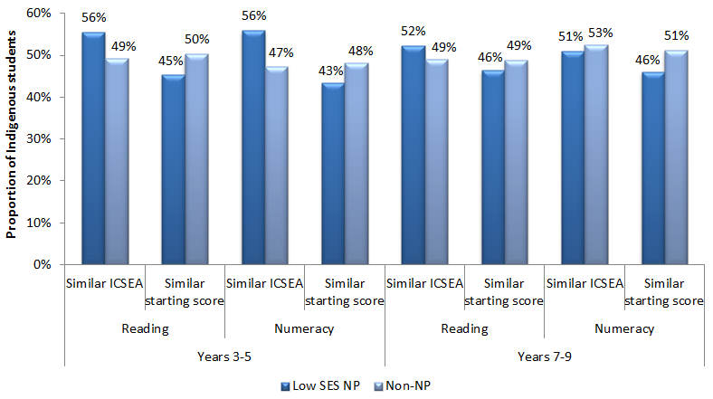
 |  |  | Low SES NP schools | Non-NP schools
Year 3 to Year 5 | Reading | Similar ICSEA | 56% | 49%
Year 3 to Year 5 | Reading | Similar starting score | 45% | 50%
Year 3 to Year 5 | Numeracy | Similar ICSEA | 56% | 47%
Year 3 to Year 5 | Numeracy | Similar Starting score | 43% | 48%
Year 7 to Year 9 | Reading | Similar ICSEA | 52% | 49%
Year 7 to Year 9 | Reading | Similar starting score | 46% | 49%
Year 7 to Year 9 | Numeracy | Similar ICSEA | 51% | 53%
Year 7 to Year 9 | Numeracy | Similar Starting score | 46% | 51%
Source: PGA constructed graph using data provided by NSW DEC and ACARA
As outlined in the evaluation scope, outcomes were analysed for metropolitan and non-metropolitan schools participating in the Low SES NP. This analysis was conducted using the regression discontinuity design for primary schools which constituted most participating partnership schools. The results suggest that students at non-metropolitan schools, particularly among the 2010-2012 cohort, were more likely to exhibit higher growth in Numeracy and Reading compared to students at similar non-NP schools. However, these results should also be interpreted carefully as schools’ location was not necessarily used as a criterion for selection into the partnerships. Moreover, the approach to the Low SES NP was likely to have varied between metropolitan and non-metropolitan locations. Given the lack of information on the multitude and complexity of implemented programs, it is not possible to attribute observed estimates to particular metropolitan or non-metropolitan initiatives.
When achievement at the primary school level was analysed using NAPLAN bands (Figure 2.5), a general increase in the proportion of students at or below NMS was observed across all NSW schools. This is a national trend in NAPLAN achievement, with a lower proportion of students surpassing NMS at higher grade levels. Although this trend was also observed in Low SES NP schools, the relative increase in Numeracy was less than that found across all NSW schools. At the secondary school level, the relative proportion of students falling below NMS at Low SES NP schools in Reading was less than that found across all NSW schools.
Figure 2.5: Proportion of students at or below NMS (Year 3 2010-Year 5 2012) in NAPLAN, NSW schools commencing Low SES NP in 2009/2010
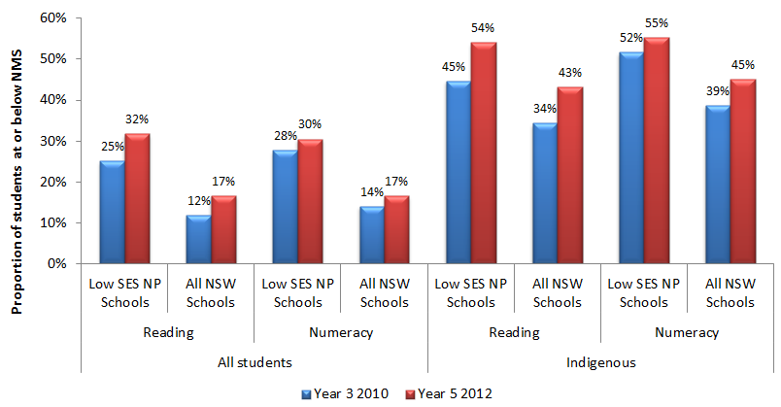
 |  |  | Year 3 2010 | Year 5 2010
All students | Low SES NP Schools | Reading | 25% | 32%
All students | Low SES NP Schools | Numeracy | 12% | 17%
All students | All NSW Schools | Reading | 28% | 30%
All students | All NSW Schools | Numeracy | 14% | 17%
Indigenous | Low SES NP Schools | Reading | 45% | 54%
Indigenous | Low SES NP Schools | Numeracy | 34% | 43%
Indigenous | All New Schools | Reading | 52% | 55%
Indigenous | All New Schools | Numeracy | 39% | 45%
Source: PGA constructed using NSW DEC (2013); ACARA (2012)
It is important to note that Low SES NP schools targeted other fundamental outcomes in addition to achievement, such as student attendance and engagement. These are further discussed in subsequent sections of this chapter.

NAPLAN Participation at Low SES NP schools
When NAPLAN participation at Low SES NP schools was assessed, little differences were found in participation rates between 2008 and 2012 at both the primary school and secondary school levels. Similar results were found among Indigenous students, although participation rates peaked in 2010 and 2011. These patterns of NAPLAN participation at Low SES NP schools were similar to those observed in all NSW schools. Therefore it is unlikely that overall changes in achievement were affected by NAPLAN attendance trends though this would still affect school-level analyses.

Achievement in LNNP schools
Overall, NSW LNNP schools met or exceeded five targets set to acquire reward LNNP funding, made progress towards three targets and did not meet four targets. Between 2008 and 2011, the proportion of Year 3 and Year 5 students at or above the NMS for Reading and Numeracy improved by between 1.4 and 3.4 percentage points. In addition, the proportion of Year 3 and Year 5 Indigenous students at or above NMS for Reading and Numeracy improved by between 1.9 and 10.3 percentage points (COAG Reform Council 2012).
Further analysis of achievement in NSW LNNP schools compared the proportion of students at LNNP schools who achieved above average growth to the corresponding proportion of students at similar non-NP schools. This analysis was limited to just the Government and Catholic sectors where unit-record data was available. Only students in the lowest four ICSEA deciles as well as the lowest four deciles of previous NAPLAN scores were considered in this analysis, as these were identified as the students with the greatest learning needs. For the 2009-2011 student cohort, the proportion of students who achieved above average growth was 3% higher in both Reading and Numeracy amongst students at LNNP schools compared to those at non-NP schools with similar socioeconomic backgrounds (Figure 2.6). However, different results were found when the analysis compared LNNP schools to non-NP schools with similar starting points. Moreover, analysis of data from the 2010-2012 student cohort showed the proportion of students who achieved above average growth was higher in non-NP schools with similar starting scores.
Figure 2.6: Proportion of Years 3-5 students in LNNP schools who achieved above average growth compared to that of students in similar non-NP schools, NSW Government and Catholic sectors
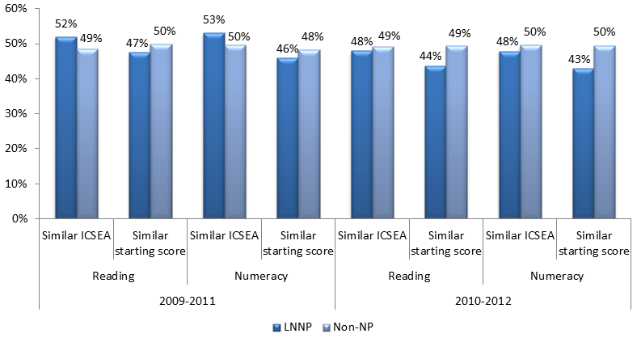
 |  |  | LNNP schools | Non-NP schools
2009 to 2011 | Reading | Similar ICSEA | 52% | 49%
2009 to 2011 | Reading | Similar starting score | 47% | 50%
2009 to 2011 | Numeracy | Similar ICSEA | 53% | 50%
2009 to 2011 | Numeracy | Similar starting score | 46% | 48%
2010 to 2012 | Reading | Similar ICSEA | 48% | 49%
2010 to 2012 | Reading | Similar starting score | 44% | 49%
2010 to 2012 | Numeracy | Similar ICSEA | 48% | 50%
2010 to 2012 | Numeracy | Similar starting score | 43% | 50%
Source: PGA constructed graph using data provided by NSW DEC and ACARA
When considering only Indigenous students, available data suggests that the LNNP seemed to have its greatest effect in Numeracy, particularly for the Year 3 level. For instance, between 2008 and 2011, the gap between Indigenous students in LNNP schools and those in other NSW schools was almost completely eliminated (Figure 2.7).
Figure 2.7: NAPLAN Scores - Year 3 Numeracy for Indigenous and Non-Indigenous students, 2008-2011, NSW LNNP schools
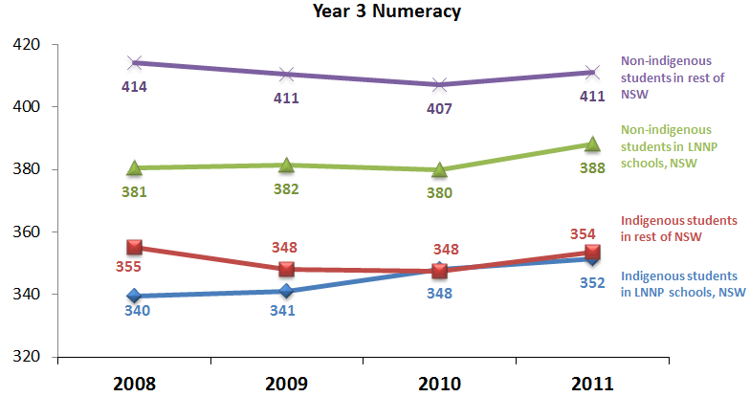
Year 3 Numerac  y | 2008 | 2009 | 2010 | 2011
Indigenous students in LNNP schools, NSW | 340 | 341 | 348 | 352
Indigenous students in rest of NSW | 355 | 348 | 348 | 354
Non-indigenous students in LNNP schools, NSW | 381 | 382 | 380 | 388
Non-indigenous students in rest of NSW | 414 | 411 | 407 | 411
Source: Data from Erebus International (2012a)
The analysis shown above presents the change in achievement patterns for the same year level over time. It does not provide sufficient evidence of the impact of the LNNP on a cohort of students at schools participating in the partnership for a number of years. To identify how the LNNP may have impacted such students, additional analysis of achievement among Indigenous students in NSW Government and Catholic LNNP schools was undertaken using the same method described for Figure 2.4. In the 2009-2011 cohort of Indigenous students, the results show that above average growth in both Reading and Numeracy was more frequently observed amongst LNNP students compared to students at non-NP schools with similar ICSEA deciles, but not when starting scores were controlled for (Figure 2.8). However, in the 2010-2012 student cohort, a higher proportion of Indigenous students in LNNP schools achieved above average growth in Numeracy compared to their peers at similar non-NP schools when controlling for both socioeconomic status and starting scores. This effect was not observed in Reading.

Figure 2.8: Proportion of Years 3-5 Indigenous students in LNNP schools who achieved above average growth compared to that of Indigenous students in similar non-NP schools, NSW Government and Catholic sectors
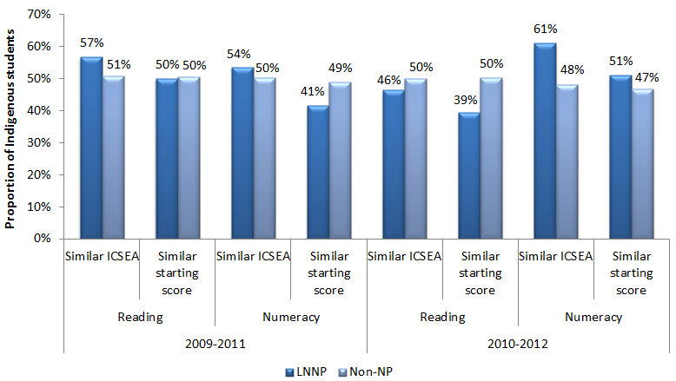
 |  |  | LNNP schools | Non-NP schools
2009 to 2011 | Reading | Similar ICSEA | 57% | 51%
2009 to 2011 | Reading | Similar starting score | 50% | 50%
2009 to 2011 | Numeracy | Similar ICSEA | 54% | 50%
2009 to 2011 | Numeracy | Similar starting score | 41% | 49%
2010 to 2012 | Reading | Similar ICSEA | 46% | 50%
2010 to 2012 | Reading | Similar starting score | 39% | 50%
2010 to 2012 | Numeracy | Similar ICSEA | 61% | 48%
2010 to 2012 | Numeracy | Similar starting score | 51% | 47%
Source: PGA constructed graph using data provided by NSW DEC and ACARA
When analysis of achievement at the primary school level was undertaken by location using the same method described for Figure 2.4, the proportion of students at non-metropolitan LNNP schools who achieved above average NAPLAN Reading and Numeracy growth was found to be higher than that of students at metropolitan LNNP schools. This result was observed among both the 2009-2011 and 2010-2012 cohort, while similar results were also found when the analysis compared students with similar starting points.
In NSW, all LNNP schools chose to focus their initiatives on either Literacy or Numeracy. As a result, additional analysis at these schools using unit-record data was undertaken to assess the effect of such a focus on Years 3-5 students. Compared to students at non-NP schools with similar socioeconomic backgrounds, the results show that the proportion of students who achieved above average growth in their school’s focus area was higher at LNNP schools in the 2009-2011 student cohort but not in the 2010-2012 student cohort. However, when starting scores were controlled for, only 44% of LNNP students achieved above-average growth in their schools’ focus area compared to approximately half of their peers at non-NP schools (Figure 2.9).

Figure 2.9: Proportion of Year 3-5 students in LNNP schools who achieved above average growth in their school’s focus area (Literacy/Reading or Numeracy) compared to that of students in similar non-NP schools, NSW Government and Catholic sectors
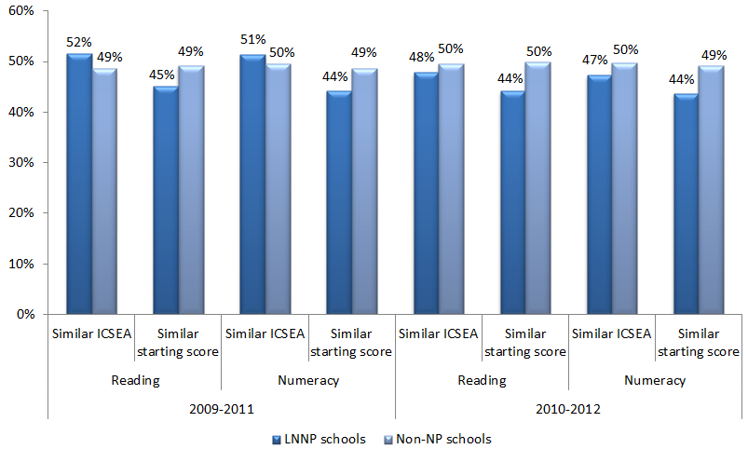
 |  |  | LNNP schools | Non-NP schools
2009 to 2011 | Reading | Similar ICSEA | 52% | 49%
2009 to 2011 | Reading | Similar starting score | 45% | 49%
2009 to 2011 | Numeracy | Similar ICSEA | 51% | 50%
2009 to 2011 | Numeracy | Similar starting score | 44% | 49%
2010-2012 | Reading | Similar ICSEA | 48% | 50%
2010-2012 | Reading | Similar starting score | 44% | 50%
2010-2012 | Numeracy | Similar ICSEA | 44% | 50%
2010-2012 | Numeracy | Similar starting score | 44% | 49%
Source: PGA constructed using data provided by NSW DEC and ACARA
Although NAPLAN growth rates may not have been as large in all LNNP schools as those in non-NP schools, no less than 42% of students in any grade level showed higher growth rates than peers at similar schools. It is recommended that further research be undertaken with this group to determine why some students at LNNP schools achieved greater success than others.
Case Study: Airds Community of Schools: Community Engagement & Indigenous Students Achievement (NSW DEC 2013).
Airds Community of Schools (CoS) in the South West Sydney region of NSW includes one high school and three primary schools, all committed to increasing the engagement of the community to support Indigenous student achievement.
Through NP funding, they employed additional staff that included:
- a Deputy Principal (Indigenous Education), across the Airds CoS, to support the school leadership team in identifying and providing strategies for Indigenous students and to coordinate an after school community engagement program for students and parents;
- a Community Liaison Officer to promote more effective parental engagement with their child’s learning at school and at home; and
- an Assistant Principal, School Learning Support Officer and School Administration Officer.
- The additional staff facilitated a number of school community engagement programs that included:
- an interactive and technology-based Personalised Learning Plan process across the Airds CoS, to ensure consistency for students, parents and teachers;
- a CoS cultural awareness tour for parents and teachers in collaboration with the local Aboriginal Education Consultative Group (AECG) to schools with high populations of Indigenous students in north western NSW, which built community and school relationships as well as community capacity to participate in school improvement;
- supporting the work of the AECG, across the Airds CoS, in implementing a TAFE Certificate III program for parents and community members that focused on improving the understanding and involvement of community in the local and state AECG;
- involvement of teachers in Cultural Immersion training;
- provision of training for Indigenous Elders and Indigenous community members in supporting literacy and numeracy in the classroom;
- regular community meetings to guide the future direction of the school;
- redesign of the school newsletter, in consultation with the parent community; and
- organisation of Indigenous cultural events in the school.
Improvements made included:
- NAPLAN growth data for Year 5 Numeracy indicated that 50% of Indigenous students exceeded expected growth, with an average of 102 points compared to 93 for the state;
- in Year 5 Numeracy, only 10% of Indigenous students were at or below the National Minimum Standard (NMS) compared to 60% in 2010;
- in Year 5 Reading, the percentage of Indigenous students at or below the NMS fell from 66.6% in 2010 to 50% in 2011;
- eight Indigenous people from the Airds CoS completed their Certificate III program.

Case Study: Wiley Park Public School: Improvement in Reading and Numeracy Outcomes for Students with Non-English Speaking Backgrounds (NSW DEC 2012).
Wiley Park Public School (WPPS) is a government primary school situated in Sydney’s South West region, attended by approximately 530 students. Of these, 97% are from non-English speaking backgrounds, representing 38 languages and 29 countries of origin. WPPS commenced participation in the Low SES School Communities National Partnership (Low SES NP) in 2011 with a view to implementing strong reform and improving learning outcomes for students.
NP Funding was used to employ additional staff. They included an Assistant Principal (ESL) and an Assistant Principal (Literacy), who facilitated professional learning in ESL pedagogy, numeracy teaching, and Information Communication Technology (ICT). A paraprofessional was also appointed to support underperforming students.
WPPS operated a range of programs to support student learning including the Early School Support Program; English as a Second Language (ESL); Samoan, Arabic and Vietnamese community language program; reading recovery programs; learning assistance programs; and Homework Centres. WPPS also participated in a number of community programs such as a Multicultural Playgroup and Good Beginnings; maintains productive partnerships with organisations such as Sydney University and the Canterbury Bankstown Migrant Resource Centre; and is part of the Priority Schools’ Program; the Successful Language Learners Project; and the School and Community Centres Project.
WPPS experienced excellent results by the end of their first year of participation in the Low SES NP. Four reading targets and four numeracy targets were set for the school in 2011, and all were achieved or exceeded, as supported by NAPLAN data:
- Year 3 Reading: the proportion of students in the top two NAPLAN bands increased from 27% in 2010 to 33% in 2011, while the proportion of students in the bottom bands decreased from 25% in 2010 to 18% in 2011;
- Year 3 Numeracy: the proportion of students in top two NAPLAN bands increased from 13% in 2010 to 28% in 2011, while the percentage of students in the bottom bands decreased from 31% in 2010 to 21% in 2010;
- Year 5 Reading: 50% students achieved expected growth, with an average of 79 points (compared to the state average of 72);
- Year 5 Numeracy: 60.7% students achieved expected growth, with an average of 112 points (compared to the state average of 94).

Case Study: Cabramatta High School: Raising Outcomes through Community Partnerships, Extending Library Hours and Activities; and Dedicated Learning Support (NSW DEC 2012).
Cabramatta High School (CHS) is a government co-educational high school located in Sydney’s South West region. Catering to students in Years 7 to 12, 97% are from a Language Background Other Than English (LBOTE), including 45 refugee students.
In addition to the NP, CHS was also supported by the Priority Schools Programs (PSP) and by funding from Priority Action Schools (PAS); both of which are equity programs targeting schools in low socio-economic communities. The school utilised this funding to improve learning outcomes in literacy and numeracy for all students by developing positive strategies in home, school and community partnerships, school organisation and quality teaching and learning.
CHS established learning partnerships with over 50 community organisations, including the Australian Business Community Network, giving students the opportunity to be mentored, learn about the wider community, and develop leadership and work-related skills. CHS also cultivates a strong community, with strong attendance at school council and parent meetings; implementation of the Families in Cultural Transition Program; and effective communication with parents through the work of six Community Liaison Officers.
On commencing participation in the Low SES NP, CHS targeted improved literacy and numeracy outcomes for students and sustainable reform. Funding facilitated the extension of school library operating hours, thereby providing for a homework centre and opportunities for students to engage in tutoring in literacy, numeracy, and subject-specific areas. Funding was also utilised to appoint a dedicated teacher, who developed and implemented strategies including targeted tutorials, study skills workshops, mentoring activities, Individual Learning Plans and links with external agencies.

After one year in the Low SES NP, CHS experienced excellent student outcomes, evidenced in NAPLAN data compared across 2010 and 2011, particularly for Year 9:
- Reading: 64% students exceeded expected growth in 2011, with an average of 49.5 points (compared to a state average of 37 points);
- The proportion of students in the top two NAPLAN bands for Reading increased from 6% to 8%, and the proportion of students in bottom bands decreased from 59% to 37%;
- Numeracy: 63% of students achieved expected growth in 2011, with an average of 48.7 points (compared to a state average of 39.6); and
- The proportion of students in the top two NAPLAN bands for Numeracy increased from 22% to 31%, and the proportion of students in bottom bands decreased from 36% to 26%.

Outcome 2:
Increased proportion of students enrolled in and attending school (particularly Indigenous students) and a higher proportion completing year 10
Schools selected for the Low SES NP were often comprised of students facing multiple sources of disadvantage over an extended period of time. Addressing these entrenched disadvantages required a focus on more vital issues such as attendance and engagement before student achievement could be lifted. In NSW, school Learning Support Officers, Aboriginal Education Workers and community engagement officers were employed to enhance student retention and attendance through the development and ongoing review of Individual Learning Plans. Other initiatives included programs that aimed at building emotional intelligence, learning centres for disengaged students, healthy eating programs, breakfast clubs, transition programs and resilience building programs.
Attendance in NSW was not measured on a state level, although the Government and Catholic sectors provided sector level attendance data using different measures of attendance. In NSW Government schools (Figure 2.10), attendance was measured across three Low SES NP school cohorts, consisting of schools beginning in 2009/2010 (cohort 1), 2011 (cohort 2) and 2012 (cohort 3). Attendance rates among all three cohorts increased slightly from 2009 to 2011. By 2012, the attendance rates in cohorts 1 and 3 had dipped back to baseline (2009) levels, but remained higher than baseline in cohort 2. Among Indigenous students, the attendance rates between 2009 and 2012 increased by 0.4% in cohort 1 (with an increase of 0.7% between 2009 and 2010), 0.6% in cohort 2 and 1.2% in cohort 3. However, it is not clear if these increases were statistically significant.
Figure 2.10: Attendance data for NSW Government Low SES NP schools
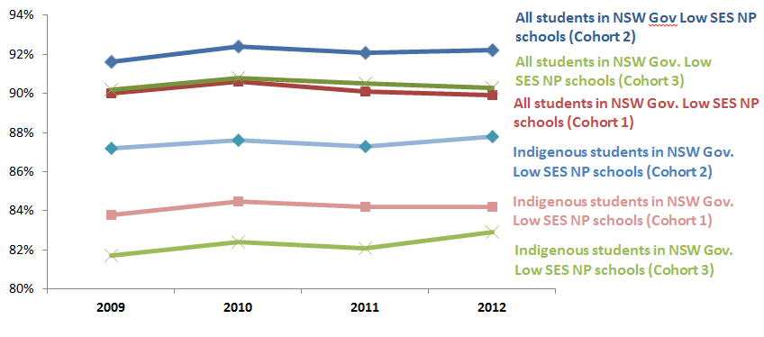
 | 2009 | 2010 | 2011 | 2012
Indigenous students in NSW Government Low SES NP schools (Cohort 1) (starting 2009/2010) | 84% | 85% | 84% | 84%
All students in NSW Government Low SES NP schools (Cohort 1) (starting 2009/2010) | 90% | 91% | 91% | 90%
Indigenous students in NSW Government Low SES NP schools (Cohort 2) (starting 2011) | 87% | 88% | 87% | 88%
All students in NSW Government Low SES NP schools (Cohort 2) (starting 2011) | 92% | 92% | 92% | 92%
Indigenous students in NSW Government Low SES NP schools (Cohort 3) (starting 2012) | 82% | 82% | 82% | 83%
All students in NSW Government Low SES NP schools (Cohort 3) (starting 2012) | 90% | 91% | 91% | 90%
Source: NSW DEC (2013)
In Catholic schools, attendance rates between 2009 and 2012 increased by 1.2% in cohort 1 and 1% in cohort 2. Among Indigenous students, attendance had increased notably between 2009 and 2012, rising by 4.3% for cohort 1 and 1.7% for cohort 2.
To better understand the impact of the Low SES NP on attendance, further analysis was undertaken comparing trends in student attendance at participating schools to those in non-NP schools. On average, attendance at non-NP schools was found to be higher at both primary and secondary levels compared to Low SES NP schools. The analysis used aggregated school-level data from all NSW Government and Catholic schools to determine whether the difference in attendance rates between Low SES NP schools and non-NP schools declined over time following the commencement of the partnership. The difference in attendance rates between Low SES NP schools and non-NP schools decreased by only 0.1% in primary schools and 0.3% in secondary schools. Amongst Indigenous students however (Figure 2.11), attendance rates at Low SES NP schools were found to have significantly improved compared to their peers at non-NP schools. At the primary school level, the gap between Indigenous students’ attendance rates at Low SES NP schools compared to non-NP schools declined by 5.4% This statistically significant improvement is equivalent to a 77% reduction in the initial gap between Low SES NP and non-NP schools. At the secondary school level, attendance rates among Indigenous students at Low SES NP schools improved from being 3.5% less than that in non-NP schools to 2.7% higher. This was also found to be statistically significant.
Figure 2.11: Attendance rates of Indigenous students in NSW Government and Catholic schools
Secondary school level figures include only Year 7-10 as year 11-12 attendance data was not provided for the Catholic sector. Primary school level figures exclude Grade Prep.
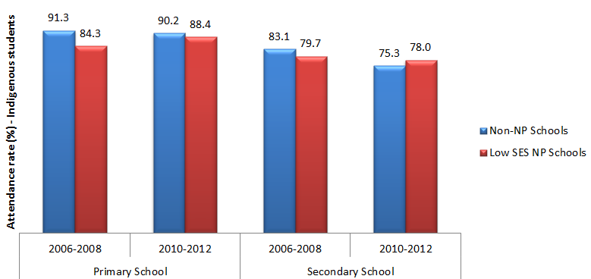
 |  | Non-NP Government and Catholic schools | Low SES NP Government and Catholic schools
Primary School | 2006 to 2008 | 91.3 | 84.3
Primary School | 2010 to 2012 | 90.2 | 88.4
Secondary School | 2006 to 2008 | 83.1 | 79.7
Secondary School | 2010 to 2012 | 75.3 | 78
Source: PGA constructed graph based on attendance data provided by NSW DEC and DEEWR
NB: Secondary school level figures include only Years 7-10, as Years 11-12 attendance data was not provided for the Catholic sector. Primary school level figures exclude Grade Prep.
The apparent retention rate (ARR) was estimated for schools in NSW to investigate the relationship between participating in the Low SES NP and student retention. The ARR is measured as a ratio of students in a particular grade level divided by the number of students in an earlier grade level. Analysis of data from NSW Government schools commencing Low SES NP participation in 2009/2010 showed that both the Year 10-11 and Year 10-12 ARRs at Low SES NP schools had decreased significantly compared to non-NP schools (Figure 2.12). Among Indigenous students however, the Year 10-11 ARR at Low SES NP schools increased from 62.5% to 71.5%. This improvement was 4.7% higher than that observed at non-NP schools, a result that was found to be statistically significant. The increase in the Year 10-12 ARR among Indigenous students was 1.4% higher at Low SES NP schools. This result was also statistically significant. Despite this, the results should not be taken as causal evidence of the impact of the Low SES NP as the ARR is an aggregated measure of student enrolment and does not control for student movement between schools, an important factor that may be driving the observed changes.
Figure 2.12: Apparent retention rates in NSW Government schools commencing Low SES NP participation in 2009/2010.
The pre-NP commencement figures are the averages ARRs between 2006 and 2009. The post-NP commencement figures are the ARRs between 2011 and 2012 for years 10-11 and between 2010 and 2012 for Years 10-12
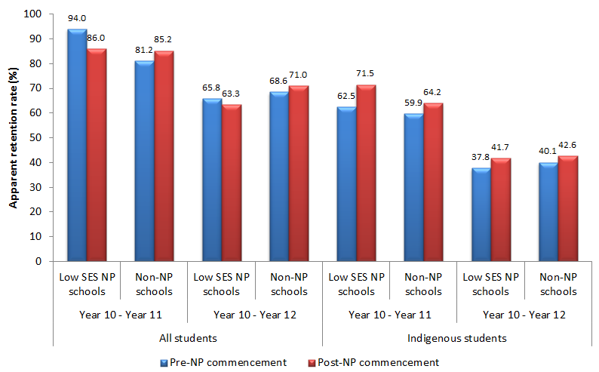
 |  |  | Pre-NP commencement | Post-NP commencement
All students | Low SES NP schools | Year 10 to Year 11 | 94 | 86
All students | Low SES NP schools | Year 10 to Year 12 | 65.8 | 63.3
All students | Non-NP schools | Year 10 to Year 11 | 81.2 | 85.2
All students | Non-NP schools | Year 10 to Year 12 | 68.6 | 71
Indigenous students | Low SES NP schools | Year 10 to Year 11 | 62.5 | 71.5
Indigenous students | Low SES NP schools | Year 10 to Year 12 | 37.8 | 41.7
Indigenous students | Non-NP schools | Year 10 to Year 11 | 59.9 | 64.2
Indigenous students | Non-NP schools | Year 10 to Year 12 | 40.1 | 42.6
Source: PGA constructed graph based on enrolment data provided by NSW DEC and DEEWR
CASE STUDY: Macleay Vocational College Student Attendance and Engagement Improvement (NSW DEC 2013).
Macleay Vocational College is an independent Special Assistance School located in South Kempsey. The College caters for students from Years 9 to 12 who are returning to education after a history of having been suspended or expelled from traditional education settings, periods of chronic truancy and for those exiting Juvenile Detention. Over 76% of the students were Indigenous.
Attendance and engagement in learning is the critical issue for this school; and improvement in attendance rates was a key priority in 2012.
Strategies implemented to increase attendance included:
- employing an Aboriginal Education Worker (AEW) full time to support attendance by assisting students to get to school and workplace experience opportunities.
- offering incentives and rewards to students who achieved set targets for their attendance;
- adding a breakfast program, ensuring that students are ready, and able to learn every morning;
- introducing interest electives, to increase student engagement; and
- the principal directly focusing on creating and nurturing student leaders, including providing real and meaningful duties for these leaders.
Student attendance rates increased since the introduction of these strategies, with over 40% of students meeting their attendance targets in 2012. Attendance of the Indigenous students improved as well, and the number of Indigenous students who sat final exams increased by 15% from the mid-year exam numbers.

Outcome 3:
Appropriate use of data by schools to plan, implement and evaluate programs
In order to monitor students and effectively identify their particular learning needs, teachers and staff were coached in the use of various data analysis programs such as Dynamic Indicators of Basic Early Literacy Skills (DIBELS), DASA and SMART2 data. The use of data was an integral focus of the SSNP in NSW. LNNP school leaders reported that more teachers were accessing and using data, especially NAPLAN data, when planning teaching and learning for their classes (Erebus International, 2012a).

Figure 2.13: Effect of data use on teaching in NSW LNNP schools
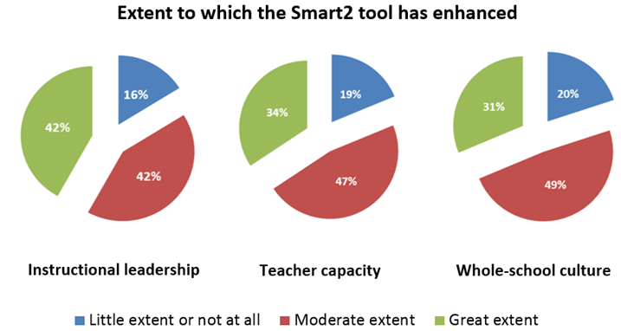
Extent to which the Smart2 tool has enhanced

 | Instructional leadership | Teacher capacity | Whole-school culture
Little extent or not at all | 16% | 19% | 20%
Moderate extent | 42% | 47% | 49%
Whole-school culture | 42% | 34% | 31%
Source: Data from Erebus International (2012a)
Survey data shows at least 80% of LNNP school teachers who used the Smart2 software for data analysis and planning found it either moderately or greatly enhanced instructional leadership/leadership for learning, teacher capacity, and whole-school culture (Figure 2.13). In addition, a cross-sectoral impact survey of NSW SSNP schools found that the proportion of teachers who reported a ‘large’ or ‘very large’ increase in the use of student achievement data had improved from 20% in 2010 to 34% in 2012 (Figure 2.14). An improvement was also observed amongst principals, with equivalent figures of 18% in 2010 and 45% in 2012. These results were both found to be statistically significant.

Figure 2.14: Change in the use of student achievement data between 2010 and 2012 in NSW SSNP schools
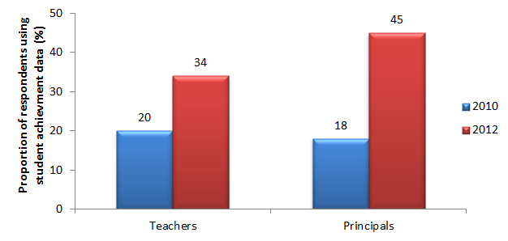
 | Student achievement data 2010 | Student achievement data 2012
Teachers | 20 | 34
Principals | 18 | 45
Figures show the proportion of teacher and principals in NSW SSNP schools who reported a ‘large’ or ‘very large’ increase in the use of student achievement data
Source: PGA constructed graph based on the ARTD Consultants (2012)
Case Study: Use of Student Data at Regional High School (NSW DEC 2012b)
Regional High is a public high school catering for over 700 students in western NSW. The school’s Low SES SSNP strategy is to enhance student engagement and performance through improvement of staff performance and accountability, better management of student attendance, and improvement of teaching and learning.
Low SES SSNP funding has enabled the school to resource a professional learning strategy, which is integrated into the Teacher Assessment and Reporting Schedule (TARS) process. The broader aim of this strategy was to change the school culture, with teachers becoming more adaptable and open to suggestions for improving their teaching practice.
Teachers were trained to use the School Measurement, Assessment and Reporting Toolkit (SMART) online. The analysis of SMART and other data were used to inform target setting related to attendance, retention, suspensions, programming and professional development. All faculties were involved in planning and development of targets and implementing strategies to achieve school targets. The school also undertook faculty reviews as part of the improvement process and involved external people to provide a broader perspective.
Training in student data analysis and use was reported to have resulted in increased staff use of evidence to inform decisions related to lesson planning and student achievement. According to an Executive Member, the school spends “much more time looking at data and planning right down to the teacher level”.

Outcomes 4 and 5:
Increased proportion of students completing Year 12 or AQF Certificate II, including Indigenous and disadvantaged students; Increased proportion of students participating in post-school education or training.
The increased proportions of students completing Year 12 (or equivalent) and participating in post-school education or training were long-term intended outcomes among NSW Low SES NP schools. While it is premature to anticipate systemic improvements in the limited timeframe under analysis, a number of schools selected for the Low SES NP have anecdotally noted an increase in the number of Indigenous students completing Year 12 in 2011 (NSW DEC 2012).
Case Study: Community Engagement at North Coast Public School. (NSW DEC 2012c)
North Coast is a K-6 government school catering for over 400 students in a small town in the mid-North Coast region. Through the Low SES SSNP, the school aimed to forge a stronger partnership with a diverse group of families and school community members. The school developed a community engagement strategy based on a ‘whole school approach’. Its key areas of focus were: creating time and space for collaboration; improving staff intercultural communication skills; responding in a more targeted and sensitive way to Indigenous parents; greater effort to involve parents in teaching and learning; providing parent workshops and information sessions; seeking parent feedback and input; encouraging greater parental involvement in decision making and connecting the school with other education /training providers.
Between 10 and 20 parents, on average, attended workshops organised by the school. The workshops were developed in response to perceived needs and interests, and included sessions on language and literacy learning; numeracy skill development; NAPLAN testing; positive parenting programs; transition to high school; teaching ‘jolly phonics in the kinder’; and ‘how to do reading in 5 minutes’. For example, the numeracy workshops which were implemented because of the perception that parents were confused about the terminology used by students, attracted an average of 20 parents per workshop. Regional Office staff assisted with the implementation, providing parents with insights into learning at all stages and introducing games that could be played at home.
As a result, the school staff reportedly developed a resilient attitude. According to the Assistant Principal, rather than “beating ourselves up about the low turn up of parents at workshops, we look at different ways of working with parents”.

Outcome 6:
Increased capacity for school-based innovation focused on improving student outcomes
School-based innovation in NSW aimed at raising student outcomes. This involved the introduction of new technologies, such as the use of video conferencing, iPads and digital notebooks to develop effective clusters and facilitate access to and sharing of digital resources.
Other school-based innovations such as out-of-school hours care and homework centres were further identified as effective. Teaching staff reported that the introduction of homework centres had provided them with the opportunity for more personalised teaching, as well as directly targeting areas of difficulty for each student. Furthermore, through workshops at school, parents were reported to be increasingly building the knowledge and skills to better support children in their homework. This is reported to have resulted in higher confidence and increased interaction with schools.
Case Study: Improving Indigenous Student Attendance, Engagement and Employability Skills at Maclean High School (NSW DEC 2013).
Maclean High School is in the North Coast region and had an enrolment of 1107 students in 2011, 8% of whom were Indigenous. Funding from the Low SES National Partnership was used to implement programs to support students at risk of disengaging from school.
The initiative aimed at building Indigenous student employability skills. A number of community and business partnerships were created through the Career Express Program to support the delivery of vocational education and training programs, including school based apprenticeships and traineeships. As part of Career Express, a Year 10 class of 27 students engaged in work placement one day a week under the supervision of the Transition Adviser. As well as formal vocational classes, students were given the opportunity to participate in job skills credentialing.
Other programs to support students at risk of disengaging from schooling included implementing literacy and numeracy programs such as QuickSmart, Blitzing Literacy In Secondary School Literacy Program, Spellodrome, etc.; Year 6 to Year 7 transition program for Year 6 students from 12 partner schools attending Maclean High School for one day each term throughout the year; Cultural Immersion program; and the completion of Deadly Food Enterprise in Year 9 Indigenous Studies. Professional learning was provided by the Technology Coordinator on integrating technology into teaching and learning strategies. Student attendance was monitored and followed up on using text messages, interviews with parents and newsletter articles related to good attendance.
Significant progress was been made in the areas of retention, engagement, attendance and Indigenous education strategies for students at risk of disengaging from schooling. The school achieved its target of improving the retention rate from 83% in 2011 to 85% in 2012. The number of students completing their HSC with Work Skills and Industry Qualifications increased from 62% in 2011 to 66% in 2012, including 80% for Indigenous students. The Year 7 to 12 attendance rate of 89% was above the regional rate of 87%.
An increased number of students are gaining employment due to improved work readiness resulting from participation in the Career Express Program. Seven students gained full time employment as a result of the program. Surveys indicated that many students have received part-time jobs as a result of their new work skills.

Outcome 7:
Increased capacity of teachers to collaborate to deliver quality literacy/numeracy teaching
In line with established findings on the importance of cooperation amongst teachers, collaborative networks across schools were created to optimise resources in order to better meet student needs. This primarily took the form of sharing of information, programs, strategies and expertise. Collaborative efforts also involved regular meetings between principals and coordinators to share information and develop partnerships between schools. For example, half of the NSW LNNP schools reported working with other schools to implement the partnership. The following figure shows the various ways in which schools collaborated.

Figure 2.15: Forms of collaboration practiced by NSW LNNP schools who reported to have worked with other schools
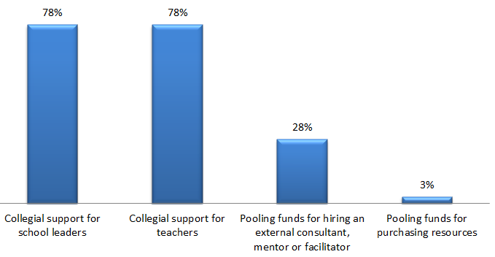
 | Proportion of NSW LNNP schools who reported to have worked with other schools
Collegial support for school teachers | 78%
Collegial support for teachers | 78%
Pooling funds for hiring an external consultant, mentor or facilitator | 28%
Pooling funds for purchasing resources | 3%
Source: Data from Erebus International (2012a)
In 78% of schools that worked together, teachers and their school leaders were found to have worked collaboratively to share resources, experience and advice. Furthermore, approximately 30% of collaborating schools pooled funds to hire a shared consultant or facilitator. In addition, teachers reported that collaboration with other teachers led to significant gains in their confidence and knowledge as well as engagement in their practice.
Further evidence of enhanced teacher collaboration was presented in the results of the cross-sectoral impact survey, where the proportion of teachers who reported a ‘large’ or ‘very large’ increase in the quality of teacher collaboration was found to have significantly improved from 26% in 2010 to 41% in 2012 (Figure 2.16). Although the proportions of teachers reporting ‘large’ or ‘very large’ increases in collaboration with teachers from other schools and with universities were higher in 2012 than in 2010, the differences were not found to be statistically significant.

Figure 2.16: Changes in the extent of teacher collaboration between 2010 and 2012 in NSW SSNP schools
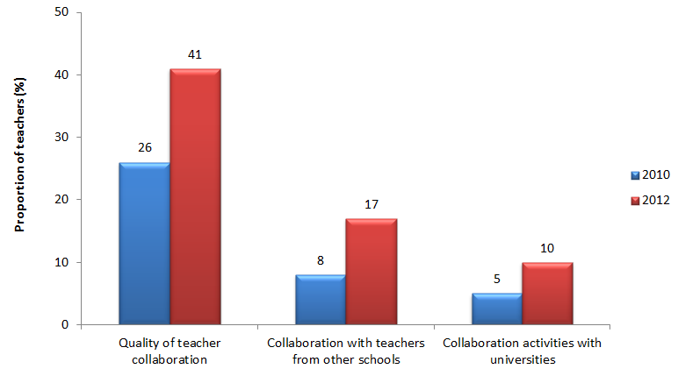
 | Teacher collaboration 2010 | Teacher collaboration 2012
Quality of teacher collaboration | 26 | 41
Collaboration with teachers from other schools | 8 | 17
Collaboration activities with universities | 5 | 10
Figures show the proportion of teachers in NSW SSNP schools who reported a ‘large’ or ‘very large’ increase in each collaboration activity
Source: PGA constructed graph based on the ARTD Consultants (2012)

Outcome 8:
Enhancement in teaching pedagogy
Targeting the enhancement of teaching pedagogy was an important intended objective which is likely to be a leading indicator of future improvement in other student outcomes. Developing pedagogical knowledge and skills amongst teachers took place mainly through the coaching or training of teachers by professional experts in specific literacy and numeracy intervention programs. These professionals were also employed to Individual Learning Plans (ILP). In addition, ‘Highly Accomplished Teachers’ were employed to model high quality teaching across their schools and lead the development and refinement of teaching practices. Evidence of enhancement in teaching pedagogy (Figure 2.17) was found in the aforementioned survey of LNNP schools. Over 77.5% of survey respondents believed that involvement in the LNNP positively impacted teacher knowledge of pedagogy to a moderate or great extent. Additionally, nearly all of the schools surveyed believed that participation in LNNP had impacted on the quality of the teaching and learning environment to either a moderate or great extent (Erebus International 2012a).

Figure 2.17: Impact of LNNP on developing pedagogy as reported by teachers in NSW LNNP schools
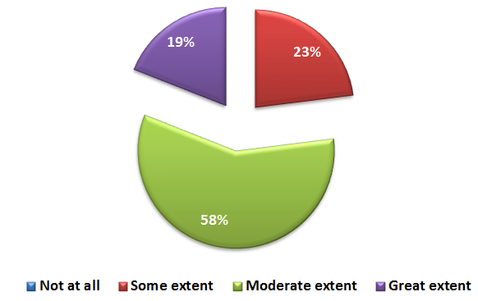
 | Not at all | Some extent | Moderate extent | Great extent
Impact of LNNP |  | 23% | 58% | 19%
Source: Data from Erebus International (2012a)
Among LNNP teachers surveyed in the cross-sectoral impact survey, the proportion who reported a ‘large’ or ‘very large’ increase in the improvement of overall teaching practices was significantly higher in 2012 (42%) than in 2010 (26%) (Figure 2.18). In addition, teachers reported a significantly greater focus on teaching and learning practices in 2012 (52%) compared to 2010 (30%). Although not statistically significant, teachers also noted an increase in professional learning support to enhance teaching skills and teacher capacity as a result of SSNP-funded school learning support staff. Among principals, the proportions who reported a ‘large’ or ‘very large’ increase in these four factors relating to teaching skills and practices were higher in 2012 compared to two years earlier.

Figure 2.18: Changes in teaching skills and practices between 2010 and 2012 in NSW SSNP schools
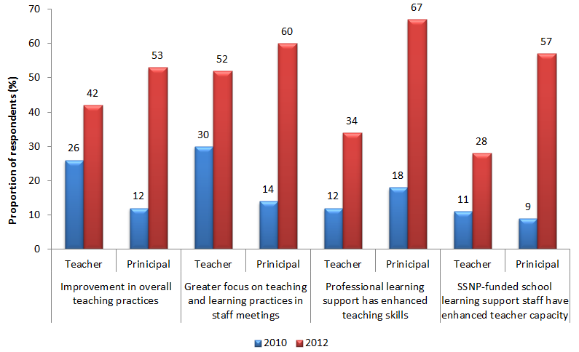
 |  | Improvement in overall teaching practices | Greater focus on teaching and learning practices in staff meetings | Professional learning support has enhanced teaching skills | SSNP-funded school learning support staff have enhanced teacher capacity
Teacher | 2010 | 26 | 30 | 12 | 11
Teacher | 2012 | 42 | 52 | 34 | 28
Principal | 2010 | 12 | 14 | 18 | 9
Principal | 2012 | 53 | 60 | 67 | 57
Figures show the proportion of teachers and principals in NSW SSNP schools who reported a 'large' or 'very large' increase in factors related to teaching skills and practices
Source: PGA constructed graph based on the ARTD Consultants (2012)
Case Study: Professional Learning at Orange Christian School raises outcomes for all. (NSW DEC 2011)
At Orange Christian School, the National Partnership funding provided the opportunity to focus on and improve literacy standards by equipping staff with the skills, understanding, resources and motivation to tackle the task at hand.
Through an intensive professional development program and mentoring by the Association of Independent Schools’ consultants, teaching practices improved to better meet students’ individual needs.
Literacy standards were lifted considerably by establishing a system in which teachers gauged students’ abilities through the use of School Measurement, Assessment and Reporting Toolkit (SMART) data and standardised tests, equipping teachers with appropriate skills through professional development, implementing interventions through the use of new reading resources, and regularly reviewing student progress.
It established a common language, and a more unified approach with exciting new resources to engage and motivate students; building a cultural change not only within the student body but also in the broader school community.
Numbers of students engaged in regular reading activities have increased dramatically:
- 70% of students have increased the regularity of their reading;
- 50% of students are reading daily for leisure;
- 70% of students have an improved satisfaction and enjoyment of reading;
- more than 20 students have graduated through the MULTILIT program with 3 students completing the MULTILIT extension program; and
- MULTILIT has become part of the school culture and has been incorporated as a component of one of the senior subjects.

2.3 NSW CONCLUSION
Available evidence suggests that participation in the Low SES NP had a significant positive effect on student achievement. The most robust analysis involving regression discontinuity design shows that Low SES NP school students made significant gains in Years 3-5 Numeracy and in Years 7-9 Reading and Numeracy, ranging from 1.9 points to 6.5 points depending on the domain, year level and student cohort. A separate analysis of student gains in NAPLAN additionally found greater growth in Years 3-5 Numeracy among Indigenous students in Low SES NP schools compared to those in similar non-NP schools. In LNNP schools, it is worthy to note that between 2008 and 2011, achievement patterns amongst Indigenous students at Year 3 were found to have converged to those of Indigenous students in non-NP schools. Additional analysis of matched student data showed that the most disadvantaged students at LNNP schools in the 2009-2011 cohort were more likely to have achieved above average growth in primary school level Reading and Numeracy compared to their peers in similar non-NP schools. This was also observed in Numeracy among the 2010-2012 student cohort, especially for Indigenous students. However, these gains for all LNNP students appear to be driven by their lower starting points since different results were found when the analysis controlled for prior achievement, where higher growth rates at LNNP schools were limited to Indigenous students.
In addition to utilising evidence from case studies, annual reports and the evaluator’s own analysis of student data, this evaluation synthesised findings from several state-based independent evaluations of LNNP-related activities to better understand the effects of the partnership. These evaluations used a combination of comprehensive content analysis and interviews with system representatives (Erebus International 2012b). The analysis of findings from these evaluations in this section shows some of the pathways by which some observed effects appear to have operated.
Improvements in student achievement at NSW LNNP schools were reported to be linked to a combination of evidence-based literacy and numeracy programs and Individual Learning Plans (ILP). Through ‘Multilit’ for example, many students were found to not only demonstrate reading gains but also increases in confidence, reading enjoyment and attitudes to reading and schoolwork (Erebus International 2012b). Moreover, the ‘Reading to Learn’ program was reported to have improved students’ confidence in reading and increased student capacity to use a variety of strategies to develop comprehension. This program also enabled students to transfer literacy skills and strategies into other key learning areas and extended the diversity of texts that students were engaged in reading both in and out of school. While NAPLAN results of students in the ‘Reading to Learn’ program highlighted minimal student improvement, internal assessments from principals and teachers were largely positive. For example, evidence based on teachers’ reports identified improvements in reading and comprehension skills for the majority of Indigenous students (Erebus International 2012b). In addition, NAPLAN data revealed that Indigenous students in classes implementing ‘Accelerated Literacy’, ‘Taking Off With Numeracy’ (TOWN) and ILP achieved higher gain scores than non-Indigenous students in Literacy and Numeracy, respectively (Erebus International 2012b). However, it is unclear if starting scores were taken into consideration, as Indigenous students may have started at lower initial scores that resulted in higher gains. ILP were also associated with improvements in reading and comprehension skills among disadvantaged non-Indigenous students, as such students with ILP achieved slightly higher NAPLAN Reading score gains than those exhibited amongst students across most LNNP literacy focus schools (Erebus International 2012b). Students with ILP were reportedly observed to have increased enjoyment of reading and reading fluency. In addition, students with ILP exhibited improved social skills as well as enhanced attitudes to homework (Erebus International 2012b). These improvements in attitudes to learning and reading in particular may represent leading indicators of subsequent improvement in these students’ NAPLAN achievement.
Qualitative evidence suggests that the intermediate outcome of increased teacher collaboration may also have a future impact on student outcomes. Increased collaboration was observed in numerous programs, with notable examples including the Accelerated Literacy program which was associated with a noticeable increase in staff collaboration and collegial trust (Erebus International 2012b). The potential benefits of this intermediate outcome can be seen in teachers’ reports that collaboration with colleagues led to significant gains in confidence, knowledge, engagement in their practice and a greater sense of collective responsibility for student outcomes (Erebus International 2012a). Most of these teachers reported positive impacts on their teaching practice and expressed increased willingness to exchange ideas about professional practice as a result of collaborations.
Enhanced use of student data to plan, implement, evaluate programs and inform ILP has been identified as an additional intermediate outcome that enhanced student achievement. At Low SES NP schools, comprehensive school plans based on situational analysis and data analyses were employed to strengthen school accountability. In LNNP schools, leaders reported a rise in the number of teachers accessing and using student assessment data, especially NAPLAN data, when planning teaching and learning programs for their classes. LNNP school teachers also reported that data analysis and planning using SMART2 software had substantially enhanced their instructional leadership, teaching capacity and whole-school culture (Erebus International 2012a). Enhanced use of student assessment data may be linked to the implementation of a number of literacy and numeracy programs. As a result of ‘Multilit’ for example, some teachers reported enhanced knowledge, awareness, confidence and skills in relation to their use of student data and targeted approaches to reading (Erebus International 2012b). Reports have also suggested that ‘Accelerated Literacy’ has enhanced the use of quality assessments among teachers to make judgements about students’ progress, resulting in more accurate assessments and diagnoses of students’ reading needs (Erebus International 2012b). Additionally, teachers reported making better use of student data in order to set and monitor ILP.
Survey data comprising teachers’ opinions at LNNP schools demonstrate that the partnership enhanced teacher’s perception of their pedagogical methods, an outcome that is likely to influence student achievement. The majority of surveyed teachers believed that involvement in the LNNP positively impacted their knowledge of pedagogy and their willingness to engage in professional learning. For example, the ‘Mindful Learning Mindful Teaching’ program was reported to have specifically enhanced teachers’ knowledge, skills and attitudes about teaching reading comprehension. Teachers reported that due to this development, they were more targeted in their classroom pedagogy with students whom they identified as having difficulties with reading comprehension. This was claimed to have resulted in a number of positive changes among students, including greater enthusiasm and confidence in reading, enhanced understanding of reading comprehension and a greater willingness to discuss what has been read (Erebus International 2012b). Principals were also likely to notice these changes with the majority for instance reporting that ‘Accelerated Literacy’ increased the commitment and enthusiasm in the teaching of reading. Furthermore, the ‘Focus of Reading 3-6’ program was reported to have enhanced teachers’ reading pedagogy by improving their comprehension strategies, increasing their willingness to participate in discussion of reading with other staff and increasing their belief in the ability to improve the literacy outcomes of all students by translating literacy theory into practice (Erebus International 2012b). As a result of the ‘Reading to Learn’ program, teachers reported being more reflective about their own teaching practice, being more discriminating in selecting topics and resources to address student interest and needs. In addition, teachers participating in the program reported feeling better prepared to assist students and develop well-structured lessons using more explicit teaching strategies (Erebus International 2012b). Similar outcomes were reported with regards to numeracy pedagogy as a result of the whole school component of TOWN.
While these outcomes may not have led to observed changes in overall NAPLAN scores at all LNNP schools on average, the survey also found that nearly all teachers engaged in a numeracy or literacy based initiative reported that participation in the initiative had a “moderate” or “great” impact on students’ numeracy or literacy outcomes (Erebus International 2012b).
In addition to improved student achievement, increase engagement among disadvantaged students was an intended outcome in NSW NP schools that appears to have been achieved in some cases. For example, attendance rates of Indigenous students at Low SES NP Government and Catholic schools were found to have significantly improved compared to non-NP schools at both the primary and secondary levels. In addition, the Year 10-11 and Year 10-12 ARRs of Indigenous students in Low SES NP schools increased at greater rates compared to those observed in non-NP schools. Qualitative evidence gleaned from the annual reports suggests that these results are likely to be due to the employment of Indigenous professionals and paraprofessionals to support student learning, such as School Learning Support Officers, Aboriginal Education Workers and community engagement officers. These staff worked to improve the relationship between teachers and parents, with the aim of enhancing student retention and attendance through the development and ongoing review of ILP.
Whereas information ascertained from annual reports and other independent evaluations suggest improvements in intended outcome areas, it is important to note that due to limitations in the available data, it is difficult to determine the exact impact and relative roles of the diverse range of NP programs and activities. For example, non-NP funded activities at both NP and non-NP schools may have confounded the observed impact of the NP. In addition, most available information linking activities and outcomes is limited to anecdotal evidence of a few cases or a small number of schools. Only analyses of comprehensive data that clearly link the interventions and outcomes at participating and non-participating schools can provide conclusive evidence of which programs worked better than others. Analysis of such data is crucial to provide better understanding of the link between interventions and outcomes in order to inform policymakers’ and educators’ decisions around which programs can best reduce the impact of disadvantage and enhance the skills of low-achieving students. As outlined in the final chapter, such data can be collected through further research involving surveys and focus groups that can map data on specific activities to intended student achievement and engagement outcomes.

GLOSSARY
ARR: Apparent Retention Rate
DASA: Data Analysis Skills Assessment
DET: Department of Education and Training
DIBELS: Dynamic Indicators of Basic Early Literacy Skills
EARS: Executive Assessment and Review Schedule
ESL: English as a Second Language
FoR 3-6: Focus on Reading 3-6.
HAT: Highly Accomplished Teachers
ILP: Individual Learning Plan
ISLC: Independent Schools Leadership Centre
LBOTE: Language Background Other Than English
LNNP: Literacy and Numeracy National Partnership
Low SES NP: Low Socioeconomic School Community National Partnership
NAPLAN: National Assessment Program – Literacy and Numeracy
NMS: National Minimum Standard
NSW: New South Wales
MEGS: Making Educational Gains Sustainable
MINILIT: Meeting Initial Needs in Literacy
MULTILIT: Making Up Lost Time in Literacy
PARS: Principal Assessment and Review Schedule
PLP: Personal Learning Plan
SMART: School Measurement Assessment and Reporting Toolkit
SMART2: School Measurement Assessment and Reporting Toolkit Version 2
SSNP: Smarter Schools National Partnership
TARS: Teachers Assessment Review Schedule
TELL: Teaching English Language Learners
TOWN: Taking Off With Numeracy

Northern Territory

Low SES NP and LNNP
In the Northern Territory, the SSNP was implemented using various initiatives at the school, system, region and sector levels. School-level initiatives were given the greatest priority and included:
- Remote Whole School Reform (RWSR)
- Engaging Remote Indigenous Students (ERIS)
- Engaging Urban Students (EUS)
- Supporting Indigenous Residential Students and Families (SIRSF)
- Maximising Improvement in Literacy and Numeracy’ (MILaN)

Targeted Outcomes
- Young people are meeting basic literacy and numeracy standards, and overall levels of literacy and numeracy achievement are improving.
- Halve the gap in reading, writing and numeracy achievement for Indigenous children within a decade.
- All children are engaged in and benefitting from school.
- Schooling promotes social inclusion and reduces educational disadvantage.
- Halve the gap for Indigenous students in Year 12 attainment or equivalent rates by 2020.
- Young people make a successful transition from school to work and further study.

Key findings from synthesis of existing data
Participation in the Low SES NP was associated with:
- Higher gains in mean NAPLAN scores between Grade 7 and Grade 9 in both domains and between Grade 3 and Grade 5 in Numeracy. These higher gains were observed for both Indigenous and non-Indigenous students.
- Above-average achievement growth in primary school level Numeracy.
- Limited impact on overall school enrolment and attendance, although schools participating in a particular program known as Engaging Urban Students (EUS) witnessed a year on year improvement in enrolment and attendance of Indigenous students
- An increased Years T-6 apparent retention rate (ARR) and an increased Years 10-12 (ARR) among non-Indigenous students.
- An increased proportion of 15-19 year olds participating in VET and school based apprenticeships
- An increase in the number of high school completions among non-Indigenous students.
Participation in the LNNP was found to be associated with:
- Significant improvements in both Reading and Numeracy NAPLAN scores in MILaN schools compared to non-NP schools, particularly among Indigenous students.
- Above-average achievement growth in secondary school level Reading and Numeracy.

3.1 NT ACTIVITIES & OUTPUTS

Overview
In the Northern Territory, 118 schools participated in the Low SES NP while 25 schools were selected for LNNP. Only seven schools participated in both partnerships. Taken together, partnership schools represented 71% of all schools in the Northern Territory and over 83% of the Territory’s Indigenous population (Table 3.1). Selection of schools into the Low SES NP (2009-2015) was based on the Index of Relative Socioeconomic Disadvantage (IRSED). Selection into the LNNP was determined primarily by a school’s demonstrated capacity for improvement in Literacy, Numeracy and leadership. Other conditions included a minimum NAPLAN test cohort of 10 students per year level and a minimum school population of 50 students, with at least 20% of these students identifying as Indigenous.
Table 3.1: Participation in the SSNPs, NT
Low SES NP and LNNP in NT
 | School  s | All Students in NP schools |  | Indigenous Students in NP school  s
 | Number of  NP schools | Number of students | Proportion of all NT students | Number of Indigenous students | Proportion of all Indigenous NT students
Low SES NP | 111 | 13,550 | 35.1% | 10,420 | 68.2%
LNNP | 18 | 5,990 | 15.5% | 1,580 | 10.3%
Both NP | 7 | 1,515 | 3.9% | 762 | 5.0%
Total | 136 | 21,055 | 54.5% | 12,761 | 83.5%
Source: DEEWR (2011)
The SSNP in the Northern Territory were characterised by implementing initiatives at the school, system, region and sector levels. School-level initiatives were the main priority and are summarised in Table 3.2. However, it must be noted that these initiatives often targeted a small subset of students within a school. In addition, a number of activities funded under the Low SES NP or LNNP were also co-funded by the Improving Teacher Quality (ITQ) and Closing the Gap (CtG) National Partnerships.

Table 3.2: Summary of major School-level Initiatives under the Low SES NP and LNNP, NT
Low SES NP
- Remote Whole School Reform (RWSR): Providing intensive resourcing to very large remote school communities to support enhanced community engagement, student engagement and achievement. This included teacher coaching and training and the employment of liaison officers, cultural advisors and community mentors.
- Engaging Remote Indigenous Students (ERIS): Similar to RWSR, provides targeted resourcing to smaller remote and very remote school communities through identified regions and/or school priorities.
- Engaging Urban Students (EUS): Emphasising student wellbeing as well as linking home and school for disadvantaged students.
- Supporting Indigenous Residential Students and Families (SIRSF): Supporting remote Indigenous students studying in residential boarding facilities.
LNNP
- Maximising Improvements in Literacy and Numeracy (MILAN): Supporting schools in training teachers and tutors in evidence-based literacy and numeracy interventions to support school wide strategies.

School-Level Initiatives
Initiatives undertaken at the school-level were given the greatest priority in the Northern Territory. These included ‘Remote Whole School Reform’ (RWSR), ‘Engaging Remote Indigenous Students’ (ERIS), ‘Engaging Urban Students’ (EUS), Supporting Indigenous Residential Students and Families (SIRSF) and ‘Maximising Improvement in Literacy and Numeracy’ (MILaN).
RWSR provided intensive resourcing to the largest very-remote communities in the Northern Territory, targeting 20 schools from the Government sector and 3 Catholic schools. This resourcing was primarily in the form of teacher coaching and training programs as well as the employment of cultural and home liaison officers, cultural advisors, community mentors and curriculum managers.
Similar resourcing was adopted under the ERIS initiative, although ERIS specifically supported the smaller remote and very remote schools, including 51 Government, 3 Independent and 2 Catholic schools. The EUS program focused on student wellbeing and better linking home and school for disadvantaged students, operating at 14 Government schools and 1 school in each of the Catholic and Independent sectors.
The SIRSF program supported remote Indigenous students studying in residential boarding facilities, primarily through the ‘Residential Care Workers’ (RWC) project. This allowed over 70 staff to complete the Certificate IV in Community Service Work (Residential Boarding). A total of 6 schools participated in the SIRSF program including 5 Independent schools and 1 Catholic school.
MILaN, the main strategy employed under the LNNP in the NT, supported 22 Government and 3 Catholic schools in the training of teachers and tutors in a number of evidence-based literacy and numeracy intervention programs. These included First Steps and Accelerated Literacy that were implemented school-wide, and the use of Reading Doctor and Mathletics for targeted intervention. First Steps was a suite of resources for literacy and numeracy learning with practical, accessible and classroom-tested teaching procedures and activities, while Accelerated Literacy involved a highly supportive literacy teaching approach to improving literacy levels for all students who are falling behind. The Reading Doctor software was used to support reading by adjusting to student strengths and weaknesses as well as providing ‘scaffolding’ learning support. Mathletics was a K-12 e-learning resource primarily consisting of student activities for math learning. In addition, MILaN involved professional development for teachers as well as specialist Literacy and Numeracy Coordinators to support student learning needs, particularly at-risk students.

System-Level Initiatives
Student wellbeing was an important element of the system-level initiatives in the Northern Territory Low SES NP schools, with the ‘School Wide Positive Behaviour Support’ (SWPBS) program adopted as the major initiative. The program aimed at creating a positive school environment and supported at-risk students through building resilience, promoting role models and providing access to effective and accurately implemented instructional and behavioural practices. SWPBS was conducted at 47 schools in 2010 and 33 schools including 30 Government and 3 non-Government schools in 2011.
In addition to SWPBS, student wellbeing initiatives involved bullying prevention and management strategies, a ‘Drug Education and Wellbeing’ program and peer forums. Other Low SES NP programs conducted as system-level initiatives included ‘School Improvement Awards’, the ‘Strong Literacy and Numeracy in Communities’ pilot, and a number of leadership and teaching programs such as the ‘Teaching Multi-Lingual Learners’ (TML). The School Improvement Awards scheme rewarded NP schools across sectors for notable achievements related to NP outcomes such as NAPLAN performance, staff retention and student attendance. The Strong Literacy and Numeracy in Communities Pilot involved the training of paraprofessional staff who worked with Indigenous students, while the TML program employed officers to provide targeted coaching support to teachers and school leaders to deliver effective teaching and learning to English as Additional Language/Dialect (EAL/D) learners. By 2012, a total of 212 teachers across 94 sites and 6 cohorts were enrolled in the TML program.
The ‘Virtual School’ program was another major system-level initiative at Low SES NP schools, consisting of ‘Virtual Schooling (Ready to Run)’ and ‘Flexible Schooling’ (boarding). Virtual Schooling used digital design and interactive technology to enhance the availability of course offerings to students where face-to-face support was limited. It was trialled at four very remote school sites in 2009 and eight sites in 2010 before expanding to further sites in subsequent years. ‘Flexible Schooling’ on the other hand catered for students who travel from remote communities by allowing them to board during the school week.
Evidence-based whole school approaches such as diagnostic assessment tools were adopted as system-level initiatives at both Low SES NP and LNNP schools. In Low SES NP schools for example, the Student Achievement Information System (SAIS) enabled teachers to access and input data for monitoring purposes, while the Assessment of Student Competencies (ASC) was used for screening and identifying students who may be at risk and require early intervention. Evidence-based whole school approaches at LNNP schools included a range of diagnostic assessment tools supported by Data Literacy and Diagnostic Systems Project Officers. Another major system-level initiative at LNNP schools was the ‘Indigenous and Remote Workforce Development’ program. In 2011, 56 remote Indigenous school staff completed education related qualifications through the program, with the figure increasing to 70 in 2012.

Region-Level Initiatives
Region-level programs primarily took the form of activities within the ‘Regional Family and Community’ initiative, funded under the Low SES NP. These included community-based programs such as the ‘Principals and Communities in Partnership Leading Whole School Reform’, community forums and programs with partner organisations. A number of pre-school activities were also implemented under the ‘Regional Family and Community’ initiative, such as play groups, early years programs and the employment of pre-school support and executive support workers. In addition, family-based activities were undertaken, including workshops and parent programs with the intention of encouraging parents to view children’s work as well as the provision of incentives to parents who improved school attendance of their children. Other activities undertaken as part of the ‘Regional Family and Community’ initiative focused directly on students. These included reading programs, performing arts programs, sports events, homework centres, support for student transport and provision of Vocational Education and Training (VET) and technology resources.
A number of region-level activities funded by the Low SES NP were also adopted under the ‘Regional Student Attendance and Engagement’ initiative. These included the ‘Kites’ program which encouraged school attendance and engagement through the participation of 158 students in Alice Springs, ‘Mind Matters’, a whole-school mental health program and ‘Honey Ant Reader Project’ aimed at enhancing literacy, student self-confidence, and self-esteem. Various nutrition programs were also implemented to target Indigenous students. Further region-level initiatives funded under the Low SES NP aimed at strengthening school leadership through programs such as ‘Mentor Capacity Building’ to provide on-site support for staff mentoring and coaching and ‘Business Support School’, where Business Support Consultants provided site-based professional support for both school leaders and administrative staff to carry out finance, human resource and administrative responsibilities.
At LNNP schools, ‘Assessment for Learning/Data Literacy’ was the main region-level initiative. Six Assessment for Learning coaches were appointed across regions to work with school leaders to develop data literacy skills and support school review processes. The coaches also provided professional development for teachers to enhance their use of data and diagnostic systems to inform teaching practice and better assess student learning needs.

Sector-Level Initiatives
In addition to activities implemented at the system and region levels, Low SES NP-funded initiatives were also implemented at the sector level in the NT. The major sector-level initiative undertaken was entitled ‘Sustainable Remote and Indigenous Leadership’, aimed at building the capacity of remote school leadership, primarily by focusing on enhancing Indigenous leadership groups through intensive support. The government sector also adopted activities aimed at building the capacity of local Indigenous community members to participate in school governance, including governance training workshops, regional governance training and site-specific school governance training. A total of 23 local Indigenous community members participated in three school governance training workshops, while regional governance training was delivered to 22 Indigenous community members in seven very remote communities. Site specific school governance training was additionally delivered to eight very remote school sites with 69 Indigenous community members participating. Indigenous leadership was also a focus in Catholic schools through two sector-wide initiatives known as the ‘Discourse and Discernment’ program and the ‘Indigenous School Leadership’ project, which provided targeted support directly to the leadership team of each of the five Indigenous Catholic Community Schools.

3.2 NT IMPACT
The following section highlights the main findings from the synthesis of existing information on the Low SES NP and LNNP in NT. Findings are reported under the agreed outcomes in the NT program logic (Appendix 6).

Outcomes 1 and 2:
Young people are meeting basic literacy and numeracy standards, and overall levels of literacy and numeracy achievement are improving; Halve the gap in reading, writing and numeracy achievement for Indigenous children within a decade
A common outcome to both partnerships in the NT was the improvement of students’ literacy and numeracy achievement. This was targeted primarily through initiatives that aimed to enhance effective teaching such as coaching and training programs. Improvement awards were also provided as incentives for schools that exhibited improved student results.

Achievement in Low SES NP schools
Analysis of unit-record achievement data in all NT schools was used to assess the progress of students in Low SES NP schools compared to that made by students in similar non-NP schools. Similar schools were grouped according to their students’ socioeconomic background as measured by the school ICSEA prior to the commencement of the Low SES NP, with the analysis focusing on the lowest four ICSEA deciles which contained both Low SES NP and non-NP schools. Due to low student numbers, this analysis was only feasible at the primary school level. In both the 2009-2011 and 2010-2012 student cohorts, the proportion of primary school students in the lowest four ICSEA deciles who achieved above average growth was higher in Low SES NP schools in both domains (Figure 3.1). The most notable differences were found in Numeracy, where the proportion of Low SES NP primary school students achieving above average growth exceeded that in non-NP schools by 16% in the 2009-2011 student cohort and by 9% in the 2010-2012 cohort. However, these results should be interpreted with caution due to low student numbers in certain deciles and the fact that the comparison does not include the entire treated population, as certain deciles at Low SES NP schools did not have a comparison group. These caveats meant that an analysis controlling for similar starting points based on previous NAPLAN achievement was not feasible.
Figure 3.1: Proportion of students in Low SES NP schools who achieved above average growth between Years 3 and 5 compared to that of students in non-NP schools with similar socioeconomic backgrounds, NT Government and Catholic sectors
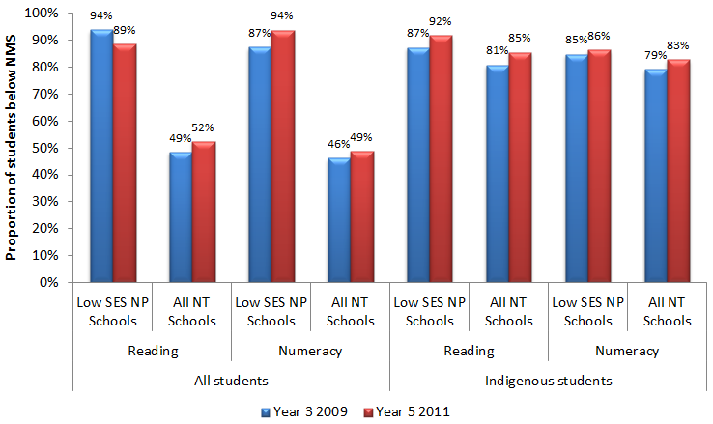
 |  | Low SES NP school | Non- NP schools
Reading | 2009-2011 | 60% | 51%
Reading | 2010-2012 | 48% | 44%
Numeracy | 2009-2011 | 57% | 41%
Numeracy | 2010-2012 | 58% | 49%
Source: PGA constructed graph using data provided by NT DET
When achievement at the primary school level was analysed using NAPLAN bands (Figure 3.2), a general increase in the proportion of students at or below NMS was observed across all NT schools. Among Low SES NP schools however, this figure was found to have relatively decreased by 5.6% in Reading among all students. At the secondary school level, the general increase in the proportion of students in the lower two bands was also a territory-wide trend. However, in Low SES NP schools, the relative proportion of students in the lower two Readings bands decreased by 4.7% for all students and 1.4% for Indigenous students.

Figure 3.2: Proportion of students at or below NMS (Year 3 2009- Year 5 2011) in NAPLAN, NT
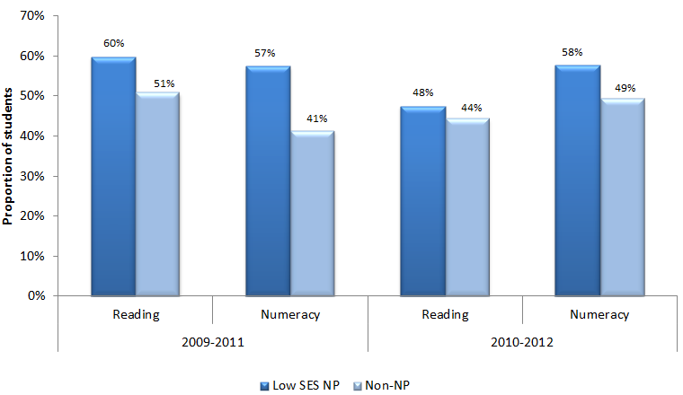
 |  |  | Year 3 2009 | Year 5 2011
All students | Reading | Low SES NP | 94% | 89%
All students | Reading | All NT Schools | 49% | 52%
All students | Numeracy | Low SES NP | 87% | 94%
All students | Numeracy | All NT Schools | 46% | 49%
Indigenous students | Reading | Low SES NP | 87% | 92%
Indigenous students | Reading | All NT Schools | 81% | 85%
Indigenous students | Numeracy | Low SES NP | 85% | 86%
Indigenous students | Numeracy | All NT Schools | 79% | 83%
Source: PGA constructed chart using NT DET (2013); ACARA (2012)
It is important to note that the mixed results exhibited in NAPLAN data do not provide causal evidence of the impact of the Low SES NP on student achievement. For instance, Low SES NP schools often had lower average scores, increasing the likelihood of achieving greater apparent gains. Moreover, as earlier outlined, intended achievement outcomes may not be realised in the limited timeframe under analysis. This could be particularly true for Low SES NP schools where activities were likely to have targeted only some students or aimed at achieving other fundamental outcomes, such as enhancing student attendance and engagement.

NAPLAN Participation at Low SES NP schools
Analysis of NAPLAN participation rates in Low SES NP schools shows patterns that were similar to those observed in all NT schools. Therefore it is unlikely that overall changes in achievement were affected by NAPLAN attendance trends.

Achievement in LNNP schools
Overall, Northern Territory LNNP schools met or exceeded seven of the 14 targets set to acquire reward LNNP funding. In addition, progress was made towards meeting a further six targets. In general, observed improvements were found to be greater for Indigenous students than non-Indigenous students. From 2008 to 2011, the change in the proportion of Year 3 and 5 non-Indigenous students at or above NMS for Reading and Numeracy ranged from a decline of 3.2 percentage points to an improvement of 4.0 percentage points. Furthermore, the proportion of Year 3 and Year 5 Indigenous students at or above NMS for Reading and Numeracy improved by between 0.4 and 16.1 percentage points (COAG Reform Council 2012).
In LNNP schools, students appear to have achieved higher apparent NAPLAN mean score gains, particularly in Reading, when compared to the apparent gains made across all NT schools. However, this may again be due to students at LNNP schools having a lower starting score. Figure 3.3 shows the average apparent cohort gains for all students and Indigenous students transitioning from Year 3 in 2009 to Year 5 in 2011.
Figure 3.3: Year 3 to Year 5 apparent cohort gains (2009-2011) in NAPLAN mean scores, NT
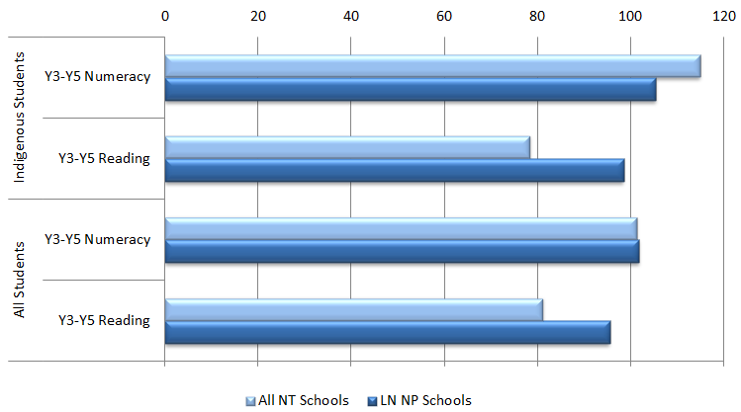
 |  | All NT Schools | LN NP Schools
Indigenous Students | Year 3 to Year 5 Numeracy | 115 | 105
Indigenous Students | Year 3 to Year 5 Reading | 78 | 98
All Students | Year 3 to Year 5 Numeracy | 101 | 102
All Students | Year 3 to Year 5 Reading | 81 | 95
Source: PGA constructed chart using NT DET (2012); ACARA (2012)
Further analysis shows that when compared to similar schools, based on regional distribution and size, students at LNNP schools appeared to experience positive outcomes as a result of the partnership. Overall, data on the Maximising Improvements in Literacy and Numeracy (MILaN) initiative indicated that students at the 25 schools participating in the initiative showed significant improvements in both Reading and Numeracy NAPLAN scores. Improvements appeared to be greater at schools who participated for the full two years (Figure 3.4). Comparisons showed that the rate of improvement of students in MILaN schools (as measured by Year 3 to Year 5 gain), was greater than that experienced by a comparison group of similar non-NP schools during the MILaN implementation period (2009-11). Such gains did not arise in the previous comparable period (2008-2010) which suggests that they may be due to MILaN in 2009-11. They may also be due to the fact that MILaN schools were selected to participate in the LNNP based on displaying both early signs of growth and the potential for improvement (Tremblay 2012).
Figure 3.4: Average achievement gains for students participating in MILaN – Year 3 2009 to Year 5 2011, NT
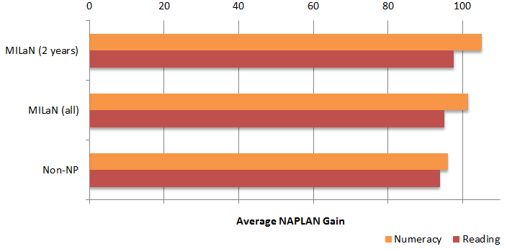
 |  | Numeracy | Reading
Average NAPLAN Gain | MILaN (2 years) | 105.16 | 97.7
Average NAPLAN Gain | MILaN (all) | 101.58 | 95.17
Average NAPLAN Gain | Non-NP | 96.08 | 93.93
Source: Tremblay (2012)
Similar results were found for Indigenous students, as the Indigenous cohort within the 2 MILaN groupings (‘all MILaN’ or ‘2- years MILaN’) was found to have outperformed the comparative groups with respect to both reading and numeracy mean score gains in the 2009-11 period (Figure 3.5).

Figure 3.5: Average achievement gains for Indigenous students participating in MILaN – Year 3 2009 to Year 5 2011, NT
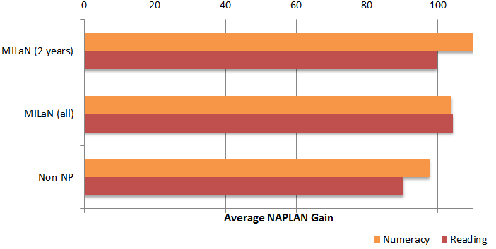
 |  | Numeracy | Reading
Average NAPLAN Gain | MILaN (2 years) | 112 | 99.7
Average NAPLAN Gain | MILaN (all) | 103.9 | 104.3
Average NAPLAN Gain | Non-NP | 97.7 | 90.3
Source: Tremblay (2012)
These results point to a potentially positive effect of the MILaN initiative - the largest initiative under the LNNP in the NT – on student achievement. However, this analysis did not control for the starting point between LNNP schools and the comparison group. In addition, it is not possible using existing information to identify which literacy and numeracy programs, such as coaching or effective monitoring of student performance data, had achieved the intended effects.
Further analysis of achievement in the NT LNNP Government and Catholic schools assessed the proportion of students who achieved above average growth in NAPLAN mean scores. This compared students in LNNP schools to students in similar non-NP schools based on ICSEA deciles as well as deciles of previous NAPLAN scores. As in the equivalent analysis at Low SES NP schools, the analysis was not feasible at the secondary school level due to low student numbers. For the 2009-2011 student cohort, a higher proportion of primary school students at LNNP schools were found to achieve above average growth compared to students at non-NP schools with similar ICSEA values. This proportion was 7% higher in LNNP schools in Reading and 20% higher in Numeracy (Figure 3.6). However, this was not found to be the case when primary school students in LNNP schools were compared to peers at non-NP schools with similar starting scores, particularly in Reading. For the 2010-2012 student cohort, students at LNNP schools were also more likely to achieve above average growth when compared to those at non-NP schools with a similar socioeconomic background, with a difference of up to 5% in Reading. However, as with the 2009-2011 cohort, the observed gains amongst primary school LNNP students appear to be driven by lower starting scores. When compared to peers in non-NP schools with similar starting scores, only 42% of students in LNNP schools achieved above-average growth in Numeracy. Although NAPLAN growth rates may not have been as large in all LNNP schools as those in non-NP schools, at least 44% of LNNP students in the 2009-2011 cohort and 42% of those in the participating 2010-2012 cohort showed above-average growth when compared to students at non-participating similar schools.
Figure 3.6: Proportion of students in LNNP schools who achieved above average growth between Years 3 and 5 compared to that of students in similar non-NP schools, NT Government and Catholic sectors
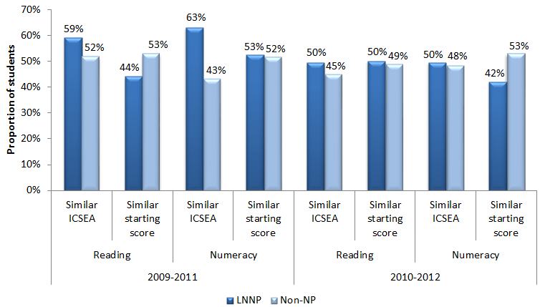
 |  |  | LNNP schools | Non-NP schools
2009 to 2011 | Reading | Similar ICSEA | 59% | 52%
2009 to 2011 | Reading | Similar starting score | 44% | 53%
2009 to 2011 | Numeracy | Similar ICSEA | 63% | 43%
2009 to 2011 | Numeracy | Similar starting score | 53% | 52%
2010-2012 | Reading | Similar ICSEA | 50% | 45%
2010-2012 | Reading | Similar starting score | 50% | 49%
2010-2012 | Numeracy | Similar ICSEA | 50% | 48%
2010-2012 | Numeracy | Similar starting score | 42% | 53%
Source: PGA constructed graph using data provided by NT DET
CASE STUDY: Targeted Programs for Student Achievement at Alyangula Area School (NT DET 2011)
Alyangula Area School employed a full time Coordinator and data analyst to deliver the intervention program to targeted groups of students using QuickSmart academic skills program. The performance of the target cohort was assessed as part of the Northern Territory’s QuickSmart evaluation; and demonstrated significant gains in attainment of 32% improvement higher than the comparison group.

CASE STUDY: Literacy and Numeracy Improvement in the Barkly Region (NT DET 2011; NT DET 2012)
The Barkly region introduced the Barkly Deadly Readers initiative which was built on the success of the PM Benchmark reading program within the region. In 2011, there was a focus on use of interactive technologies within program planning, as well as provision of First Steps Numbers training. Three Literacy and Numeracy Coaches work with schools across the region, supporting leaders in creation of whole school improvement agendas, as well as individual teachers’ pedagogical approaches within classrooms.
The integrated, multilayered approach being taken is showing positive results, in particular for students’ numeracy achievement. Data also showed that 25% students have improved their reading by a minimum of two PM Benchmark reading levels during 2010. In one class, a student moved up three NTCF ESL bands in six months. Both grade 3 and grade 5 students (Indigenous and total) have shown improvement in NAPLAN results.

CASE STUDY: Whole School Spelling and Grammar Improvement at Jingili Primary School (NT DET 2012)
Jingili Primary School focussed on a whole school approach, and program implementation that could be sustained beyond the period of the funding. Through analysis of previous years’ data, a transition to Year 6 spelling and grammar program was identified and implemented, allowing for continuity throughout students’ time in the school, and cumulative skill and knowledge development. Implementation of the program improved students’ achievement in NAPLAN across both spelling and grammar in grades 3 and 5.

CASE STUDY: Combining Intervention Programs and Learning Support to Enhance Student Achievement at Bradshaw Primary School (NT DET 2013)
Bradshaw Primary School offered a range of intervention programs including phonological awareness, QuickSmart® literacy and QuickSmart® numeracy and the Gateways Oral Language program.
The school also instituted Irrkerlantye Indigenous Support Program which provided wrap-around services such as bus services for pick-up and drop-off, showers, provision of uniforms, breakfast, recess and lunches, medical intervention and medical appointments with Central Australian Indigenous Congress and NT Hearing. Support staff and teachers work closely together to provide the best educational opportunities for their education.
Survey results of staff, students and parents were overwhelmingly positive. The school was a regional finalist in the inaugural Smart Schools Award for excellence in improvement in numeracy and literacy outcomes. NAPLAN results saw continued improvement since 2008, with increases in the majority of test domains for both Year 3 and Year 5 students. Year 5 reading in particular has consistently improved since 2008, with increasing percentages of student at or above the national minimum standard every year.

Outcomes 3 and 4:
All children are engaged in and benefitting from school; Schooling promotes social inclusion and reduces educational disadvantage
School attendance in NT was an intended outcome equally as important as student achievement, especially among Indigenous students in Low SES NP schools. Schools selected for this NP were often comprised of students facing multiple sources of disadvantage over an extended period of time. Addressing these entrenched disadvantages therefore required a focus on more foundational issues such as attendance and engagement before student achievement could be lifted.
Strategies aimed at achieving these objectives included hiring cultural and home liaison officers, community mentors and curriculum managers, in order to create a positive school environment and support at risk students. Initiatives included bullying prevention and management strategies, a ‘Drug Education and Wellbeing’ program and peer forums. In addition, ‘Virtual Schooling’ using digital design and interactive technology was offered to enhance the availability of course offerings to students where face-to-face support is limited. Additional measures were introduced to cater for students who travel from remote communities by allowing them to board during the school week under the Flexible Schooling program.
In 2012, 23 schools which participated in the Low SES NP showed improved attendance rates for Indigenous students compared to 2011. Nineteen of these schools improved attendance rates by over 5%, even though enrolment remained stable compared to the previous year. To better understand the impact of the Low SES NP on attendance, further analysis was undertaken comparing trends in student attendance at participating schools to those in non-NP schools. The analysis used aggregated school-level data from all NT Government and Catholic schools to compare whether the difference in attendance rates between Low SES NP schools and non-NP schools declined over time following the commencement of the partnership. Prior to the Low SES NP, attendance rates at NP schools were generally lower than average. The results found that attendance rates at Low SES NP schools showed little to no improvement relative to non-NP schools at both the primary school level and at middle school. This trend was also observed among Indigenous students at the primary school level. There were mixed results at the middle school level for Indigenous students, where the initial gap between Low SES NP and non-NP schools was found to have significantly increased by 3.4% in term 1 but significantly decreased by 7.5% in term 2 (Figure 3.7). The results should however be interpreted with caution, as multiple and significant policy changes and interventions in NT have affected both NP and non-NP schools through time. This is likely to have had a significant impact on student attendance patterns.
Figure 3.7: Attendance rates of Indigenous students at the middle school level in NT Government and Catholic schools
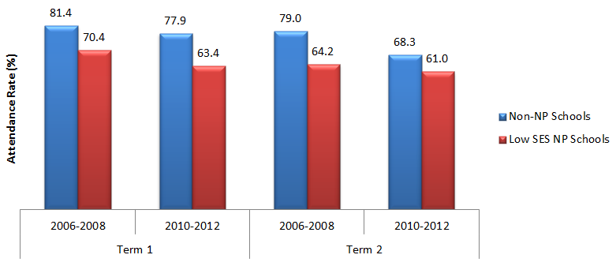
 |  | Non-NP Schools | Low SES NP Schools
Term 1 | 2006-2008 | 81.4 | 70.4
Term 1 | 2010-2012 | 77.9 | 63.4
Term 2 | 2006-2008 | 79.0 | 64.2
Term 2 | 2010-2012 | 68.3 | 61.0
Source: PGA constructed graph based on attendance data provided by NT DET and DEEWR
A number of differences were observed in apparent retention rates (ARR) which was estimated for NT schools to investigate the relationship between participating in the Low SES NP and student retention. The ARR is measured as a ratio of students in a particular grade level divided by the number of students in an earlier grade level. Among Indigenous students, the ARR increased from Years T-6, remained stable from Years 7-9 and decreased from Years 10-12 (Figure 3.8). The increase in ARR of Indigenous students in the primary years was approximately 21%, the overwhelming majority of which happened between 2011 and 2012 (19.1% increase) (NT DET 2013). Among non-Indigenous students, there was an increase in ARR from Years T-6 and Years 10-12, but a decrease from Years 7-9. While part of these fluctuations could be due to enhancements in data systems, a higher ARR was consistent with improvements observed at a local level. Once again, caution should be taken in interpreting these results, as policy changes and interventions other than the NP in NT are likely to have had a significant impact on student enrolment patterns.

Figure 3.8: Apparent Retention Rates at Low SES NP Schools, NT
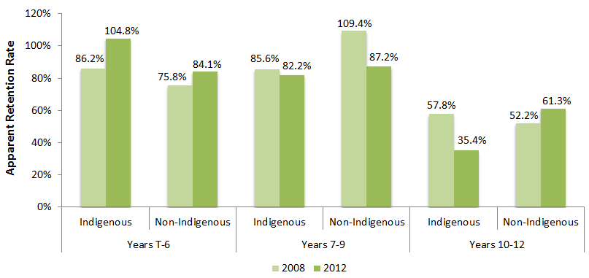
 |  | 2008 | 2012
Years T to 6 | Indigenous | 86.2% | 104.8%
Years T to 6 | Non-Indigenous | 75.8% | 84.1%
Years 7 to 9 | Indigenous | 85.6% | 82.2%
Years 7 to 9 | Non-Indigenous | 109.4% | 87.2%
Years 10 to 12 | Indigenous | 57.8% | 35.4%
Years 10 to 12 | Non-Indigenous | 52.2% | 61.3%
Source: NT DET (2013)
Additional analysis of aggregated student enrolment data from both Government and Catholic schools in the NT was undertaken for the purposes of this evaluation. This analysis explored changes in the Year 10-11 ARR between the pre-NP commencement period (average ARR of 2007-2008, 2008-2009 and 2009-2010) and the period following NP commencement (average ARR of 2010-2011 and 2011-2012). The results show a 16% decrease in the Year 10-11 ARR across NT Government and Catholic Low SES NP schools who commenced Low SES NP participation in 2010 and a 15.4% reduction in ARR among Indigenous students (Figure 3.9). Both results were found to be statistically significant. However, these results should not be taken as causal evidence of the impact of the SSNP, as the ARR is an aggregated measure of student enrolments and does not control for student movement between schools, an important factor that may be driving the large observed changes. In addition, the ARR was difficult to measure at non-NP schools due to an inadequate sample size. It is therefore possible that similar trends may have occurred at non-NP schools and that the changes at Low NP schools are reflective of the territory-wide trend as opposed to a result of NP participation.
Figure 3.9: Years 10-11 apparent retention rates in NT Government and Catholic schools commencing Low SES NP participation in 2010
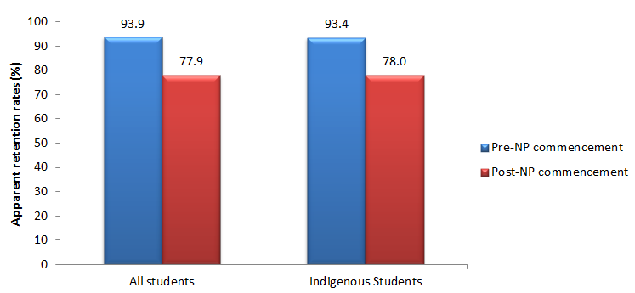
 | Pre-NP commencement | Post-NP commencement
All students | 93.9 | 77.9
Indigenous students | 93.4 | 78.0
Source: PGA constructed graph using student enrolment data provided by NT DET and NT CEO
NB: The pre-NP commencement figures are the average ARRs between 2007 and 2010. The post-NP commencement figures are the average ARRs between 2010 and 2012.
In addition, there has been a year on year improvement in enrolment and attendance of Indigenous students at the 16 schools which participated in the Engaging Urban Students (EUS) program. At these schools, overall enrolment and attendance increased by 10% and 2% respectively between 2009 and 2011 (NT DET 2013). In 10 EUS schools, the number of students attending over 80% of school days grew by at least 10% between 2009 and 2010 (NT DET 2011). It is important to note that these improvements may not be directly attributed to the EUS initiatives due to the confounding effects of other enduring programs, in addition to substantial socio-demographic changes that occurred in regional centres where EUS schools are located (Tremblay 2011).
CASE STUDY: School-wide Strategy to Improve Attendance at Elliot School (NT DET 2011)
Elliot School employed a Home Liaison Officer (HLO) to improve the enrolment and attendance of students. The HLO regularly visited family homes, instilling the importance of education in parents and carers encouraging them to enrol and support their children in regularly attending school. Also, four staff (the Principal, a teacher, an assistant teacher and a community member) underwent professional development to enhance positive school-wide behaviour, and developed a school-wide strategy. A kitchen was also built for students to use in their study for VET hospitality.
As a result, the school saw significant improvement in student attendance. Average student attendance was 60% in Semester 2, 2009, rising 20% to 72.1% by Semester 2, 2010. Students were also more engaged in schooling, with NAPLAN results showing improvement in 2010.

CASE STUDY: Community Engagement to Improve Attendance at MacFarlane Primary School (NT DET 2011)
MacFarlane Primary School employed an Indigenous Cultural Coordinator to provide male mentorship to both Indigenous students and teachers. The Coordinator’s role included provision of Indigenous Studies in each class - with art used as the basis for engaging students and encouraging cultural exchange. Activities such as making artefacts, Indigenous song and dance and storytelling formed part of the program which also integrated the use technology to enhance literacy and numeracy learning. The Coordinator was also responsible for broader family and community engagement. The Coordinator organised cultural events and local excursions to enhance connections between the school and the community.
As a result of their sustained focus on student engagement and wellbeing, the school community is increasingly engaged in the school, with over 300 families and community members attending the Breakfast with Mentor program, harmony day and end of year concert events in 2010. In the Engaging Urban Students (EUS) target student cohort, average attendance improved from 77.4% in 2009 to 80.9% in 2010. The average attendance of the student cohort living in town camp communities improved from 61.7% in 2009 to 71.6% in 2010.

CASE STUDY: Partnerships with Families & Community to Improve Attendance and Achievement at Milner Primary School (NT DET 2012).
At Millner Primary School, the Educating Remote Indigenous Children in Urban Settings (ERICUS) program was built on five critical partnerships with local organisations working together with the school on initiatives such as sport activities, a breakfast program, and a homework centre. Through the ERICUS program, the school developed a multi-faceted approach to promote engagement, improve attendance, raise academic achievement and foster wellbeing for all students.
Average attendance of the children who continued with the program over 4 years improved from 33% in 2008 to 80% in 2011. Students in the program who were assessed for PM reading level for December 2010 and January 2012 showed an increase in reading levels averaging 10 levels, with 5 students jumping more than 10 reading levels in this period. These significant outcomes are seen as a result of the common understanding that the education of every child in the school is a shared responsibility with families and the community. The number of parents regularly attending family days averaged 22 in 2011 as compared to 13 in 2009.

Outcomes 5 and 6:
Halve the gap for Indigenous students in Year 12 attainment or equivalent rates by 2020; Young people make a successful transition from school to work and further study
Outcomes relating to school completion and transitions beyond compulsory schooling were long-term aspirational targets under the Low SES NP. Systemic improvement in these indicators is therefore not expected in the four years under analysis, though some localised leading indicators have emerged. An increase in the proportion of 15-19 year olds participating in VET and school based apprenticeships was observed for both Indigenous and non-Indigenous students at Low SES NP schools. The number of Year 12 Northern Territory Certificate of Education (NTCE) completions was also found to have increased for non-Indigenous students (NT DET 2013).

3.3 NT CONCLUSION
The synthesis of currently available data in the Northern Territory provides mixed results with some evidence of a positive impact of the NP on the achievement of some students. Between 2009 and 2011 in the NT, students in Low SES NP schools exhibited higher average apparent gains than students at all NT schools in both Reading and Numeracy at the secondary school level, and in Numeracy at the primary school level. Similar results were observed among Indigenous students. When compared to students in similar non-NP schools, the proportion of primary school students who achieved above average growth in Low SES NP schools was found to be higher in both Reading and Numeracy, with the most notable difference being observed in Numeracy among the 2009-2011 student cohort. These results were not replicated at the secondary school level. In LNNP schools, the 2009-2011 student cohort achieved higher apparent NAPLAN gains than that in all NT schools in Reading at the primary school level among all students and Indigenous students. However, these are likely to be driven by lower starting scores since comparisons controlling for initial achievement found 44% of primary school students at LNNP schools made above-average gains. Higher growth rates were found at the secondary level, where the same comparisons controlling for initial achievement found the proportions of LNNP secondary school students exhibiting above-average gains to be 64% and 56% in the 2009-2011 and 2010-2012 student cohorts, respectively. In addition, data from the 25 schools that participated in the MILaN initiative indicate that students in these schools showed significant improvements in both Reading and Numeracy NAPLAN scores, a result that was particularly exhibited amongst Indigenous students and at schools who participated for the full two years (Tremblay 2012).
The improvements in student achievement, where they were observed, are a likely result of teacher coaching and training programs such as the evidence-based literacy and numeracy interventions employed under MILaN. For example, reported case studies suggest that interventions such as Quick Smart, First Step Numbers and certain literacy programs contributed to enhanced achievement outcomes. Case studies also suggest that Literacy and Numeracy coaches who worked with teachers in classrooms are also likely to have had a positive impact on student achievement. These coaches focused on mentoring programs to build evidence based approaches to literacy and numeracy pedagogy, enhance teaching partnerships with paraprofessionals and develop approaches to teaching for students with language backgrounds other than English. Furthermore, certain initiatives such as the Support for teachers of Indigenous learners of English as a second language program, under which teachers in remote schools enhanced their training by undertaking a Graduate Certificate in Education in partnership with Charles Darwin University, may have also had an impact on Indigenous students’ achievement (NT DET 2010; NT DET 2011). The education literature has repeatedly found that the quality of teachers acts as a major influence on learning (Barber & Mourshed 2007; Wenglinsky 2000), accounting for 30% of variations in student achievement (Hattie, 2009). If trained teachers remain at these schools, such programs are therefore likely to have a subsequent impact on student outcomes as teacher professional development has been found to influence student achievement through improved teacher knowledge and skills, which in turn impact the quality of classroom teaching (Yoon 2007).
Enhancing student engagement in NT was equally as important as student achievement as an intended outcome, especially among Indigenous students in Low SES NP schools. However, analysis of student attendance data in NT Low SES NP Government and Catholic schools found little to no improvement relative to non-NP schools at both the primary school level and at middle school. Mixed evidence was found when retention rates were analysed, with a decrease in the Year 10-11 ARR between the pre-NP commencement period and the period following NP commencement across NT Government and Catholic Low SES NP schools. However, there was an improvement in the Years 10-12 ARR among non-Indigenous students and a 21% increase in the Years T-6 ARR among Indigenous students between 2008-2011. In addition, improvements in enrolment and attendance of Indigenous students were reported at the 16 schools that participated in the Engaging Urban Students (EUS) program (NT DET 2011; NT DET 2013).
The evidence therefore suggests that some Low SES NP schools were successfully able to raise student engagement. While the large number of activities implemented under a variety of circumstances at different schools may prevent the identification of which activities led to desired outcomes, local reports suggest particular strategies may have succeeded in improving student enrolment and attendance. These include interventions that used a whole-school approach such as the Remote Whole School Reform (RWSR) and the EUS programs. An important characteristic of these programs is their approach to identify solutions beyond the school gate, with family and community engagement forming an important component in all the initiatives. For example, support positions such as community liaison officers and cultural advisors not only aimed to create positive relationships between communities and schools, but also worked to align the curriculum along community aspirations. In addition, the officers led programs of direct benefit to local communities. Other strategies aimed at increasing student engagement included flexible learning, support delivery methods and boarding facilities for those in remote locations. Combined with wellbeing programs such as bullying prevention and drug education, as well as incentives to reward high attendance, these initiatives represent a comprehensive and holistic approach that is likely to have yielded positive results. Growing evidence on school-based wellbeing and prevention programs indicates that not only do they help alleviate behavioural, social and emotional problems, but they also improve student academic achievement (CASEL 2009; Durlak & Wells 1997).
Although certain indications suggest that the NP positively influenced student achievement and engagement in NT amongst some treated schools, insufficient information on specific interventions within the diversity of implemented challenge the clear delineation of ways in which they may have influenced the intended outcomes. For example, the MILaN initiatives alone, that aimed at enhancing student achievement, consisted of several literacy and numeracy programs. Therefore, it is only possible to ascertain the exact impact of each individual activity through adequate data that clearly link the interventions and outcomes.

GLOSSARY
ARR: Apparent Retention Rates
DET: Department of Education and Training
ERIS: Engaging Remote Indigenous Students
EUS: Engaging Urban Students
IRSED: Index of Relative Socioeconomic Disadvantage
KiTES: Kits in Teaching Elementary Science
LBOTE: Language Background Other Than English
LNNP: Literacy and Numeracy National Partnership
Low SES NP: Low Socioeconomic School Community National Partnership
MILaN: Maximising Improvement in Literacy and Numeracy
NAPLAN: National Assessment Program – Literacy and Numeracy
NMS: National Minimum Standard
NP: National Partnership
NT: Northern Territory
NTCE: Northern Territory Certificate of Education
RWC: Residential Care Workers
RWSR: Remote Whole School Reform
SIRSF: Supporting Indigenous Residential Students and Families
SSNP: Smarter Schools National Partnership
SWPBS: School Wide Positive Behaviour Support
VET: Vocational Education and Training

Queensland


Low SES NP and LNNP
In QLD, the Low SES NP and LNNP were implemented under various reform areas targeting:
- Staff incentivisation
- Innovative instruction
- Effective planning
- Structural enhancements
- Family and community partnerships
- Strong leadership
- Teacher training and development
- Monitoring student performance

Targeted Outcomes
- Higher proportion of students at or above NMS in literacy and numeracy (including Indigenous students)
- Increased mean score of students in literacy and numeracy (including Indigenous students)
- Higher proportion of students enrolled in and attending school (particularly Indigenous students) and a higher proportion of Indigenous students completing year 10
- Increased levels of parent satisfaction, student satisfaction and wellbeing at school
- Young people make a successful transition from school to work and further study
- Research case studies that highlight the achievements of disadvantaged student cohorts
Key findings from synthesis of existing data
Participation in the Low SES NP was associated with:
- Higher NAPLAN gains in Year 5-7 Reading for non-Indigenous and LBOTE students.
- Above-average achievement growth among Indigenous students in schools with the lowest SES
- An improvement in the Years 8-10 apparent retention rate.
- Increased attendance among Indigenous students at the secondary school level.
- Improvements in both parent and student satisfaction.
- Improvements in student behaviour and wellbeing.
- An increase in the proportion of young people participating in post-school education and training six months after school.
Participation in the LNNP was found to be associated with:
- Higher mean gains in NAPLAN Reading scores between Years 3-5 and Years 5-7 among disadvantaged students.
- Above-average achievement growth in Years 3-5 Reading at schools with the lowest SES, particularly among Indigenous students.
- An increased proportion of students at or above NMS in Reading between Years 5-7.
- Significant progress in Year 3 PAT Math and Reading in Government schools.

4.1 QLD ACTIVITIES & OUTPUTS

Overview
In Queensland, 169 schools participated in the Low SES NP, beginning in 2009, 2010 and 2011 respectively (Figure 4.1). A wide range of activities were undertaken under this partnership with a focus on staff incentivisation, innovative instruction, effective planning and external partnerships. In addition, 278 schools participated in the LNNP, 34 of which also participated in the Low SES NP. The majority of LNNP schools chose to focus their initiatives on Literacy. LNNP schools emphasised capacity building for teachers and school leaders, in addition to effective usage of data for monitoring student performance.
Figure 4.1: The Low Socioeconomic Communities and Literacy and Numeracy National Partnerships in QLD
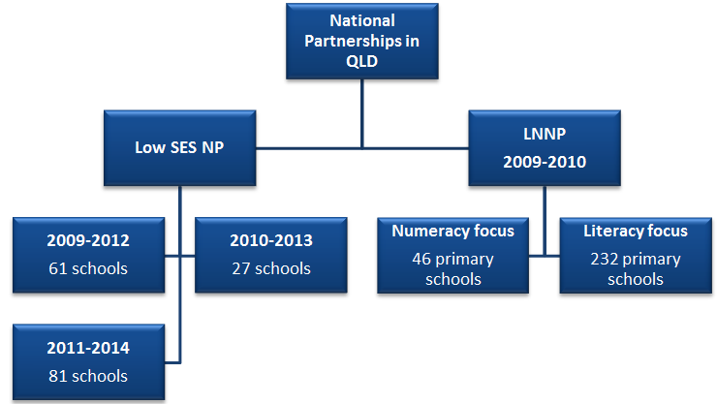
The National Partnerships in Queensland consisted of the Low SES NP and the LNNP
Under the Low SES NP:
2009 to 2012 there were 61 schools
2010 to 2013 there were 27 schools
2011 to 2014 there were 81 schools
The LNNP had a numeracy focus and a literacy focus.
Over 2009-2010:
46 primary schools with a Numeracy Focus participated in the LNNP
232 primary schools with a Literacy Focus participated in the LNNP
The Low SES NP and LNNP activities in Queensland focused around the following six key output areas:
- School reform and improvement - School-based strategies and planning to target various cohorts such as low SES students, Indigenous students, refugees, ESL students and homeless students, as well as students with disabilities and learning difficulties.
- Enhanced principal leadership - Leadership development programs including workshops, leadership teams, literacy leadership and professional dialogues.
- Increased commitment to monitor student performance and effective use of data - Use of student data to determine the most appropriate teaching practices.
- Continuous professional development, specialist support and mentoring - Provision of literacy and numeracy coaches and professional development to improve teacher pedagogy.
- Implementation of innovative models to increase student engagement - Adoption of innovative models such as the Cape York Aboriginal Australian Academy, Summer Schools and use of technology to improve student engagement.
- Ongoing enhancement of community partnerships - Increased family and community engagement with schools through partnerships, collaborative work and extended services.

School reform and improvement
Partnership schools across all sectors participated in school-based strategies and planning. Notable initiatives under this output area included the Four Year School Strategic Plan initiative which was designed to increase the capacity of Government Low SES NP schools in educating students from low SES backgrounds. This was implemented by identifying explicit strategies based on research findings and prioritising reform activities that could tackle disadvantage. Facilitated through local community consultations, school strategic plans focused on enhancing engagement and learning outcomes for various student cohort groups such as students with disabilities and learning difficulties as well as refugees, Indigenous, ESL and homeless students. Additionally in Government Low SES NP schools, progress on school strategic plans was annually reviewed and reported on using the Principal Performance Review (PPR). Under the PPR, principals discussed implementation of their strategic plans and the progress towards school improvement with their supervisor and the Executive Director. Reviews were held annually for all principals at Low SES NP schools.
An important aspect of school reform and improvement in Government Low SES NP schools was the Turnaround Teams initiative. Turnaround Teams provided targeted specialist advice to several school leaders, teachers, other staff, students and parents to ensure whole school, innovative and flexible approaches to address issues such as literacy and numeracy, student wellbeing and data analysis. Led by an Executive Director, each team included experienced teachers with expertise in areas such as curriculum planning and implementation, literacy and numeracy teaching, assessment, student wellbeing and data analysis. The first turnaround team of four specialist teachers began in 2010 with a second commencing work with 12 schools later that year. In 2011, 10 Turnaround Teams worked with over 100 Low SES NP schools, while seven Turnaround Teams worked with over 100 Low SES NP schools in 2012.
Government sector schools participating in both the Low SES NP and LNNP also adopted Teaching and Learning Audits in 2010 to assess key curriculum, teaching, learning and assessment practices. This was a program based on a review of international best practices as a benchmark to provide schools a clearer picture of where their strengths and weaknesses lie, and what actions must be taken to improve their performance. A small team of 23 highly successful School Principals undertook audits of all Queensland state schools. Schools were assessed against eight domains including analysis and discussion of data, tailored classroom learning and evidenced-based teaching. A report was produced for each school, highlighting recommendations for further improvements in school performance.
Catholic Low SES NP schools employed a range of school reform strategies designed to meet individual school needs, including increased provision of resources, small group tutoring, and reduction of class sizes. Whole-school planning at these schools was also adopted to support new teaching staff. In Independent LNNP schools, the ‘Effective Schools Framework’ tool to assist schools in engaging in a process of self-assessment was used to strategically plan improvements.

Enhanced principal leadership
Leadership development programs were an important component of the Low SES NP in Queensland. In the Government sector, this included a customised induction program, attended by all 46 principals whose schools commenced the Low SES NP in 2009, and 14 principals from schools commencing in 2010. Through this program, principals were given the opportunity to engage in professional dialogue with other NP principals and to hear about successful strategies implemented in other NP schools. In addition, principals and deputy principals from the 46 schools that commenced Low SES NP in 2009 attended a two-day workshop in Brisbane in 2010. The workshop focused on implementation of the National Partnership Agreement and included sessions on the suite of strategies being utilised by principals in their School Strategic Plans as well as activities in their district and regional school clusters. In 2012, 27 Government Low SES NP school principals were sponsored to undertake the Queensland Education Leadership Institute (QELi) Creating Superb School Leadership Teams program. This program aimed to build the capability of school leaders to work together in teams for whole school improvements. In the Catholic sector, the Principals as Literacy Leaders’ program was used in 2011 and 2012 to train LNNP school principals and deepen their knowledge around literacy leadership in schools.

Increased commitment to monitor student performance & effective use of data
Effective use of student data was a key feature of NP schools across sectors. This was used for overall school improvement as well as monitoring and improving student performance. In Government LNNP schools, the Queensland Department of Education, Training and Employment (DETE) created a performance reporting dataset in OneSchool. Through this tool, the data of individual students, classrooms and the entire school were analysed to determine the most appropriate teaching practices. In addition, a workshop was conducted at Government LNNP schools for teachers, coaches and principals to better understand how to use data to inform teaching and learning, and to develop individual student improvement plans in order to promote and support data-driven decision making. As an additional means of monitoring student achievement, Progressive Achievement Test (PAT) for Reading (PAT-R) and Maths (PAT Math) were administered by 172 Government LNNP schools in 2011 to students in Years 3, 5 and 7 to measure student progress in Literacy and Numeracy. The Collaborative data inquiry model was also used to assist Government LNNP schools with data analysis. The model was rolled out across the LNNP Schools through coach training conferences and Regional Principal forums and was made available online. In this model, teachers work collectively to improve student learning through analysing data, brainstorming possible challenges and trying new instructional approaches (Kennedy, 2011). The program therefore aims to influence the culture of schools so that multiple data sources are used effectively, continuously and collaboratively to improve teaching and learning (Love, 2008).
Both Low SES NP and LNNP schools in the Catholic sector have made extensive use of NAPLAN data and standardised testing to evaluate and track student learning and to inform teaching and learning strategies. Standardised tests that have been used include PAT-R, PAT-M, DRA 2, Probe test of reading comprehension, Neale Analysis of Reading, DMT (Diagnostic Maths Tests), First Steps Number diagnostic tasks, SA Spelling test and PM Benchmark reading levels. In Independent LNNP schools, data was used to pinpoint specific student need areas and inform instruction. Schools were given access to a suite of analysis software including DRA 2, SunLANDA (developed by the Queensland Studies Authority) and Datapak, developed by Independent Schools Queensland (ISQ) to assist in the interpretation of NAPLAN data. A Reading Assessment Process was also developed which allowed teachers flexible opportunities for assessing students’ reading abilities. The computer-based process provided a management system for assigning reading tasks and questions, recording oral reading, marking, and evaluation.

Continuous professional development, specialist support and mentoring
The provision of professional development for teachers was a priority in Queensland NP schools. This was primarily targeted through Literacy and Numeracy coaches who were engaged to directly support teachers and school leadership teams in planning and assessment to improve teacher pedagogy and student performance in literacy and numeracy. In the Government sector, 91 literacy and numeracy coaches were employed across all LNNP schools early in 2010. Following the addition of 35 Government schools to the LNNP in Term 3, the number of coaches increased to 107. In 2011, training was provided in the form of two-day conferences for 56 newly appointed LNNP coaches and 42 Low SES NP coaches in Government schools. Both sets of coaches focused on whole-school improvement as well as on individual teachers, supporting quality teaching across the early and middle phases of learning. In addition, eight reading forums were held, providing explicit reading strategies to promote literacy and numeracy across all key learning areas. At these forums, 119 coaches had the opportunity to discuss how, when and to whom each of the strategies could be shared with teachers. A further 60 Government sector coaches were trained in 2012.
Teachers were able to access additional professional development to improve their literacy and numeracy pedagogy through the Vacation Professional Development (PD) initiative. This focused on developing the teaching of literacy, numeracy and science for Government LNNP school teachers across Queensland during the vacation periods. The program ranged from one to five day sessions and focused on developing higher order thinking skills in literacy, numeracy and science. A total of 325 teachers across nine regions attended the 2009 Vacation PD program. In 2010, the Vacation PD initiative successfully delivered 33 programs focused on literacy and numeracy across curriculum areas to 617 school teachers across all Education Queensland regions.
In addition, a number of conferences were held for new and existing staff at NP schools to develop their skills and share their experiences. This included the annual state-wide Teacher Induction Conferences which were conducted for teachers and principals in Low SES NP schools. Participants at the Teachers’ Induction Conference held in 2010 represented 46 Government schools. These included 134 graduate, newly appointed and transferred teachers as well as 40 principals, deputy principals, heads of department, heads of curriculum and executive directors. In 2011, an SSNP Teacher’s Conference was held for 149 teachers who were appointed or transferred to Low SES NP Government schools, while 200 newly appointed teachers and 50 pre-service teachers from 131 Government schools were invited to attend the 2012 SSNP Teacher’s Conference. Low SES NP Government school teachers working in Indigenous communities were given a specialised remote area induction program and some schools provided school-level induction programs.
In the Catholic sector, 10 newly appointed Low SES NP school teachers participated in a teacher induction program in 2010. In addition, coaches at LNNP schools attended mentoring/coaching training sessions and supported teachers particularly in analysing student achievement data and the implementation of appropriate strategies to address student learning needs. The major initiative for Independent schools was the development of the Literacy and Numeracy Coaching Academy, launched in LNNP schools at the end of 2011. The Academy provided targeted support and training of school-based literacy and numeracy coaches. In 2012, 58 schools joined the Academy with 63 nominated coaches beginning their training.

Implementation of innovative models to increase student engagement
A number of innovative models to enhance student engagement were adopted across NP schools in all sectors. In the Government sector, the Cape York Aboriginal Australian Academy (CYAAA) commenced in 2010 in LNNP schools and engaged Indigenous students from Prep to Year 7 in an education program that supported their bi-cultural identity. Another Government sector LNNP initiative under this output area were Summer Schools which were established at 73 sites between 2009 and 2012 to provide intensive literacy and numeracy teaching for over 11000 Year 5, 6 and 7 students requiring additional help. Each class at the Summer School had a registered, experienced teacher, with a coordinator appointed to each school to ensure smooth running. Education Queensland’s pre-Prep curriculum strategy Foundations for Success was also adopted using LNNP funding to enhance the engagement of Indigenous students across 29 Cape York and Torres Island communities and six other discrete Aboriginal communities. This was a non-compulsory, sessional early learning program for 3½ to 4½ year old children delivered by qualified early childhood teachers and teacher assistants in a range of settings that are school based, within licensed child care centres and/or through community kindergartens. At Catholic Low SES NP schools, interactive Whiteboards and e-learning sites, were used in the teaching of literacy and numeracy to improve student engagement and participation. Technology was also used to enhance student engagement in Independent LNNP schools. For example, the iPod Touch program in 2010 and 2011 gave ESL learners 24 hours access to interactive resources to help improve their English oral and reading abilities. Through the iPod Touch program, teachers also used portable learning tools to increase learning opportunities for their students.

Ongoing enhancement of community partnerships
In the Government sector, Low SES NP schools focused on increasing attendance rates by involving parents through co-curricular activities, information sessions and workshops. The Cunnamulla Campaign for example consisted of local school and community collaborations, with strategies to strengthen school wide positive behaviour, increase attendance and achievement and develop a positive sense of identity. Low SES NP schools also formed partnerships with neighbouring schools, tertiary institutions and external agencies to focus on Indigenous engagement and mobility issues as well as the engagement of Indigenous families. For example, three schools worked in close partnership with James Cook University on a program called Let’s Stay Put to address student mobility issues. Similarly, another State school collaborated with the Smith Family to engage Indigenous families with school. In LNNP schools, cluster based models were initiated to extend schools into the local community. Examples included the Hervey Bay State Schools Community Engagement Project and the Deception Bay Community Literacy Strategy Project which aimed to build reading engagement and improve literacy levels of students by enlisting the support of local community organisations and businesses.
External partnerships in the Catholic sector focused on support for Indigenous students at Low SES NP schools as well as improving community confidence in the school. Such partnerships included visits by Participation Officers to remote Indigenous communities to reinforce partnerships between families and schools. In the Independent sector, a web-based social network initiative titled ‘Strategic School Community’ was launched in 2011 to provide improved levels of communication and interaction across Low SES NP schools and to encourage and nurture greater interaction with external agencies. A number of community engagement initiatives in the Independent sector were also adopted to address the needs of Indigenous students and their families. One of the eight Low SES NP schools for instance employed an Indigenous teacher to work on the school curriculum by engaging members of the community to ensure that the curriculum was appropriate from a cultural and educational aspect. Another Low SES NP school appointed a Parent Liaison Officer (PLO) to grow community links with parents from remote Indigenous communities.

4.2 QLD IMPACT
The following section highlights the main findings from the synthesis of existing information on the Low SES NP and LNNP in Queensland. Findings are reported under the agreed outcomes in the Queensland program logic (Appendix 6).

Outcomes 1 and 2:
Higher proportion of students at or above NMS in literacy and numeracy (including Indigenous students); Increased mean score of students in literacy and numeracy (including Indigenous students)
Improved performance in literacy and numeracy was targeted through a number of initiatives, such as the appointment of Literacy and Numeracy Coaches. Coaches directly supported teachers and school leadership teams in planning and assessment to improve student performance, monitored using student assessment data. Teacher professional development opportunities such as the Vacation Professional Development initiative focused on teaching literacy, numeracy and science. Survey data showed that teachers found this initiative to be useful and to have extended their professional knowledge (QLD DETE 2012a). In addition, teachers in six schools participating in Foundations for Success during 2009-2010 reported positive benefits in children’s literacy, numeracy and social development outcomes. The program is reported to have facilitated much exciting, meaningful and innovative learning among Indigenous children, pre-Prep educators and parents and other community members (QLD DETE 2012b).

Achievement in Low SES NP schools
Queensland NP schools appear to have shown some improvements in Reading and Numeracy between 2009 and 2011 even though the apparent gains were not consistent across the cohorts, domains, levels and student demographic groups. Analysis of results among the 2009-2011 cohort allowed for at least two years of Low SES NP participation for schools commencing in the baseline year of 2009.
The available data showed that when aggregated NAPLAN results were analysed using the 2009-2011 student cohort (Figure 4.2), apparent gains in mean NAPLAN scores at Low SES NP schools were found to exceed the apparent gains achieved by all Queensland schools in Year 3-5 Numeracy for all students (+7 points) and for Indigenous students (+6 points). This was also the case in Year 5-7 Reading for all students (+8 points), and to a lesser extent in LBOTE and Indigenous students. However, these differences were not found to be statistically significant. In addition, Low SES NP schools achieved similar apparent gains (< 5 points difference) among all students when compared to the rest of the state in Year 3-5 Reading and Year 5-7 Numeracy. Similar apparent gains were also achieved in Year 5-7 Reading among Indigenous students and in Year 3-5 and Year 5-7 Reading among LBOTE students. In all other domains and year levels, apparent gains in Low SES NP schools were generally lower than those observed in all Queensland schools, although the differences were not statistically significant.
Figure 4.2: Apparent gains in aggregated NAPLAN mean scores from 2009 to 2011 for schools in all three QLD sectors that commenced Low SES NP participation in 2009
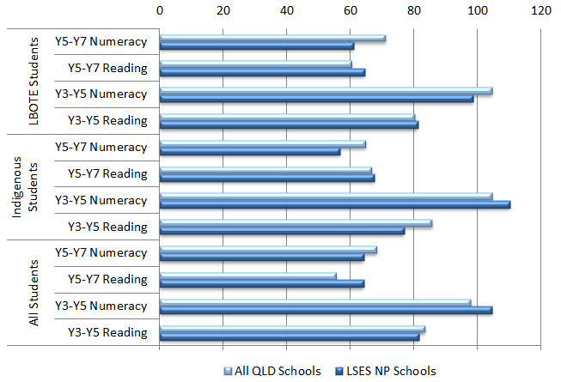
 |  | Gain (all QLD schools) | Gain (Low SES NP schools)
LBOTE Students | Year 5 to Year 7 Numeracy | 71 | 61
LBOTE Students | Year 5 to Year 7 Reading | 61 | 65
LBOTE Students | Year 3 to Year 5 Numeracy | 105 | 99
LBOTE Students | Year 3 to Year 5 Reading | 80 | 81
Indigenous students | Year 5 to Year 7 Numeracy | 65 | 57
Indigenous students | Year 5 to Year 7 Reading | 67 | 68
Indigenous students | Year 3 to Year 5 Numeracy | 105 | 110
Indigenous students | Year 3 to Year 5 Reading | 86 | 77
All students | Year 5 to Year 7 Numeracy | 68 | 64
All students | Year 5 to Year 7 Reading | 56 | 64
All students | Year 3 to Year 5 Numeracy | 98 | 105
All students | Year 3 to Year 5 Reading | 84 | 82
Source: PGA constructed using QLD DETE (2013); ACARA 2012
Analysing achievement data using NAPLAN bands provides additional information on progress at participating schools. In particular, it is important to consider patterns in the proportion of students who are at or below NMS due to their critically low skill levels. When this was examined for the cohort moving from Year 3 in 2009 to Year 5 in 2011, a general increase in the proportion of students at or below NMS was observed across all QLD schools (Figure 4.3). This is a national trend, with a greater proportion of students found to be below NMS at higher grade levels. Among Low SES NP schools however, evidence of improvement was found for low achieving students in some areas. In Numeracy, the proportion of students at or below NMS was found to have relatively decreased by 9.4% for all students and 6.8% for Indigenous students.
Further analysis for students transitioning from Years 5 to 7 showed a general reduction in the proportion achieving in the lower two bands across all QLD schools. However, this was found to have risen in Reading at Low SES NP schools, with observed increases of 6.3% for all students and 3.3% for Indigenous students.
Figure 4.3: Proportion of students at or below NMS (Year 3 2009- Year 5 2011) in NAPLAN, QLD schools commencing Low SES NP in 2009
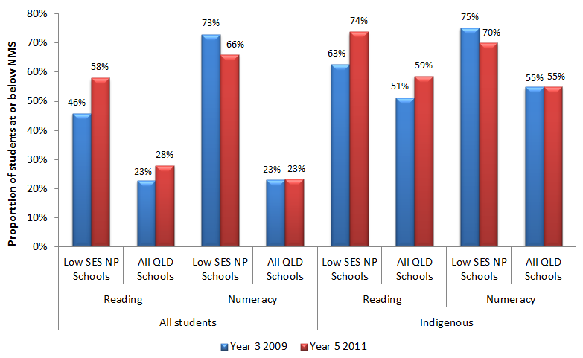
All student  s |  |  | Year 3 2009 | Year 5 2011
All student  s | Reading | Low SES NP Schools | 46% | 58%
All student  s | Reading | All QLD Schools | 23% | 28%
All student  s | Numeracy | Low SES NP Schools | 73% | 66%
All student  s | Numeracy | All QLD Schools | 23% | 23%
Indigenous | Reading | Low SES NP Schools | 63% | 74%
Indigenous | Reading | All QLD Schools | 51% | 59%
Indigenous | Numeracy | Low SES NP Schools | 75% | 70%
Indigenous | Numeracy | All ACT Schools | 55% | 55%
Source: PGA constructed using QLD DETE (2013); ACARA (2012)
The analysis of aggregated NAPLAN data was also undertaken using the 2010-2012 student cohort for schools who commenced the Low SES NP in 2010. In this analysis, the apparent gains in mean NAPLAN scores at Low SES NP schools (Figure 4.4) were only found to exceed the apparent gains achieved by all Queensland schools in Year 5-7 Reading for all students (+6 points) and among LBOTE students in Year 5-7 Reading (+12 points) and Numeracy (+3 points). However, Low SES NP schools were able to achieve similar apparent gains (< 5 points difference) among all students when compared to the rest of the state in Year 5-7 Numeracy. Similar apparent gains were also achieved in Year 3-5 Numeracy, Year 5-7 Reading and Year 5-7 Numeracy among Indigenous students and in Year 5-7 Numeracy among LBOTE students. No differences were found to be statistically significant.

Figure 4.4: Apparent gains in aggregated NAPLAN mean scores from 2010 to 2012 for schools in all three QLD sectors that commenced Low SES participation in 2010
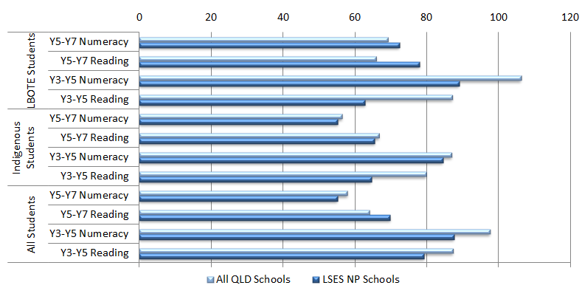
 |  | Gain (all QLD schools) | Gain (Low SES NP schools)
LBOTE Students | Year 5 to Year 7 Numeracy | 69 | 72
LBOTE Students | Year 5 to Year 7 Reading | 66 | 78
LBOTE Students | Year 3 to Year 5 Numeracy | 106 | 89
LBOTE Students | Year 3 to Year 5 Reading | 87 | 63
Indigenous students | Year 5 to Year 7 Numeracy | 56 | 55
Indigenous students | Year 5 to Year 7 Reading | 67 | 65
Indigenous students | Year 3 to Year 5 Numeracy | 87 | 84
Indigenous students | Year 3 to Year 5 Reading | 80 | 65
All students | Year 5 to Year 7 Numeracy | 58 | 55
All students | Year 5 to Year 7 Reading | 64 | 70
All students | Year 3 to Year 5 Numeracy | 98 | 88
All students | Year 3 to Year 5 Reading | 87 | 79
Source: PGA constructed using QLD DETE (2013); ACARA 2012
Some evidence of improvements for low achieving Year 3 students was also found in schools selected for the Low SES NP starting 2010. Across all QLD schools on average, an increase in the proportion of students at or below NMS was observed for students moving from Year 3 in 2010 to Year 5 in 2012 (Figure 4.5). In contrast, the proportion of students at critically low achievement levels has declined in Low SES schools, as a relative decrease of 5.5% was found in Reading for all students in Low SES NP schools. This improvement was not seen for students in Year 5 when the partnership began. Among all Low SES NP students transitioning from Years 5 to 7, there was a relative increase of 23.1% in the proportion of students in the lower two Numeracy bands, despite a decrease in this proportion across all QLD schools.

Figure 4.5: Proportion of students at or below NMS (Year 3 2010- Year 5 2012) in NAPLAN, QLD schools commencing Low SES NP in 2010
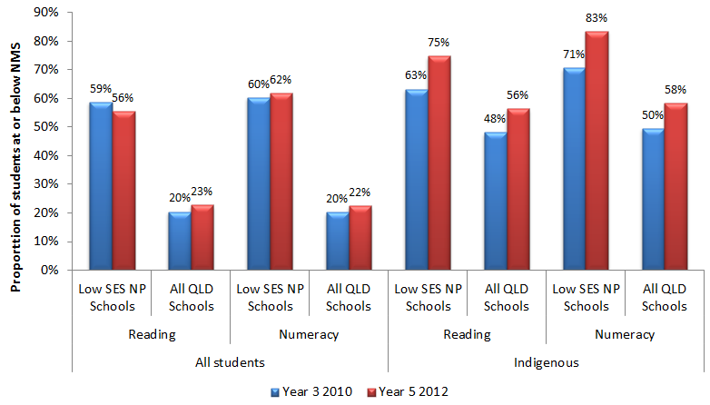
All student  s |  |  | Year 3 2010 | Year 5 2012
All student  s | Reading | Low SES NP Schools | 59% | 56%
All student  s | Reading | All QLD Schools | 20% | 23%
All student  s | Numeracy | Low SES NP Schools | 60% | 62%
All student  s | Numeracy | All QLD Schools | 20% | 22%
Indigenous | Reading | Low SES NP Schools | 63% | 75%
Indigenous | Reading | All QLD Schools | 48% | 56%
Indigenous | Numeracy | Low SES NP Schools | 71% | 83%
Indigenous | Numeracy | All QLD Schools | 50% | 58%
Source: PGA constructed using QLD DETE (2013); ACARA (2012)
While the data shown in Figures 4.2-4.5 reveals some positive results, they cannot be used to determine whether observed gains can be directly attributed to the Low SES NP, as the analysis does not control for schools’ starting points and characteristics which were found to be important determinants of student progress. Additional analysis of achievement in QLD Low SES NP schools was therefore undertaken using regression discontinuity (RD) design modelling (see Appendix 4). This quasi-experimental form of analysis has gained wide recognition as a robust means of program evaluation when clear selection criteria are used to determine program entry. The results presented in this section arise from analysis of unit-record achievement data of students in both Government and Catholic schools. The use of student-level data is necessary to ensure results represent the best estimates of the impact of the Low SES NP on students who were at schools that participated in the partnership for at least two years. Results of the RD analysis present the estimated average impact of participating in the Low SES NP on growth in student achievement. For both the 2009-2011 and 2010-2012 student cohorts, mixed results were found. For example, participation in the Low SES NP was found to be associated with an additional 3.1 points of growth in Year 5-7 Numeracy in the 2010-2012 student cohort but a decrease of 8.7 points in Years 3-5 Reading (Figure 4.6). However, no result was found to be statistically significant, indicating varied outcomes throughout Low SES NP schools.

Figure 4.6: Estimated effect of the Low SES NP on growth in student achievement in QLD Government and Catholic schools
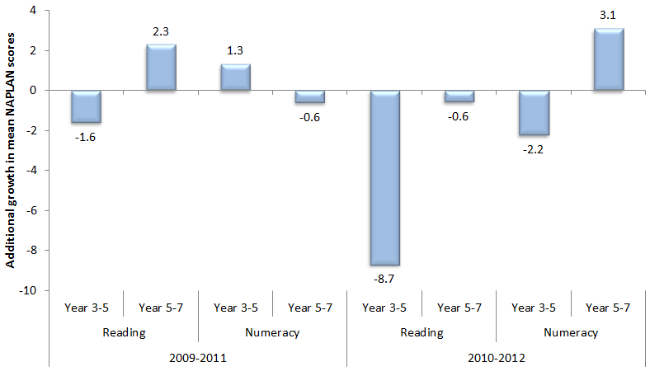
 |  | Year 3 to Year 5 | Year 5 to Year 7
2009 to 2011 | Reading | -1.6 | 2.3
2009 to 2011 | Numeracy | 1.3 | -0.6
2010 to 2012 | Reading | -8.7 | -0.6
2010 to 2012 | Numeracy | -2.2 | 3.1
Source: PGA constructed graph using data provided by ACARA
Analysis of achievement among Indigenous students was undertaken using unit-record data in all QLD Government and Catholic schools to assess the progress of Indigenous students in Low SES NP schools compared to that made by Indigenous students in similar non-NP schools. Similar schools were grouped according to their students’ socioeconomic background as measured by the school ICSEA or their achievement prior to the commencement of the Low SES NP. In both measures, the analysis focused on the lowest four deciles in which both Low SES NP schools and non-NP schools were adequately represented. In both the 2009-2011 and 2010-2012 student cohorts, the comparison of schools within the same ICSEA deciles shows that above average growth among Indigenous students in Low SES NP schools was achieved in greater proportions than in non-NP schools, particularly in Year 5-7 Reading where the difference was found to be 11%.This result was not replicated among schools with similar starting scores.

Figure 4.7: Proportion of Indigenous students in Low SES NP schools who achieved above average growth compared to that of Indigenous students in similar non-NP schools, 2010-2012 student cohort in QLD Government and Catholic sectors
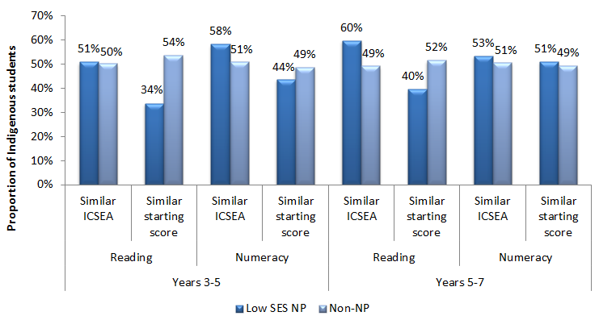
 |  |  | Low SES NP schools | Non-NP schools
Year 3 to Year 5 | Reading | Similar ICSEA | 51% | 50%
Year 3 to Year 5 | Reading | Similar starting score | 34% | 54%
Year 3 to Year 5 | Numeracy | Similar ICSEA | 58% | 51%
Year 3 to Year 5 | Numeracy | Similar Starting score | 44% | 49%
Year 5 to Year 7 | Reading | Similar ICSEA | 60% | 49%
Year 5 to Year 7 | Reading | Similar starting score | 40% | 52%
Year 5 to Year 7 | Numeracy | Similar ICSEA | 53% | 51%
Year 5 to Year 7 | Numeracy | Similar Starting score | 51% | 49%
Source: PGA constructed graph using data provided by ACARA
As outlined in the evaluation scope, outcomes were analysed for metropolitan and non-metropolitan schools participating in the Low SES NP. This analysis was conducted the same method described for Figure 4.7for primary schools which constituted most participating partnership schools using the regression discontinuity design. When the analysis compared students with similar socioeconomic backgrounds, the proportion of students at metropolitan Low SES NP schools who achieved above average NAPLAN Numeracy growth compared to similar non-NP schools was higher than that of students at non-metropolitan Low SES NP schools. This result was also observed in Reading but only among the 2009-2011 cohort. When the analysis compared students with similar starting points, growth patterns between students at metropolitan and non-metropolitan Low SES NP schools were comparable, except in Reading among the 2010-2012 cohort, where above average growth was more evident among students at non-metropolitan Low SES NP schools.
It is important to note that the mixed evidence provided by NAPLAN does not necessarily mean that the Low SES NP did not affect student achievement. As earlier outlined, intended achievement outcomes may not be realised in the limited timeframe under analysis. This could be particularly true for Low SES NP schools where other fundamental outcomes were targeted, such as student attendance and engagement.

NAPLAN Participation at Low SES NP schools
The analysis of NAPLAN participation rates in Low SES NP schools found that the proportion of students who sat both Reading and Numeracy assessments generally declined between 2008 and 2012 (Figure 4.8). The greatest decrease was observed in Grade 5 Reading, where participation in 2008 was 7% higher than in 2012. Decreases in NAPLAN participation rates between 2008 and 2012 were also observed at the secondary school level but to a smaller extent. Similar patterns of participation were observed among Indigenous students, with the Grade 5 Reading participation rate decreasing by 11% between 2008 and 2012. Although NAPLAN participation rates in all QLD schools also declined, these decreases were less than half of those observed in Low SES NP schools. As the proportion of students exempt from sitting NAPLAN was consistent between 2008 and 2012, the decrease in NAPLAN participation at Low SES NP schools appears to be driven largely by students classified as withdrawn or absent.
Figure 4.8: NAPLAN participation at the primary school level in QLD Low SES NP schools
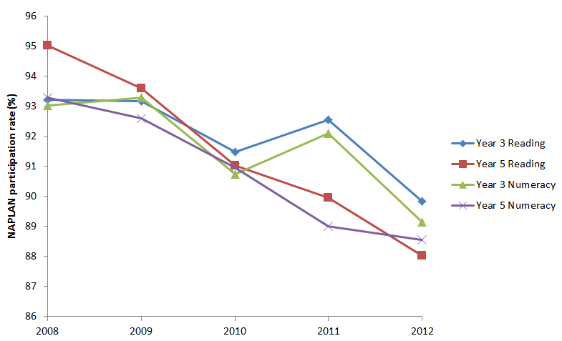
 |  | 2008 | 2009 | 2010 | 2011 | 2012
Reading | Year 3 | 93% | 93% | 92% | 93% | 90%
Reading | Year 5 | 95% | 94% | 91% | 90% | 88%
Numeracy | Year 3 | 93% | 93% | 91% | 92% | 89%
Numeracy | Year 5 | 93% | 93% | 91% | 89% | 89%
Source: PGA constructed chart using QLD DETE (2013)
NB: NAPLAN participation rates have been recalculated by considering only students who were assessed

Achievement in LNNP schools
Queensland LNNP schools were found to have met or exceeded eight of the targets set to acquire reward LNNP funding, while making progress towards seven targets and not meeting one target. In general, Year 3 students showed a greater improvement than Year 5 students. In LNNP schools from 2008 to 2011, the proportion of Year 3 students at or above NMS in Reading improved by 6.6 percentage points, but declined by 0.1 for Year 5 students. The proportion of Year 3 Indigenous students at or above NMS in Reading and Numeracy improved by 11.4 and 8.9 percentage points respectively (COAG Reform Council 2012).
The aggregated data on LNNP schools available to this evaluation included 175 schools, all from the Government sector. Using the 2009-2011 student cohort, the analysis showed that LNNP schools only achieved higher gains in Year 5-7 Reading when compared to all QLD schools, although differences across all year levels and domains did not exceed 3 points on the NAPLAN scale (Figure 4.9).
Figure 4.9: Gains in NAPLAN mean scores from 2009 to 2011 for QLD Government schools
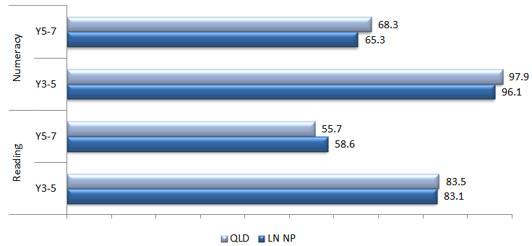
 |  | QLD | LN NP
Numeracy | Year 5-7 | 68.3% | 65.3%
Numeracy | Year 3-5 | 97.9% | 96.1%
Reading | Year 5-7 | 55.7% | 58.6%
Reading | Year 3-5 | 83.5% | 83.1%
Source: PGA constructed chart using QLD DETE (2012c)
Consistent with the pattern in gains, notable improvement in the proportion of students at or above NMS among LNNP schools was seen in Reading between Years 5-7 (Figure 4.10). LNNP schools had a higher proportion of students falling below the NMS in Reading from Years 3-5. Limited changes were observed in Numeracy. The apparent improvement in Reading may seem to contrast the previously discussed notion that Numeracy is expected to respond prior to Reading. This could be due to several reasons. It is firstly not clear whether the observed reduced proportion of students below NMS is statistically significant. Moreover, a higher starting proportion of students below NMS in Reading in Year 3 may have led to greater reductions compared to Numeracy. The observed result could also be due to program elements as the majority of LNNP schools in QLD chose to focus their initiatives on Literacy. The data in Figure 4.10 are descriptive and will be augmented by further analysis using unit-record data in more robust models.
Figure 4.10: Change in the proportion of students in QLD Government schools at or above NMS - 2009 to 2011
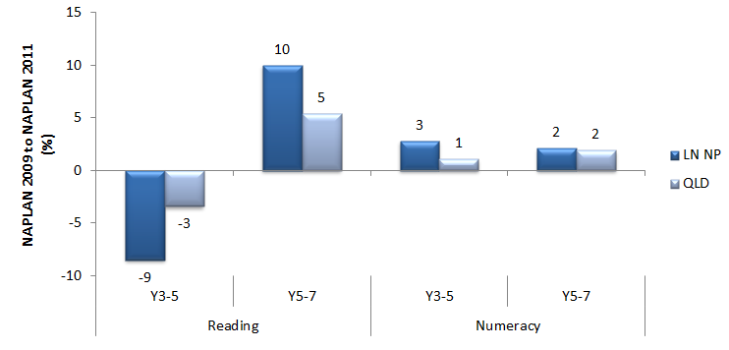
 |  | LN NP | QLD
Reading | Year 3-5 | -9 | -3
Reading | Year 5-7 | 10 | 5
Numeracy | Year 3-5 | 3 | 1
Numeracy | Year 5-7 | 2 | 2
Source: PGA constructed chart using QLD DETE (2012c)
Leading indicators of future improvements in achievement were found in the analysis of student outcomes on the Progressive Achievement Test (PAT). The results showed significant progress in Maths and Reading by at least two stanines for Year 3 students in LNNP Government schools (QLD DETE 2012c). This evidence contrasts NAPLAN results which show little difference in relative student gains, with slightly lower relative gains for students in schools implementing Reading coaching programs compared to similar non-participating schools. However, Progressive Achievement Tests (PAT) which enable closer examination of student progress within the same year suggest that coaching may have had a positive effect on student achievement (QLD DETE 2012d).
PAT-R results show that schools with Reading coaches experienced positive shifts in student achievement towards performance levels at or above average (Figure 4.11). Only one-third of Year 3 students achieved below average results in Test 2 in 2010, compared to 63% in Test 1. Moreover, the proportion of students with above average achievement in these schools rose from 2% to 12% between Tests 1 and 2 in 2010. Similar results were found across other year levels.
Figure 4.11a: PAT-R results in QLD Government LNNP schools with a Reading coach - 2010
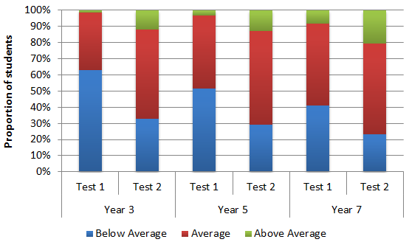
 |  | Below Average | Average | Above Average
Year 3 | Test 1 | 2538 | 1436 | 68
Year 3 | Test 2 | 1335 | 2224 | 483
Year 5 | Test 1 | 3552 | 3119 | 227
Year 5 | Test 2 | 2034 | 3991 | 900
Year 7 | Test 1 | 2848 | 3553 | 566
Year 7 | Test 2 | 1602 | 3930 | 1435
Source: PGA constructed chart using QLD DETE (2012d)
Figure 4.11b: PAT-R results in QLD Government LNNP schools with a Reading coach – 2011
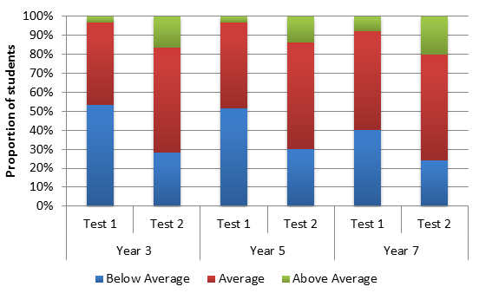
 |  | Below Average | Average | Above Average
Year 3 | Test 1 | 3409 | 2745 | 226
Year 3 | Test 2 | 1814 | 3505 | 1061
Year 5 | Test 1 | 3408 | 3001 | 221
Year 5 | Test 2 | 1981 | 3721 | 928
Year 7 | Test 1 | 2867 | 3734 | 568
Year 7 | Test 2 | 1744 | 3985 | 1440
Source: PGA constructed chart using QLD DETE (2012d)
Analysis of unit-record achievement data in all QLD Government and Catholic schools also assessed the progress of students in LNNP schools compared to that made by students in similar non-NP schools. Employing the same methodology used to construct Figure 4.7, similar schools were grouped according to their students’ socioeconomic background as measured by the school ICSEA or their achievement prior to the commencement of the LNNP, with the analysis focusing on schools in the lowest four deciles of either measure. Amongst both the 2009-2011 (Figure 4.12) and 2010-2012 student cohorts, comparison of students at schools within the same ICSEA deciles shows that the proportion of students at LNNP schools who achieved above average growth was greater than that in non-NP schools. This result was not replicated among schools with similar starting scores, although differences were less than 5%. Although NAPLAN growth rates may not have been as large in all LNNP schools as those in non-NP schools, approximately 45% of students at LNNP schools exhibited above-average growth when compared to students at similar non-participating schools. It is recommended that further research be undertaken with this group to determine why some students at LNNP schools achieved greater success than others.
Figure 4.12: Proportion of students in LNNP schools who achieved above average growth compared to that of students in similar non-NP schools, 2009-2011 student cohort in QLD Government and Catholic sectors
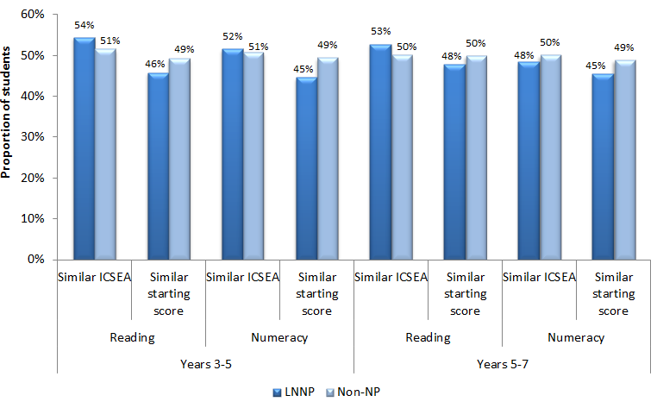
 |  |  | LNNP | Non-NP
Year 3 to Year 5 | Reading | Similar ICSEA | 54% | 51%
Year 3 to Year 5 | Reading | Similar starting score | 46% | 49%
Year 3 to Year 5 | Numeracy | Similar ICSEA | 52% | 51%
Year 3 to Year 5 | Numeracy | Similar Starting score | 45% | 49%
Year 5 to Year 7 | Reading | Similar ICSEA | 53% | 50%
Year 5 to Year 7 | Reading | Similar starting score | 48% | 50%
Year 5 to Year 7 | Numeracy | Similar ICSEA | 48% | 50%
Year 5 to Year 7 | Numeracy | Similar Starting score | 45% | 49%
Source: PGA constructed graph using data provided by ACARA
A similar analysis of achievement among Indigenous students in QLD Government and Catholic LNNP schools was undertaken. In the 2009-2011 cohort of Indigenous students, the results show that the proportion of students at LNNP schools who achieved above average growth in Years 3-5 Numeracy was greater than that in non-NP schools. This pattern was also found in Years 3-5 Reading among Indigenous students attending schools in the lowest four ICSEA deciles (Figure 4.13). These results were not replicated for Indigenous students moving from Year 5 to Year 7 in the 2009-2011 cohort or Indigenous students starting in both Year 3 and Year 5 in the 2010-2012 cohort.
Figure 4.13: Proportion of Indigenous students in LNNP schools who achieved above average growth compared to that of Indigenous students in similar non-NP schools, 2009-2011 student cohort in QLD Government and Catholic sectors
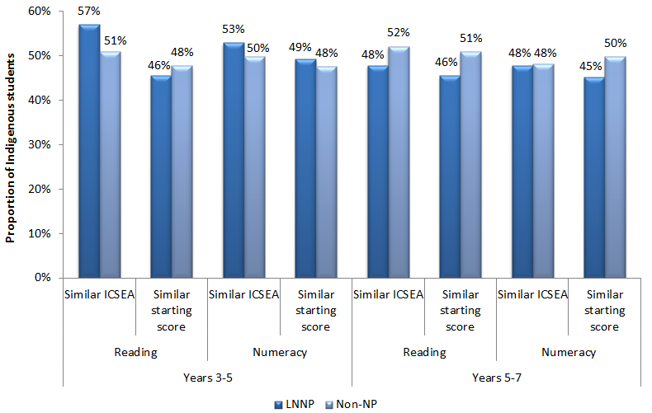
 |  |  | LNNP | Non-NP
Year 3 to Year 5 | Reading | Similar ICSEA | 57% | 51%
Year 3 to Year 5 | Reading | Similar starting score | 46% | 48%
Year 3 to Year 5 | Numeracy | Similar ICSEA | 53% | 50%
Year 3 to Year 5 | Numeracy | Similar Starting score | 49% | 48%
Year 5 to Year 7 | Reading | Similar ICSEA | 48% | 52%
Year 5 to Year 7 | Reading | Similar starting score | 46% | 51%
Year 5 to Year 7 | Numeracy | Similar ICSEA | 48% | 48%
Year 5 to Year 7 | Numeracy | Similar Starting score | 45% | 50%
Source: PGA constructed graph using data provided by ACARA
All LNNP schools in QLD chose to focus their initiatives on either literacy or numeracy. As a result, additional analysis using unit-record data was undertaken to assess the effect of such a focus. Amongst the 2009-2011 student cohort, the proportion of students at LNNP schools who achieved above average growth in their school’s focus area was found to be either higher than or comparable to that in non-NP schools with a similar socioeconomic background (Figure 4.14). This was not found to be the case however when students at LNNP schools were compared to their peers at non-NP schools with similar NAPLAN starting scores, with only 43% of Years 3-5 students and 46% of Years 5-7 students achieving above-average growth in their school’s focus area. Amongst the 2010-2012 cohort, students transitioning from Year 3 to Year 5 at previously low-achieving LNNP schools which focused on Numeracy appear to have benefitted from their schools’ focus area. The results show that approximately 53% of these students exhibited above average growth in Numeracy compared to half of students at non-NP schools with similar starting scores. LNNP students were less likely to achieve above-average growth in other grades and domains though the difference was only 3% on average.
Figure 4.14: Proportion of students in LNNP schools who achieved above average growth in their school’s focus area (Literacy/Reading or Numeracy) compared to that of students in similar non-NP schools, QLD Government and Catholic sectors, 2009-2011 student cohort
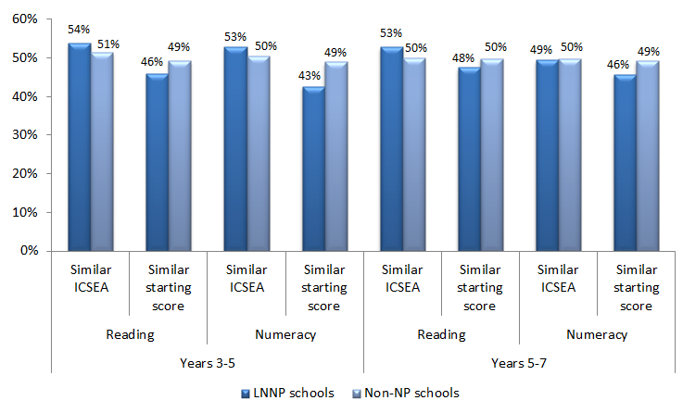
 |  |  | LNNP | Non-NP
Year 3 to Year 5 | Reading | Similar ICSEA | 54% | 51%
Year 3 to Year 5 | Reading | Similar starting score | 46% | 49%
Year 3 to Year 5 | Numeracy | Similar ICSEA | 53% | 50%
Year 3 to Year 5 | Numeracy | Similar Starting score | 43% | 49%
Year 5 to Year 7 | Reading | Similar ICSEA | 53% | 50%
Year 5 to Year 7 | Reading | Similar starting score | 48% | 50%
Year 5 to Year 7 | Numeracy | Similar ICSEA | 49% | 50%
Year 5 to Year 7 | Numeracy | Similar Starting score | 46% | 49%
Source: PGA constructed graph using data provided by ACARA
When analysis of achievement at the Year 3 to Year 5 level was undertaken by location using the same method described for Figure 4.7, NAPLAN Reading and Numeracy growth patterns between students at metropolitan and non-metropolitan LNNP schools were comparable when comparing students with similar socioeconomic backgrounds. When the analysis compared students with similar starting points, the proportion of students at metropolitan schools who achieved above average growth was higher than that of students at non-metropolitan schools among the 2010-2012 cohort. This was also observed for the 2009-2011 cohort, but only in Reading.
At LNNP schools, it is not possible using existing information to identify which initiatives had the desired effects. Although some students at coached schools appear to have made positive progress, insufficient evidence exists to identify the exact contribution of coaching to this finding. Other concurrent initiatives such as increased resources, Turnaround Teams, Vacation Professional Development or Summer Schools may have also confounded observed effects. For example, pre- and post-achievement measures for students in the Summer School Program for 2011 and 2012, implemented in nearly half of the LNNP schools, showed that more than three quarters of students demonstrated improvement in at least one aspect of literacy and numeracy (QLD DETE 2012e). In addition, the limited timeframe being analysed is another important consideration that may have affected observed outcomes.
CASE STUDY: Enhancing Reading Achievement at Tingalpa State School (QLD DETE 2012e)
Tingalpa State School is a co-educational primary school with a 2011 enrolment of 318 students including 12 indigenous students and 35 ESL students speaking 18 languages at home. The School identified improving reading levels as its number one priority.
Each term, every child set individualised reading goals that were signed by the child, teacher, parent and Principal/Deputy Principal. All teachers met with the Principal or Deputy Principal every five weeks to discuss student data, and plan the coming five weeks’ teaching and learning targets. The Literacy Coach met with teachers to discuss their literacy program and class data to set focused goals; build relationships with teachers to establish situations where modelling, observation and co-teaching are comfortably undertaken by both; and provide feedback and engage in reflective conversations.
The School achieved above the state average in every strand in all year 3, 5 and 7 tests, and above the nation in 12 out of 15 strands. Tingalpa was one of most improved schools (overall) in Queensland in 2011, and achieved the second highest improvement in the state (private and state schools) in year 5. Results of Progressive Achievement Test – Reading from February 2011 to October 2011 showed up to 23.2% improvement across 25 of 28 questions for year 3; up to 45.5% improvement across 31 of 34 questions for year 5; and up to 31% improvement across 32 of 35 questions for year 7.

CASE STUDY: Development of Numeracy Competencies in Toowoomba Diocese (QLD DETE 2012e)
Toowoomba diocese is located in the south west corner of Queensland. It administers to 32 schools, including 24 primary schools, teaching over 8300 children from P-12. The diocese had three targeted schools for the LNNP with an enrolment of approximately 3% Indigenous students. These schools focused on developing numeracy competencies as the teaching of sound mathematical concepts in the early years was found to be an area of need.
The Mathematics Activity Guidelines (MAGs) are hands-on, engaging, age appropriate, and addressing a range of learners and learning styles in the early years. It developed ten core concepts per term per year level from Prep to Year 3 – a total of forty activity guidelines per year level. The Guidelines included: introduction, background reading, classroom organisation, assessment, modifications and extensions, resources and curriculum links. In addition to the MAGs a software package named Fun With Construction (FWC) was developed. FWC is based on a Question-a-Day strategy with questions from previous NAPLAN tests used to support a flexible and collaborative approach to solving NAPLAN questions. Teachers were encouraged to teach concepts using the NAPLAN questions as a stimulus for concept development. The stimulus material provided activities for students in problem solving, consolidation, review and extension. Classroom teachers attended workshops on the effective implementation of the MAGs and FWC resources; and received in-class coaching. Principals also attended professional development and accessed coaching.
In a survey to assess its effectiveness, teachers described themselves and the students as being positive about mathematics and looking forward to maths sessions with 96% teachers stating that the MAGs have enhanced the way that they teach numeracy. The table below shows improvements made by the schools in NAPLAN Year 3 numeracy:
NAPLAN results for NP schools in Toowoomba Diocese, 2009-2011
 | Above NMS |  | At & Above NMS |  | Mean Scale Score
 | 2009 | 2011 | 2009 | 2011 | 2009 | 2011
School 1 | 70.8% | 89.8% | 93.8% | 100% | 362.6 | 392.2
School 2 | 50% | 87.9% | 85% | 97% | 339.7 | 348.8
School 3 | 80% | 82.9% | 88% | 95.1% | 385.9 | 392.9

Outcome 3:
Higher percentage of students enrolled in and attending school (particularly Indigenous students) and a higher proportion of Indigenous students completing year 10
School attendance in Queensland was an intended outcome equally as important as student achievement, especially among Indigenous students in Low SES NP schools. Schools selected for this NP were often comprised of students facing multiple sources of disadvantage over an extended period of time. Addressing these entrenched disadvantages therefore required a focus on more vital issues such as attendance and engagement before student achievement could be lifted. A number of innovative models to enhance student engagement were therefore adopted. Notable examples included the Cape York Aboriginal Australian Academy which engaged Indigenous students from Prep to Year 7 in an education program that supported their bi-cultural identity.
To better understand the impact of the Low SES NP on attendance, further analysis was undertaken comparing trends in student attendance at participating schools to those in all QLD schools. The analysis used aggregated school-level data from Government and Catholic schools to compare whether the difference in attendance rates between Low SES NP schools and all QLD Government and Catholic schools declined over time following the commencement of the partnership. The results showed little or no improvement at Low SES NP schools relative to all QLD Government and Catholic schools at the primary school level. At the secondary school level however (Figure 4.15), the attendance rate among Indigenous students at Low SES NP schools was found to have improved significantly compared to all QLD Government and Catholic schools, with a decrease of 3.0 percentage points in the initial attendance gap, representing a 54% reduction in the overall difference. When all students were considered, only a small change (0.5 percentage points) in the attendance rate gap was observed.
Figure 4.15: Attendance rates of secondary school students at QLD Government and Catholic schools commencing Low SES NP participation in 2009/2010.
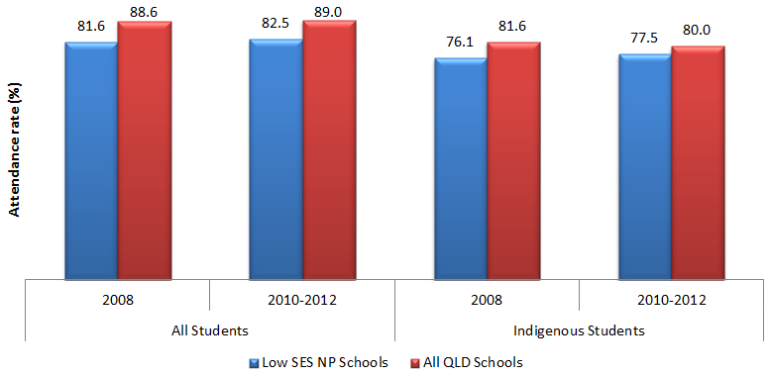
 |  | Low SES NP Schools | All QLD Schools
All Students | 2008 | 81.6 | 88.6
All Students | 2010 to 2012 | 82.5 | 89.0
Indigenous Students | 2008 | 76.1 | 81.6
Indigenous Students | 2010 to 2012 | 77.5 | 80.0
Source: PGA constructed graph based on attendance data provided by QLD DETE and DEEWR
In addition, case studies highlighted in state-level reports suggest that some positive results were noted where attendance was targeted. Other localised evidence showed schools reporting that the restructuring of school leadership roles had led to improved student attendance. Case studies of some schools also indicated that carefully designed interventions were capable of yielding significant improvements. For example, school-specific programs which focused on Indigenous culture and community involvement showed improvements in both enrolment and attendance rates.
To investigate the relationship between participating in the Low SES NP and retention of Indigenous students, the apparent retention rates (ARR) were assessed using student enrolment data. This was analysed for Years 8-10 (Government and Catholic sectors), Years 10-11 (Government sector) and Years 10-12 (Government sector). The ARR is measured as a ratio of students in a particular grade level divided by the number of students in an earlier grade level. Compared to all QLD Government schools, the results show little or no improvement in the Year 10-11 and Year 10-12 ARRs of Indigenous students at Government Low SES NP schools (Figure 4.16). However, an improvement of 8.8% in the Year 8-10 ARR was found in Low SES NP Government and Catholic schools. Such an improvement was not observed in all QLD Government and Catholic schools. Despite this observed improvement, the results should not be taken as causal evidence of the impact of the Low SES NP as the ARR is an aggregated measure of student enrolments and does not control for student movement between schools, an important factor that may be driving the observed changes.
Figure 4.16: Apparent retention rates of Indigenous students in QLD Government and Catholic schools commencing Low SES NP participation in 2009/2010.
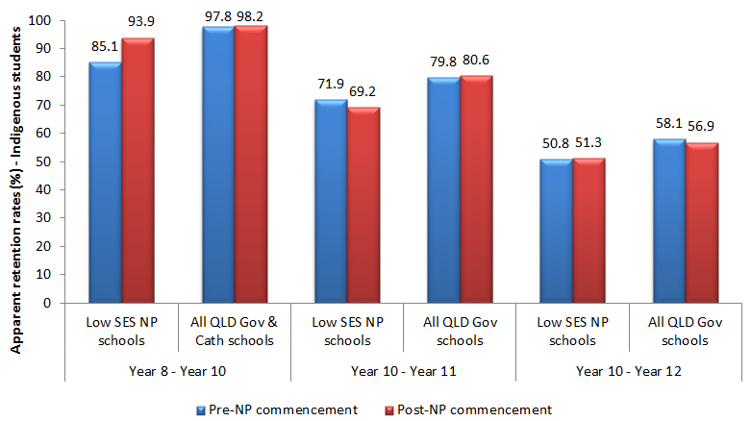
 | Low SES NP Schools |  | All QLD Government and Catholic Schools
 | Pre-NP commencement | Post-NP commencement | Pre-NP commencement | Post-NP commencement
Year 8 to Year 10 | 85.1 | 93.9 | 97.8 | 98.2
Year 10 to Year 11 | 71.9 | 69.2 | 79.8 | 80.6
Year 10 to Year 12 | 50.8 | 51.3 | 58.1 | 56.9
Source: PGA constructed graph based on attendance data provided by QLD DETE and DEEWR
NB: Year 8-10 ARRs include Government and Catholic schools. Year 10-11 and Year 10-12 ARRs represent only Government schools. The pre-NP commencement figures are the ARRs between 2008 and 2010 for Years 8-10

CASE STUDY: Student Engagement Through Community Collaboration and Strengthened Positive Relationships at Bundaberg West State School (QLD DETE 2011).
Bundaberg West State School’s Strategic Plan included a range of programs and strategies designed to improve the learning outcomes and engagement of students, particularly Indigenous students. Their strategies included
- the 100% Club program and the Every Day Counts;
- employment of a Community Liaison Officer;
- development of the Indigenous West Alumni program;
- employment of Indigenous staff to work in classrooms with students and ‘Living the Crossing Cultures’ program;
- provision of funding for all students to access extension activities and high interest programs such as Reach In, Reach Out (sporting program), Personal Development Identity Program (run in conjunction with the Bundaberg Indigenous Wellbeing Centre) and the school’s Adopt an Elder program; and
- implementation of the Making Connections program linking the school with local Indigenous community members.
These strategies were underpinned by the strong, positive relationships the school has developed with the Indigenous community over many years; and making families welcome at the school.

Outcome 4:
Increased levels of parent satisfaction, student satisfaction and wellbeing at school
Increasing student and parent satisfaction was an intended outcome targeted under both the Low SES NP and LNNP. The evaluation used the School Opinion Survey (SOS) which was administered to all QLD Government sector schools to measure various aspects relating to parent and student satisfaction. The survey results show an improvement in parent perceptions regarding their child’s school (+2.8%) at NP schools between 2009 and 2012 while perceptions of the quality of education their child was receiving also rose by 5.1% (Figure 4.17). This was unlike the case in non-NP schools where the perception of parents was found to have experienced little change. Due to this, the initial gaps in parental perception between NP and non-NP schools in 2007 had been practically eliminated by 2012.

Figure 4.17: Parents’ opinion of their child’s school, QLD Government sector – School Opinion Survey
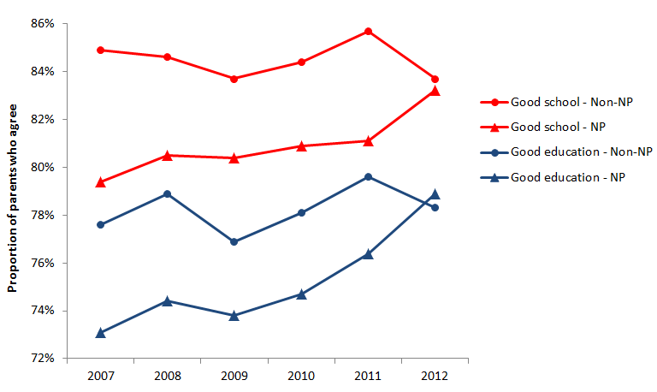
 |  | 2007 | 2008 | 2009 | 2010 | 2011 | 2012
Good school | Non-NP | 85% | 85% | 84% | 84% | 86% | 84%
Good school | NP | 79% | 81% | 80% | 81% | 81% | 83%
Good education | Non-NP | 78% | 79% | 77% | 78% | 80% | 78%
Good education | NP | 73% | 74% | 74% | 75% | 76% | 79%
Source: PGA constructed graph using the QLD Government SOS. The survey statements represented in the graph are; 1) ‘This is a good school’ (Good school); 2) ‘Your child is getting a good education at this school’ (Good education).
Among primary school NP students, there was a slight improvement in the perceptions of their school (+1.9%) and of the quality of education received at their school (+2.8%) between 2009 and 2012. This was 1.2% and 0.1% respectively higher than the improvement in non-NP schools. Among secondary school students, the improvement at NP schools was a lot more pronounced (Figure 4.18). Students’ perceptions of their school and the quality of education received at their schools were found to have improved by 10.5% and 6.5% more than in non-NP schools, respectively, virtually eliminating the initial gap in 2007.

Figure 4.18: Students’ opinion of their school, QLD Government sector – School Opinion Survey
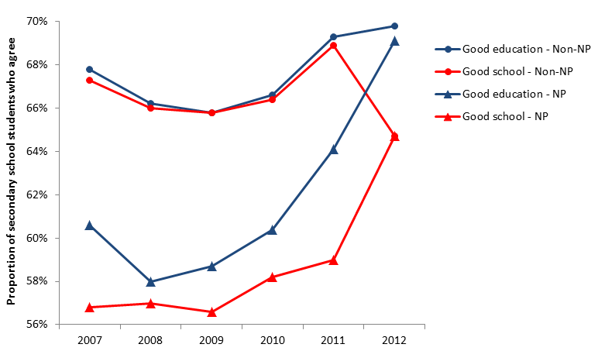
 |  | 2007 | 2008 | 2009 | 2010 | 2011 | 2012
Good school | Non-NP | 67% | 66% | 66% | 66% | 69% | 65%
Good school | NP | 57% | 57% | 57% | 58% | 59% | 65%
Good education | Non-NP | 68% | 66% | 66% | 67% | 69% | 70%
Good education | NP | 61% | 58% | 59% | 60% | 64% | 69%
Source: PGA constructed graph using the QLD Government SOS. The survey statements represented in the graph are; 1) ‘This is a good school’ (Good school); 2) ‘You are getting a good education at this school’ (Good education).
In addition to improvements in overall satisfaction levels, parents and students appear to be particularly satisfied with the Summer Schools program. Qualitative and quantitative feedback provided by parents/carers and students indicated high levels of satisfaction with the delivery of this program. Online surveys to evaluate both the 2011 and 2012 Summer Schools programs showed that of the 500 parents/carers who completed the survey each year, over 90% were satisfied with their child’s improvement in Literacy and Numeracy. Respondents also noted that Summer Schools had boosted their child’s confidence in Literacy and Numeracy and that they had observed a positive change in their child’s attitude towards school and learning. Among students, 80% indicated that they had enjoyed the program and approximately 95% felt more confident about Literacy and Numeracy (QLD DETE 2012d).
In addition, several school case studies demonstrated improvements in both parent and student satisfaction as evident in their involvement and engagement in school work. A number of schools have reported improvements in student behaviour and wellbeing which resulted in a decrease in incidences requiring intervention, primarily as a result of programs that focused on social and emotional wellbeing (QLD DETE 2012e).
CASE STUDY: Kids Matter Program for Student Behaviour Improvement at Our Lady of Fatima School (QLD DETE, 2012e)
Our Lady of Fatima School, Acacia Ridge has an enrolment of 118 students from P-7 with 3 Indigenous students and 9 students with disability.
The implementation of the Kids Matter Program in conjunction with School Wide Positive Behaviour Support has resulted in significant improvements in the general behaviour of students, whole school consistent approach to expectations and behaviour support and learning. Data was collected since 2009 to support these findings. With the establishment of calm, happy and more focused environment for learning and teaching to occur, student achievement and learning reportedly witnessed greater improvement, notably throughout the early years classes.

CASE STUDY: Alternative Pathways to Student Engagement at Gin Gin State High School (QLD DETE, 2012e)
The Gin Gin Alternative Pathways Programme (GGAP) was a program developed for students, particularly boys in Middle Years of schooling, at risk of disengagement from their learning. It recognised that students’ learning is affected by individual developmental considerations and social factors. GGAP offered a high interest learning model delivered through practical/hands on frameworks. Literacy and Numeracy skills were embedded within these frameworks, ensuring students Literacy and Numeracy requirements were being met. The program offered individualised tailored subjects that eventually lead to the awarding of certificates, work placements, traineeships or apprenticeships.
The GGAP program was successful in that all students were engaged and showed vast improvement in their social/emotional wellbeing, attendance, behaviour and academic performance with a corresponding positive impact on learning.

Outcome 5:
Young people make a successful transition from school to work and further study
Another intended outcome of the Low SES NP was facilitating a successful transition of students from school to work and further study. Although this was a long-term outcome, the state-wide Next Step survey results (QLD DETE 2013) found that the proportion of young people participating in post-school education and training six months after school rose from 59.6% in 2009 to 63.0% in 2012. Though there is no systemic evidence of its link to the SSNP, a number of case studies have highlighted how the partnerships helped achieve this outcome at particular schools.
CASE STUDY: Community Engagement at Wadja Wadja High (QLD DETE 2012f)
At Wadja Wadja High School, a position of head of curriculum was funded under the NP program, and a liaison officer was also partially funded under the program. This allowed for an improved, more relevant and comprehensive curriculum to be developed resulting in stronger engagement between teachers and students. The Liaison officer provided a crucial link between the parents and the school as parents were often reluctant to engage with the school directly due to their lack of understanding of the school system and poor literacy. Liaison officers provide a safe link for parents as they are well respected community members. Liaison officers used the school bus to pick up students for school and encouraged parents to engage with the school. A partnership program with the local health department was also developed through the Program.
As a result, the school saw an increase in the number of students finishing Year 12 with a VET or QCE qualification. Three students received apprenticeships with mining companies, one student engaged in full time work and two students involved in school-based apprenticeships with a local pastoral company. Some disengaged students reengaged with school. The delivery of health and nutrition programs at school through the partnership with local health department saw improvements in student health.

Outcome 6:
Research case studies that highlight the achievements of disadvantaged student cohorts
CASE STUDY: Meeting Student Needs through Community Involvement at Beenleigh State School (QLD DETE 2012e)
Beenleigh SS is a metropolitan school with 452 students in July 2011, of which 40 (8.8%) were Indigenous students. It is located in an area where a high percentage of families experience extreme economic and social disadvantage.
The Beenleigh SS’s Great Futures Program (BGF) used community resources such as volunteer mentors, and donated food to maximise opportunities for disengaged students to participate in school life. The program evolved in response to the need to create “Unity in Diversity” within the school and broader community. BGF aimed to meet the students’ essential needs (e.g. food, warmth); foster in each student a full sense of belongingness, a greater appreciation of their inherent worth, and a greater capacity to be resilient; and identify, cultivate and release each students’ unique talents for their own and the community’s good.
The BGF Program comprised of a suite of school-based community programs:
- The Breakfast Club that provided nutritious food for healthy bodies and healthy minds;
- ‘Walk in My Shoes’ program that replaced ill-fitting or dilapidated shoes; and
- a mentoring program to address ‘poverty of the mind’.
The Mentoring Program involved mentors (community volunteers) who were matched to mentees (students) on the grounds of common interests and talents. Mentees were encouraged to reach their individual potential through regular meeting and work in mutual areas of interest and talents. e.g. landscaping and gardening, carpentry, cooking, drawing and craft. Literacy and numeracy skills were embedded in the activities and were very practical and real-world oriented.
Since the commencement of the program, the school noted a significant reduction in disciplinary referrals, and more focussed and quality learning. As a result, Beenleigh SS enjoyed a growing reputation as a community-based school that demonstrated exemplary and inclusive practices.

CASE STUDY: Wellbeing, Mentoring, Job Skills and Community Engagement At Glenala State High School (QLD DETE 2012f)
Glenala SHS is a metropolitan high school with a total student population of 462 students in 2012, of which 17.1% of students were Indigenous and 19.7% students were from LBOTE.
Glenala SHS formed a corporate partnership with Minter Ellison Lawyers (ME) with the objective of getting students involved to become valued members of the community, and ensuring the development of positive attitudes to schooling, and improved transitions into the work force. It involved:
- the development of a culture of high expectations and standards e.g. wearing of school uniform, attending school on time;
- promotion of healthy lifestyles and wellbeing by providing breakfasts before school for all students, and sun hats for all staff and students;
- Reading Mentoring Program (RISE) and Literacy Day for Year 8 students;
- Career Path Mentoring Program for Year 10 Students;
- scholarships for outstanding Years 11 and 12 students;
- Job Skills Preparation for Year 12 students;
- Princess Party for girls from low socio-economic areas; and
- the active involvement of representatives from ME in school activities.
The school achieved measurable improvement evidenced in their nomination as state finalist for Queensland Showcase Awards as well as the receipt of a National Australia Bank $50,000 Impact Award in 2011. The school saw improvements in literacy and numeracy results on NAPLAN tests as well as Year 12 results. School based data indicated strong improvement in attendance and increase in enrolment, improvement in community and parent engagement, and improved transitions into the workforce. It also saw a significant reduction in student behavioural incidents, and a decline in the number of incidents of vandalism in the school.

CASE STUDY: Closing the Gap through Community Engagement at Waterford West State School (QLD DETE 2013)
Waterford West SS is a metropolitan primary school with a total student population of 635 students in 2012, with 11.5% of it representing Indigenous and LBOTE students.
Through space, dance, language, song, process, people and stories, Waterford West SS built an equitable educational environment, connecting the school’s Indigenous community to the school and to close the gap between the performance of non-Indigenous students and Indigenous students.
The development of an after school hours program (Bareibunn Boul) aimed to improve the academic achievement of Indigenous students through a multi-layered approach. This was done to ensure that Indigenous student identities were lodged at the forefront of all work and play, and a safe place is created for Indigenous students to learn cultural skills and customs. It allowed Indigenous and non-Indigenous students the opportunity to experience Indigenous culture. Dance taught at the Boul led to formation of the ‘Deadly Jarjums’, the school’s Indigenous dance troupe. Yugambeh, the local Indigenous language was taught as Language Other than English (LOTE). Community partnerships consisting of parents and caregivers, Community Durithunga, Queensland University of Technology Faculty of Education, staff and students, and the traditional owners of the land of Yugambeh was established to develop the program to engage and build pride in the school’s Indigenous students.
School-based data indicated that students who regularly attended Bareibunn Boul achieved improvements on end of semester reports. It re-established the school choir with a multi-cultural choir and Deadly Jarjums dance troupe representing the school at community functions, and established Durithunga Deadly Day, an inter-school sports competition. It developed leadership capacity of Indigenous students, and increased staff knowledge of Indigenous culture leading to embedding it into the curriculum. Bareibunn Boul served as a ‘draw card’ for students wanting to be at school and to attend the after school hours program; and developed positive relationships between multi-cultural groups.

4.3 QLD CONCLUSION
The analysis of existing data shows mixed results associated with participation in either of the Low SES NP and the LNNP. Aggregated achievement data showed that apparent gains in mean NAPLAN scores in QLD Low SES NP schools exceeded the apparent gains achieved by all QLD schools in Year 3-5 Numeracy and in Year 5-7 Reading. Increased growth in both NAPLAN domains associated with participation in the Low SES NP was also observed among Indigenous students in the lowest four ICSEA deciles and in both Years 3-5 and Years 5-7. However, robust regression analysis of achievement in QLD showed no significant differences between student gains in Low SES NP and non-NP schools, suggesting variation in the impact of the program throughout the state. Analysis of student growth LNNP schools as measured by NAPLAN achievement found that the proportion of students who achieved above average growth in these schools was slightly below that in non-NP schools. Among students in the lowest four ICSEA deciles however, the proportion achieving above average growth in Reading was slightly higher at LNNP schools, particularly for Indigenous students from Years 3-5. Furthermore, a notable increase in the proportion of students at or above NMS among LNNP schools was observed in Reading between Years 5-7. In addition to the mixed NAPLAN evidence, leading indicators of future improvements in achievement were found in the analysis of student outcomes on the Progressive Achievement Test (PAT), with the results showing significant progress in Math and Reading by at least two stanines for Year 3 students in LNNP Government schools.
Although changes in achievement at NP schools were found to be similar to those observed in non-NP schools, a number of case studies indicated significant improvements in certain schools. These improvements may be attributed to the professional development of teachers, as qualitative evidence suggests perceived growth in teacher knowledge and professionalism at NP schools in addition to a more sophisticated and strategic approach to school improvement (QLD DETE 2012b). For example, the Vacation PD program was regarded as relevant, useful, and most likely to impact classroom practice by 95% of the teachers who attended it. Participant feedback from targeted initiatives such as Turnaround Teams and the Summer School Program suggests that these may have also had a positive impact. The support provided by Turnaround Teams was reported to have been beneficial in planning, implementing and reflecting on data and evidence-based pedagogy (QLD DETE 2012b). In addition, over three quarters of students in the Summer School program showed improvement in at least one aspect of literacy and numeracy (QLD DETE 2012d), with parents and students expressing a high degree of satisfaction with this program. These initiatives along with others such as the enhanced use of student data have informed teaching and learning and may therefore have a subsequent impact on student achievement.
Evidence from QLD shows participation in the NPs seemed to have positively impacted student engagement. For example, the Year 8-10 apparent retention rate as well as the attendance rate among secondary school level Indigenous students at Low SES NP schools were found to have improved significantly compared to all QLD schools. Localised evidence from case studies suggests improved student attendance at Low SES NP schools may have resulted from the restructuring of leadership roles to focus on a single role rather than multiple roles. In addition, case studies indicated that interventions focusing on Indigenous culture and community involvement yielded significant improvements in the attendance and retention of Indigenous students. Analysis of data from the School Opinion Survey (SOS) additionally found improved perceptions among both parents and students regarding NP schools in general as well as the quality of education they delivered. This was unlike the case in non-NP schools where such perceptions experienced little change over the evaluation period. Program level evidence suggests that increased levels of student satisfaction and wellbeing at NP schools were primarily associated with programs that focused on developing students’ social and emotional wellbeing (QLD DETE 2012e).
While there were indications of certain localised SSNP interventions resulting in a positive impact on student achievement and engagement, clear and consistent evidence for all NP schools could not be found. It is not possible to gauge the extent of all outcomes across all NP schools, as some evidence relating to particular outcomes is only based on a few case studies. In addition, the diversity of program implemented in NP schools makes it challenging to determine the intervention programs that best contributed to achieving intended outcomes. However, it is important to identify and analyse the activities that achieved their intended outcomes for the efficacy of future interventions. It is only possible to ascertain the exact impact of each individual activity through adequate data that clearly link the interventions and outcomes. As outlined in the final chapter, such data can be collected through further research involving surveys and focus groups that can map data on specific activities to intended student achievement and engagement outcomes. Further research can then determine why certain NP schools performed better than others and can inform policymakers and educators how to best support low achieving students or those from disadvantaged backgrounds.

GLOSSARY
CYAAA: Cape York Aboriginal Australian Academy
DETE: Department of Education, Training and Employment
DMT: Dilatometer Test
DRA 2: Developmental Reading Assessment
ESL: English as a Second Language
GGAP: Gin Gin Alternative Pathways Programme.
ISQ: Independent School Queensland
LBOTE: Language Background Other Than English
LNNP: Literacy and Numeracy National Partnership
Low SES NP: Low Socioeconomic School Community National Partnership
MEL: Minter Ellison Lawyers
NAPLAN: National Assessment Program – Literacy and Numeracy
NMS: National Minimum Standard
NP: National Partnership
QCE: Queensland Certificate of Education
QLD: Queensland
QELi: Queensland Education Leadership Institute
PAT: Progressive Achievement Test
PAT Math: Progressive Achievement Test for Maths
PAT-R: Progressive Achievement Test for Reading
PPR: Principal Performance Review
RISE: Reading Is Essential
SC: State College
SHS: State High School
SS: State School
SSNP: Smarter School National Partnership
SunLANDA: Literacy and Numeracy Data Analysis
VET: Vocational Education and Training

South Australia


CMaD NP and LNNP
The Low SES NP in South Australia was renamed the ‘Communities Making a Difference’ National Partnership (CMaD NP), with CMaD NP schools applying a combination of:
- Whole-of-school approaches
- Individual targeted support
Schools chosen for the LNNP chose to focus on either Literacy or Numeracy. NP schools employed a range of initiatives focused on:
- School reviews and plans
- Principal and teacher capacity development
- Engaging Indigenous students
- Community partnerships

Targeted Outcomes
- Better whole-of-school student outcomes achieved through strengthened school leadership and application of innovative approaches
- Increased student a) attainment and b) engagement (particularly for Indigenous students), through case management, mentoring and other personalised support
- Student learning maximised through effective teaching practices used in the classroom
- Stronger connections between students, schools, parents and communities from authentic engagement processes
- Young people make a successful transition from school to work and further study
Key findings from synthesis of existing data
Participation in the CMaD NP was found to be associated with:
- Greater NAPLAN gains in Reading at both the primary and secondary school levels.
- Substantial gains among students who were below the NMS.
- Gradual improvement in attendance and an increase in the level of engagement of students who were previously highly disengaged.
- Increased parental engagement in student learning, especially amongst Indigenous families.
- Progress towards facilitating the successful transition of young people from school to work and further study.
Participation in the LNNP was associated with:
- Improvement in Numeracy scores.
- Improvement in results of Indigenous students, particularly in primary school level Reading
- A decrease in the proportion of students below NMS at Grades 3, 5 and 7.
- Above-average achievement growth in both Reading and Numeracy among students with a low

5.1 SA ACTIVITIES & OUTPUTS

Overview
The Low SES NP in South Australia was renamed ‘Communities Making a Difference’ (CMaD) NP and involved the participation of 236 schools. This partnership consisted of a ‘Whole of School’ intervention at the 236 participating schools, and ‘Individualised Targeted Support’ (ITS) interventions for over 11000 disconnected and disengaged students across Government schools. The Whole of School intervention focused on strengthening school leadership, School Diagnostic Reviews and strengthening parental and community engagement. It was implemented over three different phases, with 96 schools commencing in 2010, 117 in 2011 and 19 in 2012. The ITS intervention, which consisted of personalised support such as case-management and mentoring, involved 8908 students tracked students in 2012 (5012 commencing in 2012 and 3896 continuing their participation from 2010/2011). To assess the impact of ITS interventions, a further 1224 students who ceased the CMaD program in 2011 continued to be tracked in 2012. Both the ‘Whole of School’ and ITS interventions were conducted over four years. The LNNP’s major initiative was the provision of Literacy and Numeracy coaches. This involved the participation of 78 schools, 39 of which chose to focus their initiatives on Numeracy and 39 on Literacy. Only 13 schools participated in both partnerships.
The selection of schools to participate in the SSNP was sector-specific. In the Government sector, CMaD NP schools were identified by the Commonwealth and included schools with a significant number of Indigenous enrolments. The selection criteria to participate in the LNNP included disadvantage, geographic location, the potential for improvement in literacy and numeracy performance, the capacity and commitment to effectively participate and the enrolment of a significant number of Indigenous students. In the Catholic sector, the criteria for selecting CMaD NP schools included relative disadvantage and a focus on Indigenous students and students with refugee experience or English as a second language background. On the other hand, selection into the LNNP favoured rural communities and was dependent on NAPLAN data indicating that students require further and additional support. In the Independent sector, the invitation to participate in the SSNP took into consideration the school’s capacity to participate through a consultation process and the presence of particular cohorts of students, including students who are at risk of becoming disengaged with schooling, Indigenous students, students who speak English as a second language and students with refugee backgrounds.
Figure 5.1: Participation in the CMaD NP and LNNP
The National Partnerships in SA consisted of the CMaD NP and the LNNP
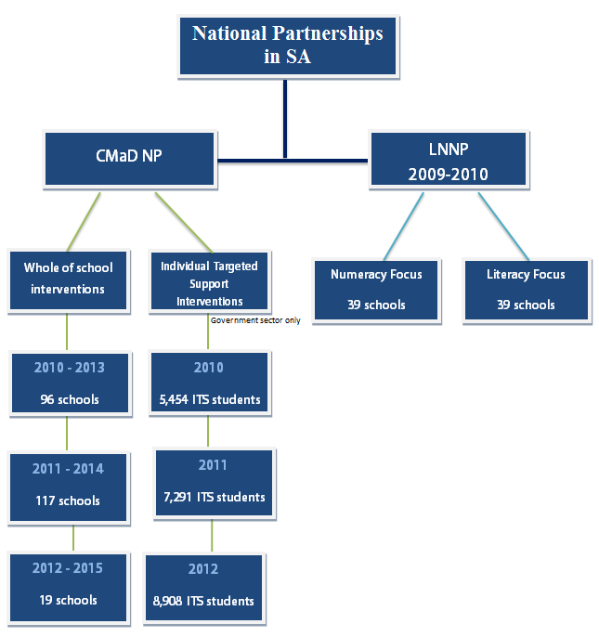
The CMaD NP consisted of a Whole of School intervention and Individualised Targeted Support intervention.
Under the Whole of School intervention:
2010 to 2013 there were 96 schools
2011 to 2014 there were 117 schools
2012 to 2015 there were 19 schools
Under the ITS intervention:
2010 there were 5,454 ITS students
2011 there were 7,291 ITS students
2012 there were 8,908 ITS students
The LNNP had a numeracy focus and a literacy focus.
Over 2009-2010:
39 schools with a Numeracy Focus participated in the LNNP
39 schools with a Literacy Focus participated in the LNNP
The activities and outputs of both partnerships are discussed under the five key areas outlined in the SA SSNP Program Logic (Appendix 6).

Teacher Support and Development
Supporting teachers and helping them develop their skills was an important component of the both partnerships in South Australia with particular emphasis on this area in the LNNP. Teachers were supported with lesson planning, teaching strategies, resources and training in the targeted use of data to identify and enhance learning opportunities for students either through specialist in-school support or professional development opportunities.
The main strategy adopted to support teachers at LNNP schools in SA was the appointment of literacy and numeracy coaches. Even though this was a common initiative across the three sectors, with all schools receiving only either a literacy or numeracy coach, each of the sectors developed a model tailored to suit their contexts and scale of implementation required. In the Government sector, the initiative involved the appointment of 14 school-based literacy coaches and 14 school-based numeracy coaches to provide specialised support to teachers at 37 schools, either through one-to-one contact or through professional development activities. In the Catholic sector, networks of coaches worked in 13 metropolitan and eight regional Catholic schools to implement school strategic plans for improved literacy or numeracy outcomes. Each of the 20 Independent LNNP schools used NAPLAN and diagnostic data to identify either a literacy or numeracy focus for a specific cohort of students, resulting in the appointment of a literacy or numeracy coach. This provided the necessary focused leadership needed to support staff in working towards improved student outcomes. Together with formative assessment processes, the coaches supported class teachers with the identification, collection and use of data to monitor and track student progress.
Another professional development initiative targeting teachers in the Government sector was the Teaching for Effective Learning Pedagogy Research Project. Implemented under the CMaD NP, this initiative saw a researcher employed to work with designated Specialist Teachers and the state office team to establish a baseline profile of current teacher practices as well as baseline profiles of student engagement and achievement. This was used to inform teachers for their next stage of learning and teaching. Between 2010 and 2012, 22 schools had participated in this project with 5985 hours of classroom observations, involving a total of 249 teachers and 5057 students.
Using a whole-school approach involving all staff members, the School-based Local Expert Teachers program led to the employment of 10 Literacy Local Expert Teachers (LETs) in 10 of the 21 LNNP Catholic schools and 11 Numeracy LET in the remaining 11 schools. LETs collaborated with their school principal and centrally-based Literacy and Numeracy Consultants. These Consultants regularly visited schools to work with LETs to identify and implement effective strategies for intervention and improvement of all students, particularly those in target groups. They coached classroom teachers through in-class observation, mentoring, review, lesson demonstration and the use of student data to inform learning. CESA also developed Professional Learning Communities under CMaD, where small groups of teachers take a collaborative inquiry approach to an area of shared professional practice, for the purpose of identifying best practice to improve student learning outcomes. In 2010, 12 principals and 250 teachers participated in the professional learning communities established in 12 participating schools. In 2011, professional development activities were offered to 45 school leaders, 632 teachers and 43 non-teaching staff across all 23 participating CMaD NP schools.
The main programs undertaken by the Independent sector to support teachers under the LNNP included the Key Teacher Initiative and the Teaching ESL Students in Mainstream Classrooms (TESMC) program. The Key Teacher Initiative involved the appointment of 10 Literacy Key Teachers in 10 of the 20 LNNP schools and 10 Numeracy Key Teachers in the remaining 10 schools. Key Teachers addressed a range of individualised student needs and helped teachers collect and use appropriate data to support student learning. In addition, the Key Teachers created networks to share ideas and expertise amongst teachers within and across schools as well as parents and community. TESMC involved training teachers to provide explicit teaching methodologies for ESL and Indigenous students that included teaching language structures, grammar, vocabulary and genres across the curriculum. The course was facilitated at four schools during 2010. Through TESMC, all schools in the Independent sector were also provided with the School Measurement and Reporting Tool (SMART) software to enable the analysis of NAPLAN data to inform teaching and learning. Teachers were also supported at Independent CMaD NP schools, primarily through the In School Specialist Support Program, adopted by all seven CMaD NP schools to assist staff in developing and implementing inclusive learning programs for students with special needs. Under this program, an occupational therapist, three speech pathologists, a behaviour management adviser and two psychologists were employed to assist 16 classroom teachers, six school leaders, five special education teachers and eight school support officers. The individual targeted support program included a total of 65 students.

Principals and School Leaders Development
The second key area targeted under the partnerships in SA was the development of school leaders’ skills. This was undertaken through tailored professional development opportunities to lead learning, school review and improvement. Incentives for attracting and retaining school leaders and teachers in ‘hard to staff’ schools were also adopted under this area.
The Principals as Literacy Leaders (PALL) program was designed to provide principals with strategies for whole school literacy improvement. As part of this five-day program, Government school principals actively worked with teachers to improve Literacy learning, while professional learning communities in Literacy leadership were also established. In 2010, 61 CMaD NP schools participated in the program while 59 schools participated in 2011 and 2012.
A total of 72 principals, school leaders and teachers from the 23 CMaD Catholic schools engaged in learning workshops with Professor Michael Fullan between 2010 and 2012. Up to three workshops were held each November, involving a different group of staff per workshop. The focus of these workshops was to apply principles of ‘Motion Leadership’ to achieve educational change in school communities.
In the Independent sector, three principals and three aspiring principals participated in the Australian College of Educational Leaders (ACEL) Inspire Leadership Program in 2010. Two of the three participating principals were from rural schools. In 2011, four principals engaged in the ten day AISSA Leadership program. Both of these programs involved professional development in mentoring and coaching for school leaders. In 2012, principals and leaders from five schools were funded to attend the ACEL conference that targeted staff who will play a role in shaping the future of their organisations, schools and the wider community.

Student Learning and Engagement
In recognition of the importance of student engagement for learning, activities that focused on enhancing student engagement formed a key component of the CMaD NP. This was primarily undertaken in the Government sector, with Innovative Community Action Networks (ICAN) being the most prominent of these activities. ICAN was a targeted program which intervened with specific students rather than an entire cohort, with a focus on engaging and re-engaging students experiencing multiple disadvantage and disruption in their lives.
Major ICAN initiatives included offering students Flexible Learning Option (FLO) enrolments. FLO-enrolled students were characterised by a history of minimal attendance and participation in mainstream schooling with little previous success in re-engaging these students back into school. This stemmed from a range of significant complex life circumstances such as homelessness, justice issues, caring responsibilities for family members, parenting responsibilities, mental health issues and a history of transience due to unstable family life. FLO provided each school with a flexible enrolment fund that was used to broker the services of a qualified case manager, such as a social worker or psychologist. FLO also provided a customised and flexible accredited learning plan for each student to address the barriers preventing successful engagement in learning at school and to assist them to stay in school learning programs. In addition, ICAN provided case management to support students identified as being at significant risk of poor transition to secondary school. The number of low SES students supported by ICAN over three years is presented in the table below. This included 581 Indigenous students in 2011 and 778 in 2012.
Table 5.1: Number of students supported by ICAN
Year | FLO-enrolment | Case Management | Total
2010 | 2859 | 667 | 3526
2011 | 3387 | 774 | 4167
2012 | 5282 | 706 | 5988
Source: DECD (2012)
Through the ICAN Community Grants program, 15 regional and remote government schools with a high enrolment of Indigenous students implemented the Passport program which was aimed at increasing attendance. Through this program, students received reward points for attendance that could be redeemed to cover costs of school camps/excursions, school uniforms and other necessary school items.
Student engagement was further targeted through a number of mentoring programs which were implemented under this key area. The Community mentoring program involved the creation of local clusters and networks of voluntary mentors who were trained by Local Community Mentor Coordinators to improve student engagement, learning and wellbeing outcomes. A total of 214 voluntary mentors were trained in 2010 (supporting 227 students), 326 in 2011 (supporting 432 students, including 56 Indigenous students) and 440 in 2012 (supporting 563 students in years 5-7). Other mentoring programs included the Secondary Student Mentoring and E-Mentoring programs. The Secondary Student Mentoring program provided one-to-one mentoring support to thousands of secondary students identified as at-risk of disengaging from school. E-Mentoring also provided one-to-one mentoring support to at-risk students but used an electronic mode of delivery that targeted rural and remote students, including hundreds of Indigenous students. Indigenous students were also mentored through the Aboriginal Student Mentoring Program which provided support for engagement and improvement of Indigenous students’ outcomes in Year levels 5 to 9. The program mentored 398 Indigenous students in 2010, over 1,100 in 2011 (in 54 schools) and 1,459 in 2012 (across 67 schools).
Other notable programs implemented in CMaD NP schools in SA aimed to enhance student engagement by supporting students through important transition phases. This included the Youth Development through Transitions project which employed regional Youth Development Coordinators to promote successful transitions from Years 7 to 8. It also focused on engaging students in Years 5 to 9 through programs to develop social and emotional competencies and promote practices that supported transitions. In 2012, 194 Youth Development initiatives were implemented, involving a total of 18,744 students. The Vocational Education and Training (VET) scholarships program was another notable example, supporting students in undertaking higher level VET programs through scholarships. This program engaged 200 students in 2010, 456 students in 2011 (including 55 LBOTE, 49 disability, 43 Indigenous and 4 refugee students) and 868 students in 2012 (including 102 Indigenous, 75 disability and 54 LBOTE students). Further support for Indigenous students was provided through the Government sector’s Wiltja program. This allowed students (107 in 2011 and 116 in 2012) from remote and isolated areas in far north SA to board at a Wiltja residence in Adelaide to continue their schooling. These students received scholarships and individual academic tutoring. In addition, 23 Wiltja students who were over 16 years of age participated in the Driver License Program in which direct instruction was provided in progressing towards attaining a Provisional South Australian Drivers Licence. This helped prepare these students for the job market by improving their employment prospects.

School Review and Improvement
The School Diagnostic Reviews initiative was the key school review and improvement activity across the three sectors under the CMaD NP. This emphasised whole-school review processes and sector-wide support systems for sharing effective practices and implementing school improvement plans. In addition, the initiative involved whole-school practices in the collection and use of data to monitor individual student progress and inform differentiated learning plans. In the Government sector, School Diagnostic Reviews were undertaken by external teams that included peer principals in 156 schools between 2010 and 2012. The teams also supported the schools in developing school improvement plans. The Catholic sector’s Self-guided Strategic Planning Processes involved contemporary academic models and current research to guide and support 12 school communities in developing and implementing improvement plans. In the Independent sector, the AISSA School Review and Development Team undertook diagnostic reviews of schools and assisted the schools with the implementation of their School Improvement Plans. School Diagnostic Reviews assisted six Independent schools in comprehensive school improvement in 2011 and a seventh school in 2012.

Parents and Community Involvement
To increase the involvement of families and the community in student learning, innovative school-community partnerships were established. In addition, workshops were carried out to help parents and families better understand children and their literacy and numeracy development, especially those in the early years. In the Government sector, the Learning Together and Aboriginal Turn Around Team (ATAT) initiatives targeted families with children aged less than five. The Learning Together program focussed on children’s oral language development, reading to children, development of children’s dispositions to learning and the critical parental role in supporting their children. A total of 220 families (281 children) attended Learning Together programs in 2010, 320 families in 2011 and 391 families (496 children) across 16 sites in 2012. The ATAT program was designed to improve relationships between Indigenous families and support agencies to enhance participation in the education of Indigenous children with additional and complex needs. It also provided intensive family support and integrated regional service delivery to students, including crisis intervention. By 2012, the program had attracted 35 families and 91 students with the involvement of 45 support agencies across 40 sites.
In the Catholic sector, a number of schools developed three-way conferences that involved parents, students and teachers discussing effective ways of engaging parents in their children’s learning. Many schools also used the Strengthening Parent and Family Engagement in Student Learning Resource audit tool. This allowed staff, parents and students to set goals and directions for parent and community involvement.
Community engagement in the Independent sector focused on the services of specialists such as occupational therapist, speech pathologists, psychologists and behaviour consultants. These specialists conducted family forums to assist parents with managing the educational needs of their students. In one CMaD NP school for example, a playgroup was established for its largely Indigenous parent cohort to provide parent education on a range of topics including nutrition, positive play and reading to babies and toddlers. In addition, workshops for parents on early intervention strategies for at risk students were carried out in three CMaD NP schools.

5.2 SA IMPACT
The following section highlights the main findings from the synthesis of existing information on the CMaD NP and LNNP in South Australia. Findings are reported under the agreed outcomes in the South Australia program logic.

Outcomes 1, 2a and 3:
Better whole-of-school student outcomes achieved; Increased student attainment (particularly in Indigenous students); Student learning maximised
A common outcome to both partnerships in SA was the improvement of students’ literacy and numeracy achievement. However, this was approached differently in each partnership due to the differences in the targeted population. A combined approach was adopted in the CMaD NP, including whole-of-school initiatives within each sector, as well as Individualised Targeted Support (ITS) in the Government sector for students identified as disconnected and disengaged from learning and education pathways, with the aim of addressing challenges facing students from disadvantaged communities. LNNP schools on the other hand used literacy or numeracy coaches, in addition to receiving consultancy support at the sector level. Given the differences in implementation and target groups across and within partnerships, achievement outcomes are reported by each partnership type.

Achievement in CMaD NP schools
To improve student achievement, CMaD NP schools emphasised the development of school leadership. The major initiative to strengthen school leadership in Government schools was the Principals as Literacy Leaders (PALL) program, designed to provide principals with strategies for whole school literacy improvement. Principals reported a number of positive impacts as a result of participating in the PALL program. These included greater confidence in their leadership of learning, building vision, setting directions and the use of data and evidence to guide teaching and learning. Moreover, participating principals reported greater ability to create better learning conditions, engage parents and community for support, as well as lead and engage in professional development with staff. In addition, schools used a much more systematic approach to the leadership and teaching of reading and report examples of improvements in children’s reading skills as a result (DECS 2011a). In the Independent sector, principals participated in a range of leadership programs aimed at assisting school leaders to build the organisational capacity of their schools in order to deliver high quality education. At Catholic schools, principals, school leaders and teachers engaged in a school improvement professional learning program. This combined a series of extended interactions with Professor Michael Fullan, with ongoing in-school collaboration between school leadership teams and CESA consultants and advisors.
School Diagnostic Reviews represented another central focus of CMaD NP schools in South Australia. In the Government and Independent sectors, participating schools undertook an external review process which focused on strategies for improvement in literacy and numeracy as well overall school improvement. Strategic planning for overall school improvement in Catholic CMaD NP schools followed a self-directed process coupled with central support. Following the review processes, three key areas of change were identified in schools including the adoption of whole of school approaches to teaching, the establishment of professional learning communities or groups, and the recognition of the importance of use of data in more structured and purposeful ways (SA SSNP Council - Schooling 2013a).
Analysis of NAPLAN cohort mean score gains between 2010 and 2012 showed that CMaD NP schools achieved slightly higher apparent gains in Y3-Y5 Reading, Y5-Y7 Reading and Y5-Y7 Numeracy compared to all SA schools (Figure 5.2). The selection of the 2010-2012 cohort for analysis provided at least two years of Low SES NP participation, with 2010 being early enough to be considered as an appropriate baseline. Aggregated apparent gains were lower amongst Indigenous students transitioning from Year 3 to Year 5 at CMaD NP schools compared to apparent gains achieved by Indigenous students at all SA schools. Compared to LBOTE students at all SA schools, LBOTE students in participating schools exhibited comparable apparent gains in Year 3 to Year 5 Numeracy, with slightly higher apparent gains for the Year 5 to Year 7 cohort.

Figure 5.2: Apparent mean gains (2010-2012) in NAPLAN scores for SA schools commencing CMaD NP initiatives in 2010
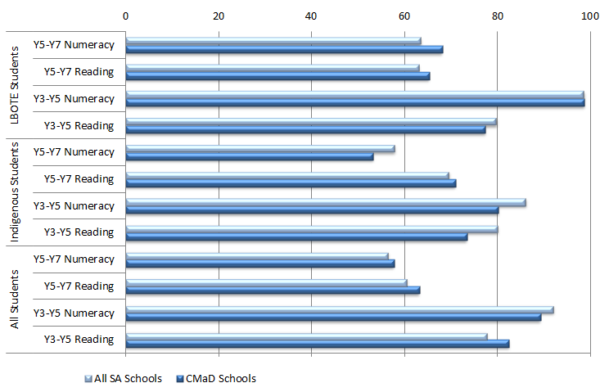
 |  | Mean gain (all SA schools) | Mean gain (CMaD schools)
LBOTE Students | Year 5 to Year 7 Numeracy | 64 | 68
LBOTE Students | Year 5 to Year 7 Reading | 63 | 65
LBOTE Students | Year 3 to Year 5 Numeracy | 99 | 99
LBOTE Students | Year 3 to Year 5 Reading | 80 | 77
Indigenous students | Year 5 to Year 7 Numeracy | 58 | 53
Indigenous students | Year 5 to Year 7 Reading | 70 | 71
Indigenous students | Year 3 to Year 5 Numeracy | 86 | 80
Indigenous students | Year 3 to Year 5 Reading | 80 | 73
All students | Year 5 to Year 7 Numeracy | 57 | 58
All students | Year 5 to Year 7 Reading | 61 | 63
All students | Year 3 to Year 5 Numeracy | 92 | 89
All students | Year 3 to Year 5 Reading | 78 | 82
Source: PGA constructed using SA SSNP Council – Schooling (2013b); ACARA (2012)
Additional analysis of NAPLAN cohort mean score gains between 2010 and 2012 was undertaken using Government and Ca tholic sector school-level data provided by ACARA. This data allowed the comparison of apparent gains between CMaD NP schools and non-NP schools. The data shows that the apparent cohort gains made at CMaD NP schools were comparable to the apparent gains at non-NP schools in Reading and in Years 5-7 Numeracy (Figure 5.3). Although the apparent Years 3-5 Numeracy gain at CMaD NP schools was 5.5% less than that observed in non-NP school, the difference was not found to be statistically significant.

Figure 5.3: Comparison of apparent mean gains (2010-2012) in NAPLAN scores of SA Government and Catholic schools commencing CMaD NP initiatives in 2010 to non-NP schools
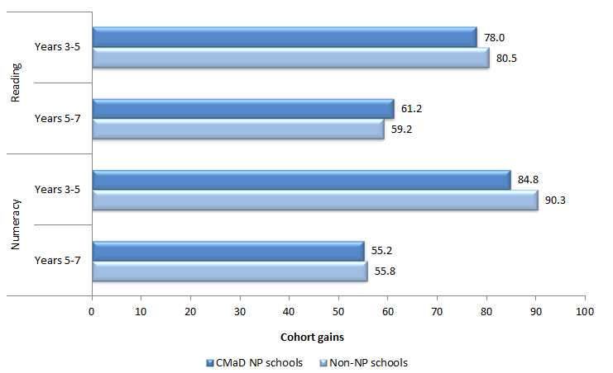
 |  | Mean gain (CMaD schools) | Non-NP schools
Reading | Year 3 to Year 5 | 78.0 | 80.5
Reading | Year 5 to Year 7 | 61.2 | 59.2
Numeracy | Year 3 to Year 5 | 84.8 | 90.3
Numeracy | Year 5 to Year 7 | 55.2 | 55.8
Source: PGA constructed using data provided by ACARA
When achievement was analysed using NAPLAN bands for the Year 3 2010 to Year 5 2012 student cohort (Figure 5.4), a general increase in the proportion of students at or below NMS was observed across all SA schools. This was consistent with the national trend as well as what was found in all jurisdictions. Although this trend was also observed in Low SES NP schools, the relative increase among students in Reading was notably less than that found in the average of all SA schools. Among students transitioning from Years 5 to 7, the proportion in the lower two bands generally decreased across all SA schools. This trend was also observed in Low SES NP schools.

Figure 5.4: Proportion of students at or below NMS (Year 3 2010- Year 5 2012) in NAPLAN for SA schools commencing CMaD NP initiatives in 2010
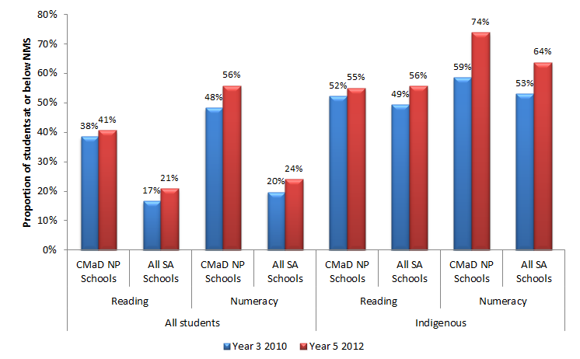
 |  |  | Year 3 2010 | Year 5 2012
All students | Reading | CMaD NP Schools | 38% | 41%
All students | Reading | All SA Schools | 17% | 21%
All students | Numeracy | CMaD NP Schools | 48% | 56%
All students | Numeracy | All SA Schools | 20% | 24%
Indigenous students | Reading | CMaD NP Schools | 52% | 55%
Indigenous students | Reading | All SA Schools | 49% | 56%
Indigenous students | Numeracy | CMaD NP Schools | 59% | 74%
Indigenous students | Numeracy | All SA Schools | 53% | 64%
Source: PGA constructed using SA SSNP Council – Schooling (2013b); ACARA (2012)
As outlined in the evaluation scope, outcomes were analysed for metropolitan and non-metropolitan schools participating in the CMaD NP schools at the Year 3 to Year 5 level. Similar schools were grouped according to their students’ socioeconomic background as measured by the school ICSEA or their achievement prior to the commencement of the CMaD NP, with the analysis focusing on schools in the lowest four deciles of either measure. Among schools with similar socioeconomic backgrounds, the proportion of non-metropolitan CMaD NP schools who achieved above average NAPLAN Reading and Numeracy growth compared to similar non-NP schools was higher than that of metropolitan CMaD NP schools in the 2009-2011 cohort. The opposite was observed for the 2010-2012 cohort. When the analysis compared schools with similar starting points, above average growth was more evident at metropolitan CMaD NP schools in Reading in both cohorts, while above average growth in Numeracy in both cohorts was observed to a greater extent in non-metropolitan schools.
It is important to note that the mixed evidence provided by NAPLAN results does not necessarily mean that the CMaD NP did not affect student achievement. A number of methodological limitations firstly restrict attribution of these results to the NP, particularly as the comparison group is all schools in SA since data on similar non-participating schools was not available. Furthermore, as earlier outlined, intended achievement outcomes may not be realised in the limited timeframe under analysis. This could be particularly true for CMaD NP schools where other fundamental outcomes were targeted, such as student attendance and engagement.

Achievement among CMaD ITS students
Within Government schools, students who were identified as at-risk or disconnected from education pathways were selected for directed support through ITS activities. Selected students were most notably targeted through the Innovative Community Action Networks (ICAN) program, aimed at re-engaging students experiencing multiple disadvantage and disruption in their lives. Through ICAN, activities such as Flexible Learning Option (FLO) enrolments and case management were utilised to support the most vulnerable and disengaged students, especially those experiencing complex life circumstances. Other ITS initiatives included a major focus on mentoring through numerous programs. Various mentoring programs were tailored to the target student group which ranged from rural and remote students at risk of disengagement to Indigenous students and secondary school students in general. Students selected for the CMaD ITS were further supported through Vocational Education and Training (VET) scholarships.
Apparent mean gains in ITS NP students’ NAPLAN scores were mostly lower than apparent gains achieved by all SA students, with some exceptions including Year 5 to Year 7 Reading for all students and Year 3 to Year 5 Reading for LBOTE students (Figure 5.5).

Figure 5.5: Apparent mean gains (2010-2012) in NAPLAN scores for SA Government school students who had participated in CMaD ITS for 1-3 years by 2012
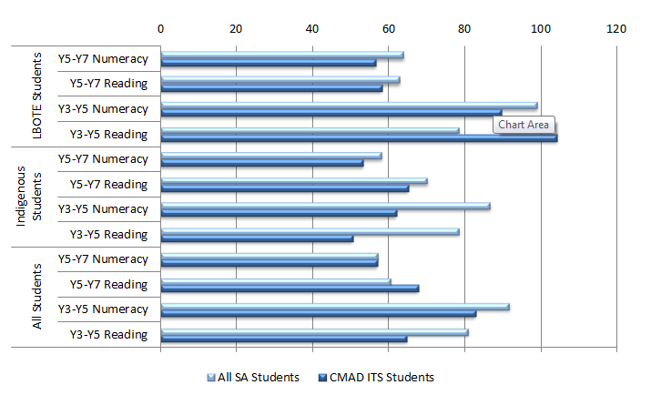
 |  | All SA Students | CMaD ITS Students
LBOTE Students | Year 5 to Year 7 Numeracy | 64 | 57
LBOTE Students | Year 5 to Year 7 Reading | 63 | 58
LBOTE Students | Year 3 to Year 5 Numeracy | 99 | 90
LBOTE Students | Year 3 to Year 5 Reading | 79 | 104
Indigenous Students | Year 5 to Year 7 Numeracy | 58 | 53
Indigenous Students | Year 5 to Year 7 Reading | 70 | 65
Indigenous Students | Year 3 to Year 5 Numeracy | 87 | 62
Indigenous Students | Year 3 to Year 5 Reading | 79 | 51
All Students | Year 5 to Year 7 Numeracy | 57 | 57
All Students | Year 5 to Year 7 Reading | 61 | 68
All Students | Year 3 to Year 5 Numeracy | 92 | 83
All Students | Year 3 to Year 5 Reading | 81 | 65
Source: PGA constructed chart using SA SSNP Council – Schooling (2013b); ACARA (2012)
Since gains in aggregated NAPLAN scores are affected by students’ starting scores, it is important to consider the changes experienced by the same group of students over time. Analysis of NAPLAN band results suggest substantial gains appear to have been experienced by those who were below the NAPLAN NMS. Over half of CMaD ITS students who were ‘below’ NMS in reading in 2010 improved their reading results to ‘at or above’ NMS in 2012 (Figure 5.6). In addition, 54.6% of students ‘below’ NMS in numeracy in 2010 were able to lift their numeracy results to ‘at or above’ NMS in 2012. This suggests a strong improvement over a short period of time for students who had been highly disengaged from learning. However, since CMaD ITS students engaged in a range of programs and activities that could potentially contribute towards improved performance in NAPLAN, it is hard to ascertain which activities contributed most to this progress.

Figure 5.6: Number of CMaD ITS students ‘below’ NMS in NAPLAN Reading and Numeracy in 2010 who have improved to ‘at or above’ NMS in NAPLAN Reading and Numeracy in 2012, SA Government schools
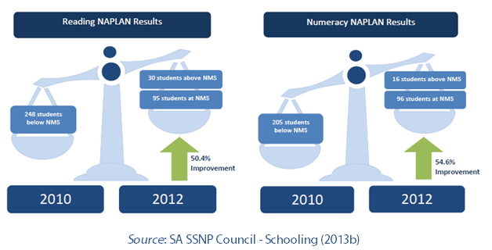 |  | Reading NAPLAN Results | Numeracy NAPLAN Results | Percentage rate of improvement
2010 | Students below NMS | 248 | 205
2012 | Students at NMS | 95 | 96 | 50.4%
 | Students above NMS | 30 | 16 | 54.6%
Source: SA SSNP Council – Schooling (2013b)

NAPLAN Participation at CMaD NP schools
Analysis of NAPLAN participation rates in CMaD NP schools shows patterns that were similar to those observed in all SA schools. Therefore it is unlikely that overall changes in achievement were affected by NAPLAN attendance trends though this may affect outcomes at the school-level. NAPLAN data cannot capture the full extent of potential impacts of the NP, as other outcomes which can be seen as prerequisites to improvements in achievement were a particular focus for the disengaged students targeted by CMaD ITS. Some lead indicators of future learning success can be seen in localised evidence. A survey of 83 mentored students in the E-Mentoring program under CMaD ITS showed small but statistically significant improvements in a range of indicators, such as perceptions of success at school, ability to complete tasks, personal satisfaction and sense of control over what happens at school (SA SSNP Council - Schooling 2013b).

Achievement in LNNP schools
Under the LNNP, maximising student learning was the primary intended outcome across all sectors with a focal strategy of capacity building for teachers. This was mostly implemented through in-school literacy and numeracy coaches in addition to sectoral support. Coaches provided specialised support to teachers, either through professional development activities or through one-to-one contact involving in-class observation, mentoring, review, lesson demonstration and the use of student data to inform learning.
Overall, the results suggest a positive association between LNNP participation and achievement when NAPLAN results were analysed for mean score gains, distribution of scores across bands, and changes in proportion of students performing below or above NMS. Year-on-year analyses also shows a decline in the proportion of Year 3, 5 and 7 students falling below NMS at LNNP schools. Moreover, the achievement of Indigenous students approached results achieved by students in all SA schools for both literacy and numeracy (SA SSNP Council - Schooling 2012a).
Of South Australia’s 20 targets set to acquire reward the second round of LNNP funding, six targets were found to have been met or exceeded by LNNP schools, while progress was made towards five targets and nine targets were not met. From 2008 to 2011, the proportion of Year 3 and Year 7 students at or above NMS for Reading improved by 2.5 and 1.0 percentage points respectively, but declined for Year 5 students by 0.6 percentage points. The proportion of Year 3 and Year 5 students at or above NMS for Numeracy increased by 0.2 and 3.2 percentage points respectively, but decreased for Year 7 students by 0.6 percentage points. For Indigenous students, South Australia used a gain measure, tracking improvement of cohorts of students from 2009 to 2011. The gain from Year 3 to Year 5 for Reading was 95.9 points, exceeding the target by 11.8 points. For Year 5 to Year 7 Reading, the gain (44.8 points) was below the target, although only a limited number of matched students could be assessed in this group (COAG Reform Council 2012).

Achievement in Government LNNP schools
Additional evidence from a Government sector evaluation of the LNNP also suggested that the program is likely to have had a positive influence on student achievement. Of the 31 original Government schools who commenced LNNP participation in 2009, 15 received Literacy coaching, with Numeracy coaches being appointed at the other 16 schools. NAPLAN results for the 2009-2011 LNNP cohort were analysed in domains for which the school had employed coaches (Figure 5.7). Apparent mean score gains in coached domains at LNNP schools were generally found to be higher compared to similar schools that had been considered for the LNNP but were not selected. The results also showed that numeracy coaching had a much more consistent impact on NAPLAN scores than literacy coaching. This was consistent with evidence from similar interventions which found achievement in numeracy to be more responsive to interventions in the short-term. Reading skills on the other hand have been found to require sustained support over an extended period for significant improvements to occur (UMass 2007). The findings also suggest larger apparent gains for students transitioning from Year 3 in 2009 to Year 5 in 2011. Causal attribution of these gains to coaching is not possible however, as data on the starting scores of comparison schools was not available.
Figure 5.7: Average apparent gain (2009-2011) in mean NAPLAN score, SA Government LNNP schools
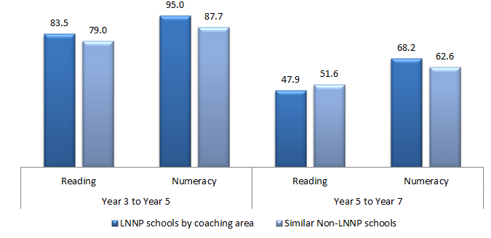
 |  | LNNP schools by coaching area | Similar Non-LNNP schools
Year 3 to Year 5 | Reading | 83.5 | 79.0
Year 3 to Year 5 | Numeracy | 95.0 | 87.7
Year 5 to Year 7 | Reading | 47.9 | 51.6
Year 5 to Year 7 | Numeracy | 68.2 | 62.6
LNNP figures show average apparent gain by domain for schools that employed coaches in that domain.
Source: SA DECS (2011)

Achievement in Government and Catholic LNNP schools
Analysis of school-level achievement data in all SA Government and Catholic schools also assessed the progress of LNNP schools compared to that exhibited by similar non-NP schools. Similar schools were grouped according to either their socioeconomic background as measured by the school ICSEA or their achievement prior to the commencement of the LNNP, with the analysis focusing on schools in the lowest four deciles of either measure. In both the 2009-2011 and 2010-2012 student cohorts, the proportion of schools in the lowest four ICSEA deciles who achieved above average growth was generally higher among LNNP schools than in non-NP schools, particularly in Years 5-7 Reading where the differences were 13% in the 2009-2011 cohort (Figure 5.8) and 8% in the 2010-2012 cohort (Figure 5.9). However, this was not found to be the case when schools’ starting scores were controlled for. This was most apparent in Years 3-5 Numeracy, where only 34% of LNNP schools exhibited above-average growth compared to 53% of non-NP schools with similar starting scores. Although NAPLAN growth rates may not have been as large in all LNNP schools as those in non-NP schools, at least one-third of LNNP schools showed above-average growth in all domains. It is recommended that further research be undertaken with this group to determine why some LNNP schools achieved greater success than others.
Figure 5.8: Proportion of LNNP schools who achieved above average growth compared to that of similar non-NP schools, 2009-2011 cohort in SA Government and Catholic sectors
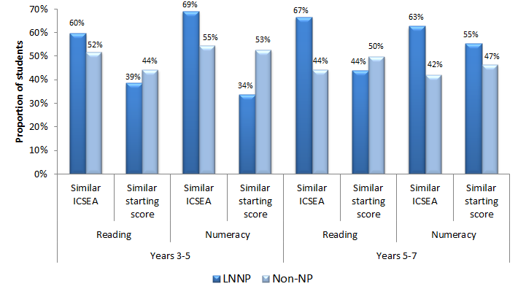
 |  |  | LNNP schools | Non-NP schools
Years 3-5 | Reading | Similar ICSEA | 60% | 52%
Years 3-5 | Reading | Similar starting score | 39% | 44%
Years 3-5 | Numeracy | Similar ICSEA | 69% | 55%
Years 3-5 | Numeracy | Similar starting score | 34% | 53%
Years 5-7 | Reading | Similar ICSEA | 67% | 44%
Years 5-7 | Reading | Similar starting score | 44% | 50%
Years 5-7 | Numeracy | Similar ICSEA | 63% | 42%
Years 5-7 | Numeracy | Similar starting score | 55% | 47%
Source: PGA constructed graph using data provided by ACARA

Figure 5.9: Proportion of LNNP schools who achieved above average growth compared to that of similar non-NP schools, 2010-2012 cohort in SA Government and Catholic sectors
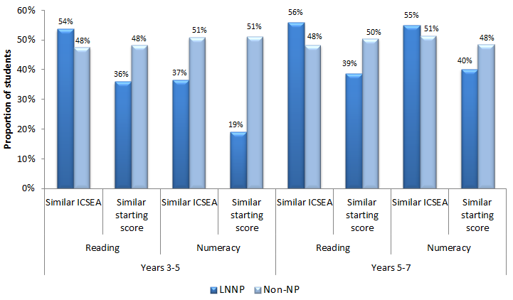
 |  |  | LNNP Schools | Non-NP Schools
Years 3 to 5 | Reading | Similar ICSEA | 54% | 48%
Years 3 to 5 | Reading | Similar Starting Score | 36% | 48%
Years 3 to 5 | Numeracy | Similar ICSEA | 37% | 51%
Years 3 to 5 | Numeracy | Similar Starting Score | 19% | 51%
Years 5 to 7 | Reading | Similar ICSEA | 56% | 48%
Years 5 to 7 | Reading | Similar Starting Score | 39% | 50%
Years 5 to 7 | Numeracy | Similar ICSEA | 55% | 51%
Years 5 to 7 | Numeracy | Similar Starting Score | 40% | 48%
Source: PGA constructed graph using data provided by ACARA

Analysis of achievement was also undertaken at both metropolitan and non-metropolitan LNNP schools at the Year 3 to Year 5 level using the same method described for Figure 5.8. When the analysis compared schools with similar socioeconomic backgrounds, the proportion of non-metropolitan LNNP schools in the 2010-2012 cohort who achieved above average NAPLAN Reading and Numeracy growth compared to similar non-NP schools was higher than that of metropolitan LNNP schools. The opposite was observed among the 2009-2011 cohort. When the analysis compared schools with similar starting points, the proportion of non-metropolitan LNNP schools who achieved above average growth compared to similar non-NP schools was found to be higher than that of metropolitan schools in both domains and among both cohorts.
It is important to consider achievement-related outcomes other than NAPLAN as test results may not capture all the potential LNNP benefits to student learning in the limited timeframe under analysis. Evaluation survey results indicated that teachers as well as principals strongly believed that the school-based coaching model positively influenced student engagement in learning (SA DECS 2011b). Respondents cited a number of the aspects through which coaching made a difference. These included:
- The use of evidence to guide teaching.
- Opportunities for professional discussions on diverse student learning needs.
- The development of a broad range of strategies for teaching literacy and numeracy.
- Consistency of data collection within schools.
- Improved case-study management and appropriate intervention for students ‘at risk’.
- Whole-school consistency of literacy or numeracy pedagogy.
These findings are all consistent with the literature on impacts of coaching as a strategy to improve literacy and numeracy, especially when student assessment data is used to guide instruction (UMass 2007).
While it was evidently an important component in LNNP schools, it is difficult to separately identify the contribution of coaching to observed improvements. The diversity of activities implemented in these schools, restricts attribution of effects to particular initiatives using available data.

Outcome 2b:
Increased student engagement (particularly Indigenous students)
Enhancing student engagement and attendance was an intended outcome in SA that was equally as important as student achievement, especially among Indigenous students in CMaD NP schools. Schools selected for this NP were often comprised of students facing multiple sources of disadvantage over an extended period of time. Addressing these entrenched disadvantages therefore required a focus on more foundational issues such as attendance and engagement before student achievement could be lifted.

Engagement in CMaD NP schools
Evidence of the influence of CMaD NP programs on enhancing student engagement can be synthesised from attendance results. Of the 23 CMaD NP schools (excluding those designated Aboriginal/Anangu) who have participated in CMaD NP ‘whole of school’ interventions for more than 1 year and whose school attendance rate (SAR) was below average (SAR < 85%) in 2010, 16 schools had shown an increase in SAR by 2012, ranging from an annual growth rate of 0.1% to 3.7%.
When all CMaD NP schools commencing in 2010 were considered, the proportion of schools with below-average attendance declined from 13.2% in 2009 to 11.5% in 2012 (Table 5.2). However, below average attendance in 2012 was observed to be up to three percentage points higher at CMaD NP schools which entered the partnership in 2011. It is not clear if these differences are statistically significant for either group of CMaD NP schools or if compositional differences between the group explain the apparent variation in outcomes.
Table 5.2: Proportion of SA CMaD NP schools with below average attendance (SAR < 85%), participating from 2010 and from 2011
 | 2009 | 2010 | 2011 | 2012
Schools commencing CMaD NP in 2010 | 13.2%  (12/91 Schools) | 14.3%  (13/91 Schools) | 12.6%  (11/87 Schools) | 11.5%  (10/87 Schools)
Schools commencing CMaD NP in 2011 |  | 19.8%  (24/121 Schools) | 21.2%  (25/118 Schools) | 23.1%  (27/117 Schools)
Source: SA SSNP Council - Schooling (2013b)

Engagement among CMaD ITS students
Students who were individually supported through the CMaD ITS were found to have higher attendance following their participation. This was particularly true for students with poor attendance rates in 2009, defined as having an Individual Attendance Rate (IAR) below 80%. Nearly three-quarters of those students had higher attendance rates in 2012 with an average improvement of 33.9%. This suggests an increase in the level of engagement of the most disengaged students, which in turn is likely to lead to successful school attainment and completion (SA SSNP Council - Schooling 2013b). In addition, the IAR for all students who had a valid attendance rate reported for each year was found to have increased from 73% in 2009 to 86% in 2012 (Figure 5.10).
Figure 5.10: 2012 CMaD ITS students’ average attendance rate by year of commencement, SA Government schools
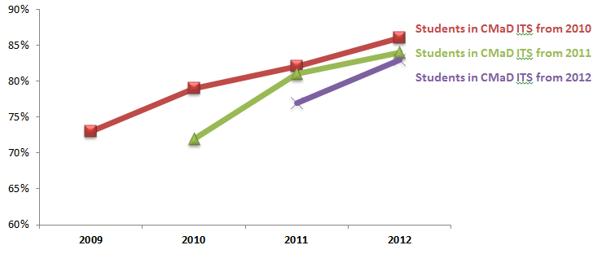
 | 2009 | 2010 | 2011 | 2012
Students in CMaD ITS from 2010 | 73.0% | 79.0% | 82.0% | 86.0%
Students in CMaD ITS from 2011 |  | 72.0% | 82.0% | 83.0%
Students in CMaD ITS from 2012 |  |  | 77.0% | 83.0%
Source: Data from SA SSNP Council – Schooling (2013b)
In addition, the proportion of CMaD ITS students with below average attendance, defined as attending school less than 85% of the time, had substantially decreased between 2010 and 2012, including among Indigenous, LBOTE, and students with a disability (Figure 5.11). For all students participating in ITS for 1-3 years, the figure shows a reduction in below-average attendance. Similar results were found for students commencing ITS in 2012.

Figure 5.11: Below-average attendance amongst SA Government school students who have participated in CMaD ITS for at least 1 year
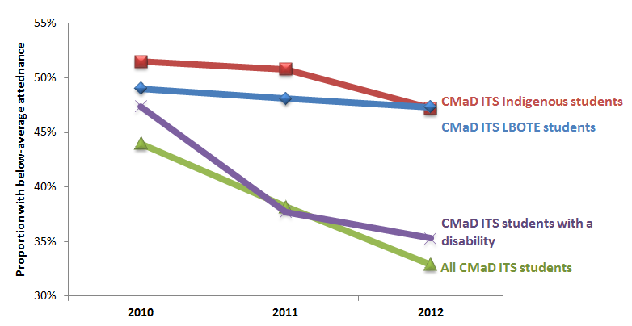
 | 2010 | 2011 | 2012
CMaD ITS Indigenous Students | 51.5% | 50.8% | 47.3%
CMaD ITS LBOTE students | 49.0% | 48.1% | 47.3%
CMaD ITS students with a disability | 47.4% | 37.7% | 35.3%
All CMaD ITS students | 44.00% | 37.70% | 32.90%
Source: Data from SA SSNP Council – Schooling (2013b)
Similarly, the ICAN program, most notably through Flexible Learning Options (FLO), reported positive outcomes in terms of engagement in learning for all categories of disadvantaged students. In particular, evidence from case studies suggests ICAN was reported to be most effective where there was family support and willingness to work in partnership with the school and case manager. ICAN was also reported to have established links and enhanced service capacity in communities by providing opportunities for development and expansion amongst NGOs responding to case management services and grants for innovative learning programs (SA DECD 2012). In addition, students who participated in the Secondary Student Mentoring program appear to have found it easier to remain engaged, and successfully complete SACE or transition into the workforce (SA SSNP Council - Schooling 2013b).
CASE STUDY: The Passport Program at Airdale Primary School - (SA SSNP Council – Schooling 2013b)
Airdale Primary School’s students come from a mix of socio-economic and cultural backgrounds. Over 40% of students are either Indigenous or have a non-English speaking background, while 25% of students have a disability. Around 80% of students’ families are entitled to ‘school card’ benefits indicative of families experiencing financial disadvantage.
Enrolment numbers have been steadily declining over the past four years (from 187 in 2008 to 138 in 2012); and fluctuate significantly throughout the year, as many families are transient (approximately 17%). Punctuality has also been identified as a major issue.
The Passport program sought to strengthen the relationship between parents and the school, and to focus on a reciprocal partnership whereby ‘reward points’ can be earned by students, family and community members in response to provision of support at school and/or for students’ regular attendance. Rewards took the form of covering the costs of school camps/ excursions, or provision of school uniforms or other necessary school items.
Baseline data indicated an attendance rate of approximately 74% for the first five weeks of Term 3 2012. After the introduction of the Passport Attendance Program in Week 6, attendance increased to 84%, with an overall Term 3 average of 82%. This increase was maintained in Term 4 with average attendance of 83% and even reaching a high of 91%; contrary to previously identified trends where Term 4 attendance significantly decreased. Anecdotal accounts also reflected a number of unanticipated positive outcomes such as generating interest in joining the program by students who had not attended school all term; and students informing and encouraging others to join. This contributed to significant increases in attendance by students with poor attendance; increased positive student relationships and interactions where students shared their Passport ‘rewards’ with others. Teachers reported noticeable improvements in ‘whole of class’ levels of engagement, participation and learning.

Outcome 4:
Stronger connections between students, schools, parents and communities from authentic engagement processes
A number of CMaD NP initiatives appeared to strengthen the connections between students, schools, parents and communities, an important intended outcome under this partnership. For instance, observations and survey responses indicate improvements in parents’ literacy-related activities with their children, increased parental understanding of their children’s development and enhanced interaction between parents and children.
Outcomes from an extensive internal evaluation of the Learning Together program in 2012 also found substantial improvement in families’ involvement in their children’s learning (Figure 5.12). Families additionally reported that this heightened engagement led to better communication and higher confidence in over 90% of children, while over two-thirds of participating children asked to be read to more often (SA SSNP Council - Schooling 2013b)
Figure 5.12: Reported outcomes from the Learning Together program for families, SA
Increases in the proportion of families
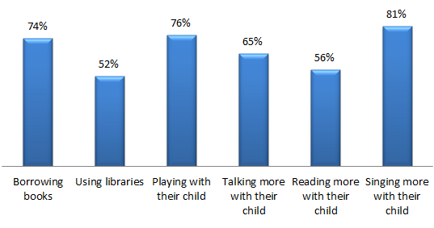
 | Proportion
Borrowing books | 74%
Using libraries | 52%
Playing with their child | 76%
Talking more with their child | 65%
Reading more with their child | 56%
Singing more with their child | 81%
Source: SA SSNP Council – Schooling (2013b)
Parent-teacher-student conferences that sought active involvement of parents in their children’s learning have also been reported to significantly increase parental engagement. A number of programs also targeted Indigenous family involvement such as the Aboriginal Turn Around Team (ATAT) and the Aboriginal Student Mentoring Program. As a result of ATAT, students and their families have been reported to demonstrate greater self-reliance and self-determination, improved school attendance, and re-engagement into education. Similarly, the Aboriginal Student Mentoring Program reported increasing parental involvement in linking mentoring with Individual Learning Plans (ILP) over the years (SA SSNP Council - Schooling 2013b).
CASE STUDY: Parent and Community Engagement to Improve Attendance at St. Gabriel’s School (SA SSNP Council – Schooling 2013b)
St Gabriel’s School is a metropolitan Catholic primary school with an enrolment of about 300 students. Students come from over 29 different cultural backgrounds. The school experienced low parent attendance at the 2011 AGM, parent information nights and parent/teacher interviews. Through involvement in the CMaD NP Network, the Principal and key teachers came up with a strategy to engage the community and parents.
Parents were invited to an ‘Open House’ at which their children took them on a tour of the school to demonstrate a 21st century learning environment; making teaching and learning visible to all members of the community by showcasing their understanding in an area of their learning and invited their parents to use rubrics to assess their child’s work. Literacy workshops for parents were held over the year, focusing on providing parents with strategies to support their children at home. Parents were invited to lead the discussions, sharing with teachers their child’s strengths and challenges; and student-led conferences to engage their parents in conversations about their learning. A community room was established to provide parents and families a place to gather for discussions, meetings, social gatherings, learning workshops. The school’s website was reconstructed to improve communication with parents and invite the wider community to learn more about the school. Class blogs were established to provide parents opportunities to communicate with their child’s teacher.
Survey responses and feedback indicated that both staff and parents were appreciative of the strong commitment shown by the school to strengthen parent engagement in children’s learning and in the life of the school community.

CASE STUDY: Parental Engagement through a Playgroup at Murray Bridge Christian College (AISSA) (SA SSNP Council – Schooling 2013b)
Murray Bridge Christian College, Murray Bridge (MCC-MB) is one of two campuses which form Murraylands Christian College. The Murray Bridge campus caters for 95 students in Years R–7 with a co-located Early Learning Centre. The College is situated in a rural Low Socio-economic community and a quarter of its students were Indigenous in 2012.
In a survey of parents undertaken as part of their school review process, the school found that some parents were less likely to engage with the school and it was with these parents that the school sought to forge stronger connections; recognizing that parent involvement and parenting programs are key to promoting the wellbeing of children and preventing the development of later problems.
A playgroup was established, and was led by the chaplain and an Indigenous mother. It ran every Friday morning, with an average attendance of 10-15 parents with their children. The College also employed a ‘team-around-the child’ approach with a core team of leadership, teachers and chaplaincy meeting weekly to monitor and address the wellbeing needs of identified students and find ways to make better connections with home.
While it is still in the early stages of development, the school reported sound indicators of stronger parent involvement and attendance across a range of events at the school.

Outcome 5
Young people make a successful transition from school to work and further study
Outcomes relating to school completion and transitions beyond compulsory schooling were long-term aspirational targets under the CMaD NP. Systemic improvement in these indicators is therefore not expected in the four years under analysis, though some localised leading indicators have emerged. Retention and SACE completion data for Secondary Student Mentoring students from 2011 indicated positive outcomes, with 95% of students being retained in ‘learning or earning’ and over 80% of the Year 12 students in this program completing their SACE (SA SSNP Council - Schooling 2012b). A survey in June 2012, conducted with 110 randomly selected students from eight secondary sites involved in Secondary Student Mentoring, showed that 74.6% of respondents believed mentoring had helped them and 78% identified ‘increased involvement in learning’ as the biggest effect of having a mentor (SA SSNP Council - Schooling 2013b).

5.3 SA CONCLUSION
The CMaD NP in South Australia consisted of a ‘Whole of School’ approach at all participating schools and ‘Individualised Targeted Support’ (ITS) interventions for disconnected and disengaged students in the Government sector. Analysis of achievement data revealed mixed evidence associated with participation in the different NP approaches. Aggregates school-level data showed apparent NAPLAN cohort gains in Reading at both the Year 3-5 and Year 5-7 levels were higher in CMaD NP schools than in all SA schools. Apparent mean gains at CMaD Government and Catholic schools were found to be generally comparable to those observed in non-NP schools. Amongst ITS NP students, apparent mean gains in NAPLAN scores were mostly lower than apparent gains achieved by all SA students although the majority of CMaD ITS students who were ‘below’ NMS in both Reading and Numeracy in 2010 improved their results to ‘at or above’ NMS in 2012. Improvements in attendance were observed in both NP approaches. CMaD NP schools whose attendance rate was below average in 2010 saw gradual improvements between 2009 and 2012 while the attendance rate of CMaD ITS students was found to have increased from 73% in 2009 to 86% in 2012. Improved attendance rates were also observed among Indigenous, LBOTE and special needs students.
Localised evidence and some survey data suggest improvements in student achievement and engagement identified in CMaD NP schools may be due to a number of NP initiatives. Certain activities implemented under the ICAN program for example, were reported to have produced positive outcomes in terms of engagement in learning for all categories of disadvantaged students. Improved individual attendance rates of CMaD ITS students as well as the reduction in the proportion of ITS students below NMS highlight the positive outcomes associated with making learning accessible to disadvantaged students through flexible learning options and case management. In particular, ICAN was reported to be most effective where there was family support and willingness to work in partnership with the school and case manager (SA DECD 2012). This is consistent with the fact that risk factors for disengagement include family characteristics and community factors (Smart, et al, 2008).
In addition, other mentoring programs may have also contributed to improving student engagement. Students who participated in the Secondary student mentoring program appear to have found it easier to remain engaged and successfully complete SACE or transition into the workforce, with approximately 75% reporting that mentoring had been helpful by increasing their involvement in learning (SA SSNP Council - Schooling 2013b). Another survey of mentored students in the E-Mentoring program showed small but statistically significant improvements in a range of student perceptions that may represent lead indicators of future learning success, such as students’ perceptions of success at school, ability to complete tasks, personal satisfaction and control over what happens at school (SA SSNP Council - Schooling 2013b). Although the evaluation covers a limited phase, with improvements possibly reached subsequent to the period under observation, international research has shown that mentoring programs are particularly effective in targeting engagement. Within the span of one academic year, mentoring arrangements have been reported to result in improved academic achievement, school attendance and lowered discipline referrals in at-risk students in middle years (Lampley & Johnson, 2010).
The School Diagnostic Reviews and the PALL program represented two major initiatives that are likely to have had a positive impact on both student achievement and engagement. School Diagnostic Reviews aimed at setting a more systematic and strategic improvement plan that is tailored to each school’s need. Often the areas of focus for improvement and the choice of strategies, such as forming professional learning teams or enhancing the use of student data, were reportedly guided by the Reviews. Alongside the Diagnostic Reviews, PALL appears to have augmented principals’ leadership of learning across all sectors. While representative data is not available to causally establish the mechanism by which these two major initiatives impacted schools, the education literature supports these pathways. In their review, Leithwood et al (2004) point out that leadership serves as a critical bridge between reform initiatives and their consequences for students. It is reported to be next to only classroom instruction in terms of its strength of influence among all the factors that contribute to what students learn at school. In addition, its impact appears to be greatest in disadvantaged schools. This was mirrored in the observational evidence from CMaD schools which reported an improved learning culture through the adoption of whole of school approaches to teaching, establishment of professional learning communities and the use of data in more structured and purposeful ways.
Student engagement as a result of CMaD NP participation is likely to have also been strengthened by the enhanced connections between students, schools, parents and communities. For instance, observations and survey responses indicate that the Learning Together program was able to increase parental literacy-related activities with their children, increase parental understanding of their children’s development and enhance the interactions between parents and children. Outcomes from an extensive internal evaluation of the Learning Together program in 2012 found a substantial increase in families borrowing books, using libraries and interacting more with their child such as through playing, talking, singing and reading together. As a result, families reported an increase in confidence among their children as well as a better ability to communicate (SA SSNP Council - Schooling 2013b). This is noteworthy given that the program involved over 200-300 families in 16 sites every year between 2010 and 2012. Parent-teacher-student conferences that sought active involvement of parents in their children’s learning have also been reported to significantly increase parental engagement. Studies conducted elsewhere have frequently shown similar results, noting that programs and interventions that engage families in supporting their children’s learning at home are linked to improved student achievement (Jordan, Snow & Porche, 2000; Starkey & Klein, 2000).
CMaD NP programs that aimed to enhance the involvement of parents and community are also likely to have contributed to improved achievement and engagement among Indigenous students. The Aboriginal Turn Around Team (ATAT) program brought together over 91 Indigenous students in 35 families with special and complex needs across 45 support agencies to enhance their participation in education. These students and their families have been reported to demonstrate greater self-reliance and self-determination, improved school attendance and re-engagement into education. Similarly, the Aboriginal Student Mentoring Program reported increasing parental involvement in planning and implementing Individual Learning Plans (ILP) for students with mentors over the years (SA SSNP Council - Schooling 2013b).
As in CMaD NP schools, participation in the LNNP was associated with higher apparent gains in school mean NAPLAN scores among Government schools, with the benefits more pronounced at primary school level Numeracy. However, further analysis of aggregated achievement data in SA Government and Catholic LNNP schools showed mixed results. When controlling for socioeconomic status, above average growth in NAPLAN scores was achieved to a greater extent in LNNP schools, particularly in Years 7-9 Reading. When controlling for NAPLAN starting scores, the proportion of LNNP schools achieving above average growth was generally higher among non-NP schools.
Feedback from participants implies literacy and numeracy coaching, the main intervention used in LNNP schools, played an important role at these schools. Evaluation survey results indicated that teachers as well as principals strongly believed that the school-based coaching model positively influenced student engagement in learning (SA DECS 2011b). They cited the use of evidence to guide teaching, opportunities for professional discussions on diverse student learning needs and the development of a broad range of strategies for teaching literacy and numeracy as some of the ways in which coaching made a difference. These strategies involved professional development sessions and one-on-one classroom-based consultations that included demonstrations and lesson observations to provide feedback. They also provided specialised help to support students with special learning needs. This targeting of diverse teacher and student needs is consistent with the advice from research literature which suggests that coaches work most effectively when using a variety of approaches (Lynch & Alsop, 2007) In addition, the results of the surveys also suggest that the coaches played important roles in developing consistency of data collection within schools, contributing to improved case study management and appropriate intervention programs for ‘at risk’ students and ensuring consistency of literacy or numeracy pedagogy across classes in each school. The coaching support that teachers received in making use of student data is of great importance, as gains in student achievement have often been found to be dependent on the extent to which teachers are able to translate assessment data into instructional actions, especially for at-risk students (UMASS 2007).
While there are some indications of improved student achievement in both CMaD NP and LNNP schools in SA, it must be noted that all analyses used school level data and as such estimates’ precision may be affected by this aggregation level. School-level data does not compare the same students over time as it is insensitive to student movement in and out of schools. In addition, a number of programs implemented under both partnerships targeted specific students within schools. Similar analysis using student-level is required to provide a more accurate estimate of the effect of the NPs on student achievement. There are also indications of improved student engagement at SA NP schools. However, since NP schools participated in a range of programs and activities that could potentially contribute towards improved achievement and engagement, it is hard to ascertain which activities were the most successful. Currently available data also do not permit identifying non-NP activities that may have been funded at both NP and non-NP schools, which are likely to confound observed program effects. However, it is important to identify and analyse the activities that achieved their intended outcomes to understand why some programs funded under the NP may have been more successful under certain circumstance. Further analyses of such data can provide better understanding of the link between interventions and outcomes in order to inform policymakers’ and educators’ decisions around which programs work better than others and to enhance the efficacy of future interventions. As outlined in the final chapter, such data can be collected through further research involving surveys and focus groups that can map data on specific activities to intended student achievement and engagement outcomes.

GLOSSARY
ACEL: Australian College of Educational Leaders
ATAT: Aboriginal Turn Around Team
CESA: Catholic Education South Australia
CMaD: Communities Making a Difference
DECS: Department of Education and Children’s Services
ESL: English as a Second Language
FLO: Flexible Learning Option
IAR: Individual Attendance Rate
ICAN: Innovative Community Action Networks
ICSEA: Index of Community Socio-Educational Advantage
ILP: Individual Learning Plan
ITS: Individual Targeted Support
LBOTE: Language Background Other Than English
LETs: Literacy Local Expert Teachers
LNNP: Literacy and Numeracy National Partnership
NAPLAN: National Assessment Program – Literacy and Numeracy
NMS: National Minimum Standard
NP: National Partnership
PALL: Principal as Literacy Leaders (PALL)
PRC: Premier’s Reading Challenge
SA: South Australia
SACE: South Australian Certificate of Education
SAR: School Attendance Rate
SSNP: Smarter School National Partnership
TESMC: Teaching ESL Students in Mainstream Classrooms
VET: Vocational Education and Training
WoS: Whole of School

Tasmania


Low SES NP and LNNP
In Tasmania, the Low SES NP was implemented primarily using:
- School-based strategies
- Systemic strategies
The LNNP focused on:
- Enhancing teaching
- Leadership
- Student performance

Targeted Outcomes
- Improvement of literacy and numeracy achievement for targeted students in NP schools
- Improvement in attendance of students in the NP schools (particularly Indigenous students) and a higher proportion of Indigenous students completing year 10
- Increased satisfaction of students at school
- Increase in the number of school networks and partnerships with parents, communities, businesses and higher education providers
- Increase in the number of full service schools providing access to extended services
- Young people make a successful transition from school to work and further study
Key findings from synthesis of existing data
Participation in the Low SES NP was associated with:
- Higher NAPLAN mean score gains in Years 3-5 Numeracy and in Years 7-9 Reading and Numeracy.
- Limited changes in the levels of student satisfaction and attendance.
- A significant increase in the proportion of students retained from Year 10 to 11 among both Indigenous and non-Indigenous students.

- A slight improvement in the Year 7-10 apparent retention rate at Low SES NP schools relative to non-NP schools
- Greater connections with the business community, child and family centres and government agencies.
Participation in the LNNP was found to be associated with:
- Improvement in Reading achievement at the secondary school level.
- Above-average achievement growth in secondary school level Reading and Numeracy.

6.1 TAS ACTIVITIES & OUTPUTS

Overview
The Low SES NP in Tasmania involved 74 schools, 71 of which have participated for four years between 2009 and 2012 and another three schools commencing one year later. The state adopted multiple strategies under the Low SES NP aimed to complement, and build on, successful initiatives already in place across the three schooling sectors. The seven main strategies implemented in Tasmanian Low SES NP schools are outlined below:
Government sector only
- Flexible Learning Tasmania
- Formal Federations
- Extended & Integrated Service Delivery
- School Improvement Reform through Intervention
Government and Catholic sectors
- Low SES Secondary Renewal
- Post-Year 10 Transition Strategies
All three sectors
- Individual Low SES School Reforms
Four of the seven Low SES NP strategies were implemented at the school-level, either as individual school-level reforms, in a federation of schools within a sector, or in a network of schools across sectors. These strategies included Formal Federations that were implemented in a federation of schools in the Government sector, Extended & Integrated Service Delivery that was implemented by six Government schools, Secondary Renewal that was implemented by a network of schools in the Government and Catholic sectors, and School Reforms that were implemented by individual schools across all three sectors. The remaining three strategies were classified as systemic strategies and aimed to provide innovative opportunities for schools to develop activities to improve student achievement. Flexible Learning and School Improvement Reform through Intervention were implemented across the system in the Government sector, while Post-Year 10 Transition Strategies were implemented across schools in the Government and Catholic sectors.
The LNNP involved 73 primary and secondary schools, 35 of which also participated in the Low SES NP. This partnership was implemented under three reform areas aimed at enhancing effective teaching, strong leadership and monitoring of student performance.

Low SES NP

Flexible Learning Tasmania
This initiative catered for students with particular interests and learning needs, including highly able and gifted students, disengaged students across the state, students for whom regular school is not a viable option and students who could not attend school for a variety of physical, medical or geographical reasons. The Tasmanian government provided over $3 million under this targeted reform area over three years to support fifteen partnership programs between government schools and the non-government sectors. These programs were specifically designed to provide flexible learning opportunities for students at risk of not attending school. In addition, two Start-up Support Services teams were established to provide training and support to Low SES NP schools. Over the 2011 – June 2012 period, these teams worked with 100% of Low SES NP high schools and district schools and 35% of participating primary schools.
Progress in the implementation of the Flexible Learning Tasmania (FLT) strategy was reported to have helped advance, align with, and complement school level planning and improvement approaches. School and early education in Tasmania is organised into three regional Learning Services (South, North-West, and North) led by General Managers. In each Learning Service, networks of schools are supported by Principal Network Leaders. Funding under the FLT strategy assisted the regional Learning Services in implementing projects that respond to local need and were designed through extensive consultation with school and communities. For example, Learning Services North implemented practical strategies to improve transition options and outcomes for targeted disengaged students, while Learning Services South implemented the NotSchool pilot, an online learning program for disengaged students that provides them with access to an online teacher. Learning Services South strengthened inter-agency networks and Learning Services Northwest provided Project officer support for intervention, flexibility, attendance and primary to secondary transition in Circular Head. Each project had a strong focus on connecting with the wider educational and general community. Strong and continuous working links with parents, other educational sectors and work places were an integral part of the projects.
An eLearning Start-up Support Service which was established in 2011 provided targeted training and support to Low SES NP schools through to June 2012. Projects to consolidate and embed eLearning approaches with designated schools were finalised during the first half of 2012. Through the eLearning Start-up Support Services, school operational arrangements aimed to encourage innovation and flexibility. These included the provision of online and blended learning opportunities and services for students unable to attend mainstream school, students at risk of disengaging from school and highly able students. By December 2012, all government schools were using eLearning, 141 teachers were trained to use the service and 543 students were accessing it to support their engagement. The Connected Any Student Any School (CASAS) project was another form of implementing school operational arrangement that foster innovation and flexibility. The Virtual Learning Environment (VLE), a part of CASAS, was trialled within Tasmanian schools of all sectors to allow them to share a single learning environment that derives student data from different systems. Several online courses were adapted and implemented in the VLE for availability as state-wide exemplars to particularly suit the needs of Low SES NP cohorts. Notable examples of courses included the ICT Skills Portfolio for students in Years 6 and 10, Chinese Mandarin self-paced course at beginner level and a Year 8 Australian Curriculum English unit including differentiation, a range of pedagogical practices and the use of digital resources.

Formal Federations
Under this strategy, schools united as federations to implement locally designed innovative and flexible school organisational arrangements. The objective of these federations was to improve outcomes for students and enhance opportunities for teachers to improve their teaching practice. Actions included changes to school leadership and governance models, progression towards global budgeting, as well as increasing school and community partnerships. Federations mainly focused on building capability of teachers, such as by increasing their capacity to personalise learning for students and ultimately improving student outcomes in literacy and numeracy. Federations were initially funded for three years, with a further two years of funding made available, subject to the achievement of targets, milestones and an ambitious forward plan.
The following federations were established: Circular Head Federation, East Tamar Federation, East Coast Federation, Wellington Alliance and Jordan River Learning Federation. The five Federations featured a continued focus on collaborative professional learning for teachers as the underpinning element in helping students achieve to their best potential. Federations also implemented initiatives to reach and engage families to involve them in student development. Building relationships with parents, in addition to the wider community, was reported to be continuing as a key long-term strategy in addressing attendance, achievement and sustainability. Launching into Learning (LiL) is another key continuing program under this strategy, engaging families of children before they start Kindergarten, with the aim of building the relationships between staff, families and communities that are needed to ensure a child’s successful transition into formal schooling. By 2012, all Tasmanian primary schools had access to funding to set up the LiL program, enabling more support for the most vulnerable children and families.

Extended & Integrated Service Delivery in Low SES Communities
This strategy funded schools for four years and was intended to enable a sustainable model through which schools develop and maintain external partnerships with parents, other schools, businesses and communities, in order to provide access to extended services through a full service school. The strategy focused on schools with links to major infrastructure such as Child and Family Centres (CFCs) and Trade Training Centres (TTCs). CFCs are places where families with children aged below 5 could access a range of services to improve the wellbeing, education and care of their children. On the other hand, TTCs provided practical training to give students the skills they need to make the transition into employment or further education and training.
Federations demonstrated strong partnerships between networked schools with a sharing of curriculum expertise, resourcing and location-specific activities with shared access. Strong connections with the business community were established in high schools with significant input from the Beacon Foundation brokering the partnerships. Schools additionally focused on building greater connections with Child and Family Centres in their areas which also contributed to more integrated services as well as creating greater partnerships with other government agencies. Improving parent access to Birth–Four Years programs was reported to be another successful integrated service in many schools.

School Improvement Reform through Intervention
This strategy involved the creation of network structures to support school and system reform aimed at improving student learning outcomes. Each of these networks was supported by a Principal Network Leader (PNL) who underwent an intensive six-day induction to the role of supporting each school principal with a focus on school improvement and accountability. The PNL role focused on improving the performance of all government schools by building the leadership capacity of all school principals to improve the quality of educational programs and the performance of all students. Eleven PNLs across the state supported all Government school principals. In 2012, one-third of Government school principals were newly appointed.

Low SES Secondary Renewal
The Low SES Secondary Renewal project constituted networks of three or more high schools and district high schools working collaboratively on a set of agreed school capabilities, with a goal to improving student attendance and engagement. Schools focused on personalised learning and tailored education programs to engage learners in education, along with programs designed to re-engage students who are at risk of disengaging from the system. Leadership team development, building capability of teachers and sustainability featured under this strategy which funded schools for four years. Some of the initiatives adopted at various schools included the Flex Allsorts flexible learning program, used to re-engage identified at-risk students struggling in the traditional classroom setting. Other initiatives included partnerships with local industry and businesses, creation of a strong school culture and professional development for teachers so they could understand the diverse nature of the student population and differentiate the curriculum to meet varying needs. Teachers were also supported to become data literate so they are more equipped to use evidence-based data to inform their planning.

Post-Year 10 Transition Strategies
Each participating college in the Low SES NP employed a 0.5 FTE Attendance Case Manager to provide a personalised approach to help students problem-solve when issues arise that are likely to de-rail their successful engagement in Year 11 education. In addition, the provision of pilot programs such as Taste of Polytechnic (TOP), Taste of College (TOC) and the youthBuild program were also used to provide personalised interventions to support student transition from Year 10 into Year 11.
The TOP program offered a range of personalised interventions to cater for individual student needs and provide applied vocational taster programs to Year 10 students in Low SES NP schools. In 2012, there were 51 programs operating across Tasmania with 43562 hours of Polytechnic courses delivered. In total, 686 students across the state participated in these programs. The TOC initiative provided longer and more extensive taster programs for Year 10 students to help them understand the wide range of opportunities available in Years 11 and 12. In addition, TOC involved the development of career awareness programs for Year 11 students to help them understand the wide range of employment opportunities open to them in order to motivate them to finish Year 12. The youthBUILD program provided an innovative learning experience, whereby 48 at-risk Year 10 students from five southern high schools attended college one day per week in a simulated work environment. The program engaged the students and informed their choices about possible career and study pathways, especially in the areas of manufacturing and construction.
Under this strategy, a pilot program for Indigenous students was also developed, based around three focus colleges with large numbers of Indigenous students. The program ran as a joint initiative to promote linkages between the colleges. A teacher was employed as a coordinator in each setting to work with high-achieving Year 9 and Year 10 Indigenous students and their families to help link families with colleges. The coordinator ran a structured program that allowed these students to support each other and work together to understand the requirements of further education and training. In addition, the coordinator engaged the students in the Duke of Edinburgh program to develop leadership skills and community service activities. The students were also involved in a research project on Indigenous identity and culture and were given access to careers tasters and subsequent industry mentoring. In 2012, 45 students participated in the program. Particular attention was also given to regional and rural students in Years 9 to 11 to ensure a smooth transition to the final two years of high school. Low SES NP rural schools arranged a long orientation program with their local college. This program provided bridging opportunities that enhanced student transition to further studies and training. The program was not restricted to working with the college, as some cases included familiarisation visits to transport, hospital, police and other community agencies in the city.
In addition, The ‘Rock and Water’ program was believed to be an effective social skills initiative aimed at supporting students through their transition to young adulthood. The program offered a framework of exercises and ideas on anti-bullying strategies, alternatives to aggression responses, self-respect, control and confidence. Under this program, professional learning was provided to staff working with students so that they may then run the program with other students. By the end of 2012, 121 staff state-wide had been trained to deliver the Rock and Water program.
Funds were also provided to colleges according to the number of associated Low SES NP feeder schools to allow previous year’s Year 10 coordinators, or any person selected by the associate high schools, to be present in the college on three half days at the beginning of the year. These high school staff spent time helping students settle into colleges while all colleges additionally arranged reciprocal staff visits. From 2013 onwards, Pathway Planning Officers will spend five days between the beginning of Term 1 and Easter in colleges to ease transition for students.
Building external partnerships was another key theme of Post Year 10 Transition Strategies. This stemmed from an understanding that one of the most significant barriers to student engagement was the attitude of the community and families towards the need to complete Year 12. In response, the multifaceted ‘Reach your Potential’ advertising campaign in March 2012 aimed to advise students, parents and the community of changed skill needs and the necessity for students to gain a Year 12 qualification or equivalent.

Individual Low SES School Reforms
Individual Low SES School Reforms aimed at improving educational outcomes through the use of a targeted approach by identifying areas of student needs or concerns. Schools focused on tailoring learning to each individual student with Personalised Learning Plans (PLPs). There was also a strong focus on the social and emotional wellbeing of students, particularly using whole school strategies through teacher capacity building and curriculum development around social and emotional wellbeing themes. Improving school culture and implementing best practices in teaching and learning were areas of focus, with many schools developing professional learning communities and focusing on professional development. Several schools also concentrated on working to engage parents and local community organisations to improve student learning. Other areas of focus included programs to engage the disengaged students and early intervention programs for early childhood years.

LNNP

Effective and evidence-based teaching of literacy and numeracy
Throughout the years, a number of evidence-based teaching programs were widely implemented in Government schools. A total of 95 staff from 32 schools completed a 6-day training qualification in QuickSmart Maths, while two schools completed a 6-day training workshop in Catch Up Literacy. QuickSmart is an academic skills program aimed at the middle years and consisting of both literacy and numeracy components, while Catch Up Literacy is a structured one-on-one intervention for students who struggle in reading. Other evidence-based teaching programs in the Government sector included Lexia and Bridges Literacy. These were targeted literacy programs involving tutor intervention of at least 3 x 30 minutes lessons per week for an average period of about 12 weeks each. Lexia was computer-based and could be tailored to individual student learning needs while Bridges Literacy involved one-to-one intervention for students requiring additional support.
In the Catholic sector, the LNNP funded national and international experts to work directly with teachers on several levels. The collaboration included explicit and directed learning, small group workshops to enhance teacher skills and the development of specific plans of action. LNNP funding in Independent schools assisted in the implementation of a number of evidence-based teaching, including MULTILIT and Letters and Sounds. MULTILIT encompassed explicit instruction in the key learning areas of phonemic awareness, phonics, vocabulary, and comprehension. In 2010, LNNP funding was used to train staff members in 10 schools to complete MULTILIT training, while in 2011, staff members from an additional eight schools were also trained. Letters and Sounds is a phonics resource that aimed to build children’s speaking and listening skills as well as to prepare them for learning to read by developing their phonic knowledge and skills. During 2012, 12 schools, 35 teachers and 731 students were supported to participate in Letters and Sounds.

Strong leadership and whole school engagement with literacy and numeracy
In 2012, the Department of Education initiated a Lead School/Lead Teacher strategy to provide leadership, direction and high level support to all principals and schools across the networks. In addition, there was an increased use of flexible use of digital technologies in student learning since the initiation of the LNNP.
Another important activity in the Catholic sector in 2011 was the development of a Literacy/Numeracy Strategy for implementation in 2012-2014. An Education Officer has been involved in the development of this whole schools strategy and will support colleges in its implementation. In the Independent sector, the Kids Matter Primary (KMP) framework was adopted as the major whole school approach to engagement with literacy and numeracy. KMP is a national mental health promotion, prevention and early intervention initiative aimed at primary school students. It is based on the premise that sound mental health is integral to academic learning, and therefore aimed at integrating teaching of social and emotional skills into classrooms to enhance learning of literacy and numeracy. In 2010, 22% of schools completed the KMP Readiness survey and whole school training in KMP was delivered to 21 % of schools. In addition, KMP parent information sessions were presented to 21% of Independent schools. All staff from four targeted schools also participated in professional learning in two-day workshop sessions. By 2011, 13 Independent schools had completed all preliminary requirements of KMP and had begun to teaching its core skills. In addition, seven schools attended training in wellbeing and/or behaviour support as a means to reduce disruption and enhance student engagement with literacy and numeracy. In-school consultancy and support was also being provided to 10 Independent schools in the North/West coast region in 2011. Under this reform strategy, a Curriculum Initiative was also instated for sustained learning through network meetings each term, requiring all school staff to participate, complete pre-meeting reading and follow up practice ‘tasks’.

Monitoring student and school performance to identify where support is needed
In 2010, a Numeracy/Literacy Project Officer was appointed in each Government sector federation. The main role of the officer was to provide coaching and mentoring support for classroom teachers. The officer also worked with schools on implementing a collective approach to using student performance data. This included NAPLAN, as well as PAT Maths and PAT Reading. Through the work of the officer, all schools have increased staff participation in literacy and numeracy-specific professional learning, instructional coaching and developing further assessment strategies. In the Independent sector, the Performance Indicators in Primary Schools (PIPS) program was adopted as a performance based measure that ensures a starting point for longitudinal tracking of student progress. This provided an evidence base for educational decision-making while ongoing data was used to inform teacher planning and practice. In 2010, PIPS was administered twice yearly in 10 LNNP schools, with 16 schools participating in 2011.

6.2 TAS IMPACT
The following section highlights the main findings from the synthesis of existing information on the Low SES NP and LNNP in Tasmania. Findings are reported under the agreed outcomes in the Tasmania program logic (Appendix 6).

Outcome 1:
Improvement of literacy and numeracy achievement for targeted students in NP schools
In Tasmania, groups of schools worked together and focussed on collaborative professional learning for teachers and building teacher capacity to personalise learning for students with the aim of improving student achievement. All sectors appointed literacy and/or numeracy coaches to mentor classroom teachers. A number of evidence based teaching programs were also implemented across the three sectors. These included QuickSmart Maths, ACTION Maths, Lexia, Catch-up Literacy, Positive Start, Bridges Literacy, MULTILIT and Letter and Sounds. A major initiative for the Government sector was the development of the Literacy/Numeracy Framework and the appointment of 11 lead teachers to provide at-the-shoulder literacy and numeracy support to classroom teachers as well as to provide support in using student performance data. In addition, the government sector appointed 11 Principal Network Leaders to support school principals with school improvement, to build leadership capacity, to enhance the quality of educational programs and the performance of all students. There was also an increase in the use of digital technologies in student learning.

Achievement in Low SES NP schools
To assess the intended outcome of improving student achievement, apparent NAPLAN gains were first calculated for both Low SES NP schools and all Tasmanian schools using the average difference in means scores of the 2009-2011 student cohort (Figure 6.1). The selection of the 2009-2011 cohort for analysis allowed for at least two years of Low SES NP participation, with 2009 being early enough to be considered as an appropriate baseline. Aggregated summary data showed that apparent NAPLAN mean score gains in Y3-Y5 Numeracy and in Y7-Y9 Reading and Numeracy were found to be greater in Low SES NP schools than in all Tasmanian schools. However, these differences were all less than 3 points. Among Indigenous students, Low SES NP schools achieved higher apparent gains in three of the four domains, including a difference of +10.8 points in Y7-Y9 Reading. Positive trends were also observed among LBOTE students where Low SES NP schools achieved higher apparent gains in all four domains, with differences ranging from +1.6 points in Y7-Y9 Numeracy to +4.3 points in Y3-Y5 Reading. Despite these encouraging results for Indigenous and LBOTE students at Low SES NP schools, the differences may not be statistically significant due to the low numbers of Indigenous and LBOTE students in Tasmania.
Figure 6.1: Apparent gain in NAPLAN mean scores between 2009 and 2011, Tasmania
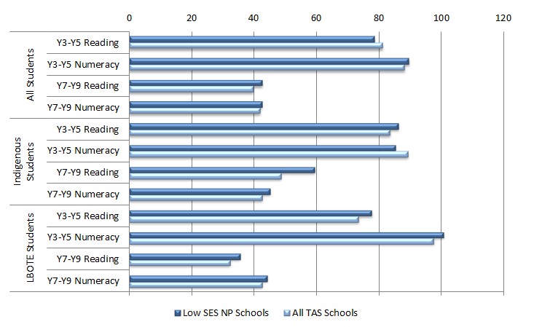
 |  | Low SES NP Schools | All TAS schools
All Students | Year 3 to Year 5 Reading | 78.6 | 81.2
All Students | Year 3 to Year 5 Numeracy | 89.7 | 88.2
All Students | Year 7 to Year 9 Reading | 42.7 | 39.8
All Students | Year 7 to Year 9 Numeracy | 42.6 | 42.0
Indigenous Students | Year 3 to Year 5 Reading | 86.3 | 83.6
Indigenous Students | Year 3 to Year 5 Numeracy | 85.3 | 89.3
Indigenous Students | Year 7 to Year 9 Reading | 59.5 | 48.7
Indigenous Students | Year 7 to Year 9 Numeracy | 45.2 | 42.7
LBOTE Students | Year 3 to Year 5 Reading | 77.8 | 73.5
LBOTE Students | Year 3 to Year 5 Numeracy | 100.7 | 97.6
LBOTE Students | Year 7 to Year 9 Reading | 35.6 | 32.4
LBOTE Students | Year 7 to Year 9 Numeracy | 44.3 | 42.7
Source: PGA constructed chart using TAS DoE (2013); ACARA (2012)
Additional analysis of apparent NAPLAN cohort mean score gains between 2010 and 2012 was also undertaken using Government and Catholic sector school-level data provided by ACARA. Rather than comparing apparent gains between Low SES NP schools and all Tasmanian schools, this data allowed the comparison of apparent gains between Low SES NP schools and non-NP schools. The results shows that in three of the four assessments, the apparent cohort gains made at Low SES NP schools were higher than in non-NP schools (Figure 6.2). Most notably, Low SES NP schools achieved an apparent gain in Years 7-9 Reading that was 7.4% higher than that in non-NP schools, although this was not found to be statistically significant.

Figure 6.2: Comparison of apparent mean gains (2010-2012) in NAPLAN scores of TAS Government and Catholic schools commencing Low SES NP initiatives in 2010 to that in non-NP schools
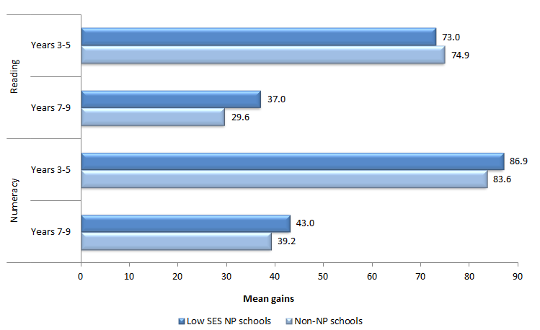
 |  | Low SES NP schools | Non-NP schools
Reading | Years 3 to 5 | 73.0 | 74.9
Reading | Years 7 to 9 | 37.0 | 29.6
Numeracy | Years 3 to 5 | 86.9 | 83.6
Numeracy | Years 7 to 9 | 43.0 | 39.2
Source: PGA constructed graph using data provided by ACARA
When achievement at the primary school level was analysed using NAPLAN bands (Figure 6.3), a higher proportion of Year 5 students (2011) were found to be at or below the National Minimum Standard (NMS) compared to the proportion of Year 3 students in 2009 on average across all Tasmanian schools. This is a national pattern in the NAPLAN data, with a lower proportion of students attaining the NMS at higher grade levels. Among Low SES NP schools however, positive outcomes in Numeracy were evident for all students and Indigenous students, with a reduction in the proportions of students at or below NMS between Year 3 and Year 5. At the secondary school level, the general increase in the proportion of students in the lower two bands between Year 7 (2009) and Year 9 (2011) was also a state wide trend. This result was mimicked in Low SES NP schools, although the increase was higher in both domains for all students but lower among Indigenous students.

Figure 6.3: Proportion of students at or below NMS (Year 3 2009- Year 5 2011) in NAPLAN, Tasmania
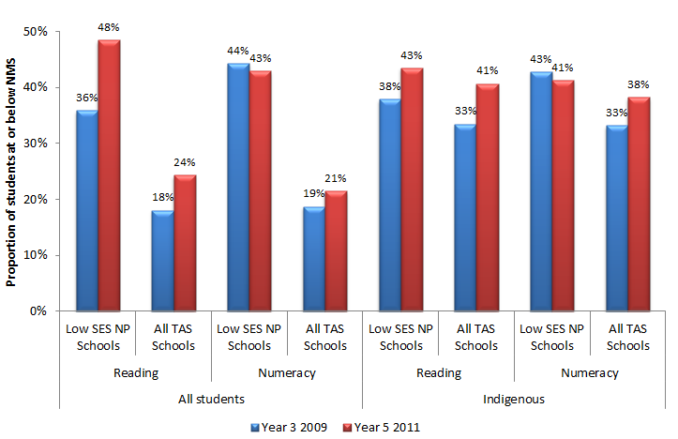
 |  |  | Year 3 2009 | Year 5 2011
All students | Reading | Low SES NP | 36% | 48%
All students | Reading | All TAS Schools | 18% | 24%
All students | Numeracy | Low SES NP | 44% | 43%
All students | Numeracy | All TAS Schools | 19% | 21%
Indigenous | Reading | Low SES NP | 38% | 43%
Indigenous | Reading | All TAS Schools | 33% | 41%
Indigenous | Numeracy | Low SES NP | 43% | 41%
Indigenous | Numeracy | All TAS Schools | 33% | 38%
Source: PGA constructed chart using TAS DoE (2013); ACARA (2012)
It is important to note that the limited evidence on gains in NAPLAN results amongst Low SES NP schools does not necessarily mean that the Partnership did not affect student achievement. As earlier outlined, intended achievement outcomes may not be realised in the limited timeframe under analysis. This could be particularly true for Low SES NP schools where other fundamental outcomes were targeted, such as student attendance and engagement.

NAPLAN Participation at Low SES NP schools
When NAPLAN participation at Low SES NP schools was analysed, little differences were found in participation rates between 2008 and 2012 at the primary school level. Similar results were observed at the secondary school level, except in Year 7 Numeracy, where NAPLAN participation rates decreased from 91% in 2011 to 84% in 2012 (Figure 6.4). Among Indigenous students, NAPLAN participation rates in 2012 were generally lower than in 2008, with notable differences of 4.5%, 4.2% and 3.8% in Year 7 Numeracy, Year 5 Reading and Year 9 Numeracy, respectively. These patterns of NAPLAN participation among all students and Indigenous students at Low SES NP schools were similar to those observed in all Tasmanian schools, with the exception that the decrease in participation in Year 7 Numeracy in all Tasmanian schools was not observed.
Figure 6.4: NAPLAN participation at Year 7 in Tasmania
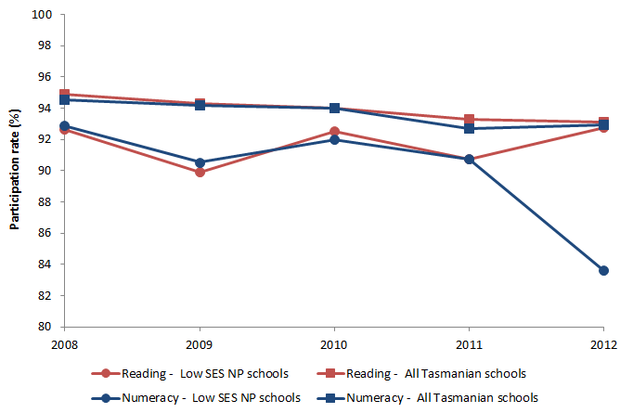
 |  | 2008 | 2009 | 2010 | 2011 | 2012
Reading | Low SES NP Schools | 93% | 90% | 93% | 91% | 93%
Reading | All TAS schools | 95% | 94% | 94% | 93% | 93%
Numeracy | Low SES NP Schools | 93% | 91% | 92% | 91% | 84%
Numeracy | All TAS Schools | 95% | 94% | 94% | 93% | 93%
NAPLAN participation rates have been recalculated by considering only students who were assessed Source: PGA constructed using TAS DoE (2013)
CASE STUDY: Teacher Professional Development to Improve Math Achievement at Warrane Primary School (Source: Tas DoE 2013).
Warrane Primary School focused on professional growth of teachers in mathematics. Key strategies used for improving mathematics were:
- individual assessment of students using Assessment Tools for Common Misunderstandings (tool dependent on students’ current ability) and Mental Computation Basic Facts test to inform learning experiences, and sequences learning to develop their understandings;
- daily explicit teaching of mathematics content strand number with reduced class numbers – either with maths support teacher or classroom teacher;
- regular collaborative planning and assessment meetings; and
- a whole-school maths day in September to celebrate National Literacy and Numeracy Week.
Improvement in Numeracy outcomes were as follows:
- increase in percentage at or above NMS for Year 3 NAPLAN: 2010 (81%); 2011 (90%); and 2012 (93%);
- increase in percentage of students at or above NMS f or Year 5 NAPLAN: 2010 (70%); 2011 (88%); and 2012 (100%).

Achievement in LNNP schools
Of Tasmania’s 16 targets set to acquire reward LNNP funding, seven targets were achieved by LNNP schools, three were partially achieved and six were not achieved. Achieved targets included meeting the proportions of Year 5 students at or above NMS in Reading and Numeracy. These improved by 5.9 and 3.1 percentage points respectively between 2008 and 2011. In addition, the aggregated proportion of Years 5, 7 and 9 Indigenous students at or above NMS for Reading and Numeracy improved by 2.2 percentage points, reversing a downward trend in results from 2008-2010 (COAG Reform Council 2012). Although a number of achievement targets were met, it is not possible to determine whether this can be directly attributed to the LNNP. Moreover, existing information does not permit the identification of which literacy and numeracy intervention programs had the desired effects.
Analysis of school-level achievement data in all Tasmanian Government and Catholic schools also assessed the progress in LNNP schools compared to that exhibited by similar non-NP schools. Similar schools were grouped according to their students’ socioeconomic background as measured by the school ICSEA or their achievement prior to the commencement of the LNNP, with the analysis focusing on schools in the lowest four deciles of either measure. For the 2009-2011 student cohort, the proportion of schools in the lowest four ICSEA deciles achieving above average growth was higher in LNNP schools than in non-NP schools in three of the four grade-domain combinations, with differences of up to 20% in Years 7-9 Reading (Figure 6.5). The proportion of schools achieving above-average growth compared to schools with similar starting scores in NAPLAN was found to be up to 12% higher in non-NP schools at the primary school level. At the secondary school level, a higher proportion of LNNP schools achieved above average growth compared non-NP schools with similar starting scores, with differences of 11% in Reading and 9% in Numeracy. Amongst the 2010-2012 student cohort the proportion of primary schools in the lowest four ICSEA deciles that achieved above average growth was higher LNNP schools, with differences of over 20% in both domains. This was not observed when LNNP schools were compared to non-LNNP schools with similar starting scores. At the secondary school level, the proportion of students achieving above average growth was higher in LNNP schools. This was most apparent in Numeracy among students in the lowest four deciles of previous NAPLAN achievement, where a difference of 27% was observed (Figure 6.6).

Figure 6.5: Proportion of LNNP schools achieving above average growth compared to similar non-NP schools, 2009-2011 cohort in the Tasmanian Government and Catholic sectors
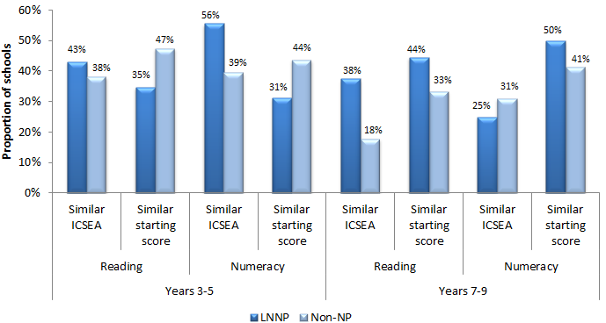
 |  |  | LNNP Schools | Non-NP Schools
Years 3 to 5 | Reading | Similar ICSEA | 43% | 38%
Years 3 to 5 | Reading | Similar starting score | 35% | 47%
Years 3 to 5 | Numeracy | Similar ICSEA | 56% | 39%
Years 3 to 5 | Numeracy | Similar starting score | 31% | 44%
Years 7 to 9 | Reading | Similar ICSEA | 38% | 18%
Years 7 to 9 | Reading | Similar starting score | 44% | 33%
Years 7 to 9 | Numeracy | Similar ICSEA | 25% | 31%
Years 7 to 9 | Numeracy | Similar starting score | 50% | 41%
Source: PGA constructed graph using data provided by ACARA
Figure 6.6: Proportion of LNNP schools who achieved above average growth compared to similar non-NP schools, 2010-2012 cohort in the Tasmanian Government and Catholic sectors
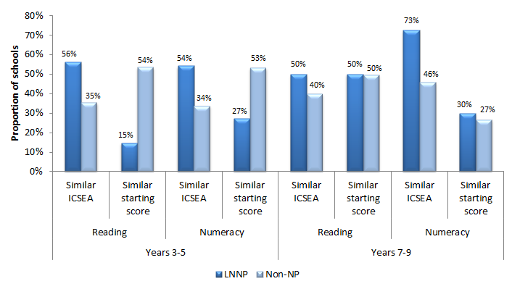
 |  |  | LNNP Schools | Non-NP schools
Years 3 to 5 | Reading | Similar ICSEA | 56% | 35%
Years 3 to 5 | Reading | Similar starting score | 15% | 54%
Years 3 to 5 | Numeracy | Similar ICSEA | 54% | 34%
Years 3 to 5 | Numeracy | Similar starting score | 27% | 53%
Years 7 to 9 | Reading | Similar ICSEA | 50% | 40%
Years 7 to 9 | Reading | Similar starting score | 50% | 50%
Years 7 to 9 | Numeracy | Similar ICSEA | 73% | 46%
Years 7 to 9 | Numeracy | Similar starting score | 30% | 27%
Source: PGA constructed graph using data provided by ACARA
Although NAPLAN growth rates may not have been as large in all LNNP schools as those in non-NP schools, notable patterns of improvement were found in Year 7 to Year 9 Reading, while above-average growth was also detected in at least one-third of participating primary schools. It is therefore recommended that further research be undertaken with this group to determine why some LNNP schools achieved greater success than others.
CASE STUDY: Use of Phonics Program to Boost Literacy in Independent Sector Schools (Tas DoE 2013).
In the Independent sector, Letters and Sounds, a phonics program to build children’s speaking and listening skills as well as to prepare them for learning to read by developing their phonic knowledge and skills was implemented.
It was reported to have had a positive impact on schools that participated in the program. For example, in 2012, Channel Christian School, Calvin Christian School, The Hutchins School and Southern Christian College reported achievement of their best Performance Indicators in Primary Schools (PIPS) results since the assessment began. Additional quantitative evidence found significantly higher reading levels for students accessing Letters and Sounds, with levels generally one year higher than in previous years when different methodologies were used to teach students to read.

Outcome 2:
Improvement in attendance of students in the NP schools (particularly Indigenous students) and a higher proportion of Indigenous students completing year 10
School attendance was equally as important an intended outcome as student achievement. Schools selected for this NP were often comprised of students facing multiple sources of disadvantage over an extended period of time. Addressing these entrenched disadvantages therefore required a focus on more foundational issues such as attendance and engagement before student achievement could be lifted.
To improve student attendance, networks of three or more high and district high schools worked collaboratively on personalised learning and tailored education programs to re-engage students who were at risk of disengaging from the system. In addition, the Connected Any Student Any School (CASAS) project through the Flexible Learning Tasmania strategy was adopted to provide a dynamic environment for flexible, anywhere, anytime learning. This was especially the case for Low SES NP schools, who were challenged by issues such as rurality, isolation and poor student attendance, engagement and retention.
To better understand the impact of the Low SES NP on attendance, analysis was undertaken comparing trends in student attendance at participating schools to those in non-NP schools. The analysis used aggregated school-level data from all Tasmanian Government and Catholic schools to compare whether the difference in attendance rates between Low SES NP schools and all Tasmanian schools declined over time following the commencement of the partnership. The results show that attendance rates at Low SES NP schools showed no improvement relative to non-NP schools at both the primary school and secondary school levels (Figure 6.7).
Figure 6.7: Student attendance rates at Tasmanian Government and Catholic schools
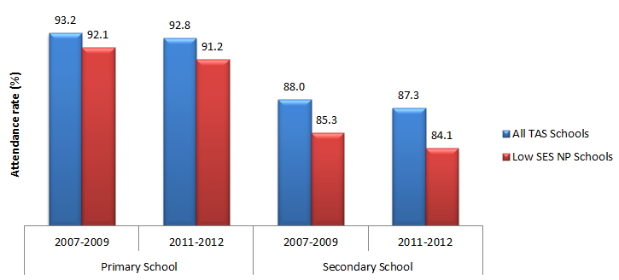
 |  | All TAS Schools | Low SES NP Schools
Primary School | 2007 to 2009 | 93.2% | 92.1%
Primary School | 2011 to 2012 | 92.8% | 91.2%
Secondary School | 2007 to 2009 | 88.0% | 85.3%
Secondary School | 2011 to 2012 | 87.3% | 84.1%
Secondary school level figures include only Years 7-10, as Years 11-12 attendance data was not provided for either sector. Primary school level figures exclude Grade Prep.
Source: PGA constructed graph based on attendance data provided by TAS DoE and DEEWR
This lack of improvement in attendance rates was consistent with the data presented by the Tasmanian Department of Education (Figure 6.8). However, the apparent retention rates (ARR) from Year 10 to 11 in Low SES NP Government schools increased significantly from 58.4% in 2007 to 75.2% in 2012 (Figure 6.8). The ARR is measured as a ratio of students in a particular grade level divided by the number of students in an earlier grade level and can be used to investigate the relationship between participating in the Low SES NP and student retention. Similar trends were found among Indigenous students in Low SES NP schools, where the aggregated proportion of Indigenous students retained between Years 10 and 11 rose from 43.2% in 2008 to 67.4% in 2012. When student enrolment data aggregating the Government and Catholic sectors was analysed, the change in the Year 7-10 ARR at Low SES NP schools between the period preceding participation in the Low SES NP (2007-2010) and the period following its commencement (2009-2012) was found to be 1.2% higher than that observed in all Tasmanian schools (Figure 6.9). Despite this, the results should not be taken as causal evidence of the impact of the Low SES NP as the ARR is an aggregated measure of student enrolments and does not control for student movement between schools, an important factor that may be driving the observed changes.
Figure 6.8: Attendance and retention rates in Tasmanian Low SES NP Government schools, 2007-2012
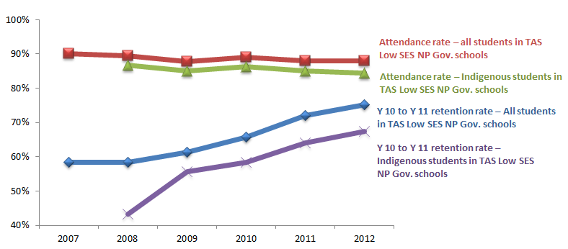
 | 2007 | 2008 | 2009 | 2010 | 2011 | 2012
Attendance rate – all students in TAS Low SES NP Gov. schools | 90% | 90% | 88% | 89% | 88% | 88%
Attendance rate – Indigenous students in TAS Low SES NP Gov. schools |  | 87% | 85% | 86% | 85% | 85%
Year 10 to Year 11 retention rate – All students in TAS Low SES NP Gov. schools | 58% | 58% | 61% | 66% | 72% | 75%
Year 10 to Year 11 retention rate – Indigenous students in TAS Low SES NP Gov. schools |  | 43% | 56% | 58% | 64% | 67%
Some changes may be related to system-wide changes for post-year 10 institutions and related data systems
Source: TAS DoE (2013)
Figure 6.9: Year 7-10 apparent retention rates at Tasmanian Government and Catholic schools
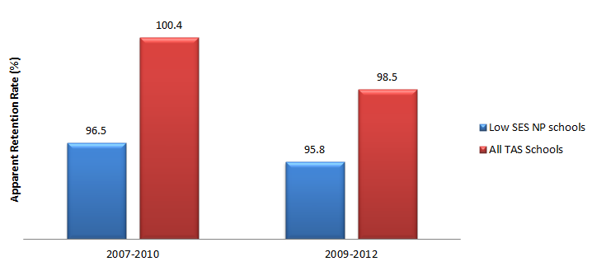
 | Low SES NP Schools | All TAS Schools
2007 to 2010 | 96.5% | 100.4%
2009 to 2012 | 95.8% | 98.5%
Source: PGA constructed graph based on enrolment data provided by TAS DoE and DEEWR
NB: The pre-NP commencement figures are the average ARRs between 2007 and 2010, while the post-NP commencement figures are the average ARRs between 2009 and 2012.
CASE STUDY: Context-based Study Options to Improve Attendance and Retention at Triabunna District High School
Triabunna District High School focused on providing students with genuine learning opportunities aligned to their specific school context and location. The school focused on the provision of the Explore the Coast and Outdoor Education Programs, emphasising the career pathways and further study options that these marine based programs offered – with particular relevance to tourism, aquaculture marine management and sustainability. In 2012, the school had 42 secondary students directly involved in these programs.
The outcomes of attendance and retention demonstrated improvement trends. Attendance data for 2012 showed a consistent rate of 91.1%. The success of the programs, and a reflection of the engagement of students, was also seen in the suspension data for 2012 – which reflected a drop of 4.2 % in suspensions in 2012. The retention rate also showed an upward trend (achieving 80% for 2011 in comparison to 36% in 2009 and 31% in 2010) (TAS DoE 2013).

Outcome 3:
Increased satisfaction of students at school
Analysis of the Tasmania Satisfaction Survey showed general satisfaction of students and parents at Government Low SES NP schools remained stable between 2007 and 2011, the years for which the data was available (Figure 6.10). In addition, there was a significant increase in staff satisfaction between 2008 and 2009, which also remained at higher levels until 2011. It is not known however if these trends were specific to Low SES NP schools or if they were also observed at non-participating schools in Tasmania.

Figure 6.10: Index of General Satisfaction, Tasmanian Government Low SES NP schools
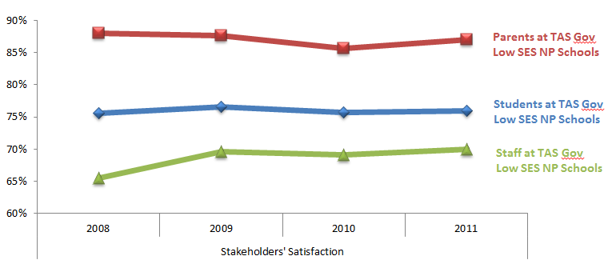
 | 2008 | 2009 | 2010 | 2011
Parents at TAS Gov Low SES NP Schools | 88% | 88% | 86% | 87%
Students at TAS Gov Low SES NP Schools | 76% | 77% | 76% | 76%
Staff at TAS Gov Low SES NP Schools | 66% | 70% | 69% | 70%
Source: PGA constructed chart using the Tasmania Student, Parent and Staff Opinion Survey data for Government schools (DoE 2013)

Outcomes 4 and 5:
Increase in the number of school networks and partnerships with parents, communities, businesses and higher education providers; Increase in the number of full service schools providing access to extended services
In line with the intended objectives in Tasmania, Low SES NP schools also appeared to have established greater connections with the business community, family centres and government agencies. Initiatives aimed at improving parent access to Birth–Four Years programs have been observed many schools. These included the Launching into Learning (LiL) program that engaged families of children before they start Kindergarten. LiL was reported to have helped build relationships between staff, families and communities that facilitated a child’s successful transition into formal schooling. Schools additionally focused on building greater connections with Child and Family Centres as well as other government agencies in their areas which also contributed to more integrated services. Strong connections with the business community were also established in high schools
CASE STUDY: Hospitality and Tourism Study Options to Engage Students (TAS DoE 2013)
Some schools used a hospitality and tourism option stream to engage learners. Students were given the opportunity to participate in Master Chef classroom learning; engage with industry through barista classes, Responsible Service of Alcohol and Safe Food Handling; access mentoring opportunities with industry professionals; experience site visits; and partake in Nationally Accredited Training delivered through Registered Training Organisations. Students ran community events and enterprises such as breakfast clubs, business catering, and school event catering. Students also competed in the Whirlpool Cooking Challenge, which was supported by a number of Tasmanian businesses and industries. Student learning was supported through the Beacon Foundation Ambassador program, which engaged students in activities such as industry visits and mentoring, and mock interviews, providing them with multilayered learning outcomes across the curriculum, personal development and employability skills.

CASE STUDY: Enhancing Learning Opportunities and Parental Involvement to Improve Outcomes at the Jordan River Learning Federation (TAS DoE 2013).
‘Launching into Learning’ was a state-wide initiative alongside the Smarter Schools implementation at Jordan River Learning Federation (JRLF), to provide all students with learning opportunities (such as a personalised curriculum based on their interests) to improve students’ learning outcomes. The Federation culture involved programs and activities such as athletics and swimming carnivals, co-operation between campuses to support specialised needs for students, mentor programs (older and younger students), and training programs (Year 10 and 11 students undertaking childcare and foods hospitality courses). A share-point, website and newsletter was also established to promote the Federation. A Business Manager was appointed at JRLF that centralised administration.
This resulted in shared practices, philosophies and a common work culture across the Federation. It also enabled the Federation to build capabilities through internal professional development of staff.
Parents were engaged in Launching into Learning through open days, home visits, school activities and events. Increasing resourcing enabled increased staffing and release time for home visits to increase community connections and strengthen networks in place. Provision of transportations to pick families up to take them to Launching into Learning, especially in winter, increased access to the service.

CASE STUDY: Interagency Early Intervention Program at South George Town Primary School (TAS DoE 2013).
South George Town Primary School focused on the development of a strong birth to school interagency service provision. The Launching into Learning program worked closely with Early Childhood Intervention Service staff to offer early intervention playgroups for children who were at risk, and for families who had difficulty accessing mainstream programs because of their child’s behaviour, disability, or for their own mental health issues. Other services such as St Giles Therapy Services, Gateway and Child Health and Parenting Service were part of the parent support structure.
Of the 33 children in Kindergarten assessed in 2012, against KDC markers, 20 achieved all markers. Of the 17 students who were regular Launching into Learning attendees 14 children achieved all markers.

Outcome 6:
Young people make a successful transition from school to work and further study
Outcomes relating to school completion and transitions beyond compulsory schooling were long-term aspirational targets under the Low SES NP. Systemic improvement in these indicators is therefore not expected in the four years under analysis, though some localised leading indicators have emerged.
Initiatives in this area emphasised career awareness programs during school years and transition support to encourage continued student engagement. One initiative involved the provision of funds to allow previous year’s Year 10 coordinators to attend colleges to support the settling of transitioning students. Additional initiatives included the Taste of Polytechnic (TOP), Taste of College (TOC), and the youthBuild programs, offering vocational taster programs to Year 10 student. These were implemented alongside career awareness programs to help students better understand the wide range of opportunities available in Years 11 and beyond. The advantages of gaining a Year 12 qualification or equivalent were also promoted through the multifaceted ‘Reach your Potential’ advertising campaign in March 2012.
Indigenous student transition through schooling was addressed through the employment of a coordinator to work with high-achieving Year 9 and Year 10 students living in regional and rural areas to ensure a smooth transition to the final two years of high school. Rural schools also arranged a long orientation program with their local college. This provided bridging opportunities that enhanced Indigenous student transition to further studies and training.

6.3 TAS CONCLUSION
In Tasmania, the evaluation found a mostly positive association between participation in the Low SES NP and student achievement in literacy and numeracy. Among the 2009-2011 student cohort for example, aggregated apparent NAPLAN mean score gains in Numeracy at both the primary and secondary school levels were found to be greater in Low SES NP schools than in all Tasmanian schools. In addition, aggregated data for Indigenous and LBOTE students at Low SES NP schools show that these students achieved greater apparent gains than the average observed in all Tasmanian schools. The aggregated data further revealed that apparent gains made by Low SES NP schools between 2010 and 2012 in NAPLAN scores were slightly higher than the apparent gains made by non-NP schools, particularly in secondary school level Reading. In addition, a significant increase in the Year 10-11 ARR was found among all students and Indigenous students in the Government Low SES NP schools. Despite this, it is unclear if this effect was due to participation in the Low SES NP, as enrolment data at non-NP schools was not available. Moreover aggregated student enrolment data in the Government and Catholic sectors showed a minor improvement in the Year 7-10 ARR at Low SES NP schools relative to non-NP schools.
In LNNP schools, analysis of achievement data showed mixed results. Compared to non-NP schools with similar socioeconomic status, LNNP schools in both the 2009-2011 cohort and the 2010-2012 cohort were found to be generally more likely to achieve above average growth in NAPLAN scores, most notably in Years 3-5 Numeracy and Years 7-9 Reading. When controlling for NAPLAN starting scores, only 31% to 35% of LNNP primary schools and 44-50% of LNNP secondary schools achieved above-average growth in the 2009-2011 cohort. With the exception of Years 7-9 Reading, these rates appeared to be lower for the 2010-2012 cohort.
A number of NP initiatives in Tasmania are likely to have improved student achievement and engagement. These included encouraging innovation and flexibility and establishing greater connections with parents and the wider community such as businesses, government agencies and child and family centres. For example, teacher coaching and mentoring as well as evidence-based literacy and numeracy programs such as QuickSmart, Catch Up Literacy and Letters and Sounds were likely to have had a positive impact, as in a number of schools, the Letters and Sounds program was found to be quite successful based on both qualitative and quantitative evidence (TAS DoE 2013). Evidence-based literacy and numeracy intervention programs targeting students at risk of failing have been found to be effective, especially when they are matched to their learning profiles (Purdie & Ellis, 2005). For example, Munro (2006) reports that at-risk readers can achieve the same level of progress as average readers when exposed to interventions that match their existing literacy learning profiles. The success of these programs may be attributed to the identification and targeting of at-risk students as well as the information sessions and communication strategies developed for parents who wish to support their children at home. The involvement of parents in the programs has been found to assist in sustaining a balanced, researched and successful approach to developing student skills in literacy and numeracy (TAS DoE 2013). The type of interventions adopted in the programs are also likely to have resulted in improved student outcomes. In Letters and Sounds for example, the emphasis on thorough letter/sound correspondence knowledge was reported to have enabled students to become more accurate, fluent and better skilled in accessing the meaning of the text (TAS DoE 2013). The potential for this to impact student learning is backed in research suggesting that students learn best when teachers adopt a reading approach that integrates phonemic awareness, phonics, fluency, vocabulary knowledge and comprehension (Rowe 2005).
The Launching into Learning (LiL) program is a state initiative implemented in Tasmania that may have positively influenced student achievement and engagement. This program, which engages families of children before they start Kindergarten, was found to have had a significant impact in improving literacy and numeracy skills among children aged 0-4, particularly on students from more disadvantaged socioeconomic backgrounds (TAS DoE 2013). Given its impact on children at the pre-school level, the LiL program is likely to be associated with improved future student achievement at the primary school level and beyond.
Other NP interventions involved the professional development of school leaders and teachers, aimed at enhancing leadership capacity and teaching pedagogy. Principals and teachers were equipped with the skills to manage and encourage innovation and continuous improvement. For example, the Lead school/Lead Teacher initiative was adopted to support teachers to better understand the diverse nature of the student population and differentiate the curriculum to meet varying needs, especially those of at-risk students (TAS DoE 2013). The initiative also introduced a number of innovative practices that improved student motivation, such as the Literacy and Numeracy apps being used broadly via iPads (TAS DoE 2013). Through enhancing leadership capacity, teaching pedagogy and student motivation, professional development programs are likely to lead to improved student achievement outcomes. Both school leadership (Leithwood et al 2004) and teachers, especially through their classroom instruction, have among the strongest influences on student outcomes (Hattie 2009). Improving leadership and teachers through professional development can therefore lead to subsequent positive influences on student achievement, although current data may not reflect this. Professional development programs have been found to have a positive impact on student achievement (Johnson et al 2007), particularly when they address the concrete, everyday challenges involved in teaching and learning specific academic subject matter (Darling-Hammond et al 2009).
Another crucial intervention at Tasmanian NP schools involved supporting the transition of students to work or further education, such as the Post Year 10 Transition initiative. This initiative particularly focused on promoting the transition from Year 10 into Year 11, with an emphasis on building strong relationships between high schools and Years 11/12 providers as well as on personalised interventions to cater for individual student needs (TAS DoE 2013). It is therefore conceivable that this initiative is the major contributor to the improved Year 10-11 retention rate in Tasmanian Low SES NP Government schools between 2007 and 2012. Promoting social and emotional wellbeing was a further focus in Tasmanian NP schools as this was recognised as being integral to learning outcomes.
The emphasis on targeted programs tailored to individual student needs for those at risk is likely to have improved student achievement and engagement at Tasmanian NP schools, though the observed effects of each program at this stage is based on limited data. Moreover, currently available data do not permit identifying non-NP activities that may have been funded at both NP and non-NP schools, which are likely to confound observed program effects. It is only possible to determine the exact impact of each individual activity by obtaining adequate data that clearly links them to the outcomes. Further analyses of such data can provide better understanding of the link between interventions and outcomes in order to inform policymakers’ and educators’ decisions around which programs work better than others. As outlined in the final chapter, such data can be collected through further research involving surveys and focus groups that can map data on specific activities to intended student achievement and engagement outcomes.

GLOSSARY
CASAS: Connected Any Student Any School
CFC: Child and Family Centre
DOE: Department Of Education
ECIS: Early Childhood Intervention Services
FLT: Flexible Learning Tasmania
FTE: Full Time Equivalent
ICT: Information and Communications Technology
KMP: Kids Matter Primary
LBOTE: Language Background Other Than English
LiL: Launching into Learning
LINC: Learning and Information Centre
LNNP: Literacy and Numeracy National Partnership
Low SES NP: Low Socioeconomic School Community National Partnership
MULTILIT: Making Up Lost Time in Literacy
NAPLAN: National Assessment Program – Literacy and Numeracy
NCN: National Clinicians Network
NP: National Partnership
PAT: Progressive Achievement Test
PIPS: Performance Indicators in Primary Schools
PLP: Personalised Learning Plan
PNL: Principal Network Leader
RTBCTG: Raising the Bar Closing the Gap
SRC: Social Research Consultants
SSNP: Smarter School National Partnership
TOC: Taste of College
TOP: Taste of Polytechnic
UTAS: University of Tasmania
VLE: Virtual Learning Environment

Victoria


Low SES NP and LNNP
In Victoria, the Low SES NP and LNNP adopted the same initiatives which included:
- Building leadership capacity
- Building teacher capacity (in-school support/coaches and professional learning opportunities)
- Improved monitoring of student performance information
- Timely students intervention and support
- Enable and enhance the capacity of families to be engaged in learning
- Enable and strengthen school-community/business partnerships to maximise learning opportunities and to extend schools

Targeted Outcomes
- Young people are meeting literacy and numeracy National Minimum Standards
- Overall levels of literacy and numeracy achievement in national testing are improving
- Improved leadership and teacher capacity
- All children are engaged in and benefiting from schooling
- Schooling promotes social inclusion (including attendance and retention for both y7-y10 and y10-y12) and reduces the educational disadvantage of children, especially Indigenous children
- Increase in the proportion of students participating in post-school education, training and employment
Key findings from synthesis of existing data
Participation in the Low SES and LNNP was associated with:
- Significant improvement in student achievement in primary school level Numeracy and in secondary level Reading and Numeracy.
- Growth in achievement among the most disadvantaged Indigenous students, particularly at the primary school level.
- Higher student perception of their learning environment and their perception of engagement with the teaching practices they experience.
- An increase in leadership and teaching capacities.
- Improved attendance rates of Indigenous students at the secondary school level.
- Improved Year 7-10 apparent retention rates among all students and Indigenous students.
- Strengthened engagement of families and the community in student learning.

7.1 VIC ACTIVITIES & OUTPUTS

Overview
In Victoria, both SSNPs focused on building leadership and teacher capacity, as well as recognition and response to individual learning needs. The engagement of families and the community with schooling and the provision of extended services at schools were also prioritised. A total of 327 schools were selected into the Low SES NP, based on the level of educational disadvantage amongst students. Participation in the LNNP, involving 210 schools, was generally determined by the number of students performing at or below NMS in literacy or numeracy in NAPLAN results. Only 17 schools participated in both partnerships.
Implementation of both partnerships in Victoria followed a different path to that adopted by most other Australian states. The integrated approach to the SSNP firstly enabled schools to adopt initiatives regardless of the type of partnership they had been selected for. The comprehensive approach was cross-sectoral and emphasised collaboration on best practice as evidenced by the SSNP reforms.
Decisions around funding and activities for participating schools in Victoria were devolved to regions. A Regional Network Leader was responsible for supporting a coordinated response targeting the individual needs of each school. Therefore, schools invested resources from the partnerships in programs they had selected based on their analysis of their students’ needs.

Low SES NP and LNNP Activities
The school-driven reform approach resulted in the implementation of over 77 activities throughout Victorian SSNP schools. However, several similar programs may have targeted similar goals under different titles. Table 7.1 groups comparable activities implemented throughout Victoria under each targeted reform area. It additionally presents the outputs measured from the most wide-reaching adopted activities in each sector.

Table 7.1. Activities and outputs in Victorian Low SES and LNNP schools, 2008-2012
Building Leadership Capacity
Activity | Output
Coaching for the Principal Class (G)  Coaching for Experienced Principals (G)  Principal Coaching Program (C)  Leadership Coaching Strategy (C)  Principal Advisors (I)  Principal Preparation Program (G)  Mentoring for First Time Principals (G)  360° Leadership Diagnostic Tools (C)  Aspiring to Principalship Program (C)  Year 2 Principal Induction Program (C)  Exploring Leadership for New Principals Seminar Program (I)  Leadership Learning Support Grants (C)  Innovative Study Tour Grants (I)  Instructional Rounds (G)  Learning Walks (G)  Leaders in the Making (G)  Masters in Wellbeing for Inclusive Schooling (C)  Masters in Educational Leadership (C)  Change2 ICON Principal’s Briefing (C)  nhancing Leadership Team Capability (ELTC) Project (C)  Southern Cross Project (I) | Government: The main leadership capacity building program in the Government sector was Coaching for the Principal Class. The program over two cohorts and involved 10 hours of on-site individual coaching of 50 principals, 135 assistant principals, 12 acting principals and 1 lead teacher, all in the first three years of their role.  Catholic: In the Catholic sector, the Leadership Coaching Strategy involved in-school coaching to over 100 leaders in 2010, while in 2011, 527 hours of coaching were provided to principals and 9 experienced principals were trained as coaches. In 2012, the Leadership Coaching Strategy provided five hours of coaching to 53 principals across Archdiocesan schools and additional leaders from 11 schools in the Sale Diocese. In 2010, 89 leaders completed Units towards the Masters in Educational Leadership at either ACU or the University of Melbourne, with a further 148 enrolments in 2011 and 104 enrolments in 2012. Since 2009, 136 principals have completed the Aspiring to Principalship program.  Independent: The Independent sector employed four Principal Advisors, who visited the 43 NP schools to provide face-to-face coaching and mentoring of principals. In 2012 alone, the Advisors spent a total of 1711.5 hours with principals, including 64 hours at Worawa Aboriginal College. The sessions focused on long term strategic planning, managing change, developing a collaborative learning community, devising and implementing annual action plans, analysing data and developing effective teaching and learning plans.

Building Teacher Capacity
Activity | Output
Literacy Coach Training (G)  Numeracy Coach Training (G)  Instructional Coach Training (G)  Professional Learning Teams (PLTs) (G)  Digital Content Strategy (G)  Koorie Literacy Coaching (G)  Social and Emotional Learning (SEL) (C)  External Coaches (C)  Cognitive Coaching (I)  Evidence Based Observation (EBO) (I)  Extending Mathematical Understanding (EMU)(C,I)  Reading Recovery (G)  Post Graduate Certificate in Mathematics Leadership (C)  Post Graduate Certificate in Literacy Leadership (C)  Engaging Boys in Literacy (I)  Identification of Students at Risk (I)  National Accelerated Literacy Program (I)  Curriculum Planning program (I)  Early Years program (I)  Integrating ICT (including iPads) into the Curriculum (I)  Students with Disabilities and Learning Difficulties program (I)  Student Wellbeing program (I)  Professional Learning Communities (I)  How to establish Assessment on Demand (I)  Professional Learning seminars (I)  New Insights for School Improvement seminars (I)  English as an Additional Language (EAL) seminars (I)  Students with Individual Needs seminar (I)  Primary Mathematics Specialists (G)  Language Support Coordinators (G)  School Welfare and Community Engagement (SWCE) Advisors (I)  Identifying Quality Teachers in Practice, Implementing National Standards Pilot Project Phase 2 (ALL)  Supporting New Teachers Practice Program (G)  e5 Training (I)  Annual Thinking and Learning Conference (I)  One-Day Teacher Forum (I)  Casual Relief Teacher (CRT) (I) | Government: The Bastow Institute of Educational Leadership (BIEL) ran Literacy, Numeracy and Instructional Coach Training programs, consisting of eight full day workshops, an Ultranet design space with online learning communities, pre-reading and in-between session tasks, needs analysis survey, data collection, network group meetings and individual school visits by the providers. The Numeracy and Instructional Coach Training programs commenced in November 2009 with a total cohort of 102 coaches, while the Literacy Coach Training program began in March 2010. In 2010, 213 participants were involved across the three programs, while in 2011, there were 31 participants in Literacy coaching and 23 participants in Numeracy coaching. In addition, a total of 122 teachers participated in the Supporting New Teachers Practice program in 2010, with the number increasing to 277 in 2011 and 272 in 2012. This program involved a series of workshops and collaborative networks aimed at building the teaching capacity of first year teachers and their mentors by diagnosing a challenge of practice, applying evidence-based solutions and evaluating the impact of action undertaken.  Catholic: The Catholic sector’s activities to build teacher capacity included the Social and Emotional Learning (SEL) program, an intensive professional coaching of staff to build the capacity of schools to lead a whole school approach to social and emotional learning. The SEL program involved 10 schools and 295 staff in 2010, nine schools (six primary and three secondary) and 597 staff in 2011 and 13 schools (12 primary and one secondary) in 2012. The sector also used coaches to work with teachers and leaders on an individual or small group level to build pedagogical knowledge and skills, with a strong focus on literacy and numeracy. In 2009, 16 external coaches were appointed (seven Literacy coaches and nine Numeracy coaches) with 22 staff commencing training as external coaches. By 2010, the number of coaches had increased to 20. In 2011, all 75 Catholic LNNP schools received coaching, although this had dropped to 31 schools in 2012.  Independent: In 2010, a total of seven Literacy and Numeracy (L/N) and SWCE Advisors visited schools on a regular basis to provide in-school support for teachers. By 2012, the number of L/N and SWCE Advisors increased to eight. Combined, these Advisors spent 4472 hours mentoring, encouraging and supporting teachers. In 2010, over 160 teachers attended Professional Learning programs, while in 2011, 42 teachers attended eight seminars on the topic of Students with Individual Needs (i.e. autism, Aspergers Syndrome), while an additional 48 teachers attended four ESL seminars and three seminars for teachers of students with language difficulties. In 2012, 466 Professional Learning seminars across a range of educational disciplines were offered to leaders and teachers.

Improved Monitoring of Student Performance Information
Activity | Output
Individual Learning Plans (ILPs) (ALL)  Literacy and Numeracy Intervention Framework (C)  Number Intervention P-4 (C)  Review of Assessment Instruments (C)  Mathletics (G)  Data Literacy Support (G)  Literacy and Numeracy 6-18 Month Strategy (G)  Employing Advisors (I)  School Welfare and Community Engagement (SWCE) Advisors (I)  Principal Advisors (I) | Government: Mathletics was used to provide immediate feedback to students, teachers and parents. It was offered to 31% of NP schools in 2010, 70% in 2011 and 71% in 2012, accounting for over 140,000 students. In addition, ‘Data Literacy Support’ was provided to approximately 500 leaders and teachers.  Catholic: The Literacy and Numeracy Intervention Framework is a whole school approach to identifying appropriate intervention and was adopted by all four dioceses. Number Intervention P-4 trains teachers to become number intervention specialist teachers. It was offered to 54 primary teachers at 46 primary schools.  Independent: In addition to four Principal Advisors and three SWCE Advisors, four L/N Advisors trained leaders and teachers to track analysis data for individual students and develop the skills necessary to respond to individual learning needs.

Timely Student Intervention and Support
Activity | Output
Innovative Clustering Arrangements (G)  Instrumental Enrichment and Mediated  Learning Experience courses (I)  Reading Recovery (G,C)  Extending Mathematical Understanding (EMU) (C,I)  Writing for ESL Learners seminar (I)  Linking Oral Language to Written Language seminar (I)  Fast ForWord Literacy (G)  QuickSmart Numeracy  Getting Ready in Numeracy (GRIN) (G)  Speaking and Listening Supporting Early Literacy (SALSEL) (G)  Yachad Accelerated Learning Project (YALP) (G)  New Arrivals program (G)  Local Learning and Employment Networks (G)  Foundation House (G)  Jigsaw wellbeing program (I)  Tools to Enhance Assessment Literacy (TEAL) for Teachers of EAL (ALL)  ESL Proficiency Assessment Tool (ALL)  On Demand Testing (G)  Digging Deeper (G)  Intervention Framework (C)  Wellbeing Officers (G)  Koorie Engagement Support Officers (KESOs) (G)  Transition Officers (G)  Advisor Support for Indigenous Students (I)  Koorie Literacy programs (G)  Wannik: Learning Together – Journey to Our Future program (G)  Indigenous Cultural workshop (I)  African Languages workshop (I)  Bastow Stronger Leadership program (G)  Wiltja program (I) | Government: QuickSmart Numeracy aimed to increase students’ skill levels across all four operations. In the Grampians region alone, over 200 students across 17 schools participated in QuickSmart Numeracy in 2010. By 2011, this had risen to 400 students across 30 schools. While GRIN targets students experiencing difficulty in maths, SALSEL is a language support program that was offered to two schools in 2011 and 12 schools in 2012. Through YALP, trained tutors have supported students in six schools across the Shepparton network, many of whom were Indigenous. The Government sector also adopted various activities that targeted disadvantaged student cohorts. For example, The New Arrivals program aimed to improve the educational opportunities and outcomes of newly arrived EAL students who received intensive English language tuition for two to four school terms. In addition, Transition Officers worked intensively with high needs students, including refugees and humanitarian entrants and their guardians to find appropriate schools and programs. The sector also collaborated with Local Learning and Employment Networks and Foundation House to support at-risk refugee students.  Catholic: As previously outlined the Catholic sector developed an intervention framework to identify key principles, structures and processes which need to be considered in developing effective school practice.  Independent: In the Independent sector, timely student interventions focused on Indigenous students, primarily at Worawa Aboriginal College. These included wellbeing programs, cultural workshops and the development of Individual Learning Plans (ILPs) for needy Indigenous students. Activities that targeted disadvantaged student cohorts included Instrumental Enrichment and Mediated Learning Experience courses. This allowed 10 teachers to augment the special education programs of five schools and help children with learning difficulties to overcome cognitive, emotional and psychological challenges. Seminars were also offered to teachers of students with learning needs and language difficulties. These seminars included Writing for ESL Learners, Linking Oral Language to Written Language, an African Languages workshop and four days of Professional Learning for four ESL classroom teachers.

Increased engagement of families and the community in learning to improve student outcomes and to extend schools
Activity | Output
Leading Communities module (G)  Koorie Literacy Coaches (G)  Professional learning and parenting seminars (C)  REDI for the Early Years (G)  Bear Necessities program (G)  Teddies on Tour (G)  Sensory Snack Packs (G)  Kimochi (G)  Professional Learning for KEWs (C)  Koorie Education Learning Plan (KELP) (G)  Municipal Literacy Partnership Project (G)  Family Engagement Workers (G)  Family Liaison Officers (G)  Welfare Officers (G)  Family therapists (G)  Language Support Coordinators (G)  Multicultural Education Aides (G)  Family Engagement Officers (G)  Engaging with Recent Arrival Parents program (I)  Indigenous consultants (I)  School Welfare and Community Engagement (SWCE) Advisors (I)  Prep Family Engagement Project (G)  After-school club for Indigenous (G)  Koori Academy of Excellence workshops (G)  After school homework clubs (I)  Indigenous wellbeing workshops (I)  Family Education programs (G)  Information Nights (G)  Social Get-Togethers (G)  Family School Partnership Convenors (FPSCs) (C)  Action Team for Partnerships (ATP) (C)  Learning Beyond the Bell (C)  Playgroup (C)  Baby Bounce (C)  Refugee parent group (C)  Breakfast club (C)  Community garden (C)  Literacy groups (C)  Community Conversations (C)  Parent information sessions (I)  Careers nights/weeks (I)  Living with Kids program (C)  Cultural liaisons and cultural support groups (C)  Family orientation and transition programs (C)  Parent reading support groups (I)  Homework club language assistance for parents (I)  Autism Network (G)  Extended Schools Hubs (G)  Careers Education Programs and Exhibitions (G)  Community Classrooms (C)  Parent forums and symposiums (I)  Indigenous wellbeing forums (I)  Cultural Development Project (C)  Curriculum information nights (I)  Multi-language translations of newsletters (I)  Bi-lingual translators on switch boards (I)  Translators at information sessions (I)  Parent-teacher interviews (I) | Government: By 2011, four Extended Schools Hubs were established and involved 14 schools, with locations at Geelong North (2010), Wyndham (2010), Sandhurst (2010) and Frankston North (2011). A fifth hub at Berendale School was established in 2012. The hubs aimed to coordinate partnerships with business, local government, universities (i.e. Deakin Uni in Geelong North Hub) and community based agencies to reduce barriers to learning and to provide complementary learning programs and services. Across the sector, Family Engagement Workers, Family Liaison Officers, Welfare Officers and Family therapists were employed to connect with families, encourage their participation in school activities, engage them in learning and assist them in supporting their children at home. In addition, a Municipal Literacy Partnership Project was adopted to improve the way in which schools, early childhood providers and wider community groups approach and aid literacy development. Through this project, two literacy villages were established in 2010 and a further 10 established in 2011. A number of programs were adopted to support Indigenous students and their families, such as the Koorie Education Learning Plan (KELP). This was an on online tool for parents, teachers and students to work together to improve outcomes for Indigenous students. In addition, Multicultural Education Aides were employed to better link families from culturally diverse backgrounds with schools, while Family Engagement Officers assisted families in supporting their children at home. The sector also employed a Leading Teacher who worked across 20 school sites with Principals, teachers classroom and parents to set up an Autism Network of parents and develop a network autism support plan.  Catholic: Family School Partnership Convenors (FSPCs) supported leadership teams, teachers, families and communities in 46 Catholic schools to implement initiatives that promote family and community engagement in learning. Community Classrooms were also adopted by the sector, bringing teachers together on a regular basis (within and between schools) to review strategies that engage families in their child’s learning. In 2010, the program involved four primary schools and eight teachers in the two clusters of Epping & Hume. By 2012, the program expanded to involve nine schools and 27 teachers with an additional cluster in Yarra. Indigenous students in the Catholic sector were supported by Professional Learning for KEWs, who worked across all dioceses. Support for disadvantaged students was administered through cultural liaisons and cultural support groups, focusing on parents of at-risk refugee students. Additionally the Cultural Development Project explored policies, procedures, structures and approaches to creating learning environments that embraced diversity and maximised outcomes for all families, particularly refugees and newly-arrived migrant families. Through Community Conversations, school community members, including families, meet together to engage in open conversation about any issues that are important to them.  Independent: In the Independent sector, parental engagement in schools was targeted through parent information sessions, parent forums and symposiums, parent reading support groups, after school homework clubs, careers nights/weeks and the Engaging with Recent Arrival Parents program. A number of these activities were facilitated by the 4 SWCE advisors. In the Engaging with Recent Arrival Parents program, SWCE Advisors assisted the principal, teachers and church leaders to identify issues seen to be barriers to closer parent engagement of recently arrived Sudanese students. Support was also provided for LBOTE students and their families through after school homework clubs, curriculum information nights, multi-language translations of newsletters, bi-lingual translators on switch boards, translators at information sessions, parent-teacher interviews and homework club language assistance for parents.
Source: PGA synthesis of information from Victorian 2008-2012 annual reports, in addition to the VIC implementation plan.

7.2 VIC IMPACT
The following section highlights the main findings from the synthesis of existing information on the Low SES NP and LNNP in Victoria. Findings are reported under the agreed outcomes in the Victorian program logic (Appendix 6).

Outcomes 1 and 2:
Young people are meeting literacy and numeracy National Minimum Standards; Overall levels of literacy and numeracy achievement in national testing are improving

Achievement in all SSNP schools
A common intended outcome to both partnerships in Victoria was the improvement of students’ literacy and numeracy achievement. This was targeted primarily through developing leadership and teacher capacity. The available data showed that when aggregated NAPLAN results were analysed using the 2009-2011 student cohort, apparent gains in mean NAPLAN scores at all NP schools were found to be similar to the apparent gains made by all Victorian schools (Figure 7.1). The selection of the 2009-2011 cohort for analysis allowed for at least two years of Low SES NP participation, with 2009 being early enough to be considered as an appropriate baseline. However, this analysis does not control for schools’ starting points and characteristics which were found to be important determinants of student progress. The results of further analysis controlling for these important characteristics are shown in subsequent sections of this chapter.
Figure 7.1: Apparent gains in aggregated NAPLAN mean scores from 2009 to 2011 for all three Victorian sectors
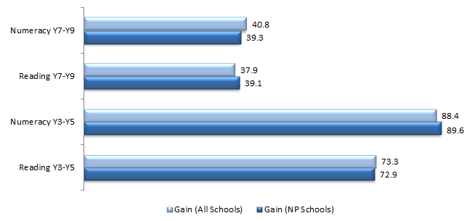
 | Gain (All Schools) | Gain (NP Schools)
Numeracy Year 7 to Year 9 | 40.8 | 39.3
Reading Year 7 to Year 9 | 37.9 | 39.1
Numeracy Year 3 to Year 5 | 88.4 | 89.6
Reading Year 3 to Year 5 | 73.3 | 72.9
Source: PGA constructed chart using VIC DEECD (2013); ACARA (2012)
Analysing achievement data using NAPLAN bands provides additional information on progress at participating schools. In particular, it is important to consider patterns in the proportion of students who are at or below National Minimum Standard (NMS) due to their critically low skill levels. When this was examined for the cohort moving from Year 3 in 2009 to Year 5 in 2011 (Figure 7.2), a general increase in the proportion of students at or below NMS was observed across all Victorian schools. This is a nationally consistent result as historical NAPLAN data shows a greater proportion of students at or below NMS in higher grade levels. Among Low SES NP schools however, this figure was found to have relatively decreased by 7.0% in Numeracy for all students, suggesting low achieving students in these schools are likely to have benefited from the partnership. Further analysis for students transitioning from Year 7 to Year 9 during that same period show signs of improvement amongst Indigenous students in the bottom two bands. In contrast to a general increase in this figure across Victoria, the proportion of Indigenous students at or below Reading NMS in Low SES schools declined by 18.3%.

Figure 7.2: Proportion of students at or below NMS (Year 3 2009- Year 5 2011) in NAPLAN, Victoria
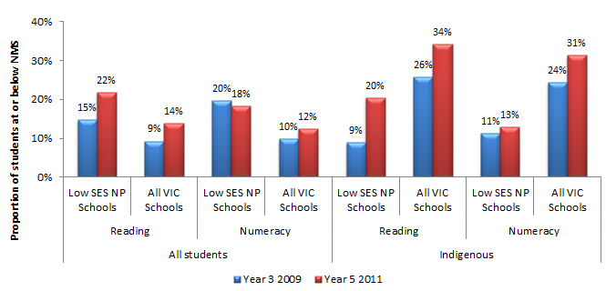
 |  |  | Year 3 2009 | Year 5 2011
All students | Reading | Low SES NP Schools | 15% | 22%
All students |  | All VIC Schools | 9% | 14%
All students | Numeracy | Low SES NP Schools | 20% | 18%
All students |  | All VIC Schools | 10% | 12%
Indigenous | Reading | All Low SES NP Schools | 9% | 20%
Indigenous |  | All VIC Schools | 26% | 34%
Indigenous | Numeracy | Low SES NP Schools | 11% | 13%
Indigenous |  | All VIC Schools | 24% | 31%
Source: PGA constructed chart using VIC DEECD (2013); ACARA (2012)

Achievement in Low SES NP schools
The results presented in Figures 7.1 and 7.2 show limited differences in the change in student achievement between NP and non-NP schools. However as earlier outlined, a number of caveats apply, as the figures do not account for differences in school characteristics, starting points and cohort movement. Therefore, additional analysis of achievement in Victorian Low SES NP schools was undertaken using regression discontinuity design modelling (see Appendix 4). This quasi-experimental form of analysis has gained wide recognition as a robust means of program evaluation when clear selection criteria are used to determine program entry. The results presented in this section arise from analysis of unit-record achievement data of students in Government, Catholic and Independent schools. The analysis used the selection criteria employed by each sector to compare growth in achievement amongst students whose schools participated in the Low SES NP to the achievement patterns of their peers at similar schools that were not selected for the partnership. The use of student-level data is necessary to ensure results represent the best estimates of the impact of the Low SES NP on students who were at schools that participated in the partnership for at least two years. Results of the regression discontinuity (RD) analysis present the average estimated impact of participating in the SSNP on growth in student achievement. For the 2009-2011 student cohort, the results show a statistically significant association between the Low SES NP and growth in student achievement in Years 3-5 Numeracy, with an additional growth of 8.3 points associated with participating in the Low SES NP, holding all else equal (Figure 7.3). Significant additional growth in student achievement at the secondary school level was also found for the 2010-2012 student cohort at Low SES NP schools. This corresponded to an estimated impact of 19.2 points in Reading and 13.1 points in Numeracy.
Figure 7.3: Estimated effect of the Low SES NP on growth in student achievement in all VIC Low SES NP schools
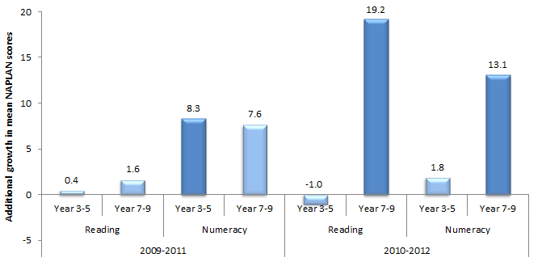
 |  | 2009-2011 | 2010-2012
Reading | Year 3 to Year 5 | 0.4 | -1.0
Reading | Year 7 to Year 9 | 1.6 | 19.2
Numeracy | Year 3 to Year 5 | 8.3 | 1.8
Numeracy | Year 7 to Year 9 | 7.6 | 13.1
Bars represented in dark colours are significant at the 5% confidence level while the light coloured bars are not significantly different from zero at the 5% level.
Source: PGA constructed graph using data provided by VCAA
Analysis of achievement among Indigenous students in all Victorian Low SES NP schools was undertaken using unit-record data to assess the progress of Indigenous students in Low SES NP schools compared to that made by Indigenous students in similar non-NP schools. Similar schools were grouped according to their students’ socioeconomic background as measured by the school ICSEA or their achievement prior to the commencement of the Low SES NP, with the analysis focusing on the lowest four deciles with sufficient school numbers for comparison. In the 2009-2011 student cohort the results show that Indigenous students in Low SES NP primary schools were more likely to exhibit above average growth compared to their peers in non-NP schools with a similar socioeconomic profile. This was more apparent in Reading, where over 64% of Indigenous students at Low SES NP schools achieved above average growth compared to 50% of Indigenous students at non-NP schools with a similar ICSEA. In the 2010-2012 student cohort a higher proportion of Indigenous at students Low SES NP schools generally achieved above average growth compared to their peers in non-NP schools. This was true for all grades and domains with the exception of Years 7-9 Numeracy at schools with similar ICSEA (Figure 7.4).

Figure 7.4: Proportion of Indigenous students in Low SES NP schools who achieved above average growth compared to that of Indigenous students in similar non-NP schools, 2010-2012 student cohort in VIC Government, Catholic and Independent sectors
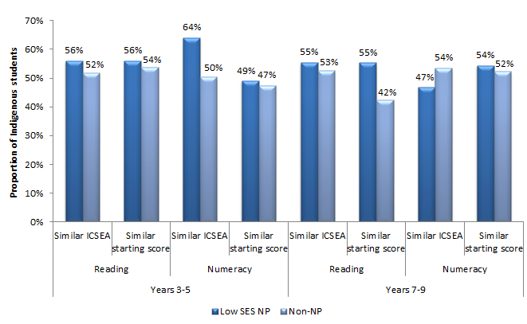
 |  |  | Low SES NP Schools | Non-NP Schools
Years 3 to 5 | Reading | Similar ICSEA | 56% | 52%
Years 3 to 5 | Reading | Similar starting score | 56% | 54%
Years 3 to 5 | Numeracy | Similar ICSEA | 64% | 50%
Years 3 to 5 | Numeracy | Similar starting score | 49% | 47%
Years 7 to 9 | Reading | Similar ICSEA | 55% | 53%
Years 7 to 9 | Reading | Similar starting score | 55% | 42%
Years 7 to 9 | Numeracy | Similar ICSEA | 47% | 54%
Years 7 to 9 | Numeracy | Similar starting score | 54% | 52%
Source: PGA constructed graph using data provided by VCAA
As outlined in the evaluation scope, outcomes were analysed for metropolitan and non-metropolitan schools participating in the Low SES NP. This analysis was conducted using the regression discontinuity design for primary schools which constituted most participating partnership schools. Compared to students at similar non-NP schools, the results suggest that students at non-metropolitan Low SES NP schools, particularly among the 2010-2012 cohort, were more likely to exhibit improvements in Reading. Relative improvements in Numeracy were greater among students at metropolitan schools in the 2009-2011 cohort. However, these results should also be interpreted carefully as schools’ location was not necessarily used as a criterion for selection into the partnerships. Moreover, the approach to the Low SES NP may have varied between metropolitan and non-metropolitan locations. Given the lack of information on the multitude and complexity of implemented programs, it is not possible to attribute observed estimates to particular metropolitan or non-metropolitan initiatives.

Achievement in LNNP schools
In LNNP schools, Victoria was found to have met or exceeded ten targets set to acquire reward LNNP funding, made progress towards seven targets, and did not meet one target. While Victoria fell behind the 2008 baseline in three Year 3 Numeracy measures, the majority of results improved from 2009 to 2011. From 2008 to 2011, the proportion of Year 3 and Year 5 students at or above NMS for Reading and Numeracy improved by between 0.4 and 2.1 percentage points. In addition, the proportion of Year 5 Indigenous students at or above NMS for Reading and Numeracy improved by 3.8 and 6.9 percentage points respectively (COAG Reform Council 2012).
Analysis of unit-record achievement data in all Victorian schools also assessed the progress of students in LNNP schools compared to that made by students in similar non-NP schools. This was undertaken with the same methodology used to construct Figure 7.4. Figure 7.5 presents the proportion of students in the 2010-2012 cohort who exhibit above-average growth in LNNP and similar non-LNNP schools using both definitions of similarity. In both the 2009-2011 and 2010-2012 student cohorts and across both domains and years levels, the proportion of students who achieved above average growth in LNNP schools was comparable to that in similar non-NP schools. The results show that at least 46% of LNNP students in any grade level showed higher growth rates than peers at similar non-participating schools. Although NAPLAN growth rates may not have been as large in all LNNP schools as those in non-NP schools, it is recommended that further research be undertaken with this group to determine why some students at LNNP schools achieved greater success than others.
Figure 7.5: Proportion of students in LNNP schools who achieved above average growth compared to that of students in similar non-NP schools, 2010-2012 student cohort in VIC Government, Catholic and Independent sectors
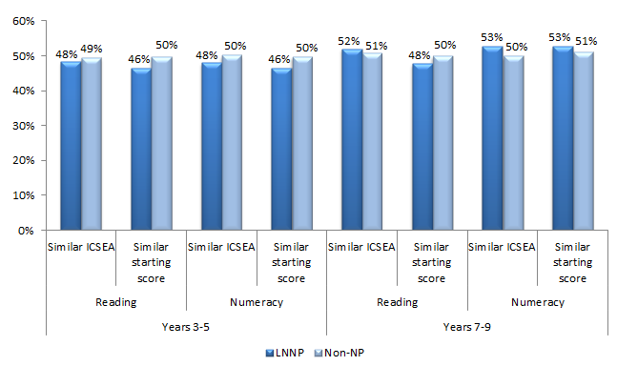
 |  |  | LNNP Schools | Non-NP Schools
Years 3 to 5 | Reading | Similar ICSEA | 48% | 49%
Years 3 to 5 | Reading | Similar starting score | 46% | 50%
Years 3 to 5 | Numeracy | Similar ICSEA | 48% | 50%
Years 3 to 5 | Numeracy | Similar starting score | 46% | 50%
Years 7 to 9 | Reading | Similar ICSEA | 52% | 51%
Years 7 to 9 | Reading | Similar starting score | 48% | 50%
Years 7 to 9 | Numeracy | Similar ICSEA | 53% | 50%
Years 7 to 9 | Numeracy | Similar starting score | 53% | 51%
Source: PGA constructed graph using data provided by VCAA
Amongst Indigenous students at LNNP schools, above-average growth was also more likely to be observed compared to Indigenous students at non-NP schools with students from a similar socioeconomic background. In the 2009-2011 student cohort, the results show that with the exception of Years 7-9 Numeracy, above average growth among Indigenous students in LNNP schools was achieved in greater proportions than in non-NP schools when controlling for socioeconomic status. This was most notable in Years 3-5 Reading where there was a difference of 8%. However, these results were not found when controlling for schools’ starting scores. In the 2010-2012 student cohort on the other hand, a higher proportion of Indigenous students at LNNP schools achieved above average growth compared to their peers in similar non-NP schools. This was found to be true in all grades and domains (Figure 7.6). The differences were most apparent in Years 3-5 Numeracy (10%) and Years 7-9 Reading (14%) among Indigenous students at schools with similar starting scores.
Figure 7.6: Proportion of Indigenous students in LNNP schools who achieved above average growth compared to that of Indigenous students in similar non-NP schools, 2010-2012 student cohort in VIC Government, Catholic and Independent sectors
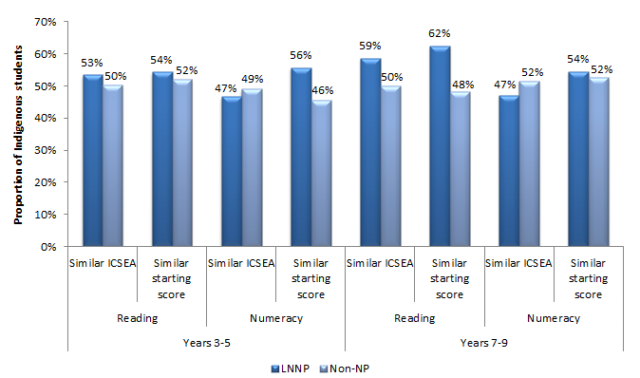
 |  |  | LNNP Schools | Non-NP Schools
Years 3 to 5 | Reading | Similar ICSEA | 53% | 50%
Years 3 to 5 | Reading | Similar starting score | 54% | 52%
Years 3 to 5 | Numeracy | Similar ICSEA | 47% | 49%
Years 3 to 5 | Numeracy | Similar starting score | 56% | 46%
Years 7 to 9 | Reading | Similar ICSEA | 59% | 50%
Years 7 to 9 | Reading | Similar starting score | 62% | 48%
Years 7 to 9 | Numeracy | Similar ICSEA | 47% | 52%
Years 7 to 9 | Numeracy | Similar starting score | 54% | 52%
Source: PGA constructed graph using data provided by VCAA
When analysis of achievement at the primary school level was undertaken by location using the same method described for Figure 7.4 NAPLAN growth patterns between students at metropolitan and non-metropolitan LNNP schools were generally comparable for both the 2009-2011 and 2010-2012 cohorts. However, a notable difference was observed in Numeracy among the 2010-2012 cohort, where the proportion of students at non-metropolitan LNNP schools that achieved above average growth was notably higher than that of students at metropolitan schools. This difference was found to be 11% among students with similar socioeconomic backgrounds and 5% when the analysis compared students with similar starting points.

NAPLAN Participation at SSNP schools
At the primary school level, patterns of NAPLAN participation at SSNP schools were similar to those observed in all Victorian schools. Therefore it is unlikely that overall changes in achievement at the primary school level were affected by NAPLAN attendance trends. At the secondary school level however and specifically in Numeracy, there was a 6% increase in participation at Year 9 and a 6% decrease at Year 7 between 2009 and 2012 in SSNP schools (Figure 7.7). These were different to the trends observed at all Victorian schools. Analysis of NAPLAN participation rates among Indigenous students in SSNP schools shows patterns that were similar to those observed in all Victorian schools.
Figure 7.7: NAPLAN participation in Numeracy at the secondary school level in VIC SSNP schools
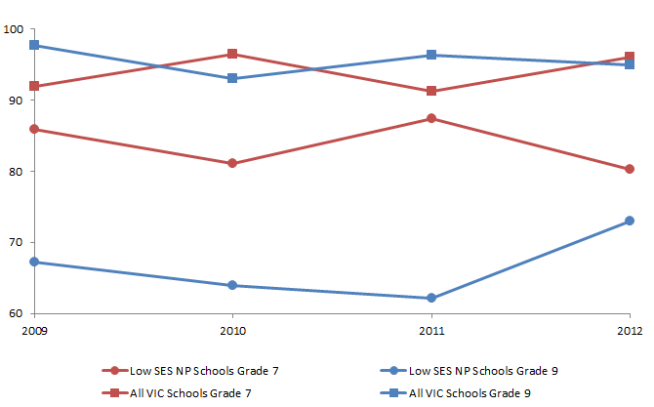
 | 2009 | 2010 | 2011 | 2012
Low SES NP Schools Grade 7 | 85.91 | 81.15 | 87.37 | 80.22
All VIC Schools Grade 7 | 91.90 | 96.50 | 91.30 | 96.10
Low SES NP Schools Grade 9 | 67.18 | 63.91 | 62.16 | 72.99
All VIC Schools Grade 9 | 97.70 | 93.10 | 96.30 | 95.00
NB: NAPLAN participation rates have been reclaculated by considering only students who were assessed
Source: PGA constructed using VIC DEECD (2013)
CASE STUDY: Professional Learning and Coaching delivers results at St. Leo the Great Primary School (Source: VIC DEECD 2012)
St. Leo the Great Primary School demonstrated significant improvement in Numeracy outcomes. The school worked on providing each teacher with extensive Professional Learning. Each teacher attended twelve days of evidence based Professional Learning focused on best practice approaches. Numeracy Coaches provided school support and assisted teachers with their planning of Mathematics curriculum units and in-class support to teachers. This ‘shoulder to shoulder’ support enabled staff to gain confidence with their teaching of Mathematics. The school also implemented a number Intervention Programs over the previous two years, enabling the school to develop a comprehensive 10 to 15 week teaching cycle for low attaining students in Years 1-4. Students were taught individually, in pairs or trios. This program combined with the extensive improvement in the teachers’ pedagogical content knowledge provided from the Professional Learning for classroom teachers has enabled the school to improve their student learning in Mathematics.

CASE STUDY: Evidence Based Observation in improving students’ cognitive levels and student engagement with classroom work
Newhaven College and St Anthony’s Coptic Orthodox College were two of the 13 schools engaged in Evidence Based Observation (EBO) and Coaching in 2011. Teachers were observed at least twice as they taught. The observation was followed immediately by a feedback session to allow the teacher to reflect on the data collected by the observer. After two terms of observations, an increase in student cognitive level was noted at Newhaven, and increased student engagement at St Anthony’s. The trends observed were:
- At Newhaven, an increase in the cognitive skills was noted in Term 3: 31% rated themselves as ‘highly cognitive’ (Term1: 6%), 63% rated ‘medium cognitive’ (Term 1: 52%), and only 6% rated’ low cognitive’ (42% in Term 1)
- At St Anthony’s in Term 1, 16% of target students were engaged 100% of the time, 47% engaged more than 70% of the time with their classroom work; in Term 2, 45% of target students were engaged 100% of the time, 87% engaged more than 70% of the time.

Outcome 3:
Improved leadership and teacher capacity
In addition to being a critical focus for the purpose of raising student achievement, leadership and teacher capacity development were targeted as separate outcomes. In general, schools selected for the SSNP in Victoria reported significant improvements relating to teaching and leadership capacity through a variety of programs across all three sectors. In the Government sector, skills, strategies and insights regarding effective leadership and teacher capacity were reported to have been significantly developed by a number of NP programs, including Coaching for the Principals Class, the Principal Preparation Program, Primary Mathematics Specialists and Supporting New Teachers’ Practice (VIC DEECD 2011; VIC DEECD 2012; VIC DEECD 2013).
Similarly in the Catholic sector, NP school leaders were reported to have improved their professional practice, mainly through the Principal Coaching program and the 360° Leadership Diagnostic Tools, both of which received consistent positive feedback (VIC DEECD 2012; VIC DEECD 2013). In addition, Catholic schools made strong progress in their capacity to lead Social and Emotional Learning (SEL) in their communities, as evident by a formal evaluation of the SEL program (VIC DEECD 2012). Furthermore, pre-service teachers (PSTs) in the Catholic sector described strong engagement with their school communities. They were found to demonstrate a high level of confidence in their potential as teachers and their capacity to lead their school communities. Part of these effects may have been due to their undertaking of the Bachelor of Education Multi-Modal project and the Masters programs in Educational Leadership (VIC DEECD 2011; VIC DEECD 2012).
In the Independent sector, there was a strong consensus that leadership capacity had increased as a result of the NP, with 83% of principals attributing such an improvement to the principal advisors (VIC DEECD 2013). Additionally, 74% of NP teachers in the independent sector reported that there has been an increase in the number of in-school workshops and professional development programs offered to them as a result of the sector’s model of coaching and mentoring in the NP (VIC DEECD 2012).

Outcomes 4 and 5:
All children are engaged in and benefiting from schooling; Schooling promotes social inclusion (including attendance and retention for both Y7-Y10 and Y10-Y12) and reduces the educational disadvantage of children, especially Indigenous children
Student engagement and social inclusion were important focus areas for Low SES NP schools in Victoria. Various activities to engage disadvantaged student cohorts were adopted, especially targeting refugee and Indigenous students. For example, The New Arrivals program provided intensive English language tuition to newly arrived students, while Transition Officers worked intensively with refugees to find appropriate schools and programs. Refugees were also supported through collaborations with Local Learning and Employment Networks and Foundation House.
Wellbeing programs and cultural workshops were further offered to needy Indigenous students, in addition to the development of Individual Learning Plans (ILPs). Furthermore, the Career Enhancement Pathways for Indigenous Education Workers program allowed Koorie Education Workers (KEWs) to guide teacher knowledge and appreciation of Indigenous cultures. This has reportedly helped increase participation of members of the local Indigenous community in teaching and learning forums (VIC DEECD 2012).
Student engagement and social inclusion in Victoria were also addressed through programs aimed at increasing the engagement of families and the community in schooling. Such programs included the Extended School Hubs and the Municipal Literacy Partnership project in the Government sector. Extended Schools Hubs aimed to coordinate partnerships with families, businesses, local government, universities and community based agencies to reduce barriers to learning and to provide complementary learning programs and services. The Municipal Literacy Partnership project was adopted to increase connections between schools, early childhood services and the broader community. Although it is not possible to separate the effects of each program, anecdotal and localised evidence suggests these initiatives may have raised families’ involvement in schooling while improving parents’ understanding of how they can assist their child’s learning.
In the Catholic sector, evidence indicates that participating schools have had an enhanced understanding of the role of family-school-community partnerships in learning, and the number of school community strategies and initiatives with this focus has increased (VIC DEECD 2011). A notable initiative was the appointment of Family School Partnership Convenors (FSPCs) that supported leadership teams, teachers, families and communities to implement engagement initiatives.
Parental engagement in the Independent sector was mainly targeted through parent information sessions and forums, parent reading support groups, after-school homework clubs and careers nights. Programs adopted a particular focus on LBOTE students. Anecdotal evidence further suggest that schools valued advice and support from experienced Principal and Community Engagement Advisors who were employed to regularly visit schools to promote school-community engagement (VIC DEECD 2012).
A significant causal impact of the NP on engagement and learning was additionally found in Victoria beyond basic literacy and numeracy skills measured in NAPLAN (Figure 7.8). Participation in the program was firstly linked to raising students’ perception of their learning environment. Analysis of Student Opinion Surveys show substantially higher levels of reported teacher effectiveness in Government NP schools compared to non-NP schools. Students in Government NP schools also reported an increase of between 12 and 15 percentage points in opinion surveys measuring engagement with the teaching practices they experience.
Figure 7.8: Student perceptions on matters related to their learning experience, 2011 Student Opinion Survey, Victorian Government NP schools
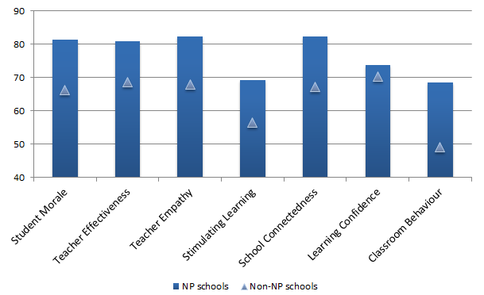
 | NP schools | Non-NP schools
Student Morale | 81.5 | 66
Teacher Effectiveness | 81 | 69
Teacher Empathy | 82 | 68
Stimulating Learning | 69 | 56
School Connectedness | 82 | 67
Learning Confidence | 74 | 70
Classroom Behaviour | 68 | 49
Figures reported on a 100-point scale for each factor
Source: Helal (2012)
In addition, trends in student opinion survey data in Catholic primary and secondary schools in Victoria between 2010 and 2012 suggest a potential impact of the SSNP at these schools. The data collected included the extent to which students perceived their school stimulated learning and the degree to which students felt connected to school, motivated to learn and confident in their ability to learn. At NP schools in 2012, students’ perceptions of being stimulated to learn and their connectedness to school were found to be slightly higher than in 2010, a trend not observed in non-NP schools (Figure 7.9). Although these results do not seem to be statistically significant, the figure suggests student engagement may have improved at Catholic schools that received partnership funding. Little changes were observed in student motivation and learning confidence among both school groups between 2010 and 2012.

Figure 7.9: Results of student opinion surveys in Victorian Catholic primary and secondary schools
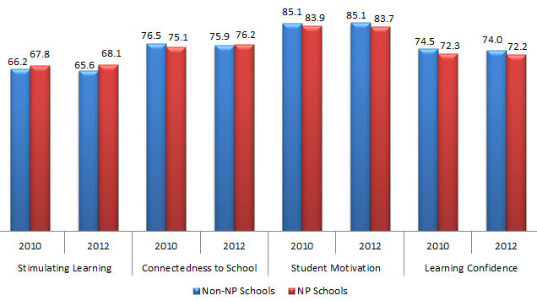
 |  | Non-NP Schools | NP Schools
Stimulating Learning | 2010 | 66.2 | 67.8
Stimulating Learning | 2012 | 65.6 | 68.1
Connectedness to School | 2010 | 76.5 | 75.1
Connectedness to School | 2012 | 75.9 | 76.2
Student Motivation | 2010 | 85.1 | 83.9
Student Motivation | 2012 | 85.1 | 83.7
Learning Confidence | 2010 | 74.5 | 72.3
Learning Confidence | 2012 | 74.0 | 72.2
Source: PGA constructed graph based on data provided by the Catholic Education Office Melbourne
Staff opinion surveys were also carried out in Victorian primary and secondary Catholic schools. These were used to assess a number of factors, including staff perceptions of supportive leadership, professional growth, student motivation, empowerment and overall enthusiasm between 2010 and 2012. Among NP schools, the 2012 results show higher levels of supportive leadership, student motivation and overall enthusiasm than in 2010 (Figure 7.10). As non-NP schools also experienced improvements in these areas, it is unclear if the improvements at NP schools were due to their participation in the partnerships.

Figure 7.10: Results of staff opinion surveys in Victorian Catholic primary and secondary schools
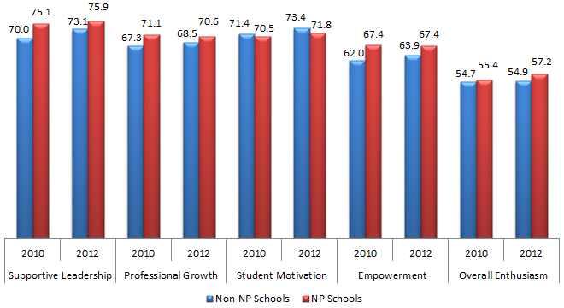
 |  | Non-NP Schools | NP Schools
Supportive Leadership | 2010 | 70.0 | 75.1
 | 2012 | 73.1 | 75.9
Professional Growth | 2010 | 67.3 | 71.1
 | 2012 | 68.5 | 70.6
Student Motivation | 2010 | 71.4 | 70.5
 | 2012 | 73.4 | 71.8
Empowerment | 2010 | 62.0 | 67.4
 | 2012 | 63.9 | 67.4
Overall Enthusiasm | 2010 | 54.7 | 55.4
 | 2012 | 54.9 | 57.2
Source: PGA constructed graph based on data provided by the Catholic Education Office Melbourne
Evidence of the potential impact of the SSNP on student engagement was also found in an analysis of Independent NP schools’ student survey data between 2009 and 2012 for students in Years 5-12. Survey questions assessed student perceptions of their school environment, teacher support and guidance, and their own confidence in learning. Between 2009 and 2012, statistically significant increases in student perceptions were observed among all these variables (Figure 7.11). This improvement was most apparent in the provision of quality teachers, provision of excellent resources and teacher knowledge, suggesting that the NP may have impacted student learning at these schools through improving the quality of teaching and resources. It must be noted however that changes in these variables were not measured at non-NP schools. Therefore, it remains unclear as to whether the improvements at NP schools are reflective of the state-wide trends or if they truly are a result of NP participation.

Figure 7.11: Results of student opinion surveys in Victorian Independent NP schools
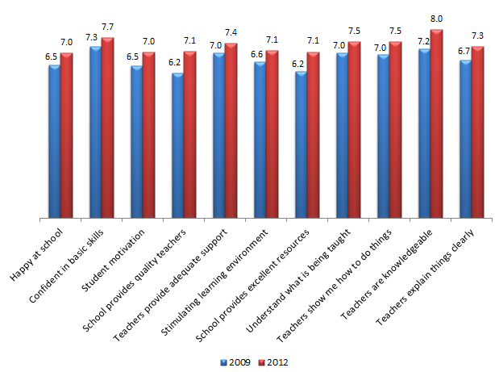
 | 2009 | 2012
Happy at school | 6.5 | 7.0
Confident in basic skills | 7.3 | 7.7
Student motivation | 6.5 | 7.0
School provides quality teachers | 6.2 | 7.1
Teachers provide adequate support | 7.0 | 7.4
Stimulating learning environment | 6.6 | 7.1
School provides excellent resources | 6.2 | 7.1
Understand what is being taught | 7.0 | 7.5
Teachers show me how to do things | 7.0 | 7.5
Teachers are knowledgeable | 7.2 | 8.0
Teachers explain things clearly | 6.7 | 7.3
Source: PGA constructed graph based on data provided by Independent Schools Victoria
To better understand the impact of the Low SES NP on attendance, analysis was undertaken comparing trends in student attendance at participating schools to those in non-NP schools. The Victorian Government sector monitors student attendance at school by recording the number of days absent. This differs to the case in other jurisdictions as well as the Victorian Catholic sector, where attendance is monitored by the number of school days attended. The varying measures used by each sector prevented the aggregation of sector level data and hence attendance was analysed separately for each sector.
Low SES NP schools generally had higher absence rates prior to the commencement of the partnership. In Victorian Government schools, analysis of attendance used school-level data to compare whether the difference in the average yearly absence rate per student between Low SES NP schools and non-NP schools declined over time. Following three years of NP participation, the number of absence days for all students at Low SES NP schools showed little change relative to non-NP schools at both primary and secondary school levels. No improvement was also observed among Indigenous students at the primary school level. However, among Indigenous students at the secondary school level attendance appeared to have improved, as Figure 7.12 shows that the gap in the number of absence days at Low SES NP schools compared to non-NP schools, declined by 6.7 absence days per year. This accounted for 76.8% of the attendance gap for Indigenous students in secondary schools.
Figure 7.12: Average number of absence days per year among Indigenous students in VIC Government schools
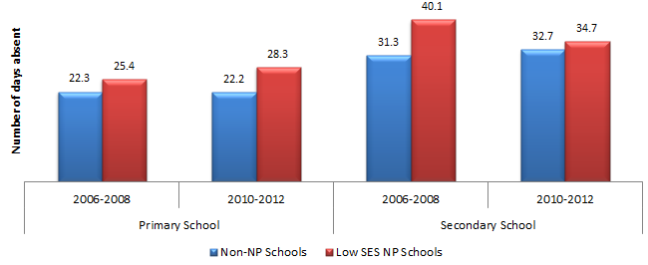
 |  | Non-NP Schools | Low SES NP Schools
Primary School | 2006 to 2008 | 22.3 | 25.4
Primary School | 2010 to 2012 | 22.2 | 28.3
Secondary School | 2006 to 2008 | 31.3 | 40.1
Secondary School | 2010 to 2012 | 32.7 | 34.7
NB: Primary School figures exclude Grade Prep
Source: Primary school figures exclude Grade Prep
CASE STUDY: Pre-service teachers engage students at East Preston Islamic College (VIC DEECD 2012)
At East Preston Islamic College, students benefited from the coaching they received from PST tutors, building trusting relationships and literacy skills, receiving assistance with understanding and completing homework, and gaining confidence to participate more actively in the classroom setting. Teachers indicated that students’ engagement and motivation was improving as a result of the confidence they gained from the program.

CASE STUDY: Effective use of technology to raise engagement and performance at Warringa Park School (VIC DEECD 2013).
Through the collective efficacy amongst teachers to differentiate learning for every student, Warringa Park School made a significant difference to student achievement. The school has shown that all students can learn and make significant progress in Literacy and Numeracy if they are given the opportunity, and if staff members know how to use assessment and data to drive this learning. The iPad, as the preferred learning device, has increased engagement, personalised learning for students, and enabled teachers to be more focused on their instructional practice. There was a seven per cent increase in literacy outcomes and an 11% increase in numeracy outcomes. In 2012, 100 per cent of students completed their VCAL certificate, optimising their opportunities for accessing authentic post-school options.

CASE STUDY: Koorie Literacy engagement and support in the Gippsland region (VIC DEECD 2012).
The Gippsland Region reported that as a result of the Koorie Literacy project, as well as the work of Koorie Engagement Support Officers and other indigenous support staff, over 90% of Indigenous families have increased their engagement with schools. In some cases, families met with teachers at the school for the first time since their children attended school.
Similar analysis of the gap in attendance between Low SES NP and non-participating schools was undertaken for Catholic schools. This analysis assessed average attendance rates at both primary and secondary schools. The data indicates that overall attendance rates in Low SES NP schools showed little change relative to non-NP schools at both primary and secondary school levels. Among Indigenous students at the primary school level however, the increase in attendance rates at Low SES NP schools was 2.4% higher than that observed in non-NP schools. Moreover, Indigenous students’ attendance was found to be higher in 2012 at Low SES NP schools (Figure 7.13). In addition, the attendance rates of Indigenous students in Low SES NP schools at the secondary school level were found to have significantly improved compared to their peers in non-NP schools, with the initial gap decreasing by 17.8 percentage points or approximately 65% of its initial value.

Figure 7.13: Attendance rates of Indigenous students in VIC Catholic schools
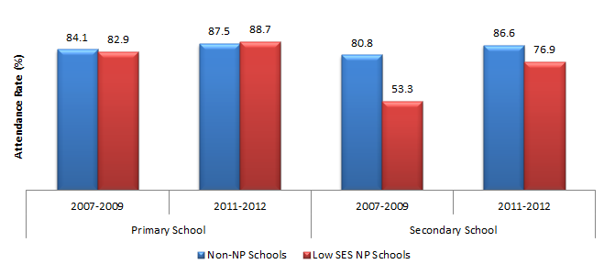
 |  | Non-NP Schools | Low SES NP Schools
Primary School | 2007 to 2009 | 84.1% | 82.9%
Primary School | 2011 to 2012 | 87.5% | 88.7%
Secondary School | 2007 to 2009 | 80.8% | 53.3%
Secondary School | 2011 to 2012 | 86.6% | 76.9%
NB: Secondary school level figures include only Years 7-10, as years 11-12 attendance data was not provided for the Catholic sector. Primary school level figures exclude the Preparatory year level.
Source: PGA constructed graph based on attendance data provided by DEEWR.
CASE STUDY: Involving parents and the local community in the Eastern Metropolitan Region (VIC DEECD 2011).
By inviting parents to engage in school activities, Eastern Metropolitan Region reported increased confidence in parents, leading to greater valuing of education and increased school attendance. By enabling students to participate in local community activities, student self-esteem and community engagement have increased in low socio-economic settings.
Apparent retention rates (ARR) were also assessed as an indication of student engagement by investigating the relationship between participating in the Low SES NP and student retention. The ARR is measured as a ratio of students in a particular grade level divided by the number of students in an earlier grade level. Aggregated Government and Catholic school enrolment data showed that in Low SES NP schools, the Year 7-10 ARR increased from 103.7% between 2007 and 2010 to 107.3% between 2009 and 2012 (Figure 7.14). This increase was significantly higher than that observed in non-NP schools. Among Indigenous students, the Year 7-10 ARR at Low SES NP schools was also found to have increased by over three times the amount in non-NP schools. However, this result should be interpreted with caution due to the small number of schools with sufficient Indigenous student enrolment to be included in the analysis. A different scenario was observed in the Year 10-12 ARR in the Government sector. At Low SES NP schools, the Year 10-12 ARR decreased by 5.6% when comparing the period prior to NP-commencement with the period following commencement (Figure 7.15). There was also a decrease in non-NP schools, although this was found to be 4.1%. Among Indigenous students however, there was a 17.6% reduction in the Year 10-12 ARR at Low SES NP schools, with no differences found in non-NP schools. These results should not be taken as causal evidence of the impact of the SSNP on student retention due to the small number of schools with an adequate enrolment of Indigenous students. In addition, apparent retention rates are aggregated measures of student enrolments which do not control for student movement between schools, an important factor that may be driving the large observed changes in the ARR.
Figure 7.14: Apparent Year 7-10 retention rates in VIC Government and Catholic schools commencing Low SES NP participation on 2010
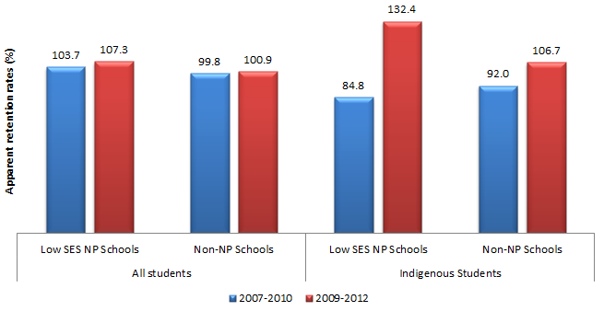
 |  | 2007 to 2010 | 2009 to 2012
All students | Low SES NP Schools | 103.7% | 107.3%
 | Non-NP Schools | 99.8% | 100.9%
Indigenous students | Low SES NP Schools | 84.8% | 132.4%
 | Non-NP Schools | 92.0% | 106.7%
Source: PGA constructed graph based on enrolment data provided by VIC DEECD and DEEWR

Figure 7.15: Apparent Years 10-12 retention rates VIC Government schools commencing Low SES NP participation on 2010
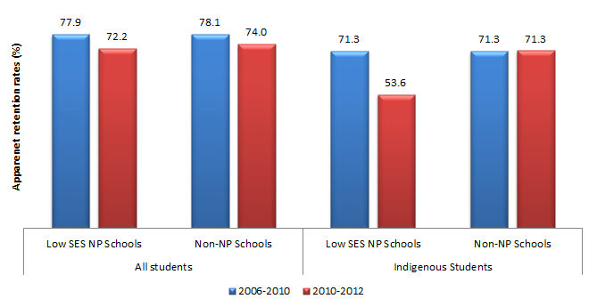
 |  | 2006 to 2010 | 2010 to 2012
All students | Low SES NP Schools | 77.9% | 72.2%
 | Non-NP Schools | 78.1% | 74.0%
Indigenous students | Low SES NP Schools | 71.3% | 53.6%
 | Non-NP Schools | 71.3% | 71.3%
NB: The 2006-2010 figures are the average ARRs between 2009 and 2010
Source: PGA constructed graph based on enrolment data provided by VIC DEECD

7.3 VIC CONCLUSION
In Victoria, the NP was found to have had a positive effect on student achievement in primary school level Numeracy and in secondary school level Reading and Numeracy. Positive associations between NP participation in both Reading and Numeracy were also observed among Indigenous students in the lower ICSEA deciles, particularly at the primary school level. Activities implemented under the NP seem to have raised students’ perceptions of their learning environment and improved the engagement of disadvantaged students. For example, among Indigenous students at the secondary school, the attendance rates at Low SES NP schools were found to have improved significantly compared to non-NP schools. In addition, school enrolment data showed that in Low SES NP schools, the Year 7-10 ARR among all students and Indigenous students increased more than three times higher than that observed in non-NP schools.
One area through which the NP are likely to have had an impact is the significantly enhanced teaching and leadership capacity reported at Victorian NP schools through a variety of programs. Principals have reported that participation in the NP has facilitated a change of culture in schools and teacher practices, particularly in the use of evidence-based approaches and focused planning to meet students’ needs. Improved student achievement and engagement in Victorian NP schools may have also been facilitated by the often-cited enhanced engagement of families and the community in student learning. Addressing the complex interactions among family, community and school is increasingly viewed to be important to consider in order to close achievement gaps (Boethel, 2003). Programs and interventions that engage families in supporting their children’s learning at home have been frequently linked to improved student achievement (Jordan, Snow & Porche, 2000; Starkey & Klein, 2000).
The multitude of programs implemented under the SSNP challenge the identification of exact activities that led to observed outcomes, though common patterns are evident. In the Government sector, skills, strategies and insights regarding effective leadership and teacher capacity were reported to have been significantly developed by a number of NP programs, including Coaching for the Principals Class, Principal Preparation Program, Primary Mathematics Specialists program, Coaching and Supporting New Teachers’ Practice Program (VIC DEECD 2011; VIC DEECD 2012; VIC DEECD 2013). The coaching programs not only prepared teachers to deal with teaching and learning within the context of their schools and classrooms but also prepared principals to take on a leadership role that promotes student learning.
Developing principals’ capacity to lead schools appears to have been a common pathway for the impact of the NP across all schooling sectors. Evidence suggests that this was achieved through coaching activities such as the Principal Coaching program and the 360° Leadership Diagnostic Tools in Catholic schools, both of which received overwhelmingly positive feedback (VIC DEECD 2012; VIC DEECD 2013). In the Independent sector, there was a strong consensus that leadership capacity had increased as a result of the NP, with 83% of principals attributing such an improvement to the principal advisors (VIC DEECD 2013). Additionally, 74% of NP teachers in the independent sector reported an increase in the number of in-school workshops and professional development opportunities as a result of the sector’s model of coaching and mentoring in the NP (VIC DEECD 2012).
The NP was also successful in increasing the understanding of the roles and the importance of connections between schools, early childhood services and the broader community, primarily through the Municipal Literacy Partnership project. Partnerships, governance arrangements and principal engagement were strengthened through the extended school hubs, with all hubs having formed a range of partnerships between schools, non-government organisations, local government, business and the broader local community. Furthermore, the involvement of families in schooling, relationships amongst parents and between them and a greater parent understanding of how they can assist their child, were all reported to have improved as a result of family education programs. These programs were centred around literacy and numeracy, training parents as school volunteers and communicating with families through newsletters and online. Moreover, particular programs appear to have been successful in increasing family engagement specifically for Indigenous students. Guiding teacher knowledge and appreciation of Indigenous cultures through programs such as Koorie Education Workers for instance, has reportedly helped increase participation of members of the local Indigenous community in teaching and learning forums (VIC DEECD 2012). This is likely to have improved the engagement of Indigenous students and their families by promoting a better understanding of Indigenous culture and Indigenous student needs at school. Evidence in the Catholic sector also indicates that participating schools have had an enhanced understanding of the role of family-school-community partnerships in learning, primarily through the work of Family School Partnership Convenors. This has been recognised with further increases in the number of school community strategies and initiatives with this focus (VIC DEECD 2011). At the Independent NP schools, regular advice and support from both the principal and Community Engagement Advisors was reported to have developed greater school-community engagement (VIC DEECD 2012).
Overall, there are clear indications of improved student achievement and engagement in Victoria during the NP funding period, with the NP programs seeming to have created positive influences in participating schools. At this stage however, the effect of each initiative or activity cannot be causally evaluated. The implementation of a number of similar activities at NP schools suggests that these improvements are likely due to enhanced teaching and leadership capacities as well as strengthened engagement of families and the community in student learning. However, it is important to identify and analyse the activities that achieved their intended outcomes for the efficacy of future interventions. Currently available data do not permit identifying non-NP activities that may have been funded at both NP and non-NP schools, which are likely to confound observed program effects. Further analyses of such data can provide better understanding of the link between interventions and outcomes in order to inform policymakers’ and educators’ decisions around which programs work better than others. As outlined in the final chapter, such data can be collected through further research involving surveys and focus groups that can map data on specific activities to intended student achievement and engagement outcomes.

GLOSSARY
ACU: Australian Catholic University
ATP: Action Team for Partnerships
BIEL: Bastow Institute of Educational Leadership
CRT: Casual Relief Teacher
EAL: English as an Additional Language
EBO: Evidence Based Observation
ELTC: Enhancing Leadership Team Capability
EMU: Extending Mathematical Understanding
ESL: English as a Second Language
FSPC: Family School Partnership Convenors
GRIN: Getting Ready in Numeracy
ICT: Information and Communications Technology
ILP: Individual Learning Plans
KELP: Koorie Education Learning Plan
KESO: Koorie Engagement Support Officers
KEW: Koorie Education Workers
LBOTE: Language Background Other Than English
L/N: Literacy and Numeracy
LNNP: Literacy and Numeracy National Partnership
Low SES NP: Low Socioeconomic School Community National Partnership
NAPLAN: National Assessment Program – Literacy and Numeracy
NMS: National Minimum Standard
NP: National Partnership
PD: Professional Development
PLEQT: Partnerships in Learning: Enhancing Quality Teaching
PLC: Programmable Logic Controller
PLT: Professional Learning Team
PST: Pre-Service Teacher
REDI: Resilience Education and Drug Information
RR: Reading Recovery
SALSEL: Speaking and Listening Supporting Early Literacy
SEL: Social and Emotional Learning
SSNP: Smarter School National Partnership
SWCE: School Welfare and Community Engagement
TEAL: Tools to Enhance Assessment Literacy
VCAL: Victorian Certificate of Applied Learning
YALP: Yachad Accelerated Learning Project

Western Australia


Low SES NP and LNNP
In WA, the Low SES NP and LNNP were implemented under various reform areas targeting:
- Incentives for teachers and leaders
- Innovative instruction
- Effective school planning
- Improving school operational practices
- Family and community partnerships
- Effective teaching
- Student monitoring and assessment
- Whole-school engagement with literacy and numeracy

Targeted Low SES NP Outcomes
- Progress towards improvement in literacy and numeracy achievement
- Progress towards improvement in regular student attendance and engagement, particularly among Indigenous students
- Increase in the:
- number of external partnerships and programs established
- external partnerships with parents, other schools, businesses and communities and the provision of access to extended services
- level of parental involvement
- Greater autonomy, innovation and flexibility is achieved
- Progress towards improvement in school accountability through self-assessment, planning and reporting
- Progress towards improvement in attracting high quality and experienced principals and teachers to Low SES schools
- Young people make a successful transition from school to work and further study
- Targeted LNNP Outcomes
- Progress towards improvement in literacy and numeracy achievement in NAPLAN (mean and distribution)
- Differentiated curriculum is provided for case managed students
- Progress towards improvement in school self-assessment, planning and reporting
- Increased use of evidence-based whole school planning and approaches

Key findings from synthesis of existing data
Participation in the Low SES NP was associated with:
- Significant improvement in achievement in Years 5-7 Numeracy.
- Limited changes in attendance rates at Government schools and Independent schools while attendance rates appear to have risen in Catholic schools.
- Increase in the Years 10-11 and 10-12 apparent retention rates of Indigenous students in Government schools.
- Greater autonomy, innovation, flexibility and accountability at schools.
- Attracting high quality and experienced principals and teachers.
- Increased parental involvement and a rise in the number of external partnerships.
Participation in the LNNP was found to be associated with:
- Significant improvement in mean student NAPLAN scores in Year 3 Numeracy and to a lesser extent Reading.
- An increase in the proportion of Government school students at or above NMS between Years 5 and 7.
- Improvement in PAT-R among Catholic school students in Years 7 and 8.
- A majority of case-managed Indigenous students on track to meet achievement targets in Literacy and Numeracy.
- An increased effectiveness of ongoing assessment, whole-school planning and reporting.

8.1 WA ACTIVITIES & OUTPUTS

Overview
In WA, a total of 155 schools participated in the Low SES NP, aimed at addressing the needs of disadvantaged students. Partnership schools were allocated into various waves commencing between 2010 and 2012. For example, Government schools participated in a phased rollout over five waves. Schools in all three sectors were selected for a four-year period based on the Index of Relative Socio-Economic Disadvantage (IRSED). WA additionally identified schools believed to warrant inclusion, due to their low Socio-Economic Index (SEI) score. Under the Low SES NP, several systemic initiatives were adopted, including establishing specialist teacher positions, incentives for teachers and leaders and capacity building. Schools in the Low SES NP further implemented a range of activities targeting flexible operations and increased autonomy, external partnerships, whole-school planning and extended services.
Selection into the LNNP, involving 209 schools was dependent on the proportion of students who were at or below NMS in literacy and numeracy. Consideration was also made in relation to each school’s student background characteristics, including enrolment size, student language background and Indigenous status. LNNP schools emphasised professional learning, tailored support, evidence-based teaching strategies and active use of data.
Of the 349 Low SES NP or LNNP schools in WA, only 15 schools (4.3%) participated in both partnerships, all of which were either Catholic (11) or Independent (4) schools.
Figure 8.1: Participation in the Low SES NP and LNNP in Western Australia
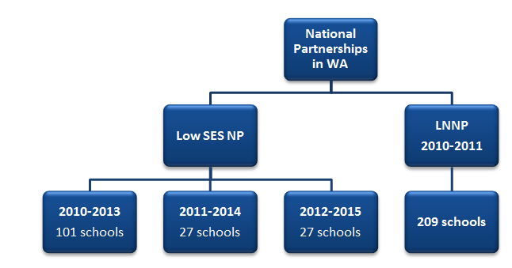
The National Partnerships in Western Australia consisted of the Low SES NP and the LNNP.
Under the Low SES NP:
2010 to 2013 there were 101 schools
2011 to 2014 there were 27 schools
2012 to 2015 there were 27 schools
Over 2010-2011, Western Australia had 209 schools participating in the LNNP.

Low SES NP
Schools participating in the Low SES NP in WA aimed to:
- transform the way that schooling takes place in participating schools to address the complex and interconnected challenges facing students in disadvantaged communities;
- improve student engagement, educational attainment and well-being in participating schools and make inroads to entrenched disadvantage.
Strategies to address these aims comprised undertaking school self-assessments, enhancing planning and reporting, attracting high quality principals and teachers, increasing parental involvement and external partnerships and enabling students to make successful transitions to further study and work. Within these strategies, a range of initiatives were implemented. Notable initiatives included evidence-based literacy and numeracy programs, early childhood programs and school community partnerships. In addition, systemic initiatives were a key component of the Low SES NP such as increasing school flexibility, autonomy and accountability, building partnerships across sectors, increasing learning time, and enhancing school improvement planning across all areas.

Incentives to attract high performing principals and teachers
Notable programs adopted under this strategy included the ‘Attracting Outstanding Principals’ and ‘Consultant Teacher’ programs, both of which were specific to the Government sector. Attracting Outstanding Principals offered remuneration packages specifically designed to attract and retain high quality principals to address educational equity and improve student outcomes in disadvantaged Indigenous, rural/remote and hard-to-staff-schools. It was implemented in 2011 with two appointments made under the Attracting Trial during 2012 (WA DoE 2013a). The Consultant Teacher program trialled a new specialist teacher position at selected Low SES NP schools, with the school-based position focused on improving the quality of teaching, as well as leading teachers in the development and refinement of their teaching practice to improve student outcomes. It was designed and initiated in 2011, with seven schools advertising to fill positions for 2012.
The Kimberley Success Zone (KSZ) project aimed to create, develop and maintain authentic educational partnerships across the three sectors in Kimberley region by providing access to leadership support and development across the three sectors in the Kimberly region (WA DoE 2013a). As a result, 24 Kimberley school leaders were enrolled in a coaching accreditation program. This program was designed for leaders and managers in the education sector who are committed to significantly building their leadership skills in order to manage themselves and others towards greater performance. KSZ also provided opportunities for ‘new to Kimberley’ teachers to connect through the establishment of an online environment in which new teachers from all sectors can ask questions of a moderator, learn from each other, articulate professional learning needs, utilise an expanding resource library and maintain professional relationships with colleagues.
The Government and Catholic sectors also adopted a three-year program (Fogarty EDvance) to support school principals to improve leadership capabilities within their school as well as the educational outcomes of children located in Low SES communities. The program consisted of coursework and cohort topics for meetings relevant to the schools’ context and learning journey. The first group of schools commenced their participation in the leadership program in April 2012 (WA DoE 2013a). A total of eight schools were selected, including six primary (4 Government, 2 Catholic) and two Government senior high schools.
In the Independent sector, the ‘Principal Mentor’ program was used to support new principals settling into remote schools with the aim of improving their retention in addition to building their quality and skills and forming positive links to the community. Two schools undertook this initiative in 2011.

Adoption of performance management and staffing arrangements that articulate a clear role for principals
The Low SES NP provided schools with additional resources to explore a range of school level reforms, including sharing resources and staff expertise to meet the needs of their students and communities. Low SES NP funding was also used by a number of schools to reduce class sizes. Survey responses highlighted the contribution of the Low SES NP to allowing schools to introduce flexible and innovative operating practices. Survey responses also showed that schools have been able to develop deeper, more effective distributed leadership through various initiatives. Such initiatives include professional development, increasing the number of Aboriginal and Islander Education Officers (AIEOs) within classrooms, and providing greater opportunities for collaboration amongst teachers within a school and across several schools (WA DoE 2013b).
At the system-level, Catholic schools adopted a number of strategies, including performance review processes for the school and the principals. Additionally all Catholic schools continued to use the Quality Catholic Schooling framework to monitor, discuss and plan for school improvement across all areas, including leadership and staff development in 2011 (WA DoE 2012a). The Catholic sector also commenced the Promoting Alternative Thinking Skills (PATHS) program in 2009, which has since been implemented across the 13 Catholic Low SES NP schools in the Kimberley region. PATHS was aimed at addressing behavioural management, self-confidence and student engagement. It involved the employment of a PATHS coordinator (2010) and a PATHS consultant (2011 and 2012) who trained teachers and principals in the 13 schools to build teacher and leader capacity (WA DoE 2011; WA DoE 2012a; WA DoE 2013a). In the Independent schools, all principals and teachers in Low SES NP schools were mentored and supported to meet performance expectations set as part of their performance appraisal (WA DoE 2011).

School operational arrangements which encourage innovation and flexibility; Strengthen school accountability
Low SES NP schools in the Government sector established school networks to share staff resources, staff expertise, best practice and professional learning (PL) communities, in addition to employing additional staff to improve school operational arrangements. In 2012, 38% of Low SES NP schools indicated that they were implementing strategies to improve school operational arrangements which encourage innovation and flexibility. During the same year, the collection, analysis and interpretation of data was another key focus in 48% of Government Low SES NP schools, in order to inform school planning and improve reporting of student outcomes (WA DoE 2013a).
All Catholic NP schools were reported to have conformed to School Level Plans posted online, enhancing school accountability. In addition, the ‘Extending the School Day’ project was an innovative project in this sector focused on activities which were conducted before or/and after school. In this project, teachers and Aboriginal Teacher Assistants (ATAs) or community members were paid to deliver a program that links to the key aims and outcomes of the school. This was initiated in 2010 and by 2011, 28 Low SES NP schools in the non-Kimberly region had been provided with additional support (WA DoE 2011; WA DoE 2012a).

Providing innovative and tailored learning opportunities

Early childhood initiatives
In 2011, 36 Low SES NP Government schools reported introducing early intervention strategies, including playgroup programs, 0-4 school readiness programs, oral language programs and speech therapy programs. In 2012, 71 Low SES NP Government schools indicated that they were implementing innovative and tailored learning opportunities for students. This involved systematic and explicit literacy teaching for K-3 by sharing good practices through classroom observations and mentoring. In the Independent sector, early childhood initiatives included participation in professional learning with 20 schools developing staff teaching practices in line with the Early Childhood Reforms in 2011 (WA DE 2012a). These reforms were undertaken in seven Low SES NP Primary schools, as well as in the Indigenous schools, or schools with a high proportion of Indigenous students.

Attendance and participation programs
Strategies aimed at improving student attendance in Government Low SES NP schools involved a range of initiatives that often included partnering with community organisations, with a number of these initiatives focusing on Indigenous students. These included the Sports Programs, Transition Support programs and the Special Programs for Attendance and Retention of Kids (SPARK). SPARK involved the employment of an Indigenous Youth Officer to maintain positive relationships with the community and to work collaboratively with the Aboriginal School Education Officer on program development for both parents and students. In the Catholic sector, attendance monitoring was enhanced through the ‘Tracking Students Project’ where a unique identifier was allocated to all students in the Kimberly. This was used in conjunction with the KSZ Tri-border initiative to deliver live and current attendance information to a Central Schools Database (CSD). The focus in the Independent sector was on improving engagement in the Middle Years. For example, the curriculum was re-designed for at-risk middle school students in three Curriculum and Re-engagement in Education (CARE) schools, taking into account students’ context and the need for the content to be accessible and relevant.

Literacy and Numeracy interventions
The development of innovative teaching and learning strategies targeting the literacy and numeracy outcomes of students in Low SES NP schools across the three sectors was targeted through coaching, individualised plans and literacy and numeracy support programs. In 2010, 70 Low SES NP Government schools implemented strategies to improve the Numeracy outcomes of all students. By 2012, 81% of these schools reported progress in implementing the reforms. ‘First Steps Reading’ is another important program that was used in many Government schools. It supported key teachers in developing whole-of-school approaches and learning area audit tools in the literacy field. Other literacy and numeracy programs adopted at Low SES NP Government schools included Reading Recovery and MULTILT. In 2012, KSZ subsidised positions for all three sectors to access “Stronger Smarter” leadership professional learning as part of a focus on maintaining high expectations and educational outcomes for Indigenous students (WA DoE 2013a).
Catholic sector strategies included the Reading Recovery (RR) program and the Extending Mathematical Understandings (EMU) program, both of which provided additional intensive Literacy and Numeracy support. Furthermore, 13 Catholic Kimberley schools received further support through consultant visits to provide coaching and mentoring. In the Independent sector, a dedicated Low SES NP consultant was employed at five Kimberley schools to train teachers in Reading Recovery. Independent schools also focused on providing literacy and numeracy support to Indigenous and disadvantaged students. Innovative strategies were introduced through the implementation of the ‘ICT project’ for Indigenous students. This initiative aimed to up-skill teachers and students in the use of iPads and electronic whiteboards to improve literacy engagement.
Independent schools adopted the ‘Alta-1’ education pathway for at-risk students who had been asked to leave their previous schools for various anti-social reasons. Alta-1 attended to students’ social and emotional well-being first, before addressing the literacy and numeracy skills in supportive and challenging ways.

Pathways to work, training or university
Partnership funding enabled 11 Indigenous Government schools (with a very high proportion of Indigenous student enrolment) to undertake initiatives aimed at facilitating pathways to work, training or university. For example, follow-up support was provided to students who attended boarding schools in metropolitan and regional centres to assist them in completing upper-secondary schooling. Other schools introduced support programmes to facilitate a smooth transition from primary school to high school that began at year 5. In addition, a partnership between a cluster of schools in the Midland region, a number of community agencies and a university, was established to not only focused on keeping students in school but also helping them make a successful transition to tertiary education and employment (WA DoE 2013a). In the Independent sector, ‘Transition to the Workplace’ was an initiative that linked industry to the skill sets of students to ensure their smooth transition to the workforce upon school completion. Support was also provided to 15 Aboriginal Education Workers (AEWs) who commenced a Certificate III in Education Assistance in 2011 to enable them to support students more effectively (WA DoE 2012a).

Approaches to improving outcomes for Indigenous students and students with special learning needs
number of programs were implemented in WA Low SES NP schools to improve outcomes for Indigenous students and students with special learning needs. This included programs that involved Indigenous communities in school decision-making processes, most notably through the “Stronger Smarter Leadership” program that involved 25 Low SES NP Government schools. This program engaged with parents and communities to support student attendance and learning by making it relevant to their needs and interests, particularly through sports, culture and dance. It also engaged young Indigenous mothers and their children in early childhood care and education programmes (WA DoE 2013a). The ‘Extending the School Day Project’ was a notable program in the Catholic sector, involving 24 schools. Under this program, authors, artists and musicians were invited to encourage innovative and tailored learning opportunities for students before and after school. An Aboriginal consultant was appointed in Catholic Low SES NP schools in 2009 as part of the Aboriginal Teacher Assistant (ATA) program to raise the capacity of ATAs by providing them with professional development. In the Independent sector, two Indigenous schools engaged Behaviour Management specialists to support fostering a positive learning environment for Indigenous students in 2011, with improved outcomes reported the following year (WA DoE 2012a). Independent schools also offered an online portal to connect remote schools through the ‘Aboriginal Independent Community (AIC) Cluster Project’. This provided resources to assist teachers in 12 remote Indigenous schools in 2012 to effectively target the unique learning needs of Indigenous students and build a network for teachers and AEWs. Some schools additionally employed coaches and mentors to support 14 AEWs in up-skilling and improving their qualifications upon returning to their communities

External partnerships with parents, other schools, business and community and the provision of access to extended services
In 2011, 34 Low SES NP Government schools reported the provision of access to extended services such as child care services, playgroups, health and social care, after hours support, parenting programs and partnerships with universities. In 2012, 48% of Low SES NP Government schools were further reported to have established external partnerships with parents. External partnerships with communities included the ‘Swan Extended Services Hub’. In addition, a grant agreement was signed between the Department of Education and the Smith Family which provided funds to establish a school-community hub with coordination of extended services to a cluster of schools in 2012. The Hub was used to create improved Literacy and Numeracy development, enhance retention to Year 12 and ultimately aid in successful transition to tertiary education and employment. The Low SES NP also supported Government school principals to explore strategies for establishing extended school services through the Extended Services Schools Exchange Tour in June 2012. As part of this initiative, eight secondary principals travelled to Victoria to learn about the Extended Service Schools Pilot project.
Catholic sector partnerships included inter-school partnerships aimed at providing collegiate support and professional development such as that between St Mary’s Star of the Sea and Nagle Catholic College for teachers of Years 6-10 students. A partnership with Curtin University in speech therapy and occupational therapy was also established in 12 city and south west schools. This placed six supervised third and final year speech therapy students in participating schools for one day a week. Most Catholic Low SES NP schools also provided support for students from remote schools enrolling in formal senior secondary studies, primarily WACE, through senior secondary support projects. Two of these schools established a partnership with The University of Notre Dame Australia (UNDA) in Literacy and Numeracy support, in which final year university students in the Education program provided one-on-one tutoring to students at these schools. In addition, one Low SES NP Independent school with students from a diverse range of cultural backgrounds implemented community activities to foster networking and relationships between parents and to acknowledge the cultures of the families in the school community.

LNNP

Effective and evidence-based teaching of literacy and numeracy
In the Government sector, a range of monitoring, professional development and case management approaches were adopted to enhance effective teaching. To identify students that may potentially struggle during their first years of school, all Government LNNP schools completed an assessment of early childhood students on entry in 2011. Under the LNNP, literacy specialist teachers were also appointed at 62 schools while numeracy specialist teachers were appointed in 44 schools. In addition, a three-day ‘Leadership Coaching’ course was offered to 25 Literacy and Numeracy Specialist Teachers at NP schools in 2011, tailored to address the leadership needs of these teachers. Professional learning strategies were also used to support Literacy and Numeracy Specialist teachers, as well as teachers teaching English as an Additional Language/Dialect (EAL/D). The strategies emphasised the role of specialist teachers as mentors, coaches and classroom planning collaborators and involved a one-day professional learning workshop for EAL/D Specialist Teachers each term. This program encouraged EAL/D Specialist Teachers to share and evaluate professional learning in their own school contexts. Another important activity was the use of case management in Government LNNP schools to cater for students achieving at or below the National Minimum Standard (NMS), particularly Indigenous students and ESL students. In 2011, 93% of participating schools in this sector reported to have implemented case-management approaches to a major or a considerable extent.
In order to enhance effective teaching of literacy and numeracy, Catholic LNNP schools employed consultants through the Regional Support Model which provided schools with professional development strategies, including data analysis and data-informed literacy and numeracy plans. In 2009, a complete analysis of school NAPLAN data in the Catholic sector was undertaken and a number of schools with higher numbers of students at or below benchmarks in Years 3, 5 and 7 literacy and numeracy were identified. These schools were provided with additional support such as after school support activities and teacher assistants. In addition, a liaison person for collaborative learning was appointed in 2010 to provide an effective professional learning base as well as opportunities for sharing across LNNP schools. Intervention programs in literacy and numeracy including RR and EMU were also implemented widely across Catholic NP schools for all students and with a particular focus on Indigenous students.
The LNNP enabled 41 Independent schools to access professional learning programs related to effective teaching. These included assistance in the understanding and interpretation of data, with the data being used to inform classroom programs at 38 schools. Training in data use and interrogation was also delivered to school leaders and professional learning teams or teachers from 19 schools. In 2011, coaching leaders supported schools in ensuring that whole school plans were being appropriately implemented in classrooms. In addition, six consultants provided coaching and in-class support across LNNP schools to help schools develop an understanding of what effective teaching looks like and to use this understanding as the basis for coaching conversations.

Strong school leadership and whole-school engagement with literacy and numeracy
Ongoing planning and collaboration were central to developing whole-school engagement with literacy and numeracy. Two Consultant Principals and five Support Principals were employed to provide quality support to 68 Government LNNP schools to develop school plans. Moreover, in all sectors, professional Learning Teams (PLTs) were established by literacy and numeracy consultants to develop leaders from the teaching staff. Leaders were responsible for facilitating whole school literacy and numeracy improvement plans. In addition, a number of Government schools participated in facilitator training programs in 2011. These programs comprised of shared training for specialist teachers in literacy and numeracy, who subsequently delivered training to their school colleagues.
Since 2010, Catholic sector schools began using the Quality Catholic Schooling framework to monitor, discuss and plan for school improvement across all areas. In 2011, 73 primary and 12 secondary Catholic LNNP schools developed literacy and numeracy whole school improvement plans, in consultation with the school support consultant, key literacy and numeracy teachers and the leadership team. In the same year, all 73 primary schools were additionally provided with up to 12 days of teacher relief for the key literacy and numeracy teachers to attend specialised professional development to support literacy and numeracy. The effectiveness of teachers and school leaders were important focuses for the NP schools in the Independent sector. LNNP schools in the Independent sector were supported in building capacity for Whole School Planning (WSP) by developing leadership knowledge of effective WSP processes. Coaching was also used to build leadership capacity in relation to curriculum specialisation (English, Mathematics and Early Childhood) in addition to supporting leaders with PLT development, which acted as a vehicle for WSP work.

Monitoring student and school literacy and numeracy performance
A key reform area under the LNNP in WA was the enhanced monitoring of student and school performance data. To achieve this, Government LNNP schools adopted the ‘Monitoring Review Framework’ which enabled them to assess their progress towards implementing the milestones of the LNNP and to reflect on the progress of case-managed students. Evidence-based interventions that allow diagnoses and assessment of progress were used to ensure effectiveness in literacy and numeracy teaching for students of all ability levels. As of 2011, 93% of Government schools had reported implementing evidence-based literacy strategies, while 68% were found to have implemented numeracy intervention strategies to a considerable or a major extent. In 2011, 92% of Government schools were reported to have effectively used student performance information to monitor progress and to inform school planning to a major or considerable extent. This was, a 13% increase from 2010, when only 79% of schools reported effective use (WA DoE 2011; WA DoE 2012a).
Numeracy plans as well as intervention/support strategies were developed in 12 Catholic schools in collaboration with the centrally based numeracy consultant after adequate data analysis. Catholic school teachers also used the Collaborative Professional Learning model to develop a culture of whole school dialogue about literacy and numeracy. Following the development of the aforementioned whole school plan, ongoing team-planning through the use of data analysis was regularly used to evaluate student progress and performance. As of 2011, professional learning had been facilitated in at least 38 Independent LNNP schools in the area of assessment. In 2010, 20 schools were provided with software to assist them with NAPLAN data interpretation. Teachers have reported using this software to learn how to better interpret and analyse NAPLAN test results, as well as the results of additional assessments Running Records, Early Numeracy Interview, Words Their Way Inventories, and diagnostic tasks from First Steps mathematics.

8.2 WA IMPACT

Targeted Low SES NP Outcomes
The following section highlights the main findings from the synthesis of existing information on the Low SES NP in WA. Findings are reported under the agreed outcomes in the WA program logic (Appendix 6).

Outcome 1:
Progress towards improvement in literacy and numeracy achievement
Available aggregated data allowed mean apparent NAPLAN cohort gains to be calculated between 2010 and 2012, specifically for the student cohort commencing Low SES NP participation in 2010. The selection of the 2010-2012 cohort for analysis provided at least two years of Low SES NP participation, with 2010 being early enough to be considered as an appropriate baseline. The results show that Low SES NP schools achieved notably higher apparent gains than all WA schools in Y5-Y7 Reading and Numeracy for all students, Y3-Y5 Reading among Indigenous students and Y5-Y7 Numeracy among LBOTE students (Figure 8.2).
Figure 8.2: Years 3-5 and Years 5-7 apparent cohort gains (2010-2012) in mean NAPLAN scores for WA schools commencing Low SES NP in 2010
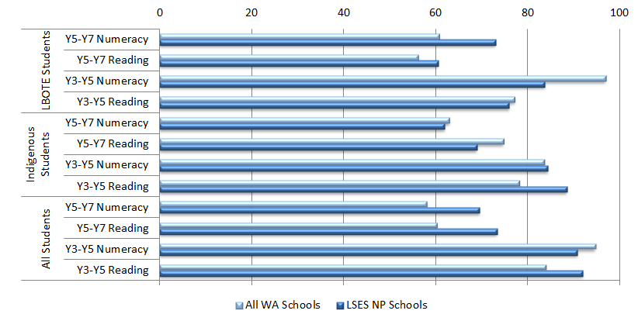
 |  | All WA Schools | LSES NP Schools
LBOTE Students | Year 5 to Year 7 Numeracy | 61 | 73
LBOTE Students | Year 5 to Year 7 Reading | 56 | 61
LBOTE Students | Year 3 to Year 5 Numeracy | 97 | 84
LBOTE Students | Year 3 to Year 5 Reading | 77 | 76
Indigenous Students | Year 5 to Year 7 Numeracy | 63 | 62
Indigenous Students | Year 5 to Year 7 Reading | 75 | 69
Indigenous Students | Year 3 to Year 5 Numeracy | 84 | 84
Indigenous Students | Year 3 to Year 5 Reading | 78 | 89
All Students | Year 5 to Year 7 Numeracy | 58 | 70
All Students | Year 5 to Year 7 Reading | 60 | 73
All Students | Year 3 to Year 5 Numeracy | 95 | 91
All Students | Year 3 to Year 5 Reading | 84 | 92
Source: PGA constructed chart using WA DoE (2013a); ACARA (2012)

While this data reveals some positive trends, the aggregated summary statistics cannot be used to determine whether observed gains can be directly attributed to the NP. In addition, the analysis does not control for schools’ starting points and characteristics which were found to be important determinants of student progress. For example, schools with initially lower scores, as is the case with many Low SES NP schools, are likely to make greater gains than schools with higher starting scores.
A more robust analysis of achievement in WA Low SES NP schools was undertaken using regression discontinuity design modelling (see Appendix 4). This quasi-experimental form of analysis has gained wide recognition as a robust means of program evaluation when clear selection criteria are used to determine program entry. The results presented in this section arise from analysis of school-level achievement data of schools in both Government and Catholic schools. Results of the regression discontinuity (RD) analysis present the average estimated impact of participating in the Low SES NP on growth in student achievement. For the 2009-2011 student cohort, the results show no statistically significant associations between the Low SES NP and apparent gain in school mean achievement in any domain or year level (Figure 8.3). On the other hand, significant additional apparent gain in Years 5-7 Numeracy was found for the 2010-2012 student cohort at Low SES NP schools. The estimates suggest that this additional growth, holding all else equal, was approximately 32.5 points.
Figure 8.3: Estimated effect of the Low SES NP on growth in student achievement WA Government and Catholic schools
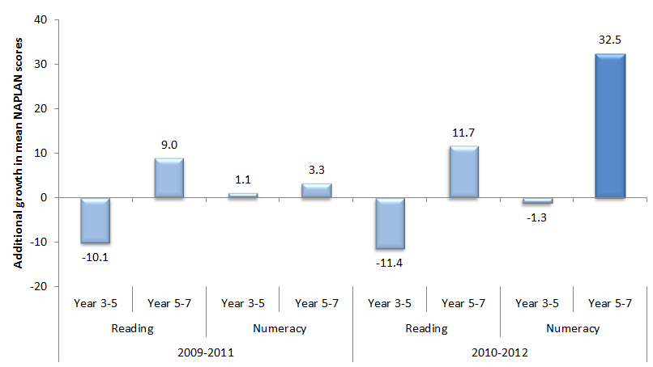
 |  | 2009-2011 | 2010-2012
Reading | Year 3 to Year 5 | -10.1 | -11.4
Reading | Year 5 to Year 7 | 9.0 | 11.7
Numeracy | Year 3 to Year 5 | 1.1 | -1.3
Numeracy | Year 5 to Year 7 | 3.3 | 32.5
Source: PGA constructed graph using data presented on the MySchool website as well as data provided by ACARA
Analysing achievement data using NAPLAN bands suggests that it is more difficult to attain NMS at Year 5 compared to Year 3, evidenced by the greater proportion of Australian students failing to meet the standards in Year 5. This national trend was also observed in WA. Despite this, there was a 10.4% relative decrease in the percentage of all students in the lower two Reading bands at WA Low SES NP schools (Figure 8.4). Further analysis for students transitioning from Years 5 to 7 showed a general reduction in the proportion of students in the lower two bands in WA. However, the proportion of students in the lower two Numeracy bands at WA Low SES NP schools rose by 16 percentage points for all students and three percentage points for Indigenous students.
Figure 8.4: Proportion of students at or below NMS (Year 3 2010- Year 5 2012) in NAPLAN, WA schools commencing Low SES NP in 2010
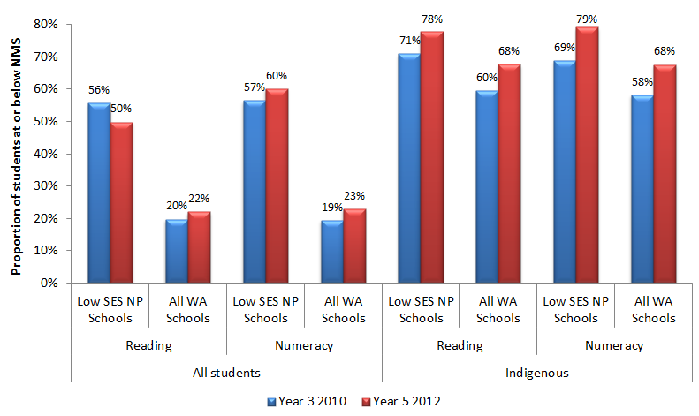
 |  |  | Year 3 2010 | Year 5 2012
All students | Reading | Low SES NP | 56% | 50%
All students | Reading | All WA Schools | 20% | 22%
All students | Numeracy | Low SES NP | 57% | 60%
All students | Numeracy | All WA Schools | 19% | 23%
Indigenous | Reading | Low SES NP | 71% | 78%
Indigenous | Reading | All WA Schools | 60% | 68%
Indigenous | Numeracy | Low SES NP | 69% | 79%
Indigenous | Numeracy | All WA Schools | 58% | 68%
NB: Only students who sat for NAPLAN were considered in calculating the proportion of students at or below NMS
Source: PGA constructed chart using WA DoE (2013a); ACARA (2012)
Regression analysis in the Government sector was also undertaken, controlling for changes in cohort composition and state-wide trends in achievement across all WA Government schools (Table 8.1). This analysis using school-level data found no significant differences in student achievement between Low SES NP schools and statistically similar non-NP schools (WA DoE 2013b).
Table 8.1: Estimated effect of the Low SES NP on student achievement, WA Government schools
Estimated Effect of the Low SES NP, WA Government schools
Reading |  |  | Numeracy
Year 3 | Year 5 | Year 7 | Year 3 | Year 5 | Year 7
-4.51 | -0.19 | 0.69 | 3.7 | -0.48 | 0.57
Model controls for changes in cohort composition and changes common to all WA Government schools.
Statistical significance: * = P < 0.01, ** = P < 0.05, *** P < 0,01
Source: WA DoE (2013b)
However, the proportion of students achieving at or above NMS in Low SES NP schools in both domains increased significantly between Years 5 and 7. The increase was also considerably higher than the increase observed for all WA schools. Variation between cohorts may be due to cohort effects as well as demographic differences between schools participating in different phases.
As outlined in the evaluation scope, outcomes were analysed for metropolitan and non-metropolitan schools participating in the Low SES NP. This analysis was conducted using for primary schools which constituted most participating partnership schools. Similar schools were grouped according to their students’ socioeconomic background as measured by the school ICSEA or their achievement prior to the commencement of the Low SES NP, with the analysis focusing on schools in the lowest four deciles of either measure. Among schools with similar socioeconomic backgrounds, the proportion of metropolitan Low SES NP schools who achieved above average NAPLAN Reading and Numeracy growth compared to similar non-participating schools was higher than that of non-metropolitan Low SES NP schools in the 2009-2011 cohort. The opposite was observed for the 2010-2012 cohort. When the analysis compared schools with similar starting points, above average growth was more evident at metropolitan Low SES NP schools in both domains and in both cohorts.
It is important to note that the mixed evidence provided by NAPLAN does not necessarily mean that the Low SES NP did not affect student achievement. As earlier outlined, intended achievement outcomes may not be realised in the limited timeframe under analysis. This could be particularly true for Low SES NP schools where other fundamental outcomes were targeted, such as student attendance and engagement. Some localised evidence of progress has also been observed. For instance, 35% of Low SES NP school principals reported a considerable or major improvement in Indigenous students’ literacy outcomes, with approximately 32% reporting the same in numeracy.

NAPLAN Participation at Low SES NP schools
When NAPLAN participation was analysed, participation rates in Low SES NP schools showed patterns that were similar to those observed in all WA schools. Therefore it is unlikely that overall changes in achievement were affected by NAPLAN attendance trends though this may affect school-level outcomes.

Outcome 2:
Progress towards improvement in regular student attendance and engagement, particularly among Indigenous students
Regular student attendance and engagement was an important intended outcome in WA, especially among Indigenous students in Low SES NP schools. Schools selected for this NP were often comprised of students facing multiple sources of disadvantage over an extended period of time. Addressing these entrenched disadvantages therefore required a focus on more foundational issues such as attendance and engagement before student achievement could be lifted.
In the Government sector, strategies aimed at improving student engagement included a number of targeted support programs combined with community engagement. The use of technology to improve literacy engagement in particular was also adopted. The proportion of Government school students with attendance rates of at least 90% increased from 45.6% in 2009 to 50.7% in 2010 (WA DoE 2011). In 2012, 25 schools increased the proportion of students attending 90% or more of the time (WA DoE 2013a). These improvements may not necessarily be due to the partnerships, as despite these positive results, regression analysis found that as of the end of 2012, the Low SES NP did not appear to have had a statistically significant impact on Primary and Secondary attendance rates (WA DoE 2013b).
To better understand the impact of the Low SES NP on attendance in the Government sector, further analysis was undertaken comparing trends in student attendance at participating schools to those in all WA Government schools. The analysis used school-level data to compare attendance rates between Low SES NP schools and all Government schools over time. Consistent with the regression analysis of attendance discussed in the previous paragraph, the initial difference in attendance rates between Low SES NP schools and all WA Government schools was found to have increased by 0.2% at the primary school level and 1.5% in secondary schools (Figure 8.5). Similar trends were also observed among Indigenous students with increases in the initial difference between the two school sets of 0.8% and 3.5% at the primary and secondary school levels, respectively.

Figure 8.5: Student attendance rates in WA Government schools commencing Low SES NP participation in 2010/2011
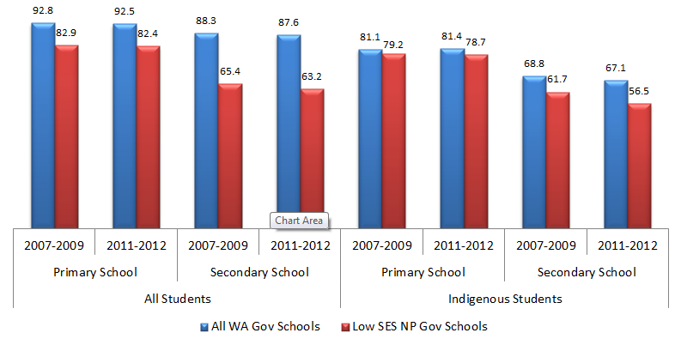
 |  |  | All WA Gov Schools | Low SES NP Gov Schools
All Students | Primary School | 2007 to 2009 | 92.8 | 82.9
All Students | Primary School | 2011 to 2012 | 92.5 | 82.4
All Students | Secondary School | 2007 to 2009 | 88.3 | 65.4
All Students | Secondary School | 2011 to 2012 | 87.6 | 63.2
Indigenous Students | Primary School | 2007 to 2009 | 81.1 | 79.2
Indigenous Students | Primary School | 2011 to 2012 | 81.4 | 78.7
Indigenous Students | Secondary School | 2007 to 2009 | 68.8 | 61.7
Indigenous Students | Secondary School | 2011 to 2012 | 67.1 | 56.5
NB: Schools commencing Low SES NP participation in 2012 were excluded from the analysis
Source: PGA constructed graph using data provided by WA DoE
Engagement at Government Low SES NP schools was also analysed by examining the apparent retention rates (ARR) of Indigenous students. The ARR was estimated to investigate the relationship between participating in the Low SES NP and student retention. It is measured as a ratio of students in a particular grade level divided by the number of students in an earlier grade level. The data shows that the Year 10-11 ARR of Indigenous students in WA Low SES NP Government schools increased from 74.3% before the partnership to 82.8% following participation in the Low SES NP (Figure 8.6). This was in contrast to All WA Government schools where there was an average decrease in ARR by 0.3%. In addition, the Year 10-12 ARR of Indigenous students at all WA Government schools was found to have dropped by 2.7%, while at Low SES NP schools, there was a marginal increase of 0.7%. Despite this, the results should not be taken as causal evidence of the impact of the Low SES NP as the ARR is an aggregated measure of student enrolments and does not control for student movement between schools, an important factor that may be driving the observed changes.

Figure 8.6: Apparent retention rates of Indigenous students in WA Government schools commencing Low SES NP participation in 2010
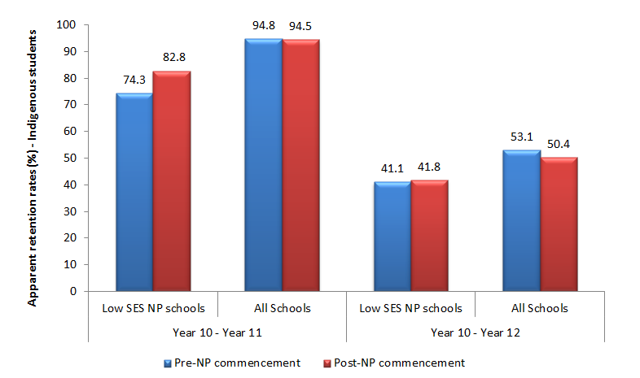
 |  | Pre-NP commencement | Post-NP commencement
Year 10 to Year 11 | Low SES NP Schools | 74.3% | 82.8%
Year 10 to Year 11 | All Schools | 94.8% | 94.5%
Year 10 to Year 12 | Low SES NP Schools | 41.1% | 41.8%
Year 10 to Year 12 | All Schools | 53.1% | 50.4%
NB: The pre-NP commencement figures are the average ARRs between 2008 and 2010 for Years 10-11 and between 2011 and 2010 for Years 11-12. The post commencement figures are the average ARRs between 2007 and 2010 for Years 10-11 and between 2010 and 2012 for Years 10-12.
Source: PGA constructed graph using student enrolment data provided by WA DoE.
Of the 23 Catholic Low SES NP schools in 2010, 16 were reported to have improved their attendance in the 90%+ category, eight of which were found to be significant (WA DoE 2011), while in 2011, 10 of the 28 Catholic Low SES NP schools significantly improved their attendance in this category (WA DoE 2012a). Attendance rates in 2012 were comparable to those in 2011 (WA DoE 2013a). Improvements were reported to be related to enhancements in centralised systems designed for timely monitoring of student attendance. Such improvements were consistent with the analysis of attendance in WA Catholic schools in this evaluation, where at the primary school level, trends in student attendance at participating schools were compared to those in non-NP schools. In WA Catholic primary schools, the increase in average attendance at Low SES NP schools between the period preceding the Low SES NP (2007/2008) and the period following commencement of the partnership (2011/2012) was 3.0% higher than in non-NP schools (Figure 8.7), with the result found to be statistically significant. The increase in attendance in Low SES NP schools at the secondary school level was comparable to that observed in non-NP schools. Among Indigenous students, there was a notable improvement in attendance at non-NP schools at both primary and secondary levels. This was also the case at the primary level in Low SES NP schools but to a lesser extent. At the secondary level however, the 0.9% drop in Indigenous student attendance at Low SES NP schools contrasted the 15.1% improvement observed in non-NP schools, with the difference found to be statistically significant.
Figure 8.7: Student attendance in WA Catholic schools
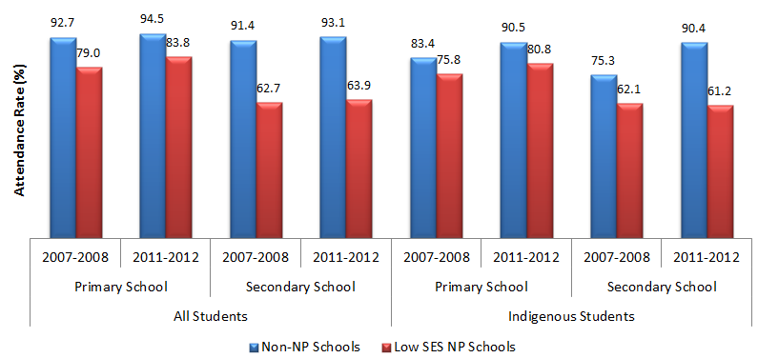
 |  |  | Non-NP Schools | Low SES NP Schools
All Students | Primary School | 2007-2008 | 92.7% | 79.0%
All Students | Primary School | 2011-2012 | 94.5% | 83.8%
All Students | Secondary School | 2007-2008 | 91.4% | 62.7%
All Students | Secondary School | 2011-2012 | 93.1% | 63.9%
Indigenous Students | Primary School | 2007-2008 | 83.4% | 75.8%
Indigenous Students | Primary School | 2011-2012 | 90.5% | 80.8%
Indigenous Students | Secondary School | 2007-2008 | 75.3% | 62.1%
Indigenous Students | Secondary School | 2011-2012 | 90.4% | 61.2%
NB: Secondary school level figures include only Years 7-10, as years 11-12 attendance data was not provided for the Catholic sector
Source: PGA constructed graph using data provided by DEEWR
Initiatives in the Independent sector included developing the capacity of teachers and Aboriginal Education Workers as well as the development of community links. In addition, there was a focus on improving engagement in the Middle Years. This included a specific curriculum that provided accessible and relevant content for at-risk middle school students in a number of schools. Among the Low SES NP faith-based schools, eight schools had attendance rates which continued to remain above 90% (WA DoE 2013a).
CASE STUDY: Emphasis on Middle Schooling for Improved Outcomes at Derby District High School & Yule Brook Community College
Derby District High School (DDHS) emphasised ‘middle schooling’ which has not only led to an improvement in attendance rates, but also improved Numeracy and Literacy outcomes. The implementation of the Ability Grouping in Education (AGE) model at the School aimed at enhancing teacher aided instructional competencies and flexible cohort organisation for classes. Students were taught through targeted, evidenced-based interventions. This led to improvements in Year 9 student performance in Literacy and Numeracy in 2011. DDHS also implemented a range of alternative pathways to tertiary education, leading to greater Year 12 graduation rates. The number of Indigenous students who were regular attendees has rose 4.3% between 2009 and 2011 (WA DoE 2012a).
Yule Brook Community College targeted Literacy program for girls in middle school also reported strong success. For a school with an Indigenous population of 37%, it reported a rise of 8.9% in the number of Indigenous students who were regular attendees between 2009 and 2011. It also saw a significant decrease in problem behaviours, increased engagement and improved Literacy and Numeracy results for Indigenous students (WA DoE 2012a).

CASE STUDY : Transition Support to Enhance Retention at Kalumburu Remote Community (WA DoE 2012a).
Kalumburu Remote Community School in the Kimberley Region used National Partnership funding to develop a strategy to address poor retention of Indigenous students. The Kalumburu Transition Support Program addressed the poor retention of Indigenous students through the employment of a transition support coordinator who provided one-on-one support to students and their families. The program assisted the transition of high school students from Kalumburu to other secondary schools. Early indications suggested improved in-school retention; and a 3.6 % increase in regular attendance (90 % or more) was reported in 2011.

CASE STUDY: The Attendance Team at Dudley Park Primary School (WA DoE 2013a).
Dudley Park Primary School used the Low SES NP funding to form an attendance team. The attendance team case managed students along with a reward day for 100% attendance per fortnight. Lunchtime activities included building life skills and a reward system for attendance and behaviour that gives students the opportunity to have lunch with the Principal and access the recreation room.
Since the implementation of the program, the number of regular attendees increased by 2%, while the number of moderate to severe non-attendees decreased by 6% as of 2012.

CASE STUDY: The Girls Basketball Academy to Improve Student Outcomes at Broome Senior High School (WA DoE 2012a)
Broome Senior High School appointed a full-time female Aboriginal and Torres Strait Islander Education Officer to support students in the Girls Basketball Academy. The Girls Basketball Academy aimed to improve attendance, life skills, Literacy and Numeracy in a caring and welcoming environment with strong links to parents/caregivers. The Education Officer was responsible for supporting the girls with Literacy, Numeracy, attendance and life skills.
The school reported improved attendance of Indigenous girls involved in the Academy. The number of Indigenous students who are regular attendees rose by 7.5% between 2009 and 2011.

Outcome 3a:
Increase in the number of external partnerships and programs established
A total of 64 Government Low SES NP schools indicated that they had utilised NP funding for establishing partnerships with external organisations. The majority of partnerships were found to be with not-for-profit organisations and other State government agencies. Approximately 25% of all Government Low SES NP schools reported ‘very good’ or ‘excellent’ progress, citing a slow pace in these partnerships due to the reliance on third parties (WA DoE 2013b).
Catholic sector partnerships included inter-school partnerships aimed at providing collegiate support and professional development, as well as university partnerships for specific development programs. For example, a number of Perth and South West Low SES NP schools formed a partnership with Curtin University for Speech Therapy support one day per week from third and fourth year Speech Therapy students under supervision from a qualified speech therapist. As all the schools involved were also in the LNNP, the speech therapy program has supported literacy development. During 2012 CEOWA has negotiated with Curtin University to implement the Speech Therapy and Occupational Therapy more widely across a number of schools as an important system wide initiative. Six schools will implement the speech therapy program in 2013. In addition, one primary school and one secondary school established a partnership with the University of Notre Dame Australia in Literacy and Numeracy support. This involved final year education students undertaking testing of students and one-on-one support. Anecdotal evidence cited in WA reporting has shown that reading ages of participating students increased dramatically (WA DoE 2013a).
Interschool partnerships were a feature in the Independent sector, where an on-line learning community was formed through the introduction of a literacy portal to connect 12 remote Indigenous schools. This provided teachers with the opportunity to engage in a professional learning community, resources to assist in the improvement of their teaching and learning programs and an online forum to connect and promote collaborative practices (WA DoE 2013a).

Outcome 3b:
Increase in the external partnerships with parents, other schools, businesses and communities and the provision of access to extended services
Partnerships with parents, business and community organisations represented an intended outcome of the Low SES NP, taking different forms ranging from extended service hubs to collaboration for specific programs. An increasing numbers of schools established early learning intervention programs (0-4) and engaged parents and their children in these programs. These are not expected to influence NAPLAN achievement outcomes for a number of years as not all students participating in these programs have reached Year 3. Intervention strategies include access to extended services in partnership with the community and other agencies such as health services, playgroups, childcare, breakfast programs, Foodbank and organisations running parenting programs. A number of schools used NP Funds to establish 0-4 learning programs. In some communities, schools introduced a waiting list of parents hoping to join the early intervention program (WA DoE 2013a). In 2012, 45% of Low SES NP Government schools reported the provision of access to extended services such as child care services, playgroups, health and social care, after hours support, parenting programs and partnerships with universities. Of those schools, 60% described their progress in this key reform area as ‘very good’ or ‘excellent’ (WA DoE 2013b).

Outcome 3c:
Increase in the level of parental involvement
While some schools report substantial challenges to parental involvement due to low education levels amongst parents, aspects of this program showing increasing success in Government Low SES NP schools include early years programs as well as access to school facilities and technology (WA 2013b). In Independent Low SES NP schools, an increase in parental involvement was noted, particularly in Indigenous schools (with a very high proportion of Indigenous student enrolment). Parent and Community partnership agreements increased engagement in school life, emphasising cultural and linguistic component of learning (WA DoE 2013a).

Outcome 4:
Greater autonomy, innovation and flexibility is achieved
Low SES NP schools received funding to implement key reforms at the local level to meet the needs of their students and communities, with principals making their own decisions about how funds were used. Efforts to promote autonomy, innovation and flexibility were reported to contribute to a deeper and broader distributed leadership within schools. Such strategies included pooling funds by groups of schools to employ instructional leaders and establishing more effective classroom structures based on ability rather than age, thereby improving student engagement and behaviour. The opening of school facilities outside normal school hours and the extension of the effective school day were also implemented to benefit students and the community (WA DoE 2013b).
In a 2012 survey of all Government Low SES NP school principals conducted by the Department of Education, 70% of respondents reported providing innovative and tailored learning opportunities, of which 62% described their progress in this area as ‘very good’ or ‘excellent’ (Figure 8.8). Three out of ten Low SES NP Government schools identified operational arrangements that encourage innovation and flexibility as a priority, with 52% of these schools reporting progress that was at least ‘very good’. In addition, it was reported that approximately 30% of WA Government schools were using National Partnership funding to implement school operational practices that encourage innovation and flexibility, 45% of which described progress in this area as ‘very good’ or ‘excellent’ (WA DoE 2013b).
Figure 8.8: Progress in autonomy, innovation and flexibility at Government Low SES NP schools in WA
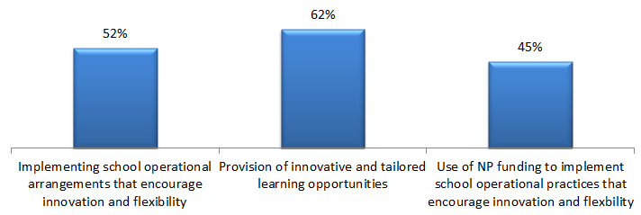
 | Progress
Implementing schools operational arrangements that encourage innovation and flexibility | 52%
Provision of innovative and tailored learning opportunities | 62%
Use of NP funding to implement school operational practices that encourage innovation and flexibility | 45%
Figures show the percentage of schools reporting ‘very good’ or ‘excellent’ progress as a proportion of Low SES NP schools which focussed on each initiative.
Source: WA DoE (2013b)

Outcomes 5:
Progress towards improvement in school accountability through self-assessment, planning and reporting
In order to inform school planning and improve reporting of student outcomes, 48% of Government Low SES NP schools reported focusing on improving accountability practices that include the collection, analysis and interpretation of data. Of these schools, 54% reported making significant progress in this area (WA DoE 2013a).

Outcome 6:
Progress towards improvement in attracting high quality and experienced principals and teachers to Low SES schools
Approximately 25% of respondents to the survey of principals at Government Low SES NP schools claimed that their schools had made ‘very good’ or ‘excellent’ progress in providing incentives to attract high performing principals and teachers (WA DoE 2013a). In the Independent sector, the ‘Principal Mentor’ program was used to support new principals settling into two remote schools with the aim of improving their retention in addition to building their quality and skills and forming positive links to the community (WA DoE 2012a). In addition, both Aboriginal Community Independent Schools and Metropolitan Independent schools participated in the Promoting Reflective Innovative Collaborative Educators (PRICE) mentoring program to assist both teachers and principals in setting goals for their own career development and the outcomes of their students. By 2012, a total of 10 new teachers had completed this program (WA DoE 2013a).

Outcome 7:
Young people make a successful transition from school to work and further study
Initiatives aimed at enhancing young people’s transition have been implemented, although this is a much longer-term intended outcome which cannot be assessed in this evaluation. Funding under the Low SES NP enabled 11 Government schools to implement initiatives emphasising pathways to work, training or university. In the Independent sector, ‘Transition to the Workplace’ was an initiative that linked industry to the skill sets of students to ensure smooth transition to the workforce upon school completion.
CASE STUDY: Preparing for Boarding Schools at One Arm Point Remote Community School (WA DoE 2013a)
In 2012, One Arm Point Remote Community School (government sector) established a program that provided support for students who will leave the town to go to boarding school so they may complete upper-secondary schooling.
No student was reported to have returned home from boarding school early, as has been typical prior to their participation in the Low SES NP.

Targeted LNNP Outcomes
The following section highlights the main findings from the synthesis of existing information on the LNNP in WA. Findings are reported under the agreed outcomes in the WA program logic (Appendix 6).

Outcome 8:
Progress towards improvement in literacy and numeracy achievement in NAPLAN (mean and distribution)
The improvement of students’ literacy and numeracy achievement was a common outcome to both NPs. Under the LNNP, this was targeted in WA primarily through initiatives that aimed to enhance effective teaching such as the introduction of literacy or numeracy coaches and the Catholic sector’s ‘Making the Links’ project to support literacy teaching of Year 7-9 students (CEOWA 2011a). Individualised learning plans were also developed with active case-management of students identified as requiring additional support.
Overall, WA LNNP schools achieved the majority of targets set to acquire reward LNNP funding over the period 2008-2011. Ten of the 18 targets were met or exceeded and progress was made towards the remaining eight targets. The proportion of Years 3, 5 and 7 students at or above NMS for Reading and Numeracy improved by between 0.4 and 3.0 percentage points. Greater progress was achieved among Indigenous students. In Year 7 Reading for example, Indigenous students in WA LNNP schools were found to improve by 16.9 percentage points (COAG Reform Council 2012).

Achievement in Government LNNP Schools
Analysis showed that Government LNNP schools exhibited positive shifts in student cohorts who were performing below or at an expected level (Figure 8.9a) based on their socio-economic index. For instance, only four LNNP schools performed significantly below expectations in Year 5 Reading in 2011 compared to 17 schools in Year 3 two years earlier. Between Year 5 and Year 7 in the same period, the number of schools performing higher than expected rose from four in Numeracy and Reading to 12 and six schools respectively (Figure 8.9b).

Figure 8.9a: Achievement in WA Government LNNP schools – Year 3 to Year 5
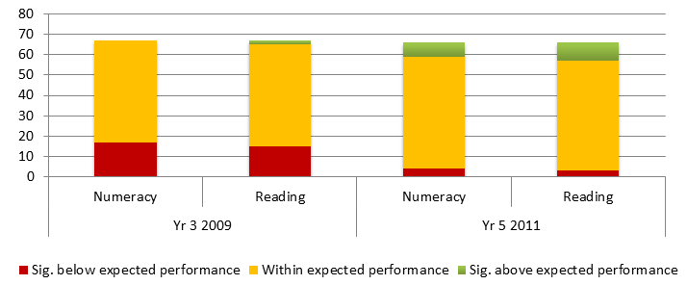
 |  | Significantly below expected performance | Within expected performance | Significantly above expected performance
Year 3 2009 | Numeracy | 17 | 50
 | Reading | 15 | 50 | 2
Year 5 2011 | Numeracy | 4 | 55 | 7
 | Reading | 3 | 54 | 9
Performance significantly above (below) expectations defined as results greater (less) than one standard deviation above expected achievement
Source: WA DoE (2012b)
Figure 8.9b: Achievement in WA Government LNNP schools – Year 5 to Year 7
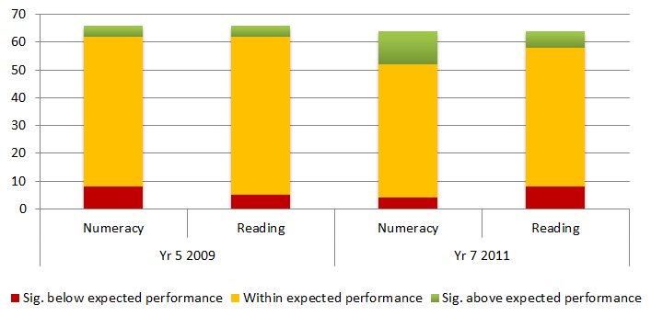
 |  | Significantly below expected performance | Within expected performance | Significantly above expected performance
Year 5 2009 | Numeracy | 8 | 54 | 4
Year 5 2009 | Reading | 5 | 57 | 4
Year 7 2011 | Numeracy | 4 | 48 | 12
Year 7 2011 | Reading | 8 | 50 | 6
Performance significantly above (below) expectations defined as results greater (less) than one standard deviation above expected achievement
Source: WA DoE (2012b)
When regression analysis was undertaken for Government LNNP schools, the results show that LNNP schools scored 4.72 points higher than comparable non-NP schools in Grade 3 Reading and 15.18 points higher in Grade 3 Numeracy, both results being statistically significant (Table 8.2).
Table 8.2: Estimated effect of the LNNP on student achievement in WA Government schools
Estimated Effect of the LNNP, WA Government schools
Reading |  |  | Numeracy
Year 3 | Year 5 | Year 7 | Year 3 | Year 5 | Year 7
4.72* | 0.11 | 0.04** | 15.18** | -2.42 | 6.32
Model controls for changes in cohort composition and changes common to all WA schools.
Statistical significance: * = P < 0.01, ** = P < 0.05, *** P < 0,01
Source: WA DoE (2013b)
The estimated effect was found to be insignificant for both domains in Years 5 and 7. It must be noted that the analysis uses school level data and as such estimates’ precision may be affected by limited samples. In addition, achievement starting points are not accounted for as the available evidence does not consider growth in student achievement.

Achievement in Catholic LNNP Schools
As part of the Making the Links project, Progressive Achievement Tests in Reading (PAT-R) were undertaken at the eight participating schools. Two tests were administered at 7-8 month intervals in each of 2010 and 2011 in order to gather information about student achievement at the beginning of the program and at the end of the school year. The 2011 PAT-R results show improvement and growth at participating schools (CEOWA 2011a). These schools experienced positive shifts in student achievement towards performance levels at or above average in Comprehension, Vocabulary and Spelling at both the Year 7 (Figure 8.10a) and Year 8 (Figure 8.10b) levels. The 2010 PAT-R results showed similar findings (CEOWA 2011a).

Figure 8.10a: PAT-R results for Year 7 students in WA Catholic schools participating in ‘Making the Links’ project – 2011
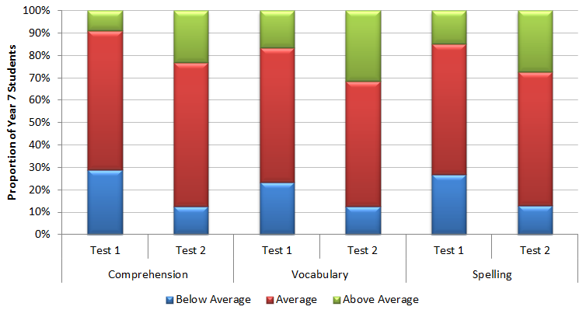
 |  | Below Average | Average | Above Average
Comprehension | Test 1 | 29 | 62 | 9
Comprehension | Test 2 | 12.5 | 64.5 | 23
Vocabulary | Test 1 | 23.5 | 60 | 16.5
Vocabulary | Test 2 | 12.5 | 56 | 31.5
Spelling | Test 1 | 27 | 58 | 15
Spelling | Test 2 | 13 | 59.5 | 27.5
Source: PGA constructed chart using CEOWA (2012)
Figure 8.10b: PAT-R results for Year 8 students in WA Catholic schools participating in ‘Making the Links’ project - 2011
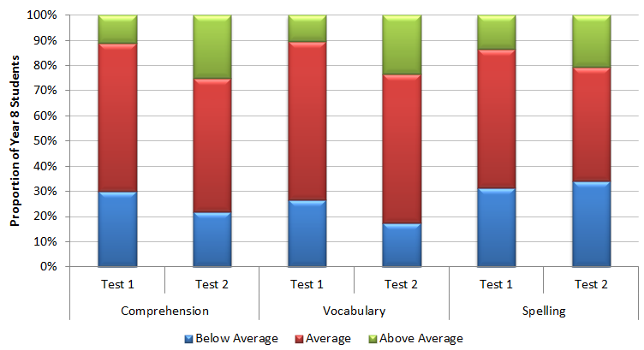
 |  | Below Average | Average | Above Average
Comprehension | Test 1 | 30 | 59 | 11
Comprehension | Test 2 | 22 | 53 | 25
Vocabulary | Test 1 | 26.5 | 63 | 10.5
Vocabulary | Test 2 | 17.5 | 59 | 23.5
Spelling | Test 1 | 31.5 | 55 | 13.5
Spelling | Test 2 | 34 | 45.5 | 20.5
Source: PGA constructed chart using CEOWA (2012)

Achievement in Government and Catholic LNNP Schools
Analysis of school-level achievement data in all WA Government and Catholic schools also assessed the progress of LNNP schools compared to that exhibited by similar non-NP schools. Similar schools were grouped according to their students’ socioeconomic background as measured by the school ICSEA or their achievement prior to the commencement of the LNNP, with the analysis focusing on schools in the lowest four deciles of either measure. For the 2009-2011 student cohort, the proportion of schools in the lowest four ICSEA deciles that achieved above average apparent gains were generally higher among LNNP schools than in non-NP schools (Figure 8.11). This was most prominent at Years 3-5, with differences of 7% in Reading and 18% in Numeracy. When LNNP schools in the 2009-2011 cohort were compared to non-NP schools with similar starting scores, the proportion of schools with above average growth was found to be higher in LNNP schools at Years 3-5 but lower at Years 5-7. For the 2010-2012 student cohort, the proportion of schools achieving above average growth was generally higher in non-NP schools (Figure 8.12). The most notable differences were observed in Reading among schools in the lowest four deciles of previous NAPLAN scores. The proportion of LNNP schools achieving above average apparent Reading growth at Years 3-5 was 12% less than that in non-NP schools with similar starting scores and 8% less at Years 5-7. Although NAPLAN growth rates on average may not have been as large in all LNNP schools as those in non-NP schools, it is recommended that further research be undertaken with this group to determine why some LNNP schools achieved greater success than others.

Figure 8.11: Proportion of LNNP schools achieving above average growth compared to that of similar non-NP schools, 2009-2011 cohort in WA Government and Catholic sectors
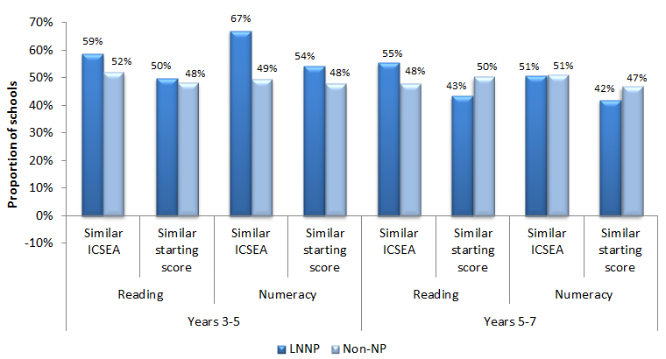
 |  |  | LNNP Schools | Non-NP Schools
Years 3 to 5 | Reading | Similar ICSEA | 59% | 52%
Years 3 to 5 | Reading | Similar Starting Score | 50% | 48%
Years 3 to 5 | Numeracy | Similar ICSEA | 67% | 49%
Years 3 to 5 | Numeracy | Similar Starting Score | 54% | 48%
Years 5 to 7 | Reading | Similar ICSEA | 55% | 48%
Years 5 to 7 | Reading | Similar Starting Score | 43% | 50%
Years 5 to 7 | Numeracy | Similar ICSEA | 51% | 51%
Years 5 to 7 | Numeracy | Similar Starting Score | 42% | 47%
Source: PGA constructed graph using data presented on the MySchool website as well as data provided by ACARA

Figure 8.12: Proportion of LNNP schools achieving above average growth compared to that of similar non-NP schools, 2010-2012 cohort in WA Government and Catholic sectors
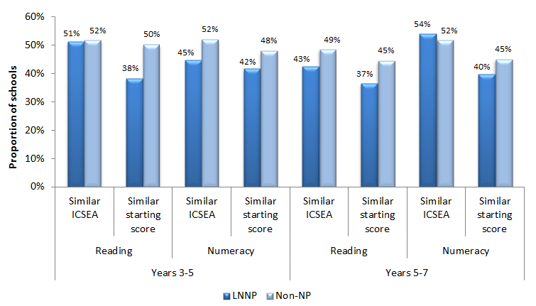
 |  |  | LNNP Schools | Non-NP Schools
Years 3 to 5 | Reading | Similar ICSEA | 51% | 52%
Years 3 to 5 | Reading | Similar Starting Score | 38% | 50%
Years 3 to 5 | Numeracy | Similar ICSEA | 45% | 52%
Years 3 to 5 | Numeracy | Similar Starting Score | 42% | 48%
Years 5 to 7 | Reading | Similar ICSEA | 43% | 49%
Years 5 to 7 | Reading | Similar Starting Score | 37% | 45%
Years 5 to 7 | Numeracy | Similar ICSEA | 54% | 52%
Years 5 to 7 | Numeracy | Similar Starting Score | 40% | 45%
Source: PGA constructed graph using data presented on the MySchool website as well as data provided by ACARA
Analysis of achievement was also undertaken at both metropolitan and non-metropolitan LNNP schools at the Year 3 to Year 5 level using the same method described for Figure 8.11. When the analysis compared schools with similar socioeconomic backgrounds, the proportion of non-metropolitan LNNP schools in the 2010-2012 cohort who achieved above average NAPLAN Reading and Numeracy growth was higher than that of metropolitan LNNP schools. This result was also observed among the 2009-2011 cohort but only in Numeracy. On the hand, when the analysis compared schools with similar starting points, the proportion of non-metropolitan LNNP schools who achieved above average growth was generally lower than that of metropolitan schools, with the exception of Reading among the 2010-2012 cohort.
CASE STUDY: Improvement of Literacy and Numeracy Achievement in Low Performers at a School in the Pilbara Region (WA DoE 2013c)
This primary school serves a culturally and linguistically diverse student community with a 30% Indigenous student enrolment. There were 313 children (K-7) enrolled at the school in 2012.
The school’s focal point in 2010 was Years 3, 5 and 7 students who were at and just above the National Minimum Standard (NMS); and students below NMS. The school aimed to arrest the decline in Reading performance; and reduce the number of students achieving at or below the Reading NMS to equivalent or lower than like schools. During the second year of the Partnership, similar target for numeracy were introduced. Case-management plans were developed and coaches worked with teachers across the school over the two years. Individual Education Plans were used for those performing below NMS.
NAPLAN mean scores showed gradual improvements between 2008 and 2011, except for a slight decline in Year 3 for 2009, which was reversed raising this cohort to an average score that was well above what was achieved by previous cohorts by the time of the 2011 Year 5 test. By 2011, the school’s numeracy strategies resulted in the Year 3 and Year 7 cohorts achieving above the average for similar schools. There was a noticeable decline in the proportion of students achieving at or below the Reading NMS across Year 3 and 7.
Comparisons of the same year cohorts over tests two years apart showed that whereas in 2009, 30% of Year 3 students and 39% of Year 5 students were below the NMS in literacy; these proportions had fallen to 5% and 7% of students on the Year 5 and 7 tests in 2011.
The proportion of students at or below the NMS in numeracy between 2009 and 2011 was also reduced. This was particularly the case for those students from the 2009 Year 3 cohort, where this proportion fell from 63% to 14%.
These improvements continued in 2012 NAPLAN results post National Partnership. Comparisons with statistically similar schools suggested that the student cohorts were more likely to achieve Reading mean scores at least one standard deviation above the mean of students in similar schools.

CASE STUDY: A Whole-School Literacy Improvement Plan at a School in a Metropolitan Location (WA DoE 2013c)
This school had an enrolment of approximately 200 students, with 20% of the enrolment being Indigenous students and 17% considered to be LBOTE in 2011 in Pre-Primary to Year 7 including a Kindergarten located on the school site.
The school aimed to reduce the percentage of students performing below NMS in Reading and Numeracy and increasing the percentage of students achieving scores equivalent to or higher than like schools, particularly for indigenous students.
A whole-school Literacy Plan was developed and implemented by the Literacy Leadership Team, which included the school’s Literacy Coordinator (Specialist Teacher), Principal, and teachers.
The school employed a Literacy Coordinator (Specialist Teacher) and an Education Assistant (0.5 FTE) to work across the school supporting teachers and children in collaboration with the school’s Aboriginal and Islander Education Officer. Case-management plans were developed for all students with identified needs in literacy, allowing the school to track progress in each term.
The mean scores for the NAPLAN Reading test between 2008 and 2011 saw some improvement for Years 3 and 7, but not for Year 5. The proportion of students at and below the NMS for Literacy in Year 3 was reduced substantially over the four years, and was approximately halved by 2010. Reductions were achieved in the proportion of students at or below the NMS for cohorts tested two years apart for both literacy and numeracy.
In 2012, post Partnership, mean scores for Reading for Year 3 and Year 5 cohorts showed particularly strong improvements while the Year 7 saw a drop, likely to be due turnover in the cohort and a number of students having learning difficulties or were from an EAL/D background. The school managed to close the gap to similar schools that existed prior to the Partnership, and by 2012, Year 3 results were well above the similar schools benchmark.

Outcome 9: Differentiated curriculum is provided for case managed students
Students in need of differentiated support were identified through NAPLAN and teacher judgements. In addition, on-entry testing in pre-primary was mandated for all Government schools in 2011 to identify students for case-management. Nine in 10 Government LNNP school principals reported that this provided effective teaching of literacy and numeracy. In addition, case management in Government LNNP schools was adopted to cater for students achieving at or below NMS in NAPLAN, particularly Indigenous and ESL students. This was adopted by approximately 93% of participating Government schools reported to have implemented case-management approaches (WA DoE 2013b). Program specific analysis in Government schools showed that 61% of Indigenous students case-managed for literacy were on track to meet achievement targets, while 59% of those case-managed for numeracy were on track (WA DoE 2012a). A variety of initiatives aimed at differentiating the curriculum were reported in 38 of 41 Independent LNNP schools in 2011 (WA DoE 2012a).
The Making the Links project in Catholic schools involved addressing students’ needs through differentiated teaching based on diagnostic assessment data. Assessment data helped teachers identify areas for targeted growth and differentiate not only the levels of text presented to students, but also ways in which teachers structured their pedagogy. Teachers in this program were found to be able to adapt strategies presented in the professional learning workshops to suit the particular needs of their students and subjects. They also reported a heightened sense of the value of differentiation as well as an increase in its application among participating teachers (CEOWA 2011a; CEOWA 2012).

Outcomes 10 and 11:
Progress towards improvement in self-assessment, planning and reporting; Increased use of evidence-based whole school planning and approaches
Ongoing planning and collaboration were central to developing whole-school engagement with literacy and numeracy. Over 30% of Government schools identified ongoing assessment, planning and reporting among the three most effective elements of the LNNP at their schools (WA DoE 2012b). More than 90% of Government LNNP school principals surveyed reported whole-school planning had substantially contributed to a number of key areas which are likely to be leading indicators of future improvement, as presented in Figure 8.13.
Figure 8.13: Whole-school planning benefits reported by more than 90% of WA Government LNNP school principals
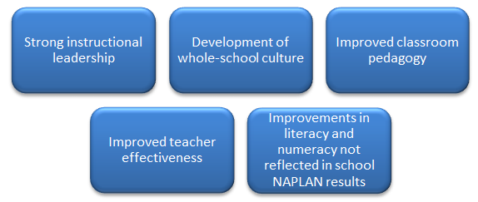
- Strong instructional leadership
- Development of whole-school culture
- Improved classroom pedagogy
- Improved teacher effectiveness
- Improvements in literacy and numeracy not reflected in school NAPLAN results
Source: (WA DoE 2013b)

As nearly all Government schools implemented whole-school planning along with data analysis, case-management and coaching, insufficient individualised evidence exists to determine the specific contribution of whole-school planning. Whole school engagement with literacy and numeracy strategies through the whole-school planning process was reported to have had a significant impact on student outcomes over the course of the LNNP (WA DoE 2013b). At the heart of this impact on outcomes were the:
- Relationship between engagement across the school and the development of a whole-school culture based on high expectations in relation to both student achievement and teacher performance.
- Accountability of the school leadership for outcomes and the explicit targets set to satisfy that accountability. These ofte n flowed down to targets at the classroom/student level.
- Consistency of pedagogy across the school.
In the Catholic and Independent sectors, whole-school planning was also a key feature of the LNNP. Plans were tailored to the specific needs of schools based on careful data analysis. Schools under this Partnership also prepared detailed Literacy and Numeracy plans outlining intervention strategies, support strategies and milestone performance results. School Support Consultants (SSCs) in the Catholic sector were appointed to assist schools in developing such plans. A 2011 survey of Catholic LNNP K-7 schools found that both school leaders and staff reported high to very high satisfaction with the SSC’s knowledge and assistance in planning for whole school improvement in Literacy and Numeracy as well as documenting school Literacy and Numeracy plans (CEOWA 2011b).
The Making the Links project in the Catholic sector involved the use of evidence-based strategies to help teachers of different subjects incorporate teaching of literacy in their learning areas using a systematic approach to assessment, planning and intervention. Through this project, teachers were involved in data collection and analysis to inform their teaching, discussions about pedagogy and peer mentoring. This process of exploring literacy appears to have resulted in teachers refocusing on good teaching practice and ways to address the needs of their students. Some schools also reported that the project served as a catalyst to develop a coordinated or school wide approach to the teaching of literacy (CEOWA 2011a; CEOWA 2012).

8.3 WA CONCLUSION
Participation in the Low SES NP in WA was associated with significant additional growth in Years 5-7 Numeracy, There is also some evidence of improved student engagement in Low SES NP schools. In the Catholic sector for example, there was an increase in average attendance at Low SES NP schools that was 3% higher than that in non-NP schools. At WA Low SES NP Government schools, the Years 10-11 and 10-12 ARRs of Indigenous students were found to have notably increased despite a general decrease at all WA Government schools. In LNNP schools, regression analysis found significant improvements in Year 3 Reading and Numeracy in the Government sector. In addition, student cohorts in LNNP Government and Catholic schools who were performing below or at an expected level previously were performing at or above that level following their participation in the LNNP. Compared to non-NP schools with similar socioeconomic status, LNNP schools in the 2009-2011 student cohort were found to be more likely to achieve above average apparent gain in NAPLAN scores at Years 3-5, particularly in Numeracy. This was not found to be the case among the 2010-2012 student cohort. When controlling for NAPLAN starting scores, between 42% and 54% of LNNP schools achieved above-average apparent gain in the 2009-2011 cohort. These rates appeared to be lower among the Years 5-7 students and the 2010-2012 cohort.
Improvements in student achievement and engagement in WA Low SES NP schools during the NP funding period may have been due to the programs implemented under the NP. These include practices such as enhanced autonomy, innovation and flexibility at schools, as over 40% of Government school principals participating in the Low SES NP reported ‘Very Good’ to ‘Excellent’ progress in these areas. In addition, half of the Low SES NP schools who focused on accountability practices, reported making good progress in collection, analyses and interpretation of data to inform school planning and improve student outcomes. The provision of innovative and tailored learning opportunities may have also contributed positively to student learning outcomes, as 62% of respondents in a survey of Government Low SES NP schools described their progress in this reform area as ‘very good’ or ‘excellent’.
A number of specific activities undertaken at WA Low SES NP schools may have also positively impacted student learning outcomes. These include initiatives to attract high quality principals and teachers such as the ‘Attracting Outstanding Principals’, ‘Consultant Teacher’ programs and leadership support programs such as the KSZ project, the ‘Principal Mentor program’ and the Catholic sector’s Promoting Alternative Thinking Skills (PATHS) program. The potential for these programs to impact student outcomes is backed by education research showing that both school leadership (Leithwood et al 2004) and teachers, especially through their classroom instruction, have among the strongest influences on student outcomes (Hattie 2009). Improving leadership and teachers’ capacity through professional development can therefore lead to subsequent positive influences on student achievement. Professional development programs have been found to have a positive impact on student achievement (Johnson et al 2007), particularly when they address the concrete, everyday challenges involved in teaching and learning specific academic subject matter (Darling-Hammond et al 2009).
Innovative initiatives such as the use of assessment data to monitor student performance may have additionally contributed to student outcomes. Use of data to inform teaching can be a powerful means to improve student learning. For example, research shows that the use of formative assessment by teachers to reflect on the effectiveness of their teaching can have an equivalent effect of slightly more than two years’ worth of academic growth (Hattie 2009). Student data have been used across all three sectors to inform lesson planning and to identify the cases where intervention is necessary to ensure the best possible student outcomes. Such interventions include the introduction of Literacy and Numeracy intervention programs like ‘First Steps’, ‘Reading Recovery’ and EMU. The combined and integrated nature of these programs has led to a holistic approach to improving student outcomes (WA DoE 2013. There is also empirical evidence to support the effectiveness of literacy and numeracy intervention programs such as these, targeting students with learning difficulties as indicated in a review by Purdie and Ellis (2005).
Increased partnerships and extended services at Low SES NP schools are likely to have resulted in improved student engagement in Low SES NP schools, with half of the Low SES NP Government schools reporting ‘very good’ or ‘excellent’ progress in establishing such initiatives. Early intervention strategies were a major feature of these initiatives, such playgroup programs, 0-4 school readiness programs, oral language programs and speech therapy programs. However the effects of such programs are not likely to manifest in the short-term but may have a subsequent impact on these students’ future achievement and engagement at the primary school level. By 2012, all Catholic Low SES NP schools formed partnerships with external agencies such as speech therapy and occupational therapy partnerships with Curtin University. Independent schools also established partnership agreements with Indigenous parents and communities for their involvement in student learning. Although research findings in this area are inconclusive, several studies suggest that strengthening family-community-school connections among minority and low-income student populations is important in closing the achievement gap (Boethel 2003). Family involvement, especially in the early primary school years has also been reported to be a strong predictor of literacy achievement for at-risk children (Dearing 2006). In addition, the ways in which schools welcome and reach out to families have been found to be influential factor in involving families and empowering them to help and support their children (Hoover-Dempsey 2005).
Sports programs, transition support programs and the Special Programs for Attendance and Retention of Kids (SPARK) may have also played a positive role in increasing student engagement in WA Low SES NP schools. In addition, the improved engagement of Indigenous students in the Government sector may be a result of the ‘Extending the School Day Project’ and the ‘Stronger Smarter Leadership’ program, both of which targeted Indigenous students. Whilst ‘Extending the School Day’ assisted students through building on the daily learning program, ‘Stronger Smarter Leadership’ engaged parents and the community to improve student learning. Extended school programs can serve academic, recreational and cultural purposes and have been found to be effective and beneficial to students under certain circumstances. This includes situations where the programs are appropriately structured, actively engage the community, involve well-trained staff and volunteers and are accommodative to the need and interests of participants (Fashola, 1998).
Observed improvement in student literacy and numeracy achievement at WA LNNP schools are likely to be due to the promotion of a differentiated curriculum, a major initiative under this partnership. By tailoring the curriculum to students’ needs, teachers could address individuals’ strengths and areas that require development. Case management in particular appears to have also benefited many students, especially Indigenous students, with over 70% of the principals surveyed reporting that case management of students contributed towards improved outcomes (WA DoE 2013b). Program specific analysis showed that 61% of Indigenous students case-managed for literacy, and 59% of those case-managed for numeracy were on track to meet achievement targets (WA DoE 2012a).
The use of evidence-based whole school approaches in WA was another widely adopted initiative that may have positively impacted student achievement in LNNP schools. Although this may not have yet manifested in NAPLAN scores, more than 90% of Government LNNP school principals surveyed reported whole-school planning had substantially contributed to a number of key areas which are likely to be leading indicators of future improvement, including student performance in Literacy and Numeracy (WA DoE, 2013b). Major whole-school approaches included Literacy or Numeracy coaching and professional learning strategies as well as a variety of Literacy and Numeracy intervention programs. These are likely to have helped develop teachers’ capacity to build student skills in literacy and numeracy. In addition, on-entry student assessments, the Catholic sector’s ‘Making the Links’ project and data-informed individualised and whole-school literacy and numeracy improvement plans are all examples of initiatives that saw student data closely monitored for progress assessment and support planning. By 2012, almost all Government schools reported to have effectively used student performance data to monitor progress and inform school planning to a considerable extent (WA DoE 2013a).
While there are some indications of intended outcomes being successfully achieved in WA SSNP schools, further evidence is needed to draw causal links between the partnership and observed outcomes. For instance, analyses of achievement used school level data and as such estimates’ precision may be affected by limited sample sizes. In addition, aggregated school-level data does not allow for the comparison of the same students over time as it is insensitive to student movement in and out of schools. Similar analysis using student-level is required to provide a more accurate estimate of the effect of the SSNPs on student achievement. There are also indications of improved student engagement at WA SSNP schools. However, the exact effect of each program on both student achievement and engagement in WA is currently only based on localised evidence. It is therefore not possible to ascertain the exact impact of each individual activity in light of the variety of initiatives implemented at SSNP schools, as well as numerous external factors that cannot be currently accounted for. These factors include the presence of non-NP funded activities at both NP and non-NP schools that may have confounded the observed impact of the NP. As outlined in the final chapter, such data can be collected through further research involving surveys and focus groups that can map data on specific activities to intended student achievement and engagement outcomes. This is essential for the efficacy of future interventions as it will inform policymakers’ and educators’ decisions around which programs are more successful than others in achieving the intended outcomes.

GLOSSARY
AEW: Aboriginal Education Workers help teaching staff in schools in the preparation of teaching materials and with general classroom non-teaching duties.
ATA: Aboriginal Teacher Assistant establishes strong links between Indigenous families, Indigenous students and school staff, related to the teaching and learning process of all Indigenous students.
Attracting Outstanding Principals: An incentive to attract and retain high quality principals to address educational equity and improve student outcomes in disadvantaged Indigenous, rural/remote and hard-to-staff-schools.
CARE: Curriculum and Re-engagement in Education schools offer curriculum to engage at risk students and improve attendance, or integrated programs to address students’ needs.
Consultant Teacher: A specialist teacher position focused on improving the quality of teaching and leading teachers in the development and refinement of their teaching practice to improve student outcomes.
EAL/D: English as an Additional Language/Dialect.
EMU: Extending Mathematical Understandings is a research-based intervention program aiming to improve children’s learning and confidence in mathematics.
KSZ: Kimberley Success Zone builds productive partnerships across schools, sectors and communities to investigate ways of accelerating improvements and attendance for Indigenous students.
NMS: National Minimum Standard encompasses one band at each Year level and therefore represents a wide range of the typical skills demonstrated by students at this level.
PATHS: Promoting Alternative Thinking Skills, to build teacher and leader capacity for teachers and principals.
PLT: Professional Learning Teams develop a common language was established in order to engage in professional dialogue about teaching and learning.
Principal Mentor: Program to support new principals by skill-building and forming positive links to the community.
Quality Catholic Schooling: A framework to monitor, discuss and plan for school improvement across all areas, including leadership and staff development in the Catholic sector.
Reading Recovery: An intensive reading program which aims to reduce the number of Year 1 students having difficulties learning to read and write.
SPARK: Special Programs for Attendance and Retention of Kids maintains positive relationships with the community through programs developed for both parents and students from Indigenous backgrounds.
Swan Extended Services Hub: A school-community hub with coordination of extended services to a cluster of schools.

Core Evaluation

Proposed Plan

Proposed Plan for a Potential Core Evaluation Stage
As outlined in the Evaluation Scope and the SSNP National Evaluation Framework, the Impact Evaluation phase requires the identification of gaps in existing literature and data relating to the focus areas defined in the SCSEEC Evaluation Strategy. Following a synthesis of existing information, the Scope further requires the development of a plan for a potential Core Evaluation to gather any necessary data/information to address identified gaps in existing knowledge.
The Core Evaluation is a key stage and forms the final component of the National Evaluation Strategy. There are a number of potential benefits to the proposed Core Evaluation. First, as the following section explains, the final stage would answer important questions around the impact and effectiveness of the Low SES NP and LNNP. This includes exploring the positive or negative indirect consequences of the partnership as well as investigating whether outcomes realised under the NP are sustainable. Second, the benefit of the Core Evaluation extends beyond further research into the effect of the SSNP. The current evaluation has collated extensive data on student outcomes from all jurisdictions. Along with the data collection strategies proposed for the final stage, this information can provide valuable policy lessons from each NP to inform future directions. It will therefore allow identification of what works, for whom and in what context within with the breadth of activities implemented under the NP, thus forming a key learning tool for policymakers and practitioners in each jurisdiction.
The following proposed plan has been developed based on PGA’s consultations with NPIWG members from all jurisdictions across Australia. It is important to note that while the Core Evaluation formed the final component of the National Evaluation Strategy, the Australian Government Department of Education has not yet decided whether this stage will proceed. In the case that a Core Evaluation is to be carried out, further consultation with the NPIWG will take place once the decision is made to ensure that the stage is aligned with jurisdictions’ priorities and plans at the time. This section outlines the information gaps following the synthesis of existing information, highlighting the benefits, requirements and methodology for the Core Evaluation.

Intended Outcomes of the Low SES NP and LNNP
All intended outcomes under either partnership can be classified as either relating to achievement or to various forms of engagement (Figure 9.1). Both the Low SES NP and the LNNP define achievement as an explicit targeted outcome. For disadvantaged students, engagement is seen to be an essential element for sustainable improvements in learning (Marzano 2013; Patterson 2006). Hence, the goals of the Low SES NP extended beyond achievement to additional essential outcomes such as enhancing student engagement including enrolment, attendance, retention and school completion.
As Figure 9.1 shows, the type of information available in this stage of the evaluation does not comprise all that is needed to measure the full set of intended outcomes. It is firstly evident that some long-term outcomes will not be measurable within the evaluation timeframe. Among the remaining intended outcomes it is only achievement data that is currently available at a national level and in a consistently collected manner in the form of NAPLAN results. On the other hand, it is not possible to determine the impact of the Low SES NP on student engagement nationally, as this was not uniformly measured across jurisdictions.
Figure 9.1: Evaluating the Low SES and Literacy and Numeracy National Partnerships

 | Partnership Goals
 | Achievement  (Low SES NP & LNNP) | Engagement  (Low SES NP)
Relevant outcomes | - Young people are meeting basic literacy and numeracy standards, and overall levels of literacy and numeracy achievement are improving.  - Australian students excel by international standards. | - All children are engaged in and benefiting from schooling.  - Schooling promotes the social inclusion and reduces the education disadvantage of children, especially Indigenous children.  - Young people make a successful transition from school to work and further study.
Information required | - Initiatives targeting achievement  - NAPLAN  - Other student assessments  - International assessment data | - Initiatives targeting engagement  - Student attendance  - Enrolment and retention  - Engagement in learning  - School completion  - Post-school destination
Type of available information | - Quantitative NAPLAN results in Reading and Numeracy;  - National & Jurisdictional  - Time-series and panel  - Quantitative Progressive Achievement Test results;  - Jurisdictional  - Panel  - Qualitative and quantitative survey and/or case study data on student progress;  - Jurisdictional and Localised  - Ad-hoc | - Quantitative attendance, enrolment and retention data for all students;  - Jurisdictional/sectoral  - Time-series  - Quantitative survey data on student, parent and community engagement;  - Jurisdictional/sectoral  - Time-series  - Qualitative case study data and observational evidence;  - Localised  - Ad-hoc
Potential for evaluation / attribution | - Measurement of progress achieved in NP schools is possible.  - With appropriate data on outcomes for all students/schools, estimating treatment effects of the NP is possible at a national or jurisdictional level.  - Estimating effects of particular initiatives is challenging due to insufficient detail on combination of activities in NP schools. | - Measurement of progress achieved in attendance and retention within NP schools is only possible at a jurisdictional or sectoral level due to variation in type of data available.  - Progress in other engagement indicators can only be measured in some jurisdictions.  - It is not possible to estimate overall treatment effects of the Low SES NP on engagement using available data.

Current information available on a jurisdictional level
The Impact Evaluation Scope required the synthesis of existing information with no provisions for additional data collection beyond that outlined above. At a jurisdictional level, available information was further found to vary as summarised in Figure 9.2. Internal and external validity of evaluation findings necessitate comprehensive evidence collected from multiple sources. Systematically robust evidence based on both quantitative and qualitative data, with extensive information on implemented activities and what worked, could only be found in two jurisdictions. Data in two other states/territories was comprehensive in relation to a specific subset of initiatives, while in a further two jurisdictions it was comprised of selected evidence on multiple aspects of the partnership. In the remaining two jurisdictions, limited evidence currently exists with only aggregated summary data and some localised or anecdotal information on what worked.

Figure 9.2: Variation in Jurisdictional Data

 |  | Quality of Evidence
 |  | Selected | Comprehensive
Information Sources | Specific | 2 of 8 states/territories exhibited:  Limited qualitative information relating to some aspects of NP  Aggregated summary data  Limited information on what worked.  Case studies | 2 of 8 states/territories exhibited:  Qualitative or quantitative information relating to several aspects of NP at jurisdiction and/or program level  Tracked data  Some information on what worked.  Case studies
Information Sources | Multiple | 2 of 8 states/territories exhibited:  Representative quantitative or qualitative information relating to several aspects of NP  Tracked data  Program-specific information on what worked.  Case studies | 2 of 8 states/territories exhibited:  Representative quantitative and qualitative information relating to several or all aspects of NP  Thorough information on what worked.  Tracked data  Case studies

Core Evaluation Scope
Following PGA’s synthesis of all existing evidence, a number of gaps in existing knowledge around the impact and effectiveness of the Low SES NP and LNNP have been identified. The gap areas, or questions that remain unanswered are:
Figure 9.3: Identified Gap Areas
Gap Area | Focus
Gap Area  1 | Do we have an understanding of what works? What is the link between activities, outputs and outcomes? Which activities/programs conducted under the NP were deemed/found to be the most successful? For which cohort of students were these activities/programs most effective? Which activities did not lead to the intended outcomes?
Gap Area 2 | How did the intensity of treatment influence the outcomes of the NP? In other words, how did outcomes vary by the duration of NP participation, level of centralised support, investment activity, etc.?
Gap Area 3 | To what extent are the outcomes realised under the NP sustainable and how does this differ across students and schools?
Gap Area 4 | What are the external factors (such as major non-NP activities/programs that are being undertaken at system-, sector- and region-levels) that were/are being undertaken concurrently with the NP? Do these factors confound the impact of the NP or are they also part of the context necessary for success?
Gap Area 5 | What are the indirect consequences of the NP?
Gap Area 6 | What policy lessons can be extracted from each NP to inform future directions?
The Core Evaluation plan that is outlined in this chapter has been proposed in compliance with the need for such a plan as outlined in the Evaluation Scope. However, a number of caveats need to be acknowledged as a result of institutional changes and major transformations affecting the education sector throughout Australia at the time of writing. The first limitation of this plan is that it is developed at a time of uncertainty surrounding the Core Evaluation stage. As the stage is yet to be confirmed, the plan represents an ideal scenario for a potential national approach following consultation with all jurisdictions, though reservations have been expressed by some jurisdictions arising from this stage’s indeterminate state. Secondly, in addition to the unconfirmed timing of the Core Evaluation stage if it were to proceed, its scope may need to be altered due to policy changes since the start of the partnerships. The Evaluation Scope had mandated the identification of knowledge and policy gaps, as well as the development of a plan to address these gaps in a Core Evaluation stage. However, the nature and objective of this stage may need to be reassessed by the NPIWG in light of the end of the partnerships and the adoption of the Australian Education Act 2013. It is recommended that the Australian Government Department of Education revisits the scope of this stage to confirm whether its initial objectives need to be updated. Based on the evaluator’s consultation with jurisdictions, it is evident that while there may be reservations about conducting further evaluation activity for initiatives which have concluded, the majority of jurisdictions continue to believe valuable policy lessons on what works, for whom, and in what context, can still be extracted from the largest set of interventions in Australian education history.
The evaluator acknowledges the reservations expressed by some jurisdictions regarding the difficulty of collecting implementation information from NP schools that have undergone staffing or policy changes which complicate the recollection of NP initiatives. In other instances, it may be the case that the complexity of multi-layered activities implemented in NP schools may prevent attribution of outcomes to certain initiatives. While both of these issues are important, they do not affect every jurisdiction and can be substituted by other evaluation activities where they are prevalent, such as conducting policy reviews using information from central education authorities amongst other approaches that will need to be agreed in future if the core evaluation stage does proceed. It is recommended that further consultations with jurisdictions take place if and when the Australian Government Department of Education confirms the timing and goals of this stage. The ensuing plan has been designed in accordance with the initial core evaluation scope.

Proposed Activities
In order to obtain the necessary data/information to answer the six questions identified as gaps in the knowledge, it is suggested that a Core Evaluation stage include the following activities:
- National Program Logic integrating all current state and territory program logic maps to describe the common and distinct approaches to the NP.
- Literature Review of relevant research that relates to similar programs and interventions implemented in other countries.
- Survey of NP school principals and teachers
- All school leaders and teachers at schools that have participated in the Low SES NP or LNNP schools will be invited to complete an optional 10-20 minute online survey as described in Figure 3. These school leaders and teachers would be those who have been actively involved in the NP programs and activities or those familiar with programs previously funded under the NP. The survey will contain a set of national questions as well as a second set of questions specific to each jurisdiction. Questions will be developed in consultation with sector representatives from each jurisdiction as well as the Australian Government Department of Education.
- Jurisdiction-specific Focus Groups of principals and teachers
- Up to two focus groups will be undertaken at each jurisdiction, involving one focus group for school leaders and another for teachers. The moderator’s guide for each of the focus groups will be informed by the results of the survey and will be developed in consultation with the Australian Government Department of Education as well as sector representatives from each jurisdiction. Participation in these focus groups will be optional.
- In-depth Interviews with NP program managers
- Desktop Analysis of additional student engagement and achievement data to determine the longer term impact of the Low SES NP and LNNP. This may include achievement and attendance data for 2013 and 2014 as well as exploring other areas such as analysing the impact of intensity of treatment on student learning outcomes.
As a result of this additional research, the six gap areas in the knowledge can be addressed as outlined below.

Gap Area 1: Addressed through the Literature Review, the Survey and Desktop Analysis
School leaders and teachers will be surveyed on a number of items. These include:
- The types of initiatives funded by the Low SES NP or LNNP at their respective schools. Based on the program logic of all eight jurisdictions, PGA recommends that all NP activities be grouped under the following initiatives:
- Building leadership capacity
- In-school teacher professional development (such as coaching)
- External teacher professional development
- Attracting and retaining high-performing principals and teachers Improved monitoring and usage of student performance information
- Individualised support (including Literacy and Numeracy intervention programs; Case-management; ILPs; mentoring; student incentives)
- Whole-school planning and initiatives
- Family and community involvement in schooling
- Extended services
- The extent to which the initiatives were implemented at each school (i.e. duration, proportion of students involved). This will include:
- Initiatives undertaken by the school that are not funded by the Low SES NP or LNNP
- The method by which schools received funding and the devolved decision-making.
Survey data will be mapped to student engagement and achievement outcomes (determined through desktop analysis) specified in the national program logic to identify the most successful initiatives. Where it is not possible to identify participating students at NP schools, survey data will instead be mapped to cohorts at participating schools. In addition, in consultation with jurisdictions, a number of NP schools with considerable improvement and NP schools where improved outcomes were not observed will be identified for analyses. This analysis will help identify the initiatives and factors associated with improved outcomes. The overall findings will be compared to research findings from the literature review.

Gap Area 2: Addressed through the Survey, Focus Groups and Desktop Analysis
Desktop analysis will be used to evaluate the impact of treatment intensity on student outcomes. This will attempt to identify the various types of support received by NP and non-NP schools to provide a better understanding of the optimal support needed for significant improvement in disadvantaged or low-achieving schools. Such support may include the amount of funding provided to schools and the amount of coaching hours that teachers received. This analysis will be complemented with information drawn from the survey data and focus groups which can improve its accuracy by accounting for confounding factors as well as any other centralised support and expenditure. Furthermore, cases of schools that received comparatively less resources but performed highly under the NPs will be analysed more closely to gain a greater insight into the initiatives or strategies that provide the greatest impact. External factors such as turnover at schools or schools’ previous experience in implementing certain initiatives will also be explored in the focus groups.

Gap Area 3: Addressed through Desktop Analysis, Survey and Focus Groups
Ideally, desktop analysis of the 2013 and 2014 student attendance and NAPLAN data, together with the 2008-2012 data collected in this evaluation, will be used to determine the ongoing effects and the likelihood of sustainability of outcomes associated with the NP for schools no longer in the program. This will include Low SES NP schools who completed their participation in 2012 as well as all LNNP schools. In the case of LNNP schools, additional analysis can be undertaken by comparing trends in achievement in schools that were part of the concluded LNNP to those which continued on to the Improving Literacy and Numeracy National Partnership (ILNNP). Through the Survey and Focus Groups, programs and activities initiated through the NP that have become institutionalised within school programs and activities will be identified, including ways in which they have evolved, and the perceived or measured impacts they have on student achievement and engagement outcomes.

Gap Area 4: Addressed through the Focus Groups and Interviews
Focus groups with school leaders and teachers and interviews with NP program managers will provide a richer understanding of the external factors that are an inseparable part of why particular outcomes were observed under the NP. Confounding factors at a local, system or national level will additionally be explored.

Gap Area 5: Addressed through Focus Groups and Interviews
Focus groups with school leaders and teachers and interviews with NP program managers will provide a richer understanding of the indirect consequences of the NP.

Gap Area 6: Addressed through the Survey, Focus Groups, Interviews and Desktop Analysis
It is recommended that this be regarded as one of the most important objectives of a potential Core Evaluation stage. Policy lessons from the NP to inform future directions will be drawn from the findings of all four recommended evaluation strategies. These may be lessons for broader application across sectors and jurisdictions or more specific to certain sectors or jurisdictions according to their priorities.
PGA has proposed this plan as a potential pathway to address the identified gaps after synthesising all existing information. It therefore represents the evaluator’s view of the best means of determining what works for disadvantaged and low achieving students and identifying key lessons for policy-makers and practitioners. The current evaluation has collated extensive data, particularly relating to achievement and attendance, from all jurisdictions. Though this data remains informative and necessary to address the identified gap areas, it does not allow definitive identification of what constitutes good practice. The additional information that needs to be collected in the Core Evaluation can enhance current knowledge in order to arrive at transferrable examples of policies and programs within a variety of contexts that can deliver improved student learning outcomes.
While we have proposed an overall map of the core evaluation, the extent and details of data-collection for each of the gaps may differ for sectors and jurisdictions depending on what is already known or available, as indicated in Figure 2 and the state-specific plans. Furthermore, PGA is cognisant of the potential burden on schools and systems that evaluation activities can create, particularly during certain periods within the academic year. Therefore, the Core Evaluation is proposed to occur during dates that are determined in consultation with different sectors and jurisdictions to minimise any potential disruption to teaching and learning. At the time of writing, the decision to conduct the Core Evaluation and its subsequent scope are unconfirmed. If the Australian Government Department of Education were to proceed with the Core Evaluation, its details would be confirmed with members of the NPIWG. In accordance with the evaluation scope, this phase would be state specific. This is expected given the numerous methods and programs adopted under the SSNP, along with the varied priorities in each jurisdiction.
Although a number of years have passed since the commencement of the Low SES NP and the LNNP, the Core Evaluation need not only address the impact of these programs. The aims of enhancing engagement in education, reducing the impact of disadvantage – especially amongst Indigenous students – and ensuring that Australian students excel by international standards remain common to all jurisdictions. Future directions can thus be informed by further research that links inputs, activities and outputs within targeted outcomes. By exploring the nature of activities implemented by schools and systems through a largely flexible resourcing program, the Core Evaluation can answer questions of why and how programs and activities shaped observed outcomes. This is of vital importance due to its practical significance and application potential for teachers, principals and education policymakers.

ACT-Proposed Plan
Existing evidence on the Low SES NP and LNNP in the ACT can be found in annual reports. The six Gap Questions will be addressed through all of the above activities under the proposed Core evaluation plan. Interviews with NP program managers will be additionally crucial for answering several of the Gap Questions in the ACT. The proposed sample for the Core Evaluation in the ACT is as follows.
Australian Capital Territory Proposed Core Evaluation Plan | Low SES NP | LNNP
Number of schools | 4 | 26
Number of school leaders to be surveyed | 1-4 | 6-30
Number of teachers to be surveyed | 4-10 | 15-50
Number of school leaders and teachers in focus group | 7-10 | 7-10

NSW-Proposed Plan
The type and level of data to be collected in the Core Evaluation stage for New South Wales will take into consideration several evaluations that have already been undertaken in this state. These evaluations include:
- ‘Analysis of the NSW Smarter Schools National Partnerships Cross-Sectoral Impact Survey’ (CSIS) undertaken by ARTD Consultants. In this evaluation, principals, executives and teachers were surveyed to compare education practices in SSNP schools and classrooms prior to participating in the SSNP with post-participation. The data provided an increased understanding of the changes and the extent of reform in critical education practices in SSNP schools and the impacts of these on a range of outcomes. Areas that were investigated included:
- Teaching capacity, pedagogy and professional development
- School management, accountability and planning
- Instructional leadership and leadership for learning capacity
- Policy action and resourcing
- Staffing
- Use of performance data to monitor student performance
- Collaboration between teachers
- ‘Evaluation of the School Staffing, Management and Accountability Initiatives’ undertaken by the University of Melbourne’s Centre for Research on Education Systems.
- ‘External Partnerships in Low SES School Communities’ undertaken by the University of Canberra.
- ‘Evaluation of the Take-up and Sustainability of New Literacy and Numeracy Practices in NSW Schools’ undertaken by Erebus International. In addition to analysing student achievement outcomes at LNNP schools, this evaluation involved the interviewing of key sector representatives, regional staff, school leaders and teachers to comprehensively understand issues relating to the implementation of Literacy and Numeracy programs. A follow-up online survey of all participating schools was also conducted to allow schools to further comment on the planning and implementation of the specific activities in which they were involved.
- ‘Strategic Review of the Outcomes of Evaluations of Literacy and Numeracy Programs’ undertaken by Erebus International. This evaluated the following of eight literacy and numeracy whole-of-school and intervention programs:
- Multilit (individual intervention program)
- Accelerated Literacy
- Focus on Reading 3-6
- Reading to Learn
- Taking Off With Numeracy (TOWN)
- Quicksmart (individual intervention program)
- Mindful Learning Mindful Teaching (whole-school approach)
- Individual Learning Plans
Certain information in the above-listed evaluations will be used to inform the design of the national survey instrument to address Gap questions 1 (an understanding of what works), 3 (extent to which outcomes are sustainable), 4 (external factors) and 6 (policy lessons). The Core Evaluation stage survey, focus groups and interviews will be designed in a way so that this information is not duplicated. The proposed sample for the Core Evaluation in NSW is as follows:
New South Wales Proposed Core Evaluation Plan | Low SES NP | LNNP
Number of schools | 723 | 171
Number of school leaders to be surveyed | 200-700 | 50-150
Number of teachers to be surveyed | 350-1400 | 80-340
Number of school leaders in focus group | 7-10 | 7-10
Number of teachers in focus group | 7-10 | 7-10

Northern Territory-Proposed Plan
In addition to annual reports, evidence on the impact of the SSNP from the Northern Territory can be found in two evaluations: the ‘Evaluation of the Maximising Improvements in Literacy and Numeracy (MILaN) Initiative’ and the ‘Evaluation of the Engaging Urban Students (EUS) Initiative’. The MILaN study explored the impact of evidence-based literacy and numeracy interventions on student outcomes, while the EUS evaluation explored the effects of wellbeing programs on the engagement of disadvantaged students. These studies were very comprehensive, particularly in their exploration of the first Gaps question relating to developing an understanding of what works. The Core Evaluation stage literature review, program manager interviews and desktop data analysis in the Northern Territory will therefore take this into consideration. The proposed sample for the Core Evaluation in the Northern Territory is as follows.
Northern Territory Proposed Core Evaluation Plan | Low SES NP | LNNP
Number of schools | 118 | 25
Number of school leaders to be surveyed | 30-100 | 6-20
Number of teachers to be surveyed | 60-200 | 15-50
Number of school leaders and teachers in focus group | 7-10 | 7-10

QLD-Proposed Plan
Evaluations in Queensland focused on specific activities undertaken in the state, including:
- Literacy and Numeracy Coaching
- Summer Schools
- Vacation Professional Development
- Four Year School Strategic Plan
- Turnaround Teams
- Foundations for Success
The Core Evaluation stage literature review, survey and desktop analysis in Queensland will take this into consideration when exploring Gaps question 1 relating to an understanding of what works. The proposed sample for the Core Evaluation in Queensland is as follows.
Queensland Proposed Core Evaluation Plan | Low SES NP | LNNP
Number of schools | 169 | 278
Number of school leaders to be surveyed | 50-150 | 80-250
Number of teachers to be surveyed | 100-300 | 150-500
Number of school leaders in focus group | 7-10 | 7-10
Number of teachers in focus group | 7-10 | 7-10

South Australia-Proposed Plan
Evaluations in South Australia focused on specific activities undertaken in the state, including:
- Literacy and Numeracy Coaching
- Innovative Community Action Networks (ICAN) program
- School Diagnostic Reviews
- Principals as Literacy Leaders
- Supporting Improved Literacy Achievement (SILA) project
The Core Evaluation stage literature review, survey and desktop analysis in South Australia will take this into consideration when exploring Gaps question 1 relating to an understanding of what works. The proposed sample for the Core Evaluation in South Australia is as follows.

South Australia Proposed Core Evaluation Plan | Low SES NP | LNNP
Number of schools | 236 | 78
Number of school leaders to be surveyed | 60-200 | 30-70
Number of teachers to be surveyed | 100-400 | 40-150
Number of school leaders in focus group | 7-10 | 7-10
Number of teachers in focus group | 7-10 | 7-10

Tasmania-Proposed Plan
Existing evidence on the Low SES NP and LNNP in Tasmania can be found in annual reports. The six Gap Questions will be addressed through all of the above activities under the proposed Core evaluation plan. Interviews with NP program managers will be additionally crucial for answering several of the Gap Questions in Tasmania. The proposed sample for the Core Evaluation in Tasmania is as follows.
Tasmania Proposed Core Evaluation Plan | Low SES NP | LNNP
Number of schools | 74 | 73
Number of school leaders to be surveyed | 20-70 | 20-70
Number of teachers to be surveyed | 40-150 | 40-150
Number of school leaders and teachers in focus group | 7-10 | 7-10

Victoria-Proposed Plan
In Victoria, existing evidence on the Low SES NP and LNNP can be found in annual reports as well as the evaluation of the SSNP in Government schools: ‘School Resources, Autonomy and Student Achievement: Evidence from a Regression Discontinuity Design’, undertaken by the Melbourne Institute of Applied Economic and Social Research. This study explored the effects of NP participation on student achievement and engagement outcomes in Victorian Government schools as well as the impact per amount invested. The Core Evaluation stage survey, focus groups and desktop analysis in Victoria will take this into account when exploring Gaps question 2 relating to the intensity of treatment and its influence on NP outcomes. The proposed sample for the Core Evaluation in Victoria is as follows:
Victoria Proposed Core Evaluation Plan | Low SES NP | LNNP
Number of schools | 327 | 210
Number of school leaders to be surveyed | 80-300 | 50-200
Number of teachers to be surveyed | 150-600 | 100-400
Number of school leaders in focus group | 7-10 | 7-10
Number of teachers in focus group | 7-10 | 7-10

Western Australia-Proposed Plan
The type and level of data to be collected in the Core Evaluation stage for Western Australia, and specifically the Government sector, will take into consideration state evaluations, as reported in the ‘Evaluation of the Partnerships in the Western Australian public school system’ as well as the ‘Success and Achievemet of the Partnerships Schools’ reports, by PWC. In these evaluations, principals and other staff at NP schools were surveyed and consulted on a number of partnership elements to assess their impact on student learning outcomes. These elements included:
- School leadership and whole-school engagement with literacy and numeracy
- Monitoring of school and student literacy and numeracy performance
- Differentiated curriculum for case-managed students
- Strategies to attract high-performing principals and teachers
- Performance management and staffing arrangements
- Flexibility and innovation in school operational practices
- Innovation in teaching and learning strategies
- Strengthened school accountability
- Community partnerships and parental involvement in schooling
- Provision of access to extended services
- Mechanisms to support the sustainability of implemented strategies
Certain information in the above-listed evaluations can be used to answer Gap questions 1 (an understanding of what works), 3 (extent to which outcomes are sustainable) and 6 (policy lessons). The Core Evaluation stage survey, focus groups and interviews will be designed in a way so that this information is not duplicated. The proposed sample for the Core Evaluation in Western Australia is as follows.
Western Australia Proposed Core Evaluation Plan | Low SES NP | LNNP
Number of schools | 155 | 209
Number of school leaders to be surveyed | 50-150 | 50-200
Number of teachers to be surveyed | 80-300 | 100-400
Number of school leaders in focus group | 7-10 | 7-10
Number of teachers in focus group | 7-10 | 7-10

Timeline and Deliverables
- Week 1: Submission of draft national program logic
- Week 2: Acceptance of national program logic (Deliverable 1)
- Week 3: Submission of draft survey questions to each jurisdiction and the DoE
- Week 5: Acceptance of survey
- Week 6: Online survey setup (Deliverable 2)
- Weeks 7-10: Survey open for respondents
- Weeks 11-12: Analysis of survey data
- Week 13: Interim results seminar (Deliverable 3)
- Week 15-17: Design of focus group guides in consultation with jurisdictions and based on survey findings
- Weeks 18-19: Focus groups in each state/territory
- Week 20: In-depth interviews with program managers
- Weeks 21-23: Desktop Analysis of:
- 2013 and 2014 student attendance
- 2013 and 2014 NAPLAN data
- Funding data
- Week 24: Submission of draft final report to each jurisdiction and the DoE
- Week 25: Submission of policy report and provision of interactive school resource (Deliverable 4)
- Week 27: Acceptance of final report (Deliverable 5)

References
ARTD Consultants. (2012). Analysis of the NSW Smarter Schools National Partnerships Cross-Sectoral Impact Survey: Phase 1
Atelier Learning Solutions. (2012). Final report on analysis of activity and evaluation effort in the Smarter Schools National Partnerships: Phase 1 of the national evaluation of the Smarter Schools National Partnerships.
Australian Capital Territory Department of Education and Training (ACT DET). (2012). Smarter Schools National Partnerships, Australian Capital Territory Annual Report for 2011.
Australian Capital Territory Department of Education and Training (ACT DET). (2013). Smarter Schools National Partnerships, Australian Capital Territory Annual Report for 2012.
Australian Curriculum, Assessment and Reporting Authority. (2012), NAPLAN Achievement in Reading, Persuasive Writing, Language Conventions and Numeracy: National Report for 2012, ACARA, Sydney.
Ball, D. L., Hill, H. C., & Bass, H. (2005). Knowing mathematics for teaching: Who knows mathematics well enough to teach third grade, and how can we decide? American Educator, 29(3).
Barber, M. & Mourshed, M. (2007). How the world’s best performing schools come out on top. McKinsey & Co.
Boethel, M. (2003). Diversity: School, family, and community connections. Austin, TX: National Center for Family and Community Connections with Schools.
Burgess, S. R., Hecht, S. A., & Lonigan, C. J. (2002). Relations of the home literacy environment (HLE) to the development of reading-related abilities: A one-year longitudinal study. Reading Research Quarterly, 37(4).
Catholic Education Office of Western Australia. (2011a). Making the Links: Integrating Spelling, Vocabulary Knowledge and Comprehension across the Curriculum.
Catholic Education Office of Western Australia. (2011b). Survey of Literacy and Numeracy K-7 National Partnership Schools.
Catholic Education Office of Western Australia. (2012. Making the Links: Integrating Spelling, Vocabulary Knowledge and Comprehension across the Curriculum.
COAG Reform Council. (2012). National Partnership Agreement on Literacy and Numeracy: Performance report for 2011.
Collaborative for Academic, Social, and Emotional Learning (CASEL). (2003). Social and emotional learning (SEL) and student benefits: Implications for safe schools/ healthy students core elements. Retrieved October 1, 2012, from http://casel.org/wp-content/uploads/1A_Safe_Sound-rev-21.pdf
Darling-Hammond, L., Wei, R.C., Andree, A., Richardson, N. & Orphanos, S. (2009). Professional learning in the learning profession: A status report on teacher development in the United States and abroad. Palo Alto, CA: National Staff Development Council and the School Redesign Network.
Dearing, E., Kreider, H., Simpkins, S., & Weiss, H. B. (2006). Family involvement in school and low-income children’s literacy performance: Longitudinal associations between and within families. Journal of Educational Psychology, 98(4), 653–664.
Department of Education and Early Childhood Development/ DEECD (2010). Pathways to re-engagement through flexible learning options: A policy direction for consultation. Melbourne, VIC.
Department of Education, Employment and Workplace Relations (DEEWR). (2011). Northern Territory Smarter Schools National Partnerships Fast Facts.
Durlak, J.A. & Wells, A.M. (1997). Primary prevention mental health programs for children and adolescents: A meta-analytic review. American Journal of Community Psychology, 25(2), 115-151.
Erebus International. (2012a). Evaluation of the take-up and sustainability of new literacy and numeracy practices in NSW schools, final report phase 1.
Erebus International. (2012b). Strategic review of the outcomes of evaluations of Literacy and Numeracy programs, progress report phase 2a.
Fashola, O.S. (1998). Review of extended-day and after-school programs and their effectiveness. Report no. 24. Center for Research on the Education of Students Placed At Risk (CRESPAR), Johns Hopkins University.
Ferguson, C., Ramos, M., Rudo, Z. & Wood, L. (2008). The school-family connection: Looking at the larger picture a review of current literature. Austin, TX: National Center for Family and Community Connections with Schools.
Garet, M. S., Porter, A. C., Desimone, L., Birman, B. F., & Yoon, K. S. (2001). What makes
professional development effective? Results from a national sample of teachers. American Educational Research Journal, 38(4).
Hahn, J., Todd, P., & Van der Klaauw, W. (2001). Identification and Estimation of
Treatment Effects with a Regression-Discontinuity Design, Econometrica, 69(1), 201-209.
Hattie, J. (2009). Visible learning: A synthesis of over 800 meta-analyses relating to academic achievement. New York: Routledge.
Helal, M. (2012). School Resources, Autonomy and Student Achievement: Evidence from a Regression Discontinuity Design. Melbourne Institute of Applied Economic and Social Research.
Hoover-Dempsey, K. V., Walker, J. M. T., Sandler, H., M., Whetsel, D., Green, C. L., Wilkins, A. S., & Closson, K. (2005). Why do parents become involved? Research findings implications. The Elementary School Journal, 106(2), 105-130.
Imbens, G., & Lemieux, T. (2008). Regression Discontinuity Designs: A Guide to Practice, Journal of Econometrics, 142(2), 615-635.
International Reading Association (2004). The role and qualifications of the reading coach in the United States. Newark, DE.
Johnson, C. C., Kahle, J. B. & Fargo, J. D. (2007). A study of the effect of sustained, whole-school professional development on student achievement in science. Journal of Research in Science Teaching, 44 (6), 775-786.
Jordan, G. E., Snow, C. E., & Porche, M. V. (2000). Project EASE: The effect of a family literacy project on kindergarten students’ early literacy skills. Reading Research Quarterly, 35(4), 524–546.
Kennedy, J. (2011). Use collaborative inquiry and multiple data sources to improve practice. Learning Forward. The Leading Teacher.
Lampley, J.H. & Johnson, K.C. (2010). Mentoring At-risk Youth: Improving Academic Achievement in Middle School Students. Nonpartisan Education Review, 6 (1).
Lee, D., & Lemieux, T. (2010). Regression Discontinuity Designs in Economics. Journal
of Economic Literature, 48(48), 281-355.
Leithwood, K., Louis, K.S., Anderson, S. & Wahlstrom, K. (2004). How leadership influences student learning. New York: The Wallace Foundation.
Lockwood, J. R., McCombs, J. S., & Marsh, J. (2010). Linking reading coaches and student
achievement: Evidence from Florida middle schools. Educational evaluation & policy analysis, 32 (3), 372-388.
Love, N., Stiles, K.E., Mundry, S., & DiRanna, K. (2008). The data coach’s guide to improving learning for all students: Unleashing the power of collaborative inquiry. Thousand Oaks, CA: Corwin Press.
Lynch, J. & Alsop, S. (2007). The effectiveness of literacy coaches. What Works? Research, Research Monograph #6. The Literacy and Numeracy Secretariat and the Ontario Association of Deans of Education.
Marzano, R. (2013). Ask yourself: Are students engaged? Educational Leadership, 70 (6).
Melhuish, E.C., Phan, M.B., Sylva, K., Sammons, P., Siraj-Blatchford, I., Taggart, B. (2008). Effects of the home learning environment and preschool center experience upon literacy and numeracy development in early primary school. Journal of Social Issues, 64(1).
Munro, J. (2006). Literacy intervention: Extending the evidence base for determining effective options. Canberra: Department of Education, Science and Training (DEST).
New South Wales Department of Education and Communities (NSW DEC). (2011). Smarter Schools National Partenerships, New South Wales Annual Report for 2010.
New South Wales Department of Education and Communities (NSW DEC). (2012). Smarter Schools National Partenerships, New South Wales Annual Report for 2011.
New South Wales Department of Education and Communities (NSW DEC). (2012b). Low Socio-Economic Communities Smarter School National Partnership Evaluation: Case studies of the School Staffing, Management and Accountability Initiatives Second Progress Report.
New South Wales Department of Education and Communities (NSW DEC). (2012c). Low Socio-Economic Communities Smarter School National Partnership Evaluation: Case Studies of School External Partnerships: Parent Partnerships Second Progress Report.
New South Wales Department of Education and Communities (NSW DEC). (2013). Smarter Schools National Partenership, New South Wales Annual Report for 2012.
Northern Territory Department of Education and Training (NT DET). (2011). Smarter Schools National Partnerships, Northern Territory Annual Report for 2010.
Northern Territory Department of Education and Training (NT DET). (2013). Smarter Schools National Partnerships, Northern Territory Annual Report for 2012.
Parkville Global Advisory. (2013). National evaluation of the Low SES National Partnership and the Literacy and Numeracy National Partnership - Phase 2: National evaluation framework.
Patterson, J. (2006). Whole of government action on young people’s engagement and re-engagement with learning and earning: The SA experience of interagency collaboration, AARE 2006 International Education Research Conference.
Purdie, N. & Ellis, L. (2005). Literature review: A review of empirical evidence identifying effective interventions and teaching practices for students with learning difficulties in Year 4, 5, and 6. Camberwell, VIC.
Queensland Department of Education, Training and Employment (QLD DETE). (2011). Smarter Schools National Partnerships, Queensland Annual Report for 2010.
Queensland Department of Education, Training and Employment (QLD DETE). (2012a). Final Report Vacation PD for Teachers.
Queensland Department of Education, Training and Employment (QLD DETE). (2012b). Smarter Schools National Partnership Interim Evaluation Summary.
Queensland Department of Education, Training and Employment (QLD DETE). (2012c). Smarter Schools Evaluation Report on Low-SES and LNNP 2008-2011.
Queensland Department of Education, Training and Employment (QLD DETE). (2012d). Evaluation Report Summer Schools September 2011 and January 2012.
Queensland Department of Education, Training and Employment (QLD DETE). (2012e). Smarter Schools National Partnerships, Queensland Annual Report for 2011.
Queensland Department of Education, Training and Employment (QLD DETE). (2012f). Smarter Schools National Partnerships, Queensland Progress Report 2012.
Queensland Department of Education, Training and Employment (QLD DETE). (2013). Smarter Schools National Partnerships, Queensland Annual Report for 2012.
Rowe, K. (2005). National Inquiry into the Teaching of Literacy (Australia), "Teaching Reading". http://research.acer.edu.au/tll_misc/5
Smart, D., Sanson, A., Baxter, J., Edwards, B. & Hayes, A. (2008). Home-to-school transitions for financially disadvantaged children. Sydney, NSW: The Smith Family.
Smarter Schools National Partnerships Bilateral Agreement between the Commonwealth of Australia and the Australian Capital Territory. (2009).
Smarter Schools National Partnerships Bilateral Agreement between the Commonwealth of Australia and New South Wales. (2009).
Smarter Schools National Partnerships Bilateral Agreement between the Commonwealth of Australia and Tasmania. (2009).
Smarter Schools National Partnerships Bilateral Agreement between the Commonwealth of Australia and South Australia. (2009).
Smarter Schools National Partnerships Bilateral Agreement between the Commonwealth of Australia and the Northern Territory of Australia. (2009).
Smarter Schools National Partnerships Bilateral Agreement between the Commonwealth of Australia and the State of Queensland. (2009).
Smarter Schools National Partnerships Bilateral Agreement between the Commonwealth of Australia and the State of Victoria. (2009).
Smarter Schools National Partnerships Bilateral Agreement between the Commonwealth of Australia and Western Australia. (2009).
South Australia Department for Education and Child Development (SA DECD). (2012). Innovative Community Action Network (ICAN) Evaluation, Interim Report. September 2012 - ARTD Consultants.
South Australia Department of Education and Children’s Services (SA DECS). (2011a). Principals as Literacy Leaders, Final Report. 2011 - Griffith University.
South Australia Department of Education and Children’s Services (SA DECS). (2011b). Evaluation of the Literacy and Numeracy National Partnership, Final Report. October 2011 - KPMG.
South Australia Smarter Schools National Partnership Council - Schooling (SA SSNP Council - Schooling). (2012a). Rapid Appraisal of Literacy and Numeracy Achievements: Literacy and Numeracy National Partnership Schools. May 2012.
South Australia Smarter Schools National Partnership Council - Schooling (SA SSNP Council - Schooling). (2012b). Smarter Schools National Partnerships, South Australia Annual Report for 2011.
South Australia Smarter Schools National Partnership Council - Schooling (SA SSNP Council - Schooling). (2013a). Evaluation of School Review Processes. February 2013
South Australia Smarter Schools National Partnership Council - Schooling (SA SSNP Council - Schooling). (2013b). Smarter Schools National Partnerships, South Australia Annual Report for 2012.
St Leger, L., Young, I., Blanchard C., Perry, M. (2010). Promoting Health in Schools: From Evidence to Action..
Starkey, P., & Klein, A. (2000). Fostering parental support for children’s mathematical development: An intervention with Head Start families. Early Education and Development, 11(5), 659–680.
Tasmania Department of Education (TAS DoE). (2012). Smarter Schools National Partnerships, Tasmania Annual Report for 2011.
Tasmania Department of Education (TAS DoE). (2013). Smarter Schools National Partnerships, Tasmania Annual Report for 2012.
Thistlethwaite, D., & Campbell, D. T. (1960). Regression-Discontinuity Analysis: An
Alternative to the Ex Post Facto Experiment. Journal of Educational Psychology, 51(6),
309-317.
Timperley, H. S. (2005). Instructional leadership challenges: The case of using student achievement for instructional improvement. Leadership and Policy in Schools, 4(1), 3-22.
Tremblay, P. (2011). Evaluation of the Engaging Urban Students Initiative, Northern Territory Department of Education and Training (DET).
Tremblay, P. (2012). Evaluation of the Maximising Improvements in Literacy and Numeracy (MILaN) Initiative, Northern Territory Department of Education and Training (DET).
University of Massachusetts (2007). Gaining Traction - Urban Educators’ Perspectives on the Critical Factors Influencing Student Achievement in High and Low Performing Urban Public Schools.
University of Massachusetts (2007). Gaining Traction - Urban Educators’ Perspectives on the Critical Factors Influencing Student Achievement in High and Low Performing Urban Public Schools.
Victorian Department of Education and Early Childhood Development (VIC DEECD). (2011). Smarter Schools National Partnerships, Victoria Annual Report for 2010.
Victorian Department of Education and Early Childhood Development (VIC DEECD). (2012). Smarter Schools National Partnerships, Victoria Annual Report for 2011.
Victorian Department of Education and Early Childhood Development (VIC DEECD). (2013). Smarter Schools National Partnerships, Victoria Annual Report for 2012.
Waddell, G. & Lee, G. (2008). Crunching numbers, changing practices: A close look at student data turns the tide in efforts to close the achievement gap. JSD: The Journal of the National Staff Development Council, 29(3), 18-21.
Wenglinsky, H. (2000). How teaching matters: Bringing the classroom back into discussions of teacher quality. Princeton, NJ: Milken Family Foundation and Educational Testing Service.
Western Australian Department of Education (WA DoE). (2013c). Literacy and Numeracy National Partnership Case Studies.
Western Australian Department of Education. Smarter schools literacy and numeracy national partnerships: success and achievements of the partnership schools. 2012b.
Western Australian Department of Education. “Smarter schools national partnerships: evaluation of the Partnerships in the Western Australian public school system. 2013b.
Western Australian Department of Education (WA DoE). (2010). Smarter Schools National Partnerships, Western Australia Annual Report for 2009.
Western Australian Department of Education (WA DoE). (2011). Smarter Schools National Partnerships, Western Australia Annual Report for 2010.
Western Australian Department of Education (WA DoE). (2012a). Smarter Schools National Partnerships, Western Australia Annual Report for 2011.
Western Australian Department of Education (WA DoE). (2013a). Smarter Schools National Partnerships, Western Australia Annual Report for 2012.
What Works Clearinghouse. (2013), Procedures and Standards Handbook, Institute for Education Sciences: Washington, DC.
Yoon, K. S., Duncan, T., Lee, S. W.Y., Scarloss, B., & Shapley, K. (2007). Reviewing the evidence on how teacher professional development affects student achievement (Issues & Answers Report, REL 2007-No. 033). Washington, DC.

Appendices

APPENDIX 1 – NP Funding by Jurisdiction
Table A: Total Low SES NP and LNNP Funding by Jurisdiction (in millions)
 | Low SES NP | LNNP Facilitation | LNNP Reward | LNNP Total | Total
NSW | $593.30 | $40.80 | $95.20 | $136.00 | $729.30
VIC | $275.25 | $26.83 | $62.60 | $89.43 | $364.68
QLD | $231.75 | $41.59 | $97.04 | $138.63 | $370.38
WA | $96.75 | $18.51 | $43.20 | $61.71 | $158.46
SA | $159.75 | $12.12 | $28.27 | $40.39 | $200.14
TAS | $70.12 | $3.87 | $9.02 | $12.89 | $83.01
ACT | $3.00 | $1.82 | $4.25 | $6.07 | $9.07
NT | $70.13 | $4.47 | $10.42 | $14.89 | $85.02
Total | $1,500.05 | $150.01 | $350.00 | $500.01 | $2,000.06
Source: State and Territory Bilateral Agreements with the Commonwealth of Australia

 |  | Government | Catholic | Independent | Total
NSW | LNNP Only | 88 | 23 | 9 | 120
NSW | LSES Only | 569 | 72 | 32 | 673
NSW | Both NPs | 45 | 5 | 1 | 51
NSW | NSW Total | 702 | 100 | 42 | 844
VIC | LNNP Only | 101 | 76 | 16 | 193
VIC | LSES Only | 237 | 46 | 27 | 310
VIC | Both NPs | 17 | 0 | 0 | 17
VIC | VIC Total | 355 | 122 | 43 | 520
QLD | LNNP Only | 182 | 38 | 24 | 244
QLD | LSES Only | 104 | 27 | 4 | 135
QLD | Both NPs | 27 | 3 | 4 | 34
QLD | QLD Total | 313 | 68 | 32 | 413
WA | LNNP Only | 83 | 74 | 37 | 194
WA | LSES Only | 103 | 17 | 20 | 140
WA | Both NPs | 0 | 11 | 4 | 15
WA | WA Total | 186 | 102 | 61 | 349
SA | LNNP Only | 29 | 21 | 15 | 64
SA | LSES Only | 198 | 23 | 2 | 223
SA | Both NPs | 8 | 0 | 5 | 13
SA | SA Total | 235 | 44 | 22 | 301
TAS | LNNP Only | 17 | 6 | 15 | 38
TAS | LSES Only | 36 | 3 | 0 | 39
TAS | Both NPs | 33 | 1 | 1 | 35
TAS | TAS Total | 86 | 10 | 16 | 112
ACT | LNNP Only | 13 | 7 | 6 | 26
ACT | LSES Only | 4 | 0 | 0 | 4
ACT | Both NPs | 0 | 0 | 0 | 0
ACT | ACT Total | 17 | 7 | 6 | 30
NT | LNNP Only | 16 | 2 | 0 | 18
NT | LSES Only | 95 | 6 | 10 | 111
NT | Both NPs | 6 | 1 | 0 | 7
NT | NT Total | 117 | 9 | 10 | 136
Total by Sector |  | 2011 | 462 | 232 | 2705

APPENDIX 2 – Schools Selected for the Low SES NP and LNNP
Table B: Schools Participating in the Literacy & Numeracy and Low SES National Partnerships
Last updated: October 2013
State | Type | Government | Catholic | Independent | Total
NSW | LNNP Only | 88 | 23 | 9 | 120
NSW | LSES Only | 569 | 72 | 32 | 673
NSW | Both NPs | 45 | 5 | 1 | 51
NSW | NSW Total | 702 | 100 | 42 | 844
VIC | LNNP Only | 101 | 76 | 16 | 193
VIC | LSES Only | 237 | 46 | 27 | 310
VIC | Both NPs | 17 | 0 | 0 | 17
VIC | VIC Total | 355 | 122 | 43 | 520
QLD | LNNP Only | 182 | 38 | 24 | 244
QLD | LSES Only | 104 | 27 | 4 | 135
QLD | Both NPs | 27 | 3 | 4 | 34
QLD | QLD Total | 313 | 68 | 32 | 413
WA | LNNP Only | 83 | 74 | 37 | 194
WA | LSES Only | 103 | 17 | 20 | 140
WA | Both NPs | 0 | 11 | 4 | 15
WA | WA Total | 186 | 102 | 61 | 349
SA | LNNP Only | 29 | 21 | 15 | 64
SA | LSES Only | 198 | 23 | 2 | 223
SA | Both NPs | 8 | 0 | 5 | 13
SA | SA Total | 235 | 44 | 22 | 301
TAS | LNNP Only | 17 | 6 | 15 | 38
TAS | LSES Only | 36 | 3 | 0 | 39
TAS | Both NPs | 33 | 1 | 1 | 35
TAS | TAS Total | 86 | 10 | 16 | 112
ACT | LNNP Only | 13 | 7 | 6 | 26
ACT | LSES Only | 4 | 0 | 0 | 4
ACT | Both NPs | 0 | 0 | 0 | 0
ACT | ACT Total | 17 | 7 | 6 | 30
NT | LNNP Only | 16 | 2 | 0 | 18
NT | LSES Only | 95 | 6 | 10 | 111
NT | Both NPs | 6 | 1 | 0 | 7
NT | NT Total | 117 | 9 | 10 | 136
Total by Sector |  | 2011 | 462 | 232 | 2705

APPENDIX 3 – Student Participation in the Low SES NP and LNNP
Table C: Number of Students Participating in the Literacy & Numeracy and Low SES National Partnerships
Last updated: May 2013
National Partnership | All Students in NP Schools | As a % of all students | Indigenous students in NP schools | As a % of Indigenous students
LNNP | 369,717 | 10.70% | 18,934 | 12.10%
Low SES NP | 433,401 | 12.50% | 56,619 | 36.30%
Both NP | 50,507 | 1.40% | 9,548 | 6.20%
Total | 853,625 | 24.60% | 85,137 | 54.60%
Table D: Number of Students Participating by SSNP and Jurisdiction

 | % of all students |  |  |  | % of all Indigenous students
Jurisdiction | LNNP | Low SES NP | Both NPs | Total | LNNP | Low SES NP | Both NPs | Total
ACT | 21.6 | 2.4 | 0 | 24.0 | 20.3 | 5.4 | 0 | 25.7
NSW | 3.1 | 16.7 | 1.2 | 21.0 | 5.0 | 41.5 | 4.8 | 51.3
NT | 15.5 | 35.1 | 3.9 | 54.5 | 10.3 | 68.2 | 5.0 | 83.5
QLD | 15.0 | 6.2 | 1.7 | 22.9 | 18.1 | 18.7 | 9.9 | 46.7
SA | 9.3 | 21.5 | 0.6 | 31.4 | 6.6 | 60.1 | 1.5 | 68.2
TAS | 15.1 | 10.0 | 10.3 | 35.4 | 8.6 | 17.8 | 21.8 | 48.2
VIC | 9.9 | 10.6 | 0 | 20.5 | 18.6 | 22.6 | 0 | 41.2
WA | 26.7 | 6.8 | 1.3 | 34.8 | 16.6 | 40.9 | 1.9 | 59.4
Total | 10.7 | 12.5 | 1.4 | 24.6 | 12.1 | 36.3 | 6.2 | 54.6
Last updated: July 2011

APPENDIX 4 – Quantitative Methodology – Low SES NP

Background
The typical empirical challenge in causal evaluation is the inability to observe individuals in counterfactual states. Nevertheless, applied statistical techniques have been developed by econometricians to provide causal estimates in such circumstances. These have been subjected to repeated robustness checks and have become widely recognised as leading standards in impact evaluation. This appendix describes the methodology used in the quantitative analysis of changes in student achievement as a result of the Smarter Schools National Partnership.
The What Works Clearinghouse – a U.S. Department of Education initiative set up in 2002 to assess evidence on the effectiveness of educational interventions – has defined evidence arising from Regression Discontinuity analysis in the strongest evidence category (WWC 2013). The esteemed Journal of Policy Analysis and Management, ranked in the highest category by the Excellence in Research for Australia (ERA) standards, has declared that policy impact assessments will not be accepted for publication if they do not employ at least one of strictly defined empirical methods among which is Regression Discontinuity.

Regression Discontinuity Design
In any intervention, subjects are either exposed or not exposed to a treatment T, defined here as selection into the Smarter Schools National Partnership.
Therefore, the evaluator can only observe an outcome Y under two states as presented below:
• The treated outcome for those who have been treated by T and
• The untreated outcome for those not chosen for the intervention.
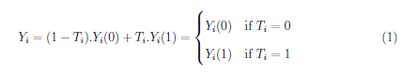
Under truly randomised allocation into treatment and control groups, the causal effect of the treatment is then simply given by:
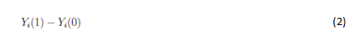
However, many interventions in education deliberately target groups of students in a non-random pattern. In particular, selection into treatment is often on the basis of low achievement or disadvantage. This may violate the assumption of orthogonality with the un-observables. Simple ordinary least squares regressions would therefore result in biased coefficient estimates as they do not account for endogenous selection into the program.
The Regression Discontinuity Design is an empirical framework that allows for estimation of treatment effects in non-experimental settings when defined criteria are used to determine selection of treated individuals or groups. The methodology exploits whether one or more observed criteria, known as allocation variables, exceed a designated cut-off. This was found to be the case in the Low SES NP since schools were allocated into the program according to a threshold on a socioeconomic index.
Regression Discontinuity (RD) analysis does not necessitate a firm threshold for all treated individuals or groups. Sharp RD is employed where all subjects above a particular threshold are treated with certainty. If exceeding a particular threshold increases treatment likelihood substantially but does not guarantee it, Fuzzy RD analysis methods must be applied.

The Smarter Schools National Partnership as RD
The major criterion for selection of schools into the Low SES NP was a school’s score on the Index of Relative Socioeconomic Disadvantage (IRSED). IRSED is an index constructed by the ABS specifically to identify disadvantage. It uses relevant, objective and transparent data variables from the National Census of Population and Housing.
Regression Discontinuity (RD) considers schools that were marginally above the threshold but not selected for the program as observations which only differ by their treatment status when compared to NP schools. Therefore, the quasi-experimental technique is often referred to as local randomisation with program assignment considered exogenous for schools just above or below the threshold. By tying selection to the IRSED score, the Low SES NP program effectively randomises in the vicinity of the threshold. This allows for causal estimation despite non-random assignment. No such threshold was clearly found for the Literacy and Numeracy National Partnership (LNNP) therefore preventing a national RD analysis of the LNNP.
Thresholds for school selection varied across the eight jurisdictions participating in the Low SES NP. In addition, the probability of treatment above these thresholds did not equal 100% as some schools that were below the threshold may have been treated while some with IRSED above nominated thresholds were not selected. Therefore as described above, Fuzzy RD methods were needed for causal estimation of the impact of the Low SES NP.

RD in Practice
Whilst different estimators have been proposed, Hahn et al. (2001) show the link between Fuzzy RD estimation strategy and the “Wald” formulation of the treatment effect in an instrumental variables setting. The discontinuity around the threshold becomes an instrumental variable for treatment status. In a two-staged-least-squares framework, the fuzzy RD design can be described by:
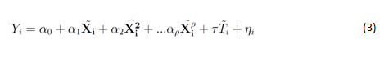
Reduced form:
First-stage:
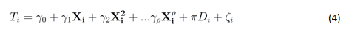
T denotes treatment status and D is a dummy equal to one if the unit crosses the assignment threshold.
In the Low SES NP context, this was estimated using a national value-added model that controls for prior achievement, a vector of covariates and a dummy for national partnerships participation as well as state, sector and socioeconomic status controls. The model is given by:
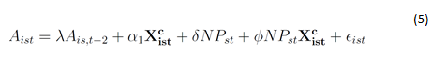
δ , the coefficient on NP, is the parameter of interest. It measures the difference in value-added between students in the schools just above the cut-off who were in the Low SES NP and those at non-participating schools who were just below the cut-off. This is known in the impact evaluation literature as the Local Average Treatment Effect.

Results and Robustness Checks
Table IV.1 presents the results of the regression discontinuity analysis described in (5). The coefficient on NP_LSES represents the estimated local average treatment effect of participation in the Low SES NP.
Table E: RD: Year 3 2009 to Year 5 2011 – LSES
Variable  s | Numeracy (IV) | Reading (IV)
NP_LSES | 5.547 | -4.294
 | (2.79)*** | (2.11)**
ICSEA | 0.184 | 0.170
 | (29.95)*** | (26.93)***
Size | 0.005 | -0.002
 | (5.24)*** | (1.93)*
Sector 2 | 3.022 | 4.922
 | (2.77)*** | (4.71)***
Sector 3 | -4.913 | -2.918
 | (6.79)*** | (3.89)***
Jurisdiction 2 | -9.425 | 5.110
 | (5.27)*** | (2.62)***
Jurisdiction 3 | -8.613 | -8.621
 | (2.91)*** | (1.80)*
Jurisdiction 4 | -9.665 | -5.129
 | (10.39)*** | (5.40)***
Jurisdiction 5 | -14.925 | -4.963
 | (13.89)*** | (4.68)***
Jurisdiction 6 | -3.700 | 6.121
 | (2.21)** | (2.94)***
Jurisdiction 7 | -2.226 | 2.271
 | (2.99)*** | (3.29)***
Jurisdiction 8 | -3.315 | 0.338
 | (3.10)*** | (0.33)
Sample stability | 0.134 | 0.142
 | (4.15)*** | (4.64)***
Starting score | 0.378 | 0.454
 | (28.50)*** | (33.92)***
R² | 0.72 | 0.78
N | 5,182 | 5,181
Adj. R² first stage | .43 | .43
Figures represent coefficients from a value-added regression with state, sector, socioeconomic and school size controls. State and sector names have been withheld in accordance with the SSNP National Evaluation Framework.
* p<0.1; ** p<0.05; *** p<0.01
A series of robustness checks were undertaken to ensure estimates were consistent. First stage statistics support the endogeneity of treatment as well as the validity and exogeneity of the selected instrument. Results proved robust to all alternate specifications. Other checks were implemented as described in Imbens and Lemieux (2007). These checks affirmed essential conditions of covariate continuity at the threshold and a lack of discontinuity at points other than the threshold.
The presence of conditions for the use of RD has permitted analysis leading to causal estimates of the impact of the Low SES NP. However, other factors related to the nature of the program may result in these estimates not representing the full causal effect. For example, this could be due to support provided to non-NP schools or other reasons described in this report. As such, they should be considered as the best estimates given available data and the nature of the SSNP. Further analysis at the state level using unit record data in an RD framework is included in the final report.

APPENDIX 5 – Quantitative Methodology – LNNP
Selection into the LNNP did not follow a clearly quantifiable measure as was the case for the Low SES NP, where the value of a school’s IRSED index or a related measure of its students’ socioeconomic background was used to select schools into the partnership. Schools were selected for participation in the LNNP based on a combination of quantitative and qualitative criteria that varied between jurisdictions. As a result, in the absence of thresholds determining entry, applying the regression discontinuity analysis to evaluate the impact of the LNNP was not possible. Instead, the relationship between participating in the LNNP and achievement was assessed by comparing progress between participating schools and similar non-participating schools. This section describes the methodology used for this analysis.

Data
The similar schools analysis was conducted using either school level achievement data from the MySchool website or unit-record achievement data provided by ACARA or jurisdictions’ TAA. Unit-record data was used for NSW, VIC, QLD, ACT and NT while school-level data was used in the remaining jurisdictions as permission to use unit-record data for students at both NP and non-NP schools was not granted in these states. The school-level method utilised cohort mean scores over a two year period, beginning in either 2009 or 2010, for students starting in Year 3 in all states, Year 5 in QLD, WA and SA and Year 7 in NSW, VIC, TAS, NT and the ACT. Whilst the data did not allow the identification of students who moved schools or did not participate in NAPLAN in either year, the year levels and calendar years were chosen to allow for cohorts to have experienced LNNP initiatives for the greatest period of time. The unit-record method used students’ individual scores in Reading or Numeracy matched over the same period and year levels. Students who moved schools or missed an assessment in either the baseline or later year were excluded from this analysis.

Comparison Groups and Method
The change in NAPLAN scores at a school (or student level) over two years was compared between LNNP schools (or students) and similar non-LNNP schools (or students). Two definitions of similarity were used. The first defines similar schools on the basis of the socioeconomic background of their students as measured by the school’s ICSEA value. In this definition NP schools are compared to non-NP schools with an ICSEA value in the same decile. For analysis of the 2009-2011 cohort, the 2009 ICSEA value was used, while the 2010 ICSEA value was used for analysing the 2010-2012 cohort. The ICSEA value The second approach defines similar schools as those with comparable achievement prior to the commencement of the LNNP. In this definition NP schools are compared to non-NP schools with an average NAPLAN score in the same decile in the baseline year. Average growth, or the change in mean NAPLAN scores, was measured within each decile for NP and non-NP schools. The proportion of students who surpass this average growth was then calculated for each decile and the mean proportion compared between the two groups. In both the similar ICSEA and similar prior score methods, the analysis focused on schools in the lowest four deciles of either measure, as these were identified as the most disadvantaged schools.

This figure of $540 million includes $40 million that was used to fund national projects.
For more information see (PGA 2013)
International evidence shows that the effect of coaching for instance, a common initiative across the majority of states, is related to the amount of time coaches spend at a school. Research has found that the impact of sustained professional development, such as coaching, on achievement is best seen after more than 2 years at a school (Garet et al 2001; IRA 2004; Lockwood et al 2010).
Since the ABS Index of Relative Socio-economic Disadvantage (IRSED) was used as the basis for identifying disadvantaged schools for selection into the Low SES NP, a quasi-experimental approach can yield causal outcomes.
The Year 3-5 NAPLAN scale suggests that 52 points on the assessment equate to an academic year, while the Year 5-7 and Year 7-9 scales both indicate that an academic year of learning is equivalent to 26 points. The estimated effects associated with Low SES NP participation from Year 7-9 are therefore equivalent to approximately 3-4 months of learning improvements in Numeracy.
Cohort gains refer to the growth or increases in students’ mean scores from the baseline year to two years later. Where possible the same student cohort should be used to determine real cohort gain. If only aggregated data is available, the term apparent cohort gain has been used.
This poses a potential threat to the validity of comparing outcomes in participating schools to those in non-participating schools. While systemic evidence could not be captured in existing literature, targeted support to non-participating schools was reported in several jurisdictions. This important external factor can be further explored in the core evaluation stage.
Eight of the 15 Catholic schools in the REI have been selected for two years from 2012 while eight Independent schools were selected for three years.
The number of Low SES NP schools was provided to PGA by the Australian Government Department of Education and consists of all schools who took part in the NPs, including those that have now closed down or merged.
This represents the number of LNNP schools in 2009/2010. In 2011, a merger between two schools reduced the number of LNNP schools to 77.
The 2012 ITS figure includes 5,012 ITS students participating for less than 1 year; 3,896 ITS students participating for 1-3 years and 1,224 students tracked immediately following their ITS.
WA’s SEI is constructed in a similar manner to IRSED. The SEI uses data from ABS collection districts of the actual addresses for all children enrolled at the school. There were notable differences in the demographics between partnership groups. For example, the Semester 1, 2010 cohort was dominated by remote schools while metropolitan schools were more heavily represented in the Semester 2, 2010 cohort.
In addition to having similar enrolment, attendance rates and ICSEA values, comparable schools achieved similar NAPLAN results to LNNP schools in the previous year.
The number of NP schools was provided to PGA by the Australian Government Department of Education and consists of all schools who took part in the NPs, including those that have now closed down or merged.
While RD was initially due to Thistlewaite and Campbell (1960), its emergence in applied economics was most notably through Hahn, Todd and van der Klaauw (2001). See Lee & Lemieux (2010) or Imbens & Lemieux (2007) for a detailed review of the method.
This refers to the proportion of students who have NAPLAN results at two year levels in a given school.

