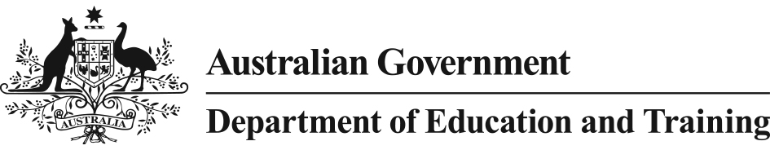 

Literacy and Numeracy Test for Initial Teacher Education Students

*Information for Students*

### What is the Literacy and Numeracy Test for Initial Teacher Education Students?

The Literacy and Numeracy Test for Initial Teacher Education Students (the Test) is an examination of aspects of your personal literacy and numeracy skills that can appropriately be measured through an online, machine marked assessment.

The literacy component will assess your reading and technical skills of writing. The numeracy component will look at your capability in numbers and algebra, measurement and geometry, and statistics and probability.

It is not a measurement of your ability to teach these core skills.

**Why is the Literacy and Numeracy Test being implemented?**

The Teacher Education Ministerial Advisory Group report, *Action Now: Classroom Ready Teachers*, found teacher employers had concerns with the classroom readiness of initial teacher education graduates and that the confidence in the quality and effectiveness of new teachers must be addressed. The introduction of a national literacy and numeracy test is a key recommendation of the Advisory Group’s report. In 2011 Australia’s Education Ministers agreed to implement the *Accreditation of Initial Teacher Education Programs in Australia: Standards and Procedures,* which outline that initial teacher education entrants will have personal literacy and numeracy skills broadly equivalent to those of the top 30 per cent of the adult population*.*

On 18 September 2015, all Education Ministers agreed to amend the Standards and Procedures to make the national Test the means through which higher education providers will assess that students are in the top 30 per cent of the adult population.

Implementation of a nationally consistent literacy and numeracy test will provide one response to public concerns about the quality of initial teacher education graduates and raise confidence in the effectiveness of existing programmes in preparing new teachers.

### When is the Literacy and Numeracy Test being implemented?

The Test was available in August and September 2015 on a voluntary basis for up to 5000 students.

From 1 July 2016, all initial teacher education students will have to pass the Test to meet the new requirements.

### When in my course will I have to sit the Literacy and Numeracy Test?

From 1 July 2016 if you are studying an initial teacher education course, you will need to pass the Test in order to meet the new requirements. The decision about when you will have the opportunity to sit the Test in your course will be made by your higher education provider.

### What if I don’t pass the Literacy and Numeracy Test?

Your higher education provider is required under the *Accreditation of Initial Teacher Education Programs in Australia: Standards and Procedures* to ensure that arrangements are in place to support you to achieve the required standard before you graduate.

Higher education providers already make allowance for this support.

If you successfully complete one component of the Test, but not the other, you will be able to ‘bank’ the component that you pass and will not have to sit that part of the Test again. Literacy is one component; Numeracy a separate component.

From 1 July 2016, you will need to successfully complete both components of the Test in order to meet the new requirements.

Further information about these arrangements will be available from your higher education provider ahead of national implementation from 1 July 2016.

## 2015 Implementation

### Why was the Literacy and Numeracy Test introduced in stages?

The Test was available in 2015 as part of a phased implementation to provide experience in its implementation before it is introduced as a national requirement from 1 July 2016.

A phased implementation also allows higher education providers who educate teachers an early opportunity to begin planning any additional assistance that they may need to provide to their students, ahead of national implementation from 1 July 2016.

### When will the Test be available?

There are no further Test sittings in 2015. The Test will be available nationally from 1 July 2016.

## 2016 National Implementation

### I am due to complete my course in the first half of 2016. Do I have to sit the Test?

No. Only those students who are due to complete their course from 1 July 2016 will be required to pass the Test to meet the new requirements.

### I am due to complete my course at the end of 2016. Do I have to sit the Test?

Yes. From 1 July 2016, you will need to pass the Test to meet the new requirements.

### I am not due to complete my course until 2017 onwards. When do I have to sit the Test?

Your higher education provider will advise when you will need to complete the Test.

### Will I have to pay to sit the Test?

Yes. From 2016 the cost of sitting the Test will be your responsibility.

Further details on arrangements for the Test will be provided through your higher education provider ahead of national implementation from 1 July 2016.

### Where will the Test be held?

Details on where you can sit the Test will be provided through your higher education provider ahead of national implementation from 1 July 2016. It is intended that delivery of the Test will be flexible and account for students in a range of locations.

### I study through distance education, how can I sit the Test?

We understand that if you study through distance education, it is not always practical to be able to sit a test in a designated location.

Details on how you can sit the Test will be provided through your higher education provider ahead of national implementation from 1 July 2016.

### What happens if I don’t pass one component of the Test?

If you successfully complete one component of the Test, for example, literacy, but not the other, you will be able to ‘bank’ the component that you passed and will not need to sit that part again. You must, however, successfully complete the second component in order to meet the new requirements.

### Will I receive support from my higher education provider if I don’t pass the Test?

Yes. Higher education providers are required under the *Accreditation of Initial Teacher Education Programs in Australia: Standards and Procedures* to ensure that arrangements are in place to support you to achieve the required standard before graduation.

Higher education providers already make allowance for this support and will be further informed in their work by the outcomes of the 2015 sittings of the Test.

Further information about these arrangements will be available from your higher education provider ahead of national implementation from 1 July 2016.