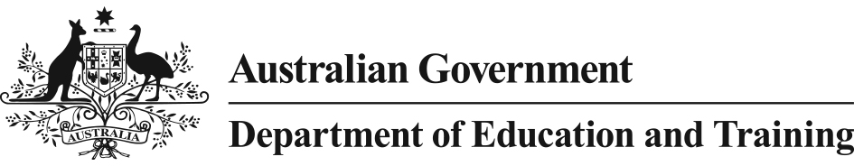 

Literacy and Numeracy Test for Initial Teacher Education Students

*Frequently Asked Questions*

### What is the Literacy and Numeracy Test for Initial Teacher Education Students?

The Literacy and Numeracy Test for Initial Teacher Education Students (the Test) is an examination of aspects of an individual’s personal literacy and numeracy skills that can appropriately be measured through an online, machine marked assessment.

The literacy component will assess an individual’s reading and technical skills of writing. The numeracy component will look at an individual’s capability in numbers and algebra, measurement and geometry, and statistics and probability.

The Test is not a measurement of an individual’s ability to teach these core skills.

### Why is the Literacy and Numeracy Test being implemented?

The Teacher Education Ministerial Advisory Group report, *Action Now: Classroom Ready Teachers*, found teacher employers had concerns with the classroom readiness of initial teacher education graduates and that the confidence in the quality and effectiveness of new teachers must be addressed. The introduction of a national literacy and numeracy test is a key recommendation of the Advisory Group’s report.

In 2011 Australia’s Education Ministers agreed to implement the *Accreditation of Initial Teacher Education Programs in Australia: Standards and Procedures,* which outline that initial teacher education entrants will have personal literacy and numeracy skills broadly equivalent to those of the top 30 per cent of the adult population*.*

On 18 September 2015, Education Ministers agreed to amend the Standards and Procedures to make the national Test the means through which higher education providers will assess that students are in the top 30 per cent of the adult population.

Implementation of a nationally consistent literacy and numeracy test for initial teacher education students will provide one response to public concerns about the quality of initial teacher education graduates and raise confidence in the effectiveness of existing programmes in preparing new teachers.

### When is the Literacy and Numeracy Test being implemented?

The Test was available in August and September 2015 on a voluntary basis for up to 5000 students.

From 1 July 2016, all initial teacher education students will need to pass the Test to meet the new requirements.

### What does ‘top 30 per cent’ of the population mean?

With the release of the *Accreditation of Initial Teacher Education Programs in Australia: Standards and Procedures* in 2011, a national approach to accreditation of initial teacher education programmes was realised. The Standards require that students who graduate from teacher education programs must have personal literacy and numeracy skills equivalent to those in the top 30 per cent of the adult population.

To achieve this, national and international literacy and numeracy frameworks were used to establish the level of competence which is equivalent to the top 30 per cent of the population.

The Test was trialled in 2014 with results benchmarked by experts to determine the pass mark. Students sitting the Test will receive results as either a pass or fail against the established benchmark.

### What does the Literacy and Numeracy Test involve?

The Literacy and Numeracy Test will be delivered online and involves 65 literacy and   
65 numeracy questions, with a mixture of multiple choice and constructed response questions.

Sample questions will be available from the administrator’s website ahead of 1 July 2016 to enable students to familiarise themselves with the type of questions included in the Test.

### How long does the Literacy and Numeracy Test take to complete?

It is expected that up to 2 hours will be allocated for the literacy component and 2 hours for the numeracy component.

### Does the Test measure all aspects of literacy and numeracy?

No. The Test is designed to assess elements of an individual’s personal literacy and numeracy skills that can appropriately be measured through an online, machine marked assessment.

The literacy component will assess an individual’s reading and technical skills of writing. The numeracy component will look at an individual’s capability in numbers and algebra, measurement and geometry, and statistics and probability.

Other aspects of literacy and numeracy will continue to be assessed during the completion of a teacher preparation course as has been the case in the past. The Test is not a measurement of an individual’s ability to teach the core skills of literacy and numeracy.