

Review of My School Website

Final Report to the Australian Government Department of Education

**8/09/2014**

**Grahame Cook PSM  
Director**

ISBN

978-1-76028-061-1 [PDF]  
978-1-76028-062-8 [DOCX]

Creative Commons

With the exception of the Commonwealth Coat of Arms, the Department’s logo, any material protected by a trade mark and where otherwise noted all material presented in this document is provided under a [Creative Commons Attribution 3.0 Australia](http://creativecommons.org/licenses/by/3.0/au/) (http://creativecommons.org/licenses/by/3.0/au/) licence.

The details of the relevant licence conditions are available on the Creative Commons website (accessible using the links provided) as is the full legal code for the [CC BY 3.0 AU licence](http://creativecommons.org/licenses/by/3.0/au/legalcode) (http://creativecommons.org/licenses/by/3.0/au/legalcode).

The document must be attributed as the Review of *My School*.

**Grahame Cook Consulting Pty Ltd**

**ABN 59 132 859 977**

**PO Box 4**

**Sunnybank Qld 4109**

**Disclaimer**

While Grahame Cook Consulting Pty Ltd endeavours to provide reliable analysis and believes the material it presents is accurate, it will not be liable for any claim by any party acting on such information.

This document takes into account the Terms of Reference and requirements of the Australian Government Department of Education.

# Acknowledgments

Grahame Cook Consulting would like to thank the Executive and staff of the Australian Curriculum Assessment and Reporting Authority for freely sharing information and data related to the   
*My School* website throughout the course of this review.

Grahame Cook Consulting would also like to thank all those with whom informal consultations were held as part of the *My School* review process. Their real world experience of the *My School* website provided valuable insights for the review.

Grahame Cook Consulting also wishes to thank and acknowledge the support provided throughout the review by officers of the Evidence Services Group of the Australian Department of Education

The views expressed in this review and any errors and omissions remain the responsibility of the author.

Table of Contents

Acknowledgments 3

Acronyms 7

Executive Summary 8

Background 8

Main issues 8

Key findings 9

Recommendations 11

Strategic issues and next steps 12

Website design and data release 13

Chapter 1 – The *My School* Initiative 14

The *My School* Website 14

Investment in *My School* Website 14

Stated purpose of *My School* 15

Key *My School* Stakeholders and Information Needs 16

Parents and students 16

School Communities 17

School Staff 17

State and Territory Governments 18

Commonwealth Government 18

Other Stakeholders 18

Context of National Reporting 18

National Assessment and Reporting Framework 18

Development of My School 19

Publication of Agreed Indicators 20

Governance of My School 21

Criticisms of My School 22

Key Findings 23

Chapter 2 – Usage of *My School* 24

Data sources and constraints 24

Overall Usage of *My School* 24

Referral Traffic 28

Qualitative and Quantitative Research 30

Analysis of *My School* Pages 32

*My School* Home Page 32

*CAPTCHA Page* 32

*School profile page analysis* 32

Comments 35

*NAPLAN Performance data analysis* 35

*NAPLAN - Results in graphs* 36

Comments 38

*NAPLAN – Results in numbers* 38

Comments 39

*NAPLAN - Results in bands* 40

Comments 42

NAPLAN – Student Gain 42

Comments 44

NAPLAN - Similar schools 44

Comments 45

Financial data analysis 46

Comments 48

VET data analysis 49

Comments 50

Local Schools analysis 50

Comments 51

Key Findings 52

Chapter 3 – International Developments in School Reporting 54

OECD – *My School* case study 54

USA – New York City 54

USA - Colorado 57

USA – Tennessee 58

United Kingdom 59

World Bank - EdStats 61

Conclusions 63

Key Findings 64

Chapter 4 – Reform agenda and Options for Improvement 65

Government policy agenda 65

Parent and Community Engagement 65

School Autonomy 65

Indigenous closing the gap targets 66

Development of an evidence base of performance data 66

Rationale for change 67

Additional useful indictors 67

Value-adding enhancements 68

Better targeted information 69

Presentation 70

Efficiencies 72

Key issues moving forward 73

Key Findings 75

Chapter 5 – Conclusions and recommendations 76

Synthesis of key findings 76

Options for changes 78

Assessment of way forward 79

Recommendations 80

Strategic issues and next steps 80

Website design and data release 81

Appendices 83

Appendix 1 – Terms of Reference for Review 83

Appendix 2 – Methodology and Data Sources 84

Methodology 84

Data Sources 84

Appendix 3 – Key References 85

End Page 87

# Acronyms

| **Acronym** | **Description** |
| --- | --- |
| ABS | Australian Bureau of Statistics |
| ACARA | Australian Curriculum Assessment and Reporting Authority |
| ATAR | Australian Tertiary Admission Rank |
| CAPTCHA | Completely Automated Pubic Turing test to tell Computers and Humans Apart |
| COAG | Council of Australian Governments |
| EdStats | World Bank Education Statistics |
| FAQ | Frequently Asked Question |
| FDWG | ACARA Finance Data Working Group |
| FTE | Full time equivalent |
| ICSEA | Index of Community Socio-Educational Advantage |
| IPS | Independent Public Schools |
| LBOTE | Language Background other than English |
| MCEECDYA | Ministerial Council on Education, Early Childhood Development and Youth Affairs |
| MCEETYA | Ministerial Council on Education, Employment, Training and Youth Affairs |
| NAPLAN | National Assessment Plan - Literacy And Numeracy |
| NYC | New York City |
| OECD | Organisation for Economic Cooperation and Development |
| PDF | Portable Document Format |
| PIAAC | Progress in International Assessment of Adult Competencies |
| PIRLS | Progress in International Reading Literacy Study |
| PISA | Programme for International Student Assessment |
| TIMMS | Trends in International Mathematics and Science Study |
| SCSEEC | Standing Council on School Education and Early Childhood |
| SWD | Students with Disabilities |
| TVASS | Tennessee Value-Added Assessment System |
| UK | United Kingdom |
| USA | United States of America |
| VET | Vocational Education and Training |
| WCAG 2.0 | Web Content Accessibility Guidelines version 2 |

# Executive Summary

## Background

As part of its *Policy for Schools: Students First* platform for the 2013 Federal Election, the Government committed to review the [*My School*](http://www.MySchool.edu.au/) website (www.MySchool.edu.au). The   
Australian Department of Education subsequently commissioned a review of *My School* to provide advice on:

* + - The success of the site in meeting the original purpose of *My School*;
    - How information published on *My School* is currently used and displayed;
    - The level to which the current suite of information available supports the Government’s reform agenda;
    - The publication of additional indicators; and
    - Opportunities for improvements.

The advice is to identify options for changes to the *My School* website and make recommendations for those changes. The full terms of reference for the review are at Appendix 1.

*My School* has not previously been formally reviewed although an evaluation of the website is being progressed by the Australian Curriculum Assessment and Reporting Authority (ACARA).

## Main issues

The *My School* website is inherently complex due to nature of the National Assessment Plan - Literacy and Numeracy (NAPLAN) data covered and sensitivities about comparisons between schools and the interpretation of the data and information presented. This has been exacerbated by the status of ACARA as a multi-jurisdictional body and complex governance arrangements, which make decision making a process of negotiation and allow for jurisdictional vetos at both the senior official and Ministerial Council levels. The end result can be less than optimal outcomes in the policy framework in which *My School* is developed and implemented.

Much of the sensitivity around *My School* relates to the NAPLAN data and concerns about it being misinterpreted or used for unproductive purposes, such as development of “league tables”, which can draw inappropriate comparisons between schools. The web site has been designed to try to overcome these problems, often at the expense of useability.

A related issue is the interpretation of “similar” schools, which are based on schools having students with statistically similar background known as the Index of Community Socio-Educational Advantage (ICSEA). ACARA has put substantial effort into improving this index to make it more robust and stable over time. Nevertheless it is recognised that the ICSEA is not designed to capture the qualitative factors that influence parents and school communities’ perceptions about their school.

A key issue that flows from consideration of these matters is the primary purpose of *My School* and the key audience it is expected to serve. During 2008 and 2009 the Commonwealth Government pushed a transparency and accountability agenda through the Council of Australian Governments (COAG) and Ministerial Council processes as part of a broader educational reform agenda.

In making the decision to establish *My School* the then Ministerial Council agreed that there were three key purposes for individual school performance reporting, namely:

1. To enable evaluation of school performance - to allow governments and researchers to analyse how well schools are performing by reference to nationally comparable data and to their own performance over time.
2. For public accountability (and transparency) purposes - to improve outcomes and equity for all students by using nationally comparable school performance data to build a substantive evidence base to support future improvements.
3. For better resource allocation – to enable identification of where resources are most needed to lift attainment as an aid to policy makers and to build pressure for change by placing parents and the broader community in the same position as education officials.

The current *My School* website says that the website “has two main purposes:

* It provides parents and students with information on each school – its view of itself and its mission, its staffing, its resources and its students’ characteristics and their performances.
* It provides schools and their communities with comparisons of their students’ performances in literacy and numeracy with those of students in other schools, most importantly those in schools that serve similar students. These comparisons provide information to support improvements in schools.”

The Government’s *Policy for Schools: Students First* undertakes to improving schools and education outcomes through policies to deliver more say for parents and teachers, a sound national curriculum, improved quality teaching, and certainty over school funding. The key government policies relevant to this review are parent and community engagement; school autonomy; Indigenous closing the gap targets; and development of an evidence base of performance data. The *My School* website has the capability to help advance this agenda.

## Key findings

*My School* represents a valuable, nationally consistent data set on Australian schools across all jurisdictions and all sectors. The systematic collection of new data, the refinement of its statistical underpinnings and further development of the system architecture has increased the potential value of the website over time. However, *My School* is a complex website with a lot of technical and statistical information that is not designed to be general user friendly. Consequently, the national data repository that *My School* now represents is probably underutilised.

There is some lack of clarity among stakeholders about the core purpose of *My School* and therefore its audience. The Commonwealth has a policy focus on transparency and accountability through publication of nationally consistent school level data. This is based on the absence of such data prior to *My School* and international evidence that clear accountability assists create a learning environment that encourages innovation and excellence. From a Commonwealth perspective, as a major funder and with both social policy and economic interests in educational outcomes, *My School* serves a valuable purpose.

For parents qualitative research results suggest that *My School* is perceived to be mainly about NAPLAN scores and academic performance, which is one aspect of how they make choices about schools. Nevertheless some parents use the website for helping choose a school, monitoring school performance and providing context for their own child’s achievement. Use of *My School* by principals and school system administrators is limited, in part because school systems are using NAPLAN and broader data to help drive school improvement. It would be useful to re-articulate the purpose of *My School* to focus on national transparency and accountability at the school level, while acknowledging its important benefits as a tool for educational improvement.

There is only limited data on the usage of *My School*, including by whom and for what purpose. In general usage of *My School* has been tending to decline but is still substantial. The available data shows that that there is spike in usage of *My School* at the time that new releases are made and to a lesser extent at the time NAPLAN tests are conducted and when the results are released. It could be expected that the main users at these times would be parents and school leaders.

The functionality of *My School* has been enhanced over time and the quality of data improved, especially the ICSEA methodology. Moreover, the *My School* work plan provides for the addition of further data sets in a phased manner. However, the website’s functionality and useability remains constrained by the complex Commonwealth, state and territory governance and policy framework in which ACARA operates. The *My School* design has been partly driven by the policy objective of making the collation and publication of league tables difficult, reflecting education union and other stakeholder concerns.

The available evidence suggests that the full functionality and utility of *My School* generally is not well understood, either by parents or teachers. As NAPLAN data relating to individual student performance is directly made available to parents and schools, the value added by *My School* relates to nationally consistent data for a school over time and comparative data for schools having students with statistically similar backgrounds and for all schools. Importantly, this includes where available student educational growth as presented in the NAPLAN student gain page.

*My School* website traffic data shows that the school profile, NAPLAN results in numbers and NAPLAN results in graphs pages together account for three-quarters of all page views. Other pages such as NAPLAN results in bands, VET in schools, local schools and school finances represent only a small proportions of total page views. The usage of the student gain page is small but appears to be increasing. This simple analysis indicates that most users are only interested in a small proportion of the information on offer or may find the website too complex to explore it more fully.

As a data rich website having a lot of information presented in graphical and tabular form with colour coding, statistical and educational terminology and explanatory notes and caveats, it is understandable that ordinary users may find the website challenging. Moreover, interpretation of the data can be difficult as, for example, the average NAPLAN results of students at a school can vary by year and by domain and margins of error overlap. A more sophisticated understanding of school performance than is offered by *My School* is required by school leaders in order to design educational interventions but the website can prompt important conversations.

With the 2015 release of *My School* a total of seven years of school level data will be publicly available. This means that for the first time results will be available for students who sat the first NAPLAN tests in year 3 in 2008 and have completed the full cycle of year 3, 5, 7 and 9 annual assessments. This data set will be very valuable to anyone interested in school performance and student gain over the 2008 to 2014 period. It also opens up the possibility of different ways of presenting data such as in time series form, which would be welcomed by parents.

Available research indicates that parents are interested in other indicators of school quality as well as those presented on *My School*, such as the ‘feel’ of a school, relationships and behaviour management, programs and facilities and other qualitative factors that are best determined by visiting a school and talking to teachers and other parents. The survey research also suggests that only a minority of parents utilise *My School*. Development of a specific summary page to better meet the needs of parents would help them make the most of the website. This approach could be broadened to create similar pathways for other stakeholder groups over time, depending on need.

The presentation of much of the content on *My School* may need significant reworking to meet current policy for accessibility for users with a disability – that is, compliance with the Web Content Accessibility Guidelines version 2 (WCAG 2.0). For example, while colour and audio options are available on some pages, the presentation of graphs, which do not specify the end points, and the use of colour coding make access by people using screen reading technology quite difficult.

In terms of international comparisons, a study undertaken under the auspices of the OECD noted that the transparency achieved through *My School* has placed the broader community in the same position as education officials in having access to national data. It also noted that *My School* presents school data in a way that places each school at the centre of the reports and is designed to avoid the misinterpretation that often arises with school league tables. A brief look at some similar websites in the United States of America (USA) and United Kingdom (UK) indicates that *My School* will need further development to remain a world-class mechanism for school accountability and reporting.

There is deal of interest from state and territory jurisdictions, academics, media and some other users to accessing the data repository that supports the *My School* website. ACARA agrees to requests for information that are judged to be for a good purpose. A more liberal policy of data release would be beneficial.

Under current arrangements any changes to the policy and protocols under which *My School* operates would require the endorsement of the Education Council.

A more detailed of analysis of *My School* is provided in the body of this report.

## Recommendations

The following recommendations are designed to improve the longevity, useability and utility of *My School* consistent with its role in improving the transparency and accountability of Australia’s school education system. The recommendations are grouped into higher level and more detailed recommendations for ease of reference

# Strategic issues and next steps

This review recommends that:

1. The *My School* website continues to be supported by all Australian jurisdictions as a nationally consistent school reporting system for the next four year ACARA work plan period commencing 1 July 2016. The next ACARA work plan is scheduled to be considered and approved during 2015.
2. The primary purpose of *My School* be focused on accountability at the school level, based on nationally consistent data. The primary accountability should be to parents and school communities. Use of the website for education improvement should be a secondary, albeit important, purpose.
3. The consensus decision making arrangements for *My School* be modified to allow for a more agile and user responsive approach to the further enhancement of the website. This will mean removing the right of veto and allowing any majority of jurisdictions and sectors that wish to proceed with the implementation of enhancements in content or presentation to do so.
4. The priority for future development of *My School* should be to collect, analyse and present data on the indicators previously agreed by Education Ministers so as to give a more rounded picture on schools and school outcomes. This will require significant work, including on standardised definitions, and should not be delayed because one or more jurisdictions or sectors cannot agree.
5. The Commonwealth negotiate with the state and territory jurisdictions to empower ACARA to improve the usability of *My School*, including of comparative data. This should include at a technical level meeting the requirements of the Double A standard of WCAG 2.0 in line with exiting Commonwealth policy. A leading website design and development company should be contracted as an adviser.
6. In the interests of transparency and full accountability all the data and information on   
   *My School*, including areas already agreed to be included, be available to all users, accepting that many users will not utilise elements of the website. A portal approach where certain information is reserved for categories of users would undermine the credibility of *My School*.
7. The Commonwealth take a lead role, including by working with ACARA and state and territory jurisdictions, to promote better understanding of the primary purpose, functionality and value of the *My School* website. This will help ensure that better value is derived from the investment in the site and of the seven years of data to be available from early 2015.
8. The Commonwealth prepare a paper for consideration and endorsement by senior officials and the Education Ministers’ Council to recommit to maintenance and enhancement of the national data base that underpins *My School*; to rearticulate the primary propose of   
   *My School*; to endorse the work plan to add additional data collections to the website; and to modify the governance and decision making processes to allow a majority of jurisdictions and sectors who wish to proceed with new initiatives to do so without full consensus having to be reached.

## Website design and data release

This review also recommends that:

1. The landing page for *My School* be simplified and the video material reviewed to make it more user friendly. The landing page should make a short statement about ACARA and the purpose of *My School* so the users understand the context immediately.
2. As the most widely used component of *My School* the school profile page should be made more useful by eliminating extraneous text and including a brief snapshot of the most recent NAPLAN results as presented in the results by numbers page.
3. School principals and school councils be given up to an additional 100 words on the school profile page to better articulate the education philosophy, behaviour management, programs and facilities, which research shows are of particular interest to parents.
4. A parent’s guide to *My School* and a parent’s page be developed based on further research into what parents actually value and want from the site and in what form they would like to access it. This page should include appropriate contextual information and the ability to choose relevant data and make comparisons from the NAPLAN and other pages that are of most interest to them.
5. That generally no further development work be put into *My School* pages that have proved to be of little interest to users of the site. These include the local schools page, the NAPLAN results in bands page; and the school finances page. To the extent that policy makers may wish to undertake further analyses in these areas that can be done from the underlying data set.
6. That some additional development work be done on the VET in schools page and underlying data set to enable consistent cohort comparisons of enrolments to completions for students undertaking the vocational stream of education. Similarly the student gain page be further developed to allow longer term analyses to be undertaken, especially for students with the same starting points.
7. Requests from education researchers and academics for access to de-identified *My School* data be granted as a matter of course and data sets already released be made publicly available, with the onus on ACARA to demonstrate why not. This is consistent with the broader movement towards open government and with encouraging innovation in the use of government data.

# Chapter 1 – The *My School* Initiative

This chapter focuses on key background and contextual information about the *My School* website.

## The *My School* Website

The *My School* website was launched in January 2010 by ACARA with the publication of 2008 and 2009 school data. It provides basic school profiles and NAPLAN performance data for virtually every Australian school. *My School* is the first nationally consistent source of schooling data, which can be used by parents, community associations, schools and governments. It therefore fulfils an important transparency and accountability function.

In May 2010 the then Government announced that ACARA would be asked to convene a *My School* Working Party, comprising education experts and representatives of teachers, principals and parents, to address concerns raised by the Australian Education Union and other groups about the first version of *My School*. The Working Party also considered enhancements previously agreed by the Ministerial Council on Education, Early Childhood Development and Youth Affairs (MCEECDYA).

Amongst other things, members of the Working Party were concerned that presentation of NAPLAN results on the school profile page conveyed the impression that it was the major indictor of school effectiveness and performance; that the focus should be on contextual information and NAPLAN results presented on a separate page.

From the second version of *My School* released in early 2011 with 2010 data, NAPLAN results have been presented separately and a number of significant enhancements made. These include new content (the CAPTCHA page to prevent computerised data gathering; financial information for each Australian school, student progress information); better data (enhanced ICSEA); and clearer presentation of some data (schools with statistically similar students – colour coded bubble graph).

Prior to the introduction of *My School*, there also had been a long-term issue with the lack of reliable and consistent data for policy development. There was no nationally-comparable data or single source of data at school level to provide a basis for analysis for policy options and rational and equitable distribution of national resources. The *My School* website and the full population NAPLAN publication have significantly closed this data gap. *My School* helps ensure that there is sufficient funding transparency to enable the public to understand how students’ needs are being met.

*My School* is designed to provide parents, students and the community with important information on each school including student learning, school culture, student background, school profile, workforce and school finances. The *My School* website can be searched by location, sector or school name and has profiles for over 9,500 Australian schools, which cater for over 3.63 million students.

## Investment in *My School* Website

Since May 2009 about $18.3 million has been invested in and committed to the development and hosting of the *My School* website as shown in Table 1.1 below. During 2009-10 to 2011-12 ACARA engaged a third party to assist with the development of the *My School* website but subsequently bought the development services in-house. This has reduced direct costs substantially.

The funding agreement between the Commonwealth and the states and territories provides for funding for *My School* to be contributed 50 per cent by the Commonwealth and 50 per cent by the states and territories according to their populations.

Table 1.1: *My School* Direct Expenditure: 2008-9 to 2014-15

| **Direct Expenditure** | **2008-09**  **$’000** | **2009-10**  **$’000** | **2010-11**  **$’000** | **2011-12**  **$’000** | **2012-13**  **$’000** | **2013-14**  **Prelim**  **$’000** | **2014-15 Budget**  **$’000** |
| --- | --- | --- | --- | --- | --- | --- | --- |
| Salaries & Wages | 8 | 1,200 | 2,112 | 2,155 | 1,387 | 1,402 | 1,402 |
| Contractors | 5 | 1,536 | 1,666 | 554 | 475 | 139 | 261 |
| Website Hosting | 0 | 604 | 362 | 340 | 306 | 350 | 276 |
| Travel | 1 | 160 | 134 | 36 | 7 | 11 | 10 |
| Advertising | 0 | 628 | 0 | 0 | 0 | 0 | 0 |
| Legal Advice & Other | 0 | 269 | 229 | 86 | 128 | 41 | 10 |
| **Total** | 14 | 4,397 | 4,502 | 3,171 | 2,303 | 1,943 | 1,959 |

***Source:*** ACARA internal financial information.

***Notes:*** The above expenditure reflects direct costs only; no indirect costs have been assigned. The ACARA Board was appointed on 28 May 2009, so data for 2008-09 reflects only some start up activity. The 2013-14 figures are subject to audit. Totals may not add due to rounding.

The total investment in *My School* would be much larger than shown above if indirect and opportunity costs were to be accounted for, such as the time spent by officials and Ministers in all eight jurisdictions and executives in the Catholic and Independent school sectors on *My School* matters, expert working parties and so on. However accurate attribution of such costs to *My School* would be an extensive exercise.

## Stated purpose of *My School*

The then Ministerial Council on Education, Employment, Training and Youth Affairs (MCEETYA), In agreeing to the *My School* website implementation in September 2008 agreed that it would serve three key purposes for individual school performance reporting:

1. To enable evaluation of school performance - school level information allows governments and researchers to analyse how well schools are performing by reference to nationally comparable data and to their own performance over time.
2. For public accountability purposes - the aim of the transparency and accountability policy agenda is to improve outcomes and equity for all students by using nationally comparable school performance data, presented on *My School*, to build a substantive evidence base to support future improvements.
3. For better resource allocation - school level information has enabled identification of where resources are most needed to lift attainment. Making the results publicly available aids policy makers and builds pressure for change in school communities by placing parents and the broader community in the same position as education officials.

The current ACARA *My School* “fact sheet” says that the “website provides an opportunity for everyone to learn more about Australian schools, and for Australian schools to learn more from each other. It contains a set of quality data that teachers, schools, parents and the wider community can use, along with other information, to help ensure that every child in every classroom receives a high quality education”.

At the same time the current ACARA *My School* website page says that the website “has two main purposes:

* It provides parents and students with information on each school – its view of itself and its mission, its staffing, its resources and its students’ characteristics and their performances.
* It provides schools and their communities with comparisons of their students’ performances in literacy and numeracy with those of students in other schools, most importantly those in schools that serve similar students. These comparisons provide information to support improvements in schools. Amongst schools with similar students, those achieving higher student performances can stimulate others to lift expectations of what they and their students can achieve. The schools with higher-performing students can be a source of information for others on the policies and practices that produce those higher performances.”

While each of these statements has a common theme of transparency and accountability it appears that there has been a shift of emphasise and a broadening of the perceived potential audience(s) for *My School*.

## Key *My School* Stakeholders and Information Needs

It is obvious that the information needs of parents and students, who are seeking to make a choice of school or engage with a school about issues of interest, will differ both in the scope and depth of information needed compared to principals and school leaders who are seeking to design interventions to drive school improvement. It is also the case that parents and students are influenced by a much broader range of information than *My School* is designed to provide; while principals and school leaders will also need more information but of a different kind, including school assessments, performance relative to the curriculum, professional development and so on.

### Parents and students

Parents and students, as the primary clients of schools, are interested in a wide range of information regarding schools’ educational experience and quality. The information needed will change depending on individual circumstances and whether students are commencing school, moving from primary to secondary school or moving location. In many cases, of course, parents and students, have no realistic alternative other than to attend their local public school. At the same time, however, about one third of all school students attend non-government schools as a matter of choice. In addition, Australian Bureau of Statistics (ABS) net interstate migration figures indicate that in 2013 over 50,000 school age children moved interstate[1] and hence a choice of government or non-government school would need to be made.

It seems clear from survey work commissioned by parent and principals associations and by ACARA[2] that parent choice of school is informed by a range of factors such as the ‘feel’ of a school, relationships and behaviour management, extra-curricular activities and other qualitative factors that are best determined by visiting a school and talking to teachers and other parents. *My School* is used as one source of information. Some parents with children already enrolled in a school may be more focussed in their own child’s performance rather than the school’s results as such, or the average growth in education across assessment periods.

Nevertheless, there is anecdotal and qualitative research evidence that some parents use *My School* as source of information and data to engage in a dialogue with their school outside the normal course of events. For example, a parent may use the website as contextual background to inform a discussion about their child’s performance.

### School Communities

The school “community” includes students, parents, teachers, principals, volunteers, extended family members and in many cases local clubs and community associations, business groups and local government. The level of engagement by the community broadly defined is likely to be driven by a range of reputational and social factors and perceived needs over and above what is published on *My School*. Nevertheless *My School* can provide valuable insights as a basis for celebration or concern.

The local school or schools are usually seen as a key institution within a community adding substantially to its social and human capital. The fact that many members of a local community engage with a school, including by fund raising for improved facilities, is testament to this.

### School Staff

Principals and school leaders require reliable information on student and school performance for the effective management of schooling operations. They also require dependable information on how well students are performing in relation to school goals for improvement relative to present and past levels of achievement. *My School* can provide some of that information as well as the achievements in other schools with students with statistically similar backgrounds.

Consultations indicate that there is some usage of *My School* in this way, especially by non-systemic schools, but that its role is limited in developing intervention/improvement programs. This is because principals and school leaders need more and different information, including their own or system provided analysis, school assessments, performance relative to the curriculum, professional development needs of staff, and direct feedback from teachers.

For teachers, data published on *My School* can initiate a discussion which could assist change their classroom teaching practice as they know their students well and can apply their professional judgment and experience to better meet the learning needs of individual students.

### State and Territory Governments

State and territory governments and their education departments are responsible for the delivery of quality education to all students and require reliable, accurate and consistent information on the performance and progress of schools. Effective management depends on an ability to monitor system-wide and school performances over time, to gauge the effectiveness of special programs and targeted resource allocations, to monitor the impact of policies, and to evaluate the success of initiatives aimed at disadvantaged and underachieving students.

Consultations indicate that the extent to which *My School*, and the underlying data set, is used varies according to the sophistication of the systems used in individual jurisdictions, across sectors and between schools within sectors. The larger school systems do not appear to use *My School*, relying instead on their own data analysis and information systems[3].

### Commonwealth Government

The Commonwealth Government and the Department of Education do not run schools but have major policy interest in education from both social policy (e.g. equity and participation) and economic policy (e.g. skilled workforce, productivity) perspectives. As a major funder of school education the Commonwealth has a keen interest in ensuring the best outcomes are achieved from that investment. Ensuring appropriate transparency and accountability on a nationally consistent basis at the school level is an important objective in this regard.

The nationally consistent data set that underpins *My School* and the analysis presented on the site is also a valuable resource to help inform policy and program development, as well as providing a public evidence base on which to draw for discussions with all jurisdictions and all sectors (government, independent, catholic) on matters of interest to the Commonwealth. For example, the school finances data set was an important input into the 2011 *Review of Funding for Schooling[4].*

### Other Stakeholders

Other stakeholders include academic researchers and policy developers, think tanks, commentators, media and so on. Their interests in *My School* are likely to vary from international comparative studies to developing simplistic league tables to generate stories.

Without *My School* such stakeholders would not have access to nationally consistent data at the school level.

## Context of National Reporting

### National Assessment and Reporting Framework

The *My School* website is one element of a national assessment and reporting framework designed to achieve accountability and report on improvement in student performance. The framework also combines the development of goals, monitoring and reporting at the national level with local evaluation and assessment practices shaped by jurisdiction-level school improvement frameworks. This includes national and international assessment programs, an annual national report on schooling, state and territory reporting, the provision of individual school performance information, the publication of annual school reports and individual student assessments.

### Development of My School

In December 2008 the Ministerial Council for Education, Employment, Training and Youth Affairs (MCEETYA) agreed to the *Melbourne Declaration on Educational Goals for Young Australians*. The declaration committed all Australian governments to meet two high level educational goals for education at all stages of a child's schooling:

* Australian schooling promotes equity and excellence; and
* All young Australians become successful learners, confident and creative individuals, and active and informed citizens.

MCEETYA’s key strategies to address these issues included improving educational outcomes for Indigenous youth and disadvantaged young Australians, especially those from low socioeconomic backgrounds and strengthening accountability and transparency.

The development and launch of the *My School* website followed agreement at the 29 November 2008 COAG meeting that greater transparency and high quality accountability and reporting on the performance of Australian schools was essential to ensure that every child receives the highest quality education and the opportunity to achieve through participation in employment and society. The information on schooling was agreed to be both locally and nationally relevant, timely, consistent and comparable and that this would be delivered through a national website.

In April 2009, Education Ministers resolved that financial information for each Australian school would be included from the 2010 release of the *My School* website onwards. ACARA established the Finance Data Working Group (FDWG) to develop a methodology to support a nationally consistent system for the reporting of school level financial data. The methodology developed by the FDWG focused on providing comparable data across individual schools.

In February 2011 ACARA released the 2010 *My School* 2.0 website. The website has been since updated on a yearly basis with specific information to be included in a phased manner. The 2014 update to the *My School* website was launched on 5 March 2014 and adds another year (2013) of data to the website, 2012 financial data information, an update of the ICSEA methodology, as well as some functionality and appearance enhancements. The current forward work plan for *My School* includes a full school opinion survey for *My School* 5.0 due for release in 2015 and improved reporting of nationally consistent data on comparable senior secondary information, including Australian Tertiary Admission Rank (ATAR) information, in 2016.

Importantly, with the 2015 release of *My School* a total of seven years of school level data will be publicly available. This means that for the first time results will be available for students who sat the first NAPLAN tests in year 3 in 2008 and have completed the full cycle of year 3, 5, 7 and 9 annual assessments. This data set will be very valuable to anyone interested in school performance and student gain over the 2008 to 2014 period.

### Publication of Agreed Indicators

As agreed by MCEECDYA, the full set of indicators originally requested for *My School* is listed in Table 1.2 below; together with the year it was first published on the *My School* website.

Table .2: *My School* Indicators.

Indicator First year published

1. School profile data (sector, year range, enrolments etc.) 2010
2. School attendance rate 2010
3. Staff information:
   1. Teaching and non-teaching staff numbers 2010
   2. Proportions of teachers at each level of expertise n/a
4. School finances: sources of income and capital expenditure 2011
5. Student characteristics:
   1. SES profile 2010
   2. % LBOTE 2011
   3. % Indigenous 2010
   4. % with disability n/a
6. School comments 2010
7. School outcomes:
   1. NAPLAN 2010
   2. VET attainment/participation 2011
   3. Post-school destinations 2010  
      (for schools in Western Australia, Queensland and Victoria)
   4. Proportion attaining Year 12 or Equivalent n/a
   5. Tertiary score information n/a
8. Measures of gain/growth 2011/2012
9. Comparisons with statistically similar schools 2010
10. Comparisons with local schools 2010
11. Parent/student satisfaction n/a
12. Staff satisfaction n/a

***Source:*** Ministerial Council decisions

As can be seen from the above table, of those indicators initially agreed, a small but important set are yet to be published. These include:

* Proportions of teachers at each level of expertise. Further information on teaching staff would give parents a greater appreciation for the level of educational experience and expertise in each school. Schools are already required to publish data on qualifications in their annual reports. However a collection would need to be developed to collect information on Bachelor, Masters, and PhD qualification directly from schools. It was envisaged that this data collection would be based on the development of a nationally consistent approach to the certification of accomplished teachers and school leaders through the Smarter Quality Teaching National Partnership.
* Percentage of students with disabilities. This indicator was proposed due to its capacity to assist with funding decisions, however until now, the data collection was not carried out homogeneously and definitions used across jurisdictions to identify these students were not consistent. A nationally consistent data collection is currently in its implementation phase with disability data expected to be published on *My School* when the data quality is of an appropriate level.
* Proportion of students attaining Year 12 equivalent. This is a key piece of information required to assess the performance of schools in terms of educational outcomes. The feasibility for collecting school level Year 12 equivalent data requires agreement on and application of a nationally consistent definition, noting that there are significant differences between attainment and completion.
* Tertiary entrance score information. This is another key piece of information required to assess the performance of schools. There are issues with access to this data which is held by University Admission Centres. An alternative measure could be to collect and report on the percentage of students eligible for university entrance.
* Information on parent, student and staff satisfaction. A survey and data collection tool for a National School Opinion Survey was developed by ACARA and made available in 2013 but Education Ministers declined to make it mandatory. While schools are currently required to publish satisfaction survey results in their annual reports there is a lack of consistency on the collection and reporting of this data at a school, sector and jurisdiction level. At least one jurisdiction considers that opinion survey results are not relevant to school outcomes. Arguably, opinion survey results provide valuable insights into the culture within a school, relationship and communication issues and judgements about the quality of teaching, all of which have bearing on student achievement. Clearly further work will be required to achieve reporting of this information on *My School*.

The above discussion shows the complexities of agreeing, collecting, analysing and presenting nationally consistent data sets on *My School*. While the direct and indirect costs of new data sets are not insignificant and there are always competing priorities, these factors must be weighed against the national benefits obtained from publication of a better rounded set of indicators and important missing information on school outcomes.

### Governance of My School

Although ACARA is established under Commonwealth legislation it operates as a national body. This is reflected in its governance and funding arrangements. It is important to understand this context as it permeates through everything that ACARA does. *My School* is no different.

As outlined earlier, the route to establishment of *My School* was complex involving the Education Ministers’ Council and COAG. Decisions about the content and presentation of information and data on *My School* have to be agreed by senior officials and then the Education Ministers’ Council. Due to a combination of jurisdiction, stakeholder and other sensitivities, and technical complexities the decisions made at Ministerial Council level have usually involved a high degree of detail that prescribe the parameters of *My School*.

Consequently there is often a tension between the agreed principles of transparency, accountability (and more generically open government) and usability and what is actually reported and how it is reported on *My School*.

### Criticisms of My School

There has been some controversy and concerns raised about the *My School* website of interest to this review. These include:

* The focus on NAPLAN as the primary source of information and performance of schools.
* The unintended consequences in school and student’s behaviour resulting from the publication of NAPLAN results, such as:
  + teachers moving away from a broad commitment to school learning and teaching towards the test.[5]
  + students becoming stressed before the test and this impacting on test results as well as damaging student wellbeing.
  + students being requested to stay at home out of fear that if they have a poor performance, the school will be disadvantaged.
* The gap between the time NAPLAN tests is administered and when the test results are made available, which limits the test usefulness as an appropriate diagnostic tool.
* The use of league tables by the media to rank schools and the resulting naming and shaming of schools.
* The lack of other indicators that would provide further information about the school providing context to the data.

The Senate Inquiry Report into the *Effectiveness of the National Assessment Program – Literacy and Numeracy* conducted in May-June 2013 found that “While most submitters, particularly teachers and principals, offered in-principle support for NAPLAN testing and the careful use of data, in conjunction with teacher assessment, strong criticism was reserved for the publication of individual schools data on the *My School* website”.

The limited consultations undertaken to help inform this review elicited some similar concerns and others that involved reservations about aspects of the *My School* financial data and statistically similar schools.

However it is important that these criticisms be seen in context. For example, *My School* is only designed to provide a limited amount of data about a school, a lot of effort has been made to achieve national consistency in the data collected, and terms and conditions of use and design features incorporated in the website to minimise the risk of inappropriate use of information. More fundamentally, the accountability and transparency agenda has meant that an unprecedented amount of nationally consistent data is now publicly available about Australian schools, including comparative information on the performance of students at a selected school in literacy and numeracy over time and their performance in relation to schools with statistically similar students.

This provides a rich source of information to supplement information provided by the National Report on Schooling, State and Territory reporting, individual schools’ annual reports, school student reporting to parents, research reports and so on.

It is also worth noting that ACARA has been undertaking a range of activities to examine the feasibility of conducting NAPLAN tests on-line. This includes pilot studies and trialling test design in schools, with further trials in 300 schools scheduled for August-September 2014. Successful implementation of online testing would enable better targeting of tests to students and much faster turnaround for results to be available.

On balance, while *My School* could be improved, in the judgement of the reviewer the benefits clearly outweigh actual and perceived deficiencies.

## Key Findings

* Three key purposes for the reporting of individual school performance on *My School* were originally articulated: to enable evaluation of school performance; for public accountability purposes; and for better resource allocation. Over time there appears to have been a shift to put more emphasis on broadening the range of information provided to parents and students and to provide schools and their communities with comparisons of their students’ performances in literacy and numeracy with those of students in other schools. As a result of media and other stakeholder interest there has been some broadening of the potential audiences for *My School*.
* There has been a substantial direct expenditure on the *My School* website but the annual costs of the site have stabilised at around $2 million in recent years, of which the Commonwealth pays half.
* The *My School* website is one element of a national assessment and reporting framework designed to achieve accountability and improvement in student learning. The website should be considered in this broader context of national assessment and reporting.
* The stakeholders most relevant to *My School* range from parents and students, through school principals and staff to governments. Each stakeholder group has different data and information requirements and interests. Trying to meet all these needs is a substantial challenge.
* There are a number of key data sets originally agreed by Education Ministers that are yet to be published on *My School* although some development work has been completed (e.g. School Opinion Survey) and other work is proceeding (e.g. students with a disability).
* There are many complexities and sensitivities in agreeing, collecting, analysing and presenting nationally consistent data sets on *My School*. The direct and indirect costs of new data sets are not insignificant and should be weighed against the national benefits obtained from including further key information on school outcomes.
* The national governance arrangements for ACARA and *My School*, together with stakeholder sensitivities, have resulted in the website operating within a very prescriptive policy and operational framework, often to the detriment of useability.
* The *My School* initiative has attracted a deal of criticism despite it being agreed by all jurisdictions and sectors. These criticisms should to be seen and weighted in the context of what *My School* is designed to do and the enhancement of accountability and transparency through the publication of nationally consistent data.

# Chapter 2 – Usage of *My School*

This chapter draws together fairly detailed information on the functionality and usage of *My School* on a page by page basis within the limitations of the data available.

## Data sources and constraints

The images of *My School* web pages in this chapter are screen shots from the current *My School* website but without including the identity of the school. The images have been selected to be representative rather than comprehensive of what *My School* has to offer.

*My School* website data on visits, unique visits and page views is sourced from ACARA. For reasons of appropriateness and privacy ACARA does not track users of the site. Through use of Google Analytics some information can be gleaned on what other websites users have come from.

The questions of who is using the website, how often, for what purpose and how influential it is cannot be answered directly but can only be inferred from other sources such as quantitative and qualitative research commissioned by ACARA and surveys undertaken for their own purposes by some stakeholder groups.

The descriptive text on functionality and the commentary on the use of *My School* pages in this chapter should be read in this context.

## Overall Usage of *My School*

The overall picture that emerges from the *My School* website traffic data (see Table 2.1 below) is that usage in terms of visits and unique visitors dropped sharply after the first release of *My School* and has tended to be reasonably stable but nevertheless decline slowly since. The initial peak of interest is not unexpected because of the public debates about the pros and cons of *My School* in the period leading up to the website first going live. The continuing level of usage of *My School* with 1.45 million visits, including 0.79 million unique visitors for *My School* 2013 indicates that it is filling a significant need. At the same time 0.66 million users were repeat visitors.

To put these figures in broad context, a simplistic analysis suggests that with 3.63 million full time equivalent (FTE) students enrolled in 9,393 schools in 2013, and an average fertility rate of 1.93 children per women[6], the number of parents with children enrolled in schools could be in the order of 3.7 million. Also in 2013 there were 261,585 FTE teaching staff in schools[7]. Considering that there are a range of other stakeholders, it can be estimated that the potential users of *My School* well exceeds 4 million people.

Further details of the aggregate picture are discussed below. This includes the bar chart that compares school enrolments to page views (Figure 2.1); the graphs of monthly *My School* traffic (Figure 2.2); the average number of pages visited (Figure 2.3); and the bar chart of individual page views as a proportion of the total number of page views for each release of *My School* (Figure 2.4).

It is important to note that the numbers for *My School* 2014 used in this chapter are only for the part-year from 5 March to 30 June 2014. However there is good reason to believe that the past pattern (Figure 2.2) of another but lesser peak in August/September with the release of the summary NAPLAN reports and individual student reports, and then a decline until the 2015 release of *My School*, will be repeated.

Table 2.1: *My School* visits by release

| ***My School* release** | **Visits** | **Unique Visitors** | **Time period** |
| --- | --- | --- | --- |
| ***My School 1*** | 4,610,716 | 3,182,490 | 28 Jan 2010 to 3 Mar 2011 |
| ***My School 2*** | 1,777,200 | 961,319 | 4 Mar 2011 to 23 Feb 2012 |
| ***My School 2012*** | 1,609,775 | 913,062 | 24 Feb 2012 to 12 Mar 2013 |
| ***My School 2013*** | 1,448,904 | 791,045 | 13 March 2013 to 4 March 2014 |
| ***My School 2014*** | 555,081 | 340,465 | 5 March 2014 to 30 June 2014 only |
| ***Total*** | 10,001,676 | 6,188,381 |  |

***Source****:* ACARA website data

The period covered by *My School* releases does not coincide with school years so a direct comparison between page views and school enrolments is not practicable with exiting data. However a number of analyses undertaken for this review suggest that while initially there were proportionally more page views from states and territories performing below the national average, over time the level of usage of *My School* is not substantially different across the eight jurisdictions. One analysis is shown in Figure 2.1.

Figure 2.1 – 2012 School Enrolments to *My School* Views by State/Territory

Graph of 2012 School Enrolments to MySchool views by State and Territory.
This table shows that all states had on average 0-1 percentage difference between the 2012 enrolments and page views over the same period. 
***Sources:*** [*Report on Government Services 2014*](http://www.pc.gov.au/gsp/rogs/childcare-education-training)*( http://www.pc.gov.au/gsp/rogs/childcare-education-training)*; and ACARA data

Notes: Total Australian Enrolments is 3,576,900. The Report on Government Services 2014 reports on 2012 data. The comparison used is *My School* views from 1 March 2011 to 7 July 2014

An analysis of the *My School* monthly website usage data from ACARA shows that visits to the website follow a clear cycle with a major spike in interest associated with each new *My School* release in March, and lesser spikes associated with NAPLAN tests in May and release of the summary NAPLAN report and student reports in September. The pattern of usage is demonstrated in Figure 2.2.

Figure 2.2: *My School* traffic by month

*Depicts monthly usage of MySchool page traffic broken down by month as per 500,000 views. This is broken down by page views, visits and unique visitors.

Results show a spike in MySchool page views to over 4,500,000 views in March 2011, with peaks of over 2,500,000 throughout February and March in 2012, 2013 and 2014.
*

***Source:***ACARA website data from March 2011 to June 2014

***Notes:*** A *page view* refers to every request to load a single page. If a user navigates away and returns an additional page view is recorded. A *visit* refers to the number of individual sessions by all users of the website. A *unique visitor* is a user who has not previously visited the website. A first time user of the website counts as both a *visit* and a *unique visitor*.

It is interesting that there does not appear to be a particular peak associated with school enrolment periods suggesting that usage of *My School* as an aid for parental choice is more distributed across the year and years prior to enrolment.

An analysis of daily *My School* traffic for the March 2014 launch, the May 2014 NAPLAN testing and September 2013 NAPLAN results release (representative of each of the peak periods of usage) shows that the peak is concentrated around a short period of only a few days before usage subsides. This may suggest that much of the peak reflects use by parents with children involved in NAPLAN testing as well as school principal, media and other stakeholder interest around these events.

Turning to what *My School* pages are used by visitors to the website, Figure 2.3 below shows that the average number of pages visited by each visitor is tending to reduce over time but is still quite substantial. This seems to imply that during the initial releases of *My School*, peopled tended to explore the site more. However, it is not unexpected that as users become more familiar with the website that the number of pages visited would decline.

Figure 2.3: Average number of *My School* pages visited.

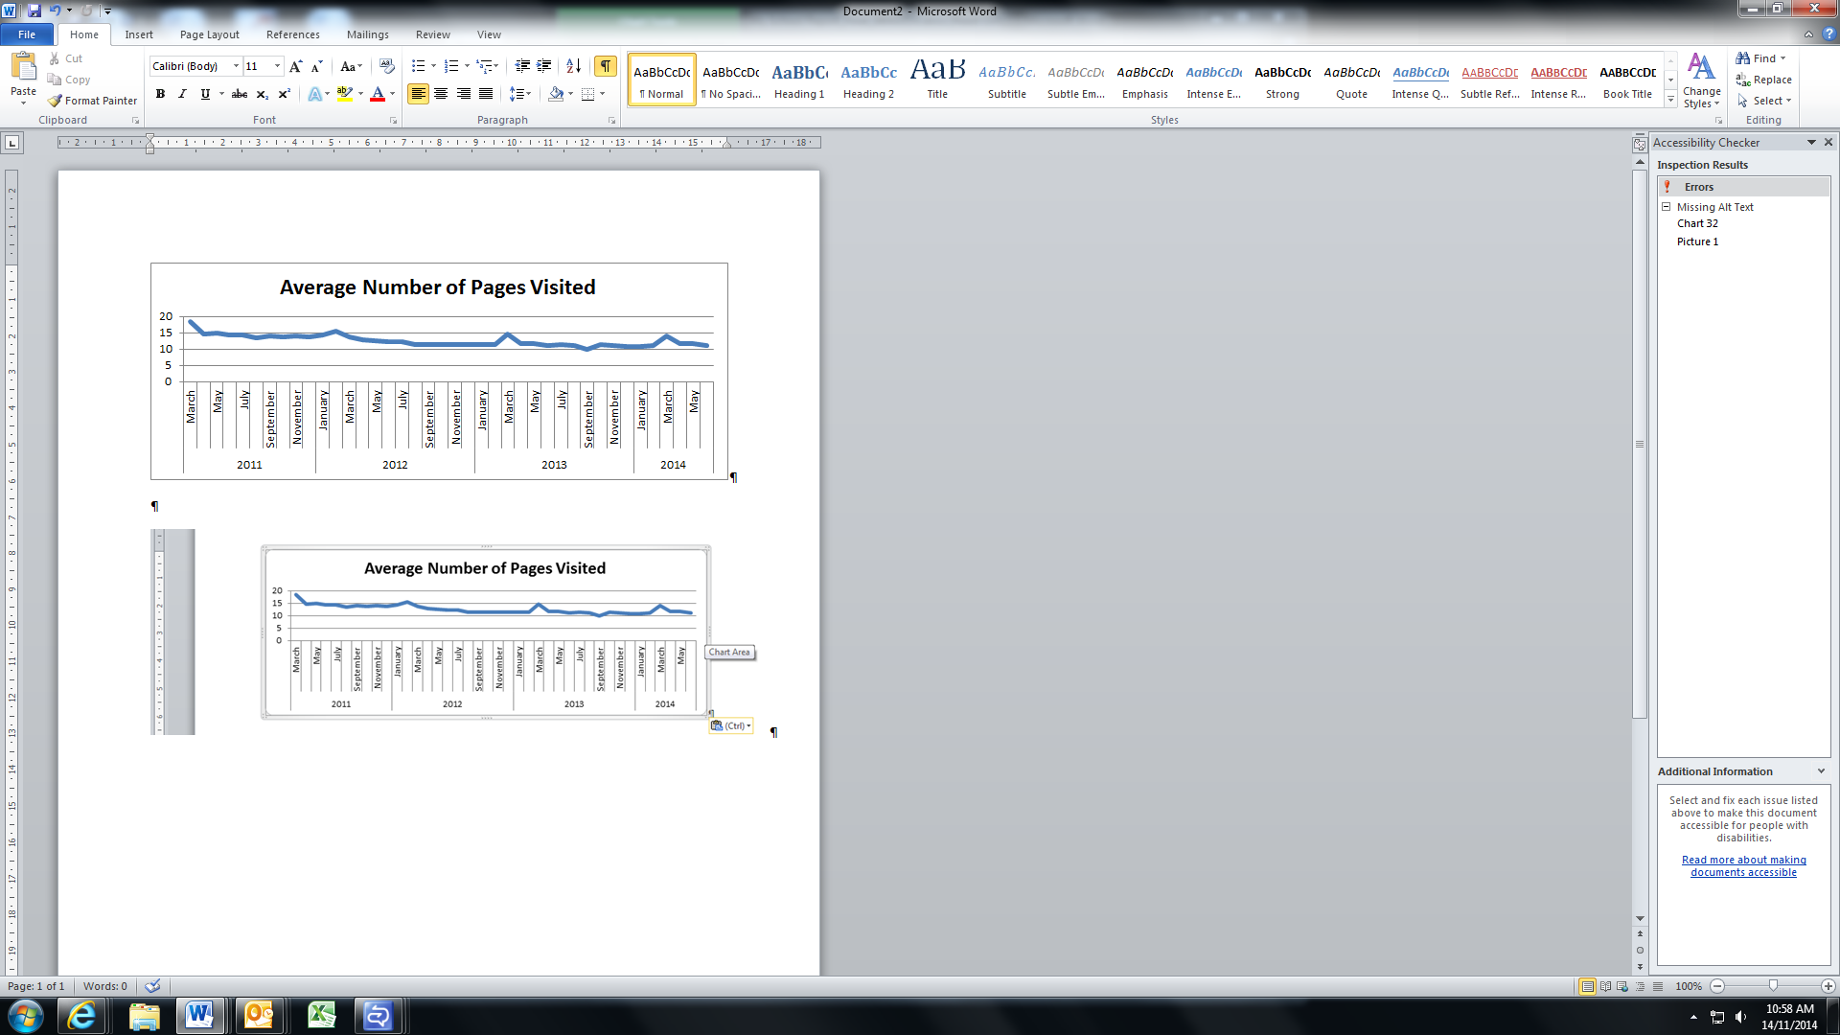

***Source:*** ACARA website data

A deeper analysis of individual *My School* page views as a proportion of total page views shows that the *School Profile* page is overwhelmingly the most visited area of the web site. Arguably, the number of visits to this page reflects the fact that this page is the first page opened once a particular school is selected.

The proportion of views for each page visited has stayed fairly consistent for each *My School* release. However, there is a small increase in the proportion of people visiting the *Student Gain* page and a small decrease in the proportion of people visiting the NAPLAN *Similar Schools,* the NAPLAN *Results in Bands* and the *Local Schools* pages. The proportion of visits to the *VET in Schools* and *School Finances* pages is very small.

Interestingly, the NAPLAN *Results in Numbers* page is by far the most popular presentation of NAPLAN results and the NAPLAN *Results in Bands* page the least popular as measured by page views. Individual *My School* pages are discussed in more detail later in this chapter.

Figure 2.4 shows the distribution of pages viewed on *My School*.

Figure 2.4: *My School* Page Views by Year.

As described in previous paragraphs. Shows an increase in the School profile pages from 35 per cent in 2011 to 40 per cent in 2014.
There has similarly been a decline in views of the NAPLAN results by graphs page from 15 to 13 per cent over the same period.


***Source:***Website data provided by ACARA

Website data collected by ACARA does not provide sufficient information to determine who is viewing each page. However this data clearly shows that some pages are viewed more than others.

## Referral Traffic

Detailed data on users of *My School* is not collected for privacy and other reasons. However data provided by ACARA utilising Google Analytics provides some information on where referred users of *My School* originated from.

Over the 2013-14 financial year the top 10 sources of referral traffic in order of importance were: acara.edu.au; myschool.com.au; nap.edu.au; liveinvictoria.vic.gov.au; profile.education.tas.gov.au; kidspot.com.au; schools.nsw.edu.au; theage.com.au; sa.gov.au; and education.gov.au. These are mainly government sites but there is also one commercial education resource site (myschool.com.au), one parenting site (kidspot.com.au) and one media site (theage.com.au). These top 10 sources represented 177,426 visits or about 12 per cent of total visits to *My School* over this period. Of this number 111,604 were new users. The bounce rate (i.e. those who enter the site but leave without viewing any other pages) was quite significant at 33.3 per cent. However the users who stayed on the site on average viewed nine pages and stayed for just over six minutes.

Longer term referral traffic data from 1 March 2011 to 7 July 2014 shows 905,730 sessions (16.7 per cent of the total sessions over this period) were originated from other sites. Of these 571,469 were new users. The average bounce rate was 35.6 per cent, while the average session duration was 6.25 minutes and comprised 10.6 page views. There were only 13 sites that generated more than 1 per cent of traffic. In order of importance these were: myschool.com.au (15 per cent); myschool.edu.au; acara.edu.au; schools.nsw.edu.au; liveinVictoria.gov.au; nap.edu.au; deewr.gov.au; smh.com.au; education.qld.au; google.com.au; heraldsun.com.au; profile.education.tas.gov.au and couriermail.com.au.

An analysis of the category of websites that generated 100 or more referrals over the period is shown in Figure 2.5 below. It can be seen that the vast majority of traffic is generated by “.com” or “.edu” websites.

It is not possible to draw any firm conclusions from the referral traffic as to the type of user that is coming to *My School* direct from another site. However the importance of the “.com” sites as source of referral traffic, including the number of media sites that generate traffic, suggest that media briefings and success stories are a useful mechanism to raise the profile and develop a more productive view of *My School*.

Figure 2.5: Referral traffic to *My School*

As described in previous paragraphs this depicts in a pie chart the website referrals to MySchool from 1 March 2011 to 7 July 2014.
Results show that 41 per cent of referrals were from .com sites, 40 per cent were from .edu sites, 12 per cent were from the Australian Government .gov sites, 4 per cent from .net sites, 2 percent from .org sites and 1 per cent from other sites.


***Source:*** ACARA Google Analytics information

***Notes:*** Chart represents 832,684 (92 per cent of total) referrals from 573 sites from which there were 100 or more referrals.

## Qualitative and Quantitative Research

Consumer research undertaken by Colmar Brunton during mid-2010 on behalf of ACARA[8] showed that parents felt that *My School* was of most use for those who were in the process of making decisions about the schooling and education of their children. *My School* was seen as one avenue, in addition to word of mouth and school information, to help evaluate a school’s academic performance. The most useful information was the “School Facts” bar on the school profile page. The NAPLAN results were described as the least useful and difficult to interpret.

Teachers saw the site as being less relevant to them and more relevant to parents. Teachers saw *My School* as a restrictive way to evaluate a school and other factors that make a good teacher and a good school should be taken into consideration.

The Colmar Brunton report considered that there were three key areas that should be considered when developing future versions of *My School*:

* perceived content gaps on the school profile page around subjects and extracurricular activities, integration programs and the proportion of students who have English as a second language;
* the website being more explicit about the purpose of *My School* and information about ACARA be made more prominent; and
* simplify the way in which NAPLAN results and statistics are presented.

Of the 1001 people in the Colmar Brunton quantitative sample, 83 per cent were aware of the   
*My School* website with 42 per cent actually visiting the site. Of those who visited the website 66 per cent (i.e. 28 per cent of the sample) did so to check how their child’s school performed in NAPLAN; while 47 per cent were comparing the performance of different schools to help them make decisions about their child’s schooling and 33 per cent were researching information about schools they may send their child to (note that users may have visited for more than one purpose). Again of those who visited the website two-thirds were satisfied that they could find what they were looking for and understand the results presented.

In 2014 Colmar Brunton was commissioned by ACARA[9] to conduct further qualitative research by way of parent and principal focus groups and key stakeholder interviews. The report on that work is not finalised but some preliminary findings suggest that there are still mixed views among both parents and principals.

Parents are generally supportive of *My School*. Some see it as offering a limited range of information while others see it as a useful starting point in selecting a school in conjunction with school websites, visits and discussions with other parents. Some parents use *My School* to monitor the progress of a school and this is especially important for those who have chosen an independent school with high fees. Some find *My School* useful to provide context for the NAPLAN scores of their children.

Parents identified two key issues that can impact on the usefulness of *My School*. First the focus on statistical information and literacy and numeracy in particular, presents a narrow view of a school. Second, the overall layout of the website makes it difficult to find and understand relevant information.

Some principals see *My School* as a useful source of information for parents and the community. For schools with high NAPLAN scores, *My School* can provide a positive marketing message. Other principals see *My School* as not particularly relevant as there is other, more comprehensive information available. Some principals who had been concerned about *My School* are now more relaxed as parents are not using the website as much as they had expected and publication of league tables has not been an issue. However some principals still have more negative views about   
*My School* relating to misinterpretation of the data, the lack of a holistic view of a school, the implication for lower socioeconomic areas with lower NAPLAN scores, the pressures placed on students, parents and teachers and philosophical objections.

The Australian Parents Council, *My School* *- A guide for parents,* includes a brief summary of a survey it conducted of parents in 2008. The survey indicated that the factors that parents considered most important in choosing a primary or secondary school included pupils per teacher; facilities and resources, support for struggling or gifted students; and approach to discipline.

When parents were asked to rank the factors they considered to be of highest importance about a school the top five factors were: the happiness of students; the general direction of the school; the quality of the relationship between staff and students; the quality of teaching staff; and behaviour management. Student’s results in public tests or exams were ranked number nine in order of importance.

A survey entitled *What Parents Want,* conducted in late 2010 by Independent Schools Queensland, indicated that the top three factors for parents in choosing to send their child to an independent school were: preparation for students to fulfil their potential; good discipline; and encouragement of a responsible attitude to work. The survey found that parents are more likely to take note of what other people say than of a web site such as *My School*. Only 8.2 per cent of parents cited the   
*My School* website among the three sources of information most likely to influence their choice of school. *My School* was ranked number eight in a list of the most influential sources of information.

A 2012 survey conducted of Australian and Independent Education Union members by the Whitlam Institute on “high stakes testing”[10] indicated that a large majority of respondents believed that publication of weaker than expected NAPLAN results would impact negatively on a school. Teachers were fairly evenly divided on the usefulness of NAPLAN but two thirds of principals believed it was useful. Slightly less than half the respondents used NAPLAN information to identify areas of weakness that were common to the majority of the class and then make changes to their teaching practices. Forty–six per cent of respondents reported that their school spent time looking to implement reform based on the NAPLAN data.

Of the surveys discussed above, only the Colmar Brunton research specifically relates to *My School* and shows that a significant group of parents use the website to assist in making decisions about choice of school and that some principals also find it useful. It is interesting that the general themes about what parents value and their sources of information are broadly consistent across the relevant surveys. The Whitlam Institute survey suggests that despite reservations, NAPLAN results are used by a significant proportion of schools to trigger discussions on school improvement.

All of the quantitative and qualitative research undertaken to date has its limitations and it would be useful to have a more comprehensive and up to date picture of the characteristics of *My School* users, the purposes for which they use *My School*, how often they use the website, the value they place on the various elements of the website, the influence the content has on their decision making, and how the website might be refined and redesigned to make it more useful from their perspective.

## Analysis of *My School* Pages

It is useful to examine the use of individual pages on the *My School* website in more detail to gain further insights into which areas of the website attract most attention.

## *My School* Home Page

The *My School* home page contains a lot of information with elements of duplication between the Chair’s message, the CEO’s video, *My School* Overview video and the “what’s new” section. Some rationalisation and simplification of the page would make it more users friendly.

The *My School* overview video and PDF text contains a lot of detail and could be presented differently as a users’ guide to *My School*.

There is a large amount of explanatory and supplementary information linked to the page. For example, the “glossary” is nearly five pages of technical definitions. The “more information” page has links to PDF versions of 11 fact sheets, FAQs, and guides and five detailed reports.

The “contact us” page includes a link to Principals’ Portal help. This Portal allows principals to view information about their school, raise any queries they may have and update the “schools comments” section.

The *Find a School* function enables a user to select government, non-government or all schools. The *search* button takes the user direct to the CAPTCHA page

## *CAPTCHA Page*

This page is a security measure designed to prevent automated data mining of the site. While an audio option is available for the CAPTCHA code the page raises accessibility issues for users with a disability.

The user is required to accept the Terms of Use (two pages) and Privacy Policy (four pages). As these are both dense documents it would not be surprising if many users simply ticked the box. Importantly, however, some key information is included in the terms of use (e.g. *My School* is one source of information, it should not be used to create lists of comparative school performance for commercial purposes) and privacy policy (e.g. ACARA’s mission).

Such key information should be more explicitly drawn to the user’s attention.

Together with the home page but ignoring the PDF documents, a user could read over 20 pages of information before being able to access their selected school profile.

## *School profile page analysis*

This page provides important contextual information about the selected school including; school type, enrolments, attendance rates, staff numbers, and information about the student population such as gender and the percentage of students from a Language Background other than English (LBOTE).

The page provides information about senior secondary outcomes and Vocational Education and Training (VET) in Schools (for relevant secondary schools), a link to the school website and a section for the principal to provide important contextual information and commentary about the school. It also includes an overview of the school’s finances and information on the school’s ICSEA value. The ICSEA value is complemented by the distribution of students by quartile to provide a better insight into the demographics of the student body. The ISCEA value determines which schools have statistically similar students.

Importantly, the school profile page has side tabs which enable the user to move quickly from the school profile to obtain further information on school finances, NAPLAN results, VET in schools and local schools.

A partial screen shot of a primary *school’s profile* page is shown in Figure 2.6.

Figure 2.6: Partial screen shot of School Profile Page.

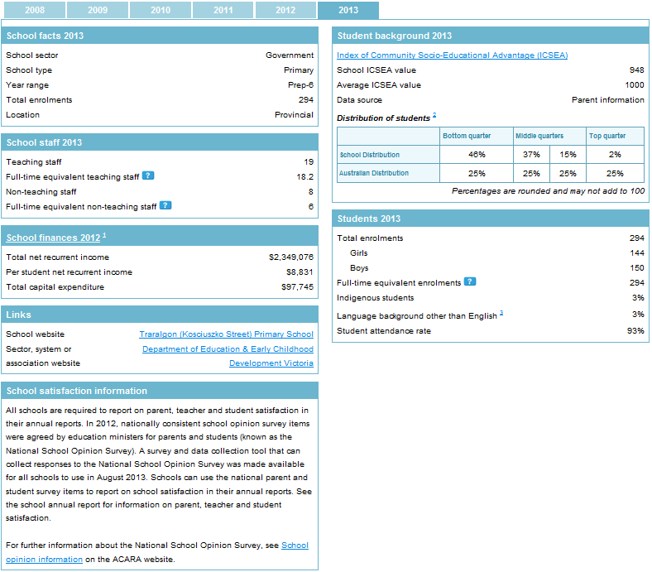

***Source:*** *My School* website

The following graph (Figure 2.7) shows the number of page views and unique page views per month for the s*chool profile* page.

Figure 2.7: School Profile traffic

Depicts monthly usage of the school profile page broken down by month per 100,000 views. 
Shows significant spikes in February and March of each year when My School is released. Also shows small peaks in April and May and steady usage from August to October, with declines in usage in November and December.
*Source: ACARA website data*

## Comments

Survey results show that parents who use *My School* value the summary information presented and the contextual information about the school. This is complemented by provision of a link to the school web site. Survey results also show that many parents find the ICSEA value hard to understand and evaluate.

It is questionable whether the inclusion of the school satisfaction information box in its current form is meaningful for parents. It could be replaced with a simple statement that such information is currently only available on the school website. The space saved might be better used to provide the current year’s summary of NAPLAN results by numbers.

Consistent with the overall traffic pattern for *My School*, monthly school profile page views fluctuate with a major peak with each new *My School* release and lesser peaks in May and September each year. Apart from being the first page users see after selecting a particular school, the fact that the school profile page accounts for 40 per cent of *My School* traffic may suggest that for many users the overview information provided is sufficient for their purpose (e.g. they may then go to the selected school website if they are in the process of choosing a school).

## *NAPLAN Performance data analysis*

The NAPLAN performance data on *My School* has been separated into five separate measures – results in graphs; results in numbers; results in bands; student gain and similar schools. Each of these presentations provides a different perspective on NAPLAN results although there is some inherent duplication of information. To take full advantage of the information presented a user needs to have a reasonable level of statistical literacy (e.g. to understand confidence levels and margins of error) and the cognitive ability to assimilate a large amount of data presented in different forms. As time series data is not available, a user has to manually move between years and between domains to obtain a picture of student and school performance over time. In general, if a user wished to make accurate comparisons over time this would require transcribing and analysing the data themselves.

As mentioned earlier, it is therefore not surprising that the NAPLAN-results in numbers is the most popular of the various presentations. In terms of school value-add and school improvement the student gain and similar schools pages are the most useful, although currently little used.

The following sections provide a separate analysis of each of the five NAPLAN presentations.

## *NAPLAN - Results in graphs*

This page shows the selected school’s NAPLAN results across each of six years, as well as an average result. Dropdown menus are used to select the various student cohorts and the NAPLAN test domains. The graph displays averages and margins of error for results.

The results achieved by the selected school can be visualised against schools with similar students and all schools and interpretation of the results is aided by the explanatory notes and colour coding to indicate statistical significant differences.

A user can also choose to view the results in terms of scores if they prefer.

The proportion of students participating in the NAPLAN tests is provided in tabular format.

A number of colour combination choices are available to assist people who have difficulty distinguishing certain colours.

A partial screen shot of the *results in graphs* page is provided at Figure 2.8.

Figure 2.8: Partial screen shot of results in graphs page.

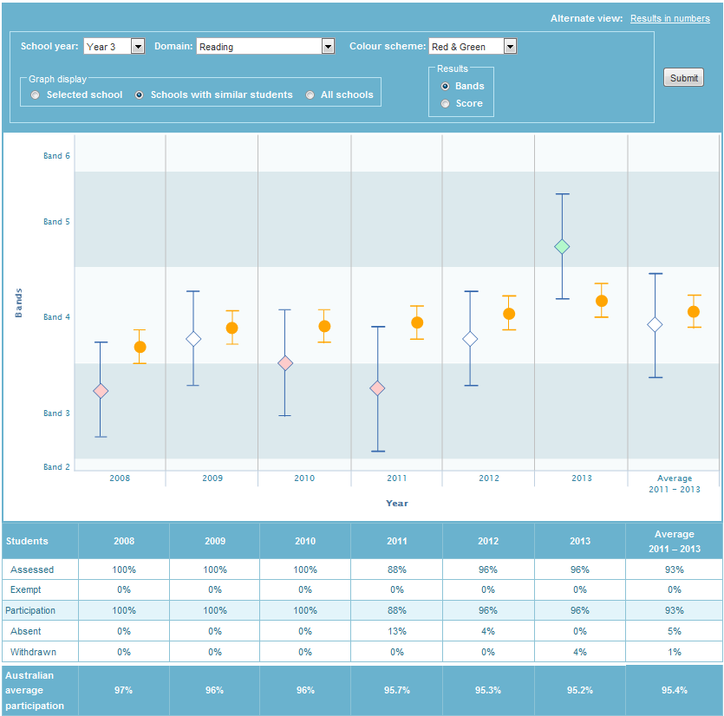

***Source:*** *My School* website

The following graph (Figure 2.9) shows the number of page views and unique page views per month for the r*esults in graphs* page.

Figure 2.9: Results in graphs traffic

***Depicts monthly usage of NAPLAN results in Graphs page broken down by month per 100,000 views.
Shows large peaks in February and March of each year, and decline in usage in July, November and December.
Source:*** ACARA website data

## Comments

The usage of the results in graphs page is consistent with the overall traffic pattern for *My School* discussed earlier and represents about 13 per cent of the website’s total page views. Monthly page views have been relatively stable over time but the numbers are much lower than for the school profile page. The number of unique page views is relatively low.

Visually impaired people using screen reader technology are likely to experience difficulties with this presentation as, while results can also be seen as scores, the points on the graph are not specified.

## *NAPLAN – Results in numbers*

This page displays a table showing the average NAPLAN scores achieved for the selected school in each test domain and for each student cohort by year of the test. The selected school’s scores are displayed, as are the average scores for statistically similar schools and all Australian schools.

The average achievement scores presented include a range of scores that represents the margin of error at a 90 per cent level of confidence. Colour coding is used to indicate the magnitude of the differences in averaged results (i.e. above the mean, not statistically different, or below the mean).

A number of colour combination choices are available to assist people who have difficulty distinguishing certain colours.

A partial screen shot of the *results in numbers* page is provided at Figure 2.10.

Figure 2.10: Partial screen shot of results in numbers page.

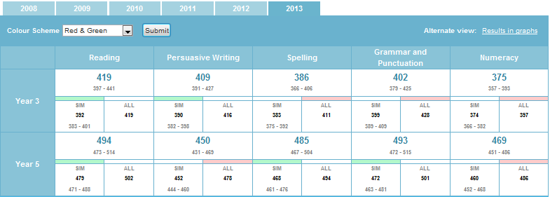

***Source:*** *My School* website

Figure 2.11: Results in numbers traffic.

Depicts monthly usage of NAPLAN results in numbers page, broken down by month per 100,000 views. 
Shows spikes in usage in February to March, and declines in usage over November to December.
Monthly usage of this presentation is shown in Figure 2.11.

***Source:*** ACARA website data

## Comments

The amount of detail presented by the selected school, similar schools and all schools in the form of a year by domain matrix with colour coding takes a little while to understand. However a significant advantage is that it brings a lot of data in numeric form together in one place. That may help explain why this is the second most highly accessed *My School* page (around 22 per cent of total page views). Another reason is that users may find the key numbers and related colour coding easier to comprehend than the presentation of results in graphs and bands.

The number of unique page views of this page is relatively high.

However the current colour coding to indicate statistical significance is unlikely to pass a useability test for someone dependent on screen reader technology.

## *NAPLAN - Results in bands*

This page shows the spread of a school’s student achievement results for the NAPLAN test domains for each student cohort at the school and compares these to results achieved at statistically similar schools and all Australian schools for that year. The comparison is presented in bar chart form and percentage of students. A user can navigate between the NAPLAN domains and between years.

Test participation data is also provided for the selected school and all Australian schools.

A partial screen shot for a primary school of the r*esults in bands* page is provided at Figure 2.12.

Figure 2.12: Partial screen shot of results in bands page.

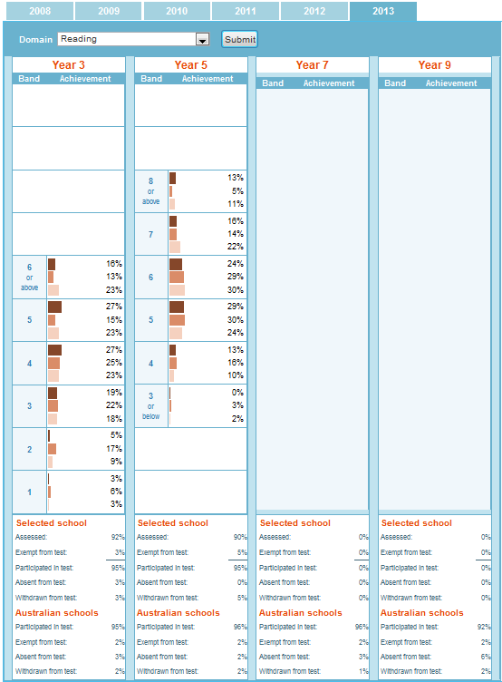

***Source:*** *My School* website

Monthly page views of this presentation are shown in Figure 2.13.

Figure 2.13: Results in bands traffic.

***Shows usage by page views and unique page views, broken down by month per 100,000 views Indicates peak usage occurring in February 
Shows peak usage in March 2011 with over 300,000 visits to the site, and subsequent peaks of between 100,000 to 200,000
Source:*** ACARA website data

## Comments

The level of usage of this page is low, representing only 4-5 per cent of total *My School* page views. This could mean that users may have difficulty interpreting the information presented. For example, the level of achievement by students in different years is difficult to interpret as the bands are equidistant and the testing year results overlap. That said, this is a deliberate feature of the NAPLAN reporting design.

Another possibility is that users progressively working their way through the *My School* website may well have decided by this point that they had obtained sufficient information on NAPLAN results for their purposes (i.e. the perceived value of this information over and above what has come before is not high).

## NAPLAN – Student Gain

This pageshows the educational progress made by students in the same school between two NAPLAN testing years by domain. For example, the educational gain made by those students in the same domain, who remained in the same school, between their year 3 and year 5 NAPLAN tests. It is not a measurement of gain by the whole student cohort as such as some students may have left the school and other students arrived between the two testing years.

A user can navigate between the test domains and the results can be viewed by bands or by scores and student gain observed for the selected school, schools with similar students, students with the same starting scores and for all schools.

A partial screen shot of the *student gain* page is provided at Figure 2.14.

Figure 2.14: Partial screen shot of student gain page.

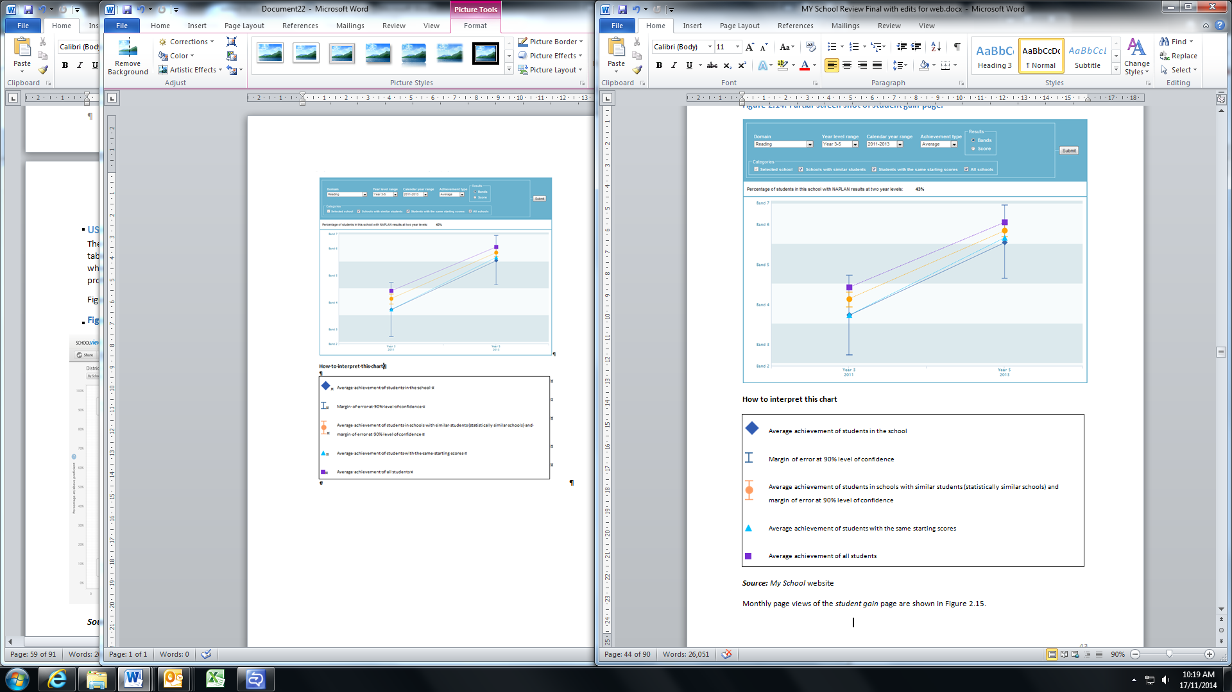

***Source:*** *My School* website

Monthly page views of the *student gain* page are shown in Figure 2.15.

Figure 2.15: Student gain traffic.

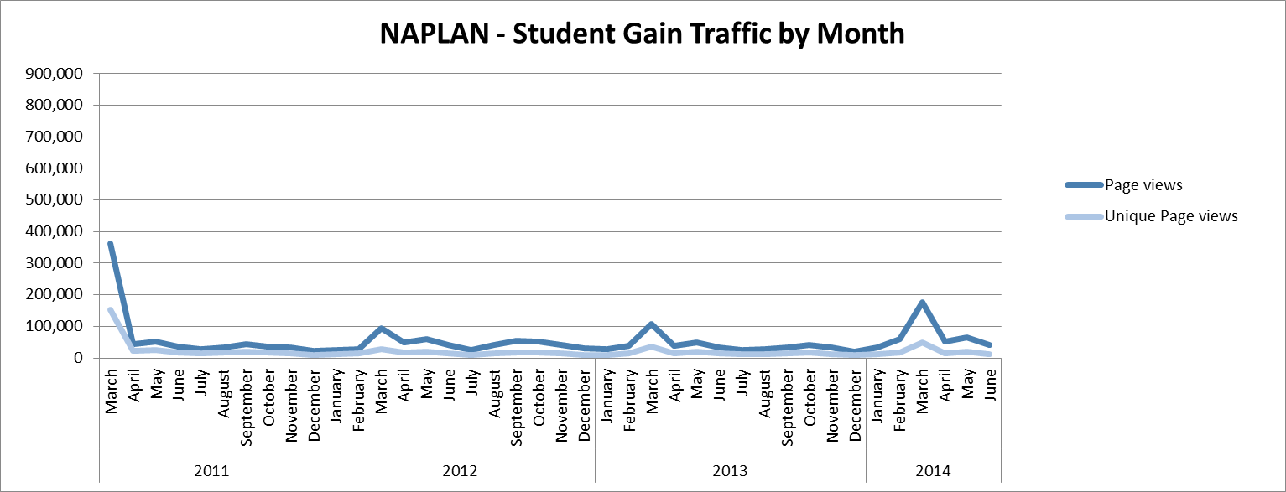

***Source:*** ACARA website data

## Comments

Once the concept of student gain is understood this is an important indicator of student progress and by inference the quality of teaching in a school.

As the distances between the bands and the scale of scores are both equidistant there is an issue of interpretation. Nevertheless the comparisons that can be made are very instructive.

Although usage of this page is small, there has been a slight increase more recently. This trend may reflect that over time users are becoming more familiar with the concept and recognising its potential value as a tool for school improvement.

Recent qualitative research undertaken on behalf of ACARA indicates that many principals find the student gain information useful, including for school improvement purposes.

However, due to privacy concerns related to small numbers of students and also student mobility, there is no or only partial information available on student gain for between 1,000 and 2,000 schools. This represents a substantial gap in the national data available for this measure.

## NAPLAN - Similar schools

This page allows users to put the NAPLAN results of a school in context by showing how its performance compares with that of statistically similar schools. Colour is used to indicate whether each of the statistically similar schools performs at a level that is close to, above, substantially above, below or substantially below that of the selected school. Results are available by year and domain.

The user can obtain the name of the similar school by hovering over the relevant “bubble” in the chart.

A partial screen shot of the s*imilar schools* page is provided at Figure 2.16.

Figure 2.16: Partial screen shot of similar schools page.

As described in previous paragraph.
Example shows results for Year 3 students for 2013 in Reading.

***Source:*** *My School* website

The monthly page views of the *similar schools* page are shown in Figure 2.17.

Figure 2.17: Similar schools traffic.

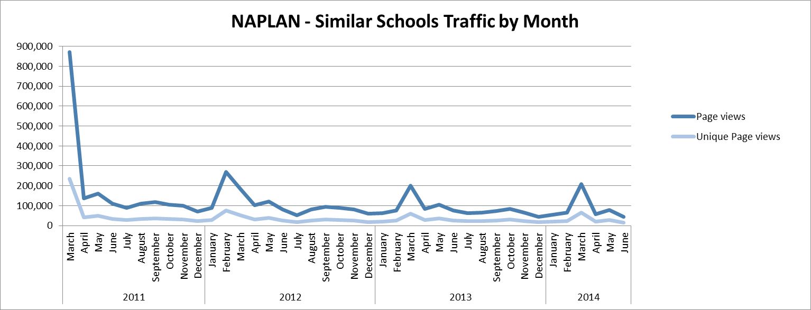***Source:*** ACARA website data

## Comments

Without the colour coding used to show the position of the selected school relative to those with a higher or lower average it would be difficult for a user to discern whether other schools were performing materially different from the selected school.

Through looking at different years the user is able to gain an impression of how the school is performing relative to similar schools over time in a particular domain.

Usage of this page is relatively low and has been trending down slightly.

Qualitative research undertaken on behalf of ACARA indicates that generally parents and principals consider the ACARA definition of similar schools (similar ICSEA scores, statistically similar students) to be too narrow and expect to compare schools with similar characteristics (e.g. catholic, single sex, selective, comprehensive, size and so on). Many principals would like to nominate which schools they compare their own school to.

## Financial data analysis

Information on the school finances page provides details about the resources available to individual schools to support the education of their students. The information provided is comparable across all schools in all sectors in Australia.

The page includes an overview of the gross and net recurrent income attributed to a school over a given calendar year and the capital expenditure for that year. However the page does not provide figures on the overall financial position of a school as would be reflected in a statement of profit and loss and a balance sheet (assets and liabilities).

The school finances page also provides details of the number of full time equivalent student enrolments relating to funding at the school.

A partial screen shot of the *schools* *finances* page is provided at Figure 2.18.

Figure 2.18: Partial screen shot of school finances page.

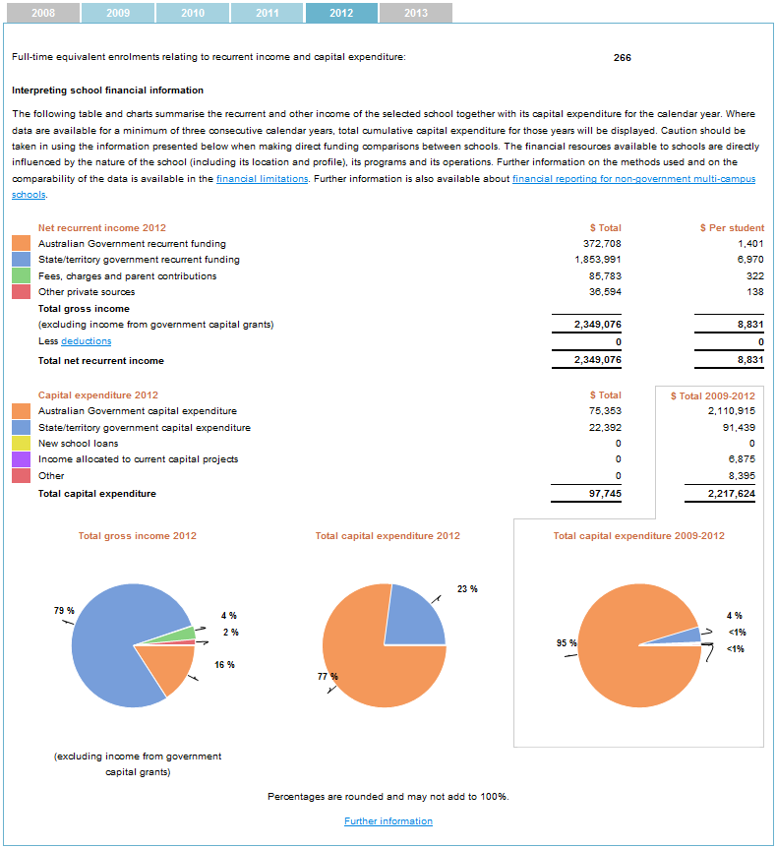

***Source:*** *My School* website

The monthly page views of the *schools finances* page are shown in Figure 2.19.

Figure 2.19: School finances traffic.

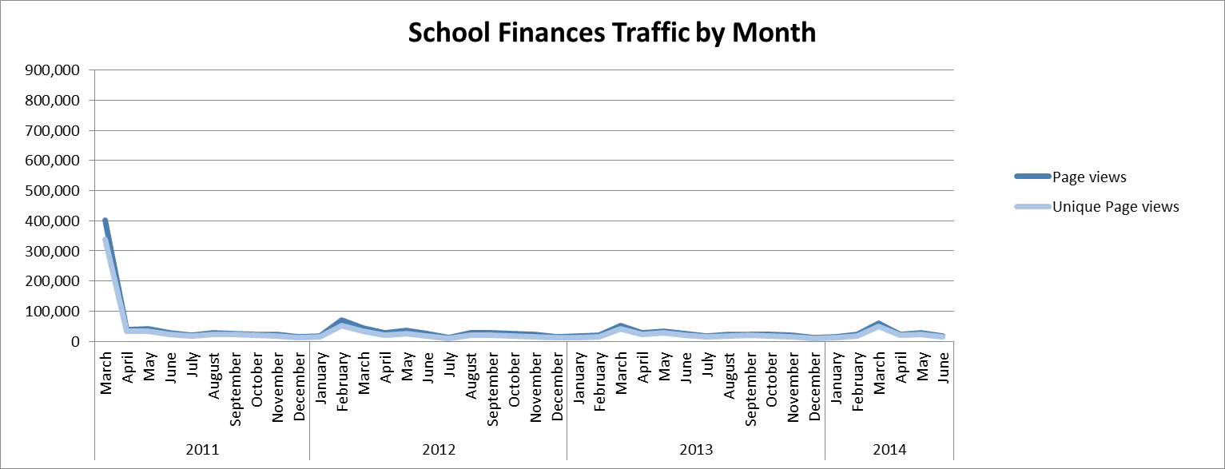

***Source:*** ACARA website data

## Comments

It is important for the user to understand that for schools operating within a system, the cost of running that system is apportioned to each school. The recurrent expenditure figure includes an apportionment of school system overheads and is not the funds actually spent at the school. The discretionary funding available to a school to run intervention programs is a much different figure.

A further issue is that due to the methodology employed the full-time equivalent enrolments number may not be the same as reported on the School profile page.

The usage of this page is very low and may reflect a number of factors, including that the partial information provided does not reflect a school’s overall financial position and is of limited interest to parents. However the information published may have contributed to less concern about:

* the perceived financial advantage of independent compared to public schools as comparable NAPLAN results are achieved in high performing schools regardless of sector; and
* average funding as the move to needs-based funding will see smaller, remote and disadvantaged schools generally being resourced to compensate for such factors.

Recent qualitative research undertaken on behalf of ACARA indicates that generally parents are not particularly interested in school finances and principals have better sources of information.

From a policy perspective the school finances information could be quite useful, particularly if further disaggregated to show the loadings associated with disadvantaged students, size of enrolments, school location and so on.

## VET data analysis

Secondary school students are able to undertake VET courses. The data provided in this section show the level and range of VET activity at an individual school. Numbers are provided on enrolments and separately by completion by industry area and qualification level.

Providing information on VET courses is an important aspect of reporting non-NAPLAN outcome measures on *My School*. While schools differ in the mix of courses and programs they offer to meet students’ needs, showing VET information is useful to parents, students and the community, particularly for students interested in pursuing a vocation-related course of study.

A partial screen shot of the *VET in schools* page is shown at Figure 2.20.

Figure 2.20: Partial screen shot of VET in schools page.

As described in previous paragraphs.
Depicts an example of the VET in schools page for a mix of VET courses for an unnamed school using 2012 results.


***Source:*** *My School* website

The monthly page views of the *VET in schools* page are shown in Figure 2.21. As can be seen the usage of this page is very low, representing only one per cent of total *My School* page views.

Figure 2.21: VET in schools traffic.

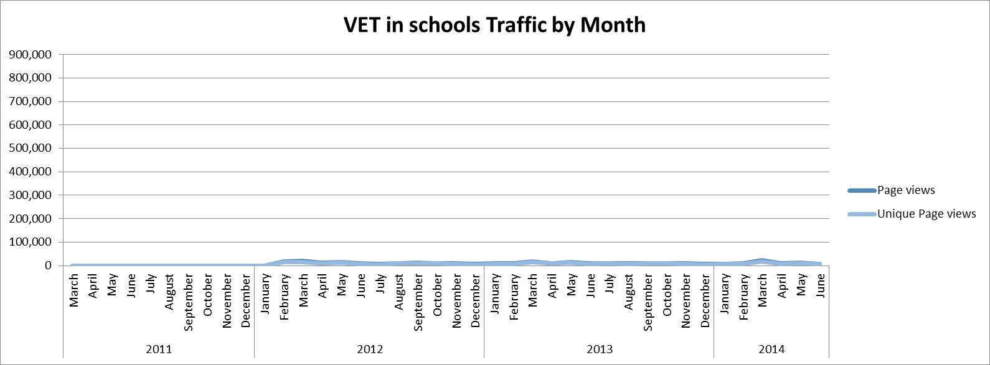

***Source:*** ACARA website data

## Comments

It should be recognised only about 27 per cent of students aged 15 to 19 undertake apprenticeships, traineeships or other VET programs while at secondary school. Consequently the potential audience for the VET in Schools page is relatively small. In addition, enrolments in VET courses are for all cohorts of students and cannot be compared directly with completions.

The results presented are highly qualified with over a page of general caveats and information on the data available for each jurisdiction. Among other issues, data on qualifications completed may need to be collected from a Registered Training Organisation outside the school.

In light of these factors the utility of this page in its current configuration has to be questioned. A nationally consistent approach to collection of VET in schools data and the ability to make more meaningful comparisons would be required to make this page more useful.

## Local Schools analysis

This page provides a list and displays a map of up to 20 schools within an 80 kilometre radius of the selected school, colour coded by type of school. The page enables users to research schools that are geographically close to the selected school by selecting the web link for each of these schools.

The user can select only non-government, only government or all schools by choosing that option on the *My School* home page.

A partial screen shot of the *local schools page* is shown at Figure 2.22.

Figure 2.22: Partial screen shot of local schools page.

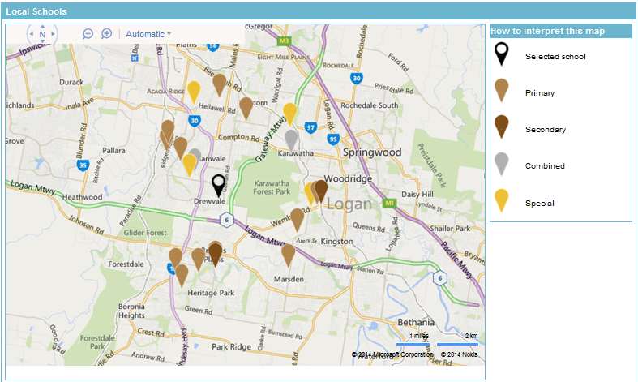

***Source:*** *My School* website

The monthly page views of the *local schools* page are shown in Figure 2.23. As can be seen the usage of this page is declining, representing about four per cent of total *My School* page views.

Figure 2.23: Local schools traffic.

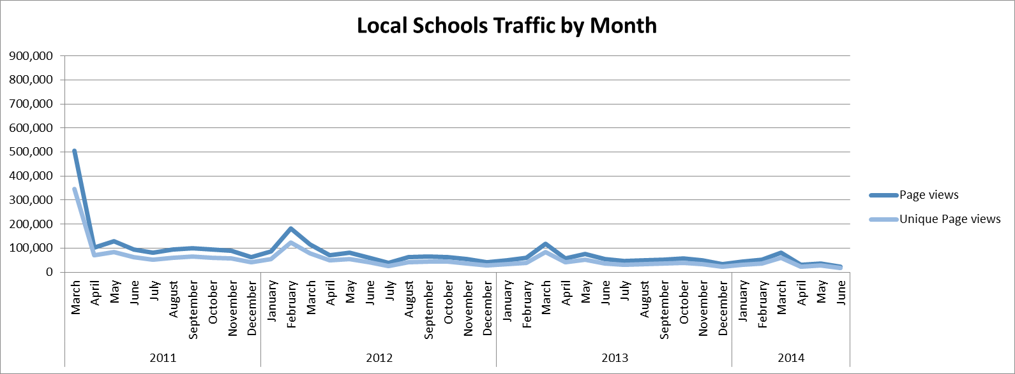

***Source:*** ACARA website data

## Comments

While this page provides a link to each school’s website, the only way a user can make a comparison between the same types of schools is to do so manually by navigating back through the *My School* website and/or going to the website of each school of interest. This is a deliberate feature of the page design.

The utility of this page in its current form has to be questioned as similar information can be obtained from the [Australian School Directory](http://www.australianschooldirectory.com.au/) (www.australianschooldirectory.com.au) and a simple Google search. It is not surprising that usage of this page is declining.

Qualitative research undertaken for ACARA suggests that parents would like to be able to compare the type of school they are interested in side by side on the same page. The local schools page is a good illustration of the tension between policy directions underpinning *My School* (i.e. make direct comparisons difficult other than for schools with statistically similar students) and actual user needs.

## Key Findings

* There has been a reduction in the usage of *My School* over time. The first release of   
  *My School* saw 3,182,490 unique visitors (from 28 Jan 2010 to 3 March 2011). In comparison, for the 2013 *My School* release the number of unique visitors fell to 791,045 (from 13 March 2013 to 4 March 2014). This represents a 75 per cent reduction in unique visitors.
* The reduction in unique visits has occurred across all pages on *My School*, although some have declined more than others. It would seem that as a result of the additional transparency that *My School* has brought, together with some of the pre-existing beliefs about schools and fears about the consequences of *My School* having proved to be unfounded, the interest in the website has declined.
* An analysis of *My School* traffic by month shows that that there are clear cycles of interest with more usage at the time of the yearly update, start of NAPLAN testing and publication of the NAPLAN summary report and release of student reports.
* Website referral traffic data from 1 March 2011 to 7 July 2014 shows 905,730 sessions   
  (16.7 per cent of total sessions) were originated from other sites. The average bounce rate was 35.6 per cent, while the average session duration was 6.25 minutes and comprised 10.6 page views. There were only 13 sites that generated more than one per cent of traffic, the largest of which was myschool.com.au.
* The visitor, page view, and referral traffic data provides no information on who is using   
  *My School,* for what purpose or on what influence it may have.
* The count of page views shows that the School Profile, NAPLAN – Results in numbers and the NAPLAN – results in graphs account of over two thirds of the total.
* In comparison page views of school finances, NAPLAN – results in bands, VET in schools and local schools represent only small fraction of total *My School* usage.
* Page views of NAPLAN – student gain has increased in proportional terms while that of local schools has decreased.
* The local schools page is a good illustration of the tension between policy directions underpinning *My School* and actual user needs as parents would like to be able to compare the type of school they are interested in side by side on the same page.
* Qualitative and quantitative research undertaken by Colmar Brunton showed that parents felt that *My School* was of most use for those who were in the process of making decisions about schools*. My School* was seen as one avenue, in addition to word of mouth and school information, to help evaluate a school’s academic performance.
* Teachers saw *My School* as a restrictive way to evaluate a school and other factors that make a good school should be taken into consideration.
* Recent preliminary qualitative research points to perceived content gaps on the school profile page around subjects, extracurricular activities, integration programs and the proportion of LBOTE students; the need for the website to be more explicit about its purpose and to simplify the way in which NAPLAN results are presented.
* Parents are generally supportive of *My School*. Some see it as offering a limited range of information while others see it as a useful starting point in selecting a school. Some parents use *My School* to monitor the progress of a school, especially those who have chosen an independent, high fee school. Some find the website useful to provide context for the NAPLAN scores of their children.
* Parents identified two key issues that can impact on the usefulness of *My School* - the focus on statistical information and literacy and numeracy, which presents a narrow view of a school; and the overall layout of the website, which makes it difficult to find and understand information.
* Generally parents and principals consider the ACARA definition of similar schools to be too narrow and expect to compare schools with similar characteristics (e.g. catholic, single sex, selective, comprehensive, size and so on). Many principals would like to nominate which schools they compare their own school to.
* There are mixed views about *My School* amongst principals. Some see *My School* as a useful source of information for parents and the community, while others do not see it as particularly relevant. Some principals, who had been concerned about *My School,* are now more relaxed about it but others still have negative views about the website.

# Chapter 3 – International Developments in School Reporting

Internationally there are a variety of transparency and accountability measures used for schools. Information provided ranges from high level state or jurisdiction averages to school level data. A small number of international school reporting systems, with purposes similar to *My School*, are briefly reviewed in this chapter.

## OECD – *My School* case study

The OECD undertook a case study of the policy-making process in Australia, which lead to the public release of information on every school in Australia through the *My School* website. The 2012 OECD report, *Delivering School Transparency in Australia: National Reporting through My School*, found that despite protestations from some segments of the community (e.g. opposition to league tables) there was support more generally in favour transparency of school performance information nationally.

The Australian experience was seen as something that other countries could consider and possibly take some lessons from.

## USA – New York City

New York City’s (NYC) accountability measures provide detailed feedback to its 1,819 schools and information to parents and the NYC Department of Education on where schools are succeeding, where they are falling short, and some of the reasons why[11]. NYC’s primary accountability measures and academic supports are:

* The Progress Report, which evaluates schools by synthesizing multiple quantitative measures of student outcomes and school environment;
* The Quality Review, which measures how well the practices, systems, and structures in a school community serve to strengthen teaching and learning; and
* Academic resources and supports, which help educators strengthen curriculum and instruction.

According to the NYC Department of Education their schools have made great progress over the past decade and student outcomes have improved across many dimensions. The school accountability system has contributed to NYC’s student achievement gains as it has:

1) focused educators on student outcomes, especially the outcomes of students who have fallen behind;

2) enabled the Department to target school support and intervention based on a detailed understanding of the needs of each school; and

3) provided important information to parents, school communities, and the general public.

The Progress Report[12] evaluates schools by synthesizing multiple quantitative measures of student outcomes and school environment. It emphasises individual students’ progress and measures their levels of achievement; compares each school to other schools with similar students; and rewards success in moving all children forward, especially those with the highest needs such as students with disabilities, LBOE students and the lowest-performing students. All reports measure State assessment results, attendance, and results of parent and teacher surveys about the school environment. Middle and high school reports also measure course outcomes, student survey results, success in advanced subjects, and preparation for and success in the next level of schooling or early career.

A school’s results on these metrics are compared to up to 40 other schools serving similar populations and to all schools across NYC. The results are summarized with A to F letter grades (both overall and for Student Progress, Student Performance, School Environment, and for high schools College and Career Readiness) and provided to school communities and the public.

A partial screen snapshot of the overview page of one NYC Department of Education’s high school’s *progress report* is at Figure 3.1.

Figure 3.1: Partial screen shot of Progress Report overview page

As described in previous paragraphs, shows an example of Abraham Lincoln High School progress report.

***Source:*** NYC Department of Education Progress Report 2012-13, Abraham Lincoln High School

## USA - Colorado[13]

The Colorado Department of Education provides several different sources of information including tables of average scores by school and grade. Colorado also produce an interface called SCHOOLview which presents schools as individual points on an interactive graph showing average student proficiency compared with average student gain for maths, reading and writing.

Figure 3.2 provides a screen shot of a demonstration SCHOOLview page.

Figure 3.2: Screen shot of SCHOOLview page.

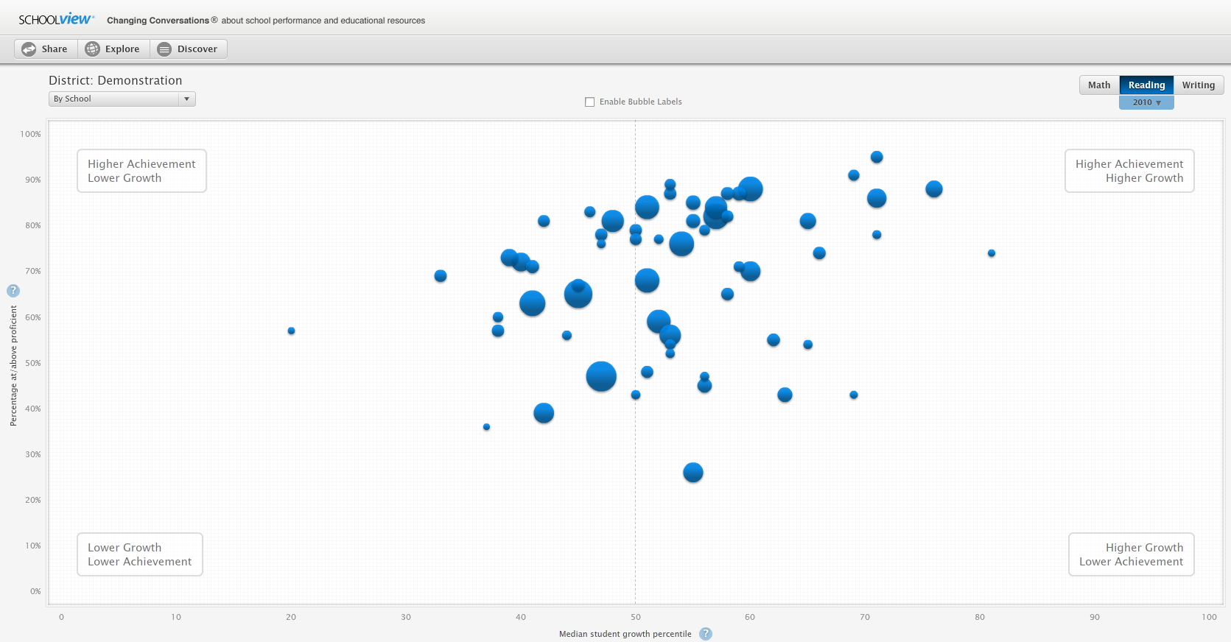

***Source:*** Colorado Department of Education

In Colorado, gain is calculated with reference to a minimum standard, with each student’s progress compared to the progress of other students in the state with a similar score history. When a specific school is selected further details are provided around actual average gain versus projected average gain. Above average and below average gain are clearly identifiable[14] - see Figure 3.3 below.

Figure 3.3: Screen shots of individual school bubbles.

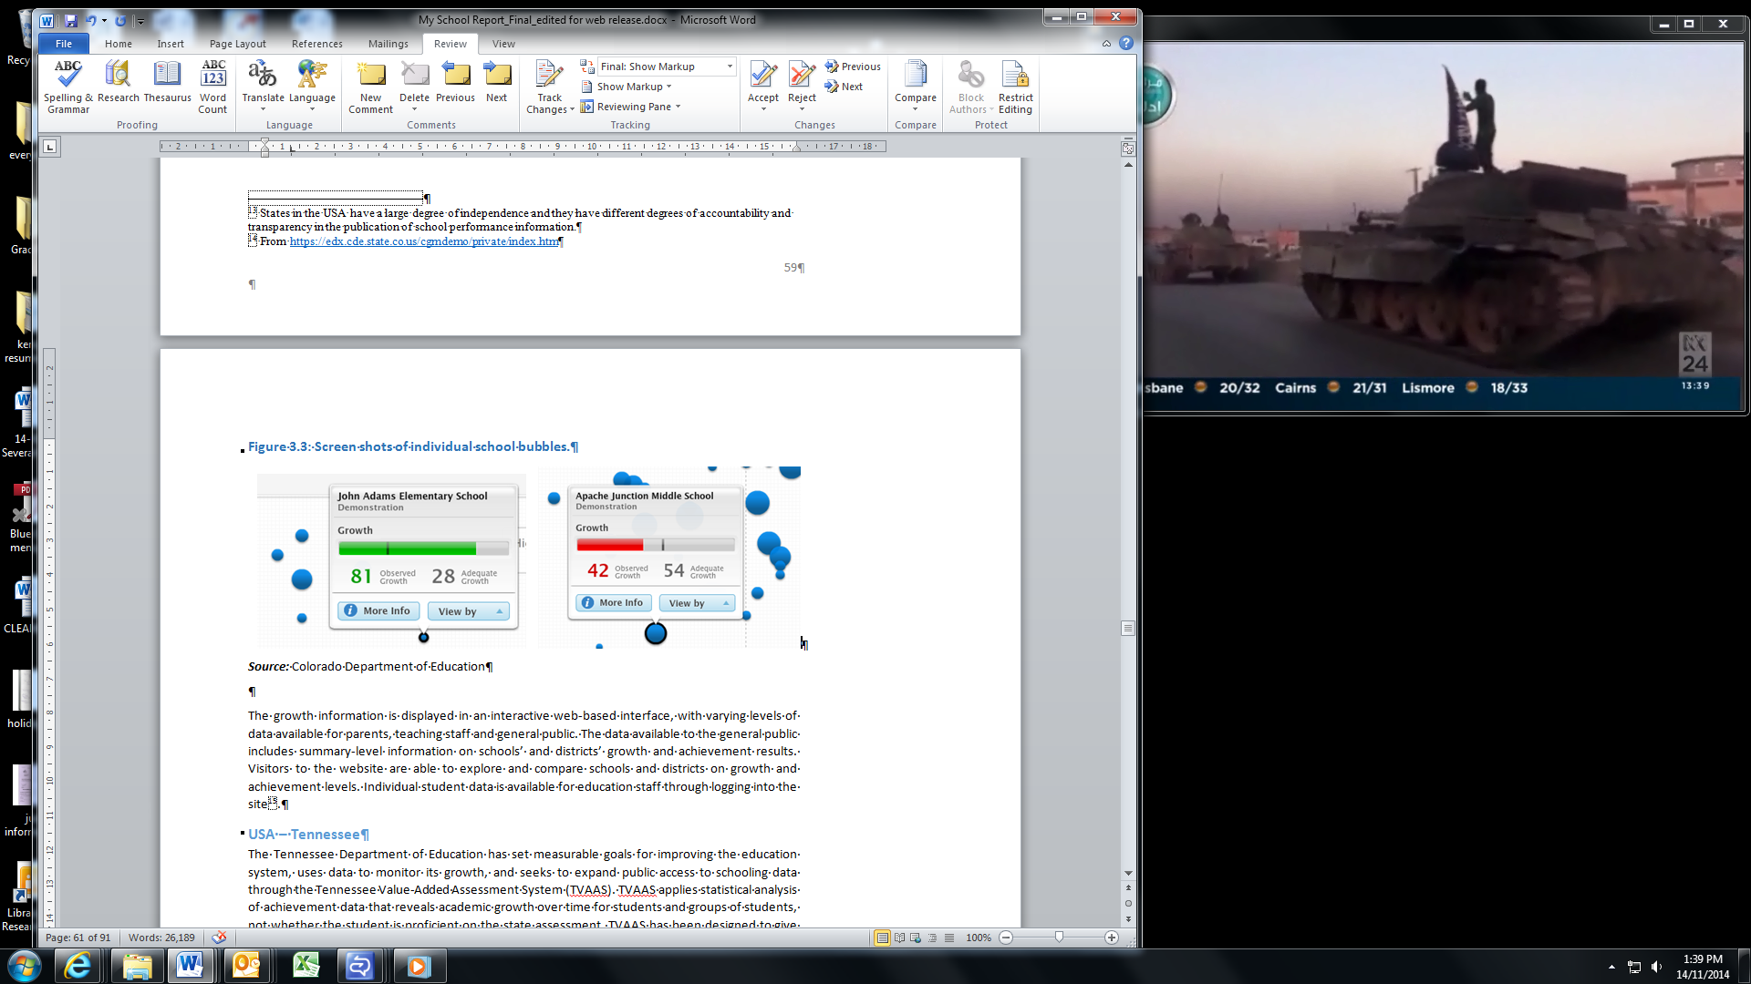

***Source:*** Colorado Department of Education

The growth information is displayed in an interactive web-based interface, with varying levels of data available for parents, teaching staff and general public. The data available to the general public includes summary-level information on schools’ and districts’ growth and achievement results. Visitors to the website are able to explore and compare schools and districts on growth and achievement levels. Individual student data is available for education staff through logging into the site[15].

## USA – Tennessee

The Tennessee Department of Education has set measurable goals for improving the education system, uses data to monitor its growth, and seeks to expand public access to schooling data through the Tennessee Value-Added Assessment System (TVAAS). TVAAS applies statistical analysis of achievement data that reveals academic growth over time for students and groups of students, not whether the student is proficient on the state assessment. TVAAS has been designed to give teaching staff feedback on student progress over time and assesses the influence of schooling on that progress.

TVAAS’s methodology follows the progress of individual students with up to five years of students’ data used by the model to estimate performance. By using individual student longitudinal data, each student serves as his or her own ‘control’, thereby eliminating the impact of demographic variables, such as economic status or racial/ethnic group. An example of the presentation of TVAAS growth measures is provided in Figure 3.4.

Figure 3.4: Screen shot of TVASS measures.

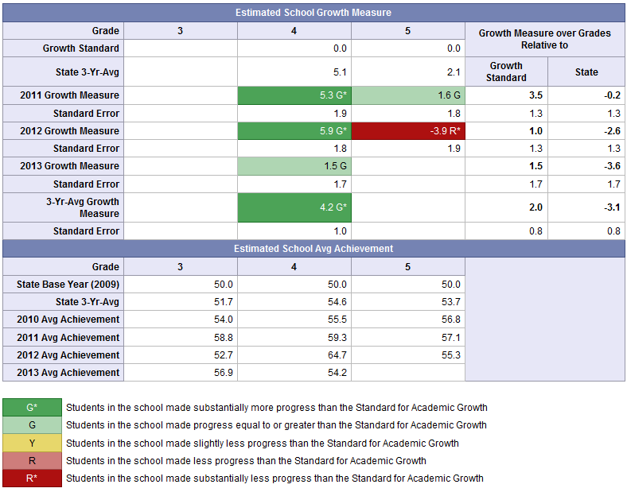

***Source:*** Tennessee Department of Education

Through TVAAS, teachers are able to access individual teacher value-added reports. Reports are available for each grade/subject taught. This report includes a visual representation of the progress made by the teacher’s students compared to the state growth standard[16].

## United Kingdom

The United Kingdom (UK) publicly reports across a large range of categories. Tables of information are published and give information on the achievements and progress of pupils in schools, including how each school compares with others in the local authority area and in England as a whole. Information reported in these tables include; test performance in reading and mathematics; progress on expected targets; average points scores; a value added score; performance of disadvantaged students; teacher assessments; absence rates; schools income and expenditure; and school workforce information.

Students have a minimum expectation for the rate of progress that should be made between test periods, regardless of their starting points. The ‘expected progress’ measures in the tables for each of reading, writing and maths show the proportion of eligible students who, by the end of the assessment period, have reached adequate progress. Figure 3.5 below displays the minimum expectations of students and the relationship between the first and second assessment period.

Figure 3.5: Screen shot of expected level of progress.

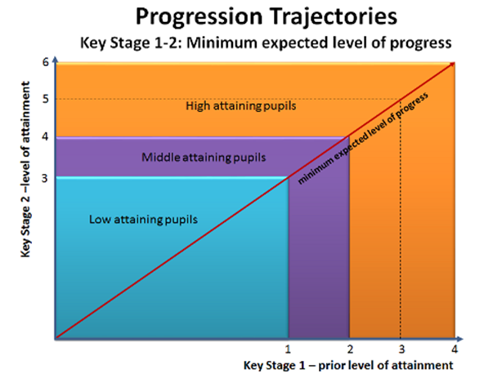

***Source:*** UK Department of Education

The UK also utilises a value added measure to measure how much progress pupils have made between the end of the first assessment period and the end of the second, and to compare their progress with pupils nationally who were assessed at similar levels at the end of the first. There are four value added measures, one for progress in each of reading, writing and maths, and an overall measure which takes account of progress made in all three subjects[17].

A partial screen shot of a primary school’s results is at Figure 3.6 below.

Figure 3.6: Partial screen shot of primary school results.

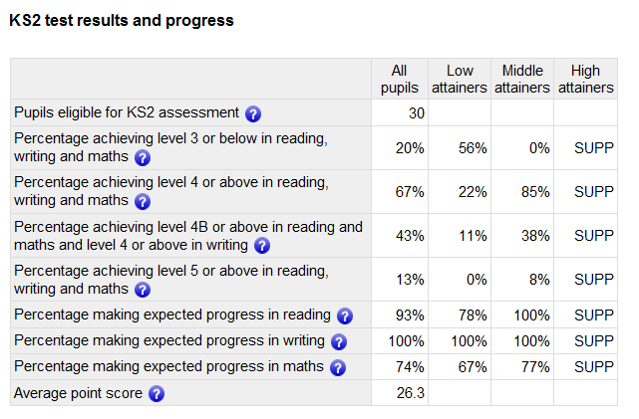

***Source:*** UK Department of Education school performance tables

Similarly to Colorado and Tennessee, the United Kingdom also provides a comparison between actual average gain versus projected average gain in maths, reading and writing. In the United Kingdom projected average (or expected progress) is counted as an improvement in two levels between testing periods[18].

## World Bank - EdStats

The World Bank’s Education Statistics (EdStats) portal is a comprehensive data and analysis source for key topics in education. EdStats tools and resources help users visualize and analyse education data.

EdStats uses a variety of interactive web pages to display information and to highlight performance differences between countries or by region. The EdStats dashboard (Figure 3.7) below shows an example of Key Indicators for Australia compared to all other countries. There are similar dashboards for learning outcomes, attainment, equality policy data and education projects. These dashboards present raw data from a variety of sources (such as PIRLS, TIMMS, PISA and PIAAC) in graphs, tables and quadrants.

Figure 3.7: Example EdStats dashboard

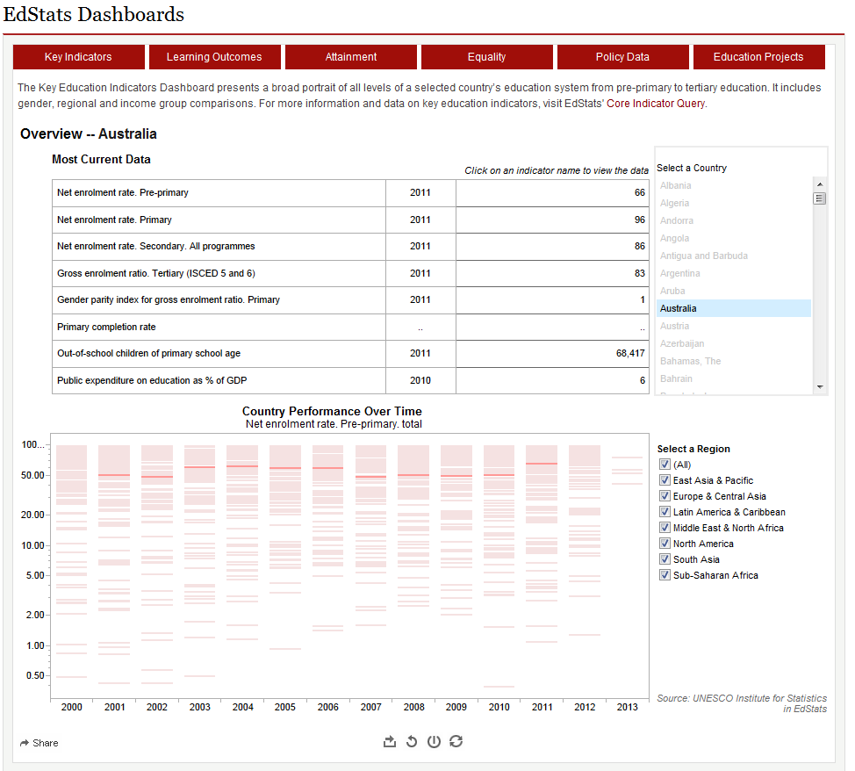

***Source:*** World Bank Education Statistics portal

In addition to dashboards, EdStats has developed a data visualiser tool to display education statistics. This data visualiser is a customisable tool that enables the user to create unique displays of data. For example the graph below (Figure 3.8) has been customised to show the relationship between PISA mean science performance and PISA mean maths performance

Figure 3.8: Example Data visualiser

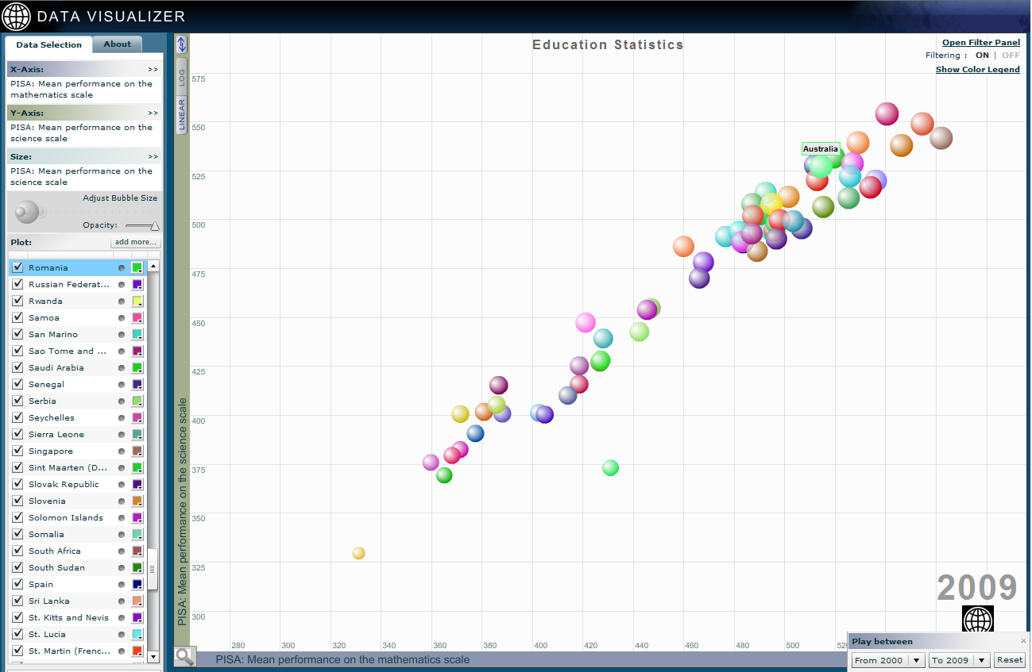

***Source:*** World Bank Education Statistics portal

## Conclusions

Taken as a whole the above developments demonstrate that other countries, states within countries and international bodies are moving forward with enhanced school accountability and reporting mechanisms and taking advantage of new data analysis and visualisation tools to better meet the needs of users. Clearly there is great value in sharing experience and learning from what others are doing in this area. The ambition should be to identify and adapt or adopt future best practice not just current best practice in order to ensure *My School* can sustain international excellence.

In the opinion of the reviewer, *My School* will need to be further enhanced to retain its standing as a world-class school accountability and reporting mechanism. One way forward would be for an international comparison project to be initiated, taking into account the evaluation of *My School* currently being progressed by ACARA, and formally adopted by the Education Ministers’ Council in the forthcoming work plan. Alternatively there is scope for the Commonwealth to initiate such a project and to promote the lessons learnt.

## Key Findings

* The 2012 OECD report on *My School*, found that there was general support in Australia in favour transparency of school performance information nationally.
* Internationally there are a variety of transparency and accountability measures used for schools, reflecting the particular context in which they have been developed.
* Various methods are used to display the data in a user friendly manner, including tables, graphs, colour coding and so on. Some presentations of data are interactive and involve a high level of user input to choose the desired presentation of data.
* Few systems report on raw scores as such, relying on other methods, such as reporting off the average, value adding and student gain.
* There are also a number of international websites, such as the World Bank, where Australia’s school performance can be compared with other countries. The Word Bank data visualiser demonstrates the power of such tools for a user.
* International developments in school performance reporting are useful comparators for   
  *My School* and its future development, including in relation to visualisation techniques and user choice of comparisons.
* The brief scan of international developments suggests that there is great value in sharing experience and learning from what others are doing. In the opinion of the reviewer *My School* will need to be further enhanced to retain its standing as a world-class school accountability and reporting mechanism.

# Chapter 4 – Reform agenda and Options for Improvement

This chapter discusses arrange of issues related to possible future directions for the *My School* website.

## Government policy agenda

The Coalition Government’s *Policy for Schools: Student First* undertakes to improving schools and education outcomes through policies to deliver more say for parents and teachers, a sound national curriculum, improved quality teaching, and certainty over school funding. The key government policies relevant to this review are:

* Parent and Community Engagement;
* School Autonomy;
* Indigenous closing the gap targets; and
* Development of an evidence base of performance data.

### Parent and Community Engagement

There is a range of information published on *My School*, which serves to improve transparency and accountability at the school level on a nationally consistent basis. This information is of interest to parents and broader school communities. Also there is a significant level of awareness about the   
*My School* website. However the current information provided and the way in which it is presented probably falls short of what is needed by parents and school communities to engage more fully with their local schools.

For instance, school performance information published on *My School* relies heavily on NAPLAN data, when research has found that the “School Facts” side bar which can be found on each school’s profile was the most useful to parents. Some parents have found the presentation of the statistics confusing and difficult to interpret. Many parents in the research highlighted that more contextual information, the student attendance rate, details about teaching staff and Information about Year 12 results were particularly relevant. The addition of such data will help promote better parent and community engagement through providing a more rounded picture of school outcomes.

In short, *My School* is, and has greater potential to be, a powerful tool for parent and community engagement across all sectors. There is some qualitative evidence to suggest that currently   
*My School* is used more in the independent than government school sector.

### School Autonomy

There is currently no formal reporting of school autonomy on *My School*. According to the Productivity Commission report on Schools Workforce[19], centralised control of schools can limit the scope for principals and other school leaders to exercise leadership. The report also found that increased school autonomy should improve student outcomes, provided:

* schools have the necessary leadership skills
* school-level governance arrangements ensure accountability for student outcomes, with appropriate oversight from education authorities

The Commonwealth Government has committed to working with states and territories to encourage 1500 (or 25 per cent) of existing public schools to participate in its $70 million “Independent Public School” (IPS) initiative by 2017. However, states such as Western Australia and Queensland publish list of IPS school on their state websites. These schools are linked to state initiatives and are not linked to *My School* data.

It would be straightforward to include another field on the *school profile* page to indicate whether a government school has IPS status.

### Indigenous closing the gap targets

*My School* does publish the proportion of Indigenous students for each school on the *school profile* page. However, there is no information directly related to Indigenous closing the gap targets. The Australian Government’s highest priority in Indigenous affairs is getting children to school (*Closing the Gap Prime Minister’s Report 2014*). Four out of seven closing the gap targets relate to educational outcomes:

1. Ensuring all Indigenous four-year-olds in remote communities have access to early childhood education within five years (by 2013)
2. Halve the gap for Indigenous children in reading, writing and numeracy within a decade (by 2018)
3. Halve the gap for Indigenous people aged 20-24 in Year 12 or equivalent attainment rates (by 2020)
4. End the gap between Indigenous and non-Indigenous school attendance within five years.

In terms of target two above, information on Indigenous student results are published by domain and by jurisdiction in the NAPLAN national report but not at school level on *My School*. However, the performance of Indigenous students is reflected in *My School* for schools with all or predominately Indigenous students. In relation to target four above the *school profile* page also includes the overall student attendance rate and that is a useful indicator for schools with all or predominately Indigenous students.

Through the nationally consistent data reported on *My School* parents and school communities with all or predominately Indigenous students have the capacity to compare their school with schools with statistically similar students and against all schools. The insights obtained can be used to engage in discussions about the closing the gap targets. The extent to which this may occur is not known.

### Development of an evidence base of performance data

The aim of the transparency and accountability policy agenda is to improve outcomes and equity for all students by using nationally comparable school performance data to build a substantive evidence base to support future improvements. *My School* is an important component to the government’s commitment to a national evidence base since it is the only source of nationally comparable school performance data available to parents and community members. It also fulfils a fundamental requirement for schools to be accountable for the public funding they receive.

With the release of the next version of *My School* in early 2015, not only will seven years of nationally comparable data will be available, but for the first time data will be available on a cohort of students who have completed year 3, 5, 7 and 9 NAPLAN assessments. This will add substantially to the richness of the analyses that can be undertaken, including the possibilities for time series to be produced, which qualitative research indicates would be valued by parents.

The availability of a full cycle of NAPLAN test data also raises the possibility of new longitudinal studies being undertaken across primary and secondary schooling. However that would require the agreement of the states and territories and non-government sectors to provide student identifier data, which is not currently provided to ACARA and is likely to be strongly resisted. One option could be to explore the possibility of longitudinal studies being done on a jurisdiction and sector basis to a consistent, agreed methodology.

More generally, the publication of additional indictors, which is discussed further below, will add more value to *My School* and the underpinning data sets.

## Rationale for change

The available data suggests that *My School* is most useful for parents in the process of choosing a school and less so in terms of raising issues with a school once their child is enrolled. In part this is explicable by the range of interaction a parent will have with a school and the direct reporting they receive on their child’s progress. However it is also clear that many parents find the *My School* web site overly complex and many aspects difficult to understand and interpret. This argues for simplification of the website to improve its useability.

There is no compelling argument for using *My School* as a mechanism for reporting on school autonomy other than as discussed above. Issues around school autonomy largely relate to government run school systems and there are differences in the approach taken between jurisdictions. However the national trend is to provide schools with greater levels of autonomy. Arguably, there are higher priorities for *My School* such as adding Year 12 equivalents.

As discussed earlier, the NAPLAN website contains national data, which allows Indigenous and non-Indigenous students’ results to be compared. Collecting such data is clearly important to understand progress towards the target but reporting this at a school level through *My School* raises some sensitive issues, including for relationships between parents and students. This may be particularity sensitive where only a minority of students at a school identify as Indigenous.

There is no doubt that nationally comparable school performance data, presented on *My School*, to build a substantive evidence base is a key component of accountability to parents and the community at large. For the Commonwealth Government having such data also provides a national perspective on the outcomes of schooling, including differences between and within jurisdictions and sectors, and facilitates the design of policies that are focused on school improvement. For states and territories it is a useful source of data for benchmarking purposes although less so for managing their school systems.

## Additional useful indictors

The future development of *My School* needs to be considered in the context of the primary purpose of the website (transparency and accountability to parents and school communities) and whether:

* the indicators currently being published are still appropriate;
* new indicators should be added to provide additional useful information, particularly on educational outcomes;
* *My School* is the most appropriate place for such information to be published; and
* the national benefits achieved outweigh the costs of collecting, analysing and publishing the data.

As discussed in Chapter 1, there are a number of indicators that have previously been agreed at Ministerial Council level and are in progress or have not been progressed as originally conceived. These are:

* the proportion of teachers at each level of expertise;
* the percentage of students with a disability;
* students’ post school destinations;
* the proportion of students attaining a Year 12 or equivalent qualification;
* student tertiary score information;
* parent and student satisfaction with the school; and
* staff satisfaction with the school.

From a public accountability perspective the publication of such indictors would provide additional, nationally consistent insights into the staffing and student profile of the school; the performance of the school in terms of both academic and broader life outcomes; and the judgements of parents, students and teachers about the school. Taken together these indicators would provide a broader perspective on a school, including qualitative information, than can currently be obtained through *My School*. Although some of this information, such a satisfaction survey data, can be obtained through individual school annual reports, it is not nationally consistent or easily assembled.

Provision of such information would also provide a richer picture of a school for parents in the process of choosing a school and for those wishing to engage in a discussion about the performance of a school.

Currently the comparative data on *My School* allows comparisons to be made against schools with statistically similar students and against the national average. It is also possible to see the performance of a school’s students relative to a national minimum standard. However there is no measure of performance against an expected achievement standard. This raises the question as to whether the national minimum standard is the appropriate benchmark. Interestingly the National Performance Plan sample tests do measure student’s achievement against a more challenging proficiency standard.

In light of the protracted debate that would enviable ensue over introduction of an expected achievement standard, priority should be given to those things already agreed but with a view to the introduction of more value added measures and a greater focus on student gain in the medium to longer term.

Similarly, any decision to not publish anything that is currently available on *My School* is likely to generate a debate and could only be done after extensive consultation and communication of the issues. The pragmatic approach is to not remove anything until all the priority additions are achieved. At that point a more comprehensive review could be undertaken.

## Value-adding enhancements

There appear to be different understandings of the concept of accountability in the context of   
*My School*. Accountability can be thought of as:

* accountability to governments – federal and state/territory;
* accountability to the Australian community at large;
* accountability to a school community;
* accountability to the parents of children at a school.

Arguably, *My School* is not about accountability to governments as there are various mechanisms by which governments hold schools accountable for their performance and for funding provided. State and territory governments have more detail available to them than could or should be published on *My School*.

In contrast, *My School* does provide a range of nationally consistent key information across jurisdictions and across sectors at the school level to the Australian community at large that would not otherwise be available. As this information is at the school level it therefore also enhances accountability to the school community and to parents. In the opinion of this review accountability to parents and school communities should be the main focus of *My School*.

Consistent with this interpretation of accountability, value adding enhancements to *My School* should therefore be guided by what school communities and parents want to know and the options and tools for analysis that they would like to have available. This information can then be assessed against the four criteria discussed earlier. Enhancements should not be driven by what governments are prepared to release or by philosophical objections of Education Unions or other stakeholders.

## Better targeted information

Within the Australian community there are groups that will wish to use *My School* for different purposes. Some are more interested in some aspects of the website than others. There are also different levels of ability and skills to interpret the data and information that is published. The current approach of an essentially one-size-fits-all audiences design can disenfranchise significant groups of potential users to the detriment of accountability. Qualitative research indicates that parents would like more choice over the types of comparisons available and how those are presented.

Table 4.1 below is an attempt to identify the particular interests of possible user groups, recognising that their interests will be driven by different motivations. For example, a parent’s interest in the NAPLAN results pages as context for their own child’s performance is quite different to a journalist looking for a story. A parent’s interest in the school profile page will be to get a snapshot view of a school whereas a State education authority’s interest could be driven by issues of accuracy.

Table 4.1: Matrix of possible user interests

| User Group | School Profile | School finances | NAPLAN  results | Similar schools | Student Gain | VET in schools | Local schools |
| --- | --- | --- | --- | --- | --- | --- | --- |
| Parents | Yes | Few | Some | Few | Some | Some | Few |
| Local Community | Yes | Some | Some |  |  | Some |  |
| School Students | Yes |  | Some |  |  | Some | Few |
| School leaders | Yes |  |  | Some | Some |  |  |
| State Education Authorities | Yes |  |  | Some |  |  |  |
| National Education Authorities | Yes | Yes | Yes | Yes | Yes | Yes |  |
| Local Businesses | Yes |  | Yes |  |  | Some |  |
| Academics | Yes | Yes | Yes | Yes | Yes | Yes |  |
| Journalists | Yes | Yes | Yes | Yes |  |  |  |

***Source:*** Reviewer’s own impressions based on the anecdotal and other evidence available.

This simplistic analysis reinforces the point that the school profile page is particularly important in providing a snapshot of a school and a pathway into the *My School* web site for all potential user groups.

## Presentation

Figure 4.1 below is a copied screenshot of the school profile page from *My School* 2010. According to the 2010 Colmar Brunton report the boxed areas are those that participants found most useful while the ISCEA scores boxed in red were the least useful. Arguably, this presentation conveyed more useful information in one page than the current version shown earlier in this review, as it included NAPLAN results in numbers.

Figure 4.1: Partial screen shot of school profile page 2010

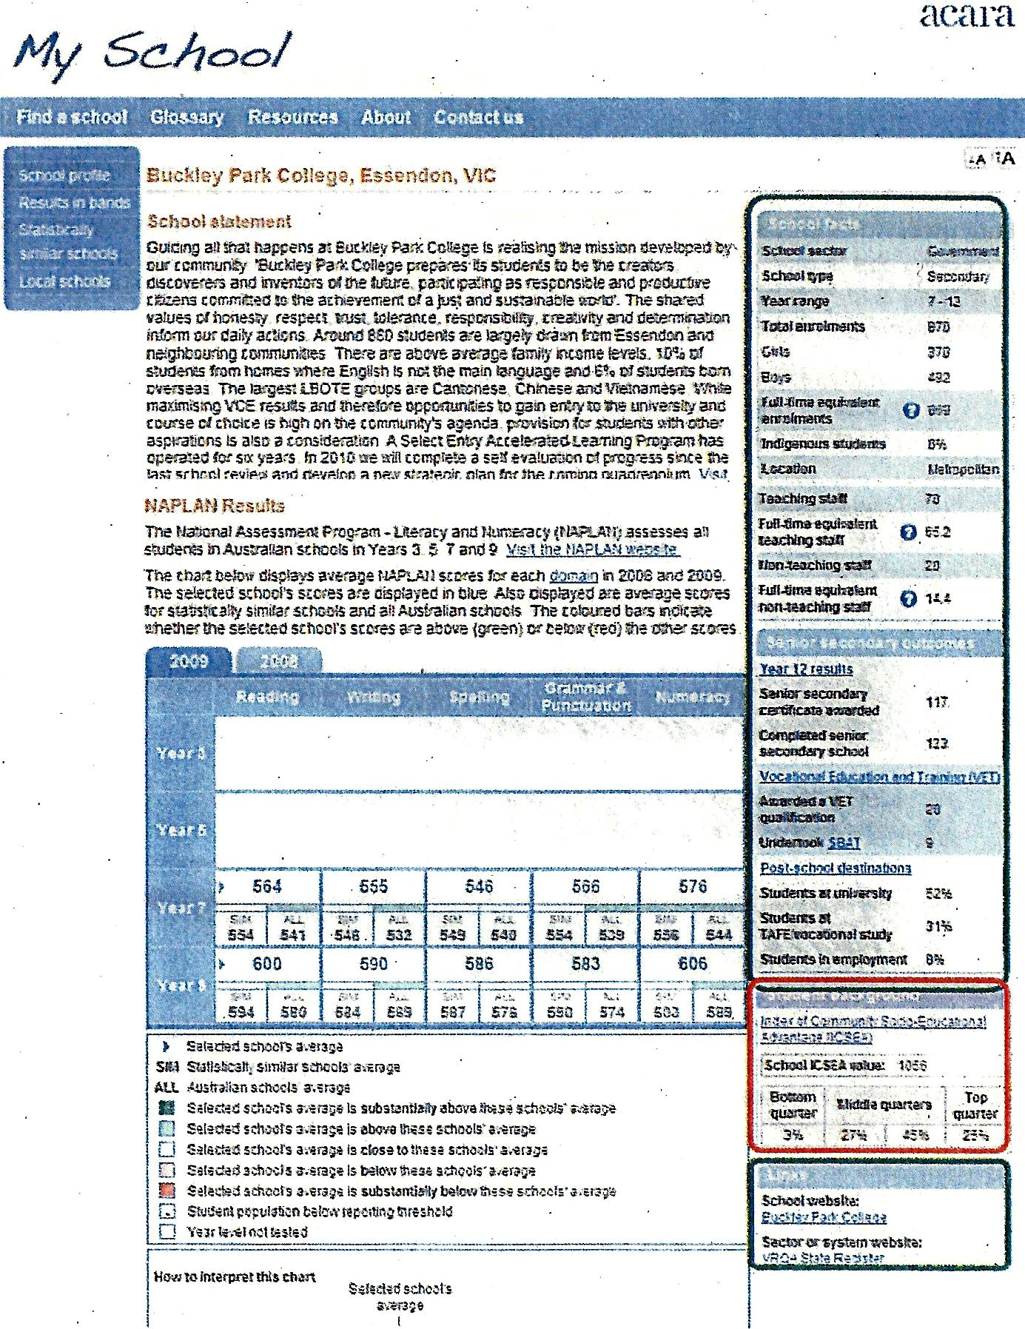

***Source:*** Colmar Brunton 2010

As discussed earlier in this review, in 2010 members of the then *My School* Working Party were concerned that presentation of NAPLAN results on the school profile page conveyed the impression that it was the major indictor of school effectiveness and performance; that the focus should be on contextual information and NAPLAN results presented on a separate page. From the second version of *My School* released in early 2011, NAPLAN results have been presented separately.

As discussed in Chapter 2, qualitative research is indicating that the current school profile page is still thought to be deficient. This raises the question as to whether reversion to a presentation closer to the original would be beneficial as it combines features of the two most highly used website pages – the *school profile* page and *NAPLAN results in numbers*. In the medium to longer term, inclusion of *student gain* could be more powerful in showing educational outcomes but in the opinion of the reviewer, as one of the least accessed *My School* pages and in light of the gap in data available, the concept is not yet sufficiently well understood to be a successful substitute.

More broadly, the analysis of the individual *My School* pages presented earlier, together with preliminary feedback from qualitative research currently being undertaken for ACARA, suggests that there is a need and scope to make the website more user friendly for the general public. It appears that the website design has been driven by three key factors:

* the constraints imposed on content and presentation by the governance arrangements under which ACARA operates, and in particular the detailed decisions of Education Ministers;
* the considerable influence of some key stakeholders, especially the education unions, on Education Ministers and in key advisory bodies such as the *My School* Working Party; and
* the expert, technical and metrics driven culture of ACARA itself and its advisory bodies.

These factors have resulted in something of a mismatch between the *My School* design and ordinary parent’s needs and expectations. That said, parents who are well educated and technically and educationally literate, appear to be able to navigate and understand the web site without much difficulty.

## Efficiencies

As shown by the expenditure table in Chapter 1, expenditure on *My School* by ACARA has been declining in actual and real terms with salaries and wages accounting for 66 per cent of direct expenditure over the past two financial years and website hosting a further 15 per cent. Expenditure on contractors has declined sharply.

The major costs associated with the website are in the technical development work, negotiation and clearance of data collections, quality control, and analysis prior to publication on *My School*. Many of these costs are borne by jurisdictions in addition to the ACARA budget. However there is a strong rationale for these data to be collected in the national interest anyway.

The review has not identified any significant areas where the direct costs of *My School* could be easily reduced. Some minor efficiencies could be made by not investing further in website pages that are little used, with the exception of the *VET in schools* and *student gain* pages because of their inherent importance.

It is noted that new data collections in the forward work program will need to be funded with some supplementation of the *My School* budget in the new four year work program commencing in July 2016. Future funding has yet to be negotiated.

Due to the early stage of the considerations, the review is not able to offer an informed assessment of whether efficiencies will be gained by the transfer of data responsibilities from ACARA to the Department of Education in so far as the *My School* website is concerned.

Achieving efficiencies will require continued attention to priorities, careful management of enhancement projects and close monitoring of expenditure at a level of detail beyond the scope of this review.

## Key issues moving forward

In considering the way forward for *My School* there are a number of key challenges that will need to be addressed. These include governance and decision making issues; accessibility issues; possible movement of functions; financial resources; access to the underlying data base; and the results of an evaluation of the website.

The governance and decision making arrangements under which *My School* operates have been successful in getting participation by all jurisdictions and sectors on a consensus basis and in sharing development and implementations costs. On the other hand these arrangements have slowed decision making, frustrated the adoption of some new ideas, seen changes in previously agreed positions, and resulted in an almost lowest common denominator approach.

In the opinion of the reviewer, for *My School* to become more agile and responsive to actual user needs the established decision-making processes should be modified on the basis of the following principles:

* That all jurisdictions continue to share the development costs of all initiatives in the current and future ACARA *My School* work plans;
* That in relation to the implementation phase (i.e. development/modification of website pages and publication) the decision-making processes allow for a clear majority of jurisdictions (six out of eight or 75 per cent) to move forward with new initiatives on the basis of them providing some supplementary funding to do so;
* If the remaining jurisdictions and non-government sectors did not wish to participate, including the Commonwealth, they could opt out with the ability to opt in at any future point;
* Individual jurisdictions, including the Commonwealth, could continue to design and fund pilots or trials of initiatives related to *My School* if they choose to do so; and
* These changes would not in any way impact on the other arrangements between jurisdictions and sectors outside the scope of *My School.*

These modified arrangements should allow for the collection, analysis and presentation of key missing indicators to be moved forward more expeditiously without all jurisdictions and sectors having to agree on all details. Indeed this approach should be extended to new indicators such as expected gain.

It is recognised that this approach could cause some unease, and would not achieve a nationally consistent data set in the first instance. However, it would at least provide multi-jurisdiction, multi-sector comparable data for those jurisdictions and sectors that agreed to participate. All jurisdictions and sectors could then be held accountable for the decisions they took and could not shelter behind a cloak of collective responsibility.

This concept could be extended more broadly, including to different forms and styles of data presentations and use of analytical tools on an opt-in or opt-out basis. While initially the website might look more complex with more options available, public pressure should lead to a nationally consistent result for things that really matter.

Turning to accessibility, under the *Disability Discrimination Act 1992*, Australian government departments have an obligation to provide our information and services in a manner accessible to everyone regardless of ability. Current policy is that government websites should be compliant with the WCAG 2.0 Double A standard by the end of 2014. At present the *My School* website generally meets level A and is designed to display on commonly used web browsers and to work with accessibility hardware and software. Website pages have been kept to a reasonable size and are scalable to accommodate common screen resolutions.

The particular challenges for making *My School* compliant with the WCAG 2.0 Double A standard are:

* the data rich nature of the website with a lot of tabular and graphical information presented in a small space, which poses problems for users dependent on screen readers;
* the requirement to minimise automated ‘scraping’ of data to prevent the building of league tables, which is at odds with WCAG 2.0 requirement to make data machine readable;
* the use of colours to highlight comparisons has been addressed in part by providing alternatives but remains an issue; and
* the need for additional button clicks to access different formats.

A discussed earlier, a related issue is the general ease of use and understanding of the information on the *My School* website for parents and school communities. With the addition of further data sets and their related pages the web site will become more complex given its current design. External website design and development expertise may be required to introduce new and innovative thinking and thereby ensure the website can better met the needs of ordinary users, even within existing policy constraints.

In an environment of budget constraints in all jurisdictions, and in the absence of any obvious efficiencies in direct expenditure on the *My Schoo*l website, finding the resources to develop new pages for additional data sets will not be straightforward. Taking the addition of information on Students with Disabilities (SWD) as an example the costs to ACARA of data analysis and non-public reporting are estimated at $3.9 million, while the direct costs of a new SWD *My School* web page are around $132,000.

ACARA currently provides with each new release the de-identified data underpinning the *My School* website to government departments of education and the catholic and independent schools sectors. This enables the education authorities to undertake other analyses of their jurisdictions and sectors if they so choose. ACARA has also received under its data access program some 270 applications for data since April 2011. ACARA approves applications it considers to be for a good purpose and has approved 55 per cent of applications received. The top five sources of applications are universities (61 per cent approved), consultants/private companies (22 per cent approved), the federal government (83 per cent approved), state/territory governments (70 per cent approved) and non-profit organisations (75 per cent approved). Given the increasing extent and richness of the underpinning data for research and policy purposes the number of data requests is likely to increase. Consistent with broader policy directions, ACARA should need to show that actual harm would result if data were to be released. It should also make generally available all data released in response to requests.

The current ACARA work plan for *My School* includes an evaluation of the website. Some qualitative research is being undertaken to inform that process, including whether *My School* is consistent with the principals and protocols for reporting on schooling and whether it has increased accountability and transparency. The findings of this review are expected to be taken into account by the Commonwealth in the context of the evaluation exercise.

## Key Findings

* There is a strong rationale for continued development of the *My School* website to provide appropriate school level accountability for parents, school communities and the Australian community more broadly.
* The *My School* website can support key elements of the Government’s school policy agenda and there is potential to undertake some more powerful analyses;
* There is a compelling argument for indictors previously agreed by Ministers to be published on *My School* as soon as practicable to provide better information on schools and school outcomes;
* *My School* should not attempt to do everything as it is one part of the national performance and reporting framework but more emphasise should be given to provision of better targeted information and more readily understandable presentation of data.
* No obvious efficiencies in the direct expenditure on *My School* have been identified although moving NAPLAN testing to an online platform may offer efficiencies in related areas.
* Further development of *My School* will need to address a number of key challenges, including governance and decision making issues; accessibility issues; usability issues; possible movement of data functions; financial resources; access to the underlying data base; and the results of an evaluation of the website.
* For *My School* to become more agile and responsive to actual user needs the established decision-making processes should be modified to allow for a clear majority of jurisdictions (six out of eight) to move forward with implementation of new initiatives on the basis of them providing some supplementary funding to do so.

# Chapter 5 – Conclusions and recommendations

This final chapter seeks to draw the main findings of the review together and makes a number of recommendations for change.

## Synthesis of key findings

*My School* represents a valuable source of nationally consistent data on Australian schools across all jurisdictions and all sectors. With the systematic collection of new data, the refinement of its statistical underpinnings and further development of the system architecture the potential value of *My School* has increased over time. However, *My School* is by its nature a complex website with a lot of technical and statistical information. While it is a rich source of information it is not designed to be general user friendly. Unfortunately, the national data repository that *My School* now represents is probably underutilised.

In terms of the current policy context, the key Commonwealth Government policies relevant to this review relate to parent and community engagement; school autonomy; Indigenous closing the gap targets; and development of an evidence base of performance data. It is clear that the *My School* website and its underlying data sets can play a useful role in assisting with the promotion and implementation of the government’s agenda.

There remains a lack of clarity among stakeholders about the core purpose of *My School* and therefore its main audience. Official documentation shows a Commonwealth policy focus on transparency and accountability through publication of nationally consistent school level data. This is based on the absence of such data prior to the introduction of *My School* and international evidence that clear accountability assists create a learning environment that encourages innovation and excellence. From a Commonwealth perspective, as a major funder and with both social policy and economic interests in educational outcomes, *My School* serves a valuable policy and analytical purpose.

For other stakeholders the evidence is more mixed. Qualitative research results suggest that   
*My School* is perceived to be mainly about NAPLAN scores and academic performance, which is only one aspect of how parents make choices about and engage with schools. Parents are therefore interested in seeing more contextual information. Consultations indicate that use of *My School* by principals and school system administrators is limited, in part because school systems are using NAPLAN and broader data to help drive school improvement within schools. Re-articulating the purpose to focus on national transparency and accountability to parents and school communities, with less emphasis on its benefits as a tool for educational improvement would be beneficial.

There is only limited data on the usage of *My School*, including by whom, for what purpose and what impact it may have. Overall usage of *My School* has been declining slightly but is still substantial. The available data shows that there is spike in usage of *My School* at the time that new releases are made and to a lesser extent at the time NAPLAN tests are conducted and when results are released. Website traffic referral information indicates that users are linked to *My School* predominately from commercial (including media) and educational websites but also from government and community sites.

There is a deal of interest from the Commonwealth, state and territory jurisdictions, academics, media and some other users in accessing the data repository that supports the *My School* website. ACARA agrees to requests for information that are judged to be for a good purpose. Consequently, it agrees to most requests from governments, universities and non-profit bodies but relatively few from other stakeholders. Making the underlying data base more readily available would encourage new more innovative uses and analyses.

The functionality of *My School* has been enhanced over time and the quality of data improved. For example, the recent update of the ICSEA methodology will provide more stable outcomes. However the functionality and useability of the website is constrained by the complex Commonwealth, state and territory governance and policy framework in which ACARA operates. The *My School* design has been partly driven by the policy objective of making the collation and publication of league tables difficult, reflecting education union and other stakeholder concerns.

Anecdotal and survey evidence suggests that the full functionality and utility of *My School* generally is not well understood, either by parents or teachers. As NAPLAN data relating to individual student performance is directly made available to both parents and schools, the value added by *My School* relates to nationally consistent comparative data for a school over time, across schools having students with statistically similar backgrounds and across all schools. Importantly, this includes student educational growth as presented in the NAPLAN student gain page.

An analysis of page views of the *My School* website pages shows that the school profile, NAPLAN results in numbers and NAPLAN results in graphs are the most frequently viewed pages, representing three-quarters of total page views. However some *My School* pages are accessed by only a small minority of users, including NAPLAN results in bands, NAPLAN student gain, NAPLAN similar schools, VET in schools, local schools and school finances. Of these pages, NAPLAN student gain is an important growth measure and VET in schools is important for students pursuing a vocational stream of education. The local schools page offers the least utility for users in its current form.

While *My School* can only provide part of the information and data needed to understand the quality of a school and educational achievement of students, the interpretation of the data can be difficult. For example, the average NAPLAN results of students at a school can vary by year and by domain and margins of error overlap. A judgement is required as to whether, overall, a school is improving and about the factors that might be driving the outcomes achieved. A more sophisticated understanding than what *My School* can provide is required by school leaders in order to design educational interventions and for individual teachers to change their teaching. However *My School* can prompt a useful conversation about such issues.

Available research indicates that parents are interested in indicators of school quality in addition to those presented on *My School*, such as the ‘feel’ of a school, relationships and behaviour management, programs and facilities and other qualitative factors that are best determined by visiting a school and talking to teachers and other parents. The survey research also suggests that a minority of parents utilise *My School* and mainly for choosing a school. Some parents use the website for monitoring school performance and for providing context for their own child’s NAPLAN results. Some parents have also identified content gaps such as Year 12 completions that are of interest to them. Development of a specific website page to better meet the needs of parents would help them in using *My School*.

The presentation of much of the content on *My School* may need significant reworking to meet current policy for accessibility for users with a disability (WCAG 2.0). For example, while colour and audio options are available on some pages, the presentation of gain graphs, which do not specify the end points, and the use of colour coding make access by people using screen reading technology quite difficult.

With the 2015 release of *My School* a total of seven years of school level data will be publicly available. This means that for the first time results for students who sat the first NAPLAN tests in year 3 in 2008 and have completed the full cycle of year 3, 5, 7 and 9 annual assessments will be available. This data set will be very valuable to anyone interested in school performance and student gain over the 2008 to 2014 period. It also opens up the possibility of different forms of analyses and new ways of presenting data such as in time series form and possibly longitudinal studies.

In terms of international comparisons, a case study undertaken under the auspices of the OECD noted that the transparency achieved through *My School* has placed the broader community in the same position as education officials in having access to national data. It also noted that *My School* presents school data in a way that places each school at the centre of the reports and is designed to avoid the misinterpretation that often arises with school league tables.

The work being done in other countries such as the USA and UK provides useful comparators for  
 *My School.* There are useful lessons to be learnt from international experience, including in data visualisation and user choice, and *My School* is to will need to be further enhanced to retain its standing as a world-class school accountability and reporting mechanism

## Options for changes

From a public accountability perspective the publication of key missing indictors previously agreed by Education Ministers would provide additional, nationally consistent insights into the staffing and student profile of the school; the performance of the school in terms of both academic and boarder life outcomes; and the judgements of parents, students and teachers about the school. Taken together these indicators would provide a broader perspective on a school, including qualitative information, than can currently be obtained through *My School*. Although some of this information, such a satisfaction survey data, can be obtained through individual school annual reports, it is not nationally consistent or easily assembled.

Provision of such information would also provide a richer picture of a school for parents in the process of choosing a school. At the same time, however, it will make the website somewhat more complex.

Currently the comparative data on *My School* allows comparisons to be made against schools with statistically similar students and against the national average. It is also possible to see the performance of a school’s students relative to a national minimum standard. However, there is no measure of performance against an expected achievement standard. Interestingly the National Performance Plan sample tests do measure student’s achievement against a more challenging proficiency standard.

In light of the protracted debate that would enviable ensue over introduction of an expected achievement standard, priority should be given to those things already agreed but with a view to the introduction of more value added measures in the medium to longer term.

As discussed above, the 2015 release of *My School, with* a total of seven years of school level data on students who have completed the full cycle of 3, 5, 7 and 9 annual assessments, not only allows more sophisticated analyses but also opens up the possibilities for presenting *My School* data in the form of time series. Qualitative research indicates that this would be welcomed by parents as being more readily understandable and avoiding the work involved in having to manually move between different years in the current website design.

As discussed earlier in this report, there are opportunities to refine and simplify the website to make it more user friendly for ordinary parents and school communities. This would best be done based on further research on what parents actually want and with the assistance of a leading external website design and development company to ensure new thinking is brought to bear. Such an approach may assist to resolve the tension between the policy directions guiding *My School* and the actual needs of users.

The changes in presentation and design discussed above would, of course, require some additional investment (the direct costs of development of a new website page are in the order of $132,000) but would result in an enhanced *My School* from both an accountability and user experience perspective. In the opinion of the reviewer, maintaining the website on its current trajectory will fail to achieve the best outcomes for the investment made.

The governance and decision making arrangements under which *My School* operates have been successful in getting participation by all jurisdictions and sectors but have slowed decision making, frustrated the adoption of some new ideas, seen changes in previously agreed positions, and resulted in an almost lowest common denominator approach. As discussed in more detail earlier, for *My School* to become more agile and responsive to actual user needs the established processes should be modified so as to allow the collection, analysis and presentation of already agreed and possible new missing indicators to be moved forward expeditiously without all jurisdictions and sectors having to agree on all details.

## Assessment of way forward

Any significant change in content and presentation of *My School* data and information will take time to negotiate, develop test and implement. Due to the funding and governance arrangements for ACARA and sensitivities around ownership of data, there is little the Commonwealth can do directly to change *My School*. Collaboration and negotiation with the states and territories will be required.

The Commonwealth can, however, pursue a strong leadership role, including through publicly arguing the case for change drawing on the best evidence available and through the established senior officials and Ministerial Council processes. This could include moving away from consensus-based decision making and achieving agreement from a majority jurisdictions and sectors in order to make some gains for *My School* and to build pressure for the remaining jurisdiction and sectors to come on board.

While the Commonwealth does not have broad direct linkages to schools it could utilise other mechanisms to engage more directly with parents and school communities. For example, the Commonwealth has extensive policy and funding linkages into preschool education and therefore a capacity to engage and influence parents in this crucial feeder group. *My School* offers useful information and insights for parents looking at the future of their child’s education.

Due to budgetary constraints there is limited scope to use funding leverage given the Commonwealth-state/territory funding agreements and commitments already in place and the lack of discretionary funding available. To the extent that funding could be found the Commonwealth could institute pilot programs to develop methodologies, collect sample data and undertake analyses. Such approaches have been influential in the past.

It is also recognised that since the initial agreements to establish and launch *My School* and the work program to support it, there have been changes in both the political composition of Commonwealth, state and territory governments and numerous changes in the ministers responsible for school education across the jurisdictions. This means that the level of ownership of past decisions about   
*My School* among current governments and education ministers is variable.

The current situation and past experience suggests that changes will not be easily achieved but the importance of *My School* as a school centred accountability mechanism argues for a significant effort to be made to ensure it reaches its full potential. There are a number of factors that argue for early action. These include: the release of full cycle NAPLAN data with *My School* 2015; the continued feedback from parents that *My School* is not fully meeting their needs; the need to improve the accessibility of the website for users with a disability; the fact that international developments in data visualisation and user choice of analyses appear to be overtaking *My School*; and the need to consider in 2015 the four year work plan commencing 1 July 2016.

## Recommendations

The following recommendations are designed to improve the longevity, useability and utility of   
*My School* consistent with its role in improving the transparency and accountability of Australia’s school education system. The recommendations are grouped into higher level and more detailed recommendations for ease of reference.

### Strategic issues and next steps

This review recommends that:

1. The *My School* website continues to be supported by all Australian jurisdictions as a nationally consistent school reporting system for the next four year work plan period commencing 1 July 2016. The next ACARA work plan is scheduled to be considered and approved during 2015.
2. The primary purpose of *My School* be focused on accountability at the school level, based on nationally consistent data. The primary accountability should be to parents and school communities. Use of the website for education improvement should be a secondary, albeit important, purpose.
3. The consensus decision making arrangements for *My School* be modified to allow for a more agile and user responsive approach to the further enhancement of the website. This will mean removing the right of veto and allowing any majority of jurisdictions and sectors that wish to proceed with the implementation of enhancements in content or presentation to do so.
4. The priority for future development of *My School* should be to collect, analyse and present data on the indictors previously agreed by Ministers so as to give a more rounded picture on schools and school outcomes. This will require significant work, including on standardised definitions, and should not be delayed because one or more jurisdictions or sectors cannot agree.
5. The Commonwealth negotiate with the state and territory jurisdictions to empower ACARA to improve the usability of *My School*, including of comparative data. This should include at a technical level meeting the requirements of the Double A standard of WCAG 2.0 in line with exiting Commonwealth policy. A leading website design and development company should be contracted as an adviser.
6. In the interests of transparency and full accountability all the data and information on *My School*, including areas already agreed to be included, be available to all users, accepting that many users will not utilise elements of the website. A portal approach where certain information is reserved for categories of users would undermine the credibility of the website.
7. The Commonwealth take the a lead role, including by working with ACARA and state and territory jurisdictions, to promote better understanding of the primary purpose, functionality and value of the *My School* website. This will help ensure that better value is derived from the investment in the website and of the seven years of data to be available from early 2015.
8. The Commonwealth prepare a paper for consideration and endorsement by senior officials and the Education Ministers Council to recommit to maintenance and enhancement of the national data base that underpins *My School*; to rearticulate the primary propose of *My School;* to endorse the work plan to add additional data collections to the website; and to modify the governance and decision making processes to allow a majority of jurisdictions and sectors who wish to proceed with new initiatives to do so without full consensus having to be reached.

### Website design and data release

This review also recommends that:

1. The landing page for *My School* be simplified and the video material reviewed to make it more user friendly. The landing page should make a short statement about ACARA and the purpose of *My School* so the users understand the context immediately.
2. As the most widely used component of *My School* the school profile page should be made more useful by eliminating extraneous text and including a brief snapshot of the most recent NAPLAN results as presented in the results by numbers page.
3. School principals and school councils be given up to an additional 100 words on the school profile page to better articulate the education philosophy, behaviour management, programs and facilities, which research shows are of particular interest to parents.
4. A parent’s guide to *My School* and a parent’s page be developed based on further research into what parents actually value and want from the site and in what form they would like to access it. This page should include appropriate contextual information and the ability to choose relevant data and make comparisons from the NAPLAN and other pages that are of most interest to them.
5. That generally no further development work be put into *My School* pages that have proved to be of little interest to users of the site. These include the local schools page, the NAPLAN results in bands page; and the school finances page. To the extent that policy makers may wish to undertake analyses in these areas that can be done from the underlying data set.
6. That some additional development work be done on the VET in schools page and underlying data set to enable consistent cohort comparisons of enrolments to completions for students undertaking the vocational stream of education. Similarly the student gain page be further developed to allow longer term analyses to be undertaken, especially for students with the same starting points.
7. Requests from education researchers and academics for access to de-identified   
   *My School* data be granted as a matter of course and data sets already released be made publicly available, with the onus on ACARA to demonstrate why not. This is consistent with the broader movement towards open government and with encouraging innovation in the use of government data.

# Appendices

## Appendix 1 – Terms of Reference for Review

The following terms of reference for the review were specified by the Australian Government Department of Education.

This independent *My School* review will examine and report on the following:

* The success of the site in meeting the original purpose of *My School* including functionality and accessibility.
* How information published on *My School* is currently used and displayed. This includes the information published on the School’s Profile page, all performance data, all financial data, VET data and the Local Schools page.
* The level to which the current suite of information available supports the Government’s reform agenda, in particular, for parent and community engagement, school autonomy and the development of an evidence base of outcome and performance data.
* The publication of additional indicators, including those already agreed by the Ministerial Council.
* Opportunities for improvements, including better targeted information, efficiencies and enhancements to meet the objectives of *My School* and the school reform agenda.

The reviewer will provide a report of its findings, identify options for changes to the *My School* website and make recommendations for those changes.

## Appendix 2 – Methodology and Data Sources

### Methodology

The review of *My School* has been informed by a range of inputs including:

* examination of official background documentation and Ministerial Council decisions;
* discussions with the Australian Curriculum Assessment and Reporting Authority;
* analysis of a range of *My School* information and data provided by ACARA;
* targeted discussions with a number of stakeholders to gain further user insights;
* a survey of relevant official and stakeholder reports (see Appendix 3);
* consideration of some similar websites in other countries;
* discussions with Australian Government Department of Education officers.

The qualitative and quantitative analysis undertaken during the review was used to develop the findings relevant to the terms of reference and in turn identify and assess options for change and the recommendations of this report.

### Data Sources

Except where otherwise identified, the data for the analysis of use of the *My School* website was provided on request by ACARA based on their own website traffic data and also through the use of Google Analytics. The presentation of the data in the review is the responsibility of the reviewer.

The review also drew on qualitative and quantitative research on *My School* commissioned by ACARA.

## Appendix 3 – Key References

Australian Curriculum Assessment and Reporting Authority, 2010, *Report of the ACARA Working Party on the My School Website*, ACARA, Sydney

Australian Curriculum Assessment and Reporting Authority on behalf of the Standing Council on School Education and Early Childhood, 2012, *Measurement Framework for Schooling in Australia*, ACARA, Sydney

Australian Curriculum Assessment and Reporting Authority, 2013, *National Report on Schooling 2011*, ACARA, Sydney

Australian Curriculum Assessment and Reporting Authority, 2013, *Annual Report 2012-13*, ACARA, Sydney

Australian Curriculum Assessment and Reporting Authority, *My School website*, accessed at [www.myschool.edu.au](http://www.myschool.edu.au), June and July 2014.

Australian Curriculum, Assessment and Reporting Authority, 2013*, NAPLAN Achievement in Reading, Persuasive Writing, Language Conventions and Numeracy: National Report for 2013*,

ACARA, Sydney.

Australian Parents Council Inc., 2013, *My School – A guide for parents*, accessed at [www.austparents.edu.au](http://www.austparents.edu.au), July 2014

Canvass Strategic Opinion Research, 2013, *Primary Principals: Perspectives on NAPLAN Testing and Assessment*, Sydney, accessed at www.appa.asn.au, July 2014

Dulfer N, Polesel J, Rice S, 2012, *The Experience of Education: The impacts of high stakes testing on school students and their families*, Whitlam Institute within the University of Western Sydney, Rydalmere

Independent Schools Queensland, 2011, *What Parents Want: An Independent Schools Queensland Survey- Key Findings*, accessed at www.aisq.qld.edu.au, July 2014

Jensen B, 2010, *Measuring What Matters: Student Progress*, Grattan Institute, Melbourne

Loughnane B, 2013, *The Coalition’s Policy for Schools: Students First*, Liberal Party of Australia, Barton

Masters, G, Rowley G, Aniley J, Khoo S, 2008, *Reporting and Comparing School Performances*, Paper prepared for the MCEETYA Expert Working Group, ACER, Melbourne

MCEETYA, 2008, *Melbourne Declaration on Educational Goals for Young Australians*, Ministerial Council on Education, Employment, Training and Youth Affairs, Melbourne

New York City Department of Education, 2013, *What’s Next for School Accountability in New York City*, New York

New York City Department of Education, 2013, *Progress Report 2012-13, Abraham Lincoln High School*, New York

Standing Council on School Education and Early Childhood (now known as the Education Council), *Communiqués and Media Releases*, accessed at [www.scseec.edu.au](http://www.scseec.edu.au), June 2014

Taig C, 2010, *Australian Curriculum and Reporting Authority, Consumer Evaluation of My School Version One: Qualitative and quantitative research findings*, Colmar Brunton Social Research, South Melbourne

The Senate Education and Employment References Committee, 2011*, Effectiveness of the National Assessment Program – Literacy and Numeracy, Final Report*, Canberra

Zanderigo T, Dowd E, Turner S, 2012, *Delivering School Transparency in Australia: National Reporting Through My School,* OECD Publishing, Paris

## End Page

1. ABS, Migration, Australia, 2012-13, Catalogue 3412.0
2. See Independent Schools Queensland, 2011; Australian Parents Council, 2013; Canvass Strategic Opinion Research, 2013; Taig, C, 2010
3. See for example, NSW Department of Education & Communities, Centre for Education Statistics and Evaluation, www.cese.nsw.gov.au
4. Review of Funding for Schooling, Final Report, December 2011 (known as the Gonski report)
5. Education and Employment References Committee report: *Effectiveness of the National Assessment Program—Literacy and numeracy.*
6. ABS Births Australia 2012, Catalogue 3301.0
7. ABS Schools Australia 2013, Catalogue 4221.0
8. See Taig, C, 2010
9. Colmar Brunton, 2014 – work in progress at the time of this review.
10. See Dulfer N, et al, 2012
11. See NYC DOE 2013, *What’s Next for School Accountability in New York City*,
12. See NYC DOE 2013, *Progress Report 2012-13*
13. States in the USA have a large degree of independence and they have different degrees of accountability and transparency in the publication of school performance information.
14. From <https://edx.cde.state.co.us/cgmdemo/private/index.htm>
15. From <https://edx.cde.state.co.us/cgmdemo/private/index.htm>
16. From (<http://www.tn.gov/education/assessment/doc/TVAAS_TE_Report_Help.PDF>) and (<http://www.state.tn.us/education/research/index.shtml>)
17. From: <http://www.education.gov.uk/schools/performance/primary_13/p4.html>
18. From <http://www.education.gov.uk/cgi-bin/schools/performance/search.pl?searchType=location&location=fulham&distance=1&phase=all>
19. Productivity Commission Research Report: Schools Workforce (2012), page 223: <http://www.pc.gov.au/__data/assets/pdf_file/0020/116651/schools-workforce.pdf>