Review of Higher Education Access and Outcomes for Aboriginal and Torres Strait Islander People
Context paper and call for submissions
September 2011
© Commonwealth of Australia, 2011.
ISBN: 978-0-642-78085-0 [PRINT version]
ISBN: 978-0-642-78086-7 [PDF version]
The document can also be accessed via the DEEWR website at: www.deewr.gov.au/iher
This work is copyright. You may download, display, print and reproduce this material in unaltered form only (retaining this notice) for your personal, non-commercial use or use within your organisation. All other rights are reserved.
Disclaimer:
The material contained in this paper has been developed by the Panel for the Review of Higher Education Access and Outcomes for Aboriginal and Torres Strait Islander People . The views and opinions expressed in the materials do not necessarily reflect the views of or have the endorsement of the Commonwealth or of any Minister, or indicate the Commonwealth’s commitment to a particular course of action.
The Commonwealth and the members of the Panel for the Review of Aboriginal and Torres Strait Islander People accept no responsibility for the accuracy or completeness of the contents and accept no liability in respect of the material contained in the paper. The Commonwealth recommends users exercise their own skill and care and carefully evaluate the accuracy, completeness, and relevance of the paper and where necessary obtain independent professional advice appropriate to their own particular circumstances.
In addition, the Commonwealth and the members of the Panel for the Review of Aboriginal and Torres Strait Islander People, and their members, employees, agents and officers accept no responsibility for any loss or liability (including reasonable legal costs and expenses) or liability incurred or suffered where such loss or liability was caused by the infringement of intellectual property rights, including the moral rights, of any third person.
Note: All data included in the document are sourced from the Department of Education, Employment and Workplace Relations (DEEWR) Higher Education Collection Datasets unless otherwise specified. All student statistics refer to 2009 data unless otherwise specified.
The Higher Education Statistics Collections are available at:
www.deewr.gov.au/HigherEducation/Publications/HEStatistics/Publications/Pages/Home.aspx
A letter from the Review Panel
In 2008, the Australian Government accepted the Review of Australian Higher Education (commonly known as the ‘Bradley Review’) which recommended that the Australian Government regularly review the effectiveness of measures to improve higher education access and outcomes for Indigenous people in consultation with the Indigenous Higher Education Advisory Council (IHEAC).
To this end the Government has established a Review of Higher Education Access and Outcomes for Aboriginal and Torres Strait Islander People. A whole of sector review of this scope has never been done before and the Panel is delighted to be overseeing this process.
As you will see from the information in the context paper the figures for Aboriginal and Torres Strait Islander people attending higher education have remained comparatively static for many years. The Review will have a clear focus on closing the gap to ensure that Aboriginal and Torres Strait Islander people have access to the life chances that a quality university education provides.
We will also focus on the knowledges and perspectives of Aboriginal and Torres Strait Islander people and indeed how that knowledge can benefit not just Aboriginal and Torres Strait Islander people but also non-Indigenous university students and staff as well as other professions in the broader community.
The Review will establish broad common ground as to what the problems are—what things are creating barriers, what accounts for the lack of success—and set future strategic directions that can guide the sector going forward. A key question for the Review will be whether support for Aboriginal and Torres Strait Islander students could be better targeted.
The context paper canvasses key issues the Review will investigate and provides key statistics relating to Aboriginal and Torres Strait Islander participation in higher education, in effect providing a baseline from which improvements are to be achieved.
The Review will be informed by the Terms of Reference, written submissions, face-to-face consultations with university leaders and Aboriginal and Torres Strait Islander students and staff; consultations with key stakeholders across the country; and commissioned research and think pieces from experts in the field both within Australia and in comparable countries.
We invite responses which provide relevant evidence regarding the effectiveness of current measures to improve higher education access and outcomes for Aboriginal and Torres Strait Islander people and provide examples of good practice that have the potential for broader adoption. While all contributions and constructive input are welcome, I especially encourage targeted responses based on issues within the scope of the Review with which you or your organisation are directly involved.
We hope that students, graduates, academics, general staff, university administrators, industry, professional bodies, and community members will find the information in the Context Paper of assistance in the preparation of their submissions.
Professor Larissa Behrendt (Chair) on behalf of the Review Panel
September 2011
Table of Contents
Review of Higher Education Access and Outcomes for Aboriginal and Torres Strait Islander People 1
A letter from the Review Panel 3
September 2011 3
LIST OF TABLES AND FIGURES 5
Review of Higher Education Access and Outcomes for Aboriginal and Torres Strait Islander People 6
Context 6
Vision 7
Scope 7
Review of Australian Government programs addressing access and outcomes for Indigenous Australians 12
Call for submissions 12
How to make a submission 12
Publication of written submissions 12
Attachment A: Aboriginal and Torres Strait Islander people in Higher Education: A Statistical Overview 14
A note on data 14
Students 14
Staff 32
Attachment B: Key Questions 35

LIST OF TABLES AND FIGURES
Figure 1.1 Comparison of Aboriginal and Torres Strait Islander and all domestic students by number of enrolments, commencements and award course completions, 2001-2009________________________________________________________________________________________________15
Figure 1.2 Comparison of Aboriginal and Torres Strait Islander and all domestic students by number of enrolments, commencements and award course completions , 2001-2009______16
Table 1. Commencing students’ basis of admission to university , 2009______________________17
Table 2. Profile of commencing students, 2009_________________________________________________18
Figure 2. Proportion of domestic student enrolments by field of education (%), 2009________________________________________________________________________________________________19
Figure 3. Proportion of domestic student commencements by field of education (%), 2009________________________________________________________________________________________________20
Figure 4. Retention Rate (%), 2008______________________________________________________________21
Figure 5. Proportion of domestic student completions by field of education (%), 2009_____22
Table 3: Aboriginal and Torres Strait Islander student enrolments by broad level of course, 2009________________________________________________________________________________________________23
Figure 6a. Index of Aboriginal and Torres Strait Islander student enrolments by broad level of course, 2004-2009 (2004=100)______________________________________________________________ 24
Figure 6b. Index of all domestic student enrolments by broad level of course , 2004-2009 (2004=100)________________________________________________________________________________________25
Figure 7. Proportion of domestic student enrolments by type of university, 2009__________26
Table 4. HDR enrolments 2004–2009___________________________________________________________29
Table 5. HDR commencements 2004–2009 ____________________________________________________ 30
Table 6. HDR completions 2004–2009__________________________________________________________ 30
Figure 8. Proportion of domestic HDR enrolments by field of education (%), 2009_________ 31
Table 7. Proportion of graduates who were available for full-time employment and found
full-time employment within four months after graduation __________________________________ 31
Figure 9. Proportion of Aboriginal and Torres Strait Islander higher education staff (%), 2004-2010_________________________________________________________________________________________32
Figure 10. Indigenous Higher Education Staff : Actual and population parity (2010)______________________________________________________________________________________________33

Review of Higher Education Access and Outcomes for Aboriginal and Torres Strait Islander People
The Review of Higher Education Access and Outcomes for Aboriginal and Torres Strait Islander People forms part of reforms to Australia’s higher education system implemented by the Australian Government in response to the findings of the Review of Australian Higher Education (commonly known as the ‘Bradley Review’). The Australian Government accepted key recommendations of the Bradley Review, and articulated its policy directions in the statement, Transforming Australia’s Higher Education System, including a commitment to the Review of Higher Education Access and Outcomes for Aboriginal and Torres Strait Islander People.
The Review of Higher Education Access and Outcomes for Aboriginal and Torres Strait Islander People was announced by the Hon Senator Chris Evans, Minister for Tertiary Education, and the Hon Senator Kim Carr, Minister for Innovation, on 14 April 2011. The Review will report to the Australian Government within 12 months of the announcement.
The Review Panel is chaired by Professor Larissa Behrendt, Professor of Law and Indigenous Studies at the University of Technology, Sydney. Other Review Panel members are Professor Steven Larkin, Chair of the Indigenous Higher Education Advisory Council (IHEAC), Robert Griew, Associate Secretary, Department of Education, Employment and Workplace Relations (DEEWR), and Patricia Kelly, Deputy Secretary, Department of Industry, Innovation, Science and Research (DIISR).
The call for submissions is complemented by a background paper - Indigenous Australian Higher Education: Trends, Initiatives and Policy Implications, prepared for the Review Panel by Ekaterina Pechenkina and Professor Ian Anderson from the University of Melbourne. Using a comparative analysis of commencement and completion statistics between 2004 and 2009 across 40 universities, the paper provides an overview of Aboriginal and Torres Strait Islander participation in higher education, which may provide useful background information for those who wish to make a submission to the Review.

Context
Australia’s prosperity into the future will depend on our ability to adapt to a competitive, knowledge-based global economy. In order to achieve this, we need to encourage individuals to upgrade their skills and knowledge and ensure access to education and training opportunities for people from all backgrounds. Within this broad context, increasing the representation of Aboriginal and Torres Strait Islander people in the higher education sector is critical.
While the participation, commencement and completion rates for Aboriginal and Torres Strait Islander people have all increased in general over the past two decades, these figures have not kept pace with the increase in the Aboriginal and Torres Strait Islander population and increased participation by non-Indigenous students. Consequently, the gap between the participation levels of Aboriginal and Torres Strait Islander and non-Indigenous students across these measures appear to have widened since 1990. Supporting data is provided at Attachment A: ‘Aboriginal and Torres Strait Islander people in Higher Education: A Statistical Overview,’ sourced from the Department of Education, Employment and Workplace Relations (DEEWRs) Higher Education Statistics Collection.
There are a number of costs associated with the current situation, including the direct costs to universities and government of relatively high attrition rates among Aboriginal and Torres Strait Islander students across the higher education system; opportunity cost resulting from the failure to provide successful pathways for capable Aboriginal and Torres Strait Islander people into higher education and through to graduation; personal cost to individual students and their families. Further detail on the social and private benefits of higher education is provided in the Background Paper for the Higher Education Base Funding Review (page 57).
Each of Australia’s universities has an individual mission, history, profile and geographic footprint that influences their achievement to date and their opportunity to contribute to improving higher education outcomes for Aboriginal and Torres Strait Islander people. It is unlikely the Review will find a one size fits all answer. While there is clearly much activity across the sector and commitment to making a difference, there is also an emerging consensus that it is timely to take stock and identify the strategies that are effective as well as the gaps in sector performance and consider fresh approaches to transforming overall performance.

Vision
Our vision is for a higher education sector that is contributing to the common goals of improving the socio-economic position of Aboriginal and Torres Strait Islander people and continuing to grow vibrant and healthy communities. The higher education sector needs to take an active role in:
- Producing Aboriginal and Torres Strait Islander graduates across the spectrum of academic disciplines who are equipped to enter professional practice, build the capacity of their communities and revitalise professions through their involvement.
- Developing an academy enriched by Indigenous participation and knowledge that will contribute to the continued development of intellectual capability, cultural enrichment and first-rate research.

Scope
The Review’s Terms of Reference state that the Review is to provide advice and make recommendations to Government in relation to:
- Achieving parity for Aboriginal and Torres Strait Islander students, researchers, academic and non-academic staff.
- Promoting best practice and opportunities for change inside universities and other higher education providers (spanning both Indigenous specific units and whole-of-university culture, policies, activities, and programs).
- Improving the effectiveness of existing Commonwealth Government programs that aim to encourage better outcomes for Indigenous Australians in higher education.
- Increasing the recognition and equivalence of Indigenous knowledge in the higher education sector.
A note on parity
While the Review Panel is tasked with making recommendations in relation to achieving parity, it should be noted that determining the appropriate parity rate is in itself a question for the Review. A population parity rate of 2.2% is used in this paper. This is consistent with the parity rate used in the Bradley Review. The population parity rate reflects the proportion of the population aged between 15-64 years of age that is Aboriginal or Torres Strait Islander according to 2006 ABS population statistics.
When discussing parity, it is appropriate to also consider the demographic profile of Aboriginal and Torres Strait Islander people compared with the wider higher education aged population. A question for the Review is whether the figure of 3.1% (currently used by DEEWR) accurately reflects projected the Aboriginal and Torres Strait Islander population.
A note on scope
The Review is focused on the higher education sector and will examine issues such as pathways into study and employment within the professions from that perspective. There is a role for the sector in building aspirations and preparedness for higher education study and ensuring graduates are job ready. The Review will examine how successfully universities and other higher education providers support Aboriginal and Torres Strait Islander students. The review will also test the effectiveness of Commonwealth Government programs that aim to support students through their academic journey.
The Review will consider community and social factors, such as housing and justice systems only in relation to the higher education sector engagement with these issues.
The areas covered by the scope of the Review are presented below.
The Student Journey
Raising aspirations
Access and Entry
Pathways, enabling programs, accreditation and Recognition of Prior Learning
Student support, mentors, role models
Modes of delivery
Funding and scholarships
Remote, online and flexible delivery models
Representation in all disciplines
Graduate attributes
Enriching the Academy
Growing participation and quality outcomes for Aboriginal and Torres Strait Islander staff, in light of the National Indigenous Higher Education Workforce Strategy
Developing an academy enriched by Indigenous participation and knowledges
Indigenous knowledge
Funding and scholarships
Post-graduate studies
Supervision, mentors and role models
Traineeships and Cadetships
The role of universities
Promoting best practices
Collaborative approaches
The role of universities in wider society – building stronger communities
Governance structures
Cultural awareness
Indigenous Education Units
Whole of university approaches and embedding practices
Targets and strategies
Links with schools, vocational education and training and Indigenous communities
Review of Existing Australian Government Programs targeting better access and outcomes for Aboriginal and Torres Strait Islander People
Literature Review - Australian and International Research
Case studies
Commissioned Research
Each of these areas are described in more detail in the following pages.

I. The Student Journey
The Review is tasked with advising on how to achieve parity for Aboriginal and Torres Strait Islander students in higher education. In pursuit of this objective, the Review will consider how to attract more students who are academically prepared for further study, achieve better retention and graduate with high quality outcomes.
The Review will also examine the role of universities in increasing the aspirations of Aboriginal and Torres Strait Islander people (particularly youth) to seek a higher education, and approaches to grow academic readiness.
The introduction of demand-driven funding and targets for low SES inclusion means that universities are being encouraged to explore other approaches to gauge readiness and academic preparedness for entry to university.
Aboriginal and Torres Strait Islander students often enter higher education in ways that differ from other domestic students. For example, in 2009, 46% of Aboriginal and Torres Strait Islander students entered university on the basis of their prior educational attainment. By contrast, 82% of all domestic students entered university on the basis of their prior educational attainment.
The effectiveness of current approaches to promoting access will be examined including enabling programs and recognition of prior learning. Current university approaches to outreach will be examined and the most effective approaches will be highlighted.
Aboriginal and Torres Strait Islander student retention rates were lower than non-Indigenous retention rates across all broad course levels in 2008. The Aboriginal and Torres Strait Islander student retention rate for Bachelor degrees was 71.9%, compared with 83.8% for non-Indigenous.
The Review will consider issues around student support (including financial, academic and mentoring support as well as pastoral care) and other factors that contribute to retention and completion. The Review will also consider the qualification profile of Aboriginal and Torres Strait Islander students and graduates, compared with non-Indigenous students, with particular focus on disciplines where there is low participation by Aboriginal and Torres Strait Islander students compared to the broader student population. Consideration will also be given to the impact of role models and mentors at all levels of study.
The professions themselves can be important vehicles for change and opportunity. The Review will consider existing programs and initiatives that aim to increase the presence of Aboriginal and Torres Strait Islander people in the professions across all sectors of the economy in order to highlight good practice examples. The current work of the Australian Indigenous Doctors’ Association (AIDA) with the universities provides an example of the contribution which can be made by professions.

II. Enriching the Academy
The Review will consider university and Government initiatives to increase the number and capacity of Aboriginal and Torres Strait Islander staff within universities in both academic and non-academic roles, in light of the recently released National Indigenous Higher Education Workforce Strategy. The impact of Australian Government research funding and performance schemes, including those administered by the Australian Research Council will also be examined. The Review will also consider the important role of the Australian Institute of Aboriginal and Torres Strait Islander Studies (AIATSIS) for Aboriginal and Torres Strait Islander researchers.
Recognising that Aboriginal and Torres Strait Islander people bring significant strengths to learning, teaching and research, the Review will consider ways to include Indigenous knowledge systems and Aboriginal and Torres Strait Islander perspectives (including within the curriculum), in order to inform and diversify university research and scholarship, and increase the breadth of of research.
Consideration will be given to the recognition of Indigenous knowledges as an academic pursuit and the experiences of Aboriginal and Torres Strait Islander students in the sector and the experiences of Aboriginal and Torres Strait Islander Higher Degree by Research (HDR) students – our next generation of Aboriginal and Torres Strait Islander academics. Their experiences will be benchmarked against the experiences of non-Indigenous HDR students. Funding support to Aboriginal and Torres Strait Islander HDR students will also be considered.
The Review will also consider how the non-Indigenous academic workforce can be engaged and supported to ensure universities are better placed to embrace Aboriginal and Torres Strait Islander perspectives and better able to validate research that impacts on Aboriginal communities.

III. The Role of Universities
Australian universities are currently implementing a range of strategies to increase Aboriginal and Torres Strait Islander participation in the sector. There may also be lessons that can be learnt from other countries that have had a focus on increasing the participation of first nations or minority groups. The Review will explore these examples and will identify and promote best practice in the sector.
Governance structures and their relationship to Aboriginal and Torres Strait Islander outcomes will be explored, including an examination of the level and influence of Aboriginal and Torres Strait Islander people within the decision-making forums of universities. This will include the role Indigenous Education Units play and whether greater responsibility should be accepted by the wider institution to support students and drive change.
The Review will also examine the effectiveness of collaborative approaches between universities to increase the access and outcomes of Aboriginal and Torres Strait Islander people.
The role of universities in bringing about social change and improved outcomes for Aboriginal and Torres Strait Islander people within the broader community will also be examined. This includes looking at examples where universities are building relationships with the communities in which they are located and the impacts these relationships have.

Review of Australian Government programs addressing access and outcomes for Indigenous Australians
The Review will consider the effectiveness of the Australian Government’s current relevant Indigenous higher education programs, taking into account the potential impact of recent higher education, research and research training reforms. It will provide advice on the effectiveness of current measures to improve access and outcomes for Aboriginal and Torres Strait Islander people in higher education and provide recommendations on ways to better design and target such measures.

Call for submissions
The Review Panel is seeking written submissions from interested individuals, organisations, institutions and peak bodies. In particular, Aboriginal and Torres Strait Islander people are encouraged to make a submission. The Review Panel invites responses that provide relevant evidence regarding the effectiveness of current measures to improve higher education access and outcomes for Aboriginal and Torres Strait Islander people and provide examples of good practice that have the potential for broader adoption. While all contributions and constructive input is welcome, the Review Panel especially encourages targeted responses based on issues within the scope of the Review with which you or your organisation are directly involved.
To help frame those submissions, the Review Panel and the Indigenous Higher Education Advisory Council have developed a series of key questions that can be responded to (Attachment B). Written submissions should, wherever possible, respond to some or all of these questions.

How to make a submission
Written submissions should address some or all of the key questions set out in Attachment B or respond to the issues raised in this paper or the accompanying background paper. Submissions must be lodged by 5.00pm on 18 November 2011.
By email: ReviewSubmissions@deewr.gov.au
By post:
Ms Jasmin Fielder
Director, Review Secretariat
Department of Education, Employment and Workplace Relations
Loc Code: C50MC9, GPO Box 9880, CANBERRA CITY ACT 2601
Your submission should clearly identify:
‐ Name of organisation or individual
‐ If an organisation, please indicate the name of a contact person
‐ Contact information (ie. postal and email address, telephone number)
Enquiries about the Context Paper may be directed via email: ReviewSubmissions@deewr.gov.au.

Publication of written submissions
Please note that written submissions may be published on the Review website. Submissions provided on a wholly confidential basis will not be accepted. However, submissions may include appended material marked ‘confidential’. DEEWR will accept confidential submissions from individuals where those individuals can argue credibly that publication might compromise their ability to express a particular view. Please note that any request for access to material marked confidential made under the Freedom of Information Act 1982, will be determined in accordance with that Act.

Attachment A: Aboriginal and Torres Strait Islander people in Higher Education: A Statistical Overview

A note on data
All student and staff data referred to in this paper have been sourced from DEEWR’s Higher Education Statistics Collection and the Graduate Careers Australia Australian Graduate Survey, 2009. This includes published and unpublished student and staff data for 2009 from DEEWR’s Higher Education Statistics Collection.
The population parity rate 2.2% used in this paper is consistent with the parity rate used in the Bradley Review. This population parity rate reflects the proportion of the population aged between 15-64 years of age that is Aboriginal or Torres Strait Islander according to 2006 ABS population statistics.
When discussing parity, it is appropriate to also consider the different age demographic profile of Aboriginal and Torres Strait Islander people compared to the wider population. Because of this, DEEWR has historically also compared student levels using a parity rate that aims to estimate the proportion of Australian students that would be expected to be Aboriginal or Torres Strait Islander, if Aboriginal and Torres Strait Islander people were represented according to their proportion of the higher education aged population. A question for the Review is whether this figure, 3.1%, accurately reflects projected population demographic change into the future.

Students
Since 2001:
- The total number of Aboriginal and Torres Strait Islander students participating in higher education has increased by 20.8%.
- Yet, due to increasing rates of participation in higher education by non-Indigenous students, the Aboriginal and Torres Strait Islander proportion of total students has remained unchanged at approximately 1.3%.
The Australian Government’s Overcoming Indigenous Disadvantage report (2009) highlights that in 2006, Aboriginal and Torres Strait Islander people aged 20–24 years attended university at about one-fifth the rate of non-Indigenous people (4.9% and 23.9%, respectively). While both Aboriginal and Torres Strait Islander student enrolments and commencements have increased since 2005, there has been a decline in award course completions from 2007 to 2008 among Indigenous students (see Figure 1, overleaf).

Aboriginal and Torres Strait Islander student profile in 2009
In 2009 there were 813,896 domestic students enrolled of which 10,440 identified as Aboriginal or Torres Strait Islander.
Aboriginal and Torres Strait Islander students were more likely to be over 20 years of age than non-Indigenous domestic students.
The largest single group of Aboriginal and Torres Strait Islander students enrolled was women aged 25 and over (representing 39.8% of Aboriginal and Torres Strait Islander student enrolments).
Aboriginal and Torres Strait Islander students entered university in a variety of ways, whereas overall domestic students entered study based predominantly on their secondary or previous higher education attainment.
Figure 1. Comparison of Aboriginal and Torres Strait Islander and all domestic students by number of enrolments, commencements and award course completions, 2001-2009
ALL DOMESTIC STUDENTS

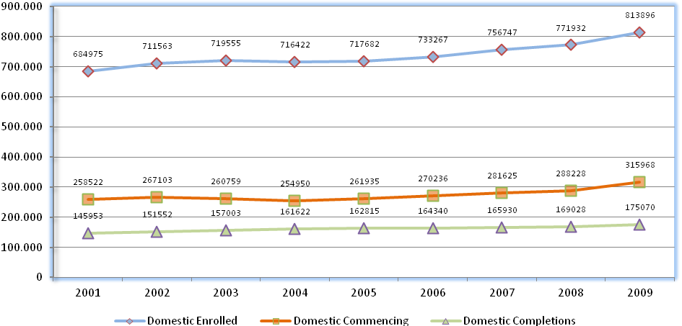
Source: DEEWR Higher Education Statistics
ABORIGINAL AND TORRES STRAIT ISLANDER STUDENTS
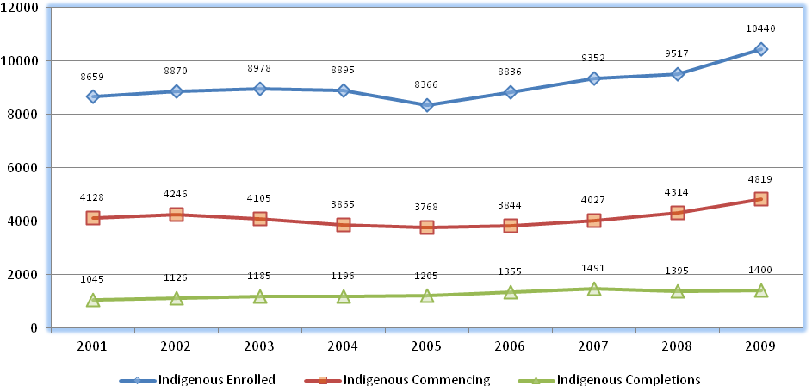
Source: DEEWR Higher Education Statistics, unpublished data

Student Access
Only 46% of Aboriginal and Torres Strait Islander students entered university on the basis of their prior educational attainment. By contrast, 82% of all domestic students entered university on the basis of their prior educational attainment (see Table 1). The ‘Other’ basis for admission category refers to a form of entry not covered by the other categories that involves the institution’s assessment of a prospective student’s individual circumstances.
Table 1. Commencing students’ basis of admission to university, 2009
 | Aboriginal and Torres Strait Islander | All Domestic
Whose basis for admission was... | Previous HE course – 25%  Secondary education – 15%  VET Award course – 6%  Mature age special entry – 8%  Professional qualification – 1%  Other – 45% | Previous HE course – 43%  Secondary education – 32%  VET Award course - 7%  Mature age special entry – 5%  Professional qualification – 1%  Other – 12%
Whose previous highest qualification was ... | Postgraduate course – 4%  Bachelor course – 11%  Sub-degree course – 4%  Incomplete HE course – 17%  VET award course – 11%  Secondary education – 29%  Other – 9%  None – 12% | Postgraduate course – 8%  Bachelor course – 21%  Sub-degree course – 3%  Incomplete HE course – 11%  VET award course – 7%  Secondary education – 38%  Other – 3%  None – 6%
Source: DEEWR Higher Education Statistics, unpublished data, 2009

Student Demographics
The demographic information and patterns of study for Aboriginal and Torres Strait Islander university students were quite different to those seen across all Australian domestic students commencing a course of study in the same year. Demographic details for students commencing study in 2009 are summarised in Table 2.
Table 2. Profile of commencing students, 2009
 | Aboriginal and Torres Strait Islander students | All Domestic students
Who were aged ... | Under 20 – 29%  20 to 24 yrs – 19%  25 to 39 yrs 31%  Over 40 – 21% | Under 20 – 40%  20 to 24 yrs 22%  25 to 39 yrs. 26%  Over 40 – 12%
Who were female | 65% | 59%
Who come from metropolitan areas | 55% | 80%
Whose home is in a low SES postcode | 39% | 15%
Who attended university part time | 34% | 32%
Whose mode of attendance was ... | Internal – 57%  External – 29%  Multi-modal – 14% | Internal – 77%  External – 17%  Multi-modal – 5%
Source: DEEWR Higher Education Statistics, unpublished data, 2009
Table 2 above shows statistics for student commencements in all course levels. Similar trends were observed for commencing undergraduate students in most demographic characteristics. However, there were some notable differences in age, type of attendance and mode of attendance.
- The proportion of Aboriginal and Torres Strait Islander commencing undergraduates aged 25 to 39 years (29%) was nearly twice that of all domestic commencing undergraduates (15%). By contrast, 35% of Aboriginal and Torres Strait Islander undergraduates were aged below 20 compared with 58% of all domestic undergraduates. This indicates that Aboriginal and Torres Strait Islander undergraduates were more likely to commence in undergraduate courses at an older age.
- There was a larger proportion of Aboriginal and Torres Strait Islander commencing undergraduates who attended university part time (25%) compared with all domestic commencing undergraduates (18%).
- At least one quarter (26%) of Aboriginal and Torres Strait Islander commencing undergraduates used an external mode of attendance compared with just 10% of all domestic commencing undergraduates.

Aboriginal and Torres Strait Islander student enrolments by field of education
In 2009, the proportion of Aboriginal and Torres Strait Islander student enrolments was larger than that for non-Indigenous domestic student enrolments in the following fields of education (see Figure 2):
- Society and Culture (25.6% Indigenous; 18.6% non-Indigenous)
- Teacher Education (16.6% Indigenous; 9.8% non-Indigenous)
- Other Health (8.0% Indigenous; 7.4% non-Indigenous)
- Nursing (7.1% Indigenous; 5.5% non-Indigenous)
- Other Education (2.3% Indigenous; 1.4% non-Indigenous)
- Justice and Law Enforcement (1.4% Indigenous; 0.9% non-Indigenous)
On the other hand, the proportion of non-Indigenous domestic students enrolled in Management and Commerce (18.9%) was almost twice that for Aboriginal and Torres Strait Islander students (9.6%). Science and Engineering were also more popular amongst non-Indigenous domestic students than Aboriginal and Torres Strait Islander students (Science: 7.3% non-Indigenous compared with 3.4% Indigenous; Engineering: 6.5% non-Indigenous compared with 2.3% Indigenous).
Figure 2. Proportion of domestic student enrolments by field of education (%), 2009
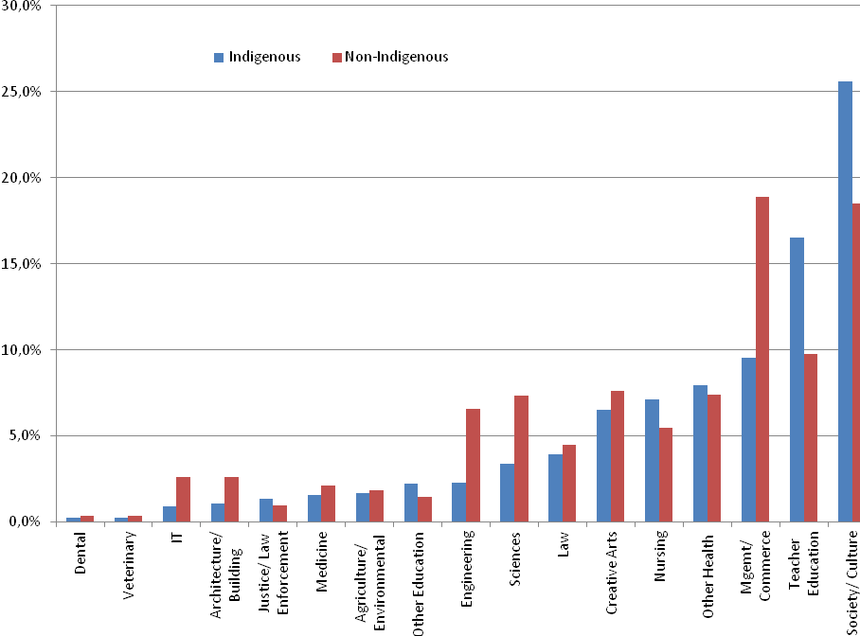
Source: DEEWR Higher Education Statistics, unpublished data, 2009
Note: This chart identifies the major field of the student and does not count the second major where a student is studying a combined degree.

Aboriginal and Torres Strait Islander student commencements by field of education
A large proportion of Aboriginal and Torres Strait Islander students commenced study in 2009 in Society and Culture (25.3%) and Teacher Education (15.1%, see Figure 3). This compares with 18.9% and 10.5% respectively for non-Indigenous domestic students. Nursing was marginally more popular amongst Aboriginal and Torres Strait Islander students (6.6%) than for non-Indigenous domestic students (6.2%).
Similar to enrolments, the proportion of non-Indigenous domestic student commencements were larger than that for Aboriginal and Torres Strait Islander students in Management and Commerce (17.2% non-Indigenous; 8.1% Indigenous); Science (6.9% non-Indigenous; 3.3% Indigenous) and Engineering (5.3% non-Indigenous; 1.9% Indigenous) courses.
Figure 3. Proportion of domestic student commencements by field of education (%), 2009
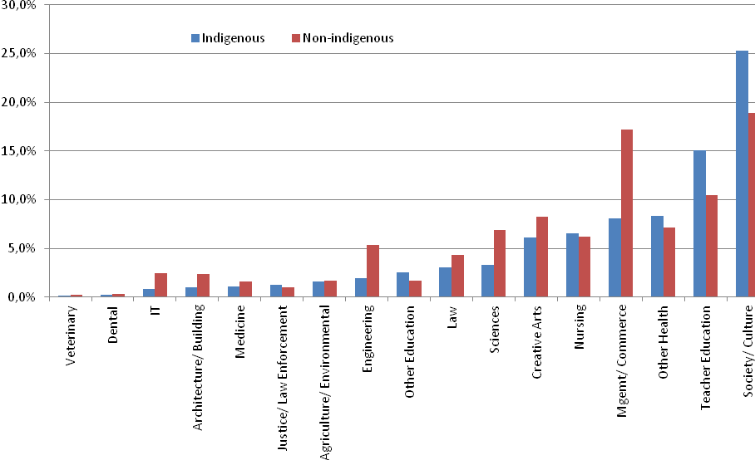
Source: DEEWR Higher Education Statistics, unpublished data, 2009
Note: This chart identifies the major field of the student and does not count the second major where a student is studying a combined degree.

Aboriginal and Torres Strait Islander student retention rates
The retention rate for the below data is defined as the number of domestic students who studied in 2008 and studied again in 2009 at the same provider (excluding any students who completed in 2008) as a proportion of the domestic students who studied in 2008 (excluding any who completed in 2008).
Aboriginal and Torres Strait Islander student retention rates were lower than non-Indigenous domestic student retention rates across all broad course levels (see Figure 4).
- The Aboriginal and Torres Strait Islander student retention rate was highest for Higher Degree by Research courses (80.5%), followed by overall Higher Degree courses (71.9%).
- The gap in retention rates for Higher Degree by Research courses (2.3 percentage points) was less than half the gap for overall Higher Degree courses (5.8 percentage points).
- The Aboriginal and Torres Strait Islander student retention rate for Bachelor was 71.9%, compared with 83.8% for non-Indigenous domestic students.
Figure 4. Retention Rate (%), 2008
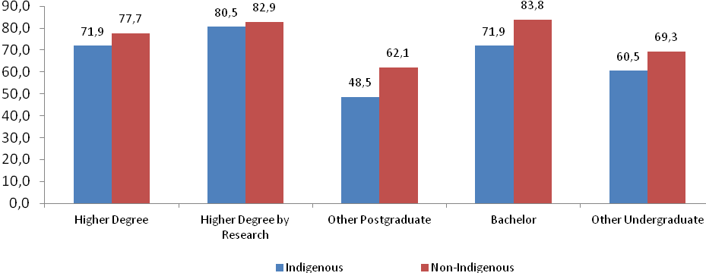
Notes:
- Includes all Table A higher education providers only.
- Includes only domestic students with a Permanent Home Address in Australia.
- Higher Degree = Doctorate by Research, Doctorate by Coursework, Masters by Research, and Masters by Coursework
- Higher Degree by Research = Doctorate by Research and Masters by Research
- Other postgraduate = Postgraduate Qualifying/Preliminary, Graduate/Postgraduate Diploma, and Graduate Certificate
- Bachelor = Bachelor Graduate Entry, Bachelor Honours, and Bachelor Pass.
- Other Undergraduate = Associate degree, Advanced Diploma (AQF), Diploma (AQF), and Other undergraduate award course.
Source: DEEWR Higher Education Statistics, unpublished data

Aboriginal and Torres Strait Islander student completions by field of education
Completions by field of education were similar to patterns in enrolments and commencements.
The proportion of Aboriginal and Torres Strait Islander student completions was larger in Society and Culture (10.5% Indigenous; 20.5% non-Indigenous), Teacher Education (18.1% Indigenous; 11.9% non-Indigenous), Other Health (11.0% Indigenous; 7.6% non-Indigenous), Nursing (8.6% Indigenous; 6.5% non-Indigenous), Other Education (3.1% Indigenous; 1.6% non-Indigenous), Justice and Law Enforcement (1.4% Indigenous; 1.2% non-Indigenous) and Veterinary Studies (0.3% Indigenous; 0.2% non-Indigenous).
Management and Commerce was more popular amongst non-Indigenous domestic students (20.5%) compared with Aboriginal and Torres Strait Islander students (10.5%) in terms of completions. Science and Engineering courses were also more popular amongst non-Indigenous domestic students than Aboriginal and Torres Strait Islander students (Science: 7.3% non-Indigenous compared with 2.8% Indigenous; Engineering: 4.7% non-Indigenous compared with 2.4% Indigenous).
Figure 5. Proportion of domestic student completions by field of education (%), 2009
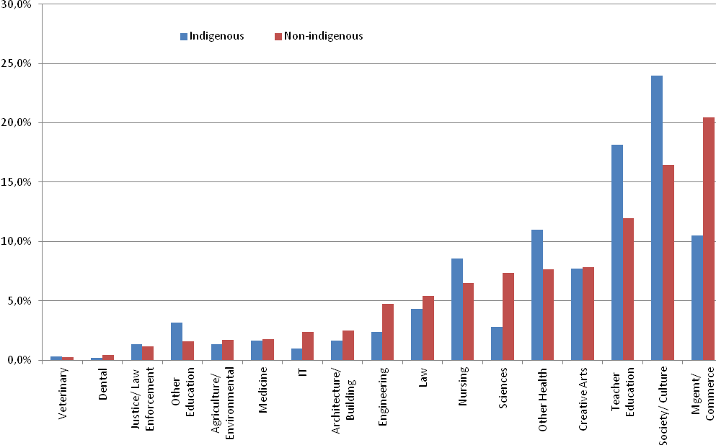
Source: DEEWR Higher Education Statistics, unpublished data, 2009
Note: This chart identifies the major field of the student and does not count the second major where a student is studying a combined degree.

Aboriginal and Torres Strait Islander student enrolments by broad level of Course
In 2009, a large majority of Aboriginal and Torres Strait Islander student enrolments were in Bachelor courses (66.8%, see Table 3). This was followed by enabling and non-award courses (12.0%) and higher degree courses (10.0%).
Table 3: Aboriginal and Torres Strait Islander student enrolments by broad level of course, 2009
Broad level of course | Number | % Share
Higher Degree | 1040 | 10.0%
Other postgraduate | 579 | 5.6%
Bachelor | 6,975 | 66.8%
Other undergraduate | 594 | 5.7%
Enabling and non-award | 1,252 | 12.0%
Total students | 10,440 | 100.0%
Source: DEEWR Higher Education Statistics, unpublished data, 2009
Between 2004 and 2009, increases were recorded in the number of Aboriginal and Torres Strait Islander student enrolments in higher degree courses (up by 31.3%), other postgraduate courses including postgraduate diploma and graduate certificate (up by 34.0%), bachelor courses (up by 25.2%), and enabling and non-award courses (up by 22.3%, see Figure 6a). However, other undergraduate courses (including associate degree, advanced diploma and diploma) fell by 44.8% during this period.
All domestic student enrolments increased in all broad course levels between 2004 and 2009 (see Figure 6b). In contrast to the trend observed for Aboriginal and Torres Strait Islander students, other undergraduate courses recorded the largest increase in all domestic student enrolments during this period (up by 47.9%), followed by enabling and non-award courses (up by 23.1%).
Figure 6a. Index of Aboriginal and Torres Strait Islander student enrolments by broad level of course, 2004-2009 (2004=100)
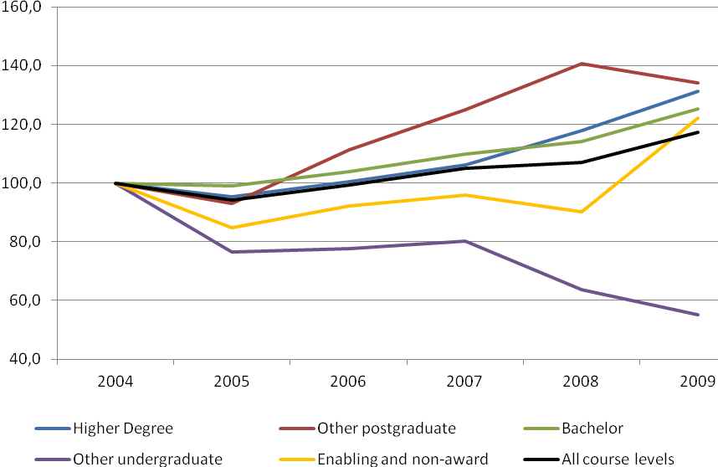 Source: DEEWR Higher Education Statistics, unpublished data, 2009
Figure 6b. Index of all domestic student enrolments by broad level of course, 2004-2009 (2004=100)
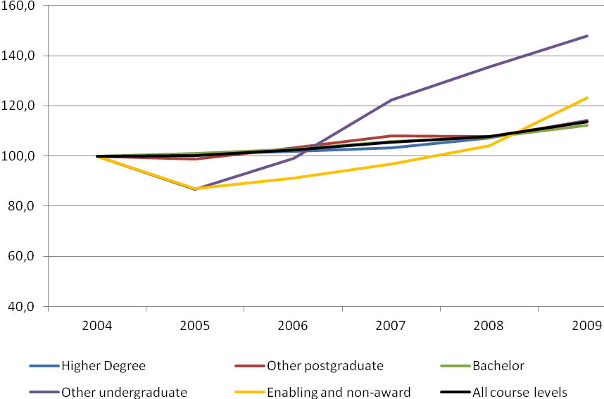
Source: DEEWR Higher Education Statistics

Aboriginal and Torres Strait Islander student enrolments by type of university
In 2009, the proportion of Aboriginal and Torres Strait Islander students who attended a Group of Eight university (14.6%) was around half that of non-Indigenous domestic students (28.9%). On the other hand, a larger proportion of Aboriginal and Torres Strait Islander students (23.0%) attended an Innovative Research University compared with non-Indigenous domestic students (15.7%). This is also true for Non-Aligned Universities (47.3% for Aboriginal and Torres Strait Islander students compared with 38.3% for non-Indigenous domestic students, see Figure 7).
Historically, universities have been compared within their cohort groupings and comparisons have not been made across all universities. The review will consider the usefulness of traditional cohort groupings and may choose to make recommendations outside of these groupings. For example, the Review may consider the appropriateness of grouping universities by similar population cohorts in catchment areas.
Figure 7. Proportion of domestic student enrolments by type of university, 2009
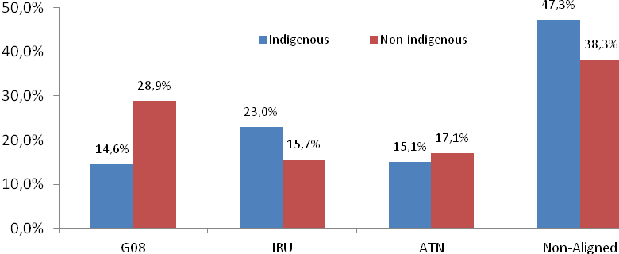
Source: DEEWR Higher Education Statistics, unpublished data, 2009
Type of university
Group of Eight Member Universities (Go8)
Monash University
The Australian National University
The University of Adelaide
The University of Melbourne
The University of New South Wales
The University of Queensland
The University of Sydney
The University of Western Australia
Innovative Research Universities (IRU)
Charles Darwin University
Flinders University of South Australia
Griffith University
James Cook University
La Trobe University
Murdoch University
The University of Newcastle
Australian Technology Network of Universities (ATN)
Curtin University of Technology
Queensland University of Technology
RMIT University
University of South Australia
University of Technology Sydney
Non-Aligned Universities
Australian Catholic University
Batchelor Institute of Indigenous Tertiary Education
Bond University
Central Queensland University
Charles Sturt University
Deakin University
Edith Cowan University
Macquarie University
Southern Cross University
Swinburne University of Technology
The University of New England
The University of Notre Dame Australia
University of Ballarat
University of Canberra
University of Southern Queensland
University of Tasmania
University of the Sunshine Coast
University of Western Sydney
University of Wollongong
Victoria University

Aboriginal and Torres Strait Islander Higher Degree students
Between 2004 and 2009, there has been an increase of 31.3% in Aboriginal and Torres Strait Islander domestic student enrolments in higher degree courses (Doctorate by Research; Doctorate by Coursework; Masters by Research; and Masters by Coursework). This is more than twice the increase in all domestic student enrolments in higher degree courses during the same period (up by 14.2%).
For the purposes of this paper, the rest of this section will focus on Higher Degree by Research (HDR)courses.

Aboriginal and Torres Strait Islander Higher Degree by Research students
Aboriginal and Torres Strait Islander student enrolments in HDR courses (Doctorate by Research and Masters by Research) increased by 24.0% between 2004 and 2009 (see Table 4). By comparison, all domestic student enrolments in HDR courses increased by just 0.5% during this period.
The number of Aboriginal and Torres Strait Islander HDR enrolled students as a proportion of all domestic HDR enrolled students has grown from 0.85% in 2004 to 1.05% in 2009, but it is still well below the parity rate of 2.2%. The number of Aboriginal and Torres Strait Islander HDR enrolments would need to at least double to reach the population parity.
Aboriginal and Torres Strait Islander student commencements in HDR courses was 4.1% higher in 2009 compared with 2004 (see Table 5). This is in contrast to all domestic student commencements which fell by 6.7% during the same period.
However, the increase in completions for Aboriginal and Torres Strait Islander students was relatively small (up by 12 students, see Table 6).
Table 4. HDR enrolments 2004–2009
Enrolments | 2004 | 2005 |  | 2006 | 2007 | 2008 | 2009 | 2009 Parity number
Indigenous (domestic) | 338 | 334 | 357 |  | 371 | 398 | 419 | 876
All domestic | 39,614 | 39,943 | 40,486 |  | 40,267 | 39,670 | 39,796
% Indigenous | 0.85% | 0.84% | 0.88% |  | 0.92% | 1.00% | 1.05% | 2.2%
Source: DEEWR Higher Education Statistics
Table 5. HDR commencements 2004–2009
Commencements | 2004 | 2005 | 2006 | 2007 | 2008 | 2009 | 2009  Parity number
Indigenous (domestic) | 98 | 75 | 86 | 86 | 104 | 102 | 190
All domestic | 9,236 | 8,683 | 8,769 | 8,687 | 8,121 | 8,621
% Indigenous | 1.06% | 0.86% | 0.98% | 0.99% | 1.28% | 1.18% | 2.2%
Source: DEEWR Higher Education Statistics
Table 6. HDR completions 2004–2009
Completions | 2004 | 2005 | 2006 | 2007 | 2008 | 2009 | 2009  Parity number
Indigenous (domestic) | 24 | 29 | 33 | 41 | 33 | 36 | 118
All domestic | 5,220 | 5,510 | 5,566 | 5,506 | 5,556 | 5,382
% Indigenous | 0.46% | 0.53% | 0.59% | 0.74% | 0.59% | 0.67% | 2.2%
Source: DEEWR Higher Education Statistics
As the number of Aboriginal and Torres Strait Islander HDR students is very small, caution should be exercised if conclusions are made from this data.

Higher Degree by Research enrolments by field of education
In 2009, the proportion of Aboriginal and Torres Strait Islander HDR enrolments was larger than that for non-Indigenous HDR enrolments in the following fields of education (see Figure 8):
- Society and Culture (43.4% Indigenous; 23.9% non-Indigenous)
- Creative Arts (10.7% Indigenous; 7.1% non-Indigenous)
- Other Education (8.4% Indigenous; 5.0% non-Indigenous)
- Other Health (8.1% Indigenous; 6.1% non-Indigenous)
- Teacher Education (4.8% Indigenous; 3.9% non-Indigenous)
- Nursing (3.3% Indigenous; 1.6% non-Indigenous)
On the other hand, the proportion of non-Indigenous domestic HDR enrolments in Science courses (18.7%) was at least three times that for Aboriginal and Torres Strait Islander students (6.2%). Engineering was also more popular amongst non-Indigenous domestic students than Aboriginal and Torres Strait Islander students (9.0% non-Indigenous compared with 1.2% Indigenous).
Figure 8. Proportion of domestic HDR enrolments by field of education (%), 2009
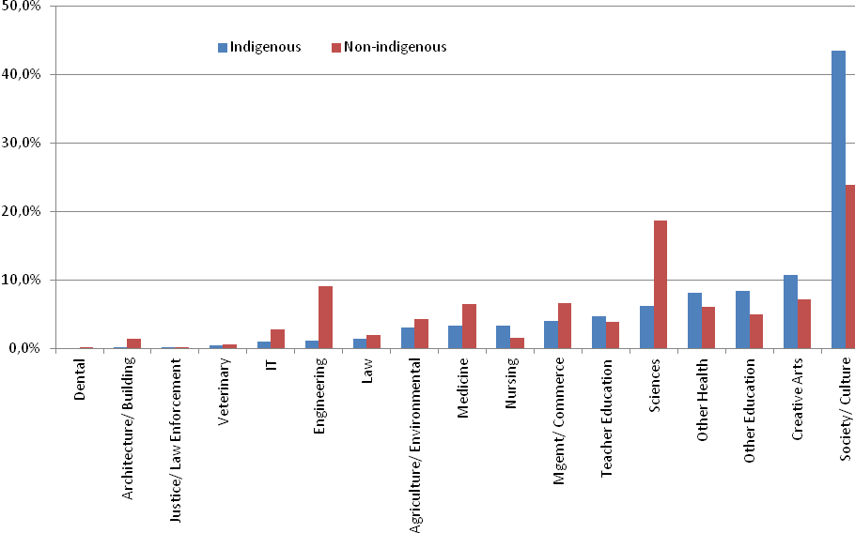
Source: DEEWR Higher Education Statistics, unpublished data, 2009

Aboriginal and Torres Strait Islander graduates
The following information has been obtained from the Graduate Destinations Survey (GDS) which is a census of all graduates four months after graduation, conducted by Graduate Careers Australia. In the 2010 GDS, new graduates who completed their requirements for their qualifications in the calendar year 2009 were surveyed regarding their major activities, including participation in full-time employment. The 2010 GDS had an overall 61.8% response rate for Australian citizens and permanent residents. The number of responses from Aboriginal and Torres Strait Islander graduates was 756.
Of those who were available for full-time employment, the proportion of graduates who found full-time employment within four months after graduation was higher for Aboriginal and Torres Strait Islander graduates (84.1%) compared with non-Indigenous graduates (80.1%, see Table 7).
Table 7. Proportion of graduates who were available for full-time employment and found full-time employment within four months after graduation
 | Indigenous | Non- Indigenous | Total
Percentage in full-time work (4 months after graduation) | 84.1% | 80.1% | 80.1%
Source: Graduate Destinations Survey, 2010 unpublished data

Staff
From 2004 to 2010:
- The number of Aboriginal and Torres Strait Islander staff in higher education has increased by 46.0%.
- The proportion of staff in higher education who are Aboriginal and Torres Strait Islander has increased from 0.8% to 1.0%.
From 2004 to 2010, the number of Aboriginal and Torres Strait Islander staff in higher education and research increased at more than twice the rate of all staff (46.0% and 20.7% respectively). Most of these gains were driven by increasing numbers of non-academic Aboriginal and Torres Strait Islander staff (57.6% increase compared with 17.3% for all staff). The growth in number of academic staff was similar between Aboriginal and Torres Strait Islander academics (27.1%) and all staff (25.6%).
The proportion of Aboriginal and Torres Strait Islander non-academic staff has increased from 0.86% in 2004 to 1.16% in 2010 (see Figure 9). However, the proportion of Aboriginal and Torres Strait Islander academic staff has remained relatively steady at around 0.70%.
Figure 9. Proportion of Aboriginal and Torres Strait Islander higher education staff (%), 2004-2010
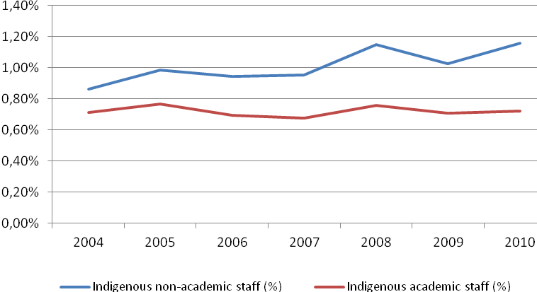
Source: DEEWR Higher Education Statistics, unpublished data, 2010
Figure 10 compares the number of Aboriginal and Torres Strait Islander university staff with staff parity, by function. In 2010, the number of ‘research only’ staff (69) is five times lower than population parity (345). The number of ‘Teaching and research’ staff (245) would need to almost triple and the number of ‘teaching only’ staff (26) would need to almost double to reach parity levels.
Figure 10: Indigenous Higher Education Staff: Actual and population parity (2010)
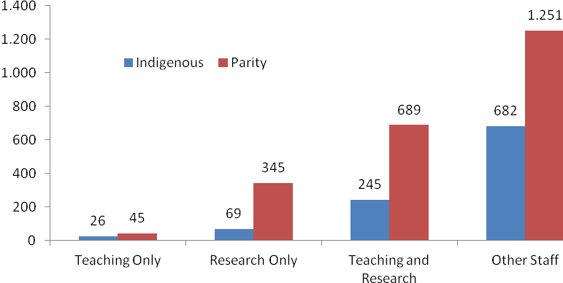
Source: , DEEWR Higher Education Statistics
Even with the implementation of government programs supporting Aboriginal and Torres Strait Islander undergraduate and postgraduate students and research programs, the current base of Aboriginal and Torres Strait Islander researchers within Australian universities is low.
Building Aboriginal and Torres Strait Islander researcher capacity may be complicated by a number of factors, such as:
- A significant underrepresentation of Aboriginal and Torres Strait Islander students at all levels of higher education.
- A significant underrepresentation of Aboriginal and Torres Strait Islander academic staff to supervise Aboriginal and Torres Strait Islander postgraduates and act as role models.
- Limited cultural competence among non-Indigenous academic staff.
- Competition with other career opportunities available to Aboriginal and Torres Strait Islander graduates.
- Lack of a supportive network for emerging Aboriginal and Torres Strait Islander researchers and likely isolation of Aboriginal and Torres Strait Islander postgraduates.
Consideration needs to be given as to what options exist in capacity building of higher degree by research students, including how the Government might modify existing programs to support Aboriginal and Torres Strait Islander undergraduates.

Aboriginal and Torres Strait Islander participation in university decision making
As a condition of receiving Indigenous Support Program funds, universities supply an annual Indigenous Education Statement (IES) to DEEWR. Through their IES, universities report on their specific strategies to meet the desired program outcomes, including those that seek to increase Aboriginal and Torres Strait Islander participation in the provider’s decision-making processes. In 2010 IES reports, of those universities that reported on Aboriginal and Torres Strait Islander member involvement decision making processes, well over 80% reported Aboriginal or Torres Strait Islander representation on their Council or Senate, while all reported Aboriginal and Torres Strait Islander representation on academic or management committees, including those devoted to research assessment, teaching and learning, special admissions and student appeals, equal opportunity, student unionism, occupational health and safety, and the appointment of both professorial and academic staff.

Attachment B: Key Questions
Broadly, the Review of Higher Education Access and Outcomes for Aboriginal and Torres Strait Islander People will seek to answer the following key question:
What needs to change to lift current access and participation levels for Aboriginal and Torres Strait Islander People including in post graduate research and research training and ensure that universities are taking advantage of the deep knowledge base that Aboriginal and Torres Strait Islander People can bring to the higher education sector?
In answering the key question, submissions may wish to explore the following key questions:
How can we attract more Aboriginal and Torres Strait Islander students into higher education?
–– How do current arrangements/practices work?
–– What can be done differently or what new arrangements are needed to improve aspiration and access to higher education?
How can we ensure that more Aboriginal and Torres Strait Islander students stay at university, complete their studies and graduate?
–– How do Indigenous Education Units (IEUs), other Indigenous centres and support from within mainstream schools and faculties impact Aboriginal and Torres Strait Islander student access, retention, and completion?
What more can be done to increase the number of Aboriginal and Torres Strait Islander people achieving professional qualifications, particularly those already working in relevant fields?
–– Is there a role for professional associations and Indigenous professional bodies to work with Aboriginal and Torres Strait Islander students and mainstream schools and faculties in providing professional degree programs?
How can we increase the number and level of academic and non-academic Aboriginal and Torres Strait Islander university staff?
–– What do universities need to do to recruit more Aboriginal and Torres Strait Islander staff across the university?
–– What arrangements enable career development and capacity building of Aboriginal and Torres Strait Islander academics? How effective are these and why?
–– What arrangements can affect the recruitment and retention of Aboriginal and Torres Strait Islander postgraduate and research students and develop early- and mid-career researchers?
How should mainstream research, teaching and learning practices take account of Aboriginal and Torres Strait Islander perspectives. What kind of relationship should universities have with Aboriginal and Torres Strait Islander communities with which it engages?
–– How should universities involve Aboriginal and Torres Strait Islander people, Indigenous Education Units (IEUs) and other Indigenous centres in the academic and corporate governance of their institutions?

Review of Australian Higher Education, pages 10 and 28, http://www.deewr.gov.au/HigherEducation/Review/Pages/ReviewofAustralianHigherEducationReport.aspx
Retention rate is defined as the number of domestic students who studied in 2008 and studied again in 2009 at the same provider (excluding any students who completed in 2008) as a proportion of the domestic students who studied in 2008 (excluding any who completed in 2008).
Review of Australian Higher Education, pages 10 and 28, http://www.deewr.gov.au/HigherEducation/Review/Pages/ReviewofAustralianHigherEducationReport.aspx
SCRGSP (Steering Committee for the Review of Government Service Provision) 2009, Overcoming Indigenous Disadvantage: Key Indicators 2009, Canberra: Productivity Commission.
. This includes examination or assessment by the institution, employment experience, or other special entry provisions.
SES calculations are based on the postcode of the students' Permanent Home Residence, with Low SES being the postcodes corresponding to postal areas in the bottom 25% of the population nationally based on the SEIFA Index of Education and Occupation. The low SES proportion is the proportion of low SES students out of all students who have a valid SES.
Higher degree courses include Doctorate by Research; Doctorate by Coursework; Masters by Research; and Masters by Coursework
Other postgraduate courses include Postgraduate Qualifying or Preliminary (for Masters, Doctorate or Higher Doctorate); Postgraduate Diploma (pass or honours) involving new academic, professional or vocational area; Postgraduate Diploma (pass or honours) extending skills and knowledge in a professional area previously studied; and Graduate Certificate.
Bachelor courses include Bachelor’s Graduate Entry; Bachelor’s Honours; Bachelor’s Pass.
Other undergraduate courses include Associate degree; Advanced Diploma (AQF); Diploma (AQF); and Other undergraduate award course
Non-award courses include Bridging for overseas trained professionals.
The population parity rate used for staff is 2.2% which reflects the proportion of the population aged between 15-64 years who is Aboriginal or Torres Strait Islander according to 2006 ABS population statistics.
33 of 39 eligible universities

