

Completion Rates of Domestic Bachelor Students - A Cohort Analysis, 2005-2013



Opportunity through learning

ISBN  
978-1-76028-037-6 [PDF]  
978-1-76028-038-3 [DOCX]

Creative Commons

With the exception of the Commonwealth Coat of Arms, the Department’s logo, any material protected by a trade mark and where otherwise noted all material presented in this document is provided under a [Creative Commons Attribution 3.0 Australia](http://creativecommons.org/licenses/by/3.0/au/) (http://creativecommons.org/licenses/by/3.0/au/) licence.

The details of the relevant licence conditions are available on the Creative Commons website (accessible using the links provided) as is the full legal code for the [CC BY 3.0 AU licence](http://creativecommons.org/licenses/by/3.0/au/legalcode) (http://creativecommons.org/licenses/by/3.0/au/legalcode).

The document must be attributed as the ‘Completion Rates of Domestic Bachelor Students – A Cohort Analysis, 2005-2013’.

For questions regarding higher education data or for further information, please email

[university-statistics@education.gov.au](mailto:university-statistics@education.gov.au).

Contents

Key messages 4

Background 4

Updated analysis 5

Outcomes for the 2005 cohort 5

Four year outcomes - influence of the demand driven system 7

Six year outcomes 9

Eight year outcomes 9

Data notes 10

Appendix - detailed tables and charts 11



# Key messages

* Almost three quarters (73.6%) of the 2005 cohort of domestic bachelor students commencing at Table A universities completed a course within nine years of commencement.
* After four years since commencement, the proportion of additional students who complete a course diminishes each year. Only 1.3% of the 2005 student cohort completed a course between eight and nine years after commencement.
* Nationally, and across many student characteristics, four year outcome data for the 2010 Table A commencing domestic bachelor student cohort (the first student group influenced by the demand driven system) showed marginally lower completion rates than for previous years. The four year completion rate for the 2010 cohort was 45.1%, compared to an average of 46.6% for the 2005 to 2009 cohorts.
* The proportion of 2010 cohort students who were ‘engaged’ with Higher Education (had either completed a course after four years or were still enrolled), however, was similar to previous years.
* Future data will need to be analysed to confirm if the four year outcomes for the 2010 student cohort were a direct result of the shift to the demand driven system.

# Background

This report extends the *Completion Rates of Domestic Bachelor Students: A Cohort Analysis*, published by the Department of Education in mid-2014. The previous report tracked all domestic bachelor students commencing at Table A universities[1] in 2005 until the end of 2012, using their student ID (within institution) and their Commonwealth Higher Education Student Support Number, CHESSN[2] (across institutions).

The results provided an overview of student outcomes between 2005 and 2012. That is, as at the end of 2012, how many students had completed their studies[3], how many were still studying, and how many were neither studying nor had completed an award and therefore were no longer at the original institution or the institution they had transferred to. An additional focus of the previous report was to analyse student outcomes by different student characteristics (for example, by age group, basis of admission to university or field of education).

The tracking of cohorts over time enables a better understanding of the progression of students through the Higher Education System. Tracking outcomes also assists in understanding student performance and is a useful tool in identifying students with specific characteristics who are more likely to drop out and may benefit most from early assistance.

# Updated analysis

The current report extends the previous analysis to review 2013 outcomes for the 2005 Table A commencing domestic bachelor student cohort. When these data are compared with 2012 data, the change in student outcomes eight and nine years after commencement can be analysed.

In addition to reviewing the 2005 cohort nine years after commencement, this report provides information on student cohorts four, six and eight years after starting their course. For each of these groups, different commencing year cohorts are compared to see if there are changes in student outcomes over time. This information builds on data in the previous report, by incorporating student outcomes by 2013.

Detailed tables and charts of cohort data can be found in the Appendix.

# Outcomes for the 2005 cohort

Nine years after the 2005 cohort of Table A commencing domestic bachelor students enrolled, 73.6% of students had completed a course (Chart 1). A very small proportion of the 2005 cohort were still enrolled after nine years (4.2%), with the remainder either re-enrolling, but dropping out before 2013 (14.0%) or never returning after 2005 (8.2%). Nine year outcomes compared to previous year outcomes are shown in Chart 1.

**Chart 1. The percentage of the 2005 Table A commencing domestic bachelor student cohort, by outcome, four, six, eight and nine years after commencement (2013).**

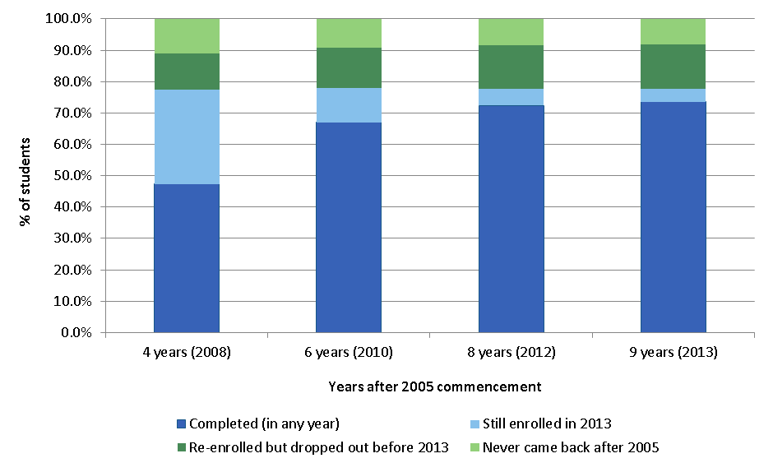

## Completions

The proportion of additional students who have completed a course diminishes each year, after four years since commencement (Chart 2). The proportion of the 2005 student cohort who had completed a course increased by only 1.3% nine years after commencement, compared to eight years after commencement (from 72.3% to 73.6%).

## Engagement

The proportion of students ‘engaged’ with Higher Education includes those students who have completed a course or are still enrolled. The proportion of the 2005 cohort who were engaged remained stable from four years after commencement until nine years after commencement (the sum of the dark and light blue bars in Chart 1). The engagement rate for the 2005 student cohort ranged from 77.5% to 78.0% (four years after commencement and six years after commencement respectively).

**Chart 2. Percentage point increase in completions each year, from four years after commencement, for the 2005 Table A commencing domestic bachelor student cohort.**

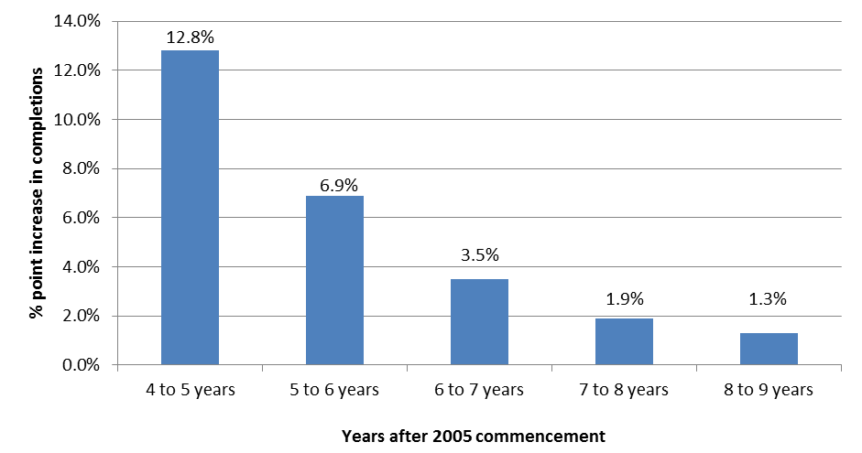

Table 1 and Chart 3 (see Appendix) show detailed attrition and completion information by student characteristics for the 2005 student cohort nine years after commencement. Eight year outcomes for the 2005 cohort are shown in Table 4 and Chart 6. Similar to the total change, the pattern of attrition and completion information by student characteristics changed little between eight and nine years after commencement.

# Four year outcomes - influence of the demand driven system

From 1 January 2012, the Australian Government lifted limits on the number of Commonwealth supported places for domestic bachelor degree students at public universities (excluding medical places) under the ‘demand driven system’. Although the demand driven funding system was fully implemented in 2012, it was preceded by a transition period where the previous 5% over enrolment cap increased to 10% for 2010 and 2011.

The 2010 cohort data provides the first indication of how of students’ attrition and completion outcomes under the demand driven system compares to that of commencing students prior to the demand driven system. With the release of 2013 data, four year outcomes for the 2010 cohort of Table A commencing domestic bachelor students is now available and can be assessed[4]. Comparative cohorts include 2005-2008, 2006-2009, 2007-2010, 2008-2011 and 2009-2012. Data for four year outcomes of cohorts are shown in Table 2 and Chart 4.

As noted in the previous report, four year outcome data was fairly consistent across cohorts, taking into account normal minor fluctuations in the data. However, nationally and across many student characteristics, four year outcome data for the 2010 cohort showed marginally lower completion rates than for other years. On average, 46.6% of students had completed after four years for the 2005 to 2009 cohorts, compared to 45.1% for the 2010 cohort. It should be noted however, that the proportion of students who had completed or were still enrolled was 79.8% for the 2010 cohort, which was very similar to the equivalent figure for other years (an average of 79.9% for the four cohorts prior to 2010). To confirm whether the slight decrease in completion rates for the 2010 cohort is a result of the introduction of the demand driven system (as opposed to other factors which lead to small fluctuations in results from year to year), future cohorts under the demand driven system will need to be analysed.

## Minor differences across four year cohorts

Although the pattern of attrition and completion outcomes across student cohorts four years after commencement was relatively stable, there were some minor differences:

* Completion rates for students undertaking a Bachelor’s Honours course fluctuated, ranging from a high of 81.4% in 2009 down to 74.5% in 2010[5].
* Completion rates for Bachelor’s Graduate Entry courses across the cohorts showed a decline from 73.2% in 2005 to 67.0% in 2009, before increasing again in 2010 to 68.3%5.
* Fluctuating completion rates for students with ATAR’s between 30 and 49 and 50 and 59 occurred between cohorts5. For students with ATARs between 30 and 49, the proportion of students who had completed a course after four years was as low as 28.5% for the 2006 cohort, and as high as 35.9% for the 2007 cohort. The lowest completion rate for students with ATARs between 50 and 59 was 29.3% in 2010, while the highest completion rate was 34.5% in 2008.
* Completion rates showed a decline across cohorts for those students who enrolled in an enabling course prior to their bachelor course. For this group, the 2005 cohort had a completion rate of 39.8%, compared to just 35.9% for the 2010 cohort. There was also a slight decrease for this group in the number of students who had either completed or were still enrolled (down from 75.5% for the 2006 cohort to 73.3% for the 2010 cohort).
* There was a trend for a decrease in the completion rate for those admitted on an ‘other basis for admission’. The completion rate for these students declined from 49.1% in 2005 to 45.4% in 2010. The proportion of students who had either completed or were still enrolled, however, remained fairly consistent across the 2006 to 2010 cohorts (75.4% on average).
* For students from a low socio-economic background, completion rates decreased slightly between the 2008 and 2010 cohorts (from 43.5% to 41.8%), although the proportion of students who had either completed or were still enrolled remained stable (76.2% for the 2008 cohort compared to 76.1% for the 2010 cohort).
* The completion rate for fee-paying students fluctuated significantly across the 2005 to 2010 cohorts, from a low of 49.1% in 2007 to a high of 65.3% in 2010. The fluctuation was influenced by a change in policy, where from 1 January 2009, under HESA, domestic fee-paying places for commencing undergraduate students were no longer offered. This change resulted in a significant reduction in the number of fee-paying domestic undergraduate students and influenced attrition and completion information for this group.
* Overall, there were not any major variations in completion rates across most broad fields of education for the cohorts analysed. However, there were a few fields of education, where some variations occurred:
  + The completion rate of education students declined in successive cohorts, from 55.5% for the 2005 cohort to 42.9% for the 2010 cohort.
  + To a lesser extent, the completion rate of health students also declined, from 58.1% for the 2006 cohort to 54.4% in the 2010 cohort.
  + For students studying an Architecture and Building course, completion rates for the most recent three cohorts (2008, 2009 and 2010) were lower than for the previous three cohorts (2005, 2006 and 2007) – an average of 43.8% for the 2008, 2009 and 2010 cohorts, compared to an average of 48.5% for 2005, 2006 and 2007 cohorts.

# Six year outcomes

Available six year outcome data includes students commencing a domestic bachelor course at a Table A university in 2005, 2006, 2007 and 2008. Across these four groups, the profile of attrition and completion information was very stable nationally and for most student characteristics (see Table 3 and Chart 5). There were some minor differences noted, however, which also appeared in the four year outcome data:

* Completion rates for students undertaking a Bachelor’s Honours course fluctuated, ranging from 82.8% in 2007 to 86.2% in 2006.
* Completion rates for those secondary education students with ATARs between 30 and 49, and 50 and 59 fluctuated between cohorts. For students with ATARs between 30 and 49, the proportion of students who had completed a course after six years was as low as 41.3% for the 2008 cohort, and as high as 50.6% for the 2007 cohort. The lowest completion rate for students with ATARs between 50 and 59 was 46.3% in the 2006 cohort, while the highest completion rate was 51.9% in the 2008 cohort.

These variations were in part influenced by small numbers of students within these groups.

# Eight year outcomes

The Department has now been able to obtain data for two cohorts of Table A commencing domestic bachelor students spanning eight years (2005 cohort and 2006 cohort). Table 4 and Chart 6 show that the two cohorts have very similar patterns of attrition and completion information overall and by student characteristics. The eight year outcome similarity between the 2005 and 2006 cohorts is not surprising, given that these two cohorts have similar attrition and completion profiles six years after commencement (see Table 4 and Chart 6).

# Data notes

* This publication is based on data compiled from the Higher Education Student Collection maintained by the Department of Education.
* A distinct cohort of international bachelor students has been constructed for comparison purposes (see Appendix for data). It is not possible, however, to determine what percentage of international students may have completed their studies at another institution because they do not have a CHESSN.
* Data presented in this report details the relationship between completion rates and a number of student characteristics. No allowance is made for inter-relationships between student characteristics. For example, older students may have lower completion rates as they are more likely to be part-time students, who also have lower completion rates.
* Attrition and completion proportions for those students studying a course in Food, Hospitality and Personal Services are highly variable across years, due to very small numbers in each cohort.

# Appendix - detailed tables and charts

Table 1: Cohort Analysis for Table A commencing domestic Bachelor students in 2005, showing attrition and completion information by 2013

|  | |  | **Completed  (in any year)** | **Still Enrolled  in 2013** | **Re-enrolled but dropped out before 2013** | **Never came back after 2005** |
| --- | --- | --- | --- | --- | --- | --- |
| National Total (domestic bachelor students) | | | 73.6 | 4.2 | 14.0 | 8.2 |
| Comparison figure for Overseas students | | | 74.2 | 0.1 | 15.1 | 10.5 |
| Course Level | Bachelor's Graduate Entry | | 82.4 | 1.9 | 7.6 | 8.0 |
| Bachelor's Honours | | 86.1 | 1.5 | 5.1 | 7.3 |
| Bachelor's Pass | | 73.1 | 4.3 | 14.3 | 8.2 |
| Mode of Attendance | Internal | | 76.6 | 3.8 | 12.7 | 6.9 |
| External | | 46.6 | 8.1 | 25.0 | 20.4 |
| Multi-modal | | 70.6 | 4.3 | 16.7 | 8.4 |
| Type of Attendance | Full-time | | 78.8 | 3.5 | 11.9 | 5.8 |
| Part-time | | 49.2 | 7.4 | 23.9 | 19.5 |
| Gender | Males | | 70.9 | 4.4 | 15.9 | 8.8 |
| Females | | 75.5 | 4.0 | 12.7 | 7.8 |
| Age | 19 and under | | 80.3 | 3.7 | 11.0 | 4.9 |
| 20-24 | | 70.4 | 4.3 | 15.9 | 9.4 |
| 25 and over | | 58.5 | 5.4 | 20.1 | 16.0 |
| Basis for Admission | Other Basis for admission | | 69.4 | 4.4 | 16.0 | 10.2 |
| Secondary education | | 78.7 | 3.9 | 11.6 | 5.8 |
| ATAR band (for school leavers) | 30-49 | | 51.4 | 5.0 | 26.0 | 17.6 |
| 50-59 | | 56.1 | 6.3 | 21.8 | 15.8 |
| 60-69 | | 65.4 | 5.5 | 18.6 | 10.5 |
| 70-79 | | 73.5 | 4.9 | 14.7 | 6.9 |
| 80-89 | | 82.8 | 3.7 | 9.8 | 3.7 |
| 90-94 | | 89.8 | 2.4 | 5.9 | 1.9 |
| 95-100 | | 94.5 | 1.6 | 3.1 | 0.8 |
| ATAR not provided or not required | | 69.3 | 4.5 | 16.0 | 10.2 |
| Enabling Indicator | Prior enabling course | | 64.1 | 6.1 | 19.3 | 10.6 |
| No prior enabling course | | 73.9 | 4.1 | 13.8 | 8.1 |
| Indigenous Indicator | Indigenous | | 46.7 | 8.0 | 25.0 | 20.4 |
| Not Indigenous | | 73.9 | 4.2 | 13.9 | 8.1 |
| NESB Indicator | Person from non-English speaking background | | 78.7 | 3.6 | 11.6 | 6.1 |
| Not from non-English speaking background | | 73.4 | 4.2 | 14.1 | 8.3 |

|  |  | **Completed  (in any year)** | **Still Enrolled  in 2013** | **Re-enrolled but dropped out before 2013** | **Never came back after 2005** |
| --- | --- | --- | --- | --- | --- |
| Socio-Economic Status | Low SES | 68.9 | 4.8 | 16.3 | 10.0 |
| Medium SES | 72.6 | 4.3 | 14.4 | 8.6 |
| High SES | 77.7 | 3.7 | 12.1 | 6.5 |
| Regional Classification (MCEETYA)* | Metro | 75.0 | 4.1 | 13.5 | 7.5 |
| Regional | 69.8 | 4.6 | 15.6 | 10.1 |
| Remote | 59.5 | 5.7 | 19.9 | 14.8 |
| Liability Category | Commonwealth Supported students | 73.6 | 4.2 | 14.0 | 8.1 |
| Fee-Paying students | 72.9 | 2.2 | 13.6 | 11.3 |
| Broad Field of Education | Natural and Physical Sciences | 77.5 | 4.6 | 12.3 | 5.6 |
| Information Technology | 63.3 | 4.9 | 20.7 | 11.1 |
| Engineering and Related Technologies | 74.7 | 5.4 | 14.2 | 5.7 |
| Architecture and Building | 79.1 | 3.0 | 12.3 | 5.6 |
| Agriculture, Environmental and Related Studies | 66.9 | 4.8 | 17.3 | 11.0 |
| Health | 81.6 | 2.6 | 9.5 | 6.3 |
| Education | 74.7 | 3.3 | 12.8 | 9.1 |
| Management and Commerce | 72.3 | 4.1 | 14.8 | 8.7 |
| Society and Culture | 71.8 | 5.1 | 14.7 | 8.4 |
| Creative Arts | 75.6 | 3.5 | 13.7 | 7.3 |
| Food, Hospitality and Personal Services | 88.0 | 4.0 | 4.0 | 4.0 |
| TOTAL | | 73.6 | 4.2 | 14.0 | 8.2 |

*based on the Ministerial Council on Employment, Education, Training and Youth Affairs (MCEETYA) classification of regions.

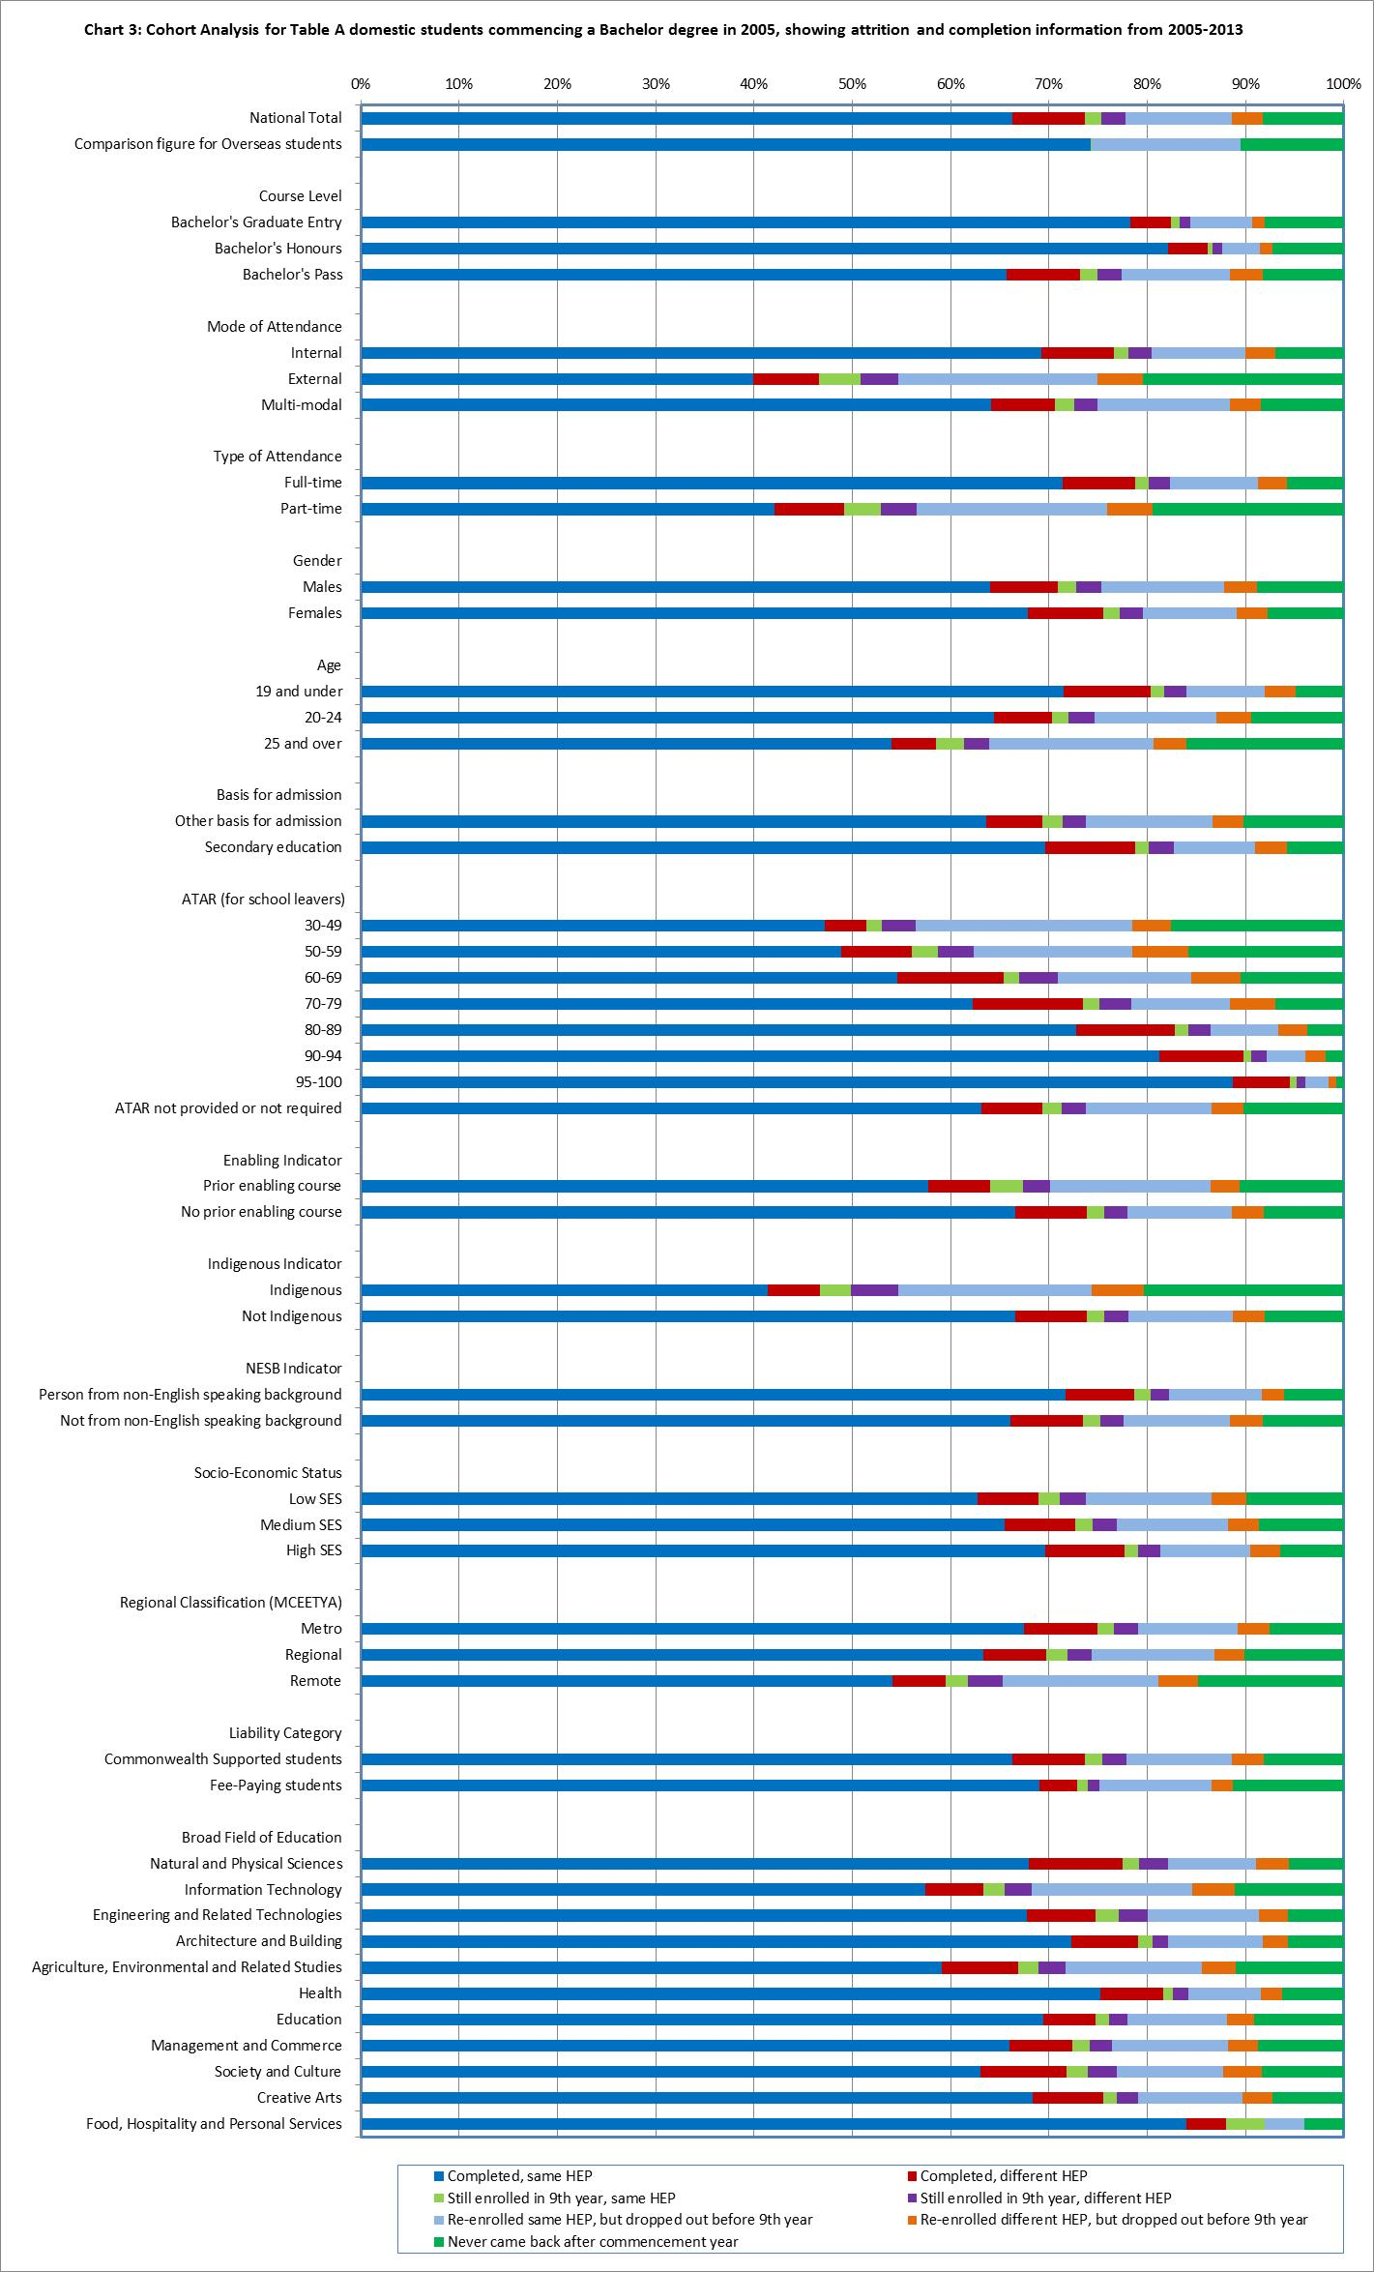

Table 2: Cohort Analysis for Table A commencing domestic Bachelor students over a four year period, 2005-2008, 2006-2009, 2007-2010, 2008-2011, 2009-2012 and 2010-2013

|  |  |  |  |  |  |
| --- | --- | --- | --- | --- | --- |
|  |  | **Completed  (in any year)** | **Still Enrolled at the end of the 4 year cohort period** | **Re-enrolled but dropped out** | **Never came back after the first year** |
| **National Total (Domestic students)** | 2005 | 47.3% | 30.2% | 11.5% | 11.0% |
| 2006 | 46.7% | 32.7% | 10.6% | 10.0% |
| 2007 | 45.9% | 33.8% | 10.4% | 9.9% |
| 2008 | 46.7% | 33.5% | 10.9% | 8.9% |
| 2009 | 46.1% | 34.3% | 11.1% | 8.5% |
| 2010 | 45.1% | 34.7% | 11.2% | 9.0% |
| **Comparison figure for Overseas students** | 2005 | 64.9% | 11.4% | 13.0% | 10.7% |
| 2006 | 67.5% | 11.7% | 10.6% | 10.2% |
| 2007 | 68.4% | 12.2% | 10.4% | 9.0% |
| 2008 | 70.0% | 11.2% | 10.4% | 8.4% |
| 2009 | 71.3% | 10.6% | 10.3% | 7.7% |
| 2010 | 71.2% | 10.5% | 10.5% | 7.7% |
| **Course Level** | | | | | |
| **Bachelor's Graduate Entry** | 2005 | 73.2% | 9.6% | 7.0% | 10.3% |
| 2006 | 72.4% | 12.2% | 6.0% | 9.3% |
| 2007 | 70.7% | 11.9% | 7.2% | 10.2% |
| 2008 | 69.5% | 14.0% | 6.8% | 9.7% |
| 2009 | 67.0% | 16.5% | 7.9% | 8.6% |
| 2010 | 68.3% | 15.3% | 7.4% | 9.0% |
| **Bachelor's Honours** | 2005 | 78.9% | 6.6% | 4.6% | 9.9% |
| 2006 | 81.0% | 8.6% | 3.0% | 7.3% |
| 2007 | 77.8% | 8.7% | 5.4% | 8.1% |
| 2008 | 77.8% | 9.0% | 5.4% | 7.9% |
| 2009 | 81.4% | 7.6% | 4.8% | 6.3% |
| 2010 | 74.5% | 14.4% | 4.6% | 6.4% |
| **Bachelor's Pass** | 2005 | 46.0% | 31.2% | 11.7% | 11.0% |
| 2006 | 45.5% | 33.7% | 10.8% | 10.1% |
| 2007 | 44.7% | 34.8% | 10.6% | 9.9% |
| 2008 | 45.6% | 34.3% | 11.1% | 8.9% |
| 2009 | 44.9% | 35.2% | 11.3% | 8.5% |
| 2010 | 43.9% | 35.6% | 11.4% | 9.1% |
| **Mode of Attendance** | | | | | |
| **Internal** | 2005 | 49.5% | 30.6% | 10.5% | 9.4% |
| 2006 | 48.7% | 33.1% | 9.7% | 8.6% |
| 2007 | 47.8% | 34.2% | 9.4% | 8.5% |
| 2008 | 48.7% | 33.9% | 9.8% | 7.6% |
| 2009 | 48.0% | 34.7% | 10.1% | 7.2% |
| 2010 | 47.0% | 35.2% | 10.2% | 7.7% |

|  |  | **Completed  (in any year)** | **Still Enrolled at the end of the 4 year cohort period** | **Re-enrolled but dropped out** | **Never came back after the first year** |
| --- | --- | --- | --- | --- | --- |
| **Mode of Attendance continued…..** | | | | | |
| **External** | 2005 | 24.9% | 29.4% | 19.5% | 26.2% |
| 2006 | 24.4% | 32.1% | 18.6% | 24.9% |
| 2007 | 24.3% | 33.3% | 19.0% | 23.3% |
| 2008 | 24.9% | 32.6% | 20.1% | 22.5% |
| 2009 | 25.5% | 33.6% | 19.5% | 21.4% |
| 2010 | 25.9% | 33.2% | 18.9% | 22.0% |
| **Multi-modal** | 2005 | 50.4% | 24.8% | 13.6% | 11.2% |
| 2006 | 49.1% | 28.1% | 12.7% | 10.1% |
| 2007 | 50.6% | 27.7% | 12.4% | 9.4% |
| 2008 | 50.5% | 28.3% | 12.8% | 8.4% |
| 2009 | 50.1% | 28.9% | 13.1% | 7.9% |
| 2010 | 49.5% | 30.4% | 12.7% | 7.4% |
| **Type of Attendance** | | | | | |
| **Full-time** | 2005 | 52.2% | 29.7% | 9.9% | 8.1% |
| 2006 | 51.3% | 32.2% | 9.1% | 7.4% |
| 2007 | 50.4% | 33.2% | 9.0% | 7.3% |
| 2008 | 51.3% | 32.9% | 9.3% | 6.5% |
| 2009 | 50.5% | 33.8% | 9.6% | 6.1% |
| 2010 | 49.3% | 34.3% | 9.7% | 6.6% |
| **Part-time** | 2005 | 24.1% | 32.3% | 18.8% | 24.9% |
| 2006 | 23.5% | 35.4% | 17.9% | 23.2% |
| 2007 | 23.1% | 36.6% | 17.7% | 22.6% |
| 2008 | 22.9% | 36.6% | 19.1% | 21.5% |
| 2009 | 23.0% | 37.0% | 19.1% | 21.0% |
| 2010 | 22.7% | 36.7% | 18.8% | 21.8% |
| **Gender** | | | | | |
| **Males** | 2005 | 42.4% | 33.4% | 12.7% | 11.5% |
| 2006 | 42.1% | 35.8% | 11.7% | 10.4% |
| 2007 | 41.3% | 37.1% | 11.3% | 10.3% |
| 2008 | 42.3% | 37.0% | 11.6% | 9.1% |
| 2009 | 41.6% | 37.7% | 12.1% | 8.6% |
| 2010 | 40.6% | 38.1% | 12.1% | 9.2% |
| **Females** | 2005 | 50.8% | 27.9% | 10.6% | 10.6% |
| 2006 | 50.0% | 30.6% | 9.7% | 9.7% |
| 2007 | 49.1% | 31.5% | 9.8% | 9.6% |
| 2008 | 49.7% | 31.0% | 10.4% | 8.8% |
| 2009 | 49.2% | 32.0% | 10.4% | 8.4% |
| 2010 | 48.3% | 32.3% | 10.5% | 8.9% |

|  |  | **Completed  (in any year)** | **Still Enrolled at the end of the 4 year cohort period** | **Re-enrolled but dropped out** | **Never came back after the first year** |
| --- | --- | --- | --- | --- | --- |
| **Age** | | | | | |
| **19 and under** | 2005 | 48.1% | 35.4% | 9.4% | 7.2% |
| 2006 | 47.4% | 37.6% | 8.5% | 6.5% |
| 2007 | 46.6% | 38.6% | 8.2% | 6.5% |
| 2008 | 47.9% | 38.0% | 8.5% | 5.6% |
| 2009 | 47.1% | 38.8% | 8.7% | 5.4% |
| 2010 | 45.9% | 39.4% | 8.9% | 5.8% |
| **20-24** | 2005 | 53.0% | 21.1% | 13.1% | 12.8% |
| 2006 | 51.8% | 24.2% | 12.2% | 11.9% |
| 2007 | 51.3% | 25.0% | 12.2% | 11.5% |
| 2008 | 51.6% | 24.9% | 12.7% | 10.8% |
| 2009 | 51.2% | 26.0% | 13.0% | 9.8% |
| 2010 | 50.6% | 26.4% | 12.8% | 10.3% |
| **25 and over** | 2005 | 39.5% | 25.2% | 15.6% | 19.7% |
| 2006 | 39.1% | 27.4% | 15.1% | 18.4% |
| 2007 | 37.9% | 28.2% | 15.3% | 18.6% |
| 2008 | 37.5% | 28.3% | 16.6% | 17.5% |
| 2009 | 37.4% | 29.6% | 16.3% | 16.7% |
| 2010 | 37.1% | 29.3% | 16.3% | 17.3% |
| **Basis for Admission** | | | | | |
| **Other basis for admission** | 2005 | 49.1% | 24.6% | 13.0% | 13.3% |
| 2006 | 48.2% | 27.2% | 12.1% | 12.5% |
| 2007 | 47.0% | 28.2% | 12.4% | 12.4% |
| 2008 | 46.5% | 28.8% | 13.0% | 11.7% |
| 2009 | 46.1% | 29.7% | 13.2% | 11.0% |
| 2010 | 45.4% | 29.7% | 13.2% | 11.7% |
| **Secondary education** | 2005 | 45.3% | 36.9% | 9.7% | 8.2% |
| 2006 | 45.2% | 38.7% | 8.9% | 7.3% |
| 2007 | 44.9% | 39.3% | 8.5% | 7.4% |
| 2008 | 46.9% | 38.1% | 8.9% | 6.2% |
| 2009 | 46.1% | 39.1% | 8.9% | 5.9% |
| 2010 | 44.9% | 39.8% | 9.0% | 6.3% |
| **ATAR (for school leavers)** | | | | | |
| **30-49** | 2005 | 35.7% | 24.7% | 18.1% | 21.5% |
| 2006 | 28.5% | 32.8% | 18.8% | 19.9% |
| 2007 | 35.9% | 26.3% | 20.0% | 17.8% |
| 2008 | 29.5% | 32.0% | 20.8% | 17.8% |
| 2009 | 34.2% | 33.3% | 18.3% | 14.1% |
| 2010 | 28.6% | 31.0% | 19.5% | 20.8% |

|  |  | **Completed  (in any year)** | **Still Enrolled at the end of the 4 year cohort period** | **Re-enrolled but dropped out** | **Never came back after the first year** |
| --- | --- | --- | --- | --- | --- |
| **ATAR continued…..** | | | | | |
| **50-59** | 2005 | 31.5% | 30.3% | 17.5% | 20.6% |
| 2006 | 31.7% | 31.1% | 17.6% | 19.6% |
| 2007 | 30.4% | 35.2% | 15.2% | 19.2% |
| 2008 | 34.5% | 33.2% | 15.7% | 16.5% |
| 2009 | 33.1% | 36.7% | 16.5% | 13.7% |
| 2010 | 29.3% | 39.1% | 17.2% | 14.4% |
| **60-69** | 2005 | 37.9% | 33.5% | 14.4% | 14.2% |
| 2006 | 37.1% | 35.7% | 14.2% | 13.0% |
| 2007 | 36.7% | 36.2% | 13.4% | 13.8% |
| 2008 | 38.6% | 35.6% | 14.1% | 11.8% |
| 2009 | 36.6% | 38.2% | 13.8% | 11.5% |
| 2010 | 35.8% | 37.9% | 14.8% | 11.5% |
| **70-79** | 2005 | 43.2% | 34.6% | 12.1% | 10.1% |
| 2006 | 45.0% | 36.5% | 10.2% | 8.2% |
| 2007 | 43.5% | 37.9% | 10.1% | 8.4% |
| 2008 | 44.5% | 37.9% | 10.6% | 7.0% |
| 2009 | 43.7% | 38.3% | 11.6% | 6.3% |
| 2010 | 41.3% | 39.8% | 11.3% | 7.6% |
| **80-89** | 2005 | 49.8% | 36.2% | 8.4% | 5.6% |
| 2006 | 49.6% | 38.4% | 7.4% | 4.6% |
| 2007 | 49.1% | 39.4% | 6.9% | 4.7% |
| 2008 | 50.4% | 38.6% | 7.3% | 3.7% |
| 2009 | 49.3% | 39.8% | 7.3% | 3.6% |
| 2010 | 48.0% | 40.8% | 7.5% | 3.7% |
| **90-94** | 2005 | 50.7% | 41.3% | 5.0% | 3.0% |
| 2006 | 51.9% | 41.3% | 4.6% | 2.2% |
| 2007 | 51.3% | 42.2% | 4.4% | 2.1% |
| 2008 | 54.0% | 40.2% | 4.1% | 1.7% |
| 2009 | 52.0% | 41.6% | 4.6% | 1.8% |
| 2010 | 52.0% | 41.5% | 4.5% | 1.9% |
| **95-100** | 2005 | 46.5% | 48.4% | 3.7% | 1.3% |
| 2006 | 47.0% | 49.3% | 2.7% | 1.0% |
| 2007 | 47.1% | 48.9% | 2.7% | 1.3% |
| 2008 | 50.2% | 46.3% | 2.7% | 0.8% |
| 2009 | 50.4% | 46.2% | 2.3% | 1.1% |
| 2010 | 49.4% | 46.5% | 2.9% | 1.2% |

|  |  | **Completed  (in any year)** | **Still Enrolled at the end of the 4 year cohort period** | **Re-enrolled but dropped out** | **Never came back after the first year** |
| --- | --- | --- | --- | --- | --- |
| **ATAR continued…..** | | | | | |
| **ATAR not provided or not required** | 2005 | 48.2% | 25.4% | 13.0% | 13.4% |
| 2006 | 47.2% | 28.5% | 12.0% | 12.3% |
| 2007 | 46.3% | 29.3% | 12.2% | 12.2% |
| 2008 | 46.3% | 29.7% | 12.7% | 11.3% |
| 2009 | 46.1% | 30.4% | 12.8% | 10.7% |
| 2010 | 45.2% | 30.6% | 12.9% | 11.3% |
| **Enabling Indicator** | | | | | |
| **Prior enabling course** | 2005 | 39.8% | 33.1% | 14.0% | 13.1% |
| 2006 | 39.5% | 36.1% | 12.6% | 11.8% |
| 2007 | 38.9% | 35.9% | 13.2% | 12.0% |
| 2008 | 37.6% | 37.5% | 14.9% | 10.0% |
| 2009 | 36.9% | 37.5% | 14.6% | 11.0% |
| 2010 | 35.9% | 37.5% | 14.8% | 11.9% |
| **No prior enabling course** | 2005 | 47.5% | 30.1% | 11.4% | 10.9% |
| 2006 | 46.9% | 32.6% | 10.5% | 9.9% |
| 2007 | 46.2% | 33.7% | 10.3% | 9.8% |
| 2008 | 47.1% | 33.3% | 10.7% | 8.9% |
| 2009 | 46.5% | 34.2% | 11.0% | 8.4% |
| 2010 | 45.5% | 34.5% | 11.0% | 8.9% |
| **Indigenous Indicator** | | | | | |
| **Indigenous** | 2005 | 28.4% | 27.6% | 18.3% | 25.7% |
| 2006 | 30.5% | 28.2% | 19.6% | 21.7% |
| 2007 | 26.9% | 31.8% | 18.4% | 22.9% |
| 2008 | 29.8% | 30.0% | 20.2% | 20.0% |
| 2009 | 27.1% | 32.7% | 20.3% | 19.9% |
| 2010 | 25.5% | 33.5% | 20.2% | 20.8% |
| **Not Indigenous** | 2005 | 47.5% | 30.3% | 11.4% | 10.8% |
| 2006 | 47.1% | 32.8% | 10.5% | 9.7% |
| 2007 | 46.2% | 33.8% | 10.3% | 9.7% |
| 2008 | 46.9% | 33.6% | 10.8% | 8.7% |
| 2009 | 46.4% | 34.4% | 10.9% | 8.3% |
| 2010 | 45.5% | 34.7% | 11.0% | 8.8% |
| **NESB Indicator** | | | | | |
| **Person from non-English speaking background** | 2005 | 50.5% | 32.3% | 9.5% | 7.6% |
| 2006 | 50.2% | 34.6% | 8.9% | 6.3% |
| 2007 | 49.2% | 35.4% | 8.9% | 6.4% |
| 2008 | 48.7% | 36.0% | 9.1% | 6.3% |
| 2009 | 48.7% | 36.6% | 9.0% | 5.7% |
| 2010 | 47.6% | 35.6% | 9.9% | 6.8% |

|  |  | **Completed  (in any year)** | **Still Enrolled at the end of the 4 year cohort period** | **Re-enrolled but dropped out** | **Never came back after the first year** |
| --- | --- | --- | --- | --- | --- |
| **NESB Indicator continued……** | | | | | |
| **Not from non-English speaking background** | 2005 | 47.2% | 30.1% | 11.5% | 11.1% |
| 2006 | 46.6% | 32.7% | 10.6% | 10.1% |
| 2007 | 45.8% | 33.7% | 10.5% | 10.0% |
| 2008 | 46.6% | 33.4% | 11.0% | 9.1% |
| 2009 | 46.0% | 34.2% | 11.2% | 8.6% |
| 2010 | 45.0% | 34.6% | 11.2% | 9.1% |
| **Socio-Economic Status** | | | | | |
| **Low SES** | 2005 | 45.5% | 28.9% | 12.6% | 12.9% |
| 2006 | 44.0% | 31.3% | 12.3% | 12.4% |
| 2007 | 43.8% | 32.5% | 11.8% | 11.9% |
| 2008 | 43.5% | 32.7% | 12.7% | 11.2% |
| 2009 | 42.8% | 33.7% | 13.1% | 10.4% |
| 2010 | 41.8% | 34.3% | 12.9% | 11.0% |
| **Medium SES** | 2005 | 47.1% | 29.5% | 11.8% | 11.5% |
| 2006 | 46.5% | 32.1% | 10.9% | 10.6% |
| 2007 | 45.5% | 33.1% | 10.9% | 10.6% |
| 2008 | 46.4% | 32.9% | 11.3% | 9.4% |
| 2009 | 45.8% | 33.7% | 11.4% | 9.1% |
| 2010 | 44.6% | 34.3% | 11.6% | 9.5% |
| **High SES** | 2005 | 48.8% | 31.8% | 10.4% | 9.0% |
| 2006 | 48.4% | 34.5% | 9.2% | 7.9% |
| 2007 | 47.6% | 35.6% | 9.1% | 7.8% |
| 2008 | 48.8% | 34.7% | 9.4% | 7.1% |
| 2009 | 48.2% | 35.7% | 9.5% | 6.6% |
| 2010 | 47.8% | 35.5% | 9.5% | 7.1% |
| **Regional Classification (MCEETYA)** | | | | | |
| **Metro** | 2005 | 47.9% | 30.9% | 11.1% | 10.1% |
| 2006 | 47.2% | 33.5% | 10.2% | 9.2% |
| 2007 | 46.4% | 34.5% | 10.0% | 9.2% |
| 2008 | 47.2% | 34.1% | 10.5% | 8.3% |
| 2009 | 46.5% | 35.0% | 10.7% | 7.8% |
| 2010 | 45.5% | 35.2% | 10.8% | 8.5% |
| **Regional** | 2005 | 46.1% | 27.7% | 12.7% | 13.4% |
| 2006 | 45.1% | 30.1% | 11.9% | 12.8% |
| 2007 | 44.5% | 31.2% | 12.0% | 12.2% |
| 2008 | 45.3% | 31.2% | 12.3% | 11.2% |
| 2009 | 44.9% | 31.7% | 12.6% | 10.8% |
| 2010 | 43.8% | 33.0% | 12.4% | 10.8% |

|  |  | **Completed  (in any year)** | **Still Enrolled at the end of the 4 year cohort period** | **Re-enrolled but dropped out** | **Never came back after the first year** |
| --- | --- | --- | --- | --- | --- |
| **Regional Classification (MCEETYA) continued…..** | | | | | |
| **Remote** | 2005 | 37.5% | 27.8% | 15.9% | 19.0% |
| 2006 | 36.4% | 30.9% | 14.5% | 18.2% |
| 2007 | 36.9% | 33.8% | 13.1% | 16.2% |
| 2008 | 34.3% | 32.1% | 15.8% | 17.8% |
| 2009 | 35.9% | 33.5% | 15.4% | 15.1% |
| 2010 | 35.2% | 34.7% | 14.0% | 16.1% |
| **Liability Category** | | | | | |
| **Commonwealth Supported students** | 2005 | 47.2% | 30.3% | 11.5% | 11.0% |
| 2006 | 46.5% | 32.8% | 10.6% | 10.0% |
| 2007 | 45.8% | 33.9% | 10.4% | 9.9% |
| 2008 | 46.6% | 33.5% | 10.9% | 8.9% |
| 2009 | 46.0% | 34.4% | 11.1% | 8.5% |
| 2010 | 45.1% | 34.8% | 11.2% | 9.0% |
| **Fee-Paying students** | 2005 | 51.3% | 24.4% | 11.6% | 12.7% |
| 2006 | 52.9% | 28.9% | 10.0% | 8.3% |
| 2007 | 49.1% | 31.2% | 10.9% | 8.7% |
| 2008 | 49.5% | 32.0% | 9.6% | 9.0% |
| 2009 | 60.8% | 18.5% | 11.6% | 9.0% |
| 2010 | 65.3% | 13.2% | 10.7% | 10.7% |
| **Broad Field of Education** | | | | | |
| **Natural and Physical Sciences** | 2005 | 47.3% | 34.6% | 10.0% | 8.1% |
| 2006 | 47.5% | 36.7% | 8.9% | 6.8% |
| 2007 | 45.5% | 38.7% | 8.8% | 7.0% |
| 2008 | 47.4% | 37.1% | 9.4% | 6.1% |
| 2009 | 48.8% | 36.2% | 9.3% | 5.7% |
| 2010 | 47.5% | 37.4% | 9.1% | 5.9% |
| **Information Technology** | 2005 | 36.1% | 34.1% | 15.7% | 14.1% |
| 2006 | 35.8% | 35.0% | 15.3% | 13.9% |
| 2007 | 35.1% | 37.6% | 14.2% | 13.1% |
| 2008 | 37.6% | 35.0% | 14.9% | 12.5% |
| 2009 | 37.0% | 36.6% | 15.1% | 11.3% |
| 2010 | 37.8% | 36.8% | 14.4% | 11.0% |
| **Engineering and Related Technologies** | 2005 | 26.2% | 55.3% | 10.8% | 7.7% |
| 2006 | 25.5% | 58.8% | 9.4% | 6.3% |
| 2007 | 24.9% | 59.8% | 9.3% | 6.0% |
| 2008 | 25.7% | 58.6% | 10.2% | 5.5% |
| 2009 | 25.8% | 59.2% | 9.5% | 5.4% |
| 2010 | 25.0% | 59.6% | 9.8% | 5.6% |

|  |  | **Completed  (in any year)** | **Still Enrolled at the end of the 4 year cohort period** | **Re-enrolled but dropped out** | **Never came back after the first year** |
| --- | --- | --- | --- | --- | --- |
| **Broad Field of Education continued…….** | | | | | |
| **Architecture and Building** | 2005 | 48.2% | 35.1% | 8.9% | 7.8% |
| 2006 | 50.0% | 34.5% | 8.2% | 7.2% |
| 2007 | 47.3% | 35.5% | 8.8% | 8.4% |
| 2008 | 43.7% | 38.4% | 10.3% | 7.6% |
| 2009 | 43.6% | 39.1% | 10.0% | 7.3% |
| 2010 | 44.0% | 37.9% | 10.0% | 8.1% |
| **Agriculture, Environmental & Related Studies** | 2005 | 42.8% | 29.3% | 13.4% | 14.5% |
| 2006 | 43.5% | 31.4% | 13.0% | 12.2% |
| 2007 | 44.1% | 30.1% | 12.9% | 12.9% |
| 2008 | 45.3% | 31.8% | 12.7% | 10.2% |
| 2009 | 43.6% | 31.6% | 13.6% | 11.2% |
| 2010 | 42.0% | 33.3% | 12.8% | 11.9% |
| **Health** | 2005 | 59.0% | 24.2% | 8.3% | 8.4% |
| 2006 | 58.1% | 26.2% | 7.9% | 7.7% |
| 2007 | 55.9% | 28.5% | 7.8% | 7.8% |
| 2008 | 55.9% | 28.8% | 8.2% | 7.1% |
| 2009 | 54.8% | 29.6% | 8.5% | 7.1% |
| 2010 | 54.5% | 29.4% | 8.6% | 7.4% |
| **Education** | 2005 | 55.5% | 21.8% | 10.8% | 11.9% |
| 2006 | 53.1% | 24.8% | 10.5% | 11.6% |
| 2007 | 51.4% | 25.8% | 10.7% | 12.1% |
| 2008 | 49.0% | 27.8% | 11.5% | 11.6% |
| 2009 | 45.5% | 30.2% | 12.8% | 11.5% |
| 2010 | 42.9% | 32.6% | 12.4% | 12.2% |
| **Management and Commerce** | 2005 | 44.1% | 33.0% | 11.8% | 11.1% |
| 2006 | 43.6% | 35.3% | 11.0% | 10.1% |
| 2007 | 43.2% | 36.6% | 10.6% | 9.6% |
| 2008 | 45.1% | 35.8% | 10.9% | 8.2% |
| 2009 | 45.0% | 36.1% | 10.8% | 8.0% |
| 2010 | 43.5% | 36.7% | 11.2% | 8.5% |
| **Society and Culture** | 2005 | 40.1% | 35.9% | 12.2% | 11.8% |
| 2006 | 38.6% | 39.3% | 11.1% | 10.9% |
| 2007 | 38.2% | 39.9% | 11.3% | 10.6% |
| 2008 | 39.7% | 38.9% | 11.6% | 9.7% |
| 2009 | 39.7% | 39.6% | 11.9% | 8.8% |
| 2010 | 39.2% | 39.2% | 11.9% | 9.7% |

|  |  | **Completed  (in any year)** | **Still Enrolled at the end of the 4 year cohort period** | **Re-enrolled but dropped out** | **Never came back after the first year** |
| --- | --- | --- | --- | --- | --- |
| **Broad Field of Education continued…….** | | | | | |
| **Creative Arts** | 2005 | 53.6% | 24.2% | 12.0% | 10.3% |
| 2006 | 53.5% | 26.6% | 10.6% | 9.3% |
| 2007 | 53.3% | 27.0% | 10.3% | 9.4% |
| 2008 | 54.5% | 25.3% | 10.9% | 9.3% |
| 2009 | 53.2% | 27.0% | 11.3% | 8.6% |
| 2010 | 52.0% | 27.4% | 11.8% | 8.8% |
| **Food, Hospitality and Personal Services** | 2005 | 80.0% | 4.0% | 8.0% | 8.0% |
| 2006 | 43.8% | 31.3% | 18.8% | 6.3% |
| 2007 | 58.8% | 41.2% | 0.0% | 0.0% |
| 2008 | 61.9% | 14.3% | 9.5% | 14.3% |
| 2009 | 55.6% | 16.7% | 22.2% | 5.6% |
| 2010* | - | - | - | - |

* There were no students studying Food, Hospitality and Personal Services at Table A universities in 2010.

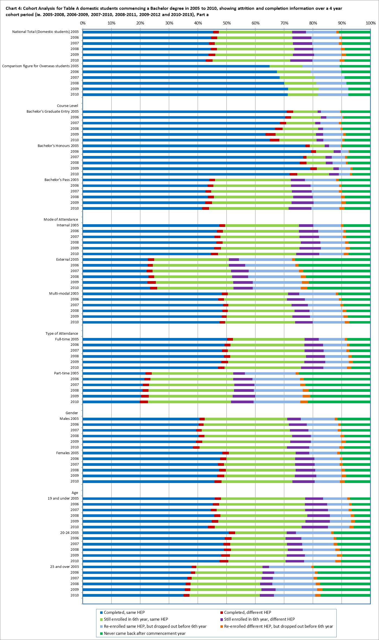

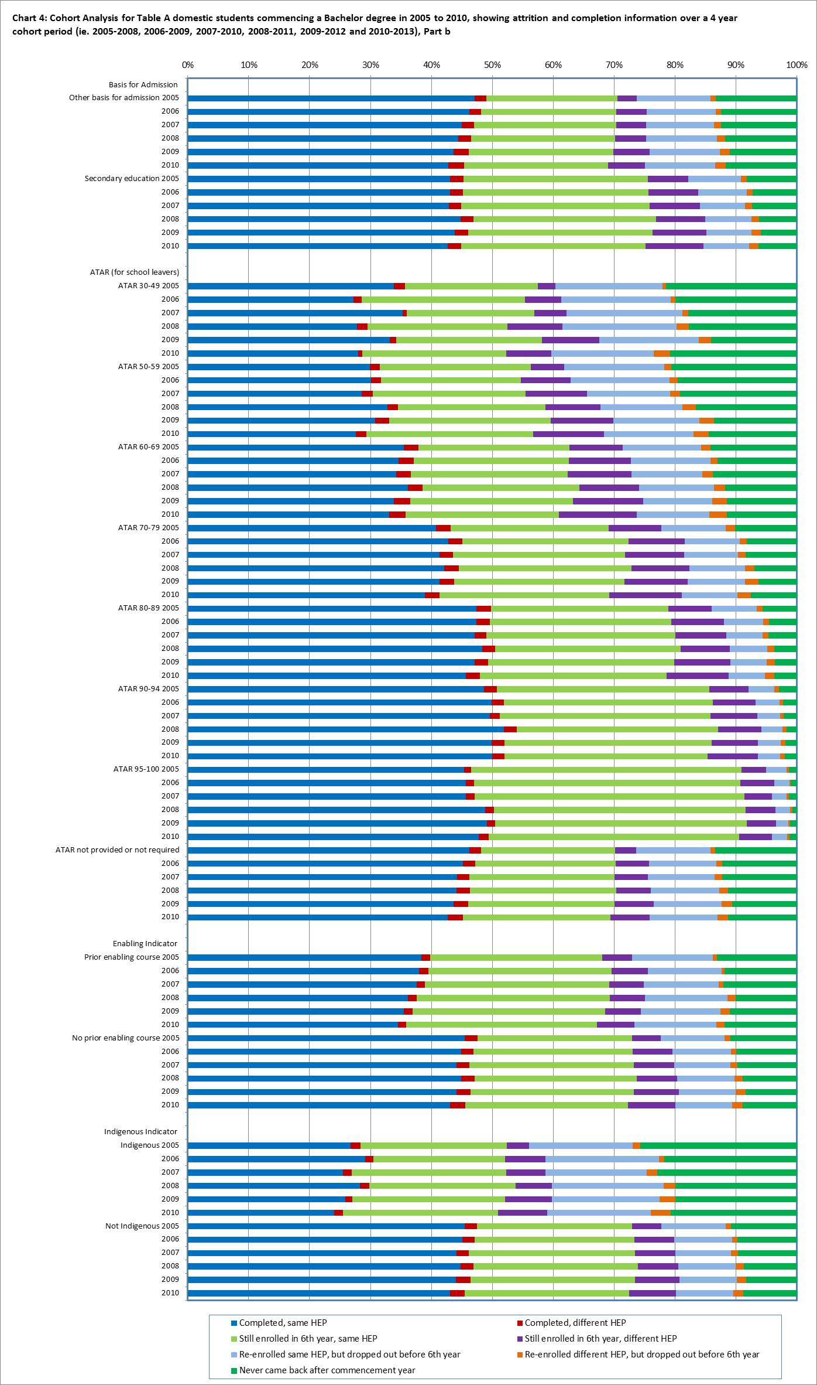

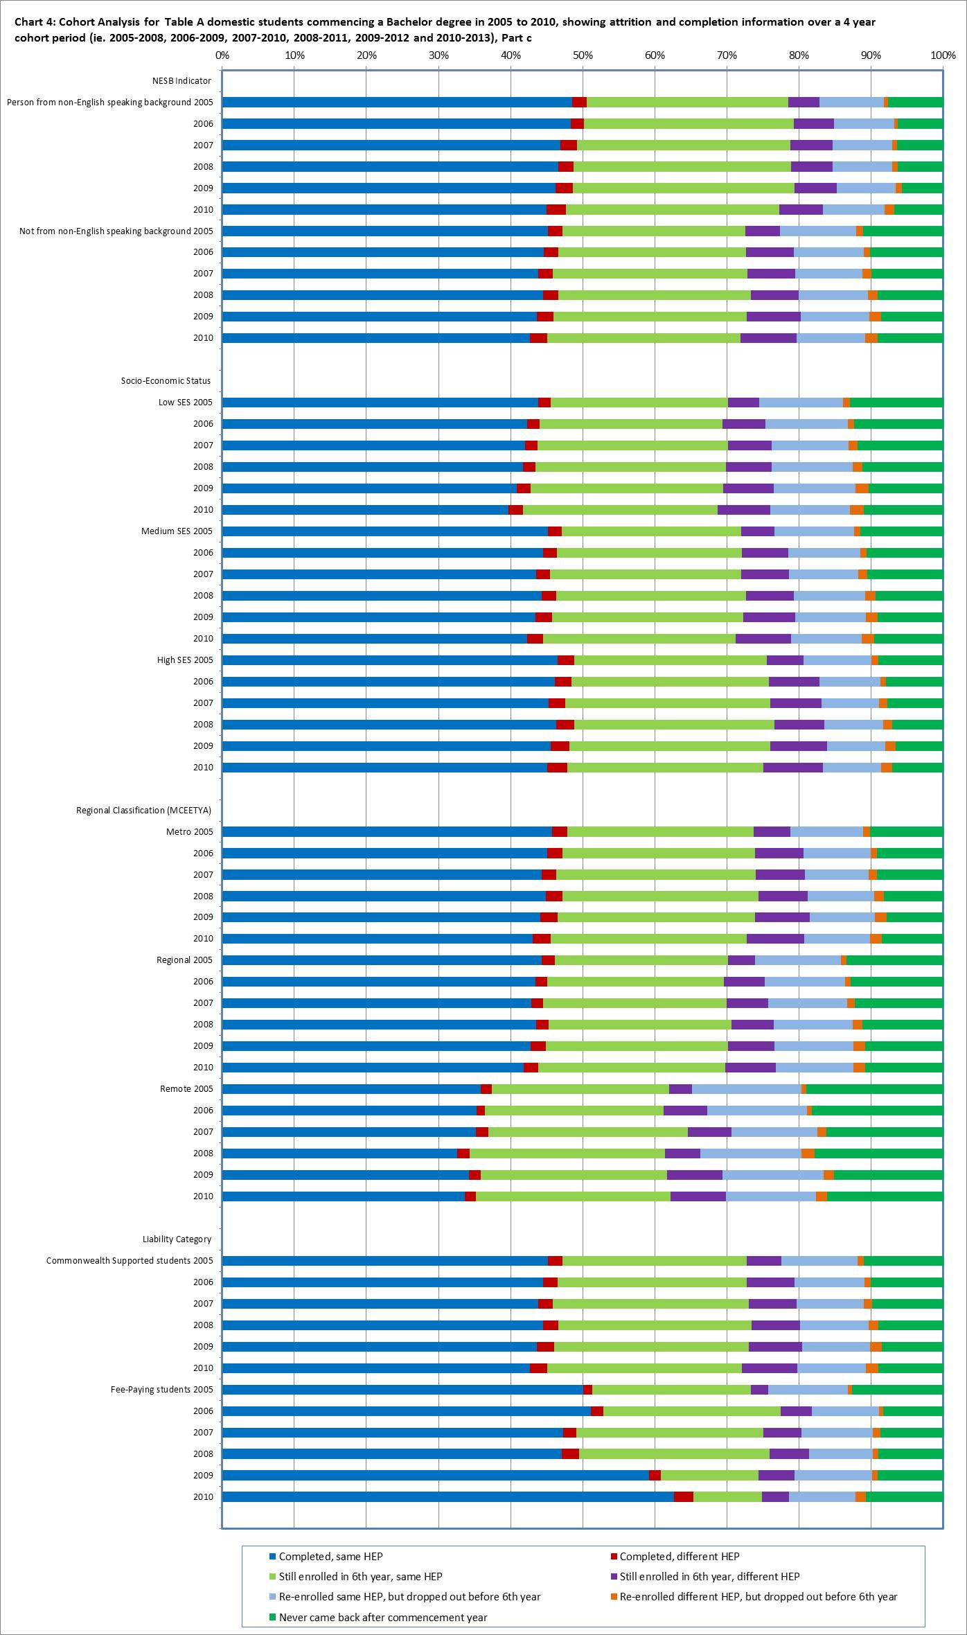

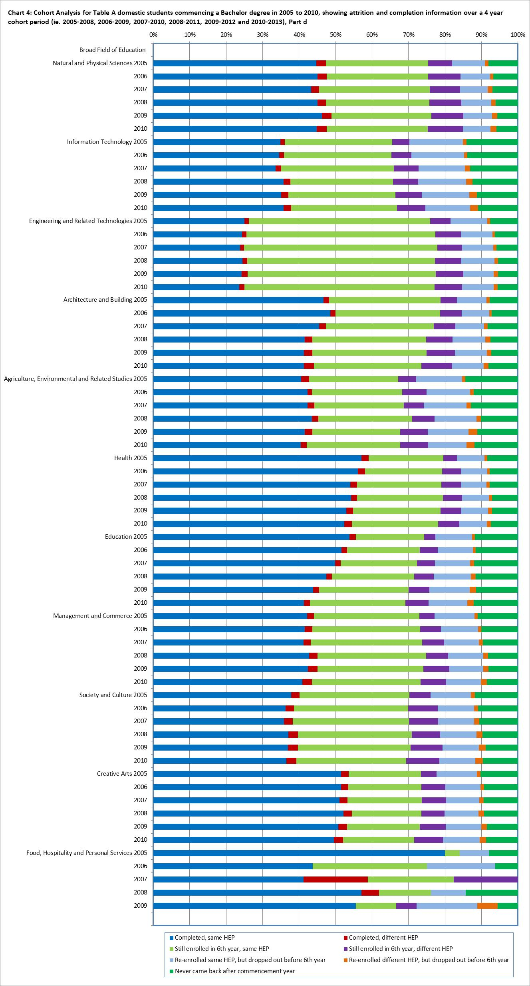

Note: There were no students studying Food, Hospitality and Personal Services at Table A universities in 2010.

Table 3: Cohort Analysis for Table A commencing domestic Bachelor students over a six year period, 2005-2010, 2006-2011, 2007-2012 and 2008-2013

|  |  | **Completed  (in any year)** | **Still Enrolled at the end of the 6 year cohort period** | **Re-enrolled but dropped out** | **Never came back after the first year** |
| --- | --- | --- | --- | --- | --- |
| **National Total (Domestic students)** | 2005 | 67.0% | 11.0% | 12.9% | 9.1% |
| 2006 | 66.8% | 11.0% | 13.4% | 8.8% |
| 2007 | 66.6% | 11.4% | 13.4% | 8.6% |
| 2008 | 67.1% | 11.3% | 13.8% | 7.9% |
| **Comparison figure for Overseas students** | 2005 | 73.3% | 1.3% | 14.8% | 10.6% |
| 2006 | 76.0% | 1.4% | 12.5% | 10.1% |
| 2007 | 77.5% | 1.4% | 12.2% | 8.9% |
| 2008 | 78.2% | 1.4% | 12.1% | 8.3% |
| **Course Level** | | | | | |
| **Bachelor's Graduate Entry** | 2005 | 79.3% | 4.6% | 7.3% | 8.8% |
| 2006 | 79.9% | 4.7% | 7.2% | 8.2% |
| 2007 | 78.1% | 5.1% | 7.6% | 9.2% |
| 2008 | 78.2% | 5.3% | 7.6% | 8.8% |
| **Bachelor's Honours** | 2005 | 84.2% | 3.2% | 4.5% | 8.1% |
| 2006 | 86.2% | 2.8% | 4.1% | 6.9% |
| 2007 | 82.8% | 4.1% | 6.0% | 7.1% |
| 2008 | 83.6% | 3.8% | 5.5% | 7.1% |
| **Bachelor's Pass** | 2005 | 66.3% | 11.3% | 13.2% | 9.2% |
| 2006 | 66.1% | 11.3% | 13.7% | 8.8% |
| 2007 | 66.0% | 11.7% | 13.7% | 8.6% |
| 2008 | 66.5% | 11.5% | 14.1% | 7.9% |
| **Mode of Attendance** | | | | | |
| **Internal** | 2005 | 70.2% | 10.4% | 11.7% | 7.7% |
| 2006 | 69.8% | 10.5% | 12.3% | 7.5% |
| 2007 | 69.6% | 10.8% | 12.1% | 7.4% |
| 2008 | 70.1% | 10.7% | 12.5% | 6.6% |
| **External** | 2005 | 37.4% | 17.2% | 22.9% | 22.5% |
| 2006 | 37.3% | 16.5% | 23.8% | 22.3% |
| 2007 | 37.4% | 17.2% | 24.4% | 21.0% |
| 2008 | 38.1% | 17.1% | 24.4% | 20.4% |
| **Multi-modal** | 2005 | 65.2% | 10.2% | 15.2% | 9.3% |
| 2006 | 64.2% | 10.8% | 16.1% | 8.9% |
| 2007 | 65.1% | 11.4% | 15.4% | 8.1% |
| 2008 | 66.0% | 10.8% | 15.7% | 7.5% |

|  |  | **Completed  (in any year)** | **Still Enrolled at the end of the 6 year cohort period** | **Re-enrolled but dropped out** | **Never came back after the first year** |
| --- | --- | --- | --- | --- | --- |
| **Type of Attendance** | | | | | |
| **Full-time** | 2005 | 72.8% | 9.6% | 11.0% | 6.5% |
| 2006 | 72.2% | 9.8% | 11.6% | 6.4% |
| 2007 | 72.0% | 10.2% | 11.5% | 6.4% |
| 2008 | 72.5% | 10.0% | 11.9% | 5.7% |
| **Part-time** | 2005 | 39.5% | 17.3% | 21.7% | 21.4% |
| 2006 | 39.6% | 16.8% | 22.8% | 20.8% |
| 2007 | 39.2% | 17.8% | 22.8% | 20.2% |
| 2008 | 39.0% | 18.1% | 23.6% | 19.4% |
| **Gender** | | | | | |
| **Males** | 2005 | 63.6% | 12.0% | 14.7% | 9.8% |
| 2006 | 63.5% | 12.3% | 15.0% | 9.2% |
| 2007 | 63.5% | 12.5% | 14.9% | 9.1% |
| 2008 | 64.3% | 12.6% | 15.0% | 8.1% |
| **Females** | 2005 | 69.4% | 10.3% | 11.6% | 8.7% |
| 2006 | 69.1% | 10.1% | 12.4% | 8.5% |
| 2007 | 68.7% | 10.7% | 12.3% | 8.3% |
| 2008 | 69.0% | 10.4% | 12.9% | 7.8% |
| **Age** | | | | | |
| **19 and under** | 2005 | 73.3% | 10.9% | 10.2% | 5.6% |
| 2006 | 72.7% | 11.2% | 10.6% | 5.6% |
| 2007 | 72.4% | 11.5% | 10.5% | 5.5% |
| 2008 | 73.3% | 11.3% | 10.7% | 4.8% |
| **20-24** | 2005 | 65.1% | 9.8% | 14.6% | 10.5% |
| 2006 | 64.3% | 9.6% | 15.7% | 10.5% |
| 2007 | 64.5% | 9.9% | 15.5% | 10.1% |
| 2008 | 64.5% | 9.9% | 16.1% | 9.6% |
| **25 and over** | 2005 | 51.7% | 12.5% | 18.4% | 17.4% |
| 2006 | 51.7% | 12.0% | 19.5% | 16.7% |
| 2007 | 50.4% | 12.9% | 19.9% | 16.8% |
| 2008 | 50.0% | 12.8% | 21.0% | 16.1% |
| **Basis for Admission** | | | | | |
| **Other basis for Admission** | 2005 | 63.5% | 10.5% | 14.7% | 11.3% |
| 2006 | 62.9% | 10.4% | 15.5% | 11.1% |
| 2007 | 62.1% | 11.0% | 15.9% | 11.0% |
| 2008 | 61.8% | 11.2% | 16.4% | 10.6% |
| **Secondary education** | 2005 | 71.2% | 11.6% | 10.7% | 6.6% |
| 2006 | 71.0% | 11.6% | 11.2% | 6.2% |
| 2007 | 71.0% | 11.8% | 10.9% | 6.3% |
| 2008 | 72.3% | 11.3% | 11.2% | 5.2% |

|  |  | **Completed  (in any year)** | **Still Enrolled at the end of the 6 year cohort period** | **Re-enrolled but dropped out** | **Never came back after the first year** |
| --- | --- | --- | --- | --- | --- |
| **ATAR (for school leavers)** | | | | | |
| **30-49** | 2005 | 48.6% | 8.1% | 24.1% | 19.2% |
| 2006 | 44.4% | 11.3% | 26.2% | 18.0% |
| 2007 | 50.6% | 12.2% | 21.3% | 15.9% |
| 2008 | 41.3% | 15.0% | 27.5% | 16.3% |
| **50-59** | 2005 | 49.3% | 13.9% | 19.6% | 17.2% |
| 2006 | 46.3% | 14.1% | 22.8% | 16.9% |
| 2007 | 48.2% | 14.8% | 20.2% | 16.7% |
| 2008 | 51.9% | 14.1% | 19.6% | 14.4% |
| **60-69** | 2005 | 57.5% | 13.3% | 17.1% | 12.0% |
| 2006 | 57.2% | 13.6% | 17.8% | 11.3% |
| 2007 | 56.6% | 14.6% | 16.7% | 12.1% |
| 2008 | 58.3% | 14.3% | 17.5% | 9.9% |
| **70-79** | 2005 | 65.1% | 13.4% | 13.6% | 7.9% |
| 2006 | 67.4% | 12.4% | 13.3% | 6.9% |
| 2007 | 66.5% | 13.1% | 13.5% | 7.0% |
| 2008 | 67.5% | 13.3% | 13.4% | 5.8% |
| **80-89** | 2005 | 75.2% | 11.4% | 9.1% | 4.3% |
| 2006 | 75.1% | 11.7% | 9.4% | 3.8% |
| 2007 | 75.7% | 11.7% | 8.7% | 3.8% |
| 2008 | 76.7% | 11.2% | 9.1% | 3.0% |
| **90-94** | 2005 | 82.4% | 9.9% | 5.5% | 2.2% |
| 2006 | 83.3% | 9.8% | 5.2% | 1.8% |
| 2007 | 82.7% | 9.9% | 5.6% | 1.8% |
| 2008 | 84.4% | 8.8% | 5.4% | 1.4% |
| **95-100** | 2005 | 87.3% | 8.5% | 3.2% | 0.9% |
| 2006 | 87.0% | 9.4% | 2.8% | 0.8% |
| 2007 | 86.9% | 8.7% | 3.3% | 1.1% |
| 2008 | 87.8% | 8.0% | 3.6% | 0.6% |
| **ATAR not provided or not required** | 2005 | 63.3% | 10.8% | 14.7% | 11.3% |
| 2006 | 63.1% | 10.7% | 15.3% | 10.9% |
| 2007 | 62.3% | 11.2% | 15.7% | 10.8% |
| 2008 | 62.7% | 11.2% | 16.0% | 10.1% |
| **Enabling Indicator** | | | | | |
| **Prior enabling course** | 2005 | 56.5% | 14.6% | 17.3% | 11.5% |
| 2006 | 58.0% | 14.9% | 16.8% | 10.3% |
| 2007 | 58.2% | 13.5% | 17.4% | 10.9% |
| 2008 | 58.3% | 14.1% | 18.4% | 9.1% |
| **No prior enabling course** | 2005 | 67.3% | 10.9% | 12.8% | 9.1% |
| 2006 | 67.1% | 10.9% | 13.3% | 8.7% |
| 2007 | 66.9% | 11.3% | 13.2% | 8.6% |
| 2008 | 67.4% | 11.2% | 13.6% | 7.9% |
| **Indigenous Indicator** | | | | | |
| **Indigenous** | 2005 | 41.0% | 13.8% | 22.7% | 22.5% |
| 2006 | 41.1% | 13.4% | 25.9% | 19.6% |
| 2007 | 40.0% | 15.1% | 24.7% | 20.1% |
| 2008 | 41.2% | 14.3% | 26.4% | 18.2% |
| **Not Indigenous** | 2005 | 67.2% | 11.0% | 12.8% | 9.0% |
| 2006 | 67.2% | 11.0% | 13.3% | 8.5% |
| 2007 | 66.9% | 11.4% | 13.2% | 8.5% |
| 2008 | 67.5% | 11.2% | 13.6% | 7.7% |
| **NESB Indicator** | | | | | |
| **Person from non-English speaking background** | 2005 | 72.5% | 10.0% | 11.0% | 6.6% |
| 2006 | 72.1% | 10.4% | 11.7% | 5.7% |
| 2007 | 71.3% | 11.1% | 11.9% | 5.8% |
| 2008 | 70.9% | 10.7% | 12.7% | 5.6% |
| **Not from non-English speaking background** | 2005 | 66.8% | 11.0% | 13.0% | 9.2% |
| 2006 | 66.6% | 11.0% | 13.5% | 8.9% |
| 2007 | 66.4% | 11.4% | 13.4% | 8.8% |
| 2008 | 66.9% | 11.3% | 13.8% | 8.0% |
| **Socio-Economic Status** | | | | | |
| **Low SES** | 2005 | 62.9% | 11.1% | 15.0% | 11.0% |
| 2006 | 61.8% | 11.1% | 16.0% | 11.0% |
| 2007 | 61.7% | 12.2% | 15.5% | 10.6% |
| 2008 | 61.8% | 12.1% | 16.2% | 10.0% |
| **Medium SES** | 2005 | 65.9% | 11.2% | 13.3% | 9.6% |
| 2006 | 65.8% | 11.0% | 13.9% | 9.3% |
| 2007 | 65.3% | 11.5% | 13.9% | 9.2% |
| 2008 | 66.1% | 11.3% | 14.3% | 8.3% |
| **High SES** | 2005 | 70.9% | 10.6% | 11.3% | 7.3% |
| 2006 | 70.7% | 11.0% | 11.5% | 6.8% |
| 2007 | 70.8% | 10.9% | 11.5% | 6.8% |
| 2008 | 71.1% | 10.9% | 11.8% | 6.2% |

|  |  | **Completed  (in any year)** | **Still Enrolled at the end of the 6 year cohort period** | **Re-enrolled but dropped out** | **Never came back after the first year** |
| --- | --- | --- | --- | --- | --- |
| **Regional Classification (MCEETYA)** | | | | | |
| **Metro** | 2005 | 68.2% | 11.0% | 12.4% | 8.4% |
| 2006 | 67.9% | 11.1% | 12.9% | 8.0% |
| 2007 | 67.8% | 11.4% | 12.8% | 8.0% |
| 2008 | 68.1% | 11.4% | 13.3% | 7.3% |
| **Regional** | 2005 | 63.5% | 10.7% | 14.5% | 11.2% |
| 2006 | 63.0% | 10.5% | 15.1% | 11.4% |
| 2007 | 62.4% | 11.4% | 15.4% | 10.8% |
| 2008 | 63.6% | 11.0% | 15.4% | 10.0% |
| **Remote** | 2005 | 53.0% | 11.8% | 18.6% | 16.6% |
| 2006 | 54.1% | 11.3% | 18.7% | 16.0% |
| 2007 | 53.5% | 12.7% | 19.1% | 14.6% |
| 2008 | 50.6% | 13.3% | 19.9% | 16.3% |
| **Liability Category** | | | | | |
| **Commonwealth Supported students** | 2005 | 66.9% | 11.1% | 12.9% | 9.1% |
| 2006 | 66.6% | 11.1% | 13.5% | 8.8% |
| 2007 | 66.5% | 11.5% | 13.4% | 8.7% |
| 2008 | 66.9% | 11.3% | 13.8% | 7.9% |
| **Fee-Paying students** | 2005 | 68.6% | 7.0% | 12.8% | 11.6% |
| 2006 | 72.2% | 8.2% | 12.0% | 7.6% |
| 2007 | 70.1% | 9.5% | 12.5% | 7.8% |
| 2008 | 71.1% | 8.9% | 11.9% | 8.1% |
| **Broad Field of Education** | | | | | |
| **Natural and Physical Sciences** | 2005 | 70.4% | 12.1% | 11.2% | 6.3% |
| 2006 | 70.5% | 12.6% | 11.0% | 5.9% |
| 2007 | 69.6% | 12.7% | 11.8% | 5.9% |
| 2008 | 70.8% | 12.3% | 11.5% | 5.3% |
| **Information Technology** | 2005 | 56.1% | 13.1% | 18.6% | 12.2% |
| 2006 | 55.4% | 12.3% | 20.0% | 12.3% |
| 2007 | 56.0% | 13.6% | 18.7% | 11.7% |
| 2008 | 56.6% | 13.2% | 19.3% | 10.9% |
| **Engineering and Related Technologies** | 2005 | 63.0% | 18.2% | 12.4% | 6.3% |
| 2006 | 62.8% | 18.4% | 13.1% | 5.6% |
| 2007 | 62.9% | 18.8% | 13.1% | 5.3% |
| 2008 | 62.0% | 18.6% | 14.5% | 4.9% |
| **Architecture and Building** | 2005 | 72.0% | 10.9% | 10.8% | 6.3% |
| 2006 | 72.8% | 10.5% | 10.2% | 6.5% |
| 2007 | 69.9% | 10.7% | 12.0% | 7.3% |
| 2008 | 68.2% | 11.5% | 13.6% | 6.6% |

|  |  | **Completed  (in any year)** | **Still Enrolled at the end of the 6 year cohort period** | **Re-enrolled but dropped out** | **Never came back after the first year** |
| --- | --- | --- | --- | --- | --- |
| **Broad Field of Education continued…….** | | | | | |
| **Agriculture, Environmental & Related Studies** | 2005 | 59.9% | 11.6% | 16.1% | 12.4% |
| 2006 | 59.8% | 12.0% | 17.4% | 10.8% |
| 2007 | 60.7% | 11.1% | 16.5% | 11.7% |
| 2008 | 62.6% | 11.8% | 16.1% | 9.5% |
| **Health** | 2005 | 77.0% | 7.0% | 9.1% | 7.0% |
| 2006 | 76.6% | 7.2% | 9.4% | 6.8% |
| 2007 | 75.8% | 7.8% | 9.7% | 6.7% |
| 2008 | 76.2% | 7.5% | 9.9% | 6.3% |
| **Education** | 2005 | 70.2% | 7.8% | 11.8% | 10.1% |
| 2006 | 68.2% | 8.6% | 12.9% | 10.3% |
| 2007 | 66.7% | 9.1% | 13.4% | 10.8% |
| 2008 | 65.2% | 9.7% | 14.6% | 10.5% |
| **Management and Commerce** | 2005 | 65.7% | 11.2% | 13.6% | 9.4% |
| 2006 | 65.5% | 11.2% | 14.2% | 9.1% |
| 2007 | 66.0% | 11.5% | 14.0% | 8.6% |
| 2008 | 67.2% | 11.3% | 14.2% | 7.4% |
| **Society and Culture** | 2005 | 63.5% | 13.5% | 13.5% | 9.5% |
| 2006 | 62.6% | 13.3% | 14.7% | 9.4% |
| 2007 | 62.5% | 14.0% | 14.4% | 9.2% |
| 2008 | 63.0% | 13.8% | 14.7% | 8.5% |
| **Creative Arts** | 2005 | 70.2% | 8.2% | 13.3% | 8.3% |
| 2006 | 70.2% | 8.8% | 13.0% | 8.1% |
| 2007 | 69.9% | 9.1% | 12.7% | 8.2% |
| 2008 | 70.0% | 8.8% | 13.2% | 8.0% |
| **Food, Hospitality and Personal Services** | 2005 | 84.0% | 8.0% | 4.0% | 4.0% |
| 2006 | 50.0% | 18.8% | 25.0% | 6.3% |
| 2007 | 82.4% | 11.8% | 5.9% | 0.0% |
| 2008 | 76.2% | 4.8% | 4.8% | 14.3% |

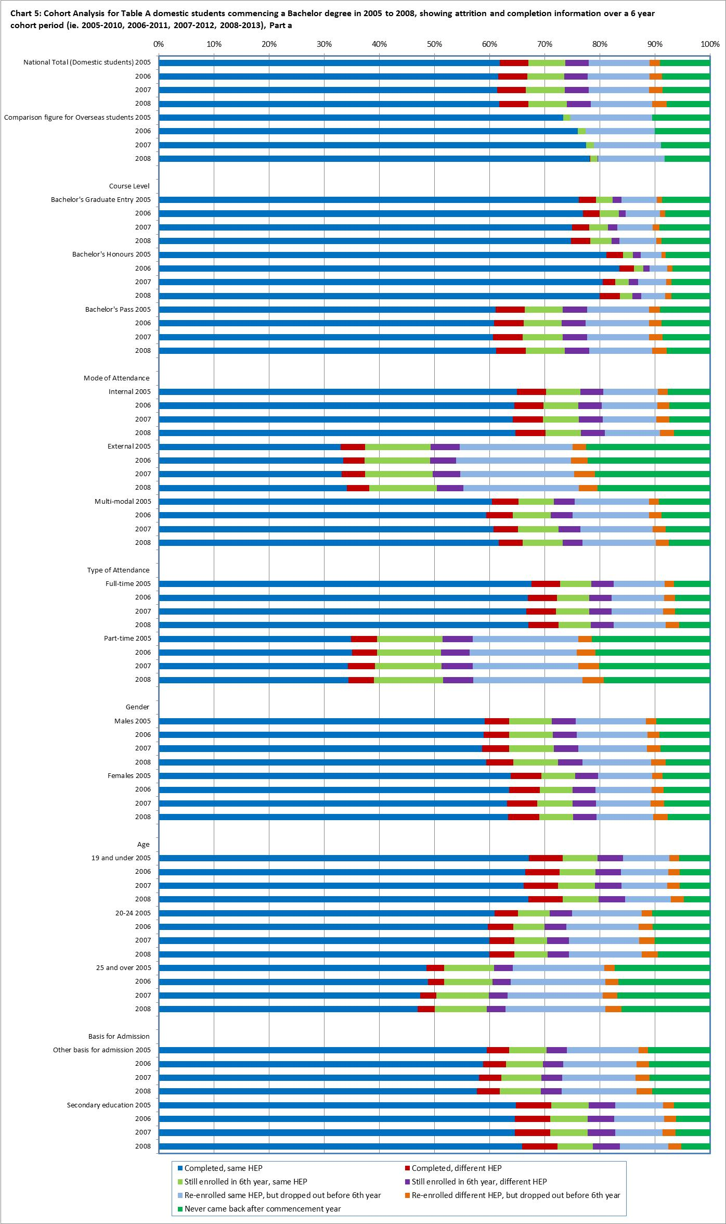

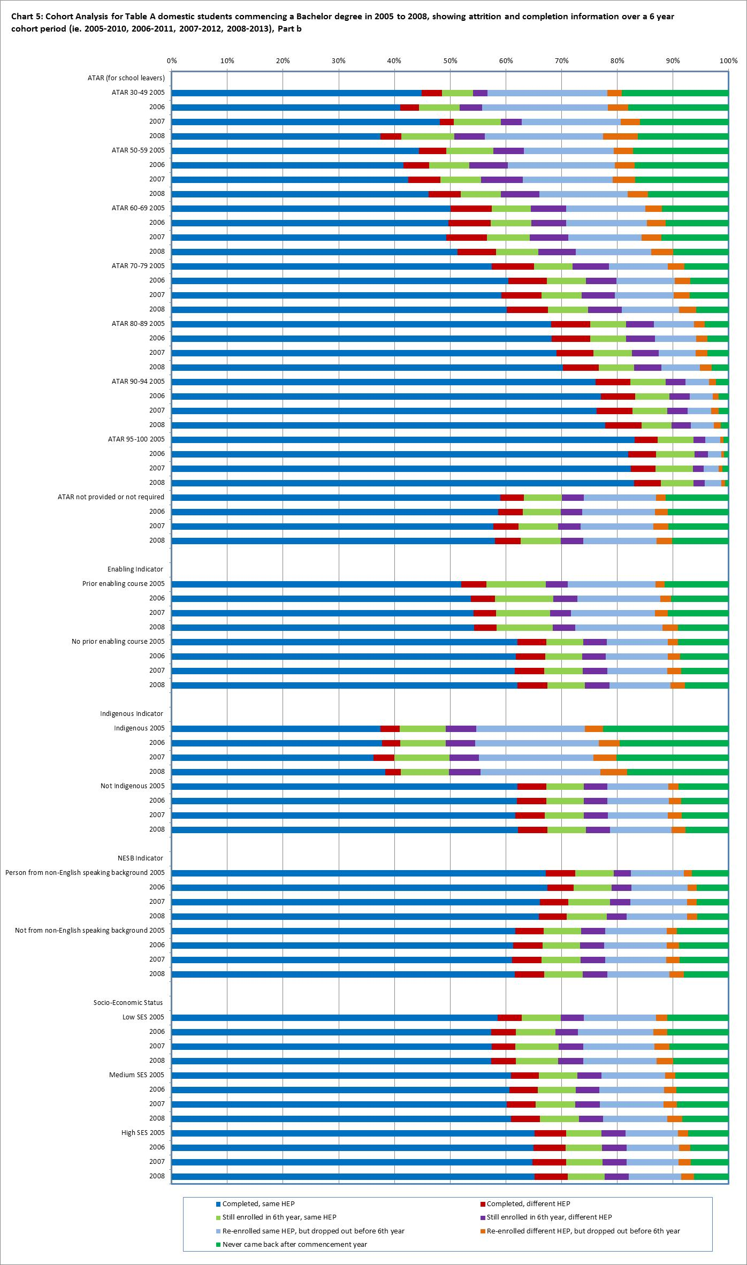

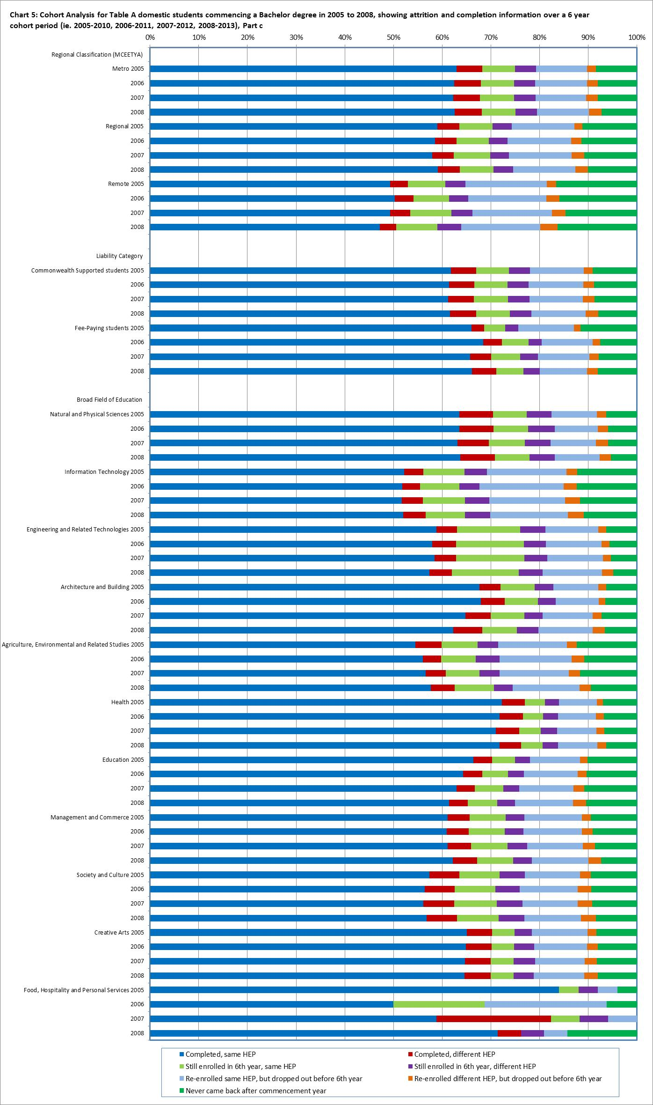

Table 4: Cohort Analysis for Table A commencing domestic Bachelor students over an eight year period, 2005-2012 and 2006-2013

|  |  | **Completed  (in any year)** | | **Still Enrolled at the end of the 8 year cohort period** | | | **Re-enrolled but dropped out** | | **Never came back after the first year** | |
| --- | --- | --- | --- | --- | --- | --- | --- | --- | --- | --- |
| **National Total (Domestic students)** | 2005 | 72.3% | | 5.3% | | | 13.9% | | 8.4% | |
| 2006 | 72.1% | | 5.5% | | | 14.3% | | 8.1% | |
| **Comparison figure for Overseas students** | 2005 | 74.1% | | 0.3% | | | 15.0% | | 10.5% | |
| 2006 | 76.9% | | 0.3% | | | 12.7% | | 10.0% | |
| **Course Level** | | | | | | | | | | |
| **Bachelor's Graduate Entry** | 2005 | 81.8% | | 2.6% | | | 7.5% | | 8.2% | |
| 2006 | 81.9% | | 2.5% | | | 8.0% | | 7.6% | |
| **Bachelor's Honours** | 2005 | 85.7% | | 1.6% | | | 5.3% | | 7.5% | |
| 2006 | 87.7% | | 1.4% | | | 4.4% | | 6.4% | |
| **Bachelor's Pass** | 2005 | 71.8% | | 5.5% | | | 14.2% | | 8.5% | |
| 2006 | 71.6% | | 5.6% | | | 14.6% | | 8.1% | |
| **Mode of Attendance** | | | | | | | | | | |
| **Internal** | 2005 | 75.4% | | 4.9% | | | 12.6% | | 7.1% | |
| 2006 | 75.1% | | 5.1% | | | 13.0% | | 6.9% | |
| **External** | 2005 | 44.4% | | 9.9% | | | 24.8% | | 20.9% | |
| 2006 | 44.1% | | 9.4% | | | 25.8% | | 20.8% | |
| **Multi-modal** | 2005 | 69.5% | | 5.5% | | | 16.5% | | 8.6% | |
| 2006 | 68.7% | | 6.2% | | | 17.1% | | 8.0% | |
| **Type of Attendance** | | | | | | | | | | |
| **Full-time** | 2005 | 77.7% | | 4.5% | | | 11.8% | | 6.0% | |
| 2006 | 77.2% | | 4.7% | | | 12.3% | | 5.8% | |
| **Part-time** | 2005 | 47.1% | | 9.3% | | | 23.6% | | 20.0% | |
| 2006 | 46.7% | | 9.4% | | | 24.5% | | 19.4% | |
| **Gender** | | | | | | | | | | |
| **Males** | 2005 | 69.5% | | 5.8% | | | 15.7% | | 9.1% | |
| 2006 | 69.5% | | 5.9% | | | 16.0% | | 8.6% | |
| **Females** | 2005 | 74.3% | | 5.1% | | | 12.6% | | 8.0% | |
| 2006 | 74.0% | | 5.2% | | | 13.1% | | 7.7% | |
| **Age** | | | | | | | | | | |
| **19 and under** | 2005 | 79.1% | | 4.8% | | | 11.0% | | 5.1% | |
| 2006 | 78.7% | | 5.1% | | | 11.2% | | 5.0% | |
| **20-24** | 2005 | 69.2% | | 5.5% | | | 15.7% | | 9.7% | |
| 2006 | 68.2% | | 5.5% | | | 16.7% | | 9.6% | |
| **25 and over** | 2005 | 57.1% | | 6.6% | | | 19.9% | | 16.4% | |
| 2006 | 56.6% | | 6.9% | | | 20.9% | | 15.7% | |
| **Basis for Admission** | | | | | | | | | | |
| **Other basis for admission** | 2005 | 68.1% | | 5.5% | | | 15.9% | | 10.5% | |
| 2006 | 67.4% | | 5.7% | | | 16.6% | | 10.4% | |
| **Secondary education** | 2005 | 77.4% | | 5.1% | | | 11.5% | | 6.0% | |
| 2006 | 77.3% | | 5.3% | | | 11.8% | | 5.6% | |
| **ATAR (for school leavers)** | | | | | | | | | | |
| **30-49** | | | 2005 | | 50.7% | 4.7% | | 26.5% | | 18.1% |
| 2006 | | 49.6% | 6.5% | | 27.2% | | 16.7% |
| **50-59** | | | 2005 | | 55.1% | 6.9% | | 21.7% | | 16.3% |
| 2006 | | 51.8% | 8.2% | | 24.6% | | 15.4% |
| **60-69** | | | 2005 | | 63.7% | 7.1% | | 18.4% | | 10.9% |
| 2006 | | 63.5% | 7.0% | | 19.3% | | 10.1% |
| **70-79** | | | 2005 | | 71.9% | 6.3% | | 14.6% | | 7.2% |
| 2006 | | 73.5% | 6.2% | | 14.2% | | 6.2% |
| **80-89** | | | 2005 | | 81.3% | 5.0% | | 9.8% | | 3.9% |
| 2006 | | 81.7% | 5.1% | | 9.8% | | 3.3% |
| **90-94** | | | 2005 | | 88.6% | 3.6% | | 5.9% | | 2.0% |
| 2006 | | 89.5% | 3.8% | | 5.1% | | 1.6% |
| **95-100** | | | 2005 | | 93.8% | 1.9% | | 3.4% | | 0.8% |
| 2006 | | 94.1% | 2.1% | | 3.1% | | 0.8% |
| **ATAR not provided or not required** | | | 2005 | | 68.0% | 5.7% | | 15.8% | | 10.5% |
| 2006 | | 67.8% | 5.8% | | 16.3% | | 10.1% |
| **Enabling Indicator** | | | | | | | | | | |
| **Prior enabling course** | | | 2005 | | 62.5% | 7.1% | | 19.6% | | 10.7% |
| 2006 | | 64.2% | 7.5% | | 18.9% | | 9.3% |
| **No prior enabling course** | | | 2005 | | 72.6% | 5.3% | | 13.7% | | 8.4% |
| 2006 | | 72.4% | 5.4% | | 14.1% | | 8.0% |
| **Indigenous Indicator** | | | | | | | | | | |
| **Indigenous** | | | 2005 | | 45.5% | 9.3% | | 24.5% | | 20.8% |
| 2006 | | 45.2% | 8.9% | | 27.5% | | 18.3% |
| **Not Indigenous** | | | 2005 | | 72.6% | 5.3% | | 13.8% | | 8.3% |
| 2006 | | 72.6% | 5.4% | | 14.1% | | 7.8% |
| **NESB Indicator** | | | | | | | | | | |
| **Person from non-English speaking background** | | | 2005 | | 77.7% | 4.3% | | 11.8% | | 6.2% |
| 2006 | | 77.0% | 4.9% | | 12.8% | | 5.4% |
| **Not from non-English speaking background** | | | 2005 | | 72.1% | 5.4% | | 14.0% | | 8.5% |
| 2006 | | 72.0% | 5.5% | | 14.3% | | 8.2% |
| **Socio-Economic Status** | | | | | | | | | | |
| **Low SES** | | | 2005 | | 67.7% | 5.8% | | 16.3% | | 10.3% |
| 2006 | | 66.5% | 6.3% | | 17.1% | | 10.2% |
| **Medium SES** | | | 2005 | | 71.3% | 5.7% | | 14.2% | | 8.9% |
| 2006 | | 71.0% | 5.6% | | 14.7% | | 8.6% |
| **High SES** | | | 2005 | | 76.5% | 4.7% | | 12.1% | | 6.7% |
| 2006 | | 76.6% | 4.9% | | 12.2% | | 6.3% |

|  |  | **Completed  (in any year)** | **Still Enrolled at the end of the 8 year cohort period** | **Re-enrolled but dropped out** | **Never came back after the first year** |
| --- | --- | --- | --- | --- | --- |
| **Regional Classification (MCEETYA)** | | | | | |
| **Metro** | 2005 | 73.7% | 5.3% | 13.3% | 7.7% |
| 2006 | 73.4% | 5.4% | 13.8% | 7.4% |
| **Regional** | 2005 | 68.5% | 5.6% | 15.5% | 10.4% |
| 2006 | 67.7% | 6.0% | 15.8% | 10.5% |
| **Remote** | 2005 | 58.2% | 6.4% | 20.0% | 15.3% |
| 2006 | 58.8% | 6.3% | 19.8% | 15.2% |
| **Liability Category** | | | | | |
| **Commonwealth Supported students** | 2005 | 72.3% | 5.4% | 13.9% | 8.4% |
| 2006 | 72.0% | 5.6% | 14.3% | 8.1% |
| **Fee-Paying students** | 2005 | 72.4% | 2.9% | 13.3% | 11.4% |
| 2006 | 76.7% | 3.1% | 13.0% | 7.2% |
| **Broad Field of Education** | | | | | |
| **Natural and Physical Sciences** | 2005 | 76.2% | 5.7% | 12.2% | 5.8% |
| 2006 | 76.6% | 5.8% | 12.3% | 5.3% |
| **Information Technology** | 2005 | 61.8% | 6.7% | 20.3% | 11.3% |
| 2006 | 61.1% | 6.3% | 21.2% | 11.4% |
| **Engineering and Related Technologies** | 2005 | 72.8% | 7.1% | 14.2% | 5.8% |
| 2006 | 73.7% | 7.4% | 13.7% | 5.2% |
| **Architecture and Building** | 2005 | 77.7% | 4.5% | 12.0% | 5.8% |
| 2006 | 78.1% | 4.3% | 11.5% | 6.1% |
| **Agriculture, Environmental & Related Studies** | 2005 | 65.3% | 6.1% | 17.2% | 11.4% |
| 2006 | 65.5% | 6.2% | 18.2% | 10.1% |
| **Health** | 2005 | 80.8% | 3.4% | 9.4% | 6.4% |
| 2006 | 80.5% | 3.6% | 9.8% | 6.2% |
| **Education** | 2005 | 73.8% | 4.1% | 12.7% | 9.3% |
| 2006 | 72.1% | 4.6% | 13.9% | 9.5% |
| **Management and Commerce** | 2005 | 71.1% | 5.3% | 14.7% | 8.9% |
| 2006 | 70.8% | 5.4% | 15.3% | 8.5% |
| **Society and Culture** | 2005 | 70.2% | 6.5% | 14.6% | 8.7% |
| 2006 | 69.1% | 6.8% | 15.5% | 8.6% |
| **Creative Arts** | 2005 | 74.5% | 4.3% | 13.7% | 7.5% |
| 2006 | 74.6% | 4.6% | 13.5% | 7.3% |
| **Food, Hospitality and Personal Services** | 2005 | 88.0% | 4.0% | 4.0% | 4.0% |
| 2006 | 62.5% | 6.3% | 25.0% | 6.3% |

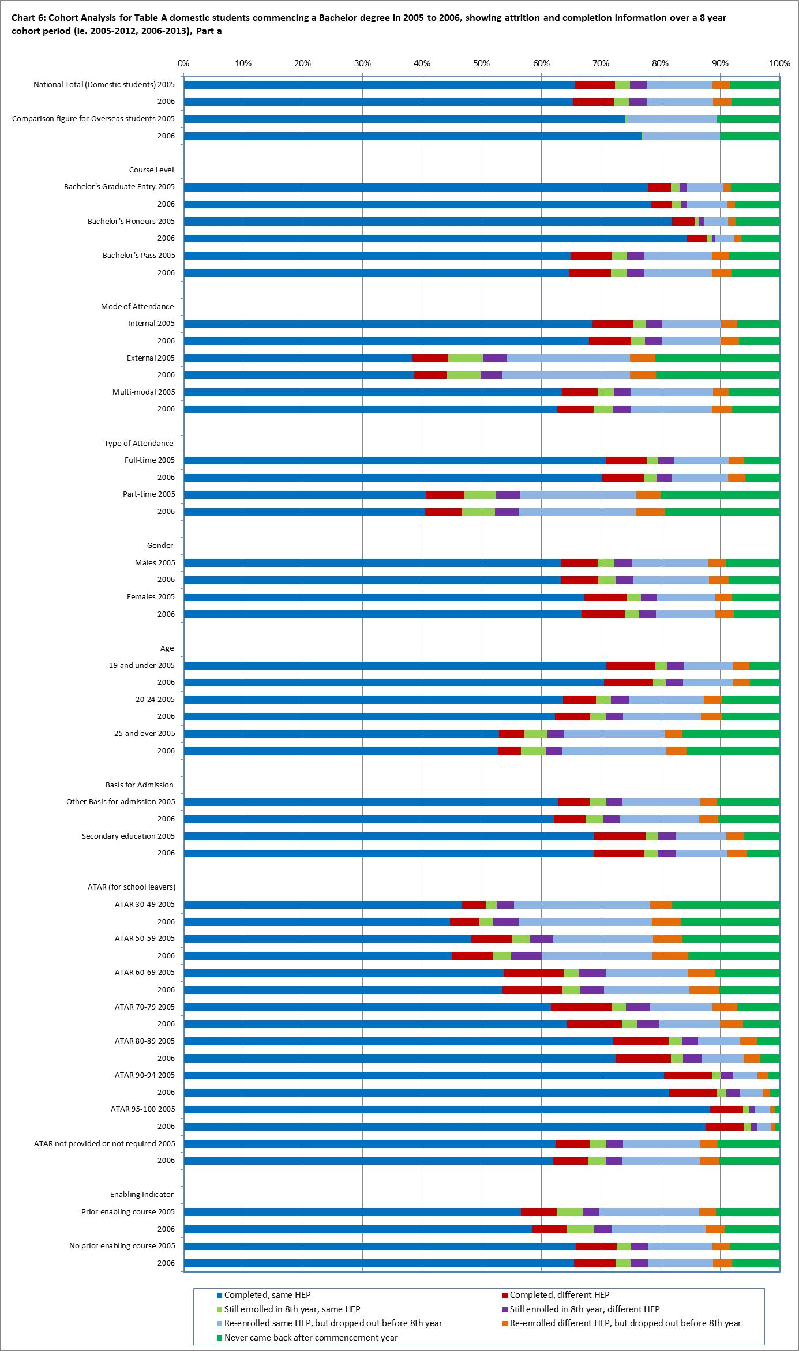

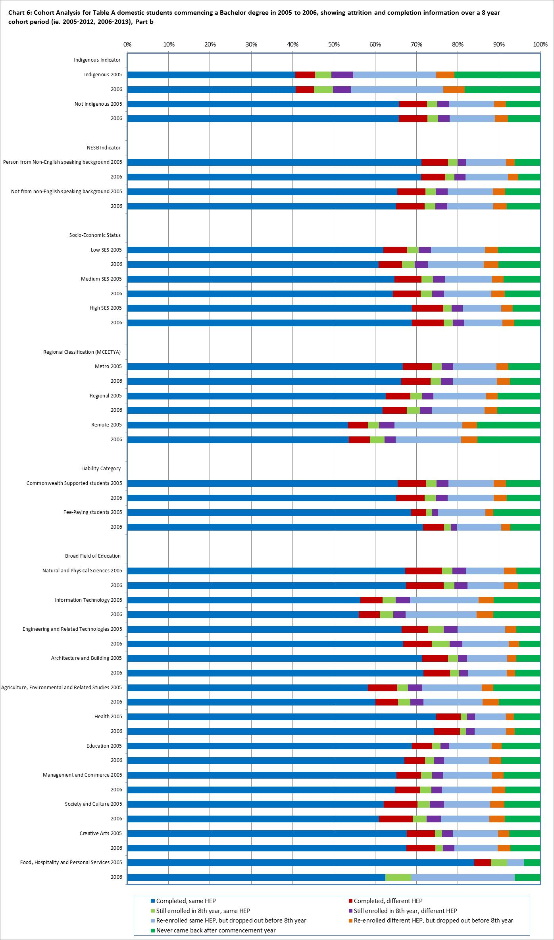

1. Public universities, plus the Batchelor Institute of Indigenous Tertiary Education. For a list of providers included under ‘Public universities’, see ‘[2013 List of higher education institutions](https://education.gov.au/selected-higher-education-statistics-2013-student-data)’ at https://education.gov.au/selected-higher-education-statistics-2013-student-data.
2. The CHESSN was first implemented in the Higher Education Student Data Collection in 2005, under new policy initiatives introduced through the *Higher Education Support Act 2003* (HESA).
3. Students who completed an award course. The award course may not necessarily be the same course that the student initially enrolled in. For example, a student who commenced a Bachelor Pass degree course in 2005 and by 2012, their award course completion could be for a Bachelor Honours degree. Similarly for field of education, a student may have commenced a Science degree but completed an Arts degree. Likewise, a student may have commenced study at one institution, but completed their study at a different institution.
4. Cohort data includes all bachelor level courses (Bachelor’s Pass, Bachelor’s Honours and Bachelor’s Graduate Entry), rather than just Bachelor’s Pass courses, which are the focus of the demand driven system. The number of Graduate Entry and Honours students are small, however, making up approximately 4% of the 2010 cohort.
5. Variation was in part influenced by the small number of students.