Trade Training Centres in Schools Program
2012 Progress Report

The Australian Government is investing nearly $1.4 billion over 7 years (2008 – 2015) through the Trade Training Centres (TTCs) in Schools Program
(the Program) to enable secondary school students in Australia to have access to modern trade training facilities.
Through their education authorities, eligible schools could access Program funding to build new or upgrade existing trade or vocational education and training facilities; and to equip those facilities with industry standard equipment. Eligible secondary schools could apply for funding under the Program either individually or in groups, called ‘clusters’.
The objectives of the Program seek to help
- support the achievement of a national Year 12 or equivalent attainment rate of 90 per cent by 2015
- address skills shortages in traditional trades and other eligible occupations by
- improving student access to trade training facilities that meet industry standards
- improving the quality of schooling offered to secondary students undertaking trade related pathways
- assisting young people to make a successful transition from school to work or further education or training, and
- support the Council of Australian Government’s ‘Closing the Gap’ initiative to halve the gap between Aboriginal and Torres Strait Islander and other students in Year 12 or equivalent attainment rates by 2020.

Participation
The 217 operational TTCs in 2012 had 380 sites where facilities were either constructed or refurbished and equipped. The TTCs enrolled students from over 525 schools. Figure 1 features the number of operational TTCs 2010-2012.
Figure 1: Number of operational TTCs by Year
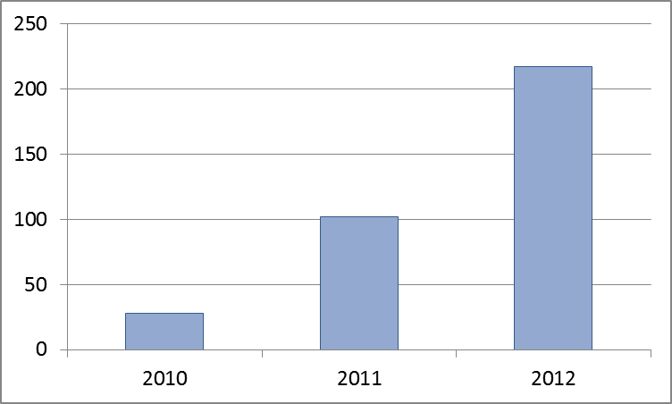
Source: TTC Activity Report data.
Operational results show that enrolments in approved courses are concentrated in the senior years, with more than half of participating enrolments in Year 11, followed by almost a third in Year 12. See Figure 2.

Figure 2: TTCs Enrolments by State and Territory and Student Year Level (2012)
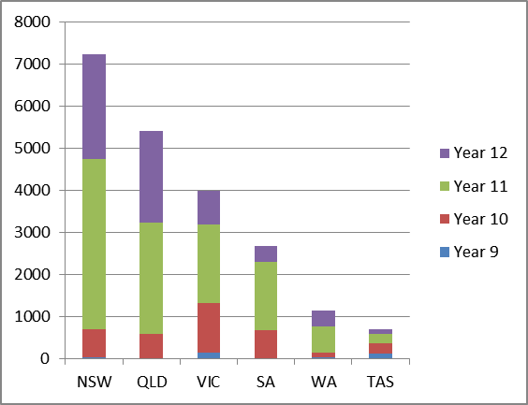
Source: TTC Activity Report data.
The increase in the number of operational TTCs coincides with an increase in the number of student enrolments. Table 1 articulates enrolments in TTCs by various categories.
Table 1: Enrolments in TTCs by Year
Enrolments | 2010 | 2011 | 2012
Certificate I | 294 | 3711 | 5887
Certificate II | 648 | 4808 | 14064
Certificate III | 778 | 672 | 1456
Male | 1448 | 7043 | 15963
Female | 272 | 2148 | 5444
Indigenous | 350 | 1047 | 1669
Non-Indigenous | 1370 | 8144 | 19738
Source: TTC Activity Report data.
Certificate II enrolments increased during 2012, see Figure 3.
Figure 3: Enrolments in TTCs by Certificate Level by Year
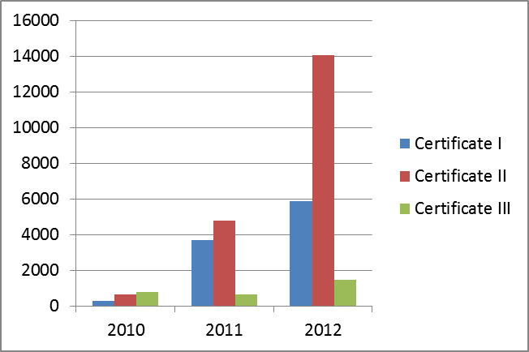
Source: TTC Activity Report data.
The Program aims to address skills shortages in traditional trades and occupations in local demand. Skills shortages tend to occur in traditionally male dominant industries such as engineering, automotive trades and construction.
Enrolment data for 2012 show that females make up one quarter of all TTC enrolments, predominantly in the fields of hospitality and hairdressing, see Figure 4. By contrast males make up three quarters of TTC enrolments and are mainly enrolled in the fields of Engineering and Building and Construction, see
Figure 5.
Figure 4: Female TTC Enrolments by Field of Study (2012)
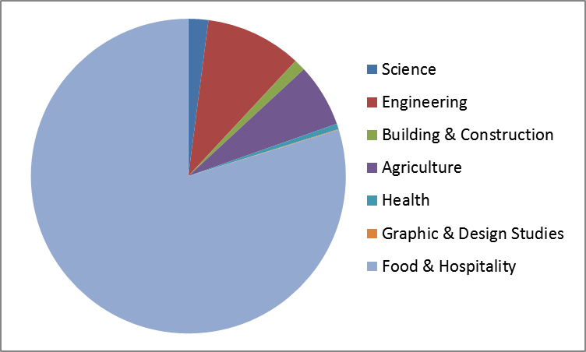
Source: TTC Activity Report data.
Figure 5: Male TTC Enrolments by Field of Study (2012)
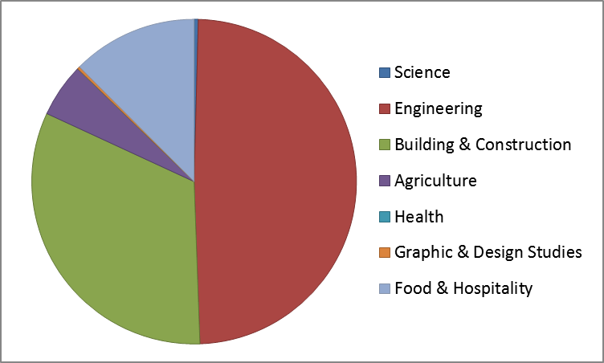
Source: TTC Activity Report data.

There were no operational TTCs in the Australian Capital Territory during the 2012 academic year. Figure 6 shows all 2012 TTC enrolments by broad fields of study and by jurisdiction.

Figure 6: Total Enrolments in TTCs by Field of Study by Jurisdiction (2012)
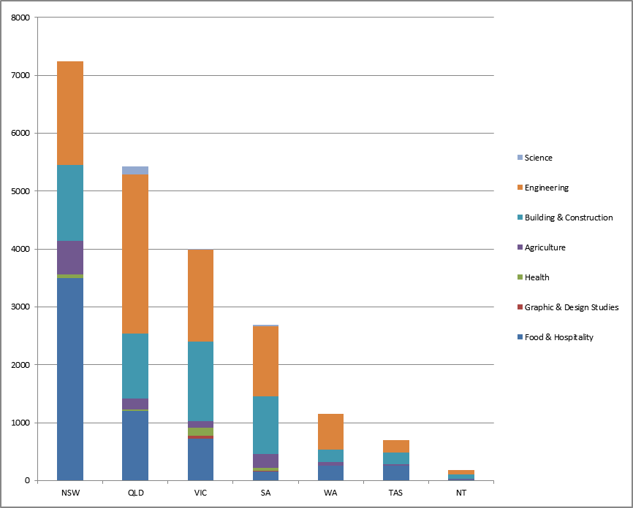
Source: TTC Activity Report data.

Outcomes
The Program built or refurbished a total of 1232 indoor teaching spaces at the 380 sites which reported activity during 2012.
- the average time students spend studying approved courses is approximately 8.5 hours a week
- assuming a 25 hour week, TTCs have on average a 60 per cent utilisation rate

In 2012, 758 TTC students were enrolled in either Australian School Based Apprenticeships or Traineeships.
The number and level of approved courses completed (called completions) are depicted in Table 2 and
Figure 7.
Table 2: Completions in TTCs by Year
Completions | 2010 | 2011 | 2012
Certificate I | 306 | 1625 | 2068
Certificate II | 112 | 1933 | 3256
Certificate III | 1 | 200 | 529
Male | na | 3466 | 4365
Female | na | 1257 | 1488
Indigenous | na | 439 | 363
Non-Indigenous | na | 4284 | 5490
Source: TTC Activity Report data.
Figure 7: Completions at TTCs by Certificate Level by Year
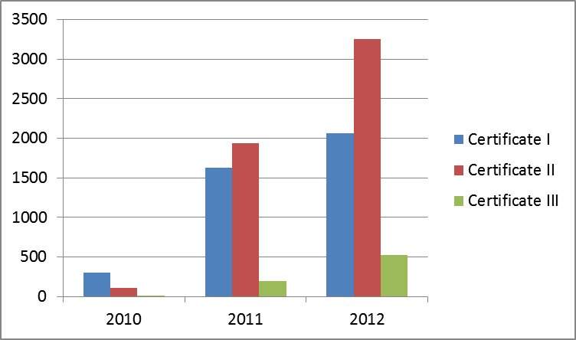
Source: TTC Activity Report data.

Table 2 and Figure 8 indicate how many students successfully completed a unit of study (competency) within a certificate during 2012.
Table 4: Number of TTC Students that Completed a Unit of Competency by Certificate Level and Year
Students | 2010 | 2011 | 2012
Certificate I | 102 | 222 | 2301
Certificate II | 340 | 362 | 9259
Certificate III | 222 | 157 | 869
Source: TTC Activity Report data.
Figure 8: Number of TTC Students that Completed a Unit of Competency by Certificate Level and Year
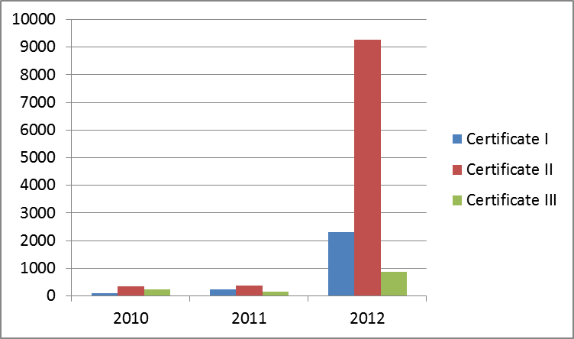
Source: TTC Activity Report data.
For more information visit: www.education.gov.au/trade-training-centres-schools-program

