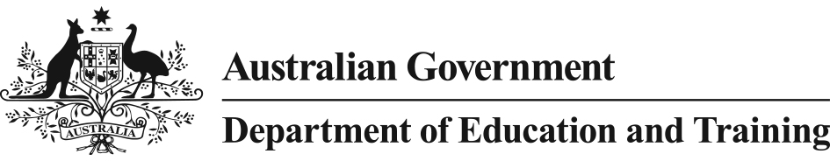 

Australian Government Response

*Action Now: Classroom Ready Teachers* Report

The Teacher Education Ministerial Advisory Group Report, *Action Now: Classroom Ready Teachers*, released on 13 February 2015 recommends significant improvement to the content and delivery of teacher education courses in Australia. The Report recognises that while there are examples of excellent practice, pockets of poor practice remain.

The Australian Government believes that the Advisory Group’s recommendations are practical and achieveable with the potential to make a real impact on the quality of teaching and student outcomes in Australia.

# Swift and decisive action

The Australian Government’s Response to the Report addresses five themes:

* stronger quality assurance of teacher education courses
* rigorous selection for entry to teacher education courses
* improved and structured practical experience for teacher education students
* robust assessment of graduates to ensure classroom readiness
* national research and workforce planning capabilities.

By responding to the Report with swift and decisive action, the Government will seek to make a real difference to the training of our teachers. Using the expertise of the Australian Institute for Teaching and School Leadership (AITSL) and the shared commitment of state and territory governments and non-government schools, along with universities, the Commonwealth will provide national leadership to drive improvement in teacher education in Australia.

*Stronger quality assurance of teacher education courses*

To drive high expectations of teaching and to lift confidence in the preparation of all beginning teachers, the Government supports improved course accreditation processes that require universities to provide better quality information and will instruct AITSL to work with states and territories and universities to increase the rigour of course accreditation. This information will need to include why each course has been designed the way it has and provide the evidence that this will ensure their teacher education students possess the knowledge and skills they need to be successful in the classroom.

The Government notes the Report recommendation to establish a new national regulator of teacher education courses, but does not believe a new body will necessarily deliver better quality assurance nationally. Instead, the Government will utilise the expertise of existing bodies to achieve this outcome. AITSL will be given greater responsibility for driving improvement in the quality of initial teacher education and will work with state and territory teacher regulatory authorities to increase the rigour of assessment of courses for accreditation

*Rigorous selection for entry to teacher education courses*

The Government supports rigorous selection processes for entry into teacher education courses and will instruct AITSL to develop and set clear expectations of universities to make sure that those going into teaching have the right mix of academic and personal qualities that give them the best chance of becoming effective teachers. This will also help make sure university and school resources are directed to those best suited to a teaching career.

Teachers must also possess strong personal literacy and numeracy skills to foster the development of these skills in their students. The Government will therefore work with universities to make available a national literacy and numeracy test for teacher education students graduating from 2015. From 2016, all teacher education students will be required to pass the test before they graduate.

*Improved and structured practical experience for teacher education students*

The Australian Government agrees that timely, high quality, structured and supported practical experience is critical for teacher education students to develop the knowledge and skills they need to be effective teachers. The Government believes this experience should be provided to students as early in their initial teacher education training as possible.

To ensure universities and schools provide student teachers with the opportunity to apply theory to the practice of the classroom, the Government will instruct AITSL to develop the essential requirements of effective practical experience. This will include the identification of examples of best practice and clear expectations for the experience and assessment of student teachers. This work will be developed in partnership with universities, schools and education authorities.

*Robust assessment of graduates to ensure classroom readiness*

Robust assessment of teacher education students is vital to giving schools and families the confidence that all graduates are classroom ready. To achieve this, the Government supports the development of a framework for the robust and consistent assessment of teacher education students throughout the duration of their course.

The Government also supports a nationally consistent approach to induction and ongoing assistance for beginning teachers to ensure all are given the support needed to become an effective teacher.

Classroom readiness includes the ability for new teachers to effectively teach core subject areas, such as mathematics and science. The Government agrees that every new primary teacher should graduate with a subject specialisation. This does not mean primary teachers will teach only in their area of specialisation, but rather that their expertise will be available within the school to assist other teachers to teach the subject effectively.

*National research and workforce planning capabilities*

More reliable research and data is needed to better inform the development of teacher education courses and to better plan for future workforce needs. A national focus on research in teacher preparation will be led by Professor John Hattie, Chair of AITSL, to address this gap. Part of this work will monitor the effectiveness of improved course accreditation arrangements. This includes a review of the Graduate level of the Australian Professional Standards for Teachers to make sure they continue to reflect the knowledge, skills and capabilities required of beginning teachers.

The Government will instruct AITSL to work collaboratively with states and territories, the non-government school sector, teacher regulatory authorities and universities to build on existing data sources to develop national teaching workforce data.

# Next steps

*Action Now: Classroom Ready Teachers* provides an excellent blueprint for the reform of initial teacher education. The Government will ask AITSL to immediately commence key pieces of work arising from the recommendations, working in close collaboration with the states and territories, non-government school sector, universities and other key stakeholders to ensure this work is underpinned by a strong evidence base.

The Australian Government has a responsibility to provide national leadership to lift the quality and consistency of teaching courses in Australia and provide the world class education each child deserves.

# Further Information

Information on the Teacher Education Ministerial Advisory Group including the *Action Now: Classroom Ready Teachers* Report and the Australian Government response are available on the *Students First* website at: [www.studentsfirst.gov.au](http://www.studentsfirst.gov.au).