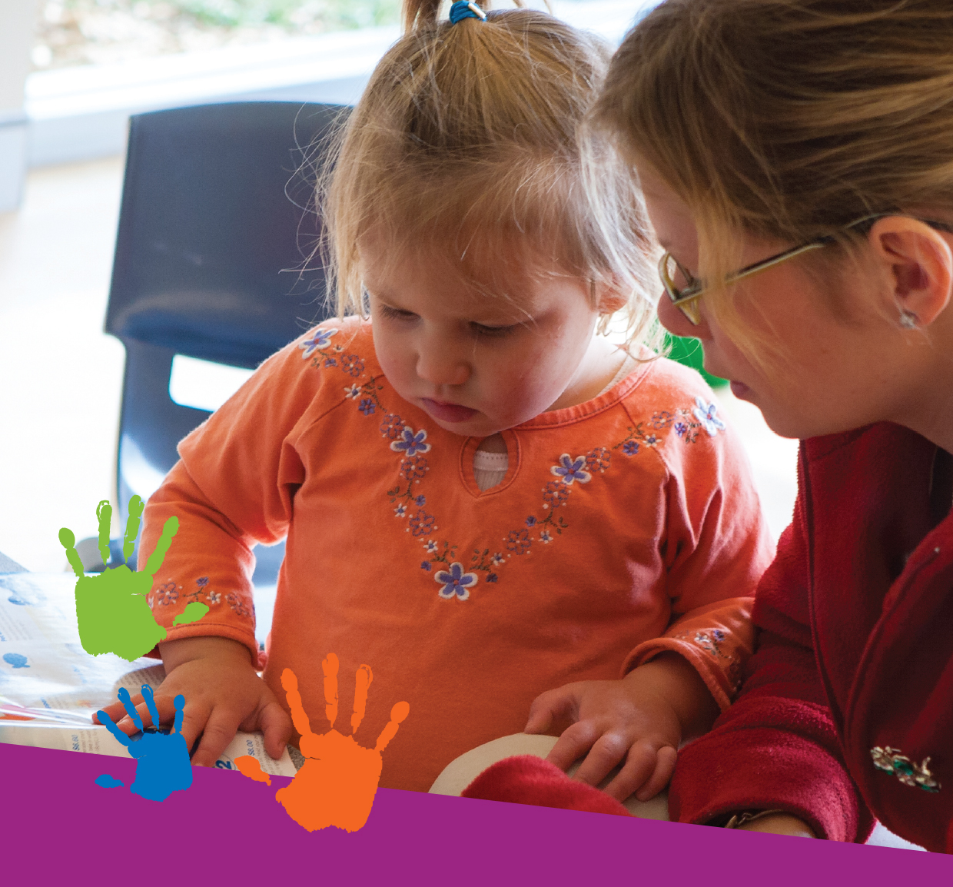



Early Childhood
Literacy and Numeracy
Building Good Practice
Marilyn Fleer and Bridie Raban

EARLY CHILDHOOD LITERACY AND NUMERACY CARDS
This set of cards has been developed to help you support young children in learning to read, write and do maths. They are the result of careful research into how young children learn.
The cards show how literacy and numeracy are developed through simple family activities, and how these link to later learning at school.
Each card depicts a family involved in every day interactions, includes a key literacy or numeracy message at the bottom and a description of what children and adults might say and do.

LITERACY CARDS

Watching and listening develops language
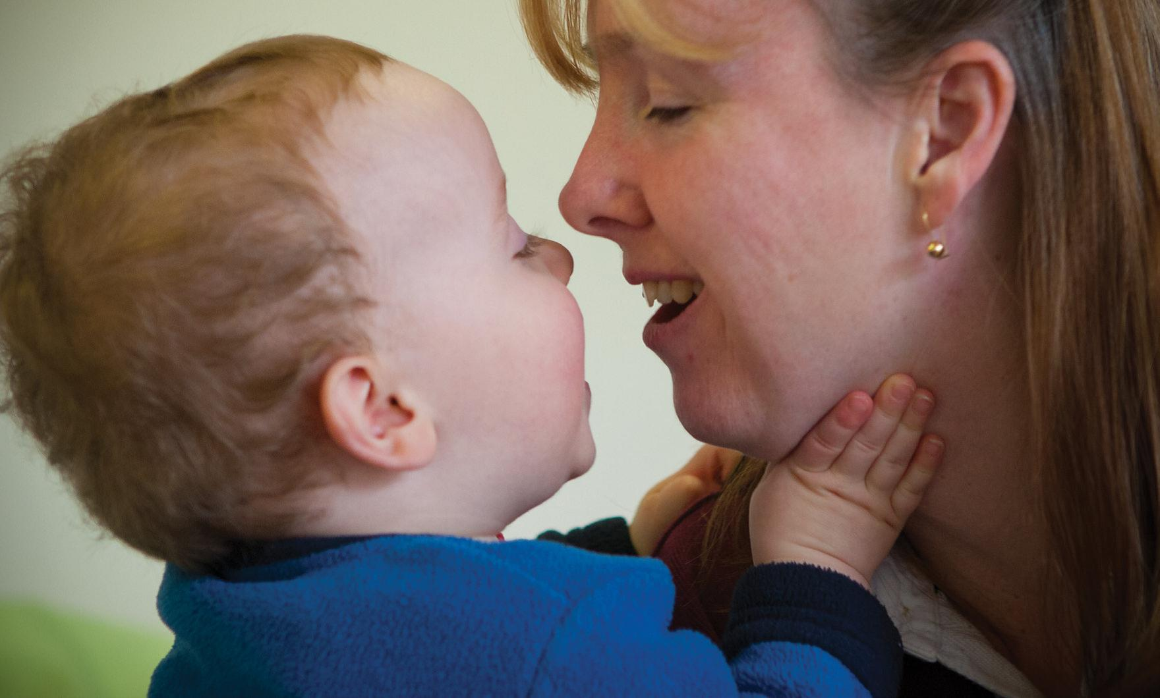

What we do and what it means
Mum: Up you come; is that better? You’re happy now.
We use our hands, eyes, face and words to communicate with very young babies, because this shows them how people communicate.
Soon, the baby’s babbling noises will sound like adult talk.
They begin to take turns and wait for a response.
Later, children will choose the right words and body language to communicate their feelings and needs.

Playing with rhymes helps children practice sounds
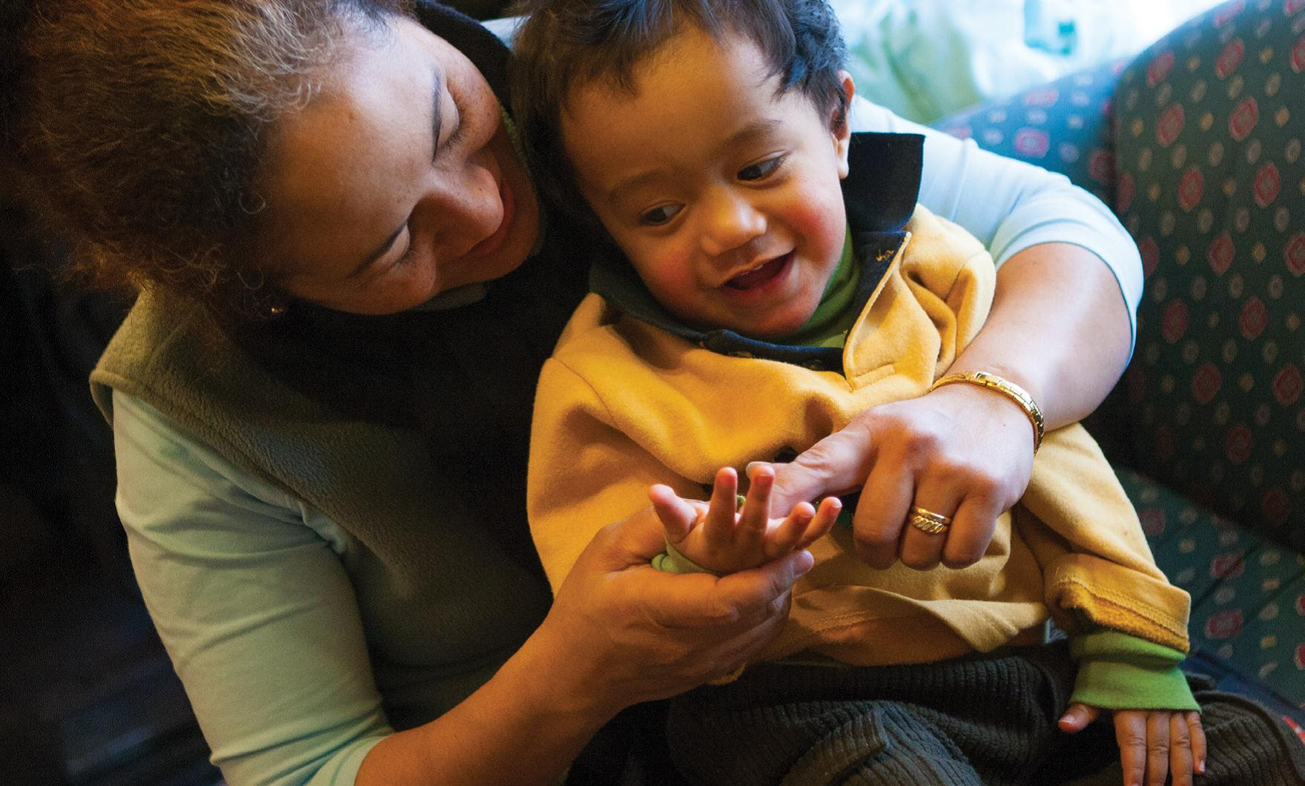

What we do and what it means
Sebastian and his mum like to say favourite rhymes: Round and round the garden…
We sing rhymes and jingles with children so that they learn to hear and match words that sound the same.
Later, children will begin to match sounds to alphabet letters on the page. This will be very important in learning to read, write and spell.
When English is a second language, adults share rhymes in their first language with children.

Describing things and grouping them develops the language of classifying
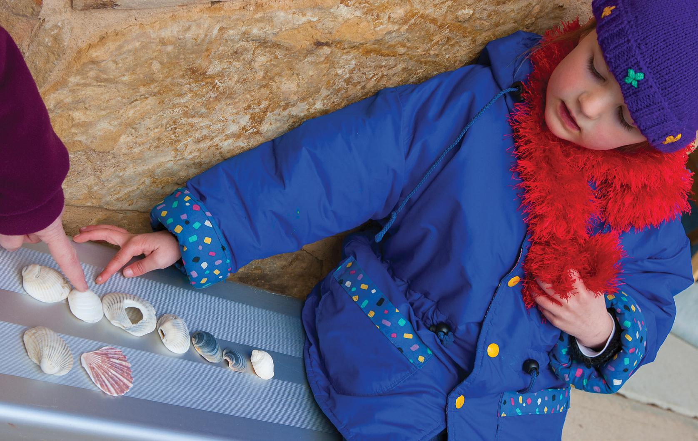

What we do and what it means
Mum: Which shells look the same?
Maria: There are big ones and some smaller colourful ones.
We ask children to describe objects and get them to look for similarities and differences. We help children to develop the language to classify, sort and group things.
They need language for classifying in literacy and numeracy later.

Sharing books is the beginning of reading
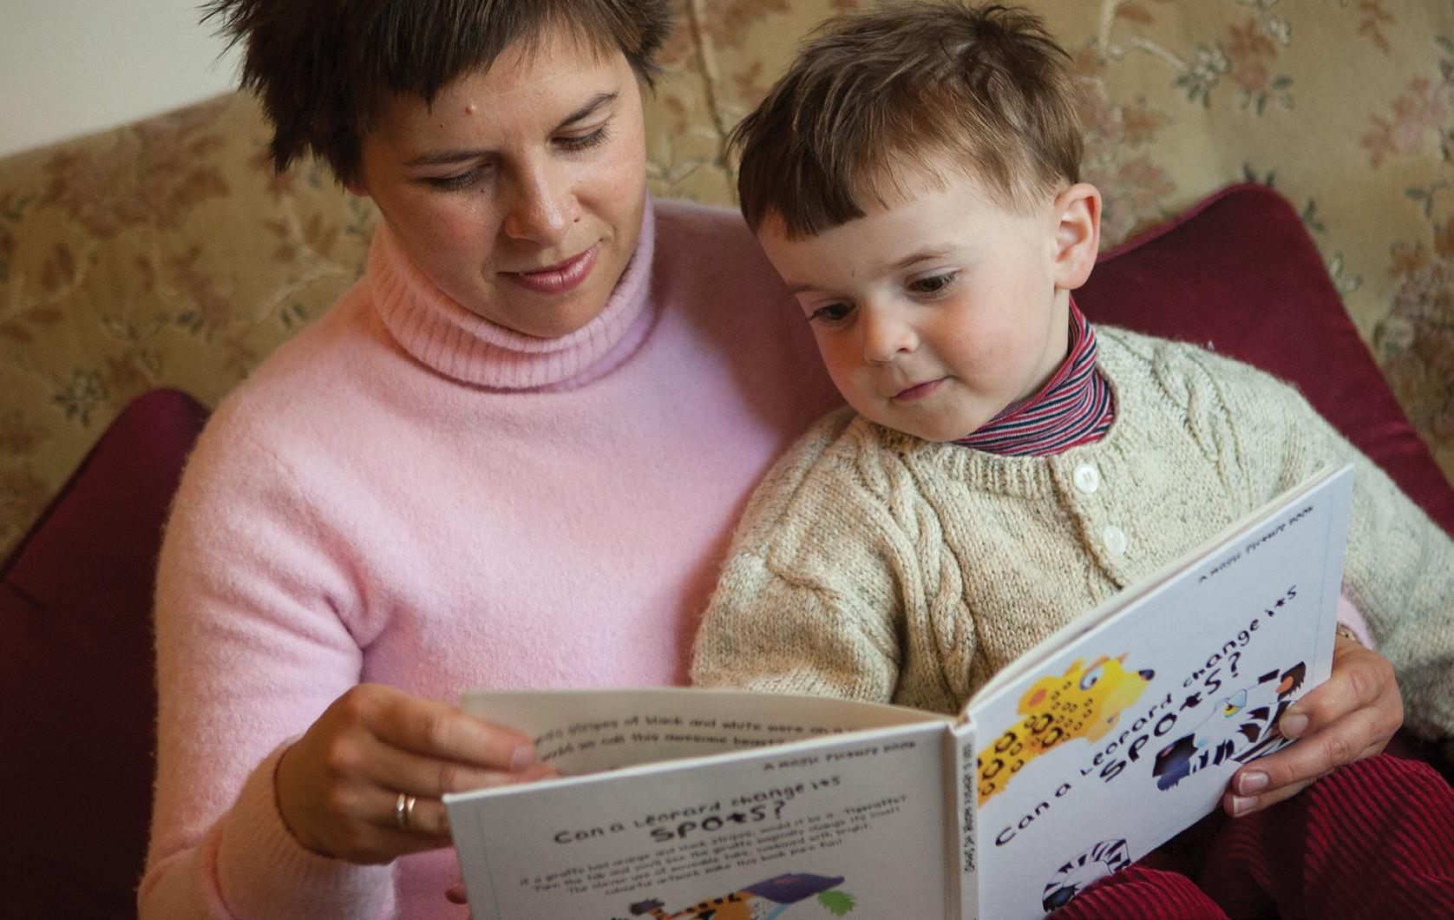

What we do and what it means
Big bear, little bear over there.
Being close to a special adult while looking at a book makes a child feel warm and safe. Very young babies like nursery rhyme books best. The rhythms of the rhymes and the sounds of the words soothe them and they may touch, smell and even chew the book.
Later, children will hold the book the right way up and turn the pages. They will choose favourite stories. Learning how a book works and that it is fun, is an important part of learning to read.

‘Pretend Reading’ is real reading
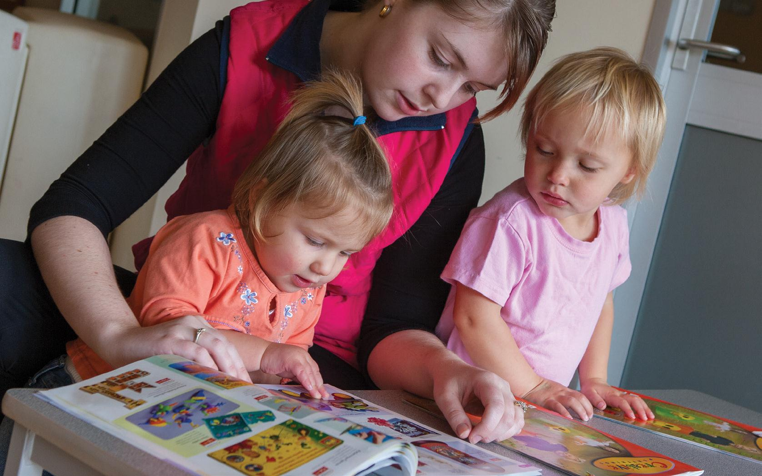

What we do and what it means
Mum: What happened to the little duck?
Bonny: The little duck went out one day and he got lost, but his daddy found him; the end.
Children make up a story to go along with the pictures before they are able to read the words.
Children can do this because they expect a story to have characters, a beginning, an end and some action in the middle. Adults listen to the child’s story to show that they know this ‘pretend reading’ is a practice for reading the words and pictures properly later.

Signs and words are all around us
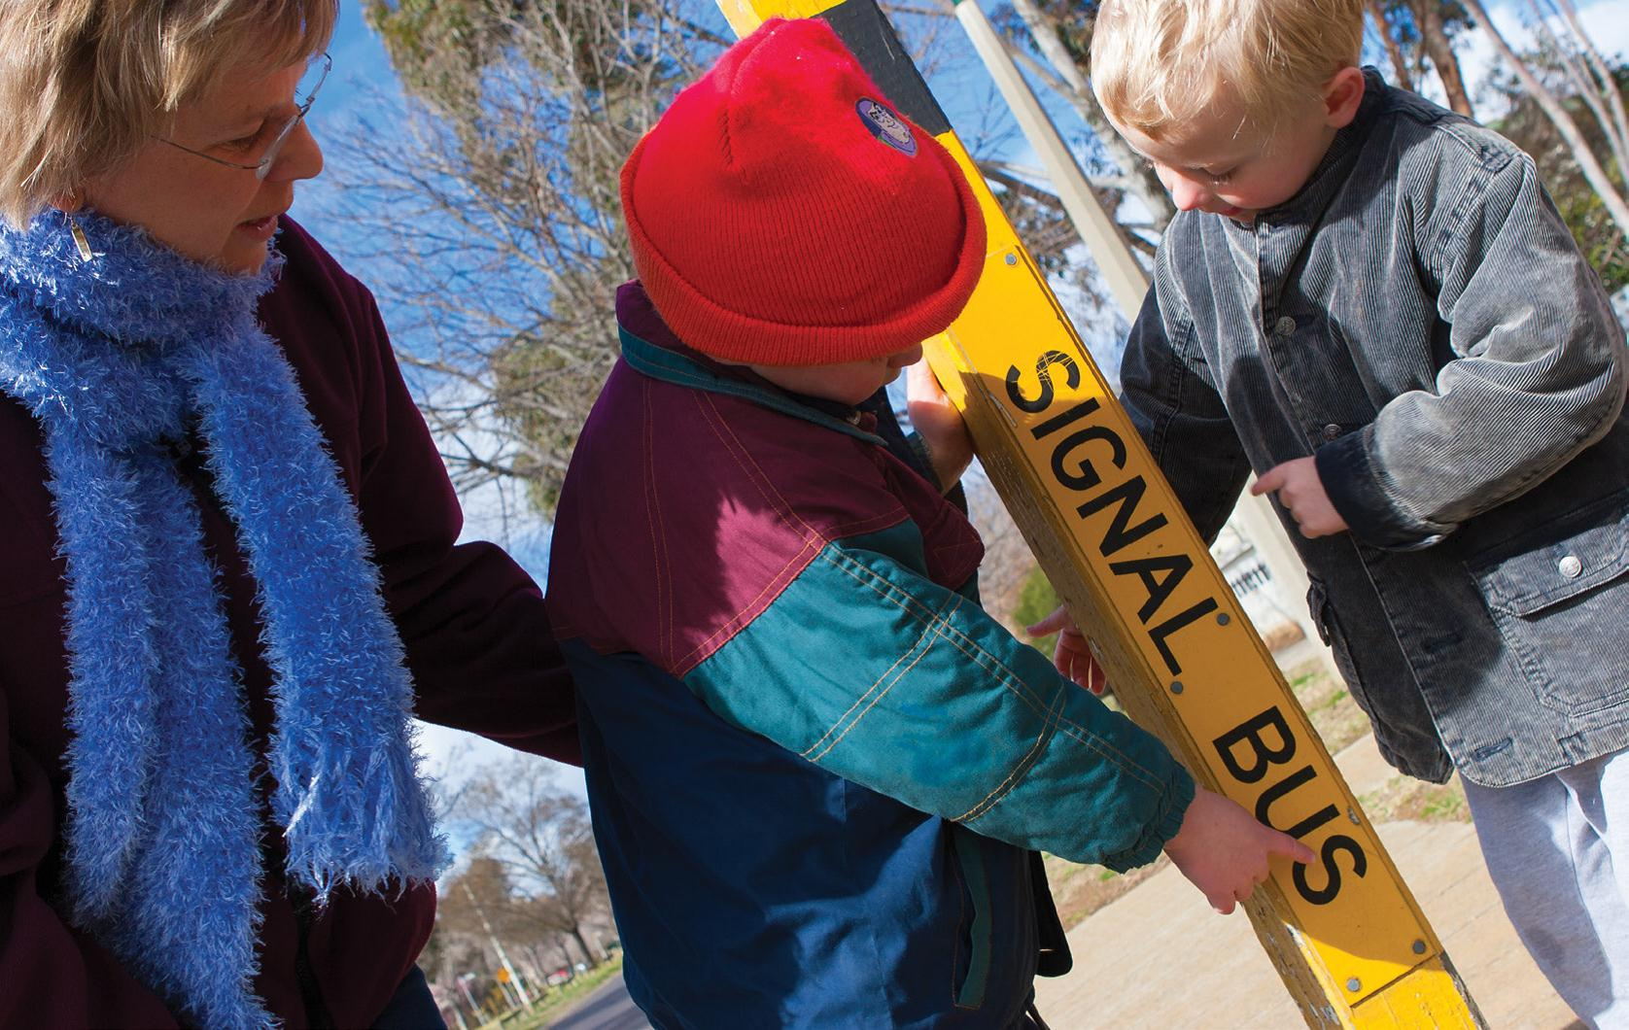

What we do and what it means
Mum: This is where the bus will pick us up. Look! The sign says bus!’
Drawing children’s attention to signs in the environment helps them learn to read letters and words.
Children begin to recognise symbols that are important to them, such as letters in their own name, the word for their street and the signs on buildings, or shops, that they pass often.
Later, children will learn that words keep the same meaning, even when they appear in different places. This idea is very important for literacy learning.

You can’t read too many stories
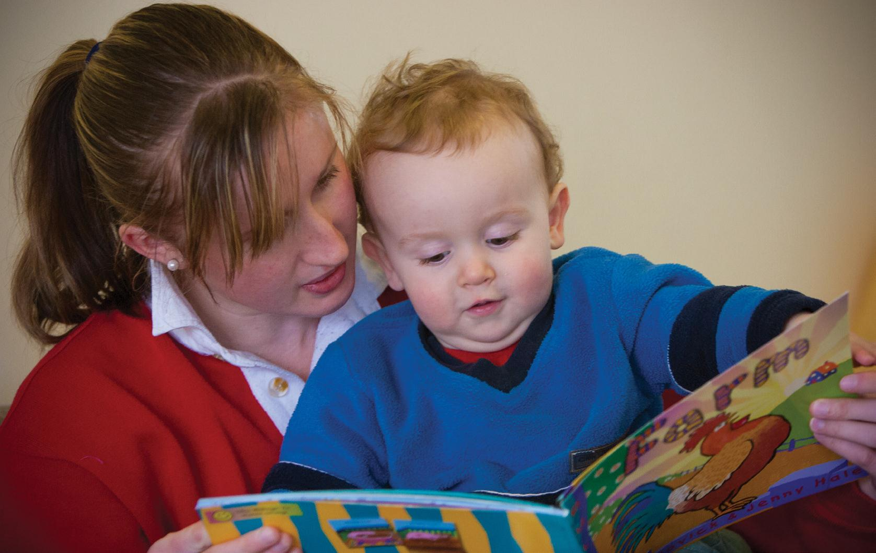

What we do and what it means
Once upon a time there were three bears, reads mum.
Baby bear, says Jack.
We read lots of stories to children from the very earliest age, so that they learn how particular stories work.
Children begin to recognise what kind of story it is and to predict the words and the action that will come next.
Being able to predict is an important skill in learning to read.

Reading gives us information
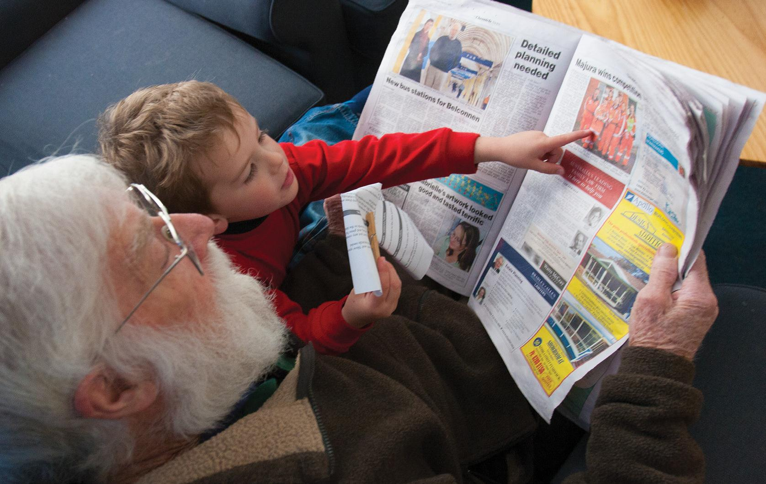

What we do and what it means
Wade: Grandad, that’s the Rovers.
Grandad: Yes, I think they’re playing tonight.
We read everyday materials like newspapers, magazines and catalogues with children so they can see how useful reading is.
Some children, especially some boys, are more interested in information reading than in stories.
Later, they will work at learning to read so they can find out about things and follow instructions.

Learning to read carefully takes time
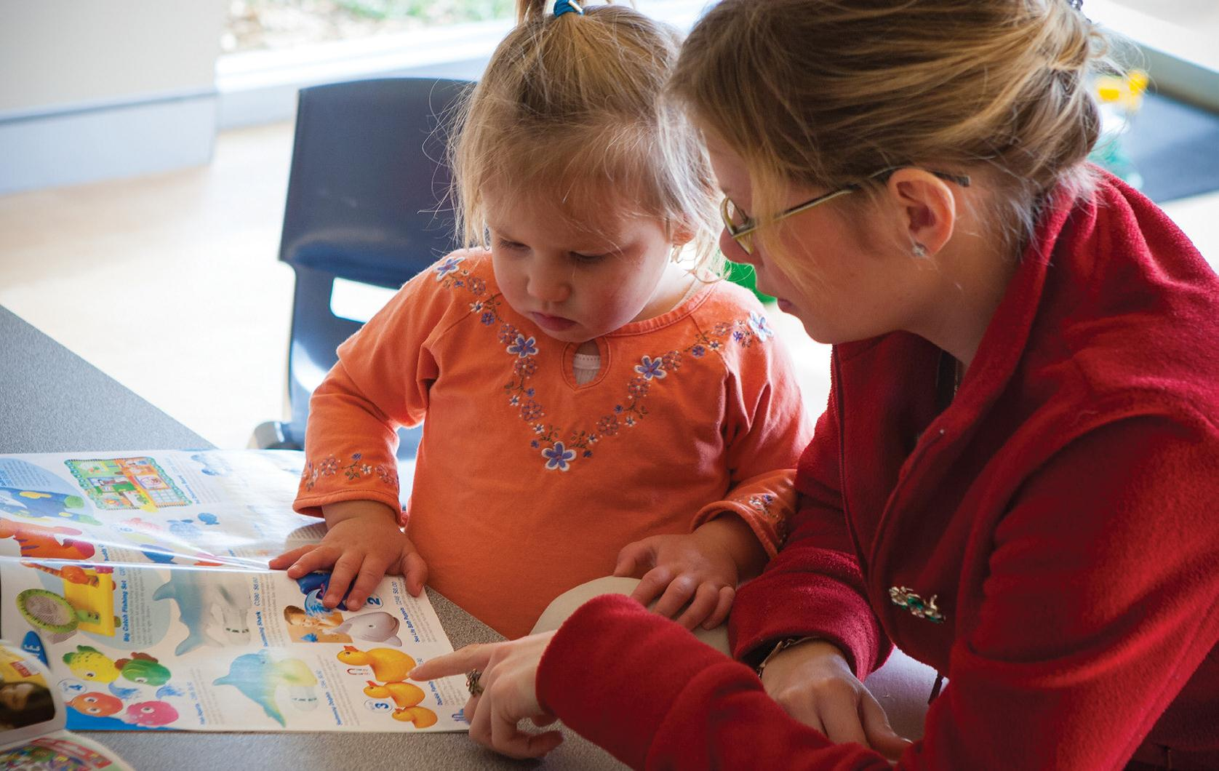

What we do and what it means
Bonny wants mum to buy things from the toy catalogue.
Mum: Look how expensive they are.
Children like to look at catalogues and choose things they’d like to own.
With an adult helping, they learn to think about value for money and whether the family can afford it.
Later, they will realise that advertising is ‘selling something’ and learn to read it carefully.

Talking about TV helps children learn
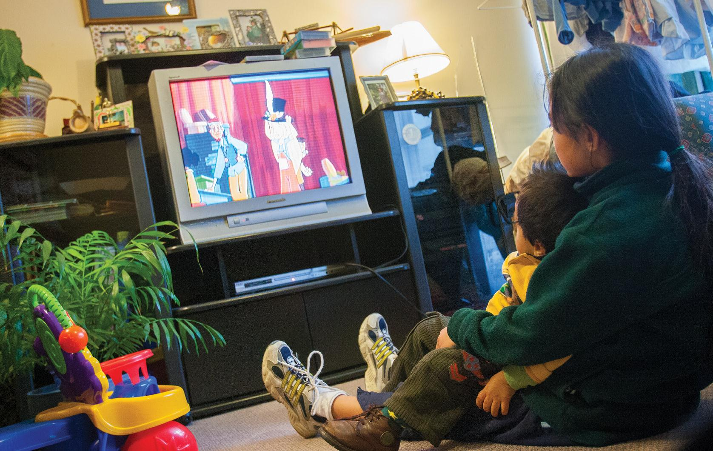

What we do and what it means
There’s a bear in there, the children sing.
What is the bear doing? asks Jess.
Adults talk to children about what they see on TV because they want them to be thinking, not just watching.
They encourage children to join in games and songs because that keeps their minds active and they learn things they can do away from the TV.

We can tell stories in lots of ways
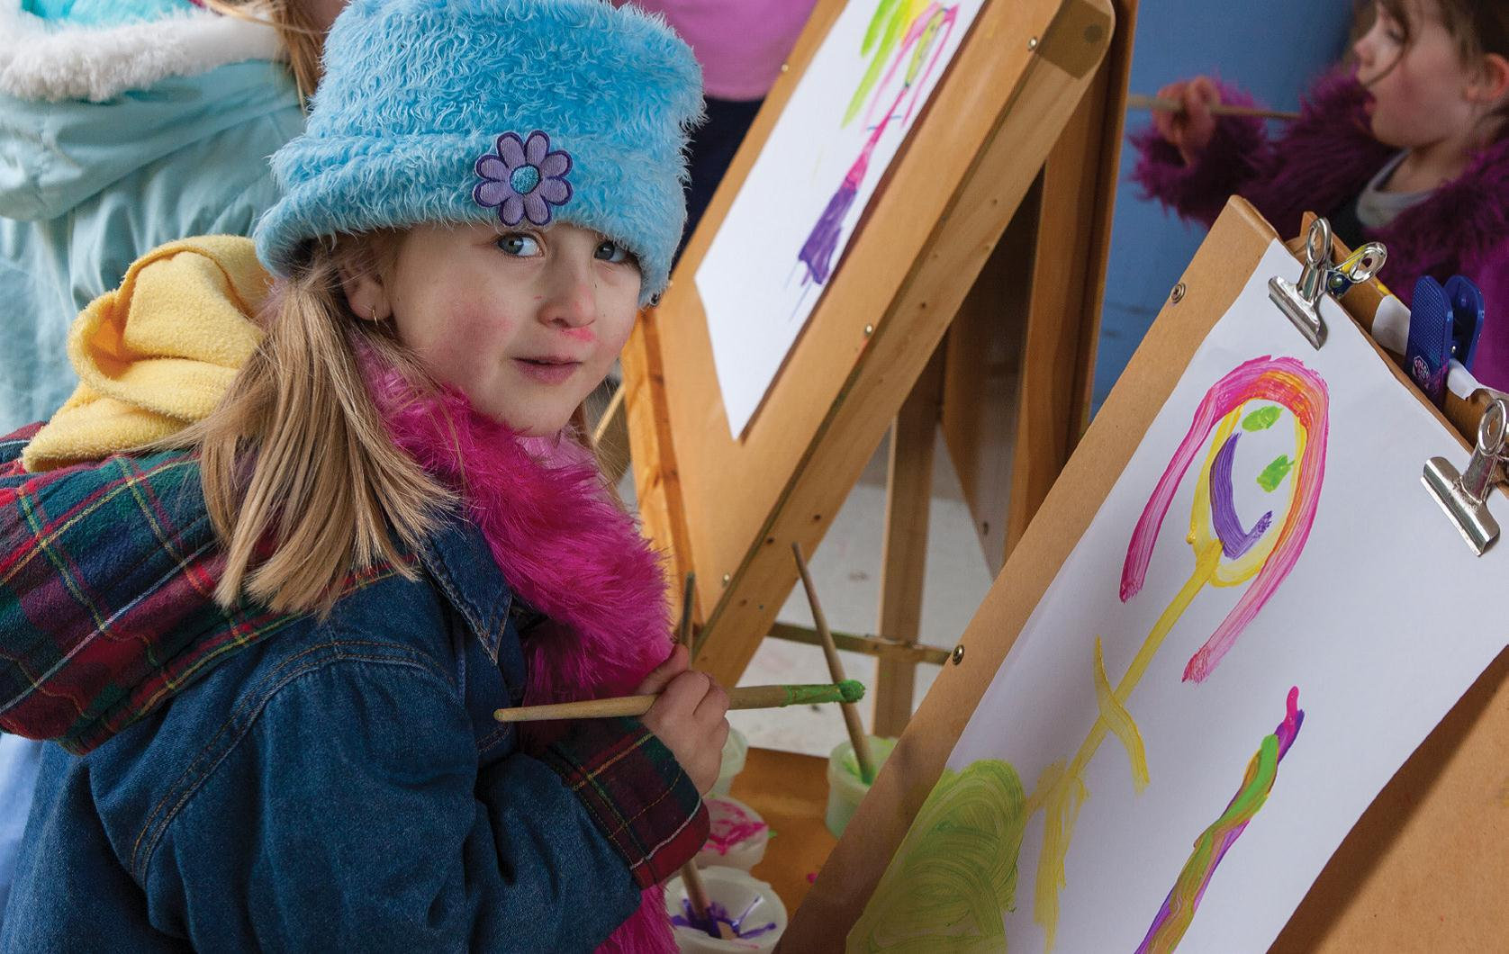

What we do and what it means
The child draws the story about the animal to show the others. Children learn how to read and write by being with their community.
They listen to how adults and older children tell stories and draw them for others to read.
They begin to imitate by telling stories, reading the signs and drawing events.

Reading helps us get things done
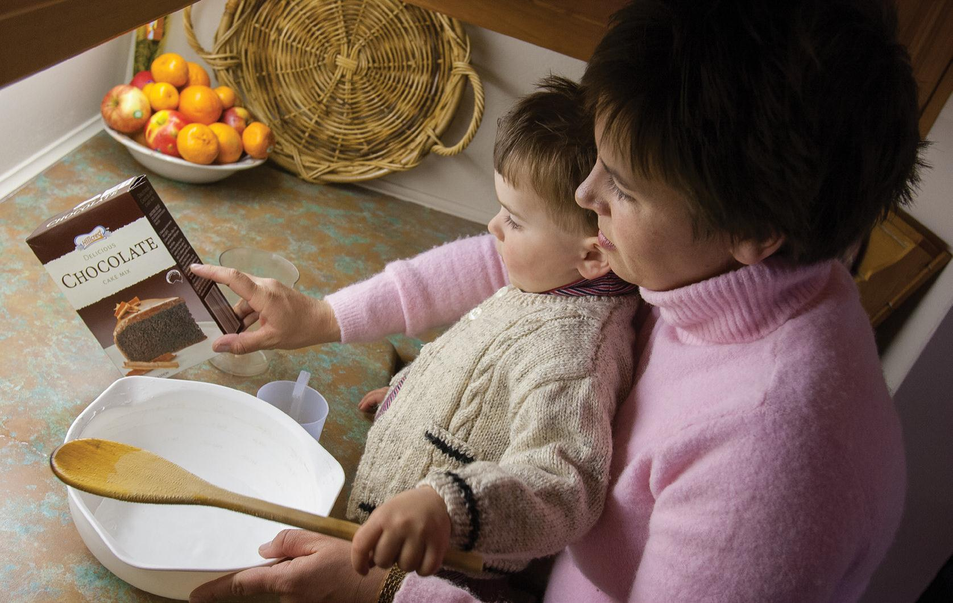

What we do and what it means
How many eggs do we need, Sam? Let’s check the recipe.
When we do things like cooking or gardening with children, we involve them in reading the packets, recipes or planting instructions.
This shows them how we use written materials like these.
Later, children will realise that you have to read carefully and follow a sequence of instructions.

Messages can be sent from one place to another
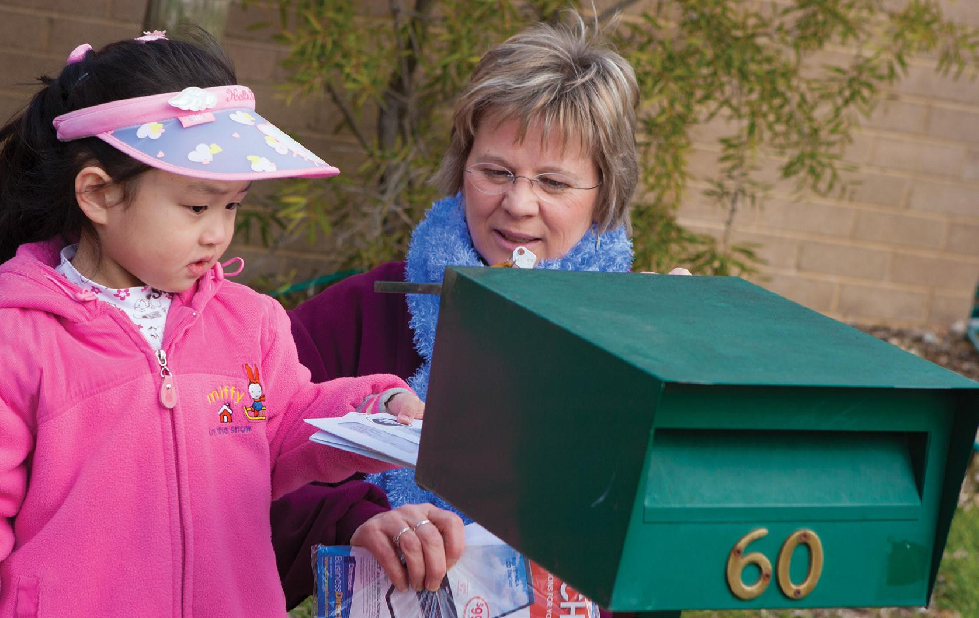

What do we do and what does it mean
Look, you’ve got a letter. What does it say?
When we talk about the mail we’ve received, children learn that written language can carry a message from one place to another.
Later, they will learn that there are different kinds of messages. Some are cards and letters from family and friends; others may be advertising or bills.

Drawing and scribbling lead to writing
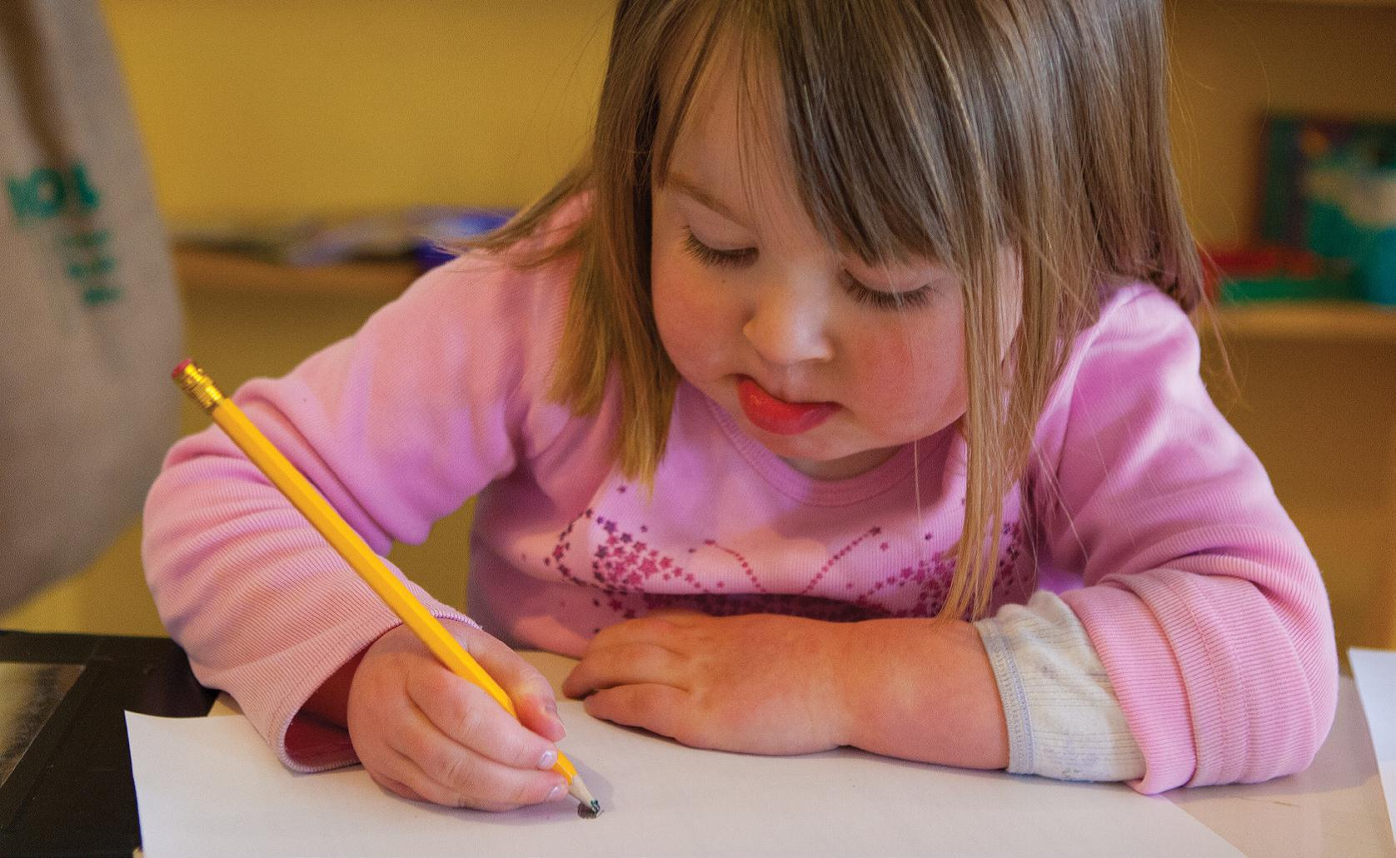

What we do and what it means
What have you drawn this time?
Letting children scribble and draw helps them learn to write.
Over time, children learn that writing is a particular kind of ‘drawing’ that carries a message.
Later, children will learn that writing can be used to make lists, fill out forms and to tell people about things in stories and letters.

Making lists is useful writing
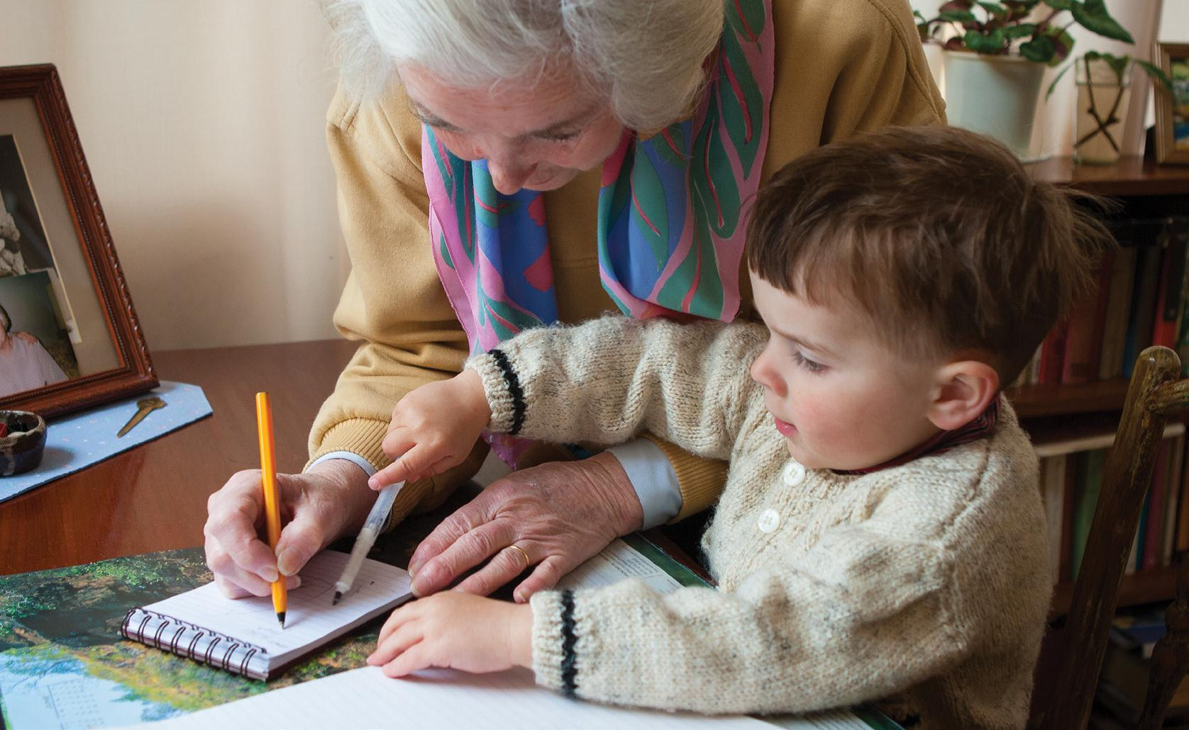

What we do and what it means
Grandma makes a list, saying, Now Carl, what do we need to buy at the supermarket?
When we write in front of children and talk to them about it, they learn that writing helps us to carry information and to remember things.
Later, children will learn that various kinds of writing look different – a list goes down the page; a message to someone goes from left to right across the page – and that they serve different purposes for us.

Other people can read what we write
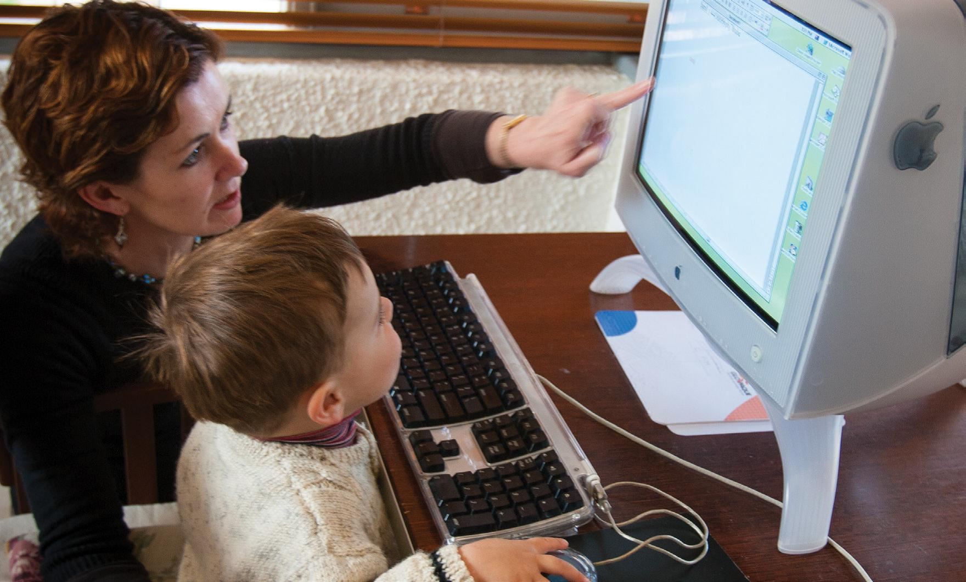

What we do and what it means
Claire asks, What do you want to say to Auntie Jan?
I’ve got a new bike and Jason came over.
By involving children when we’re writing a letter or an email, we show them some of the ways messages can be sent from one person to another.
They can add some words, a drawing or a photo.
Later, children will learn that what they have written has the same meaning when it is read somewhere else. They will learn that messages sent by computer cover long distances quickly.

NUMERACY CARDS

‘More’ and ‘less’ are about comparing things
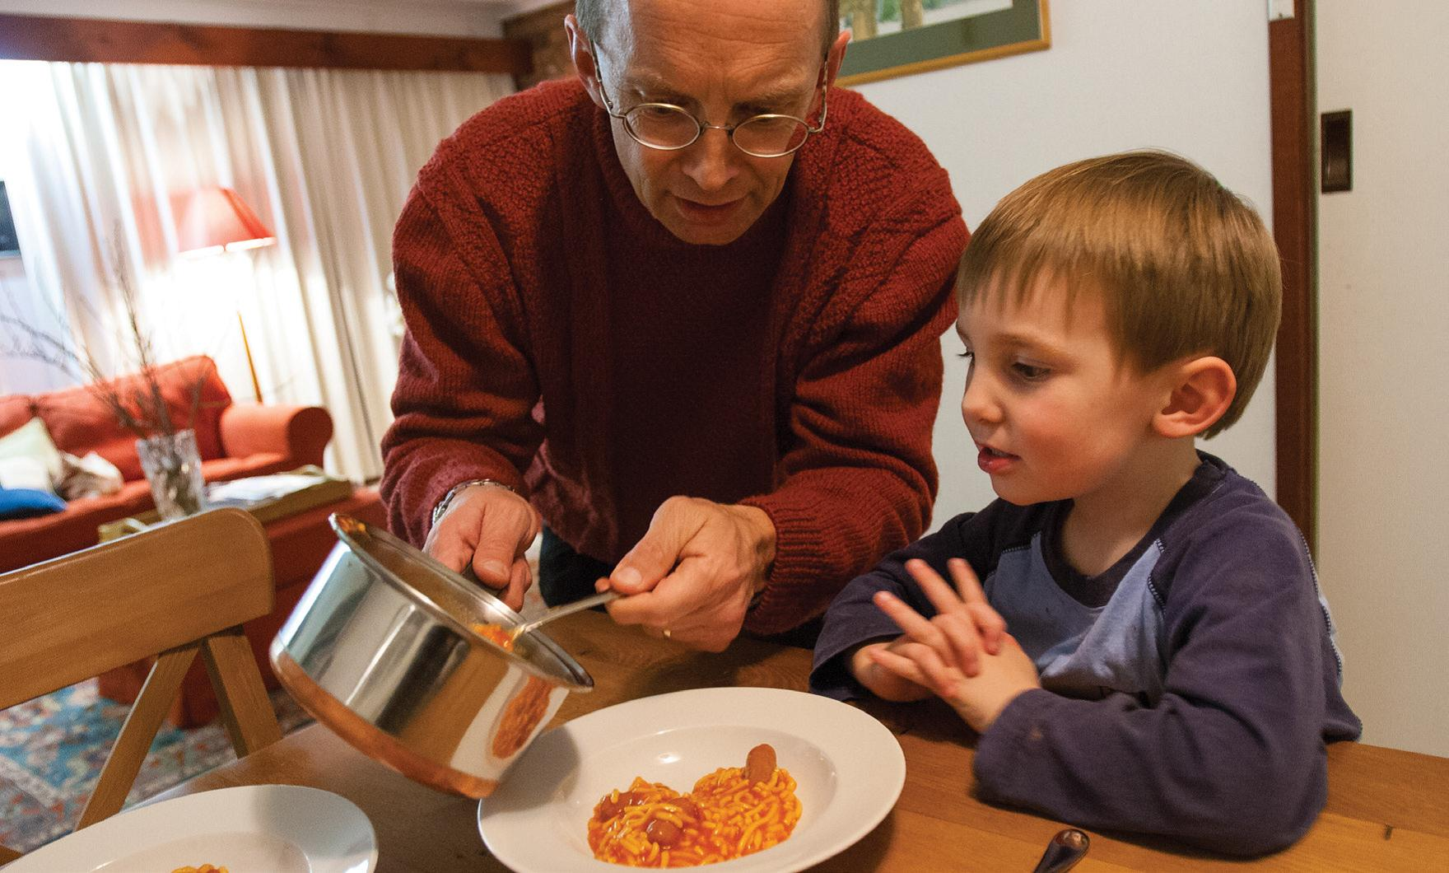

What we do and what it means
Dad: Ollie, there isn’t any more spaghetti. Do you want some more sausages?
Ollie: No, I have enough. Look how many I got!
Knowing what ‘more’ and ‘less’ means helps children know how to compare different amounts.
Comparing different amounts is necessary for maths development because later children will be able to compare groups of things, counting which has more.

‘Upside down’ is about position and direction
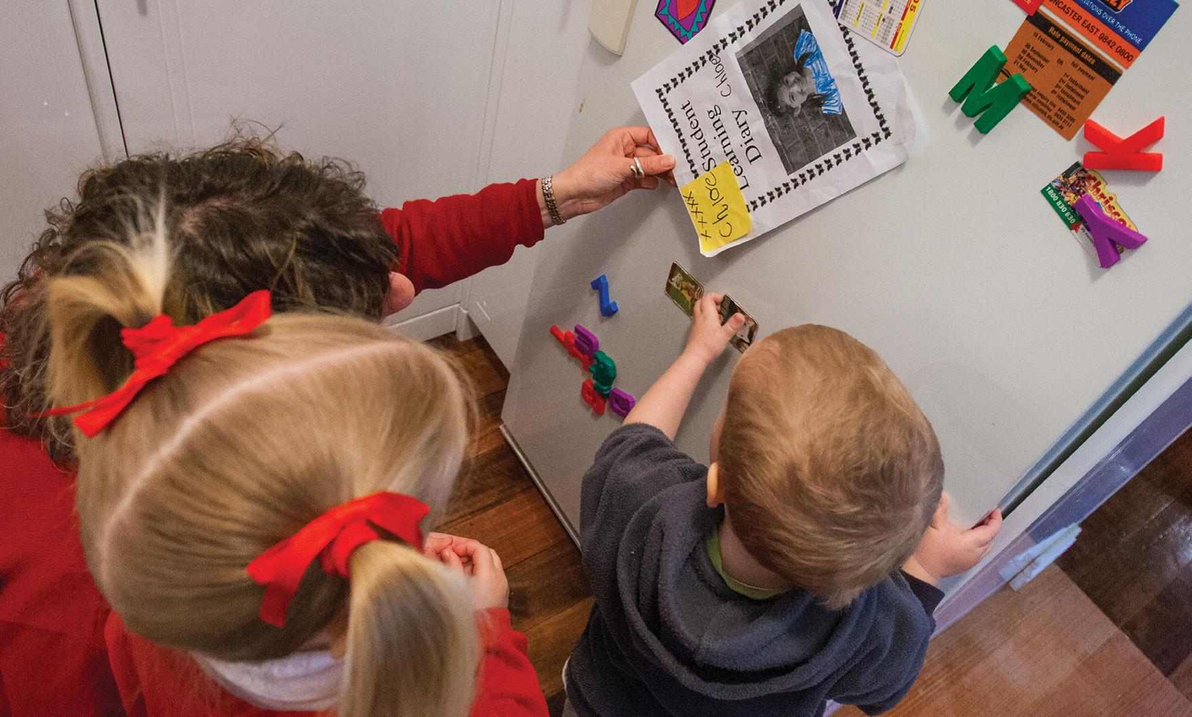

What we do and what it means
Mum: The picture is upside down. Turn it around the other way.
When we talk about turning things around, moving things closer or state which way up something is, children are learning about the position of something.
Position (where something is) and direction (where they go) are key ideas in mathematics.
Later, children learn to pay attention to position, order and direction.

‘Up’, ‘down’ and ‘next to’ are about position
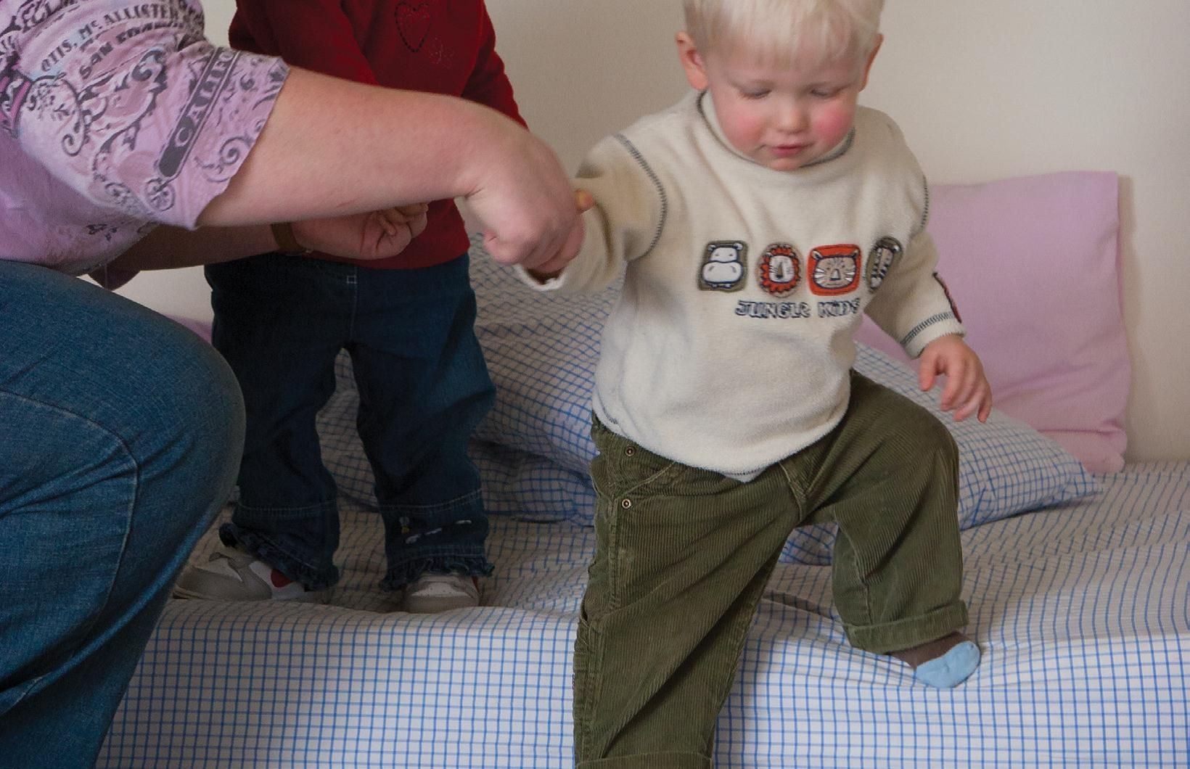

What we do and what it means
Mum: Down we go!
When we talk about ‘up’ and ‘down’, ‘over’ and ‘next to’, children are learning about the position of something.
Over time children learn that there are words (for example upside down, next to, behind) which describe position.
Later, children learn to pay attention to position, order and direction. They are key ideas in mathematics.

‘Top’ and ‘edge’ are about area
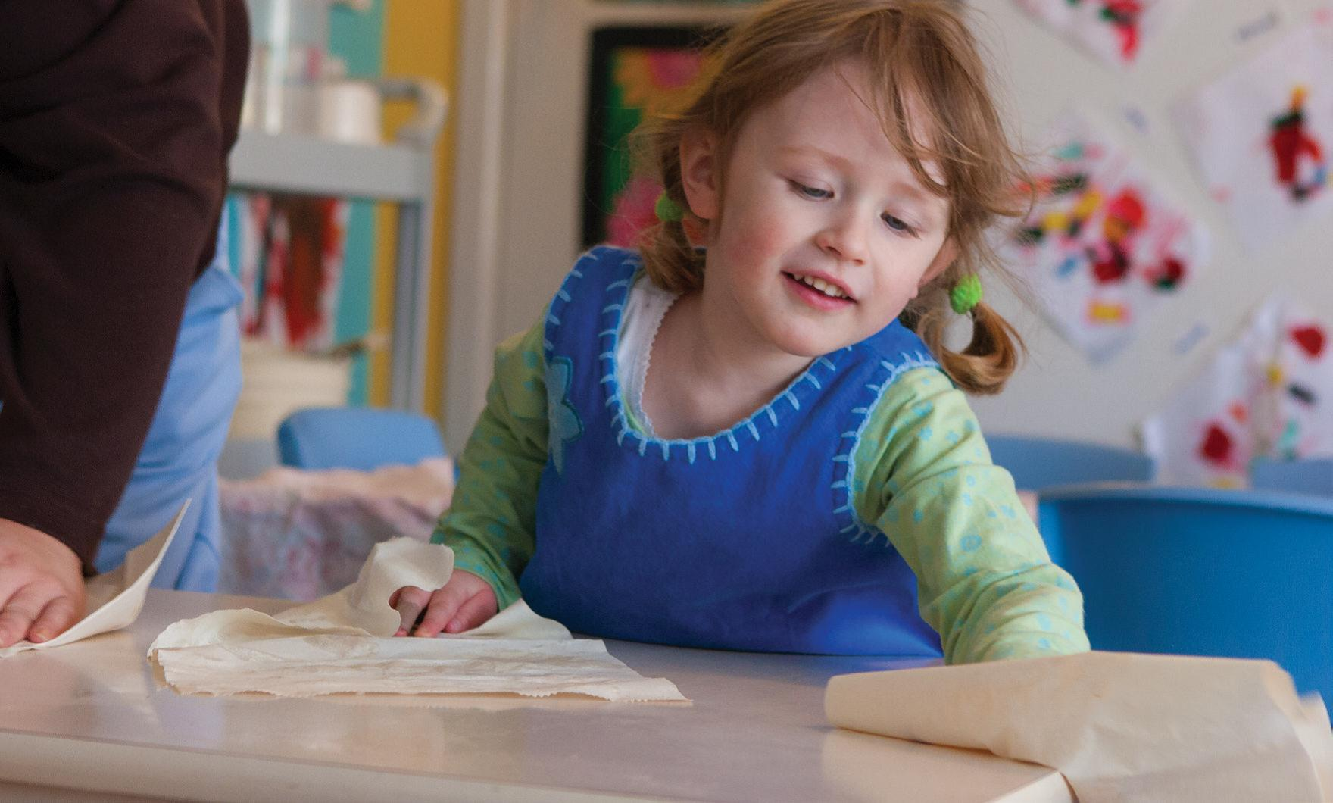

What we do and what it means
Dad: Let’s wipe the table together.
Using paper towels, the children wipe the table.
Dad: Did you wipe to the edge? We cover the whole surface!
When we talk about ‘edge’, ‘top’ and ‘bottom’, we can help children learn about area. Children often don’t think about area. Helping children pay attention to it helps them later on when they will measure these surfaces and make comparisons.

‘Straight’, ‘curved’ and ‘bent’ are about shape
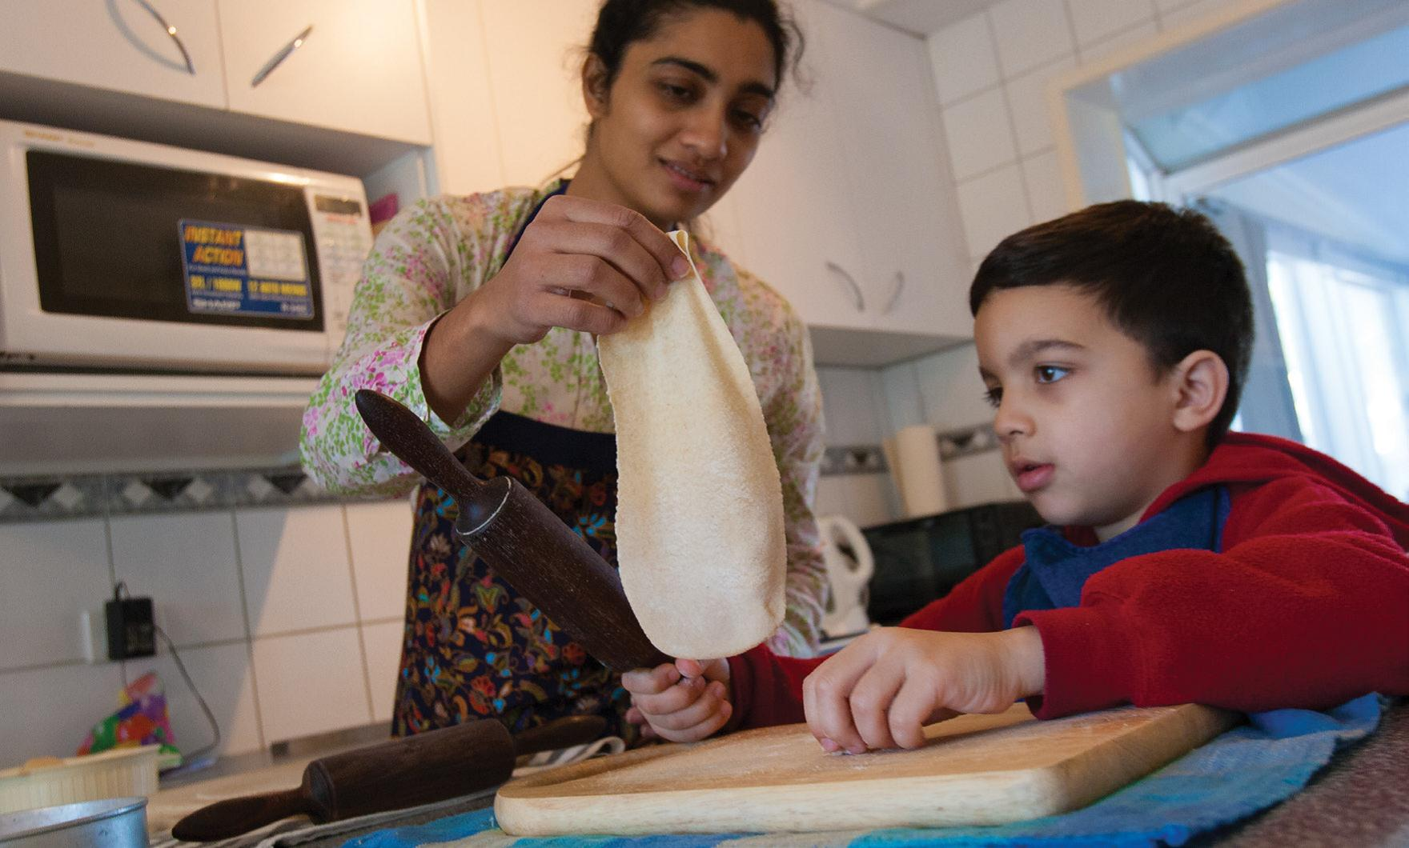

What we do and what it means
Ashraf: Look what I made. It’s curved like a raindrop.
Using everyday words to describe shape such as ‘a raindrop’, ‘egg shape’, ‘curved’ and ‘round’ are important for helping children understand shape.
Over time children will use words such as ‘triangle’, ‘square’ and ‘circle’. These words help children to talk about the shapes in their environment. Noticing and studying shape is important for learning geometry later.

‘Half here! Half over there!’ is about fractions
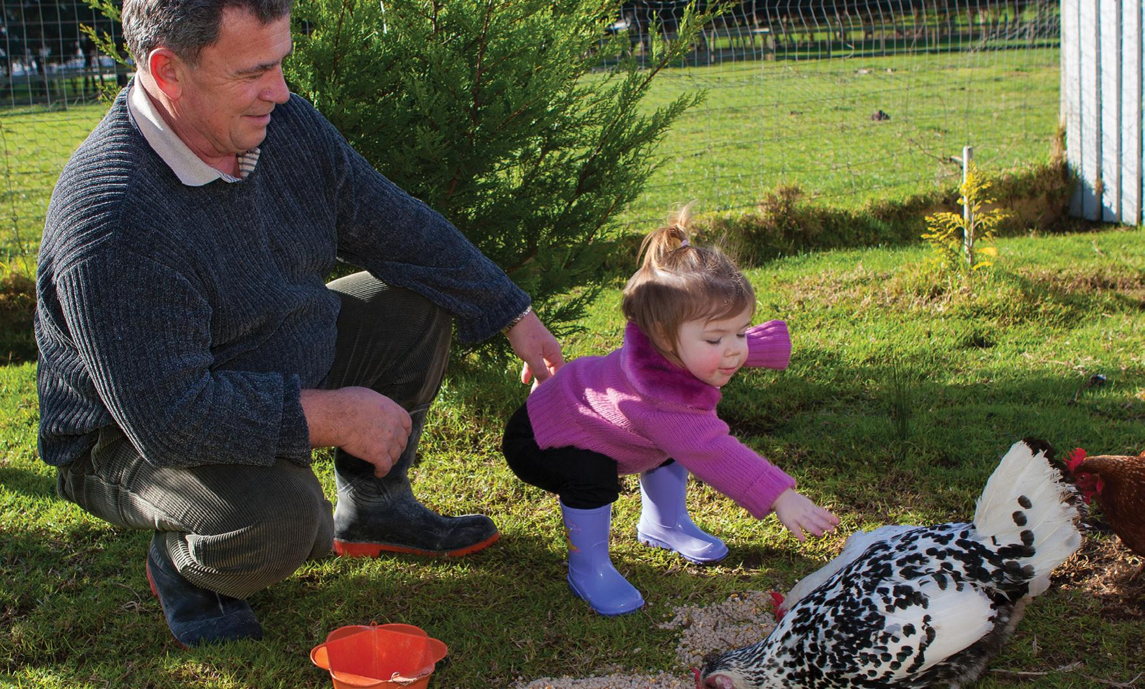

What we do and what it means
Grandad: Let’s give the chickens some yummy, yummy feed.
Half here! Half over there!
Children hear words like ‘half’ or ‘quarter’ every day.
Having lots of experiences with splitting things into equal amounts helps children understand fractions later.

‘Grouping things together’ is about noticing if something is the same or different
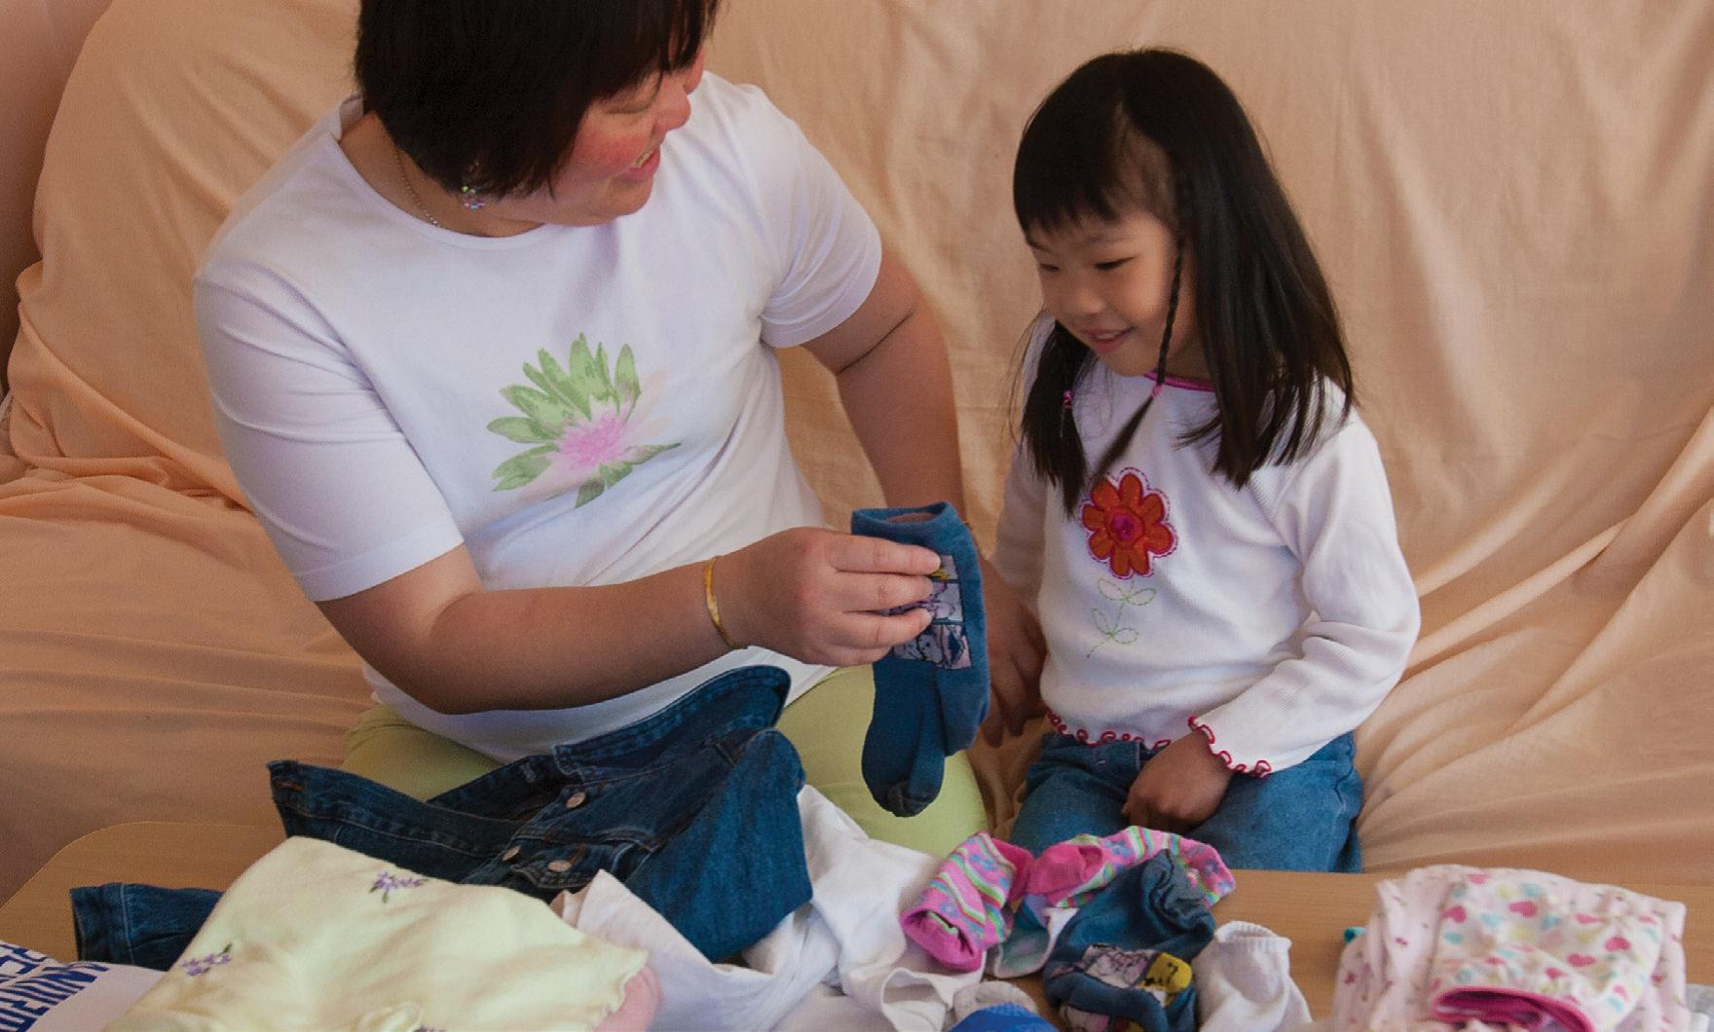

What we do and what it means
Mum: Adele, come and help Mummy with the laundry.
Adele picks up a sock.
Mum: Oh good. You’ve found the other one?
Children learn to group things together when they notice if something is the ‘same’ or ‘different’.
Lots of experiences with ‘same and different’ help children later on with describing how something may be different (eg has three more), rather than just how things look.

‘Sorting things’ is about classifying
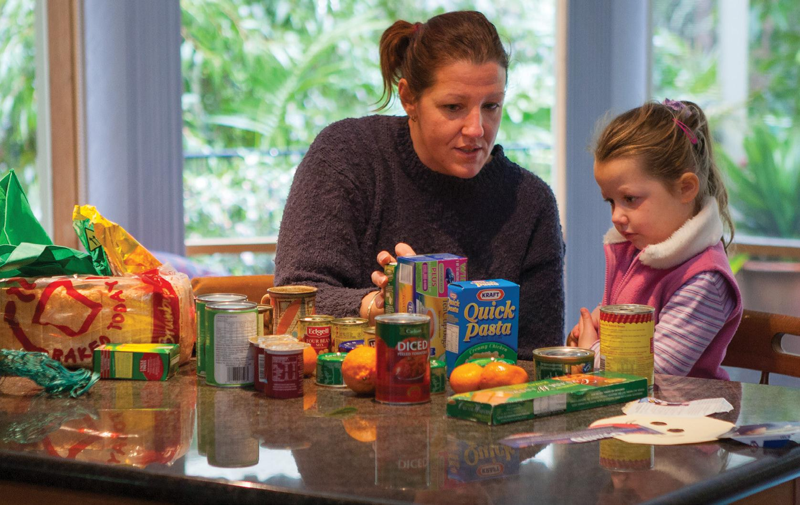

What we do and what it means
Jana: Where does this go?
Mum: That goes in the cupboard.
Jana: The oranges go in the fridge?
When we unpack the shopping we sort things as we put them away. Early on, children sort by what is ‘the same’ and ‘what is different’. They may start by sorting colour and end up sorting by size.
Later, children keep using the same sorting system (classification) and can tell you how they sorted.

‘Grouping’ and ‘matching’ are about counting
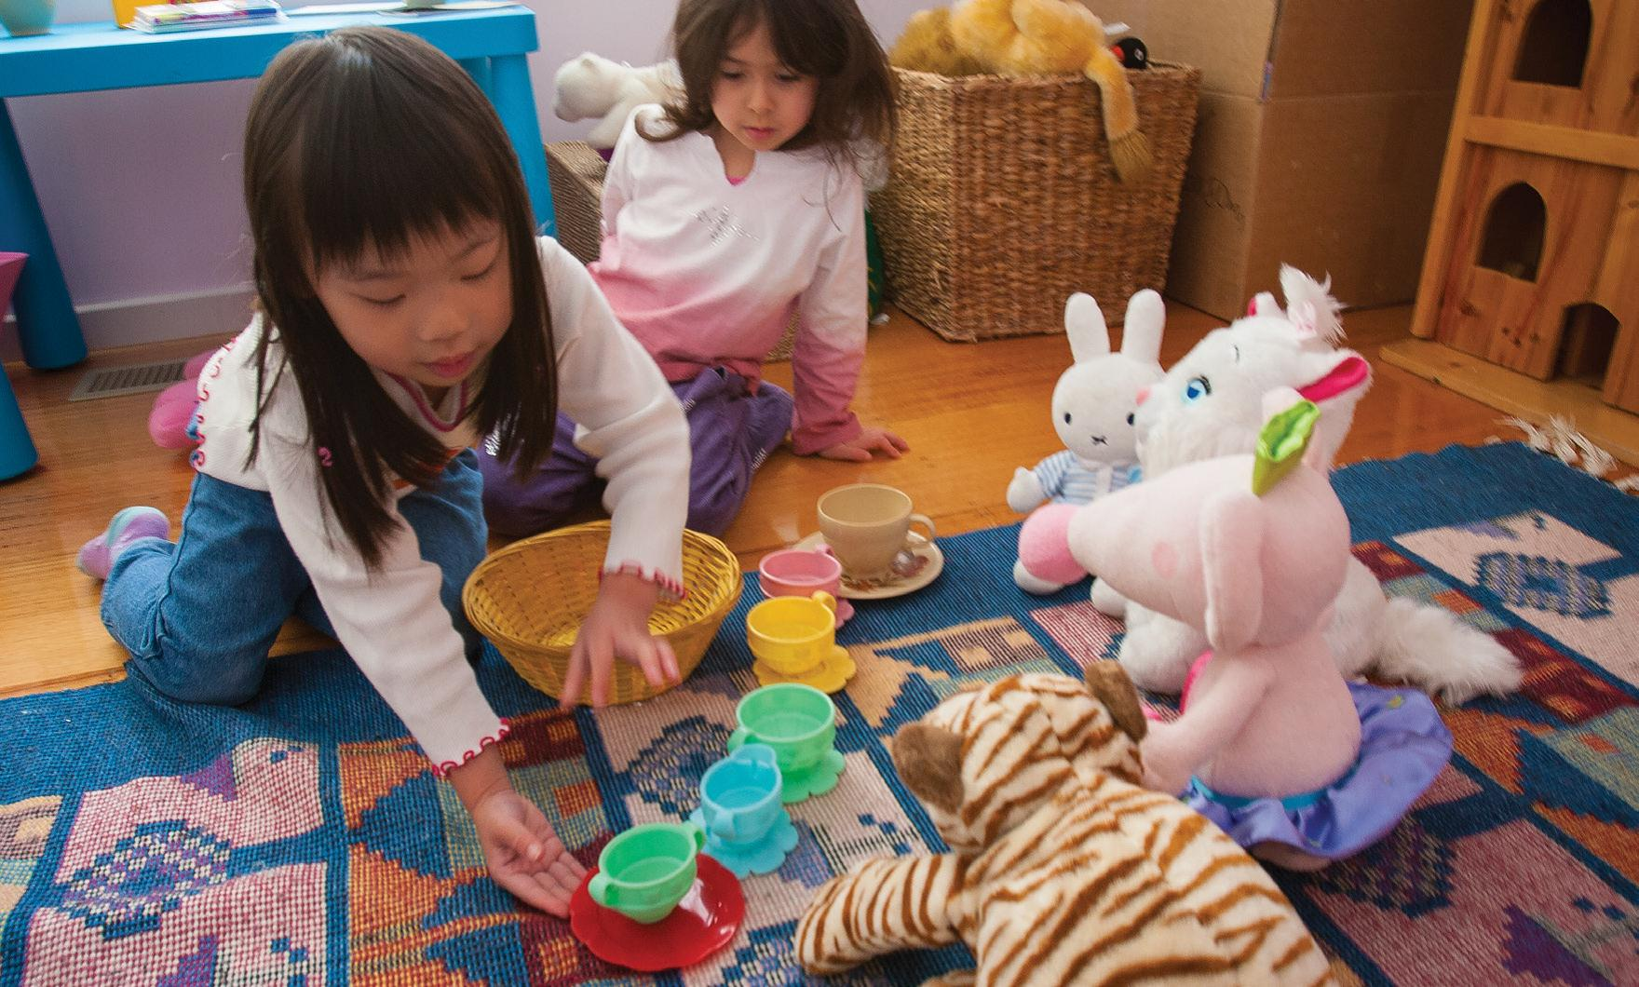

What we do and what it means
Mum: How many friends are coming to the tea party?
Aaliya: Five!
Mum: How many cups do we need? Let’s see if we have enough.
When friends play together they often group things, and ask
‘How many are there altogether?’ Finding out how many there are of something helps children think about the group of things (and not just the last thing they counted).
Later children will understand that a number can represent a group of things and will trust that number, for example 5, will always represent a group of things.

‘1, 2, 3, 4, 5’ is about learning number names
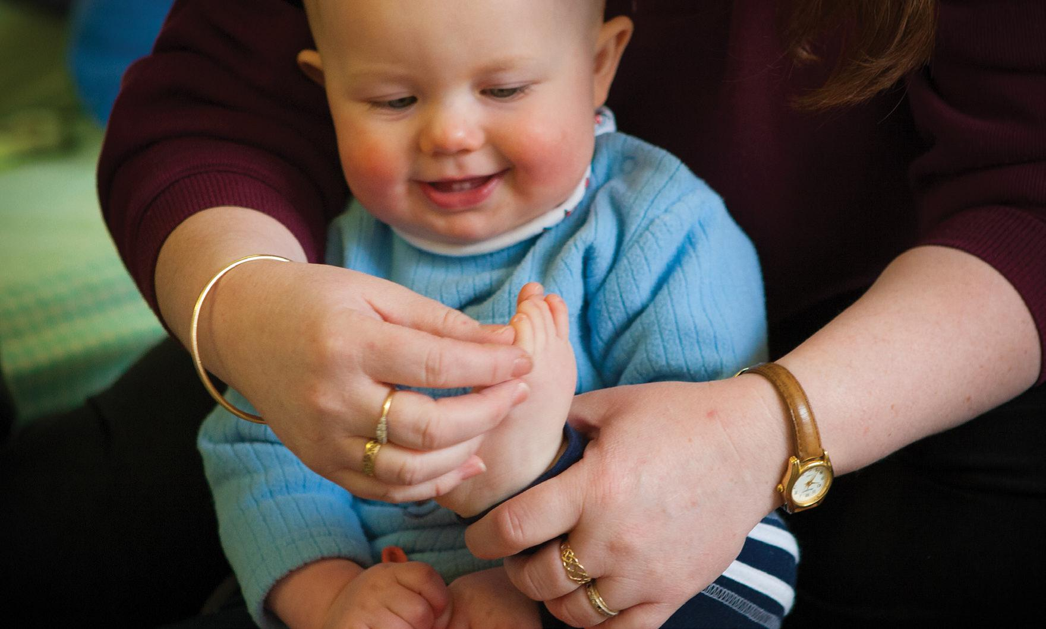

What we do and what it means
Mum: 1, 2, 3, 4, 5 toes! (tickling each toe as she counts).
You have 5 toes.
There are patterns in the way we say numbers and they help children to remember their order. Children need to learn the order of the early number names by saying number rhymes and imitating the order they hear.
When the numbers begin to be repeated (21, 22, 23, 24 etc) children notice the pattern of the numbers so they can work out what number comes next. When using number order to count objects children need to learn that the last number tells them how many.

Numbers are about ‘how much’, ‘how long’ and ‘how many’
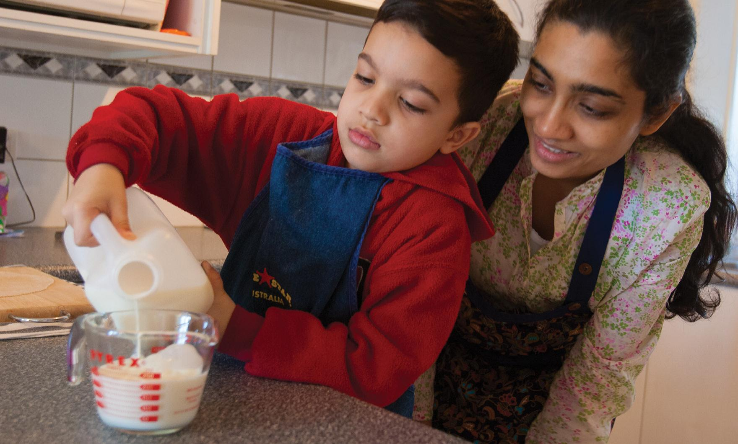

What we do and what it means
Mum: We are supposed to put in 300ml of milk.
Children will hear and see numbers being used to describe ‘how much’, ‘how many’ or ‘how long’.
Knowing that numbers can be used in different ways is important for later learning in mathematics.

‘High’ and ‘low’ are about measurement
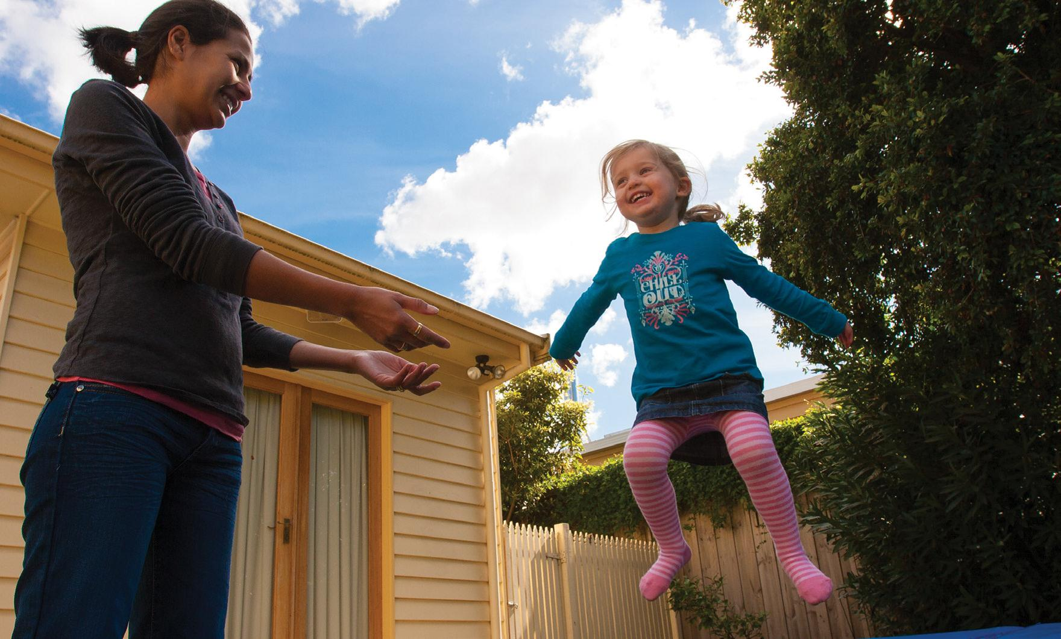

What we do and what it means
Camryn: I can jump so high!
Mum: Whee … let’s try and touch the sky.
Things can be higher or lower, thicker or thinner, smaller or larger. All of these are comparisons.
Later, children will learn to use centimetres (cm), kilograms (kg), degrees, etc to make comparisons.

‘Big’ and ‘little’ are about measurement
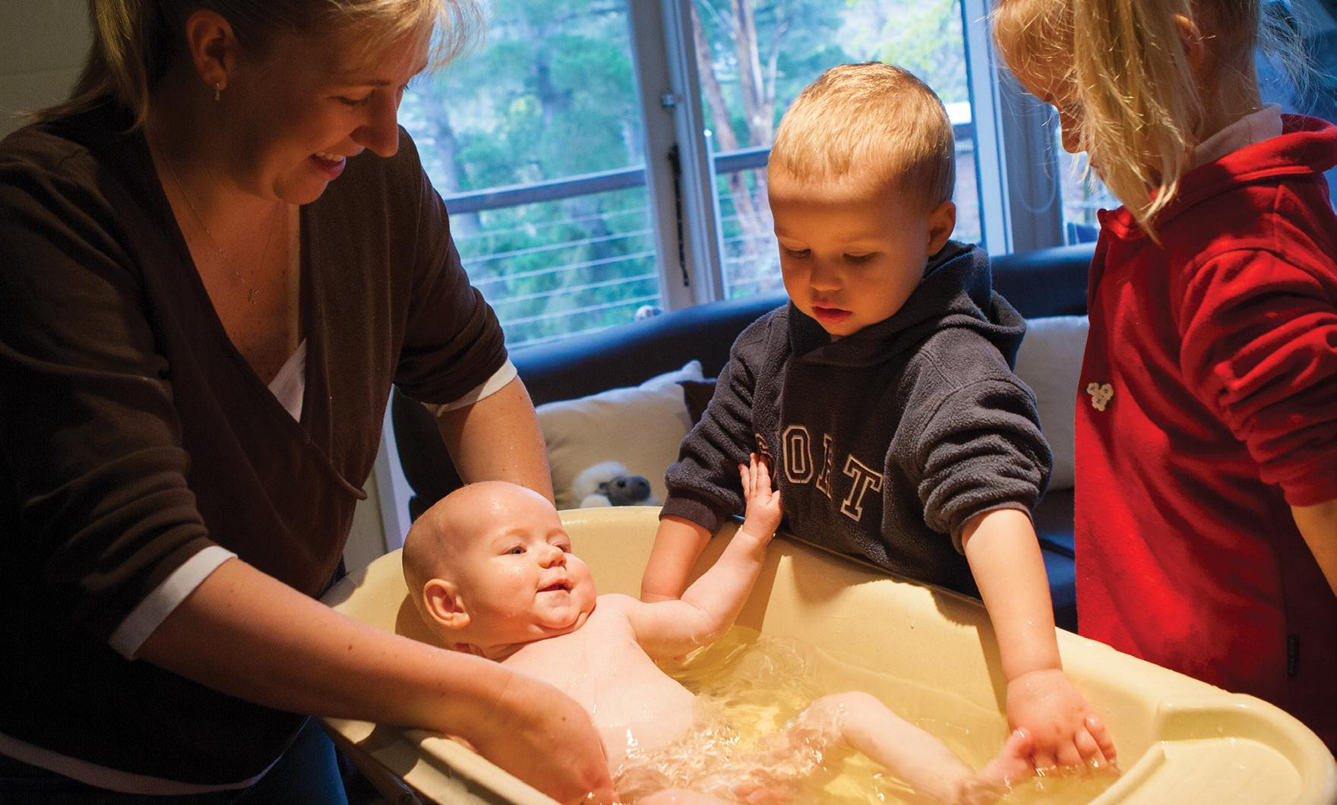

What we do and what it means
Mum: We are going to give the baby a bath. Could you fit into that bath, Charlotte?
Charlotte: No, I am a big girl.
Children hear and use words such as ‘bigger’, ‘smaller’, ‘taller’ or ‘thinner’. They are important for learning about measurement.
Later, when children are older, they use centimetres (cm), kilograms (kg) and degrees to measure and compare more accurately, or to find out ‘how much more’.

‘Full’ and ‘empty’ are about measurement
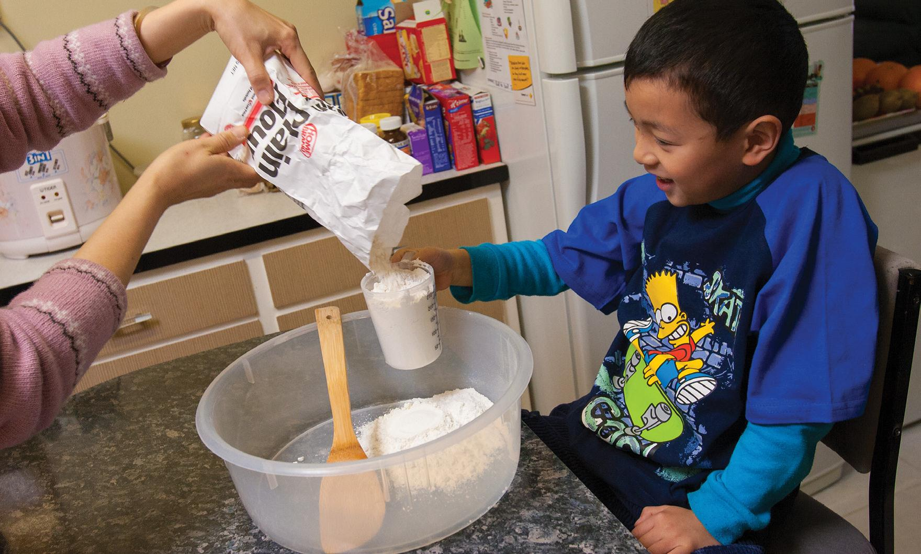

What we do and what it means
Mum: We need two cups of plain flour. We’ll fill the cup right to the top.
Tommy: I can do it.
Filling a measuring cup helps children think about measurement. Words such as ‘full’, ‘half a cup’ and ‘empty’ help children pay attention to measurement.
Later, children will learn that measuring how much is about capacity, and will use words such as litres (l) or millilitres (ml).

‘Heavy’ and ‘light’ are about mass
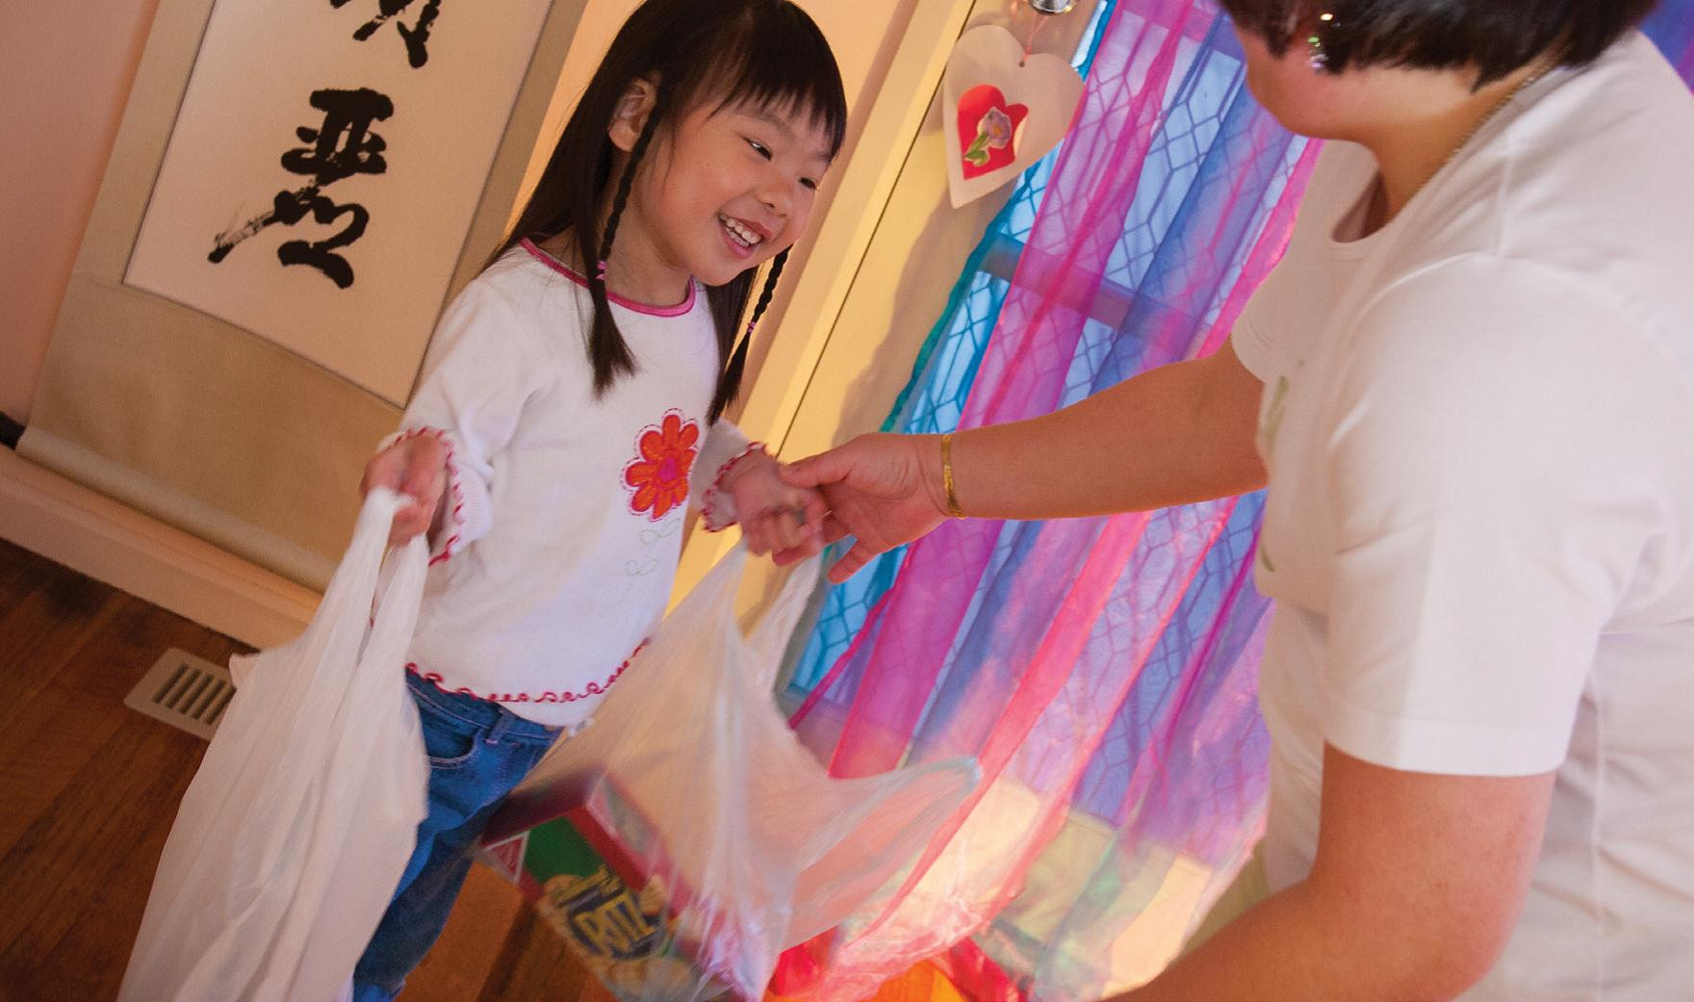

What we do and what it means
Mum: Is this too heavy for you?
Adele: I can carry it. It’s only little.
When children are lifting and carrying things they will talk about ‘heavy and light’, and ‘big and small’.
Later, they will notice that the biggest thing is not always the heaviest or the smallest thing not always the lightest. Having lots of experience like this helps children understand about ‘mass’ (how dense something is).

‘Sharing’ is about division
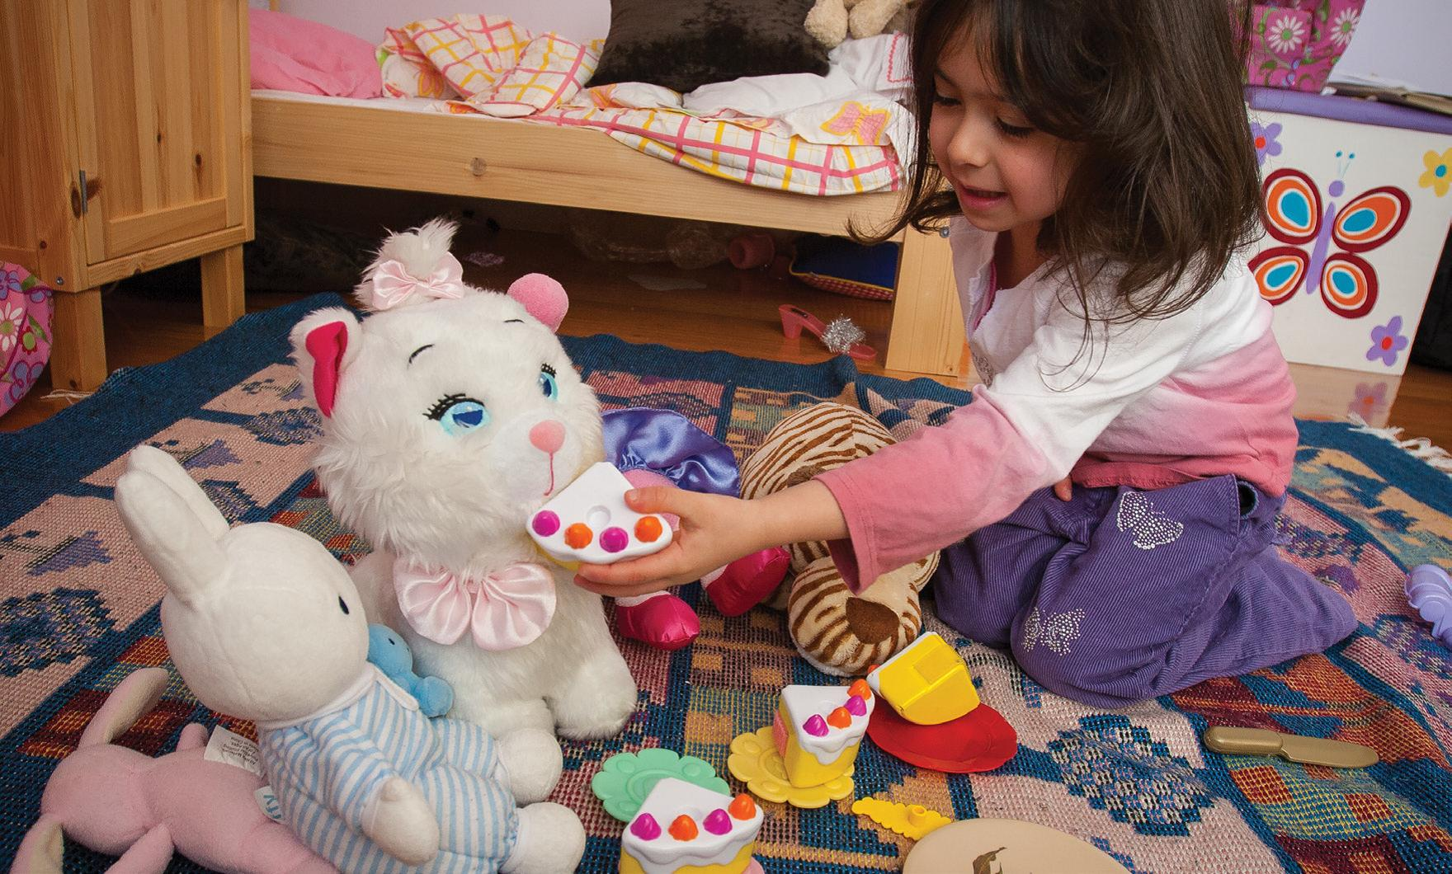

What we do and what is means
Mum: Can you share out the cake for the toys?
Aaliya: One for you, and one for you, and one for you…
Children will share out by saying ‘one for you’ and ‘one for you’ until nothing is left. Later, children will learn that sharing out is about division and will know what to do with the ‘left over’.

