

SMARTER SCHOOL NATIONAL PARTNERSHIPS
South Australia
2012 Annual Report
Appendix
Additional Performance Information
Sections 8 and 9
April 2013
(1 January – 31 December 2012)





TABLE OF CONTENTS
Section 8 – South Australia Performance Measures CMaD NP……………………………………………..… 126

Summary of schools participating in CMaD NP ‘whole of school’ interventions…………………………………..…. 126

CMaD NP ‘whole of school’ student measurement cohort participating in NAPLAN…………………………...... 127

Overall 2012 CMaD NP ‘whole of school’ student measurement cohort achievement……………….………….. 128

Section 9 Part 1 – CMaD NP schools participating in ‘Whole of School’ change strategies and approaches………………………………………….……………………………………………………………………………….... 135

Overall 2012 CMaD NP ‘whole of school’ attendance achievement…………………………………………………….... 136

Section 9 Part 2 - Students in the CMaD NP participating in ‘Individual Targeted Support’ strategies and approaches…………………………………………………………………………………………………...... 148

Summary of students participating in CMaD NP ‘Individual Targeted Support’ interventions in 2012….… 149

Overall 2012 achievement of students participating in CMaD NP ‘Individual Targeted Support’ interventions……………………………………………………………………………………………………………………………………….… 150

Increased attendance rates…………………………………………………………………………………………………………………... 150

Improvements in students ‘Below’ National Minimum Standard in Reading and Numeracy…………………. 152

Section 9 Part 3 – Student Engagement and Wellbeing……………………………………………………………. 169

Acknowledgement
The National Partnership Agreements on Literacy and Numeracy, Low Socio-economic Status School Communities (known as Communities Making a Difference in South Australia) and Improving Teacher Quality are collaborative initiatives supported by funding from the Australian Government, the South Australian Government and the Catholic and Independent school sectors.

South Australia Smarter Schools National Partnerships

2012 Annual Report Appendix Additional Performance Information
This Appendix to the SA Smarter Schools National Partnerships 2012 Annual Report contains the additional performance information as agreed with the Australian Government for the Communities Making a Difference National Partnership (known nationally as Low Socio-Economic Status School Communities National Partnership).

Section 8 – South Australia - Performance Measures Communities Making a Difference NP
Through the Communities Making a Difference National Partnership (CMaD NP) South Australia is working to achieve improved educational outcomes for students in two different ways:
- through specifically identified schools participating in ‘whole of school’ strategies and approaches (all three schooling sectors - reported in Section 8 and Section 9), and
- through ‘Individualised Targeted Support’ strategies and approaches for students who are disconnected and disengaged from learning and education pathways. (Government sector only - reported in Section 9)

Section 8 Performance Measures reports National Assessment Program - Literacy and Numeracy (NAPLAN) information for 223 schools participating in CMaD NP ‘whole of school’ interventions, for three groups:
- schools participating in CMaD NP ‘whole of school’ interventions since 2010 (87 CMaD NP schools)
- schools participating in CMaD NP ‘whole of school’ interventions since 2011 (117 CMaD NP schools)
- schools participating in CMaD NP ‘whole of school’ interventions since 2012 (19 CMaD NP schools)
As these schools commenced in the CMaD NP in different periods, they are being reported and tracked on separate tables over the life of the partnership.

Summary of schools participating in CMaD NP ‘whole of school’ interventions
In 2012, there were 223 schools participating in CMaD National Partnership ‘whole of school’ interventions across South Australia with a total student enrolment of 61,726 students. Of these, 140 schools (62.8%) were designated junior primary/primary (49.1% of total student enrolments in CMaD NP schools or 30,289 students). This reflects the important focus on improving learning outcomes in the primary years.

The other CMaD NP schools for 2012 were:
- 30 Secondary/High schools (13.5%), representing 32.0% of total student enrolments in CMaD NP schools (or 19,724 students)
- 23 schools (10.3%) were various combinations of primary and secondary schools, such as Area schools in regional SA, representing 15.7% of total student enrolments in CMaD NP schools (or 9,715 students)
- 19 schools (8.5%) were designated as Aboriginal/Anangu schools (1.5% of total student enrolments in CMaD NP schools or 932 students)
- 9 schools (4.0%) were designated as Special schools (0.8% total student enrolments in CMaD NP schools or 519 students)
- 2 schools (0.9%) were ‘Other’ types of specialised schools not elsewhere classified (0.9% total student enrolments in CMaD NP schools or 547 students).
The majority (52.9%) of CMaD NP schools (118 schools) were situated in regional South Australia, with just over half (52.7%) of all CMaD NP Indigenous student enrolments in these schools. There were 105 CMaD NP schools located in metropolitan Adelaide (47.1%), with the majority (63.9%) of total student enrolments for 2012.
The largest statistical division area of CMaD NP schools (54 schools or 24.2%) was the northern suburbs of metropolitan Adelaide (representing 35.9% of total student enrolments in CMaD NP schools or 22,133 students). Adelaide’s northern suburbs include some of the locations where residents may experience some of the most disadvantages in South Australia.

CMaD NP ‘whole of school’ student measurement cohort participating in NAPLAN
The SA 2012 student measurement cohort includes the NAPLAN results achieved by year levels 3, 5, 7 and 9 in CMaD NP schools (with students sitting both the Reading and the Numeracy component of NAPLAN testing included more than once). The SA 2012 student measurement cohort represents approximately 29.1% of the 223 CMaD NP schools’ total student enrolments. Eleven CMaD NP schools had no students participate in NAPLAN testing, as they only had junior primary or senior secondary students in 2012.
Government schooling reform initiatives across South Australia over the last 4 years have resulted in the amalgamation of some schools into new schools with different names and campuses. This will continue to impact on the total number of CMaD NP schools participating in ‘whole of school’ interventions across reporting periods. Where possible, for the newly established or created schools participating in the CMaD NP ‘whole of school’ intervention, NAPLAN results for the schools have been historically mapped to their former school(s).
It is important to note that year-on-year the NAPLAN information in this report is for different groups of students within a school, and is not sufficiently sensitive to show a significant change to the overall CMaD NP population average in the relatively short period, from 2010 to 2012. Any analysis of this information should take into account the numerous external factors which may have influenced student outcomes. For example, students in special schools contributing to the increase in exempt students.

Overall 2012 CMaD NP ‘whole of school’ student measurement cohort achievement
Some promising trends in NAPLAN can be seen in students reading results, which are showing a steady shift of students from the lower proficiency bands (those below and at national minimum standard) to the middle/ upper proficiency bands from 2010 to 2012.
As Graph 1 illustrates, a proportional improvement has occurred in Year 5 and Year 9 reading results for the 205 schools who have participated in a CMaD NP ‘whole of school’ interventions for more than 1 year (since 2010 and 2011). Assessed students (excluding those who were exempt) have shown a shift of 7.3 percentage points and 5.0 percentage points respectively from the lower (‘below’ national standard) proficiency bands into the middle/upper (‘above’ national minimum standard) proficiency bands. This trend can also be seen for Indigenous students Year 3, 5, 7 and 9 reading results in these schools.
Graph 1: Proportion of Year 3, 5, 7 and 9 Reading results in the NAPLAN LOWER TWO PROFICIENCY BANDS 2010 to 2012, for all assessed students in schools participating in CMaD NP ‘whole of school’ interventions for more than 1 year
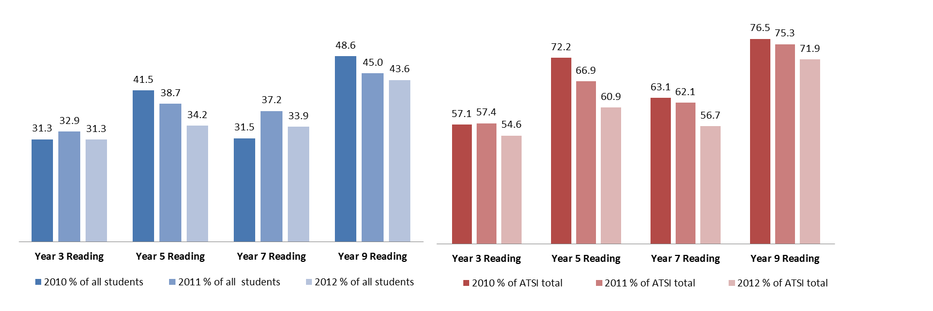
All Assessed Students
All Indigenous Assessed Students

Detailed footnotes regarding all Section 8 tables are available on pages 133 and 134. Further NAPLAN information regarding these CMaD NP schools is also available in Section 9 – Part 1.
Communities Making a Difference (CMaD - Low SES School Communities) National Partnership schools participating in 'whole of school' interventions by Reading and Numeracy results for Years 3, 5, 7 and 9 students using NAPLAN, 2010 to 2012 ⁽⁸⁾ ⁽⁹⁾:
Table 1.1(a) – All Students in CMaD NP ‘whole of school’ interventions participating since 2010

Table 1.1(b) – All Students in CMaD NP ‘whole of school’ interventions participating since 2011

Table 1.1(c) – All Students in CMaD NP ‘whole of school’ interventions participating since 2012

Table 1.2(a) – Indigenous Students in CMaD NP ‘whole of school’ interventions participating since 2010

Table 1.2(b) – Indigenous Students in CMaD NP ‘whole of school’ interventions participating since 2011

Table 1.2(c) – Indigenous Students in CMaD NP ‘whole of school’ interventions participating since 2012

Table 1.3(a) – Language Background Other Than English (LBOTE) Students in CMaD NP ‘whole of school’ interventions participating since 2010

Table 1.3(b) – Language Background Other Than English (LBOTE) Students in CMaD NP ‘whole of school’ interventions participating since 2011

Table 1.3(c) – Language Background Other Than English (LBOTE) Students in CMaD NP ‘whole of school’ interventions participating since 2012

Footnotes Section 8 - Table 1.1(a), Table 1.1(b), Table 1.1(c), Table 1.2(a), Table 1.2(b), Table 1.2(c), Table 1.3(a), Table 1.3(b) & Table 1.3(c)
(1) Includes students who sat the National Assessment Program - Literacy and Numeracy (NAPLAN) or were exempt, in Year levels 3, 5, 7 and 9, as a percentage of the total number of students within the reporting year level (including absent and withdrawn) for CMaD NP schools. Students who sit both the Reading and the Numeracy component of the NAPLAN testing may be included more than once.
(2) Exempt students are defined as those who were not assessed and are deemed not to have met the national minimum standard, as a percentage of the total number of students in the reporting year level (including assessed, absent and withdrawn).
(3) Includes assessed students who achieved the first band of the national minimum standard (NMS) for the selected NAPLAN domains, as a percentage of the total number of assessed students in the reporting year level (including exempt). For this report those students in the first band of NMS excludes exempt students, who are reported separately on this table.
(4) Includes assessed students who achieved the second band of the national minimum standard (NMS) for the selected NAPLAN domains, as a percentage of the total number of assessed students in the reporting year level (including exempt).
(5) Based on the Weighted Likelihood Estimates (standard scale score) of all students assessed in the NAPLAN. The mean scale scores for exempt students are not included as they do not receive a scale score. 95% confidence intervals are reported for the population mean scale score, using a normal distribution.
(6) Includes all students who identify as being Australian Aboriginal and/or Torres Strait Islander students. These figures may under represent the true number of Indigenous students due to the technical difficulties associated with data collection and reliance on self identification.
(7) Includes all students who identify as having a language background other than English (LBOTE), where either the student, or the student’s parents or carers, speak a language other than English at home. These figures may under represent the true number of LBOTE students due to the technical difficulties associated with data collection and reliance on self identification.
(8) Current government schooling reform initiatives across South Australia have resulted in the amalgamation of some schools into new schools with different names and campuses. This will impact on the total number of CMaD NP schools participating in ‘whole of school’ change strategies and approaches across reporting periods. Where possible newly established or created CMaD NP participating schools NAPLAN results have been historically mapped to their former school(s).
(9) Please note year-on-year NAPLAN information is for a different group of students within a school. Changes in performance for student cohorts should be considered with caution due to the different students tested each year, all of which have different characteristics, circumstances and abilities. The CMaD NP schools reported in these tables only commenced from 2010-2012, with NAPLAN testing held in May of the reporting year.

Section 9 – South Australia – State Performance Measures CMaD NP
Section 9 State Performance Measures - CMaD NP is provided in three parts:
- Part 1 refers to all students in CMaD NP schools participating in ‘whole of school’ change strategies and approaches;
- Part 2 refers to those students participating in CMaD NP ‘Individualised Targeted Support’ change strategies and approaches; and
- Part 3 provides information about student engagement and wellbeing.

Section 9 Part 1 – CMaD NP schools participating in ‘Whole of School’ change strategies and approaches
Section 9 (Part 1) comprises student results for the 223 South Australian CMaD NP schools participating in ‘whole of school’ change strategies and approaches, across three groups:
- schools participating in CMaD NP ‘whole of school’ interventions since 2010 (87 CMaD NP schools)
- schools participating in CMaD NP ‘whole of school’ interventions since 2011 (117 CMaD NP schools)
- schools participating in CMaD NP ‘whole of school’ interventions since 2012 (19 CMaD NP schools)
As these schools commenced in the CMaD NP in different periods, they are being reported and tracked on separate tables over the life of the partnership.
The SA 2012 student measurement cohort for the National Assessment Program - Literacy and Numeracy (NAPLAN) results achieved by year levels 3, 5, 7 and 9 in CMaD NP schools (with students sitting both the Reading and the Numeracy component of NAPLAN testing included more than once). In 2012, 11 of the 223 CMaD NP schools had no students who participated in NAPLAN, as they only had junior primary or senior secondary students. The SA 2012 student measurement cohort represents approximately 29.1% of the total 2012 student enrolments (61,726 students) of the 223 schools who participated in CMaD NP in South Australia.
Government schooling reform initiatives across South Australia have resulted in the amalgamation of some schools into new schools with different names and campuses. This will continue to impact on the total number of CMaD NP schools participating in ‘whole of school’ interventions across reporting periods. Where possible, for the newly established or created schools participating in the CMaD NP ‘whole of school’ intervention, NAPLAN results for schools have been historically mapped to their former school(s).
It is important to note that year-on-year the NAPLAN information in this report is for different groups of students within a school, and is not sufficiently sensitive to show a significant change to the overall CMaD NP population average in the relatively short period, from 2010 to 2012. Any analysis of performance information for these CMaD NP schools should take this into account and the numerous external factors which may have influenced student outcomes.

Overall 2012 CMaD NP ‘whole of school’ attendance achievement
There were 23 schools (excluding those designated Aboriginal/Anangu) who have participated in CMaD NP ‘whole of school’ interventions for more than 1 year (11.2% of total 205 schools) whose school attendance rate (SAR) was below average (84.5% SAR or less) in 2010. By 2012, 16 of these 23 schools (69.6%) have shown a SAR increase since 2010, ranging from a 0.1% to 3.7% annual growth rate. Although this shift may not be substantial enough to move these schools into a different SAR category used below, it does indicate that improvements in attendance have been made in these schools.
Detailed footnotes regarding Section 9 tables follow each group of performance information.

Communities Making a Difference (CMaD - Low SES School Communities) National Partnership for schools participating in 'whole of school' strategies and approaches by School Attendance Rates results, 2010 to 2012:
Table 1.1(a) – All Schools in CMaD NP ‘whole of school’ interventions participating since 2010
 |  | 2009 |  | 2010 (baseline) |  | 2011 |  | 2012
Description | School Attendance Rate (SAR) Categories ⁽¹⁾ | No. of Schools | % of Total Schools | No. of Schools | % of Total Schools | No. of Schools | % of Total Schools | No. of Schools | % of Total Schools
Number of CMaD NP schools participating since 2010, by School Attendance Rate Categories ⁽¹⁾ | Category 1 (< 80% SAR) | 4 | 4.4 | 6 | 6.6 | 6 | 6.9 | 4 | 4.6
 | Category 2 (80% - 84% SAR) | 8 | 8.8 | 7 | 7.7 | 5 | 5.7 | 6 | 6.9
 | Category 3 (85% - 89% SAR) | 23 | 25.3 | 21 | 23.1 | 22 | 25.3 | 26 | 29.9
 | Category 4 (90% - 94% SAR) | 47 | 51.6 | 51 | 56.0 | 47 | 54.0 | 46 | 52.9
 | Category 5 (95%> SAR) | 5 | 5.5 | 5 | 5.5 | 6 | 6.9 | 4 | 4.6
 | Not Available ⁽²⁾ | 4 | 4.4 | 1 | 1.1 | 1 | 1.1 | 1 | 1.1
 | Total | 91 | 100.0 | 91 | 100.0 | 87 | 100.0 | 87 | 100.0

Table 1.1(b) – All Schools in CMaD NP ‘whole of school’ interventions participating since 2011
 |  | 2010 |  | 2011 (baseline) |  | 2012
Description | School Attendance Rate (SAR) Categories ⁽¹⁾ | No. of Schools | % of Total Schools | No. of Schools | % of Total Schools | No. of Schools | % of Total Schools
Number of CMaD NP schools participating since 2011, by School Attendance Rate Categories ⁽¹⁾ | Category 1 (< 80% SAR) | 15 | 12.4 | 18 | 15.3 | 19 | 16.2
 | Category 2 (80% - 84% SAR) | 9 | 7.4 | 7 | 5.9 | 8 | 6.8
 | Category 3 (85% - 89% SAR) | 27 | 22.3 | 29 | 24.6 | 33 | 28.2
 | Category 4 (90% - 94% SAR) | 59 | 48.8 | 54 | 45.8 | 48 | 41.0
 | Category 5 (95%> SAR) | 6 | 5.0 | 5 | 4.2 | 4 | 3.4
 | Not Available ⁽²⁾ | 5 | 4.1 | 5 | 4.2 | 5 | 4.3
 | Total | 121 | 100.0 | 118 | 100.0 | 117 | 100.0

Table 1.1(c) – All Schools in CMaD NP ‘whole of school’ interventions participating since 2012

(1) Includes the total (aggregated) attendance rate for all full-time students enrolled (excluding those studying via distance education) across year levels 1 to 10 for the relevant CMaD NP participating school(s). Definitions and the method of collection vary across sectors in South Australia. The government sector collects attendance data in Term 3 for the Semester 1 period, while non-government sectors include the last 20 days (4 weeks) in May of the reporting period. Information based on the ‘My School’ website. Australian Curriculum, Assessment and Reporting Authority (ACARA).
(2) Includes schools that were established after the student attendance reporting period, or schools where no attendance information was available during the reporting period (for example special schools that do not have mainstream year levels, or adult re-entry colleges that do not record attendance in the DECD census).
Communities Making a Difference (CMaD - Low SES School Communities) National Partnership schools participating in 'whole of school' strategies and approaches by Reading and Numeracy results for Years 3, 5, 7 and 9 students using NAPLAN, 2010 to 2012:
Table 2.1(a) – All Students in CMaD NP ‘whole of school’ interventions participating since 2010

Table 2.1(b) – All Students in CMaD NP ‘whole of school’ interventions participating since 2011

Table 2.1(c) – All Students in CMaD NP ‘whole of school’ interventions participating since 2012

Table 2.2(a) – Indigenous Students in CMaD NP ‘whole of school’ interventions participating since 2010
Table 2.2(b) – Indigenous Students in CMaD NP ‘whole of school’ interventions participating since 2011

Table 2.2(c) – Indigenous Students in CMaD NP ‘whole of school’ interventions participating since 2012

Table 2.3(a) – Language Background Other Than English (LBOTE) Students in CMaD NP ‘whole of school’ interventions participating since 2010
Table 2.3 (b) – Language Background Other Than English (LBOTE) Students in CMaD NP ‘whole of school’ interventions participating since 2011

Table 2.3 (c) – Language Background Other Than English (LBOTE) Students in CMaD NP ‘whole of school’ interventions participating since 2012

Footnotes Section 8 (Part 1) - Table 2.1(a), Table 2.1(b), Table 2.1(c), Table 2.2(a), Table 2.2(b), Table 2.2(c), Table 2.3(a), Table 2.3(b) and Table 2.3(c)
(1) Includes students who sat the National Assessment Program - Literacy and Numeracy (NAPLAN) or were exempt, in Year levels 3, 5, 7 and 9 within the reporting year level for CMaD NP schools. Students who sit both the Reading and the Numeracy component of the NAPLAN testing may be included more than once.
(2) Includes all students assessed in NAPLAN or were exempt, in Year levels 3, 5, 7 and 9, as a percentage of the total number of students within the reporting year level (including absent and withdrawn).
(3) Exempt students are defined as those who were not assessed and are deemed not to have met the national minimum standard, as a percentage of the total number of students in the reporting year level (including assessed, absent and withdrawn).
(4) Includes all assessed students who achieved 'At' or 'Above' the national minimum standard (NMS) for the selected NAPLAN domains, as a percentage of the total number of assessed students in the reporting year level (including exempt). ‘At’ or ‘Above’ is based on the proficiency band specified to an assessed student. Exempt students are deemed not to have met the national minimum standard and are considered 'Below the NMS'.
(5) Based on the Weighted Likelihood Estimates (standard scale score) of all students assessed in the NAPLAN. The mean scale scores for exempt students are not included as they do not receive a scale score.
(6) For comparison purposes the State Mean Scale Scores reported are based on the Weighted Likelihood Estimates (WLE) for all assessed NAPLAN students in South Australia. These results may differ slightly from other State Mean Scale Scores reported nationally.
(7) Includes all students who identify as being Australian Aboriginal and/or Torres Strait Islander. These figures may under represent the true number of Indigenous students due to the technical difficulties associated with data collection and reliance on self identification.
(8) Includes all students who identify as having a language background other than English (LBOTE), where either the student, or the student’s parents or carers, speak a language other than English at home. These figures may under represent the true number of LBOTE students due to the technical difficulties associated with data collection and reliance on self identification.
(9) Current government schooling reform initiatives across South Australia have resulted in the amalgamation of some schools into new schools with different names and campuses. This will impact on the total number of CMaD NP schools participating in ‘whole of school’ change strategies and approaches across reporting periods. Where possible newly established or created CMaD NP participating schools NAPLAN results have been historically mapped to their former school(s).
(10) Please note year-on-year NAPLAN information is for a different group of students within a school. Changes in performance for student cohorts should be considered with caution due to the different students tested each year, all of which have different characteristics, circumstances and abilities. Additionally schools reported in these tables may not have had an extended time in the CMaD NP prior to NAPLAN testing held in May of each reporting year.

Section 9 Part 2 - Students in the CMaD NP participating in ‘Individual Targeted Support’ strategies and approaches
The South Australian Department for Education and Child Development (DECD) provided a comprehensive suite of individualised support programs to young people who had become disconnected from school, were at risk of leaving school early and/or who had disengaged from learning. This Section 9 Part 2 of the State Performance Measures - CMaD NP provides information for 10,132 tracked individual students who participated in CMaD National Partnership ‘Individual Targeted Support’ interventions in government schools, across two groups:
- those students who have participated in CMaD NP ‘Individual Targeted Support’ interventions for 1 to 3 years (5,120 students)
- those students who have participated in CMaD NP ‘Individual Targeted Support’ interventions for less than 1 year (5,012 students)
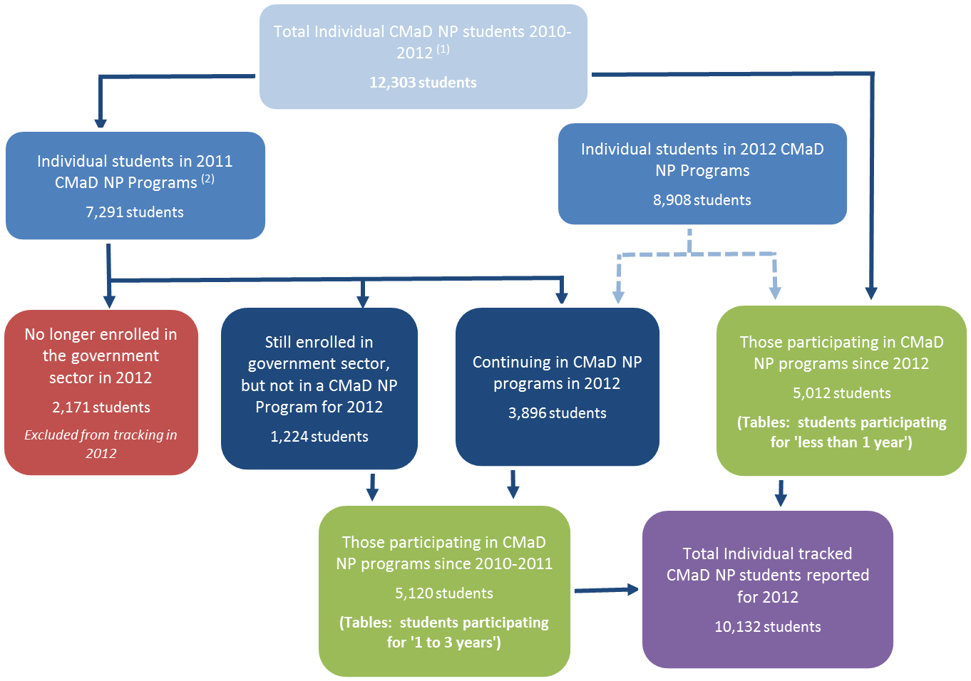
The following chart outlines how SA CMaD NP ‘Individual Targeted Support’ students have been tracked and reported in the following tables in this section.

Footnotes Section 9 Part 2 – 2012 Individual Students tracked in CMaD NP Chart
(1) Excludes 12 students who were either under school age at the time of reporting, or commenced in a CMaD NP program after the DECD August census for 2012.
(2) Includes 280 students who participated in a 2010 CMaD NP program and re-enrolled in a CMaD NP program in 2012, after no longer appearing as enrolled in the government sector in 2011.
Only students enrolled at a school in the government sector in 2012 and/or in a CMaD NP program for 2012 are included in the reporting analysis. DECD Targeted Student Support programs have also been provided to many more children and young people who are not being tracked here.
In 2012, 2,171 (29.8%) tracked CMaD NP students who participated in 2011 were no longer enrolled in the government sector. Of these students, 51.1% were enrolled in year level 12/13 in 2011 (when most senior secondary students finish their schooling). When a student is no longer enrolled in the government sector in the reporting period they are removed from historical tables in this report to ensure a true picture of improvement is provided in a given year.
As well, 1,224 tracked students continued their schooling in the government sector but were no longer receiving the individualised targeted support. These students have continued to be tracked for the year proceeding their involvement in the CMaD NP to measure their improvement after participating in CMaD NP ‘Individual Targeted Support’ interventions.

Summary of students participating in CMaD NP ‘Individual Targeted Support’ interventions in 2012
In 2012, there were 8,908 tracked students involved in a range of CMaD NP ‘Individual Targeted Support’ interventions:

2012 CMaD NP Program Profile: | % of CMaD NP Individual Students
Innovative Community Action Networks (ICAN) Flexible Learning Option (FLO)  including ICAN case management services | 62.7%
Student Mentoring | 17.6%
Vocational Education and Training (VET) scholarships | 9.5%
Aboriginal Student Mentoring | 7.5%
Community Mentoring | 4.1%
E-Mentoring | 1.1%
Aboriginal Turnaround Teams | 0.7%
Wiltja | 0.6%
Section 3 of the SA Smarter Schools 2012 Annual Report provides further information about each of these programs.
Some students require significant support and may have participated in more than one program. Only 3.7% (333 students) of the 8,908 tracked students participating in CMaD NP programs in 2012 were supported by multiple programs. In the following profile and tables each student is only reported once in each category.
The Individual Targeted Support programs also focussed on students from key diversity groups. Of the 8,908 tracked students participating in CMaD NP programs in 2012:
- 19.8% of students identify as Australian Aboriginal and/or Torres Strait Islander
- 11.2% of students were from a language background other than English (LBOTE); and
- 19.6% of students were eligible for the DECD Disability support program.
It is important to note students participating in ‘Individualised Targeted Support’ include students who: have complex life responsibilities and/or issues that impact upon their successful engagement with learning; may be significantly disengaged from their learning; and may not have been attending school, often for some years (even though they may be of compulsory schooling age). Any analysis should keep in mind these numerous factors, which may impact upon student learning outcomes. In particular year-on-year NAPLAN information is for different groups of individual students who only commenced in the supported programs for a short period of time.

Overall 2012 achievement of students participating in CMaD NP ‘Individual Targeted Support’ interventions
During 2012, 8,908 DECD students participated in CMaD National Partnership ‘Individualised Targeted Support’ interventions and were tracked. Of these current CMaD NP tracked students over half (53.9%) were male, 47.3% (4,212 students) were enrolled in Senior Secondary year levels (11 and 12/13), and had an average age of 16.2 years. A further 15.5% (1,382 students) of 2012 CMaD NP students were enrolled in Primary School Year levels (Reception to year level 7) in 2012, of which 80.9% commenced in support programs in 2012.

Increased attendance rates
Of the 8,908 tracked students who participated in CMaD National Partnership ‘Individualised Targeted Support’ interventions in 2012, 83.1% (7,407 students) had a valid attendance rate for both 2011 and 2012.
In 2011, 2,695 of the tracked students with an attendance rate for both 2011 and 2012, had an below average (less than 80%) Individual Attendance Rate (IAR). In 2012, the majority of these students (73.9%) have shown a clear improvement, with their average attendance rate increasing by 33.9% from an average of 56.1% IAR to an average of 75.1% IAR. This suggests an increase in the level of engagement of the most disengaged students, which in turn is more likely to lead to successful school attainment and completion.

As well, Graph 2 illustrates the average attendance rate for all students who had a valid attendance rate reported for each year, and who participated in CMaD National Partnership ‘Individualised Targeted Support’ interventions in 2012 by the year they started in a CMaD NP program(s). The red lines below highlight the marked improvement from prior to their participation in the CMaD NP ‘Individual Targeted Support’ interventions, to the latest available result for that student. Consistently high attendance is necessary for improved engagement and achievement outcomes.
Graph 2: 2012 students participating in CMaD NP ‘Individual Targeted Support’ interventions by attendance rate category and year of commencing in a CMaD NP ‘Individual Targeted Support’ program
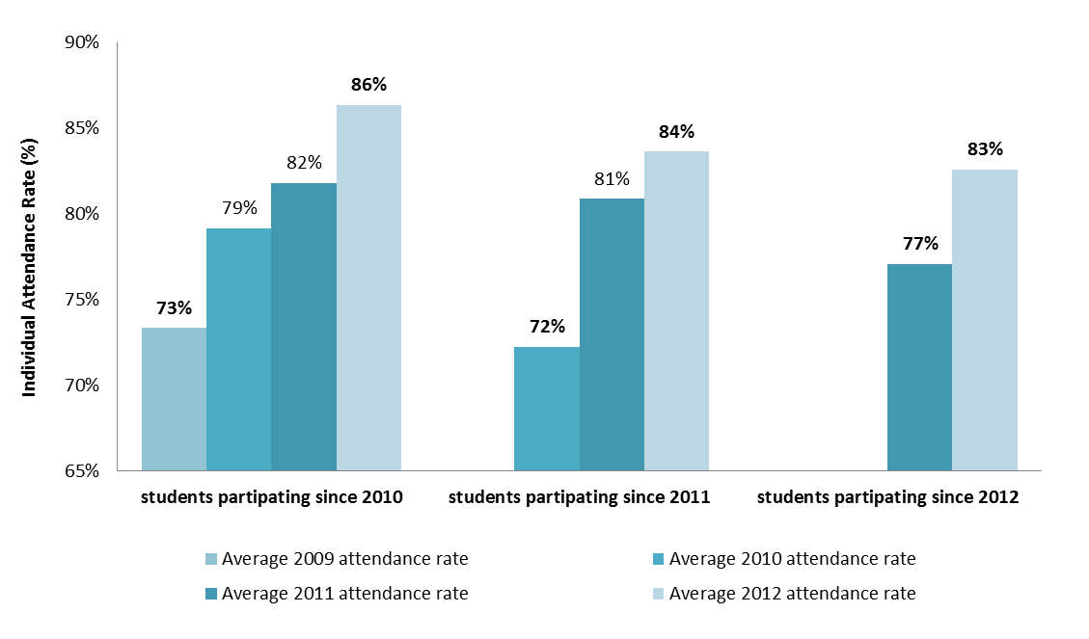

Improvements in students ‘Below’ National Minimum Standard in Reading and Numeracy
In 2012, there were 350 students who participated in 'Individual Targeted Support' interventions (including those who have subsequently returned to main stream schooling) whose 2010 NAPLAN reading and numeracy results were ‘below’ the National Minimum Standard (NMS). Over half (50.4%) of students ‘below’ National Minimum Standard in reading in 2010, have improved their reading results to ‘at or above’ the National Minimum Standard. As well, 54.6% of students ‘below’ National Minimum Standard in numeracy in 2010, have improved their numeracy results to ‘at or above’ the National Minimum Standard in 2012. As illustrated in the following diagram, this suggests a strong improvement over a short period of time for students previously highly disengaged from learning.
Diagram 1: Number of CMaD NP students ‘below’ National Minimum Standard (NMS) in NAPLAN Reading and Numeracy in 2010 who have improved to ‘at or above’ National Minimum Standard in NAPLAN Reading and Numeracy in 2012
Reading NAPLAN Results
2012
2010
248 students below NMS
30 students above NMS
95 students at NMS
50.4% Improvement
2010
Numeracy NAPLAN Results
205 students below NMS
2012
54.6% Improvement
16 students above NMS
96 students at NMS

Detailed footnotes regarding Section 9 Part 2 tables and graphs follow each group of performance information.
Numeracy NAPLAN Results
205 students below NMS
2012
54.6% Improvement
16 students above NMS
96 students at NMS
Communities Making a Difference (CMaD - Low SES School Communities) National Partnership for all students participating in 'Individual Targeted Support' strategies and approaches summary information, 2010 - 2012:

Footnotes summary table
(1) Students who were assessed as Indigenous, LBOTE and/or with a disability may be included in multiple cohorts. Includes 280 students who participated in a 2010 CMaD NP program and re-enrolled in a CMaD NP program in 2012, after not appearing as enrolled in the government sector in 2011. Excludes 12 students who were either under school age at the time of reporting, or who commenced in a CMaD NP program after the DECD August census for 2012.
(2) Includes all students who identify as being Australian Aboriginal and/or Torres Strait Islander students in 2012. These figures may under represent the true number of Indigenous students due to the technical difficulties associated with data collection and reliance on self-identification.
(3) Includes all students who identify as having a language background other than English (LBOTE), where either the student, or the student’s parents or carers, speak a language other than English at home in 2012. These figures may under represent the true number of LBOTE students due to the technical difficulties associated with data collection and reliance on self-identification.
(4) Includes all students who are eligible for the SA Department for Education and Child Development (DECD) Disability Support Program. Eligibility for the Disability Support Program requires evidence of both impairment, as described in the DECD Disability Support Program 2007 Eligibility Criteria, and the ways in which a student’s impairment does, or will, impact significantly on progress in the curriculum and on his/her ability to participate in learning activities and the school community. Please refer to http://www.decd.sa.gov.au/speced/pages/specialneeds/intro/ for further information.
(5) Includes all primary or secondary students with a disability (physical, intellectual etc.) that impacts significantly on his/her access to and participation in schooling; primary or secondary students in non-special schools with a designated special class or language and communication class; secondary students who are in ungraded subjects for adult (re-entry) who are not undertaking SACE, VET or UniPAL subjects; and any other students who have had a special class placement negotiated.
(6) Includes all primary or secondary students in CMaD NP (Low SES) participating since 2011, that have no 2012 results in the demographic collection process, and have subsequently been deemed to have left the government schooling sector. Over half (51%) of these students were in their final year of schooling in 2011 (Year levels 12/13), and would be expected to have left school and therefore no longer participating in CMaD NP programs in 2012.

Communities Making a Difference (CMaD - Low SES School Communities) National Partnership for all students participating in 'Individual Targeted Support' strategies and approaches by Individual Student Attendance Rates, 2010-2012:
Table 1.1(a) – Students participating in CMaD NP ‘Individual Targeted Support’ interventions for 1 to 3 years

Table 1.1(b) – ALL Students participating in CMaD NP ‘Individual Targeted Support’ interventions for less than 1 year

Table 1.2(a) – Indigenous Students participating in CMaD NP ‘Individual Targeted Support’ interventions for 1 to 3 years

Table 1.2(b) – Indigenous Students participating in CMaD NP ‘Individual Targeted Support’ interventions for less than 1 year

Table 1.3(a) – Language Background Other Than English (LBOTE) Students participating in CMaD NP ‘Individual Targeted Support’ interventions for 1 to 3 years

Table 1.3(b) – Language Background Other Than English (LBOTE) Students participating in CMaD NP ‘Individual Targeted Support’ interventions for less than 1 year
Table 1.4(a) – Students with disabilities participating in CMaD NP ‘Individual Targeted Support’ interventions for 1 to 3 years

Table 1.4(b) – Students with disabilities participating in CMaD NP ‘Individual Targeted Support’ interventions for less than 1 year
Footnotes Section 9 Part 2 – Graph 1, Table 1.1(a), Table 1.1(b), Table 1.2(a), Table 1.2(b), Table 1.3(a), Table 1.3(b), Table 1.4(a) & Table 1.4(b)
(1) Includes the total attendance rate for all CMaD NP students participating and enrolled (excluding those studying via distance education) in the government sector since 2012, across all year levels (1 - 12), rounded to the nearest whole number. The Government sector collects attendance data in Term 3 for the Semester 1 period. Please note: the attendance rate given is the rate for the student for the semester, not at one particular school.
(2) Includes students with no attendance recorded, this generally includes students who were enrolled after Semester 1 of the reporting year, or left before Semester 1 of the reporting year, were adult students (e.g. a student born in 1949), or enrolled in one of the four adult re-entry colleges, Open Access or the Youth Education Centre of the reporting year.
(3) Includes all students who identify as being Australian Aboriginal and/or Torres Strait Islander students in 2012. These figures may under represent the true number of Indigenous students due to the difficulties associated with collecting data which relies on self identification.
(4) Includes all students who identify as having a language background other than English (LBOTE), where either the student, or the student’s parents or carers, speak a language other than English at home in 2012. These figures may under represent the true number of LBOTE students due to the technical difficulties associated with data collection and reliance on self identification.
(5) Includes all students who are eligible for the SA Department for Education and Child Development (DECD) Disability Support Program. Eligibility for the Disability Support Program requires evidence of both impairment as described in the DECD Disability Support Program 2007 Eligibility Criteria, and the ways in which a student’s impairment does, or will, impact significantly on progress in the curriculum and on his/her ability to participate in learning activities and the school community. Please refer to http://www.decd.sa.gov.au/speced/pages/specialneeds/intro/ for further information.

Communities Making a Difference (CMaD - Low SES School Communities) National Partnership for all students in 'Individual Targeted Support' strategies and approaches by Reading and Numeracy results for Years 3, 5, 7 and 9 students using NAPLAN, 2010-2012:

Table 2.1(a) – All Students participating in CMaD NP ‘Individual Targeted Support’ interventions for 1 to 3 years *

Table 2.1(b) – All Students participating in CMaD NP ‘Individual Targeted Support’ interventions for less than 1 year

Table 2.2(a) – Indigenous Students participating in CMaD NP ‘Individual Targeted Support’ interventions for 1 to 3 years *

Table 2.2(b) – Indigenous Students participating in CMaD NP ‘Individual Targeted Support’ interventions for less than 1 year

Table 2.3(a) – Language Background Other Than English (LBOTE) Students participating in CMaD NP ‘Individual Targeted Support’ interventions for 1 to 3 years *

Table 2.3(b) – Language Background Other Than English (LBOTE) Students participating in CMaD NP ‘Individual Targeted Support’ interventions for less than 1 year

Table 2.4(a) – Students with disabilities participating in CMaD NP ‘Individual Targeted Support’ interventions for 1 to 3 years *

Table 2.4(b) – Students with disabilities participating in CMaD NP ‘Individual Targeted Support’ interventions for less than 1 year

Footnotes Section 9 Part 2 - Table 2.1(a), Table 2.1(b), Table 2.2(a), Table 2.2(b), Table 2.3(a), Table 2.3(b), Table 2.4(a) and Table 2.4(b)
* Includes the NAPLAN results for tracked students that were still enrolled (excluding those studying via distance education) in the government sector but are no longer receiving the individualised targeted support in 2012. Excludes students in CMaD NP (Low SES) participating since 2011 that subsequently left the government sector in 2012, and are 'no longer applicable' for reporting purposes.
(1) Includes students who sat the National Assessment Program - Literacy and Numeracy (NAPLAN) or were exempt, in Year levels 3, 5, 7 and 9 within the reporting year level. Students who sit both the Reading and the Numeracy component of the NAPLAN testing may be included more than once. Students who were assessed as Indigenous, LBOTE and/or with a disability may be included in multiple cohorts. Some Year 3 and Year 5 students have not been included in some cohorts due to the number of students being fewer than five. The reporting of these results could identify students.
(2) Includes all students assessed in NAPLAN or were exempt, in Year levels 3, 5, 7 and 9, as a percentage of the total number of students within the reporting year level (including absent and withdrawn).
(3) Exempt students include those with severe intellectual or functional disabilities or from a non-English speaking background who have been learning English in Australia for less than one year, and are defined as not assessed and deemed not to have met the national minimum standard, as a percentage of the total number of students in the reporting year level (including assessed, absent and withdrawn).
(4) Includes all assessed students who achieved 'At' or 'Above' the National Minimum Standard (NMS) for the selected NAPLAN domains, as a percentage of the total number of assessed students in the reporting year level (including exempt). ‘At’ or ‘Above’ is based on the proficiency band specified to an assessed student. Exempt students are deemed not to have met the National Minimum Standard and are considered 'Below the NMS'.
(5) Based on the Weighted Likelihood Estimates (standard scale score) of all students assessed in the NAPLAN. The mean scale scores for exempt students are not included as they do not receive a scale score.
(6) For comparison purposes the State Mean Scale Scores reported are based on the Weighted Likelihood Estimates (WLE) for all assessed NAPLAN students in South Australia. These results may differ slightly from other State Mean Scale Scores reported nationally. NAPLAN mean scale scores by disability status are not available for all students in South Australia.
(7) Includes all students who identify as being Australian Aboriginal and/or Torres Strait Islander students in 2012. These figures may under represent the true number of Indigenous students due to the technical difficulties associated with data collection and reliance on self identification.
(8) Includes all students who identify as having a language background other than English (LBOTE) in 2012, where either the student, or the student’s parents or carers, speak a language other than English at home. These figures may under represent the true number of LBOTE students due to the technical difficulties associated with data collection and reliance on self identification.
(9) Includes all students who are eligible for the SA Department for Education and Child Development (DECD) Disability Support Program. Eligibility for the Disability Support Program requires evidence of both impairment as described in the DECD Disability Support Program 2007 Eligibility Criteria, and the ways in which a student’s impairment does, or will, impact significantly on progress in the curriculum and on his/her ability to participate in learning activities and the school community. Please refer to http://www.decd.sa.gov.au/speced/pages/specialneeds/intro/ for further information.
(10) Please note year-on-year the NAPLAN results are for a different group of students, comparisons of results across annual reporting periods should not be made. Additionally schools may not have had an extended time in the CMaD NP prior to NAPLAN testing held in May of each reporting year.

Section 9 Part 3 – Student Engagement and Wellbeing
All three sectors have included a focus on increasing student engagement and wellbeing within CMaD NP schools. A critical part of this work during 2012 was strengthening students’ families’ involvement with their children’s learning and increasing the connection between schools and their local communities (see for example pages 96 to 105 of Section 3 of this 2012 Annual Report).
In the Independent sector, the specialist in-school support services provided access to understanding, training, skills and resources so that CMaD NP schools were better able to meet the needs of vulnerable learners. AISSA has also established a successful early years intervention project to support young children’s language development.
Whole school change initiatives in CMaD NP schools in the Catholic sector have included an agenda of improved wellbeing and learning outcomes for all students in these schools with a specific emphasis on personalised and precision teaching. Schools explored new ways of increasing the engagement of parents in their child’s learning as a priority, including through student-led three way conferences between the student, the teacher and parents to review learning and set new goals.
In the Government Sector, the engagement measures used in the Teaching for Effective Learning (TfEL) Research are designed to measure change in engagement resulting from the quality of the immediate learning environment. The focus is on students’ engagement in learning, and understanding what aspects of teachers’ pedagogy influence this engagement in learning.
The Student Engagement Questionnaire is based on previous theoretical work and empirical research, which relate to the behavioural, affective and cognitive aspects of pedagogy. The questions (set of scales) were trialed and refined prior to being used as base line data in this project. The set of scales in the survey are:
- Involvement: Defined as the behaviour of active involvement in and focus on learning.
- Wellbeing: Defined by:
  - Happiness and satisfaction (measured using positive and negative affect scales)
  - Positive social functioning
- Dispositions to learning: Positive dispositions to the new and unknown.
- Interest: the combination of innate and situational curiosity.
Data gathered so far has shown:
- Learners with a positive disposition to learning are significantly more likely to demonstrate interest. Interest is a strong predictive of positive affect – happiness.
- Positive affect is strongly predictive of involvement in learning. There is no involvement without the attendant emotion of happiness.
The design of measures which are sensitive to immediate learning context was intended to support the measurement of the difference to engagement made by those aspects of teaching and learning over which teachers have control.
Analysis of the student engagement questionnaires at the level of the TfEL Domains shows a statistically significant correlation between Domain 4 (Personalise and connect) and students’ interest and dispositions to learning. (For information about the TfEL Domains see http://www.learningtolearn.sa.edu.au/tfel/pages/tfelresources/satfelframework/ )
In other words, teachers who design and plan for learning that builds on students’ understandings, connects to their lives and aspirations, and assess learning in authentic contexts while communicating in multiple modes support students to be more positively orientated and to take a proactive stance in relation to learning, as well as stimulating their curiosity – both key precursors to active involvement in the learning process.
Also within the Government sector, the ICAN Engagement Matrix is used to assess 17 aspects from the spheres of wellbeing, relationships and involvement in learning for each child or young person receiving individualised targeted support through case management or student mentoring. It is used by a student’s case manager, mentor and/or school-based staff to identify the student’s status at the point of referral, as well as at other points throughout their participation, based on each student's individualised flexible learning or mentoring plan.
The Engagement Matrix is premised on research that student wellbeing is a fundamental contributor to successful engagement in learning. Poor peer, student-teacher and/or young person's family and community relationships can also prevent successful engagement in learning. Case managers, mentors and teachers find the instrument a useful tool in working with each student to identify areas for specific attention and to reflect on progress made.
The Engagement Matrix was formally assessed and validated through a validation exercise conducted by the Australian Council for Educational Research (ACER). From Term 2, 2011, data collected through this instrument has been entered into the DECD central data base as part of the student record. The Engagement Matrix is an important tool to assist in monitoring individual student progress and the collection of this data is not designed for collation at a whole program or systems level to inform systems level program planning.
A small number of DECD schools are currently trialling the Middle Childhood Inside and Out: The Psychological and Social World of Children 9-12 instrument, developed by the University of British Columbia, which focusses on obtaining children’s self-reports about their social and emotional development along with their experiences with families, friends, schools, and neighbourhoods.
At a broader level, as an Adelaide Thinker in Residence during 2012-13, Dr Martin Seligman has raised the profile of and debate about the importance of wellbeing to South Australia’s prosperity now and into the future. His definition of wellbeing is underpinned by five key areas, abbreviated as PERMA - Positive emotion, Engagement, Relationships, Meaning and Accomplishment. In 2012, the three schooling sectors participated in his residency, including wide student, staff and parent attendance at presentations and workshops focussed specifically on student wellbeing. Dr Seligman will prepare a report, including recommendations, for the Premier at the conclusion of his residency in 2013.

