

**Research Infrastructure Policy and Priorities in Australia**

David de Carvalho

Head of Higher Education Group

5 November 2013



**Research funding snapshot**

* GERD = 2.2% of GDP in 2008
* $9.1 b (€6.1 b) in 2011-12
* R&D Tax concessions = 22%
* University research = 20%
* ARC and NHMRC = 20%
* Other agencies = 20%



**Other agencies = 20%**

* Commonwealth Scientific and Industrial Research Organisation (CSIRO) - $734m
* Defence Science and Technology Organisation (DSTO) - $427m
* Australian Nuclear Science and Technology Organisation (ANSTO) - $229m
* Geoscience Australia - $113m
* Australian Institute of Marine Science (AIMS) - $32m
* Australian Bureau of Meteorology - $28m



**Australian Research Committee   
(ARCom)**

* + - Chaired by Chief Scientist for Australia
    - Provide integrated and strategic advice on investment across the science, research and innovation system



**National Research Investment Plan (2012)**

NRIP comprises:

* + - a framework that enables the development of Australia’s research capacity and capability for all sectors
    - a set of research investment principles that ensures government investments are objective and efficient
    - a statement of strategic research priorities

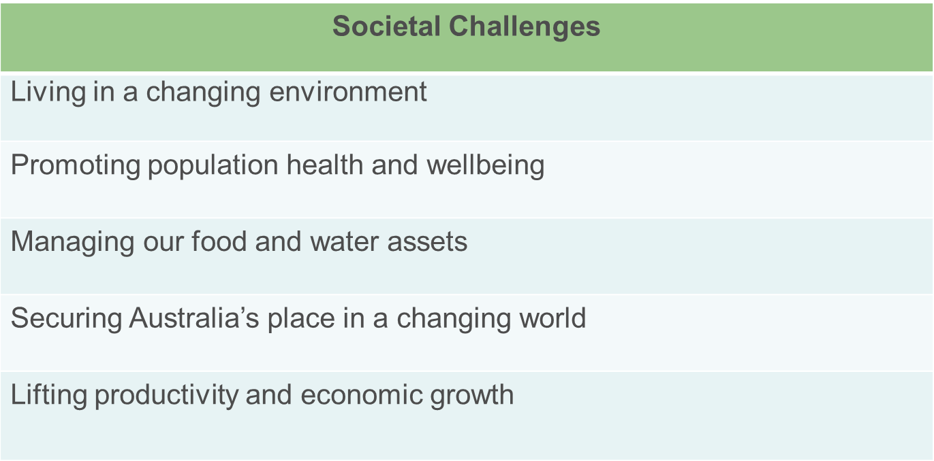

**Strategic Research Priorities**



**Prioritisation of research infrastructure**

**2011 Strategic Ro**a**dmap for Australian Research Infrastructure**

Identified priority research infrastructure areas for next 5-10 years;

* national scale
* 12 research outcome targeted priority areas
* 7 enabling capability areas
* Strategic and collaborative



**Investment in Australian Research Infrastructure**

* + - National Collaborative Research Infrastructure

Strategy ($542m, 2006-11)

* + - Super Science Initiative ($901m, 2009-13)
    - Education Investment Fund ($746m to date)
    - Collaborative Research Infrastructure Scheme ($60m, 2013-14)
    - The renewed National Collaborative Research Infrastructure Strategy ($186m, 2013-15)



**Workshop themes**

The Australia-European Union Workshop on Research Infrastructure will focus on;

* + - Healthy Ageing
    - Clean Energy
    - Sustainable Cities
    - Industry Links



**Outcomes from earlier workshops**

* + AMMRF and EuroBioimaging
    - Strategic partnership
    - Visits, workshops
  + BioPlatforms Australia and European Bioinformatics Institute
    - Collaborative letter of intent
    - Training workshops
  + CSIRO and ECCSEL
    - Knowledge sharing on establishment, operation and governance of infrastructure
    - Follow up workshop in Perth 2012

**DEPARTMENT OF EDUCATION**

Industry House

10 Binara Street

Canberra City, ACT 2601, Australia

Telephone +61 2 6213 6000