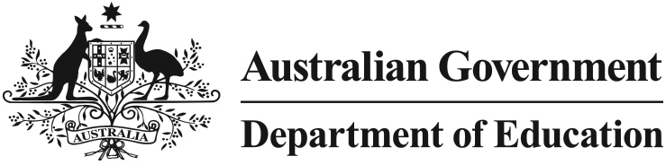 

Independent Public Schools

# Giving schools more choice

## What is the Independent Public Schools initiative?

There is no doubt that those at the local level – school principals, teachers and parents – are best placed to know what will make a difference in their school.

The Australian Government is responding to growing demand for greater school autonomy and flexibility with its new $70 million Independent Public Schools initiative, to help selected schools in participating states and territories become more autonomous and independent if they choose.

The Independent Public Schools initiative recognises the great work that principals already do, and is about giving them even more support and freedom to make decisions for the benefit of their school.

## Why is it good for schools?

Research from Australia and overseas shows increasing school autonomy is an important aspect of any school improvement strategy.

Western Australia and Queensland have already made a move towards greater school autonomy through their Independent Public Schools programmes.

Evidence from Western Australia shows that principals in participating schools feel more empowered and better able to cater for students’ specific needs. Schools are also reporting increased engagement with their community.

## How will it work?

The Australian Government wants even more schools to be given the chance to enjoy the benefits of increased control over decision making. We are working with states and territories to encourage around 1500 existing public schools to participate in the Independent Public Schools initiative by 2017.

Schools participating in the Independent Public Schools initiative will remain part of their government school system and will continue to receive support from state governments. They will not charge tuition fees to parents or have selective enrolments processes.

Schools that take part in the initiative will be able to use funding for a range of activities that will help them become more independent. This could include:

* professional development and training for principals
* training for school leadership teams and school council members
* programmes to improve parents’ understanding and involvement in school decision making processes
* education programs for the school community.

The Australian Government has also developed a *Guide for Parents on School Boards and School Councils* to help encourage stronger links between schools, parents and the local community. The Guide brings together information from each state and territory on school board participation.

## Who should I contact if I want my school to become an Independent Public School?

The Australian Government is writing to all Members of Parliament inviting them to become ambassadors in their community for the Independent Public Schools initiative. A full list of participating MPs will be available soon.

## Where can I find more information?

More information on the Independent Public Schools initiative, and the *Guide for Parents on School Boards and School Councils* is available at [studentsfirst.gov.au](http://www.studentsfirst.gov.au/principal-autonomy).