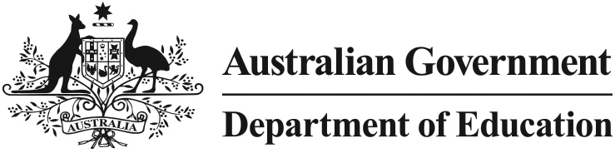 

Independent Public Schools

# What it means for parents and carers

## What is the Independent Public Schools initiative?

There is no doubt that those at the local level – school principals, teachers and parents – are best placed to know what will make a difference in their school.

The Australian Government is responding to growing demand for greater school autonomy and flexibility with its new $70 million Independent Public Schools initiative, to help selected schools in participating states and territories become more autonomous and independent if they choose.

The Independent Public Schools initiative builds on the great work already being done in local schools and will give parents and carers even more support and freedom to make decisions for the benefit of their school.

## How can your school benefit?

Research suggests that school communities benefit when parents and carers are involved in school planning and improvement processes.

One of the aims of the Independent Public Schools intiative is to increase the level of involvement you as a parent or carer can have in your school. This will help schools to better respond to your children’s needs, and the needs of the local community.

Western Australia and Queensland have already made a move towards greater school autonomy through their Independent Public Schools programmes.

Evidence from Western Australia shows that principals in participating schools feel more empowered and better able to cater for students’ specific needs. Schools are also reporting increased engagement with their community.

## How will it work?

The Australian Government wants parents and carers in more schools to be given the chance to be involved in decision making. We are working with states and territories to encourage around 1500 existing public schools to participate in the Independent Public Schools initiative by 2017.

Schools participating in the Independent Public Schools initiative will remain part of their government school system and will continue to receive support from state governments. They will not charge tuition fees to parents or have selective enrolments processes.

Schools that take part in the initiative will be able to use funding for a range of activities that will help them become more independent. This could include:

* programmes to improve parents’ understanding and involvement in school decision making processes
* training for school leadership teams and school council members
* education programs for the school community
* professional development and training for principals.

The Australian Government has also developed a *Guide for Parents on School Boards and School Councils* to help encourage stronger links between schools, parents and the local community. The Guide brings together information from each state and territory on school board participation.

## Who should I contact if I want my school to become an Independent Public School?

The Australian Government is writing to all Members of Parliament inviting them to become ambassadors in their community for the Independent Public Schools initiative. A full list of participating MPs will be available soon.

## Where can I find more information?

More information on the Independent Public Schools initiative, and the *Guide for Parents on School Boards and School Councils* is available at [studentsfirst.gov.au](http://www.studentsfirst.gov.au/principal-autonomy).