RESEARCHER PROFILES

**July 2010**

The following researcher profiles were developed by the 2010 Department of Innovation, Industry, Science and Research graduate cohort as part of their major project on *Mapping research career pathways in Australia*, and provided input into the Research Workforce Strategy.

The profiles have been compiled from interviews conducted by the graduate cohort in July 2010. Interviewees were selected so as to provide a range of different backgrounds and experiences.

# Dr Jonathan Baell

## Research Fellow, WEHI

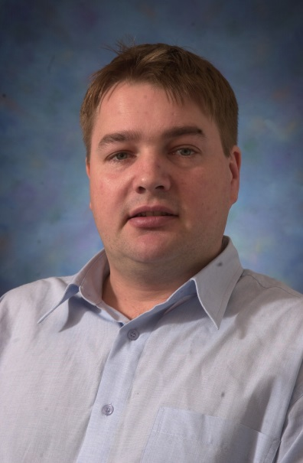An impassioned and dedicated chemical biologist, Dr Jonathan Baell is a Research Fellow with the Walter and Eliza Hall Institute of Medical Research (WEHI) in Bundoora, Victoria.

Jonathan never doubted his future in drug discovery and medical research. “I’ve never experienced Monday Morning-itis like other people I know,” he says, “when you do what you love you can’t wait to get back to it each day.”

It is this love for his work that has been the primary driver of his career, and ensured that skills obtained during his PhD, like computer aided drug design, remained useful.

Whilst Jonathan acknowledges that times have somewhat changed and Doctoral programs have become more prescribed, the need to keep a balance in life and take advantage of speaking engagements at conferences remains as relevant as ever.

“The very best scientists I know are also skilled communicators, not the stereotypical scientists undergraduate students may have in mind when they think of the PhD.” Not only this, but communication skills are a clear differentiator when applying for research positions and grant funding – a major aspect in the life of a research scientist.

This intellectual freedom was not without competing thoughts. “I can remember after graduating that I compared my wages with friends who did a trade. Most were already on the way to owning their own home.” Whilst these financial and family pressures will play on the minds of PhD students, Jonathan says enthusiastically that he’d always pursue his Higher Degree by Research if he had his time again.

Jonathan remarks a good mentor will make all the difference as you are introduced to their networks. If you get the chance to enter a highly competitive international post-doc overseas, consider that the publication record and future placements is well worth those years of high pressure work.

# Dr Rowena Ball

## ARC Future Fellow, ANU

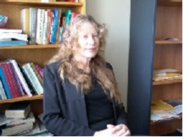Dr Rowena Ball, currently an Australian Research Council (ARC) Future Fellow at the Australian National University (ANU), has been a firm believer in the power of education and knowledge since beginning her undergraduate degree.

Rowena completed her PhD in 1997 at Macquarie University and was offered postdoctoral positions in prestigious institutions, such as Manchester and Cambridge universities and the Commonwealth Scientific and Industrial Research Organisation (CSIRO). After a year at Leeds University she took up a research fellowship at ANU. Rowena reflects back on her PhD as time well spent, especially making note of the legacy of knowledge that theses and published documents leave behind.

As an example of this, Rowena was recently contacted by a big company who is developing new carbon dioxide capture technologies based on research that she did for her PhD and published 12 years ago.

“In research nothing you complete goes away. You are always at the cutting edge of the field and the research you do comes back in ways that you cannot anticipate. This is a unique feature of a research career.”

Rowena’s research career has been mainly university-based; however she has also had research experience in other environments such as the Department of Defence and working with an industrial partner.

One of the great things about research that appeals to Rowena is that all of her work rests on what previous brilliant people have already done. For Rowena, it is important to get a grasp on the cultural and historical base of her discipline. This is something that she would encourage others to do so that they can appreciate and learn from the research world.

“In my area of applied mathematics I found an interdisciplinary world where I could learn more and more about physical, biological, and socioeconomic systems as well as mathematics. Working for my PhD was a wonderful time when I could obtain deep understanding of my project and find new answers to problems, and also be as creative as I liked. Success in research depends not only on technical abilities, but also on creativity.”

Her passion and hard work resulted in numerous prizes and accolades including a University Medal and a Student Prize from the Royal Australian Chemical Institute.

# Dr Axel Bruns

## Associate Professor, QUT

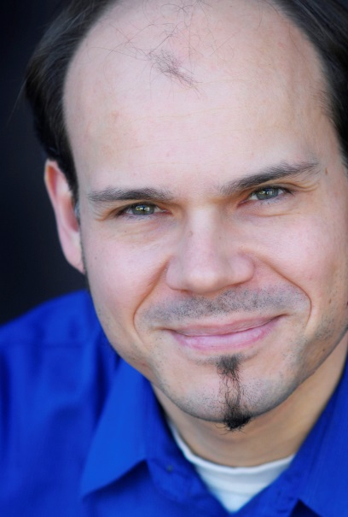Associate Professor Axel Bruns, a researcher of and active participant in creative industries, is now poles away from his early university years. By following his academic interests, he has been led from an undergraduate degree in physics in Germany to a buoyant career in media and communications in Australia.

After studying undergraduate physics for a brief period in Germany, Axel decided to pursue his interest in learning English by moving to an English-speaking country. His physical move was mirrored by his simultaneous decision to stop studying science and instead begin a Bachelor of Arts majoring in English. Axel completed an Honours year during which he founded a Media and Cultural Studies online journal (“M/C Journal” [www.media-culture.org.au](http://www.media-culture.org.au)) which continues to this day.

Axel’s PhD investigated early online resource sites, an emerging form of user-produced information and news aggregation and distribution. Shortly before the completion of his PhD, he was offered a part-time teaching position with the Creative Industries Faculty at the Queensland University of Technology (QUT). After obtaining permanent residency, Axel began developing core course material for the newly offered degree in creative industries.

Since this first, part-time appointment his career within QUT has blossomed, first being promoted to Senior Lecturer in 2007, and then to Associate Professor in 2009. He has also conducted cooperative research projects with the private sector, and is currently undertaking new cross-disciplinary research with computer scientists.

Axel believes that his research work has been key to his career progression – providing him with very well developed skills, but also raising his profile within and outside of the university. Visibility and self-promotion, he says, are valuable in a field of research with its finger on the pulse of social trends and awareness. He hopes to use his current experience and work to open ever new exciting areas of research, especially large scale quantitative measurement of social media.

Axel would advise students considering the PhD to use the experience as a chance to build both their skills and public profile. Your skills can be developed by undertaking novel research which appeals to your interests. Your profile can be built by regularly communicating with others in the field, and by making your passions known.

# Dr Bruce Buchan

## Senior Lecturer, Griffith University

Dr Bruce Buchan’s academic career in the humanities is one that many aspire to. He holds a tenured position as senior lecturer in his fields of expertise: the history of western political thought and theories of violence. His successful career has been generated as much by hard work as by making the most of every opportunity that arises.

Bruce entered academia in 1986 to commence a Bachelor of Arts in history and politics. After completing it with Honours, Bruce went on to do a Master of Arts by research and subsequently a PhD. An obvious love of and dedication to learning steered Bruce’s career down the academic path. He began lecturing full-time in 2003 and was promoted to senior lecturer in 2008.

Growing up, Bruce was familiarised with the university world and way of life through his family. “My ambition was to work in universities but I never seriously thought that it would happen.” Bruce was lucky enough to win a PhD scholarship with a well-known academic in his field.

As well as researching and lecturing, Bruce currently supervises students as they embark on their own PhD journeys. Bruce recognises that there are currently very few opportunities for academic careers, particularly in the humanities. However he thinks the skills one develops during their PhD can be useful in many potential jobs and careers that can be just as fulfilling.

A training in the humanities allows you “to be agile, to be perceptive, to think through tensions and contradictions and to be able to present cogent and coherent arguments”.

A PhD in the humanities gives you the opportunity to develop a range of skills to a tremendously high level. Among these skills are the ability to think laterally and the ability to bring information together and communicate it in a clear, concise and elegant way.

Bruce advises that PhD students recognise that career opportunities in academia are rare and that the skills developed in a PhD are useful in a diverse range of careers.

# Dr Rachel Burt

## Senior Medical Research Officer, WEHI

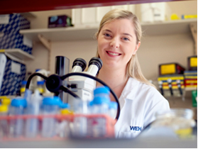Dr Rachel Burt is a Senior Medical Research Officer in the Molecular Medicine division of the Walter and Eliza Hall Institute of Medical Research(WEHI). Rachel conducts research on the genetic basis of complex diseases. The aim of such research is to develop definitive diagnostic tests and identify drug targets for prevention and cure of disease.

Rachel’s development as a scientist began as an undergraduate student enrolled in a Bachelor of Science. As an undergraduate student, Rachel did not have a clear idea of what she wanted to do once she graduated. During her Honours year, Rachel became excited about and interested in the research she was conducting. She became aware of what a PhD entailed and considered it as something she would enjoy doing.

Rachel completed her PhD in genetic resistance to malaria at WEHI. She enjoyed the experience, although admits that it was hard work with very long hours. Rachel’s supervisor was supportive, always available to help and enthusiastic about her research.

After completing her PhD, Rachel held a post-doctoral position at Rockefeller University in New York. She felt that it was quite challenging – she was far away from her personal and professional contacts. Rachel also had to adapt to a new work environment because the lab operated differently to what she was used to in Australia.

Rachel decided to return to Australia after three years in New York and resumed work at WEHI in a post-doctoral capacity. As part of her current role as a Senior Research Officer at WEHI, she is a Project Leader for the Hearing Cooperative Research Centre, and she is also a Director of the Australian Society for Medical Research.

What motivates Rachel in her career is that the research she is conducting is having a positive impact on science and academia, and has the potential to benefit many people. Rachel highlights that the research “is interesting, is exciting, and when something does work, it’s great!”

Rachel advises that you need to go into your PhD with your eyes open. It can be very challenging. It is good to speak to other PhD students to gain a range of opinions and experiences.

# Dr Megan Clark

## Chief Executive Officer, CSIRO

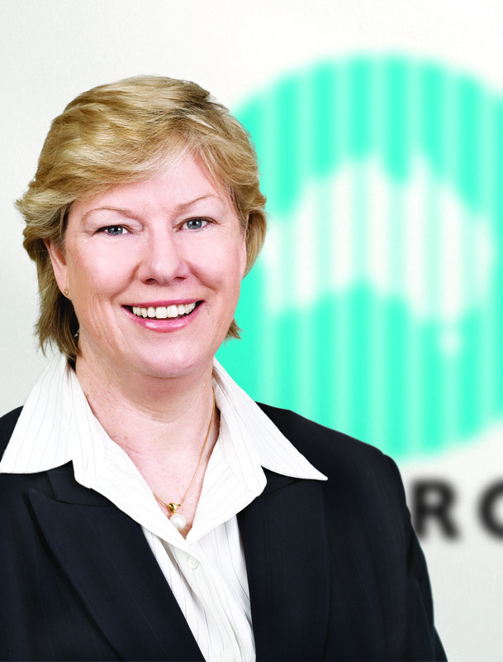Dr Megan Clark is the current Chief Executive of the Commonwealth Scientific and Industrial Research Organisation (CSIRO). CSIRO is the national research agency of Australia and is one of the largest and most diverse research organisations in the world. Megan has a “deep love and respect for the CSIRO” and wanted to work there so she could “make a difference to things that mattered to this nation and to humanity”.

After completing her undergraduate degree in geoscience, Megan knew that she wanted to complete a PhD at some point in her career. Straight out of uni, Megan commenced work at Western Mining Company (WMC). WMC had a “fantastic” supported study leave program that enabled Megan to go to Canada to complete her PhD in Economics Geology. After her PhD, Megan returned to Australia and worked for WMC in several roles for the next 18 years.

Megan describes her PhD project as “novel but hugely relevant” to her career field, giving her an opportunity to obtain a “deeper mastery of science” and to “fall deeper in love” with it.

The PhD experience is essentially a “deep dive”. Some people don’t surface from it, while others find it is the one time they can go deeper into their research area to be indulged and stimulated.

Due to her “thirst for learning”, Megan expanded her horizons by moving into finance for four years. Her PhD gave her the confidence to move into new fields and acquire the relevant skills in new areas.

This transition “opened up pathways of not just doing science, but investing in science”. Megan states she would not have had the career opportunities at BHP Billiton and CSIRO without this financial experience.

Megan never had a long term career plan. She remarks that at any point in her career, if she was to look back five years, she wouldn’t have conceived that she would end up where she did.

Her advice to people considering a PhD is to “go and work with the best people you can…in the world” and then bring it back and apply this expertise and knowledge in Australia.

# Dr Matthew Cuthbertson

## CEO, Cooperative Research Centre for Advanced Automotive Technology

Dr Matthew Cuthbertson
Dr Matthew Cuthbertson completed his PhD at the University of Queensland in 1979. His thesis was on reaction mechanisms in organo-metallic chemistry. Initially, Matthew intended to complete Honours and a Diploma of Education before starting a career in teaching. However, encouraged by his supervisor, Matthew was convinced he would make a greater contribution through research. He therefore decided to go ahead and apply for a PhD scholarship.

Over the course of his PhD, Matthew found that he enjoyed the experimental work, the intellectual challenge and the company of people involved with his studies.

Matthew did not have a specific career plan when he commenced his PhD. “I really did not have a lot of maturity or understanding of what careers or what options were available, but I liked the idea of doing research as a career, so that’s why I did a PhD.”

Matthew had some experience as a manager and participated in training on project management at ICI Australia. “I actually found that I had a better feel for it than most of my peers,” he said. Matthew’s aptitude and passion for management is the reason he is in a management role today.

Matthew believes that other skills developed during his career have become more important than the technical content of his PhD. Nonetheless, the PhD has given him valuable skills which he has constantly applied in his career. “I still understand the process of doing research very well; I understand how people organise themselves – no matter what the discipline. I can still think like a researcher, I can still understand how researchers think and I can understand what they respond to, and what motivates them, and what they don't respond to.”

When considering a PhD, Matthew recommends “keeping your options open; when you are making career choices, think about whether this enhances or limits your options.”

# Dr Anna Daniel

## Research Associate, QUT and Monash

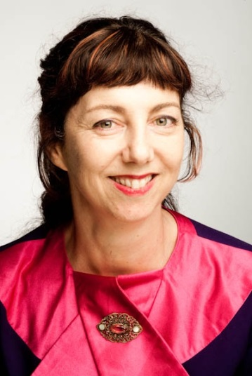Dr Anna Daniel is a researcher who has successfully moved between the public, private and university sectors. Her career pathway is far from conventional. During a successful career working in a top tier global firm, Anna decided to take up a part-time PhD in businessout of interest. Her thesis looked at the recent digitalisation of the music sector.

Anna’s workplace supervising partner saw her PhD as a distraction from her high-flying career. Juggling full-time work and study was tough, but Anna was highly motivated. The PhD was “an exercise in perseverance” but it was also “definitely worthwhile… despite the pressures at work, I really loved it”.

Towards the end of her PhD Anna moved back to the family farm, and worked there during a difficult time of drought, whilst writing up her thesis. When the drought broke, she relocated to Melbourne and began her current ‘virtual’ academic positions at Queensland University of Technology (QUT) and Monash University.

Anna says her decision to move from a private company to academia meant she had to take a big pay cut and move from national research leadership to a research associate role. However she is now doing what she loves and with an improved quality of life. “Academic work can be obsessive, but it is very rewarding” – interesting work, opportunities to travel and the luxury of intellectual freedom are just a few of the perks.

Anna says her PhD provided a segueway from her private sector work to the more creative fields she works in now. “It’s really changed my life… I’m a much more rounded person since doing a PhD.”

Anna has worked in academia, industry and government, and her experience suggests each sector requires different technical skills and styles (e.g. academic writing is very different from business and government writing). While the private sector was revenue-focussed; the public sector was all about due process and public value. She would not say that any one sector was better than another – they’re just different.

A word of advice from Anna is that “you have to be able to adapt your working style to change sectors”.

# Dr Chris Deller

## Senior Research Engineer, CiSRA

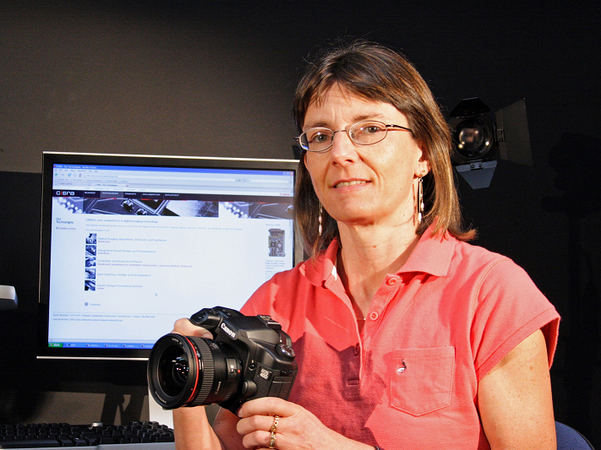Dr Chris Deller is a Senior Research Engineer at Canon Information Systems Research Australia (CiSRA). Chris has always been very interested and involved in science and research. Her PhD gave her the opportunity to really understand what research is, and allowed her to adopt it as the foundation of a career.

After graduating from high school Chris worked as a technical assistant for the Commonwealth Scientific and Industrial Research Organisation (CSIRO) before leaving to start a family. After having four children, in her early 30’s she decided to pursue a career in science, initially studying part-time.

As an undergraduate student at the University of Technology Sydney (UTS), Chris studied applied physics and geology. Chris focused on physics, with an Honours thesis on energy efficient windows. After her Bachelor of Science, Chris received an Australian Postgraduate Award to undertake a PhD on energy efficient lighting at UTS, which she commenced immediately.

Chris found maintaining a work-life balance and the change of study mode quite difficult in her transition to a PhD, but states that “the more work I did the more confident I became”.

Immediately after finishing her PhD, Chris felt lucky to have had the opportunity to walk straight into a research position with CiSRA.

Chris has some regrets in starting her PhD late, saying if she was younger she would have been more ambitious with her career path. Nonetheless the lab skills and technical writing skills learned during her PhD have really come in handy. In her current position, Chris also relies on her teamwork and leadership skills which were mostly developed in extra-curricular activities throughout her life.

Looking back over her PhD experience, Chris can see both positives and negatives. Her decision to do a PhD was never about money, but rather for her love of science research. Her PhD helped her life by broadening ways of thinking and working with others. However Chris states that one should be mindful of the timeframe in undertaking a PhD, because it is quite a long road. She says that even a short break between her undergraduate and post graduate study would have been of benefit.

Chris advises that PhD students need to “be interested in the area [they] are going to focus on, and be motivated in that area”.

# Dr Graham Durant

## Director of Questacon

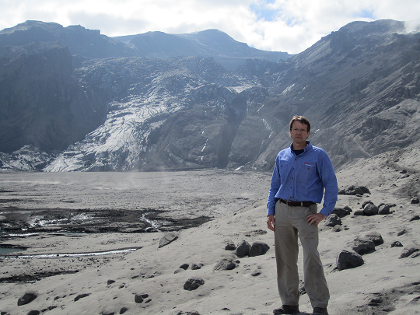Dr Graham Durant is the Director of Questacon – the National Science and Technology Centre based in Canberra. He completed his first degree and PhD at the University of Wales, Aberystwyth.

Graham’s PhD was in petrology and geochemistry. Graham explored the mineral chemistry of rocks from the roots of underwater volcanoes. His research involved him diving for rocks off the west coast of Scotland, an experience he greatly enjoyed.

After receiving first class honours, Graham was encouraged to start a PhD – an experience that would allow him to “discover world first, new information”. He enjoyed discovering things as well as demonstrating and lecturing. This passion has only increased in the 25 years since Graham completed his PhD.

Graham did not have a planned career path and remarks that he still doesn’t. “I am still trying to work out what I want to be when I grow up.” Since completing his PhD Graham has held several diverse positions at the University of Glasgow, such as the Senior Curator and Deputy Director of the Hunterian Museum. Graham moved to Australia in 2003 to join Questacon.

Without a PhD, Graham states these positions would not have been available to him. Graham also says that he feels lucky to have been involved with the University of Glasgow which encourages diverse areas of learning. This diversity meant there was always something new on the horizon.

Graham found the analytical and communication skills he developed during his PhD to be very useful in his research career. After his PhD his advocacy and leadership skills were further developed with a spell as advisor to the Scottish Government. Graham set up a charitable company in 1990 and the experience as a director of this company gave Graham business and financial management skills.

Looking back, Graham feels he wouldn’t have changed much, remarking “I had a blast and would certainly do it again”. However, he may have tried to publish more papers and worked harder at canoeing for Olympic selection after being British Universities Canadian doubles champion.

Graham’s advice to PhD students who are starting their research career is to “never stop learning, embrace the accelerated change of today, and maintain a healthy and active lifestyle”.

# Dr James Fitzsimons

## Director of Conservation

## The Nature Conservancy

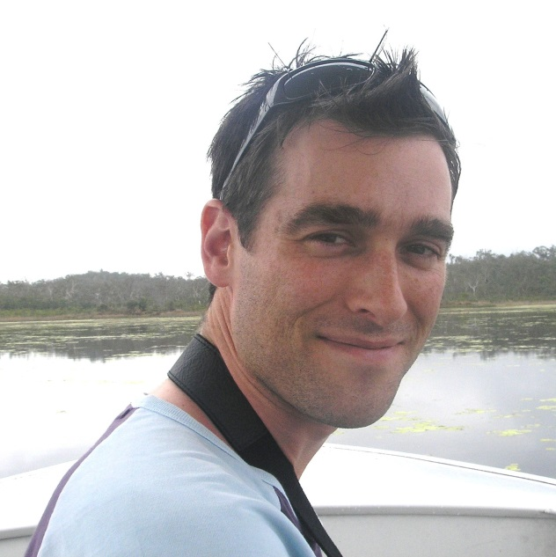Dr James Fitzsimons is the Director of Conservation at The Nature Conservancy – a leading conservation organisation which protects ecologically important lands and waters.

As an undergraduate student, James studied environmental science at Deakin University. During his Honours year, he commenced working at the Victorian Department of Sustainability and Environment, where he worked on conservation policy and protected area establishment. Whilst still working at the Department, James commenced his PhD, which he felt was multidisciplinary in nature - “it touched on ecological and social sciences, policy, planning and governance”. James never really had an ambition to do a PhD. However, he knew that he wanted to work in the area of environmental conservation and he felt that a PhD would give him the freedom to pursue this interest.

James’ PhD experience was mostly enjoyable. For him, it was motivating that he was able to work in the area of conservation whilst studying. The most stressful part of the process was writing up his work. In addition, working for the Department of Sustainability and Environment during his PhD gave James access to data sets and knowledgeable staff. James also felt that it provided both positive stimulation and a good distraction during his PhD.

Since completing his PhD, James has worked in a number of organisations – in both the public and private sectors. At the Victorian Environmental Assessment Council, he worked on two major projects, including the River Red Gum Forests Investigation.

He also worked at the Office for the Commissioner for Environmental Sustainability and at Bush Heritage Australia. Working three jobs at once was incredibly intense, and he wouldn’t recommend it.

James took up his current position at The Nature Conservancy because he felt that he wanted to experience something different. In all the positions he has held, he felt that he had contributed positively to biodiversity conservation - “In all jobs I felt like I’ve really achieved something.”

In his current role at The Nature Conservancy, James values the opportunity to travel around Australia and work with diverse people on various large-scale conservation projects.

James advises that PhD students should be passionate about the project they are doing. They should have some background knowledge about the topic, and just keep going.

# Dr Stuart Gordon

## Principal Research Scientist, CSIRO

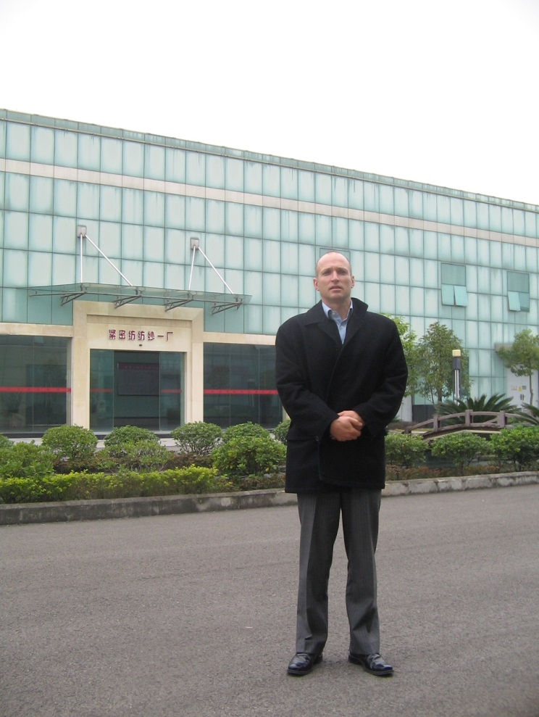Having previously completed a degree in agricultural science, Dr Stuart Gordon began a PhD on cotton fibres sponsored by the Australian cotton industry. It wasn’t a decision he thought too much about. He just knew he enjoyed studying, student life and having time to think. Continuing his higher education was a way to keep all of that.

The Australian cotton industry through the Cotton Research and Development Corporation (CRDC) was really supportive of PhD students and helped Stuart make plenty of valuable connections.

Overall Stuart says his PhD gave him general problem solving, writing and analytical skills. However he said there are some sacrifices you make in order to do a PhD, such as you start earning money at a later date than undergraduates that go straight into industry.

When he graduated, Stuart didn’t have a specific career path in mind. Having the CDRC behind him helped guide him into a career.

After finishing his PhD Stuart went on to do post-doctoral work at the Commonwealth Scientific and Industrial Research Organisation (CSIRO) and the United States Department of Agriculture (USDA) before moving into private industry working at a textile mill. Stuart found that the people running the textile mill were particularly keen to gain a high end understanding of the cotton spinning process.

Stuart then went on to get a job as a research scientist at CSIRO. He felt that in his field, academia can be a bit removed from the action. He enjoys working at CSIRO because it provides a nice balance of theory and practice.

Stuart also enjoys working with Australian farmers to grow things more efficiently and sustainably in comparison to other countries. Through his work he has travelled widely in Asia, the USA and Europe and he says Australia is much more efficient in getting return from the research and development (R&D) dollar.

Overall, Stuart thinks the impact of his PhD on his career has been positive and he would recommend it to anybody.

# Dr Lynn Gribble

## Business owner, Talking Trends

Dr Lynn Gribble was the first PhD student from Southern Cross University to undertake her entire term of studying long distance. After two and a half years of emails, phone calls and flights, Lynn was awarded her PhD in 2001. Her thesis focused on the psychological underpinnings of the effects of retrenchment.

Since being awarded her PhD, Lynn has continued on with a Masters of Labour Law and Relations at the University of Sydney. She has run her own business, taught overseas and worked for major companies across various industries. She has held teaching roles at a number of universities, on both undergraduate and postgraduate levels – something she is very proud of.

Lynn says: “at the end of the day if one or two people get something out of what I say it’s worthwhile. At least I know I did something valuable in society.”

Because of her research qualifications as well as her practical experience, she was able to give qualified advice to industry. In addition to this, Lynn has enjoyed success working as an academic and running her own business.

Lynn found that the skills she gained from doing her PhD were also useful in her everyday life, regardless of whether she was dealing with clients or colleagues. “I can take on any argument or discussion and take it forward.”

Lynn has also learnt to take criticism, has a mind which is open to ideas and is able to deliver under pressure. Lynn says that each of these traits were sharpened through her PhD.

Lynn’s advice to prospective PhD students would be to find a good supervisor and be willing to work hard. “When my students tell me they haven’t had enough time, I ask them – have you been out, or slept in? – well then you have time.”

# Dr Gerald Haaima

## Director of Business Development, QIMR

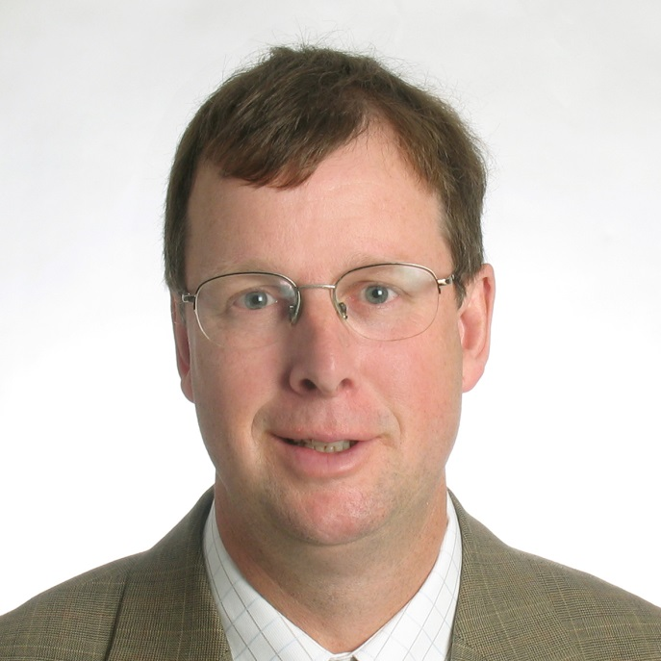Dr Gerald Haaima is the Director of Business Development at the Queensland Institute of Medical Research (QIMR). His current role takes him outside the lab, managing research contracts, intellectual property issues and patents for the research groups that make up the Institute.

Gerald did his PhD at the University of Otago in New Zealand. He was inspired by a successful Honours year, a love of research and a “non-negotiable” interest in chemistry. He loved his PhD experience, particularly the flexibility and opportunities to be self-directed. At this point he did not have a specific career in mind. However, he did think he would end up in research and that a PhD was a necessity for this career path.

Gerald pursued post-doc research positions, some of which took him overseas to the USA and Denmark. He values his overseas experiences because they proved to be an important part of developing his career in research.

During a post-doc position, Gerald decided that he wanted his career to take a different path. So he “dropped out” for a year to do a Master of Business Administration (MBA) in technology management. He feels that the time and money invested has been more than returned in the form of career advancement.

Following his MBA, Gerald took advantage of an opportunity offered by the Queensland Government to travel to the USA for six months to work in biotechnology. Since then he has worked in business development.

While not directly using the technical skills he acquired as a PhD student and researcher, Gerald credits his PhD as a major factor in his successful transition to business development. He notes that his PhD acts as a “calling card”. He enjoys having a rapport with scientists and the opportunity to be involved in scientific discovery without the “emotional rollercoaster”.

Gerald suggests that PhD students should focus on their research but still take the time to explore other options. He says “a PhD will open more doors than you think”.

# Dr John Henstridge

## Managing Director, Data Analysis Australia

Photo - Dr John Henstridge
Dr John Henstridge was working in the Public Service when he took leave to do a PhD. He “loved mathematics and statistics, and [the PhD] seemed like an opportunity to go further into it”.

John did his PhD under the supervision of distinguished statistical researcher, Ted Hannan. During his PhD, John was exposed to a high-powered department where the “the giants in statistics” walked the hallways. He says it was “a great place for learning”.

John expected he would return to the Public Service post-PhD. However during his PhD he started to get a feel for academia, and met and married a pure mathematician whose career prospects were most likely in academia.

After his PhD, John and his wife moved to Western Australia where John took a short-term teaching contract in mathematics at the University of Western Australia. Later, he got a tenured position as a statistician in the agriculture department. His job consisted of about “one-third research, one-third teaching and one-third consulting”.

Then in 1983 John had a choice: he was offered a mid-level academic position at Murdoch University as well as a consulting role at Siromath, a Commonwealth Scientific and Industrial Research Organisation (CSIRO) start-up company. John says “I like seeing statistical theory applied in practice.”

A few years later, when his wife took sabbatical leave, John took leave without pay from Siromath and spent a year away in Oxford. During this time he resigned from Siromath and decided to start his own business.

Returning to Australia in 1988, John set up Data Analysis Australia. He had to teach himself accounting, and some of the legal aspects of running a company. Twenty-two years later, Data Analysis Australia is the leading mathematical and statistical consultancy firm in the Australian private sector.

Although the PhD can greatly expand your knowledge and skills base, John sees it essentially as training for an academia career. He advises that if you decide to go into a commercial environment post-PhD you may have to unlearn some habits and processes. For example, you will have to shift your focus from your own interests to your client’s needs. He also advises that it is worth being selective of universities because so much of the PhD experience comes from the environment where you do your PhD.

# Mr Ray Hingst

## Lecturer, University of Southern Queensland

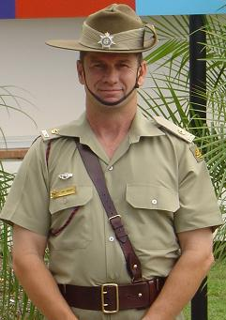Ray Hingst is a lecturer and researcher in the Faculty of Business at the University of Southern Queensland (USQ) in Toowoomba. Six years ago Ray completed his Masters of Administrative Leadership by research. He has just begun his PhD on group formation and team development. Ray is doing his PhD through a program offered at the Australian Defence Force Academy by the University of New South Wales.

Ray began his academic career as a teacher in Queensland TAFE colleges before moving to USQ. The opportunity for Ray to do his Masters by research arose because of his interest in the research area and his management experience.

Ray’s motivation for undertaking his Masters was career development and his enjoyment of research. “Someone in my position is expected to have a postgraduate qualification – I wouldn’t have been in this role for long without it.” Ray’s PhD will further assist in his career development, as he cannot be promoted further until he receives a PhD.

Ray teaches courses on administrative management and is the coordinator of his faculty’s integrated learning program. His research at USQ is in teaching and learning, logistics, and group formation and team development. Most of these research areas are related to either his Masters or his PhD.

Throughout his career, Ray has also been an army reservist. He says that he has been able to make time to juggle his commitments to his academic career and the army, but it has been difficult.

“Finding the balance between my workload, research and family has proved difficult at times, but I’m glad I stuck with the army as it’s been very rewarding.”

Ray advises that a research student needs to have a genuine interest in their research area to succeed. He notes that difficulties will be experienced along the way and stresses that hard work and persistence will pay off.

# Dr Rosemary Keogh

## Senior Research Fellow, Royal Women’s Hospital

Dr Rosemary Keogh is a Senior Research Fellow at the Department of Perinatal Medicine (Pregnancy Research Centre) at the Royal Women’s Hospital and an Honorary Senior Fellow of the Department of Obstetrics and Gynaecology, University of Melbourne. Her current research is in cardiovascular reproductive biology. She is investigating uterine spiral artery remodelling in human pregnancy.

Photo - Dr Rosemary Keogh
As an undergraduate science student at the University of Melbourne, Rosemary majored in bio-chemistry and physiology. After graduating with a Bachelor of Science with Honours, Rosemary worked as a research assistant at the university’s Department of Medicine (Royal Melbourne Hospital) in the Faculty of Medicine, Dentistry and Health Sciences. Rosemary’s inspiration for pursuing her interest in science came from her mother, who completed a science degree in bio-chemistry in the 1940s.

Rosemary was motivated to undertake a PhD due to her interest in science and the challenge and learning opportunities a PhD promised. Strategically, she also thought that she could convert the research she was conducting as a research assistant into a PhD qualification.

Although the PhD was a good learning experience which presented many opportunities, Rosemary’s PhD also had its setbacks. When comparing herself with people who have not pursued a higher degree by research, Rosemary believes that they are better-off – “they have a house, have ten years more super than you, and are more established overall.” Furthermore, a career in research gives no guarantee of career linearity. It is difficult to plan and strategise because you are generally employed on short-term three-year contracts.

After completing her PhD, Rosemary worked in the UK (University of Cambridge, Royal Veterinary College and University of London) and the USA (Ohio State University).

Working overseas could be quite lonely and financially stressful. Rosemary nonetheless enjoyed living in different countries and meeting people – “I wouldn’t change the experience at all.”

Rosemary decided to return to Australia after having lived overseas for nearly a decade. In addition to her current research position at the Royal Women’s Hospital, Rosemary is a Director of the Australian Society for Medical Research, a role which she thoroughly enjoys.

Rosemary advises prospective PhD students that they need to bemotivated and want to do it; and that they need to be interested in learning, science and discovery.

# Professor Steve Larkin

## Pro Vice-Chancellor - Indigenous Leadership

## Charles Darwin University

Professor Steve Larkin is the Pro Vice-Chancellor – Indigenous Leadership at the Charles Darwin University. Steve is a Kungarakany man from Darwin in the Northern Territory. He is the first Indigenous Australian to be appointed to the position of Pro Vice-Chancellor. Steve is currently finishing his PhD in race relations through the Queensland University of Technology.

Before becoming Pro Vice-Chancellor, Steve held roles regarding Indigenous Affairs in both the public and community sectors. During this time, he identified “making things better” as a “fairly compelling imperative” in his work. He notes that there are not many Indigenous Australians in the private sector. Working mainly in health and employment, it was these “work threads that contributed to [him] wanting to do a thesis” in race relations.

There were multiple motivations for Steve to undertake a PhD. He had already completed a Master of Social Science, but wanted to make a further “contribution to knowledge” and to expand the intellectual framework in his field. He also wanted to remain competitive in his field because he aspires “to lead something that will make a difference”.

Steve’s PhD experience to date has enhanced his planning and organisation skills. He states that it has taught him the structure behind research and that the “detached objective voyeur of reality does not fit anymore”. Instead, in his field you need to show that you are not just objectively across the field but also understand how your views fit into the research landscape.

Steve has to balance his time between the competing pressures of full time, high profile work (as Pro-Vice Chancellor) and finishing his thesis. Steve finds himself often “colonised as a resource” at work and has to maximise the time he can give to his thesis. It is frustrating that he is not full time as he is “in and out of that intellectual space”. He notes that this delicate balance of priorities can be the most difficult aspect of completing a PhD.

Looking back, Steve would have started his PhD earlier. He advises older postgraduates to negotiate with their employer for whatever time you can obtain and to take it. More generally he recommends selecting a topic that you are passionate about as it will keep you going in the tough times.

# Dr Robyne Le Brocque

## Senior Research Fellow,

## The School of Medicine, University of Queensland

Photo - Dr Robyne Le Brocque
Dr Robyne Le Brocque is a health sociologist who researches the impact of trauma on children and their parents. After much experience in market research and academia, Robyne decided to undertake further study. She completed her Masters in Social Science and her PhD so she could become an independent researcher. Robyne’s career now allows her to make a real difference to people’s quality of life.

Whilst working for market research companies, Robyne gained practical experience in how to design and carry out research projects. During this time she was very involved in every step of the research process. Returning to academia as a senior research assistant and subsequently a Masters student, Robyne was keen to develop her knowledge of research methodology and social theory.

Robyne decided to do a PhD after her Masters because she felt that she needed to progress further in academia. For Robyne “the PhD was the icing on the cake”. It formally recognises and frames her as a researcher who is capable of conducting independent research.

As a sociologist, Robyne feels she can “slot in just about anywhere”. Working in the Medical School at the University of Queensland, Robyne is constantly working with researchers and professionals of various academic backgrounds.

Since being awarded her PhD in 2005, Robyne has held Research Fellow and Senior Research Fellow positions at the Centre of National Research on Disability and Rehabilitation Medicine (CONROD). Driven by compassion, inquisitiveness and persistence, she continues to undertake exciting and groundbreaking research, publish her work and collaborate with fellow researchers.

Although there are many challenges associated with working in academia (particularly in obtaining funding), Robyne says academia encourages life long learning and can be very rewarding.

Robyne advises that if you’d like to become an academic, do your PhD early on in your career. “Once you have a PhD, it actually opens up a lot of doors. And not necessarily in the area your PhD is in.”

# Dr Guillaume Lessene

## Faculty Member, WEHI

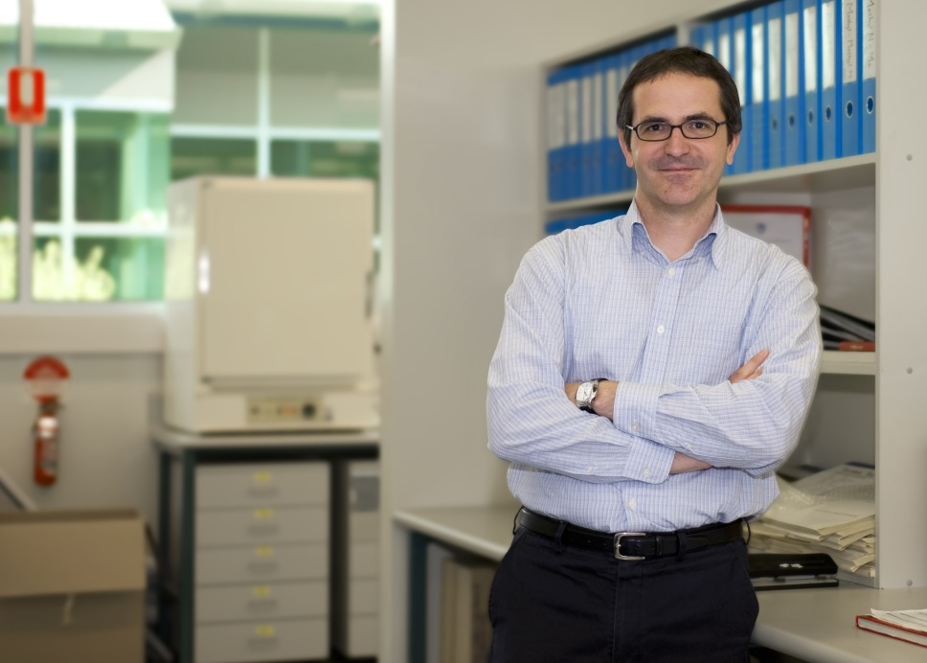Dr Guillaume Lessene is a faculty member of the Walter and Eliza Hall Institute of Medical

Research (WEHI). As one of the leaders of the WEHI Medicinal Chemistry Group, Dr Lessene conducts research aimed at developing new molecules for therapeutic use.

Guillaume completed his PhD in organic

chemistry at the University of Bordeaux. Guillaume decided to complete a PhD because he was interested in pursuing a research career in organic chemistry. He felt as though a PhD was the “logical next step” in his career.

Guillaume recalls his PhD experience as being a particularly challenging one. “I was given a project that was flawed; and I spent two years of my PhD looking at the flaws of my predecessor.” This challenge forced Guillaume to build his own project and persevere in his research.

Following his PhD, Guillaume completed two years of post-doctoral research in the USA, investigating the organic synthesis of natural product. For Guillaume, the post-doc was an opportunity to confirm his aspiration to become a professional researcher. Guillaume thought at the time: “This is really where I’m going to see if I like it or if I'm good at it.”

“So I looked for a position where I would do that and through people I knew, I got this position in the States and that worked really well. So that was very reassuring,” Guillaume said.

Having moved to Australia due to personal circumstances, Guillaume found a position at WEHI, just as the institute was creating its drug discovery lab. Without his PhD, Guillaume thinks he may not have been able to secure his position at WEHI.

Guillaume sees a PhD as the highest degree you can get and something that will be recognised anywhere in the world. He believes that if you have a PhD you might be overqualified, but you will never be underqualified – and according to him, that is all that matters.

# Dr Christine Lin

## Research Fellow, The George Institute for Global Health

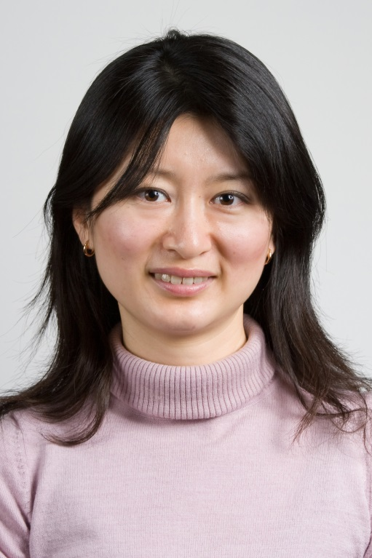

Christine Lin of the George Institute for Global Health undertook her PhD from 2005-2008 on the rehabilitation of ankle fractures. She saw the PhD as an opportunity to expand her research and critical thinking skills.

Christine says: “I’ve always been interested in research in general. I like the fact that a research career is always challenging and you are continuously asked to improve your thinking, skills and research output. It may seem difficult at the time, but (if all goes well!) it is rewarding to look back after a few years to see how you have contributed.”

One aspect of her PhD and current research job that Christine particularly enjoys is the opportunity to travel to conferences and visit other research institutes. She says that travel opportunities have expanded her knowledge base and allowed her to network with and learn from experts all over the world. “All researchers I’ve met are very approachable and willing to lend support to junior researchers. I’ve found it immensely beneficial first as a PhD student and now as an early career researcher to be involved with the wider scientific community,” Christine says.

Through her PhD experiences, Christine has also been able to develop a strong work ethic and time management skills. Christine says that research is highly competitive and “you get rejected a lot from submitting for publications and for funding”. So, she believes that another essential skill for a junior researcher is to learn how to handle rejections and be persistent.

If she could have her time over again, she would still do her PhD as it has helped her to get to a place where she’s happy with what she is doing.

Her advice to students would be: “A PhD can be very rewarding but is also a huge commitment. So you have to be clear why you want to do a PhD, be excited about your topic, and choose a good supervisor and a good research team.”

# Dr Tek Maraseni

## Research Fellow, Australian Centre for Sustainable Catchments

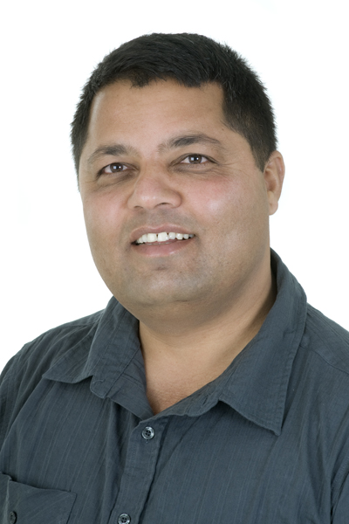After receiving four scholarship offers from around the world Dr. Tek Maraseni successfully completed a PhD at the University of Southern Queensland in 2008. However, achieving a PhD qualification was not the beginning of this successful scientist’s career.

After completing two Bachelor of Science degrees in his homeland (Nepal), Tek worked for several years as a Forestry Officer. He then undertook his PhD in Climate Change and Forestry in the South Burnett. Tek supplemented his scholarship by undertaking teaching and marking across 14 courses including economics and statistics. He remarks that “I am using 100 per cent of the skills from my PhD” to this day.

Despite this heavy workload Tek still managed to produce high quality publications – 55 papers in the last five years. As a result he has received many awards and was sponsored to attend international events hosted by organisations including the American National Science Foundation and the Intergovernmental Panel on Climate Change. Although Tek admits that he nearly missed out on the latter because “I thought it was a joke, I deleted the email three times”.

He has faced many challenges in his career, including moving his family to a new country and being unable to return to Nepal due to political unrest. Tek also notes that whilst the earning potential for science is not as high as other sectors, he enjoys the quality of life it has provided for him and his family. Tek doesn’t regret the decisions he has made and loves being able to work as a researcher.

Tek continues to pursue his passion for climate change research and is hoping to become more involved in climate change policy, especially in collaboration with the Australian Government and developing nations.

Tek’s advice to PhD students is to make sure you choose a field that is both interesting to you and saleable in the research market. He suggests PhD students remember to “think globally, you need to be competitive”.

# Dr Nicola Markus

## Chief Conservation Officer, Bush Heritage Australia

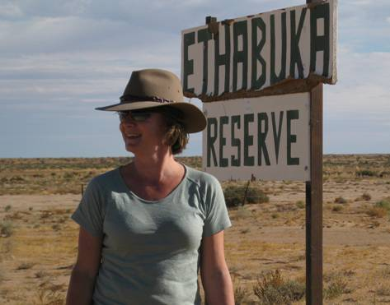Dr Nicki Markus works at the “coalface of conservation” in her current role as Chief Conservation Officer at the non-government organisation, Bush Heritage Australia.

Nicki and her team work on a range of intellectual and practical challenges related to nature conservation in Australia. Her focus is on the management of threatened species and ecosystems to ensure their future in the landscape.

At the time of commencing a PhD Nicki did not have a firm career trajectory. Nor did she have a clear understanding about what having a PhD would mean for her. Nicki undertook her PhD in an area she was passionate about (flying fox ecology) and subsequently developed a strong understanding of how an animal species can be a flagship for broader conservation issues.

Nicki completed her PhD in Zoology in 2000. As a PhD student Nicki immersed herself in the area of her future career by doing volunteer consultation work on conservation issues.

Through her volunteer work she developed skills in lobbying, public relations, advocacy and communication with different bodies such as government and industry groups. Nicki uses these skills in her current role as Chief Conservation Officer.

Through her own experiences doing a PhD, Nicki understands the high level of dedication, independence and commitment required to obtain such a qualification.

She feels that in her experience, NGOs also

recognise and value this qualification. It is common for people in the conservation sector to be highly qualified and educated and the PhD can act as a “calling card”.

Nicki attributes her career successes in part to her PhD and in part to the volunteering and work experience that she undertook alongside her studies. Her advice to prospective PhD candidates is to ensure that they take advantage of all opportunities related to their chosen field and build a broad set of skills and experience at an early stage.

# Professor Jenny Martin

## Research Fellow, Institute for Molecular Bioscience

Photo - Professor Jenny Martin
After completing Bachelor’s and Master’s degrees at the Victorian College of Pharmacy in Melbourne, Jenny Martin couldn’t decide between a career in research or a career in pharmacy. At the age of 24 she opted to travel, and to focus on a research career only if she could secure a PhD scholarship to Oxford University. It was at Melbourne Airport as she was leaving on her travels, that Jenny was given the news that she had been awarded a prestigious 1851 Scholarship to study at Oxford. This was soon followed by four other scholarships and bursaries. Clearly, fate had decreed that Jenny’s future lay in research.

Jenny describes her PhD experience at Oxford as “magical, a dream come true”. She developed skills and expertise in protein crystallography and drug design and established networks with leaders in these fields. Undertaking her PhD overseas also impacted on her personal growth. She says, “I grew up in a large and very close family in Dandenong, Victoria. Moving to the UK on my own meant I had to step out of my comfort zone, to challenge myself to become independent, self-directed and self-motivated.”

On top of the world after her DPhil was awarded, Jenny returned to Australia in June 1990 to a position at Bond University. However, the School of Science and Technology was closed down just six months after she arrived. This was a devastating blow so early in her career, but Jenny says it ultimately proved positive. “Events like these are extremely distressing, but they can also represent opportunities.” Jenny subsequently took up a research position in Rockefeller University in New York, where she further developed her skills and networks. She returned to Australia in 1993 funded by a Queen Elizabeth II Fellowship. She has been

a group leader at the University of Queensland ever since. Jenny says that an academic research career is by no means easy, with long hours and a competitive grant system that at times seems capricious. However, there’s not much she would change; “the thrill of discovery is addictive, and I’ve been lucky to have had wonderful mentors and to work with the most amazing people.”

Her hard work has certainly paid off. In 2009, Jenny was one of 15 researchers, and only two women, to receive a prestigious five-year Australian Laureate Fellowship to fund her research.

Her advice for prospective students is to be clear about why they want to do a PhD. “If you have a passion for discovery, a burning desire to understand and improve our world then a career in research may well be for you.”

# Dr Emmi Mikedakis

## Associate Director, Research Excellence Branch, ARC

Dr Emmi Mikedakis from the Australian Research Council (ARC) says her PhD integrated many of her interests. It was an important part of her life and has made it possible for her to contribute to the community through her post-PhD employment.

Emmi undertook undergraduate studies at the University of New South Wales (UNSW) in Greek studies – a multidisciplinary degree incorporating political science, Greek language and linguistics. After completing her Honours thesis, Emmi proceeded directly to a PhD which focussed on the political language used by Georgios Papadopoulos, a Greek dictator. Whilst working on her PhD, she was also employed by UNSW as a casual lecturer and later as a full-time curriculum developer for the university’s Modern Greek Studies Program.

After five years of teaching and curriculum development, Emmi returned to her PhD with a renewed focus and clarity. Her PhD brought together her interests: politics, language and modern Greek history. The PhD was, she says, as integral to her as she was to it.

Towards the end of her PhD, Emmi took a position as a live captioner with the Australian Broadcasting Corporation (ABC) News. She then took up work with Parliamentary Hansard and, after a protracted search, gained a position with the ARC.

Emmi says that her search for employment in the government sector was difficult, but what she ultimately wanted to achieve. “I’ve always wanted to use my skills to contribute to the community.” Though she felt she had the skills and motivation to fill roles in the public service, she was often told that she lacked public sector understanding, especially in the development of government policy work. The PhD, Emmi says, may not have played a major role in gaining entry into the public sector, but the analytical and research skills developed during her PhD have been essential to her work and progression at the ARC. She advises that the transition to employment, especially into government, may be unexpectedly difficult or frustrating for PhDs.

Emmi’s advice to prospective students is that you should love the research as much as, if not more, than your topic. Your thesis topic is likely to evolve but you will need to maintain high quality research for the qualification and your later work.

# Professor Terry Mills

## Senior Cancer Data Analyst, LMICS

Photo - Prof Terry Mills
Professor Terry Mills is an experienced researcher who has had a distinguished academic career. Terry completed a Masters and a PhD in mathematics early in his career. Terry was motivated to attain these qualifications as he wanted to be an academic. He later completed a second Masters in mathematical statistics.

After completing his PhD in Florida, Terry worked as a post-doctorate associate and subsequently a visiting Professor in Montana. When Terry returned to Australia, he took on a lecturing position at the Bendigo Campus of La Trobe University. Terry performed various roles at La Trobe, including Head of Mathematics and Professor of Mathematics, until he left academia in 2008. Terry was made an Emeritus Professor in 2007.

Terry is now a Senior Cancer Data Analyst with the Loddon Mallee Integrated Cancer Service (LMICS), which manages, plans, and develops cancer services for a large part of regional Victoria. Terry uses all of the skills he developed from his higher research degrees. He says that everything the higher degrees taught him is useful and that he continually develops his skills through his work.

Terry’s career hasn’t been without low points, including not being offered sought positions. But Terry says that low points can be positive, as had he been offered certain jobs, he may not have ended up with the opportunities that he has had.

Terry has changed fields throughout his career and done a lot of work that is largely unrelated to his PhD or Masters topics. Despite having no background in cancer research, Terry found himself writing papers and presenting his research to experts in health care soon after leaving academia.

Terry’s advice for a prospective PhD student is “do something that you love doing. When there are low points, your love of your subject gets you through.” Terry also says that finding the right supervisor, someone who has significant experience and networks, is very important.

Finally, Terry says that a student should be open minded, and not expect a job in an area directly related to their PhD or in a particular sector. He encourages students to explore a wide variety of career options.

# Professor Clive Morley

## Deputy Head,

## Graduate School of Business and Law, RMIT

Photo - Prof Clive Morley
Professor Clive Morley is the passionate deputy head of the Graduate School of Business and Law at the Royal Melbourne Institute of Technology (RMIT). Clive knew early on that academia was the career for him and decided that doing a PhD was the best way to establish him in that sector.

Clive said that doing a PhD places a lot of responsibility on the individual, and it can get “lonely” at times. However, doing the PhD gave him an opportunity to broaden his field of knowledge by researching in areas such as economics. It also helped him gain credibility in the academic world.

Whilst completing his PhD Clive began teaching Master of Business Administration (MBA) courses at RMIT. Whilst at RMIT, he developed and co-ordinated the running of a Doctorate of Business Administration (DBA) program. He set up the DBA to be a more industry relevant higher research qualification. He found this to be an exciting and stimulating time in his career. The students doing the DBA were from industry, generally high-powered, and very intelligent individuals.

Clive comments that there are some marked differences between industry and academia, with few researchers being able to make smooth transitions between them. He suggests that perhaps disparities in pay could be a reason for this.

Since then Clive has been running sections of the Business school at RMIT and has held a number of the top jobs in this area. His current position is the deputy head of learning and teaching at the Graduate School of Business and Law, RMIT.

As Clive moved up the academic career ladder his job moved further into the field of administration and management and became less focused on research and teaching. He sees this as typical when you advance in the academic field, and has come to enjoy some of his new managerial tasks.

If he had his time again, Clive would definitely do the PhD as it has helped get him to where he is today.

# Dr Jane O’Sullivan

## Senior Researcher, University of Queensland

Photo - Dr Jane O'Sullivan
Dr Jane O’Sullivan is a Senior Researcher specialising in crop nutrition. She was inspired to pursue studies in science by an interest in human ecology and the systems by which people are sustained by agriculture. Jane experienced many challenges as a PhD student and described her journey as a difficult one.

Jane has some clear advice for future students. She suggests investigating prospective research groups to find an environment that is collaborative and supportive, saying “a PhD should be like a scientific apprenticeship. Too often, graduate students are seen as a cheap way to explore speculative areas, and left to their own devices on dead-end projects. Ensure your supervisor has a strong vested interest in the success of your project”.

Jane says that choosing a topic with clear direction and expected outcomes is very important and points out that the most successful post-docs are building their careers on productive PhDs. She also suggests students consider spending some time as research assistants to make more informed decisions about the research they would like to pursue.

Despite the hurdles she faced, Jane completed her PhD with four publications that were accepted without revisions. She then moved to a post-doc position in the UK, during which time she also travelled to Germany, Ecuador and Peru to conduct further research and participate in fieldwork. Jane describes her experiences overseas as some of the highlights of her career.

After returning to Australia Jane joined the University of Queensland as a Research Officer

and subsequently a Project Leader on a series of Australian Centre for International Agriculture Research sponsored projects. During this time she conducted research on crop nutrition, with particular focus on yams and sweet potatoes.

Because these projects involved collaborations across several countries, Jane has had the opportunity to work and travel all over the pacific.

Jane has faced funding shortages, especially in the periods between projects. She made the difficult decision to devote her own time, often unpaid, to complete the data analysis and write-up of her projects. The result has been a series of papers and two books about sweet potato and yam nutrition.

She also took time to complete a Graduate Diploma in Education in order to expand her employment opportunities.

Jane finds her work very stimulating and is inspired to continue researching science by a hope that “the work will bear fruit”. She has recently been expanding into the area of policy analysis in sustainability and climate change.

# Dr Ryan Parlett

## Business Development Associate,

## Queensland Institute of Medical Research

Ryan completed a Bachelor of Biotechnology with Honours in 2002. His Honours year focused on research, but also required students to write a product development proposal. This sparked Ryan’s interest in the business side of biotechnology. Ryan’s Honours project was to develop a diagnostic test for ovarian cancer. This diagnostic test is still part of an ongoing clinical trial.

After completing his Honours, Ryan searched for jobs, but was told that he would “go nowhere” without a PhD. Ryan enrolled in a PhD in medical research in 2003. Throughout his PhD, Ryan had the opportunity to travel to the USA and Canada to attend conferences and discuss potential post-doc opportunities. He also enrolled in a number of law courses at the end of his PhD, including intellectual property and patent law.

In 2007 (whilst writing-up his PhD thesis), Ryan took a position as a Technology Analyst with UniQuest, the main commercialisation company of the University of Queensland. Ryan’s PhD was awarded early 2009 and he maintained his position at UniQuest until mid 2009, when he accepted a four-month post-doc position at the Memorial Sloan-Kettering Cancer Center in New York.

On returning to Australia, Ryan began his current job in business development and commercialisation at the Queensland Institute of Medical Research. His job involves working with researchers and identifying, protecting and commercialising new research discoveries and developments.

Ryan believes that his PhD is crucial to his job, as he needs his background in science to be able to interact with senior researchers and to understand the technical aspects of their research. He also sees that his PhD gives him credibility when he is interacting with senior researchers and professors. Ryan also draws on the analytical skills he developed during his PhD which he applies to his current and previous positions.

Ryan is keen to pursue a career in commercialisation and business development, and sees a possible future in the legal profession. He is also pursuing his studies in law, particularly in intellectual property and contract law.

Ryan encourages current and prospective students with an interest in science and commercialisation to follow through from undergraduate study to complete a PhD. The PhD opens up a lot of different opportunities.

# Dr Adi Paterson

## Chief Executive Officer, ANSTO

Photo - Dr Adi Paterson
Dr. Adi Patersonis the current Chief Executive Officer of the Australian Nuclear Science and Technology Organisation (ANSTO). ANSTO is a public research organisation that collaborates with government, academia, industry and other research organisations.

Adi completed his first degree in engineering at the University of Cape Town, South Africa. He then commenced an applied science program from which he upgraded to a PhD on the clay industry. Adi restructured his thesis to ensure it provided a platform for practical application and further knowledge exploration.

Adi hasn’t ever really had a set career plan. He knew he wanted to have an engineering focus as he believed there would be employment opportunities in this field.

Adi decided to undertake his PhD because he enjoyed the topic, liked working with his supervisor and wanted to avoid conscription into the South African Apartheid army. He wanted to stay in South Africa and try to bring about change through research and innovation.

After completing his PhD, Adi became a volunteer in South Africa working on a Carnegie Institute project, which did social research in communities. After this, he took up a post-doc position in Leeds (UK) where he worked with the top minds of engineering ceramics in the world. Here he developed the skills of networking, writing and giving presentations.

Adi says he never suffered from being overqualified with his PhD. Indeed, given that he has met several Nobel Prize winners sometimes he feels underqualified. He says that “the PhD is not a victory - it is a pair of shoes” in the sense that he uses the skills he developed from it daily.

If he hadn’t undertaken a PhD, Adi says he would have always ended up in a “knowledge intensive organisation, because I enjoyed managing people”.

Throughout his career, Adi has been driven by research, meeting new people and the memory of the change of government in South Africa, which “positively disrupted” his career. A career highlight for Adi has been seeing the acceptance of a new national research strategy for South Africa which he had helped develop.

His advice to prospective students is that “you do have to get into good groups in this line of work, and try and work with great people.”

# Chamindie Punyadeera

## Smart Futures Fellow, University of Queensland

Dr Chamindie Punyadeera draws on her background in biotechnology and biology to research emerging health-care technologies. Her passion and expertise have created opportunities to work in both public and private sectors in many countries around the world.

Chamindie’s love of learning began at a young age. Her mother, who was a teacher, always encouraged her to be at the top of her class. After completing her Bachelor of Science in Botswana, Chamindie had many career opportunities within grasp.

Chamindie had always been interested in medical affiliated research so she considered studying medicine. However because she did not like the sight of blood, she ultimately chose to do further study in medical related research. Doing a PhD after her Masters seemed like a natural progression for Chamindie who knew that she wanted to have a career in research.

Chamindie’s first significant job was as a Senior Research Scientist for Philips Research in the Netherlands. Although she had offers to do a second post-doc, Chamindie decided to accept the Phillips job because it was a permanent position in a well regarded company which also offered much better pay. Chamindie regards her job at Philips as a career highlight.

Working at Philips challenged and developed Chamindie’s research skills. When she finished working there she had 15 patents to her name. Even though she had published in excess of 25 times, Chamindie’s transition into academia in Australia was not easy.

Chamindie moved to Australia for family and the warmer climate. She started at the University of Queensland as a post-doc but quickly got her own fellowship and team of researchers. She has recently been awarded a Queensland Government Smart State Future Fellowship for her work in developing a technology platform that enables rapid detection of biomolecules in saliva to detect heart disease at an early stage.

Chamindie advises that prospective PhD students be prepared for an intense four years of hard work and dedication – “it can be a seven-day a week job!”

# Dr Firas Rasoul

## Senior Research Fellow, AIBN and CAI

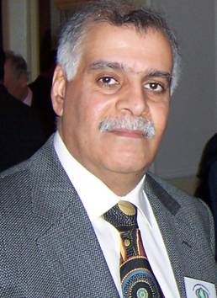Dr Firas Rasoul of the University of Queensland’s Australian Institute of Bioengineering and Nanotechnology (AIBN) and Centre for Advanced Imaging (CAI) is motivated by problem solving. He is interested in bringing better products and materials to the world – and has worked to this aim in academic and industrial sectors worldwide.

Firas began his higher education at the University of Basrah, Iraq, completing a Bachelor of Science in 1975. In the following year, he undertook a Master of Science in photochemistry at Southhampton University in the UK.

Firas went on to complete his PhD at the Liverpool University’s Department of Inorganic and Industrial Chemistry, under the supervision of distinguished chemist Professor Anthony Ledwith. His PhD topic, development and stability of novel photo-conductive polymers used in photocopy processes, was funded by Xerox USA and demonstrated his interest in and commitment to solving problems through research.

After a one year post-doc at Liverpool University, Firas became a principal research scientist at the Kuwait Institute of Scientific Research (KISR). The KISR allowed him to further pursue practical polymer research.

While attending an international conference in 1990, Firas was stranded in the UK after Iraq invaded Kuwait. Unable to return to Kuwait, he began work with Smith & Nephew UK, producing polymeric medical materials for bandages and casts.

In 1991, Firas gained a position with the University of Queensland and immigrated to Brisbane, Australia. Since moving to Australia, Firas has worked in a variety of academic settings, including at the Royal Melbourne Institute of Technology (RMIT) Cooperative Research Centre for Polymers.

He has also worked in commercial research for Chiron Mimotypes’s Melbourne laboratories and helped to found Polymerat – a research products company servicing clinical and scientific markets.

In 2004, Firas returned to the University of Queensland where he now works on a variety of medically oriented polymer-based products with industry changing potential.

Firas’s advice to prospective students considering a career in research is to think about the potential of your work, whether working in private industrial research, or publicly funded research. He says that it is important to put your research, whether applied or pure, in context and to apply cross-disciplinary lenses to your work where possible. “A well-trained PhD could work anywhere – in any sector, in any country.”

# Professor Penny Sackett

## Chief Scientist for Australia

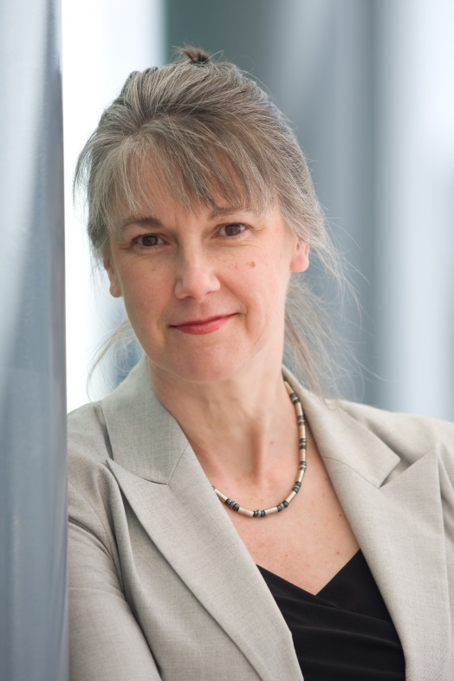Professor Penny Sackett's career path is continually evolving. Most recently as Chief Scientist for Australia, she provided independent advice to the Commonwealth Government on science, technology and innovation.

She is now exploring other ways to contribute by combining her passions for science, communication and strategic synthesis.

Penny is an accomplished cross-disciplinary scientist with a record of academic excellence on three continents. She is highly respected in the national and international communities of science and technology, both for her research and her proven experience in research management.

Penny undertook her PhD in theoretical physics in the United States of America. She says that at the time a PhD just seemed like the next logical thing to do and she was keen to keep on studying.

During her PhD, Penny recalls that there were times when she became disillusioned with her research. She remembers doubting her research, being overwhelmed by the volume of it, and not having many people to talk to. Looking back Penny feels that a lot of students probably go though similar periods of self-doubt during their PhD.

After her PhD Penny went on to have a number of exciting jobs in different countries including Program Director at the US National Science Foundation, the J. Seward Johnson Fellow at the Institute of Advanced Study in Princeton (USA), Chaired Professor at the University of Groningen (NL) and recently the Director of the Australian National University (ANU) Research School of Astronomy and Astrophysics and Mount Stromlo and Siding Spring Observatories (2002 – 07).

Penny says her PhD helped her gain a broad range of skills, including scientific computing and programming skills that she could use over and over again in different contexts. In addition, her PhD helped her develop project management skills.

Penny says that anyone considering a PhD should ask plenty of people for advice and never rely on the opinion of just one person. Penny also believes that it is important to build up a few skills that can cross over into different disciplines. For her it was mathematical modelling, but it could also be something like statistics or project management. She says “don’t be worried if something doesn’t work out according to your initial plans – challenges test you and bring out other strengths”.

# Dr Andrew Siebel

## Senior Research Officer, Baker IDI Heart and Diabetes Institute in the Metabolic and Vascular Physiology Laboratory

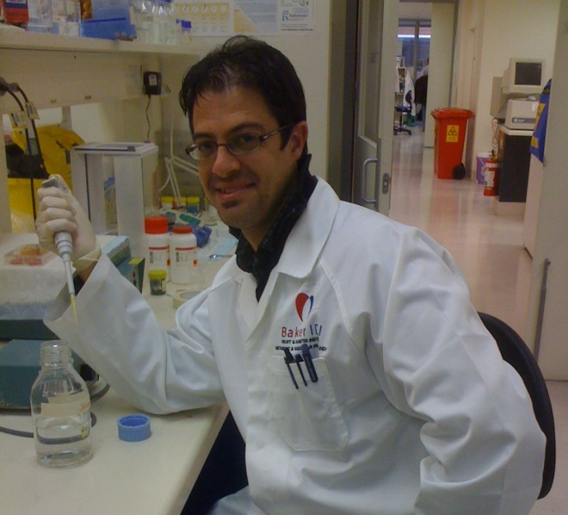Dr. Andrew Siebel completed his Bachelor of Science with Honours in zoology before working a year as a Research Assistant. He realised during this year that he wanted to direct his own research and not only work on other researchers’ projects. Andrew decided to undertake a PhD with the aim of one day leading a research team.

Andrew has held several research positions both within universities and research institutions. He has also been involved in teaching at a tertiary level. He is currently working as a Senior Research Officer of physiology at the Baker IDI Heart and Diabetes Institute. To perform this role, Andrew had to re-specialise. Andrew says it shows you are value-adding to your career when you are wanted outside your original expertise.

Andrew has a number of career highlights. These include publishing in leading international journals, being recognised as an expert in a particular field and being asked to review grants or publications.

Andrew encounters road-blocks as a researcher when he misses out on fellowships or grant funding because of intense competition. He finds it equally satisfying to win grants and independent funding.

Looking back, Andrew is pleased to have undertaken a PhD, saying that “almost any industry would see having a PhD as a positive”. It was important for his career development in gaining both technical and transferable skills, including project management, initiative, leadership and problem solving skills.

His advice to current and future PhD students is to “be open to different opportunities” during your postgraduate studies – particularly those that develop your transferable skills. Andrew recommends that you keep your options open and identify mentors early in your career.

Finally, Andrew stresses that it is important to have a good work/life balance to ensure you can conduct productive research of a high quality. He suggests that you have a break from the PhD thesis at least one day a week to ensure that you’re fresh when you’re researching.

# Dr Brad Sleebs

## Senior Postdoctoral Fellow, WEHI

Photo - Dr Brad Sleebs
Dr Brad Sleebs is a Senior Postdoctoral Fellow at the Walter and Eliza Hall Institute of Medical Research (WEHI) in Bundoora. The research in which he is involved is positioned at the crossroad between biology, structural biology and chemistry, and pursues both focused drug discovery and academic basic research.

Brad’s area of expertise is organic chemistry. He initially completed a Bachelor of Science (Hons) majoring in chemistry and biochemistry. Not being able to secure a job that was related to his academic background, Brad decided to commence a PhD. He completed it in organic chemistry at La Trobe University in 2004.

“I decided that an Honours degree wasn’t sufficient to get myself a job, so I went back and did a PhD.”

When he started his PhD, Brad intended to find a research position in a medicinal chemistry lab or a medical research institute but was unsure of exactly which sector he wanted to work in.

“At the start of my PhD, I would say I wouldn’t have known whether I wanted to do something more academic rather than something that was more commercial related. I think at the start of the PhD and at the end of the PhD you are trying to get work wherever you can, and then use those next couple of years as stepping stones to progress further.”

Working at WEHI, Brad utilises most of the skills he learnt during his PhD, including organisational, managerial and technical skills.

“I think it’s the techniques and the protocols that you learn in your PhD that you apply to your job more than anything else. It’s those skills that your employer is really looking for in what you do.”

Brad advises that prospective PhD students do their Honours and “if you enjoy it, go on and do your PhD. If you don’t enjoy it, you might as well go and do something else; because you’ll probably regret it for the rest of your life doing something that you really don’t enjoy doing.”

# Professor Debbie Terry

## Deputy Vice-Chancellor, University of Queensland

[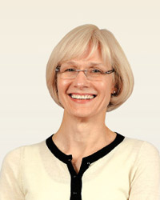](http://www.uq.edu.au/about/images/execs/exec-terry.jpg)Professor Debbie Terry completed her PhD in psychology in 1989, and describes her PhD as “the best years of my life”. She had always intended to become a researcher rather than a practicing psychologist.

During her undergraduate degree, Debbie discovered that she liked research and the “excitement of discovery”. There were some big unanswered questions in psychology, and she was very appreciative of the scholarship funding that allowed her to work on something that she had such a strong interest in.

After completing her PhD, Debbie taught for a year before taking a postdoctoral fellowship at the University of Queensland (UQ) in the School of Psychology. She later began lecturing in the School.

Debbie rose through the ranks at UQ at a very rapid pace. She has held a number of positions, including Head of the School of Psychology, Executive Dean of the Faculty of Social and Behavioural Sciences, Pro Vice-Chancellor, and Deputy Vice-Chancellor.

Debbie enjoyed the opportunity to combine a focus on research with a teaching role. Engaging students in her field and working with them as Honours and PhD students has been very rewarding. Because Debbie’s career has been spent entirely in the university sector, she has needed her PhD for each position she has had. Her PhD has been critical to qualifying her for what she wanted to do in her career, and what she has done.

Debbie says that if managed well, an academic career can provide great flexibility. “You can write anywhere, you don’t have to be in an office.” Debbie was able to continue her academic career while having a family, and credits her personal ambition and the support of her husband for being able to do this.

Debbie advises that a PhD is very good training in any discipline, as all disciplines are becoming increasingly research based. A PhD gives you the opportunity to “become the leading world expert in your field for a short time”, to contribute to the body of knowledge in your field, and to interact with fellow researchers from all over the world.

# Dr John Triantafilis

## Senior Lecturer, The University of New South Wales

Photo - Dr John Triantafilis
With his passion for soil science and research, Dr John Triantafilis has become an expert in digital soil mapping. His research portfolio includes collaboration with Australian and international researchers, including from the US and Portugal. The research is breaking new ground in the application of proximal instruments and remote sensing techniques to soil mapping.

John began his PhD in 1991 at the University of Sydney. John looks back at his PhD with fond memories as it provided him with an opportunity of a lifetime. The process of learning how to carry out scientific investigations has ultimately led to a job which he genuinely enjoys and enables him “to pursue the study of soil science with a passion.”

John says, “During my PhD I was learning things that I was genuinely interested in exploring further. The PhD was also good for me in two ways. Firstly, my supervisor encouraged me to take ownership of the research. Secondly, it provided me with the time and space to get things wrong. With these two experiences, as well as many other learning outcomes, I learnt how to carry out independent research and how to go about getting things right during my post-doctoral years.”

Despite setbacks, John has published numerous scientific papers and presented his scientific results at various World Congresses of Soil Science. Owing to his sustained contribution to understanding the spatial distribution of soil in cotton growing areas, he was awarded the Australian Cotton Growers Research award for his practical and cutting-edge PhD and post-doctoral research. In addition, he was appointed as Senior Lecturer (Soil Science) at the University of New South Wales.

John still uses the scientific and organisational skills he acquired during his PhD on a daily basis. Additionally, the challenges he faced during his PhD, such as having to work problems out for himself, have made him a stronger and more confident and accomplished soil scientist.

“The skills that you learn during your PhD can be applied to many situations outside of scientific endeavour. This is because the scientific process is readily transferable to consulting, policy development and natural resource management.” He has also learnt that a good scientist needs to accept that their work will not always be viewed favourably and to accept criticism whether it is constructive or otherwise.

As a Senior Lecturer, John continues to learn about soil science as he constantly builds his skills set every day. He has a driving passion to teach at undergraduate level and to pass on the knowledge he has acquired. He also wishes to instil in his honours and postgraduate students the confidence to take ownership of their projects and in so doing change the way farmers manage the soil resource, consultants collect and interpret soil data, government agencies drive policy initiatives and how the broader community appreciates the way soil sustains life.

# Dr Claudia Vickers

## Senior Research Fellow, AIBN,

## University of Queensland

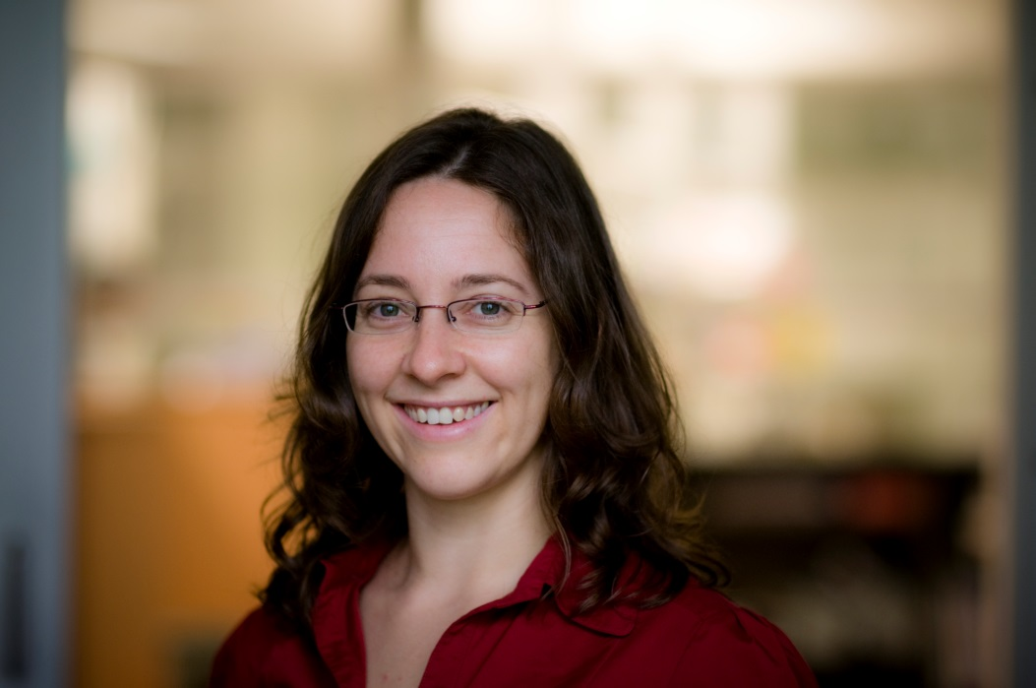Dr Claudia Vickers, of the University of Queensland’s Australian Institute for Bioengineering and Nanotechnology (AIBN), says her love of research is what has propelled her career forward. She believes that determination and demonstrated skills are the key to great results.

Claudia began her university career in a Bachelor of Science at the University of Queensland. She continued onto a successful Honours year, completing her first class thesis in molecular biology in 1998. Her familiarity with and love for research began at an early age when exposed to her mother’s workplace as a scientific researcher.

A PhD was the natural progression of Claudia’s academic career, but she deliberately chose the industrial setting of the Commonwealth Scientific and Industrial Research Organisation (CSIRO) Plant Industry’s research labs to broaden her sectoral experience. Following submission of her PhD, Claudia worked as a post-doctoral fellow at the Australian Research Council (ARC) Centre for Integrative Legume Research. She later took up the position of senior research officer at the University of Essex in the UK.

Claudia returned to the University of Queensland in 2007 to take up a position as a Senior Research Fellow at AIBN and was awarded a Smart Futures Fellowship in 2010.

Though she has led a successful career in university research, Claudia’s eyes have been open to the private sector in the past. She believes that a PhD program equips a graduate with skills that can be adapted and applied in a wide range of fields that may never even be considered by graduates.

Claudia is currently involved in efforts to advise students considering higher degrees, and so is well attuned to the interests of students. She advises students to have a well-formed view of why they want to pursue a PhD before doing so. She encourages young researchers to broaden their skills and experiences and work across sectors and disciplines because she believes that no experience or knowledge is wasted.

# Dr Chris Willems

## Associate Learning and Teaching Fellow

## University of Southern Queensland

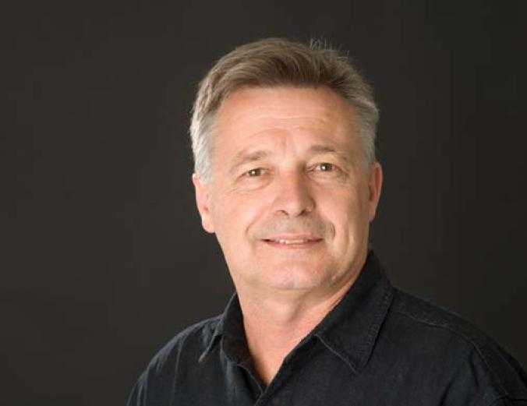Becoming an academic with a Doctor of Creative Industries (DCI) was the last thing on Dr Chris Willems’ mind when he decided to abandon his Consulting Engineering to pursue mime and television design in London. Since returning to Australia, his career story seems to have been played back to front.

With an early interest in education, Chris became a part-time Creative Arts lecturer in Queensland and South Australia in 1983, while pursuing professional careers in mime, theatre, television and music. Effectively, Chris led parallel, interdisciplinary artistic and tertiary careers for at least 25 years.

Having spent some time teaching in the academic arena, one of Chris’ academic mentors encouraged him to do a Master of Arts. He completed his Masters by practice-led research in 1997. Because he felt he had something more to offer, Chris subsequently embarked on a DCI.

For Chris, a DCI is an experience that “reconciles academic rigour, professional relevance and commercial viability” which can really contribute to personal and professional development.

After completing his DCI, Chris felt a subtle shift in his confidence and in others’ perceptions of his credibility, particularly in the academic community.

Chris is currently a lecturer and an Associate Learning and Teaching Fellow at the University of Southern Queensland (USQ), where he coaches in presenting to-camera for the online learning and teaching (L&T) environment. He was recently invited to speak at the fifth International Social SciencesConference in Cambridge.

Chris has experienced both frustrations and satisfactions in doing his DCI late in his career. Although his three years as a qualified researcher are supported by three decades of practice, he is regarded as an early researcher. Yet by doing his DCI late in his career, he was able to draw on a wealth of practical experience to support and strengthen his research.

Chris advises that students doing higher research degrees should think about the relevance of their work to the wider community. They should be prepared to answer, “what makes a doctor?”