





# 2024 National Report

**Acknowledgment of** **Country**

The Department of Education acknowledges the Traditional Owners and Custodians of Country throughout Australia and their continuing connection to land, waters and community. We pay our respects to them and their cultures, and Elders past and present.



With the exception of the Commonwealth Coat of Arms, the Department’s logo, any material protected by a trade mark and where otherwise noted all material presented in this document is provided under a [Creative Commons Attribution 4.0 International](https://creativecommons.org/licenses/by/4.0/) (https://creativecommons.org/licenses/by/4.0/) licence.

The details of the relevant licence conditions are available on the Creative Commons website (accessible using the links provided) as is the full legal code for the [CC BY 4.0 International](https://creativecommons.org/licenses/by/4.0/legalcode) (https://creativecommons.org/licenses/by/4.0/legalcode)

The document must be attributed as the (2024 Early Childhood Education and Care National Workforce Census National Report).

Contents

Executive Summary 5

Services participating in the NWC 5

Children in selected equity groups (at CCS services) 5

Children attending ECEC services 5

The ECEC workforce 6

Workforce qualifications (paid contact staff) 6

ECEC service characteristics 7

ECEC services 7

All about ACCOs 7

Children attending ECEC services 7

Maximum and typical places offered, and average service capacity 8

First Nations children and paid contact staff 9

Children in selected equity groups 11

Children with a disability or underlying long term health condition 11

Preschool programs 13

Children at dedicated preschool services 13

Selected characteristics of ECEC services offering preschool programs 14

Preschool workforce 14

Preschool program delivery 14

Curriculum or framework used in preschool programs 15

ECEC workforce characteristics 16

Workforce size 16

Workforce demographics 17

Age of Workforce 17

Age profile of the ECEC workforce 17

First Nations workers 17

Hours worked 18

Experience and job tenure 18

Pay vs the award rate 19

Qualifications and professional development 20

Workers studying for a qualification 21

Methodology 23

Weighted services data 23

Weighted workforce data 24

Data Suppression 24

Glossary 25

Service type icon key 28

## Executive Summary

The 2024 Early Childhood Education and Care (ECEC) National Workforce Census (NWC) was commissioned by the Department of Education. The NWC aims to improve the quality of information used in developing and measuring early childhood policy and programs.

The 2024 NWC follows on from censuses undertaken in 2010, 2013, 2016, and 2021. The 2024 National Report gives a brief overview of some of the key data on ECEC services and workers. A report with more detailed tables of information from the NWC will be published later in 2025.

The NWC is the only national census of its type in Australia.

### Services participating in the NWC

The 2024 NWC achieved a 97.4% response rate across CCS approved services which includes Centre Based Day Care (CBDC), Outside School Hours Care (OSHC), Vacation Care (VAC), Family Day Care (FDC), and In Home Care (IHC) services. Dedicated preschools (PRE) were invited to participate in the NWC but their participation was not mandatory.

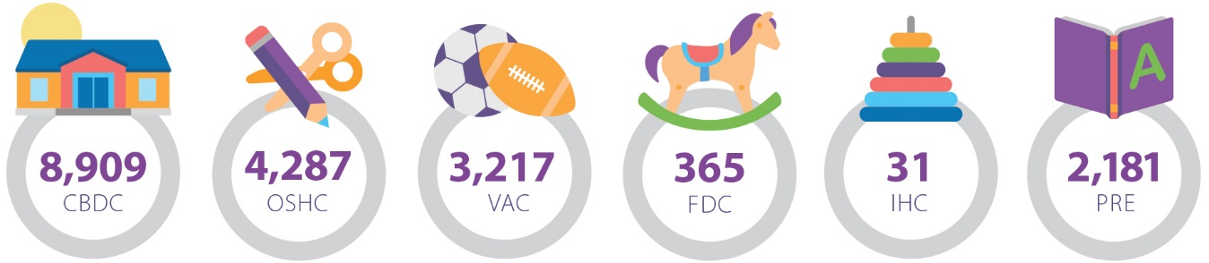

### Children in selected equity groups (at CCS services)

This figure shows the proportion of children in the selected equity groups at CCS services (CBDC, OSHC, VAC, FDC, IHC) compared to all children attending. LOTE refers to children who spoke a language other than English at home.

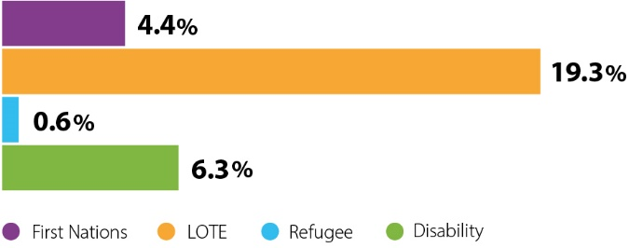

### Children attending ECEC services

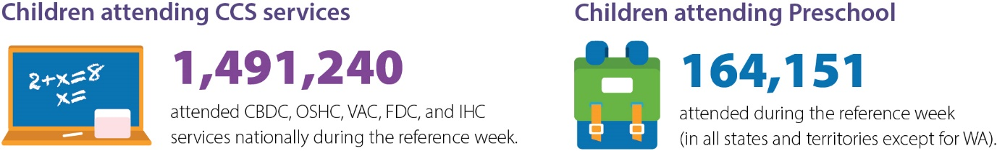

### The ECEC workforce

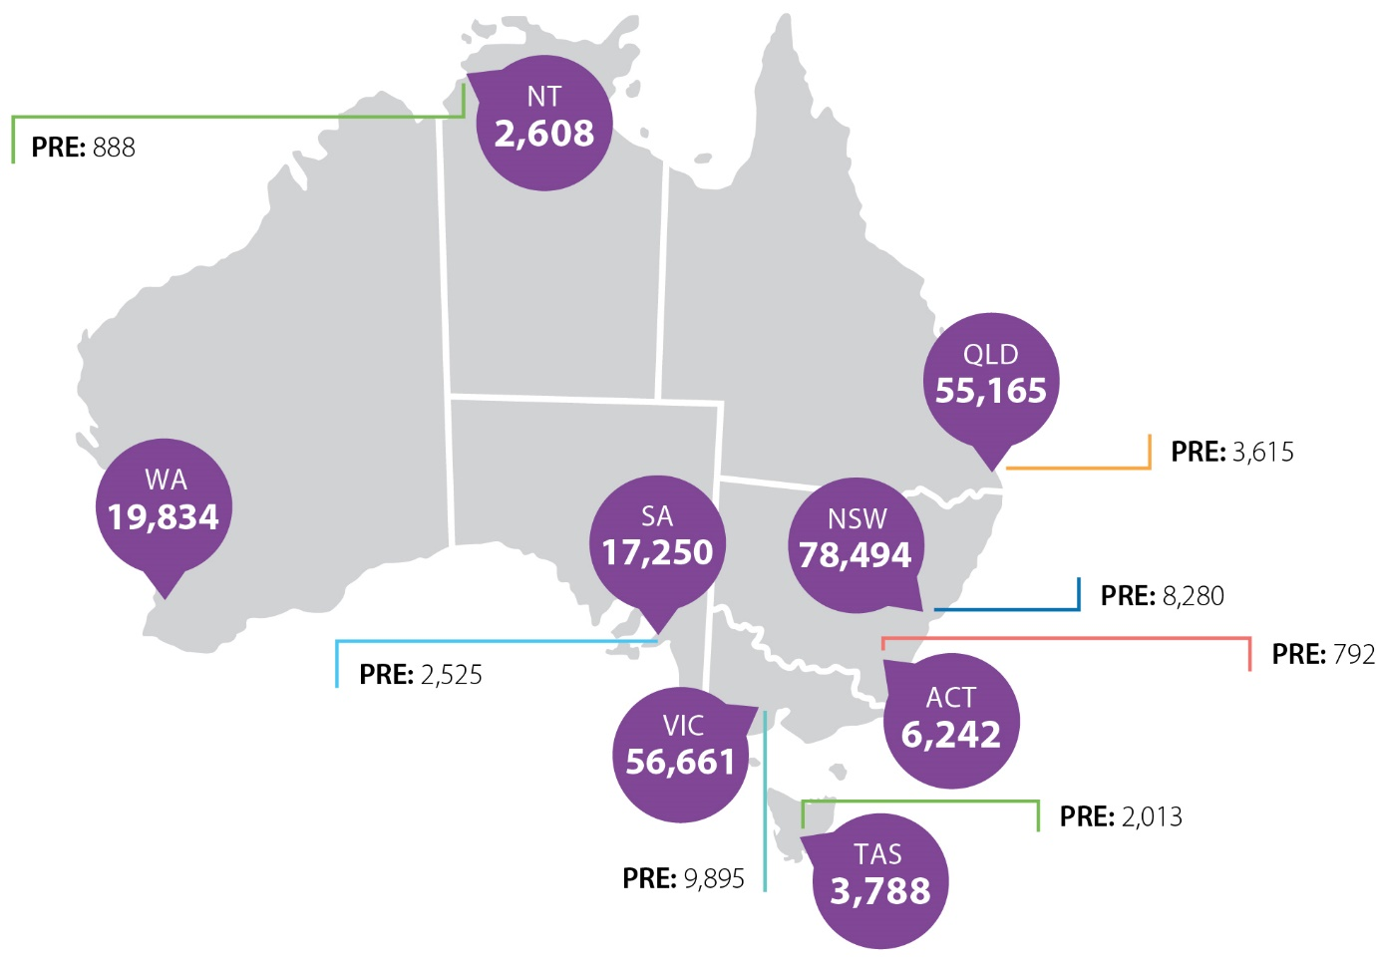This figure shows the total workforce at Child Care Subsidy (CCS) approved services. PRE is the total workforce at dedicated preschool services.

### Workforce qualifications (paid contact staff)

The majority of paid contact staff (‘total staff’) held a qualification in an ECEC field. 26,562 paid contact staff held a bachelor degree or higher in a teaching field (‘Bachelor +’). These figures include the dedicated preschool workforce.

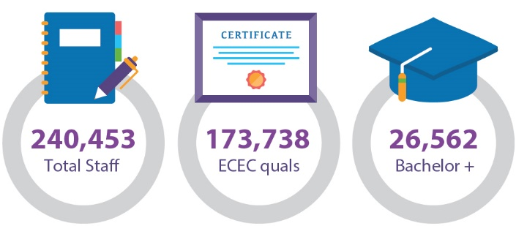

## ECEC service characteristics

We collected data from 18,990 ECEC services across Australia. This included 2,181 dedicated preschools.

Services were asked to answer questions in the NWC with respect to a reference week. The 2024 reference weeks were 8-14 or 15-21 April for vacation care services and 6-12 May for CBDC, OSHC (before/after school care), FDC, IHC, and PRE services. All results reported here are with respect to the 2024 reference week for the relevant service type.

### ECEC services

This section contains information[1] on the characteristics of CBDC, FDC, IHC, OSHC, and VAC services. These services are referred to in this report collectively as ‘CCS services’ as they are typically services approved by the Australian Government to receive CCS and Additional Child Care Subsidy (ACCS) on behalf of families.

This section does not include information on dedicated preschool services as they were asked a different set of questions from CCS services. Information on dedicated preschool services and the children attending them is reported on in the next section.

Overall, 97.4% of CCS services responded to the 2024 NWC.

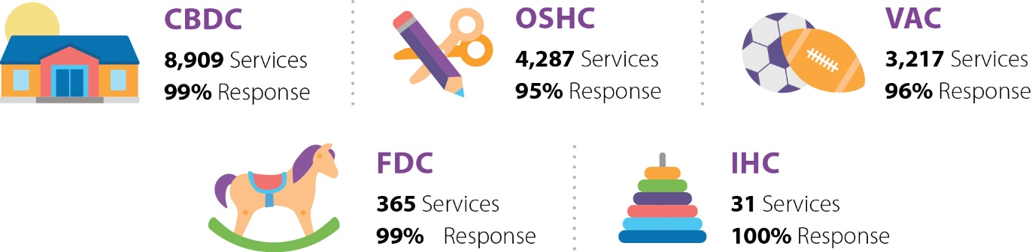

#### All about ACCOs

* Aboriginal Community-Controlled Organisations (ACCOs) are organisations controlled and operated by Aboriginal and/or Torres Strait Islander people. ACCOs play a key role in delivering services which build the strength and empowerment of Aboriginal and Torres Strait Islander communities.
* In the 2024 NWC, 338 CCS services identified themselves as ACCOs.
* This number included 244 CBDC services, 9 FDC services, 40 OSHC services, and 45 VAC services. Many of the ACCOs offering OSHC were also VAC services.

### Children attending ECEC services

The 2024 NWC counted 1,491,240 children aged 0 to 12 years attending CCS services. This is not a count of individual children. Children are not identified by name in the NWC and may attend more than one ECEC service. Double counting frequently occurs in the OSHC and VAC sectors, where many children who attend an OSHC service are also likely to attend a VAC service.

Overall, 1,491,240 children aged 0 to 12 years attending CCS services were counted in the 2024 NWC

Figure 1: Number of children attending per week in the 2016, 2021, and 2024 NWC collections

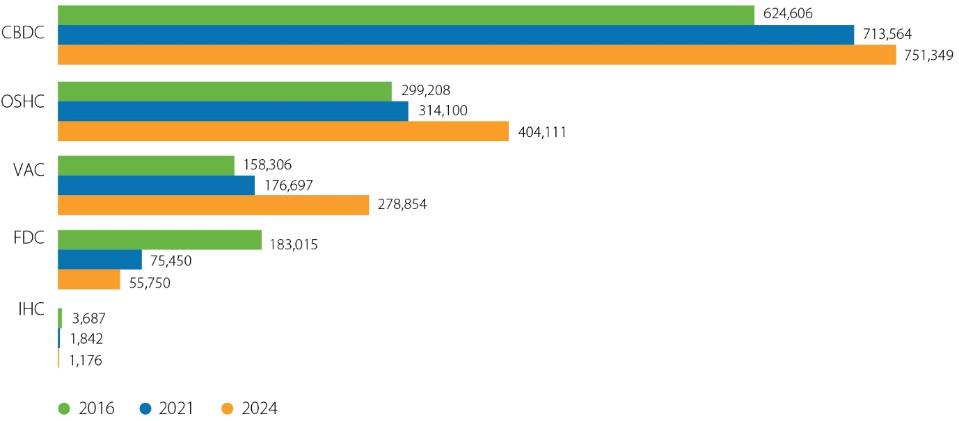

There was a large increase in VAC attendance numbers between 2021 and 2024. This increase was largely driven by an increase in vacation care services operating in Victoria since the 2021 NWC, although numbers at VAC services also rose in other states/territories during that period. Attendance at OSHC services also rose between the 2021 and 2024 NWC collections, likely related to the increase in services offering both outside of school hours and vacation care.

### Maximum and typical places offered, and average service capacity

Services were asked about the maximum number of children that they could offer care to at any one time. This may be equal to or less than the number of places the service is licensed to offer, for a variety of reasons. They were also asked about the number of children who attended at any one time on a typical day. Table 1 shows the average and typical number of places offered at CBDC, OSHC, and VAC services nationally.

The main reasons reported by services for being unable to offer places to families were staff shortages, or the lack of suitable days or times for families

Table 1: Average[2] maximum and typical number of places offered at CBDC, OSHC, and VAC services

|  |  |  |
| --- | --- | --- |
| Service Type | Average max places offered | Average typical places offered |
| CBDC | 70 | 58 |
| OSHC | 68 | 46 |
| VAC | 70 | 46 |

The NWC also reports on the average capacity of services. This is calculated using the maximum number of children that a service can offer care to at any one time, and the number of children attending the service on a typical day. The difference between these figures is used as an indicator of the spare capacity of the service. For example, if a service were able to offer care to a maximum of 100 children, and on a typical day 80 children attend the service at one time, the capacity of that service would be reported as 20%. In contrast, if 100 children attend the service at one time on a typical day the service capacity would be reported as 0% (no capacity).

Around two-in-five CBDC services and one-in-five OSHC/VAC services reported having no capacity at their service. In contrast, around a third of CBDC services and roughly two-thirds of OSHC/VAC services reported a capacity of 20% or more.

Figure 2: Service capacity at CBDC, OSHC, and VAC services

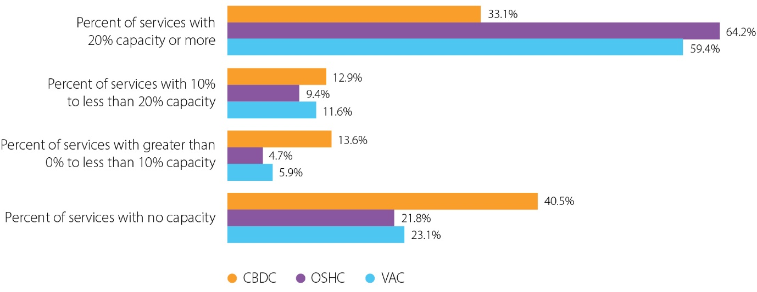

### First Nations children and paid contact staff

In 2024, 65,879 Aboriginal and/or Torres Strait Islander children attended CCS services. This was 4.4% of all children attending CCS services nationally, an increase from 3.8% in 2021 and 3.0% in 2016.

The proportion of Aboriginal and/or Torres Strait Islander children attending CCS services was highest in the Northern Territory (15.7% of all children attending, or close to one in six children attending in NT). CBDC services had the highest proportion of Aboriginal and/or Torres Strait Islander children attending (5.1% or 38,095 children).

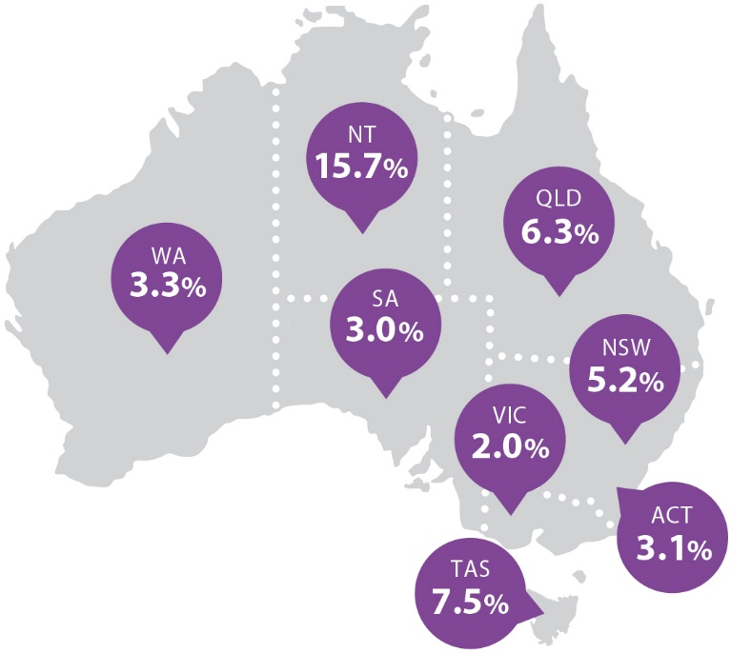

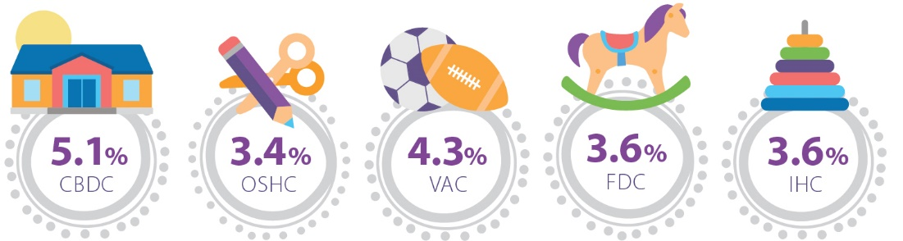

In 2024 there were 5,131 Aboriginal and/or Torres Strait Islander paid contact staff working at CCS services (see the ECEC workforce characteristics section of this report for further information on First Nations workers). This was 3.5% of paid contact staff[3]. 37.2% of Aboriginal and/or Torres Strait Islander children had access to at least one Aboriginal and/or Torres Strait Islander paid contact worker.

Table 2: Aboriginal and/or Torres Strait Islander paid contact staff at CCS services

|  |  |
| --- | --- |
| Service Type | Proportion3 of paid contact staff who were Aboriginal and/or Torres Strait Islanders |
| CBDC | 3.7% |
| OSHC | 3.5% |
| VAC | 3.7% |
| FDC | 1.0% |
| IHC | np[4] |

### Children in selected equity groups

In 2024, there were 288,012 children who spoke a language other than English (LOTE) at home (or whose parents/guardians spoke a language other than English) attending CCS services. This was 19.3% of all children attending. The proportion of children from a LOTE background was highest at FDC services (39.9% of children attending).

In 2024, 8,732 children attending CCS services (0.6% of all children attending) were from a refugee or special humanitarian program background. These were children who have settled in Australia as part of the refugee or special humanitarian program visa process. The proportion of children attending from a refugee or special humanitarian program background was highest at FDC services (7.4% of children attending).

94,330 or 6.3% of children attending CCS services had an underlying health condition or disability lasting longer than 6 months. An underlying health condition was defined as a medical condition or disease that interferes with daily life or activities and requires ongoing medical attention or medical care. Categories of underlying health conditions include difficulties in:

* learning and applying knowledge
* communication
* mobility
* self-care
* interpersonal interactions and relationships
* other areas (including general tasks, domestic life, and community and social life).

Children may fall into multiple categories of underlying health conditions.

6.3% of children aged 0-12 years attending CCS services had an underlying health condition lasting longer than 6 months, an increase from 5.2% of children attending CCS services in 2021.

#### Children with a disability or underlying long term health condition

* 30% of children who attended IHC services had an underlying health condition lasting longer than 6 months, followed by approximately 8% of children attending vacation care services.
* The most common types of underlying long term health conditions reported for children attending CCS services were conditions relating to interpersonal interactions and relationships (2.7%), communication (2.5%) and learning (2.4%).

Figure 3: Children with underlying health conditions attending CCS services by type of health condition, as a proportion of all children attending

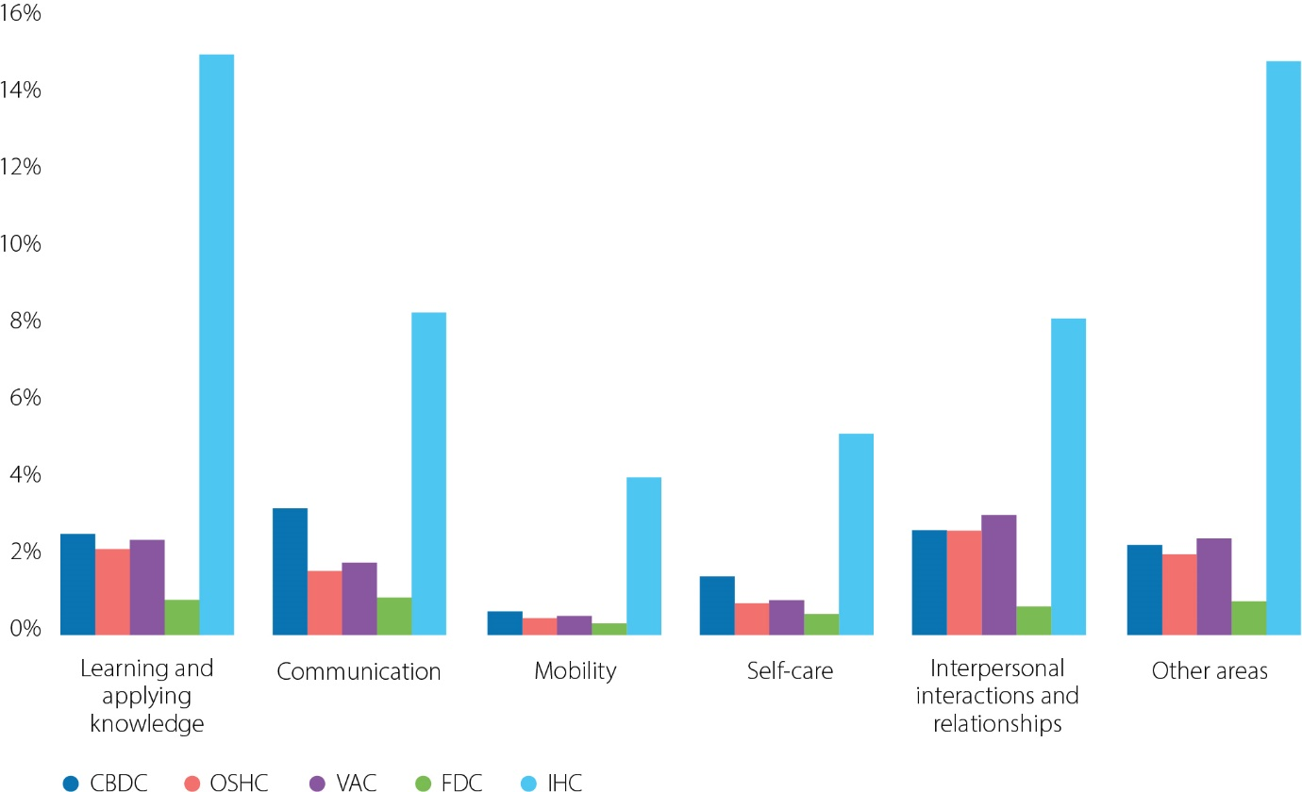

Figure 4: Children in selected equity groups attending CCS services, as a proportion of all children attending[5]

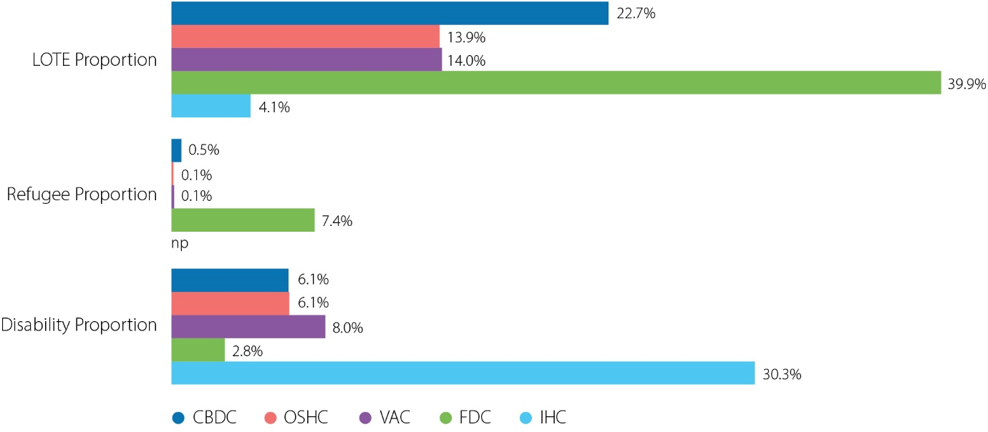

## Preschool programs

A preschool program is a structured, play-based learning program delivered by a degree-qualified teacher. Preschool is aimed primarily at children in the year or two before they begin full-time schooling. Children attend preschool programs in different settings around the country - some children attend preschool in centre based day care and some attend dedicated preschools, either standalone or attached to schools. Some IHC services offer preschool programs however there were too few IHC services offering preschool programs to report on here. The term ‘preschool programs’ is used in this report to refer to children attending at CBDC or dedicated preschools.

### Children at dedicated preschool services

Dedicated preschools provide programs that typically offer shorter or sessional hours during the school term, and may be referred to as ‘Preschool’, ‘School-based Preschool’, or ‘Kindergarten’ depending on the state or territory of the service. This report refers to all such services as ‘dedicated preschool services’ for simplicity.

Dedicated preschool services were invited to participate in the 2024 NWC but their participation was not mandatory[6]. Approximately two-thirds of dedicated preschool services in all states and territories aside from Western Australia responded to the 2024 NWC.

2,181 dedicated preschool services responded to the NWC. This is 67.1% of in-scope services

179,742 children were enrolled in dedicated preschools. This included children in the year or two years before full-time schooling. These children were typically aged from 3 to 5 years, noting state and territory age cut-offs for the first year of full-time schooling differ.

Approximately one in ten children (9.5% or 17,031 children) enrolled in dedicated preschool services needed additional assistance that was related to an underlying long-term health condition or disability lasting 6 months or longer. The proportion of children who needed additional assistance was greatest in older children enrolled in dedicated preschool services (15.5% of children aged five years or older). This may be expected in an older cohort.

Table 3: Children attending dedicated preschool services per week by age

|  |  |
| --- | --- |
| Child age | Number of children attending |
| 3 to less than 4 years | 43,812 |
| 4 to less than 5 years | 101,964 |
| 5 years plus | 18,375 |

Almost two-thirds of children attending preschool programs at dedicated preschools in the 2024 NWC were aged 4 to less than 5 years old.

### Selected characteristics of ECEC services offering preschool programs

This section covers preschool programs offered at CBDC services and dedicated preschools.

#### Preschool workforce

In 2024, 20,507 paid contact staff delivered a preschool program[7] at a dedicated preschool service nationally (excluding Western Australia). Of these workers, 36.2% held a bachelor degree in a teaching field. Across Australia 38,717 paid contact staff were involved in delivering a preschool program at a CBDC service, and 26.8% of these workers held a bachelor degree in a teaching field.

Figure 5: Highest level of ECEC-related qualification completed by paid contact staff delivering a preschool program[8]

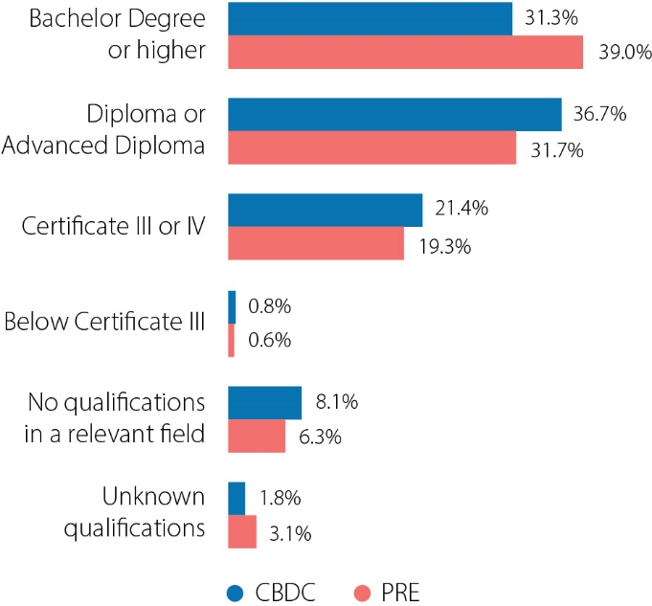

#### Preschool program delivery

In more than nine in ten (93.7%) dedicated preschool services and approximately eight in ten (81.5%) CBDC services, the preschool program was mainly delivered by a qualified Early Childhood Teacher (ECT) in person.

Figure 6: Main method of preschool program delivery at CBDC and PRE services

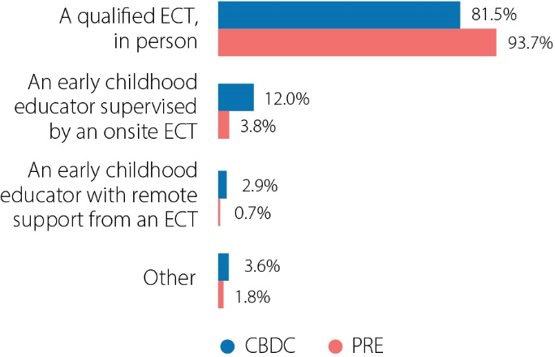

#### Curriculum or framework used in preschool programs

* 95.2% of dedicated preschools based their preschool program on Australia’s national Early Years Learning Framework (EYLF) either solely or in combination with another curriculum or framework. This was a higher proportion than CBDC (92.0%).
* 60.9% of dedicated preschools and 65.8% of CBDC services based their preschool program exclusively on the EYLF.
* 36.5% of dedicated preschool services and 27.6% of CBDC services based their preschool programs on a state/territory curriculum or framework (solely or in combination with another curriculum or framework).

## ECEC workforce characteristics

The ECEC workforce performs a vital role supporting children’s learning and development and workforce participation in the broader economy. The NWC provides the only national picture of the education and care workforce. It delivers key information about the profile of the ECEC workforce, including demographics such as age, gender, and diversity, as well as sector experience and service tenure.

In the context of the 2024 NWC, a **worker** refers to any staff who facilitate care and/or education to children, either directly (contact workers) such as teachers and educators, or indirectly (non-contact workers) such as managers, administrators, cooks, gardeners, and cleaners. This can include paid or unpaid workers, employees, independent contractors, or relief workers. The term **worker** in this report is interchangeable with **staff** and includes Family Day Care and In Home Care service workers. **Paid contact staff** are workers who work directly with children in a paid capacity.

This section contains information on the characteristics of the workforce of all ECEC service types, including dedicated preschools where possible (noting preschool services answer an abridged form of the NWC). Workers are only included in counts/proportions where they recorded hours worked during the 2024 reference week.

### Workforce size

In the 2024 NWC, we counted 240,041 workers at CCS services. Using the experimental estimate[9] of ECEC workers introduced in the 2024 NWC to account for double counting of workers at OSHC and VAC services, we estimate there were 211,518 workers at CCS services. We counted 28,009 workers at dedicated preschool services in the 2024 NWC.

The majority of workers at CCS services worked at CBDC services (69.8% or 167,439 workers). Using the new experimental estimate of ECEC workers included in the 2024 NWC, CBDC workers represented 79.2% of the total workforce at CCS services.

The rest of the ECEC workforce characteristics section uses the traditional method of counting workers to allow for comparison to numbers reported in previous cycles.

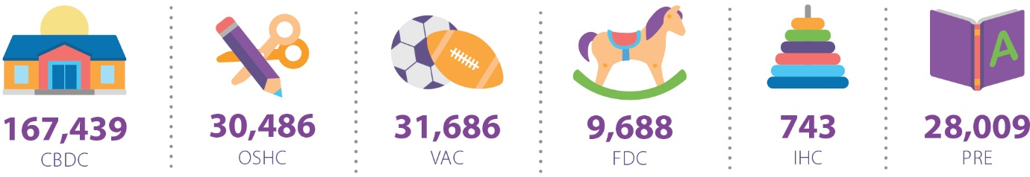

Around nine in ten workers at CCS services were contact workers, i.e. some or all of their duties involved direct contact with children. Of the 28,009 workers at dedicated preschool services (in all states/territories aside from Western Australia), just over eight in ten were contact workers.

### Workforce demographics

The majority of the ECEC workforce in 2024 (91.2%) was female. This is similar to the 2021 NWC where 92.1% of the workforce was female. 7.6% of the workforce was male, and 1.2% identified as non-binary/use a different term/prefer not to say. OSHC and VAC services had the highest proportion of men in their workforces. Both OSHC and VAC services had an approximately 19% male and 80% female workforce. The remaining 1% of the OSHC and VAC workforce were non-binary, used a different term, or preferred not to specify their gender.

The proportion of ECEC workers identified as non-binary, using a different term, or preferring not to specify their gender increased from 0.2% in 2021 to 1.2% in 2024.

### Age of Workforce

The age profile of the ECEC workforce is unique to each service type. FDC and PRE services had the oldest median worker age of 45 to 46 years, followed by CBDC workers at 32 years for men and 35 years for women. OSHC and VAC workers had a median age of 23 years for men and 25 to 26 years for women.

#### Age profile of the ECEC workforce

* FDC and PRE services employed the largest proportion of workers aged 40 and over, with 71.4% and 68.2% of workers respectively.
* OSHC and VAC services employed the largest proportion of workers under 25 years, with 48.7% and 49.2% of workers respectively.

### First Nations workers

Aboriginal and/or Torres Strait Islander workers comprised 3.8% of the total ECEC workforce[10] (at all service types, including dedicated preschools). This was approximately 7,000 workers. The proportion of Aboriginal and/or Torres Strait Islander workers was greater in Regional Australia compared to Major Cities of Australia, and greatest in Remote Australia.

Figure 7: Proportion of workers by Aboriginal and/or Torres Strait Islander status and service remoteness

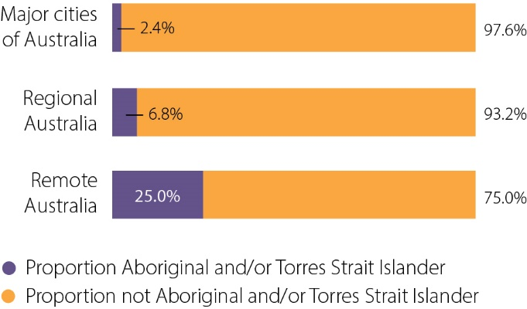

### Hours worked

The distribution of hours worked per week by ECEC workers was evenly spread with 30.8% working short part-time hours (up to 19 hours), 36.8% working long part-time hours (greater than 19 hours and up to 34 hours) and 29.3% working full-time hours (greater than 34 hours and up to 40 hours).

A small proportion (3.2%) of the overall ECEC workforce worked long hours (greater than 40 hours), however a significant proportion of FDC and IHC workers worked long hours (41.1% and 18.5% respectively). This is consistent with findings from the 2021 NWC.

Figure 8: Proportion of workers working short part-time, long part-time, full-time, or long hours during the reference week

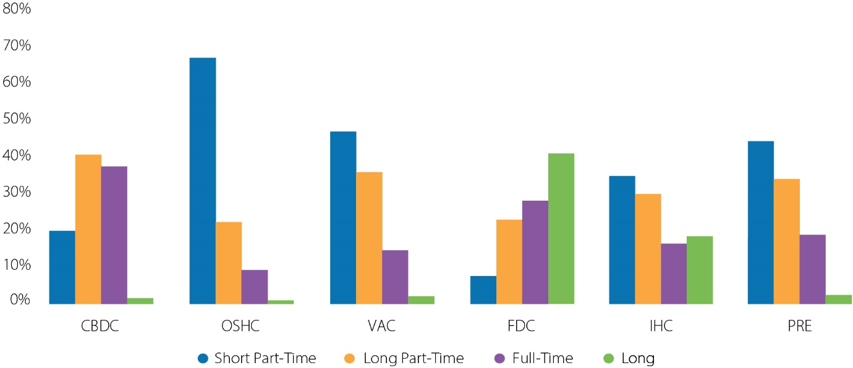

### Experience and job tenure

Paid contact staff at dedicated preschools had the most years of experience in the ECEC sector on average (13.0 years), followed by paid contact staff at FDC services (10.9 years). Paid contact staff at dedicated preschools and FDC services also had the most years of tenure at their current service on average (5.8 years and 5.5 years respectively). OSHC and VAC paid contact staff had the lowest average years of experience in the ECEC sector and tenure at their current service, likely due to the younger age profile of workers at these service types.

The following chart shows the average[11] number of years of experience of paid contact workers with specified qualifications (at all ECEC services including PRE services), and the number of years of tenure they had at their current service. Years of experience and job tenure were counted without regard to whether the worker was employed full-time or part-time and were exclusive of career breaks.

Figure 9: Average years of experience in the ECEC sector and tenure at their current service for paid contact staff with and without ECEC-related qualifications

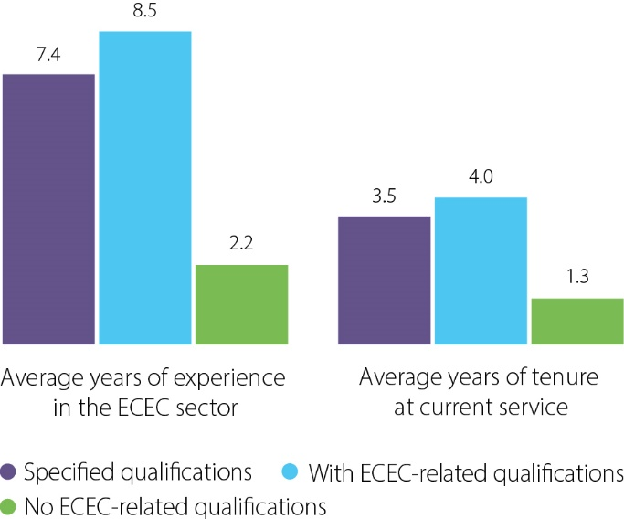

### Pay vs the award rate

42.1% of paid contact staff were paid above the award rate for their position, across all service types.

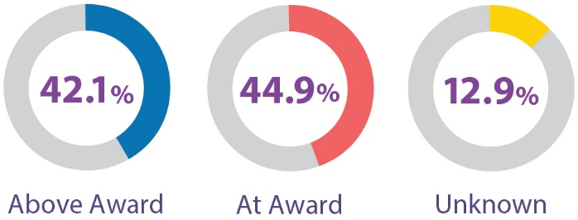

Across the whole ECEC workforce, a similar proportion of paid contact staff was paid at the award rate for their position (44.9%) compared with those paid above the award rate for their position (42.1%). Paid contact staff at CBDC services were the most likely to be paid above the award rate for their role (50.4%). A large proportion of workers at FDC and IHC services had an unknown level of pay relative to the award rate, either because services reported that they did not know how the worker was paid, or did not answer the question. This may be because workers in FDC and IHC services primarily work under a contract arrangement.

Figure 10: Proportion of paid contact staff by wages compared to the award rate for their position

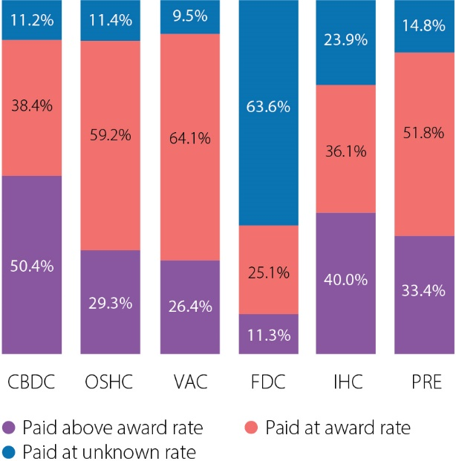

### Qualifications and professional development

Over four-fifths (81.3%) of paid contact staff at ECEC services (including dedicated preschools) had an ECEC-related qualification, including 14.7% with a bachelor degree or above. 12.4% of paid contact staff at ECEC services had a bachelor degree or higher in a teaching field (either early childhood related, primary, or secondary teaching).

Figure 11: Proportion of paid contact staff with specified qualifications[12], by the highest level of qualification completed[13]

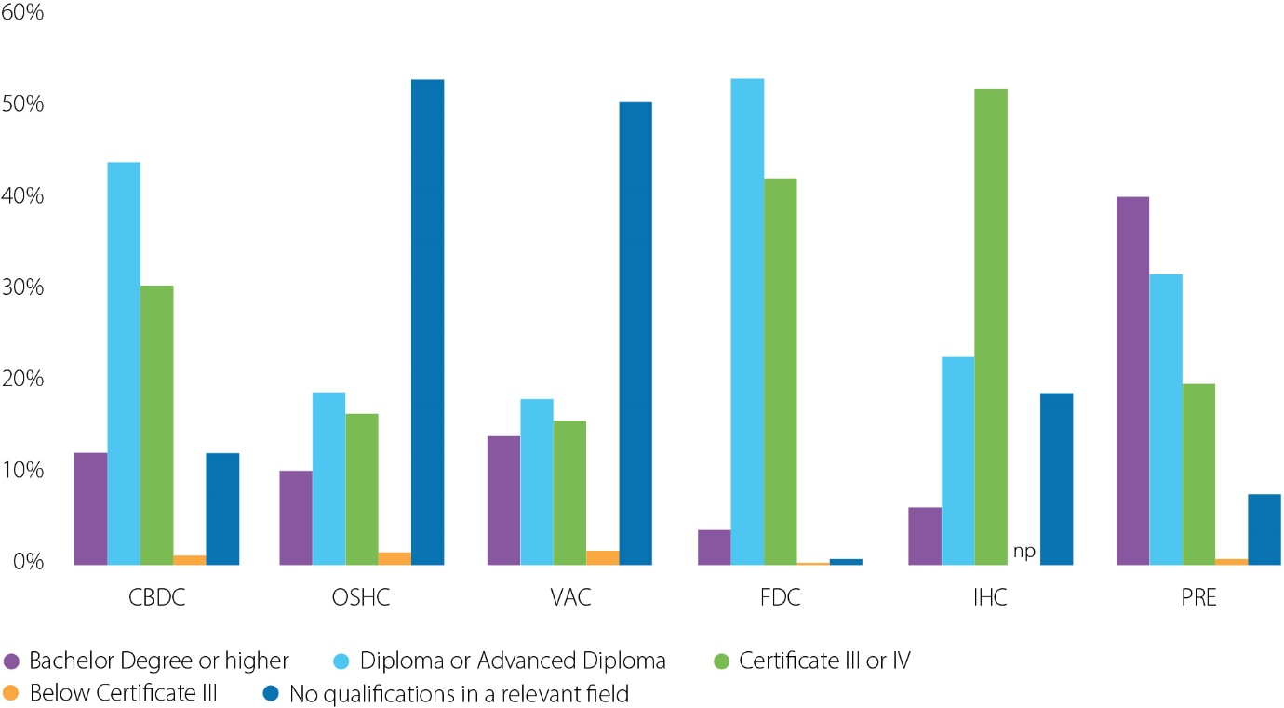

Around one in four (26.3%) paid contact staff at ECEC services (excluding dedicated preschools[14]) were studying for a qualification. This excludes staff participating in professional development but includes staff who are upskilling (i.e. studying for a higher level qualification than they already hold).

#### Workers studying for a qualification

* CBDC services had the highest proportion of paid contact staff who were studying for a qualification (28.0%), an increase from 23.7% of CBDC paid contact staff who were studying for a qualification in 2021.
* FDC services had the lowest proportion of paid contact staff studying for a qualification (3.1%). This is unsurprising as FDC services also had the highest proportion of paid contact staff with completed ECEC qualifications (99.4%).

Figure 12: Proportion of paid contact staff with specified studying status[15], by the level of qualification currently being studied[16]

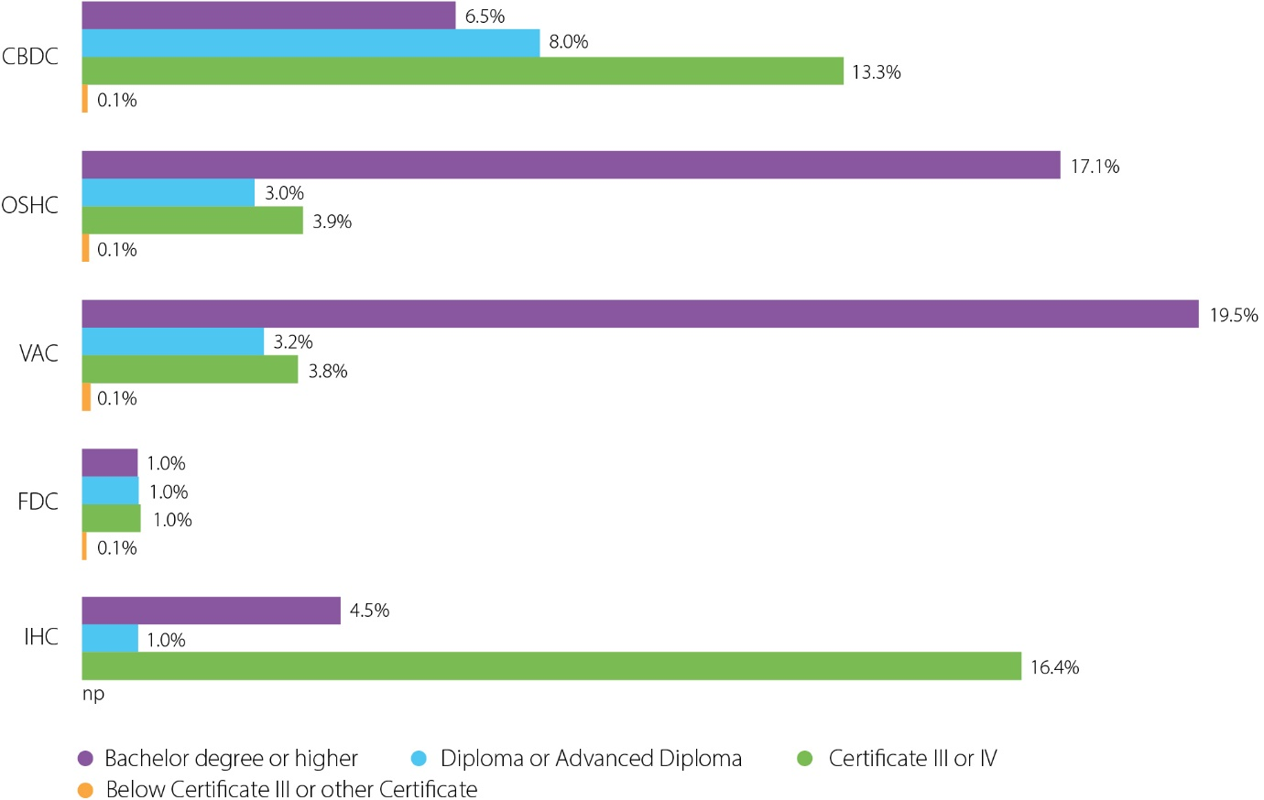

Overall, nearly nine in ten (88.7%) paid contact staff at ECEC services (excluding dedicated preschool services13) had undertaken professional development training in the 12 months preceding the NWC. The most common type of professional development training was child safety. 71.3% of paid contact staff had undertaken training in this area. This was followed by training in behaviour support / supporting complex behaviours (32.8% of paid contact staff) and training to support pedagogy or practice (28.9% of paid contact staff).

The number of paid contact staff who had not undertaken any professional development in the last 12 months decreased to 11.3% in the 2024 NWC (from 26.1% in 2021)

## Methodology

The 2024 ECEC NWC is the latest update to a valuable time series with previous collections undertaken in:

* [2010](https://www.education.gov.au/early-childhood/resources/2010-national-early-childhood-education-and-care-workforce-census) (<https://www.education.gov.au/early-childhood/resources/2010-national-early-childhood-education-and-care-workforce-census>),
* [2013](https://www.education.gov.au/early-childhood/early-childhood-data-and-reports/national-workforce-census/2013-national-early-childhood-education-and-care-workforce-census) (<https://www.education.gov.au/early-childhood/early-childhood-data-and-reports/national-workforce-census/2013-national-early-childhood-education-and-care-workforce-census>),
* [2016](https://www.education.gov.au/early-childhood/early-childhood-data-and-reports/national-workforce-census/2016-national-early-childhood-education-and-care-workforce-census) (<https://www.education.gov.au/early-childhood/early-childhood-data-and-reports/national-workforce-census/2016-national-early-childhood-education-and-care-workforce-census>), and
* [2021](https://www.education.gov.au/early-childhood/early-childhood-data-and-reports/national-workforce-census/2021) (https://www.education.gov.au/early-childhood/early-childhood-data-and-reports/national-workforce-census/2021).

The 2024 ECEC NWC collected site level information from approved early childhood education and care services. Services provided information on service capacity, usage, and the number of children with additional needs in ECEC, as well as a range of demographic information about their workforce. All CBDC, IHC, and PRE services provided information on the delivery of and participation in preschool programs. 16,809 approved child care services participated in the 2024 ECEC NWC representing 97.4% of approved child care services that were operational during the reference week.

The reference week for the 2024 NWC was:

* 8-14 or 15-21 April for VAC services
* 6-12 May for CBDC, OSHC, FDC, IHC, and PRE services

Dedicated preschools were invited to take part in the 2024 ECEC NWC but their participation was not mandatory. In 2024, Western Australia did not participate in the ECEC NWC. Dedicated preschool services completed an abridged version of the NWC.

The 2024 ECEC NWC data collection was undertaken via a self-completion methodology, with the predominant mode being online. Larger providers (of 40 or more services) were offered the option to provide consolidated data for their services via a spreadsheet, along with selected other providers whose circumstances made a group submission via spreadsheet their best option. These results were consolidated with the self-completion data, cleaned and weighted for analysis.

### Weighted services data

Unless otherwise stated, all data relating to services in this report has been weighted to the estimated in-scope population of operating services as at the reference week. Although the weighting process corrects for minor imbalances in the achieved sample with respect to service type within state and remoteness area, weighted estimates should be used with caution. Weighted estimates can be used indicatively to make comparisons between service types, jurisdictions and to derive estimates of actual usage.

### Weighted workforce data

The ECEC workforce data relates specifically to individual workers who worked during the reference week. It excludes staff who were absent for the entire reference week (e.g. staff on extended sick leave, annual or long service leave) and staff not based at the service location and those who were not involved in the day-to-day management of the service.

In this report, the estimated length of workers’ experience in the ECEC sector and years of experience are not necessarily continuous. Periods of absence of 3 months or more are subtracted from their total estimated experience.

Workforce data has been weighted by assigning a modified version of the service-level weight to each worker reported by the service. This modification adjusted for services which did not provide workforce data.

A new question was added to the 2024 NWC to account for the known issue of double counting of workers who worked at both OSHC and VAC services. OSHC and VAC services were asked whether workers worked at OSHC only, VAC only, or both. This question was used to develop an experimental weighting to be used to estimate the ‘true’ number of ECEC workers, accounting for workers who were counted in the NWC during both the OSHC and VAC reference weeks. Because this is the first time this question was asked, and due to several limitations inherent in the question (in particular, as we do not collect names in the NWC, we cannot be sure that workers who were reported as working at both OSHC and VAC services were actually counted twice in the NWC) we have not used this experimental count for the majority of the 2024 National Report. As this measure is refined in future NWC cycles we may begin to use it for more reporting of worker numbers across the ECEC sector.

### Data Suppression

Some tables or charts in this report contain low counts (less than 5) within cells for information about individual services, children or workers (excluding cells that have counts of zero). When this occurs, these values within the table or chart are suppressed (indicated by ‘np’ for not published) to preserve confidentiality.

## Glossary

**Additional child care subsidy** **(ACCS)** -The Additional Child Care Subsidy (ACCS) provides extra help with the cost of early childhood education and care to families facing difficult or challenging circumstances. ACCS will usually cover all of a child’s early childhood education and care fees.

**Approved child care services** - Approved child care services are Centre Based Day Care, Outside School Hours Care, Vacation Care, Family Day Care and In Home Care services approved by the Australian Government to receive CCS and ACCS on behalf of families. Referred to collectively as ‘CCS services’ in this report.

**Centre Based Day Care** **(CBDC)** - a centre based form of child care service in receipt of CCS and Additional Child Care Subsidy (ACCS). CBDC services provide all-day or part-time care typically for children from birth to six years old who attend the centre on a regular basis. Care is generally provided in a building, or part of a building, that has been created or redeveloped specifically for use as a child care centre, and children are usually grouped together in rooms according to age. Centres generally operate between 6:00/6:30 am and 6:00/6:30 pm on normal working days for minimum 48 weeks per year. Private operators, local councils, community organisations, employers or non-profit organisations may operate these services. Services may offer access to preschool programs for children of eligible age (age varies between jurisdictions) and provide care for school children before and after school and during school holidays.

**Child Care Subsidy (CCS)** -The Child Care Subsidy (CCS) is the main way the Australian Government helps families with child care fees. CCS is generally paid to providers who pass it on to families as a fee reduction. Providers must be approved by the department to receive CCS on behalf of families.

**Child Care Subsidy (CCS) services** - see Approved child care services.

**Contact Staff** - Contact staff work in roles with direct contact with children and can be paid or unpaid and employed under different arrangements such as employees, independent contractors, relief workers or any person who has a contractual agreement with a service. They include:

* Primary Contact workers who mainly have direct contact with children. This may include, but is not limited to, teachers, teachers’ assistants / aides, specialist teachers and therapists.
* Other Contact workers who have some duties involving direct contact with children but deal mainly with staffing or management issues such as supervising staff and handling queries from parents. This may include, but is not limited to, principals, deputy principals, centre managers and coordinators.

**Disability or underlying long term health condition** - An underlying long term health condition, or chronic disease, is a medical condition or disease that interferes with daily life or activities and requires ongoing medical attention or medical care, lasting for 6 months or more. The 2024 NWC collected data on conditions in the following areas:

**Learning and applying knowledge** – intentionally using senses to experience certain stimuli (e.g., watching, listening, touching, smelling, and tasting); ability to imitate actions or behaviours; learning to read and write; ability to solve problems, make decisions or think; and ability to focus and maintain attention to specific stimuli or tasks.

**Communication** – understanding and/or responding to spoken messages or non-verbal messages such as symbols, signs, or drawings; speaking and/or singing; making self understood in their most effective method of communication or language if applicable.

**Mobility** – ability to roll, crawl, walk, climb and move around within and outside of buildings; being able to stay in the same body position (e.g. sitting and standing) to play or carry out a task; performing coordinated actions of handling objects (such as picking something up, grasping a toy or throwing).

**Self-care** – caring for oneself by performing activities appropriate to age, such as washing and drying oneself, dressing, eating, drinking and toileting.

**Interpersonal interactions and relationships** – carrying out the tasks required for appropriate, basic and/or complex interactions with other people (including family members, friends, relatives, adults and strangers); creating and maintaining relationships in formal settings (such as child care centre); behaving within acceptable limits; responding to the feelings of others and coping with own emotions.

**Other areas** – including general tasks (such as undertaking and carrying out single or multiple tasks or being able to follow and adapt to changes in routine, or managing behaviours or emotions in completing tasks); domestic life; community and social life (such as ability to engage in groups or clubs for children that undertake activities such as play, games, sport and/or other hobbies).

**Equity Groups** - refers to populations of children who have been historically disadvantaged compared with the general population. In the 2024 NWC this includes children who:

* are Aboriginal and/or Torres Strait Islander
* speak a language other than English (LOTE) at home (or whose parents/guardians speak a language other than English)
* are from a refugee or special humanitarian program background
* had an underlying heath condition or disability lasting longer than 6 months (refer to Disability).

**Family Day Care** **(FDC)** - refers to services in receipt of the CCS and ACCS where a network of individual educators provides flexible care, typically in their own home, for other people's children and as part of coordinated home-based care schemes. Care is predominantly provided for children from birth to 6 years old who are not yet at school, but may also be provided for school-aged children up to and including 12 year olds and not attending high school. Both not-for-profit and for-profit providers may operate a FDC service.

**In Home Care (IHC)** - Families unable to access Centre-based Day Care (CBDC), Family Day Care (FDC) and Outside School Hours Care (OSHC) because of their unique circumstances may be able to access education and care provided in the family home through IHC. IHC is designed to support the provision of early childhood education and care in the home particularly for families working non-standard or variable hours, geographically isolated from other approved child care services or those with complex and challenging needs.

**Non-Contact Staff -** Non-contact staff work in roles without direct contact with children but support the delivery of education and care to children. Non-contact staff can include staff employed for cooking, cleaning, gardening, or workers who are not based at the service location and have no involvement in its day-to-day management such as executives, administrators, managers and accountants.

**Outside School Hours Care (OSHC)** - Outside School Hours Care services provide care before and after school hours and during school holidays for children who normally attend school. Care given to children during school holidays is referred to as Vacation Care (VAC). Children who do not attend school may attend Outside School Hours Care (for example, a service may provide care for preschool-age siblings of school-age children), and the mix of children attending the service can vary from day-to-day or week-to-week. However, an Outside School Hours Care service must predominantly provide care to school-age children.

**Preschool (PRE)** - also referred to as ‘dedicated preschool’. A service established with the primary purpose of providing a preschool program, usually on a sessional basis during school terms. It can be a standalone service or part of another education and care service or school. Comes under the overarching responsibility of the relevant state or territory government and generally receives state or territory funding, although some may be delivered privately.

**Preschool program** - the Early Childhood Education and Care National Minimum Dataset defines [preschool programs](https://meteor.aihw.gov.au/content/762661) (https://meteor.aihw.gov.au/content/762661) as being a structured, play based learning program, delivered by a degree qualified teacher aimed at children in the year or two before they commence full-time schooling, irrespective of the type of institution that provides it or whether it is government funded or privately provided. Programs may be delivered in a variety of service settings such as separate preschools or kindergartens, and centre based day care services including those in association with a school.

**Preschool program delivery** - refers to paid contact workers who were reported by a preschool or centre based day care service as being directly engaged in delivering a preschool program for at least one hour during the reference week.

**Reference week** - The week in which services were surveyed. The 2024 reference week was 8-14 or 15-21 April for vacation care services and 6-12 May for all other ECEC services, including dedicated preschools.

**Response rate** - completed Service Survey returns as a percent of estimated in-scope services.

**Staff** - see Workers.

**Vacation Care (VAC)** - refer to OSHC.

**Workers** - refers to all staff who facilitate care and/or education to children, either directly (contact workers) such as educators and teachers, or indirectly (non-contact workers) such as support services like managers, administrators, cooks, gardeners, and cleaners. Workers can be paid or unpaid and employed under different arrangements such as employees, independent contractors, relief workers or any person who has a contractual agreement with a service.

### Service type icon key

|  |  |  |
| --- | --- | --- |
| Icon | Acronym | Care type |
| *Building icon.* | *CBDC* | Centre Based Day Care |
| Crossed pencil and scissors icon. | OSHC | Outside School Hours Care |
| Soccer ball and football icon. | VAC | Vacation Care |
| Rocking horse icon. | FDC | Family Day Care |
| Stacking ring toy icon. | IHC | In Home Care |
| Open book icon. | PRE | Dedicated Preschools |

Acknowledgements

*The department wishes to acknowledge the valued efforts of the staff and providers of ECEC services and of dedicated preschools in contributing to this census and in improving the quality of information available to measure ECEC programs.*

*The department would also like to acknowledge The Social Research Centre for undertaking the National Workforce Census on behalf of the department, and for their assistance and support in the preparation of this report.*

1. The data presented in this report is weighted to the estimated in-scope population of services, workers, and children, unless otherwise specified. See the Methodology section for more detail.
2. The figures in this table are the weighted mean value (i.e. taking service weightings into account) to ensure they are representative of the whole population of services. Figures reported in this section in 2021 were not weighted means, meaning these results cannot be directly compared to 2021 results.
3. The proportion of Aboriginal and/or Torres Strait Islander paid contact staff is presented as a proportion of staff who specified their First Nations status, as answering questions about workers’ First Nations status was not compulsory.
4. Where there were less than 5 people in a group the proportion of staff has been suppressed (np).
5. Where there were less than 5 people in a group the proportion of children has been suppressed (np).
6. Dedicated or standalone preschool services are approved by state/territory governments and are not subject to Australian Government legislation which requires CCS services to complete the NWC as part of their mutual obligations. Dedicated preschool services were asked to fill out an abridged version of the NWC.
7. The count of staff ‘delivering a preschool program’ here includes paid contact staff at CBDC or dedicated preschool services who were directly engaged in delivering a preschool program at their service during the NWC reference week.
8. ‘Bachelor Degree or higher’ includes bachelor degrees in any ECEC-related field, i.e. not restricted to degrees in a teaching field.
9. A new question was included in the 2024 NWC to attempt to address double counting of workers at OSHC & VAC services. It is not possible to be certain of the extent of double counting as the NWC does not collect worker names or other identifying details, however this question has allowed us to make an estimation of the ‘true’ headcount of workers in the sector. As this is a new measure it has not been used throughout this report unless specifically noted.
10. Note that the figures reported in this section only include workers with a specified First Nations status. Answering questions about workers’ First Nations status was not compulsory for services.
11. Calculated as a weighted average.
12. There are no nationally consistent qualifications for OSHC/VAC staff.
13. Where there were less than 5 people in a group the proportion of staff has been suppressed (np).
14. Dedicated preschool services were not asked to specify whether their staff are currently studying for a qualification or whether they have undertaken professional development in the 2024 NWC.
15. ‘Specified studying status’ means staff who were currently enrolled in and studying for a qualification in an ECEC-related field where both the level of qualification and field were known, or who were reported by their service as ‘not currently studying’. The proportion of staff not studying is not shown in the figure but can be calculated by subtracting the reported numbers in each service type from 100%.
16. Where there were less than 5 people in a group the proportion of staff has been suppressed (np).