

# Department of Education Employer Statement 2025

The Department of Education (the department) is committed to gender equality: this includes ensuring our employees receive equal pay for equal work, regardless of gender. To review the department’s progress against this commitment, we analyse remuneration data at regular intervals and also provide it annually to the Australian Public Service Commission (APSC) as part of the [APS Remuneration Survey](https://www.apsc.gov.au/initiatives-and-programs/workplace-relations/aps-remuneration-survey), and the Workplace Gender Equality Agency (WGEA) uses the data as part of the [Commonwealth Public Sector Reporting](https://www.wgea.gov.au/reporting-guide/ps).

As at 30 September 2024, the department’s average gender pay gap was 0.7%, which is 3.8% lower than the APS overall reported in [Table 21 - APS Remuneration Data Release 2023](https://view.officeapps.live.com/op/view.aspx?src=https%3A%2F%2Fwww.apsc.gov.au%2Fsites%2Fdefault%2Ffiles%2F2024-08%2FAPS%2520Remuneration%2520Data%2520Release%25202023%2520-%2520Tables%25201%2520to%252037.xlsx&wdOrigin=BROWSELINK) and 12.8% lower than the Commonwealth Public Sector (CPS) reported in Commonwealth [Public Sector Gender Equality Scorecard](https://www.wgea.gov.au/publications/Commonwealth-public-sector-gender-equality-scorecard). This is based off the Australian Public Service’s (APS) primary gender pay gap calculation using an average (mean) base salary metric. The department’s average pay gap comprising all entitlements such as overtime, superannuation and other allowances is also within the range of 0.5 % to 1.2%.

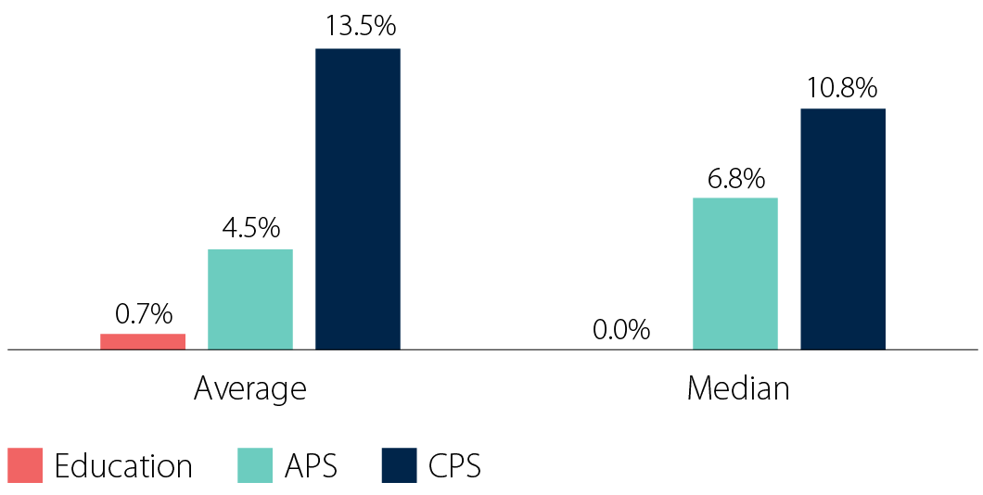**Figure 1. APS, CPS and the Department of Education average and median gender pay gap**

The department's workforce composition is predominantly women across most classification levels with 68.1% representation across the SES levels. The department’s total breakdown includes 68.3% women, 31.3% men, and 0.5% using a different term. The large representation of women including at the senior levels is the key factor behind a considerably small pay gap in the department. Figure 2 shows the percentage of men and women at each classification

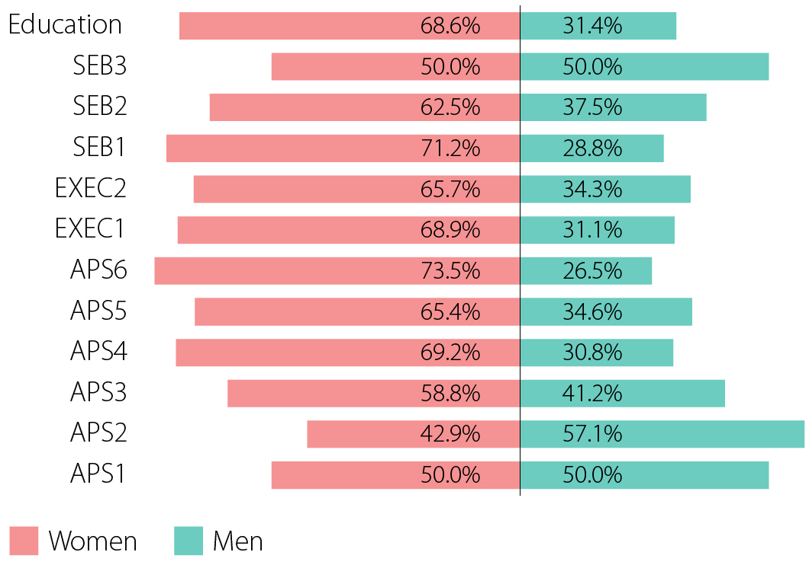**Figure 2. Department of Education gender composition by substantive classification as at 30 September 2024**

To further assess gender equality within the department, earnings were ordered from smallest to largest and divided into 4 equal groups (quartiles) with the upper quartile comprising the top 25% of earners, the upper middle the next 25% and so on. The gender composition of these quartiles in Figure 3 shows women not only make up most of the department’s workforce but are also the majority of top earners. This is especially noteworthy when compared to the CPS where only 29% of women make up the upper quartile. The department's pay quartile distribution aligns closely with the overall departmental distribution and shows that women and men undertaking work of similar value are remunerated equally.

**Figure 3. Department of Education earning quartiles and their gender compositions**

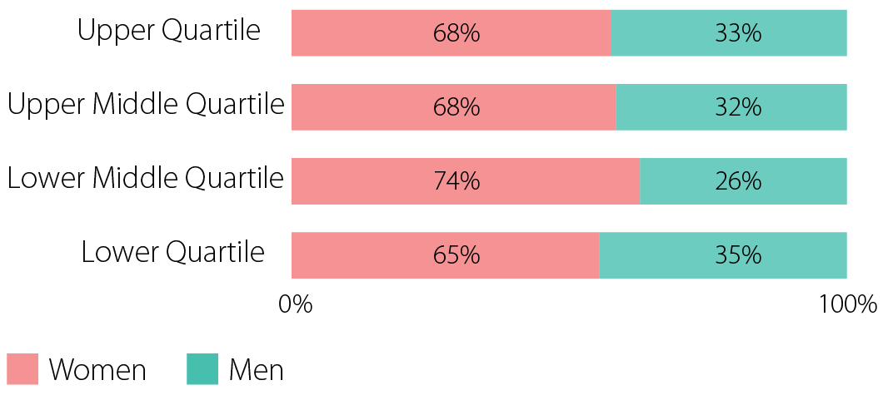

**Figure 4. Commonwealth Public Sector (CPS) earnings upper quartile**

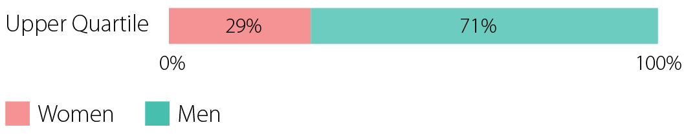

## Our ongoing commitment

The department is committed to achieving gender equality. This includes:

* Ensuring our employees receive equal pay for equal work, regardless of gender.
* Conducting a yearly pay gap analysis to monitor our commitment towards pay equality as well as a review of our commitment towards the **six (6) Gender Equality Indicators (GEIs)**.
* Continued support for, and engagement with, the Cross Agency Gender Equity Network.
* Consideration of conditions for negotiation through future APS-wide bargaining and the SES employment framework.
* Affirmative action in relation to attraction to professional and technical roles.
* Targeted measures to uplift capability and improve gender-balance in all management levels.

*Please note the APS is all employers that fall under the Public Service Act 1999 (PS Act), and the CPS captures all employers that fall under the Public Governance, Performance and Accountability Act 2013 (PGPA Act) and more than 100 employees.

The Workplace Gender Equality Act 2012 requires employers with 100 or more employees to report annually against 6 Gender Equality Indicators.  The Department of Education is committed to achieving gender equality and ensuring equal pay for equal work regardless of gender. In order to meet our commitment, we have measured the department against each indicator.

### GEI 1. Gender Composition of the Workforce

* The department tracks and reports on gender representation in all workforce categories, with a focus on maintaining women’s participation in leadership roles.
* The department regularly publishes workforce composition data to ensure transparency.
* The department's efforts in promoting gender equality are evident in the higher representation of women in executive leadership roles and the alignment of promotion and engagement rates with our workforce composition.

### GEI 2. Gender Composition of Governing Bodies

* The department adheres to the gender composition of the Executive Board which is its governing body as set out by the department’s terms of reference and monitors the gender composition to ensure balanced representation.
* The department's governing body currently has 40.0% women and 60.0% men, which is considered gender-balanced in accordance with the WGEA guidelines.

### GEI 3 Equal Remuneration for men and women

* The department conducts regular pay gap analyses.
* The department adheres to transparent pay structures and merit-based evaluation processes to ensure equitable remuneration for all employees.
* The current median and average gender pay gap within the department is neutral, ranging from 0.0% to 1.2% in the last 12 months, and is lower than the APS and CPS average and median values (see Figure 1). The WGEA guideline considers variations between -5.0% to +5.0% as neutral.

### GEI 4. Flexible work

* The department offers a range of flexible work options, including remote work, part-time arrangements, and job sharing in support of work-life balance for employees with caring responsibilities.
* Both men and women are equally encouraged to utilise flexible arrangements.
* The department also has clear guidance to support the uptake of these arrangements to ensure ease of accessibility.

### GEI 5. Consultation with employees on issues concerning gender equality in the workplace

* The department engages employees through:
  1. the APS Employee Census,
  2. the Consultative Committee, and
  3. other feedback mechanisms, such as staff surveys, to understand perceptions of gender equality.
* The department further engages with its various diversity and inclusion networks to support, consult on and oversee gender equality and other initiatives.

### GEI 6. Sexual harassment, harassment on the ground of sex or discrimination

* The department provides person centred and trauma informed approach to support staff.
* The department provides training programs to raise awareness and prevent harassment and discrimination.
* The department maintains robust reporting mechanisms and support systems for employees to report incidents safely and confidentially