

# Evaluation Strategy

2025-2027



With the exception of the Commonwealth Coat of Arms, the Department’s logo, any material protected by a trade mark and where otherwise noted all material presented in this document is provided under a [Creative Commons Attribution 4.0 International](https://creativecommons.org/licenses/by/4.0/) (https://creativecommons.org/licenses/by/4.0/) licence.

The details of the relevant licence conditions are available on the Creative Commons website (accessible using the links provided) as is the full legal code for the [CC BY 4.0 International](https://creativecommons.org/licenses/by/4.0/legalcode) (https://creativecommons.org/licenses/by/4.0/legalcode)

The document must be attributed as the 2025-2027 Evaluation Strategy.

Contents

Secretary’s Message 4

Vision 5

Purpose 5

Scope 5

About evaluation 5

Building blocks – Enabling, Doing and Growing 6

Block 1 – Accountability and Governance 6

Block 2 – Embedding Evaluation in All Stages of Policy Cycle 6

Block 3 – Evaluation Maturity and Capability Building 7

Block 1 – Accountability and Governance 7

Block 2 – Embedding evaluation in all stages of policy cycle 9

Block 3 – Evaluation maturity and capability building 11

### Secretary’s Message

The department provides strategic direction and national leadership for Australia’s education system – through early years, through school, higher education and research.

Through our work, we strive to create a better future for all Australians through education.

Evidence-based policy is essential to building an educational system that enhances learning and life outcomes for all Australians, while supporting a diverse and dynamic economy.

The Evaluation Strategy supports us to embed evaluation throughout the department and at every stage of the policy cycle. This improves the quality of our programs and policies through integrating insights and lessons from continuous evaluation and developing a better understanding of best practices.

By building our capability in evaluation, we will foster a culture of evaluative thinking – asking ourselves what success looks like from the very first stages of policy design to ensure we achieve the desired strategic outcomes.

Proficiency in evaluation is key to providing high quality policy advice ensuring our efforts are grounded in evidence, shape future policy, and contribute to a strong evidence-base to support decision makers.

Evaluation helps us learn from experience. I encourage you to become familiar with the Evaluation Strategy, and actively build your capability in evaluation to strengthen our department’s ongoing contribution to quality evaluation in the public service.

**Tony Cook PSM**

**Secretary**

### Vision

The department’s culture of evaluation enables us to learn what works, and to create a better future for all Australians through effective education policy.

### Purpose

The Evaluation Strategy 2025–2027 (the strategy) outlines the Department of Education’s approach and aims for evaluation of its policies and programs.

To support design and delivery of high quality, credible evaluation, the department established a centralised Evaluation Unit in 2023. This unit is uniquely placed to develop, refine and maintain the department’s Evaluation Strategy, and steward its implementation across the department.

This strategy provides a framework to support the evaluation of policies, programs and departmental corporate initiatives to provide a rigorous and credible understanding of policy and program operation, outcomes and impact.

### Scope

The strategy applies to all policies and programs and provides advice and direction to staff across the department.

The strategy:

Provides an overview of evaluation, why it matters, and its relationship with other activities conducted across the APS and in the department

Presents a framework to support accountability to outcomes, embed evaluative practice, and build evaluation capability across the department

Implementing this strategy will be a significant move towards embedding a culture of evaluative thinking and learning within the department, in alignment with the APS reforms and the recently established Evaluation Profession being jointly progressed by the Treasury, Home Affairs, and the Australian Public Service Commission.

### About evaluation

Evaluation is the planned, periodic and systematic determination of the quality, value and effects of a policy or program. Evaluation is generally conducted to:

* Find areas for improvement
* Generate an assessment of overall quality or value
* Increase accountability and transparency
* Contribute to evidence informed policy
* Establish robust feedback loops to support continuous decision making

High quality evaluation provides reliable information and evidence about the performance of a program or policy against its objectives.

Evaluation is critical to understanding how we can continue to create a better future for all Australians through education.

### Building blocks – Enabling, Doing and Growing

The Evaluation Strategy consists of three building blocks and supporting principles which are designed to improve accountability and governance, embed evaluation in all stages of the policy cycle and strengthen evaluation capability across the department. Each principle has a series of action areas to be progressed under the Strategy.

Together, these building blocks will enable increased and more effective use of evaluation within the department to inform our understanding of “what works” and better inform the development of future policies and programs.

#### Block 1 – Accountability and Governance

##### Enabling

High quality evaluation is enabled and supported by departmental governance, guidelines and principles

###### Principle 1

Evaluation in the department adheres to government requirements

###### Principle 2

Evaluation governance supports the delivery of credible and robust evaluation

#### Block 2 – Embedding Evaluation in All Stages of Policy Cycle

##### Doing

Evaluation is a valued and useful part of the planning, delivery, assessment and continuous improvement of policies and programs

###### Principle 3

The department engages in evaluation planning early in policy and program development

###### Principle 4

Evaluation of policies and programs is supported by robust design and evaluation methodologies

###### Principle 5

Evaluations are shared and inform our understanding of 'what works'

#### Block 3 – Evaluation Maturity and Capability Building

##### Growing

###### Useful and relevant investment in evaluation capability building is part of establishing and embedding evaluation in the department.

###### Principle 6

###### The department understands and actively develops evaluation maturity.

###### Principle 7

The department builds evaluation capability.

### Block 1 – Accountability and Governance

##### PRINCIPLE 1: Evaluation in the department adheres to government requirements

###### Align with APS approaches to evaluation

Evaluation is a core component of high-quality public policy and administration, and is embedded in legislation, policy, rules and strategies throughout the Australian Public Service (APS). This strategy should be read alongside the following documents:

[Public Governance, Performance and Accountability Act (2013) (PGPA Act)](https://www.legislation.gov.au/C2013A00123/latest/text)

[Budget Process Operational Rules (BPORs)](https://www.google.com/url?sa=t&rct=j&q=&esrc=s&source=web&cd=&ved=2ahUKEwiBxc6Div6IAxW6p1YBHe8UOwcQFnoECBkQAQ&url=https%3A%2F%2Fwww.finance.gov.au%2Fsites%2Fdefault%2Ffiles%2F2024-05%2Fbudget-process-operational-rules_0.pdf&usg=AOvVaw3H_X-PD4VpNQYS8ctYKsZH&opi=89978449)

[Commonwealth Evaluation Policy (the Policy)](https://evaluation.treasury.gov.au/about/commonwealth-evaluation-policy)

[Indigenous Evaluation Strategy](https://www.pc.gov.au/inquiries/completed/indigenous-evaluation/strategy)

[Commonwealth Grant Rules and Principles 2024](https://www.finance.gov.au/government/commonwealth-grants/grants-toolkit)

[Australian Government Guide to Policy Impact Analysis](https://oia.pmc.gov.au/resources/guidance-impact-analysis/australian-government-guide-policy-impact-analysis)

###### Incorporate Evaluation in New Policy Proposals (NPP)

All department NPPs will be reviewed by the Evaluation Unit. The review ensures that NPPs clearly identify objectives and targets, policy success is measurable, and appropriate approaches to evaluation are designed and implemented from the early stages of policy development.

##### PRINCIPLE 2: Evaluation governance supports the delivery of credible and robust evaluation

###### Harness Education Governance to Support Effective Evaluation

The following are high-level descriptions of roles and responsibilities across the department:

The department’s Executive Board will provide *strategic direction* to the department’s evaluation capability and progress.

Divisions and Branches will have overall *responsibility* and *accountability* to ensure policies and programs are evaluated, agree to and publish a response to evaluation recommendations, and ensure evaluations have appropriate governance arrangements which deliver the intended outcomes.

Sections / Teams are responsible for the *planning and operational administration* of an evaluation, including considering the design of evaluation within policy design and implementation.

External and/or independent advisory groups can have an important role in evaluation governance including, s*upporting meeting ethical practice, evaluating in partnership and working with stakeholders and communities.*

Department Evaluation Unit is responsible for providing *leadership*, *advice* and *support* for the planning and design of evaluation activities. In some cases, the Evaluation Unit will execute delivery of evaluation.

###### Conduct ethical and culturally appropriate evaluation

All evaluation must carefully consider relevant ethical standards, cultural appropriateness and privacy implications. The Evaluation Unit will develop a set of Ethics and Privacy Guidelines to guide the department on best practice for conducting ethical, culturally safe evaluation.

Additional frameworks, strategies and codes of ethics are available to guide ethical and culturally appropriate evaluation including:

[National Agreement on Closing the Gap](https://www.closingthegap.gov.au/national-agreement)

[The Framework for Governance of Indigenous Data](https://www.niaa.gov.au/resource-centre/framework-governance-indigenous-data)

[The Commonwealth Evaluation Toolkit](https://evaluation.treasury.gov.au/toolkit/related-whole-government-frameworks-policies-and-guidance)

The National Health and Medical Research Council’s [Ethical Considerations in Quality Assurance and Evaluation Activities.](https://www.nhmrc.gov.au/about-us/resources/ethical-considerations-quality-assurance-and-evaluation-activities)

### Block 2 – Embedding evaluation in all stages of policy cycle

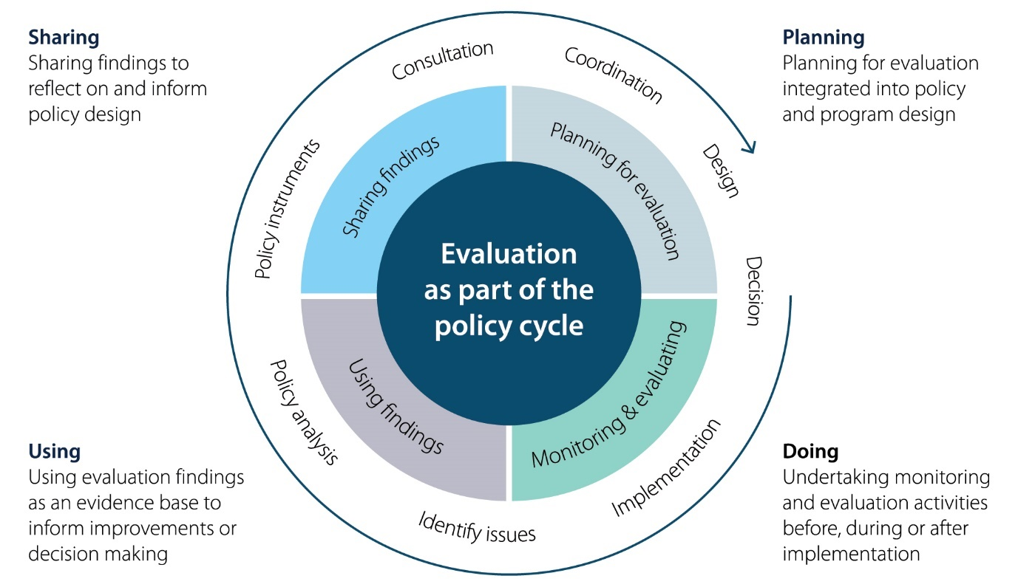

Figure 1: Policy Cycle and Evaluation

##### PRINCIPLE 3: The department engages in evaluation planning early in policy and program development

###### Plan early for evaluation

The department will consider evaluation during the early design of policy. Early engagement in evaluative thinking and planning has benefits including:

* Ensuring the high-level Theory of Change is robust
* Testing the evaluability of the policy and begin planning future evaluation
* Mapping and understanding the context in which the policy will be delivered
* Reflecting on and integrating past programs and evaluation findings

###### Support policy teams to plan and deliver effective evaluation

At the policy design stage, a clear understanding of the mechanisms by which the program or policy is expected to achieve its effects supports future evaluation.

The department uses Theories of Change to provide clarity on underlying assumptions, potential risks, change mechanisms and causal pathways, and identifies what to measure, when, how, and with whom.

The Evaluation Unit works with teams to develop Theories of Change both as standalone deliverables during policy and program development, and to help define and guide evaluative activity.

##### PRINCIPLE 4: Evaluation of policies and programs is supported by robust design and evaluation methodologies

**Appropriate design of evaluation**

A Program Evaluation Framework (PEF) structures the overall evaluation, including defining key questions that need answering, information required to answer those questions, and how this information will be analysed to provide meaningful insights. This framework is aligned to, and guided by, the Theory of Change or logic model.

###### Appropriate delivery of evaluations

**Internal evaluation**

This approach may be appropriate where independence is not required. Internal evaluation may be commissioned by policy teams with the assistance of a department data team. The Evaluation Unit works closely with both teams; the policy team to design an appropriate evaluation and data teams to support with compiling, cleaning and collating the data available.

**External evaluation**

At times, specialist professional knowledge or expertise may be required for an evaluation, or there may be merit or a requirement for the conduct of an independent evaluation. The [APS Strategic Commissioning Framework](https://www.apsc.gov.au/publication/aps-strategic-commissioning-framework) is part of the Government’s commitment to reduce the reliance on outsourcing and strengthen the capability of the APS.

The Evaluation Unit will support the procurement of evaluation and evaluation activities and consider specialised arrangements to deliver evaluations for high priority policies and programs.

##### PRINCIPLE 5: Evaluations are shared and inform our understanding of 'what works'

**Evaluation Activity Register**

An Evaluation Activity Register is in development to provide a way for policy teams to incorporate lessons learned into the design of new policies as a mechanism for iterative quality improvement. The register allows the review of previous evaluation in related policy spaces and the use of evidence to inform future policy.

**Insights Reports**

The Evaluation Unit will deliver two Insights Reports to the Executive Board (EB) annually. These insights reports will outline findings and recommendations in line with the priority action areas.

**Insights Reports**

The Evaluation Unit will deliver two Insights Reports to the Executive Board (EB) annually. These insights reports will outline findings and recommendations in line with the priority action areas.

###### Publication and communication of results

Evaluations will be shared with the community and key stakeholders. Evaluations or evaluation results will also be published on our website. This ensures the results of our evaluation are available to inform future education policy and delivery.

Evidence from evaluation will also be considered in the department’s analysis and preparation of annual performance statements and the Annual Report.

### Block 3 – Evaluation maturity and capability building

##### PRINCIPLE 6: The department understands and actively develops evaluation maturity

Evaluation maturity models are a practical framework to help individuals, teams and organisations to self-assess current evaluation standards and to provide clear and practical guidance to achieve higher quality practice.

An Evaluation Activity Register is in development to provide a way for policy teams to incorporate lessons learned into the design of new policies as a mechanism for iterative quality improvement. The register allows the review of previous evaluation in related policy spaces and the use of evidence to inform future policy.

**Monitor, understand, and develop the department’s evaluation maturity**

The Evaluation Unit will assess maturity using a consistent whole of government maturity model developed by the Australian Centre for Evaluation (ACE). A detailed capability prioritisation and implementation plan will be developed from this assessment. The Evaluation Unit will regularly monitor and report on the department’s evaluation maturity.

##### PRINCIPLE 7: The department builds evaluation capability

The purpose of Evaluation Capability Building is to develop the skills, practice, and environment to produce and use evaluation for improved performance. Evaluation Capability Building operates across the organisation as well as at individual and team levels. The activities outlined below support Evaluation Capability Building at the individual, departmental and system levels in alignment with the forthcoming APS Evaluation Profession.

###### Evaluation Capability Building for individuals and teams

Evaluation Capability Building for individuals focuses on changes in attitudes, knowledge and behaviour of staff across the department by embedding evaluative thinking.

Individuals and teams need to know how when and how to access advice and support, understand their roles and responsibilities, and actively engage with evaluation at all stages of the policy cycle.

###### Evaluation Capability Building for leadership and the department

Leadership is critical to enabling a culture of evaluation and evaluative thinking, and creating the authorising environment required to build evaluation capability. The development of systems, processes, policies and plans also integrates evaluation into the way the department accomplishes its strategic priorities.

Capability building at this level encourages the prioritisation and use of evaluation across the department.

###### Evaluation Capability Building for the APS and stakeholders

The department will engage in Evaluation Capability Building to support and elevate the use of evaluation across the government, education stakeholders and partners. Engaging with Evaluation Capability Building at the system level bolsters collaborative learning and enhances outcomes.

Capability building at this level ensures that recommendations are understood and aligned with current policy intent.